DOI: 10.1002/adem.
Microstructural evolution and microhardness variations in pure titanium
processed by high-pressure torsion

By Wanji Chen, Jie Xu*, Detong Liu, Jianxing Bao, Shima Sabbaghianrad, Debin Shan, Bin Guo, Terence G Langdon

[*] Dr. W.J. Chen, Prof. J. Xu, Ma. D.T. Liu, Dr. J.X. Bao, Prof. D.B. Shan, Prof. B. Guo
Key Laboratory of Micro-systems and Micro-structures Manufacturing of Ministry of Education, Harbin Institute of Technology, Harbin 150080, China
School of Materials Science and Engineering, Harbin Institute of Technology, Harbin 150001, China; E-mail: xjhit@hit.edu.cn
Dr. S. Sabbaghianrad, Departments of Aerospace & Mechanical Engineering and Materials Science, University of Southern California, Los Angeles, CA 90089-1453, USA
Prof. T.G. Langdon, Departments of Aerospace & Mechanical Engineering and Materials Science,
University of Southern California, Los Angeles, CA 90089-1453, USA, and Materials Research Group, Department of Mechanical Engineering, University of Southampton, Southampton SO17 1BJ, UK

Keywords: microstructure, ultrafine grains, high-pressure torsion, micro-forming, pure titanium

A grade 2 pure titanium with an initial grain size of ~50 μm is processed by high-pressure torsion (HPT) at room temperature under an imposed pressure of 6.0 GPa. The microhardness variations are examined and the results show the disks are reasonably homogeneous after 10 turns of torsional straining. The microstructural evolution is systematically characterized by optical microscopy, X-ray diffraction and transmission electron microscopy to provide information on the effect of shear strain on grain size and microstructure. The results demonstrate that the initial coarse structure is gradually refined from the edge to the center of the disk under the shear stress during HPT processing and an ultrafine-grained pure Ti is achieved with an average grain size of ~96 nm after 10 turns. A model is developed by considering the formation of subgrain boundaries, twins and high-angle grain boundaries for the grain reﬁnement of pure Ti processed by HPT.
1. Introduction
The rapid development of biomedical implant technology has brought with it a major and ever increasing need for surgical implants. Taking the dental implant technology as an example, according to incomplete statistics almost 2.5 billion people around the world at present suffer from a lack of teeth and nearly 1 million dental implants are needed in the United States and more than 10 million in China. Titanium and its alloys are potential biomaterials due to their high specific strength, low density, excellent corrosion resistance and excellent biocompatibility.^{[1-3]} Compared with coarse grained materials, ultraﬁne-grained (UFG) pure titanium is especially suitable for use as micro implant materials in the field of biological medical treatments. Nevertheless, the strength of pure titanium is not always sufficiently high so that use is made instead of the Ti-6Al-4V alloy but this introduces a potential problem with toxic alloying elements, such as Al and V, which may be harmful to human health.^{[4]} It was reported recently that a nanocrystalline pure titanium micro implant was successfully fabricated with a minimum diameter of 2.4 mm^{[5]} and there is also a report of a mini-screw that was designed with a diameter of 2.0 mm and a minimum spacing of the thread of 0.225 mm for orthodontic anchorage.^{[6]}
It is now well established that exceptional grain refinement may be achieved in metals, to the sub-micrometer or even the nanometer level, by processing through the application of severe plastic deformation (SPD)^{[7,8]} using techniques such as high-pressure torsion (HPT),^{[9]} equal-channel angular pressing (ECAP)^{[10]} or accumulative roll bonding (ARB).^{[11]} The use of ECAP is attractive because it uses relatively large samples but in practice it is generally not easy to press pure titanium at room temperature so that the numbers of imposed passes are often limited.^{[12]} Nevertheless, experiments on grade 2 pure Ti showed that a combination of 2 ECAP passes at 573 K followed by cold rolling at 173 K provided an opportunity for producing a material having ultimate tensile strengths and elongations to failure which exceeded the values associated with the Ti-6Al-4V alloy.^{[13]} At the present time, processing by HPT is generally considered the optimum processing route because it produces exceptionally small grain sizes, very high strength and, by comparison with materials processed by ECAP, higher fractions of grain boundaries having high angles of misorientation.^{[14-16]} Recent reports describe using HPT to refine the grains in pure Ti from ~40 μm to ~120 nm^{[17]} or from ~23±3 μm to ~100 nm.^{[18]} Nevertheless, the mechanism for the formation of these microstructural features and the nature of this grain refinement in hexagonal close-packed (HCP) materials such as Ti is not yet clearly defined although several reports describe the development of heterogeneous microstructures in HCP metals and their alloys, such as Zr alloys^{[19]} and Mg,^{[20]} when processing by HPT.
Accordingly, the present investigation was initiated with the objective of providing a detailed description of the microstructural evolution occurring in commercial purity (CP) Ti processed by HPT with special emphasis on the dislocation behavior and the formation of high-angle grain boundaries (HAGBs).
2. Experimental material and procedures
Experiments were conducted using a grade 2 CP titanium having a purity of 99.5 % received in the form of rods with diameters of ~10.0 mm. Initially, the as-received pure Ti rods were sliced into disks with thicknesses of ~1.2 mm. To observe the initial microstructure of the as-received metal, one of the disks was ground and then electro-polished to a mirror-like surface using a solution of 60% CH₃COOH, 25% H₂SO₄ and 15% HF with a DC voltage of 30 V for 45 s. After electro-polishing, the microstructure of the as-received sample was observed by electron backscatter diffraction (EBSD) using a Quanta 200FEG field emission scanning electron microscope (FESEM) with an operating voltage of 30 kV. These observations showed that the microstructure of the as-received pure titanium consisted of a reasonably uniform equiaxed α-phase with an average grain size of ~50 μm and with a fraction of ~94% of HAGBs having misorientations of >15° as shown in Fig. 1(a) and (b).
For HPT processing, each disk was carefully polished on both sides to a final thickness of ~0.82 mm and then placed in the depression on the surface of the lower anvil and the two anvils were brought together to impose an applied pressure. All disks were processed at room temperature (RT) under an applied pressure of 6.0 GPa through a number of turns, N, ranging from 1/4 to 10 revolutions at a rotation speed of 1 rpm.^{[21]} This processing was conducted under quasi-constrained conditions where there is a minor outflow of material around the periphery of the disk during the processing operation as shown in Fig. 1(c).^{[22, 23]} After HPT, the bottom surfaces of the disks were carefully polished to give final thicknesses of ~0.6 mm and then electro-polished to mirror-like surfaces using the same solution for microstructure examination and mechanical testing. Fig.1 (d) shows a schematic diagram of an as-deformed sample and the layout of the positions where the measurements were undertaken: the regions for the described measurements are highlighted. Vickers hardness measurements were performed along radial directions in steps of ∆r = 0.34 mm. X-ray diffraction (XRD) measurements were carried out in transmission mode (r ≥ 3 mm; beam parallel to axial direction). Samples for transmission electron microscopy (TEM) investigations were cut from the disks at r ≥ 2 mm.
Hardness measurements were taken using a Vickers microhardness tester with a load of 500 g and dwell times of 10 s. The microhardness values, Hv, were measured along randomly selected diameters on each disk with the measurements taken at intervals of 0.3 mm and at every point the local value of Hv was obtained from an average of four separate hardness measurements. The shear patterns on the disks after HPT processing were investigated using an Olympus QX71 optical microscope (OM). X-ray diffraction (XRD) was performed using both the as-received pure titanium and disks processed by HPT through 1/4 to 10 turns in order to detect any phase transformations using X'Pert Pro MPD with Cu-Kα radiation having a wavelength of 1.5405 Å. The microstructural evolution during HPT was examined by TEM using a Tecnai G2 F30 microscope under an accelerating voltage of 200 kV. For the TEM observations, the disks were ground carefully after HPT processing to thicknesses of ~70 μm and then smaller disks were punched out with diameters of 3 mm from the centers of the HPT disks and at distances of ~2.5 mm from the centers corresponding approximately to the mid-radius positions. These small disks were then twin-jet electro-polished to give the TEM samples using a solution of 60% methyl alcohol, 35% n-butyl alcohol and 5% perchloric acid at a temperature of 243 K. Selected area electron diffraction (SAED) patterns were recorded and the grain sizes were measured from the bright-field areas of the TEM micrographs.
3. Experimental results
3.1 Variation in microhardness after HPT processing
Fig. 2 shows the variations of the Vickers microhardness as a function of distance from the center of the disks after HPT processing through 1/4, 1, 5 and 10 turns (t), respectively. The initial microhardness in the as-received condition without HPT processing was reasonably uniform across the disk with a microhardness value of Hv ≈ 195. It is obvious from inspection of Fig. 2 that the microhardness increases with increasing numbers of turns and thus with increasing imposed strain. In practice, the microhardness increases significantly after HPT processing even after only 1/4 HPT turn where the hardness is Hv ≈ 280 at the edge and Hv ≈ 200 in the center of the sample. This increase in hardness is due in part to grain refinement but also it may be attributed in part to the development of an ω-phase^{[24]} which is harder than the α-phase. The individual values of the microhardness increase with increasing distance from the center of the disk and generally saturate to a reasonably constant level at distances from the center beyond ~2 mm. The microhardness near the center area increases with increasing HPT turns despite the low strain introduced in the central region, and this is due to the appearance of geometrically-necessary dislocations which are a consequence of the large strain gradient induced by HPT.^{[25]}
After one turn, the values increase slightly at both the center and the edge but for the 10 turns sample there is a major increase in hardness in the center and only a minor increase at the periphery of the disk. Thus, the microhardness distribution is reasonably homogeneous across the HPT disk after 10 turns with Hv ≈ 300. This observation is consistent with a previous investigation where the Vickers microhardness of the disks was essentially homogeneous after 5 or more turns of torsional straining.^{[21]}
3.2. OM observations
Fig. 3 shows OM images at the centers of the disks after HPT processing through (a) 1/4, (b) 1, (c) 5 and (d) 10 HPT turns. After 1/4 turn as shown in Fig. 3(a), the coarse grains tend to divide under the shear stress during HPT processing but the grains in the center are not significantly refined with a maximum grain size in this region of ~40 μm which is similar to, but slightly smaller than, the initial grain size of ~50 μm. After 1 turn of HPT in Fig. 3(b), it is apparent that the microstructure in the center of the sample continues to remain relatively coarse but these larger grains tend to be surrounded by many small grains. For the HPT samples processed through 5 and 10 turns in Figs 3(c) and (d), there is clearly a gradual refinement of grains with increasing distance from the disk center.
The OM images at the mid-radius positions of the disks are shown in Fig. 4 after processing through (a) 1/4 (b) 1, (c) 5 and (d) 10 turns. After 1/4 turn in Fig. 4(a), the grain shape is different from the shape of the grains in the central position in Fig. 3(a) due to the occurrence of very significant grain refinement which accounts for the large increase in hardness shown in Fig. 2. For the samples taken through 1, 5 and 10 turns in Fig. 4(b-d), the grain boundaries are less distinct but there is very significant grain refinement for these conditions. A comparison between the OM images shown in Fig. 4 with the images in Fig. 3 demonstrates that there is greater grain refinement in the mid-radius region of the disk and, in addition, the grain distributions at the mid-radius positions tend to be more uniform than in the central region.
3.3. XRD measurements
Fig.5 shows the XRD profiles of pure Ti before HPT processing at the lower line labeled 0 and after HPT processing through 1/4, 1, 5 and 10 turns under a pressure of 6.0 GPa. In the as-received sample, it is readily apparent that only the α-phase is visible with the four well-defined diffraction peaks of (1011), (1010), (0002), and (1012) within the angular range of 2θ from 25° to 60°. After HPT processing for 1/4 and 1 turn, the (0002) α-phase diffraction intensity becomes stronger whereas the (1010) α-phase diffraction intensity becomes weaker and the (1011) and (1012) α-phase diffraction intensities remain essentially unchanged. Nevertheless, there is also evidence for the introduction of a new (1010) ω-phase with a small diffraction peak as is evident in Fig. 5 after both 1/4 and 1 turn where this is consistent with earlier reports^{[26-28]}. Furthermore, when the sample is processed by 5 turns the (1011) α-phase diffraction intensity decreases and the (1010) ω-phase diffraction intensity becomes the strongest peak. After HPT processing through 10 turns, the XRD profile remains unchanged from 5 turns with the ω-phase having the strongest peak and with some small peaks associated with the α-phase.
The influence of the applied pressure and the shear strain on the ω-phase volume fraction is summarized in Table 1 for the present investigation and for earlier experiments.^{[29-33]} It is readily apparent that the ω-phase was detected after HPT processing with a shear strainγ= 7.85, equivalent to N = 1/4, and the fraction of this phase was ~12.8 %. A further increase in the number of rotations to 5, when the shear strain is γ= 157, gave an increase in the ω-phase fraction to ~55.71 %, which is significantly smaller than the results from an earlier investigation where a volume fraction of the ω-phase of 70 % was detected after deformation under a pressure of 6.0 GPa and a total of 5 turns. In practice, there are numerous reports of the occurrence of a phase transformation from α -Ti to ω -Ti when processing by HPT at different pressures of 1.2^{[31]}, 2^{[31]}, 3 ^{[29,31]}, 4 ^{[29]}, 5 ^{[27,29,32]} and 6.0 GPa ^{[30,31,33]}. It should be noted that the ω-phase was first detected after increasing the applied pressure to 4.0 GPa with the fraction of this phase of ~25-30 %; however, the reflections of the ω-phase were visible in the SAED pattern of the HPT sample under a pressure of 3.0 GPa which suggests that TEM observations reveal the very early stages of the localized α -Ti to ω-Ti transition under a pressure of 3.0 GPa when the ω-phase volume fraction is not sufficient to attain a signal/noise ratio during the X-ray measurements^{[27]}. It was shown also that the ω-phase is effective in increasing the hardness of pure Ti until the amount of this phase reaches a saturation level with increasing torsional straining.
3.4. TEM observations
Fig. 6 shows the microstructures and associated SAED patterns at the centers of the disks after HPT processing through (a-c) 1/4, (d-f) 1, (g-i) 5 and (j-l) 10 turns, respectively. Fig. 6 (c) and (f) are the SAED patterns corresponding to the regions marked A and B in (a) and (d) and the images shown in (b), (e), (h), (i), (k) and (l) are partially enlarged details of the regions indicated in (a), (d), (g) and (j). In Fig. 6(a-c), it is difficult to distinguish the grain boundaries from regions with high internal stress due to the high density of dislocations within the grains. An important characteristic of this microstructure is that twins are observed as reported also in pure Ti processed by ECAP.^{[34,35]} In order to clarify the structure of region A marked in (a), the SAED pattern is shown in (c) and this pattern has axial symmetry and twinning has become active. In Fig. 6 (d, e), increasing the numbers of turns from 1/4 to 1 produces a microstructure consisting mainly of a dislocation cell structure and with extensive slip bands. The SAED pattern in Fig. 6(f) shows mirror spots with respect to a plane so that twinning is again observed. In Fig. 6(g-i) after 5 turns, the grain size in the center of the sample remains reasonably coarse but finer grains appear around these coarse grains. The dislocation density is fairly high and no twinning was detected in pure Ti after 5 turns of HPT so that the microstructure is composed mainly of dislocation cells. Finally, in Fig.6 (j-l) after 10 turns, the grains in the center are refined to varying degrees which is consistent with the values of Hv in Fig. 2. It appears that the results after 10 turns are similar to those after 5 turns except that the area showing minor grain refinement becomes smaller.
Fig. 7 shows bright and dark field images, including SAED patterns, at the mid-radius positions after processing through (a-c) 1/4, (d-f) 1, (g-i) 5 and (j-l) 10 turns, respectively. Many dislocations are visible within the grains and there are many tangled dislocations near the grain boundaries. In practice, it is difficult to distinguish between the grain boundaries and areas of lattice distortion. The SAED pattern after 1/4 turn in Fig.7 (c) contains separate spots but, by contrast, the SAED patterns in Fig. 7(f, i, l) consist of rings with many diffracted beams which show that many multiple orientation grains were observed within the selected area and azimuth spreading of the reflex indicates the presence of low-angle grain boundaries (LAGBs). A comparison of the microstructures in Fig. 6 with the microstructures in Fig.7 shows that the central region of the disk is usually not refined to the same extent as the outer region of the disk and in both locations the spots in the SAED patterns have azimuth spreading which supports the existence of high internal stresses and lattice distortions when the samples are subjected to 5 or 10 turns. It should be noted that reflections of the ω-phase (marked in the red circle) are visible in the SAED pattern in Fig7 (f, i, l).
Fig. 7 shows, in the central column, the dark field images at the mid-radius positions of the disks after different numbers of rotations. These dark field images were used to calculate the grain size distributions after processing by HTP through different numbers of cycles. Thus, the grain size remains coarse after shearing through 1/4 turn of HTP as shown in Fig. 7(a) but the mean grain size was reduced to ~205 nm after 1 turn in Fig. 7(e). Average grain sizes of ~110 and ~96 nm were recorded from Fig. 7(h, k) after HPT processing through 5 and 10 turns and these grain sizes are consistent with earlier reports on Ti.^{[28,31,36]}The results in Fig. 7 demonstrate that there is a visible difference in the values of the average grain sizes at the mid-radius positions of the disks depending upon the numbers of rotations in HPT pressing. By increasing the numbers of rotations, there is a significant decrease in the value of the average grain size at the mid-radius of the sample. It is concluded, therefore, that the numbers of turns imposed in HPT processing are important in delineating the total extent of the microstructural refinement.
4. Discussion
4.1 The grain refinement mechanism in pure titanium processed by HPT
A mechanism for grain refinement is available when processing by ECAP^{[37]} but no similar mechanism is at present available when processing by HPT. Therefore, it is instructive to investigate the nature of the grain refinement mechanism in HPT.
In practice, the grain size in the central area of the disk in the early stages of deformation, such as after 1/4 turn, is very close to that of the as-received material of ~50 μm whereas the average grain size at the mid-radius position of the disk is significantly reduced to ~300 nm. The shear strain imposed on the disks under torsion is given by:^{[38]}
where N is the number of HPT turns, r is the distance from the center of the disk in the radial direction and h is the disk thickness. According to this expression, the shear strain under torsion has a linear dependence on the distance from the center of the disk, thereby indicating that the microstructure from the disk center to the periphery is gradually refined because of the continuous increase in shear strain. When the radius is r = 0, the center of the disk is not subjected to any shear strain and this suggests that the morphology of the phase domains and the value of Hv in the disk center should remain essentially unchanged. However, there are refined phase domains and an increase in Hv in the central area of the disk, as shown in Fig. 3 and Fig. 2, respectively, and the microstructure tends to become more uniform with progressive HPT deformation and therefore with increasing numbers of turns. Therefore, the coarse grains in the center of the disk are refined with the numbers of turns during HPT processing.
Strain gradient hardening was reported in low carbon steel when investigating the Hv of samples with different geometrical shapes in cross-section after one turn of HPT processing.^{[39]} These results showed that specimens with larger strain gradients have higher values of Hv and this suggests the existence of strain gradient hardening due to the gradients in plastic shear that result from the storage of geometrically-necessary dislocations.^{[40]} This tendency is associated with strain gradients which are a non-uniform deformation process. It is apparent that the accumulated plastic strain increases mostly at the edge of the sample at the beginning of the torsional straining and the strain gradient arises in the center of the disk and drops off towards the edge in subsequent turns.
During the HPT processing, a number of twins were observed within the grains at low values of the shear stress. Nevertheless, a high density of dislocations was also observed both along the grain boundaries and within the grain. This suggests that the deformation mechanisms are both deformation twinning and dislocation slip at the lower shear stresses. In addition, by increasing the numbers of HTP turns, the fraction of twins is significantly reduced so that, after a critical strain, the dominant deformation mechanism becomes exclusively dislocation slip rather than deformation twinning.
Accordingly, the grain refinement mechanism may be illustrated by a model developed for pure Ti when processing by HPT as shown by the schematic illustration in Fig.8. The procedure of grain refinement for the initial coarse grain structure in Fig, 8(a) may be divided into three representative stages. In the first stage shown in Fig. 8(b), the HPT process is applied to the CP Ti with equiaxed coarse grains and this causes excessive deformation in some of the grains. At the same time the grain boundaries become blurred or diffuse due to the absorption of lattice dislocations during processing and the consequent development of non-equilibrium boundaries containing an excess of extrinsic dislocations.^{[41-43]} A similar development of diffuse boundaries after SPD processing was recognized in early experiments conducted on samples of an Al-Mg alloy processed by HPT.^{[44]} The experiments show that some twins are activated during this initial stage of low strain deformation due to the limited number of independent slip systems available in pure Ti. In addition, dislocation slip is initiated with increasing shear stress but this dislocation motion tends to be blocked by the presence of grain and subgrain boundaries. With an accumulation of dislocations, the probabilities of the mutual interactions of dislocations rise significantly due to the increasing dislocation density. In the second stage shown in Fig. 8(c), there is the formation of grains having low angles of misorientation and dislocation absorption at these subgrain boundaries so that there is an overall increase in their misorientation angles. In the final stage shown in Fig. 8(d), there is a transition from grains having low angles of misorientation to small grains having high-angle boundaries due to the further absorption of dislocations. Thereafter, the increase in dislocation density by SPD processing tends to be essentially balanced by the absorption of dislocation at these HAGBs.
4.2. Potential application of nanostructured pure Ti in the micro-forming of mini-dental implants.
It is well known that commercial titanium is an effective bioactive material because Ti can stimulate the growth of new bone onto the biomaterial surface and spontaneously bind to living bone cells if they were previously subjected to an appropriate surface treatment.^{[45]} A study of a titanium dental implant removed 4 years after surgery showed that the attached osteoblast cells bonded onto the metallic surface.^{[46]} However, CP Ti is not generally suitable for orthopedic applications due to its relatively low mechanical properties. Nevertheless, experiments have shown that the strength of ultrafine-grained CP titanium may be appropriately adjusted to reasonably match that of conventional titanium alloys such as the Ti-6Al-4V alloy where this alloy is often used as a high strength structural implant.^{[13,47]}
One of the major problems in the application of titanium alloys in biological implants is the presence of alloying elements which may lead to potential toxicity when the toxic alloying elements are released into the body. For example, the degree of osseointegration of CP Ti and UFG Ti mini-implants was investigated by insertion in rabbits and then using removal torque tests which revealed no significant statistical difference when using removal torques of 17.0 N cm and 18.9 N cm, respectively.^{[2]} Thus, it is concluded that UFG CP Ti has a very significant potential for development as a high strength structural material which may be used in a wide range of biomedical situations including, for example, as dental implants and as mini-fasteners in orthopedic applications.
Finally, it is important to note that the use of these materials in dentistry requires appropriate testing, as reported earlier for CP Ti processed by ECAP ^{[48]} where samples were tested following the procedure developed for the evaluation of dental implants by the International Organization of Standardization. This testing procedure, designated ISO 14801, is designed specifically to effectively incorporate both the inclined loading and the bone resorption that occurs during the fatigue life of real implants under in situ conditions.
5. Conclusions
(1) Microscopy and hardness measurements were used to evaluate the evolution of grade 2 CP Ti during HPT processing. The results show that HPT processing leads to significant grain refinement from an initial grain size of ~50 μm to a final grain size of ~96 nm after 10 turns of HPT.
(2) The microhardness variations with increasing equivalent strain show that the mechanical properties can be improved significantly and ultimately the microhardness saturates at a steady-state level after HPT processing through 10 turns.
(3) TEM images together with SAED patterns show that the deformation mechanisms are both deformation twinning and dislocation slip at low shear stresses in the initial stages of processing but with increasing stress there is a transition so that dislocation slip becomes the dominant deformation mechanism. XRD profiles provide direct evidence for the development of an ω-phase with increasing numbers of HPT turns.
(4) A model is developed for grain reﬁnement in pure Ti when processing by HPT and this model incorporates the formation of subgrain boundaries and twins, the absorption of dislocations to give high-angle grain boundaries and the subsequent development of a balance between dislocation generation and absorption.
Acknowledgements
This work was supported by the National Natural Science Foundation of China under the Grant No. 51635005 and No. 51475124. Partial support was provided by the Programme of Introducing Talents of Discipline to Universities under Grant No. B18017 and the European Research Council under ERC Grant Agreement No. 267464-SPDMETALS.

Received: ((will be filled in by the editorial staff))
Revised: ((will be filled in by the editorial staff))
Published online: ((will be filled in by the editorial staff))

- H.L. Freese, M.G. Volas, J.R. Wood, in Titanium in medicine, (Eds: D.M. Brunette, P. Tengvall, M. Textor, P. Thomsen), SpringerVerlag, Heidelberg, Germany, 2001, Ch. 2.
- C.N. Elias, J.H.C. Lima, R. Valiev, M.A. Meyers, JOM 2008, 60(3), 46.
- M. Geetha, A.K. Singh, R. Asokamani, A.K. Gogia, Prog. Mater. Sci. 2009, 54, 397.
- U. Kamachimudali, T.M. Sridhar, B. Raj, Sadhana 2003, 28, 601.
- R.Z. Valiev, I.P. Semenova, V.V. Latysh. H. Rack, T.C. Lowe, J. Petruzelka, L. Dluhos, D. Hrusak, J. Sochova, Adv. Eng. Mater. 2008, 10, B15.
- C.N. Elias, M.A. Meyers, R.Z. Valiev, S.N. Monteiro, J. Mater. Res. Technol. 2013, 2, 340.
- R.Z. Valiev, R.K. Islamgaliev, I.V. Alexandrov, Prog. Mater. Sci. 2000, 45, 103.
- T.G. Langdon, Acta Mater. 2013, 61, 7035.
- A.P. Zhilyaev, T.G. Langdon, Prog. Mater. Sci. 2008, 53, 893.
- R.Z. Valiev, T.G. Langdon, Prog. Mater. Sci. 2006, 51, 881.
- Y. Saito, N. Tsuji, H. Utsunomiya, T. Sakai, R.G. Hong, Scr. Mater. 1998, 39, 1221.
[12] Y. Zhang, R.B. Figueiredo, S.N. Alhajeri, J.T. Wang, N. Gao, T.G. Langdon, Mater. Sci. Eng. A 2011, 528, 7708.
[13] V.L. Sordi, M. Ferrante, M. Kawasaki, T.G. Langdon, J. Mater. Sci. 2012, 47, 7870.
[14] A.P. Zhilyaev, B.K. Kim, G.V. Nurislamova, M.D. Baró, J.A. Szpunar, T.G. Langdon, Scr. Mater. 2002, 46, 575.
[15] J. Wongsa-Ngam, H. Wen, T.G. Langdon, Mater. Sci. Eng. A. 2013, 579, 126.
[16] J. Wongsa-Ngam, M. Kawasaki, T.G. Langdon, J. Mater. Sci. 2013, 48, 4653.
[17] R.K. Islamgaliev, V.U. Kazyhanov, L.O. Shestakova, R.Z. Valiev, Mater. Sci. Eng. A 2008, 493, 190.
[18] Y.J. Chen, Y.J. Li, J.C. Walmsley, N. Gao, H.J. Roven, M.J. Starink, T.G. Langdon, J. Mater. Sci. 2012, 47, 4838.
[19] Y.B. Wang, M. Louie, Y. Cao, Scr. Mater. 2010, 62, 214.
[20] J. Čížek, I. Procházka, B. Smola, Mater. Sci. Eng. A 2007, 462, 121.
[21] M. Shirooyeh, J. Xu, T.G. Langdon, Mater. Sci. Eng. A 2014, 614, 223.
[22] R.B. Figueiredo, P.R. Cetlin, T.G. Langdon, Mater. Sci. Eng. A 2011, 528, 8198.
[23] R.B. Figueiredo, P.H.R. Pereira, M.T.P. Aguilar, P.R. Cetlin, T.G. Langdon, Acta Mater. 2012, 60, 3190.
[24] Y. Todaka, J. Sasaki, T. Moto, M. Umemoto, Scr. Mater. 2008, 59, 615.
[25] N.A. Fleck, G.M. Muller, M.F. Ashby, J.W. Hutchinson, Acta Metall. 1994, 42, 475.
[26] A.R. Kilmametov, A.V. Khristoforov, G. Wilde, R.Z. Valiev, Z. Kristallogr. Suppl. 2007, 26, 339.
[27] Y. Todaka, J. Sasaki, T. Moto, M. Umemoto, Scr. Mater. 2008, 59, 615.
[28] K. Edalati, Z. Horita, H. Fujiwara, K. Ameyama, Metall. Mater. Trans. A 2010, 41, 3308.
[29] Y. Ivanisenko , A. Kilmametov, H. Rosner, R.Z. Valiev, Int. J. Mater. Res. 2008, 99, 36.
[30] K. Edalati, E. Matsubara, Z. Horita, Metall. Mater. Trans. A, 2009, 40, 2079.
[31] K. Edalati, T. Daio, M. Arita, S. Lee, Z. Horita, A. Togo, I. Tanaka, Acta. Mater, 2014, 68, 207.
[32] H. Shahmir, T.G. Langdon, Mater. Sci. Eng. A 2016, 667, 293.
[33] R.E. Bolmaro, V.L. Sordi, M. Ferrante, H.-G. Brokmeier, M. Kawasaki, T.G. Langdon, IOP Conf. Ser.: Mater. Sci. Eng. 2014, 63, 012147.
[34] Y. Zhang, S.N. Alhajeri, R.B. Figueiredo, N. Gao, J.T. Wang, T.G. Langdon, Mater. Sci. Forum 2011, 667-669, 719.
[35] Y. Zhang, Z.S Dong, J.T. Wang, J.Q. Liu, N. Gao, T.G. Langdon, J. Mater. Sci. 2013, 48, 4476.
[36] C.T. Wang, N. Gao, M.G. Gee, R.J.K. Woo, T.G. Langdon, wear, 2012, 280-281, 28.
[37] T.G. Langdon, Mater. Sci. Eng. A 2007, 462, 3.
[38] R.Z. Valiev, A.P. Zhilyaev, T. G. Langdon, in Bulk Nanostructured Materials: Fundamentals and Applications, Wiley/TMS, Hoboken, NJ, USA, 2013.
[39] M. Umemoto, Y. Todaka, J. Sasaki, I. Shuro, Mater. Sci. Forum 2008, 584-586, 493.
[40] Y. Ito, Z. Horita, Mater. Sci. Eng. A 2009, 503. 32.
[41] R.Z. Valiev, V.Yu. Gertsman, N.K. Tsenev, Phys. Stat. Sol. (a) 1986, 97, 11
[42] R.Z. Valiev, R.Sh. Musalimov, N.K. Tsenev, Phys. Stat. Sol. (a) 1989, 115, 451.
[43] A.A. Nazarov, A.E. Romanov, R.Z. Valiev, Acta Metall. Mater. 1993, 41, 1033.
[44] J. Wang, Z. Horita, M. Furukawa, M. Nemoto, N.K. Tsenev, R.Z. Valiev, Y. Ma, T.G. Langdon, J. Mater. Res. 1993, 8, 2810.
[45] T. Kokubo, H.M. Kim, M. Kawashita, J. Mater. Sci. Mater. Med. 2004, 15, 99.
[46] P. I. Brånemark, B. O. Hansson, R. Adell, U. Breine, J. Lindström, O. Hallén, A. Ohman, Scand. J. Plast. Reconstr. Surg. 1977, 16, 1.
[47] I.P. Semenova, R.Z. Valiev, E.B. Yakushina, G.H. Salimgareeva, T.C. Lowe, J. Mater. Sci. 2008, 43, 7354.
[48] R.B. Figueiredo, E.R.deC. Barbosa, X. Zhao, X. Yang, X. Liu, P.R. Cetlin, T.G. Langdon, Mater. Sci. Eng. 2014, A619. 312.

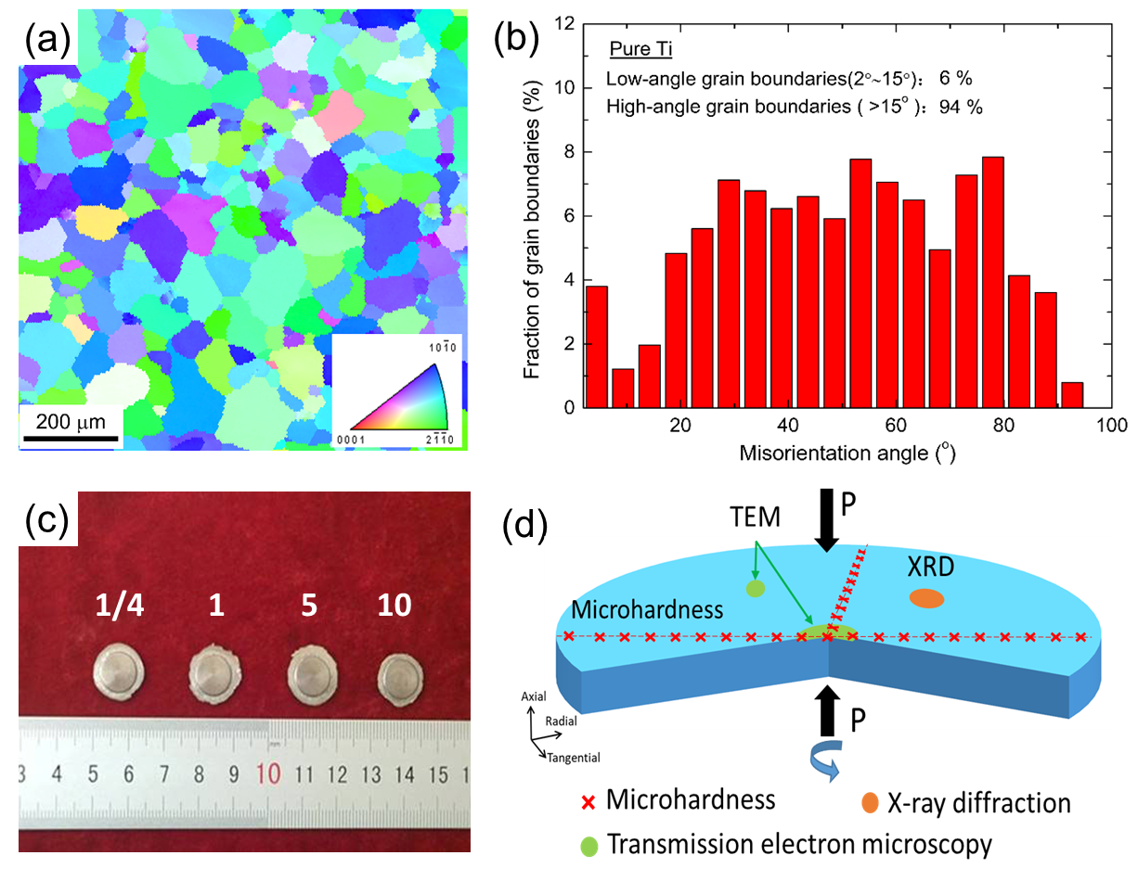
Fig. 1 (a) Microstructure of the as-received pure titanium, (b) Distribution of grain boundary misorientations; (c)Pure Ti disks after HPT through 1/4, 1, 5, 10 turns; (d)Schematic image of measurement position in HPT sample.

Fig.2. Microhardness distributions along diameters of HPT disks after different numbers of turns.

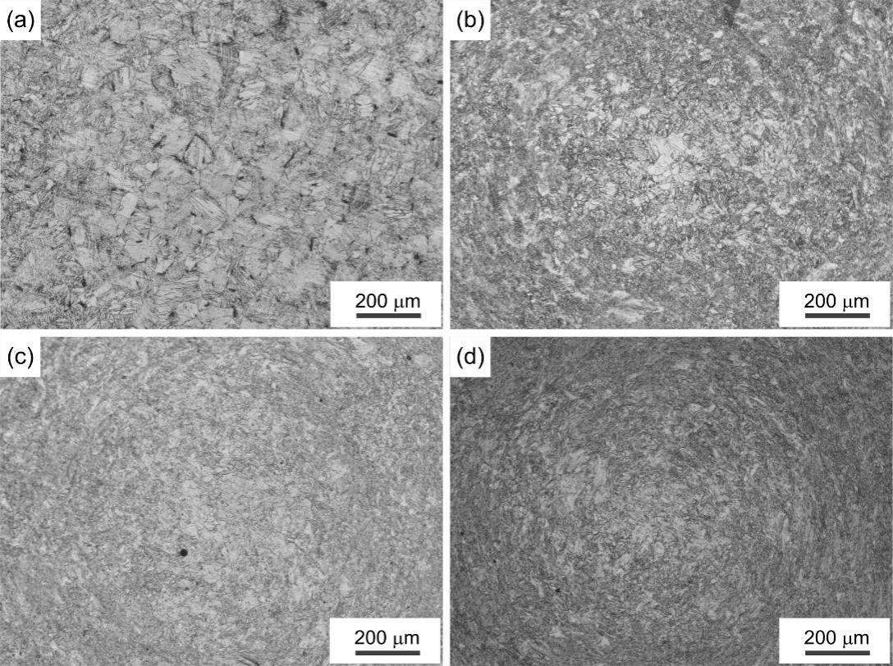
Fig. 3 OM images at the centers of the disks after HPT processing through (a) 1/4, (b) 1, (c) 5 and (d) 10 turns.

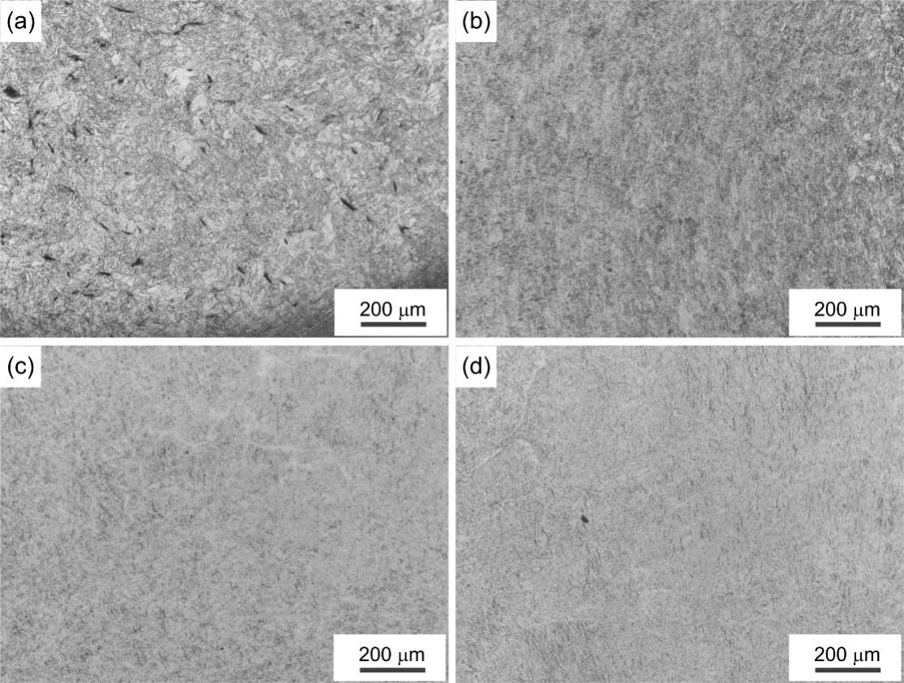
Fig. 4. OM images at the mid-radius positions of the disks after HPT processing through (a) 1/4, (b) 1, (c) 5 and (d) 10 turns

Fig. 5. X-ray diffraction profiles of pure Ti before and after HPT processing through 1/4, 1, 5 and 10 turns under a pressure of 6.0 GPa.

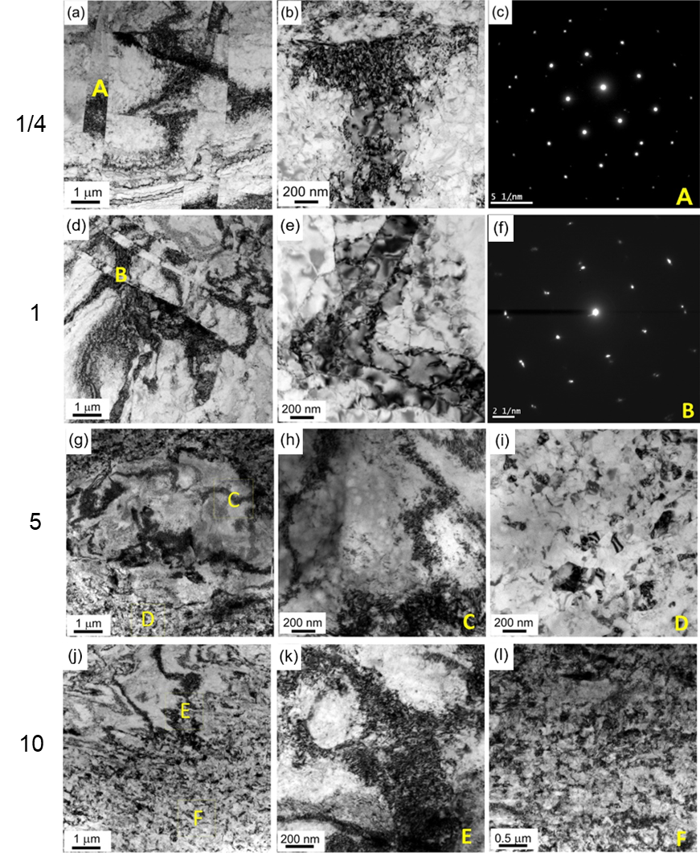
Fig.6 TEM images of the centers of the disks after HPT processing through (a–c) 1/4, (d-f) 1, (g-i) 5 and (k-l) 10 turns with a combination of bright field images and SAED patterns.

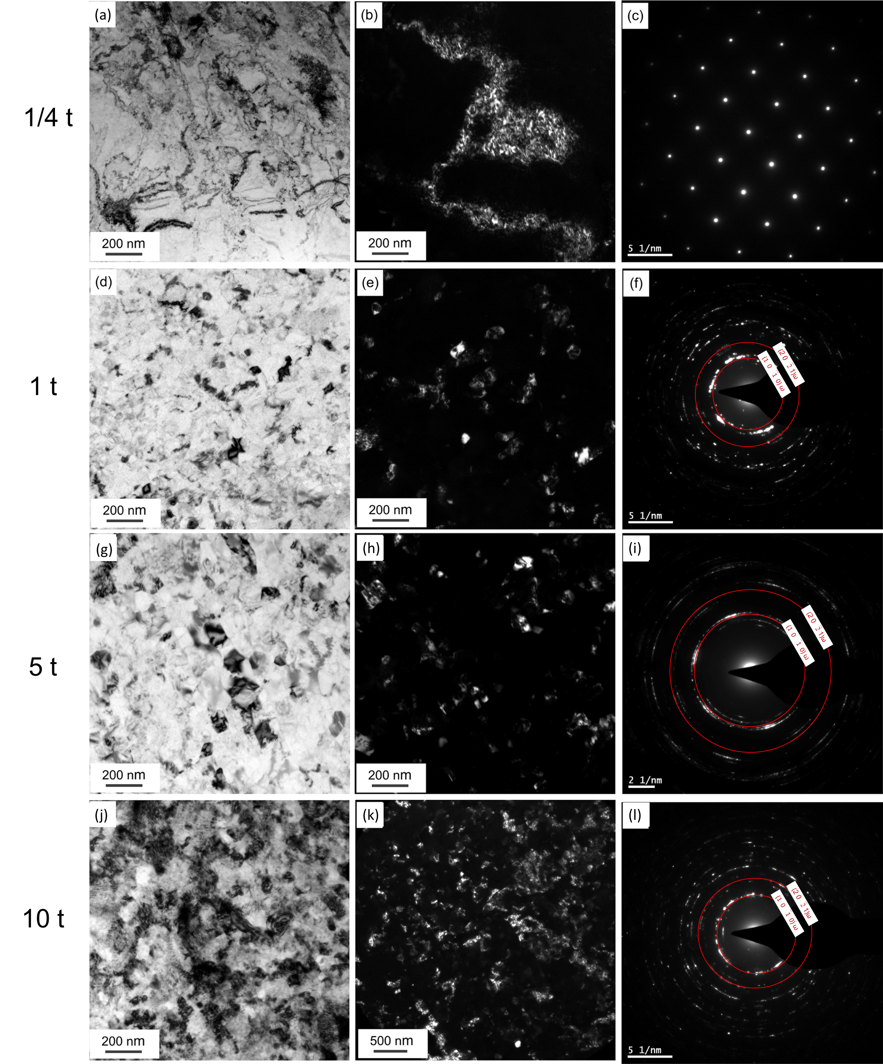
Fig.7 TEM images at the mid-radius positions of disks after HPT processing through (a-c) 1/4, (d-f) 1, (g–i) 5 and (k–l) 10 turns with a combination of bright field images, dark field images and SAED patterns.

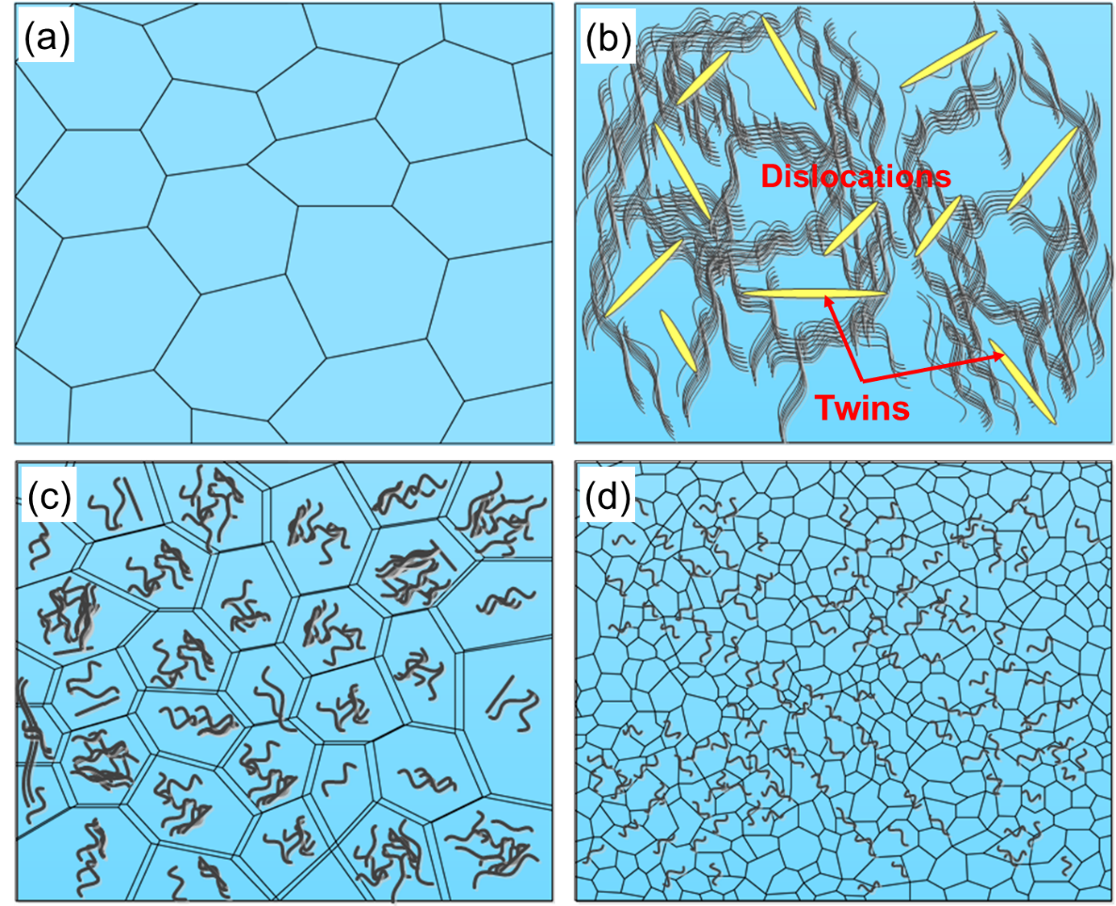
Fig. 8 A model for grain refinement in pure Ti processed by HPT.
Table 1. HPT-processing parameters and corresponding amounts of the ω-phase in titanium
Pressure  (GPa) | Rotation rate (rpm) | Number of turns  N | Relative amount of the ω-phase  (%) | Microhardness  Hv | Reference
1.2 | 0.2 | 10 | 0 | 269 | Edalati et al.^{[31]}
2 | 0.2 | 10 | 0 | 272
6 | 0.2 | 10 | ~31.10 | 347
3 | 1 | 5 | 0 | - | Ivanisenko et al.^{[29]}
5 | 1 | 5 | 25 | -
5 | 1 | 5 | 55 | -
6 | 1 | 5 | 70 | -
6 | 1 | 10 | ~80.3 | 351 | Edalati et al.^{[30]}
5 | 0.2 | 10 | ~90 | - | Todaka ^{[27]}
5 | 1 | 10 | ~27 | 300 | Shahmir et al.^{[32]}
5 | 0.5 | 10 | ~65 | 368
6 | 1 | 5 | ~50 | 400 | Bolmaro et al.^{[33]}
0 | 0 | 0 | 0 | 195 | This work
6 | 1 | 1/4 | ~12.8 | 275
6 | 1 | 1 | ~14.62 | 290
6 | 1 | 5 | ~55.71 | 305
6 | 1 | 10 | ~53.94 | 310

