Synthesis of Vanadium Nitride-Hard Carbon Composites from Cellulose and their Performance for Sodium Ion Batteries
Hang Cheng, Nuria Garcia-Araez and Andrew L. Hector*
School of Chemistry, University of Southampton, Southampton SO17 1BJ, United Kingdom.
* A.L.Hector@soton.ac.uk
Abstract
A promising material for sodium-ion battery anodes has been developed through the controlled formation of a thin, uniformly dispersed layer of vanadium nitride (VN) nanoparticles onto a high-performance hard carbon. Hard carbon is the standard (pre)commercial material for sodium-ion negative electrodes, and our hard carbon electrodes exhibit an electrochemical performance comparable to the state-of-the-art. The introduction of VN produces an increased capacity: with addition of 8.6 wt% VN, the hard carbon-based electrode achieves a first cycle reversible (oxidation, de-sodiation) capacity of 354 mA h g⁻¹ at 50 mA g⁻¹, while with pure hard carbon it is 302 mA h g⁻¹. The additional specific capacity achieved upon addition of VN, compared with the pure hard carbon, is 605 mA h g⁻¹ when referred to the mass of VN only, which is the highest capacity of VN materials in sodium-ion batteries reported to date. In addition, VN also improves the capacity retention with cycling: after 50 cycles the reversible capacity of hard carbon electrodes with 8.6 wt% VN is 294 mA h g⁻¹, while with pure hard carbon it is 239 mA h g⁻¹. This promising new material is obtained via a new and easily scalable synthesis method in which cotton wool is reacted with a vanadium source (VOCl₃), followed by a single firing step in N₂. Insights into the reaction mechanism are obtained by ex situ characterization of the discharged and charged electrodes.
Keywords: vanadium nitride, hard carbon, composite, sodium-ion, batteries
Introduction
Sodium ion batteries (SIBs) are a promising substitute for lithium ion batteries (LIBs) because of the natural abundance and lower price of sodium.¹⁻⁴ Various layered sodium oxides have been widely and successfully applied for SIB positive electrodes with a high capacity and minimal structural change with intercalation and de-intercalation of sodium ions⁵⁻⁹. However, many challenges still remain when transferring technologies from LIBs to SIBs. One of these is that the larger ionic radius of sodium (102 pm), compared with that of lithium (76 pm),has the consequence that graphite, the accepted negative electrode material in LIBs, is not a suitable SIB negative electrode,¹⁰ unless solvated.¹¹⁻¹²
Hard carbon (HC), known as “non-graphitizable” carbon, is the most popular negative electrode material in SIBs. Dahn¹³ first reported the electrochemical reversibility of Na insertion into hard carbon in 2000. In further studies, a variety of hard carbon materials have been obtained by pyrolysis of pitch¹⁴ or biomass precursors including peat moss,¹⁵ banana peels,¹⁶ cotton wool¹⁷ and glucose.¹⁸ Very promising performance has been reported: the best performing hard carbon¹⁶ delivered good capacities (339 mA h g⁻¹ at 50 mA g⁻¹) with respectable capacity retention (88% after 300 cycles). However, higher capacities are required to increase the specific energy of SIBs, and the loss of capacity with cycling is more severe than with graphite in LIBs. In this article, we investigate the development of composite materials in which the hard carbon is combined with a sodium conversion material with the aim of improving the capacity and cycling stability.
A variety of materials have been investigated as negative electrode materials for SIB, including metal alloys,¹⁹⁻²⁰ metal oxides²¹⁻²² and metal chalcogenides,²³⁻²⁴ all of which have attractive theoretical capacities. Transition metal nitrides examined include Sn₃N₄²⁵, Ni₃N²⁶, Cu₃N²⁷ and TiN²⁸ reported by ourselves, which delivered high specific capacities via sodium conversion reactions that were found to be mainly constrained to the surface of the metal nitride particles, with the core of the metal nitride particle remaining unreacted. Fe₃N has been examined by Liu et al.²⁹ and Mo₂N by Vadahanambi et al.,³⁰ both of which also exhibited a conversion mechanism. Fe₃N@C particles prepared by Li et al³¹ showed good cycling stability that was attributed to the high conductivity of Fe₃N and the beneficial role of the carbon support to accommodate for the volumetric expansion associated to the sodium conversion reactions. The use of VN in sodium ion batteries was first studied by Cui et al.³² who reported VN microparticles with stable, reversible capacity of ~300 mA h g⁻¹ at 124 mA g⁻¹ and reported HRTEM and XANES data that suggested the conversion of VN to VN_{0.35} as part of the mechanism of charge storage. Yuan³³ et al developed VN nanocrystals embedded into N-doped hollow carbon spheres that delivered a capacity of 360 mA h g⁻¹ at 100 mA g⁻¹ in sodium half cells. Song³⁴ reported VN quantum dots dispersed onto graphene with a reversible capacity of 237 mA h g⁻¹ at 74 mA g⁻¹. More recently, Wei et al³⁵ reported a new layered VN material that delivered a capacity of 372 mA h g⁻¹ at 50 mA g⁻¹.
Based on the outstanding theoretical capacity of VN of 1238 mA h g⁻¹, associated to the three electron transfer by completely reducing V³⁺ to V⁰, and encouraged by the promising electrochemistry of VN-based materials for sodium-ion applications reported in previous studies, here we selected VN as a high capacity material to deposit onto a hard carbon to improve its performance. We employ a cheap and high-performance hard carbon made from cotton wool as a baseline material, which delivered a reversible capacity of 302 mA h g⁻¹ at 50 mA g⁻¹, comparable to the state-of-the-art hard carbon electrodes for sodium ion batteries. VN is relatively expensive and undergoes a significant volumetric expansion in the conversion reaction with sodium, therefore, VN is incorporated in the form of small nanoparticles deposited on the hard carbon surface, and the mass percentage of VN in the composite is kept below 15%wt.
The preparation of the hard carbon decorated with VN nanoparticles was achieved via the reaction of the hard carbon precursor (cotton wool) with a vanadium source (VOCl₃), followed by firing under N₂ to form a hard carbon material with a thin, homogeneously dispersed VN coating. This novel synthesis method uses a single firing step (that is required anyway for the synthesis of the hard carbon) and it avoids the use of reactive gas conditions (ammonia) used in previous studies for the preparation of VN-based materials.^{33,34} Furthermore, a significant improvement in capacity is obtained upon incorporation of the VN on our hard carbon: with 8.6 wt% VN, the hard-carbon based composite electrode achieves a first cycle reversible capacity of 354 mA h g⁻¹ at 50 mA g⁻¹, 16% higher than the bare hard-carbon electrode. The capacity retention of the VN-based composite with 8.6 wt% VN is also superior, with a reversible capacity of 294 mA h g⁻¹ retained after 50 cycles. The additional capacity obtained by the incorporation of VN on the hard carbon is ascribed to the reversible conversion reaction of VN to VN_{0.2} based on the XRD characterization of the electrodes after full discharge and charge in sodium half-cells.
Experimental
VN-HC composites were obtained by a variation to the synthesis process reported recently by ourselves for TiN-HC composites.²⁸ Under N₂, hexane (200 mL, Fisher Scientific, distilled from sodium/benzophenone ketyl ether) was added to a flask containing cotton wool (5 g, Fisher Scientific, dried overnight at 80 °C). VOCl₃ (volumes between 0 and 2 mL, Sigma-Aldrich) was added and the flask was heated to reflux (75 °C) overnight. The solvent and any remaining precursor was removed in vacuo. The dried material was then fired under nitrogen at 1400 °C (ramp rate 4 °C min⁻¹ then maintained for 2 h).
Scanning electron microscopy (SEM) used a Philips XL30 with 10 kV accelerating voltage and a Jeol JSM6500 with 15 kV accelerating voltage. Energy-dispersive X-ray (EDX) analysis used a Thermofisher Ultradry detector. Transmission electron microscopy (TEM) was carried out with a FEI Tecnai T12 at 80 kV. Powder X-ray diffraction (XRD) patterns were collected in 0.6 mm silica capillaries with parallel Cu K_{α} X-rays using a Rigaku Smartlab. XRD data was analyzed with Rigaku PDXL2 and the GSAS package.³⁶ Raman spectra were collected with a Renishaw inVia Ramanscope operating at 785 nm. Raman analysis used WiRE software. Curve-fitting was carried out with a linear baseline and three peaks (G, D and D3) using Lorentzian and Gaussian functions. Thermogravimetric analysis (TGA) was measured with a TG209 F1 Libra using a ramp rate of 10 °C min⁻¹ under a mixture of Ar (50 mL min⁻¹) and O₂ (20 mL min⁻¹). The surface area was calculated by the Brunauer-Emmet-Teller (BET) method from nitrogen adsorption/desorption isotherms obtained on a Micromeritics Tristar II surface area analyzer. X-ray photoelectron spectroscopy (XPS) was carried out on a Thermo Nexsa with Al K_{α} X-rays. XPS data was analyzed using the Casa XPS software package with the XPS binding energy scale calibrated to graphitic carbon at 284.6 eV. Core peaks were fitted with a nonlinear Shirley-type background.³⁷ Peak positions and areas were optimized by a weighted least-squares fitting method using 70% Gaussian and 30% Lorentzian line shapes.
Working electrodes were obtained from inks produced using 0.1 g of VN-HC composite or HC with polyvinylidene difluoride (PVDF, Solvay) binder at a weight ratio of 95:5. These materials were mixed with N-methyl-2-pyrrolidone (0.3 mL, anhydrous, 99.5%, Sigma-Aldrich) to make a viscous ink, which was mixed with an homogenizer at speeds of 10,000, 15,000 then 20,000 rpm for 5, 3 and 2 mins, then cast onto copper foil (0.0175 mm thick, Goodfellow Ltd) using a 40 µm K-bar. The ink was air-dried overnight before the foil was cut into 11 mm diameter discs, and then further dried under vacuum overnight. The typical mass loading of as-prepared electrodes was 1-1.3 mg cm⁻². Discs of sodium with diameter of 11 mm (Sigma-Aldrich) were used as counter and pseudo-reference electrodes. Two sheets of dried Whatman GF/D glass fiber (12 mm, GE Healthcare Life Science) were used as separators, soaked with 180 µL of 1 mol dm⁻³ NaClO₄ (Alfa Aesar, anhydrous, 99%) in 1:1 ethylene carbonate (EC, Sigma-Aldrich, anhydrous, 99%) and diethyl carbonate (DEC, Sigma-Aldrich, anhydrous, ≥99%) electrolyte. Electrochemical performance was tested in ½” Swagelok cells assembled in an N₂-filled glovebox (MBraun, H₂O < 0.1 ppm, O₂ < 0.1 ppm). Galvanostatic cycling with voltage limitation (5 mV to 2 V (vs the sodium counter-electrode), GCPL) was performed at 25 °C using a Biologic MPG potentiostat. Electrochemical impedance spectroscopy (EIS) was measured at room temperature with a frequency range from 0.05 Hz to 500 kHz, and the voltage before cycling is around 2.9 V and after cycling is around 1.0 V.
Results and discussion
We have developed a strategy to make metal nitride-HC composites based on the reaction of hydrolysable metal-containing precursors with cellulose so that the hydroxide groups of the cellulose form M-O-C bonds to the metal. This distributes the metal ions across the surface, giving a uniform coating of the metal after a single pyrolysis step under nitrogen that is used anyway in the formation of HC itself (Fig. 1a). Previously we used TiCl₄ to distribute TiN nanoparticles onto HC.²⁸ VCl₄ has become difficult to obtain and has a limited shelf life, so here we used VOCl₃ as the reactive vanadium source.
Figure 1. (a) Scheme illustrating the synthesis of the VN-HC composites; SEM image of (b) HC and (c) 8.6 wt% VN-HC composite, with inset TEM image; (d and e) EDX mapping image of the 8.6 wt% VN-HC composite. Further SEM images can be found in Fig. S1.
Reaction of VOCl₃ with cotton wool produced a reddish-brown material and the color changed to green if exposed to air. After firing in N₂ at 1400 °C the fibrous, black carbon composite was ground to a fine powder. Various volumes of VOCl₃ were used in the synthesis to effect different loadings of VN on the HC (Table 1). SEM (Fig. 1b) shows the fibrous structure of the HC with a diameter of 5-10 µm, maintaining the morphology that was originally present in the cellulose. The surface of the HC fibers are noticeably rougher in the vanadium-containing samples (Fig. 1c). TEM (Fig. 1C insert) shows that this roughness is due to the presence of nanoparticles on the HC surface. EDX maps (Figs. 1d and 1e) show that vanadium disperses evenly on the HC structure.
XRD patterns of the composites (Fig. 2a) showed the expected rocksalt-type reflections of VN (PDF No. 35-0768) plus two broad peaks around 23 and 44 degrees that can be attributed to the 002 and 100 peaks of HC. The 200 peak of VN overlaps the 100 peak of HC, meaning that more structural information about the HC can be obtained by Raman (below). The VN peaks in the composites become narrower with increasing VN content, from which the particle size of VN was found to have increased from 26 nm at 4.6% loading to 56 nm at 14.6% (Table 1).
Table 1. Structural parameters for VN-HC composites
Material | VOCl₃ volume (mL) | HC |  |  | VN
 |  | d₀₀₂ (Å) | I_{D}/I_{G} |  | Crystallite size (nm) | a (Å) | BET surface  area (m² g⁻¹)
HC | 0 | 3.747(9) | 1.71 |  | - | - | 69
4.6 wt% VN-HC | 0.1 | 3.938(5) | 1.74 |  | 26(2) | 4.15304(3) | 45
6.5 wt% VN-HC | 0.2 | 3.9106) | 1.75 |  | 35(3) | 4.15111(3) | 53
8.6 wt% VN-HC | 0.4 | 3.960(8) | 1.82 |  | 39(2) | 4.15447(6) | 62
10.7 wt% VN-HC | 0.8 | 3.923(8) | 1.86 |  | 46(2) | 4.15554(2) | 55
14.6 wt% VN-HC | 2.0 | 3.966(9) | 1.90 |  | 56(6) | 4.16183(1) | 42

Thermogravimetric analysis (Fig. 2b) of the VN-HC composites was used to determine the VN content in the composite. The mass loss between 325 and 500 °C combined mass loss due to burning HC and mass increase due to oxidizing VN. After TGA analysis, the remaining product was checked by PXRD and it was identified as V₂O₅ (Fig. S2). Hence the vanadium content was calculated from this mass change.
Raman spectroscopy is useful to identify disordered materials,³⁸⁻³⁹ and as mentioned above the XRD peak overlap meant that Raman was more informative regarding the HC part of the composites (Fig. 3). Two broad peaks around 1310 and 1595 cm⁻¹ can be ascribed to disordered (D-band) and ordered graphitic (G-band) structures in HC, respectively.³⁸ The spectral analysis by curve fitting (Fig. S3) employed the D, G and D₃ bands. The D and G bands were fitted with Lorentzian functions while the small D₃ band was fitted with a Gaussian function as described by others⁴⁰. The intensity ratio I_{D}/I_{G} increases from 1.71 to 1.90 (Table 1) with increasing vanadium loading, suggesting the presence of VN increases the disorder of HC. That is consistent with previous reports of introducing metallic atoms to the amorphous substrate.⁴¹ There are no obvious strong peaks below 1000 cm⁻¹ (Fig. S4), which would have been expected to be observed if significant vanadium oxide was present.
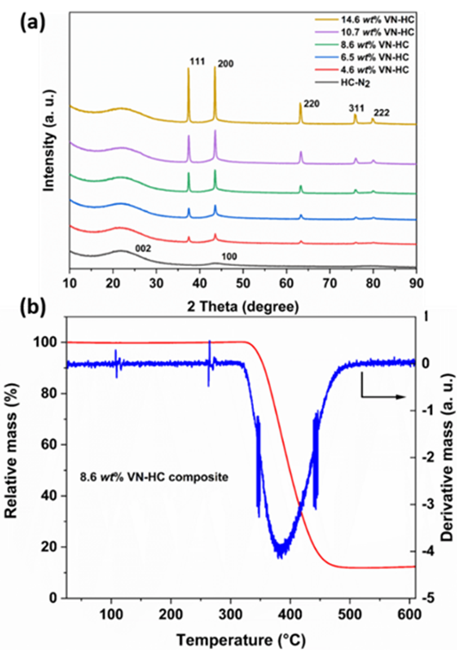
Figure 2. (a) XRD patterns of HC and VN-HC composites; (b) TGA and differential TGA results of 8.6 wt% VN-HC composite.
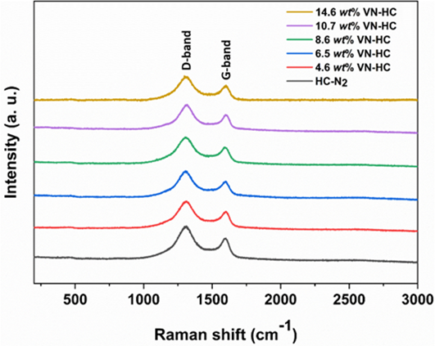
Figure 3. Raman spectra of VN-HC composites with different VN loadings.
Fig. 4a displays the nitrogen adsorption-desorption isotherms of VN-HC composites. All the samples exhibit type IV isotherms and H4 type hysteresis, which means the samples contain micro-and mesopores. A feature common to these hysteresis loops is that complete closure points should appear at nitrogen’s boiling point around P/P₀ = 0.42. However, for some materials containing micropores, low pressure hysteresis can be extended to the lowest attainable pressures as seen in these isotherms.⁴²⁻⁴⁴ Pore size distribution (Fig. 4b) obtained by density functional theory (DFT) indicates the presence of micro and mesopores. Table 1 shows the BET calculated surface area. As the volume of VOCl₃ used in synthesis increased from 0.1 to 0.4 mL, the surface area of the composites increased from 45 to 62 m² g⁻¹, suggesting that the carbothermal reduction of the vanadium precursor and the formation of nanoparticles increased surface area. However, then, as the volume of VOCl₃ increased from 0.4 to 2 mL, the surface area decreased from 62 to 42 m² g⁻¹, which can be attributed to pore blocking and the increased particle size of VN.
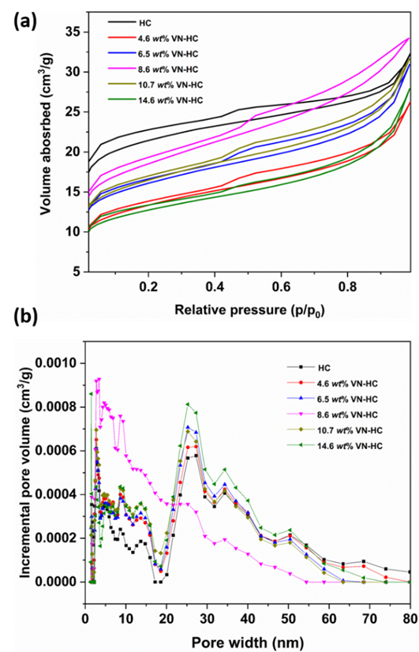
Figure 4. (a) Nitrogen adsorption-desorption isotherms of HC-N₂ and VN-HC composites; (b) pore size distribution calculated using the DFT method.
The surface composition of 8.6 wt% VN-HC was probed using XPS. The measured atom concentrations in the top few nm of the sample were C 93.4%, N 1.3%, O 2.9% and V 2.4%. The high-resolution C 1s spectrum and survey spectrum can be seen in Fig. S5. The main C 1s peak at 284.6 eV is compatible with the binding energy from sp² carbon, while the peaks with higher binding energy can be attributed to sp³ carbon, C-O, C=O and π-π*satellite.⁴⁵⁻⁴⁶ The strong peak in the N 1s region at 397.3 eV (Fig. 5a) corresponds to N in vanadium nitride,⁴⁷ with oxynitride and surface-bound nitrogen species also observed at higher binding energies.⁴⁸ The main component in the O 1s spectrum (Fig. 5b) with binding energy of 530.1 eV corresponds to vanadium oxide,⁴⁷ while another two peaks with binding energy of 531.2 eV and 532.9 eV can be assigned to carbonyl groups on the hard carbon,⁴⁹⁻⁵⁰ which is consistent with the components in the C 1s region. As the vanadium oxide does not appear in the XRD pattern or Raman spectra, the content is small and can be attributed to air exposure of the surface.^{34, 51} For the V 2p_{3/2} components, the peak position at 513.7 eV corresponds to VN and 516.8 eV is attributed to a shake-up satellite peak originating from poorly screened core hole states,⁵²⁻⁵³ while the signals at 515.4 eV and 517.4 eV are related to oxidation states higher than 3⁺.^{34, 54} In our previous study,²⁸ we discussed the absence of nitrogen doping in hard carbon. The C 1s spectrum fitting here is good without the presence of C-N at 286.2 eV,⁵⁵ suggesting no nitrogen doping of the HC component.
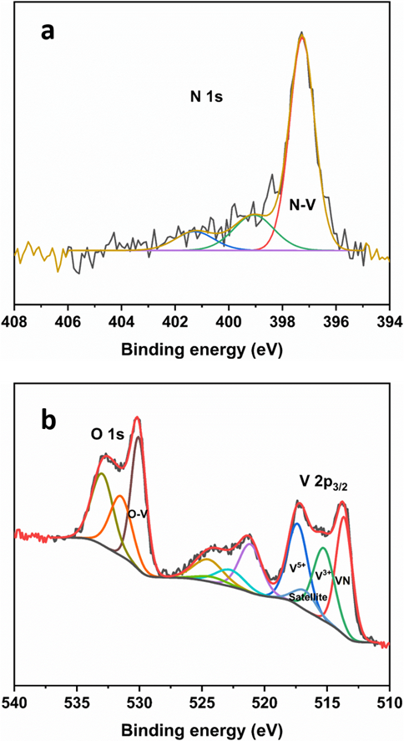
Figure 5. Fitted N 1s (a), and O 1s and V 2p (b) XPS spectra of 8.6 wt% VN-HC composite.
The electrochemical performance of the VN-HC composites was evaluated in sodium half cells by charge/discharge cycling over the voltage range 0.005-2 V (vs the sodium counter electrode). Fig. 6a shows the first cyclic differential capacity plots of HC and the VN-HC composite electrodes. The first pair of small cathodic peaks at around 1.07 V and 0.52 V (insert in Fig. 6a) can be assigned to the decomposition of electrolyte and formation of a solid electrolyte interface (SEI) and irreversible adsorption/insertion of sodium on the hard carbon.⁵⁶ These processes only appear in the first cycle (see Fig. S6). The main process of sodium insertion and extraction from the hard carbon produces a sharp peak centered at ca. 0.1 V, in agreement with previous work. The height of this main peak changes little with cycling (Fig. S6), demonstrating good cyclability of the VN-HC composite electrodes.
Figure 6. (a) First cycle differential capacity plots and (b) first cycle charge-discharge capacity curves of VN-HC composites with different VN content; (c) ex situ XRD patterns of 8.6 wt% VN-HC electrode before and after first cycling.
Fig. 6b shows the first charge/discharge profiles of HC and VN-HC electrodes at a current of 50 mA g⁻¹. The HC electrode exhibited an initial reduction (sodiation) specific capacity of 433 mA h g⁻¹ and an oxidation (reversible, desodiation) specific capacity of 302 mA h g⁻¹, with a 70% first cycle coulombic efficiency. Similar performance has been reported for hard carbon obtained from cotton wool (by heating at 1300 °C), which delivered an oxidation (reversible) capacity of 315 mA h g⁻¹ at 30 mA g⁻¹ with first cycle coulombic efficiency of 83%.¹⁷ The lower first cycle coulombic efficiency obtained here can be ascribed to the higher BET surface area (69 m² g⁻¹, compared to 38 m² g⁻¹ in previous work¹⁷). The use of PVDF binder has also been reported to decrease the coulombic efficiency⁵⁷, and further work will investigate the use of alternative binders such as sodium alginate, used in previous work.¹⁷
On the other hand, the VN-HC electrodes showed oxidation (reversible, de-sodiation) capacities of 317, 333, 354, 306 and 284 mA h g⁻¹, with increasing VN content. Therefore, an increase of 52 mA h g⁻¹ in the oxidation (reversible) capacity is achieved upon incorporation of 8.6 wt% VN on HC. This increase of 52 mA h g⁻¹ in specific capacity (normalized by the mass of the whole active material, VN and hard carbon) corresponds to a very high specific capacity of 605 mA h g⁻¹ when normalized by the mass of VN in the VN-HC composite. Since VN is the source of this extra capacity, normalization by the mass of VN in the composite electrode provides a more accurate measure of the degree of utilization of VN in the VN-HC composite in the energy storage reactions, and the value of capacity of 605 mA h g⁻¹ is the highest specific capacity of VN in sodium ion batteries that has been reported. The specific capacity of the VN-HC composite electrode with 8.6 %wt VN of 354 mA h g⁻¹ also exceeds or is comparable with the capacity of VN-based materials used previously in sodium-ion batteries, ³²⁻³⁵ whereas the material here developed has clear advantages in terms of the low content of VN (which is the most expensive component), use of very cheap carbon precursors (cotton wool) and use of an environmentally friendly and easily scalable synthesis route.
The maximum capacities are not achieved with maximum addition of VN into the hard carbon. The maximum in the BET surface area of the composites peaks at 8.6 wt% VN-HC (Table 1), the composition that also exhibits the highest sodium storage capacity. This suggests that surface area is important, although charge storage is not purely a surface area related effect since surface area is lower in all of the composites than that of the hard carbon itself. Calculated VN surface area based on the loadings and crystallite sizes shown in Table 1 (see details of calculations in the supplementary information) would suggest that the VN surface area should increase with increasing VN content – the fact that it does not is likely to be due to a larger degree of VN aggregation at the higher loadings.
In order to understand the energy storage reactions undergone by VN in the VN-HC composites, and elucidate the origin of the increase in capacity observed upon addition of VN to the hard carbon material, an ex situ XRD characterization of the electrodes before and after cycling was done (Fig. 6c). The pristine electrode, prior to cycling, showed peaks attributed to vanadium nitride and the copper substrate. After the first electrochemical reduction (sodiation) to 0.005 V, a new peak at 54.1 degrees appeared, which can be ascribed to VN_{0.2}⁵⁸, and the VN peaks decreased in intensity. The fact that VN peaks are observed for the fully sodiated electrodes suggests that the cores of the VN particles remain unreacted. Rietveld refinement of the XRD data (Fig. S7) showed that the lattice parameter of VN in the reduced and oxidized samples was the same, confirming that the sodiation reactions occur on the surface of the VN nanoparticles. From the BET data described above we know that the surface area decreases above 8.6 wt% VN and this change is likely to be responsible for the declining capacity at higher loadings. Other products of the electrochemical sodiation of VN (e.g. sodium nitride) appear to be amorphous, since they could not be detected by XRD. After the electrochemical oxidation (de-sodiation) of the sample to 2 V, the new peak associated with VN_{0.2} disappears and the VN reflections increase in intensity, becoming close to that in the original pattern, demonstrating that VN energy storage reactions are reversible.
Fig. 7a shows the cycling performance of HC and VN-HC electrodes at 50 mA g⁻¹ over 50 cycles. The 8.6 wt% VN-HC electrode exhibited an initial coulombic efficiency of 73%, higher than that of 70% from HC, and reached over 98% before the 10th cycle. The VN-HC electrodes showed initial coulombic efficiency of 69, 72, 73, 74 and 69% with increasing VN loading. After 50 cycles, the oxidation (reversible) capacity of the 8.6 wt% VN-HC electrode was 294 mA h g⁻¹, retaining 83% of its first cycle capacity (a repeat data set is in Fig. S8), while that of the HC electrode decreased to 239 mA h g⁻¹. Therefore, the difference in capacity of the VN-HC electrode with 8.6%wt VN and the HC electrode is 55 mA g⁻¹, very close to the initial difference in capacity of 52 mA h g⁻¹.
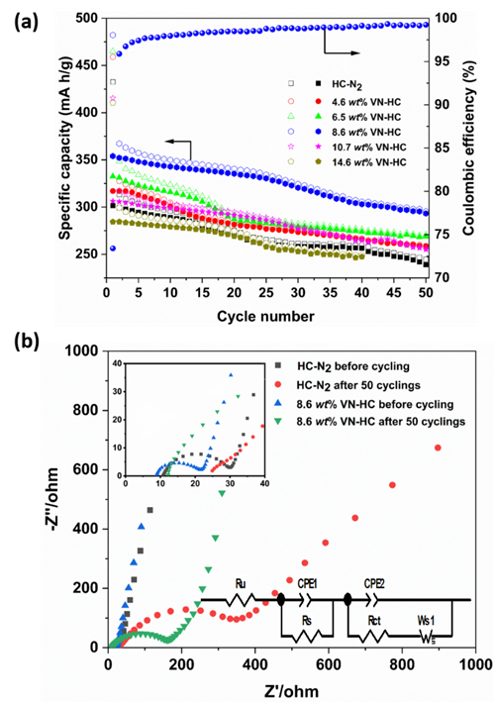
Figure 7. (a) Cycling performance of HC and VN-HC composite electrodes, with open symbols representing reduction capacity and solid symbols oxidation capacity; (b) Nyquist plots of HC and 8.6 wt% VN-HC composite electrodes before and after 50 cycles.
Fig. 7b shows the electrochemical impedance spectra for the HC and VN-HC before cycling (inset in Fig. 7b) and after 50 cycles. It is observed that the HC electrodes show a larger increase in their charge transfer resistance with cycling: the semicircle in the Nyquist plot has a width of ca. 147 Ω in the VN-HC composite compared with ca. 277 Ω in the HC electrode after 50 cycles (values obtained by fitting the data to the equivalent circuit shown in Fig. 7). The lower charge transfer resistance of the VN-HC composites, compared to pure HC, could be due to the contribution of the energy storage reaction on VN nanoparticles, in agreement with the fact that the measured specific capacity is higher. On the other hand, the rate of decrease of specific capacity with cycling is similar for VN-HC and HC electrodes, which suggests that the cause of capacity fade is the same in both cases. A recent study has shown that the capacity of cycled hard carbon electrodes in sodium half cells can be quantitatively recovered (95% of the original capacity) by replacing the electrolyte, separator and sodium metal counter electrode in the cell, indicating that the main cause of capacity degradation is due to the reactivity of the sodium metal counter electrode with the electrolyte, rather than degradation of the hard carbon.⁵⁷ This is supported by the fact that the capacity loss only affects the electrochemical reactions taking place at potentials <0.1 V, and the fact that the capacity loss in this low potential region is more severe at a higher current density (see supplementary information, Figs. S9-S12). This behavior is consistent to that reported previously by Bommier et al,⁵⁷ who explained it as reaction of the sodium counter electrode with the electrolyte, forming an SEI whose resistance increases with time. Since the measurements here reported were done in 2-electrode sodium half-cells, with sodium as both the reference and counter electrode, the increasing resistance of the sodium SEI means that the potentials applied to the hard carbon electrode during the sodiation reactions become higher with cycling. The lower voltage limit of 5 mV vs. the sodium counter electrode increasingly becomes higher than a potential limit of 5 mV vs. a Na⁺/Na reference electrode, because the IR drop contribution becomes increasingly higher. Due to the very shallow voltage profile of the HC and VN-HC electrodes at low potentials (Figs. S11-S12), the increase in the low potential limit value due to the increase in IR drop contributions produces a significant effect on the measured capacity, but this does not appear to be related to degradation of the HC or VN-HC electrode.
Conclusions
VN-HC composites have been synthesized using a pyrolysis process after reacting VOCl₃ with cellulose. The samples contained hard carbon with a morphology that emulates the fibrous structure of the cellulose precursor, with vanadium nitride nanoparticles distributed across the surfaces. The addition of 8.6 wt% VN to the hard carbon showed the best electrochemical performance, with initial reversible (oxidation) capacity of 354 mA h g⁻¹ (52 mA h g⁻¹ higher than the capacity of pure hard carbon). The additional capacity delivered by VN-HC composites, compared to pure HC, is maintained during cycling, consistent with the conclusion from previous studies that the degradation of capacity with cycling is due to the reactivity of the sodium metal counter-electrode with the electrolyte, rather than degradation of the electrode material.⁵⁷ When the additional capacity associated with addition of VN is normalised by the mass of VN only (rather than the sum of the masses of VN and hard carbon), a very high value of specific capacity of ca. 605 mA h g⁻¹ is obtained, demonstrating good utilisation of the VN in sodiation conversion reactions. The XRD characterization of the electrodes after the first reduction (sodiation) shows the transformation of VN to VN_{0.2} and other amorphous phases, and back again to VN after the first oxidation (de-sodiation). XRD also shows that the core of the VN nanoparticles remain unreacted, thus further decreasing of nanoparticle size could lead to improved performance. Other strategies for optimisation of the material could include the use of soft carbons combined with the hard carbon to improve the initial coulombic efficiency,⁵⁹ which will be the subject of further work. Overall, the new material reported here shows promising electrochemical performance and a reaction mechanism in which the advantages of HC and VN for applications in SIB are combined to produce a material with high structural stability. We expect that this facile and effective method can be extended to synthesize other metal nitride/carbon composites to apply in electrocatalysis, supercapacitors and other energy technology.
Supporting information
The supporting information includes further electron microscopy, diffraction data, spectra, electrochemical data and tabulated data. These are referred to in the main text.
Acknowledgements
H.C. would like to thank the China Scholarship Council (CSC) and University of Southampton for support. N.G.A. thanks the EPSRC for an early career fellowship (EP/N024303/1). We acknowledge Harwell XPS for collecting the XPS data and the use of the EPSRC-funded National Chemical Database service hosted by the Royal Society of Chemistry.
References
1. Kim, S.-W.; Seo, D.-H.; Ma, X.; Ceder, G.; Kang, K., Electrode Materials for Rechargeable Sodium-Ion Batteries: Potential Alternatives to Current Lithium-Ion Batteries. Adv. Energy Mater. 2012, 2 (7), 710-721.
2. Slater, M. D.; Kim, D.; Lee, E.; Johnson, C. S., Sodium-Ion Batteries. Adv. Funct. Mater. 2013, 23 (8), 947-958.
3. Yabuuchi, N.; Kubota, K.; Dahbi, M.; Komaba, S., Research Development on Sodium-Ion Batteries. Chem Rev 2014, 114 (23), 11636-11682.
4. Hwang, J. Y.; Myung, S. T.; Sun, Y. K., Sodium-Ion Batteries: Present and Future. Chem. Soc. Rev. 2017, 46 (12), 3529-3614.
5. Keller, M.; Buchholz, D.; Passerini, S., Layered Na-Ion Cathodes with Outstanding Performance Resulting from the Synergetic Effect of Mixed P-and O-Type Phases. Adv. Energy Mater. 2016, 6 (3), 1501555-1501565.
6. Wang, Y.; Xiao, R.; Hu, Y. S.; Avdeev, M.; Chen, L., P₂-Na_{0.6}[Cr_{0.6}Ti_{0.4}]O₂ Cation-Disordered Electrode for High-Rate Symmetric Rechargeable Sodium-Ion Batteries. Nat. Commun. 2015, 6, 6954-6962.
7. Komaba, S.; Murata, W.; Ishikawa, T.; Yabuuchi, N.; Ozeki, T.; Nakayama, T.; Ogata, A.; Gotoh, K.; Fujiwara, K., Electrochemical Na Insertion and Solid Electrolyte Interphase for Hard-Carbon Electrodes and Application to Na-Ion Batteries. Adv. Funct. Mater. 2011, 21 (20), 3859-3867.
8. Han, M. H.; Gonzalo, E.; Singh, G.; Rojo, T., A Comprehensive Review of Sodium Layered Oxides: Powerful Cathodes for Na-Ion Batteries. Energy Environ. Sci. 2015, 8 (1), 81-102.
9. Yabuuchi, N.; Kajiyama, M.; Iwatate, J.; Nishikawa, H.; Hitomi, S.; Okuyama, R.; Usui, R.; Yamada, Y.; Komaba, S., P₂-Type Na_{(X)}[Fe_{(1/2)}Mn_{(1/2)}]O₂ Made from Earth-Abundant Elements for Rechargeable Na Batteries. Nat. Mater. 2012, 11 (6), 512-517.
10. Stevens, D. A.; Dahn, J. R., High Capacity Anode Materials for Rechargeable Sodium-Ion Batteries. J. Electrochem. Soc. 2000, 147 (4), 1271-1273.
11. Jache, B.; Adelhelm, P., Use of Graphite as a Highly Reversible Electrode with Superior Cycle Life for Sodium-Ion Batteries by Making Use of Co-Intercalation Phenomena. Angew. Chem. Int. Ed. 2014, 53 (38), 10169-10173.
12. Kim, H.; Hong, J.; Park, Y.-U.; Kim, J.; Hwang, I.; Kang, K., Sodium Storage Behavior in Natural Graphite Using Ether-Based Electrolyte Systems. Adv. Funct. Mater. 2015, 25 (4), 534-541.
13. Stevens, D.; Dahn, J., The Mechanisms of Lithium and Sodium Insertion in Carbon Materials. J. Electrochem. Soc. 2001, 148 (8), A803-A811.
14. Li, Y.; Hu, Y.-S.; Li, H.; Chen, L.; Huang, X., A Superior Low-Cost Amorphous Carbon Anode Made from Pitch and Lignin for Sodium-Ion Batteries. J. Mater. Chem. A 2016, 4 (1), 96-104.
15. Ding, J.; Wang, H.; Li, Z.; Kohandehghan, A.; Cui, K.; Xu, Z.; Zahiri, B.; Tan, X.; Lotfabad, E. M.; Olsen, B. C.; Mitlin, D., Carbon Nanosheet Frameworks Derived from Peat Moss as High Performance Sodium Ion Battery Anodes. ACS Nano 2013, 7 (12), 11004-11015.
16. Lotfabad, E. M.; Ding, J.; Cui, K.; Kohandehghan, A.; Kalisvaart, W. P.; Hazelton, M.; Mitlin, D., High-Density Sodium and Lithium Ion Battery Anodes from Banana Peels. ACS Nano 2014, 8 (7), 7115-7129.
17. Li, Y.; Hu, Y.-S.; Titirici, M.-M.; Chen, L.; Huang, X., Hard Carbon Microtubes Made from Renewable Cotton as High-Performance Anode Material for Sodium-Ion Batteries. Adv. Energy Mater. 2016, 6 (18), 1600659-1600667.
18. Tang, K.; Fu, L.; White, R. J.; Yu, L.; Titirici, M.-M.; Antonietti, M.; Maier, J., Hollow Carbon Nanospheres with Superior Rate Capability for Sodium-Based Batteries. Adv. Energy Mater. 2012, 2 (7), 873-877.
19. Liu, Y. H.; Xu, Y. H.; Zhu, Y. J.; Culver, J. N.; Lundgren, C. A.; Xu, K.; Wang, C. S., Tin-Coated Viral Nanoforests as Sodium-Ion Battery Anodes. Acs Nano 2013, 7 (4), 3627-3634.
20. Darwiche, A.; Marino, C.; Sougrati, M. T.; Fraisse, B.; Stievano, L.; Monconduit, L., Better Cycling Performances of Bulk Sb in Na-Ion Batteries Compared to Li-Ion Systems: An Unexpected Electrochemical Mechanism. J. Am. Chem. Soc. 2012, 134 (51), 20805-20811.
21. Zhang, N.; Han, X.; Liu, Y.; Hu, X.; Zhao, Q.; Chen, J., 3D Porous γ-Fe₂o₃@C Nanocomposite as High-Performance Anode Material of Na-Ion Batteries. Adv. Energy Mater. 2015, 5 (5), 1401123-1401129.
22. Xia, X.; Chao, D.; Zhang, Y.; Zhan, J.; Zhong, Y.; Wang, X.; Wang, Y.; Shen, Z. X.; Tu, J.; Fan, H. J., Generic Synthesis of Carbon Nanotube Branches on Metal Oxide Arrays Exhibiting Stable High-Rate and Long-Cycle Sodium-Ion Storage. Small 2016, 12 (22), 3048-3058.
23. Hu, Z.; Tai, Z.; Liu, Q.; Wang, S.-W.; Jin, H.; Wang, S.; Lai, W.; Chen, M.; Li, L.; Chen, L.; Tao, Z.; Chou, S.-L., Ultrathin 2D TiS₂ Nanosheets for High Capacity and Long-Life Sodium Ion Batteries. Adv. Energy Mater. 2019, 9 (8), 1803210-1803217.
24. Choi, S. H.; Ko, Y. N.; Lee, J.-K.; Kang, Y. C., 3D MoS₂-Graphene Microspheres Consisting of Multiple Nanospheres with Superior Sodium Ion Storage Properties. Adv. Funct. Mater. 2015, 25 (12), 1780-1788.
25. Li, X.; Hector, A. L.; Owen, J. R.; Shah, S. I. U., Evaluation of Nanocrystalline Sn₃N₄ Derived from Ammonolysis of Sn(NEt₂)₄ as a Negative Electrode Material for Li-Ion and Na-Ion Batteries. J. Mater. Chem. A 2016, 4 (14), 5081-5087.
26. Li, X.; Hasan, M. M.; Hector, A. L.; Owen, J. R., Performance of Nanocrystalline Ni₃N as a Negative Electrode for Sodium-Ion Batteries. J. Mater. Chem. A 2013, 1 (21), 6441-6445.
27. Li, X.; Hector, A. L.; Owen, J. R., Evaluation of Cu₃N and CuO as Negative Electrode Materials for Sodium Batteries. J. Phys. Chem. C 2014, 118 (51), 29568-29573.
28. Cheng, H.; Garcia-Araez, N.; Hector, A. L.; Soule, S., Synthesis of Hard Carbon-TiN/TiC Composites by Reacting Cellulose with TiCl₄ Followed by Carbothermal Nitridation/Reduction. Inorg. Chem. 2019, 58 (9), 5776-5786.
29. Liu, S.; Liu, J.; Wang, W.; Yang, L.; Zhu, K.; Wang, H., Synthesis of Coral-Like Fe₂N@C Nanoparticles and Application in Sodium Ion Batteries as a Novel Anode Electrode Material. RSC Adv. 2016, 6 (89), 86131-86136.
30. Vadahanambi, S.; Park, H., Carbon Sheathed Molybdenum Nitride Nanoparticles Anchored on Reduced Graphene Oxide as High-Capacity Sodium-Ion Battery Anodes and Supercapacitors. New J. Chem. 2018, 42 (8), 5668-5673.
31. Li, Z.; Fang, Y.; Zhang, J.; Lou, X. W. D., Necklace-Like Structures Composed of Fe₃N@C Yolk-Shell Particles as an Advanced Anode for Sodium-Ion Batteries. Adv. Mater. 2018, 30 (30), 1800525-1800529.
32. Cui, Z.; Li, C.; Yu, P.; Yang, M.; Guo, X.; Yin, C., Reaction Pathway and Wiring Network Dependent Li/Na Storage of Micro-Sized Conversion Anode with Mesoporosity and Metallic Conductivity. J. Mater. Chem. A 2015, 3 (2), 509-514.
33. Yuan, J.; Hu, X.; Chen, J.; Liu, Y.; Huang, T.; Wen, Z., In Situ Formation of Vanadium Nitride Quantum Dots on N-Doped Carbon Hollow Spheres for Superior Lithium and Sodium Storage. J. Mater. Chem. A 2019, 7 (15), 9289-9296.
34. Wang, L.; Sun, J.; Song, R.; Yang, S.; Song, H., Hybrid 2D-0D Graphene-VN Quantum Dots for Superior Lithium and Sodium Storage. Adv. Energy Mater. 2016, 6 (6), 1502067-1502073.
35. Wei, S.; Wang, C.; Chen, S.; Zhang, P.; Zhu, K.; Wu, C.; Song, P.; Wen, W.; Song, L., Dial the Mechanism Switch of VN from Conversion to Intercalation toward Long Cycling Sodium‐Ion Battery. Adv. Energy Mater. 2020, 1903712-1903719.
36. Toby, B. H., Expgui, a Graphical User Interface for Gsas. J. Appl. Crystallogr. 2001, 34 (2), 210-213.
37. Shirley, D. A., High-Resolution X-Ray Photoemission Spectrum of the Valence Bands of Gold. Phys. Rev. B 1972, 5 (12), 4709-4714.
38. Sadezky, A.; Muckenhuber, H.; Grothe, H.; Niessner, R.; Poeschl, U., Raman Microspectroscopy of Soot and Related Carbonaceous Materials. Spectral Analysis and Structural Information. Carbon 2005, 43 (8), 1731-1742.
39. Dines, T. J.; Tither, D.; Dehbi, A.; Matthews, A., Raman Spectra of Hard Carbon Films and Hard Carbon Films Containing Secondary Elements. Carbon 1991, 29 (2), 225-231.
40. Jawhari, T.; Roid, A.; Casado, J., Raman Spectroscopic Characterization of Some Commercially Available Carbon Black Materials. Carbon 1995, 33 (11), 1561-1565.
41. Tembre, A.; Henocque, J.; Clin, M., Infrared and Raman Spectroscopic Study of Carbon-Cobalt Composites. Int. J. Spectrosc. 2011, 2011, 186471-186476.
42. Sing, K. S. W.; Everett, D. H.; Haul, R. A. W.; Moscou, L.; Pierotti, R. A.; Rouquerol, J.; Siemieniewska, T., Reporting Physisorption Data for Gas/Solid Systems with Special Reference to the Determination of Surface Area and Porosity. Pure Appl. Chem. 1985, 57 (4), 603-619.
43. Puziy, A. M.; Poddubnaya, O. I.; Martinez-Alonso, A.; Suarez-Garcia, F.; Tascon, J. M. D., Synthetic Carbons Activated with Phosphoric Acid II. Porous Structure. Carbon 2002, 40 (9), 1507-1519.
44. Tseng, R.-L.; Tseng, S.-K., Pore Structure and Adsorption Performance of the KOH-Activated Carbons Prepared from Corncob. J. Colloid Interface Sci. 2005, 287 (2), 428-437.
45. Lee, D. W.; Seo, J. W., sp²/sp³ Carbon Ratio in Graphite Oxide with Different Preparation Times. J. Phys. Chem. C 2011, 115 (6), 2705-2708.
46. Yu, Z.-L.; Xin, S.; You, Y.; Yu, L.; Lin, Y.; Xu, D.-W.; Qiao, C.; Huang, Z.-H.; Yang, N.; Yu, S.-H.; Goodenough, J. B., Ion-Catalyzed Synthesis of Microporous Hard Carbon Embedded with Expanded Nanographite for Enhanced Lithium/Sodium Storage. J. Am. Chem. Soc. 2016, 138 (45), 14915-14922.
47. Choi, D.; Blomgren, G. E.; Kumta, P. N., Fast and Reversible Surface Redox Reaction in Nanocrystalline Vanadium Nitride Supercapacitors. Adv. Mater. 2006, 18 (9), 1178-1182.
48. Kafizas, A.; Hyett, G.; Parkin, I. P., Combinatorial Atmospheric Pressure Chemical Vapour Deposition (cAPCVD) of a Mixed Vanadium Oxide and Vanadium Oxynitride Thin Film. J. Mater. Chem. 2009, 19 (10), 1399-1408.
49. Zielke, U.; Huettinger, K. J.; Hoffman, W. P., Surface-Oxidized Carbon Fibers: I. Surface Structure and Chemistry. Carbon 1996, 34 (8), 983-998.
50. Lakshminarayanan, P. V.; Toghiani, H.; Pittman, C. U., Nitric Acid Oxidation of Vapor Grown Carbon Nanofibers. Carbon 2004, 42 (12-13), 2433-2442.
51. Zhao, Z.; Liu, Y.; Cao, H.; Ye, J.; Gao, S.; Tu, M., Synthesis of Vn Nanopowders by Thermal Nitridation of the Precursor and Their Characterization. J. Alloy. Compd. 2008, 464 (1-2), 75-80.
52. Indlekofer, G.; Mariot, J. M.; Lengauer, W.; Beauprez, E.; Oelhafen, P.; Hague, C. F., Electronic Structure of Stoichiometric and Substoichiometric Vanadium Nitride from Photoelectron Spectroscopy. Solid State Commun. 1989, 72 (5), 419-423.
53. Glaser, A.; Surnev, S.; Netzer, F. P.; Fateh, N.; Fontalvo, G. A.; Mitterer, C., Oxidation of Vanadium Nitride and Titanium Nitride Coatings. Surf. Sci. 2007, 601 (4), 1153-1159.
54. Ghimbeu, C. M.; Raymundo-Piñero, E.; Fioux, P.; Béguin, F.; Vix-Guterl, C., Vanadium Nitride/Carbon Nanotube Nanocomposites as Electrodes for Supercapacitors. J. Mater. Chem. 2011, 21 (35), 13268-13275.
55. Vannerberg, N. G., The Esca-Spectra of Sodium and Potassium Cyanide and of the Sodium and Potassium Salts of the Hexacyanometallates of the First Transition Metal Series. Chem. Scr. 1976, 9 (3), 122-126.
56. Memarzadeh Lotfabad, E.; Kalisvaart, P.; Kohandehghan, A.; Karpuzov, D.; Mitlin, D., Origin of Non-SEI Related Coulombic Efficiency Loss in Carbons Tested against Na and Li. J. Mater. Chem. A 2014, 2 (46), 19685-19695.
57. Bommier, C.; Leonard, D.; Jian, Z.; Stickle, W. F.; Greaney, P. A.; Ji, X., New Paradigms on the Nature of Solid Electrolyte Interphase Formation and Capacity Fading of Hard Carbon Anodes in Na-Ion Batteries. Adv. Mater. Interfaces 2016, 3 (19), 1600449-1600458.
58. Rostoker, W.; Yamamoto, A., A Survey of Vanadium Binary Systems. Trans. Am. Soc. Met. 1954, 46, 1136-1167.
59. Xie, F.; Xu, Z.; Jensen, A. C. S.; Au, H.; Lu, Y.; Araullo‐Peters, V.; Drew, A. J.; Hu, Y. S.; Titirici, M. M., Hard–Soft Carbon Composite Anodes with Synergistic Sodium Storage Performance. Adv. Funct. Mater. 2019, 29 (24), 1901072-1901080.

