# Collaborative Parcels Logistics via the Carrier’s Carrier Operating Model

Fraser McLeod (corresponding author)

Faculty of Engineering and Physical Sciences

University of Southampton, Southampton, SO17 1BJ, U.K.

Email: f.n.mcleod@soton.ac.uk

Tom Cherrett

Faculty of Engineering and Physical Sciences

University of Southampton, Southampton, SO17 1BJ, U.K.

Email: t.j.cherrett@soton.ac.uk

Oliver Bates

School of Computing and Communications

Lancaster University, Lancaster, LA1 4WA, U.K.

Email: o.bates@lancaster.ac.uk

Tolga Bektaş

School of Management

University of Liverpool, Liverpool, UK.

Email: t.bektas@liverpool.ac.uk

Carlos Lamas-Fernandez

Health Sciences

University of Southampton, Southampton, SO17 1BJ, U.K.

Email: c.lamas-fernandez@soton.ac.uk

Julian Allen

Faculty of Architecture and the Built Environment

University of Westminster, London, NW1 5LS, U.K.

Email: allenj@westminster.ac.uk

Marzena Piotrowska

Faculty of Architecture and the Built Environment

University of Westminster, London, NW1 5LS, U.K.

Email: m.piotrowska@westminster.ac.uk

Maja Piecyk

Faculty of Architecture and the Built Environment

University of Westminster, London, NW1 5LS, U.K.

Email: m.piecyk@westminster.ac.uk

Andrew Oakey

Faculty of Engineering and Physical Sciences

University of Southampton, Southampton, SO17 1BJ, U.K.

Email: a.oakey@soton.ac.uk

Word count: 6473 words text + 4 tables x 250 = 7473 words

*Originally submitted: 30 July 2019; Revision submitted: 11 February 2020*

# ABSTRACT

Parcel logistics in urban areas are characterised by many carriers undertaking similar activity patterns at the same times of day. Using substantial carrier manifest datasets, this paper demonstrates advantages from rival carriers collaborating using a ‘carrier’s carrier’ operating model for their last-mile parcel logistics operations. Under these circumstances, a single carrier undertakes all the deliveries within a defined area on behalf of the carriers instead of them working independently. Modelling the daily delivery activity of five parcel carriers working over a 3.7km2 area of central London, comprising around 3000 items being delivered to around 900 delivery locations, consolidating their activity through a single carrier suggested that time, distance and associated vehicle emissions savings of around 60% could be achieved over the current business-as-usual operation. This equated to a reduction in the number of delivery vans and drivers needed from 33 to 13, with annual savings of 39,425 hours, 176,324km driven, 52,721kg CO2 and 56.4kg NOx. Reliance on vans and associated vehicle emissions could be reduced further by using cargo cycles alongside vans for the last-mile delivery, with estimated annual emissions savings increasing to 72,572kg CO2 and 77.7kg NOx. The results indicated that consolidation of items for delivery in this way would be especially beneficial to business-to-consumer (B2C) carriers whose parcel profiles comprise relatively small and light items. One of the key barriers to the wider take up of such services by individual carriers is the loss of individual brand identity that can result from operating through a carrier’s carrier.

**Keywords:** city logistics, parcel delivery, horizontal collaboration

# INTRODUCTION

With a desire to maintain competitive advantage and brand identity, the courier, express and parcel (CEP) sector has been characterised as an ‘all-to-everywhere’ industry which sees vehicles from all the major carriers operating in the same urban areas daily (*1*). The relative ease of entry to the sector also sees many smaller operators, some with only one vehicle, competing with other road users for kerbside parking and unloading space in an ever more congested urban environment (*2*). In the UK, vans undertaking delivery of e-commerce packages, including groceries, contribute around 10% of total van distance driven but make up fewer than 4% of all vans on the road (*3*). While there is scope for parcel carriers to collaborate with one another to reduce their infrastructure requirements and enhance the efficiency of their operations, traditionally, they have not entertained the idea. Exceptions occur where it is too expensive or difficult for individual carriers to provide their own dedicated services (e.g. in more remote and rural areas). An example of this occurs in the sparsely populated Highlands and Islands region of Scotland, U.K., where thirteen of the major parcel carriers transfer their deliveries to a single carrier for final transport to their consignees across 89 inhabited islands as well as the mainland. Of interest in this paper is to what extent this ‘carrier’s carrier’ (CC) operating model, consolidating loads destined for the same areas on behalf of multiple parcel logistics providers, could be transferred to densely populated cities.

City logistics (i.e. the logistics of freight distribution in cities) are becoming increasingly challenging due to the availability and cost of acquiring suitably-located depots, traffic congestion and journey time reliability, the impacts of designated 'low emission zones' and freight restrictive planning policies, and the shortage of available parking places (*4*). Parking problems are particularly acute in New York City, USA, with UPS and FedEx reportedly incurring 33.8 and 14.9 million dollar parking fines, respectively, in 2018 (*5*). Given these challenges, and the extent to which they are likely to worsen over time, collaboration between carriers may develop naturally as they seek to reduce their costs. Of interest is to what extent a CC operation in the urban context could provide an attractive business proposition where logistics providers could realise an improved service over the current, multi-competitor business-as-usual (BAU) case. This may occur, for example, where the CC has a centrally-located depot and or where they use environmentally-friendly vehicles, especially in cities that offer preferential incentives for the use of such vehicles.

With these issues in mind, this paper makes the following contributions: (i) we review the extent of collaborative working between carriers operating in an urban setting to identify key requirements and challenges; (ii) we describe a unique parcel carrier collaborative CC operation in the rural setting of the Highlands and Islands of Scotland to assess what lessons may be transferred to an urban setting; (iii) we undertake a theoretical case study analysis, based on historical parcel carrier data obtained from central London, which demonstrates environmental and operational benefits that may accrue from parcel carriers adopting the CC operating model.

# BACKGROUND

The theory and practice of collaborative working between freight carriers, often referred to as 'horizontal' collaboration or cooperation, has been widely studied but is typically focused on long-haul or general transport and logistics (*6-8*) and not usually considering the challenges of operating in an urban environment. Many carrier networks exist that consolidate loads and allow smaller transportation firms to participate within a cooperative system (*9*). Such networks enable opportunities to exchange work and improve operational efficiency by reducing deadhead mileage and increasing vehicle utilisation, and have been demonstrated in the long-haul transport sector (*10*). The two main forms of horizontal collaboration can be categorised as 'capacity sharing' (e.g. of vehicles and depots) and 'order sharing' (i.e. exchange of work), with the former appearing to be more common (*2*).

City logistics require special consideration given the multiple constraints imposed by traffic, parking and access restrictions, customer demands (e.g. delivery by a specific time) and infrastructure (e.g. depot and vehicle availability) (*11*) leading to the specification of multi-variant and complex problems and proposed solution methods (*12-14*). Many of these are stated and solved as capacitated vehicle routing problems (CVRPs), although, with often a shortage of practical information about where vehicles can park, time spent walking between delivery addresses and the parked vehicle, and the amount of time required at delivery points, it should be recognised that accurate modelling of delivery rounds is very difficult to achieve.

The main rationale of collaboration is to reduce overall operating costs. Several theoretical studies and practical applications have indicated the potential for or demonstrated tangible benefits from city logistics collaborations:

* Collaboration between one company with a 50% market share and five smaller companies delivering pharmaceutical products was modelled as a CVRP for a district of Seoul, South Korea, with the depot of the major company used as a consolidation centre, with estimated savings of 16,440kg CO2 annually (*15*).
* Consolidation of deliveries made by four parcel carriers to large apartment complexes in Seoul, South Korea, estimated vehicle distance savings of 67–71% (*16*).
* In the Netherlands and Belgium, 16 transport and distribution companies cooperate within a network, with work subdivided geographically. With one partner responsible for the city of Amsterdam, it is estimated that the collaboration results in 75% fewer vehicles being used for their combined deliveries in the city (*17*).
* In Bogota, Colombia, vehicle distance savings of 25% were estimated where three delivery companies shared vehicles and orders, with vehicle utilisation increasing from 76.7% to 84.4% (*14*).

The CC operating model in cities involves carriers using larger ‘primary’ supply vehicles (e.g. large vans or small trucks) to bring cargo loads closer to the edge of the urban area for transfer to another carrier using smaller ‘secondary’ vehicles (e.g. cargo cycles or small vans) for the last-mile delivery (*18*). The transfer of goods may take place at a micro-consolidation centre operated by the CC. The use of cargo cycles or electric vehicles based at micro-consolidation centres is becoming increasingly popular to meet demand for more sustainable city logistics (*19*). A related example comes from Berlin, Germany, where, since May 2018, its five largest parcel service providers (DHL, DPD, GLS, Hermes and UPS) have shared a government-funded micro-depot facility to make deliveries within a 3km radius using cargo cycles, although they continue to operate independently (*20*). As an alternative to cargo cycles, walking porters may also perform last-mile delivery where drop densities are sufficiently high (*21,22*), as used by a major parcel carrier in New York City, USA (*23*). The use of cargo cycles or porters are particularly relevant to the parcels sector where the majority of items are relatively small and light and thus can easily be carried. Such collaborations have the potential to reduce van traffic and parking, fuel consumption and associated pollutant emissions (*11*). The CC operating model falls within a broader class of two-echelon vehicle routing problems (*24*), where driving and cycling (or walking) form the two echelons to be optimised (*25*).

Cooperative game theory methods have been proposed as a way to ensure that costs and revenues (the pain and gain) are equitably distributed according to the contributions of collaborators although it may be difficult to satisfy all parties in practice (*2,26*). Potential collaborators may also be deterred by a lack of knowledge of what their costs and revenues will be, post-collaboration, as there are likely to be many unknowns. Other barriers to implementation may include loss of individual carrier brand visibility (where the CC uses their own vehicle livery), risk of failure (e.g. CC not providing the expected service level), lack of trust and unwillingness to give away any information that may lead to competitive disadvantage (*27*). Another important consideration is whether competition law prevents carriers with substantial market shares from working directly together.

# LEARNING FROM COLLABORATIVE LOGISTICS IN RURAL AREAS

In this section we present findings from interviews (conducted June 2018) with Menzies Distribution, a logistics company who provide a unique CC service in the north of Scotland with support from other smaller regional carriers (*28*). Menzies cover the whole of the Highlands and Islands, Grampian and Argyll regions, using their hub-and-spoke network, with hubs at Aberdeen, Inverness and Linwood near Glasgow, along with 13 satellite depots distributed around the region (**Figure 1**).

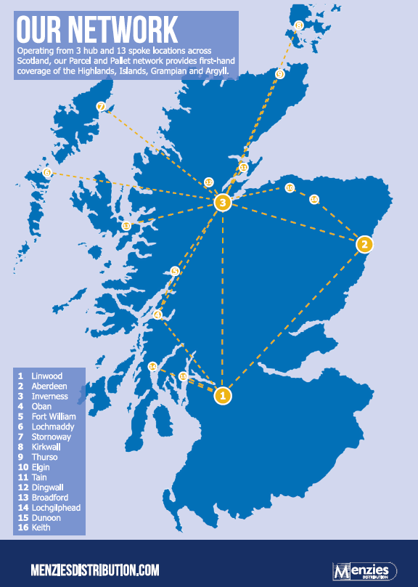

Figure 1 Menzies distribution network (Source: MacLean et al., 2019)

The Highlands and Islands are a very challenging area for logistics providers to cover due to a sparse population (447,043 people living in an area of 40,500km2, equating to 11 people per km2 (*29*), a relatively sparse road network (8,733 miles of road with only 810 miles being trunk roads and with no motorways (*30*) and with some infrequent ferry crossings (e.g. three times a week) to some of the islands. Exacerbated by hilly terrain, single track roads and road congestion during the summer tourist season, delivery trips can be slow and expensive to undertake. Reducing costs is the key motivation for carriers to use Menzies’ services with a manager estimating that it would cost carriers four to five times as much to provide their own delivery services across the region.

A key operating principle for Menzies Distribution is to be seen as a neutral consolidator, using their own vehicle livery and not that of any of the carriers they work for. This allows them to combine items from different carriers on the same vehicle without the carriers being concerned about rival branding. In terms of the operation, miscellaneous packaged and unpackaged items from the different carriers are carried together on the same vehicles, with a roughly 50/50 split of work between business-to-business (B2B) and business-to-consumer (B2C) clients. Menzies' hub at Inverness deals with between 12,000-13,000 items per day, arriving on around 16 vehicles (box trailers, rigid trucks, vans) from the various carriers, where a team of around 40 employees (warehouse staff, drivers, managers and the operations team) oversee the load consolidation and onward delivery. Collections on behalf of the carriers are also made by Menzies and comprise between 5-10% of the total volume.

The total Menzies vehicle fleet serving the Highlands, Islands, Grampians and Argyll is around 150 vans, based at the various hubs and depots, including sub-contractor vehicles and spare vehicles, with 25 vans based at Inverness. The average vehicle mileage is 42,000 miles/year, ranging from 15,000 to 70,000 miles/year with all vehicles being diesel-fuelled although there is interest in using some electric vehicles, dependent on innovations to increase payload and provision of enough charging points across the network.

A key enabler for operating as a CC for multiple carriers is an integrated IT system, able to interface with the often legacy systems used by the carriers and to provide the security and functionality they require, such as item tracking, expected time of arrival information and proof of delivery (e.g. a signature or photograph). Carriers do not provide Menzies with advance item information which precludes pre-allocation of items to vehicles, so items are grouped into pre-specified postcode areas for subsequent loading onto vehicles. The ability to use a single barcode scanner for all the carriers is the real key to success and significantly reduces the time and inconvenience associated with swapping between different devices.

In summary, the key requirements found from the Menzies operation for transferability of the CC operating model elsewhere, including densely populated cities, are:

1. An efficient operation that functions to the mutual benefit of all participants
2. A unified system based around common data (e.g. barcodes, item status, proof of delivery) so that processes remain the same for the driver irrespective of the carrier
3. Well-specified information flows and confidentiality in the handling and processing of carriers’ data
4. Building and maintaining trusted relationships with clients, carriers, and couriers
5. The need to maintain agility and flexibility in core operations with expected variations in demand
6. No preferential or priority treatment in the handling of carriers’ goods
7. Neutrality, with no risk to corporate brand image.

# METHODOLOGY AND CASE STUDY OVERVIEW

To understand to what extent the CC approach might reduce vehicle impacts if adopted by parcel carriers serving central London, historic datasets from two major parcel carriers, one mainly serving the business-to-business (B2B) market and the other mainly serving the business-to-consumer (B2C) market, were used to develop a series of dummy vehicle rounds representing five similar carriers of each type (i.e. B2B or B2C), all serving consignees across the same area. In the BAU operating model it was assumed that all carriers worked independently, while in the CC operating model, it was assumed that items from all the carriers would be consolidated at a single depot for delivery using a common vehicle fleet. For simplicity, it was assumed that all carriers used vans of the same size, with carrying capacities of 1000kg and 10m3, and that all carriers, including the CC, had a depot within the same industrial estate located 15km (9 miles) east of the modelled delivery area. Times and distances involved in carriers delivering parcels to the CC were not modelled on the basis that they would be negligible under this assumption. The selected case study area was based on locations covered by specific delivery rounds of a major parcel carrier operating in central London. The area of London is highlighted (**Figure 2**) and is approximately 2.3 km (1.4 miles) from west to east and 1.6 km (1 mile) from north to south; the 888 unique delivery locations found within the carrier data are shown in **Figure 3**. As these data contained very few timed deliveries, no time window constraints were modelled here.

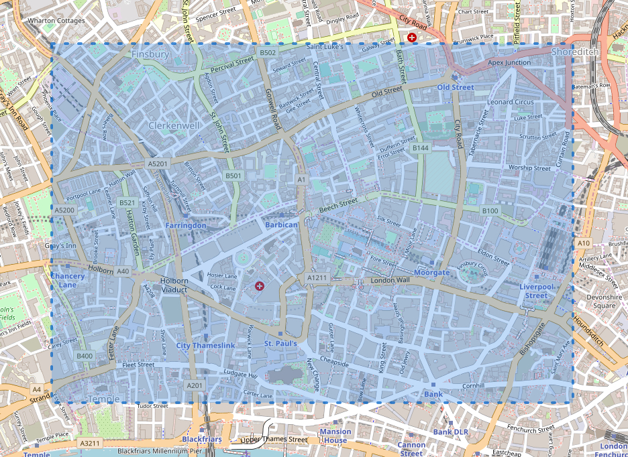

**Figure 2 Case study area in central London (2.3km x 1.6km) (© Open Street Map)**

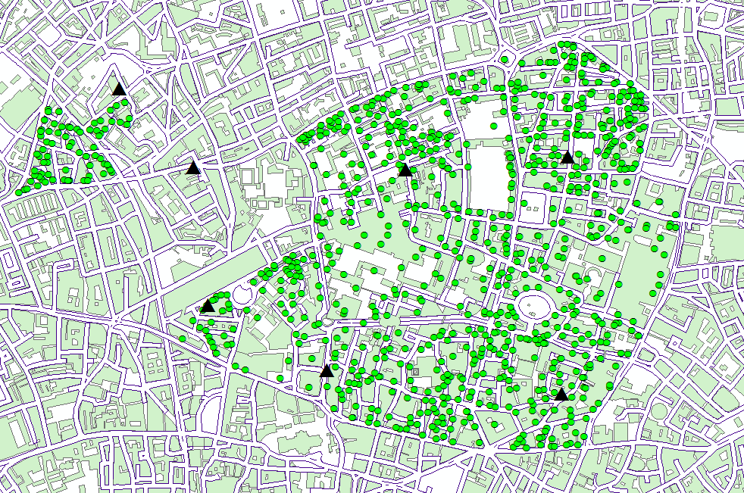

**Figure 3 Delivery locations (dots) and drop-off points used in cycling models (triangles)**

Parcel weights and volumes were obtained from the two different parcel carriers, referred to here as X and Y, by weighing and measuring 291 and 489 items, respectively, during site visits (**TABLE 1**). Carrier X delivered mainly to businesses (B2B) while Carrier Y delivered mainly to consumers (B2C). The mean item weight for carrier X (5.84kg) was almost 5 times that of carrier Y (1.2kg) and with mean item volumes almost three times larger (33.6 and 13.3 litres, respectively). For both carriers the median weight and volume values were lower than the mean values, indicating positive or right skew, due to a relatively small number of heavier or bulkier items. The correlations between weights and volumes were 0.70 for Carrier X and 0.64 for Carrier Y. To generate additional parcel data for sampling purposes, the weight and volume data were modelled as coming from Gamma probability distributions (as suggested by their profiles) with parameter values  and  derived from the relationships  and , where  and  were the mean and standard deviation values of the measured data (**TABLE 1**) 

**TABLE 1 Measured parcel statistics and assumed Gamma distribution  and  values**

|  |  |  |  |  |  |  |  |
| --- | --- | --- | --- | --- | --- | --- | --- |
| Carrier | Weight or Volume | Mean ( | Median | St.dev ( |  |  | Sample size |
| X | Weight (kg) | 5.84 | 3.15 | 6.80 | 0.74 | 7.92 | 291 |
| X | Volume (litres) | 33.6 | 21.6 | 38.4 | 0.77 | 43.89 |
| Y | Weight (kg) | 1.20 | 0.80 | 1.52 | 0.62 | 1.93 | 489 |
| Y | Volume (litres) | 13.3 | 7.5 | 16.5 | 0.65 | 20.47 |

## Random sampling of parcel data

The numbers, weights, volumes and delivery addresses of parcels for five carriers similar to carrier X (referred to later as X1, X2, X3, X4, X5) and five carriers similar to carrier Y (Y1, Y2, Y3, Y4, Y5) were randomly sampled for a single day of operation. This entailed:

* Generating a sample of 1000 parcels (described by weight and volume) for each carrier type (X and Y) using a procedure for generating correlated Gamma random variates (*31*)
* Determining the number of parcels for each carrier (**TABLE 2** and **TABLE 3**) by randomly sampling from Uniform U(200,300) and U(500,600) distributions, for carrier types X and Y, respectively, these ranges being typical within the manifest data.
* Randomly sampling delivery locations, specified in latitude, longitude format, from a set of 922 locations derived for the area, each corresponding to a different postcode (**Figure 3**).
* Consolidating the sampled data by delivery location, resulting in the number of ‘calls’ to distinct locations being less than the number of items, reflecting delivery of multiple items to the same location (**TABLE 2** and **TABLE 3**).

A commercially-available vehicle routing and scheduling optimiser (PTV Route Optimiser) was used to obtain vehicle routes for both the BAU and CC operating models, although it was recognised that such software does not consider the possibility of the driver walking between consecutive delivery addresses where they are close to each other (*25*). The delivery time per call was assumed to be 5 minutes, this amount of time having been determined from the parcel carrier manifest data. This time would have included time spent unloading items from the vehicle, walking to and from the delivery point, perhaps climbing stairs or taking an elevator, obtaining signatures and sometimes having to wait for consignees to accept items. Modelled constraints used were driver working hours of up to 9 hours, excluding any breaks taken, and van carrying capacities of 1000kg and 10m3, which represents a large van (e.g. a long wheelbase transit van). In most cases, the driver working hours constrained the work done rather than the assumed van capacity.

Operating models where van drivers were supported by cycle couriers were also considered. In the BAU model using cycles (BAU+Cycles), each carrier operated independently undertaking heavy/bulky deliveries with a single van and driver and dropping off lighter items at seven selected drop-off locations across the city (**Figure 3**) to be delivered by their own team of (four) cycle couriers. Similarly, in the CC model using cycles (CC+Cycles), parcels were first consolidated at the CC's depot then assigned to (five) vans and drivers, using an ad hoc method that grouped items geographically, and then dropped off in the city for delivery by (eleven) cycle couriers. Any parcels under a given weight (5 kg) and volume (200L) were delivered by a cycle courier while all other parcels were delivered by a van driver. The cycle couriers were also subject to maximum assumed load capacities of 125kg and 600L (*32*). Modelling was performed for carriers Y1 to Y5 only here, whose lighter and less bulky items would be better suited to using cycles than those of the carriers X1 to X5. Transfer of parcels between drivers and cycle couriers was via seven specified drop-off locations, which were stores providing parcel services, and not requiring any coordination between driver and cycle courier schedules. The modelling utilised a heuristic algorithm developed by the authors which aims to minimise the overall labour and vehicle costs. Delivery times of 3 minutes per call were assumed for cycle couriers, as had been measured during on-street trials using porters (*22*).

For both the heuristic algorithm and the vehicle routing and scheduling optimiser, average van travel speeds were in the range 8-9mph, depending on specific roads used, in line with reported traffic speed statistics for central London (*33*). For the modelling of cycles (heuristic algorithm), the average cycle speed was 10mph, based on operational data from around 30 European cycle courier companies (*34*).

# RESULTS and DISCUSSION

The BAU and CC operating models, using vans only in both cases, were compared separately for the B2B carriers (**TABLE 2**) and for the B2C carriers (**TABLE 3**). The CC operating model was estimated to save total time taken by 35.1% and 59.0% for the B2B and B2C carriers, respectively, primarily gained by reducing the number of calls and thereby the estimated delivery time, calculated as 5 minutes per call, by 30.5% and 59.5%, respectively. This result illustrates one of the main advantages of the CC operating model, namely that a substantial amount of time can be saved by having a single driver serve the same building rather than multiple drivers, since it is the number of calls rather than the number of items that impact delivery time. It is also worth highlighting that one driver instead of many would likely be welcomed by consignees in having fewer people to deal with. The CC operating model was especially beneficial for the B2C carriers, as the larger number of parcels provided greater consolidation opportunities as more items went to the same locations (e.g. apartment blocks). The time saved in making the deliveries also meant that fewer vans were needed, with fleet size reductions of 40.9% (22 to 13 vans) and 60.6% (33 to 13 vans), respectively, and with similar percentage distance savings, largely due to having fewer vehicles undertaking stem mileage between the depot and delivery area. Associated daily vehicle emissions savings of 90.3kg CO2 and 96.6g NOx for the B2B carriers (41.8% reduction) and 202.8kg CO2 and 217.0g NOx for the B2C carriers (61.4% reduction) were estimated, based on assumed diesel van emission rates of 299 g/km CO2 and 0.32g/km NOx (*35*).

TABLE 2 BAU and CC operating models using vans only (B2B carriers)

|  |  |  |  |  |  |  |  |  |
| --- | --- | --- | --- | --- | --- | --- | --- | --- |
| Carrier | Parcels  (#) | Calls  (#) | Weight  (kg) | Volume  (litres) | Vans  (#) | Distance  (km) | Travel time (h:mm) | Total time (h:mm) |
| X1 | 233 | 226 | 1371 | 8518 | 4 | 137.0 | 9:36 | 28:26 |
| X2 | 226 | 217 | 1388 | 8131 | 4 | 139.0 | 9:47 | 27:52 |
| X3 | 274 | 256 | 1652 | 9265 | 4 | 138.3 | 9:57 | 31:17 |
| X4 | 300 | 284 | 1928 | 12108 | 5 | 171.1 | 12:03 | 35:43 |
| X5 | 284 | 270 | 1798 | 11132 | 5 | 136.3 | 10:01 | 32:31 |
| **Total (BAU)** | **1317** | **1253** | **8137** | **49153** | **22** | **721.7** | **51:24** | **155:49** |
| **CC model** | **''** | **871** | **''** | **''** | **13** | **419.8** | **28:35** | **101:10** |

Note: 'call' means a delivery to the same location (may be multiple parcels and consignees)

TABLE 3 BAU and CC operating models using vans only (B2C carriers)

|  |  |  |  |  |  |  |  |  |
| --- | --- | --- | --- | --- | --- | --- | --- | --- |
| Carrier | Parcels  (#) | Calls  (#) | Weight  (kg) | Volume  (litres) | Vans  (#) | Distance  (km) | Travel time (h:mm) | Total time (h:mm) |
| Y1 | 526 | 401 | 710 | 8457 | 6 | 199.4 | 15:27 | 48:52 |
| Y2 | 598 | 439 | 798 | 9127 | 7 | 234.3 | 16:16 | 52:51 |
| Y3 | 594 | 430 | 826 | 9790 | 7 | 230.7 | 16:01 | 51:51 |
| Y4 | 565 | 419 | 696 | 8732 | 6 | 202.5 | 14:06 | 49:01 |
| Y5 | 574 | 428 | 692 | 8962 | 7 | 237.4 | 16:43 | 52:23 |
| **Total (BAU)** | **2857** | **2117** | **3722** | **45068** | **33** | **1104.3** | **78:33** | **254:58** |
| **CC model** | **''** | **888** | **''** | **''** | **13** | **426.2** | **29:20** | **103:20** |

The BAU and CC operating models were also compared where cycle couriers were used for delivery of all items below 5kg in weight and under 200 litres in volume, supported by a much reduced vehicle fleet of only one van per carrier (TABLE 4). This was done only for the B2C carriers as the vast majority of items (97%) were suitably small and light whereas around 40% of the B2B carrier items would be considered too heavy. The CC+Cycles operating model was estimated to save overall time spent by 39.1% compared with BAU+Cycles and, as before, this was mainly due to considerably fewer calls (-43.8%) and the need for only 11 cycle couriers instead of the 20 used where the individual carriers each used their own dedicated cycle couriers. With vans only undertaking around one-third of total travel in these modelling scenarios, the van distance and emissions savings were comparatively modest, with daily savings of 7.0kg CO2 and 7.5g NOx, representing a 12.0% reduction.

Although not the primary focus of this research, the results (TABLE 3 and TABLE 4) also allowed assessment of the impact of the B2C carriers using cargo cycles for both of the operating models. Where there was no collaboration between carriers it was estimated that moving from 33 vans (BAU) to 5 vans and 20 cycles (BAU+Cycles) would reduce total time taken by 40.1% and van distance by 73.1%, from 721.7km to 194.1km, equating to daily vehicle emissions savings of 157.8kg CO2 and 169g NOx. For the more efficient CC operating model, the savings from moving from 13 vans (CC) to 5 vans and 11 cycles (CC+Cycles) were lower, with total time taken estimated to reduce by 10% and van distance by 59.9%, from 426.2km to 170.8km, equating to daily vehicle emissions savings of 76.4kg CO2 and 82g NOx.

Comparing the introduction of cycles (BAU+Cycles) against the adoption of a CC operating model without using cycles, which might be of interest to a carrier considering one option but not both, it can be seen that the use of cycles brings the greater reductions in van use and associated vehicle emissions, while the CC operating model offers the greater time savings here. It should be noted, though, that results will vary depending on numbers of collaborating carriers, the extent of their delivery area overlap, stem mileages and locations of available drop-off points. The biggest differences are between the 'do-nothing' BAU and the 'do-both' CC+Cycles models, with overall time savings of 63.5% and van distance and associated emissions savings of 84.5% (from 1104.3km to 170.8km). The impacts of the four operating models (BAU, CC, BAU+Cycles, CC+Cycles) are visualised in terms of annual overall time taken and CO2 totals, obtained by factoring the modelled results by 260 (assuming 5 working days x 52 weeks, ignoring weekends, when delivery activity is significantly reduced) (Figure 4).

TABLE 4 BAU and CC operating models using vans and cycles (B2C carriers) (percentages refer to proportion undertaken by cycles)

|  |  |  |  |  |  |  |  |  |
| --- | --- | --- | --- | --- | --- | --- | --- | --- |
| Carrier | Parcels  (#) | Calls  (#) | Weight  (kg) | Volume  (litres) | Vehicles | Distance  (km) | Travel time (h:mm) | Total time (h:mm) |
| Y1 | 526 96% | 417 95% | 710 80% | 8457 89% | 1 van  4 cycles | 120.2 68% | 7:44 72% | 30:05  87% |
| Y2 | 598 96% | 458 95% | 798 80% | 9127  86% | 1 van  4 cycles | 117.8 65% | 7:12 77% | 31:36  88% |
| Y3 | 594 96% | 445 96% | 826 84% | 9790 91% | 1 van  4 cycles | 117.4 68% | 6:51 78% | 30:41  89% |
| Y4 | 565 97% | 430 97% | 696 88% | 8732  92% | 1 van  4 cycles | 114.4 67% | 6:46 78% | 29:41  90% |
| Y5 | 574 98% | 439 98% | 692 90% | 8962 92% | 1 van  4 cycles | 118.5 69% | 7:30 75% | 30:39  91% |
| **Total**  **BAU+cycles** | **2857 97%** | **2189 96%** | **3722 84%** | **45068 90%** | **5 vans 20 cycles** | **588.3 67%** | **35:57 76%** | **152:41 89%** |
| **CC**  **+ cycles** | **2857 97%** | **1230 93%** | **3722 84%** | **45068 90%** | **5 vans 11 cycles** | **449.4 62%** | **24:37 77%** | **93:00**  **86%** |

**Figure 4** **Comparison of operating models for B2C carriers (annual time and CO2 totals)**

# CONCLUSIONS and FURTHER RESEARCH

Substantial overall time and distance savings were estimated for the CC operating model, equating to vehicle emissions savings of around 42% for five B2B carriers and 61% for five B2C carriers, based on a case study comprising around 900 different delivery locations within an area of 3.7km2. Converting the modelled savings for one day of operation to annual savings indicates that the five B2B carriers could save 14,209 hours in overall time taken, 5,932 hours driving time, 78,509km driven, 23,474kg CO2 and 25.1kg NOx. Savings for the five B2C carriers could be more than double those of the B2B carriers due to the more numerous deliveries affording more opportunities for consolidating loads going to the same delivery locations: 39,425 hours in overall time taken, 12,796 hours driving time and 176,324km driven, equating to 52,721kg CO2 and 56.4kg NOx saved. Reliance on vans and associated vehicle emissions could be substantially reduced further by using 11 cargo cycles alongside 5 vans instead of 13 vans, with total annual van driving reduced by 242,717km, equating to 72,572kg CO2 and 77.7kg NOx saved.

In this research, it was considered adequate to model fixed delivery times of 5 minutes and 3 minutes per call for van driver and cycle couriers respectively, these being average times obtained from carrier manifest data and surveys. In reality, some calls to individual buildings take longer than others depending on how far away the vehicle is parked, the number of individual consignees to be serviced and the time associated with walking and riding elevators within buildings. The modelling work could be further refined by deriving regression relationships between delivery times and causal factors although this would require detailed, labour-intensive surveys, similar to those undertaken for individual buildings in Seattle, USA (*36)*. Further research into the financial and business aspects of such carrier collaborations would also be of benefit.

Despite the potentially large overall savings, carrier collaboration in cities is uncommon and examples have tended to be relatively small-scale trials. Barriers to its wider adoption have been largely associated with:

1. ***Loss of individual carrier brand identity:*** This can be a major concern for carriers in a highly competitive market where customers can easily switch between operators on a transaction-by-transaction basis and profit margins are generally small. This is not so much of a problem in the Highlands and Islands example as the sparsely populated area being covered represents a very small proportion of the carriers’ total revenue due to the low parcel volumes and high delivery costs per parcel.
2. ***Perceived compatibility of systems and data privacy:*** Carriers often use bespoke software platforms to manage their operations with specific hardware to capture transactions via unique barcoding and customer interfaces. Integrating third-party platforms into such systems can be deemed troublesome, coupled with perceived data privacy concerns arising from working with competitors.
3. ***Liability issues when using third parties:*** Typically, the carrier is liable if the package is not delivered safely to the consignee. Introducing a third party adds a layer of complexity and risk in terms of potential lost consignments and associated expense. There could also be issues with brand image if errors caused by a third-party carrier impact on the reputation of the primary carrier.

Both the CC operating model and the use of cargo cycles are based on the premise of carriers handing over their goods for others to deliver on their behalf. This has been seen to be an attractive business proposition in remote rural areas where delivery costs per parcel are high due to long delivery trips and relatively low parcel volumes but remains largely untested in cities. Transferability to cities may increase in future as carriers face even more challenging operating conditions resulting from restrictive city access policies, ultra-low emission zones and further reductions in the average price per parcel delivered. Some city authorities may also consider implementing measures that actively support consolidation of deliveries by, for example, awarding preferential access rights to designated carriers in specified areas of the city or providing depot space. They may also be able to reduce kerbside parking of delivery vans by requiring building developers to provide goods reception facilities for all major constructions to allow speedy drop-off instead of drivers spending considerable time inside buildings visiting consignees who may not be in.

# ACKNOWLEDGEMENTS

The research reported in this paper was carried out as part of the Freight Traffic Control 2050 project (www.ftc2050.com) funded by the UK Engineering and Physical Sciences Research Council.

# AUTHOR CONTRIBUTIONS

The authors confirm contribution to the paper as follows: study conception and design: McLeod, Cherrett, Bates, Bektaş, Allen, Piotrowska, Piecyk; data collection: McLeod, Cherrett, Bates, Allen, Lamas-Fernandez, Oakey; analysis and interpretation of results: McLeod, Cherrett, Bates, Allen; All authors contributed to the draft manuscript, reviewed the results and approved the final version of the manuscript. The authors do not have any conflicts of interest to declare.

# REFERENCES

|  |
| --- |
| 1. Browne, M., Rizet, C. and Allen, J. (2014). A comparative assessment of the light goods vehicle fleet and the scope to reduce its CO2 emissions in the UK and France. Procedia - Social and Behavioral Sciences, 125, 334–344. |
| 1. Allen, J., Bektas, T., Cherrett, T., Friday, A., McLeod, F., Piecyk, M., Piotrowska, M., Zaltz Austwick, M. (2017). Enabling the freight traffic controller for collaborative multi-drop urban logistics: practical and theoretical challenges. Transportation Research Record: Journal of the Transportation Research Board, 2609, 77–84. |
| 1. Braithwaite, A. (2017). The implications of internet shopping growth on the van fleet and traffic activity. RAC Foundation, https://www.racfoundation.org/wp-content/uploads/2017/11/ The_Implications_of_Internet_Shopping_Growth_on_the_Van_Fleet_and_Traffic_Activity_Braithwaite_May_17.pdf (Accessed 31 July 2019) |
| 1. Savelsbergh, M.W.P.M. and Van Woensel, T. (2016). City logistics: challenges and opportunities. Transportation Science, 50(2), 579-590. |
| 1. Baker, L. (2019). Today’s Pickup: UPS hit with $33.8 million in NYC parking fines; FedEx, $14.9 million. https://www.freightwaves.com/news/todayspickup/ups-fedex-parking-fines (Accessed 31 July 2019). |
| 1. Cruijssen, F., Dullaert, W. and Fleuren, H. (2007). Horizontal cooperation in transport and logistics: a literature review. Transportation Journal, 46, 22-39. |
| 1. Adenso-Díaz, B., Lozano, S., Garcia-Carbajal, S., Smith-Miles, K. (2014). Assessing partnership savings in horizontal cooperation by planning linked deliveries. Trans. Res. A: Policy and Practice, 66, 268-279. |
| 1. Pérez-Bernabeu, E., Juan, A. A., Faulin, J., and Barrios, B. B. (2015). Horizontal cooperation in road transportation: a case illustrating savings in distances and greenhouse gas emissions. International Transactions in Operational Research, 22(3), 585–606. |
| 1. Peeta, S. and Hernandez, S. (2011). Modeling of collaborative less-than-truckload carrier freight networks. Online report, NEXTRANS, Purdue University, USA. https://pdfs.semanticscholar.org/2d69/8203895c57b575ce3a17db1d969d7ba4455f.pdf (Accessed 31 July 2019). |
| 1. Dahl S. and Derigs U. (2011). Cooperative planning in express carrier networks - an empirical study on the effectiveness of a real-time decision support system. Decision Support Systems, 51, 620-626. |
| 1. Allen, J., Piecyk, M., Piotrowska, M., McLeod, F., Cherrett, T., Ghali, K., Nguyen, T., Bektas, T., Bates, O., Friday, A., Wise, S., Austwick, M. (2018a). Understanding the impact of e-commerce on last-mile light goods vehicle activity in urban areas: The case of London. Transportation Research Part D: Transport and Environment, 61, 325-338. |
| 1. Cattaruzza, D., Absi, N., Feillet, D., and González-Feliu, J. (2017). Vehicle routing problems for city logistics. EURO Journal on Transportation and Logistics, 6(1), 51–79. |
| 1. de Souza, R., Goh, M., Lau, H.-C., Ng, W.-S., and Tan, P.-S. (2014). Collaborative urban logistics – synchronizing the last mile, a Singapore research perspective. Procedia-Social and Behavioral Sciences, 125, 422–431. |
| 1. Muñoz-Villamizar, A., Montoya-Torres, J.R., Vega-Mejía, C.A. (2015). Non-collaborative versus collaborative last-mile delivery in urban systems with stochastic demands. Procedia CIRP 30, 263-268. |
| 1. Do, W., Park, H., Chung, K., Park, D. (2019). An effects analysis of logistics collaboration: the case of pharmaceutical supplies in Seoul. Sustainability, 11, 2442 |
| 1. Park, H., Park, D., and Jeong, I.-J. (2016). An effects analysis of logistics collaboration in last-mile networks for CEP delivery services. Transport Policy, 50, 115–125. |
| 1. Quak, H.J. (2012). Improving urban freight transport sustainability by carriers - best practices from the Netherlands and the EU project CityLog, Procedia-Social and Behavioral Sciences, 39, 158-171. |
| 1. Anderluh, A., Hemmelmayr, V.C. and Nolz, P.C. (2017). Synchronizing vans and cargo bikes in a city distribution network. Central European Journal of Operations Research, 25(2), 345-376. |
| 1. Janjevic, M. and Ndiaye, A.B. (2014). Development and application of a transferability framework for micro-consolidation schemes in urban freight transport. Procedia - Social and Behavioral Sciences 125, 284-296. |
| 1. Verkehrs Rundschau (2019). Project KOMODO: positive balance to package delivery by cargo bike (In German) https://www.verkehrsrundschau.de/nachrichten/projekt-komodo-positive-bilanz-zur-paketauslieferung-per-lastenrad-2319137.html (Accessed 31 July 2019). |
| 1. Allen, J., Bektas, T., Cherrett, T., Bates, O., Friday, A., McLeod, F., Piecyk, M., Piotrowska, M., Nguyen, T., Wise, S. (2018b). The scope for pavement porters: addressing the challenges of last-mile parcel delivery in London. Transportation Research Record: Journal of the Transportation Research Board, 2672(9), 184-193. |
| 1. Piecyk, M., Cherrett, T.J., Allen, J., Piotrowska, M., Clarke, S., Bates, O., Bektas, B., Friday, A., McLeod, F.N., Oakey, A., Wise, S. (2019). Using on-foot porters for last-mile parcel deliveries: results of a trial in central London. 98th TRB Annual Meeting, 13-17 January 2019, Washington D.C., USA. |
| 1. DHL (2018). DHL expands presence in New York City area to support burgeoning international trade. https://www.logistics.dhl/us-en/home/press/press-archive/2018/dhl-expands-presence-in-new-york-city-area-to-support-burgeoning-international-trade.html (Accessed 31 July 2019) |
| 1. Hemmelmayr, V. C., Cordeau, J.-F., and Crainic, T. G. (2012). An adaptive large neighborhood search heuristic for two-echelon vehicle routing problems arising in city logistics. Computers & Operations Research, 39(12), 3215–3228. |
| 1. Nguyên, T.B.T., Bektaş, T., Cherrett, T.J., McLeod, F.N., Allen, J., Bates, O., Piotrowska, M., Piecyk, M., Friday, A., Wise, S. (2019). Optimising parcel deliveries in London using dual-mode routing. JORS, 70, 998-1010. |
| 1. Gonzalez-Feliu, J. and Salanova, J-M. (2012). Defining and evaluating collaborative urban freight transportation systems, Procedia-Social and Behavioral Sciences, 39, 172-183. |
| 1. Lindawati, van Schagen, J., Goh, M., and de Souza, R. (2014). Collaboration in urban logistics: motivations and barriers. International Journal of Urban Sciences, 18(2), 278–290. |
| 1. MacLean, F., McLeod, F., Bates,O. (2019). Parcel carrier collaboration – can big cities learn from small communities? Chartered Institute of Logistics and Transport, Focus magazine, April 2019. |
| 1. Highlands and Islands Enterprise (2011). Area profile for Highlands and Islands. http://www.hie.co.uk/common/handlers/download-document.ashx?id=6e4ca483-1954-4858-9ec9-40cc96b6e5bc (Accessed 31 July 2019). |
| 1. HITRANS (2018). The Road Network https://hitrans.org.uk/Travel_Modes/Road (Accessed 31 July 2019). |
| 1. Wan, H. (2019). Generating random variates. https://web.ics.purdue.edu/~hwan/IE680/ Lectures/Chap08Slides.pdf (Accessed 31 July 2019). |
| 1. Urban Arrow (2019). Cargo. https://www.urbanarrow.com/en/cargo (Accessed 31 July 2019) |
| 1. Mayor of London and Transport for London (2018). TLRN performance report, Quarter 2, 2017/18. http://content.tfl.gov.uk/street-performance-report-quarter2-2017-2018.pdf (Accessed 31 July 2019). |
| 1. PRO-E-BIKE (2015). Description of PRO-E-BIKE scenario. http://www.pro-e-bike.org/wp-content/uploads/2016/06/D-6-3-Description-of-PRO-E-BIKE-scenario-1.pdf (Accessed 31 July 2019). |
| 1. Low Carbon Vehicle Partnership (2017). Emissions testing of urban delivery commercial vehicles. https://www.lowcvp.org.uk/assets/reports/LowCVP%20TfL%202016%20Test%20Programme%20Final%20Report.pdf (Accessed 31 July 2019) 2. Kim, H., Boyle, L.N., Goodchild, A. (2018). Delivery process for an office building in the Seattle Central Business District, Transportation Research Record: Journal of the Transportation Research Board, 2672(9), 173-183. |