Forest damage by deer depends on cross-scale interactions between climate, deer density and landscape structure
Rebecca Spake¹, Chloe Bellamy², Robin Gill³, Kevin Watts³, Tom Wilson⁴, Ben Ditchburn⁴, Felix Eigenbrod¹
1 School of Geography and Environmental Science, University of Southampton, Highfield Campus, Southampton, SO17 1BJ, U.K.
2 Forest Research, Northern Research Station, Roslin, Midlothian, EH25 9SY, UK.
3 Forest Research, Alice Holt Lodge, Farnham, Surrey GU10 4LH, UK.
4 Forest Research, Silvan House, 231 Corstorphine Road, Edinburgh, EH12 7AT, UK.
Corresponding author: Rebecca Spake, School of Geography and Environmental Science, University of Southampton, Highfield Campus, Southampton, SO17 1BJ, U.K. R.Spake@soton.ac.uk

Abstract
- Deer (Cervidae) populations are increasing across the temperate zone, threatening forest biodiversity and ecosystem services. However, the fundamental question of what factors make a forest susceptible to deer damage remains unanswered, hampering efforts to mitigate against damage. Previous research has assumed that deer density consistently increases forest damage. However, the effect of deer density is likely to be contingent on a range of other drivers, such as climate and landscape structure. Mitigation measures are costly, so a sound understanding of these contingencies is required to inform the targeting of appropriate management to forests most at risk of damage.
- Using records of forest damage from Britain’s National Forest Inventory, which comprises over 15,000 plots spanning environmental gradients, we applied a multi-scale approach to identify the drivers of forest susceptibility to damage by deer.
- Damage likelihood was dependent on drivers operating at multiple spatial scales and their interactions. Broadleaved stands with low tree densities and old trees were consistently found to be at high risk across Britain. The statistical influence of surrounding forest cover within 500-m of a site was modified by regional deer density and climate, in addition to landscape-level perennial cover. The effect of deer density on damage was therefore not straightforward, but context-dependent.
- Synthesis and applications. We predict the likely outcome of afforestation initiatives on the likelihood that a forest site will be damaged by deer, with important implications for management and landscape planning in Britain. The complex interactive effects uncovered are difficult to interpret. We therefore provide an interactive Deer Damage Tool (R Shiny application; https://spake.shinyapps.io/DEERDAMAGETOOL/) for practitioners to visualise how afforestation is likely to influence the probability of deer damage in different forests and regions across Britain.
Keywords: cross-scale interaction, forage, forestry, graze, habitat selection, herbivore, woodland expansion, ungulate

Introduction
Deer populations have increased dramatically throughout the northern hemisphere during recent decades (Cote, 2004). These large herbivores can substantially impact the biodiversity, structure and functioning of forest ecosystems (Ramirez, Jansen, & Poorter, 2018). By selectively grazing on palatable species, they can decimate native understory cover and richness, enhance the demographic success of invasive plants at the expense of natives (Rodewald & Arcese, 2016) and inhibit forest regeneration by browsing young trees, saplings and seedlings (Tanentzap et al., 2009). Consequently, much research has focused on quantifying ungulate density thresholds compatible with sustaining forest productivity, biodiversity and important ecosystem functions (Staines, Balharry, & Welch, 1995). Findings vary widely, indicating heterogeneity in the effects of deer densities on forest structure and composition (Ramirez et al., 2018). Indeed, even at a given density, deer damage levels can exhibit substantial spatial variation, suggesting that other social or environmental factors might moderate deer impacts (Putman, Langbein, Green, & Watson, 2011). For example, certain forest attributes such as canopy composition and structure could alter the ‘attractiveness’ as forage to deer (Reimoser, 2003). However, the interactive effects of forest attributes and climate with deer density are under-studied, particularly at broad geographic extents (Russell et al., 2017). The fundamental question of what conditions impact deer damage to forests therefore remains unanswered (Royo et al., 2017). Given that 40% of forest stands were recently classified as in ‘unfavourable’ condition for herbivore damage in Britain’s National Forest Inventory (NFI; Ditchburn, B., Wilson, T., Henderson, L., Kirby, K. & Steel, 2020), that deer populations are projected to continue increasing (Ward, 2005) and Britain has ambitious policy targets for forest expansion (Conservative and Unionist Party, 2019), this understanding is necessary to efficiently target costly management strategies that encourage successful regeneration (e.g. fencing), and population control efforts (e.g. culling).
Predicting forest susceptibility to deer damage requires an understanding of herbivore foraging location, which is influenced by a hierarchy of abiotic and biotic factors operating at multiple spatial and temporal scales (Johnson, 1980; Senft et al., 1987). Applying Johnson’s (1980) selection orders provides a framework to distil this complexity (Figure 1), by distinguishing four orders according to the frequencies or rates of pertinent drivers (Senft et al., 1987). At regional scales (first order), climatic variables throughout the animal’s geographic range are likely to be important in determining habitat selection. At the landscape scale (second order), the composition and configuration of land covers are key drivers of foraging location, due to their provision of food and shelter (Herrera & GarcÍa, 2010) and effect on perceived predation risk (Creel, Winnie, Maxwell, Hamlin, & Creel, 2005). The area over which landscape drivers exert an influence, the ‘ecological neighbourhood’ (Addicott et al., 1987) or ‘scale of effect’ (Holland, Bert, & Fahrig, 2004), is typically identified by comparing models with landscape drivers quantified at varying extents (buffer sizes) surrounding a focal point and selecting the extent yielding the best fit (Jackson & Fahrig, 2015). At the local scale (third order), patch-level variables are important; for example, in winter, roe deer (Capreolus capreolus) selectively forage in forests with more open canopies and consequently more dense understories (Ewald, Dupke, Heurich, Müller, & Reineking, 2014). Within a plant community (fourth order), a plant’s physical and chemical characteristics relative to its neighbours determine its foraging risk (Augustine and McNaughton, 1998; Schulze, 1998).
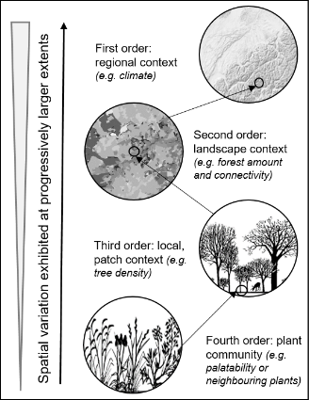
Figure 1. Foraging decisions made by large herbivores are affected by variables operating at multiple spatial scales. Adapted from Johnson (1980) and Senft (1987).
In addition to considering the effects of multiple drivers acting at multiple scales on forage selection, it is critical to consider their interactions. This is because drivers may combine and interact either synergistically or antagonistically, thus modifying their effects of each other. Numerous studies have documented how herbivore habitat selection at local and landscape scales can change on a seasonal basis, to adapt to changing forage availability and quality, and regulate against heat loss (Ewald et al., 2014). However, the extent to which regional variation in climate can modify the effects of local- and landscape-level drivers (so-called cross-scale interactions; CSIs; Peters et al., 2007), and thereby lead to context dependency in deer damage risk, is much less understood. This is because identifying regional spatial variation necessitates fine-scale, replicated empirical data collected across broad geographic extents. Characterising and understanding interactions among multiple drivers could inform the spatial targeting of management according to deer damage risk and the predicted effectiveness of actions (Spake et al., 2019), helping to respond to calls to improve deer management strategies in Britain (e.g. SNH, 2016).
In this study, we investigated forest susceptibility to deer damage in relation to a range of drivers operating at multiple scales across countries in Britain: England, Scotland and Wales. We use data from Britain’s National Forestry Inventory, a ground survey designed to measure and monitor forest structure, composition, condition, biodiversity and social use, in addition to data on deer densities based on a game census (Table 1). Specifically, we set out to: i) adopt a hierarchical approach to predict the likelihood of a forest being damaged by deer and determine the drivers and their scale of effect; ii) identify whether interactions exist between drivers operating at multiple spatial scales (CSIs), in particular whether local and landscape attributes can moderate the effects of deer density; and iii) use this this knowledge to identify where management efforts to mitigate against deer damage could be spatially targeted (Spake et al., 2019). Our analysis encompasses drivers that are amenable to management at local and landscape-scales (e.g. tree density, surrounding forest cover), and relevant to recent policy agendas related to forest expansion (DEFRA, 2018; Conservative and Unionist Party, 2019), providing practicable guidance for landscape planning and forest management in Britain.
Given that forage site selection has been shown to vary temporally with changing climate (i.e. seasonally; e.g. Godvik et al., 2009; Morellet et al., 2011; Ewald et al., 2014), we hypothesised that site selection would vary spatially with climate and deer density. In accordance with shelter-seeking behaviour, we hypothesised that deer may select to forage in, and so exert more damage in, relatively sheltered environments in harsher climates (Mitchell, Staines, & Welch, 1977). We expected this phenomenon to manifest as interacting effects of climate with local drivers (e.g. forest tree density) and landscape drivers (e.g. forest cover), with more strongly positive effects of these drivers observed in harsher climates. Moreover, we further expected forest cover to interact with regional deer density, because population density may induce the need of large herbivores to trade-off forage and shelter (Mysterud & Østbye, 1999). High population densities can intensify intraspecific interference and competition for preferred resources (i.e. highly forested, sheltered landscapes), causing large herbivores to spend more time outside of protective cover (White, Testa, & Berger, 2001; Perez-Barberıia, Hooper, & Gordon, 2013). We therefore expected that the hypothesised strong positive effects of landscape forest cover on damage probability in harsh environments might plateau or exhibit a hump-shaped relationship in regions with high densities.

Materials and methods

Records of deer damage
Site susceptibility to deer damage in Britain (across England, Scotland and Wales) was modelled using the first cycle of the Forestry Commission’s National Forest Inventory (NFI; 2010 – 2016). This rolling field survey incorporates over 15,000 1-ha forest ‘squares’ across England, Scotland and Wales, from which data describing the site’s biophysical attributes and human activities are collected using a standardised protocol (Ditchburn, B., Bellamy, C., Wilson, T., Steel, P., Henderson, L., Kirby, 2020). Sites were selected using a stratified-random strategy to ensure that each site contained at least some forest, and that forests of different types (e.g. broadleaf or conifer) and ownership types (privately or publicly owned) were proportionally representative of their regional availability (Forest Research, 2019). Each 1-ha square is subdivided into sections, areas of at least 0.05-ha that are relatively homogenous in terms of habitat and land use attributes including silvicultural system, age and height (Ditchburn, B., Bellamy, C., Wilson, T., Steel, P., Henderson, L., Kirby, 2020); Figure 2). Sections therefore represent practicable local management units.
NFI surveyors recorded signs of herbivore damage to trees, either as browsing (caused by animals feeding on tree shoots and foliage) or bark damage (either from stripping, the peeling and eating of bark, or fraying, where male deer mark their territories and clean the velvet off newly-grown antlers) (Ditchburn et al., 2020). Both are relevant to forest management, as browsing damage simplifies vegetation structure and can result in tree death, while stripping can provide an entry for fungi and insects, leading to economic losses and higher susceptibility of trees to drought and windthrow (Arnold, Gerhardt, Steyaert, Hochbichler, & Hackländer, 2018).
Records were summarised as presence/absence of recorded herbivore damage at the section level for modelling. We excluded records of damage occurring above a height of 1.8-m, which are most likely caused by squirrels (Ditchburn et al., 2020). Below this height, in addition to deer, other herbivores including cattle, horses, sheep, goats, rabbits and squirrels may be responsible for the recorded damage (Hodge & Pepper, 1998). Across Britain, a negative correlation exists between deer density and sheep density (Clutton-Brock & Albon, 1989; Degabriel et al., 2011), consistent with anecdotal and field evidence that deer avoid large concentrations of livestock and associated human presence (e.g. Cohen et al., 1989). Indeed, low deer density areas corresponded to sites with high livestock density, particularly sheep, as confirmed by the 2011 UK Government Department for Environment, Food and Rural Affairs (Defra) June agricultural survey data, disaggregated to 10-km×10-km by EDINA agcensus http://agcensus.edina.ac.uk/). In an attempt to restrict our analysis to sites where damage is most likely caused by deer, we removed areas with very low deer density estimates (below a density of 20 individuals of any deer species per 10-km×10-km) according to the National Game Bag Census (Noble, Aebischer, Newson, Ewald, & Dadam, 2012), and very high sheep density estimates (above a density of 12000 individuals per 100 square km). By removing these low deer density sites, we are unable to extend inference about browsing damage to these regions, but given that our focus is on deer, this was deemed reasonable.

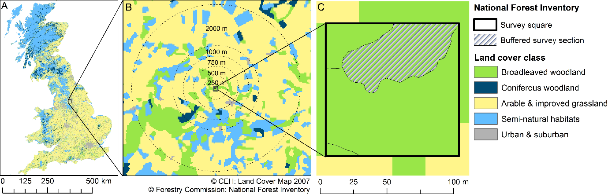
Figure 2. Landscape structure metrics hypothesised to influence the probability of deer damage establishment were quantified within multiple buffers (with radii of 250, 500, 750, 1000 and 2000-m) surrounding each National Forest Inventory square distributed across England, Scotland and Wales, using a 2007 land cover map (see text).

Explanatory variables
We used of Johnson’s (1980) selection orders to select a priori regional, landscape and local level explanatory variables that are likely to affect the probability of deer damage within a forest stand (Fig. 1), based on empirical studies of large herbivore habitat associations (Table 1). While selecting these drivers, we also developed hypotheses about possible cross-scale interactions between them (Spake et al., 2019).
Regional-level variables: We included deer density as a predictor, as the likelihood of damage can increase with cervid density, either linearly on non-linearly due to functional relationships between cervids and their food resources (Tremblay, Huot, & Potvin, 2006). Density estimates were obtained from the National Game Bag Census (see Table 1; (Noble et al., 2012)). While potential biases in bag statistics exist due to e.g. regional variation in (legal) hunting effort or reporting, geographic patterns of estimated densities are broadly in agreement with patterns derived from transect counts of live deer from the UK Breeding Bird Survey (BBS) for deer species in common between the two surveys (Newson et al., 2012; Noble et al., 2012), suggesting the data are representative of regional variability in deer densities.
Elevation, windiness, temperature and precipitation were included because they determine i) deer energy metabolism (i.e. heat loss or heat stress); harsh conditions can induce deer to seek shelter under tree canopies (Mitchell et al., 1977), and ii) the availability of food resources. For example, snow cover in colder areas at higher elevations may limit the availability of forage in open habitats, as deer have been shown to shift from foraging in grassland to forest in snowy conditions (Giroux, Dussault, Tremblay, & Côté, 2016). We calculated regional level drivers at a resolution of 10x10-km to match available deer density data.
Landscape-level variables: We quantified landscape-level forest cover (the summed cover of coniferous and broadleaved forest) and multiple classifications of other, open land cover types, because the thematic resolution of land cover maps can influence a model’s explanatory power (Bailey, Billeter, Aviron, Schweiger, & Herzog, 2007). Indeed, it is preferable to identify ‘functional’ land covers rather than structural, based on differences in resource dependencies of species or species groups rather than available land cover classes (Fahrig et al., 2011). These included: ‘open’ land (the summed cover of arable land, improved grassland, semi-natural grassland and heathland), ‘perennial’ land (the summed cover of improved grassland, semi-natural grassland and heathland), ‘open semi-natural’ land (semi-natural grassland and heathland), and ‘arable’ only. Landscape-level forest cover may confer a dilution or attraction effect, wherein the probability that a site is damaged may decline or increase with increasingly wooded surroundings. We included the open land cover classifications because high levels of these land covers may also reduce the likelihood of damage to a stand by providing an alternative (and potentially more nutritionally rich) forage source (Hurley, Webster, Flaspohler, & Parker, 2012). The density of roads is likely to exert a negative effect on the use of (and damage to) forests by deer, as large herbivores tend not to select habitats close to roads (Gagnon, Theimer, Dodd, Boe, & Schweinsburg, 2007; Meisinget, Loe, Brekkum, Moorter, & Mysterud, 2013; Gilbert, Hundertmark, Person, Lindberg, & Boyce, 2017). An appropriate landscape extent for the effect of landscape structure on deer damage was unknown a priori, so we characterised forest and perennial cover and road density in circular buffers surrounding each sample square, with radii of 250, 500, 750, 1000 and 2000-m (Spake et al., 2019). These buffer extents were considered appropriate because they i) encompass the scale of effect of landscape structure detected in a previous landscape ecological study of deer impacts (Hurley et al., 2012); and because ii) larger extents reduce both the variability amongst landscapes and potential for non-overlapping independent landscapes (Pasher et al., 2013). We investigated different buffer sizes of landscape drivers only and not at regional and local levels, because local variables were only available at the section-level, and regional-level variables were available at much coarser resolutions (deer density at 10-km raster) than the landscape-level metrics (derived from 25-m raster).
Local-level variables: Several local variables including tree density; deer have been found more likely to browse in less densely stocked stands with more open canopies where increased light availability supports a herb layer (Ewald et al., 2014). We included forest size and distance to forest edge because a range of studies have shown that deer associate with forest edges, possibly due to their higher productivity relative to forest interiors, their coincident provision of forage, shelter and concealment (Miyashita et al., 2008). Finally, we included forest type, whether coniferous, broadleaved or mixed, and whether managed, under an even-aged silvicultural regime, or unmanaged.
Table 1. Data sources of explanatory variables used in this study
Driver | Variable code | Data source and original grain for Britain | Unit (and range)
Regional-scale drivers
Deer density | DEERDENS | 10-km resolution deer density estimates were obtained from the National Game Bag Census (Noble et al., 2012) for the five species occurring in sufficient numbers in Britain to cause damage (red deer Cervus elaphus, sika C. nippon, roe C. capreolus, muntjac Muntiacus reevesi and fallow Dama dama). Individual species estimates were summed to provide an overall deer density map. See Data availability statement. | No. individuals per 10-km² (40.00-380.00)
Precipitation | PREC | Average values of temperature and precipitation were calculated from monthly 5-km resolution data from the Met Office for 2010 – 2016 via the UKCP09 website http://data.ceda.ac.uk/badc/ukcp09/ | mm (48.92-319.10)
Temperature | TEMP |  | °C (5.48-12.15)
Elevation | ELEV | 50-m resolution OS Terrain 50 data (https://www.ordnancesurvey.co.uk/xml/products/OSTerrain50Grid.xml) | m (2.21-648.84)
Windiness | WIND | An indicator representing the amount of physiologically or physically damaging wind that a forest stand on a particular site experiences in the year. The ‘DAMS’ (detailed aspect method of scoring) is as an ordinal representation of both mean wind speed and the frequency of strong winds and ranges from 3-36. Obtained from the Forestry Commission’s 250-m resolution Ecological Site Classification and aggregated to 10-km (ESC; Pyatt & Ray, 2001). | Average of ordinal variable 0-22.88
Landscape- scale drivers
Forest cover | %FOREST | Landscape metrics were calculated using 25-m resolution land cover raster for Britain, LCM2007 (Morton et al., 2014), using R package SDMTools (VanDerWal, Falconi, Stephanie Januchowski, & Storlie, 2019). Forest cover included broadleaved and coniferous forest. Open land classifications included ‘perennial’, ‘open land’, ‘arable’, and ‘open semi-natural’ (see text). Perennial cover included land cover identified as improved grassland, semi-natural grassland and heathland. | % (0.00-100.00, within 500-m buffer)
Open land cover | %PER  %OPEN  %ARAB  %SEMI |  | %PER; % (0.54 – 96.38, within 2000-m buffer)
Road density | ROAD | OS OpenRoads (https://www.ordnancesurvey.co.uk/business-and-government/products/os-open-roads.html). Measured using ArcGIS (www.esri.com, v10.2.2). | Length in km per area (0.00-9.94), within a 250-m buffer)
Local- scale drivers
Forest type | FOREST | NFI field survey. Information on forest type and silvicultural system were combined. Sites classified as ‘Young trees’ and ‘unknown’ type were removed due to ambiguity. Stands under even-aged silvicultural management are classified as such, whilst ‘unmanaged’ refers to sites with no obvious silvicultural system regime recorded. Sites of any type recorded as being managed under silvicultural systems other than coppice or even aged (including mixed systems) were grouped to ‘other’ due to low sample sizes. | Resulting categories: broadleaved even aged; broadleaved unmanaged; broadleaved coppice; coniferous even aged; coniferous unmanaged; mixed even aged; mixed unmanaged; other  .
Tree volume | TREEVOL | NFI field survey. The estimated standing volume of trees per hectare within a section. | m³ha⁻¹ (1.00-1195.00)
Tree density | TREEDENS | NFI field survey. The estimated total number of tree stems per hectare within a section. | Number of stems ha⁻¹ (8.88-5964.70)
Forest size | WOODSIZE | Derived using 2016 Forestry Commission NFI Map (vector) for Great Britain (http://data-forestry.opendata.arcgis.com/datasets/national-forest-inventory-woodland-gb). Measured from stand (NFI ‘section’) centroid to edge using ArcGIS (www.esri.com, v10.2.2). | m² (10-20132)
Distance to woodland edge | DISEDGE |  | m (0.00-150.00)
Tree age diversity | AGEDIV | Range between the youngest and oldest trees recorded. | years (0.00-200.00)
Slope | SLOPE | The slope of the section centroid derived from OS Terrain 50 at a 50-m resolution (https://www.ordnancesurvey.co.uk/xml/products/OSTerrain50Grid.xml) | degrees (0.00-32.00)

Determination of regional gradients
To identify the gradients that may affect forest susceptibility to damage by deer across Britain either directly or by interaction with local or landscape level drivers, we subjected four regional variables to Principal Components Analysis (PCA); precipitation, temperature, elevation and windiness (Table 1). We applied Box-Cox transformation, centring and scaling prior to PCA. A single component explained 70% of variation, with which precipitation, elevation and windiness were strongly negatively correlated (r = -0.87, -0.80, -0.79, respectively), and temperature positively correlated (r = 0.89). For ease of interpretation, the gradient was reversed and termed a “climatic harshness gradient” (HARSH; increasing value corresponds to increasing harshness, Figure S1.1), as it represents conditions with an increasing propensity to adopt shelter-seeking behaviour from harsh climatic conditions. Further details of the PCA are given in Appendix S1.

Hypothesised cross-scale interactions
We formulated a priori hypotheses concerning cross-scale interactions between regional, landscape and local level variables based on existing understanding of deer ecology. We hypothesised that the regional climatic harshness gradient was likely to change the importance of local and landscape-level factors that determine foraging location, and the susceptibility of a forest site to damage. Specific hypotheses and their specification as statistical terms for testing in models are given in Table 2.
Table 2. Hypothesised cross-scale interactions of drivers of tree health and their specifications in statistical models. See Table 1 for variable codes.
Hypothesised cross-scale interactions | Specification in statistical models
In accordance with shelter-seeking behaviour, in harsh conditions (i.e. high HARSH), deer may select for landscapes with higher levels of forest cover (attraction hypothesis). We therefore expected to observe an interacting effect of climate with landscape forest cover and local canopy cover, with stronger positive effects of forest cover on damage in climatically harsh regions. | HARSH*%FOREST
Interactions of climate with landscape forest cover may be further moderated by deer density, as habitat selection itself can also be density-dependent (Mobæk, Mysterud, Loe, Holand, & Austrheim, 2009), and deer density has been shown to modulate effects of landscape structure on deer impacts (Hurley et al., 2012). | %FOREST*DEERDENS  HARSH*%FOREST*DEERDENS
The effect of landscape forest cover might also depend on the amount of alternative forest, such as perennial cover, further afield. (Jarnemo, Minderman, Bunnefeld, Zidar, & Mansson, 2014). Hurley et al., (2012) found the effect of forest edge amount was modified by the interspersion of perennial land covers, with a stronger effect of edge in areas with greater interspersion. | %FOR*%PER  %FOR*%OPEN  %FOR*%ARAB  %FOR*%SEMI
In climatically benign conditions, deer may select (and are more likely to damage) forest stands with low tree densities and therefore higher amounts of ground-layer forage, while in harsh conditions, deer may select forest stands with higher tree densities to protect them from unfavourable climate.  In regions receiving low precipitation (low values on the HARSH gradient), due to competition for water with trees, dense forests may limit sub-canopy plant species composition and growth due to drought-like conditions. In these regions, denser forests may be less attractive to deer. | HARSH*TREEDENS

Statistical analysis

Model selection
We fitted generalised linear models against a binomial distribution with a log link function to the damage occurrence data. To account for the spatial non-independence of sections (homogeneous units within which damage was recorded), a single section was randomly selected from each NFI sample square, yielding a total of 10,794 NFI sections for the analysis. We used this subsampling approach instead of a mixed-effects modelling framework (with NFI squares identified as random effects), due to insufficient computational power and because handling random effects in the informatics environment is not straightforward (Grueber, Nakagawa, Laws, & Jamieson, 2011).
We initially created global models that contained the additive main effects of the local and landscape drivers and the climatic harshness gradient (HARSH) (listed in Table 1), in addition to the interaction terms representing our hypothesised cross-scale interactions (detailed in Table 2). Section area was also included as a possible offset to account its potential impact on recording damage probability. Initial global models differed in the substitutions of variables that were highly correlated: highly correlated variables did not feature in the same model (those with Spearman’s rank coefficients >0.6; see Appendix S2 for correlation coefficients, so were substituted among global models). We also substituted quadratic (second order polynomial) or log₁₀ relationships with the regional gradient (HARSH), landscape variables (%FOREST, %PER) and the local variables TREEDENS, TREEVOL and DISEDGE to test for plausible nonlinear relationships within these initial global models. Also substituted were landscape metrics if they quantified the same driver (e.g. %FOREST) but at different extents (buffer sizes), or transformations of land cover types that were not independent (e.g. %PER %SEMI, as they partially comprise the same land cover types), or transformations of the same variable (e.g. %FOREST and log₁₀(%FOREST). Initial data exploration following Zuur, Ieno, & Elphick, (2010), and screening of these initial global models, and their nested subsets, resulted in a final global model that both satisfied model assumptions and had higher support (i.e. lower AIC of global and nested models, as compared with other variations of these terms, in terms of buffer size and transformations). Further details of model set generation are given in Appendix S3. From this final global model, we generated a full set of nested models, resulting in 28,864 possible combinations of terms all to be compared with AIC using R (v. 3.4.3; R Core Team, 2017) with the package MuMIn (Bartoń, 2016). We identified a single, ‘best model’ as the model with the lowest Akaike's Information Criterion (AIC) value (Burnham & Anderson, 2002). By constructing and comparing models with specific combinations of variables in the interaction terms that corresponded to a priori hypotheses (listed in Table 2), we distinguish our testing of rigorous hypotheses from a ‘fishing expedition’ that seeks significant predictors among a large group of contenders and all of their possible second or third order interactions (Burnham & Anderson, 2002). We used model selection to obtain model coefficients (for prediction, see below), rather than averaging models over multiple models with similar support. This is because model averaging is inappropriate among nonlinear model forms (see Cade (2015)), and because models differing only in the extent of landscape variables (e.g. %FOREST) are likely to have very similar support, and such models cannot be averaged as they are technically different variables measuring the same quantity (Freckleton, 2011).
The scale of effect of landscape-level drivers were identified as the scales of %FOREST and %PER that featured in the best model. We favour this approach over the usual practice of fitting multiple univariate models for each extent of each landscape driver (e.g. Holland et al., 2004; Soranno et al., 2015), because univariate models necessarily omit important variables and interactions, increasing residual variance and leading to a bias in the statistical inference (Bradter, Kunin, Altringham, Thom, & Benton, 2013).
To ascertain the relative variable importance, we re-ran model selection with landscape-level variables quantified at the scales selected by the best model. AIC was used to identify a candidate set of considerably supported models (ΔAIC ≤4 according to Burnham & Anderson, 2004; Aho et al., 2014). Importance values were then calculated by summing the Akaike weights of models that included the term in question (Burnham and Anderson, 2004).

Visualisation and interpretation of results
We detected a three-way interaction between forest cover (%FOREST) within 500-m of a forest site, regional climatic harshness (HARSH) and deer density (DEERDENS), explaining variation in damage (see Results). Interpretation and visualisation of three-way interactions and nonlinear responses is challenging. We therefore interpret effects through differences in predicted values of damage from the best model, using logically relevant and substantively meaningful values of predictors (Hanmer & Kalkan, 2013; Breheny & Burchett, 2017). To do so in a way that produces practicable and targeted management recommendations, we designated %FOREST as the focal variable of interest, given recently proposed afforestation initiatives (DEFRA, 2018; Conservative and Unionist Party, 2019), and HARSH and DEERDENS as regional moderating variables, that interactively moderate its effect. We used R packages visreg (Breheny & Burchett, 2017) and ggplot2 (Wickham, 2016) to visualise the outputs of the best model, and represented the results in three ways:
- Marginal effect plots (Figs 3 & 4): These plots display the relationship between a focal explanatory variable (i.e. %FOREST) and the outcome (i.e. deer damage probability) with the other explanatory variables are held at some constant values. Because interaction effects are challenging to meaningfully interpret, plots displaying the marginal effect of %FOREST on deer damage, across various spatial contexts (that correspond to different combinations of constant values) are useful to visualise the variety of deer damage responses to this context-dependent driver. To do this for multiple spatial contexts in Britain, we divided the continuous gradients HARSH and DEERDENS into low, medium and high values, at sample quantiles corresponding to probabilities of 0.2 (low), medium (0.5), and high (0.8). This yielded nine groupings of HARSH and DEERDENS quantiles (low-low, low-medium, low-high etc). We graphed marginal effect plots of damage responses to %FOREST for high and low levels of perennial cover (%PER, 66% and 33%, which was also important in explaining damage, see Results), with other conditional variables (that were not graphed) held at their median or mode for continuous and categorical variables, respectively. To facilitate the spatial targeting of deer damage mitigation strategies, a map grouping UK pixels into the nearest DEERDENS and HARSH quantile groupings accompanied the marginal effect plots.
- Effect maps (Fig. 5): To visualise spatial heterogeneity in the direction and magnitude of the effect of afforestation (increasing %FOREST) on the probability of deer damage across Britain, we first mapped predicted damage using 10-km×10km pixel-level values of HARSH, DEERDENS and %PER. Occupancies were predicted for two levels of %FOREST within 500-m surrounding a site, 25% and 100%, corresponding to a plausible degree of afforestation. Occupancies were only predicted within the sampled range of predictor variables, with other conditional variables held at their median or mode. We then estimated and mapped an effect size, the risk difference (the difference in damage probabilities), to represent the direction and magnitude of the effect of afforestation (termed ‘effect maps’, sensu Spake et al., (2019)). Positive values correspond to increases in the probability of damage following afforestation from 25% to 100% %FOREST within 500-m of a forest site, while negative values corresponded to a decrease in damage probability.
- Interactive ‘Deer Damage Tool’ (Fig 6): We used the Shiny R package (Chang, Cheng, Allaire, Xie, & McPherson, 2016) to develop an interactive webtool that allows for the inspection of model predictions for selected locations across Britain. Users may dynamically select the regional context (10-km pixel), corresponding to actual DEERDENS and HARSH values, in addition to levels of local forest variables, to visualise how predicted damage probability varies with %PER and the full range of %FOREST (0-100%) surrounding a forest site.

Results
The best model (lowest AIC) explaining variation in the probability of deer damage in NFI forest sections contained regional, landscape and local-level variables and their interactions. This model included the landscape metrics: perennial cover (%PER) calculated at an extent of 2-km, forest cover (%FOREST) at 500-m, and road density (ROAD) at an extent of 250-m best explained damage probability. Multimodel inference across all models containing landscape metrics at these extents suggested that the most important drivers included the context-dependent effects of %FOREST and %PER (landscape), climatic harshness index (HARSH) and deer density (DEERDENS; regional) and their interactions, in addition to consistent effects of ROAD (landscape), forest type (FOREST), tree density (TREEDENS) and age range (AGEDIV) (local). Details of model selection are given in Appendix S3.
Locally unmanaged forest sections were the most likely to incur damage, particularly broadleaved (a best estimate of 0.67, between 0.64 and 0.71 at 95% prediction limits) and broadleaved mixed (0.69, between 0.64 and 0.73), while coniferous even-aged stands, had the lowest probability (0.55, between 0.51 and 0.58). Sections with an age range spanning 200-years had the highest damage probability of 0.72 (AGEDIV 0.66 to 0.77). Damage probability declined exponentially with TREEVOL, from a probability of around 0.75 at a stand volume of around 10-m³ha⁻¹, reaching a best estimate of 0.55 likelihood at 1500-m³ha⁻¹ at 95% prediction limits. Damage probability increased exponentially with TREEDENS, rapidly at first and reaching a plateau at about 2000 stems per hectare (Fig. 3). The probabilities reported here were estimated while holding all other parameters at their median (continuous variables) or mode (categorical).
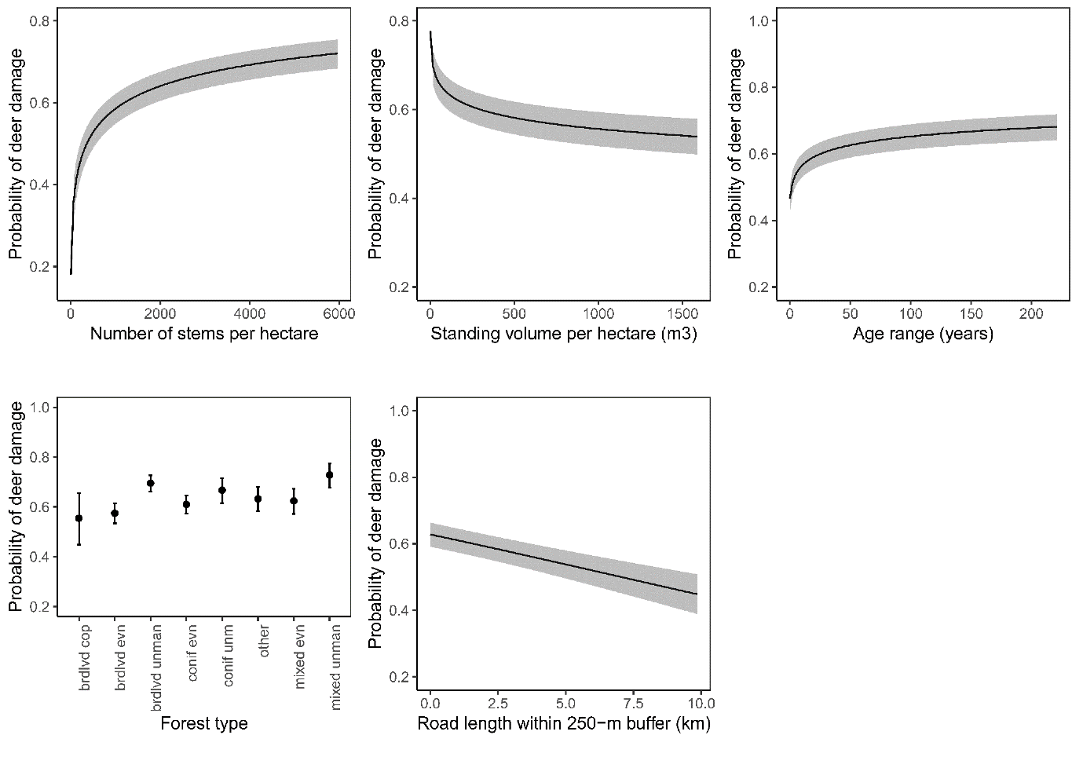
Figure 3. Marginal effects of drivers on the probability of a National Forest Inventory section being damaged by deer. Shown are the effect of TREEDENS, TREEVOL, AGEDIV, FOREST and ROAD (see Table 1 for variable codes). Plots were graphed using coefficients from the best model explaining deer damage occurrence across England, Scotland and Wales c. 2010-2016, with conditional variables not graphed held at their median (for continuous variables) or mode (for categorical variables). Shading shows 95% prediction intervals.
As hypothesized, the effect of forest cover (%FOREST) within 500-m of a NFI section depended on the degree of perennial cover (%PER) within 2-km (%FOREST*%PER), in addition to the regional climate (HARSH) and density (DEERDENS; %FOREST*HARSH*DEERDENS). Damage probability exhibited hump-shaped relationships with %FOREST in climatically favourable regions (low HARSH) that had medium to high %PER (50-100%), with damage most likely in sites with %FOREST around 40-50%. In low HARSH to mid-HARSH regions with low %PER, damage probability exhibited positive relationships with %FOREST, saturating at ~75%. These interactions manifested themselves as spatial heterogeneity in the direction and magnitude of the effect of afforestation (increasing landscape-level forest cover) across Britain. The effect map (Fig. 5c) shows that the effect of increasing forest cover from 25% to 100% within 500-m of a forest site on damage probability can vary from positive to negative across relatively short spatial extents. We note here that this effect map does not account for any estimate of uncertainty, which can be high in certain regions, as shown by the wide prediction intervals for some places in Fig. 4. Moreover, while the change of %FOREST from 25% to 100% as shown in Figure 5 is plausible, it is a somewhat arbitrary change choice that might not be feasible in some localities. However, the Deer Damage Tool is interactive, and allows for the visualisation of uncertainty and the change in damage across the full range of %FOREST. We also note that in reality, increasing forest cover will result in changes to perennial land proportional cover, which this analysis doesn’t take that into account. However, this is unlikely to exert a big effect because the scales of effect for forest and perennial cover were 5000-m and 2000-m, respectively.
The Deer Damage Tool (available at https://spake.shinyapps.io/DEERDAMAGETOOL/; Fig. 6) allows users to visualise how changing the amount of landscape-level forest cover, across a range of 0-100% within 500-m of a particular forest site, changes the likelihood that it is damaged by deer. In addition to local variables including tree density and forest type, users can select particular localities within the UK (a 10-km grid square), which correspond to values of deer density and the regional climatic harshness gradient. The selected attributes are used to dynamically update marginal effect plots of damage probability in response to forest cover, according to three levels of perennial cover further afield (within 2-km of a site).

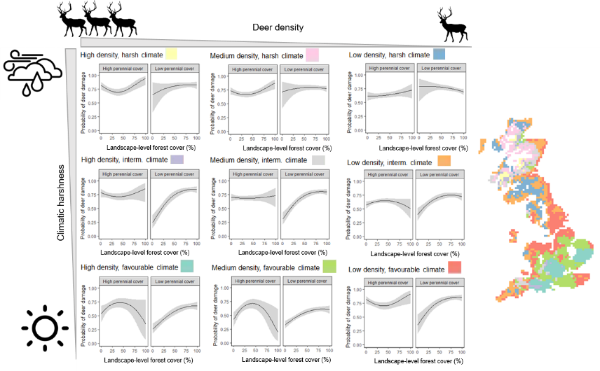
Figure 4. Marginal effect plots showing regional variation in the effects of landscape-level forest cover (%FOREST), within 500-m of a forest site, on forest damage probability, as conditional on deer density (DEERDENS), regional climatic harshness (HARSH) and landscape-level perennial cover (%PER). Three levels of DEERDENS and HARSH were distinguished as low, medium and high by their sample quantiles corresponding to probabilities of 0.2 (low), medium (0.5), and high (0.8), yielding nine regional combinations, which were mapped in space after assigning 10-km pixel values to these groups (see Methods). Relationships were graphed for each DEERDENS/HARSH combination at two levels of %PER (high- 66% and low- 33%). Plots were graphed using coefficients from the best model explaining deer damage occurrence across England, Scotland and Wales c. 2010-2016, with conditional variables not graphed held at their median or mode for continuous and categorical variables, respectively. HARSH increases from low to high from top to bottom, while DEERDENS increases from low to high from right to left. Shading shows 95% prediction intervals. White areas correspond to areas outside of the ranges of the regional variables sampled by the NFI sections selected for analysis (see Methods).
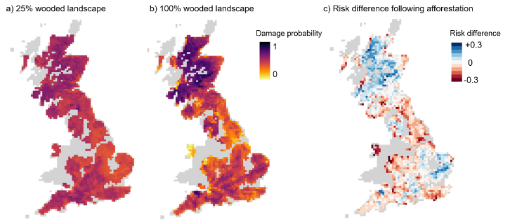Figure 5. Spatial variation damage probability across England, Scotland and Wales c. 2010-2016, as predicted by climate (the climatic harshness gradient, HARSH), deer density (DEERDENS) for forest sites surrounded by landscapes that are a) 25% and b) 100% wooded within 500-m. c) Effect map displaying spatial variation in the effect of increasing forest cover within 500-m of a forest site (%FOREST) from 25% to 100% on predicted damage probabilities, expressed as a risk difference. Positive values (blue) correspond to increases in the probability of deer damage following an increase in %FOREST, while negative values (red) corresponded to a decrease in damage probability. Shading represents the strength of this effect. Predictions were made using coefficients from the best model with covariates other than regional variables and %FOREST held at their median values (mode for categorical). Grey areas correspond to areas outside of the ranges of the regional variables sampled by the NFI sections selected for analysis (see Methods).

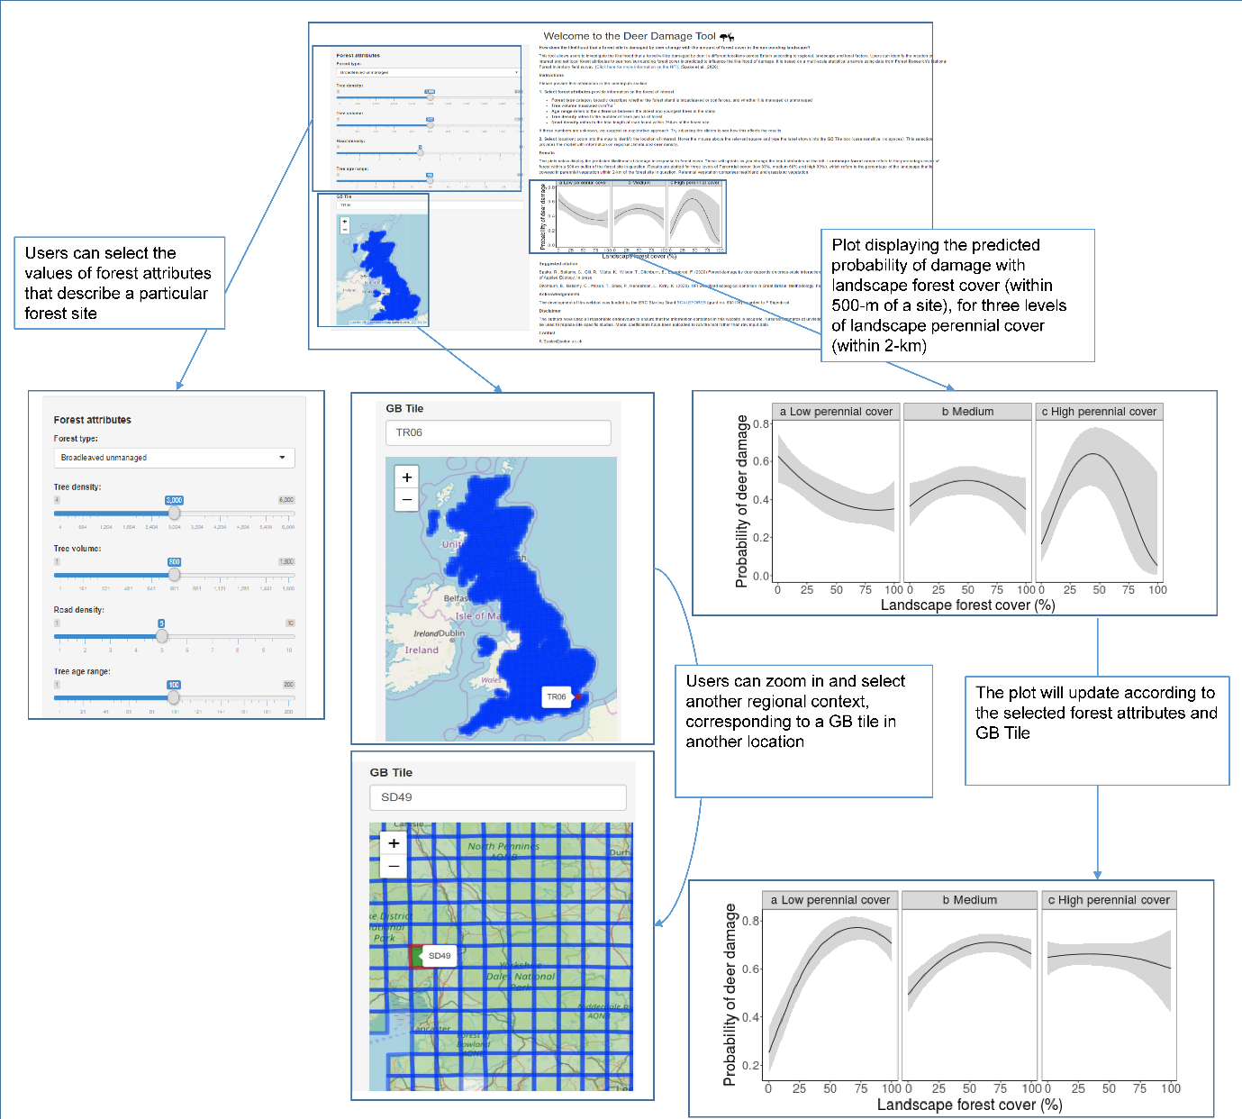Figure 6. The main features of the interactive deer damage tool (https://spake.shinyapps.io/DEERDAMAGETOOL/). Users may adjust forest attributes that describe the local variables (such as forest type and tree density) using dropdown boxes and slider bars, and select a particular location (regional context) corresponding to a tile name on the British National Grid (GB Tile). A plot displaying the predicted damage with landscape forest cover, from 0% to100%, at three levels of perennial cover, will dynamically update as the selected attributes are changed.

DISCUSSION
Through the explicit consideration of cross-scale interactions among multiple drivers operating at regional, landscape and local spatial scales, our study has allowed for the implementation of Johnson’s (1980) selection orders into a single analysis. This has enabled us to identify interactions responsible for spatial variation (context dependency) in site susceptibility to damage by deer, allowing targeted management to forests that might experience increased risk of damage in response to afforestation. Critically, our results show that deer density does not consistently drive up damage to forests across Britain; rather its effect is moderated by, or conditional upon, the regional climate, and landscape attributes. Our results suggest that management of these attributes in particular regions could alter a forest site’s ‘attractiveness’ as forage to deer, even at high deer densities. This is important because mitigation methods (e.g. fencing, culling, diversionary feeding) are costly, and so must be targeted efficiently to forests that are most at risk (Armstrong, Gill, Mayle, & Trout, 2003).
Regional climate and deer density modify the effect of landscape-level forest cover on a site’s susceptibility to damage (Fig. 4; Appendix S3). The probability of damage increased with forest cover in regions with mid to favourable climate and low levels of perennial cover, suggesting that deer select forests within wooded landscapes (at an extent of 500-m), when landscape perennial cover is low (within 2-km). This attraction effect is therefore context dependent. This agrees with previous studies demonstrating the importance of alternative forage within the landscape for reducing damage to focal habitats (Hurley et al., 2012). For example, Jarnemo et al., (2014) found that the proportion of damaged trees in forest stands across an agricultural region in Sweden was negatively related to availability of forage in the field and shrub layers of the focal stands, in addition to the proportion of forest in the landscape, and showed no relationship to any relative deer density indices. The observed hump-shaped relationship of damage with forest cover in warmer climes (Fig. 4) could result from the combination of multiple selection processes. The initial increase in damage probability that occurs from low to intermediate levels of forest cover in areas with high perennial cover could arise from deer selecting for perennial landscapes with at least some forest, either as a food resource, protection from adverse weather, or through cover-seeking behaviour typical to prey species (Staines et al., 1995; Mitchell et al., 1977). It is not clear why the probability of damage declines with further increases in forest cover in these regions. It is possible that the pattern results from a dilution effect, wherein the probability that a particular forest site is damaged declines with an increasing amount of surrounding forest cover (Hurley et al., 2012). On the other hand, it could result from deer either selecting to forage in less wooded landscapes, preferring perennial forage in favourable climes due to its potentially higher productivity. It is not possible to distinguish the mechanism without foraging data from other habitats, to understand whether they switch habitats or not. Recording deer damage in other habitats therefore represents a future monitoring priority.
The effects of local-level variables are consistent with previous studies, with deer more likely to forage in unmanaged, broadleaved sites with a large age range and low tree volume, relative to even-aged coniferous sites (Fig. 3); such sites could be prioritised for fencing. This is likely due to greater ease of movement or higher availability of understorey vegetation in these sites (Ewald et al., 2014), and preference for broadleaved tree species as browse, with Quercus and Fraxinus species among the most susceptible, and Sitka spruce (Picea sitchensis) and Scots pine (Pinus sylvestris) among the least preferred (Gill, 1992). Our results also agree with previous findings of negative effects of road density or traffic on habitat selection by large herbivores (Meisinget et al., 2013; Gilbert et al., 2017). We note here that fencing serves purposes other than forest protection from herbivore damage, such as preventing road collisions with animals, so do not suggest that fencing is directed away from roadside forests.
Our findings have important implications for deer management strategies alongside the ambitious afforestation targets that have recently been set for Britain; Scotland aims to increase forest cover from 18 to 21% by 2032 (Forestry Commission, 2009; Scottish Government, 2017), from 10%-12% in England by 2060 (DEFRA, 2018), while Wales has a target to plant at least 2,000-ha of new forest annually between 2020 to 2030 (Forestry Commission, 2018). The creation of young forest stands can benefit deer by providing abundant forage and cover (Gill, Thomas, & Stocker, 1997) The results of this analysis suggest that afforestation of landscapes in less harsh climes with low perennial cover will likely increase damage of existing forests by deer. Hump-shaped relationships between damage probability and landscape-level forest cover meant that intermediately wooded landscapes were most likely to incur damage in favourable regions with medium-to-high levels of perennial cover (Figs. 4&5). This means that mitigation methods such as fencing may be most needed to protect forests in with these particular landscape and regional contexts. This will be especially true for older forest sites with a large age ranges and low tree densities (Fig. 3), characteristics that generally correspond to unmanaged ancient semi-natural broadleaved forests (Rackham, 2008), whose lack of regeneration due to grazing threatens their biodiversity value (Spake et al., 2016). Fencing is costly and so must be directed towards forests that are most at risk of deer damage, i.e. forests with the particular local and landscape characteristics described above, whilst considering the potential impacts on the movements of other species through fencing placement and design.
Caveats
Numerous studies have shown that seasonal variation in habitat use or home range size and climate is important in predicting resource selection (e.g. Blix et al., 2014). However, damage by deer is detectable for at least a year after browsing or bark stripping has occurred, and so our analysis represents the likelihood of damage over the course of all seasons. Therefore our results are relevant for common control measures such as density reduction and fencing, but perhaps less relevant for spatially targeting diversionary feeding which is usually restricted to seasons where forests are the most vulnerable to damage (Arnold et al., 2018). Moreover, we did not consider seasonal differences in the environmental variables. For example, precipitation (a component of the climatic harshness gradient), does not distinguish between snowfall and rainfall, which differ in their effects on habitat selection by deer. Finally, in extremely severe cases of recent high herbivore grazing pressure, no browsing may have been recorded in a section due to the complete removal of seedlings, saplings and young trees (Ditchburn et al., 2020); however, bark stripping damage to the older, more established trees will remain visible in these sites.
In addition, while a range of studies have shown that deer associate with forest edges (Hurley et al., 2012), we were unable to examine the effect of spatial configuration (e.g. edge-area ratio) of forest and perennial cover, due to high collinearity between the amount and configuration of these metrics, and forest size, typical for observational studies (Fahrig et al., 2011). We can therefore only make inference about how the probability of deer damage to existing forest sites changes with forest amount within 500-m of the site across different contexts. Future research could attempt to disentangle amount from configuration effects, given that monitoring programmes are increasingly incorporating regional and landscape-level considerations in their sampling strategies (Watts et al., 2016; Gillespie et al., 2017). Furthermore, while we had a priori hypotheses concerning main and interactive effects of a limited set of environmental drivers (see ‘Explanatory variables’ and Tables 1 & 2), we did not have a priori knowledge of i) the scales of effects or landscape-level drivers, or ii) the shape of the driver-response relationships (e.g. whether linear, or quadratic). Given that landscape-level variables tend to be correlated across multiple scales of measurement, many models with the same driver but measured at different scales have similar support (Freckleton, 2011). Some caution is therefore warranted as to the interpretation of the exact scales of effects of landscape drivers.
Damage as recorded in the NFI does not distinguish among herbivore species, meaning that our response variable was a composite indicator of damage by all species of deer in Britain. Deer species in Britain differ in size, ecology and behaviour; while smaller roe and muntjac deer tend towards being solitary with relatively small home-ranges, sika, red and fallow tend towards larger group sizes and are more mobile over a larger home range (Putman et al., 2011). Such differences in species traits could affect the scale of effect of landscape drivers on damage by different species (i.e. buffer sizes, Jackson & Fahrig, 2012), possibly weakening the landscape structure-damage relationships observed in our study. Moreover, while steps were taken to avoid selecting sections damaged by other mammalian herbivores (see Methods), it is still possible that some damage was caused by other wild, feral and domestic animals including ponies, rabbits and squirrels (Ditchburn et al., 2020).
We analysed records of damage to trees only (bark stripping and browsing damage), as herbivory of other canopy levels was not recorded in the NFI field surveys. Such data could be important in explaining damage to trees, as Jarnemo et al., (2014) found that red deer damage to Norway spruce (Picea abies) stands in Sweden was negatively related to ground-layer forage availability (cover). Records of deer pellets could also be useful in explaining damage, as it might help distinguish habitat selection purposes other than forage selection. We suggest that the NFI field survey incorporates the systematic monitoring of these measures.

Synthesis and broader applications
Deer populations are increasing across the temperate zone, threatening forest biodiversity and ecosystem services. Deer mitigation methods such as fencing are costly and may threaten the movement of other wildlife. Additionally, mitigation by culling is at odds with cultural values of deer in the temperate zone; Indeed, deer contribute directly and indirectly to a range of ecosystem services such as maintaining the character of cultural landscapes, as game species, and as important prey species for large predators in Europe (Jarnemo et al., 2014). Our findings have revealed potential opportunities for reducing these trade-offs by showing that in some regional contexts and forest types, even at high deer densities, relatively little damage occurs to forests; however, in other regions, the likelihood of deer damage is high and woodland expansion will have to be balanced with efforts to mitigate against the increased vulnerability of trees.

Authors' contributions
RS, CB and FE designed the analytical approach. RS and CB carried out all statistical and GIS analyses. TW and CB collated and supplied data. RS, CB, FE and KW wrote the manuscript. All authors contributed critically to the drafts and gave final approval for publication.

Acknowledgements
This research was funded by the ERC Starting Grant “SCALEFORES” [grant no. 680176] awarded to FE. We thank two anonymous reviewers for their improvements to earlier versions of this work.

Data availability statement
All datasets used in this study are cited in the text and Table 1. All are publicly accessible except for deer density data and The National Forest Inventory field survey. Deer density data were obtained from the Game and Wildlife Conservation Trust’s National Game Bag Census. Deer density data have not been archived because permission was not granted by the data owners, Game and Wildlife Conservation Trust. Access to the data can be requested by contacting Game and Wildlife Conservation Trust at info@gwct.org.uk. With permission of the data owners, we have included the portion of data used as Supporting Information (Appendix S4). Citations of this data should be attributed to the Game and Wildlife Conservation Trust’s National Game Bag Census and Noble et al., (2012). The National Forest Inventory (NFI) field survey data used in this report is used by a division of Forest Research for the publication of Official Statistics and, as such, is subject to the Code of Practice for Official Statistics published by the UK Statistics Authority (https://www.statisticsauthority.gov.uk/code-of-practice/). The confidentiality of the location of the NFI sample plots is critical to the continued success of the NFI survey and the relationships between NFI and individual owners of woodland and forest in which NFI sample plots are located. The authors had limited access to some of these data under the strict terms of a licence agreement specifying that “access to the data is strictly limited to the named individual [co-author] and the data should not be circulated beyond this individual, nor published”. Therefore, although statistics on the data described in this document are published as NFI “Woodland Ecological Condition” reports and spreadsheets (available at https://www.forestresearch.gov.uk/tools-and-resources/national-forest-inventory/what-our-woodlands-and-tree-cover-outside-woodlands-are-like-today-8211-nfi-inventory-reports-and-woodland-map-reports/nfi-woodland-ecological-condition/), we are unable to provide access to the full input dataset used in this study without breaching the Official Statistics Code of Practice. For more information, please contact nfi@forestresearch.gov.uk.

References
Addicott, J., Aho, J., Antolin, M., Padilla, D., Richardson, J., & Soluk, D. (1987). Ecological neighborhoods: scaling environmental patterns. Oikos, 49, 340–346.
Armstrong, H., Gill, R., Mayle, B., & Trout, R. (2003). Protecting trees from deer: an overview of current knowledge and future work. Forest Research Annual Report 2001-2002, 28–39.
Arnold, J. M., Gerhardt, P., Steyaert, S. M. J. G., Hochbichler, E., & Hackländer, K. (2018). Diversionary feeding can reduce red deer habitat selection pressure on vulnerable forest stands, but is not a panacea for red deer damage. Forest Ecology and Management, 407, 166–173. Retrieved from https://doi.org/10.1016/j.foreco.2017.10.050
Bailey, D., Billeter, R., Aviron, S., Schweiger, O., & Herzog, F. (2007). The influence of thematic resolution on metric selection for biodiversity monitoring in agricultural landscapes. Landscape Ecology, 22(3), 461–473. doi:10.1007/s10980-006-9035-9
Bartoń, K. (2016). MuMIn: Multi-model inference. R package version 1.15.6. Retrieved from https://cran.r-project.org/package=MuMIn
Blix, A. W., Mysterud, A., Loe, L. E., & Austrheim, G. (2014). Temporal scales of density-dependent habitat selection in a large grazing herbivore, 123, 933–942. doi:10.1111/oik.01069
Bradter, U., Kunin, W. E., Altringham, J. D., Thom, T. J., & Benton, T. G. (2013). Identifying appropriate spatial scales of predictors in species distribution models with the random forest algorithm. Methods in Ecology and Evolution, 4(2), 167–174. doi:10.1111/j.2041-210x.2012.00253.x
Breheny, P., & Burchett, W. (2017). Visualization of Regression Models Using visreg. The R Journal, 9, 56–71.
Burnham, K. P., & Anderson, D. R. (2002). Model Selection and Multimodel Inference: A Practical Information-Theoretic Approach (2nd ed). Ecological Modelling (Vol. 172). New York: Springer-Verlag. doi:10.1016/j.ecolmodel.2003.11.004
Cade, B. S. (2015). Model averaging and muddled multimodel inferences. Ecology, 96(9), 2370–2382.
Chang, W., Cheng, J., Allaire, J. J., Xie, Y., & McPherson, J. (2016). shiny: Web Application Framework for R. Retrieved from https://cran.r-project.org/package=shiny
Clutton-Brock, T. H., & Albon, S. D. (1989). Red deer in the Highlands. Oxford: BSP Professional books.
Cohen, W. E., Drawe, D. L., Bryant, F. C., & Bradley, L. C. (1989). Observations on white-tailed deer and habitat response to livestock grazing in south Texas. Journal of Range Management, 42(5), 361–365.
Conservative and Unionist Party. (2019). Get Brexit Done. Unleash Britain’s Potential. The Conservative and Unionist Party Manifesto 2019.
Creel, S., Winnie, J., Maxwell, B., Hamlin, K., & Creel, M. (2005). Elk Alter Habitat Selection As an Antipredator Response To Wolves. Ecology, 86(12), 3387–3397.
DEFRA. (2018). A Green Future: Our 25 Year plan to improve the environment. London.
Degabriel, J. L., Albon, S. D., Fielding, D. A., Riach, D. J., Westaway, S., & Irvine, R. J. (2011). The presence of sheep leads to increases in plant diversity and reductions in the impact of deer on heather, (Ukbap 2007), 1269–1277. doi:10.1111/j.1365-2664.2011.02032.x
Ditchburn, B., Bellamy, C., Wilson, T., Steel, P., Henderson, L., Kirby, K. (2020). NFI woodland ecological condition in Great Britain: Methodology. Edinburgh.
Ditchburn, B., Wilson, T., Henderson, L., Kirby, K. & Steel, P. (2020). NFI woodland ecological condition in Britain: Classification Results. Edinburgh.
Ewald, M., Dupke, C., Heurich, M., Müller, J., & Reineking, B. (2014). LiDAR remote sensing of forest structure and GPS telemetry data provide insights on winter habitat selection of european roe deer. Forests, 5(6), 1374–1390. doi:10.3390/f5061374
Fahrig, L., Baudry, J., Brotons, L., Burel, F. G., Crist, T. O., Fuller, R. J., … Martin, J. L. (2011). Functional landscape heterogeneity and animal biodiversity in agricultural landscapes. Ecology Letters, 14(2), 101–112. doi:10.1111/j.1461-0248.2010.01559.x
Forest Research. (2019). About the NFI. Retrieved from https://www.forestresearch.gov.uk/tools-and-resources/national-forest-inventory/about-the-nfi/
Forestry Commission. (2009). The Scottish government’s rationale for woodland expansion. Edinburgh.
Forestry Commission. (2018). Woodlands for Wales: The Welsh Assembly Government’s strategy for woodlands and trees. Aberystwyth.
Freckleton, R. P. (2011). Dealing with collinearity in behavioural and ecological data: Model averaging and the problems of measurement error. Behavioral Ecology and Sociobiology, 65(1), 91–101. doi:10.1007/s00265-010-1045-6
Gagnon, J. W., Theimer, T. C., Dodd, N. L., Boe, S., & Schweinsburg, R. E. (2007). Traffic Volume Alters Elk Distribution and Highway Crossings in Arizona. Journal of Wildlife Management, 71(7), 2318–2323. doi:10.2193/2006-224
Gilbert, S. L., Hundertmark, K. J., Person, D. K., Lindberg, M. S., & Boyce, M. S. (2017). Behavioral plasticity in a variable environment : snow depth and habitat interactions drive deer movement in winter. Journal of Mammalogy, 98(1), 246–259. doi:10.1093/jmammal/gyw167
Gill, R M A. (1992). A review of damage by mammals in North temperate forests. 3. Deer. Forestry, 65(2), 145–169. doi:10.1093/forestry/65.2.145
Gill, Robin M.A., Thomas, M. L., & Stocker, D. (1997). The use of portable thermal imaging for estimating deer population density in forest habitats. Journal of Applied Ecology, 34(1273–1286).
Gillespie, M. A. K., Baude, M., Biesmeijer, J., Boatman, N., Budge, G. E., Crowe, A., … Kunin, W. E. (2017). A method for the objective selection of landscape-scale study regions and sites at the national level. Methods in Ecology and Evolution, 8(11), 1468–1476. doi:10.1111/2041-210X.12779
Giroux, M. A., Dussault, C., Tremblay, J. P., & Côté, S. D. (2016). Winter severity modulates the benefits of using a habitat temporally uncoupled from browsing. Ecosphere, 7(8). doi:10.1002/ecs2.1432
Godvik, I. M., Loe, L. E., Vik, J. O., Veiberg, V., Langvatn, R., & Mysterud, A. (2009). Temporal scales , trade-offs , and functional responses in red deer habitat selection. Ecology, 90(3), 699–710.
Grueber, C. E., Nakagawa, S., Laws, R. J., & Jamieson, I. G. (2011). Multimodel inference in ecology and evolution: Challenges and solutions. Journal of Evolutionary Biology, 24(4), 699–711. doi:10.1111/j.1420-9101.2010.02210.x
Hanmer, M. J., & Kalkan, K. O. (2013). Behind the Curve: Clarifying the Best Approach to Calculating Predicted Probabilities and Marginal Effects from Limited Dependent Variable Models. American Journal OfPolitical Science, 57(1), 263–277. doi:10.1111/j.1540-5907.2012.00602.x
Herrera, J. M., & GarcÍA, D. (2010). Effects of Forest Fragmentation on Seed Dispersal and Seedling Establishment in Ornithochorous Trees: Fragmentation Effects on Tree Recruitment. Conservation Biology, 24(4), 1089–1098. doi:10.1111/j.1523-1739.2010.01459.x
Holland, J. D., Bert, D. G., & Fahrig, L. (2004). Determining the Spatial Scale of Species’ Response to Habitat. BioScience, 54(3), 227. doi:10.1641/0006-3568(2004)054[0227:DTSSOS]2.0.CO;2
Hurley, P. M., Webster, C. R., Flaspohler, D. J., & Parker, G. R. (2012). Untangling the landscape of deer overabundance: Reserve size versus landscape context in the agricultural Midwest. Biological Conservation, 146(1), 62–71. doi:10.1016/j.biocon.2011.10.034
Jackson, H.B., & Fahrig, L. (2012). What size is a biologically relevant landscape? Landscape Ecology, (27), 929–941. doi:10.1007/s10980-012-9757-9
Jackson, Heather Bird, & Fahrig, L. (2015). Are ecologists conducting research at the optimal scale? Global Ecology and Biogeography, 24(1), 52–63. doi:10.1111/geb.12233
Jarnemo, A., Minderman, J., Bunnefeld, N., Zidar, J., & Mansson, J. (2014). Managing landscapes for multiple objectives: Alternative forage can reduce the conflict between deer and forestry. Ecosphere, 5(8). doi:10.1890/ES14-00106.1
Johnson, D. H. (1980). The Comparison of Usage and Availability Measurements for Evaluating Resource Preference. Ecology, 61(1), 65–71. doi:10.2307/1937156
Meisinget, E. L., Loe, L. E., Brekkum, O., Moorter, B. Van, & Mysterud, A. (2013). Red Deer Habitat Selection and Movements in Relation to Roads. The Journal of Wildlife Management, 77(1), 181–191. doi:10.1002/jwmg.469
Mitchell, B., Staines, B. W., & Welch, D. (1977). Ecology of Red Deer: a research review relevant to their management in Scotland. Institute of Terrestrial Ecology, 74. Retrieved from http://nora.nerc.ac.uk/id/eprint/5137
Miyashita, T., Suzuki, M., Ando, D., Fujita, G., Ochiai, K., & Asada, M. (2008). Forest edge creates small-scale variation in reproductive rate of sika deer. Population Ecology, 50(1), 111–120. doi:10.1007/s10144-007-0068-y
Mobæk, R., Mysterud, A., Loe, L. E., Holand, Ø., & Austrheim, G. (2009). Density dependent and temporal variability in habitat selection by a large herbivore ; an experimental approach. Oikos, 118, 209–218. doi:10.1111/j.1600-0706.2008.16935.x
Morellet, N., Moorter, B. Van, & Cargnelutti, B. (2011). Landscape composition influences roe deer habitat selection at both home range and landscape scales. Landscape Ecology, 26, 999–1010. doi:10.1007/s10980-011-9624-0
Morton, R. D., Rowland, C. S., Wood, C. M., Meek, L., Marston, C. G., & Smith, G. M. (2014). Land Cover Map 2007 (25m raster, GB) v1.2. NERC Environmental Information Data Centre. Retrieved from https://doi.org/10.5285/a1f88807-4826-44bc-994d-a902da5119c2
Mysterud, A., & Østbye, E. (1999). Cover as a habitat element for temperate ungulates: effects on habitat selection and demography. Wildlife Society Bulletin, 27, 385–394.
Newson, S. E., Johnston, A., Renwick, A. R., Baillie, S. R., & Fuller, R. J. (2012). Modelling large-scale relationships between changes in woodland deer and bird populations. Journal of Applied Ecology, 49(1), 278–286. doi:10.1111/j.1365-2664.2011.02077.x
Noble, D. G., Aebischer, N. J., Newson, S. E., Ewald, J. A., & Dadam, D. (2012). A Comparison of Trends and Geographical Variation in Mammal Abundance in the Breeding Bird Survey and the National Gamebag Census. JNCC Report, 468(468), 2012.
Pasher, J., Mitchell, S. W., King, D. J., Fahrig, L., Smith, A. C., & Lindsay, K. E. (2013). Optimizing landscape selection for estimating relative effects of landscape variables on ecological responses. Landscape Ecology, 28(3), 371–383. doi:10.1007/s10980-013-9852-6
Perez-Barberıia, F. J., Hooper, R. J., & Gordon, I. J. (2013). Long-term density-dependent changes in habitat selection in red deer (Cervus elaphus). Oecologia, 173, 837–847. doi:10.1007/s00442-013-2686-8
Peters, D. P. C., Bestelmeyer, B. T., & Turner, M. G. (2007). Cross-scale interactions and changing pattern-process relationships: Consequences for system dynamics. Ecosystems, 10(5), 790–796. doi:10.1007/s10021-007-9055-6
Putman, R., Langbein, J., Green, P., & Watson, P. (2011). Identifying threshold densities for wild deer in the UK above which negative impacts may occur. Mammal Review, 41(3), 175–196. doi:10.1111/j.1365-2907.2010.00173.x
Pyatt, D. G., & Ray, D. (2001). An ecological site classification for forestry in Great Britain: Forestry commission bulletin 124. Forestry Commission, Edinburgh.
Rackham, O. (2008). Ancient woodlands: modern threats, 571–586.
Ramirez, J. I., Jansen, P. A., & Poorter, L. (2018). Effects of wild ungulates on the regeneration , structure and functioning of temperate forests : A semi-quantitative review. Forest Ecology and Management, 424, 406–419. doi:10.1016/j.foreco.2018.05.016
Reimoser, F. (2003). Steering the impacts of ungulates on temperate forests. Journal of Nature Conservation, 252, 243–252.
Rodewald, A. D., & Arcese, P. (2016). Direct and Indirect Interactions between Landscape Structure and Invasive or Overabundant Species. Current Landscape Ecology Reports, 1(1), 30–39. doi:10.1007/s40823-016-0004-y
Royo, A. A., Kramer, D. W., Miller, K. V., Nibbelink, N. P., & Stout, S. L. (2017). Spatio-temporal variation in foodscapes modifies deer browsing impact on vegetation. Landscape Ecology, 32(12), 2281–2295. doi:10.1007/s10980-017-0568-x
Russell, M. B., Woodall, C. W., Potter, K. M., Walters, B. F., Domke, G. M., & Oswalt, C. M. (2017). Interactions between white-tailed deer density and the composition of forest understories in the northern United States. Forest Ecology and Management, 384, 26–33. doi:10.1016/j.foreco.2016.10.038
Scottish Government. (2017). Draft climate change plan: the draft third report on policies and proposals 2017-2032. Edinburgh.
Senft, R. L., Coughenour, M. B., Bailey, D. W., Rittenhouse, L. R., Sala, O. E., & Swift, D. M. (1987). Large Herbivore Foraging and Ecological Hierarchies. BioScience. doi:10.2307/1310545
SNH. (2016). Deer management in Scotland: report to the Scottish Government from Scottish Natural Heritage. Battleby.
Soranno, P. A., Cheruvelil, K. S., Wagner, T., Webster, K. E., & Bremigan, M. T. (2015). Effects of land use on lake nutrients: The importance of scale, hydrologic connectivity, and region. PLoS ONE, 10(8), 1–22. doi:10.1371/journal.pone.0135454
Spake, R., Bellamy, C., Graham, L., Watts, K., Wilson, T., Norton, L., … Eigenbrod, F. (2019). An analytical framework for spatially targeted management of natural capital. Nature Sustainability, 1–9.
Spake, R., van der Linde, S., Newton, A. C., Suz, L. M., Bidartondo, M. I., & Doncaster, C. P. (2016). Similar biodiversity of ectomycorrhizal fungi in set-aside plantations and ancient old-growth broadleaved forests. Biological Conservation, 194, 71–79.
Staines, B. W., Balharry, R., & Welch, D. (1995). The impact of red deer and their management on the natural heritage in the uplands. In M. B. Thompson, D. B. A. and Usher (Ed.), Heaths and moorland: Cultural landscapes. Edinburgh: SNH/HMSO.
Staines, Brian W. (1974). A review of factors affecting deer dispersion and their relevance to management. Mammal Review, 4, 79–91.
Tanentzap, A. J., Burrows, L. E., Lee, W. G., Nugent, G., Maxwell, J. M., & Coomes, D. A. (2009). Landscape-level vegetation recovery from herbivory: Progress after four decades of invasive red deer control. Journal of Applied Ecology, 46(5), 1064–1072. doi:10.1111/j.1365-2664.2009.01683.x
Tremblay, J. P., Huot, J., & Potvin, F. (2006). Divergent nonlinear responses of the boreal forest field layer along an experimental gradient of deer densities. Oecologia, 150(1), 78–88. doi:10.1007/s00442-006-0504-2
VanDerWal, J., Falconi, L., Stephanie Januchowski, L. S., & Storlie, C. (2019). SDMTools: Species Distribution Modelling Tools: Tools for processing data associated with species distribution modelling exercises. Retrieved from https://cran.r-project.org/web/packages/SDMTools/index.html
Ward, A. I. (2005). Expanding ranges of wild and feral deer in Great Britain, 35(2), 165–173.
Watts, K., Fuentes-Montemayor, E., Macgregor, N. A., Peredo-Alvarez, V., Ferryman, M., Bellamy, C., … Park, K. J. (2016). Using historical woodland creation to construct a long-term, large-scale natural experiment: The WrEN project. Ecology and Evolution, 6(9), 3012–3025. doi:10.1002/ece3.2066
White, K. S., Testa, J., & Berger, W. (2001). Behavioral and ecologic effects of differential predation pressure on moose in Alaska. Journal of Mammalogy, 82, 422–429.
Wickham, H. (2016). ggplot2: Elegant Graphics for Data Analysis. New York: Springer-Verlag.
Wisdom, M. J., Vavra, M., Boyd, J. M., Hemstrom, M. A., Ager, A. A., & Johnson, B. K. (2006). Understanding Ungulate Herbivory-Episodic Disturbance Effects on Vegetation Dynamics: Knowledge Gaps and Management Needs. Wildlife Society Bulletin, 34(2), 283–292. doi:10.2193/0091-7648(2006)34[283:uuhdeo]2.0.co;2
Zuur, A. F., Ieno, E. N., & Elphick, C. S. (2010). A protocol for data exploration to avoid common statistical problems. Methods in Ecology and Evolution, 1(1), 3–14. doi:10.1111/j.2041-210X.2009.00001.x

