EU6 OP revised v 7

Fragility fractures in Europe: Burden, management and opportunities

F Borgström ∙ L Karlsson ∙ G Ortsäter ∙ N Norton ∙ P Halbout ∙ C Cooper ∙ M Lorentzon ∙ EV McCloskey ∙ NC Harvey ∙ MK Javaid ∙ JA Kanis for the International Osteoporosis Foundation

Fredrik Borgström Medical Management Centre, Department of Learning Informatics, Management and Ethics, Karolinska Institute, Sweden

Quantify Research, Stockholm, Sweden

Linda Karlsson Quantify Research, Stockholm, Sweden

Gustav Ortsäter Quantify Research, Stockholm, Sweden

Nicolas Norton Quantify Research, Stockholm, Sweden

Philippe Halbout International Osteoporosis Foundation, Nyon, Switzerland

Cyrus Cooper MRC Lifecourse Epidemiology Unit, University of Southampton, Southampton, UK

NIHR Musculoskeletal Biomedical Research Unit, University of Oxford, Oxford, UK

Mattias Lorentzon Mary McKillop Health Institute, Catholic University of Australia, Melbourne, Australia

Geriatric Medicine, Department of Internal Medicine and Clinical Nutrition, Institute of Medicine and Clinical Nutrition, Sahlgrenska Academy, University of Gothenburg.

Eugene V McCloskey Centre for Metabolic Bone Diseases, University of Sheffield Medical School, Sheffield, UK
MRC and Arthritis Research UK Centre for Integrated Research in Musculoskeletal Ageing, Mellanby Centre for Bone Research, University of Sheffield, Sheffield, UK
Nicholas C Harvey MRC Lifecourse Epidemiology Unit, University of Southampton, Southampton, UK
Muhamamd K Javaid National Institute for Health Research (NIHR) Musculoskeletal Biomedical Research Unit, University of Oxford, Oxford, UK.
John A Kanis Centre for Metabolic Bone Diseases, University of Sheffield Medical School, Sheffield, UK
Mary McKillop Health Institute, Catholic University of Australia, Melbourne, Australia
Corresponding author
Prof. J. A. Kanis,
Centre for Metabolic Bone Diseases,
University of Sheffield Medical School,
Beech Hill Road, Sheffield, S10 2RX, UK.
Telephone: +44 114 285 1109
Email: w.j.Pontefract@shef.ac.uk

Abstract

Mini abstract This report provides an overview and a comparison of the burden and management of fragility fractures in the largest five countries of the European Union plus Sweden (EU6). In 2017, new fragility fractures in the EU6 are estimated at 2.7 million with an associated annual cost of €37.5 billion and a loss of 1.0 million quality-adjusted life-years.

Introduction
Osteoporosis is characterized by reduced bone mass and strength, which increases the risk of fragility fractures, which in turn, represent the main consequence of the disease. This report provides an overview and a comparison of the burden and management of fragility fractures in the largest five EU countries and Sweden (designated the EU6).
Methods
A series of metrics describing the burden and management of fragility fractures were defined by a scientific steering committee. A working group performed the data collection and analysis. Data were collected from current literature, available retrospective data and public sources. Different methods were applied (e.g. standard statistics and health economic modelling), where appropriate, to perform the analysis for each metric.
Results
Total fragility fractures in the EU6 are estimated to increase from 2.7 million in 2017 to 3.3 million in 2030; a 23% increase. The resulting annual fracture-related costs (€37.5 billion in 2017) are expected to increase by 27%. An estimated 1.0 million quality-adjusted life-years (QALYs) were lost in 2017 due to fragility fractures. The current disability-adjusted life-years (DALYs) per 1,000 individuals age 50 years or more were estimated at 21 years, which is higher than the estimates for stroke or chronic obstructive pulmonary disease. The treatment gap (percentage of eligible individuals not receiving treatment with osteoporosis drugs) in the EU6 is estimated to be 73% for women and 63% for men; an increase of 17% since 2010. If all patients who fracture in the EU6 were enrolled into fracture liaison services at least 19,000 fractures every year might be avoided.
Conclusions
Fracture related burden is expected to increase over the coming decades. Given the substantial treatment gap and proven cost-effectiveness of fracture prevention schemes such as fracture liaison services, urgent action is needed to ensure that all individuals at high risk of fragility fracture are appropriately assessed and treated.

Key words: disability-adjusted life-years ∙ fragility fracture ∙ fracture costs ∙ treatment gap ∙ quality-adjusted life-years

Executive Summary

Osteoporosis is a disease that weakens the bones and increases the risk of fragility fractures, where bones can break from a fall from a standing height or less. In Western Europe, about 1 in 3 women and 1 in 5 men at or above the age of 50 years will fracture during their lifetime. The number of fragility fractures and cases of osteoporosis is increasing worldwide, creating an increasing burden to society.

This report provides an overview and a comparison of the burden and management of fragility fractures in six European countries (France, Germany, Italy, Spain, Sweden, UK), hereafter referred to as EU6.

Key findings:
- The total number of fragility fractures in the EU6 is estimated to increase from 2.7 million in 2017 to 3.3 million in 2030; an increase of 23.3%.
- The annual fracture related costs in the EU6 are projected to increase from a total €37.5 billion 2017 to €47.4 billion in 2030; an increase of 27%.
- The number of disability-adjusted life-years (DALYs) per 1,000 individuals age 50 years or more in EU6 due to fragility fractures was estimated at 21 years. This is a higher estimate compared to some other chronic diseases such as stroke (13 DALYs per 1,000) and chronic obstructive pulmonary disease (COPD) (15 DALYs per 1,000).
- The risk of refracture is highest immediately after a fracture. This has been referred to as the period of imminent risk; this phenomenon suggests that there is an opportunity to optimize the benefits of fracture prevention by treating patients as soon as possible after occurrence of a fracture.
- The treatment gap (defined as the percent eligible individuals not receiving treatment with osteoporosis drugs) in EU6 in year 2017 is estimated to be 73% for women and 63% for men. Compared to analysis from the year 2010 this is a marked increase from 56% in women and 47% in men.
- The proportion of patients starting a pharmacological treatment in the year after a fracture is low. In France, Sweden and Spain 85%, 84% and 72% of fracture patients remained untreated 1 year after fracture, respectively.
- A Fracture Liaison Service (FLS) is a multi-disciplinary health care delivery model for secondary fracture prevention. This health care delivery model has become more common in recent years, but its coverage is still low.
- A growing body of evidence suggests that FLS are cost-effective care delivery models that have the potential to increase the number of high risk patients being treated, improve adherence to treatment, and reduce the risk of re-fracture.
- A FLS provides an opportunity to improve early post fracture patient identification and reduce the treatment gap.
- If FLS could be further expanded to reach all fracture patients in the EU6,
19,262 additional fractures every year would be avoided, and fracture related costs would be reduced by €285.5 million.

Key results by country:
Key Results (mean values*) | France | Germany | Italy | Spain | Sweden | UK | EU6
Lifetime risk of hip fracture in women from age 50 | 11.0% | 17.1% | 16.7% | 9.8% | 22.8% | 17.2% | 15.1%
Percentage increase in fragility fractures by 2030 | 24.4% | 18.5% | 22.4% | 28.8% | 26.6% | 26.2% | 23.3%
Annual fracture related cost per capita (€) | 83 | 137 | 159 | 91 | 199 | 79 | 114
Percentage increase in fracture related costs by 2030 | 26.4% | 23.2% | 26.2% | 30.6% | 29.4% | 30.2% | 27.7%
Percentage increase in Quality-Adjusted Life-Years (QALYs) lost by 2030 | 26.4% | 22.4% | 24.7% | 29.8% | 27.2% | 28.2% | 25.6%
Fracture related Disability-Adjusted Life-Years (DALYs) per 1,000 people | 17 | 24 | 20 | 12 | 32 | 24 | 21
Fracture related sick days per 1,000 people | 16 | 32 | 24 | 15 | 36 | 21 | 24
Relative care hours related to fractures per 1,000 people | 138 | - | 882 | 756 | 191 | 248 | 443
Overall treatment gap in women (%) | 77% | 78% | 73% | 68% | 76% | 64% | 73%
Post fracture treatment gap in women (%) - osteoporotic fracture | 85% | - | - | 72% | 84% | - | 72%-85%
Post fracture treatment gap in women (%) - hip fracture | - | - | - | 68% | 84% | 49% | 49%-84%
FRAX model with guideline available (yes/no) | YES | NO⁺ | YES | YES | YES | YES | NA
Change in the uptake of FRAX from 2010 to 2017 (%) | +100% | -6% | -16% | +17% | +118% | +99% | +75%
Number of fracture liaison services (FLS) enrolled in the Capture the Fracture (CtF) network (total) | 15 | 3 | 12 | 54 | 5 | 17 | 106
Potential reduction in number of fragility fractures (per 1,000 population) with improved coverage of FLS | 10.0 | 13.9 | 7.2 | 5.4 | 22.7 | 16.2 | 11.3
Potential reduction in fracture related costs (€) (per 1,000 of new FLS patients) with improved coverage of FLS | -143 | -193 | -139 | -79 | -370 | -216 | -168
*Mean value if not otherwise stated
⁺FRAX is available in Germany, but no guideline currently endorses it’s use

Note: Colours indicate ranking among countries (from green=best to red=worst)

Introduction
The objective of this report is to provide information on the current and future burden of osteoporosis and associated fragility fractures as well as to describe current management of the disease. Results are presented for the five largest EU countries (France, Germany, Italy, Spain and the UK) as well as Sweden, referred to as the EU6. This report was developed by the International Osteoporosis Foundation (IOF) and led by a steering committee of scientific experts assigned by the IOF. The report forms the basis of policy reports prepared by IOF for each of the EU6 countries [1-7] .

To facilitate an assessment and a comparison of the burden and management of fragility fractures a series of metrics was defined by a steering committee and thereafter quantified by a group of analysts at Quantify Research (reflected in the authorship). The metrics were classified into two broad categories with subcategories. The first category was burden of disease with epidemiology, economic cost and patient burden as sub-categories. The second category was management of disease with service provision and service uptake as sub-categories. The first part of this report provides a summary of the most important findings. An appendix that follows provides more detailed information on each metric, particularly on the analytic methods.

Osteoporosis
Osteoporosis, which means porous bone, is a disease that weakens the bones and increases the risk of fragility fractures, where bones can break from low level impact or stress that would not normally break a healthy bone. Since bones become more porous and fragile with age, the disease is mainly found in the older population, and is more common amongst women than men [8].
Bone mineral density (BMD) is the measurement used to determine whether an individual has osteoporosis. The operational definition of osteoporosis is based on the T-score for BMD in women [9, 10] and is defined as a value for BMD 2.5 SD or more below the young female adult mean (T-score less than or equal to –2.5).

The clinical relevance of osteoporosis lies in the associated fragility fractures; until such an event occurs there are usually no symptoms [8]. In the Western World, about 1 in 3 women and 1 in 5 men above 50 years of age will fracture during their remaining life-time [11]. After the age of 50 years, most sites of fracture can be considered characteristic of osteoporosis. Fractures at the hip and vertebrae are among the most common and serious sites of osteoporotic fracture. Fragility fractures of the humerus, forearm, ribs, tibia (in women, but not including ankle fractures), pelvis and other femoral fractures after the age of 50 years are fractures associated with low BMD [12, 13].

Worldwide, osteoporosis causes more than 9 million fractures a year, meaning there is a fragility fracture every 3 seconds [14]. Those who have had their first osteoporotic fracture have a higher risk for further fractures. The risk of fracture also increases with age, and as average life expectancy around the world rises, more individuals are expected to sustain fragility fractures.

The fracture-related monetary cost of fragility fractures in the 27 countries of the EU (EU27) has been estimated at €37 billion in 2010 [15], with 26,300 life-years lost and 1.16 million quality-adjusted life-years (QALYs) lost on a yearly basis [15]. With changing demography, these costs are expected to increase considerably by the year 2030.

Despite significant impacts on health and quality of life for the older population, there is a general lack of awareness of osteoporosis, including many health care agencies, which results in suboptimal care. Indeed, most individuals at high risk are never identified nor given appropriate treatment, which gives rise to further fragility fractures and worsening of health status.

The primary outcomes of interest in this report were fractures considered to be related to low BMD [12]. These include clinical vertebral fractures, fractures of distal forearm, pelvis-sacrum, ribs-sternum, clavicle, humerus and proximal femur. Fractures of the hands, feet, ankle, skull and facial bones were excluded. The report also focuses on specific fracture sites: hip fracture, clinical vertebral fracture and major osteoporotic fracture (MOFs). MOF is a grouping of the most common fractures comprising hip, clinical vertebral, distal forearm and proximal humerus fractures. The term “other” osteoporotic fractures in this report refers to osteoporotic fractures that are not MOFs unless specifically defined. The majority of vertebral fractures are sub-clinical (75%) and recognised on radiographs by a change in shape of the vertebral body [10]. In the present report, clinical vertebral fractures coming to medical attention are considered rather than these morphometric fractures.

Epidemiology of Fragility Fractures

Prevalence of osteoporosis

About one-tenth of women age 60 years, one-fifth of women age 70, two-fifths of women age 80 and two-thirds of women aged 90 years have osteoporosis and an increased risk of fragility fracture [16]. Worldwide, approximately 200 million women have osteoporosis [17] defined as a value for femoral neck BMD 2.5 SD or more below the young female adult mean (T-score less than or equal to –2.5) [10]. Note that the BMD threshold applies to men as well as women.

In 2015, there were an estimated 20 million individuals with osteoporosis in the EU6. Of those, 15.8 million were women and 4.2 million were men. The number of women with osteoporosis increased markedly with age (Fig. 1). The prevalence of osteoporosis at the age of 50 years or more, as judged by femoral neck BMD, was 6.8% in men and 22.5% in women.

Country-specific estimates for individuals with the disease age 50 years or older in women ranged from 21.8% (UK) to 23.1% (Italy). For men, the number with osteoporosis ranged from 6.7% (Germany) to 7.0% (Italy). For country-specific details and methods, see the appendix (1: Prevalence of osteoporosis).
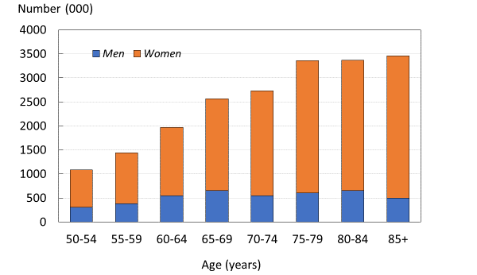
Fig. 1 Prevalence of osteoporosis in the EU6 by age and sex

Osteoporosis represents one of the greatest health risks for individuals age 50 years or more, even when compared to hypercholesterolaemia and hypertension (two major contributors to heart disease), which affect 54% and 44% of people age 50 years or more, respectively [18].

Number of fractures

There were estimated to be 2.7 million new fragility fractures in the EU6 in 2017 — equivalent to 7,332 fractures/day (or 305/h) (Table 1). Almost twice as many fractures occurred in women (66%) compared to men. Hip, vertebral and distal forearm/proximal humerus fractures accounted for 19.6, 15.5, and 17.9 % of all fractures, respectively. Other fragility fractures accounted for 49% of the fracture burden.

Table 1. Estimated number of incident fragility fractures in the EU6 by site in 2017
Fracture site | Women | Men | Men and women
Hip | 381,732 | 144,738 | 526,470
Spine | 267,194 | 148,089 | 415,283
Proximal humerus /distal forearm | 303,021 | 175,020 | 478,041
Other | 819,029 | 437,397 | 1,256,426
All | 1,770,976 | 905,244 | 2,676,220

The number of new fragility fractures in 2017 by country is shown in Fig. 2. Germany had the highest number of fractures in both men and women—approximately 765,000 incident fractures in total, predominately reflecting the large population size and comparatively high fracture incidence.
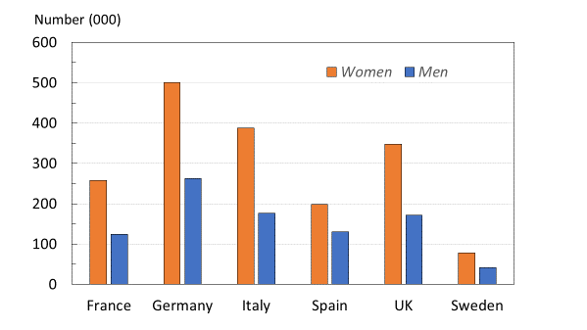

Fig. 2 Number (thousands) of new fragility fractures by country in 2017

When fracture numbers were expressed as a rate of the population at risk, there was a greater than two-fold range in risk that varied from 15/1,000 in France to 32/1,000 in Sweden (Table 2).

Table 2. The number of new fragility fractures in 2017 in men and women by country, the population at risk (men and women aged 50 years or more) and the crude incidence (/1000 of the population).
Country | New fractures  (000) | Population at risk (000) | Rate/1,000
France | 381.6 | 24,672 | 15
Germany | 764.9 | 33,399 | 23
Italy | 563.4 | 26,282 | 21
Spain | 327.6 | 16,510 | 20
United Kingdom | 519.0 | 24,048 | 22
Sweden | 119.7 | 3,787 | 32
EU6 | 2,676.2 | 128,699 | 21

A detailed breakdown of number of fractures by site and country is given together with the methods in the appendix (2: Lifetime risk of fragility fractures).

Lifetime risk of fragility fracture

The remaining lifetime risk of sustaining a hip fracture for women at the age of 50 years varied between 9.8% for Spain to 22.8% for Sweden (Fig. 3). The corresponding risk range for men was 6.1% (France) to 13.7% (Sweden). The lifetime risk of hip fracture at age 50 years was comparable to the lifetime risk of a stroke in Europe for both women (20%) and men (14%) [22].
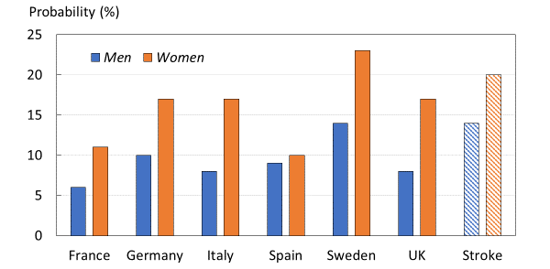
Fig. 3 Lifetime risk of hip fracture from the age of 50 years, by country and sex, and the equivalent risk for stroke.

The remaining lifetime probability of a MOF was highest in Sweden (46.3 % for women and 28.7 % for men (Fig. 4). Lifetime risk of major osteoporotic fracture was comparable to that of cardiovascular disease (CVD) in Europe, which affects 29% of women and 38% of men [19]. For methods and numerical data by fracture site and country, see the appendix (2: Lifetime risk of fragility fractures).
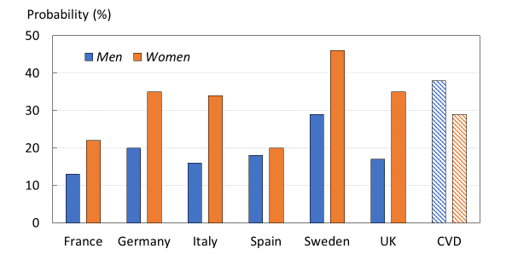
Fig. 4 Lifetime risk of fragility fracture from the age of 50 years, by country and sex, and the equivalent risk for cardiovascular disease (CVD).
Source: National fracture incidences and own calculations.

Fracture projections

There is a marked difference in the risk of fracture between countries [20]. Northern European countries have the highest fracture rates observed worldwide. The reasons for the difference in fracture risk are unknown but cannot be explained by differences in bone density. Plausible factors include differences in body mass index, low calcium intake, reduced sunlight exposure and perhaps the most crucial factor, high socio-economic status, which in turn may be related to low levels of physical activity [21, 22]. Regardless of differences in fracture risk the number of fractures in all countries is expected to increase due to an increasingly ageing population.

To estimate the annual number of new fractures between 2017 and 2030, national data on fracture incidence by type and sex were combined with demographic projections over time (see appendix, 3: Fracture projections). The total number of all fragility fractures in the EU6 is projected to increase from 2.7 million in the year 2017 to 3.3 million in 2030; an increase of 23.3% (Fig. 5). In total, 66.2% of fragility fractures were sustained by women in 2017. The total number of MOF was 1.4 million and expected to increase by 24%. For hip fracture (n=526 thousand) and clinical spine fracture (n=416 thousand), the increases projected were 28% and 23%, respectively.
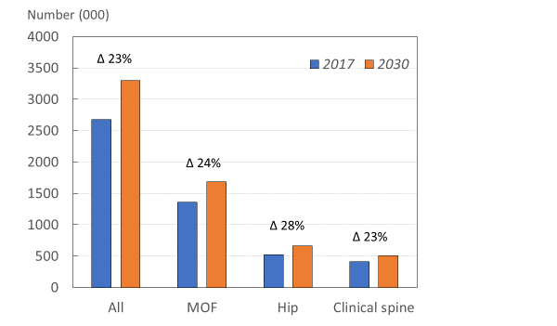

Fig. 5 Estimated number of fragility fractures by fracture category in 2017 and 2030. Numbers denote the percentage change for all fragility fractures, major osteoporotic fractures (MOF), hip and clinical spine fractures.

Variations in projections were seen between countries (Fig. 6). For example, the highest percentage increase in all osteoporotic fractures was noted in Spain (28.8%) and the lowest in Germany (18.5%), due to differences in projected populations over time up to 2030. Country-specific details for hip, vertebral fractures and MOFs are given in the appendix (3: Fracture projections).
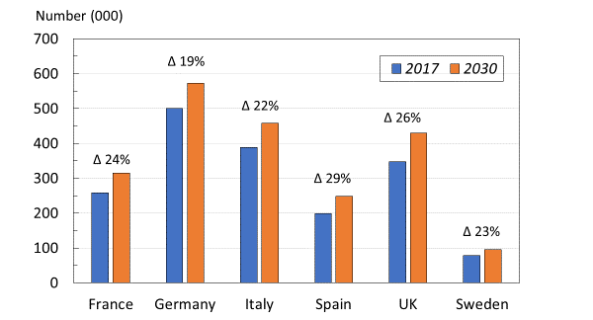
Fig. 6 Number of fragility fractures by country in the EU6 and the projected numbers in 2030

Imminent risk of fracture

Individuals who have already suffered a fragility fracture are at a greater risk for further fractures both at the same site and elsewhere. This additional risk of refracture is highest immediately after a fracture [23]. Fig. 7 shows the risk per 100,000 women at the age of 75 years following a MOF. The high subsequent fracture risk observed during the first two years following the fracture has been referred to as the period of imminent risk [23, 24]. The existence of an imminent risk period signals that there is an opportunity to optimize the benefits of fracture prevention treatments if patients could be identified and managed as soon as possible after fracture.
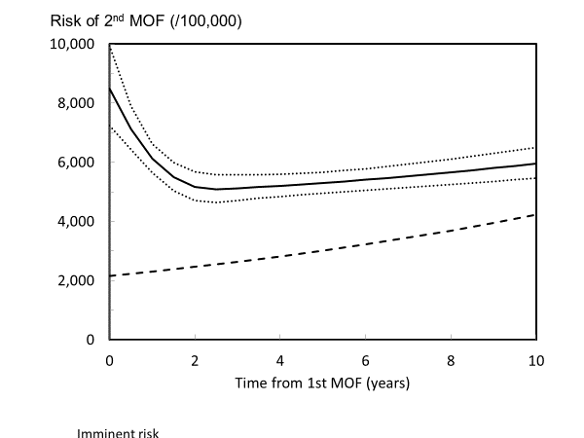
Fig. 7 Risk per 100 000 (95%CI) of a second MOF after a first MOF for a woman at the age of 75 years at her first fracture [23]. The dashed line represents the risk of first MOF in the age- and sex-matched population.

Available evidence shows that similar patterns of imminent fracture risk are observed in all countries where this has been explored [25-31]. However, there is little information to assess whether there are differences in imminent fracture risk between countries. Findings from Sweden are given in the appendix (4: Imminent fracture risk).

The empirical 10-year probability of MOF was consistently higher in those with a sentinel clinical vertebral fracture within the past two years than the FRAX probability in the population of the same age with any previous fracture, but the relative risk (observed/expected probability) varied by age. For example, the relative risk at the age of 50 years for a woman with a clinical vertebral fracture within the previous 2 years was 2.5; for the age of 80 years, the ratio was 1.2 (Table 3).

Table 3. 10-year probability of a major osteoporotic fracture (MOF) for Icelandic women at different ages, categorized by previous fracture [32]
 | 10-year probability of MOF
Age | Cohort with clinical vertebral fracture 0-2 years ago |  | Cohort with any previous fracture in adult life | Ratio
50 | 29.0 |  | 11.7 | 2.47
60 | 36.1 |  | 19.4 | 1.86
70 | 41.9 |  | 27.6 | 1.52
80 | 42.5 |  | 34.2 | 1.24
90 | 34.7 |  | 33.3 | 1.04

The impact of the adjustment in the EU6 countries is illustrated in Table 4 which shows the impact of a recent clinical vertebral fracture on conventional FRAX probabilities.

Table 4. 10-year probability of a major osteoporotic fracture (MOF) in women with a prior clinical vertebral fracture at an undetermined time and within the past two years according to country. Age set to 60 years, BMI 25kg/m², no additional risk factors [32].
 | Probability MOF (%)
Country | Undetermined time | Within the past two years
France | 9.4 | 17
Germany | 12 | 22
Italy | 12 | 22
Spain | 7.0 | 13
Sweden | 21 | 39
UK | 16 | 30

Thus, 10-year FRAX probabilities can be adjusted in the presence of a recent vertebral fracture and are likely be useful in treatment decision-making. Similar adjustments for recent fractures at other sites are a requirement for the future.
Economic cost of fragility fractures
Fracture costs and length of hospital stay

Fragility fractures incur both short-term and long-term costs for the health care sector and for society. These costs differ between fracture sites, and to some extent reflect the severity of fracture, in particular the need for hospital admission. Hip fractures are the most severe fracture site, and almost always lead to hospitalization and high costs. The length-of-hospital-stay is an important cost component and, within country, has also been shown to have implications for how patients fare over their remaining life time [33].

In the EU6, the average length-of-hospital-stay for hip fracture ranged from 11.6 days in Sweden, to 20.5 days in the UK (Table 5). Methods are given in the appendix (5: Length of hospital stay).

Table 5. Mean length of hospital stay (LOS) and standard deviation (SD) following a hip fracture
Country | LOS (days) |  | Source
 | Mean | SD
France | 12 | 8.0 | [34]
Germany | 14.5 (2.6) | 2.6 | [35]
Italy | 19.0 (25.3) | 25.3 | [36]
Spain | 11.8 (7.9) | 7.9 | [37]
Sweden | 11.6 (8.7) | 8.7 | [33]
UK | 20.5 (20.0) | 21.6 | [38]

The unit fracture costs differed substantially between countries and fracture sites (Table 6). Hip fractures were the costliest fracture type in all countries, whilst distal forearm fractures were the least costly. Fracture costs were generally high in Sweden and Germany, and the lowest in Spain. For more details, see the appendix (6: Fracture-related costs).

Table 6. Mean cost of fracture (€ 2017) in the year following fracture at the sites shown.
Country | Hip | Vertebral | Distal forearm
France | 12,856 | 3,205 | 1,468
Germany | 20,884 | 11,080 | 1,275
Italy | 21,307 | 4,713 | 1,301
Spain | 9,724 | 1,928 | 533
Sweden | 16,406 | 14,474 | 4,028
UK | 20,650 | 4,028 | 2,568

Annual fracture-related costs
If current trends in fracture prevention continue, as the general population grows and lives for longer, the hospital and societal cost of fragility fractures will continue to increase.

The fracture related costs in the EU6 amounted to €37.5 billion in the year 2017. Hip fractures accounted for the majority of the total cost (57%) whereas they accounted for 20% of fragility fractures (Fig. 8).
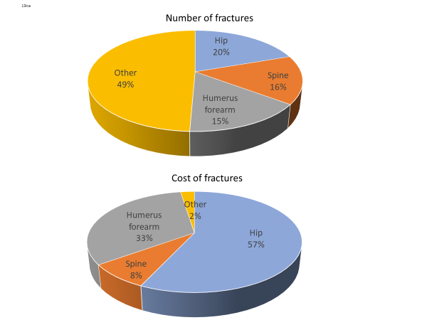
Fig. 8 Number and cost of fragility fractures in the EU6 expressed as a percentage of the totals.
Note: The estimates conservatively assume no long-term costs for ‘other fractures’.

The direct cost of fractures in each EU6 country is given in Table 7. Costs comprise the annual cost of fractures in 2017 (incident fractures), those arising from fractures before 2017 (prior fractures) and the cost of institutional care.
Table 7. The direct cost (million Euro) of fractures in 2017 (incident fractures), those arising from fractures before 2017 (prior fractures) and the cost of institutional care in each EU6 country.
Country | Incident fractures | Prior fractures | Institutional care | Total
France | 3,748 | 219 | 1,404 | 5,371
Germany | 8,176 | 414 | 2,680 | 11,270
Italy | 5,951 | 299 | 3,179 | 9,429
Spain | 2,150 | 137 | 1,915 | 4,202
United Kingdom | 2,955 | 372 | 1,919 | 5,246
Sweden | 1,199 | 81 | 690 | 1,970

In 2010, fracture-related costs in the EU6 were estimated to total €29.6 billion [39]. Fracture-related costs for the EU6 in 2017 were now estimated to total €37.5 billion (an increase of 27% since 2010), and are projected to increase to €47.4 billion in 2030 (an increase of 27% since 2017) (Fig. 9).
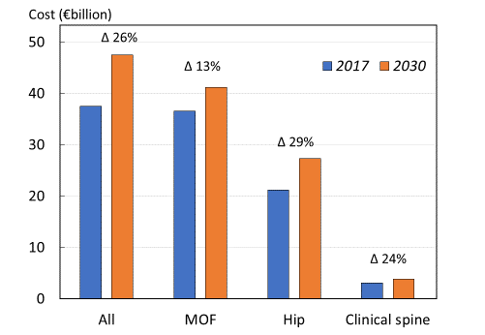
Fig. 9 Annual cost of fractures by site in the EU6 for 2017 and projected increase by 2030

As expected, costs will increase due to the increase in fracture cases. The fracture related costs in the EU6 are projected to increase by 27% from a total €37.5 billion in the year 2017 to €47.4 billion in 2030. Cost projections to 2030 are shown for each country by fracture site in Fig. 10. The dominant cost was for hip fracture. The fracture-related cost estimates provided are conservative, since costs from other fracture sites were not included in the estimation.
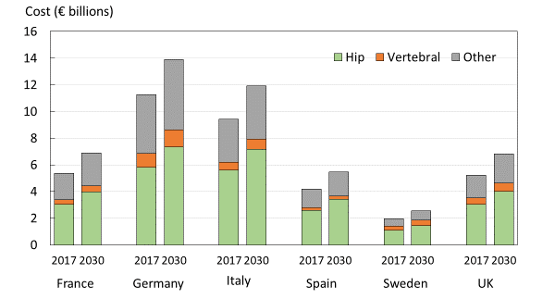
Fig. 10 Cost of fragility fractures in 2017 and that expected in 2030 by country and fracture site.

There were small variations in the percentage increase in cost by country. The greater increases were noted in Spain (+30.6%), the UK (+30.2), and Sweden (+29.4%) and lower increments in Germany (+23.2%), Italy (+26.2%) and France (+26.4%).

Cost for incident fractures in a given year and long-term cost (due to fractures that arose in previous years) as well as the cost of residing in nursing homes are detailed in the appendix (7: Annual cost of fractures).

Patient burden
Quality-Adjusted Life-Years (QALYs)

The use of QALYs is a method of measuring the burden of a disease where a year of an individual’s life is weighted by the average Health-Related Quality of Life (HRQoL) that a person had during that year. For example, 1 QALY is equal to one year spent in perfect health; 0.5 QALYs can be thought of as either half a year spent in perfect health followed by death, or one year lived at 50% of perfect health. QALYs are regularly used in economic analyses because they provide decision makers with a method for quantifying and comparing burden across diseases.

QALYs lost due to fragility fractures were estimated from fracture-based HRQoL, fracture risks and death rates [40-42]. Methods are summarised in the appendix (8: Quality-Adjusted Life-Years). Estimates of the QALY loss were generated from 2017 up to year 2030, based on population projections, to show the expected change in QALY loss for the near future.

The total health burden in 2017 due to fragility fractures in EU6 was at 1.02 million QALYs. 66% of the QALY loss was due to fractures occurring in women. The QALY loss in absolute numbers was highest in Germany due to the size of the population combined with comparatively high risk of fractures. The lowest QALY loss was observed in Sweden due to the small population size compared to the other countries. On a per capita basis, Sweden had the largest burden (4.22 lost QALYs per 1,000 people age 50 years and above) and France the lowest (2.11 lost QALYs per 1,000) (Fig. 11). The differences were driven, in large part, by differences in the risk of fractures and age distribution between countries.
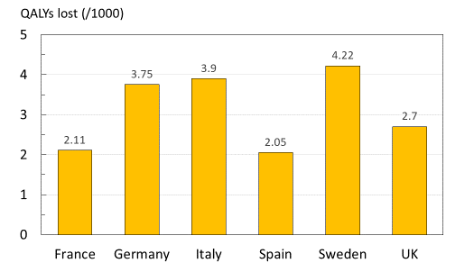
Fig. 11 Quality of life years (QALYs) lost in 2017 due to fragility fractures per 1000 of the population age 50 years or more in countries of the EU6.

The QALY burden is expected to increase by 25.6% in the year 2030 but varied by country (Fig. 12).
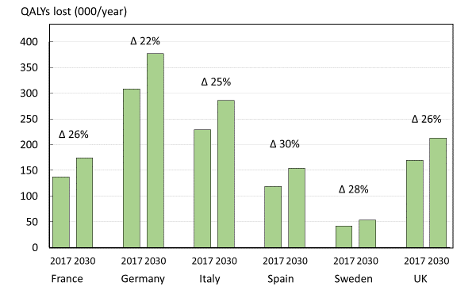
Fig. 12 Quality of life years (QALYs) lost due to fragility fractures in countries of the EU6 in 2017 and 2030.

Disability-Adjusted Life-Years (DALYs)

The DALY (or Disability Adjusted Life Year) is the World Health Organization’s (WHO) standard method of measuring the burden of a disease. DALYs are the sum of years of life lost (YLL) and the years lost due to disability (YLD) [46]. A single DALY can be thought of as one year of “healthy life” lost. Summing the DALYs across an entire population provides the gap between the current health status of a population and an ideal disease-free population, i.e. the burden [43]. Including this measure of burden allows for comparison of the burden of different diseases, both within and between countries.

When using the WHO standard method, the total DALYs related to fragility fractures in year 2016 for the EU6 (ages of 50 to 100 years) were more than 2.6 million DALYs. Average YLDs per 1,000 people (15.1) far exceeded the YLLs per 1,000 (5.5), indicating that living with a disability due to fracture drives DALY loss in osteoporosis.

The DALY burden was less for hip fracture than for vertebral fracture which, in turn was less than for other fragility fractures (Fig. 13). This dominance of other fragility fractures over hip fractures arose from the combination of a high incidence at early ages, and the large number of years spent with disability from other fractures compared with hip fracture.

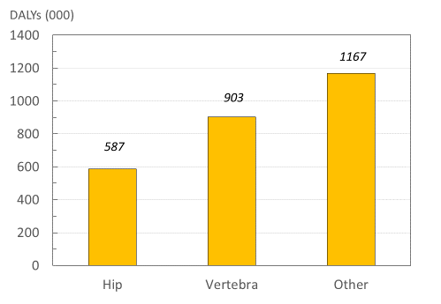
Fig. 13 Total DALY distribution by fracture site.
.
The age distributions of YLLs and YLDs differed by fracture site. In women with hip fractures (Fig. 14), the YLLs peaked at the age of 77 years, whilst the YLDs peaked at age 81 years, reflecting that most hip fractures occur around 77 years. The YLDs for non-hip, non-vertebral fractures in the female population (Fig. 15), peaked early and was sustained over age, with very low YLLs, indicating that prevalence of non-hip, non-vertebral (NHNV) fractures is high but with limited consequences for mortality when compared with to that following hip fracture. The equivalent data for men are given in the appendix (9: Disability-Adjusted Life-Years).

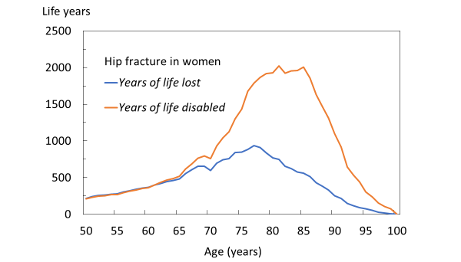
Fig. 14 Total DALYs by age for hip fractures in women

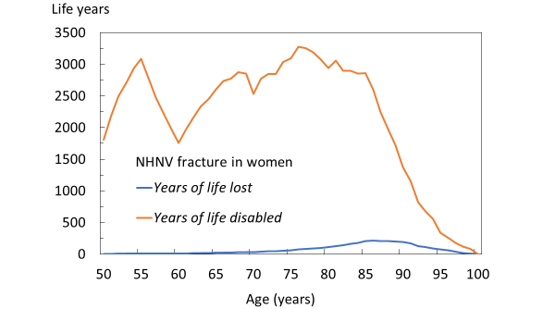
Fig. 15 Total DALYs by age for non-hip, non-vertebral (NHNV) fractures in women

The total DALY for each country varied greatly due to differences in population demography and
fracture risk (Fig. 16). The average DALY loss per 1,000 individuals was estimated to be 21 DALYs,
with Sweden showing the highest rate (32 DALYs) and Spain showing the lowest (12 DALYs).
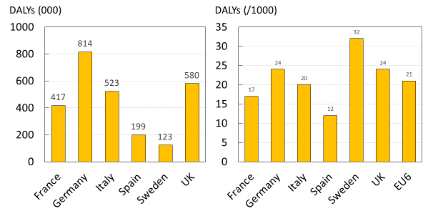
Fig. 16 Total DALYs by country (left panel) and DALYs per 1000 individuals by country (right panel)

The DALYs related to fragility fractures can be compared to corresponding estimates for other diseases. In Fig. 17, fragility fracture related DALYs are compared to 16 other common non-communicable diseases in the EU6 [44]. Among these, fragility fractures are placed as the fourth most burdensome, outranked only by ischemic heart disease, dementia and lung cancer.
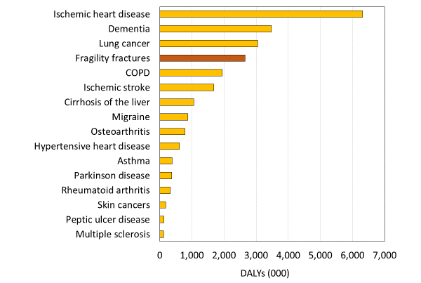
Fig. 17 DALYs by disease in EU6 in 17 selected non-communicable diseases

The DALY burden by disease category varied between countries due to differences in age distribution, risk of fracture and death. The DALY burden also varied by disease category. In Sweden, for example, the DALY burden of fractures was higher than that for dementia whereas in Spain the burden related to dementia, lung cancer and COPD surpassed that for fractures. For more details, see the appendix (9: Disability-Adjusted Life-Years and 11: DALY comparison across diseases). The metrics also provide details of the DALY distribution by fracture site.

From a national perspective, the DALY loss rate can be an important measure for motivating policy decisions and the prioritization of funds towards osteoporosis treatment. From an international perspective, the high values suggest a need for better treatment policy and practice.

Loss of productivity

Most fragility fractures occur in older retired patients. If, however, individuals sustain a fracture while still employed they will likely need to take time off from work to recover from the fragility fracture. In Sweden, for example, about 20% of fractures occur at pre-retirement age [11]. Work absence both impacts the individual’s income and creates a societal cost due to the loss of productivity.

To measure this loss of productivity, data collected in the International Costs and Utilities Related to Osteoporotic Fractures Study (ICUROS) [41, 45, 46] were used to estimate the number of sick days taken by non-retired individuals from the ages of 50 to 65 years in the year following an osteoporotic fracture. Since Germany was not included in the 11 countries that made up the ICUROS study, a combination of the other 5 countries as well as Austria and Estonia, termed ICUROS Europe, was used as a substitute measure for the EU6. Average sick days were combined with fracture projection data to estimate the total sick days taken due to fragility fractures in 2017, by non-retired individuals. Because there are no appropriate data on the proportion of the population that work beyond the age of 65 years, a retirement age was set at 65 years for all countries in the calculations. For more details, see appendix (11: Productivity loss).

Hip fractures resulted in the highest number of sick days taken in the first year after fracture (42 days), followed by vertebral fractures (20 days) and other MOFs (12 days). Sick days taken in 2017, by non-retired individuals in the EU6 totalled 7,615,719 days. The other MOFs (distal forearm and proximal humerus fracture) arose more often than hip or clinical vertebral fractures, and therefore resulted in the highest number of sick days.

When sick days taken due to fragility fracture were expressed per 1,000 people age 50 to 65 years in all countries, Sweden had the highest estimate of the EU6 countries (Fig. 18). There were no significant differences between sick leave taken by men and women with hip fractures, nor between sick leave taken by hip fracture patients with or without previous fracture.
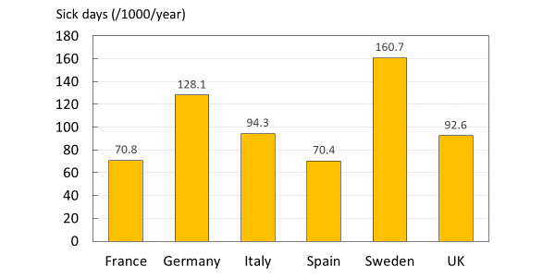

Fig. 18 Average sick days taken after fragility fracture per 1000 individuals age 50-65 years, by country

Caregiver burden

Another significant burden associated with fragility fractures and other diseases is the burden imposed on informal caregivers such as family members. Continued care provided at home can put physical, emotional and financial strain on relatives who need to take care of osteoporotic fracture patients [15, 47]. To measure the average burden placed on informal caregivers per year, survey responses from the ICUROS [41, 45, 46] were also used to determine the caregiver burden due to osteoporotic fracture. It was measured in terms of hours of care per year provided by relatives of fracture cases in ICUROS Europe (a substitute measure for the EU6), as well as selected countries. For methods and estimates by fracture type, see the appendix (12: Caregiver burden).

Hip fractures were associated with the largest caregiver burden (370 hours per year), followed by vertebral fractures (263 hours per year) and other MOFs (130 hours per year). Hours of care provided by relatives varied greatly by country. In countries where cross-generational support is more established, the impact of fragility fractures on caregivers is generally higher [48]. Accordingly, Spain and Italy had the highest caregiver burden, with averages of 756 hours and 882 hours a year, per 1,000 individuals, spent caring for patients with osteoporotic hip fractures, respectively. France (138 hours) and Sweden (191 hours) had considerably lower averages (Fig. 19). There were no significant differences in care from relatives between men and women, nor between patients with or without a previous fracture.
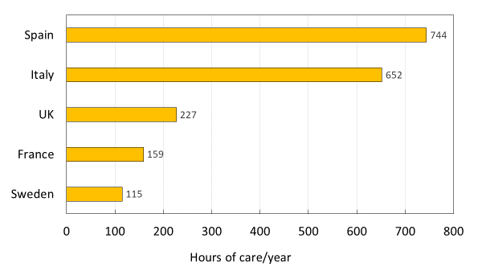

Fig. 19 Average annual hours of care by relatives after hip fracture by country.

Independent living
One major burden caused by fragility fractures is the long-term impact on independence. The fracture can result in a loss of mobility, the ability to take care of oneself, and may require the individual to move into long-term care (LTC) or care services [49]. The ICUROS provided survey responses for the percentage of individuals who needed to move into LTC as a direct result of an osteoporotic fracture. For methods, see the appendix (13: Independent living).

LTC use varied greatly, depending on the fragility fracture and the age of the individual. Hip fractures result in the largest proportion of people moving to LTC in ICUROS Europe (Fig. 20).
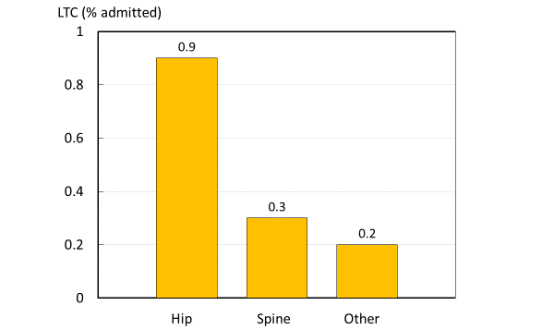

Fig. 20 Percentage of patients admitted to long term care (LTC) within 12 months after a fracture by fracture site (ICUROS Europe). Other refers to other fragility fractures

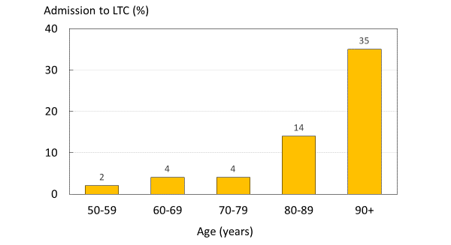
The percentage of patients moving into LTC following a hip fracture increased significantly with age, from 2.1% at ages 50-60 years to 35.3% at ages 90-100 years (Fig. 21).
Fig. 21 Percentage in long term care (LTC) at one year after hip fracture, by age group

Fracture prevention
Pharmacological treatment gap

The treatment gap (i.e. the number of women that are treated compared to the proportion of the population that could be considered eligible for treatment) in osteoporosis has been estimated for the European Union using international sales data on volume (standard units) and price (€) from IMS Health for year 2010 [15, 50]. Applying the same methodology, an update of the treatment gap was conducted using IMS sales data for year 2017. The analysis included data on sales related to all osteoporosis drugs (bisphosphonates, denosumab, parathyroid hormone and peptides, selective estrogen receptor modulators (SERMs) and strontium ranelate). Menopausal hormone treatment (MHT) was not included.

The treatment gap was estimated from the difference between the number of patients treated with an osteoporosis drug using IMS sales data and the number of patients in the population considered to be eligible for an osteoporosis treatment. Further details are given in the appendix (14: Pharmacological treatment gap). In line with European guidelines [51], patients eligible for treatment have a country- and age-specific MOF fracture probability equivalent to a woman with a prior fragility fracture based on the FRAX algorithm. The calculation of the treatment gap assumes that all treatments are given to patients above the intervention threshold. The approach does not take account of differences in treatment guidelines between countries.

The average treatment gap (percent eligible patients not treated) in EU6 in year 2017 was 73% for women and 63% for men (Fig. 22). The higher gap in women was the case in all countries with the exception of Germany which had the highest treatment gap. Only 20% of eligible men and 22% of women in Germany would receive a pharmacologic intervention. The treatment gap varied between countries. The highest treatment gap for women was in Germany, whereas the UK had the smallest treatment gap (64%) in women and in men (43%).
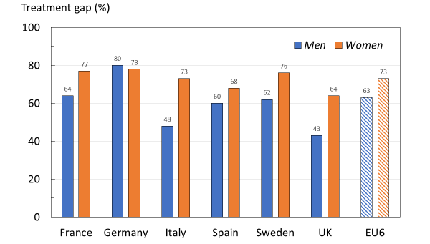
Fig. 22 Treatment gap in men and women by country in 2017

Changes in the treatment gap between 2010 and 2017 are shown for men (Fig. 23) and women (Fig. 24). Compared to the analysis from year 2010 there was a marked increase in the treatment gap for the EU6 (17% and 16% points for women and men, respectively). This increase was mainly driven by large changes in France and Spain. The adverse changes in treatment gap were most marked in France (38 percentage points increase in men and 34 percentage points in women), and Spain (by 40 and 43 percentage points increase in men and women, respectively). The treatment gap increased to a lesser extent in Italy and was relatively stable in Germany, Sweden and the UK.
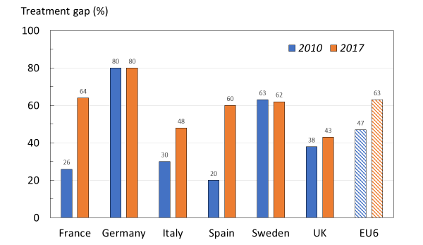
Fig. 23 The treatment gap (percent eligible patients not treated) in men from the EU6 in 2010 and 2017

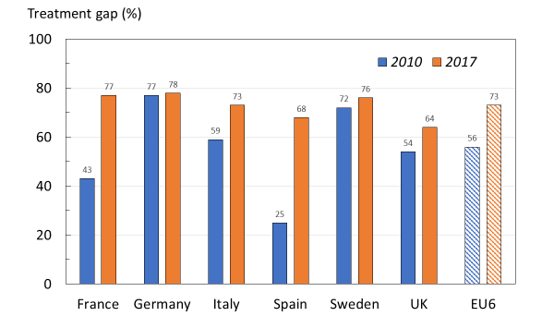
Fig. 24 The treatment gap (percent eligible patients not treated) in women from the EU6 in 2010 and 2017

Post fracture treatment gap

An alternative approach for assessing the treatment gap is to estimate the proportion of patients starting a pharmacological treatment after a fracture. Available estimates were gathered from a mix of literature, public reports (France [52] and the UK [53]), data on file at UCB (Spain) and data on file at Quantify Research (Sweden). The percentage of women who did not receive osteoporosis-specific pharmacological treatment within a year of an osteoporotic fracture is shown in Fig. 25. The analytic methods vary between the estimates making direct comparisons difficult. However, the post-fracture treatment gap can be considered large irrespective of country. With the exception of the UK, no more than 30% of women receive a treatment following a fracture. In the UK, the treatment gap was markedly lower after hip fracture (49%). For more details, see the appendix (15: Fracture treatment gap).
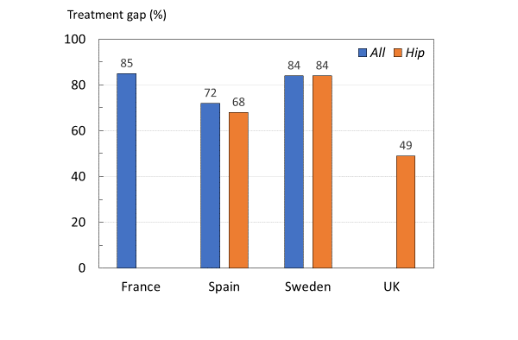
Fig. 25 Percentage (%) of women (50 years and above) not treated within a year of an osteoporotic fracture or a hip fracture.

A more detailed analysis, using the Swedish National Patient Register (NPR) and the Swedish National Prescription Register, was conducted to explore differences in the treatment gap for different sub-populations. Patients were defined as treatment-naïve if they had not collected any prescriptions for anti-osteoporotic medications during the three years prior to the fracture.

At the time of fracture, most women (89%) and men (97%) were treatment naïve. Fig. 26 shows the pattern of treatment following a fracture by treatment exposure in women. Within the year following a hip fracture, a MOF or any fragility fracture, only 11% to 12% of treatment naïve women started treatment for osteoporosis. Following a vertebral fracture, 26% of treatment naïve women started treatment. A similar pattern was observed in the male population although treatment gaps were in general higher (Fig. 27). About 5% of treatment naïve men were treated following a hip fracture, or a MOF. Following a vertebral fracture, 11% of treatment naïve men started treatment.
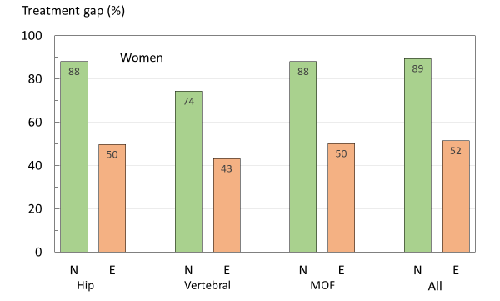
Fig. 26 Percentage of women untreated within one year of fracture by site of fracture and prior exposure to osteoporosis treatment in Sweden. N, treatment naïve; E, prior exposure.
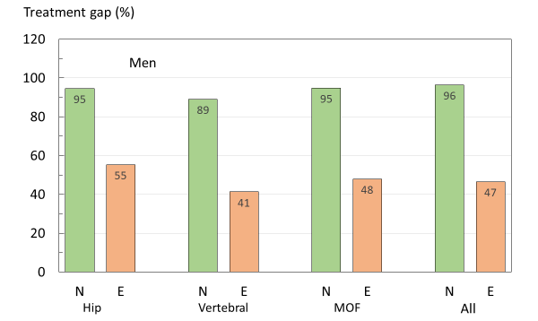
Fig. 27 Percentage of men untreated within one year of fracture by site of fracture and prior exposure to osteoporosis treatment in Sweden. N, treatment naïve; E, prior exposure.

In men and women who had previously been exposed to therapies for osteoporosis, the treatment gap was substantially lower than in treatment naïve patients. These finding illustrate important issues in that a new treatment is rarely offered to (or taken up by) patients after fracture and, even in patients previously exposed to osteoporosis treatment, only about half receive a treatment within the next year.

A limitation of this analysis is that the Swedish National Patient Register (SNPR) does not cover drugs dispensed at the hospital (mainly intravenous and subcutaneous administered medications), which are estimated to comprise 4% of medicines sold [54]. This likely leads to a slight overestimation of the treatment gap. For more details, see the appendix (16: Treatment gap by fracture type).

Fracture risk assessment

Although osteoporosis is defined in terms of BMD, there are several other factors that are associated with an increased risk of fracture that are not captured by BMD. This has led to the development of risk models, which incorporate several risk factors to improve the identification of patients at high risk [55].

There are several existing models for risk assessment in Europe, however the most widely used is FRAX [56]. FRAX, released in 2008, is a computer-based algorithm that calculates the probability of fracture in individuals using age, body mass index, BMD (optionally) and risk factors such as whether the patient had a prior fragility fracture, their parental history of hip fracture, whether they smoke, drink, have rheumatoid arthritis and other factors that increase the risk for osteoporosis [57]. FRAX models are currently available for 68 countries and are publicly available on the official FRAX website [58]. There are also several other fracture risk assessment models available.

Table 8 provides a summary of the access to FRAX and other risk assessment models in the EU6. Country-specific FRAX models exist in all 6 countries. Alternative assessment models are also recommended for use in Germany, Italy and the UK. The German DVO model, developed in 2006, is a Germany-specific risk assessment model which requires the use of BMD measurements [59, 60]. DeFra is an Italy-specific extension of the FRAX model, which allows for comparison of the BMD in different fracture sites and the inclusion of more variables [61]. QFracture® in the UK was developed in 2009, and uses variables that are available through healthcare records in the UK; it does not include BMD [62]. For more details, see the appendix (18: Fracture risk assessment)

Table 8. Risk models and guidelines available in the countries of interest
Countries | FRAX Model available | Other Models | National Guidance | Comments | Source
France | Yes | - | Yes |  | [63]
Germany | Yes | DVO Model | Yes |  | [59]
Italy | Yes | FRAHS, DeFra | Yes | FRAHS: FRAX-based | [64-66]
Spain | Yes | - | Yes |  | [67]
Sweden | Yes | - | Yes |  | [68]
UK | Yes | QFracture | Yes |  | [69]

Specific guidelines for the use of FRAX and other risk models are noted on official national health service websites for all countries except for Italy. The Italian Ministry of health does not recommend specific risk models but suggests that risk models may be useful in assessing the probability of fragility fracture. Other organizations like the Italian Society for Orthopaedics and Traumatology recommended FRAX or DeFra.

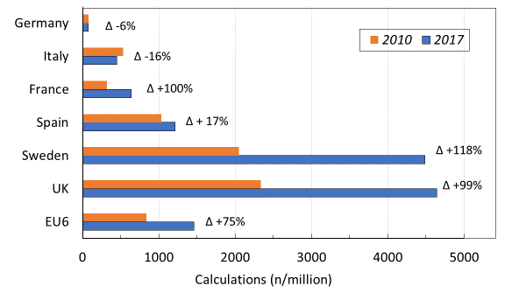
The uptake of FRAX in 2010 and 2017 is shown in Fig. 28 as the number of calculations/million persons in the general population. The UK and Sweden had the highest usage of FRAX, whereas the lowest uptakes were seen in Germany and Italy. Considering all countries in the EU6, the usage use of FRAX increased by almost 74% in 2017 compared to 2010. The highest increase was seen in the UK, France and Sweden (~100%), whereas in both Germany and Italy the usage of FRAX decreased was reduced in 2017 compared to 2010. In both Germany and Italy, the usage of FRAX decreased in 2017 compared to 2011. The decrease in the use of FRAX in both Italy and Germany may relate to the availability of other risk models such as the German specific DVO model and DeFra in Italy. For more details, see the appendix (18: Use of FRAX).
Fig. 28 FRAX calculations by URL source per million in the general population November 2010-2011 and April 2017-2018

Fracture liaison services

A Fracture Liaison Service (FLS) is a multi-disciplinary health care delivery model for secondary fracture prevention. FLS aims to systemically identify, treat and refer all eligible patients within a local population who have suffered a fragility fracture with the aim of reducing their risk of subsequent fractures. The FLS concept was first introduced in teaching hospitals in Scotland and has grown in popularity around the world due to its effectiveness in preventing secondary fractures [70]. A growing body of published evidence suggests that FLSs are a cost-effective care delivery model that has the potential to reduce the risk of re-fracture, increase the number of high-risk patients being treated and improve adherence to treatment. [71-77].

A recently published systematic literature review and meta-analysis based on 159 scientific publications studied several important outcomes of fracture liaison services [78]. Albeit, with a variety of study designs used, all the studies attempted to estimate the impact of a FLS compared to the absence of such a program. The meta-analysis indicated that FLS improved the rate of fractured patients getting BMD tests, starting treatment and adhering to treatment by about 20% (Table 9). The results also showed a significant reduction in the re-fracture rates.

Table 9. Meta-analysis results for outcomes of FLS [78]
Outcome measure | Effect of FLS (absolute change) | 95% CI | Duration of follow-up (months) | Number of studies
BMD Testing | +24% | (0.18 to 0.29) | 3-26 | 37
Treatment initiation | +20% | (0.16 to 0.25) | 3-72 | 46
Adherence | +22% | (0.13 to 0.31) | 3-48 | 9
Re-fracture | -5% | (-0.08 to -0.03) | 6-72 | 11

Even though the meta-analysis showed an overall positive impact of FLSs it did not consider that there are different types of FLS models which is likely to be associated with different outcomes. For example, some FLS only identify patients and inform them without taking any further actions whereas other more complete FLS identify, investigate, treat and monitor the patient. In another recent study, the evidence of different FLS model types (A to D) on fracture risk, DXA referrals, and other patient outcomes were reviewed [77]. The most complete FLS model (type A) was associated with reduction in re-fracture risk (hazard ratio [HR] 0.18–0.67 over 2–4 years), increased assessment of BMD (relative risk [RR] 2–3), increased treatment initiation (RR 1.5–4.25) and adherence to treatment (65%–88% at 1 year).

Along with the literature focusing on the impact of FLSs, several studies have analysed the cost-effectiveness and cost savings of providing FLSs. Estimates in Sweden and the UK for the economic impact of FLSs are shown in Table 10. For more details, see the appendix (19: Fracture liaison service impact).

Table 10. Country-specific studies on the economic impact of FLS
Country | Type | Estimate | Source
Sweden | ICER (cost-eff) | € 14 029 (per QALY gained) | [79]
UK (Hip patients) | ICER (cost-eff) | €22 700-€26 600 (per QALY gained) | [80]
UK | Cost Savings | €23 800/lifetime/1,000 patients | [74]

The large variation between different types of FLS and their evaluation complicates the assessment of the overall benefits of FLS and merits of a specific FLS model. Initiatives that promote standardised outcome frameworks for assessing FLS and increased collaboration between providers include the Capture the Fracture® and the UK FLS-Database Audit [81, 82].

Capture the Fracture®

One effort to encourage cooperation between FLS providers is Capture the Fracture® (CtF), a global initiative of IOF to “facilitate the implementation of coordinated, multi-disciplinary models of care for secondary fracture prevention” [73]. CtF has created a set of internationally endorsed standards and guides for best practice and has assembled the largest network of individual FLS providers in the world. CtF provides resources, tools and educational programmes to bridge the gap between FLS providers and helps in the creation of new FLS.

This growing network of FLS providers is mapped on their website (https://www.capturethefracture.org/map-of-best-practice-page)spain and provides a rating of the existing service providers in a given area. To be included in the CtF network, the provider must undergo a standardised external audit to determine the quality of their services. Table 11 shows the star ratings for registered FLS providers in the countries of interest. A value of 4, 3 and 2 was applied to gold, silver and bronze, respectively and a 1 to providers currently under review. Spain and the UK lead in terms of the number of registered FLS, whereas Spain, the UK and Sweden score highly in the average score/FLS.

Table 11. Number of Capture the Fracture FLS Ratings by country and scores [73]
Country | Total | Gold | Silver | Bronze | Other | Score | Score/FLS
France | 20 | 0 | 3 | 9 | 8 | 35 | 1.75
Germany | 2 | 0 | 1 | 0 | 1 | 4 | 2.0
Italy | 13 | 1 | 3 | 2 | 7 | 24 | 1.8
Spain | 65 | 13 | 13 | 22 | 17 | 152 | 2.3
Sweden | 5 | 0 | 4 | 1 | 0 | 14 | 2.8
UK | 25 | 6 | 11 | 1 | 7 | 66 | 2.6
EU6 | 130 | 20 | 35 | 35 | 40 | 285 | 2.2

There is currently no publicly available information on how many fragility fractures are referred to an FLS within the EU6 countries. A survey sent to a selected number of FLSs in the EU6, enrolled in IOF’s Capture the Fracture network, asked for the percentage of hospitals and general practitioners (GPs), on a national level, that have a system to refer fractured patients. The responses varied between an average of 2.8% in Italy, to 37.5% in Sweden for hospital referrals and 1-10% for GP referrals. In the UK, the National Osteoporosis Society has estimated that 55% of the UK population has access to a FLS. For more details, see the appendix (20: Capture the Fracture).

Closing the FLS gap

Given the available evidence showing the potential benefits of FLSs and the sub optimal coverage of such models in the EU6, it is as relevant to highlight the FLS treatment gap. When applying the information on fracture epidemiology, costs, current FLS coverage previously described in this report and evidence of FLS outcomes based on Wu et al [78] it is possible to assess the potential impact a complete coverage of FLS could have on the burden of fragility fractures.

It is estimated that, 19 262 number of subsequent fragility fractures could be avoided every year by extending the access to FLS for all citizens above 50 years of age in EU6. The reduction in the annual fracture related cost associated with these fractures are €285.4 million. Adding the additional cost related to increased FLS resources and drug administration the net impact is an increased cost of €39.7 million but at a gain of 8,858 quality adjusted life years (Table 12). The cost per QALY gained of an FLS extension would be €3,108, an estimate that can be considered cost-effective in all countries and probably underestimated because of conservative assumptions on the costs related to other osteoporotic fractures. The variation between countries is mainly driven by differences in fracture risk and cost of osteoporosis drugs.

Table 12. Potential reduced burden by closing the FLS gap
Country | Fractures avoided (per year) | Fractures avoided per 1,000 FLS patients | Reduction in annual fracture related cost (million €) | Net impact on annual burden (million €) | Net impact per patient (€) | Reduction in annual burden (QALYs)
France | 2 665 | 10.0 | -38.0 | 20.0 | 75.0 | 1 036
Germany | 5 423 | 13.9 | -75.4 | 8.2 | 21.0 | 2 335
Italy | 2 868 | 7.2 | -55.7 | -4.8 | -12.0 | 1 602
Spain | 1 249 | 5.4 | -18.4 | 20.0 | 86.0 | 584
Sweden | 1 371 | 22.7 | -22.4 | -2.3 | -38.0 | 596
UK | 5 686 | 16.2 | -75.5 | -1.4 | -4.0 | 2 705
EU6 | 19 262 | 11.3 | -285.4 | 39.7 | 16.2 | 8 858

Acknowledgements

The report was made possible by financial support from UCB to the International Osteoporosis Foundation. We are grateful to the consultation panel, listed below, for their review of the country-specific metrics
Consultation Panel
France
Bernard Cortet University Hospital Lille, France
Thierry Thomas Rheumatology Department, University Hospital St. Etienne, France
Laurent Grange Department of Rheumatology, University Hospital Grenoble, France
Germany
Claus Glüer Department of Radiology and Neuroradiology, University Medical Center Schleswig-Holstein, Kiel University, Germany
Andreas Kurth Department of Traumatology, Orthopedics and Hand Surgery, Community Hospital Mittelrhein gGmbH, Germany
Peyman Hadji Department of Bone Oncology, Endocrinology and Reproductive Medicine, Krankenhaus Nordwest, Germany
Thorsten Freikamp Federal Self-help Association for Osteoporosis (BfO), Germany
Italy
Maria Luisa Brandi Department of Endocrinology and Metabolic Diseases and Director of the Operative Unit of Diseases of Mineral and Bone Metabolism, Medical School, University of Florence, Italy
Stefano Gonnelli Department of Internal Medicine and Director of the School of Specialization in Emergency Medicine and Urgency, University of Siena, Italy
Giuseppe Sessa Department of Orthopedics and Traumatology and Orthopedic Clinic of the Vittorio Emanuele Polyclinic, University of Catania, Italy
Spain
Josep Blanch Rubio Department of the Institut Blanch de Reumatologia, Spain
Adolfo Diez-Perez Department of Internal Medicine at the Hospital del Mar, Autonomous University of Barcelona, Spain
Maria A Robles Palacios Asociación Española con la Osteoporosis y la Artrosis, Spain
Santiago Palacios Instituto Palacios, Salud y Medicina de la Mujer, Spain
Sweden
Mattias Lorentzon Department of Geriatric Medicine, Institute of Medicine, University of Gothenburg, and Osteoporosis Clinic at the Sahlgrenska University Hospital, Sweden
Lisa Keisu Lennerlöf Osteoporosforbundet, Swedish Osteoporosis Association, Sweden
UK
Cyrus Cooper MRC Lifecourse Epidemiology Unit, University of Southampton, UK and Professor of Musculoskeletal Science at the NIHR Musculoskeletal Biomedical Research Unit, University of Oxford, UK
Fizz Thompson National Osteoporosis Society, UK
Celia L Gregson Musculoskeletal Research Unit, Bristol Medical School, University of Bristol, UK
International Osteoporosis Foundation

Cyrus Cooper President

Jean-Yves Reginster Chairman Committee of National Societies

Serge Ferrari Chairman Committee of Scientific Advisors

Philippe Halbout Chief Executive Officer

Compliance with ethical standards

Competing interests
F Borgström is employed and is a shareholder in Quantify Research. A health economic research consultancy that received a grant from IOF to conduct the analysis.
L Karlsson, G Ortsäter and N Norton are employed by Quantify Research. A health economic research consultancy that received a grant from IOF to conduct the analysis.
P Halbout has no competing interests to declare.
C Cooper reports personal fees from Alliance for Better Bone Health, Amgen, Eli Lilly, GSK, Medtronic, Merck, Novartis, Pfizer, Roche, Servier, Takeda and UCB.
EV McCloskey has received consultancy/lecture fees/grant funding/honoraria from ActiveSignal, AgNovos, Amgen, AstraZeneca, Consilient Healthcare, Gilead, GSK, Hologic, Internis, Lilly, Medtronic, Merck, Novartis, Pfizer, Radius Health, Redx Oncology, Roche, SanofiAventis, Servier, Synexus, Tethys, UCB, Viiv, Warner Chilcott, I3 Innovus and Unilever
NC Harvey has received consultancy/lecture fees/honoraria/grant funding from Alliance for Better Bone Health, Amgen, MSD, Eli Lilly, Servier, Shire, UCB, Consilient Healthcare, Radius Health, Kyowa Kirin and Internis Pharma.
MK Javaid has received honoraria, unrestricted research grants, travel and/or subsistence expenses from Amgen, Lilly UK, Internis, Consilient Health, Zebra Medical Vision, Kyowa Kirin Hakin, UCB.
JA Kanis reports grants from Amgen, Eli Lilly and Radius Health; consulting fees from Theramex. JAK is the architect of FRAX® but has no financial interest.
M Lorentzon has received lecture fees from Amgen, Lilly, Meda, Renapharma, UCB Pharma, and consulting fees from Amgen, Radius Health, UCB Pharma, Renapharma and Consilient Health, all outside the presented work

Metrics

The accompanying appendix contains the individual metrics which served as the background research and evidence for the above report. The metrics include details about the estimation and reporting methods as well as additional research and source material.

References

1. International Osteoporosis Foundation (2018) Broken bones, broken lives: A roadmap to solve the fragility fracture crisis in Europe. International Osteoporosis Foundation, Nyon, Switzerland. https://www.iofbonehealth.org/broken-bones-broken-lives Accessed 09/12/2019
2. International Osteoporosis Foundation (2018) Os brisés, vies brisées: une feuille de route pour résoudre la crise des fractures de fragilité en France. International Osteoporosis Foundation, Nyon, Switzerland. https://www.iofbonehealth.org/broken-bones-broken-lives Accessed 09/12/2019
3. International Osteoporosis Foundation (2018) Ruinierte knochen, ruiniertes leben: Ein strategischer Plan zur Lösung der Fragilitätsfrakturkrise in Deutschland. International Osteoporosis Foundation, Nyon, Switzerland. https://www.iofbonehealth.org/broken-bones-broken-lives Accessed 09/12/2019
4. International Osteoporosis Foundation (2018) Ossa spezzate, vite spezzate: un piano d’azione per superare l’emergenza delle fratture da fragilità in Italia. International Osteoporosis Foundation, Nyon, Switzerland. https://www.iofbonehealth.org/broken-bones-broken-lives Accessed 09/12/2019
5. International Osteoporosis Foundation (2018) Huesos rotos, vidas rotas: guía para mejorar la atención a las fracturas por fragilidad en España. International Osteoporosis Foundation, Nyon, Switzerland. https://www.iofbonehealth.org/broken-bones-broken-lives Accessed 09/12/2019
6. International Osteoporosis Foundation (2018) Brutna ben, trasiga liv: En åtgärdsplan för att lösa krisen med benskörhetsfrakturer i Sverige. https://www.iofbonehealth.org/broken-bones-broken-lives Accessed 09/12/2019
7. International Osteoporosis Foundation (2018) Broken bones, broken lives: A roadmap to solve the fragility fracture crisis in the United Kingdom. International Osteoporosis Foundation, Nyon, Switzerland https://www.iofbonehealth.org/broken-bones-broken-lives Accessed 09/12/2019
8. International Osteoporosis Foundation (2018) What is Osteoporosis? https://www.iofbonehealth.org/what-is-osteoporosis Accessed 05/03/2018
9. Kanis JA, McCloskey EV, Johansson H, Oden A, Melton LJ, 3rd, Khaltaev N (2008) A reference standard for the description of osteoporosis. Bone 42:467-475
10. Kanis JA, Melton LJ, 3rd, Christiansen C, Johnston CC, Khaltaev N (1994) The diagnosis of osteoporosis. J Bone Miner Res 9:1137-1141
11. Kanis J, Johnell O, Oden A, Sernbo I, Redlund-Johnell I, Dawson A, De Laet C, Jonsson B (2000) Long-term risk of osteoporotic fracture in Malmö. Osteoporosis international 11:669-674
12. Kanis JA, Oden A, Johnell O, Jonsson B, de Laet C, Dawson A (2001) The burden of osteoporotic fractures: a method for setting intervention thresholds. Osteoporos Int 12:417-427
13. Warriner AH, Patkar NM, Curtis JR, Delzell E, Gary L, Kilgore M, Saag K (2011) Which fractures are most attributable to osteoporosis? J Clin Epidemiol 64:46-53
14. Johnell O, Kanis JA (2006) An estimate of the worldwide prevalence and disability associated with osteoporotic fractures. Osteoporos Int 17:1726-1733
15. Hernlund E, Svedbom A, Ivergård M, Compston J, Cooper C, Stenmark J, McCloskey EV, Jönsson B, Kanis JA (2013) Osteoporosis in the European Union: medical management, epidemiology and economic burden. Archives of osteoporosis 8:136
16. Kanis JA (2007) Assessment of Osteoporosis at the Primary health Care Level. In WHO Scientific Group (ed) WHO Scientific group Technical Report. World Health Organization, p 103
17. Cooper C, Campion G, Melton LJ, 3rd (1992) Hip fractures in the elderly: a world-wide projection. Osteoporos Int 2:285-289
18. Wolf-Maier K, Cooper RS, Banegas JR, Giampaoli S, Hense HW, Joffres M, Kastarinen M, Poulter N, Primatesta P, Rodriguez-Artalejo F, Stegmayr B, Thamm M, Tuomilehto J, Vanuzzo D, Vescio F (2003) Hypertension prevalence and blood pressure levels in 6 European countries, Canada, and the United States. Jama 289:2363-2369
19. Hippisley-Cox J, Coupland C, Robson J, Brindle P (2010) Derivation, validation, and evaluation of a new QRISK model to estimate lifetime risk of cardiovascular disease: cohort study using QResearch database. Bmj 341:c6624
20. Kanis JA, Oden A, McCloskey EV, Johansson H, Wahl DA, Cooper C (2012) A systematic review of hip fracture incidence and probability of fracture worldwide. Osteoporos Int 23:2239-2256
21. Pisani P, Renna MD, Conversano F, Casciaro E, Di Paola M, Quarta E, Muratore M, Casciaro S (2016) Major osteoporotic fragility fractures: Risk factor updates and societal impact. World J Orthop 7:171-181
22. Jakobsen A, Laurberg P, Vestergaard P, Andersen S (2013) Clinical risk factors for osteoporosis are common among elderly people in Nuuk, Greenland. Int J Circumpolar Health 72:19596
23. Johansson H, Siggeirsdottir K, Harvey NC, Oden A, Gudnason V, McCloskey E, Sigurdsson G, Kanis JA (2017) Imminent risk of fracture after fracture. Osteoporos Int 28:775-780
24. Kanis JA, Johansson H, Oden A, Harvey NC, Gudnason V, Sanders KM, Sigurdsson G, Siggeirsdottir K, Fitzpatrick LA, Borgstrom F, McCloskey EV (2018) Characteristics of recurrent fractures. Osteoporos Int 29:1747-1757
25. Bonafede M, Shi N, Barron R, Li X, Crittenden DB, Chandler D (2016) Predicting imminent risk for fracture in patients aged 50 or older with osteoporosis using US claims data. Arch Osteoporos 11:26
26. Giangregorio LM, Leslie WD (2010) Time since prior fracture is a risk modifier for 10-year osteoporotic fractures. J Bone Miner Res 25:1400-1405
27. Johnell O, Kanis JA, Oden A, Sernbo I, Redlund-Johnell I, Petterson C, De Laet C, Jonsson B (2004) Fracture risk following an osteoporotic fracture. Osteoporos Int 15:175-179
28. Johnell O, Oden A, Caulin F, Kanis JA (2001) Acute and long-term increase in fracture risk after hospitalization for vertebral fracture. Osteoporos Int 12:207-214
29. Nymark T, Lauritsen JM, Ovesen O, Rock ND, Jeune B (2006) Short time-frame from first to second hip fracture in the Funen County Hip Fracture Study. Osteoporos Int 17:1353-1357
30. Roux C, Briot K (2017) Imminent fracture risk. Osteoporos Int 28:1765-1769
31. van Geel TA, van Helden S, Geusens PP, Winkens B, Dinant GJ (2009) Clinical subsequent fractures cluster in time after first fractures. Ann Rheum Dis 68:99-102
32. Kanis JA, Harvey NC, McCloskey E, Bruyère O, Veronese N, Lorentzon M, Cooper C, Rizzoli R, Adib G, Al-Daghri N, Campusano C, Chandran M, Dawson-Hughes B, Javaid K, Jiwa F, Johansson H, Lee JK, Liu E, Messina D, Mkinsi O, Pinto D, Prieto-Alhambra D, Saag K, Xia W, Zakraoui L, Reginster J-Y (2019) Algorithm for the management of patients at low/middle/high risk of osteoporotic fracture: a global perspective. Osteoporos Int 31: 1-12
33. Nordström P, Gustafson Y, Michaëlsson K, Nordström A (2015) Length of hospital stay after hip fracture and short term risk of death after discharge: a total cohort study in Sweden. Bmj 350:h696
34. Maravic M, Jouaneton B, Vainchtock A, Tochon V (2012) Economic burden of osteoporosis in women: data from the 2008 French hospital database (PMSI). Clin Exp Rheumatol 30:222-227
35. Bassgen K, Westphal T, Haar P, Kundt G, Mittlmeier T, Schober HC (2013) Population-based prospective study on the incidence of osteoporosis-associated fractures in a German population of 200,413 inhabitants. J Public Health (Oxf) 35:255-261
36. Carnevale V, Nieddu L, Romagnoli E, Bona E, Piemonte S, Scillitani A, Minisola S (2006) Osteoporosis intervention in ambulatory patients with previous hip fracture: a multicentric, nationwide Italian survey. Osteoporos Int 17:478-483
37. Caeiro JR, Bartra A, Mesa-Ramos M, Etxebarria I, Montejo J, Carpintero P, Sorio F, Gatell S, Farre A, Canals L (2017) Burden of First Osteoporotic Hip Fracture in Spain: A Prospective, 12-Month, Observational Study. Calcif Tissue Int 100:29-39
38. National Hip Fracture Database annual report (2017) Falls and Fragility Fracture Audit Programme Royal College of Physicians, London
39. Svedbom A, Hernlund E, Ivergard M, Compston J, Cooper C, Stenmark J, McCloskey EV, Jonsson B, Kanis JA (2013) Osteoporosis in the European Union: a compendium of country-specific reports. Arch Osteoporos 8:137
40. Johnell O, Kanis, J.A., Odén, A. Sernbo I, Redlund-Johnell I, Pettersen C, De Laet C, Jonsson B (2004) Mortality after osteoporotic fractures. Ostoporos Int 15: 38-42
41. Svedbom A, Borgstom F, Hernlund E, Strom O, Alekna V, Bianchi ML, Clark P, Curiel MD, Dimai HP, Jurisson M, Kallikorm R, Lember M, Lesnyak O, McCloskey E, Sanders KM, Silverman S, Solodovnikov A, Tamulaitiene M, Thomas T, Toroptsova N, Uuskula A, Tosteson ANA, Jonsson B, Kanis JA (2018) Quality of life for up to 18 months after low-energy hip, vertebral, and distal forearm fractures-results from the ICUROS. Osteoporos Int 29:557-566
42. Szende A, Janssen B, Cabases J (2014) Self-reported population health: an international perspective based on EQ-5D. Dordrecht (NL): Springer
43. World Health Organization (2018) Metrics: Disability-Adjusted Life Year (DALY). http://www.who.int/healthinfo/global_burden_disease/metrics_daly/en/ Accessed 12/10/2017
44. Institute for Health Metrics and Evaluation (IHME) (2016) GBD Compare Data Visualization. https://vizhub.healthdata.org/gbd-compare/
45. Borgstrom F, Lekander I, Ivergard M, Strom O, Svedbom A, Alekna V, Bianchi ML, Clark P, Curiel MD, Dimai HP, Jurisson M, Kallikorm R, Lesnyak O, McCloskey E, Nassonov E, Sanders KM, Silverman S, Tamulaitiene M, Thomas T, Tosteson AN, Jonsson B, Kanis JA (2013) The International Costs and Utilities Related to Osteoporotic Fractures Study (ICUROS)--quality of life during the first 4 months after fracture. Osteoporos Int 24:811-823
46. Svedbom A, Borgstrom F, Hernlund E, Strom O, Alekna V, Bianchi ML, Clark P, Curiel MD, Dimai HP, Jurisson M, Uuskula A, Lember M, Kallikorm R, Lesnyak O, McCloskey E, Ershova O, Sanders KM, Silverman S, Tamulaitiene M, Thomas T, Tosteson ANA, Jonsson B, Kanis JA (2017) Quality of life after hip, vertebral, and distal forearm fragility fractures measured using the EQ-5D-3L, EQ-VAS, and time-trade-off: results from the ICUROS. Qual Life Res 27 :707-716.
47. Kaffashian S, Raina P, Oremus M, Pickard L, Adachi J, Papadimitropoulos E, Papaioannou A (2011) The burden of osteoporotic fractures beyond acute care: the Canadian Multicentre Osteoporosis Study (CaMos). Age Ageing 40:602-607
48. Eurocarers.org (2018) The Situation of Carers in the EU.
49. McKercher HG, Crilly RG, Kloseck M (2000) Osteoporosis management in long-term care. Survey of Ontario physicians. Can Fam Physician 46:2228-2235
50. Strom O, Borgstrom F, Kanis JA, Compston J, Cooper C, McCloskey EV, Jonsson B (2011) Osteoporosis: burden, health care provision and opportunities in the EU: a report prepared in collaboration with the International Osteoporosis Foundation (IOF) and the European Federation of Pharmaceutical Industry Associations (EFPIA). Arch Osteoporos 6:59-155
51. Kanis JA, Cooper C, Rizzoli R, Reginster JY (2019) European guidance for the diagnosis and management of osteoporosis in postmenopausal women. Osteoporos Int 30:3-44
52. l’Assurance Maladie (2016) Améliorer la qualité du système de santé et maîtriser les dépenses. Propositions de l’Assurance Maladie pour 2016, 2016 edn
53. Klop C, Gibson-Smith D, Elders PJ, Welsing PM, Leufkens HG, Harvey NC, Bijlsma JW, van Staa TP, de Vries F (2015) Anti-osteoporosis drug prescribing after hip fracture in the UK: 2000-2010. Osteoporos Int 26:1919-1928
54. Hovstadius B, Astrand B, Petersson G (2009) Dispensed drugs and multiple medications in the Swedish population: an individual-based register study. BMC Clin Pharmacol 9:11
55. Kanis JA, Borgstrom F, Compston J, Dreinhofer K, Nolte E, Jonsson L, Lems WF, McCloskey EV, Rizzoli R, Stenmark J (2013) SCOPE: a scorecard for osteoporosis in Europe. Arch Osteoporos 8:144
56. International Osteoporosis Foundation (2016) Development of the FRAX tool. https://www.iofbonehealth.org/news/development-frax-tool Accessed 05/03/2018
57. Kanis JA, Harvey NC, Cooper C, Johansson H, Oden A, McCloskey EV (2016) A systematic review of intervention thresholds based on FRAX : A report prepared for the National Osteoporosis Guideline Group and the International Osteoporosis Foundation. Arch Osteoporos 11:25
58. University of Sheffield (2008) FRAX Fracture Risk Assessment Tool. https://www.sheffield.ac.uk/FRAX/
59. Deutschsprachigen Wissenschaftlichen Osteologischen (2014) DVO Leitlinie Osteoporose 2014 Kurzfassung und Langfassung http://www.dv-osteologie.org/dvo_leitlinien/osteoporose-leitlinie-2014 Accessed 03/06/2018
60. Rendl S, Lapa C, Blumel C, Bundschuh RA, Schneider P (2013) Decision making for osteoporotic treatment using FRAX or DVO risk algorithms in a clinical setting. J Musculoskelet Neuronal Interact 13:339-345
61. Bonaccorsi G, Fila E, Cervellati C, Romani A, Giganti M, Rossini M, Greco P, Massari L (2015) Assessment of Fracture Risk in A Population of Postmenopausal Italian Women: A Comparison of Two Different Tools. Calcif Tissue Int 97:50-57
62. National Institute for Health and Clinical Excellence (2012) Osteoporosis: Fragility Fracture Risk: Osteoporosis: Assessing the Risk of Fragility Fracture. Royal College of Physicians (UK) National Clinical Guideline Centre., London
63. l'Assurance Maladie (2018) Ostéoporose : diagnostic et évolution. https://www.ameli.fr/loiret/assure/sante/themes/osteoporose/diagnostic-evolution Accessed 03/06/2018
64. Tarantino U, Iolascon G, Cianferotti L, Masi L, Marcucci G, Giusti F, Marini F, Parri S, Feola M, Rao C, Piccirilli E, Zanetti EB, Cittadini N, Alvaro R, Moretti A, Calafiore D, Toro G, Gimigliano F, Resmini G, Brandi ML (2017) Clinical guidelines for the prevention and treatment of osteoporosis: summary statements and recommendations from the Italian Society for Orthopaedics and Traumatology. J Orthop Traumatol 18:3-36
65. Ministero della Salute (Italian Ministry of Health) (2011) 1.12. Prevenzione delle fratture da fragilità. http://www.rssp.salute.gov.it/rssp/paginaParagrafoRssp.jsp?sezione=risposte&capitolo=interventi&id=2745 Accessed 02/27/2018
66. Societa Italiana di Ortopedia e Traumatologia (2017) Le Linee Guida. http://www.siot.it/pagine/soci/linee-guida.html Accessed 03/13/2018
67. Ministerio de Sanidad SSeI, , (Spanish Ministry of Health) (2010) Guía de Práctica Clínica sobre Osteoporosis y Prevención de Fracturas por Fragilidad. http://www.guiasalud.es/GPC/GPC_476_Osteoporosis_AIAQS_compl.pdf Accessed 02/27/2018
68. Socialstyrelsen (The Swedish Welfare Agency) (2018) Nationella riktlinjer för rörelseorganens sjukdomar – stöd för styrning och ledning. http://www.socialstyrelsen.se/publikationer2012/2012-5-1 Accessed 02/27/2017
69. The National Institute for Health and Care Excellence (NICE) (2018) Osteoporosis: assessing the risk of fragility fracture. https://www.nice.org.uk/guidance/cg146/chapter/1-guidance Accessed 02/27/2018
70. Mitchell PJ (2011) Fracture Liaison Services: the UK experience. Osteoporos Int 22 Suppl 3:487-494
71. Eekman DA, van Helden SH, Huisman AM, Verhaar HJ, Bultink IE, Geusens PP, Lips P, Lems WF (2014) Optimizing fracture prevention: the fracture liaison service, an observational study. Osteoporos Int 25:701-709
72. Huntjens KM, van Geel TA, van den Bergh JP, van Helden S, Willems P, Winkens B, Eisman JA, Geusens PP, Brink PR (2014) Fracture liaison service: impact on subsequent nonvertebral fracture incidence and mortality. J Bone Joint Surg Am 96:e29
73. International Osteoporosis Foundation (2018) Capture the Fracture. http://www.capture-the-fracture.org/
74. McLellan AR, Wolowacz SE, Zimovetz EA, Beard SM, Lock S, McCrink L, Adekunle F, Roberts D (2011) Fracture liaison services for the evaluation and management of patients with osteoporotic fracture: a cost-effectiveness evaluation based on data collected over 8 years of service provision. Osteoporos Int 22:2083-2098
75. Nakayama A, Major G, Holliday E, Attia J, Bogduk N (2016) Evidence of effectiveness of a fracture liaison service to reduce the re-fracture rate. Osteoporos Int 27:873-879
76. Schray D, Neuerburg C, Stein J, Gosch M, Schieker M, Bocker W, Kammerlander C (2016) Value of a coordinated management of osteoporosis via Fracture Liaison Service for the treatment of orthogeriatric patients. Eur J Trauma Emerg Surg 42:559-564
77. Walters S, Khan T, Ong T, Sahota O (2017) Fracture liaison services: improving outcomes for patients with osteoporosis. Clin Interv Aging 12:117-127
78. Wu CH, Tu ST, Chang YF, Chan DC, Chien JT, Lin CH, Singh S, Dasari M, Chen JF, Tsai KS (2018) Fracture liaison services improve outcomes of patients with osteoporosis-related fractures: A systematic literature review and meta-analysis. Bone 111:92-100
79. Jonsson E, Borgström F, Ström O (2016) PHS49 - Cost Effectiveness Evaluation of Fracture Liaison Services for the Management of Osteoporosis in Sweden. Value in Health 19:A612
80. Leal J, Gray AM, Hawley S, Prieto-Alhambra D, Delmestri A, Arden NK, Cooper C, Javaid MK, Judge A (2017) Cost-Effectiveness of Orthogeriatric and Fracture Liaison Service Models of Care for Hip Fracture Patients: A Population-Based Study. J Bone Miner Res 32:203-211
81. Javaid MK, Vasilakis N, Dickinson R, Wiles B, Shah A, Pinedo-Villanueva R (2018) Fracture Liaison Service Database Annual report December 2018. In (FFFAP) RCoPFaFFAP (ed) Fracture Liaison Service Database Annual report, London
82. Leal J, Gray A, Prieto-Alhambra D, Arden NK, Cooper C, Javaid M, Judge A, and the REFReSH Study Group (2016) Impact of hip fracture on hospital care costs: a population-based study. Osteoporos Int 27:549-558

Appendix of metrics

This appendix contains the individual metrics which served as the background research and evidence for the above report. The metrics include details about the estimation and reporting methods as well as additional research and source material.

Metric Summary
A list of the metrics detailed in this appendix are given below, which served as the background research and evidence for the main report. Click on the metric title to jump to the specific metric.

 | Metric Title | Short description | Outcome(s) units
1. | Prevalence of osteoporosis | Calculated estimates for the current osteoporosis prevalence in the EU6 by gender and age | No. people with osteoporosis, % of people age 50+ with osteoporosis
2. | Lifetime risk of fragility fractures | Micro-simulation model estimates fracture risk for men and women aged 50+, by country and fracture type | % of people who will fracture in their lifetime
3. | Fracture projections | Current and projected estimates for the number of fractures by country and fracture type from 2017 to 2030 | Number of fractures
4. | Imminent fracture risk | Swedish register data shows where the risk of subsequent fracture is highest, by gender | Hazard ratio for the risk of subsequent fracture
5. | Length of hospital stay | Swedish register data on the average lengths of hospital stay after a fragility fracture by gender and fracture type | Number of days spent hospitalized after fracture
6. | Fracture-related costs | Estimates from literature for average the cost of fractures and hospital stay lengths, by country, fracture type and gender | No. days in hospital after fracture, cost of fracture (€)
7. | Annual cost of fractures | Estimates from literature for the current and projected annual costs related to fragility fractures, from 2017 to 2030, by country and fracture type | Annual total costs from fractures (€), % of costs by fracture type
8. | Quality-Adjusted Life-Years | A burden model is used to estimate the QALY loss in each country by gender and fracture type | Annual QALY’s lost due to fragility fractures
9. | Disability-Adjusted Life-Years | The DALYs associated with osteoporosis were calculated by combining the years lost due to disability and the years of life lost, by country, fracture type and age | Total DALYs associated with fragility fractures in 2016, DALYS per 1000 people in the general population
10. | DALY comparison across diseases | DALYs due to osteoporosis were compared to DALYs from other diseases, taken from IHME data | Total DALYs in 2016, DALYS per 1000 people in the general population
11. | Productivity loss | Estimates from observational study data (ICUROS) for the number of sick days taken after a fracture, by country and fracture type | Number of sick days taken per year after a fracture
12. | Caregiver burden | Estimates from observational study data (ICUROS) for the average hours of informal care provided after a fracture, by country and fracture type | Hours of informal care provided per year after a fracture
13. | Independent living | Estimates from observational study data (ICUROS) for the percentage of fracture patients in long-term care after a fracture, by country, fracture type, gender and age | % of patients in long-term care by 12 months after fracture
14. | Pharmacological treatment gap | Using IMS sales data, estimates were derived for the % of eligible individuals who don’t receive treatment after fracture in the EU6 countries | % of fracture patients who do not receive treatment
15. | Fracture treatment gap | A structured literature review provided estimates for the country-specific treatment gap for patients with hip fractures or any fragility fracture | % of fracture patients who do not receive treatment
16. | Treatment gap by fracture type | Swedish register data were used to estimate the treatment gap after a fracture, by fracture type and gender | % of fracture patients who do not receive treatment
17. | Fracture risk assessment | Discusses the availability of fracture risk assessment models such as FRAX in the EU6 | Indicator for risk-model availability
18. | Use of FRAX | Estimates for the change in FRAX risk model usage in the EU6, from 2011 to 2017, based on the number of calculations per million in the general population | Number of risk assessment calculations per million in the general population
19. | Fracture Liaison Service impact | Estimates from literature for the impact of FLS on patient outcomes, and the cost effectiveness of FLS | % change in procedures, re-fracture and mortality, duration of follow-up (months), cost (€) per QALY gained by using FLS
20. | Capture the Fracture | Discusses the design of a network known as Capture the Fracture which catalogues and reviews fracture liaison service (FLS) providers | Number of FLS, FLS rating score

1: Prevalence of Osteoporosis

Background
The operational definition of osteoporosis is based on the T-score for bone mineral density (BMD) in women [1] and is defined as a value for BMD 2.5 SD or more below the young female adult mean (T-score less than or equal to –2.5 SD). BMD is usually measured using dual-energy X-ray absorptiometry (DXA). The reference site for measurement is at the femoral neck [2]. The aim of this metric was to assess the prevalence of osteoporosis in France, Germany, Italy, Spain, Sweden and the UK, jointly referred to as EU6.

Methods
Ideally, osteoporosis prevalence would be based on country-specific BMD data. In absence of such data in all relevant countries, it is assumed that the mean femoral neck BMD is similar across countries at the age of 50 years and so too is the rate of bone loss with age. [2, 3]. These assumptions have been used elsewhere [4-8]. The prevalence estimates were then applied to the population demography in each EU6 country, comprising approximately 131 million people aged 50 years or older [9].

Results
In 2015, there were 20 million individuals with osteoporosis in the EU6 (Fig. A 1). Of those, 15.8 million were women and 4.2 million were men. Country-specific prevalence estimates for individuals aged 50 years and older in women ranged from 21.8% to 23.1%, with an EU6 mean of 22.5% (Table A 1). For men, the prevalence ranged from 6.7% to 7.0%, with an EU6 mean of 6.8%. The prevalence of osteoporosis was highest in Italy, for both men (7.0%) and women (23.1%). Table A 2 presents the number (in thousands) of men and women with osteoporosis in the EU6.
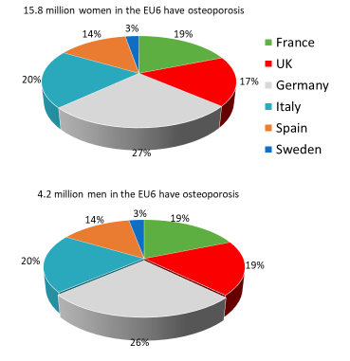
Fig. A1 The prevalence of osteoporosis in the EU6 [2, 3, 9].

Table A 1 Prevalence (%) of osteoporosis for men and women age 50 years and older per country
Country | Women (%) | Men (%)
France | 22.7 | 6.9
UK | 21.8 | 6.8
Germany | 22.5 | 6.7
Italy | 23.1 | 7.0
Spain | 22.5 | 6.8
Sweden | 22.5 | 6.9
EU6 | 22.5 | 6.8

Table A 2 Number (in thousands) of men and women (M=men, W=women) with osteoporosis according to age in the EU6 using female-derived reference ranges at the femoral neck
 | France |  | UK |  | Germany |  | Italy |  | Spain |  | Sweden |  | EU6
Age | W | M | W | M | W | M | W | M | W | M | W | M | W | M
50-54 | 137 | 54 | 147 | 57 | 215 | 88 | 150 | 58 | 112 | 44 | 19 | 8 | 780 | 308
55-59 | 201 | 69 | 194 | 69 | 289 | 105 | 200 | 70 | 152 | 54 | 28 | 10 | 1,064 | 377
60-64 | 291 | 110 | 257 | 100 | 374 | 143 | 275 | 104 | 190 | 73 | 39 | 16 | 1,426 | 546
65-69 | 396 | 134 | 380 | 132 | 439 | 151 | 386 | 128 | 251 | 83 | 62 | 22 | 1,913 | 650
70-74 | 349 | 90 | 405 | 103 | 624 | 155 | 441 | 105 | 299 | 71 | 68 | 18 | 2,187 | 544
75-79 | 450 | 100 | 442 | 104 | 877 | 191 | 578 | 125 | 343 | 72 | 66 | 16 | 2,756 | 607
80-84 | 529 | 125 | 437 | 117 | 694 | 165 | 572 | 137 | 417 | 96 | 66 | 17 | 2,714 | 657
85+ | 639 | 105 | 490 | 93 | 711 | 108 | 623 | 103 | 421 | 75 | 80 | 15 | 2,964 | 497
50+ | 2,991 | 787 | 2,752 | 775 | 4,224 | 1,105 | 3,224 | 830 | 2,186 | 567 | 428 | 122 | 15,804 | 4,186

2: Lifetime risk of fragility fractures

Background
The number of elderly individuals is expected to increase across the European Union [10]. A larger elderly population will result in an increasing number of osteoporotic fractures, and thus greater need for improvements in treatment efficiency and effectiveness.

Methods
A micro-simulation model was used to estimate the life-time risk of fracture from the age of 50 years. This simulation required data on fracture incidence and mortality for each country. National data on hip incidence was available for all six countries [11-18], but information on other fractures was incomplete. Where relevant, the incidence of vertebral and other osteoporotic fractures was only available for Sweden except for UK where estimates for incidence of wrist fractures was available. The incidence of these types of fractures in the biggest 5 EU countries was imputed from the ratio of vertebral and other osteoporotic fractures to hip observed in Sweden [14]. The relative risk increase in mortality after fractures were derived from Swedish data and were applied on population mortality rates in the other countries [19-24].

Results
The remaining lifetime risk for women of sustaining a hip fracture at the age of 50 years vary between 9.8% in Spain to 22.8% in Sweden (Fig. A 2). Corresponding risk range for men is 6.1% (France) to 13.7% (Sweden). The highest remaining lifetime risk of a MOF is in Sweden with a 46.3 % risk for women and a 28.7 % risk for men.
The lifetime risk of hip fracture at age 50 is on the same level as the lifetime risk of a stroke for both women (20%) and men (14%) [25]. Lifetime risk of major osteoporotic fracture is comparable to that of cardiovascular disease (CVD), which affects 39% of women and 52% of men [26]. Table A 3 presents the number of estimated fractures by year and type.

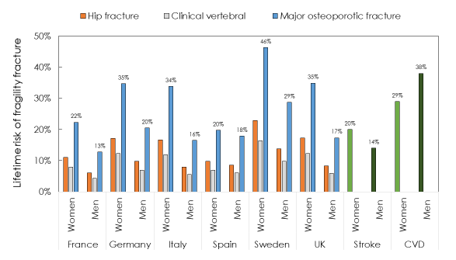
Fig. A 2 Lifetime risk of fragility fracture from the age of 50, by country, and the equivalent risk for stroke and CVD. Source: National fracture incidences and own calculations

Comments
The lifetime risk of fracture varies between countries but is comparable to corresponding risk of CVD and Stroke.

Supporting Data

Table A 3 Number of estimated fractures by year and type
 | Women |  |  |  |  | Men
 | 2017 | 2020 | 2025 | 2030 |  | 2017 | 2020 | 2025 | 2030
France
Hip fractures | 58,020 | 61,081 | 65,269 | 72,325 |  | 19,208 | 20,689 | 23,254 | 26,444
Vertebral fractures | 37,861 | 39,823 | 42,820 | 46,539 |  | 20,140 | 21,553 | 23,773 | 25,960
MOFs | 130,317 | 137,063 | 146,887 | 160,952 |  | 63,077 | 67,442 | 74,345 | 82,260
Osteoporotic fractures | 257,964 | 271,088 | 289,113 | 314,854 |  | 123,602 | 131,903 | 144,508 | 159,722
Germany
Hip fractures | 106,190 | 111,480 | 118,952 | 125,421 |  | 39,682 | 43,526 | 48,854 | 53,231
Vertebral fractures | 76,398 | 79,059 | 82,847 | 86,625 |  | 43,744 | 46,859 | 51,533 | 55,244
MOFs | 250,982 | 261,616 | 275,902 | 289,252 |  | 135,432 | 146,299 | 160,884 | 171,860
Osteoporotic fractures | 501,240 | 522,800 | 550,047 | 571,973 |  | 263,732 | 286,035 | 315,700 | 334,795
Italy
Hip fractures | 82,060 | 86,007 | 91,891 | 98,539 |  | 28,875 | 31,493 | 35,602 | 39,473
Vertebral fractures | 59,137 | 61,651 | 65,434 | 69,364 |  | 28,813 | 31,049 | 34,631 | 37,658
MOFs | 194,132 | 202,938 | 216,078 | 230,120 |  | 90,767 | 98,085 | 109,371 | 119,582
Osteoporotic fractures | 387,764 | 405,731 | 431,502 | 457,765 |  | 175,624 | 190,111 | 212,199 | 231,999
Spain
Hip fractures | 47,294 | 50,447 | 54,642 | 59,589 |  | 23,394 | 25,275 | 28,431 | 31,883
Vertebral fractures | 28,687 | 30,385 | 32,962 | 36,076 |  | 21,094 | 22,593 | 25,124 | 28,080
MOFs | 101,897 | 108,349 | 117,529 | 128,314 |  | 68,573 | 73,499 | 82,057 | 91,798
Osteoporotic fractures | 197,513 | 210,149 | 227,798 | 248,483 |  | 130,082 | 139,285 | 155,083 | 173,333
United Kingdom
Hip fractures | 71,712 | 75,313 | 82,144 | 91,445 |  | 27,098 | 29,400 | 33,344 | 38,268
Vertebral fractures | 52,977 | 55,789 | 59,808 | 65,026 |  | 27,817 | 29,975 | 33,001 | 36,768
MOFs | 171,568 | 180,314 | 194,784 | 213,838 |  | 88,340 | 95,085 | 105,259 | 171,568
Osteoporotic fractures | 348,472 | 365,768 | 393,955 | 429,948 |  | 170,504 | 183,335 | 202,363 | 226,824
Sweden
Hip fractures | 16,456 | 17,020 | 18,680 | 20,856 |  | 6,481 | 7,011 | 8,196 | 9,344
Vertebral fractures | 12,134 | 12,644 | 13,604 | 14,612 |  | 6,883 | 7,372 | 8,207 | 9,028
MOFs | 39,236 | 40,709 | 44,201 | 48,287 |  | 21,658 | 23,163 | 26,152 | 29,041
Osteoporotic fractures | 78,023 | 80,816 | 87,347 | 95,140 |  | 41,700 | 44,399 | 50,111 | 55,912
MOFs = Major Osteoporotic Fracture (hip, spine, distal forearm and proximal humerus). Osteoporotic fractures include hip and vertebral fractures and other osteoporotic fractures.

3: Fracture projections

Background
The number of elderly individuals is expected to increase across the European Union [10]. A larger elderly population will result in an increasing number of osteoporotic fractures, and thus greater need for improvements in treatment efficiency and effectiveness.

Methods
National data on fracture incidence by type and gender were combined with demographic projections over time to estimate the annual number of new fractures between 2017 and 2030. National data on hip incidence was available for all six countries [11-18] . Incidence of vertebral and other osteoporotic fractures were only available for Sweden with the exception of UK where an estimate for the incidence of wrist fractures was available. The incidence of these type of fractures in France, Germany, Italy and the UK was imputed from the ratio of vertebral and other osteoporotic fractures to hip observed in Sweden [14].

Results
The number of new fractures in EU6 in 2017 was estimated at 2.68 million. Of these, the majority (1 734 065 or 64.8%) were other osteoporotic fractures followed by hip (526 470 or 19.7%) and clinical vertebral fractures (415 685 or 15.5%).
Of all fractures, 50.7% were major osteoporotic fractures (MOFs) and 66.2% were sustained by women. The number of elderly individuals in all six countries is estimated to increase by 17.6 million (13.0%) between 2017 and 2030. The relative change of elderly individuals between 2017 and 2030 is highest in Spain (24.0%) and lowest in Germany (6.4%). By 2030, the total number of fractures in EU6 was estimated at 3.3 million, an increase of 23.3%. The largest percentage increase was observed in Spain (28.8%) and the lowest in Germany (18.5%). Fig. A 3 shows the estimated numbers of fractures by site in 2017 and 2030 and the percentage change, including estimates for the number of major osteoporotic fractures (MOFs). The figure also shows that Germany has the highest total of fragility fractures, due to its population size. Table A 3 presents the number of estimated fractures by year and type.

Comments
The number of elderly individuals is expected to increase in the EU6. Given current rates of incidence of hip, vertebral and other osteoporotic fractures, the burden of osteoporosis will continue to increase in all the countries studied. Across the six countries, the increase in incident fractures is greater than the increase in elderly individuals, indicating that the average age of elderly individuals will increase over time. Note that these projections take no account of possible changes in age- and sex-specific fracture rates with time.
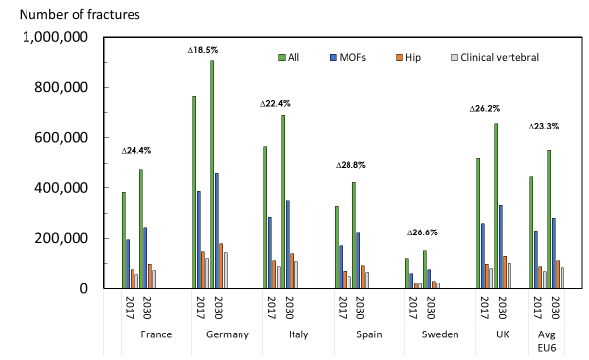

Fig. A 3 Estimated number of fractures by site and country in 2017 and 2030 and percentage change

4: Imminent fracture risk

Background
Individuals who have already suffered a fragility fracture are at a greater risk for additional fractures both at the same bone site and at other sites. This additional risk of refracture, which is commonly termed imminent risk, is highest immediately after a fracture [28]. In this analysis, the imminent risk is illustrated by estimating the hazard ratio (HR) of a subsequent MOF and estimating the number of individuals exposed to the imminent risk of a recurrent fracture.

Methods
To show the number of patients exposed to an imminent risk of refracture in Sweden, patients age 50 years or older with an osteoporotic fracture of any type between 2006 and 2013 (Inclusion period) were identified from the Swedish National Patient Register (NPR). The date of first fracture during the inclusion period is set as the index date. Separate analysis was conducted for each fracture type, implying that one patient could have more than one index date. Fracture types were based on ICD-10 codes, which can be found in Table A 4. The 2-year risk of a subsequent fracture from index date was estimated using competing risk analysis. Death was considered the competing risk. Death dates were extracted from the Swedish Cause of Death Register. The 2-year risk of subsequent fracture was then estimated for each fracture type. Patients with a diagnosis of Paget’s disease or malignancies were excluded from the analysis. Vertebral fractures were limited to clinically vertebral fractures diagnosed within specialized inpatient or outpatient care.
In a separate analysis, the Hazard Ratio (HR) of a subsequent MOF in women with an index fracture at any site was estimated using a separate sample population who had not yet experienced a fragility fracture (fracture-naïve) as a reference case.

Table A 4 Fracture codes by hip, vertebral, non-hip-non-vertebral, MOF and non-MOF
Fracture site | ICD-10 | Hip | Vertebral | Non-hip-non-vertebral | MOF | Non-MOF | Comment
Neck | S12.x |  | S12.0x-S12.2x, S12.7x |  | S12.0x-S12.2x, S12.7x
Rib, sternum, thoracic spine | S22.x |  | S22.0x-S22.1x | S22.2x-S22.5x | S22.0x-S22.1x | S22.2x-S22.5x
Lumbar spine, pelvis | S32.x |  | S32.0x | S32.1x- S32.8x | S32.0x, S32.7x, S32.8x | S32.1x-S32.6x
Shoulder, upper arm | S42.x |  |  | S42.0x-S42.4x, S42.7x-S42.9x | S42.2x - S42.3x | S42.0x, S42.1x S42.4x-S42.9x
Forearm | S52.x |  |  | S52.x | S52.5x-S52.7x | S52.0x-S52.4x, S52.8x, S52.9x
Wrist, Hand | S62.0x, S62.8x |  |  |  |  |  | Not included in analyses
Femur (including hip) | S72.x | S72.0x-S72.2x |  | S72.3x-S72.9x | S72.ox- S72.2x | S72.3x-S72.9x
Lower leg (including ankle*) | S82.x |  |  | S82.1x S82.4x |  | S82.1x, S82.2x, S82.3x, S82.4x | Women only
Collapsed vertebra, not elsewhere specified | M48.5x |  | M48.5x |  | M48.5x
Osteoporosis with pathological fracture | M80.A, M80.B, M80.F, M80.J, M80.K | M80.F | M80.0A, M80.0J, M80.K | M80.B |  | M80.A, M80.B, M80.F, M80.J,

Results
A total of 357,948 individuals with osteoporotic fractures were identified during the inclusion period. Most of these individuals (71%) were women. Available evidence suggest that these individuals face an increased risk of subsequent fractures within the following two years.
The separate analysis shows that the estimated HR is highest within the first six months after fracture. Furthermore, individuals with a previous fracture continue to have an excess risk of a subsequent fracture up until five years after fracture compared to a fracture-naïve population (Fig. A 4). Table A 5 shows the two-year cumulative subsequent fracture incidence by fracture type in Sweden, all ages.

Comments
This analysis finds a similar pattern as other studies in which the risk of a recurrent fracture is highest in the immediate aftermath of a fracture. This should be seen as an opportunity to improve fracture prevention care. Given the size of the osteoporotic population in Sweden, this can have a significant impact on the total burden of osteoporosis.
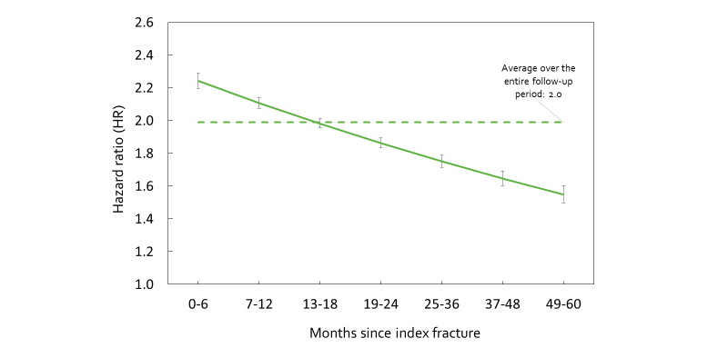
Fig. A 4 Hazard ratio of a subsequent MOF in women with index fracture at any site versus non-fracture controls [28]

Table A 5 Two-year cumulative subsequent fracture incidence by fracture type in Sweden, all ages
Fracture site by gender | No at risk at t=0 | Cumulative incidence (%) at 1 year | Cumulative incidence (%) at 2 years
Women
Hip fractures | 74,066 | 1.42 | 3.98
Vertebral fractures | 23,794 | 1.46 | 3.27
MOF | 195,533 | 4.57 | 8.28
Osteoporotic fractures | 253,637 | 6.15 | 10.48
Men
Hip fractures | 30,289 | 1.08 | 2.88
Vertebral fractures | 11,187 | 1.39 | 2.45
MOF | 64,255 | 3.38 | 5.96
Osteoporotic fractures | 104,311 | 4.69 | 7.50

5: Length of hospital stay

Background
Fragility fractures incur increased costs to the health care sector and society. The costs to the health care sector are known to peak the year following fracture and the length of hospital stay is an important cost-component [29-31]. It is therefore of interest to study the length of hospital stay the following year after fracture.

Methods
Patients age 50 years or older with an incident fragility fracture that required inpatient care between 2010 and 2014 were identified from the Swedish National Patient Register (NPR). The total number of days of inpatient care during the following year after fracture was determined. The number of days admitted was categorized as “fracture-related” if the main diagnosis code for the admission was fracture related. The ICD-10 codes used to define an admission as fracture-related is listed in (see Table A 4). The analysis was conducted by fracture site. Patients with a diagnosis of Paget’s disease or malignancy anytime during the study period (2010-2015) were excluded from the analysis.

Results
Table A 6 shows the descriptive statistics of length of hospital stay for all fracture sites that required inpatient care in Sweden between 2010 and 2014. On average, a patient was hospitalized between 6- and 8-days following fracture. Table A 7 shows the descriptive statistics of the number of fracture related days hospitalized in the year following fracture, for all fractures sites that required inpatient care in Sweden between 2010 and 2014. This estimate is comprised of two components; the length-of-hospital stay in relation to the incident fracture (shown in Table A6) and readmissions. On average, a patient was hospitalized between 10 to 12 days due to fracture related causes including the fracture event (Table A 7). Hip fractures were associated with a higher number of days (12) compared to clinical vertebral fractures (10-11 days). Osteoporotic fractures required between 10 and 11 days of hospitalization. The number of days hospitalized was similar between the two genders.
Table A 8 shows the descriptive statistics of total days hospitalized following fracture. This analysis shows that on average, a patient with an incident fracture that requires inpatient care is in total hospitalized the following year between 15 to 20 days. Vertebral fractures are associated with a higher number of hospitalization days (20 days) compared to hip fractures (18-19 days) and osteoporotic fractures (17 days).

Comments
A substantial proportion (65-71%) of the fracture related hospitalization days the year after fracture was directly related to the length of stay in connection with the fracture. Moreover, of the total hospitalization days the year following fracture, a majority (53-69%) was fracture related.

Supporting data

Table A 6 Number of days hospitalized in direct relation with incident fracture between 2010 and 2014 in Sweden
Fracture site by gender | N | Mean | SD | Q1 | Median | Q3
Women
Hip fractures | 49,572 | 8.24 | 5.71 | 4 | 7 | 11
Vertebral fractures | 10,367 | 7.69 | 5.91 | 3 | 7 | 10
MOF | 75,333 | 7.87 | 5.84 | 4 | 7 | 11
Osteoporotic fractures | 99,303 | 7.72 | 5.90 | 4 | 7 | 10
Men
Hip fractures | 20,486 | 8.30 | 7.49 | 4 | 7 | 11
Vertebral fractures | 5,090 | 6.70 | 6.23 | 2 | 5 | 9
MOF | 29,464 | 7.73 | 7.16 | 3 | 6 | 10
Osteoporotic fractures | 42,367 | 7.21 | 6.93 | 3 | 6 | 10

Table A 7 Number of fracture-related days hospitalized the year following fracture between 2010 and 2014 in Sweden
 | N | Mean | SD | Q1 | Median | Q3
Women
Hip fractures | 49,572 | 12.38 | 9.46 | 6 | 10 | 16
Vertebral fractures | 10,367 | 11.35 | 10.15 | 5 | 9 | 15
MOF | 75,333 | 11.56 | 9.49 | 5 | 9 | 15
Osteoporotic fractures | 99,303 | 11.26 | 9.54 | 5 | 9 | 14
Men
Hip fractures | 20,486 | 12.30 | 10.34 | 6 | 10 | 16
Vertebral fractures | 5,090 | 10.35 | 10.98 | 3 | 7 | 13
MOF | 29,464 | 11.49 | 10.42 | 5 | 9 | 15
Osteoporotic fractures | 42,367 | 10.58 | 10.29 | 4 | 8 | 14

Table A 8 Number of days hospitalized (all-causes) the year following fracture between 2010 and 2014 in Sweden
 | N | Mean | SD | Q1 | Median | Q3
Women
Hip fractures | 49,572 | 17.84 | 17.02 | 7 | 13 | 22
Vertebral fractures | 10,367 | 19.86 | 20.12 | 7 | 13 | 26
MOF | 75,333 | 17.25 | 17.29 | 7 | 12 | 22
Osteoporotic fractures | 99,303 | 16.84 | 17.24 | 6 | 12 | 21
Men
Hip fractures | 20,486 | 19.31 | 19.55 | 7 | 13 | 24
Vertebral fractures | 5,090 | 19.67 | 23.78 | 5 | 12 | 25
MOF | 29,464 | 18.78 | 20.40 | 6 | 12 | 24
Osteoporotic fractures | 42,367 | 17.38 | 19.89 | 5 | 11 | 22

6: Fracture-related costs

Background
Fragility fractures incur long-term consequences both in terms of costs and morbidity. However, the costs related to fracture is at its peak the period immediately following a fracture. The fracture costs in the first year following a fracture differ between fracture types, and to some extent reflect the severity of fracture. Hip fractures are the most severe fracture type, and almost always lead to hospitalization. The length of hospital stay is an important cost driver, and has also been shown to have implications on patient outcomes [30].

Methods
The mean length of stay following hip fracture, and fracture costs in the year after the fracture (reported in € 2017) (hip, vert and wrist) were retrieved from the scientific literature. All inputs are country specific. Age and gender specific data (where available) are shown in Table A 9. A literature search was undertaken utilizing PubMed as well as an ad-hoc google search.

Results
The mean length of stay following a hip fracture (Table A 10) was the highest in the UK (20.5 days), followed by Italy (19.0 days). Sweden had the shortest mean length of stay, 11.6 days, which was very similar to Spain where the corresponding was 11.8 days. As there were no large gender differences, the results are presented in total for both genders. The standard deviations were notably high in all countries except Germany, implying that there are considerable individual variations in length of hospital stay.

The fracture costs differed substantially over countries and fractures (Table A 11). Cost estimates for other fracture types than hip, vertebral and wrist fracture is very scarce and therefore not included. Hip fractures are the costliest fracture type in all countries, while wrist fractures are the least costly. Fracture costs are generally higher in Sweden and Germany, and the lowest in Spain. Table A 12 presents the sources for the average cost of fracture.

Table A 9 Age and gender-specific costs (€ 2017)
 |  |  |  | France |  | Germany |  | Italy |  | Spain |  | Sweden |  | UK
 |  |  | Age | Male | Female | Male | Female | Male | Female | Male | Female | Male | Female | Male | Female
Hip |  |  | 50-64 | 12,856 |  | 20,884 |  | 21,307 |  | 9,197 | 9,881 | 15,426 | 11,628 | 21,620 | 20,324
 |  |  | 65-74 |  |  |  |  |  |  |  |  | 14,070 | 13,553
 |  |  | 75-84 |  |  |  |  |  |  |  |  | 19,059 | 14,408
 |  |  | 85+ |  |  |  |  |  |  |  |  | 13,196 | 21,414
 |  | Vertebral |  | 3,205 |  | 11,824 | 11,803 | 4,713 |  | 1,928 |  | 14,474 |  | 4,028
 |  | Wrist |  | 1,468 |  | 1,275 |  | 1,301 |  | 533 |  | 2,477 |  | 2,568

Table A 10 Length of hospital stay following hip fracture, days, mean (SD)
Country | Mean | SD | Source
France | 12.0 | 8.0 | [32]
Germany | 14.5 | 2.6 | [33]
Italy | 19.0 | 25.3 | [34]
Spain | 11.8 | 7.9 | [35]
Sweden | 11.6 | 8.7 | [30]
UK | 20.5 | 20.0 | [36]

Table A 11 Mean cost of fracture (€ 2017), during year after fracture occurrence
Fracture | France | Germany | Italy | Spain | Sweden | UK
Hip | 12,856 | 20,884 | 21,307 | 9,724 | 16,409 | 20,650
Vertebral | 3,205 | 11,805 | 4,713 | 1,928 | 14,474 | 4,028
Wrist | 1,468 | 1,275 | 1,301 | 533 | 2,477 | 2,568

Table A 12 Sources for the average cost of fracture
 | France | Germany | Italy | Spain | Sweden | UK
Hip | Adapted from, [37]; original sources: [38, 39] | [40] | [41] | [35] | [42] | [36]
Vertebral |  | [43] |  | [44] |  | [45]
Wrist |  | [40]

7: Annual cost of fractures

Background
The societal burden of a disease can be divided into the economic burden and the health burden. The economic burden comprises the monetary costs to society related to the presence of the disease. The cost of illness can play an important role in understanding the implications of a disease and aid decisions concerning allocation of societal resources.

Methods
Fracture related costs, risks and mortality with fracture in each country were retrieved from the literature [37, 42, 45-49]. The projected annual costs related to osteoporotic fractures between years 2017-2030 were estimated accounting for both the short-term and long-term costs (due to fractures that arose in previous years) of fractures as well as the costs of residing in nursing homes. A model previously used to estimate the burden of osteoporosis in Sweden [50] was adapted to the countries included in the present study [50].The costs incurred by patients with a history of more than one fracture (subsequent fractures) was calculated from the differences between the risk of fracture (including those with a prior fracture) and risk of first fracture [14].

Results
The total monetary cost was €37.5 billion in 2017. Hip fracture represented 56% of the total fracture related costs across EU6 whilst other osteoporotic fractures and vertebral fractures accounted for 35 and 8%, respectively. Whereas hip fractures accounted for 20% of all fragility fractures, they accounted for 56 % of costs (Fig. A 5).
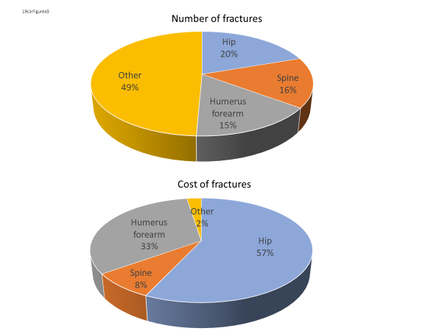
Fig. A 5 Fracture related costs (panel A, % and billion €) and number of fractures (panel B, n and %) in 2017 by fracture type, EU6.

Fig. A 6 shows the cost incurred by patients with a history of more than one fracture and the cost incurred by patients with only one fracture in 2017 in all six countries by fracture type. Of the total fracture related cost, on average 15.7% (13.1 to 8.5% depending on fracture type) is accounted for patients with more than one fracture.
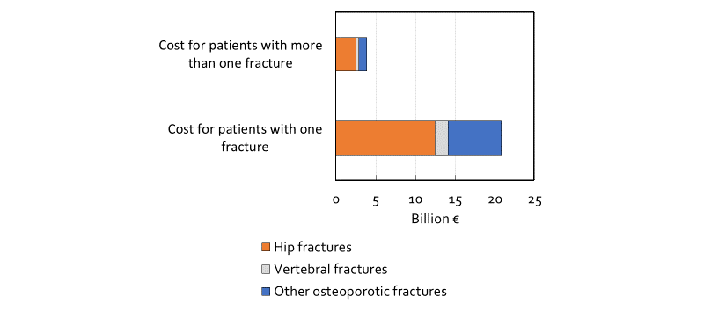
Fig. A 6 Total fracture cost by fracture history in 2017, EU6

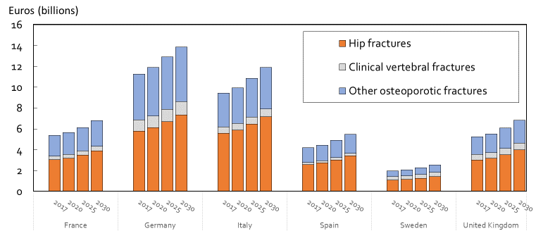
The fracture related costs in EU6 are projected to increase from €37.5 billion in year 2017 to €47.4 billion in year 2030, an increase of 26.6% (Fig. A 7). Mainly due to different population sizes, the burden is the highest in Germany and lowest in Sweden. On a per capita basis, Sweden ranked first and UK last. However, when fracture costs are considered in relation to health care spending, Italy could be interpreted as the country with the highest economic fracture burden (Fig. A 8) whereas France and the UK appear to have the lowest fracture burden. Table A 13 presents the fracture related costs in 2017. The fracture-related costs in terms of health care spending and population are presented in Table A 14. Table A 15 presents the annual fracture-related cost projections.
Fig. A 7 Estimated annual fracture related costs (billion euro) by type and country in 2017 and 2030 and percentage change

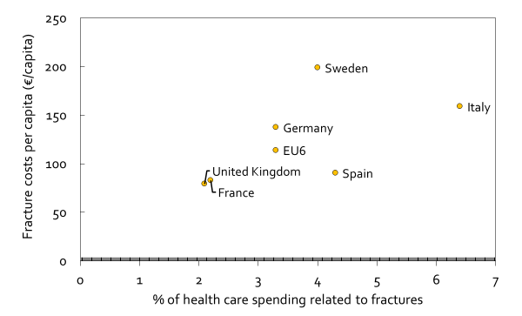
Fig. A 8 Fracture cost per capita and health care spending related to fractures

Comments
The number of elderly individuals is expected to increase in the EU6. Given current rates of incidence of hip vertebral and other osteoporotic fractures, the monetary burden of osteoporosis will increase in all countries studied. The relative change in monetary burden between 2017 and 2030 is similar to the burden in terms of QALYs.

Supporting data

Table A 13 Fracture related costs in 2017 (million euro)
Country | Incident fractures | Prevalent fractures | Institutional care | Total
France | 3,748 | 219 | 1,404 | 5,371
Germany | 8,176 | 414 | 2,680 | 11,270
Italy | 5,951 | 299 | 3,179 | 9,429
Spain | 2,150 | 137 | 1,915 | 4,202
United Kingdom | 2,955 | 372 | 1,919 | 5,246
Sweden | 1,199 | 81 | 690 | 1,970

Table A 14 Fracture related costs in terms of health care spending and population
Country | % of health care spending on fractures | Burden per capita (€)
France | 2.2% | 83
Germany | 3.3% | 137
Italy | 6.4% | 159
Spain | 4.3% | 91
United Kingdom | 2.1% | 79
Sweden | 4.0% | 199
*Estimates from 2015 [51]

Table A 15 Fracture related costs by year, million euro
 | 2017 | 2020 | 2025 | 2030
France
Incident costs | 3,748 | 3,965 | 4,259 | 4,675
Prevalent costs | 219 | 228 | 251 | 281
Institutional care costs | 1,404 | 1,467 | 1,620 | 1,832
Total | 5,371 | 5,660 | 6,130 | 6,788
Germany
Incident costs | 8,176 | 8,672 | 9,340 | 9,847
Prevalent costs | 414 | 430 | 468 | 519
Institutional care costs | 2,680 | 2,802 | 3,101 | 3,519
Total | 11,270 | 11,904 | 12,909 | 13,885
Italy
Incident costs | 5,951 | 6,309 | 6,840 | 7,367
Prevalent costs | 299 | 311 | 339 | 377
Institutional care costs | 3,179 | 3,322 | 3,671 | 4,158
Total | 9,429 | 9,942 | 10,850 | 11,902
Spain
Incident costs | 2,150 | 2,296 | 2,518 | 2,776
Prevalent costs | 137 | 144 | 158 | 179
Institutional care costs | 1,915 | 2,004 | 2,224 | 2,532
Total | 4,202 | 4,444 | 4,900 | 5,487
United Kingdom
Incident costs | 2,955 | 3,140 | 3,437 | 3,822
Prevalent costs | 372 | 388 | 427 | 481
Institutional care costs | 1,919 | 2,007 | 2,225 | 2,529
Total | 5,246 | 5,535 | 6,088 | 6,832
Sweden
Incident costs | 1,199 | 1,255 | 1,385 | 1,538
Prevalent costs | 81 | 85 | 93 | 104
Institutional care costs | 690 | 721 | 799 | 907
Total | 1,970 | 2,061 | 2,276 | 2,549

8: Quality-Adjusted Life-Years

Background
The societal burden of a disease can be differentiated into the economic burden and the health burden. The economic burden concerns the actual costs inflicted on society related to the presence of the disease. The health burden concerns the impact that the disease has on the patient in terms of quality of life (QoL) and reduced survival. The most common approach to estimate the health burden is to use the Quality-Adjusted Life-Years (QALYs) [52].

Methods
Quality of life values for the general normal population was combined with fracture related disutility multipliers to estimate the total QALY loss in each country [53, 54]. All QoL data used in the calculations was based the EQ-5D questionnaire [54]. Increased risk of mortality after fractures was derived from the literature [55]. The health burden, e.g. QALYs lost, associated with fragility fractures was estimated from year 2017 up to year 2030 based on projected demographic changes during this period.

Results
The total health burden in 2017 due to fragility fractures in the six countries is estimated at 1.02 million QALYs. 66% of the QALY loss is related to fractures occurring in women. The total health burden is expected to increase by 26% by 2030 (Fig. A 9). The QALY loss in absolute numbers was highest in Germany due to the size of the population combined with comparatively high risk of fractures. The lowest QALY loss was observed in Sweden due to the small population size compared to the other countries. However, on a per capita basis, Sweden was associated with the largest burden (4.22 lost QALYs per 1,000 population) and France the lowest (2.11 lost QALYs per 1,000 capita). The differences are driven, in large part, by the differences in the risk of fractures between the countries (Fig. A 10) and the age-distribution among elderly individuals. Table A 16 -Table A 20 present the supporting data for the burden of fragility fractures.
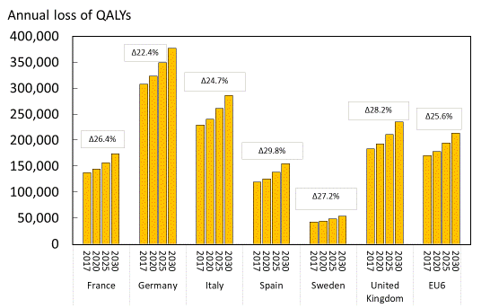
Fig. A 9 Total annual loss of QALYs by country in 2017 and 2030 and percentage change

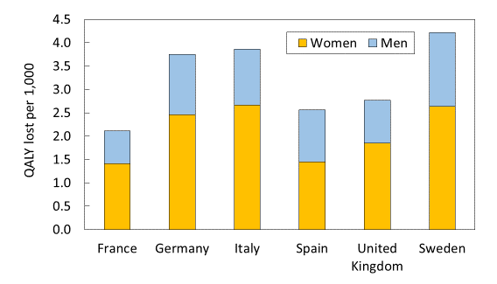

Fig. A 10 QALYs lost due to fragility fractures per 1,000 in 2017 by gender and country

Comments
Because of the increasingly elderly population the health burden (in terms of lost QALYs) related to fractures will continue to rise over the next decade. Even though there are some variation between countries due to demographic differences this pattern is apparent in all countries.

Supporting data
Table A 16 Estimated loss of QALYs per 1,000 population in 2017, both sexes
 | France | Germany | Italy | Spain | United Kingdom | Sweden
QALY loss due to morbidity
Incident hip fractures | 0.297 | 0.500 | 0.529 | 0.401 | 0.366 | 0.562
Incident vertebral fractures | 0.180 | 0.329 | 0.336 | 0.229 | 0.239 | 0.380
Incident MOFs | 0.488 | 0.880 | 0.885 | 0.605 | 0.645 | 0.989
Prevalent hip fractures | 0.408 | 0.664 | 0.731 | 0.471 | 0.477 | 0.745
Prevalent vertebral fractures | 0.500 | 0.873 | 0.934 | 0.564 | 0.608 | 1.023
Prevalent MOFs | 0.119 | 0.224 | 0.217 | 0.132 | 0.250 | 0.242
Total QALY loss due to morbidity | 1.993 | 3.471 | 3.632 | 2.401 | 2.585 | 3.941
QALY loss due to mortality
Mortality hip fractures | 0.051 | 0.114 | 0.098 | 0.071 | 0.077 | 0.113
Mortality vertebral fractures | 0.067 | 0.162 | 0.126 | 0.083 | 0.104 | 0.160
Mortality MOFs | 0.003 | 0.006 | 0.006 | 0.004 | 0.004 | 0.006
Total QALY loss due to mortality | 0.121 | 0.282 | 0.230 | 0.158 | 0.186 | 0.279
Total QALY loss due to  osteoporotic fractures | 2.114 | 3.753 | 3.862 | 2.560 | 2.770 | 4.220

Table A 17 Estimated total QALY loss of fractures in 2017, female population
 | France | Germany | Italy | Spain | United Kingdom | Sweden
QALY loss due to morbidity
Incident hip fractures | 14,225 | 29,425 | 22,871 | 11,819 | 17,399 | 3,844
Incident vertebral fractures | 7,476 | 16,975 | 13,194 | 5,798 | 10,360 | 2,316
Incident MOFs | 20,199 | 45,071 | 34,758 | 15,422 | 27,853 | 5,958
Prevalent hip fractures | 18,996 | 38,238 | 31,667 | 13,340 | 22,217 | 4,724
Prevalent vertebral fractures | 21,935 | 47,545 | 39,066 | 14,670 | 27,519 | 6,283
Prevalent MOFs | 4,853 | 11,303 | 8,668 | 3,139 | 9,643 | 1,422
Total QALY loss due to morbidity | 87,683 | 188,557 | 150,223 | 64,188 | 114,991 | 24,546
QALY loss due to mortality
Mortality hip fractures | 2,020 | 5,701 | 3,669 | 1,681 | 3,264 | 666
Mortality vertebral fractures | 2,031 | 6,629 | 4,171 | 1,401 | 3,899 | 805
Mortality MOFs | 169 | 411 | 286 | 147 | 228 | 50
Total QALY loss due to mortality | 4,221 | 12,741 | 8,125 | 3,229 | 7,391 | 1,521
Total QALY loss due to  osteoporotic fractures | 91,904 | 201,298 | 158,349 | 67,418 | 122,382 | 26,067

Table A 18 Estimated burden of fractures in 2017, male population
 | France | Germany | Italy | Spain | United Kingdom | Sweden
QALY loss due to morbidity
Incident hip fractures | 5,064 | 11,615 | 8,535 | 6,776 | 6,804 | 1,722
Incident vertebral fractures | 4,237 | 10,056 | 6,735 | 4,823 | 5,480 | 1,445
Incident MOFs | 11,492 | 27,113 | 17,797 | 12,661 | 14,803 | 3,842
Prevalent hip fractures | 7,529 | 16,273 | 11,693 | 8,537 | 9,352 | 2,659
Prevalent vertebral fractures | 10,570 | 24,076 | 16,353 | 11,513 | 12,724 | 3,851
Prevalent MOFs | 2,887 | 7,067 | 4,221 | 2,970 | 6,877 | 975
Total QALY loss due to morbidity | 41,778 | 96,199 | 65,335 | 47,280 | 56,040 | 14,493
QALY loss due to mortality
Mortality hip fractures | 1,301 | 3,665 | 2,141 | 1,633 | 1,855 | 453
Mortality vertebral fractures | 2,324 | 6,656 | 3,319 | 2,452 | 2,988 | 778
Mortality MOFs | 39 | 91 | 64 | 42 | 46 | 11
Total QALY loss due to mortality | 3,663 | 10,412 | 5,524 | 4,127 | 4,889 | 1,242
Total QALY loss due to  osteoporotic fractures | 45,442 | 106,611 | 70,859 | 51,408 | 60,929 | 15,735

Table A 19 Estimated burden of fractures in 2030, female population
 | France | Germany | Italy | Spain | United Kingdom | Sweden
QALY loss due to morbidity
Incident hip fractures | 17,692 | 34,711 | 27,425 | 14,899 | 22,121 | 4,833
Incident vertebral fractures | 9,134 | 19,206 | 15,447 | 7,300 | 12,651 | 2,757
Incident MOFs | 24,255 | 50,674 | 40,731 | 19,390 | 33,846 | 7,116
Prevalent hip fractures | 24,056 | 47,584 | 39,659 | 17,273 | 28,338 | 5,903
Prevalent vertebral fractures | 27,641 | 57,881 | 48,115 | 18,771 | 34,801 | 7,794
Prevalent MOFs | 6,116 | 13,744 | 10,664 | 4,007 | 12,182 | 1,773
Total QALY loss due to morbidity | 108,894 | 223,798 | 182,041 | 81,640 | 143,938 | 30,177
QALY loss due to mortality
Mortality hip fractures | 2,549 | 6,762 | 4,442 | 2,117 | 4,201 | 855
Mortality vertebral fractures | 2,550 | 7,671 | 4,950 | 1,738 | 4,899 | 1,003
Mortality MOFs | 211 | 508 | 359 | 191 | 290 | 63
Total QALY loss due to mortality | 5,310 | 14,941 | 9,750 | 4,046 | 9,391 | 1,921
Total QALY loss due to  osteoporotic fractures | 114,204 | 238,739 | 191,791 | 85,686 | 153,329 | 32,098

Table A 20 Estimated burden of fractures in 2030, male population
 | France | Germany | Italy | Spain | United Kingdom | Sweden
QALY loss due to morbidity
Incident hip fractures | 6,908 | 15,525 | 11,623 | 9,234 | 9,574 | 2,453
Incident vertebral fractures | 5,408 | 12,674 | 8,777 | 6,422 | 7,225 | 1,875
Incident MOFs | 14,476 | 33,884 | 23,263 | 16,767 | 19,361 | 5,038
Prevalent hip fractures | 10,170 | 22,280 | 15,989 | 11,472 | 12,883 | 3,652
Prevalent vertebral fractures | 13,884 | 31,559 | 21,584 | 15,287 | 17,049 | 5,076
Prevalent MOFs | 3,810 | 9,217 | 5,556 | 3,929 | 9,105 | 1,297
Total QALY loss due to morbidity | 54,656 | 125,139 | 86,792 | 63,112 | 75,197 | 19,392
QALY loss due to mortality
Mortality hip fractures | 1,774 | 4,787 | 2,875 | 2,193 | 2,580 | 649
Mortality vertebral fractures | 2,947 | 8,199 | 4,167 | 3,221 | 3,869 | 1,008
Mortality MOFs | 55 | 141 | 98 | 58 | 68 | 17
Total QALY loss due to mortality | 4,776 | 13,127 | 7,140 | 5,471 | 6,517 | 1,673
Total QALY loss due to  osteoporotic fractures | 59,432 | 138,266 | 93,932 | 68,583 | 81,714 | 21,065

9: Disability-Adjusted Life-Years (DALYs)

Background
The DALY (or Disability Adjusted Life Year) is a method of measuring the burden of a disease, which allows for comparison across diseases. A single DALY can be thought of as one lost year of “healthy life” and summing the DALYs across an entire population provides the gap between the current health status of a population and an ideal disease-free population, i.e. the burden [56]. Including this measure of burden allows for both comparison of the burden between populations, and comparison with other diseases.

Methods
Calculation of DALYs for fragility fractures follows the current method used and provided by the WHO. DALYs are the sum of years of life lost (YLL) and the years lost due to disability (YLD) [56]. YLL was calculated by multiplying the total incidence by age and sex for each fracture by the change in life expectancy due to that fracture. YLD was calculated by multiplying the number of fractures with the remaining life years for a person with an osteoporotic fracture at a given age and gender, and a disability weight for living with that osteoporotic fracture.
Data were assembled for the largest 5 EU countries as well as Sweden (total population: 128,699,382), to calculate the per capita and total DALYs in men and women from the age of 50 to 100 years, for hip fractures, vertebral fractures and a weighted average of other fractures associated with osteoporosis (rib, sternum, pelvis, shoulder, forearm, wrist, and other femoral fractures [57, 58]), which are referred to as Non-hip and non-vertebral fractures (NHNV). Estimates for fracture incidence rates were from Svedbom et al 2013 [6] and relative fracture mortality rates from Jönsson et al 2011 [47]. Population by age and sex, as well as normal mortality rates, were obtained through the statistics bureaus of each country [59-64], and WHO standardized fracture disutility weights were used in the calculation [65].
Based on Kanis et al 2003 and Kanis 2004 [66, 67], it was assumed that 30% of the excess mortality associated with hip and vertebral fractures can be causally related to the fracture itself. This proportion was also applied to the NHNV fractures [58]. In accord with current WHO standards, age weighting was not used in the estimation [68].

Results
The total DALYs estimated in year 2016 for people in all six countries combined from the ages of 50 to 100 years shows that more than 2.6 million life years are lost due to fragility fracture. The DALY totals for each country vary greatly due to differences in population (Fig. A 11). The average DALY loss per 1000 individuals was estimated to be 21 DALYs, with Sweden showing the highest rate (32 DALYs) and Spain showing the lowest (12 DALYs), as seen in Fig. A 12. Average YLD’s per 1000 people (15.1) far exceeded the YLL’s per 1000 (5.5), indicating that living with a disability due to fracture drives DALY loss in osteoporosis. DALYs rate varied by country, age, gender and fracture type. In all countries, women had higher DALY burden than men, with averages of 23.8 and 17.0 DALYs, respectively. The fracture category with the highest total DALY loss was “NHNV fractures” (Fig. A 13). This dominance can be explained by the combination of a high incidence at early ages, and the large number of years spent with disability due the less life-threatening nature of NHNV fractures. This is shown in Fig. A 14 and Fig. A 15, where the age distribution of YLLs and YLDs by gender for two fracture types are shown.

For hip fractures in women, the YLLs peaked at the age of 77 years, whilst the YLDs peaked at age 81 years, reflecting that most hip fractures occur around 77 years. For “NHNV fractures” in the male population, the peak is early, with very low YLLs, indicating that prevalence of NHNV fractures is fairly high. Table A 21 and Table A 22 present the supporting data for DALYs and DALYs per 1000.
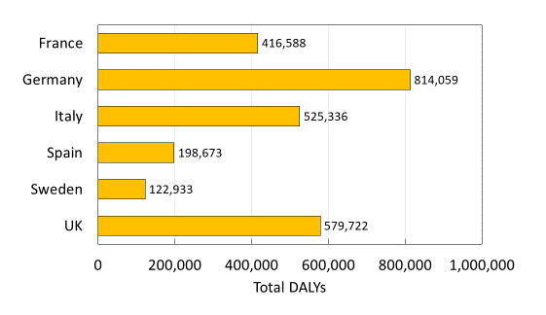
Fig. A 11 Total DALYs by Country

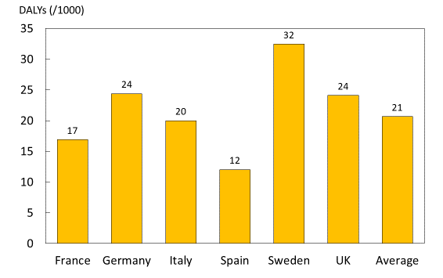

Fig. A 12 DALYs per 1000 individuals by country

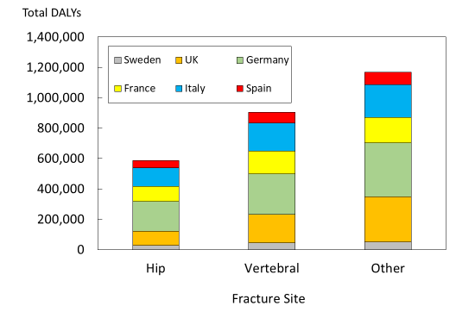
Fig. A 13 Total DALY Distribution by fracture site
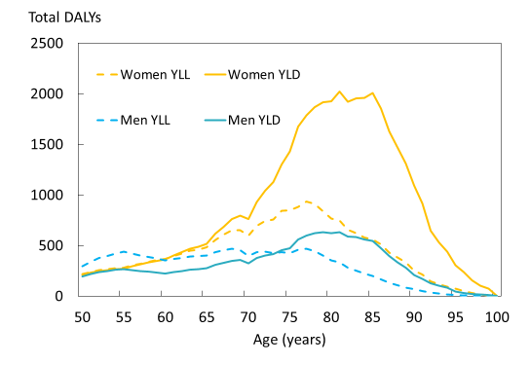

Fig. A 14 Total DALYs by age for hip fractures

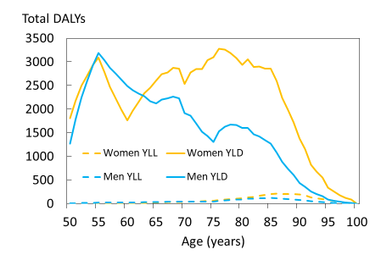

Fig. A 15 Total DALYs by age for non-hip non-vertebral fractures

Comments
From a national perspective, the DALY loss rate can be an important measure for motivating policy decisions and the prioritization of funds towards osteoporosis treatment. From an international perspective, the high values suggest a need for better treatment policy and practice. The assumption that 30% of deaths are causally linked to all fracture types in this study comes with the caveat that NHNV fractures, and vertebral fractures to a lesser degree, have a much lower relative mortality, which compensates for the constant percentage applied to causally related deaths.

Supporting data

Table A 21 YLLs and YLDs lost, by fracture type, country and gender
 | Total DALYS
 | Hip Fractures |  |  |  | Vert Fractures |  |  |  | NHNV Fractures
 | YLL |  | YLD |  | YLL |  | YLD |  | YLL |  | YLD
 | Women | Men | Women | Men | Women | Men | Women | Men | Women | Men | Women | Men | Totals
Sweden | 6,343 | 4,265 | 11,907 | 5,046 | 12,326 | 10,180 | 15,183 | 8,013 | 796 | 602 | 26,342 | 21,931 | 122933
UK | 20,803 | 18,710 | 34,656 | 19,941 | 52,142 | 46,287 | 56,713 | 31,250 | 4,989 | 3,757 | 159,474 | 131,002 | 579722
Germany | 47,632 | 29,744 | 89,173 | 28,077 | 70,777 | 68,765 | 84,973 | 41,353 | 6,449 | 3,957 | 209,247 | 133,910 | 814059
France | 23,824 | 13,561 | 45,969 | 15,590 | 43,716 | 32,867 | 49,858 | 22,903 | 3,637 | 2,178 | 93,449 | 69,035 | 416588
Italy | 26,996 | 15,375 | 61,660 | 19,814 | 49,010 | 34,823 | 74,017 | 28,901 | 4,035 | 2,681 | 127,618 | 80,405 | 525336
Spain | 9,678 | 6,233 | 24,994 | 7,439 | 16,296 | 13,781 | 28,271 | 10,412 | 1,706 | 1,127 | 48,038 | 30,698 | 198673
Total | 135,277 | 87,888 | 268,358 | 95,906 | 244,267 | 206,703 | 309,015 | 142,831 | 21,614 | 14,302 | 664,169 | 466,981 | 2,657,311

Table A 22 YLLs and YLDs per 1000 people, by fracture type, country and gender
 | DALYs per 1000
 | Hip Fractures |  |  |  | Vert Fractures |  |  |  |  | NHNV Fractures
 | YLL |  | YLD |  | YLL |  | YLD |  |  | YLL |  |  | YLD
 | Women | Men | Women | Men | Women | Men | Women | Men | Women |  | Men | Women |  | Men | Average
Sweden | 3.23277 | 2.33641 | 6.0684 | 2.76432 | 6.28184 | 5.57727 | 7.73806 | 4.38979 | 0.40592 |  | 0.32963 | 13.42551 |  | 12.01514 | 32.45845
UK | 1.64171 | 1.64467 | 2.73491 | 1.75287 | 4.11485 | 4.06876 | 4.4756 | 2.74697 | 0.39375 |  | 0.33022 | 12.58515 |  | 11.51552 | 24.10719
Germany | 2.66006 | 1.91983 | 4.97992 | 1.81227 | 3.95261 | 4.43852 | 4.7454 | 2.66914 | 0.36017 |  | 0.25543 | 11.68555 |  | 8.64335 | 24.3735
France | 1.77705 | 1.2037 | 3.42891 | 1.3838 | 3.26085 | 2.91743 | 3.71898 | 2.03299 | 0.27132 |  | 0.19334 | 6.97052 |  | 6.12776 | 16.88489
Italy | 1.89768 | 1.27527 | 4.33432 | 1.64341 | 3.44514 | 2.88833 | 5.20297 | 2.39716 | 0.28362 |  | 0.22239 | 8.9708 |  | 6.6691 | 19.98818
Spain | 1.08678 | 0.81962 | 2.80667 | 0.97817 | 1.82995 | 1.81198 | 3.17465 | 1.36899 | 0.19161 |  | 0.14816 | 5.39446 |  | 4.03648 | 12.03322
Average | 1.95833 | 1.47409 | 3.88488 | 1.60858 | 3.53613 | 3.46691 | 4.47345 | 2.39562 | 0.31289 |  | 0.23988 | 9.61482 |  | 7.8324 | 20.64743

10: DALY Comparison across diseases

Background
Disability Adjusted Life Years (DALYs) are a measure of disease burden which allows for comparison between diseases. Comparing the burden of osteoporosis (fragility fractures) to the burden of other diseases gives policy makers the knowledge to allocate resources appropriately with regards to treatment and prevention.

Methods
The osteoporosis DALY estimates from section 1p were combined with corresponding 2016 estimates from the Institute for Health Metrics and Evaluation (IHME) for 16 selected diseases by country and sex [69].

Results
The osteoporosis estimates place the burden between that of lung cancer and chronic obstructive pulmonary disease (COPD), which are two of the most burdensome diseases in these European countries (Fig. A 16). Germany makes up the greatest portion of DALY burden in each of the disease categories, followed by Italy, though total DALYs correlate strongly with population size.
Converting the total DALYs by disease into DALYs per 1,000 individuals is shown in Fig. A 17. The DALYs lost per 1 000 individuals due to fragility fractures were estimated at 20.7 years, with Sweden showing the highest rate (32 DALYS) and Spain showing the lowest (12 DALYS). In this case, osteoporosis is estimated to fall between lung cancer and COPD. The DALY burden varies between countries due to differences in age distributions, risk of fracture and death. In Sweden, for example, the DALY burden of fractures is higher than that for dementia whereas in Spain the burden related to dementia, lung cancer and COPD surpasses that for fractures. Table A 23 and Table A 24 present the supporting data for DALY comparison.
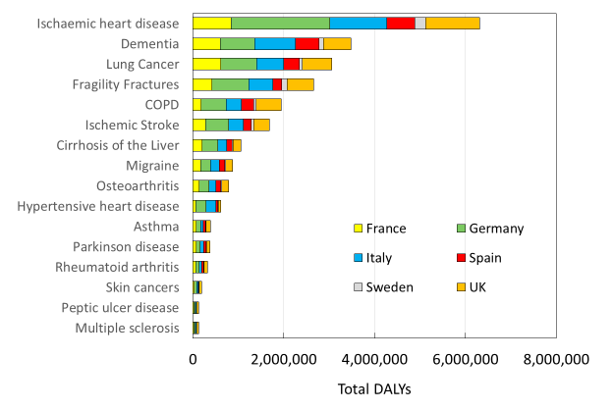
Fig. A 16 Country Contribution to Total DALYs by Disease

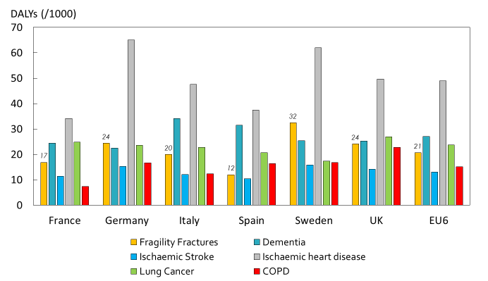

Fig. A 17 Country Comparison - DALYs per 1000 People by Disease

Comments
These results are in line with the previous DALY comparison estimates from Johnell et al 2006 [70], and show that the osteoporosis burden has grown significantly over the past 10 years. The data for the figures shown is provided below.

Supporting data

Table A 23 Total DALYs – Both Genders
Disease | France | Germany | Italy | Spain | Sweden | UK | Total
Multiple sclerosis | 19,127 | 35,331 | 17,886 | 8,890 | 5,362 | 38,181 | 124,777
Peptic ulcer disease | 14,873 | 41,260 | 16,372 | 9,428 | 4,951 | 40,704 | 127,589
Melanoma and other skin cancers | 33,195 | 50,218 | 32,244 | 16,391 | 10,031 | 44,900 | 186,979
Rheumatoid arthritis | 60,201 | 75,209 | 60,483 | 41,305 | 9,299 | 77,425 | 323,921
Parkinson disease | 69,177 | 87,849 | 82,511 | 49,744 | 12,017 | 70,112 | 371,409
Asthma | 77,558 | 94,331 | 56,518 | 50,177 | 13,327 | 91,344 | 383,255
Hypertensive heart disease | 59,759 | 225,050 | 215,324 | 46,498 | 9,695 | 56,834 | 613,160
Osteoarthritis | 142,405 | 212,026 | 152,026 | 105,817 | 21,262 | 153,251 | 786,788
Migraine | 173,153 | 212,722 | 191,854 | 121,083 | 21,054 | 157,503 | 877,369
Cirrhosis of the Liver | 204,023 | 340,499 | 197,945 | 120,945 | 19,454 | 175,447 | 1,058,313
Ischemic Stroke | 280,063 | 508,748 | 318,263 | 172,317 | 59,861 | 341,093 | 1,680,345
COPD | 181,832 | 554,887 | 325,924 | 269,982 | 63,712 | 548,267 | 1,944,604
Fragility Fractures | 416,588 | 814,059 | 525,336 | 198,670 | 122,933 | 579,722 | 2,657,308
Lung Cancer | 612,608 | 787,281 | 597,633 | 342,673 | 65,612 | 646,353 | 3,052,161
Dementia | 604,054 | 751,188 | 897,210 | 520,414 | 96,455 | 606,875 | 3,476,197
Ischemic heart disease | 841,046 | 2,172,490 | 1,249,338 | 618,672 | 234,596 | 1,195,073 | 6,311,215
All Causes | 11,134,742 | 16,761,088 | 12,189,447 | 7,164,753 | 1,823,641 | 11,869,537 | 60,943,207

Table A 24 DALYs per 100,000 – Both Genders
Diseases | France | Germany | Italy | Spain | Sweden | UK | EU6
All Causes | 451 | 502 | 464 | 434 | 482 | 494 | 474
Fragility Fractures | 17 | 24 | 20 | 12 | 32 | 24 | 21
Melanoma and other skin cancers | 1 | 2 | 1 | 1 | 3 | 2 | 1
Dementia | 24 | 22 | 34 | 32 | 25 | 25 | 27
Parkinson disease | 3 | 3 | 3 | 3 | 3 | 3 | 3
Ischemic Stroke | 11 | 15 | 12 | 10 | 16 | 14 | 13
Multiple sclerosis | 1 | 1 | 1 | 1 | 1 | 2 | 1
Migraine | 7 | 6 | 7 | 7 | 6 | 7 | 7
Hypertensive heart disease | 2 | 7 | 8 | 3 | 3 | 2 | 5
Ischemic heart disease | 34 | 65 | 48 | 37 | 62 | 50 | 49
Lung Cancer | 25 | 24 | 23 | 21 | 17 | 27 | 24
COPD | 7 | 17 | 12 | 16 | 17 | 23 | 15
Asthma | 3 | 3 | 2 | 3 | 4 | 4 | 3
Peptic ulcer disease | 1 | 1 | 1 | 1 | 1 | 2 | 1
Cirrhosis of the liver | 8 | 10 | 8 | 7 | 5 | 7 | 8
Rheumatoid arthritis | 2 | 2 | 2 | 3 | 2 | 3 | 3
Osteoarthritis | 6 | 6 | 6 | 6 | 6 | 6 | 6

11: Productivity loss

Background
Most fractures occur in elderly retired patients. However, in Sweden about 20% of fractures occur in pre-retirement ages [14]. If a fracture patient is still employed he/she most likely would be on sick leave during the recovery phase. Work absence both impacts the individual’s income and creates a societal cost due to the loss in productivity. This metric uses survey responses from the International Costs and Utilities Related to Osteoporotic Fractures Study (ICUROS) to estimate the number of sick days in the year after an osteoporotic fracture.

Methods
The ICUROS collected data on fracture consequences over 18 months after fracture. The study enrolled 5,869 patients in 11 countries [53, 71, 72]. About 19% of the study population indicated they were employed before their fracture. The same study design as ICUROS was used in a Swedish study that enrolled 635 patients [42]. In these studies, patients were asked how many days of sick leave they had taken at 4, 12 and 18 months as a consequence of the fracture. For the purpose of this analysis, the results are presented as total days of sick leave the year after hip, vertebral or other (humeral or wrist) fracture. The within-country sample size is modest and only a minority of the patients were at working ages (below 66 years). Therefore, country-specific estimates were not included. Cross country estimates were calculated using data from six of the European ICUROS countries (Austria, Estonia, France, Italy, Sweden, and the UK) and dubbed ICUROS Europe. Russia and Lithuania were excluded from the European estimate because of the low hospitalization rate in relation to fracture which cannot be considered representative for a general European setting. For consistency, Lithuania and Russia were also excluded from the other metrics which used ICUROS data. Spain was dropped from this metric due to lack of data. Fracture rates for the EU6 in 2017 was derived from the burden model and multiplied with average sick days by fracture site, in order to estimate the average number of sick days taken due to fragility fracture, per 1000 people.

Results
Estimates of the annual sick leave by fracture type for ICUROS Europe are shown in Fig. A 18. Hip fractures account for the largest number of sick leave days (42 days) followed by vertebral fracture (20 days). Fig. A 19 shows the number of days taken due to fragility fracture, per 1000 people in each of the EU6 countries. Sick days taken in 2017, by non-retired individuals in the EU6 totalled 7,615,719 days. “Other” major osteoporotic fractures (MOFs) occur significantly more often than hip or clinical vertebral fractures, and therefore resulted in the highest estimated number of sick days taken due to fragility fracture, per 1000 people in all countries, with Sweden showing the highest estimate overall in the EU6. There were no significant differences between sick leave taken by men and women with hip fractures, nor between sick leave taken by hip fracture patients with or without previous fracture.

Fig. A 18 Annual sick leave (days) by fracture type (ICUROS Europe)
*ICUROS Europe= Austria, Estonia, France, Italy, Sweden, and the UK

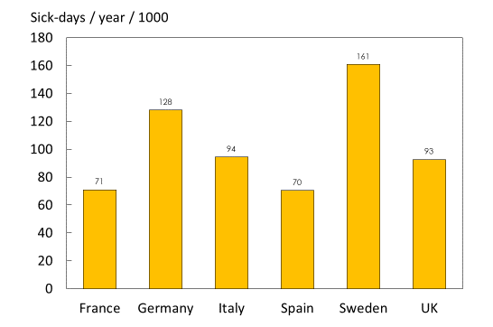

Fig. A 19 Total sick days taken in the EU6 due to fragility fracture, in 2017

Comments
The data included only individuals who indicated they were employed at the time of fracture. As the age limit for retirement rises, it is likely that average productivity loss per capita will increase as people are able to live and work for longer.

12: Caregiver burden

Background
A significant social cost associated with chronic diseases such as osteoporosis is the burden imposed on informal caregivers such as family members. Continued care provided at home can put physical, emotional and financial strain on relatives who need to take care of osteoporotic fracture patients [37, 73]. This metric uses data collected in the International Costs and Utilities Related to Osteoporotic Fractures Study (ICUROS) [53, 71, 72] to determine the caregiver burden due to osteoporotic fracture, in terms of hours of care provided by relatives.

Methods
The ICUROS collected data on fracture consequences over 18 months after fracture. The study enrolled 5,869 patients in 11 countries [53, 71]. The same study design as ICUROS was used in a Swedish study that enrolled 635 patients [42]. In these studies, patients were asked how many hours per week they received care from relatives after their fracture. This question was asked at 4, 12 and 18 months. For the purpose of this analysis, the results are presented as total hours of care for the year given by relatives after an individual’s hip, vertebral or other (humeral or wrist) fracture. Cross country estimates were calculated using data from seven of the European countries from the studies (Austria, Estonia, France, Italy, Spain, Sweden, and the UK) and dubbed ICUROS Europe. To be consistent with the estimation methods across these metrics, Lithuania and Russia were dropped.

Results
Estimates for the total hours of care provided by relatives, per individual per year after a given fracture, are shown in Fig. A 20. These estimates represent the combined average of ICUROS Europe. The results indicate that hip fractures are associated with the largest caregiver burden (370 hours per year) among major osteoporotic fractures, followed by vertebral fractures (263 hours per year). Care from relatives for hip fractures varies greatly by country. In Fig. A 21, estimates are shown for the hours of care provided by relatives for hip fracture patients in ICUROS Europe, as well as five of the countries of interest. Within the five countries of interest, Spain and Italy have the highest caregiver burden, with averages of 744 hours and 652 hours per year spent caring for individuals with osteoporotic hip fractures, respectively. The UK (227 hours) and Sweden (115 hours) have considerably lower averages. There were no significant differences in care from relatives between men and women, nor between patients with or without a previous fracture. Fig. A 22 shows the annual hours of care provided after hip fractures per 1000 individuals. Since Italy and Spain have the highest average hours of care per individual hip fracture, this trend is also present in the hours of care provided per 1000 individuals, with 882 and 756 hours per 1000 people per year, respectively. Sweden was estimated to have more hours of care provided (191 hours per 1000 people per year) than France (138 hours per 1000 people per year), which is driven by fracture incidence and population.

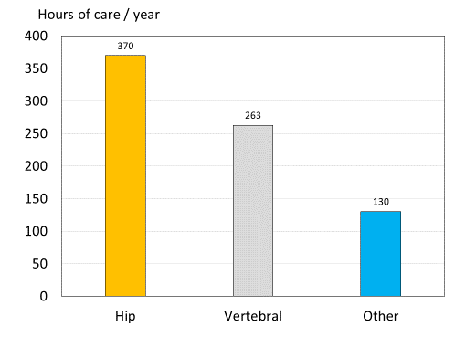
Fig. A 20 Average Annual Hours of Care by Relatives by Fracture Type in seven EU countries (ICUROS Europe)
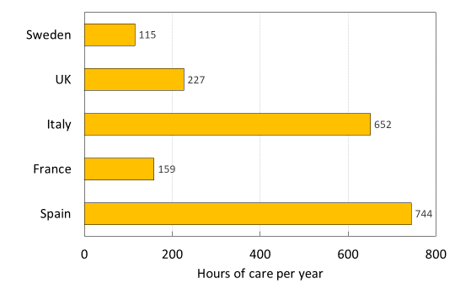

Fig. A 21 Average Annual Hours of Care by Relatives after Hip Fracture by Country
ICUROS Europe= Austria, Estonia, Spain, France, Italy, Sweden, and the UK

Fig. A 22 Annual hours of care provided in the year after hip fracture per 1000 people, by country

Comments
Care provided informally by relatives represents a significant investment of time and energy. Measuring this burden gives individual countries a better understanding of the indirect costs associated with osteoporosis.

13: Independent living

Background
One major potential consequence of a fragility fracture is the long-term impact on independence. The fracture can result in a loss of mobility, the ability to take care of oneself, and may require the individual to move into long-term care (LTC) or elderly care services. This metric uses data from the International Costs and Utilities Related to Osteoporotic Fractures Study (ICUROS) to estimate the proportion of patients that move to a long-term care facility after a fracture.

Methods
The ICUROS collected data on fracture consequences over 18 months after fracture. The study enrolled 5,869 patients in 11 countries [53, 71]. The same study design as ICUROS was used in a Swedish study that enrolled 635 patients [42]. In these studies, patients were asked if they had moved to LTC as a consequence of the fracture. The answers were used to estimate the proportion of patients that had moved from living at home to LTC at 12 months after hip, vertebral or other (humeral or wrist) fracture. Individuals who were living in LTC before their fracture were excluded. Cross country estimates were calculated using data from six of the European countries in these studies (Austria, Estonia, France, Italy, Spain and Sweden) and dubbed ICUROS Europe. To be consistent with the estimation methods across the metrics which used ICUROS, Lithuania and Russia were dropped. Due to lack of data, the UK was excluded.

Results
Fig. A 23 shows the proportion of patients residing in an LTC facility at 12 months after fracture by fracture type. LTC use varies greatly, depending on the fragility fracture and the age of the individual. Hip fractures correspond with the largest proportion of people moving to LTC in all six countries. Comparing LTC use after a hip fracture for different countries (Fig. A 24) shows that Italy has a large percentage (24.9) of hip fracture patients who enter long term care by 12 months, while the average for ICUROS Europe is lower (9.1%). Fig. A 25 shows that female hip fracture patients had a higher probability (12.0%) of moving to LTC compared to male patients (2.3%). There was no significant difference in the use of LTC between fracture patients with or without a previous fracture. Fig. A 26 shows the percentage of individuals in LTC following a hip fracture, based on 10-year age groups. The percentage in LTC 12 months after a hip fracture increases significantly by age group.

Fig. A 23 Percentage (%) in long term care (LTC) at 12 months by fracture site in 6 EU countries (ICUROS Europe)

Fig. A 24 Percentage (%) in long term care (LTC) with hip fracture at 12 months by country (ICUROS Europe = Austria, Estonia, Spain, France, Italy, Sweden)

Fig. A 25 Percentage (%) in long term care (LTC) at 12 months following a hip fracture by sex in five ICUROS countries (Austria, Estonia, Spain, France, Italy).

Fig. A 26 Percentage in LTC 1 year after hip fracture, by age group

Comments
Long-term care represents a large direct non-medical cost for a social health care system. Furthermore, each country provides these services at varying levels. Being able to measure the impact that osteoporotic fractures have on the budget for long term or elderly care can help policy makers in their decision making.

14: Pharmacological treatment gap

Background
The treatment gap in osteoporosis has been estimated previously for the EU6 using IMS Health drug sales data up to the year 2010 [37]. This metric provides an update of the treatment gap in 2017.

Methods
National data on number of patients treated are currently not readily available in many European countries. In the absence of more granular data an alternate approach using international sales data on volume (standard units) and price (€) from IMS Health have previously been used to estimate the treatment gap in osteoporosis [8, 37].
The same method was applied for this analysis. In brief, the method includes the following steps to estimate treatment gap.
- Using IMS sales data to estimate how many treatment years the sales volume, by year, cover.
- Adjusting for low adherence, i.e., the average time on treatment per patient over a year is less than 365 days. The corrective factor was derived from Swedish register data and was 77%. After this correction the number of patients potentially treated during a year is obtained.
- The proportion of the population eligible for treatment was determined using an intervention threshold based on data from FRAX of the 10-year probability of a major osteoporotic fracture of women in the EU6 countries.
- The intervention threshold set was a 10-year probability of a major osteoporotic fracture equivalent to an age-matched female with a fragility fracture [74]
- The treatment gap is obtained by dividing the patients potentially treated with the number of individuals considered to be eligible for treatment.

Also, because the IMS sales data do not differentiate by sex or age, it was assumed that 85% of sales were given to women (based on Swedish data) and all osteoporotic drugs were only given to patients age 50 years or older.
The analysis included data on sales related to osteoporosis drugs for the year 2017. These included: bisphosphonates, denosumab, parathyroid hormones (PTHs), selective oestrogen receptor modulators (SERMs) and strontium ranelate. Note that hormone replacement therapy was not included.
IMS sales data is the best source of comparative data on sales of pharmaceuticals at an international level that allows this type of analysis. However, it is also associated with some shortcomings. For example, previously it was shown that compared to Swedish prescription data the sales data seem to yield a 20% higher treatment uptake implying an underestimation of the treatment gap. [8].

Results
Fig. A 27 shows the number of patients that could be treated in 2017 and 2010 based on IMS sales data, compared to the remaining number of persons eligible for treatment. The average treatment gap (Table A 25 and Table A 26) in EU6 in year 2017 is estimated to be 73% for women and 63% for men. Compared to the analysis from year 2010 this is marked increase (17% and 16% points) in the treatment gap.
The treatment gap varies between countries and the highest treatment gap for women can be found in Germany where less than 20% of the population eligible for treatment receives an osteoporotic drug. Germany also shows the highest treatment gap for men. UK has the smallest treatment gap (64%) in women and men (43%).

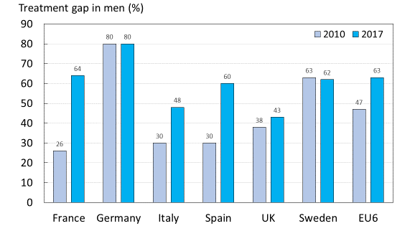
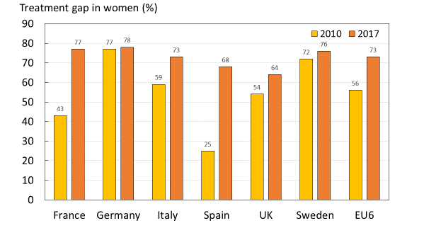

Fig. A 27 The treatment gap in women (upper panel) and men (lower panel) based on potential number of patients treated relative to eligible number of individuals above the intervention threshold.
Note: There was an error in the 2010 estimate for men in the UK [37], which is corrected in the figure above

Table A 25 Number of women eligible for treatment, treated and treatment gap in 2017
Country | Number potentially treated (1000s) | Number exceeding fracture risk threshold (1000s) | Difference (1000s) | Treatment gap (%) | Treatment gap, 2010 (%) [37]
France | 635 | 2,758 | 2,123 | 77 | 43
Germany | 692 | 3,542 | 2,849 | 80 | 77
Italy | 784 | 2,944 | 2,160 | 73 | 59
Spain | 647 | 2,013 | 1,366 | 68 | 25
UK | 971 | 2,690 | 1,720 | 64 | 54
Sweden | 95 | 392 | 296 | 76 | 72
EU6 | 3,825 | 14,340 | 10,515 | 73 | 57

Table A 26 Number of men eligible for treatment, treated and treatment gap in 2017
Country | Number potentially treated (1000s) | Number exceeding fracture risk threshold (1000s) | Difference (1000s) | Treatment gap (%) | Treatment gap, 2010 (%) [37]
France | 112 | 312 | 200 | 64 | 26
Germany | 122 | 619 | 497 | 80 | 80
Italy | 138 | 265 | 127 | 48 | 30
Spain | 114 | 289 | 175 | 60 | 20
UK | 171 | 301 | 130 | 43 | 38*
Sweden | 17 | 45 | 28 | 62 | 63
EU6 | 675 | 1,669 | 994 | 60 | 49
* Note: There was an error in the 2010 estimate for men in the UK leading to a negative estimate. This is corrected in the table above

Comments
This analysis shows that treatment of osteoporosis is poor in the EU6 countries and less than 30% of women and 40% of men receives the treatment that they need. Lack of osteoporosis treatment could lead to increased risk of fracture, increased morbidity and increased costs to society. Note that this analysis assumes that interventions are directed only to individuals at high risk which is unlikely to be invariable. Thus, the estimate of the treatment gap is conservative.

15: Fracture treatment gap

Background
An alternative approach to assessing the treatment gap with fragility fractures is to estimate the proportion of patients starting a pharmacological treatment after a fracture. National estimates can vary greatly, and to conduct such analysis, real world data on fractures and drug use is required for each country. There is a small but growing body of literature that focuses on the post-fracture treatment gap.

Methods
A structured review of published literature was conducted to find country-specific estimates for the gap in treatment following an osteoporotic fracture. Estimates for both hip and all osteoporotic fractures were found for select countries from multiple sources. Available estimates were gathered from a mix of literature, public reports (France [75] and the UK [76]), data on file at UCB (Spain) and data on file at Quantify Research (Sweden). No estimate which met the criteria could be found for Italy or Germany.

Results
The percentage of women starting an osteoporosis-specific pharmacological treatment within a year of an osteoporotic fracture or a hip fragility fracture is shown in Fig. A 28. The analytic methods vary between the estimates making direct comparisons difficult. However, the post-fracture treatment gap can be considered large irrespective of country. In the category of “all osteoporotic fractures,” France has the highest gap in treatment, with 85% of individuals not receiving osteoporosis medications after an osteoporotic fracture. Spain has the lowest treatment gap overall, with 72% of patients not receiving treatment. Hip fractures in Sweden are met with the highest gap in treatment (84%) while in the UK, only 49% of hip fracture victims do not receive treatment after their fracture. The treatment gap is also likely to vary between gender, fracture types and treatment history. Such detailed information is not currently available for all the EU6 countries. Table A 27 presents the treatment gaps after hip or any osteoporotic fracture, by country.
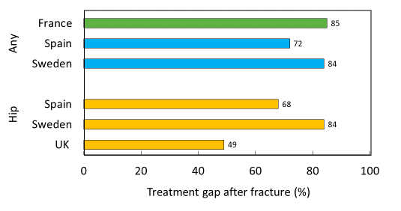

Fig. A 28 Treatment gaps after hip fracture or any osteoporotic fracture, by country

Table A 27 Treatment gaps after hip or any osteoporotic fracture, by country
Country | type | gap | uptake | year
UK | hip | 49% | 51% | 2015
Sweden |  | 84% | 16% | 2013/2014
Spain |  | 89% | 11% | 2015
 | any
Spain |  | 95% | 5% | 2015
France |  | 85% | 15% | 2016
Sweden |  | 84% | 16% | 2013/2014

Comments
The estimates provided include only the literature/data, which met the definition of receiving treatment up to one year after fracture. Other literature sources which did not meet the criteria of the question were excluded.

16: Treatment gap by fracture type

Background
Pharmacological intervention is an important approach to prevent fragility fractures. Yet, this is another area within osteoporosis where a significant gap (patients receiving treatment compared to those eligible for treatment) exists [77]. Previous studies have however relied on sales data rather than drawing on national claims and prescription data.

Methods
Patients with a fracture in 2013 and 2014 were identified from the Swedish National Patient Register (NPR). Their treatment history was extracted from the Swedish Prescribed Drug Register. Patients were defined as treatment-experienced if they had filled at least one prescription for any osteoporosis drug (including HRT) during the three years prior to the fracture. See Table A 28 for a list of products and corresponding ATC codes which defined treatment exposure. If no prescription had been filled, the patient was defined as treatment naïve. The number of patients who were treated (at least one prescription for any osteoporosis drug excluding HRT) the following year after fracture was reported together with the number of deaths. See Table A 29 for a list of products and corresponding ATC codes which defined patients as treated following fracture. Patients with a diagnosis of Paget’s disease or malignancies anytime during the study period (2010-2015) were excluded from the analysis.

Table A 28 Treatments and ATC codes that defined treatment exposure
Treatment | ATC codes | Products
Alendronate | M05BA04 | All
Alendronate + cholecalciferol | M05BB03 | All
Denosumab | M05BX04 | Prolia only
Ibandronate | M05BA06 | Bonviva only
Risedronate | M05BA07 | All
Risedronate + calcium | M05BB02 | All (no longer on the market)
Risedronate + calcium + cholecalciferol | M05BB04 | All (no longer on the market)
Zoledronate | M05BA08 | Aclasta only (prescriptions only)
Etidronate | M05BA01 | All (no longer on the market)
Etidronate + calcium | M05BB01 | All (no longer on the market)
Strontium ranelate | M05BX03 | All (no longer on the market)
Raloxifene | G03XC01 | All
Bazedoxifene | G03XC02 | All
Teriparatide | H05AA02 | All
Parathyroid hormone 1-84 | H05AA03 | All (no longer on the market)
Hormone replacement therapy | G03CA03, G03CA04, G03FA01, G03FA12, G03FA17, G03FB05, G03FB06 | Systemic HRT with indication for osteoporosis only, i.e.: Progynon; Femanest; Estradot 50/75/100 µg/h; Evopad 50/75/100µg/h; Evorel 50/75/100µg/h; Livial; Tibolon Orifarm; Activelle; Kliogest; Cliovelle; Femanor; Estalis; Duova; Indivina; Angemin; Novofem; Trisekvens; Femasekvens; Sequidot; Divina Plus; Trivina,

Table A 29 Treatments and ATC codes that defined post-fracture patients as treated
Treatment | ATC codes | Products
Alendronate | M05BA04 | All
Alendronate + cholecalciferol | M05BB03 | All
Ibandronate | M05BA06 | Bonviva only
Risedronate | M05BA07 | All
Risedronate + calcium | M05BB02 | All (no longer on the market)
Risedronate + calcium + cholecalciferol | M05BB04 | All (no longer on the market)
Etidronate | M05BA01 | All (no longer on the market)
Etidronate + calcium | M05BB01 | All (no longer on the market)
Zoledronate | M05BA08 | Aclasta only (prescriptions only)
Denosumab | M05BX04 | Prolia only
Strontium Ranelate | M05BX03 | All (i.e. Protelos)
Raloxifene | G03XC01 | All
Teriparatide | H05AA02 | All (i.e. Forsteo)

Results
At the time of fracture, a majority of women (75-88%) and men (95-98%) were treatment naïve. Fig. A 29 and Fig. A 30 show the treatment gap following fracture by treatment experience in women and men, respectively. The treatment gap in treatment naïve women within a year following a hip, a MOF or any osteoporotic fracture was around 90%. The treatment gap following a vertebral fracture was 74%. A similar pattern was observed in the male population although treatment gaps were in general higher. Treatment gap in treatment naïve men following a hip, MOF or any osteoporotic fracture was around 95%. The corresponding treatment gap following vertebral fracture was 89%. Fig. A 31 shows the treatment gap following fracture independent of treatment history. In women, the treatment gap was around 84% within one year following fracture with the exception of vertebral fractures (67%). A similar pattern was observed in the male population. Complete results can be found in Table A 30.

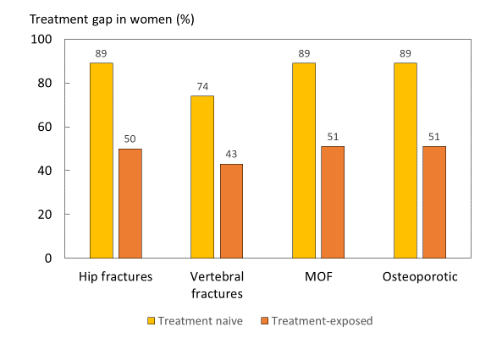

Fig. A 29 Treatment gap in women within one year from fracture in Sweden, by fracture site and treatment history

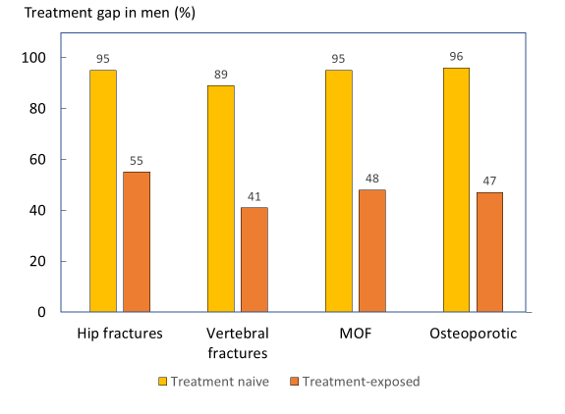

Fig. A 30 Treatment gap in men within one year from fracture in Sweden, by fracture site and treatment history

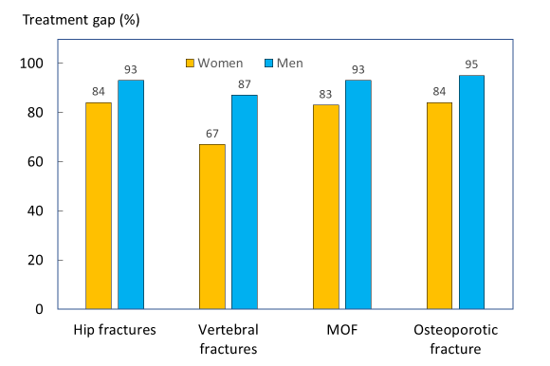
Fig. A 31 Treatment gap (independent of treatment history) within one year from fracture in Sweden, by fracture site and gender

Table A 30 Number of patients treated following fracture (by type) independent of treatment history, in 2013 and 2014, in Sweden
Category | N | No treated within a year | % | No of deaths within a year | No (and %) that started treatment and died within a year
Women
Hip fractures | 19,550 | 3,086 | 15.8% | 4,164 | 200, 4.8%
Vertebral fractures | 6,702 | 2,239 | 33.4% | 775 | 120, 15.5%
MOF | 56,609 | 9,701 | 17.1% | 6,573 | 416, 6.3%
Osteoporotic fractures | 76,974 | 12,426 | 16.1% | 8,193 | 147, 7.4%
Men
Hip fractures | 8,100 | 534 | 6.6% | 2,296 | 45, 2.0%
Vertebral fractures | 3,470 | 460 | 13.3% | 480 | 44, 9.2%
MOF | 18,734 | 1,260 | 6.7% | 3,302 | 530, 6.5%
Osteoporotic fractures | 32,027 | 1,661 | 5.2% | 4,183 | 122, 2.9%

Comments
This analysis shows that the post fracture treatment gap in Sweden is large. That is, few patients with a fragility fracture is prescribed a drug for reducing the risk of further fractures. Treatment initiation is more common following a vertebral fracture compared to other fracture types (hip, NHNS and MOF) in both women and men.

17: Fracture risk assessment

Background
In order to identify individuals for treatment who have the highest risk of fragility fracture, some form of fracture risk assessment is required. With the introduction of Bone Mineral Density (BMD) measurements, the first methods of assessing bone fragility in the elderly became available to medical professionals. However, there are a number of factors that are associated with an increased risk of fracture over and above that provided by BMD. This has led to the development of risk models, which incorporate several risk factors in order to improve the identification of patients at high risk of fracture in primary care and elsewhere [78]. This metric examines the availability of risk models in the six countries of interest, and whether official national guidelines are present for the use of fragility fracture risk assessments.
There are several existing models for risk assessment in Europe, however the most prominently used is FRAX. FRAX is a computer-based algorithm, developed in 2008, that calculates the probability of fracture in individuals using age, body mass index, BMD and dichotomized risk factors such as prior fragility fracture, parental history of hip fracture, tobacco usage, alcohol usage, rheumatoid arthritis and other causes of secondary osteoporosis [74]. The use of BMD measurements in the FRAX model is recommended but optional [79].

Methods
FRAX models are currently available for 64 countries. Country-specific FRAX models can be found on the official FRAX website [79] and are a software option for densitometers and other devices. Other risk assessment models, and guidelines for the use of risk models in each of the countries of interest were obtained from their respective health departments’ websites (sources listed in Table A 31).

Results
Table A 31 provides a summary of the access to FRAX and other risk assessment models and their guidelines in the EU6. Country-specific FRAX models exist in all 6 countries. Alternative assessment models are also recommended in Germany, Italy and the UK. The German DVO model, developed in 2006, is a Germany-specific risk assessment model which requires the use of BMD measurements [80, 81]. DeFra is an Italy-specific extension of the FRAX model, which allows for comparison of the BMD in different fracture sites and the inclusion of more data [82]. QFracture in the UK was developed in 2009 and uses variables which are readily available through healthcare records in the UK. It also utilizes a younger age range than FRAX [83].
Specific guidelines for the use of FRAX and other risk models were found on official national health service websites for all countries except for Italy. The Italian Ministry of Health did not recommend specific risk models but suggested that risk models could be useful in assessing the probability of fragility fracture. Other organizations like the Italian Society for Orthopedics and Traumatology recommended FRAX or DeFra specifically.

Table A 31 Risk models & guidelines available in the countries of interest
Countries | FRAX Model available | Other Models | National Guidance | Comments | Source
France | ✓ | - | ✓ |  | [84]
Germany | ✓ | DVO Model | ✓ |  | [80]
Italy | ✓ | FRAHS, DeFra | ✓ | FRAHS: FRAX-based | [85-87]
Spain | ✓ | - | ✓ |  | [88]
Sweden | ✓ | - | ✓ |  | [89]
UK | ✓ | QFracture | ✓ |  | [90]

Comments
Fracture risk assessment models and guidelines for their use are readily available for the 5 EU countries and Sweden. Risk assessment models based on the FRAX model are available for 23 of the 28 EU member states, and 64 countries worldwide.

18: Use of FRAX

Background
FRAX was launched in 2008 in all EU6 countries. In 2011, Hernlund et al. [37] summarized the use of FRAX in the European Union and this report provides an update of FRAX use in 2017.

Methods
Number of calculations per year was retrieved from the FRAX website and was thereafter combined with population statistics to determine the number of calculations per million in the general population per year. The statistics is based on all usage since the data do not provide the reason for use (e.g. patient assessment, education or research).

Results
The web-based usage of FRAX is shown in Fig. A 32. The UK and Sweden had the highest usage of FRAX, whereas the lowest uptake was seen in Germany. Considering all countries in the EU6 the usage of FRAX increased by almost 75% in 2017 compared to 2011. The highest increase was seen in the UK, France and Sweden (~100%), whereas in both Germany and Italy the usage of FRAX decreased in 2017 compared to 2011. Table A 32 presents the FRAX calculations by country of origin in the EU6.
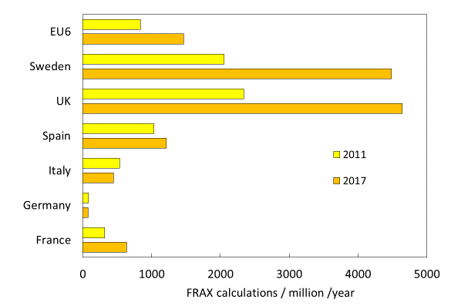

Fig. A 32 FRAX calculations by URL source per million in the general population Nov 2010-2011 and April 2017-2018

Comments
The webpage usage of FRAX has increased in the EU6 in 2017 compared to 2011. That the usage of FRAX has decreased in both Italy and Germany may relate to the availability of other risk models such as the German specific DVO model and DeFra in Italy.
Note that these data do not take account of FRAX calculations made by densitometers, iPhones and hand-held calculators.

Supporting data
Table A 32 FRAX calculations by country of origin in the EU6
Country | Calculations/year | Population (000) | Calculations/million/yr (2017) | Calculations/million/yr (2011) [37] | Difference (%)
France | 42,727 | 67,059 | 637 | 318 | 100
Germany | 6,454 | 84,312 | 77 | 82 | -7
Italy | 27,537 | 61,420 | 448 | 535 | -16
Spain | 57,985 | 47,876 | 1,211 | 1,034 | 17
UK | 315,051 | 67,842 | 4,644 | 2,337 | 99
Sweden | 45,588 | 10,167 | 4,484 | 2,052 | 119
EU6 | 495,342 | 338,677 | 1,463 | 838 | 74

19: Fracture Liaison Service impact

Background
Fracture Liaison Services (FLS) function as a first line of defence against repeat osteoporotic fractures by identifying at-risk patients and referring them to specialists for assessment and preventative treatment. The FLS model was first introduced in teaching hospitals in Scotland and has grown in popularity around the world due to its effectiveness in preventing secondary fractures, and the lower need for doctors in the administration of post-fracture preventative services [91]. A growing body of evidence suggests that FLS is a cost-effective organizational form that reduces the risk of fracture, mortality and increases adherence to treatment [92-98]. This metric summarizes current evidence of FLS patient identification and evaluation, treatment use, adherence, fracture risk, and mortality as well as economic impact.

Methods
The evidence summary was based on published systematic literature reviews evaluating FLS programs. A pragmatic search identified three recent relevant large-scale systematic literature reviews. Wu et al conducted a meta-analysis including 159 publications to estimate the impact of FLS on select patient outcomes: the rate of BMD testing, treatment initiation, adherence to treatment, re-fracture and mortality [99]. Another study by Wu et al focused on the economic impact of FLS [100]. A study by Walters et al reviewed the evidence of different model types (A to D) of FLS on fracture risk, DXA referrals, and other patient outcomes [98].

Results
The main results of the first study by Wu et al 2018 are shown in Table A 33. In the meta-analysis, introduction of FLS was associated with greater than 20% improvements, on average, in the rate of individuals getting BMD tests, starting treatment and adhering to treatment. There was also a small but significant average reduction in the re-fracture and mortality rates.
Estimates from Sweden and the UK for the economic impact of FLS are shown in Table A 34. The Swedish study focused on a hypothetical cohort of 1000 elderly women over 10 years and found that the FLS treatment group saved 19 QALYs or 40 life years in total, resulting in an incremental cost effectiveness ratio (the cost per QALY gained) of €14,029 per QALY gained. In the UK, a study involving an NHS hospital found that FLS were cost effective for both male and female patients, with ICERs of £19,955 (about €22,700) per QALY and £20,421 (about €26,600) per QALY gained, respectively. Another UK study looked at the cost savings of introducing an FLS in an area with 1000 hypothetical patients and found that the FLS saved £21,000 (about €23,800) in total over their lifetimes, with 18 subsequent fractures estimated to be prevented, using the least favourable efficiency data.

Even though the meta-analysis showed an overall positive impact of FLSs, it did not consider that there are several types of FLS models which are likely to be associated with different outcomes. For example, some FLS only identify patients and inform them without taking any further actions whereas other more complete FLS identify, investigate, treat and monitor the patient. There has been no direct quantitative comparison between the different models made, but an analysis by Walters et al 2017 [98] indicated that the FLS models which take full responsibility for investigation and treatment of fragility fractures achieved the best outcomes in terms of cost effectiveness. The re-fracture risk (hazard ratio [HR] 0.18–0.67 over 2–4 years), reduced mortality (HR 0.65 over 2 years), increased assessment of BMD (relative risk [RR] 2–3), increased treatment initiation (RR 1.5–4.25) and adherence to treatment (65%–88% at 1 year).

Comments
Because of the large scale of these review studies, and the lack of country-specific impact estimates for all patient outcomes, this metric focuses mostly on literature which estimates the impact of introducing FLS. The large variation between different types of FLSs and their evaluation complicates the assessment of the overall benefits of FLS and merits of a specific FLS model. Initiatives that promote standardised outcome frameworks for assessing FLS and increased collaboration between providers include the Capture the Fracture® and the UK FLS-Database Audit.

Outcome measure | Effect of FLS (absolute change) | 95% CI | Duration of follow-up (months) | # studies | Source
BMD Testing | +24% | (0.18 to 0.29) | 3-26 | 37 | [99]
Treatment initiation | +20% | (0.16 to 0.25) | 3-72 | 46
Adherence | +22% | (0.13 to 0.31) | 3-48 | 9
Re-fracture | -5% | (-0.08 to -0.03) | 6-72 | 11
Mortality | -3% | (-0.05 to -0.01) | 6-72 | 15
Table A 33 Meta-analysis results for patient outcomes

Table A 34 Country-specific studies on the economic impact of FLS
Country | Type | Estimate | Source
Sweden | ICER (cost-eff) | € 14,029 (per QALY gained) | [101]
UK (Hip patients) | ICER (cost-eff) | €22,700-€26,600 (per QALY gained) | [102]
UK | Cost Savings | €23,800/lifetime/1,000 patients | [95]

20: Capture the Fracture (Fracture Liaison Services)

Background
Fracture Liaison Services (FLS) function as the first line of defence against repeat fragility fractures by identifying at-risk patients and referring them to specialists for assessment and preventative treatment. FLS have been shown to reduce the risk of fracture, mortality and increase adherence to treatment, which raises their quality of life and reduces societal costs[92, 94, 96-98].
However, there are currently no official international standards for, nor much collaboration between FLS providers in different countries. This gives rise to varying standards and practices on a national and sometimes local basis. One endeavour to encourage cooperation between FLS providers is Capture the Fracture, a global initiative to “facilitate the implementation of coordinated, multi-disciplinary models of care for secondary fracture prevention” [94].

Methods
Capture the Fracture (CtF) has created a set of internationally endorsed standards and guides for best practice and has assembled the largest network of individual FLS providers in the world. The program is organized by a steering committee of medical and academic professionals from a variety of backgrounds.
CtF provides resources, tools and educational programmes to bridge the gap between FLS providers and aids in the establishment of new FLS. They connect experienced FLS professionals with prospective providers to offer auditing, consulting and can then guide the assembly of a team to oversee FLS in the interested party’s area. This ensures that the new FLS will also match the guidelines CtF promotes.

Results
This growing network of FLS providers is mapped (Fig. A 33) on their website and provides a rating of the existing service providers in a given area. To be included in this network, the provider must undergo CtF’s audit in order to determine the quality of their services.
A gold, silver or bronze is awarded to the FLS provider according to the average rating of each of the services they provide. Green stars represent providers currently under review and blue stars are providers that are just getting started. Table A 35 shows the star ratings for registered FLS providers in the countries of interest. A value of 4, 3 and 2 was applied to gold, silver and bronze, respectively and a 1 to providers currently under review or just getting started. However, because the CtF does not include all FLS it is difficult to draw any conclusion regarding the quality of FLS provision on a national level.
To date, Spain has by far the most registered FLS and gold rated providers, and Sweden has the highest average overall FLS rating. One crucial factor to note is the relatively low numbers of registered FLS providers in Sweden and Germany. As discussed in other metrics, both these countries have higher than average incidence of fragility fractures, and have, therefore, a greater need for FLS providers.

Comments
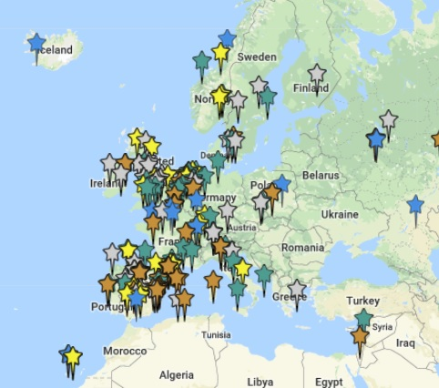
This a survey of the responsiveness of countries to the IOF Capture the Fracture initiative, and not a survey of the FLS themselves. Capture the Fracture not only helps to standardize Fracture Liaison Services but encourages cooperation between FLS providers. This in turn can allow for improved sharing of best practices and data that will promote a more efficient delivery of FLS.

Fig. A 33 Capture the Fracture's map of best practice

Table A 35 FLS ratings by country.
Country | Total | Gold | Silver | Bronze | Green | Blue | Score
France | 20 | 0 | 3 | 9 | 1 | 7 | 35
Germany | 2 | 0 | 1 | 0 | 1 | 0 | 4
Italy | 13 | 1 | 3 | 2 | 3 | 4 | 24
Spain | 65 | 13 | 13 | 22 | 9 | 8 | 152
Sweden | 5 | 0 | 4 | 1 | 0 | 0 | 14
UK | 25 | 6 | 11 | 1 | 7 | 0 | 66
All | 130 | 20 | 35 | 35 | 2 | 19 | 295

References

1. Kanis JA, Melton LJ, 3rd, Christiansen C, Johnston CC, Khaltaev N (1994) The diagnosis of osteoporosis. J Bone Miner Res 9:1137-1141
2. Looker AC, Wahner HW, Dunn WL, Calvo MS, Harris TB, Heyse SP, Johnston CC, Jr., Lindsay R (1998) Updated data on proximal femur bone mineral levels of US adults. Osteoporos Int 8:468-489
3. Kanis JA, Johnell O, Oden A, Jonsson B, De Laet C, Dawson A (2000) Risk of hip fracture according to the World Health Organization criteria for osteopenia and osteoporosis. Bone 27:585-590
4. Cawston H, Maravic M, Fardellone P, Gauthier A, Kanis JA, Compston J, Borgstrom F, Cooper C, McCloskey E (2012) Epidemiological burden of postmenopausal osteoporosis in France from 2010 to 2020: estimations from a disease model. Arch Osteoporos 7:237-246
5. Gauthier A, Kanis JA, Jiang Y, Dreinhofer K, Martin M, Compston J, Borgstrom F, Cooper C, McCloskey E (2012) Burden of postmenopausal osteoporosis in Germany: estimations from a disease model. Arch Osteoporos 7:209-218
6. Svedbom A, Hernlund E, Ivergard M, Compston J, Cooper C, Stenmark J, McCloskey EV, Jonsson B, Kanis JA (2013) Osteoporosis in the European Union: a compendium of country-specific reports. Arch Osteoporos 8:137
7. Oden A, McCloskey EV, Johansson H, Kanis JA (2013) Assessing the impact of osteoporosis on the burden of hip fractures. Calcif Tissue Int 92:42-49
8. Strom O, Borgstrom F, Kanis JA, Compston J, Cooper C, McCloskey EV, Jonsson B (2011) Osteoporosis: burden, health care provision and opportunities in the EU: a report prepared in collaboration with the International Osteoporosis Foundation (IOF) and the European Federation of Pharmaceutical Industry Associations (EFPIA). Arch Osteoporos 6:59-155
9. United Nations DESA / Population Division. (2017) World Population Prospects 2017. https://esa.un.org/unpd/wpp/Download/Standard/Population/.
10. Eurostat (2015) People in the EU: who are we and how do we live?
11. Icks A, Haastert B, Wildner M, Becker C, Meyer G (2008) Trend of hip fracture incidence in Germany 1995–2004: a population-based study. Osteoporosis international 19:1139-1145
12. Diez A, Puig J, Martinez MT, Diez JL, Aubia J, Vivancos J (1989) Epidemiology of fractures of the proximal femur associated with osteoporosis in Barcelona, Spain. Calcified tissue international 44:382-386
13. Elffors I, Allander E, Kanis J, Gullberg B, Johnell O, Dequeker J, Dilsen G, Gennari C, Vaz AL, Lyritis G (1994) The variable incidence of hip fracture in southern Europe: the MEDOS Study. Osteoporosis international 4:253-263
14. Kanis J, Johnell O, Oden A, Sernbo I, Redlund-Johnell I, Dawson A, De Laet C, Jonsson B (2000) Long-term risk of osteoporotic fracture in Malmö. Osteoporosis international 11:669-674
15. Piscitelli P, Chitano G, Johannson H, Brandi ML, Kanis JA, Black D (2013) Updated fracture incidence rates for the Italian version of FRAX®. Osteoporosis International 24:859-866
16. Izquierdo MS, Ochoa CS, Sánchez IB, Hidalgo MP, del Valle Lozano F, Martín TG (1997) Epidemiology of osteoporotic hip fractures in the province of Zamora (1993). Revista espanola de salud publica 71:357-367
17. Sosa M, Segarra M, Hernández D, González A, Limiñana J, Betancor P (1993) Epidemiology of proximal femoral fracture in Gran Canaria (Canary Islands). Age and ageing 22:285-288
18. Curtis EM, van der Velde R, Moon RJ, van den Bergh JP, Geusens P, de Vries F, van Staa TP, Cooper C, Harvey NC (2016) Epidemiology of fractures in the United Kingdom 1988–2012: variation with age, sex, geography, ethnicity and socioeconomic status. Bone 87:19-26
19. Institut national de la statistique et des études économiques (INSEE) (2015) Quotient de mortalité Q(x, x+1) pour 100 000 survivants à l'âge x (âge en années révolues) [Mortality Quotient Q (x, x + 1) per 100,000 survivors at age x (age in completed years)]. https://www.insee.fr/fr/statistiques/2851503?sommaire=2851587
20. Statistisches Bundesamt (DESTATIS) (2014) Life table (period life table): Germany, years, sex, completed age. Probability of death [q(x)]. https://www-genesis.destatis.de/genesis/online/data;jsessionid=250F248D9F4C7473F40C9067A9774254.tomcat_GO_2_1?operation=abruftabelleBearbeiten&levelindex=2&levelid=1517322385357&auswahloperation=abruftabelleAuspraegungAuswaehlen&auswahlverzeichnis=ordnungsstruktur&auswahlziel=werteabruf&selectionname=12621-0001&auswahltext=%23Z-01.01.2014%23SGES-
21. Instituto Nacional de Estadistica (INE) (2016) Tablas de mortalidad de la población de España por año, sexo, edad y funciones [Tables of mortality of the population of Spain by year, sex, age and functions]. http://www.ine.es/jaxi/Datos.htm?path=/t20/p319a/serie/p02/l0/&file=02001.px
22. Istituto Nazionale di Statistica (ISTAT) (2016) Probabilità di morte (per 1000) [Probability of death (per 1000)]. http://dati.istat.it/Index.aspx?lang=it&SubSessionId=46db532d-c21a-48a4-8745-b5611c62e6c8&themetreeid=21#
23. Statistiska Centralbyrån (SCB) (2016) Ettårig livslängdstabell, dödsrisker (promille) efter kön, ålder och år [One-year life-table, deaths (per 1000 ) by sex, age and year]. http://www.statistikdatabasen.scb.se/sq/44505
24. Office for National Statistics (ONS) (2014-2016) National life tables: Great Britain. Mortality rate. https://www.ons.gov.uk/peoplepopulationandcommunity/birthsdeathsandmarriages/lifeexpectancies/datasets/nationallifetablesgreatbritainreferencetables
25. World Health Organization (2013) Priority diseases and reasons for inclusion: Acute stroke. http://www.who.int/medicines/areas/priority_medicines/Ch6_6Stroke.pdf Accessed 04/12/2018
26. Lloyd-Jones DM, Leip EP, Larson MG, D'Agostino RB, Beiser A, Wilson PW, Wolf PA, Levy D (2006) Prediction of lifetime risk for cardiovascular disease by risk factor burden at 50 years of age. Circulation 113:791-798
27. (SCB) SS (2017) Population statistics. https://www.scb.se/en/finding-statistics/statistics-by-subject-area/population/population-composition/population-statistics/#_TablesintheStatisticalDatabase Accessed 2018-03-14 2018
28. Johansson H, Siggeirsdottir K, Harvey NC, Oden A, Gudnason V, McCloskey E, Sigurdsson G, Kanis JA (2017) Imminent risk of fracture after fracture. Osteoporos Int 28:775-780
29. Bonafede M, Shi N, Barron R, Li X, Crittenden DB, Chandler D (2016) Predicting imminent risk for fracture in patients aged 50 or older with osteoporosis using US claims data. Arch Osteoporos 11:26
30. Nordström P, Gustafson Y, Michaëlsson K, Nordström A (2015) Length of hospital stay after hip fracture and short term risk of death after discharge: a total cohort study in Sweden. Bmj 350:h696
31. Roux C, Briot K (2017) Imminent fracture risk. Osteoporos Int 28:1765-1769
32. Maravic M, Jouaneton B, Vainchtock A, Tochon V (2012) Economic burden of osteoporosis in women: data from the 2008 French hospital database (PMSI). Clin Exp Rheumatol 30:222-227
33. Bassgen K, Westphal T, Haar P, Kundt G, Mittlmeier T, Schober HC (2013) Population-based prospective study on the incidence of osteoporosis-associated fractures in a German population of 200,413 inhabitants. J Public Health (Oxf) 35:255-261
34. Carnevale V, Nieddu L, Romagnoli E, Bona E, Piemonte S, Scillitani A, Minisola S (2006) Osteoporosis intervention in ambulatory patients with previous hip fracture: a multicentric, nationwide Italian survey. Osteoporos Int 17:478-483
35. Caeiro JR, Bartra A, Mesa-Ramos M, Etxebarria I, Montejo J, Carpintero P, Sorio F, Gatell S, Farre A, Canals L (2017) Burden of First Osteoporotic Hip Fracture in Spain: A Prospective, 12-Month, Observational Study. Calcif Tissue Int 100:29-39
36. Leal J, Gray A, Prieto-Alhambra D, Arden NK, Cooper C, Javaid M, Judge A, group Rs (2016) Impact of hip fracture on hospital care costs: a population-based study. Osteoporosis International 27:549-558
37. Hernlund E, Svedbom A, Ivergård M, Compston J, Cooper C, Stenmark J, McCloskey EV, Jönsson B, Kanis JA (2013) Osteoporosis in the European Union: medical management, epidemiology and economic burden. Archives of osteoporosis 8:136
38. Stevenson M, Davis S (2006) Analyses of the cost-effectiveness of pooled alendronate and risedronate, compared with strontium ranelate, raloxifene, etidronate and teriparatide. The University of Sheffield, School of Health and Related Research
39. Stevenson M, Davis S, Kanis J (2006) The hospitalisation costs and out-patient costs of fragility fractures. Women's Health Medicine 3:149-151
40. Brecht J, Kruse H, Felsenberg D, Möhrke W, Oestreich A, Huppertz E (2003) Pharmacoeconomic analysis of osteoporosis treatment with risedronate. International journal of clinical pharmacology research 23:93-105
41. Visentin P, Ciravegna R, Fabris F (1997) Estimating the cost per avoided hip fracture by osteoporosis treatment in Italy. Maturitas 26:185-192
42. Borgström F, Zethraeus N, Johnell O, Lidgren L, Ponzer S, Svensson O, Abdon P, Ornstein E, Lunsjö K, Thorngren KG (2006) Costs and quality of life associated with osteoporosis-related fractures in Sweden. Osteoporosis international 17:637-650
43. Lange A, Zeidler J, Braun S (2014) One-year disease-related health care costs of incident vertebral fractures in osteoporotic patients. Osteoporosis International 25:2435-2443
44. Hart W, Rubio-Terres C, Burrell A, Aristegui I, Escobar-Jiménez F (2002) Análisis farmacoeconómico del tratamiento de la osteoporosis postmenopáusica con risedronato o alendronato. Revista Española de Enfermedades Metabólicas Óseas 11:97-104
45. Gutiérrez L, Roskell N, Castellsague J, Beard S, Rycroft C, Abeysinghe S, Shannon P, Gitlin M, Robbins S (2012) Clinical burden and incremental cost of fractures in postmenopausal women in the United Kingdom. Bone 51:324-331
46. Ström O, Borgström F, Sen S, Boonen S, Haentjens P, Johnell O, Kanis J (2007) Cost-effectiveness of alendronate in the treatment of postmenopausal women in 9 European countries-an economic evaluation based on the fracture intervention trial. Osteoporosis international 18:1047-1061
47. Jönsson B, Ström O, Eisman JA, Papaioannou A, Siris E, Tosteson A, Kanis JA (2011) Cost-effectiveness of denosumab for the treatment of postmenopausal osteoporosis. Osteoporosis international 22:967-982
48. Gutiérrez L, Roskell N, Castellsague J, Beard S, Rycroft C, Abeysinghe S, Shannon P, Robbins S, Gitlin M (2011) Study of the incremental cost and clinical burden of hip fractures in postmenopausal women in the United Kingdom. Journal of medical economics 14:99-107
49. Davis S, Martyn-St James M, Sanderson J, Stevens J, Goka E, Rawdin A, Sadler S, Wong R, Campbell F, Stevenson M, Strong M, Selby P, Gittoes N (2015) Bisphosphonates for preventing osteoporotic fragility fractures (including a partial update of NICE technology appraisal guidance 160 and 161). Technology Assessment Report: Final report to the National Institute for Health and Care Excellence.
50. Borgstrom F, Sobocki P, Strom O, Jonsson B (2007) The societal burden of osteoporosis in Sweden. Bone 40:1602-1609
51. Eurostat (2017) Healthcare expenditure statistics. http://ec.europa.eu/eurostat/statistics-explained/index.php/Healthcare_expenditure_statistics
52. Sassi F (2006) Calculating QALYs, comparing QALY and DALY calculations. Health Policy Plan 21:402-408
53. Svedbom A, Borgstrom F, Hernlund E, Strom O, Alekna V, Bianchi ML, Clark P, Curiel MD, Dimai HP, Jurisson M, Uuskula A, Lember M, Kallikorm R, Lesnyak O, McCloskey E, Ershova O, Sanders KM, Silverman S, Tamulaitiene M, Thomas T, Tosteson ANA, Jonsson B, Kanis JA (2017) Quality of life after hip, vertebral, and distal forearm fragility fractures measured using the EQ-5D-3L, EQ-VAS, and time-trade-off: results from the ICUROS. Qual Life Res 27(3):707-716
54. Szende A, anssen B, and Cabases J (2014) Self-reported population health: an international perspective based on EQ-5D. Dordrecht (NL): Springer
55. Johnell O, Kanis, J.A., Odén, A. et al.,, (2004) Mortality after osteoporotic fractures. Ostoporos Intl 15: 38-42
56. World Health Organization (2018) Metrics: Disability-Adjusted Life Year (DALY). http://www.who.int/healthinfo/global_burden_disease/metrics_daly/en/ Accessed 12/10/2017
57. Kanis JA, Oden A, Johnell O, Jonsson B, de Laet C, Dawson A (2001) The burden of osteoporotic fractures: a method for setting intervention thresholds. Osteoporos Int 12:417-427
58. Barrett JA, Baron JA, Beach ML (2003) Mortality and pulmonary embolism after fracture in the elderly. Osteoporos Int 14:889-894
59. Office for National Statistics (2018) Population Estimates for UK, England and Wales, Scotland and Northern Ireland. https://www.ons.gov.uk/peoplepopulationandcommunity/populationandmigration/populationestimates/datasets/populationestimatesforukenglandandwalesscotlandandnorthernireland
60. Statistiches Bundesamt (2016) Genesis: Population Tables. https://www-genesis.destatis.de/genesis/online/link/tabellen/12411*&language=en
61. Statistika Centralbyrån (2018) Folkmängden efter region, civilstånd, ålder och kön. År 1968 - 2016. http://www.statistikdatabasen.scb.se/pxweb/sv/ssd/START__BE__BE0101__BE0101A/BefolkningNy/?rxid=86abd797-7854-4564-9150-c9b06ae3ab07
62. Institut national d'études démographiques (2018) Population by age. https://www.ined.fr/en/everything_about_population/data/france/population-structure/population-age/ Accessed 01/02/2018
63. Istituto Nazionale di Statistica (2018) I.Stat: Data by Theme. http://dati.istat.it/?lang=en
64. European Statistical System (2018) Census Data by Country. https://ec.europa.eu/CensusHub2/query.do?step=selectHyperCube&qhc=false Accessed 01/02/2018
65. World Health Organization (2018) Disability weights based on patient-reported data from a multinational injury cohort. http://www.who.int/bulletin/volumes/94/11/BLT-16-172155-table-T3.html
66. Kanis JA, Oden A, Johnell O, De Laet C, Jonsson B, Oglesby AK (2003) The components of excess mortality after hip fracture. Bone 32:468-473
67. Kanis JA, Oden A, Johnell O, De Laet C, Jonsson B (2004) Excess mortality after hospitalisation for vertebral fracture. Osteoporos Int 15:108-112
68. Dept. of Information EaRW, , (2017) WHO Methods and Data Sources for Global Burden of Disease Estimates 2000-2015. http://www.who.int/healthinfo/global_burden_disease/GlobalDALYmethods_2000_2015.pdf Accessed 01/17/2017
69. Institute for Health Metrics and Evaluation (IHME) (2016) GBD Compare Data Visualization. https://vizhub.healthdata.org/gbd-compare/
70. Johnell O, Kanis JA (2006) An estimate of the worldwide prevalence and disability associated with osteoporotic fractures. Osteoporos Int 17:1726-1733
71. Borgstrom F, Lekander I, Ivergard M, Strom O, Svedbom A, Alekna V, Bianchi ML, Clark P, Curiel MD, Dimai HP, Jurisson M, Kallikorm R, Lesnyak O, McCloskey E, Nassonov E, Sanders KM, Silverman S, Tamulaitiene M, Thomas T, Tosteson AN, Jonsson B, Kanis JA (2013) The International Costs and Utilities Related to Osteoporotic Fractures Study (ICUROS)--quality of life during the first 4 months after fracture. Osteoporos Int 24:811-823
72. Svedbom A, Borgstom F, Hernlund E, Strom O, Alekna V, Bianchi ML, Clark P, Curiel MD, Dimai HP, Jurisson M, Kallikorm R, Lember M, Lesnyak O, McCloskey E, Sanders KM, Silverman S, Solodovnikov A, Tamulaitiene M, Thomas T, Toroptsova N, Uuskula A, Tosteson ANA, Jonsson B, Kanis JA (2018) Quality of life for up to 18 months after low-energy hip, vertebral, and distal forearm fractures-results from the ICUROS. Osteoporos Int 29:557-566
73. Kaffashian S, Raina P, Oremus M, Pickard L, Adachi J, Papadimitropoulos E, Papaioannou A (2011) The burden of osteoporotic fractures beyond acute care: the Canadian Multicentre Osteoporosis Study (CaMos). Age Ageing 40:602-607
74. Kanis JA, Harvey NC, Cooper C, Johansson H, Oden A, McCloskey EV (2016) A systematic review of intervention thresholds based on FRAX : A report prepared for the National Osteoporosis Guideline Group and the International Osteoporosis Foundation. Arch Osteoporos 11:25
75. l’Assurance Maladie (2016) Améliorer la qualité du système de santé et maîtriser les dépenses. Propositions de l’Assurance Maladie pour 2016, 2016 edn
76. Klop C, Gibson-Smith D, Elders PJ, Welsing PM, Leufkens HG, Harvey NC, Bijlsma JW, van Staa TP, de Vries F (2015) Anti-osteoporosis drug prescribing after hip fracture in the UK: 2000-2010. Osteoporos Int 26:1919-1928
77. Harvey NC, McCloskey EV, Mitchell PJ, Dawson-Hughes B, Pierroz DD, Reginster JY, Rizzoli R, Cooper C, Kanis JA (2017) Mind the (treatment) gap: a global perspective on current and future strategies for prevention of fragility fractures. Osteoporos Int 28:1507-1529
78. Kanis JA, Borgstrom F, Compston J, Dreinhofer K, Nolte E, Jonsson L, Lems WF, McCloskey EV, Rizzoli R, Stenmark J (2013) SCOPE: a scorecard for osteoporosis in Europe. Arch Osteoporos 8:144
79. University of Sheffield (2008) FRAX Fracture Risk Assessment Tool. https://www.sheffield.ac.uk/FRAX/
80. Deutschsprachigen Wissenschaftlichen Osteologischen (2014) DVO Leitlinie Osteoporose 2014 Kurzfassung und Langfassung http://www.dv-osteologie.org/dvo_leitlinien/osteoporose-leitlinie-2014 Accessed 03/06/2018
81. Rendl S, Lapa C, Blumel C, Bundschuh RA, Schneider P (2013) Decision making for osteoporotic treatment using FRAX or DVO risk algorithms in a clinical setting. J Musculoskelet Neuronal Interact 13:339-345
82. Bonaccorsi G, Fila E, Cervellati C, Romani A, Giganti M, Rossini M, Greco P, Massari L (2015) Assessment of Fracture Risk in A Population of Postmenopausal Italian Women: A Comparison of Two Different Tools. Calcif Tissue Int 97:50-57
83. National Clinical Guideline C (2012) National Institute for Health and Clinical Excellence: Guidance. Osteoporosis: Fragility Fracture Risk: Osteoporosis: Assessing the Risk of Fragility Fracture. Royal College of Physicians (UK) National Clinical Guideline Centre., London
84. l'Assurance Maladie (2018) Ostéoporose : diagnostic et évolution. https://www.ameli.fr/loiret/assure/sante/themes/osteoporose/diagnostic-evolution Accessed 03/06/2018
85. Tarantino U, Iolascon G, Cianferotti L, Masi L, Marcucci G, Giusti F, Marini F, Parri S, Feola M, Rao C, Piccirilli E, Zanetti EB, Cittadini N, Alvaro R, Moretti A, Calafiore D, Toro G, Gimigliano F, Resmini G, Brandi ML (2017) Clinical guidelines for the prevention and treatment of osteoporosis: summary statements and recommendations from the Italian Society for Orthopaedics and Traumatology. J Orthop Traumatol 18:3-36
86. Ministero della Salute (Italian Ministry of Health) (2011) 1.12. Prevenzione delle fratture da fragilità. http://www.rssp.salute.gov.it/rssp/paginaParagrafoRssp.jsp?sezione=risposte&capitolo=interventi&id=2745 Accessed 02/27/2018
87. Societa Italiana di Ortopedia e Traumatologia (2017) Le Linee Guida. http://www.siot.it/pagine/soci/linee-guida.html Accessed 03/13/2018
88. Ministerio de Sanidad SSeI, , (Spanish Ministry of Health) (2010) Guía de Práctica Clínica sobre Osteoporosis y Prevención de Fracturas por Fragilidad. http://www.guiasalud.es/GPC/GPC_476_Osteoporosis_AIAQS_compl.pdf Accessed 02/27/2018
89. Socialstyrelsen (The Swedish Welfare Agency) (2018) Nationella riktlinjer för rörelseorganens sjukdomar – stöd för styrning och ledning. http://www.socialstyrelsen.se/publikationer2012/2012-5-1 Accessed 02/27/2017
90. The National Institute for Health and Care Excellence (NICE) (2018) Osteoporosis: assessing the risk of fragility fracture. https://www.nice.org.uk/guidance/cg146/chapter/1-guidance Accessed 02/27/2018
91. Mitchell PJ (2011) Fracture Liaison Services: the UK experience. Osteoporos Int 22 Suppl 3:487-494
92. Eekman DA, van Helden SH, Huisman AM, Verhaar HJ, Bultink IE, Geusens PP, Lips P, Lems WF (2014) Optimizing fracture prevention: the fracture liaison service, an observational study. Osteoporos Int 25:701-709
93. Huntjens KM, van Geel TA, van den Bergh JP, van Helden S, Willems P, Winkens B, Eisman JA, Geusens PP, Brink PR (2014) Fracture liaison service: impact on subsequent nonvertebral fracture incidence and mortality. J Bone Joint Surg Am 96:e29
94. International Osteoporosis Foundation (2018) Capture the Fracture. http://www.capture-the-fracture.org/
95. McLellan AR, Wolowacz SE, Zimovetz EA, Beard SM, Lock S, McCrink L, Adekunle F, Roberts D (2011) Fracture liaison services for the evaluation and management of patients with osteoporotic fracture: a cost-effectiveness evaluation based on data collected over 8 years of service provision. Osteoporos Int 22:2083-2098
96. Nakayama A, Major G, Holliday E, Attia J, Bogduk N (2016) Evidence of effectiveness of a fracture liaison service to reduce the re-fracture rate. Osteoporos Int 27:873-879
97. Schray D, Neuerburg C, Stein J, Gosch M, Schieker M, Bocker W, Kammerlander C (2016) Value of a coordinated management of osteoporosis via Fracture Liaison Service for the treatment of orthogeriatric patients. Eur J Trauma Emerg Surg 42:559-564
98. Walters S, Khan T, Ong T, Sahota O (2017) Fracture liaison services: improving outcomes for patients with osteoporosis. Clin Interv Aging 12:117-127
99. Wu CH, Tu ST, Chang YF, Chan DC, Chien JT, Lin CH, Singh S, Dasari M, Chen JF, Tsai KS (2018) Fracture liaison services improve outcomes of patients with osteoporosis-related fractures: A systematic literature review and meta-analysis. Bone 111:92-100
100. Wu CH, Kao IJ, Hung WC, Lin SC, Liu HC, Hsieh MH, Bagga S, Achra M, Cheng TT, Yang RS (2018) Economic impact and cost-effectiveness of fracture liaison services: a systematic review of the literature. Osteoporos Int 29(6):1227-1242
101. Jonsson E, Borgström F, Ström O (2016) PHS49 - Cost Effectiveness Evaluation of Fracture Liaison Services for the Management of Osteoporosis in Sweden. Value in Health 19: A612
102. Leal J, Gray AM, Hawley S, Prieto-Alhambra D, Delmestri A, Arden NK, Cooper C, Javaid MK, Judge A (2017) Cost-Effectiveness of Orthogeriatric and Fracture Liaison Service Models of Care for Hip Fracture Patients: A Population-Based Study. J Bone Miner Res 32:203-211

