Two-dimensional apodized grating coupler for polarization-independent and surface-normal optical coupling
Zanyun Zhang, Xia Chen, Qian Cheng, Ali Z. Khokhar, Zan Zhang, Xingzhao Yan, Beiju Huang, Hongda Chen, Hongwei Liu, Hongqiang Li, David J. Thomson, and Graham T. Reed
Abstract—A four-port grating coupler with etched square holes is proposed and demonstrated for surface-normal and polarization independent coupling. Benefiting from the perfectly vertical coupling and 1×4 power splitting/combing scheme, efficient polarization independent operation was achieved. The coupling efficiency was further improved by grating apodization. According to the simulations, the proposed two-dimensional (2D) apodized grating coupler can achieve a coupling efficiency (CE) of 64.5% (-1.9dB), a low upward back-reflection of 8.5% (-11dB) and polarization-dependent loss (PDL) lower than 0.04dB across the wavelength range of 1520-1620nm. A CE of 56.3% (-2.5dB) was experimentally measured, with PDL below 0.4dB within the C-band and lower than 0.7dB within the L-band. Waveguide delay lines were used to compensate the waveguide channel phase differences at the output port.

Index Terms— Apodized grating coupler, Polarization independent, Surface-normal, Two-dimensional grating coupler

Introduction
T
HE silicon-on-insulator (SOI) platform has attracted great attention due to its strong optical confinement and CMOS compatibility, thus allows for large-scale integration and high volume production [1]-[3]. However, the submicron sized waveguide leads to a large mode size mismatch for coupling to a single mode fiber (SMF) with a fiber core diameter of several micrometers. Grating couplers (GCs) are a superior solution for converting a highly confined waveguide mode to a micrometer-scale grating diffraction mode, thus enabling efficient coupling to a SMF. Compared to edge couplers with inverse-tapers, GCs exhibit the advantages of having no restriction on their location on the chip, large alignment tolerance and wafer-scale testing capability due to its surface coupling scheme [4],[5]. Conventional one-dimensional (1D) GCs are highly polarization sensitive because of the structural birefringence between the TE mode and the TM mode. Normally, the input light in the optical fiber has a random state of polarization and the polarization can’t be preserved while propagating in standard SMF. In order to achieve polarization independent operation, various 1D GCs were proposed and demonstrated [6]-[10], which can couple both the P-polarized light (electric field parallel to the symmetry axis of the GC) and the S-polarized light (electric field perpendicular to the symmetry axis of the GC) from fibre into the corresponding TM and TE mode in the waveguides. However, as most photonic devices are operated in TE mode only, an additional polarization splitter and rotator are required to convert all the light into the TE mode, which increases the design complexity and footprint. Two dimensional (2D) GCs [11]-[13] are proposed as a more efficient way to tackle this issue. They can couple an arbitrarily polarized light and split the two orthogonal wave components into the TE modes of two waveguides.
In the work mentioned above, the SMF aligned to the 2D GC is slightly tilted to reduce the second order back-reflection. This tilted coupling scheme results in different coupling spectra of the P-polarized light and the S-polarized light, thus introducing polarization dependent loss (PDL). Many approaches are proposed and demonstrated to reduce the PDL, including utilizing an active scheme with phase shifters [14], adopting a slanted array of grating cells [16], optimizing the etching pattern of grating cells [15]-[17] and using multi-layer grating coupler designs [18]. Among those approaches, the best results were achieved using asymmetric etching patterns. A PDL below 0.3dB and 0.2dB were demonstrated for 2D GCs operating in the O band and the C band respectively [16],[17]. However, all the designs mentioned above were only adopting special structures in the gratings to compensate the birefringence caused by a tilted coupling scheme. There has been limited works [19],[20] to achieve polarization independent coupling with a surface-normal coupling scheme, which is the root approach to eliminate PDL. However, in these works only two ports were utilized and limited efficiency was achieved.
In this paper, we propose and demonstrate, for the first time, a polarization independent surface-normal grating coupler with an apodized two-dimensional grating structure. Through a four-waveguide port design, polarization independent operation is achieved with a back-to-back configuration, where delay lines are introduced to compensate the phase differences between the waveguide arms. Simulation shows that the device exhibits a high coupling efficiency of -1.9dB, low upward reflection of -11dB and PDL lower than 0.04dB. The measured CE of the coupler is 56.3% and the PDL is below 0.3dB within the C-band.

Design and principle
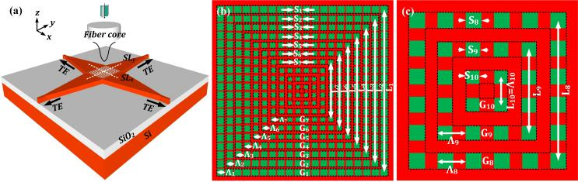
Fig .1. (a) Schematic diagram of the proposed four-port two-dimensional grating coupler. (b) A top-view of the apodized two-dimensional grating coupler. (L₁=19Λ₁, L₂=17Λ₂, L₃=15Λ₃…) (c) A zoom-in view of the 3 inner grating layers in Fig.1(b).

Fig. 1(a) shows the schematic diagram of the proposed four-port 2D apodized GC. This device is designed to be fabricated using a single etch process on a SOI platform with 340 nm thick top silicon layer and a 2 µm thick buried oxide layer. The coupler has four output waveguides orthogonally accessing the grating region. With a SMF vertically aligned, the light can be coupled and split into the TE mode of the four waveguides depending on the input polarization state. To ensure uniformity of the coupler in the four directions, the grating array is designed to be central-symmetric with respect to the grating center. As shown in Fig.1(b), the grating patterns are apodized without breaking the symmetry. The grating cells can be divided in to 10 grating layers distributed in 10 concentric square frames labeled as G₁-G₁₀ in Fig. 1(b) and 1(c). The outer grating layers consist of more grating cells than the inner grating layers. In each grating layer, the grating period (Λ₁-Λ₁₀) and etched holes’ span (S₁-S₁₀) are kept constant. The side length L_{j} of square-shaped grating layer j (center-to-center distance of two grating cells shown in Fig .1(b)) is designed according to the following rule:
$L_{j}=\left[2\left(10-j\right)+1\right]∙Λ_{j}.$ (1)
where Λ_{j} is the grating period of the grating layer. By changing the parameter set (Λ_{j} , S_{j}) of each grating layer, the distribution of effective refractive index and coupling strength can be optimized to improve the coupling performance. Firstly, the coupling directionality and strength were calculated as functions of the etched holes’ span S_{j} for uniform gratings, as depicted in Fig. 2(a) and Fig. 2(b). In this calculation, the grating etch depth is chosen as 170nm, which is an optimized parameter for our 1-D apodized GC design [21], and the period was adjusted according to the phase matching condition. As shown in the results, the directionality increases inverse-proportionally with the span S_{j}. The coupling strength α (µm⁻¹) was calculated using a cut-back method, as shown in Fig. 2(b).
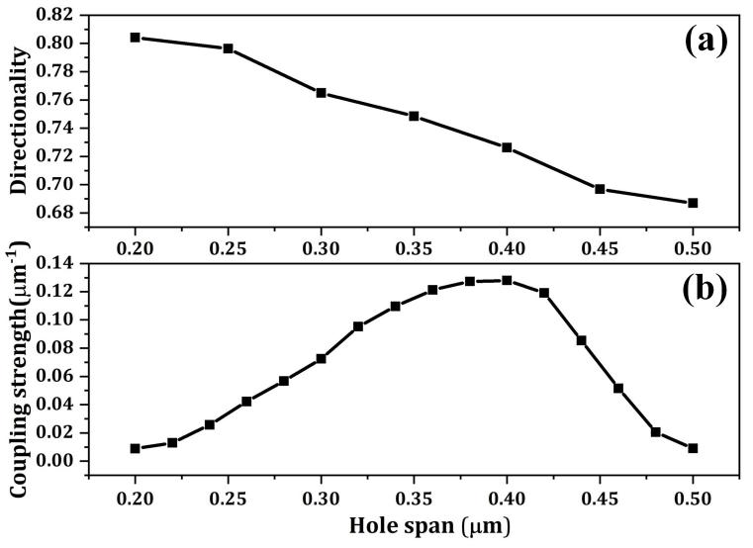
Fig .2. (a) Grating directionality as a function of the square-hole span S_{j}.(b) Grating coupling strength as a function of the square-hole span.

To obtain a Gaussian-like diffraction field G(x), the grating coupling strength distribution α(x) for a 1-D grating coupler should be tailored as follows [22]
$α\left(x\right)=G^{2}(x)/[2\left(1-\int_{0}^{x}{G^{2}\left(t\right)dt}\right)].$ (2)

for the 2D GC, the coupling strength distribution along the two orthogonal waveguide directions α(x) and α(y) should satisfy the above equation independently. However, the proposed four-port 2D GC should be seen as a superposition of two orthogonal 1D bidirectional grating couplers [23, 24], as the same amount of light would be coming into the grating from both directions in both x and y axis. Because of the central-symmetrical nature of the grating, the design of the x axis would be the same as y axis. Hence, the proposed 2D GC can be analyzed from a perspective of a 1D bidirectional grating coupler. If we consider the peak coupling wavelength (1570nm) coupling in the x direction, the bidirectional diffracted electric field E_{diff} in x axis can be calculated from an interference of two diffracted electric fields (E_{diff1} and E_{diff2}) excited by two unidirectional waveguide modes incident from both directions, as shown in the inset of Fig. 3(a). Therefore, the output electric field E_{diff} can be expressed a

$E_{diff}(x)=\sqrt{\frac{\left(E_{diff1}^{2}\left(x\right)+E_{diff2}^{2}\left(x\right)\right)}{2}∙\frac{(1+cosΔφ)}{2}}$ (3)
In the equation, Δφ represents the initial phase difference of the two incident waveguide modes. When the two incident waveguide modes are in phase, the constructive interference of the two diffracted electric fields occurs and the output electric field can be simplified as:
$E_{diff}(x)=\sqrt{\frac{\left(E_{diff1}^{2}\left(x\right)+E_{diff2}^{2}\left(x\right)\right)}{2}}$ (4)
The unidirectional diffracted fields E_{diff1} and E_{diff2} can be calculated with the given coupling strength distribution α(x) of the bidirectional GC which is central symmetric:

$\left\{\begin{aligned}E_{diff1}^{2}\left(x\right)=-dP(x)/dx=-d\left(P_{0}{∙e}^{-2α(x)x}\right)/dx \\ E_{diff2}^{2}\left(x\right)=dP(x)/dx=d\left(P_{0}{∙e}^{2α(x)x}\right)/dx\end{aligned}\right.$, (5)
in which,
$E_{diff1}\left(x\right)=E_{diff2}\left(-x\right).$ (6)
The calculated results for one sample GC design were plotted in Fig. 3(a) with a Gaussian-like mode profile as a reference. With a symmetric coupling strength distribution, a surface-normal quasi-Gaussian radiation mode can be generated. Such a working principle is also validated with 2D FDTD simulations for an analytically optimized 1D apodized bidirectional grating design and the simulation results are plotted in Fig. 3(b). As can be seen, the simulated diffraction electric field after grating apodization is quite close to a Gaussian mode than that of a uniform design. As the coupling efficiency is the overlap integral of the grating diffraction field and the fibre mode mathematically, the coupling spectra will be reshaped and the peak coupling efficiency can be enhanced [21]. The inset (i) of Fig. 3(b) shows the cross-sectional view of the simulated electric field distribution of a uniform bidirectional coupler and the apodized bidirectional coupler with two waveguide mode incidence in phase and with phase difference of π, which corresponds to a constructive interference and destructive interference at the grating interface respectively. The far field angle distribution of the output diffracted electric field intensity is plotted in the inset (ii).
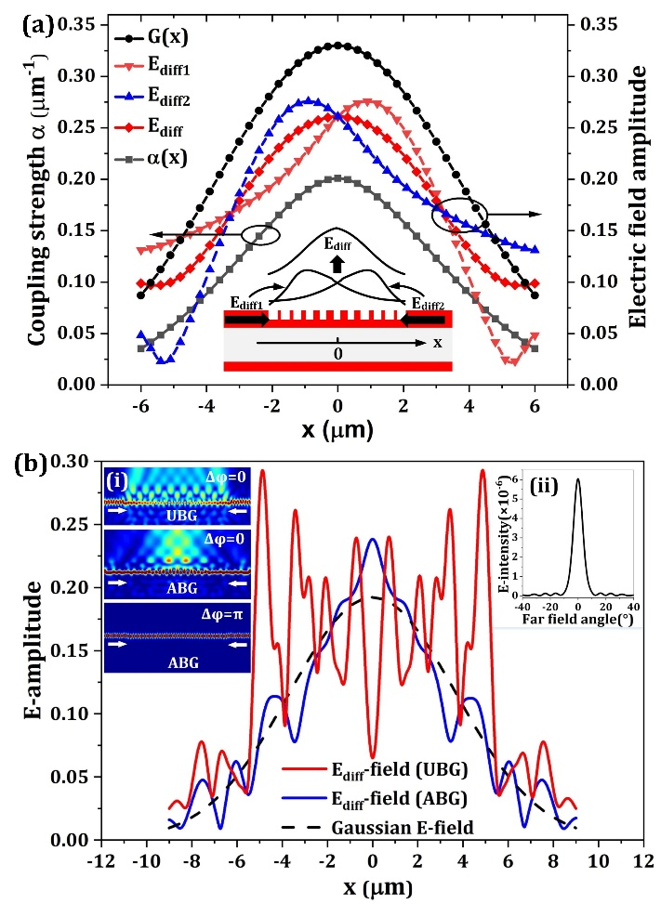
Fig .3. (a) The generation of a quasi-Gaussian radiation mode through constructive interference of a bidirectional coupling, showing the working principle of the apodized 2D GC operating in a single waveguide direction. (b) The simulated optical field distribution coupled from a 1-D uniform bidirectional grating coupler (UBG) and a 1-D apodized bidirectional grating coupler (ABG) and a Gaussian electric field for mode matching comparison. The inset (i) shows the simulated electric field distribution with waveguide incidence coupling of the UBG and the ABG. The inset (ii) shows the far field angle distribution of the diffracted electric field.

Based on the previously optimized 1D apodized GC design, we then started to optimize the 2D GC design using a numerical method. Typically, the coupler can be optimized by genetic optimization [25] or a particle swarm optimization algorithm [26]. However, searching in such a multiple parameter space using the 3D FDTD method requires a huge amount of calculation resources and the evolution procedure is quite time-consuming. Because the design was preliminarily optimized using 1D design, we can have a very limited range of parameter variation. To reduce the optimization complexity, a linear grating apodization [27] was adopted for our designs. A hill climbing optimization method [28] was utilized to determine the optimal design with multi-parameter sweeps using 3D-FDTD simulations. For a linear apodization, the grating structure is determined by only four parameters, namely the grating period and etched holes’ span of the first grating layer Λ₁ and S₁, the linear apodization steps Δ_{P} and Δ_{S} for each of them, respectively. The parameter set (Λ_{j}, S_{j}) of the grating layer G_{j} is defined as
$\left\{\begin{aligned}Λ_{j}=Λ_{1}-\left(j-1\right)∙∆_{P}. \\ S_{j}=S_{1}-\left(j-1\right)∙∆_{S}.\end{aligned}\right.$ (7)
The spacing D_{j} between the grating layer j and the grating layer j+1 can then be determined as
$D_{j}=\frac{L_{j}-L_{j+1}}{2}=\left(9.5-j\right)∙∆_{P}+Λ_{j},$ (8)
where j is a number from 1 to 9. As can be seen, the difference between D_{j} and Λ_{j} is a function of Δ_{P} and is smaller for an inner grating layer. By carefully choosing a starting design value of Δ_{S} = 10 nm and Δ_{P} = 3 nm, the parameters Λ₁ and S₁ were first swept to achieve the maximum efficiency. In these calculations, the CE is defined as the total normalized optical power coupled into the four waveguide ports. As shown in Fig .4(a), the optimal Λ₁ and S₁ for the given Δ_{S} and Δ_{P} are 570nm and 440nm respectively. For the second iteration, we set the Λ₁ and S₁ to the optimum values calculated from the first iteration, and swept the parameters Δ_{S} and Δ_{P} for to achieve maximum efficiency. The calculation results are shown in Fig .4(b), which indicates an optimal value of 12nm and 3nm for Δ_{S} and Δ_{P} respectively.
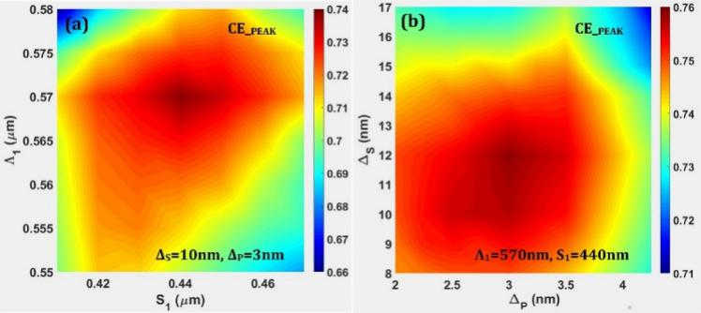
Fig. 4. (a) The parameter sweep result of the peak coupling efficiency as a function of Λ₁ and S₁. (b) The parameter sweep result of the peak coupling efficiency as a function of Δ_{S} and Δ_{P}.

Fig .5(a) and Fig .5(b) show the calculated E-intensity distribution for an input light polarization angle (PA) of π/2 and π/4 (PA=0 when the linear polarization is parallel to the x axis), and the 2D GC effectively functions as a 1×2 beam splitter and 1×4 beam splitter respectively. The electric field intensity profile of the grating plane is calculated with perfectly vertical incidence of a Gaussian mode source with linear polarization and a 1/e full width of 10.4µm. It is worth noting that the optical field is slightly focused in the grating region due to the laterally apodized structure. Simulation shows that it is possible to further reduce the width of the access waveguides without sacrificing the CE, which may be useful to reduce the device footprint.
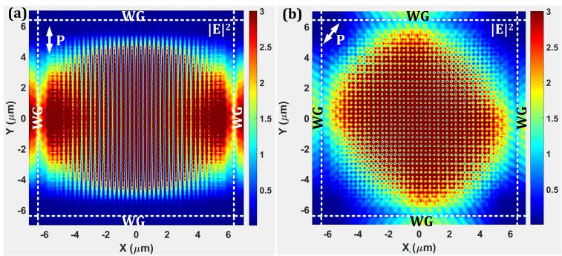
Fig .5. The calculated electric field intensity of the grating plane (a) with light incidence polarization angle of π/2 and (b) with light incidence polarization angle of π/4.

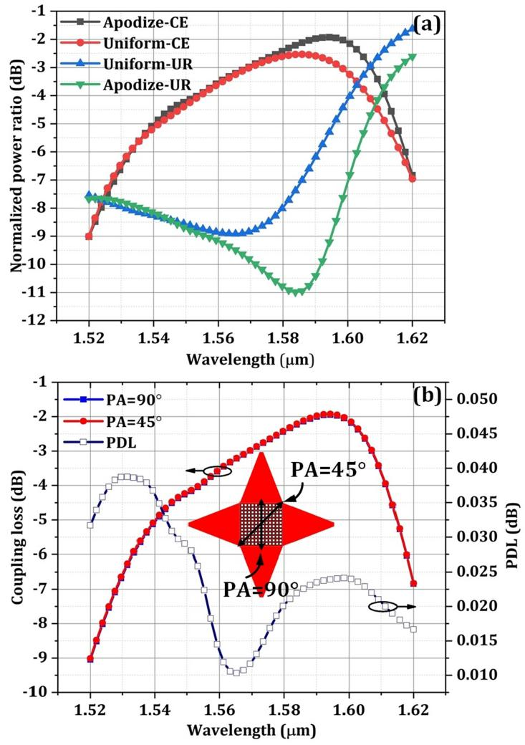
Fig .6. (a) The calculated CE and UR of a uniform 2D GC and the apodized 2D GC. (b) The calculated polarization dependent loss (PDL) of the apodized 2D GC.

To evaluate the performance improvement by apodization, an optimized uniform 2D GC is designed for comparison. Fig. 6(a) shows the calculated coupling efficiency and upward reflection power for the uniform design and the apodized design. As the waveguide can possibly support multiple waveguide modes, it is more precise to evaluate the coupling efficiency by calculate only the coupling to the fundamental TE mode. Therefore, we use mode expansion monitors at four waveguide ports to obtain the fibre-to-waveguide coupling efficiency and the total CE is obtained by combining the power coupling of the four waveguide ports. Clearly, the peak CE is enhanced by 0.7dB (from -2.6dB to -1.9dB) and the upward reflection (UR) is substantially reduced around the centre coupling wavelength range. The minimum upward reflection for the apodized design is only 8.5%, corresponding to a return loss of -11dB. One may find that the CE spectra of both the uniform and apodized design are similar, especially in the shorter wavelength region. This may be mainly attributed to the insufficient grating apodization due to the design and fabrication limitations. These limitations are mostly related to 2D and symmetrical nature of the gratings and the minimum feature size achievable using our fabrication facilities. Nevertheless, we believe our optimization is approaching the best result we can achieve within the available design space. The polarization dependence of the proposed 2D GC is also investigated. According to the general definition of the PDL, the PDL should be defined as the absolute value of the maximum difference between the CE spectra under two different incident polarizations. Although our device should have no PDL in theory due to the perfectly vertical coupling scheme and structure symmetry, we found that the total CE of the grating are slightly different with different incident polarizations. This may be attributed to the cross coupling and complex interference between the modes in x-direction and y-direction excited in the grating region. According to our simulations, the CE difference reaches a maximum between an incident PA of π/4 and π/2, which is about 0.024dB at the centre wavelength. Therefore, we simulated the CE spectra for the two polarizations for comparison as shown in Fig. 6(b). The CE spectra for an incident PA of π/4 and π/2 almost overlap with each other, resulting in a PDL lower than 0.04dB across the wavelength range from 1520nm to 1620nm.

Fabrication and measurement
The grating couplers were fabricated on a commercially available 200mm SOI wafer with a 340nm-thick top silicon layer and 2µm-thick buried oxide (BOX) layer. Firstly, the waveguide and grating structure are patterned and shallow-etched with Electron-beam Lithography (EBL) and Inductively Coupled Plasma (ICP) etching. The single mode waveguide structure is designed to be a ridge waveguide sharing the same etching depth as the 2-D grating structures. Next, a 750nm silicon dioxide top cladding layer was deposited for protection and also as an anti-reflection layer, using Plasma Enhanced Chemical Vapour Deposition (PECVD).
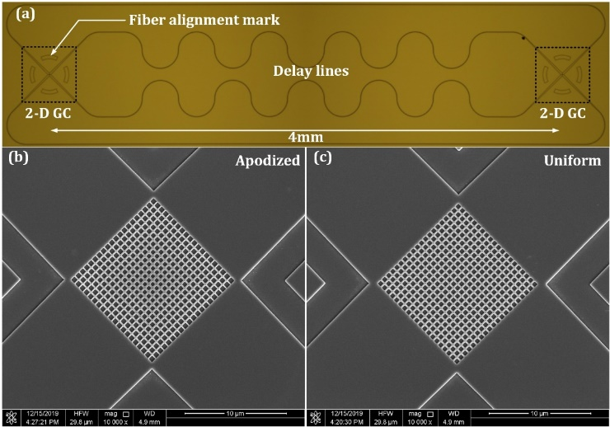
Fig .7. (a) The microscope photo of the 2-D apodized grating coupler in a back-to-back configuration. (b) the SEM image of the 2-D apodized grating coupler. (c) the SEM image of the 2-D uniform grating coupler.

For performance comparison, two types of 2D vertical coupling GCs were designed and fabricated, in a back-to-back configuration as shown in the microscope photo of Fig .7(a). Fig .7(b) and Fig .7(c) show the SEM images of the fabricated 2D apodized GC and uniform GC captured after removing the oxide cladding layer with HF:H₂O (1:7) solution. It can be observed that the square-shape grating cells are well patterned. In this testing configuration, waveguide delay lines are introduced into the two inner waveguide arms for phase difference compensation. In order to reduce the propagation loss, a ridge waveguide width of 700nm and large bend radius of 142µm is employed for the delay lines. According to our measurement results, the delay line with length of 5 times of the circumference introduces an insertion loss of about 2dB and 4.5dB for the 700nm-wide and 500nm-wide waveguide structure respectively. The fabricated 2D GCs were characterized with two vertically aligned single mode fibres. To assist the rapid alignment, two fibre alignment marks are patterned around the GCs. The input and output GCs consisting of four 400µm-long channel taper waveguides are connected with four waveguide arms of about 5mm in length (the distance between two GCs is 4mm). The fibre-to-fibre insertion loss was measured by a tunable laser and a power sensor. For polarization adjustment, a polarization controller was utilized in the measurement setup. A pair of neighbouring 1D standard GCs in a back-to-back configuration were used to calibrate the polarization to a TE or TM mode, corresponding to a polarization angle of π/4 and 3π/4 for the 2D vertical GC, respectively. The 2D GCs were firstly tested with a TE polarization incident mode. The measured fibre-to-fibre loss includes the fibre-to-chip coupling loss at both ends and the waveguide transmission loss. As the waveguide bending loss is not negligible, the waveguide arms with more bends have slightly larger loss than the straight waveguide arms. The measured waveguide loss of the 700nm-wide ridge waveguide is about 3dB/cm. Therefore, the loss of the straight waveguide arms is estimated to be about 1.7dB, including the 1.3dB waveguide propagation loss and 0.4dB bending loss. The loss of the waveguide arms with optical delay lines is about 2.2dB, including the 2dB insertion loss of the delay lines and 0.2dB loss of the other two waveguide bends connecting the taper waveguides and the delay lines. In order to estimate the fibre-chip coupling loss, the overall waveguide transmission loss is set to 2dB by taking the average. Using this figure, the coupling efficiency of the proposed 2D apodized GC and the uniform GC can be obtained from the measured fibre-to-fibre coupling losses. The results are shown in Fig .8(a). The maximum coupling efficiency of the 2D apodized GC and uniform GC is -2.5dB (56.3%) and -3.4dB (45.7%) respectively. The measured coupling spectra is blue-shifted by about 40nm with a central wavelength at about 1550nm. This is mostly due to an imperfection in etching depth during device fabrication. According to our measurement, the actual etching depth is about 190nm. This fabrication imperfection also leads to a slight decrease of coupling efficiency, to -2dB, which can be seen from the calibrated simulation results of the 2D GC depicted in Fig .8(a). The measured CE is about 0.5dB lower than the simulation result. This is possibly due to the grating sidewall roughness, the small fibre angle error in measurement and the taper waveguide loss which is not taken into account in our calculations. In addition, imperfect phase matching between the different waveguide arms is also a possible cause for the CE decrease. Simulation shows an effective refractive index difference of 5×10⁻⁵ between the bended waveguide mode and straight waveguide mode. Therefore, the delay line design may need to be optimized in the future. For example, the inner waveguide arms and outer waveguide arms are all inserted with delay lines of similar pattern, and the only difference is the straight waveguide length. Additionally, thermal phase shifters can also be introduced in the waveguide arms for active tuning. It is also observed that the measured coupling spectra exhibits two types of ripples with periods of about 0.05nm and 0.8nm. According to our calculation, the ripples with smaller period correspond to the Fabry-Perot resonance between the input and output gratings; the ripples with larger period are possibly due to the cavity resonance in the waveguide taper. The inset picture in Fig .8(a) shows the measured coupling spectrum of the 2D apodized GC in a back-to-back configuration without the optical delay lines. The interference ripples caused by phase mismatch have clearly deteriorated the coupler performance.
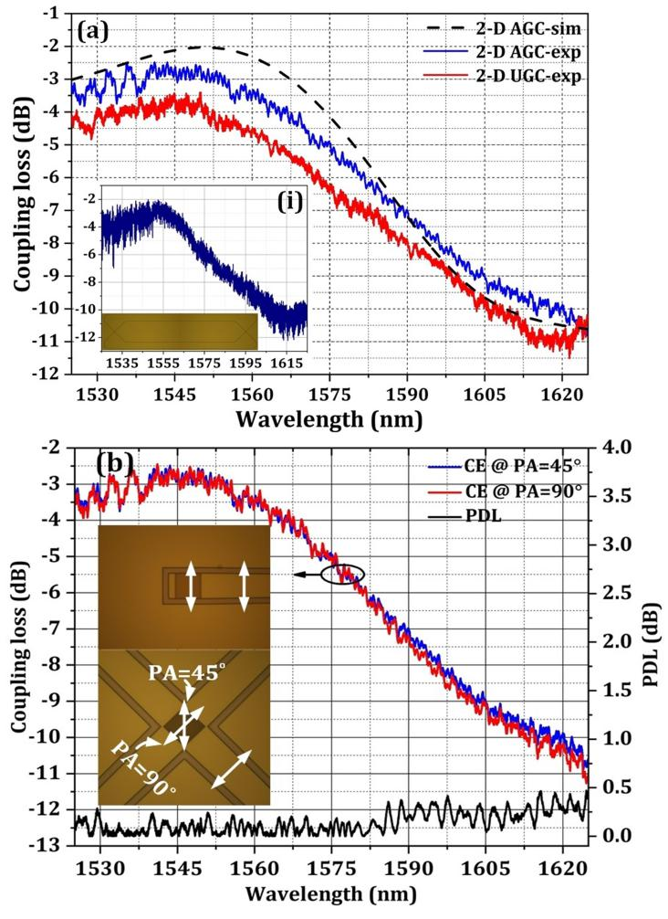
Fig .8. (a) The measured coupling efficiency spectra of the 2-D apodized grating coupler (AGC) and uniform grating coupler (UGC) in a test configuration shown as Fig .7(a), the inset picture shows the measured coupling efficiency of the 2-D apodized grating coupler in a back-to-back configuration without phase-delay compensation. (b) The measured coupling efficiency spectra of the 2-D apodized grating coupler with two orthogonal polarizations and the resulted polarization dependent loss (PDL).

To investigate the polarization dependence of the 2D apodized GC, a pair of neighboring 1D standard grating couplers connected with a straight single mode waveguide and a 2D apodized GC connected with four output 1D grating couplers are utilized for polarization calibration. As depicted in the inset picture of Fig .8(b), the polarization angle (PA) of π/4 and π/2 corresponds to the TE polarization modes for the neighboring standard 1D GCs and one-dimensional waveguide coupling of the 2D GC, which can
Table 1. Comparison of Figure of Merits of the reported PIGCs.
Refs | Year | WB | CE (dB) |  | PDL(Δλ_{PDL}) (dB(nm)) |  | No. FSs |  | GH  (nm) | MFS  (nm)
 |  |  | Sim | Exp | Sim | Exp | E | D
[14] | 2010 | C | - | -7 | - | 1(23) | 3 | 3 | 220 | 205
[15] | 2016 | C | -4.4 | -5 | 0.2(40) | 0.25(40) | 1 | 1 | 220 | ~200
[16] | 2018 | O | -3.9 | -3.9 | 0.3(60) | 0.3(60) | 1 | 1 | 200 | -
[18] | 2018 | O | -2.1 | -4.8 | 1(69) | 1(100) | 3 | 3 | 200/450/450 | 300
[17] | 2019 | C | -3.4 | -4.2 | 0.2(35) | 0.2(35) | 2 | 1 | 220 | 310
* | 2020 | C | -1.9 | -2.5 | 0.04(100) | 0.3(60) | 1 | 1 | 340 | 123
*: this work, WB: working band, CE: the best coupling efficiency of either polarizations, Sim: simulation, Exp: experiment, PDL(Δλ_{PDL}): the maximum PDL within a wavelength range of Δλ_{PDL}, No. FSs: total number of fabrication steps of the PIGCs, E and D represent the etching and deposition process respectively, GH: grating layer height, MFS: minimum feature size.

be determined by seeking the maximum optical transmission at the corresponding output ends respectively. The 2-D apodized GCs were then measured with the incidence of both polarization states. The measured CE results are plotted in Fig .8(b). As can be seen, the coupling curves almost overlap with each other within the wavelength range from 1525 to 1585nm. The resulted PDL is lower than 0.3dB within the C-band and below 0.5dB within the C-band and L-band together. The PDL is expected to be further decreased by improving the device structure design and fabrication processes. Table 1 shows the summarized comparison of the figure of merits of the reported polarization independent GCs with this proposed device. As can be seen, our coupler exhibits the advantages of ultra-low loss, low PDL and fewer fabrication steps. Such a device may find its applications in a polarimeter [29] or a polarization-independent silicon photonic receiver [30].

Conclusion
In summary, we have proposed and demonstrated a 2D apodized grating coupler for polarization independent and surface-normal optical coupling. The 2D grating coupler is optimized with a simplified linear grating apodization process using 3D FDTD calculations. For comparison, a 2D uniform grating coupler is also designed and fabricated. According to the simulation results, the 2D apodized GC and 2D uniform GC can achieve a peak coupling efficiency of -1.9dB and -2.6dB, respectively. The measured peak CE of the 2-D apodized GC and 2D uniform GC are -2.5dB and -3.4dB. The polarization dependent behavior is also investigated and the measured PDL is lower than 0.3dB within the C-band. Further improvement on coupling efficiency and PDL are possible by improving the device structure design and fabrication process.
ACKNOWLEDGMENT
The anthors would like to thank the China Scholarship Council for the award to Zanyun Zhang for 1 year’s research at the University of Southampton. D. J. Thomson acknowledges funding from the Royal Society for his University Research Fellowship.

References
- R. Soref, “The Past, Present, and Future of Silicon Photonics,” IEEE J. Sel.Top. Quantum Electron., vol.12, no. 6, pp. 1678–1687, Dec.2006.
- T. Baehr-Jones, T. Pinguet, P. L. Guo-Qiang, S. Danziger, D. Prather, and M. Hochberg, “Myths and rumours of silicon photonics,”Nat. Photonics., vol. 6, no. 4, pp. 206–208, Mar. 2012.
- G. T. Reed, G. Mashanovich, F. Y. Gardes, and D. J. Thomson,“Silicon optical modulators,” Nat. Photonics., vol. 4, no. 8, pp. 518–526, Jul. 2010.
- G. Roelkens, D. Vermeulen, S. Selvaraja, R. Halir, W. Bogaerts, and D. Van Thourhout, “Grating-Based Optical Fiber Interfaces for Silicon-on-Insulator Photonic Integrated Circuits,” IEEE J. Sel. Top. Quantum Electron., vol. 17, no. 3, pp. 571–580, Jul. 2011.
- A. Mekis, S. Gloeckner, G. Masini, A. Narasimha, T. Pinguet, S. Sahni, and P. De Dobbelaere, “A grating coupler-Enabled CMOS Photonics Platform,” IEEE J. Sel. Top. Quantum Electron., vol. 17, no. 3, pp. 597–608, Jul. 2011.
- S. Shao and Y. Wang, “Highly compact polarization-independent grating coupler,” Opt. Lett., vol. 35, no. 11，pp. 1834–1836, Jun. 2010.
- X. Chen and H. K. Tsang, “Polarization-independent grating couplers for silicon-on-insulator nanophotonic waveguides,” Opt. Lett., vol. 36, no. 6, pp. 796–798, Mar. 2011.
- W. S. Zaoui, A. Kunze, W. Vogel and M. Berroth, “CMOS-Compatible Polarization Splitting Grating Couplers With a Backside Metal Mirror,” IEEE Photonics Technology Letters., vol. 25, no. 14, pp. 1395–1397, Jul. 2013.
- Z. Cheng and H. K. Tsang, “Experimental demonstration of polarization-insensitive air-cladding grating couplers for silicon-on-insulator waveguides,” Opt. Lett., vol. 39, no. 7, pp. 2206–2209, Apr. 2014.
- J. H. Song, F. E. Doany, A. K. Medhin, N. Dupuis, B. G. Lee, and F.R. Libsch, “Polarization-independent nonuniform grating couplers on silicon-on-insulator,” Opt. Lett., vol. 40, no. 17, pp. 3941–3944, Sep. 2015.
- D. Taillaert, Harold Chong, P. I. Borel, L. H. Frandsen, R. M. DeLa Rue and R. Baets, “A compact two-dimensional grating coupler used as a polarization splitter,” IEEE Photonics Technology Letters., vol. 15, no. 9, pp. 1249–1251, Oct. 2003.
- B. Wohlfeil, G. Rademacher, C. Stamatiadis, K. Voigt, L. Zimmermann and K. Petermann, “A Two-Dimensional Fiber Grating Coupler on SOI for Mode Division Multiplexing,” IEEE Photonics Technology Letters., vol. 28, no. 11, pp. 1241–1244, Jun. 2016.
- J. Zou, Y. Yu, and X. Zhang, “Single step etched two-dimensional grating coupler based on the SOI platform,” Opt. Express., vol. 23, no. 25, pp. 32490–32495, Dec. 2015.
- R. Halir, D. Vermeulen and G. Roelkens, “Reducing Polarization-Dependent Loss of Silicon-on-Insulator Fiber to Chip Grating Couplers,” IEEE Photonics Technology Letters., vol. 22, no. 6, pp. 389–391, Apr. 2010.
- J.Zou, Y. Yu, and X. Zhang, “Two-dimensional grating coupler with a low polarization dependent loss of 0.25 dB covering the C-band,” Opt. Lett., vol. 41, no. 18, pp. 4206–4209, Sep. 2016.
- Y. Sobu, S. Jeong and Y. Tanaka, “Si-wire two-dimensional grating coupler with polarization-dependent loss of lower than 0.3 dB over a 60-nm-wide spectral range,” Jpn. J. Appl. Phys., vol. 57, no. 11,112501, Nov. 2018.
- Y. Xue, H. Chen, Y. Bao, J. Dong and X. Zhang, “Two-dimensional silicon photonic grating coupler with low polarization-dependent loss and high tolerance,” Opt. Express., vol. 27, no. 16, pp. 22268-22274, Aug.2019.
- J. C. C. Mak, W. D. Sacher, H. Ying, X. Luo, P. G. Lo, andJ. K. S. Poon, “Multi-layer silicon nitride-on-silicon polarization-independent grating couplers,” Opt. Express., vol. 26, no.23, pp. 30623–30633, Nov. 2018.
- Z. Zhang, H. Zhu, Q. Cheng, B. Huang, C. Cheng, H. Li, H. Chen, “Low polarization-dependent-loss double-layer grating coupler for three-dimensional photonic integration,” Opt. Commun., vol. 445, no. 15, pp. 247–254, Aug. 2019.
- X. Chen, C. Li and H. K. Tsang, “Two-dimensional silicon waveguide chirped grating couplers for vertical optical fibers,” Opt. Commun., vol. 283, no. 10, pp. 2146–2149, May. 2010.
- Z. Zhang, X. Chen, Q. Cheng, A. Z. Khokhar, X. Yan, B. Huang, H. Chen, H. Liu, H. Li, D. J. Thomson, and G. T. Reed, “High efficiency apodized bidirectional grating coupler for perfectly vertical coupling,” Opt. Lett., vol. 44, no. 20, pp. 5081-5084, Oct. 2019.
- X. Chen, D. J. Thomson, L. Crudginton, A. Z. Khokhar, and G. T. Reed, “Dual-etch apodised grating couplers for efficient fibre-chip coupling near 1310 nm wavelength,” Opt. Express., vol. 25, no.15, pp. 17864–17871, Jul. 2017.
- Z. Zhang, Z. Zhang, B. Huang, C. Cheng and H. Chen, “CMOS-Compatible Vertical Grating Coupler With Quasi Mach–Zehnder Characteristics,” IEEE Photonics Technology Letters., vol. 25, no. 3, pp. 224–227, Feb. 2013.
- Z. Zhang, B. Huang, Z. Zhang, C. Cheng, and H. Chen, “Bidirectional grating coupler based optical modulator for low-loss Integration and low-cost fiber packaging,” Opt. Express., vol. 21, no.12, pp. 14202–14214, Jun. 2013.
- B. Wohlfeil, L. Zimmermann, and K. Petermann, “Optimization of fiber grating couplers on SOI using advanced search algorithms,” Opt. Lett., vol. 39, no. 11, pp. 3201–3203, Jun. 2014.
- M. Mitchell, “An Introduction to Genetic Algorithms,” MIT, Mar. 1998.
- R. Marchetti, C. Lacava, A. Khokhar, X. Chen, I. Cristiani, D. J. Richardson, G. T. Reed, P. Petropoulos and P. Minzioni, “High-efficiency grating-couplers:demonstration of a new design strategy,” Scientific reports., vol. 7, no. 1 , 16670, Nov. 2017.
- S. Russell, P. Norvig. “Artificial intelligence: A Modern Approach,” Upper Saddle River,2nd ed. New Jersey: Prentice Hall, pp. 111–114, Jan. 2003.
- Z. Lin, L. Rusch, Y. Chen, W. Shi, “Optimal ultra-miniature polarimeters in silicon photonic integrated circuits,” APL Photonics., vol. 4, no. 10, 100806, Oct. 2019.
- G. Chen, Y. Yu, X. Xiao, X. Zhang, “High speed and high power polarization insensitive germanium photodetector with lumped structure,” Optics Express., vol. 24, no. 9, pp. 10030–10039, May. 2016.

Zanyun Zhang received the B.S. degree in microelectronics from Jilin University, Jilin, China, in 2009 and the Ph.D. degree in microelectronics and solid-state electronics from the Institute of Semiconductors, Chinese Academy of Sciences, Beijing, China, in 2014. He is currently an Associate Professor with Tiangong University, Tianjin, China. From November 2018 to November 2019, he has been working with the Silicon Photonic Group, University of Southampton as a Visiting Fellow. His current research interests include various vertical grating couplers and silicon photonic transmitter chip based on hybrid integration of VCSEL lasers.

Xia Chen is a senior research fellow at ORC, University of Southampton. He received B.Eng. and Ph.D. degrees in Electronics Engineering from the Chinese University of Hong Kong in 2006 and 2010, respectively. After graduation, he worked on the UK Silicon Photonic Project in University of Surrey and University of Southampton. In 2013, he joined Huawei Technologies Co. Ltd as a senior engineer to work on photonic packaging. He rejoined the Silicon Photonics group in University of Southampton in 2015. He was awarded the TSMC Outstanding Student Research Award in 2010, and the Newton International Fellowship by the Royal Society in 2011.

Qian Cheng was born in 1995. She received the B.S. degree in electronic science and technology from Changzhi University, Changzhi, China, in 2013. She is currently working toward the M.S. degree in Tiangong University, Her research interest focus on the interleaved AMMI (de)multiplexers with perfectly vertical coupling interface.

Ali Z. Khokhar has an MSc and PhD from the University of Glasgow. He is working in the field of micro and nano device fabrication since 2001. He is an electron beam (e-beam) lithography specialist and holding the post of Senior Research Fellow at the University of Southampton.

Zan Zhang received the B.S. degree in microelectronics from Xidian University, Xi’an, China, in 2010 and the Ph.D. degree in microelectronics and solid-state electronics from the Institute of Semiconductors, Chinese Academy of Sciences, Beijing, China, in 2015. He is currently working with Chang’an University, Xi’an, China. His main interests are silicon photonics, optoelectronic integrated circuits (OEIC), and microwave photonics.

Xingzhao Yan received his B.Eng. in Telecommunication Engineering from the School of Computer Science and Electronic Engineering, University of Essex and M.Sc. in Nanoelectronics and Nanotechnology from the School of Electronics and Computer Sciences, Faculty of Physical Sciences and Engineering, University of Southampton. From 2013 to 2017, he was working towards to his PhD in rare-earth-doped solid-state nanowire waveguide lasers with intensive cleanroom working experience. He joined the Silicon Photonics Group in July 2017 and is working with the CORNERSTONE project.
Beiju Huang received the B.S. degree in electronic science and technology from the University of Electronic Science and Technology of China, Xi’ an, China, in 2004 and the Ph.D. degree in microelectronics and solid-state electronics from the Institute of Semiconductors, Chinese Academy of Sciences (ISCAS), Beijing, China, in 2009. He is currently working with State Key Laboratory on Integrated Optoelectronics, ISCAS. His current research interests include optoelectronic integrated circuits, on-chip optical interconnect, optical receiver, and driver/receiver circuits.

Hongda Chen received the M.S. and Ph.D. degrees from Tianjin University, Tianjin, China, in 1990 and 1996, respectively. From 1997 to 2001, he was an Associate Professor with the Institute of Semiconductors, Chinese Academy of Sciences (ISCAS), Beijing, China. Since 2001, he has been a Full Professor with State Key Laboratory on Integrated Optoelectronics, ISCAS. His current research interests include fundamentals of semiconductor devices, optoelectronic devices and integration technology, very short reach module and system, silicon-based device, and integrated circuits for biomedical applications.

Hongwei Liu received the B.Eng. degree & M.Sc.Eng. degree from Tiangong University, Tianjin, China, the Ph.D. degree from Institute of semiconductor, Chinese Academy of Sciences. He is currently a professor in the School of Electronics and Information Engineering, Tiangong University, and also with the Tianjin Key Laboratory of Optoelectronic Detection Technology and System, Tianjin. His current work covers Micro/nano materials and solid state lighting materials, including surface Plasmon structure and GaN/InGaN multi-quantum well. His research interests also includes LED luminaires and system reliability analyzing.

Hongqiang Li received the B.S. degree in automation from Tianjin Polytechnic University, Tianjin, China, in 1998, the M.S. degree in computer application technology from Tianjin Polytechnic University, Tianjin, China, in 2002, and the Ph.D. degree in mechanical engineering from Tianjin Polytechnic University, Tianjin, China, in 2011. He is currently a Professor with Tiangong University, Tianjin, China. His current research interests is fiber Bragg gratings (FBG), FBG sensors and monitoring systems for optical biosensing, which is centered on monitoring various physiological parameters, and applying fundamental understanding in silicon-based photonic integration to develop monolithic integration of III-V/Si devices for FBG interrogation. It can make FBG interrogation system suitable for in situ physical and chemical detection.

David J. Thomson is a Royal Society University Research Fellow and Principal Research Fellow within the Silicon Photonics group of the Optoelectronics Research Centre. David leads research in the area of photonics for computing systems. His career in Photonics began with a year in industry at Nortel Networks in Paignton. David joined the University of Surrey in 2001 as an undergraduate student studying electronic engineering. He subsequently undertook PhD studies under the guidance of Professor Graham Reed investigating optical switching devices in silicon. From 2008 he worked as a research fellow in the same research group on a number of projects and different optical devices in silicon although focusing mainly on high speed active devices and their integration with other photonic and electronic devices. David moved to the University of Southampton in 2012 David taking up the role of senior research fellow.

Graham T. Reed is Professor of Silicon Photonics and Group Leader. He joined Southampton in 2012 from the University of Surrey, where he was Professor of Optoelectronics, and was Head of the Department of Electronic Engineering from 2006 to 2012. Reed is a pioneer in the field of Silicon Photonics, and acknowledged as the individual who initiated the research field in the UK. He established the Silicon Photonics Research Group at Surrey in 1989. The first Silicon Photonics company in the world, Bookham Technology Inc., was founded by Reed’s PhD student, Dr Andrew Rickman, and adopted the research developed in the Group. The Silicon Photonics Group have provided a series of world leading results since its inception, and are particularly well known for their work on silicon optical modulators.

This work was supported in part by the National Key R&D Program of China (No. 2018YFA0209000),in part by the EPSRC through programme grant “Silicon Photonics for Future Systems” (EP/L00044X/1), in part by the National Natural Science Foundation of China (No. 6171101108, 61704009, 61675191, 61177078) and the TianjinResearch Program of Application Foundation and Advanced Technology (No. 18JCQNJC01800). Zanyun Zhang, Qian Cheng, Hongwei Liu, Hongqiang Li are with the Tianjin Key Laboratory of Optoelectronic Detection Technology and Systems Tiangong University Tianjin,300387,China (e-mail: zhangzanyun@tiangong.edu.cn;1831095436@tiangong.edu.cn;liuhongwei@tiangong.edu; lihongqiang@tiangong.edu.cn). Xia Chen, Ali Z.Khokhar, Xingzhao Yan, David J.Thomsom, Graham T. Reed are with the Optoelectronics Research Centre, University of Southampton, Southampton SO171BJ, UK.(e-mail:xia.chen@soton.ac.uk; a.z.khokhar@soton.ac.uk;xingzhao.yan@soton.ac.uk;d.thomson@soton.ac.uk; g.reed@soton.ac.uk). Beiju Huang, Hongda Chen are with the State Key laboratory on Integrated Optoelectronics, Institute of semiconductors, Chinese Academy of Sciences, Beijing 100083, China (e-mail: bjhuang@-semi.ac.cn; hdchen@semi.ac.cn). Zan Zhang is with the School of Electronic and Control Engineering, Chang’an University, Xi’an 710064, China(e-mail: z.zhang@chd.edu.cn).

