The research trends of metal-organic frameworks in environmental science: a review based on bibliometric analysis

Juan Li1 & Liangjie Wang1 & Yongqiang Liu2 & Yonghui Song1 & Ping Zeng1 & Yajie Zhang 3

Abstract
Metal-organic frameworks, an emerging class of porous material, have developed rapidly in recent years. In order to clarify the application of metal-organic frameworks in the field of environmental science, 1386 articles over the last 20 years were obtained from Scopus and analysed by the bibliometric method. And the collaboration between countries, institutions and authors and the co-occurrence of keywords were also conducted using VOSviewer. The results indicated that this area of research has entered a fast-developing stage. The number of articles published has grown from 7 articles in 1999 to 378 articles in 2018. The most productive country was China with 626 articles published. The most productive institution was the Chinese Academy of Sciences, and the most productive author was Jhung SH from Kyungpook National University of South Korea. Although metal-organic frameworks have been widely used in adsorption and catalytic degradation of pollutants from the environment, the removal mechanism of pollutants by MOFs, the stability improvement and the cost reduction of metal-organic frameworks are still the main challenges for their practical applications.

Keywords Research trends . Metal-organic frameworks . Environmental science . Bibliometric

Introduction

Nowadays, serious environmental pollution has attracted worldwide attention (Awual et al. 2019). Over the last decades, a variety of materials with high surface area and large pore volume have been invented for removal of pollutants from environment, including carbonaceous material (Mauter and Elimelech 2008, Yang et al. 2019), zeolites (Siyal et al. 2020), mesoporous silica (Awual 2017, 2019; Shahat et al. 2015) and metal-organic frameworks (MOFs) (Dhaka et al. 2019; Rowsell and Yaghi 2004), and so on. Though these materials have shown excellent performance for their environ- mental applications, MOFs have attracted more and more at- tentions from researchers due to their ultrahigh porosity, high chemical and thermal stability, structural and functional tun2014). Till now, MOFs has been widely studied in adsorption of toxic gases (Saha et al. 2010, Zhi et al. 2015), adsorption of pollutants from water (Dhaka et al. 2019; Van de Voorde et al. 2014) and photocatalytic degradation of pollutants (Wang et al. 2014a; Zhang and Lin 2014), and so on. MOFs providea new possibility for the removal of pollutants from the environment.
Metal-organic frameworks (MOFs), also known as porous coordination polymer or porous coordination network, emerged approximately two decades ago and developed quickly since then (Li et al. 2012). MOFs were first introduced by Yaghi et al. (1995) in 1995. They reported coordination compounds on Nature and named the material as the metal- organic framework. Since then, the concept of metal-organic framework has been formally proposed. And then, in 1999, the Yaghi group (Li et al. 1999) reported MOF-5 on Nature. In the same year, HKUST-1 was reported by the Williams group (Chui et al. 1999) on Science. The two achievements further promoted the development of MOFs because of their high porosity and stability. In 2006, the Yaghi group reported ZIF-1 to ZIF-12 (Park et al. 2006), which exhibited excellent thermal and chemical stability. From 2007 to 2008, the Yaghi group further reported a series of ZIFs on Nature Materials (Hayashi et al. 2007), Science (Banerjee et al. 2008) and Nature (Wang et al. 2008), which greatly expanded the ZIFs family. On the other hand, in 2004 and 2005, MIL-100(Cr) and MIL-101(Cr) with high surface area and super macropore were reported by the Férey group from France on Angewandte Chemie (Férey et al. 2004) and Sciences (Férey et al. 2005). In their study, they put forward a new strategy of synthesizing MOFs by combining target chemistry and computer simula- tion methods, which opened a new page for MOFs. In 2008, UiO-66, a new type of MOFs with exceptional stability, was reported by the group of Lillerud (Cavka et al. 2008). The representative MOFs are listed in Table 1.
Several review articles have been published to introduce the development, applications and future directions of MOFs (Dhaka et al. 2019; Li et al. 2012; Zhong et al. 2019). In order to clarify the current situation of MOFs’ applications in environmental science, the bibliometric method was adapted to review the current progress. Bibliometric analysis is a method utilizing quantitative analysis and statistics to describe the characteristics of doc- uments in a given field (Zhang et al. 2017c). It has recently played a much more important role in scientific study (Aleixandre-Benavent et al. 2017) because it can effectively reflect the hotspots and future trends of specific fields by analysing big data in research database (Zhi et al. 2015). It can be used to assess the scientific production of authors, institutions, countries and journals and to identify the coop- eration between countries, institutions and authors (Li and Zhao 2015). Till now, the bibliometric method has been used in the research of environmental engineering and sci- entist, such as groundwater remediation (Zhang et al. 2017a), nanomaterials (Zhao et al. 2018) and climate change (Aleixandre-Benavent et al. 2017), and so on. MOFs, a new research hotspot in the field of environmental science, the researchers were eager to know its progress to determine their next studies. This requirement would be met by the report on the development of MOFs in environmental science through the bibliometric method.
The bibliometric method was used in this study to clarify the current state of MOFs in the field of environmental science (MOFs-ES). The analysis of the published articles included the annual number of articles; the productive journals, authors, institutions and countries; and the collaboration among au- thors, institutions and countries. In addition, to disclose the hot research topics in the MOFs-ES field, the co-occurrence analysis of keywords was conducted on the high-frequency keywords. Moreover, the relevant review articles and the newest studies on MOFs-ES research were also summarized. The results of this study cannot only clarify the overall devel- opment of MOFs and predict the future trends of MOFs in the field of environmental science but also could promote the cooperation between the groups in the related fields according to the information provided by this study.

Table 1 Representative MOFs during the development

Team | Year | Name of MOFs | Molecular formula | Journal | Citations | References
Omar M. Yaghi | 1995 | MOF | CoC6H3(COOH1/3)3(NC5H5)2·2/3NC5H5 | Nature | 1284 | (Yaghi et al. 1995)
Omar M. Yaghi | 1999 | MOF-5 | Zn4O(BDC)3·(DMF)8(C6H5Cl) | Nature | 4614 | (Li et al. 1999)
Omar M. Yaghi | 2006 | ZIF-8 | Zn(MeIM)2·(DMF) ·(H2O)3 | Proceedings of the | 2835 | (Park et al. 2006)
National Academy of Sciences of the United States of America
Omar M. Yaghi 2008 ZIF-67 Co(mIM)2 Science 2168 (Banerjee et al. 2008) Ian D. Williams 1999 HKUST-1 [Cu3(TMA)2(H2O)3]n Science 3790 (Chui et al. 1999) Kimoon Kim 2000 POST-1 [Zn3(μ3-O)(1-H)6]·2H3O ·12H2O Nature 3440 (Seo et al., 2000) Gérard Férey 2004 MIL-100(Cr) Cr3F(H2O)3O[C6H3-(CO2)3]2·nH2O (n≈28) Angewandte Chemie 534 (Férey et al. 2004) Gérard Férey 2005 MIL-101(Cr) Cr3F(H2O)2O[(O2C)-C6H4-(CO2)]3·25H2O Science 2833 (G. Férey et al. 2005)

Gérard Férey 2007 MIL-100(Fe) FeIII O(H O) F·(C H (CO ) ) ·nH O
Chemical
652 (Horcajada et al., 2007)

3 2 2
6 3 2 3 2 2

(n≈14.5)
Communications

Karl Petter Lillerud 2008 UiO-66 [Zr6O4(OH)4](BDC)6 Journal of the American Chemical Society
2122 (Cavka et al. 2008)

BDC: 1,4-benzenedicarboxylate; DMF: N,N′-dimethylformamide; MeIM and mIM: 2-methylimidazole; TMA: benzene-1,3,5-tricarboxylate

Data and method

Data source and treatment

The data was collected from the Scopus database on January 3, 2019. The following terms were searched in the topic field of article title, abstract, keywords in Scopus from 1999 to 2018: “MOF” OR “MOFs” OR “Metal organic framework” OR “Metal organic frameworks” OR “Metal-organic frame- work” OR “Metal-organic frameworks” OR “porous coordi- nation polymer” OR “porous coordination polymers” OR “porous coordination network” OR “porous coordination net- works”. The publications were limited to the category of Environmental Science. In addition, the document type of “Articles”, the source type of “Journals”, and the language of “English” was limited. After regrouping the terms to avoid duplicates and remove irrelevant articles, a total of 1386 arti- cles were obtained. In order to avoid ambiguation of authors, Scopus Author Identifier, which distributes a unique number to each author, was used in this study to obtain the accurate information of authors (Zhang and Yu 2019). This method can distinguish individuals sharing the same formatted name and thus avoid errors induced by homonyms. But some systematic errors may be produced, such as different persons may be mistakenly attributed to the same Scopus Author Identifier or articles published by the same author may be attributed to a different Scopus Author Identifier (Kolesnikov et al. 2018). To avoid these errors, manual disambiguation of Scopus au- thor profiles according to the information of researchers was conducted in this study. Bibliometric data from the disambig- uated profiles was then aggregated and recalculated for each individual. In order to observe the overall changes overtime clearly, the 20-year analysis was further divided into four pe- riods: 1999 to 2003 (the first period), 2004 to 2008 (the second
period), 2009 to 2013 (the third period) and 2014 to 2018 (the fourth period).

Methods

The methods used in this study mainly include bibliometric method and social network analysis. As an indicator of scien- tific production, the number of articles published annually and the contribution of articles for each of the authors, institutions, countries and journals were analysed. The articles published by Hongkong and Taiwan were included into China. As an indicator of scientific impact, the number of total citations, average citations per article, impact factor of journals and H- index for authors, institutions, countries and journals were included in this study. The H-index for an author (or institu- tions or countries or journals) is h of total articles of an author (or institutions or countries or journals) with at least h citations each (Hirsch 2005). The impact factor of journals was obtain- ed from Journal Citation Reports in 2018. In addition, to assess the overall change of geographical distribution, the mi- gration of centre of gravity for publications and citations were analysed according to the method reported by Zhang et al. (2017b). Moreover, the high-frequency keywords were analysed to find the hot topics in the analysed field.
R version 3.5.1 (Statistics Department of the University of Auckland, https://www.r-project.org/) was used to process the data mentioned above. The R packages which were used in these calculations and visualizations mainly included “bibliometrix”, “stringr”, “rgeos”, “ggplot2” and “rworldmap” (Aria and Cuccurullo 2017). In addition, VOSviewer (Van Eck and Waltman 2010) was used in this study to visualize the collaboration of authors, institutions, countries and the co-occurrences of keywords. In order to obtain the correct visualization of the networks, a limitation of papers was applied which would be assigned when each Figure was mentioned.

Results and discussion

Trends of publications

A total of 1386 articles were published on MOFs-ES research from 1999 to 2018. As seen in Fig. 1, the number of articles grown from 7 articles in 1999 to 378 articles in 2018, which increased greatly from 2011. This indicates that the research on MOFs-ES is attracting increasing attention of researchers in recent years. During the first decade of the analysed period (1999–2008), only 7.0% of the total articles were published, whereas in the last 5 years from 2014 to 2018, 76.0% of the total works was published. The linear fitting was conducted by dividing the 20 years into three stages according to the growth trend. The results showed that the slope was 1.47 in the first stage from 1999 to 2010, then increased to 6.5 from 2011 to 2013 and finally increased to 68.3 in the third stage from 2014 to 2018. The markedly increased growth rate in the last 5 years indicated that the research on MOFs-ES has entered a fast development stage.
The annual number and annual total citations of articles on MOFs-ES research from 1999 to 2018 are listed in Table S1. The citations number of academic papers reflects the academ- ic impact of the papers. Among the 1386 papers, 82 articles were cited more than 100 times and 218 articles were cited more than 50 times. As shown in Table S1, the annual total citations were much higher from 2011 to 2017 due to the increase of publications during that period. The maximal val- ue of total citations was 5257 in 2015 with the average value of 37.8. While for the average citations per article, the maxi- mum value was 83.0 in 2008. The average citations per article in 2016 to 2018 was much lower than those of other years because that time is necessary to accumulate citations.
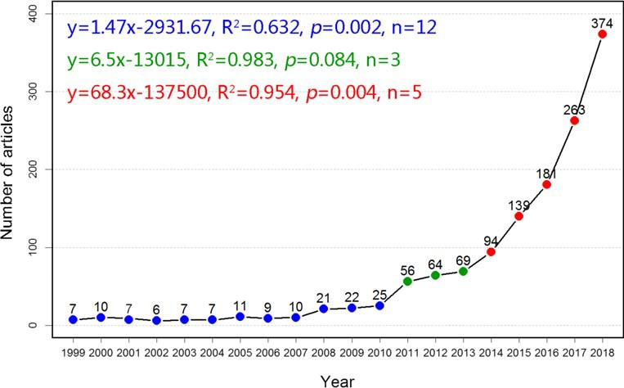Fig. 1 The annual number of articles on the research of MOFs in the field of environmental science from 1999 to 2018

However, it is predictable that the total citations in recent years would increase further over time.
Table 2 lists the top 15 most-cited articles on the research of MOFs in the field of environmental science from 1999 to 2018. Among them, seven articles issued by China, six articles issued by the USA and four articles issued by South Korea, indicating that the extremely high academic influences in this field have been achieved by the researchers in these countries. In addition, 9 of the top 15 articles have been published in Energy & Environmental Science, indicating that this journal has an extremely high influence in this field. For the research contents of the 15 most-cited articles, eight articles focused on the adsorption or capture of CO2 by MOFs, four articles stud- ied the removal of pollutants from aqueous solution, and an- other three articles researched the role of MOFs for oxygen evolution reaction. This indicated that the environment appli- cation of MOFs still mainly focused on gas adsorption. The highest citation paper was published in 2011 in Energy & Environmental Science (Mason et al. 2011) with total citations of 511. This article evaluated the potential use of two repre- sentative MOFs in post-combustion CO2 capture via temper- ature swing adsorption. The article with total citations of 431 was also published in 2011 (Haque et al. 2011), which used MOF-235 to remove harmful dyes from contaminated water. MOFs could be used as potential adsorbents for removing pollutants in solution based on their study.

Country analysis

The 1386 articles about the application of MOFs in the envi- ronment were published by 56 countries. The characteristics of the top 15 most productive countries are illustrated in Table 3. Nine of the top 15 most productive countries were developed countries. However, the country which published the highest number of papers was China with a total of 626 articles published from 1999 to 2018, accounting for 45.2% of the total articles, followed by the USA (215 articles, 15.5%) and South Korea (100 articles, 7.2%). During the period of 1999 to 2008, the USA had the highest number of published articles. However, China became the leading country in the last decade. China was also the country that had the highest total citations (15567), followed by the USA (9885) and South Korea (4135), which was consistent with the ranking of the number of articles and H-index. And the total citations of Iran, India and Saudi Arabia were much lower than those of other countries. For the average citations per article, Netherlands was the country with the highest value of 59.5, followed by the USA of 46.0, Singapore of 42.2 and South Korea of 41.4. Although China had the highest number of articles and the highest total citations, the average citations per article for China was much lower. The quality of articles published by China should be further improved while increasing the num- ber of published articles.
The geographical distribution of articles for each of the countries and the regional migration of the centre of gravity over time were conducted, as shown in Fig. 2. Each circle represents one country, the bigger the circle, the more articles were published by the country. The different colors of the circles represent the total citations of the country which was shown in the color bar. The results for publications and total citations were corresponding to those shown in Table S1. The centre of gravity for both productions and citations migrated eastward obviously over the four periods. The centre of grav- ity for productions migrated from 35° N, 69° W in the1st period, to 35° N, 58° W in the 2nd period, to 37° N, 12° W in the 3rd period and finally to 37° N, 50° E in the 4th period,

Table 2 Top 15 most frequently cited articles on research of MOFs in field of environmental science from 1999 to 2018

Author Year Country TC Journal Research highlights References

Mason JA, Sumida K, Herm ZR, Krishna R, Long JR
2011 USA, Netherlands 511 Energy & Environmental
Science
Post-combustion CO2 capture (Mason et al. 2011)

Haque E, Jun JW, Jhung SH 2011 South Korea 431 Journal of Hazardous
Materials

Environmental Science and Technology
Saha D, Bao Z, Jia F, Deng S | 2010 | USA, China | 375
Zhao D, Yuan D, Zhou HC | 2008 | USA | 320
He Y, Krishna R, Chen B | 2012 | USA, Netherlands | 309
Haque E, Lee JE, Jang IT, | 2010 | South Korea | 289

Adsorption of harmful dyes from aqueous solution by MOF-235.
Adsorption of CO2, CH4, N2O, and N2 on MOF-5, MOF-177,
and Zeolite 5A.
(Haque et al. 2011)

(Saha et al. 2010)

Energy & Environmental Science
Hydrogen storage in MOFs. (Zhao et al. 2008)

Hwang YK, Chang JS, Jegal J, Jhung SH
Yu XY, Feng Y, Guan B, Lou XWD, Paik U

Sayari A, Belmabkhout Y, Serna-Guerrero R

2016 South Korea,
Singapore, China
Energy & Environmental Science

Journal of Hazardous Materials

288 Energy & Environmental Science

Chemical Engineering Journal
2011 | Canada | 268
2009 | China | 258
2015 | China, USA | 253
2012 | China | 237
2011 | South Korea | 234
2012 | Singapore, China | 220
2016 | Singapore, China | 216
2015 | China | 206

Adsorptive separation of light hydrocarbons by 19 different MOFs.
Adsorptive removal of methyl orange from aqueous solution.

Electrocatalysis of oxygen evolution reaction by MOF-derived functional nanomaterials.
Post-combustion CO2 capture by MOFs.
(He et al. 2012)

(Haque et al. 2010)

(Yu et al. 2016)

(Sayari et al. 2011)

Song J, Zhang Z, Hu S, Wu T, Jiang T, Han B
Green Chemistry The coupling reaction of CO2
with propylene oxide catalyzed by MOF-5.
(Song et al. 2009)

Xia W, Zou R, An L, Xia D, Guo S
Energy & Environmental Science
Oxygen reduction by Co@Co3O4@C-CM derived from MOF.
(Xia et al. 2015)

Huo SH, Yan XP
Analyst Magnetic solid-phase extraction of polycyclic aromatic
hydrocarbons from environmental water samples.
(Huo and Yan, 2012)

Simmons JM, Wu H, Zhou W, Yildirim T
Energy & Environmental Science
Carbon capture by MOFs (Simmons
et al. 2011)

Yang DA, Cho HY. Kim J, Yang ST, Ahn WS
Hu H, Han L, Yu M, Wang Z, Lou XW
Wang H, Yuan X, Wu Y, Zeng G, Chen X, Leng L, Li H
Energy & Environmental Science
Energy & Environmental Science
Applied Catalysis B: Environmental
CO2 capture and conversion by Mg-MOF-74.
Oxygen reduction by MOF-engaged Co-C@Co9S8DSNCs
Photocatalytic degradation of dyes
by g-C3N4/MIL-125(Ti).
(Yang et al. 2012) (Hu et al. 2016) (Wang et al. 2015)

TC: total citations of this article
migrating eastward for 957 km, 4108 km and 5493 km, re- spectively. The centre of gravity for citations migrated from 45° N, 108° W in the 1st period, to 44° N, 80° W in the 2nd period, to 40° N, 17° W in the 3rd period, and finally to 37° N, 50° E in the 4th period, migrating eastward for 2226 km, 5060 km and 5684 km, respectively. Both the centre of gravity for productions and citations migrated from Europe and America to Asia gradually overtime.
It can be known that European and American countries started their research earlier in the field of MOFs-ES. Whereas Asian countries developed quickly in recent years though they started their research on MOFs-ES later. Therefore, the centre of gravity of publications and citations was located in the developed countries in Europe and America during the 1st and 2nd periods. While the centre of citations and publications migrated eastward to Asia during the 3rd and 4th periods due to the growing up of the countries in Asia such as China, South Korea and Iran. Another noteworthy phenom- enon was that the centre of gravity of publications was far apart from that during the first and second periods, while the centre of publications and citations were close during the 3rd and 4th periods. This was because during the first period, 20 of the total 39 articles were published by the USA, accounting for 51.3%. However, the USA had total citations of 2472 at that period, accounting for 83.6% of the total citations of world. Thus, the centre of gravity of citations was located in the United States during that period, apart from the centre of gravity of publications. It was similar to that of the second
Table 3 Most productive countries on the research of MOFs in the field of environmental science from 1999 to 2018

Country | TP | TC | TC/TP | H-index | SCP | MCP | TP
 |  |  |  |  |  |  | 1999–2003 | 2004–2008 | 2009–2013 | 2014–2018
China | 646 | 15,633 | 24.2 | 62 | 491 | 155 | 1 | 3 | 49 | 572
United States | 215 | 9885 | 46.0 | 56 | 108 | 107 | 18 | 17 | 46 | 134
South Korea | 100 | 4135 | 41.4 | 34 | 72 | 28 | – | – | 16 | 84
United Kingdom | 70 | 2278 | 32.5 | 26 | 28 | 42 | 2 | 7 | 12 | 49
France | 68 | 2095 | 30.8 | 26 | 32 | 36 | 2 | 10 | 17 | 39
Spain | 65 | 1598 | 24.6 | 25 | 28 | 37 | 1 | 4 | 14 | 46
Italy | 47 | 1253 | 26.7 | 20 | 22 | 25 | 5 | 4 | 11 | 27
Iran | 47 | 602 | 12.8 | 12 | 41 | 6 | – | – | 6 | 41
Germany | 43 | 1121 | 26.1 | 19 | 16 | 27 | 2 | 3 | 11 | 27
Australia | 37 | 920 | 24.9 | 15 | 16 | 21 | 2 | – | 10 | 25
India | 37 | 425 | 11.5 | 11 | 20 | 17 | – | – | 5 | 32
Singapore | 36 | 1518 | 42.2 | 18 | 23 | 13 | – | 1 | 5 | 30
Canada | 36 | 899 | 24.9 | 15 | 18 | 18 | 2 | 1 | 12 | 21
Saudi Arabia | 36 | 555 | 15.4 | 13 | 11 | 25 | – | – | 1 | 35
Netherlands | 31 | 1846 | 59.5 | 18 | 11 | 20 | 1 | 4 | 16 | 10
World | 1386 | 37,632 | 27.2 | – | 1056 | 330 | 37 | 58 | 236 | 1055
TP: total published articles; TC: total citations; SCP: single country publications; MCP: multiple country publications

period from 2004 to 2008, whereas with the rapid develop- ment from 2009 to 2018, the citations were accumulated from a large number of articles, and the centre of publications and citations became closer.
For international cooperation, 1056 (76.2%) of the total 1386 articles were from a single country and 330 (23.8%) were from multiple countries. This might be as the indicator of how wide of international cooperation conducted. A furtheranalysis about the collaboration network between countries is shown in Fig. 3. The analysis collected the data of countries with more than 5 articles published. In Fig. 3, each circle represents one country and the size of the circle and line rep- resent the number of articles of the country and the links between different countries, respectively. The bigger the cir- cle, the more articles are published by the country. The thicker the line, the more links between the countries. The different
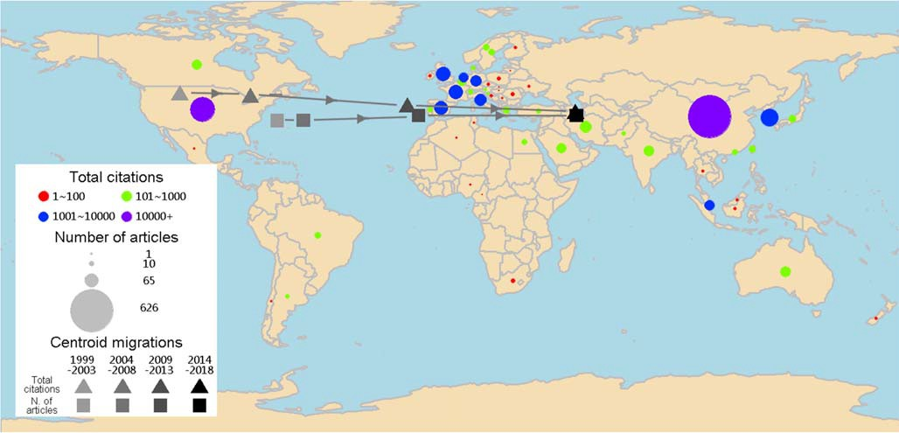
Fig. 2 Global geographic distribution and regional migration of research on MOFs in the field of environmental science from 1999 to 2018

colors correspond to clusters formed by different groups of countries. As seen in Fig. 3, five main clusters corresponding to five different colors can be distinguished, which were led by China, the United States, South Korea, France and Singapore, respectively. China had the most abundant links with other countries, followed by the USA. Moreover, the thickest line between China and the USA indicated that the two countries had the closest cooperation compared with other countries. The cooperation between Western countries and other countries was much more active than Asian countries. With the continuous development of this field, Asian coun- tries should strengthen their international cooperation with other countries to further improve their influence and achievements.

Institution analysis

The most productive institutions (> 15) on MOFs-ES research are presented in Table 4. As seen, 11 of the top 16 institutions belong to China, which might be the reason for the largenumber of articles published by China. Besides, Kyungpook National University, South Korea, ranked second. University of California, USA, ranked fifth. National University of Singapore and Nanyang Technology University, Singapore, ranked ninth and fourteenth. And King Abdulaziz University, Saudi Arabia, ranked twelfth. Among the sixteen most productive institutions, the Chinese Academy of Sciences published the highest number of articles, while Tianjin University was the first institute in China to start the study in the field of MOFs-ES since their first paper was published on 2000.
For the total citations, the Chinese Academy of Sciences had the highest citations (2878), followed by Kyungpook National University (2237), South China University of Technology (1707) and University of California (1693). In respect to the average citations per article, the University of California listed as first (65.1), followed by Nanyang Technology University (64.8) and University of Science and Technology of China (59.2). Similarly, as an indicator of impact, the H-index of the Chinese Academy of Sciences was highest which was 28,

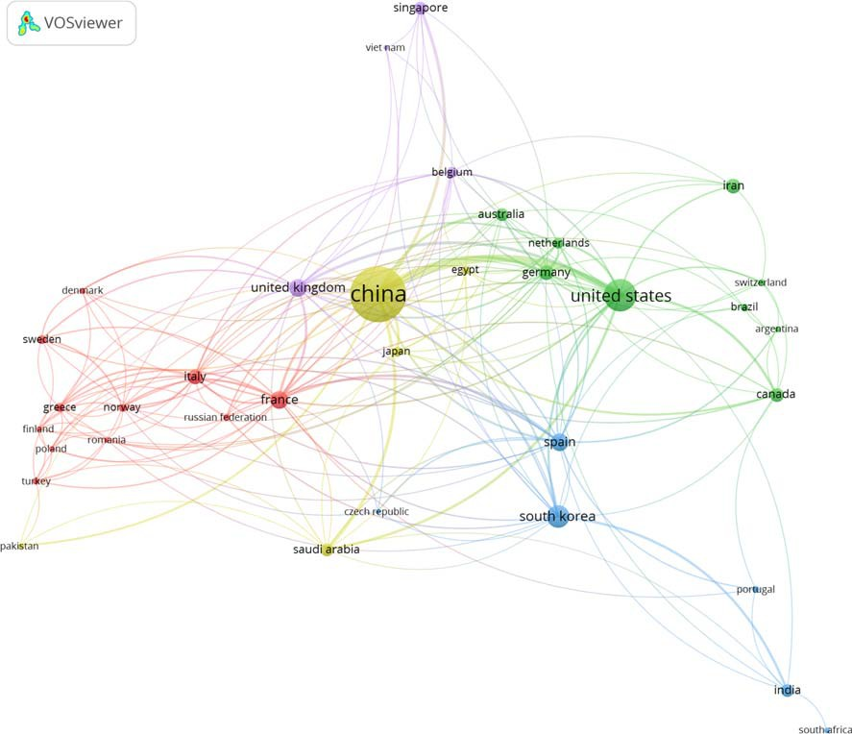
Fig. 3 Cooperation of countries and regions on the research of MOFs in the field of environmental science from 1999 to 2018

Table 4 Most productive institutions on research of MOFs in field of environmental science from1999 to 2018 (> 15 articles)

Institution | Country | TP | TC | TC/TP | SIP | MIP | H-index | TP
 |  |  |  |  |  |  |  | 1999–2003 | 2004–2008 | 2009–2013 | 2014–2018
Chinese Academy of Sciences | China | 86 | 2878 | 33.5 | 19 | 67 | 28 | – | 1 | 10 | 75
South China University of Technology | China | 46 | 1707 | 37.1 | 13 | 33 | 24 | – | – | 4 | 42
Kyungpook National University | South | 40 | 2237 | 55.9 | 35 | 5 | 23 | – | – | 11 | 29

Beijing University of Chemical Technology
Korea
China 27 790 29.3 13 14 15 – 2 5 20

University of California United States
26 1693 65.1 4 22 16 – 2 8 16

Fuzhou University | China | 21 | 970 | 46.2 | 11 | 10 | 15 | – – | 1 | 20
Nankai University | China | 19 | 708 | 37.3 | 9 | 10 | 9 | – – | 5 | 14
Tsinghua University | China | 19 | 307 | 16.2 | 8 | 11 | 8 | – – | – | 19
National University of Singapore | Singapore | 19 | 459 | 24.2 | 13 | 6 | 8 | – 1 | 4 | 14
Zhejiang University | China | 18 | 723 | 40.2 | 7 | 11 | 12 | – 1 | 4 | 20
King Abdulaziz University | Saudi | 18 | 415 | 23.1 | 0 | 18 | 10 | – – | – | 18
Arabia

Sun Yat-Sen University | China | 18 | 405 | 22.5 | 5 | 13 | 10 | – | – – | 18
Tianjin University | China | 17 | 404 | 23.8 | 3 | 14 | 10 | 1 | – 2 | 19
Nanyang Technology University | Singapore | 16 | 1037 | 64.8 | 7 | 9 | 11 | – | – 1 | 15
University of Science and Technology of China  Soochow University | China  China | 16  16 | 947  320 | 59.2  20.0 | 2  2 | 14  14 | 12  9 | –  – | – 3  – – | 13  16
World | – | 1386 | 37,632 | 27.2 | 599 | 787 | – | 37 | 58 236 | 1055
TP: total published articles; TC: total citations; SIP: single institution publications; MIP: multiple institution publicationsfollowed by South China University of Technology with 24 and Kyungpook National University with 23.
It is worth noting that the South China University of Technology, which was founded in 2011, has published 46 articles on MOFs-ES. This indicated that the research on MOFs-ES was one of the main fields for this young university. Their research mainly focused on the removal of various pol- lutants such as congo red (Yang et al. 2017), methyl orange (Wu et al. 2017), and triclosan (Dou et al. 2017) by MOFs and the synthesis of new hybrid MOFs materials (Chen et al. 2017; Yu et al. 2018). The articles published by Kyungpook National University were mainly conducted by the team led by Jhung SH. They mainly focused on removal of dyes (Haque et al. 2010), denitrogenation from model fuels (Ahmed et al. 2013a; Ahmed et al. 2013b; Ahmed and Jhung 2014; Ahmed et al. 2017) and removal of pharmaceu- ticals from water (Bhadra et al. 2017; Hasan et al. 2012; Sarker et al. 2018; Song and Jhung 2017), and so on. Beijing University of Chemical Technology was mainly en- gaged in gas adsorption (Shao et al. 2011; Wu et al. 2012) and wastewater treatment (Han et al. 2015; Xie et al. 2014) using MOFs in their earlier years, while they have begun to develop the application of MOFs in electrode materials (Shi et al. 2017) and membrane materials (Ma et al. 2017) in recent years. Similarly, the National University of Singapore has alsodeveloped the application of MOFs in membrane materials for seawater desalination (Zhu et al. 2016) and vacuum mem- brane distillation (Zuo and Chung 2016), and as anode mate- rials for batteries (Li et al. 2018b).
For the collaboration of institutions, multiple institution publications were slightly higher than single-institution publi- cations, as shown in Table 4. Some of the institutions had much more multiple institution publications such as the Chinese Academy of Sciences, South China University of Technology and the University of California. It was interest- ing that all the articles published by King Abdulaziz University were completed through the cooperation with other institutions. While some institutions had more single- institution publications such as Kyungpook National University and the National University of Singapore. Figure 4 shows the collaboration network between institu- tions, where the size of the circle and the line also represent the number of publications per institution and the links be- tween the institutions. The institutions published more than 5 articles which were collected as data. Twelve main clusters corresponding to twelve different colors can be differentiated. Chinese academy of sciences had the most abundant links to other institutions. However, Kyungpook National University, ranking third of the most productive institutions, had little cooperation with other institutions.

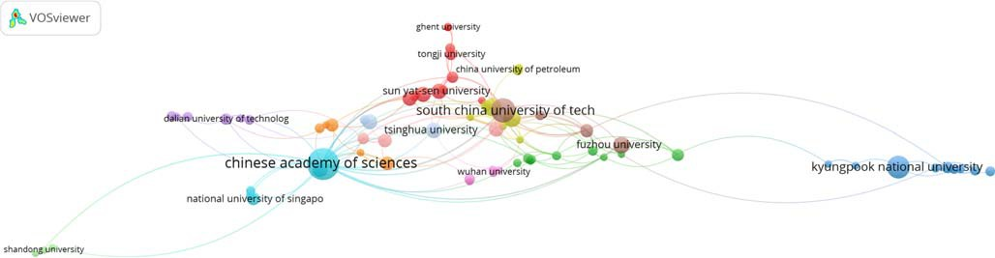
Fig. 4 Cooperation of institutions on the research of MOFs in the field of environmental science from 1999 to 2018

Authors analysis

The most productive authors (> 10 articles) in the field of MOFs-ES are shown in Table 5. Of the ten authors, five are Chinese and five are Korean. Three of them come from South China University of Technology, which is the most productive institution. And another three of them come from Kyungpook National University, which ranked second of the productive institutions. Jhung SH from Kyungpook National University was the most productive author, with 38 published articles, 2200 total citations accumulated from these studies, an H- index of 23 and an average citations per article of 57.9.
Figure 5 shows the collaboration network between authors who published more than 3 articles. The authors can be divid- ed into12 main clusters represented by 12 different colors. Each cluster represented one collaboration team. Jhung SH comes from Kyungpook National University had the most abundant links with other authors. And the team of Jhung SH cooperated most with the team of Bae YS come from Yonsei University. Li Z, who comes from the South China University of Technology, also had much cooperation with other authors. His team cooperated closely with the team of Li Y come from the same university. It can be found that most authors collaborated more with native authors, while the co- operation with foreign authors was less.

Journals analysis

The 1386 articles were published in 185 different journals. The characteristics of the top 20 journals publishing most articles on MOFs-ES research from 1999 to 2018 are shown in Table 6. The journal published most articles in the field of MOFs-ES was Chemical Engineering Journal with a total of 234 articles. The first article about MOFs-ES research published on this journal was in 2010, whereas the number of published papers increased quickly from 2014 to 2018, with 212 articles pub- lished in these 5 years. In addition, as an important indicator of impact for the journal, this journal occupied the second position with respect to the H-index of 41. Energy & Environmental Science, which occupies the sixth position according to the number of published articles, accumulated the highest citations of 6741. What’s more, as an indicator of impact, the average citations per article, impact factor and H-index of this journal were all the highest, with average citations per article of 102.1,

Table 5 Most productive authors on research of MOFs in field of environmental science from 1999 to 2018 (≥ 10 articles)

Author | ID | TP | TC | TC/TP | H-index | Country | Affiliation | First year | Last year
Jhung SH | 56532168100 | 38 | 2200 | 57.9 | 23 | South Korea | Kyungpook National University | 2010 | 2018
Li Y | 12040080600 | 16 | 667 | 41.7 | 12 | China | South China University of Technology | 2008 | 2017
Zhong C | 7202121115 | 15 | 567 | 43.6 | 11 | China | Beijing University of Chemical Technology | 2007 | 2018
Li Z | 35752191300 | 15 | 456 | 30.4 | 11 | China | South China University of Technology | 2011 | 2017
Khan NA | 35170042700 | 13 | 634 | 48.8 | 10 | South Korea | Kyungpook National University | 2011 | 2018
Xia Q | 8869056100 | 12 | 337 | 28.1 | 10 | China | South China University of Technology | 2014 | 2017
Chang JS | 18933850100 | 10 | 461 | 46.1 | 10 | South Korea | Korea Research Institute of Chemical | 2010 | 2018
Technology

Ahmed I | 55377179600 | 10 | 409 | 40.9 | 9 | South Korea | Kyungpook National University | 2013 | 2017
Bae YS | 7201465967 | 10 | 312 | 31.2 | 8 | South Korea | Yonsei University | 2012 | 2018
Zhu W | 7404232544 | 10 | 242 | 24.2 | 7 | China | Zhejiang Normal University | 2014 | 2018
TP: total published articles; TC: total citations; ID: Scopus Author Identifier

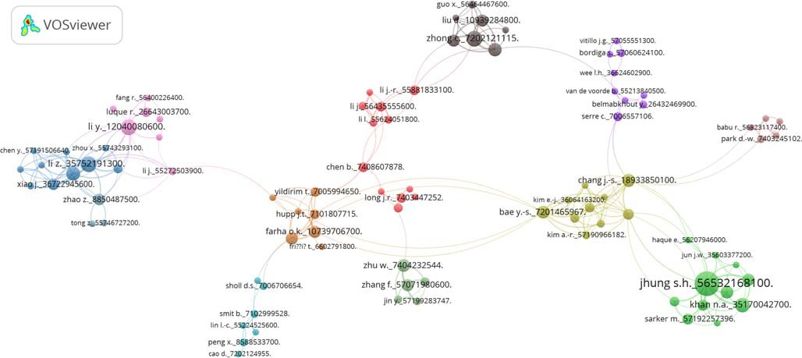
Fig. 5 Cooperation of authors on the research of MOFs in the field of environmental science from 1999 to 2018

impact factor of 30.067 and H-index of 42. This indicated that Energy & Environmental Science had the highest impact on MOFs-ES research. Environmental Science and Technology published its first article in MOFs-ES research in 1999, the first year of the period analysed. This journal had the number of citations per article with 55.2, ranking second position.

Table 6 Most productive journals on research of MOFs in field of environmental science from 1999 to 2018

Journal | IF | H-index | TP | TC | TC/TP | First year | TP
 |  |  |  |  |  |  | 1999–2003 | 2004–2008 | 2009–2013 | 2014–2018
Chemical Engineering Journal | 6.735 | 41 | 234 | 5245 | 22.4 | 2010 | – | – | 22 | 212
Applied Catalysis B: Environmental | 11.698 | 33 | 87 | 3152 | 36.2 | 2000 | 1 | 2 | 3 | 81
ACS Sustainable Chemistry and Engineering  ChemSusChem | 6.140  7.411 | 18  23 | 86  76 | 829  1906 | 9.6  25.1 | 2013  2008 | –  – | –  1 | 1  11 | 85  64
Journal of Hazardous Materials | 6.434 | 29 | 69 | 3201 | 46.4 | 2005 | – | 2 | 19 | 48
Energy & Environmental Science | 30.067 | 42 | 66 | 6741 | 102.1 | 2008 | – | 3 | 24 | 39
Green Chemistry | 8.586 | 28 | 52 | 2064 | 39.7 | 2009 | – | – | 8 | 44
Analytica Chimica Acta | 5.123 | 15 | 46 | 718 | 15.6 | 2012 | – | – | 5 | 41
Aiche Journal | 3.326 | 18 | 39 | 1295 | 33.2 | 2002 | 2 | 4 | 9 | 24
Environmental Science and Technology | 6.653 | 22 | 37 | 2043 | 55.2 | 1999 | 4 | 1 | 12 | 20
Analyst | 3.864 | 19 | 36 | 1180 | 32.8 | 2012 | – | – | 8 | 28
Science of the Total Environment | 4.610 | 13 | 28 | 850 | 30.4 | 2003 | 2 | 3 | 3 | 20
Chemosphere | 4.427 | 11 | 24 | 316 | 13.2 | 2008 | – | 1 | 7 | 16
Environmental Science and Pollution | 2.800 | 6 | 23 | 102 | 4.4 | 2014 | – | – | – | 23
Research

Journal of CO2 Utilization | 5.503 | 8 | 20 | 104 | 5.2 | 2016 | – – – | 20
Chem | 14.104 | 9 | 18 | 310 | 17.2 | 2016 | – – – | 18
Desalination and Water Treatment | 1.383 | 6 | 17 | 109 | 6.4 | 2011 | – – 1 | 16
Journal of Environmental Chemical | – | 5 | 14 | 91 | 6.5 | 2013 | – – 1 | 13
Engineering

Journal of Cleaner Production | 5.651 | 5 | 13 | 98 | 7.5 | 2011 | – | – | 1 | 12
Chinese Journal of Chemical Engineering | 1.712 | 6 | 13 | 98 | 7.5 | 2000 | 1 | 0 | 2 | 10
TP: total published articles; TC: total citations; IF: the impact factor of the journal. IF was obtained from the 2018 edition of the Journal Citation Reports

However, the number of publications in this journal on MOFs- ES research had not increased significantly in recent years, with a total number of 37 articles.
Figure 6 shows a 2 × 2 matrix where the x-axis represents the total citations of each journal accumulated from the related articles and y-axis represents the number of papers published by each journal in the field of MOFs-ES. By calculating the mean values of both variables of the top 20 journals, the journals could be divided into four groups (Fetscherin and Heinrich 2015). Quadrant A: high number of articles and high total citations; quadrant B: high number of articles and low total citations; quadrant C: low number of articles and low total citations; quadrant D: low number of articles and high total citations. Among the 20 most productive journals, 12 journals were located in quadrant C, which means that these journals had low number of articles and low total citations. And 6 journals located in quadrant A with higher number of articles and total citations, included Chemical Engineering Journal, Energy & Environmental Science, Applied Catalysis B: Environmental, Journal of Hazardous Materials, ChemSusChem, and Green Chemistry. The 6 journals with high number of articles and high total citations mainly belong to the WoS-category of chemistry and engineering & technol- ogy. The details for journals located in quadrant C are shown in Fig. S1 of supplementary material.

Keywords analysis

The analysis of high-frequency keywords is key to investigat- ing hot topics of a field. A total of 3328 keywords were ob- tained from the 1386 articles analysed. By further grouping, the high-frequency keywords were classified into 4 categories, as shown in Table 7. It can be seen that “MOFs” was a category of keywords with the highest frequency. Besides MOFs and its synonym in this category, UIO-66, MIL-101, ZIF-8 and MIL- 100(Fe) were also used as keywords frequently. MIL, ZIF and UIO were three typical types of MOFs, which has been widely used in recent years. The second category of keywords was adsorption, indicating that MOFs were widely used as adsor- bents in the removal of pollutants, whereas from the keywords in the third category, we can know that the pollutants treated by MOFs mainly included heavy metals and carbon dioxide. The fourth category of keywords was catalysis, showing that MOFs

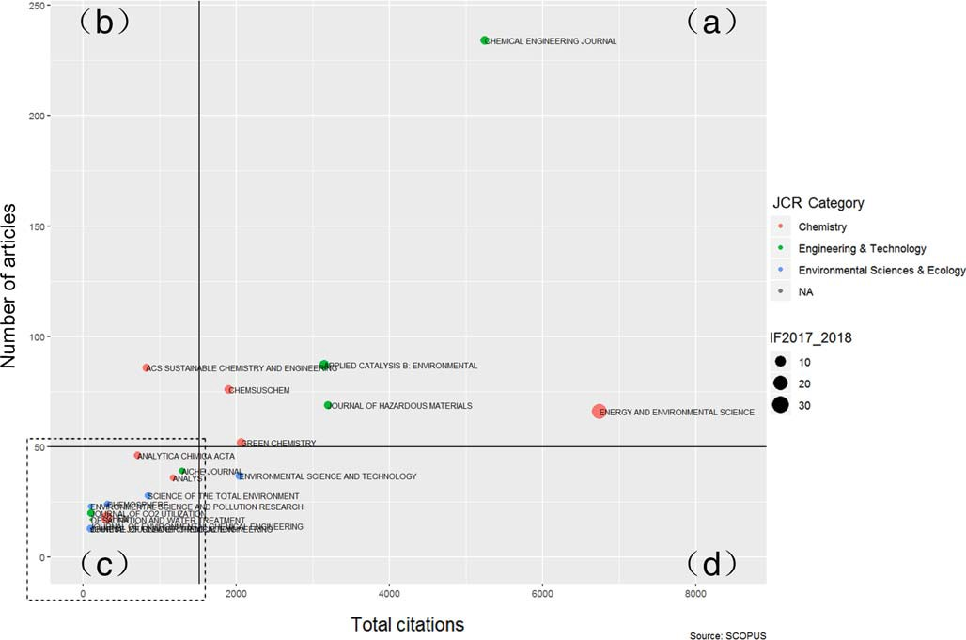
Fig. 6 The distribution of the journal in respect to the total citations and number of articles. The x-axis represents total citations and y-axis represents number of articles published by each journal

Table 7 Most frequently used keywords on research of MOFs in field of environmental science from 1999 to 2018

Category Representative keywords Frequency
of keywords

MOFs MOF/MOFs/Metal organic framework/Metal organic frameworks/ Metal - organic framework/ Metal - organic frameworks (499), UIO-66(18), MIL-101(17), ZIF-8(14), MIL-100(Fe) (12)
559

Adsorption Adsorption (176), Separation (25), Removal (16) 217

Pollutants Carbon dioxide Capture/ CO2Capture (30), Carbon dioxide (19), CO2Adsorption (11), Metals (21),
Heavy metals (17), Methylene blue (15), Copper (14)
127

Catalysis Photocatalysis/Photocatalyst (60), Heterogeneous catalysis/Heterogeneous catalyst (38) 98

were usually used in the catalysis reaction including photocatalysis and heterogeneous catalysis.
Here, high-frequency keywords which appeared more than 7 times were selected to conduct co-occurrence analysis. The keywords were regrouped in order to avoid duplicates due to pluralization. The keywords “MOF”, “MOFs”, “Metal organ- ic framework”, “Metal organic frameworks”, “Metal-organic framework” and “Metal-organic frameworks” were all named as metal-organic framework in the co-occurrence map. The co-occurrence map of keywords in the field studied is shown in Fig. 7. The size of the circle represents the frequency of the keyword. The size of the line represents the links between the keyword to the other. The thicker the line between two key- words, the more frequently that the two keywords appear to- gether. As shown in Fig. 7, metal-organic framework had theclosest links with other keywords because that the field we studied was the application of MOFs in environmental sci- ence. Thus, most of the articles should include metal-organic framework in its keywords. Other keywords with relatively large size, such as adsorption, photocatalysis, heterogeneous catalysis, separation and carbon dioxide capture, also occu- pied an important position. Moreover, the lines between metal-organic framework and adsorption, photocatalysis, het- erogeneous catalysis were thicker than other keywords, which indicated that adsorption and catalysis were the hotspots for MOFs-ES research.
The different colors of keywords in Fig. 7 represent the average publication year of keywords, as shown in the color bar. The change of color could reflect the change of hot topics in the field studied. In the purple color which represents
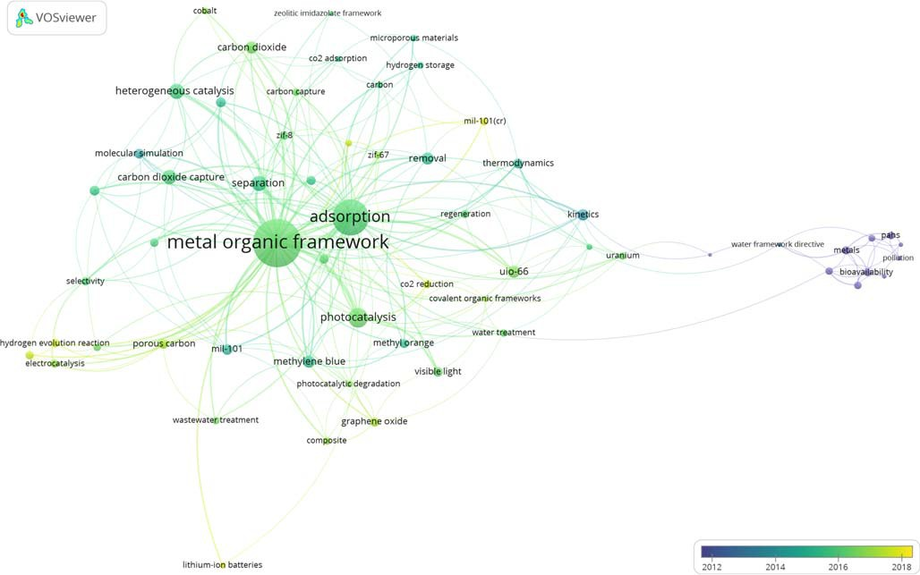
Fig. 7 The co-occurrence map of keywords on the research of MOFs in the field of environmental science from 1999 to 2018

publishing time about 2012, “metals”, “heavy metals” and “copper” were usually used as keywords, indicating that MOFs usually used for the removal of heavy metals at that time. As shown in Fig. 7, most keywords are in green color with the publishing time about 2016 because the research on MOFs-ES developed rapidly during that period. MOFs were usually used in the process of adsorption, separation and cat- alytic degradation of pollutants at that time. The keywords with publishing time about 2017 included “porous carbon”, “graphene oxide”, “composite” and “covalent organic frame- works”, indicating that some hybrid MOFs materials have been synthesized and used in the field of environmental sci- ence. The keywords published in about 2018, which were represented by the yellow color, included “hydrogen evolu- tion reaction”, “oxygen reduction reaction”, “peroxymonosul- fate”, “CO2 reduction” and “lithium-ion batteries”, showing that novel applications of MOFs have been explored. Thus, it can be concluded that the initial application of MOFs in the environmental science field mainly focused on gas adsorption, wastewater treatment and catalytic degradation of various pol- lutants, and now some new applications of MOFs have been developed. It can be predicted that the novel applications will be continuously explored.

The environmental applications of MOFs

MOFs have attracted extensive attention from researchers in the field of environmental science due to their excellent prop- erties. The environmental applications of MOFs mainly fo- cused on two aspects, namely the removal of toxic gases and the removal of various pollutants in the liquid phase by MOFs.

MOFs for the removal of toxic gases

Releasing toxic pollutants into the atmosphere has become a global risk. General harmful compounds, including SOx, NOx, CO, NH3, H2S, compounds containing nitrogen or sul- fur, hydrocarbons, volatile organic compounds (VOCs), are of main concern for air contamination (Barea et al. 2014). The effective adsorption and degradation of these compounds are of great significance to the environment and human health. Thus, developing new sorbents has gained more and more attention, with MOFs showing great prospects due to their various advantages.
MOFs have been used for the removal of toxic gases or toxic vapors, such as CO, NOX, sulfur-containing compounds and ammonia, and so on. The removal of toxic gases by MOFs is shown in Table 8. Zhang et al. (2019) prepared a series of amine-modified MOF-199 for the removal of H2S. The results showed that tertiary amine triethanolamine functionalized MOF-199 had a much higher adsorption capacity for H2S than that of parent MOF-199. Brandt et al. (2019) studied the re- moval of SO2 by MOF-177, which showed the highest capacity for SO2 adsorption by far with a maximum uptake of 25.7 mmol/g at 293 K and 0.97 bar. Gong et al. (2019) combined the nonthermal plasma technology with MOFs syn- thesis for the enhanced removal of NO. The results showed that this synergistic method could achieve an ultra-efficient NO removal through the reduction of NO to N2. In addition, MIL-101(Cr) and copper-doped MIL-101(Cr) were used for the removal of VOCs (Wang et al. 2018). The results indicated that MIL-101(Cr) and copper-doped MIL-101(Cr) had a promising potential for the removal of VOCs.
Though MOFs have shown great performance in removing toxic gases, a full set of design rules has not been established for the synthesis of MOFs capable of removing broad- spectrum toxic gases (DeCoste and Peterson 2014). The main target for the removal of hazardous gases by MOFs is to ex- plore high-affinity binding sites of MOFs and to enhance the resistance of MOFs to those toxic gases with high corrosive- ness (Li et al. 2018a). The appropriate pore size and shape of MOFs is not enough for the effective capture of harmful gases or vapors. Special interactions between hazardous gases and the adsorbents are desirable. Therefore, the effective synthesis rules for MOFs should be aimed at specific surface chemistry of MOFs, rather than only optimizing surface area (Barea et al. 2014). The degradation of hazardous gases into nontoxic sub- stances could be considered as an ideal method for air purifi- cation because it could overcome the problems of adsorbent saturation and secondary pollution (Barea et al. 2014). In ad- dition, the possible mechanisms of removing toxic gases over MOFs is not quite clear. Further research is stilled needed to understand the mechanism for removal of toxic gases by MOFs, to further improve the stability and recyclability of MOFs, to improve photocatalytic efficiency and the selectiv- ity for highly toxic gaseous pollutants (Wen et al. 2019).

MOFs for removal of pollutants from the liquid phase

The occurrence of various pollutants in an aquatic environ- ment has also attracted worldwide attention. The common pollutants in an aquatic environment mainly include organic pollutants, heavy metals and new emerging contaminants. On account of its importance to ecology and environment, the removal of pollutants with high toxicity and hard degradable properties from an aquatic environment is of great importance. MOFs are attractive candidates for the removal of pollutants in the liquid phase.
Several water-stable MOFs have been studied to remove various pollutants from wastewater. MOFs used for adsorp- tion of pharmaceuticals and personal care products, veterinary drugs, industrial emerging contaminant and miscellaneous or- ganic contaminants from aquatic systems were reviewed and summarized by Dhaka et al. (2019). Some new advances for the removal of heavy metals and organic pollutants from the liquid phase by MOFs are shown in Table 9. Xiong et al.
Table 8 Removal of toxic gases by MOFs

Toxic gases | MOFs | Conditions | Qmax (mg/g) | Reference
H2S | MIL-101(Cr) | 303.1 K, 20 bar | 1308.52 | (Hamon et al. 2009)
 | MIL-100(Cr) | 303.1 K, 20 bar | 569.07 | (Hamon et al. 2009)
 | MIL-47(V) | 303.1 K, 20 bar | 497.51 | (Hamon et al. 2009)
 | TEA/MOF-199 | 303 K | 93.37 | (Zhang et al. 2019)
 | MOF-199 | 303 K | 56.91 | (Zhang et al. 2019)
 | Zn-MOF-74 | 298 K, 1 bar | 55.88 | (Liu et al. 2017)
 | MOF-5 | 298 K, 1 bar | 37.82 | (Liu et al. 2017)
 | UiO-66-NH2 | 298 K, 1 bar | 30.96 | (Liu et al. 2017)
 | MIL-100(Fe) gel | 298 K, 1 bar | 30.67 | (Liu et al. 2017)
SO2 | MOF-177 | 293 K, 0.97 bar | 1646.34 | (Brandt et al. 2019)
 | NH2-MIL-125(Ti) | 293 K, 0.95 bar | 368.02 | (Brandt et al. 2019)
 | MIL-160 | 293 K, 0.97 bar | 245.35 | (Brandt et al. 2019)
 | MFM-300(In) | 298 K and 1 bar | 539.42 | (Savage et al. 2016)
 | MOF-74 | 298 K | 194 | (Britt et al. 2008)
 | MOF-199 | 298 K | 32 | (Britt et al. 2008)
NH3 | IRMOF-3 | 298 K | 105 | (Britt et al. 2008)
 | MOF-74 | 298 K | 93 | (Britt et al. 2008)
 | MOF-199 | 298 K | 87 | (Britt et al. 2008)
 | MOF-177 | 298 K | 42 | (Britt et al. 2008)
CO | MOF-74-Ni | 298 K, 1 bar | 169.18 | (Bloch et al. 2014)
 | MOF-74-Co | 298 K, 1 bar | 166.66 | (Bloch et al. 2014)
 | MOF-74-Fe | 298 K, 1 bar | 162.18 | (Bloch et al. 2014)
 | MOF-177 | 194.5 K and 1.08 bar | 129.97 | (Saha and Deng 2009)
 | MOF-177 | 237 K and 1.08 bar | 84.03 | (Saha and Deng 2009)
 | HKUST-1 | 298 K,1 bar | 40.61 | (Chowdhury et al. 2012)
 | MIL-101(Cr) | 298 K,1 bar | 28.85 | (Wang et al. 2014b)
 | CuAlCl4 doped MIL-101(Cr) | 298 K,1 bar | 63.30 | (Wang et al. 2014b)
 | MIL-100(Fe) | 298 K,1 bar | 10.64 | (Peng et al. 2015)
 | Cu(I)@MIL-100(Fe) | 298 K,1 bar | 77.87 | (Peng et al. 2015)
NO | MIL-88A | 298 K | 75.03 | (McKinlay et al. 2013)
 | MIL-88B | 298 K | 48.02 | (McKinlay et al. 2013)
 | MIL-88-B-NO2 | 298 K | 30.01 | (McKinlay et al. 2013)
NO2 | UiO-66-NH2 | 293 K, moist condition | 1400 | (Peterson et al. 2016)
 | UiO-66-NH2 | 293 K, dry condition | 930 | (Peterson et al. 2016)
 | HKUST-1 | 293 K, moist condition | 1200 | (Peterson et al. 2016)
 | HKUST-1 | 293 K, dry condition | 300 | (Chowdhury et al. 2012)
 | UiO-66 | Room temperature, dry condition | 73 | (Ebrahim et al. 2013)
 | UiO-66 | Room temperature, moist condition | 40 | (Ebrahim et al. 2013)
 | UiO-67 | Room temperature, dry condition | 79 | (Ebrahim et al. 2013)
 | UiO-67 | Room temperature, moist condition | 118 | (Ebrahim et al. 2013)
Cl2 | IRMOF-3 | 298 K | 335 | (Britt et al. 2008)
 | IRMOF-62 | 298 K | 92 | (Britt et al. 2008)

(2019) synthesized two novel lanthanide modified MOFs with good thermal and water stability, which also exhibited good selectivity for the separation of Th(IV) from REs(III). Liu et al. (2019) synthesized a water-stable copper-based MOF
Table 9 Removal of pollutants by MOFs from the liquid phase Pollutants
MOFs | Conditions | Qmax (mg/g) | Reference
PCN-221 MOF | Room temperature, pH 7.1, 30 min | 233.65 | (Seyfi Hasankola et al. 2020)
UiO-66-EDTA | 303 K, pH 5, 600 min | 371.6 | (Wu et al. 2019)
UiO-66-DMTD | 298 K, pH 3, 180 min | 670.5 | (Fu et al. 2019)
TMU-31 | Room temperature, pH 5, 20 min | 476.19 | (Hakimifar and Morsali 2019)
TMU-32 | Room temperature, pH 5, time 20 min | 416 | (Hakimifar and Morsali 2019)
nFe3O4@MIL-88A(Fe)/APTMS | Room temperature, pH 6, 30 min | 693.0 | (Mahmoud et al. 2020)
UiO-66-EDTA | 303 K, pH 5, 600 min | 237.2 | (Wu et al. 2019)
nFe3O4@MIL-88A(Fe)/APTMS | Room temperature, pH 6, 30 min | 536.22 | (Mahmoud et al. 2020)
TMU-31 and TMU-32 | Room temperature, pH 5, 5 min | 909 | (Hakimifar and Morsali 2019)
UiO-66-EDTA | 303 K, pH 5, 600 min | 357.9 | (Wu et al. 2019)
nFe3O4@MIL-88A(Fe)/APTMS | Room temperature, pH 2, 30 min | 1092.22 | (Mahmoud et al. 2020)
Form-UiO-66 | 298 K, pH 2, 720 min | 243.9 | (Wang et al. 2019b)
Ac-UiO-66 | 298 K, pH 2, 720 min | 151.52 | (Wang et al. 2019b)
UiO-66-EDTA | 303 K, pH 5, 600 min | 195.2 | (Wu et al. 2019)
f-ZIF-8@GO | 298 K, pH 6, 1440 min | 1872.24 | (Wei et al. 2019)
UiO-66-EDTA | 303 K, pH 5, 600 min | 291.7 | (Wu et al. 2019)
UiO-66-EDTA | 303 K, pH 5, 600 min | 281.3 | (Wu et al. 2019)
UiO-66-EDTA | 303 K, pH 5, 600 min | 243.5 | (Wu et al. 2019)
Ni-Zn MOF | 303 K, 720 min | 460.90 | (Yang and Bai 2019)
Ni MOF | 303 K, 720 min | 276.70 | (Yang and Bai 2019)
Zn MOF | 303 K, 720 min | 132.20 | (Yang and Bai 2019)
MIL-101(Cr) | 298 K, pH 7 | 420.2 | (Xu et al. 2019)
[Cu(BTTA)]n·2DMF | 298 K, pH 6.5, 450 min | 650 | (Liu et al. 2019)
Cu-BDC@GrO | 298 K, pH 4, 360 min | 182.2 | (Liu et al. 2019)
Cu-BDC@CNT | 298 K, pH 4, 360 min | 164.1 | (Ahsan et al. 2019)
UiO-66-NH2 | 298 K, pH 4, 1440 min | 153.9 | (Guan et al. 2020)
UiO-66-Br | 298 K, pH 4, 1440 min | 132.5 | (Guan et al. 2020)
UiO-66-NO2 | 298 K, pH 4, 1440 min | 117.7 | (Guan et al. 2020)
UiO-66 | 298 K, pH 4, 1440 min | 74.5 | (Guan et al. 2020)

Heavy metals Hg2+

Cd2+

Pb2+

Cr(VI)

Eu3+ Cu2+

Ni2+ Mn2+
Organic pollutants Congo red

Methyl orange Diclofenac sodium Bisphenol A

Phosphate

and used for the removal of pharmaceutical drugs from an aqueous medium. This material displayed a much higher adsorption capacity towards diclofenac sodium. Sun et al. (2019) investigated the adsorption of two typical anti- inflammatory drugs (ibuprofen and naproxen) by two types of MOFs (UiO-66 and UiO-66-NH2). The mechanism for the adsorption of ibuprofen and naproxen by MOFs was revealed according to experimental results and the calculation of den- sity functional theory. Possible mechanisms for adsorptive removal of pollutants over MOFs are shown in Fig. 8. Four mechanisms were included in the simulation for the adsorp- tion of ibuprofen and naproxen by MOFs, and the results showed that the binding energies of the four mechanisms followed the order of π-π interaction > hydrogen bonding >Lewis acid/base complexing > anion-π interaction. This study provided a new approach to further understand the removal mechanism of pollutants by MOFs.
In addition, the improvement of photocatalytic efficiency for pollutants by MOFs was also studied. He et al. (2019) reported a magnetic MIL-101(Fe)/TiO2 material for photodegradation of tetracycline under sunlight. The results showed that the combination of MIL-101(Fe) with TiO2 could improve the catalytic performance, which showed higher deg- radation efficiency of tetracycline and excellent reusability. Yu et al. (2019) combined photocatalysis of MOFs and ozone as electron acceptors to reduce the charge carrier recombination. MIL-88A(Fe) with a large number of Lewis acid sites and photo-response property showed an excellent photocatalytic
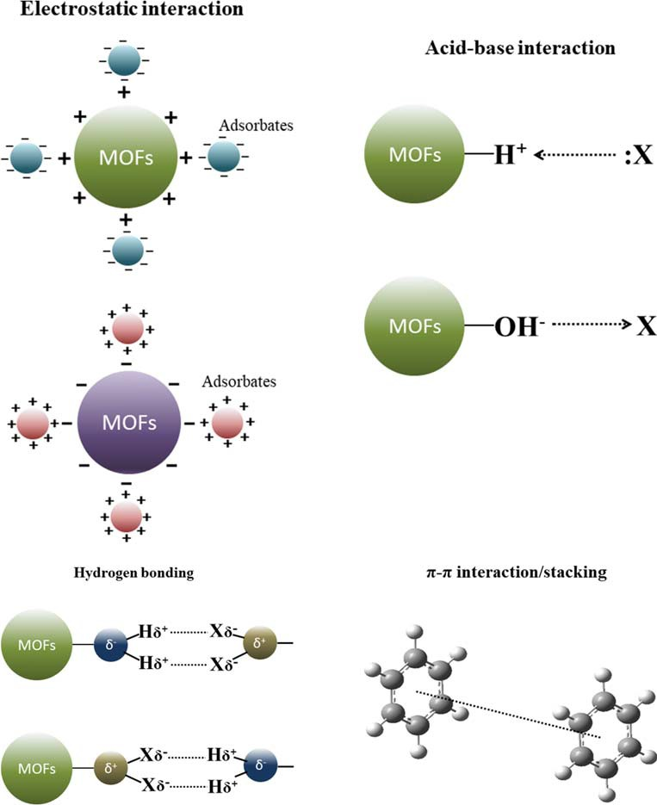Fig. 8 Possible mechanisms for adsorptive removal of pollutants over MOFs (adopted from (Dhaka et al. 2019, Hasan
&Jhung 2015))

ozonation activity due to O3-induced synergic effect. In addi- tion, it is reported that the combining of MOFs with graphitic carbon nitride could further improve the photocatalytic activ- ity of the material under visible light or sunlight irradiation (Wang et al. 2019a). However, further study is still required to better understand the photocatalytic mechanisms of MOFs and the crucial structural characteristics of controlling their photocatalytic activity (Wang et al. 2014a).
Although a lot of efforts have been made to improve the performance of MOFs in removing pollutants from solution, there are still many challenges needed to be overcome. The removal mechanism of pollutants in the liquid phase by MOFs should be further studied to improve the capacity of existing MOFs and develop new types of MOFs. In addition, applications of MOFs in the real environment are usually limited by their poor stability due to the weak coordination be- tween the metal and organic linkers (Dhaka et al. 2019). It is important to further improve the stability of MOFs while en- hancing the capacity of MOFs. On the other hand, the high cost of MOFs would also limit the applications of MOFs. It is necessary to reduce the cost of MOFs through developing sim- ple synthetic methods and easy regeneration methods (Dhaka et al. 2019). Thus, in order to realize the practical application of MOFs in environmental science, further research is still needed to improve the water stability and recyclability of MOFs, and reducing the cost for fabrication of MOFs.

Conclusions and perspective

MOFs have gained more and more attention in recent years in the field of environmental science due to their excellent prop- erties. Bibliometric analysis was used in this study to review the overall development of MOFs in the field of environmen- tal science. As a nascent field, the research on MOFs-ES has entered a fast-developing stage and it may get a faster devel- opment in the next few years. Though European and American countries started their research on MOFs-ES earlier, the obvious migration of centres of gravity for publications and citations was noteworthy due to the growing up of Asian countries. In the last decade, China has become the leading country with the largest number of publications. However, Asian countries such as China and South Korea should further strengthen their international cooperation. The information provided by this study could enhance collaboration among the groups working on research of MOFs-ES.
For future research of MOFs, new types of MOFs are still being synthesized and their environmental applications of MOFs are still being developed. In order to improve the ca- pacity of MOFs for pollutants, the removal mechanism of pollutants by MOFs should be further studied. In addition, improving the water stability of MOFs is still a major chal- lenge for their environmental application. What’s more, in order to promote the wide applicability of MOFs, researchers must strive to minimize the cost of MOFs by developing sim- ple synthetic methods, easy regeneration methods and sustain- able disposal of waste materials.

Funding information This work was financially supported by the National Major Scientific and Technological Projects for Water Pollution Control and Management (2017ZX07402003), the China Postdoctoral Science Foundation (2019M650798), and the Central Public Welfare Scientific Research Project of Chinese Research Academy of Environmental Sciences (2016YSKY-027).

References

Ahmed I, Jhung SH (2014) Adsorptive denitrogenation of model fuel with CuCl-loaded metal–organic frameworks (MOFs). Chem Eng J 251:35–42
Ahmed I, Hasan Z, Khan NA, Jhung SH (2013a) Adsorptive denitrogenation of model fuels with porous metal-organic frame- works (MOFs): effect of acidity and basicity of MOFs. Appl Catal B-Environ 129:123–129
Ahmed I, Khan NA, Hasan Z, Jhung SH (2013b) Adsorptive denitrogenation of model fuels with porous metal-organic frame- work (MOF) MIL-101 impregnated with phosphotungstic acid: ef- fect of acid site inclusion. J Hazard Mater 250-251:37–44
Ahmed I, Khan NA, Jhung SH (2017) Adsorptive denitrogenation of model fuel by functionalized UiO-66 with acidic and basic moieties. Chem Eng J 321:40–47
Ahsan MA, Jabbari V, Islam MT, Turley RS, Dominguez N, Kim H, Castro E, Hernandez-Viezcas JA, Curry ML, Lopez J, Gardea- Torresdey JL, Noveron JC (2019) Sustainable synthesis andremarkable adsorption capacity of MOF/graphene oxide and MOF/CNT based hybrid nanocomposites for the removal of Bisphenol A from water. Sci Total Environ 673:306–317
Aleixandre-Benavent R, Aleixandre-Tudó JL, Castelló-Cogollos L, Aleixandre JL (2017) Trends in scientific research on climate change in agriculture and forestry subject areas (2005–2014). J Clean Prod 147:406–418
Aria M, Cuccurullo C (2017) Bibliometrix : An R-tool for comprehensive science mapping analysis. J Inf Secur 11:959–975
Awual MR (2017) Novel nanocomposite materials for efficient and se- lective mercury ions capturing from wastewater. Chem Eng J 307: 456–465
Awual MR (2019) An efficient composite material for selective lead(II) monitoring and removal from wastewater. J Environ Chem Eng 7: 103087
Awual MR, Hasan MM, Rahman MM, Asiri AM (2019) Novel compos- ite material for selective copper(II) detection and removal from aqueous media. J Mol Liq 283:772–780
Banerjee R, Phan A, Wang B, Knobler C, Furukawa H, O’Keeffe M, Yaghi OM (2008) High-throughput synthesis of zeolitic imidazolate frameworks and application to CO2 capture. Science 319:939–943
Barea E, Montoro C, Navarro JA (2014) Toxic gas removal-metal- organic frameworks for the capture and degradation of toxic gases and vapours. Chem Soc Rev 43:5419–5430
Bhadra BN, Ahmed I, Kim S, Jhung SH (2017) Adsorptive removal of ibuprofen and diclofenac from water using metal-organic frame- work-derived porous carbon. Chem Eng J 314:50–58
Bloch ED, Hudson MR, Mason JA, Chavan S, Crocellà V, Howe JD, Lee K, Dzubak AL, Queen WL, Zadrozny JM, Geier SJ, Lin LC, Gagliardi L, Smit B, Neaton JB, Bordiga S, Brown CM, Long JR (2014) Reversible CO binding enables tunable CO/H2 and CO/N2 separations in metal-organic frameworks with exposed divalent met- al cations. J Am Chem Soc 136:10752–10761
Brandt P, Nuhnen A, Lange M, Möllmer J, Weingart O, Janiak C (2019) Metal-organic frameworks with potential application for SO2 sepa- ration and flue gas desulfurization. Appl Mater Interfaces 11:17350– 17358
Britt D, Tranchemontagne D, Yaghi OM (2008) Metal-organic frame- works with high capacity and selectivity for harmful gases. PNAS 105:11623–11627
Cavka JH, Jakobsen S, Olsbye U, Guillou N, Lamberti C, Bordiga S, Lillerud KP (2008) A new zirconium inorganic building brick forming metal organic frameworks with exceptional stability. J Am Chem Soc 130:13850–13851
Chen Y, Lv D, Wu J, Xiao J, Xi H, Xia Q, Li Z (2017) A new MOF- 505@GO composite with high selectivity for CO2 /CH4 and CO2/N2 separation. Chem Eng J 308:1065–1072
Chowdhury P, Mekala S, Dreisbach F, Gumma S (2012) Adsorption of CO, CO2 and CH4 on Cu-BTC and MIL-101 metal organic frame- works: effect of open metal sites and adsorbate polarity. Micropor Mesopor Mat 152:246–252
Chui SS-Y, Lo SM-F, Charmant JPH, Orpen AG, Williams ID (1999) A che m icall y functi onaliz abl e nanoporous ma teria l [Cu3(TMA)2(H2O)3]n. Science 283:1148–1150
DeCoste JB, Peterson GW (2014) Metal-organic frameworks for air pu- rification of toxic chemicals. Chem Rev 114:5695–5727
Dhaka S, Kumar R, Deep A, Kurade MB, Ji SW, Jeon BH (2019) Metal– organic frameworks (MOFs) for the removal of emerging contami- nants from aquatic environments. Coordin Chem Rev 380:330–352
Dou R, Zhang J, Chen Y, Feng S (2017) High efficiency removal of triclosan by structure-directing agent modified mesoporous MIL- 53(Al). Environ Sci Pollut Res 24:8778–8789
Ebrahim AM, Levasseur B, Bandosz TJ (2013) Interactions of NO2 with Zr-based MOF: effects of the size of organic linkers on NO2 adsorp- tion at ambient conditions. Langmuir 29:168–174
Férey G, Serre C, Mellot-Draznieks C, Millange F, Surblé S, Dutour J, Margiolaki I (2004) A hybrid solid with giant pores prepared by a combination of targeted chemistry, simulation, and powder diffrac- tion. Angew Chem 116:6456–6461
Férey G, Mellot-Draznieks C, Serre C, Millange F, Dutour J, Surblé S, Margiolaki I (2005) A chromium terephthalate-based solid with un- usually large pore volumes and surface area. Science 309:2040– 2042
Fetscherin M, Heinrich D (2015) Consumer brand relationships research: a bibliometric citation meta-analysis. J Bus Res 68:380–390
Fu L, Wang S, Lin G, Zhang L, Liu Q, Fang J, Wei C, Liu G (2019) Post- functionalization of UiO-66-NH2 by 2,5-Dimercapto-1,3,4- thiadiazole for the high efficient removal of hg(II) in water. J Hazard Mater 368:42–51
Gong X, Zhao R, Qin J, Wang H, Wang D (2019) Ultra-efficient removal of NO in a MOFs-NTP synergistic process at ambient temperature. Chem Eng J 358:291–298
Guan T, Li X, Fang W, Wu D (2020) Efficient removal of phosphate from acidified urine using UiO-66 metal-organic frameworks with vary- ing functional groups. Appl Surf Sci 501:144074
Hakimifar A, Morsali A (2019) Urea-based metal-organic frameworks as high and fast adsorbent for hg(2+) and Pb(2+) removal from water. Inorg Chem 58:180–187
Hamon L, Serre C, Devic T, Loiseau T, Millange F, Férey G, De Weireld G (2009) Comparative study of hydrogen sulfide adsorption in the MIL-53(Al, Cr, Fe), MIL-47(V), MIL-100(Cr), and MIL-101(Cr)
metal-organic frameworks at room temperature. J Am Chem Soc 131:8775–8777
Han T, Xiao Y, Tong M, Huang H, Liu D, Wang L, Zhong C (2015) Synthesis of CNT@MIL-68(Al) composites with improved adsorp- tion capacity for phenol in aqueous solution. Chem Eng J 275:134– 141
Haque E, Lee JE, Jang IT, Hwang YK, Chang JS, Jegal J, Jhung SH (2010) Adsorptive removal of methyl orange from aqueous solution with metal- organic frameworks, porous chromium- benzenedicarboxylates. J Hazard Mater 181:535–542
Haque E, Jun JW, Jhung SH (2011) Adsorptive removal of methyl orange and methylene blue from aqueous solution with a metal-organic framework material, iron terephthalate (MOF-235). J Hazard Mater 185:507–511
Hasan Z, Jeon J, Jhung SH (2012) Adsorptive removal of naproxen and clofibric acid from water using metal-organic frameworks. J Hazard Mater 209-210:151–157
Hayashi H, Cote AP, Furukawa H, O'Keeffe M, Yaghi OM (2007) Zeolite a imidazolate frameworks. Nat Mater 6:501–506
He L, Dong Y, Zheng Y, Jia Q, Shan S, Zhang Y (2019) A novel magnetic MIL-101(Fe)/TiO2 composite for photo degradation of tetracycline under solar light. J Hazard Mater 361:85–94
He Y, Krishna R, Chen B (2012) Metal–organic frameworks with poten- tial for energy-efficient adsorptive separation of light hydrocarbons. Energ Environ Sci 5:9107–9120
Hirsch JE (2005) An index to quantify an individual's scientific research output. PNAS 102:16569–16572
Horcajada P, Surble S, Serre C, Hong DY, SeO YK, Chang JS, Greneche JM, Margiolaki I, Ferey G (2007) Synthesis and catalytic properties of MIL-100(Fe), an iron(III) carboxylate with large pores. Chem Commun 27:2820–2822
Hu H, Han L, Yu M, Wang Z, Lou XW (2016) Metal–organic-frame- work-engaged formation of Co nanoparticle-embedded carbon@Co S double-shelled nanocages for efficient oxygen reduction. Energ Environ Sci 9:107–111
Huo SH, Yan XP (2012) Facile magnetization of metal-organic frame- work MIL-101 for magnetic solid-phase extraction of polycyclic aromatic hydrocarbons in environmental water samples. Analyst 137:3445–3451
Kolesnikov S, Fukumoto E, Bozeman B (2018) Researchers’ risk- smoothing publication strategies: is productivity the enemy of im- pact? Scientometrics 116:1995–2017
Li W, Zhao Y (2015) Bibliometric analysis of global environmental as- sessment research in a 20-year period. Environ Impact Asses 50: 158–166
Li H, Eddaoudi M, O'Keeffe M, Yaghi OM (1999) Design and synthesis of an exceptionally stable and highly porous metal-organic frame- work. Nature 402:276–279
Li JR, Sculley J, Zhou HC (2012) Metal-organic frameworks for separa- tions. Chem Rev 112:869–932
Li H, Wang K, Sun Y, Lollar CT, Li J, Zhou HC (2018a) Recent advances in gas storage and separation using metal–organic frameworks. Mater Today 21:108–121
Li J, Yan D, Hou S, Lu T, Yao Y, Chua DHC, Pan L (2018b) Metal- organic frameworks derived yolk-shell ZnO/NiO microspheres as high-performance anode materials for lithium-ion batteries. Chem Eng J 335:579–589
Liu J, Wei Y, Li P, Zhao Y, Zou R (2017) Selective H2S/CO2 separation by metal–organic frameworks based on chemical-physical adsorp- tion. J Phys Chem C 121:13249–13255
Liu W, Shen X, Han Y, Liu Z, Dai W, Dutta A, Kumar A, Liu J (2019) Selective adsorption and removal of drug contaminants by using an extremely stable Cu(II)-based 3D metal-organic framework. Chemosphere 215:524–531
Ma J, Guo X, Ying Y, Liu D, Zhong C (2017) Composite ultrafiltration membrane tailored by MOF@GO with highly improved water pu- rification performance. Chem Eng J 313:890–898
Mahmoud ME, Amira MF, Seleim SM, Mohamed AK (2020) Amino- decorated magnetic metal-organic framework as a potential novel platform for selective removal of chromium (Vl), cadmium (II) and lead (II). J Hazard Mater 381:120979
Mason JA, Sumida K, Herm ZR, Krishna R, Long JR (2011) Evaluating metal–organic frameworks for post-combustion carbon dioxide cap- ture via temperature swing adsorption. Energy Environ Sci 4:3030– 3040
McKinlay AC, Eubank JF, Wuttke S, Xiao B, Wheatley PS, Bazin P, Lavalley JC, Daturi M, Vimont A, De Weireld G, Horcajada P, Serre C, Morris RE (2013) Nitric oxide adsorption and delivery in flexible MIL-88(Fe) metal–organic frameworks. Chem Mater 25: 1592–1599
Mauter M.S., Elimelech M (2008) Environmental applications of carbon- based Nanomaterials. Environ Sci Technol 42:5843–5859
Park KS, Ni Z, Cote AP, Choi JY, Huang R, Uribe-Romo FJ, Chae HK, O’Keeffe M, Yaghi OM (2006) Exceptional chemical and thermal stability of zeolitic imidazolate frameworks. PNAS 103:10186– 10191
Peng J, Xian S, Xiao J, Huang Y, Xia Q, Wang H, Li Z (2015) A sup- ported cu(I)@MIL-100(Fe) adsorbent with high CO adsorption ca- pacity and CO/N2 selectivity. Chem Eng J 270:282–289
Peterson GW, Mahle JJ, Decoste JB, Gordon WO, Rossin JA (2016)
Extraordinary NO2 removal by the metal-organic framework UiO- 66-NH2. Angew Chem Int Ed 55:6235–6238
Qiu S, Xue M, Zhu G (2014) Metal-organic framework membranes: from synthesis to separation application. Chem Soc Rev 43:6116–6140
Rowsell JLC, Yaghi OM (2004) Metal–organic frameworks: a new class of porous materials. Micropor Mesopor Mat 73:3–14
Saha D, Deng S (2009) Adsorption equilibria and kinetics of carbon monoxide on zeolite 5A, 13X, MOF-5, and MOF-177. J Chem Eng Data 54:2245–2250
Saha D, Bao Z, Jia F, Deng S (2010) Adsorption of CO2, CH4, N2O, and N2 on MOF-5, MOF-177, and zeolite 5A. Environ Sci Technol 44: 1820–1826
Sarker M, Song JY, Jhung SH (2018) Adsorptive removal of anti- inflammatory drugs from water using graphene oxide/metal- organic framework composites. Chem Eng J 335:74–81
Savage M, Cheng Y, Easun TL, Eyley JE, Argent SP, Warren MR, Lewis W, Murray C, Tang CC, Frogley MD, Cinque G, Sun J, Rudić S, Murden RT, Benham MJ, Fitch AN, Blake AJ, Ramirez-Cuesta AJ, Yang S, Schröder M (2016) Selective adsorption of sulfur dioxide in a robust metal–organic framework material. Adv Mater 28:8705– 8711
Sayari A, Belmabkhout Y, Serna-Guerrer R (2011) Flue gas treatment via CO adsorption. Chem Eng J 171:760–774
Seo JS, Whang D, Lee H, Jun SI, Oh J, Jeon YJ, Kim K (2000) A homochiral metal–organic porous material for enantioselective sep- aration and catalysis. Nature 404:982–986
Seyfi Hasankola Z, Rahimi R, Shayegan H, Moradi E, Safarifard V (2020) Removal of Hg2+ heavy metal ion using a highly stable mesoporous porphyrinic zirconium metal-organic framework. Inorg Chim Acta 501:119264
Shahat A, Awual MR, Naushad M (2015) Functional ligand anchored nanomaterial based facial adsorbent for cobalt(II) detection and re- moval from water samples. Chem Eng J 271:155–163
Shao X, Feng Z, Xue R, Ma C, Wang W, Peng X, Cao D (2011) Adsorption of CO2, CH4, CO2/N2 and CO2/CH4 in novel activated carbon beads: preparation, measurements and simulation. AICHE J 57:3042–3051
Shi X, Liu S, Tang B, Lin X, Li A, Chen X, Zhou J, Ma Z, Song H (2017) SnO2/TiO2 nanocomposites embedded in porous carbon as a supe- rior anode material for lithium-ion batteries. Chem Eng J 330:453– 461
Simmons JM, Wu H, Zhou W, Yildirim T (2011) Carbon capture in metal-organic frameworks-a comparative study. Energ Environ Sci 4:2177–2185
Siyal AA, Shamsuddin MR, Low A, Rabat NE (2020) A review on recent developments in the adsorption of surfactants from wastewater. J Environ Manag 254:109797
Song J, Zhang Z, Hu S, Wu T, Jiang T, Han B (2009) MOF-5/n-Bu4NBr: an efficient catalyst system for the synthesis of cyclic carbonates from epoxides and CO2 under mild conditions. Green Chem 11: 1031–1036
Song JY, Jhung SH (2017) Adsorption of pharmaceuticals and personal care products over metal-organic frameworks functionalized with hydroxyl groups: quantitative analyses of H-bonding in adsorption. Chem Eng J 322:366–374
Sun W, Li H, Li H, Li S, Cao X (2019) Adsorption mechanisms of ibuprofen and naproxen to UiO-66 and UiO-66-NH2: batch experi- ment and DFT calculation. Chem Eng J 360:645–653
Van de Voorde B, Bueken B, Denayer J, De Vos D (2014) Adsorptive separation on metal-organic frameworks in the liquid phase. Chem Soc Rev 43:5766–5788
Van Eck NJ, Waltman L (2010) Software survey: VOSviewer, a computer program for bibliometric mapping. Scientometrics 84:523–538
Wang B, Cote AP, Furukawa H, O'Keeffe M, Yaghi OM (2008) Colossal cages in zeolitic imidazolate frameworks as selective carbon dioxide reservoirs. Nature 453:207–211
Wang CC, Li JR, Lv XL, Zhang YQ, Guo G (2014a) Photocatalytic organic pollutants degradation in metal–organic frameworks. Energy Environ Sci 7:2831–2867
Wang Y, Li C, Meng F, Lv S, Guo J, Liu X, Wang C, Ma Z (2014b) CuAlCl4 doped MIL-101 as a high capacity CO adsorbent with selectivity over N2. Front Chem Sci Eng 8:340–345
Wang DF, Wu GP, Zhao YF, Cui LZ, Shin CH, Ryu MH, Cai JX (2018) Study on the copper(II)-doped MIL-101(Cr) and its performance in VOCs adsorption. Environ Sci Pollut Res 25:28109–28119
Wang CC, Yi XH, Wang P (2019a) Powerful combination of MOFs and C3N4 for enhanced photocatalytic performance. Appl Catal B- Environ 247:24–48
Wang H, Yuan X, Wu Y, Zeng G, Chen X, Leng L, Li H (2015) Synthesis and applications of novel graphitic carbon nitride/metal-organicframeworks mesoporous photocatalyst for dyes removal. Appl Catal B-Environ 174-175:445–454
Wang Y, Zhang N, Chen D, Ma D, Liu G, Zou X, Chen Y, Shu R, Song Q, Lv W (2019b) Facile synthesis of acid-modified UiO-66 to enhance the removal of Cr(VI) from aqueous solutions. Sci Total Environ 682:118–127
Wei N, Zheng X, Ou H, Yu P, Li Q, Feng S (2019) Fabrication of an amine-modified ZIF-8@GO membrane for high-efficiency adsorp- tion of copper ions. New J Chem 43:5603–5610
Wen M, Li G, Liu H, Chen J, An T, Yamashita H (2019) Metal–organic framework-based nanomaterials for adsorption and photocatalytic degradation of gaseous pollutants: recent progress and challenges. Environ Sci Nano 6:1006–1025
Wu D, Wang CC, Liu B, Liu D, Yang Q, Zhong C (2012) Large-scale computational screening of metal-organic frameworks for CH4/H2 separation. AICHE J 58:2078–2084
Wu SC, You X, Yang C, Cheng JH (2017) Adsorption behavior of methyl orange onto an aluminum-based metal organic framework, MIL- 68(Al). Water Sci Technol 75:2800–2810
Wu J, Zhou J, Zhang S, Alsaedi A, Hayat T, Li J, Song Y (2019) Efficient removal of metal contaminants by EDTA modified MOF from aque- ous solutions. J Colloid Interface Sci 555:403–412
Xia W, Zou R, An L, Xia D, Guo S (2015) A metal–organic framework route to in situ encapsulation of Co@Co O @C core@bishell nano- particles into a highly ordered porous carbon matrix for oxygen reduction. Energ Environ Sci 8:568–576
Xie L, Liu D, Huang H, Yang Q, Zhong C (2014) Efficient capture of nitrobenzene from waste water using metal–organic frameworks. Chem Eng J 246:142–149
Xiong Y, Gao Y, Guo X, Wang Y, Su X, Sun X (2019) Water-stable MOF material with uncoordinated terpyridine site for selective Th(IV)/ Ln(III) separation. ACS Sustain Chem Eng 7:3120–3126
Xu W, Li W, Lu L, Zhang W, Kang J, Li B (2019) Morphology-control of metal-organic framework crystal for effective removal of dyes from water. J Solid State Chem 279:120950
Yaghi OM, Li G, Li H (1995) Selective binding and removal of guests in a microporous metal–organic framework. Nature 378:703–706
Yang M, Bai Q (2019) Flower-like hierarchical Ni-Zn MOF micro- spheres: efficient adsorbents for dye removal. Colloid Surface A 582:123795
Yang DA, Cho HY, Kim J, Yang ST, Ahn WS (2012) CO capture and conversion using Mg-MOF-74 prepared by a sonochemical method. Energ Environ Sci 5:6465–6473
Yang C, Yu L, Chen R, Cheng J, Chen Y, Hu Y (2017) Congo red adsorption on metal-organic frameworks, MIL-101 and ZIF-8: ki- netics, isotherm and thermodynamic studies. Desalin Water Treat 94:211–221
Yang X, Wan Y, Zheng Y, He F, Yu Z, Huang J, Wang H, Ok YS, Jiang Y, Gao B (2019) Surface functional groups of carbon-based adsorbents and their roles in the removal of heavy metals from aqueous solu- tions: a critical review. Chem Eng J 366:608–621
Yu LL, Cao W, Wu SC, Yang C, Cheng JH (2018) Removal of tetracy- cline from aqueous solution by MOF/graphite oxide pellets: prepa- ration, characteristic, adsorption performance and mechanism. Ecotoxicol Environ Saf 164:289–296
Yu D, Li L, Wu M, Crittenden JC (2019) Enhanced photocatalytic ozon- ation of organic pollutants using an iron-based metal-organic frame- work. Appl Catal B-Environ 251:66–75
Yu XY, Feng Y, Guan B, Lou XW, Paik U (2016) Carbon coated porous nickel phosphides nanoplates for highly efficient oxygen evolution reaction. Energ Environ Sci 9:1246–1250
Zhang T, Lin W (2014) Metal-organic frameworks for artificial photo- synthesis and photocatalysis. Chem Soc Rev 43:5982–5993
Zhang Y, Yu Q (2019) What is the best article publishing strategy for early career scientists? Scientometrics 122:397–408

Zhang S, Mao G, Crittenden J, Liu X, Du H (2017a) Groundwater reme- diation from the past to the future: a bibliometric analysis. Water Res 119:114–125
Zhang Y, Wang Y, Niu H (2017b) Spatio-temporal variations in the areas suitable for the cultivation of rice and maize in China under future climate scenarios. Sci Total Environ 601-602:518–531
Zhang Y, Zhang Y, Shi K, Yao X (2017c) Research development, current hotspots, and future directions of water research based on MODIS images: a critical review with a bibliometric analysis. Environ Sci Pollut Res 24:15226–15239
Zhang H-Y, Yang C, Geng Q, Fan H-L, Wang B-J, Wu M-M, Tian Z (2019) Adsorption of hydrogen sulfide by amine-functionalized metal organic framework (MOF-199): an experimental and simula- tion study. Appl Surf Sci 497:143815
Zhao L, Deng J, Sun P, Liu J, Ji Y, Nakada N, Qiao Z, Tanaka H, Yang Y (2018) Nanomaterials for treating emerging contaminants in water by adsorption and photocatalysis: systematic review and bibliometric analysis. Sci Total Environ 627:1253–1263
Zhao D, Yuan D, Zhou HC (2008) The current status of hydrogen storage in metal–organic frameworks. Energ Environ Sci 1:222–235
Zhi W, Yuan L, Ji G, Liu Y, Cai Z, Chen X (2015) A bibliometric review on carbon cycling research during 1993–2013. Environ Earth Sci 74:6065–6075
Zhong M, Kong L, Li N, Liu YY, Zhu J, Bu XH (2019) Synthesis of MOF-derived nanostructures and their applications as anodes in lithium and sodium ion batteries. Coordin Chem Rev 388:172–201
Zhu QL, Xu Q (2014) Metal-organic framework composites. Chem Soc Rev 43:5468–5512
Zhu Y, Gupta KM, Liu Q, Jiang J, Caro J, Huang A (2016) Synthesis and seawater desalination of molecular sieving zeolitic imidazolate framework membranes. Desalination 385:75–82
Zuo J, Chung TS (2016) Metal–organic framework-functionalized alumi- na membranes for vacuum membrane distillation. Water 8:586–601

