Occurrence and assemblage composition of intertidal non-native species may be influenced by shipping patterns and artificial structures

Kathryn A. O’Shaughnessy^{a*}, Stephen J. Hawkins^{b,c,e}, Anna L. E. Yunnie^{d}, Mick E. Hanley^{e}, Paul Luntª, Richard C. Thompson^{e}, Louise B. Firth^{e}

ªSchool of Geography, Earth and Environmental Sciences, University of Plymouth, Plymouth, PL4 8AA, UK
^{b}Ocean and Earth Science, University of Southampton, National Oceanography Centre Southampton, Southampton, SO17 3ZH, UK
^{c}The Marine Biological Association of the UK, The Laboratory, Citadel Hill, Plymouth PL1 2PB, UK
^{d}PML Applications Ltd, Plymouth Marine Laboratory, Plymouth, PL1 3DH, UK
^{e}School of Biological and Marine Sciences, University of Plymouth, Plymouth, PL4 8AA, UK

*Corresponding author: oshaug3@gmail.com

Abstract
Habitat modification coupled with the spread of non-native species (NNS) are among the top threats to marine biodiversity globally. Species are known to be transported to new locations via international shipping and secondarily spread via regional vessels and artificial structures. Rapid Assessment Surveys (RAS) combining quantitative and semi-quantitative methods compared NNS richness and assemblage composition on intertidal natural rocky shores and artificial structures in harbours in different regions along the south coast of England. Quantitative data showed that artificial habitats supported higher richness than natural habitats, while semi-quantitative data found no difference in richness among habitat types. This result was attributed to additional species found in rock pools during searches of complex microhabitats in natural habitats. Assemblages on artificial structures differed among regions, with regions and harbours with greater numbers of vessels supporting greater richness. Results highlight the importance of shipping and artificial structures for NNS introduction and spread.

Keywords
Invasive species, non-indigenous species, biodiversity, biological invasion, ocean sprawl, Rapid Assessment Surveys

Introduction
Habitat modification and the introduction and spread of non-native species (NNS) are impacting natural ecosystems and threatening global biodiversity (Manchester and Bullock, 2000; Bax et al., 2003; Simberloff, 2005). In marine coastal systems, “ocean sprawl” (sensu Duarte et al., 2012) – the proliferation of artificial structures (e.g., seawalls, groynes, piers, floating pontoons, offshore platforms) – is replacing natural habitats with a variety of hard engineered structures built to support human activities (e.g., aquaculture, transportation, industry, shipping, energy extraction), as well as stabilise and protect shorelines from rising and stormier seas (Griggs, 2005; Duarte et al., 2012; Firth et al., 2016a; Bishop et al., 2017). Artificial structures provide new ‘competitor-free’ habitat for NNS settlement and establishment (Airoldi and Bulleri, 2011; Firth et al., in review), as well as increase ecological connectivity between local and global shipping hubs (Floerl et al., 2009; Airoldi et al., 2015). These novel habitats enable the spread of cryptogenic (i.e., it is unclear whether the species is native or introduced; Kinzie, 1984; Carlton, 1996a), opportunistic (i.e., a species adapted to exploit new or disturbed habitats; Whitlatch and Zajac, 1985) and non-native species (Ruiz et al., 1997; Dafforn et al., 2009; Firth et al., 2016a). Artificial structures also facilitate the homogenisation of biological communities, supporting novel species assemblages not encountered in natural habitats, and affect the structure and functioning (physical and ecological) of the surrounding environment (McKinney and Lockwood, 1999; McKinney, 2006; Dugan et al., 2011).
The rise in global trade has meant that harbours are characterised by a range of artificial structures, with an extraordinary amount of shipping traffic arriving from ports across the globe every day (Seebens et al., 2013; Marine Traffic, 2019; World Port Source, 2019). These mobile vectors (ranging from small, local leisure craft to large inter-continental commercial tankers) are able to spread NNS among the proliferating static structures (i.e., seawalls, breakwaters, groynes, floating pontoons) in destination ports such that the latter act as species reservoirs (Ruiz et al., 1997; Neves et al., 2007; Clarke Murray et al., 2011; Mineur et al., 2012). At a global scale, the primary vectors of initial introduction are typically transoceanic ships, barges and floating platforms (i.e., mobile vectors) that dock in large international harbours (Carlton and Geller, 1993; Ruiz et al., 1997; Molnar et al., 2008). These vessels transport species in two main ways: (1) as larvae in ship ballast water (Ruiz et al., 1997; Gollasch, 2008) and (2) as adults fouling ship hulls (Gollasch, 2002; Drake and Lodge, 2007). Thus, initial NNS colonisation and settlement tend to be highest within major shipping ports compared to surrounding areas (Eno et al., 1997; Molnar et al., 2008; Keller et al., 2011). Secondary, local spread of NNS is then probably through a combination of small mobile vectors (fishing and leisure craft) to nearby artificial structures (Clarke Murray et al., 2011; Mineur et al., 2012; Airoldi et al., 2015). Planktonic larvae can also be carried away from the port of introduction by wave-driven currents (McQuaid and Phillips, 2000), settling on artificial structures along the coast (McQuaid and Phillips, 2000; Wasson et al., 2001). In this way, artificial structures can act as stepping stones, allowing non-natives to persist or spread by provision of ‘virgin’ hard substrate amongst otherwise uninhabitable habitats (e.g., 'soft bottom' sediment habitat; Apte et al., 2000; Sammarco, 2015; Airoldi et al., 2015).
The biological communities of artificial structures are typically less diverse, and support greater numbers of NNS, than comparable, nearby natural rocky shore habitats (Glasby et al., 2007; Vaselli et al., 2008; Dafforn et al., 2015a). This disparity is attributed to the physical design of artificial structures; they typically have steep profiles and reduced surface area and limited topographic complexity compared to their natural analogues (Moschella et al., 2005; Chapman and Underwood, 2011). The disturbance associated with human activities in harbours can also physically dislodge organisms and create space for new colonisers to exploit, thereby influencing successional dynamics of the community (e.g., removal of predators, loss of canopy algae; Stachowicz et al., 1999; Byers, 2002). Additionally, ports are usually located within sheltered bays or estuaries, which by nature, experience greater fluctuations in temperature and salinity (Whitehead et al., 2009), input of nutrients (Statham, 2012) and other pollutants (Stark, 1998; Johnston et al., 2017; Hitchcock and Mitrovic, 2019) compared to open coasts. More importantly, many non-natives are generalist species that often have longer planktonic larval durations or extended reproductive seasons (Dineen et al., 2001; Muxagata et al., 2004), which means they are able to take advantage of bare space as it becomes available through creation of new substrate or after disturbance events. For example, in the UK, the non-native barnacle, Austrominius modestus (Darwin, 1854), is reproductive almost year-round (Muxagata et al., 2004), while native barnacle species reproduce mainly in the spring (e.g., Semibalanus balanoides (Linnaeus, 1767)) or summer (e.g., Chthamalus montagui Southward, 1976 and C. stellatus (Poli, 1791); Burrows et al., 1992). These physical and biological factors probably interact, leaving severely disturbed areas vulnerable to more resilient and opportunistic invaders (Stachowicz et al., 1999; Airoldi and Bulleri, 2011; Johnston et al., 2017).
It is important to understand the practically synergistic interaction between ocean sprawl and global shipping so that potential introduction points can be predicted and appropriate invasive species forecasting techniques can be developed. Yet to our knowledge, we know of no studies that explored the influence of shipping patterns on occurrence of NNS in intertidal habitats along the south coast of England (an area historically known as a point of introduction to the British Isles; for a review of potential sources of NNS introduction into the British Isles see Eno et al. (1997)). Even less attention has focussed on understanding differences in NNS occurrence and assemblage compositions between natural and artificial intertidal habitats (but see Glasby et al., 2007; Dafforn et al., 2012; Dafforn et al., 2015a for natural and artificial comparison in subtidal habitats). Information from natural habitats may be useful in determining the potential for NNS to spread out from points of initial introduction (Valentine et al., 2007; Carman and Grunden, 2010; Epstein and Smale, 2018). Understanding the mechanisms underpinning the differences in NNS occurrence between natural and artificial habitats is also critical to develop a robust foundation of evidence upon which to base ecological engineering (i.e., the combination of ecological and engineering design to create sustainable ecosystems that benefit humans and nature; Mitsch and Jørgensen, 2003; Odum and Odum, 2003). To address the current knowledge gaps concerning occurrence of NNS on natural rocky shores and artificial structures in intertidal habitats, we conducted surveys of NNS in intertidal natural and artificial sites in 11 harbours along the south coast of England to test the following hypotheses:
- NNS richness would be greater, and NNS assemblage composition would differ, in artificial compared to natural habitats.
- NNS richness and NNS assemblage composition in artificial habitats would differ among harbours and regions, but would be highest in ports with higher number of arriving vessels.
Our study also provided the opportunity to compare data obtained from quantitative stratified-random quadrat-based surveys with semi-quantitative methods based on timed searches, as both approaches were used here.

Materials and methods

Study region
The English Channel is one of the busiest waterways in the world (Marine Traffic, 2019; World Port Source, 2019). The coast along the English side of the Channel is characterised by a number of harbours that support international and regional shipping and cruise traffic, military traffic, ferries to continental Europe and recreational and tourist activities (Table 1). Consequently, the south coast of England has traditionally been susceptible to invasions and is known as the point of introduction into the British Isles for many NNS from Europe and around the world (Eno et al., 1997; Bishop et al., 2015a; Bishop et al., 2015b). In this study, harbours were grouped into geographic regions following Bishop et al. (2015b) (West, Central, East; Table 1, Figure 1). One survey was done per site (hereafter referred to as ‘site’), and sites were located either within natural (rocky shores) or artificial (artificial structures) habitats. Numbers of sites surveyed per harbour varied and reflected the size of the harbour. All harbours had artificial substrata, but only harbours in the West had natural rocky shore (contained within the larger natural harbour) for comparison with artificial structures (for classification of harbours within regions see Table 1). The natural versus artificial habitat assessment involved only seawalls made from naturally-sourced rock for comparison to natural rocky shores. The comparison of NNS across all harbours along the south coast of England assessed multiple types of artificial structures, which included piers, marina wave-breaker walls, seawalls, discharge pipes, groynes, boat docks, bridge support structures, wharfs and breakwaters (Table S1). As artificial structures were opportunistically sampled, not all structure types were represented in each harbour. To compare richness and assemblage composition of artificial sites (artificial structures) among harbours and regions across the entire south coast of England, all artificial structures were used for analysis. The areas surveyed were at the mouths of any estuarine complexes and generally fully saline at high tides and thus comparable to non-estuarine ports (i.e., Torbay, Folkestone, Dover; Table S1).

Table 1. Details for NNS RAS conducted along the south coast of England, including survey details, type of vessels by harbour and harbour characteristics. Natural and artificial habitat comparisons were only done in the West region (FAL, LOE, PLY, SAL, TOR). Vessel information was obtained from Marine Traffic (2019) and World Port Source (2019). *International shipping describes types of destinations. **Continental passenger ferries (number of destinations) travel from south England to northern Europe. †International cruise lines describe types of destinations. ‡Dominant natural habitat is rocky shore (‘RS’) or soft bottom (‘SB’) habitat. ††Main features include ªsize of harbour (‘v. sm’ = very small, ‘sm’ = small, ‘med’ = medium and ‘lg’ = large); ^{b}type of harbour (natural coastal inlet, coastal breakwater); ^{c}freshwater input; ^{d}depth of main channel (‘shallow’ = < 5 m, ‘average’ = 5-9 m and ‘deep’ = > 9 m) and ^{e}average tidal range as recorded in July 2018 from Tide Plotter (v. 5.8, Belfield Software Ltd). Information on size and type of harbour, as well as depth of main channel were obtained from World Port Source (2019). Details regarding type of artificial structures surveyed in each harbour is provided in Table S1.
Survey details |  |  | Type of vessels |  |  |  |  | Harbour characteristics
Har code | Harbour/ city | Region | Int'l shipping* | Cont'l passenger ferry ** | Int'l cruise lines† | Military | Fishing vessels & leisure craft | Dom nat hab‡ | Main features
FAL | Falmouth | West | 0 | 0 | 0 | P | P | RS | medª; natural coastal inlet^{b}; moderate input^{c}; average^{d}; 3.6 m^{e}
LOE | Looe | West | 0 | 0 | 0 | 0 | P | RS | v. smª; natural coastal inlet^{b}; major input^{c}; shallow^{d}; 3.5 m^{e}
PLY | Plymouth | West | Global | 2 | 0 | P | P | RS | medª; natural coastal inlet^{b}; moderate input^{c}; deep^{d}; 3.6 m^{e}
SAL | Salcombe | West | 0 | 0 | 0 | 0 | P | RS | v. smª; natural coastal inlet^{b}; minimal input^{c}; shallow^{d}; 3.3 m^{e}
TOR | Torbay | West | 0 | 0 | 0 | 0 | P | RS | v. smª; coastal breakwater^{b}; no input^{c}; average^{d}; 3.0 m^{e}
POL | Poole | Central | 0 | 1 | 0 | 0 | P | SB | smª; natural coastal inlet^{b}; limited input^{c}; shallow^{d}; 1.0 m^{e}
SHN | Southampton | Central | Global | 0 | Global | 0 | P | SB | lgª; natural coastal inlet^{b}; moderate input^{c}; average^{d}; 2.9 m^{e}
PMH | Portsmouth | Central | 0 | 6 | 0 | P | P | SB | medª; natural coastal inlet^{b}; limited input^{c}; average^{d}; 3.1 m^{e}
SHM | Shoreham | East | 0 | 0 | 0 | 0 | P | SB | v. smª; natural coastal inlet^{b}; major input^{c}; shallow^{d}; 4.5 m^{e}
FOL | Folkestone | East | 0 | 0 | 0 | 0 | P | SB | v. smª; coastal breakwater^{b}; no input^{c}; average^{d}; 5.2 m^{e}
DOV | Dover | East | European | 2 | European | 0 | P | SB | smª; coastal breakwater^{b}; no input^{c}; average^{d}; 4.7 m^{e}

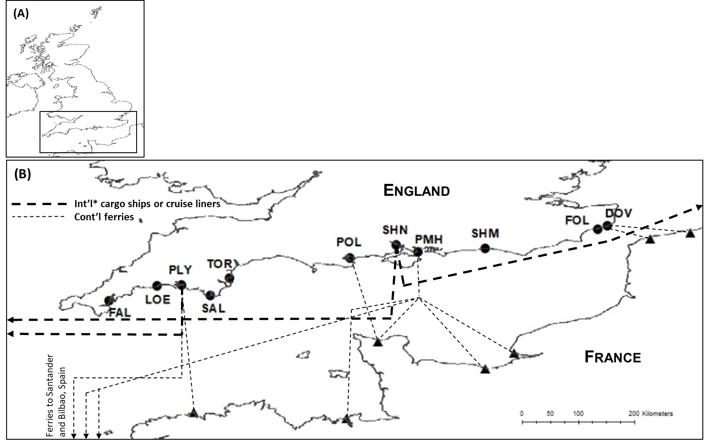
Figure 1. (A) Map of the British Isles, with the English Channel indicated by the black box. (B) Continental ferry routes across the English Channel are shown by the light dashes and internationally sailing vessels (cargo ships or luxury cruise liners) are shown by the dark dashes. Lines representing shipping routes do not reflect the numbers of vessels arriving and departing. *International cargo ships and cruise liners include only those vessels that travel outside of northern Europe (e.g., Dover supports cargo-shipping activities, but these ships regularly sail only to European destinations). Southampton and Plymouth are the only harbours with ships that sail internationally on a regular basis (dark dashes). Harbours within the West region include Falmouth, Looe, Plymouth, Salcombe and Torbay, and were the only harbours included in the natural and artificial comparison. Harbours within the Central region include Poole, Southampton and Portsmouth. Harbours within the East region include Shoreham, Folkestone and Dover. Artificial structures in all harbours were included in analyses of richness and assemblage composition in artificial habitats. See Table 1 for Harbour codes. Information was obtained from Marine Traffic (2019) and World Port Source (2019).

Sampling methods
Rapid Assessment Surveys (RAS) provide a pragmatic method of covering a large number of locations in a reasonable amount of time (Pederson et al., 2005; Arenas et al., 2006; Bishop et al., 2015a,b); they typically involve a qualitative approach, using timed searches of targeted areas and habitats (e.g., undersides of floating pontoons). In biodiversity surveys, however, the most common means of gathering data is predominantly through quantitative quadrat sampling, often avoiding topographically complex surfaces (Bulleri et al., 2005; Dafforn et al., 2012; Firth et al., 2016b). In this study, a combined approach was employed to capture NNS richness and abundance (i.e., diversity), which consisted of utilising quantitative stratified-random quadrat sampling and semi-quantitative timed searches. All artificial structures were accessed on foot at low tide. Native biota were not quantified during any of the surveys. Quantitative stratified-random quadrat sampling involved haphazardly placing 20 quadrats (25 x 25 cm) in the lower intertidal within a 10 x 10 m area and recording counts of mobile organisms and percentage cover of sessile organisms. For the purpose of this study, the lower intertidal was the area of the shore that was inundated during neap low tides but exposed at spring low tides (i.e., surveys occurred only on spring low tides when tide was ≤ 1 m above CD). Occasionally, this area was condensed because the steeper slope of artificial structures resulted in reduced area available to survey. In these cases, a longer horizontal section was sampled to compensate for lost vertical area. All NNS visible to the naked eye within the quadrats were identified and quantified. To positively identify and quantify the non-native barnacle, Austrominius modestus, 5 x 5 cm photo-quadrat images (n = 20) were taken in the densest barnacle zone and photographs were later analysed using ImageJ (Schneider et al., 2012). Slope and substrate were standardised by surveying vertical or sloping substrate (≥ 45° angle) and avoiding topographically complex surfaces (i.e., gaps, grooves, pits, crevices, rock pools). To locate rare species, one person conducted a 30-minute timed search across the study area, including complex surfaces and microhabitats (e.g., crevices, rock pools, undersides of boulders). Additional minutes were added to the search where logistical constraints delayed efficient sampling (e.g., some artificial structures had characteristics that required careful manoeuvring around the structure compared to other easily accessible structures or natural rocky shore). A semi-quantitative search-based assessment of overall abundance of each NNS was made on a scale of 0-3 (0 = absent, 1 = rare-occasional, 2 = frequent-common, 3 = abundant-superabundant; Bishop et al., 2015b). Thus, the quantitative quadrat method produced 20 quadrat replicates per site, while the semi-quantitative search-based method produced one abundance score for each NNS per site. Species that could not be identified in the field (e.g., bryozoans such as Tricellaria inopinata (d'Hondt & Occhipinti Ambrogi, 1985) and Bugulina spp.) were preserved in 70% ethanol and transported back to the laboratory for microscopic examination.

2.2.1. Comparison of NNS in natural and artificial habitats
To investigate differences of occurrence of NNS between natural and artificial habitats, NNS richness and assemblage composition were recorded in ten natural sites (rocky shores) and eleven artificial sites (seawalls) in the West region (Table 1). Natural sites were chosen based on location to closest harbour and were as sheltered as possible to reduce the influence of wave exposure gradients on assemblage composition. There was no restriction placed on size of seawall.

2.2.2. Comparison of NNS in artificial habitats along the south coast of England
To assess differences of occurrence of NNS in artificial habitats among harbours and regions, eleven harbours spanning three regions across the entire south coast of England were surveyed. Harbours within regions were chosen based on major harbours surveyed in Bishop et al. (2015b) and those which stretched across each region. As many artificial sites as possible with public access were surveyed in each harbour (Table 1).

Statistical analyses

2.3.1. Comparison of NNS in natural and artificial habitats
To compare NNS richness and assemblage composition between natural and artificial habitats, comparisons were made between ten natural sites and eleven nearby artificial sites using both quantitative quadrat and semi-quantitative search-based data separately (i.e., data from both methods were used but were analysed separately). For both sampling methods, where abundance information was used, data were fourth-root transformed to down-weight the influence of very abundant species (Anderson et al., 2008). Bray-Curtis dissimilarly matrices were then computed, and permutational multivariate analysis of variance tests (PERMANOVA; Anderson, 2001) were used to test for differences in species richness and assemblage composition. Two-way nested designs with Habitat as a fixed factor (2 levels: natural, artificial) and Site as a random factor (nested in Habitat) were employed. PERMANOVA tests were based on 9999 permutations of residuals under a reduced model. Tests for differences were conducted in PRIMER v6 with the PERMANOVA+ add-on using the PERMANOVA routine (PRIMER-E Ltd, Plymouth, UK; Anderson et al., 2008). Ordination of samples were visualised using two-dimensional non-metric multidimensional scaling (nMDS) plots. Contributions to dissimilarities among regions from each species was determined using the similarity percentages routine (SIMPER).
2.3.2. Comparison of NNS in artificial habitats along the south coast of England
Differences in NNS richness and assemblage composition in artificial habitats among harbours and regions were assessed using data from both the quantitative quadrat and semi-quantitative search-based surveys. Where abundance information was used, data were fourth-root transformed. Bray-Curtis dissimilarly matrices were then computed, and permutational multivariate analysis of variance tests (PERMANOVA) were used to test for differences in species richness and assemblage composition. For quantitative quadrat data, a three-way nested design was used for each test (species richness and assemblage composition) with Site as a random factor (number of levels depended on number of sites surveyed in each harbour) nested in Harbour as a fixed factor (number of levels varied with region) nested in Region as a fixed factor (3 levels: West, Central, East). As quantitative quadrat sampling was not undertaken in Salcombe, only ten harbours were included in quantitative quadrat analyses. Because there was not replication at the ‘Site’ level when semi-quantitative search-based data were analysed (i.e., there was one abundance value per site), two-way nested designs were used with Harbour as a fixed factor (number of levels varied with region) nested in Region as a fixed factor (3 levels) for each test (species richness and assemblage composition). Information about vessel type and the average number of vessels per harbour over a 60-day period as a proxy for boat traffic in general was obtained from the Marine Traffic (Marine Traffic, 2019) and World Port Source (World Port Source, 2019) websites. General observations comparing numbers of NNS with numbers and types of vessels were made with no formal analyses done.

Results
  - Overall results
A total of 26 NNS were recorded from natural and artificial habitats across the entire south coast of England (Table S1). Fifteen NNS were recorded from the natural and artificial habitat comparison in the West region (Falmouth to Torbay); 12 of these NNS were found in artificial, while 9 NNS were recorded in natural habitats (Table S1). Six species were exclusive to artificial habitats, while 3 species were exclusive to natural habitats, with 6 species common to both. Two NNS were discovered in new localities: colonies of the carpet sea squirt, Didemnum vexillum Kott, 2002, were found on the seaward side of a wooden wave-breaker wall and a metal pipe positioned perpendicular to the shore in Poole Harbour. Colonies were also found in Portsmouth on concrete fishing piers perpendicular to the shore. The red alga, Botryocladia wrightii (Harvey) W.E.Schmidt, D.L.Ballantine & Fredericq, 2017 (recently changed from Chrysymenia wrightii), was found in a small water-retaining pool along a stepped seawall in Portsmouth. The only previously confirmed records of B. wrightii in this study region were from marinas in Falmouth (Wood et al., 2015).
Comparison of NNS in natural and artificial habitats
Of the 15 NNS recorded across natural and artificial habitats between Falmouth and Torbay (Table S1), 9 taxa were recorded in natural (60% of total), while 12 were observed in artificial (80% of total) habitats. Species unique to natural habitats included the brown alga, Undaria pinnatifida (Harvey) Suringar, 1873 and the red algae, Grateloupia turuturu Yamada, 1941 and Asparagopsis armata Harvey, 1855. Species unique to artificial habitats included the erect bryozoan, T. inopinata, the orange cloak sea squirt, Botrylloides violaceus Oka, 1927, an unidentified Botrylloides species, Botrylloides sp. indet. (Bishop et al., 2015b), the leathery sea squirt, Styela clava Herdman, 1881, the slipper limpet, Crepidula fornicata (Linnaeus, 1758) and the red alga, Bonnemaisonia hamifera Hariot, 1891. Semi-quantitative search-based techniques found 15 NNS across natural and artificial habitats, while quantitative quadrat techniques yielded only 8 species. The use of quantitative quadrat techniques alone failed to record B. violaceus, C. fornicata, U. pinnatifida, G. turuturu, A. armata, B. hamifera and the brown alga, Sargassum muticum (Yendo) Fensholt, 1955.
Statistical analysis of quantitative quadrat data found that mean NNS richness was significantly greater in artificial compared to natural habitats (Table 2a; Figure 2a). Similarly, assemblage composition varied significantly between natural and artificial habitats (Table 2a). Statistical analysis of semi-quantitative search-based data revealed that the mean richness did not differ significantly between natural and artificial habitats, although community assemblage did differ (Table 2b; Figure 2b, c). SIMPER analysis of quantitative quadrat data showed that over 80% of dissimilarity in assemblage composition between natural and artificial habitats was attributed to A. modestus (32.6%), the red ripple bryozoan, Watersipora subatra (Ortmann, 1890) (30.9%) and the red alga, Caulacanthus okamurae Yamada, 1933 (23.1%), with all three species more abundant in artificial habitats. SIMPER analysis of semi-quantitative data revealed that > 50% of dissimilarity in assemblage composition between natural and artificial habitats was attributable to four species: S. muticum (17.3%), W. subatra (14.5%), the brown alga, Colpomenia peregrina Sauvageau, 1927 (12.4%) and the Pacific oyster, Magallana gigas (Thunberg, 1793) (11.8%). S. muticum and C. peregrina were more abundant in natural habitats, while W. subatra and M. gigas were more common in artificial habitats.

Table 2. PERMANOVA results comparing NNS richness and assemblage composition between natural and artificial habitats using (a) quantitative quadrat data and (b) semi-quantitative search-based data. Significant p-values are in bold.
(a) Quantitative data
Two-way PERMANOVA comparing species richness between natural and artificial habitats.
Source | df | SS | MS | Pseudo-F | P(perm)
Habitat | 1 | 18976 | 18976 | 7.1199 | 0.0009
Site(Habitat) | 18 | 47985 | 2665.8 | 33.327 | 0.0001
Residual | 380 | 30396 | 79.989
Total | 399 | 97274
Transformation: | pres/abs
Two-way PERMANOVA comparing assemblage composition between natural and artificial habitats.
Source | df | SS | MS | Pseudo-F | P(perm)
Habitat | 1 | 24297 | 24297 | 6.3912 | 0.0006
Site(Habitat) | 18 | 68443 | 3802.4 | 16.724 | 0.0001
Residual | 380 | 86397 | 227.36
Total | 399 | 179000
Transformation: | fourth root
(b) Semi-quantitative data
One-way ANOVA comparing species richness between natural and artificial habitats.
Source | df | SS | MS | Pseudo-F | P(perm)
Habitat | 1 | 94.912 | 94.912 | 0.59709 | 0.4781
Residual | 19 | 3020.2 | 158.96
Total | 20 | 3115.1
Transformation: | pres/abs
One-way PERMANOVA comparing assemblage composition between natural and artificial habitats.
Source | df | SS | MS | Pseudo-F | P(perm)
Habitat | 1 | 4854.7 | 4854.7 | 9.041 | 0.0001
Residual | 19 | 10202 | 536.96
Total | 20 | 15057
Transformation: | fourth root

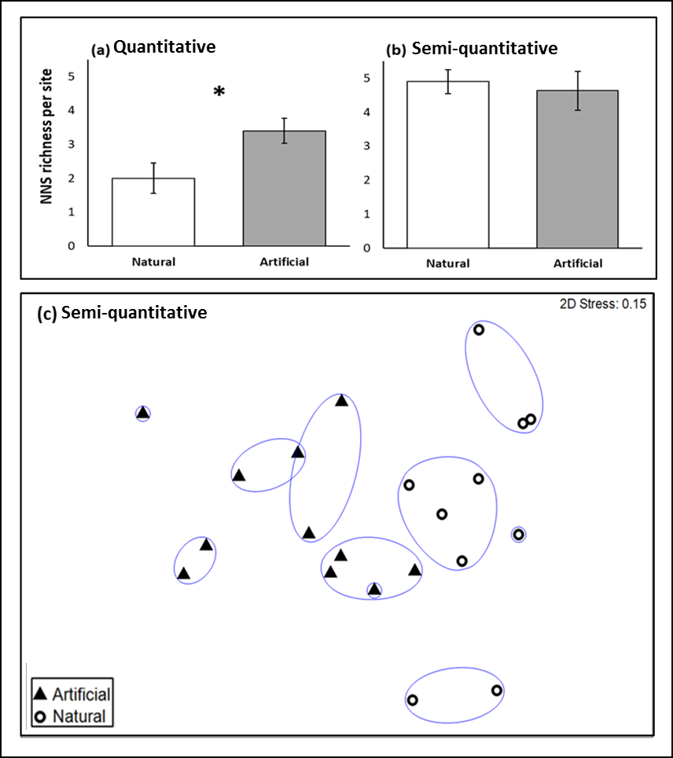
Figure 2. Comparison of mean number of NNS per site in natural and artificial intertidal habitats using (a) quantitative quadrat and (b) semi-quantitative search-based sampling techniques. *NNS richness was significantly greater in artifical compared to natural habitats using quantitative techniques (p = 0.0009) but not using semi-quantitative methods (natural sites, n = 10; artificial sites, n = 11). Error bars show standard error. (c) Non-metric multi-dimensional scaling plot (nMDS) showing significant difference in assemblage composition between natural and artificial sites using semi-quantitative search-based data. Assemblage composition between natural and artificial habitats differed significantly (p = 0.0001). The blue envelopes show a resemblance level of 75%.

Comparison of NNS in artificial habitats along the south coast of England
Overall, 26 NNS were recorded in artificial sites across eleven harbours. The barnacle, A. modestus, was encountered most (43 sites), while the erect bryozoan, Bugulina simplex (Hincks, 1886), the orange-tipped sea squirt, Corella eumyota Traustedt, 1882, B. wrightii, the green alga, Codium fragile subsp. fragile (Suringar) Hariot, 1889 and U. pinnatifida were only found at a single site each. Results are reported from both sampling methods, but only semi-quantitative search-based data were used to produce figures because this method captured more NNS overall.
Statistical analysis of quantitative quadrat data revealed that mean richness and assemblage composition were significantly different among harbours and regions (Table 3a), with the Central region supporting greater mean and total richness than the West (p = 0.0222) and East regions (p = 0.0039). Pairwise comparisons among harbours within regions revealed significantly higher richness in Torbay compared to Looe (p = 0.0084), Southampton compared to Portsmouth (p = 0.0030) and Shoreham compared to Folkestone (p = 0.0045). Pairwise comparisons showed that assemblage composition between the West and Central (p = 0.0012) and the Central and East (p = 0.0012) regions differed significantly. Differences in assemblage composition were found between Falmouth and Looe (p = 0.0232), Falmouth and Plymouth (p = 0.0292), Falmouth and Torbay (p = 0.0244), Looe and Torbay (p = 0.0073), Poole and Southampton (p = 0.0090), Southampton and Portsmouth (p = 0.0002) and Shoreham and Folkestone (p = 0.0034). SIMPER analysis revealed that the erect bryozoan, Bugula neritina (Linnaeus, 1758) contributed the most to the dissimilarity between West and Central (15%; greater in Central); whilst W. subatra contributed the most to dissimilarities between West and East (37.3%; greater in West) and Central and East regions (22.1%; greater in Central).
Analysis of semi-quantitative search-based data revealed a significant difference in NNS richness among regions, with the Central region supporting greater mean and total richness per harbour compared to West (p = 0.0472) and East regions (p = 0.0014; Table 3b, Figures 3, 4b). There were no significant differences, however, in mean richness among harbours within regions (Table 3b, Figure 4a). Assemblage composition varied significantly among both harbours and regions (Table 3b, Figure 5). Post-hoc pairwise tests comparing regions showed that the West and Central (p = 0.0144) and Central and East (p = 0.0326) assemblage compositions differed significantly. Comparisons of harbours within regions found that assemblage composition differed significantly between Falmouth and Plymouth (p = 0.0355), Poole and Portsmouth (p = 0.0131), Poole and Southampton (p = 0.0014) and Southampton and Portsmouth (p = 0.0013). SIMPER analysis revealed that W. subatra contributed the most to the dissimilarity between West and East regions (25.4%; greater in West), while C. okamurae contributed the most to dissimilarities between West and Central (11.4%; greater in West) and Central and East regions (1.6%; greater in East).

Table 3. PERMANOVA results for comparison of NNS richness and assemblage composition using (a) quantitative quadrat data and (b) semi-quantitative search-based data in artificial habitats among harbours and regions. Significant p-values are in bold.
- Quantitative data
Three-way PERMANOVA comparing species richness among regions, harbours and sites.
Source | df | SS | MS | Pseudo-F | P(perm)
Region | 2 | 60707 | 30354 | 7.0537 | 0.0025
Harbour(Region) | 7 | 118340 | 16905 | 3.9287 | 0.0019
Site(Harbour(Region)) | 30 | 118340 | 4303.2 | 15.623 | 0.0001
Residual | 760 | 118340 | 275.44
Total | 799 | 118340
Transformation: | pres/abs
Three-way PERMANOVA comparing assemblage composition among regions, harbours and sites.
Source | df | SS | MS | Pseudo-F | P(perm)
Region | 2 | 75905 | 37953 | 4.5881 | 0.0040
Harbour(Region) | 7 | 221400 | 31628 | 3.8236 | 0.0001
Site(Harbour(Region)) | 30 | 248160 | 8272 | 11.922 | 0.0001
Residual | 760 | 527330 | 693.85
Total | 799 | 1155800
Transformation: | fourth root
- Semi-quantitative data
Two-way PERMANOVA comparing species richness among regions and harbours.
Source | df | SS | MS | Pseudo-F | P(perm)
Region | 2 | 4014 | 2007 | 7.0275 | 0.0012
Harbour(Region) | 8 | 2399.2 | 299.9 | 1.0501 | 0.4183
Residual | 33 | 9424.5 | 285.59
Total | 43 | 18170
Transformation: | pres/abs
Two-way PERMANOVA comparing assemblage composition among regions and harbours.
Source | df | SS | MS | Pseudo-F | P(perm)
Region | 2 | 12842 | 6420.9 | 7.586 | 0.0001
Harbour(Region) | 8 | 15168 | 1896 | 2.24 | 0.0028
Residual | 33 | 27931 | 846.41
Total | 43 | 65127
Transformation: | fourth root

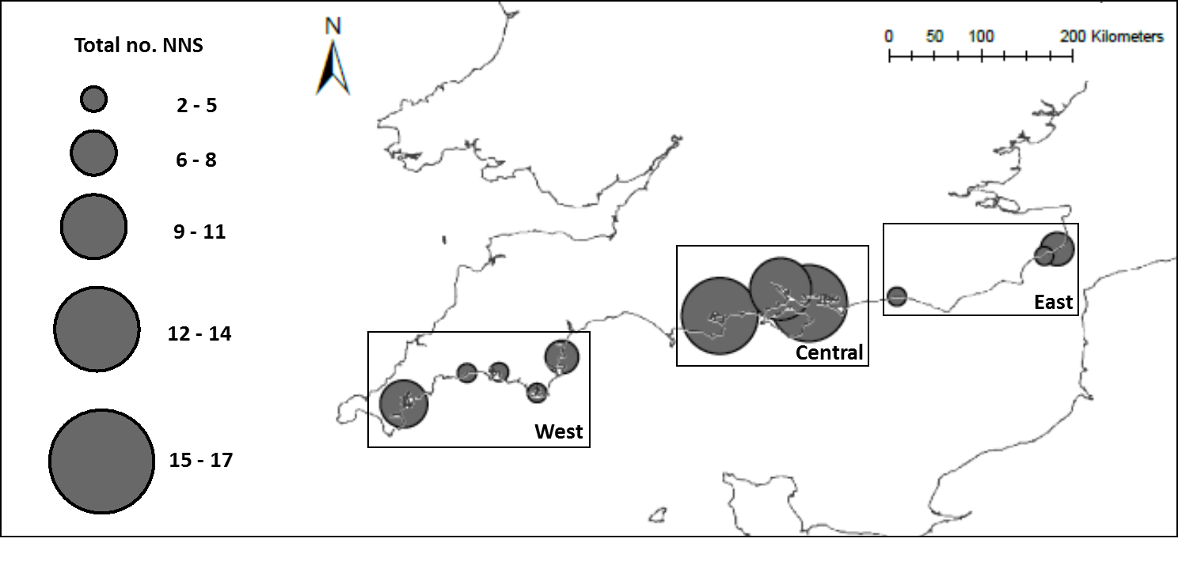
Figure 3. The number of NNS recorded per harbour from Rapid Assessment Surveys of intertidal artificial habitats along the south coast of England ranged from 2-17. Size of circles represents the total number of NNS recorded per harbour. Harbours from west to east: Falmouth, Looe, Plymouth, Salcombe, Torbay (West region), Poole, Southampton, Portsmouth (Central region), Shoreham, Folkestone and Dover (East region). Figure was produced using the semi-quantitative search-based data.

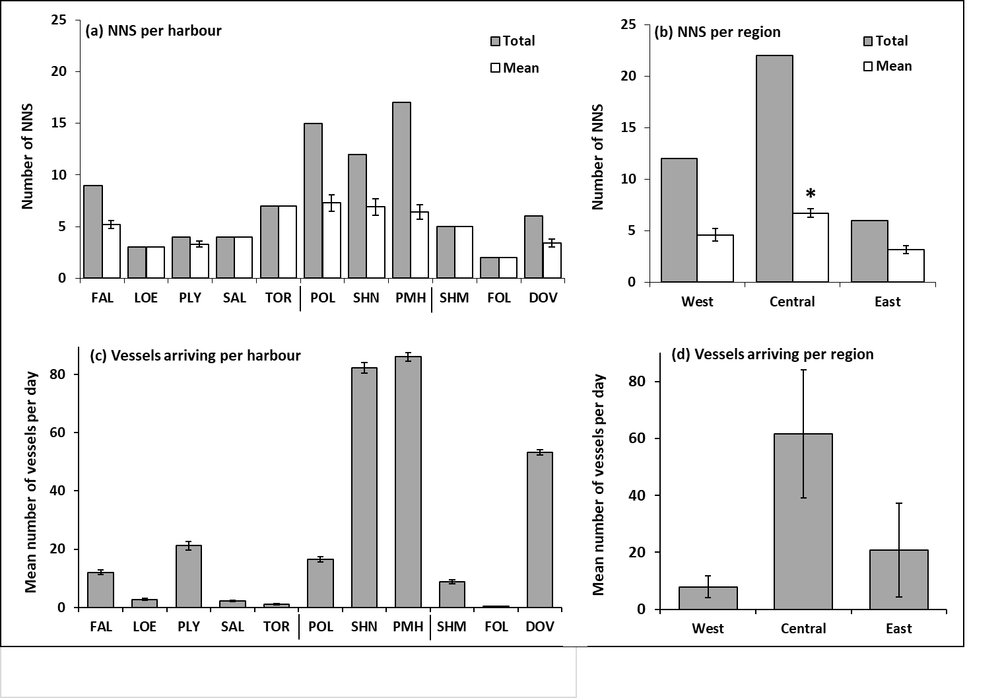
Figure 4. Total and mean number of NNS recorded from intertidal artificial habitats across the south coast of England per (a) harbour and (b) region. *Numbers of NNS were significantly greater in Central compared to the West (p= 0.0472) and East (p = 0.0014) regions. Error bars represent standard error. Bars showing means in (a) without a standard error bar represent harbours where only one site was surveyed. Mean number of vessels arriving per day (c) by harbour and (d) by region were averaged over 60 days. Figure was produced using semi-quantitative search-based data. Information was obtained from Marine Traffic (2019) using vessel data from February and March 2019.

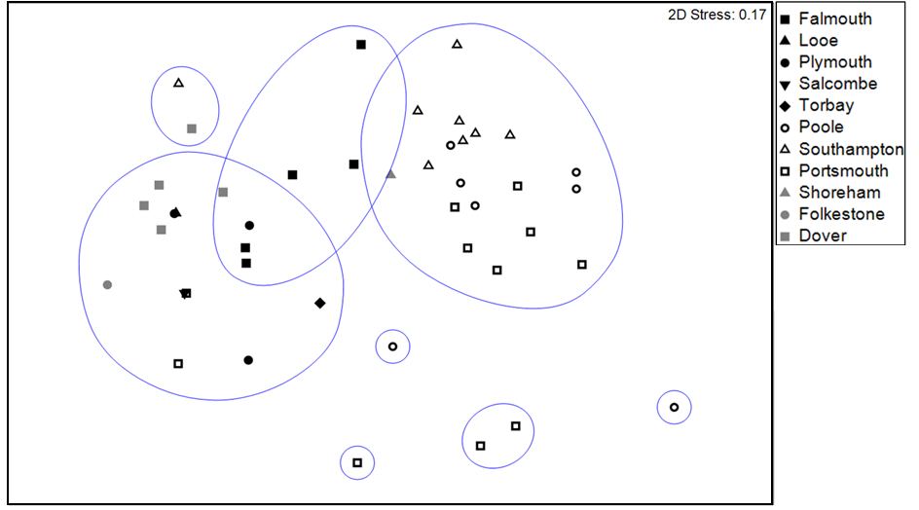
Figure 5. Non-metric multi-dimensional scaling plot (nMDS) showing significant variation in NNS assemblage composition from Rapid Assessment Surveys of intertidal artificial sites among harbours (p = 0.0028) and regions (p = 0.0001) along the south coast of England. Dark shapes represent harbours in the West region, open shapes indicate harbours in the Central region and grey shapes represent harbours in the East. Figure was created using semi-quantitative search-based data. The blue envelopes show a resemblance level of 60%.

3.4. Numbers and types of vessels by harbour
Portsmouth and Southampton supported the greatest average number of vessel arrivals per day at 86.4 and 83.1, respectively, while Folkestone supported the fewest (0.4; Figure 4c). The Central region supported the greatest average number of vessels per day at 61.6, while the West supported the fewest at 7.9 (Figure 4d). International shipping (container liner services) occurs out of Southampton with 12 carriers, as well as Plymouth and Dover with one carrier each (Table 1). Seven of the 12 container liner carriers that visit Southampton operate globally, with destinations in North and South America, Asia, India, the Pacific Islands, Australia, Europe, the Middle East, Africa and the Caribbean (World Port Source, 2019). The carrier that operates out of Plymouth is also a global carrier (similar destinations as listed above), while the carrier out of Dover only operates out of northern Europe. International cruise liners operate out of Southampton with global destinations, while cruise liners out of Dover have European destinations only. Ferries to northern Europe (France and Spain) operate from Plymouth, Poole, Portsmouth and Dover, while military bases are located in Falmouth, Plymouth and Portsmouth (Table 1, Figure 1).

Discussion
Twenty-six non-native sessile invertebrates and macroalgae were found during Rapid Assessment Surveys of artificial structures in harbours along the south coast of England. Comparisons of NNS between natural and artificial habitats found that assemblage compositions differed significantly, but differences in richness depended on the sampling technique employed. The Central region supported greater mean and total richness, as well as different assemblage compositions, compared to the West and East regions. These differences might be attributed to regional shipping patterns, as most harbours in this study with high NNS richness saw relatively large amounts of vessel traffic.
Our study provided mixed evidence to support the hypothesis that artificial sites would support greater NNS richness compared to natural sites, as results differed depending on sampling method employed. Analysis of quantitative stratified-random quadrat data found differences in richness between natural and artificial habitats, while analysis of semi-quantitative search-based data (obtained from timed searches including complex habitats) did not detect differences. Both sampling techniques, however, showed that NNS assemblages between natural and artificial habitats were indeed different. These results agreed to some extent with previous studies that found assemblages of NNS differed between natural and artificial subtidal habitats (Glasby et al., 2007; Tyrrell and Byers, 2007; Dafforn et al., 2012). Conversely, the result that richness did not differ between natural and artificial habitats from our study contrasts with work from these same studies listed above which showed that artificial supported more NNS than natural habitats. For example, Glasby et al. (2007) found that numbers of NNS were markedly greater on floating pontoons and pilings than on natural rocky reef. Furthermore, Tyrrell and Byers (2007) and Dafforn et al. (2012) experimentally showed that non-native fouling species outcompeted native species on artificial structures, but non-natives were not able to gain a foothold on natural substrate. Importantly, all of these studies were done in subtidal habitats (many on floating pontoons), which may explain the conflicting results. In the current study, semi-quantitative search-based sampling techniques allowed complex microhabitats to be searched (e.g., rock pools, crevices and gaps between boulders). Natural substrate generally provides more topographic complexity compared to artificial structures (Moschella et al., 2005; Chapman and Underwood, 2011). Thus, it is not surprising that many more NNS were observed during the searches in natural than artificial habitats. For example, whilst S. muticum, C. pergrina, U. pinnatifida, A. armata and G. turuturu were found in previous studies of artificial habitats (Arenas et al., 2006; Firth et al., 2013; Bishop et al., 2015b), they were only found in rock pools during timed searches in natural habitats in our study. This indicates the importance of water-retaining features for the successful establishment of non-native species on typically diverse natural rocky shores. These features have previously been identified as being important for providing shade and water retention at low tide to alleviate desiccation for native species in intertidal habitats (Firth et al., 2013, Firth et al., 2016). Conversely, in the subtidal zone, as desiccation is not a concern, topographic complexity may be needed for entirely different reasons, such as providing larvae and propagules refuge from predators or wave movement (Kovalenko et al., 2012; Strain et al., 2017). Different uses of topographic complexity by resident organisms between intertidal and subtidal habitats may be a reason for the differential results obtained between previous surveys and the current survey.
The frequency of arriving vessels, types and departure points of vessels arriving in harbours, as well as the subsequent secondary destinations to which species can be transported (Carlton, 1996b; Ruiz et al., 2000; Clarke Murray et al., 2011), may explain the high number and variety of NNS around Southampton and the Central region in general. The success of an introduced species is highly dependent on propagule pressure (Lockwood et al., 2005; Copp et al., 2010), and thus it is not surprising that most of the harbours supporting relatively high species richness were also harbours that supported a high frequency of arriving vessels. For example, Southampton was unique in our study in being one of the largest cruise ship and container ports in the UK, and the busiest along the English south coast (Associated British Ports, 2019; Marine Traffic, 2019; World Port Source, 2019). As such, it sees significantly more international traffic than any other of the south coast ports. Global movement of NNS into the British Isles has been described by Eno et al. (1997) who proposed scenarios depicting likely invasion pathways. Many species were proposed to have been transferred directly to the British Isles from their places of origin, such as B. hamifera from Southeast Asia, A. modestus from Australia and C. fornicata from the eastern seaboard of the US. These routes of transfer explain high propagule pressure in the port of Southampton, where cargo tankers regularly arrive from international ports. However, Eno et al. (1997) suggested many other non-natives (i.e., A. armata, S. muticum, C. peregrina) were first transported from their origin to continental Europe, followed by a secondary transfer into the British Isles across the English Channel. Bishop et al. (2015a) provided evidence for this, as their Rapid Assessment Surveys showed a general pattern of northward movement of NNS from Brittany, France across the English Channel to South West England over time. This invasion pathway might explain the high numbers of NNS in Portsmouth (and to a lesser degree, Poole), where large passenger ferries arrive from northern European destinations. The current study can only suggest the above as invasion pathways, as identifying NNS from source ports was outside the scope of this study. Thus, future research can focus on providing evidence by ground-truthing these results or using molecular markers to show that the same NNS occurred in the departing international harbours as the receiving ports in southern England.
Although the relationship between NNS richness and number of vessels arriving per day was clear at the regional level (i.e., West, Central, East), at the harbour level, there were some harbours that did not follow this trend. Poole Harbour supported a relatively high number of NNS, yet the number of arriving vessels was relatively low compared to other harbours with high species richness (i.e., Portsmouth and Southampton). This suggests that factors other than propagule pressure from international shipping play a role in determining success of NNS. The geomorphology of Poole is quite different than the other harbours in this study, in that the harbour itself has a very narrow mouth, a double high tide daily and the smallest tidal range in the study area (1.8 m), as well as very poor flushing (Humphreys, 2005; May, 2005; World Port Source, 2019). Poole has been described as a lagoon-like harbour; it is a shallow and warm body of water (Humphreys, 2005; May, 2005). These conditions may be particularly favourable for NNS originating from warmer waters, such as D. vexillum (Zaiko et al., 2007; Lambert, 2009). Moreover, slow and incomplete flushing of the harbour means larvae of NNS are present in the water for long periods of time, potentially allowing increased settlement compared to harbours with faster flushing times. These conditions are also favourable to yachting, and so smaller leisure craft regularly travel among harbours within the Solent (Central region; SJH pers. obs.), potentially acting as secondary mobile vectors (Clarke Murray et al., 2011). On the other hand, Dover sees a relatively high number of vessels per day but supports relatively few numbers of NNS. Although the numbers of vessels are high in Dover, the origins and destinations are almost exclusively European (Marine Traffic, 2019; World Port Source, 2019). This effectively means lower propagule pressure from global invaders directly. Moreover, the geomorphology of Dover is different from the other harbours in this study, in that Dover is not a natural bay or inlet. Rather, the port was artificially created when the Dover Southern Breakwater was constructed at the beginning of the 20th century. It is therefore likely that the hydrodynamics – which can affect turbidity and scouring of structures (Govarets and Lauwaert, 2009; Dugan et al., 2011), and can dictate transport of larvae in currents and tides (McQuaid and Phillips, 2000) – differ markedly between Dover and naturally-formed ports.
Evidence from this study and others suggest that artificial structures probably play an important role in the initial establishment and then secondary transport of NNS away from their initial point of introduction (Eno et al., 1997; Neves et al., 2007; Mineur et al., 2012). By nature, docks and floating pontoons are constantly in close proximity to cargo tankers, passenger ferries and recreational vessels, and thus there is a high probability of species spreading from mobile vectors (vessels) to stationary structures (floating pontoons, docks; Neves et al., 2007). In a study examining the fouling communities of boat hulls and associated floating pontoons and concrete structures in an international Brazilian port, Neves et al. (2007) found that biotic communities on hulls were similar to those on the pontoons; while communities on concrete structures were a similar but smaller subset of the species found on hulls. This is because boat hulls and floating pontoons rise and fall with the tide, while concrete structures are fixed in place (similar to intertidal natural rocky shores). Hulls of recreational boats are regularly cleaned of fouling organisms (Neves et al., 2007); it is even becoming increasingly common for transoceanic vessels to undergo regular hull cleaning (Hopkins and Forrest, 2008; PML Applications Ltd, 2019). Thus, the biological communities they support are typically younger (i.e. at earlier successional stages) than those on floating pontoons and associated docks. As such, pontoons act as “reservoirs” of established NNS communities (Neves et al., 2007; Floerl et al., 2009; Foster et al., 2016), while concrete structures support fewer numbers of species, but of which have the ability to invade intertidal natural habitats (Neves et al., 2007; Epstein and Smale, 2018). In our study, harbours east of Torbay were dominated by sedimentary substrata, thus fouling organisms typical of natural rocky shores arriving from distant hard substrata have only been able to establish and survive by colonising artificial structures in these otherwise uninhabitable areas. In this way, artificial structures may affect ecological connectivity by providing “stepping stones” for the movement of species across seascapes (Sammarco et al., 2004; Airoldi et al., 2015; Bishop et al., 2017). Moreover, smaller harbours (e.g., Folkestone) with many fewer artificial structures compared to larger harbours (e.g., Portsmouth) provided less hard substrata for NNS spread from a mobile vector to a stationary structure. These smaller harbours also supported less diverse NNS communities due to lower diversity of artificial structures (e.g., Folkestone Harbour is largely composed of rock and concrete seawalls and lacks floating pontoons). As such, these smaller harbours are less likely to act as NNS reservoirs.
The limitations of sampling natural and artificial sites equally are extremely challenging to overcome; yet a combined sampling approach (quantitative stratified-random quadrats and semi-quantitative timed searches), like those employed in this study, can address some of the problems associated with sampling in these habitats. By nature, complex microhabitats on gently sloping natural rocky shores (e.g., rock pools, gaps between boulders) are generally easier (and safer) to sample compared to those on artificial structures. This was acknowledged in the methods of the current study by slightly extending the timed search on structures that were difficult to sample due to safety and logistical reasons. For example, boulder groynes and riprap revetment provide internal compartments created by the stacking of boulders to maximise coastal protection. The interior of these structures provide functional niches that are absent on the exterior that protect organisms from desiccation, wave exposure and sand scour; thus species diversity tends to be greater within the internal compartments, which are difficult to access/observe (Sherrard et al., 2016; Liversage and Chapman, 2018). Traditional quadrat sampling avoids gaps between boulders and other complex microhabitats, consequently missing vital species diversity information. Therefore, numbers and abundances of NNS recorded from the exterior of these structures probably do not accurately represent the true NNS diversity of the entire structure. On the other hand, limited areal extent provided by other artificial structures, such as seawalls, means that the likelihood of these structures to be fully sampled (“censused”; Chapman et al., 2018) using quadrat sampling techniques is much greater than on a large natural rocky shore or more complex artificial structures, where many diverse habitats are likely to be missed (Chapman et al., 2018). In the current study, quadrat sampling was able to cover most of the available area on seawalls but missed areas in larger natural sites (e.g., rock pools). If quantitative quadrat sampling alone had been used (which is a typical method in biodiversity surveys), our study would have concluded that intertidal artificial habitats support greater (mean) numbers of NNS (per unit area) than natural habitats. By employing a timed search, this study came to a very different conclusion - that of which challenges the commonly accepted concept that artificial structures support greater NNS richness compared to natural rocky shores. Most NNS surveys along the south coast of England have focused on surveying marina pontoons in subtidal habitats (Arenas et al., 2006; Ashton et al., 2006; Bishop et al., 2015a,b; Foster et al., 2016), as these are known “hot spots” for introduction. Our study demonstrated that areas not labelled as “hot spots”, such as natural rocky shores, should not be ignored. A recent report cautioned that natural rocky shores might facilitate “spillover” of NNS from populations in marinas to natural habitats, facilitating the spread out from the initial sites of introduction (Epstein and Smale, 2018). Although not explicitly tested for, our study showed that intertidal natural sites do indeed support many NNS and may actually contribute to their spread between major transport hubs and surrounding bays and harbours.
Results from this study could be strengthened by formal tests on the effects of local environmental and physical conditions on success of NNS establishment. Physical factors, such as hydrodynamics (Horvath and Crane, 2010; Zardi et al., 2006) and pollution load (Dafforn et al., 2011; McKenzie et al., 2011) are important in influencing NNS colonisation and competition with native biota. For example, previous studies have shown that industrial and urban runoff adversely affects native composition and ecological functioning of marine communities (Johnston and Roberts, 2009; Burton and Johnston, 2010), and that species response (recolonisation) can vary depending on exposure to particular contaminants (Trannum et al., 2004). Additionally, NNS have been shown to tolerate contaminants and pollution while abundances of native species decline under the same conditions (Crooks et al., 2011; Dafforn et al., 2011; McKenzie et al., 2011). Thus, a decline in native biotic communities can easily give NNS a competitive advantage where conditions are unfavourable for native species (Johnston et al., 2017).
The loss of natural habitat caused by coastal development and ocean sprawl is leading to the need to explore alternative options to traditional hard built structures for coastal protection (Dafforn et al., 2015a; Firth et al., 2016a). There is therefore an increasing impetus to ecologically enhance hard structures to fulfil secondary management goals, such as increase biodiversity, enhance ecosystem services or reduce abundance of NNS (i.e., "ecological engineering"; Dafforn, 2017; Evans et al., 2017; Strain et al., 2019a,b). Results from our surveys clearly demonstrate that ecological engineering designs must consider the potential for colonisation by NNS (Sella and Perkol-Finkel, 2015; Dafforn, 2017; Strain et al., 2017). Traditionally, ecological engineering interventions that have included rock pools retrofitted onto seawalls (Chapman and Underwood, 2011; Browne and Chapman, 2014) or drilling pits into seawalls or breakwaters (Firth et al., 2014; Evans et al., 2016), have been advocated as a means of enhancing species diversity through water retention. Our survey showed that these interventions may increase the risk of colonisation by NNS, such as S. muticum and U. pinnatifida, which were regularly found in rock pools in natural sites. Information from biodiversity studies and Rapid Assessment Surveys should thus serve as a benchmark against which to measure change to biotic communities over time, and is an essential first step in informing management decisions concerning design details for ecological engineering of artificial structures in coastal intertidal habitats (Dafforn et al., 2015b; Mayer-Pinto et al., 2017).
Ocean sprawl is accelerating the rate of NNS introduction and spread, contributing to biotic homogenisation and the growing biodiversity crisis. Understanding the ecological role of artificial structures in the marine and coastal environments is critical for preserving native biodiversity and building resilience to establishment of NNS. Our results suggest that global shipping and artificial structures may play an important role in the introduction and spread of NNS. Other factors such as local environmental conditions and geomorphology of harbours undoubtedly contribute to NNS success, but disentangling these factors is difficult. Therefore, all potential mechanisms of NNS introduction, establishment and spread need investigation so that ecologists might develop the predictive capability to identify areas at high risk of invasion, which can aid in effective forecasting for potential invaders.

Acknowledgements
The authors are grateful to J. D. D. Bishop, C. A. Wood and F. Bunker for help with species identification.

Funding
This work was supported by the University of Plymouth (KAO). Write-up was facilitated by funding from SJH SF (KAO).

References
Airoldi, L. & Bulleri, F. (2011). Anthropogenic disturbance can determine the magnitude of opportunistic species responses on marine urban infrastructures. PLoS One, 6, e22985. 10.1371/journal.pone.0022985
Airoldi, L., Turon, X., Perkol‐Finkel, S. & Rius, M. (2015). Corridors for aliens but not for natives: effects of marine urban sprawl at a regional scale. Diversity and Distributions, 21, 755-768. 10.1111/ddi.12301
Anderson, M., Gorley, R.N. & Clarke, R.K. (2008). Permanova+ for Primer: Guide to Software and Statistical Methods, Primer-E Limited.
Anderson, M.J. (2001). A new method for non‐parametric multivariate analysis of variance. Austral Ecology, 26, 32-46. 10.1111/j.1442-9993.2001.01070.pp.x
Apte, S., Holland, B.S., Godwin, L.S. & Gardner, J.P. (2000). Jumping ship: a stepping stone event mediating transfer of a non-indigenous species via a potentially unsuitable environment. Biological Invasions, 2, 75-79. 10.1023/A:1010024818644
Arenas, F., Bishop, J.D.D., Carlton, J.T., Dyrynda, P.J., Farnham, W.F., Gonzalez, D.J., Jacobs, M.W., Lambert, C., Lambert, G., Nielsen, S.E., Pederson, J.A., Porter, J.S., Ward, S. & Wood, C.A. (2006). Alien species and other notable records from a rapid assessment survey of marinas on the south coast of England. Journal of the Marine Biological Association of the UK, 86, 1329-1337. 10.1017/S0025315406014354
Ashton, G., Boos, K., Shucksmith, R. & Cook, E. (2006). Rapid assessment of the distribution of marine non-native species in marinas in Scotland. Aquatic Invasions, 1, 209-213.
Associated British Ports. 2019. Available: http://www.southamptonvts.co.uk/ [Accessed 08 February 2019].
Bax, N., Williamson, A., Aguero, M., Gonzalez, E. & Geeves, W. (2003). Marine invasive alien species: a threat to global biodiversity. Marine Policy, 27, 313-323. 10.1016/S0308-597X(03)00041-1
Bishop, J.D., Wood, C.A., Lévêque, L., Yunnie, A.L. & Viard, F. (2015a). Repeated rapid assessment surveys reveal contrasting trends in occupancy of marinas by non-indigenous species on opposite sides of the western English Channel. Marine Pollution Bulletin, 95, 699-706. 10.1016/j.marpolbul.2014.11.043
Bishop, J.D.D., Wood, C.A., Yunnie, A.L.E. & Griffiths, C.A. (2015b). Unheralded arrivals: non-native sessile invertebrates in marinas on the English coast. Aquatic Invasions, 10, 249-264. 10.3391/ai.2015.10.3.01
Bishop, M.J., Mayer-Pinto, M., Airoldi, L., Firth, L.B., Morris, R.L., Loke, L.H., Hawkins, S.J., Naylor, L.A., Coleman, R.A., Chee, S.Y. & Dafforn, K.A. (2017). Effects of ocean sprawl on ecological connectivity: impacts and solutions. Journal of Experimental Marine Biology and Ecology, 492, 7-30. 10.1016/j.jembe.2017.01.021
Browne, M.A. & Chapman, M.G. (2014). Mitigating against the loss of species by adding artificial intertidal pools to existing seawalls. Marine Ecology Progress Series, 497, 119-129. 10.3354/meps10596
Bulleri, F., Chapman, M. & Underwood, A. (2005). Intertidal assemblages on seawalls and vertical rocky shores in Sydney Harbour, Australia. Austral Ecology, 30, 655-667. 10.1111/j.1442-9993.2005.01507.x
Burrows, M., Hawkins, S. & Southward, A. (1992). A comparison of reproduction in co-occurring chthamalid barnacles, Chthamalus stellatus (Poli) and Chthamalus montagui Southward. Journal of Experimental Marine Biology and Ecology, 160, 229-249. 10.1016/0022-0981(92)90240-B
Burton, G.A. & Johnston, E.L. (2010). Assessing contaminated sediments in the context of multiple stressors. Environmental Toxicology and Chemistry, 29, 2625-2643. 10.1007/s10530-010-9799-3
Byers, J.E. (2002). Impact of non‐indigenous species on natives enhanced by anthropogenic alteration of selection regimes. Oikos, 97, 449-458. 10.1034/j.1600-0706.2002.970316.x
Carlton, J.T. (1996a). Biological invasions and cryptogenic species. Ecology, 77, 1653-1655.
Carlton, J.T. (1996b). Pattern, process, and prediction in marine invasion ecology. Biological Conservation, 78, 97-106. 10.1016/0006-3207(96)00020-1
Carlton, J.T. & Geller, J.B. (1993). Ecological roulette: the global transport of nonindigenous marine organisms. Science, 261, 78-82. 10.1126/science.261.5117.78
Carman, M.R. & Grunden, D.W. (2010). First occurrence of the invasive tunicate Didemnum vexillum in eelgrass habitat. Aquatic Invasions, 5, 23-29. 10.3391/ai.2010.5.1.4
Chapman, M.G. & Underwood, A.J. (2011). Evaluation of ecological engineering of “armoured” shorelines to improve their value as habitat. Journal of Experimental Marine Biology and Ecology, 400, 302-313. 10.1016/j.jembe.2011.02.025
Clarke Murray, C., Pakhomov, E.A. & Therriault, T.W. (2011). Recreational boating: a large unregulated vector transporting marine invasive species. Diversity and Distributions, 17, 1161-1172. 10.1111/j.1472-4642.2011.00798.x
Copp, G., Vilizzi, L. & Gozlan, R. (2010). The demography of introduction pathways, propagule pressure and occurrences of non‐native freshwater fish in England. Aquatic Conservation: Marine and Freshwater Ecosystems, 20, 595-601. 10.1002/aqc.1129
Crooks, J.A., Chang, A.L. & Ruiz, G.M. (2011). Aquatic pollution increases the relative success of invasive species. Biological Invasions, 13, 165-176. 10.1007/s10530-010-9799-3
Dafforn, K.A. (2017). Eco-engineering and management strategies for marine infrastructure to reduce establishment and dispersal of non-indigenous species. Management of Biological Invasions, 8, 153-161. 10.3391/mbi.2017.8.2.03
Dafforn, K.A., Glasby, T.M., Airoldi, L., Rivero, N.K., Mayer-Pinto, M. & Johnston, E.L. (2015a). Marine urbanization: an ecological framework for designing multifunctional artificial structures. Frontiers in Ecology and the Environment, 13, 82-90. 10.1890/140050
Dafforn, K.A., Glasby, T.M. & Johnston, E.L. (2012). Comparing the invasibility of experimental “reefs” with field observations of natural reefs and artificial structures. PLoS One, 7, e38124. 10.1371/journal.pone.0038124
Dafforn, K.A., Johnston, E.L. & Glasby, T.M. (2009). Shallow moving structures promote marine invader dominance. Biofouling, 25, 277-287. 10.1080/08927010802710618
Dafforn, K.A., Lewis, J.A. & Johnston, E.L. (2011). Antifouling strategies: history and regulation, ecological impacts and mitigation. Marine Pollution Bulletin, 62, 453-465. 10.1016/j.marpolbul.2011.01.012
Dafforn, K.A., Mayer-Pinto, M., Morris, R.L. & Waltham, N.J. (2015b). Application of management tools to integrate ecological principles with the design of marine infrastructure. Journal of Environmental Management, 158, 61-73. 10.1016/j.jenvman.2015.05.001
Dineen, J.F., Clark, P.F., Hines, A.H., Reed, S.A. & Walton, H.P. (2001). Life history, larval description, and natural history of Charybdis hellerii (Decapoda, Brachyura, Portunidae), an invasive crab in the western Atlantic. Journal of Crustacean Biology, 21, 774-805. 10.1163/20021975-99990173
Drake, J.M. & Lodge, D.M. (2007). Hull fouling is a risk factor for intercontinental species exchange in aquatic ecosystems. Aquatic Invasions, 2, 121-131. 10.3391/ai.2007.2.2.7
Duarte, C.M., Pitt, K.A., Lucas, C.H., Purcell, J.E., Uye, S., Robinson, K., Brotz, L., Decker, M.B., Sutherland, K.R., Malej, A., Madin, L., Mianzan, H., Gili, J.-M., Fuentes, V., Atienza, D., Pagés, F., Breitburg, D., Malek, J., Graham, W.M. & Condon, R.H. (2012). Is global ocean sprawl a cause of jellyfish blooms? Frontiers in Ecology and the Environment, 11, 91-97. 10.1890/110246
Dugan, J., Airoldi, L., Chapman, M., Walker, S. & Schlacher, T. (2011). Estuarine and coastal structures: environmental effects, a focus on shore and nearshore structures. Treatise on Estuarine and Coastal Science, 8, 17-41. 10.1016/B978-0-12-374711-2.00802-0
Eno, N.C., Sanderson, W.G. & Conservation, J. (1997). Non-native marine species in British waters: a review and directory. Petersborough: JNCC.
Epstein, G. & Smale, D.A. (2018). Environmental and ecological factors influencing the spillover of the non-native kelp, Undaria pinnatifida, from marinas into natural rocky reef communities. Biological Invasions, 20, 1049-1072. doi.org/10.1007/s1053
Evans, A.J., Firth, L.B., Hawkins, S.J., Morris, E.S., Goudge, H. & Moore, P.J. (2016). Drill-cored rock pools: an effective method of ecological enhancement on artificial structures. Marine and Freshwater Research, 67, 123-130. 10.1071/MF14244
Evans, A.J., Garrod, B., Firth, L.B., Hawkins, S.J., Morris-Webb, E.S., Goudge, H. & Moore, P.J. (2017). Stakeholder priorities for multi-functional coastal defence developments and steps to effective implementation. Marine Policy, 75, 143-155. 10.1016/j.marpol.2016.10.006
Firth, L.B., Knights, A.M., Bridger, D., Evans, A.J., Mieszkowska, N., Hawkins, S.J., Moore, P.J., O’Connor, N.E., Sheehan, E.V. & Thompson, R.C. (2016a). Ocean sprawl: challenges and opportunities for biodiversity management in a changing world. Oceanography and Marine Biology - An Annual Review, 54, 189-262. 10.1201/9781315368597
Firth, L.B., Thompson, R.C., Bohn, K., Abbiati, M., Airoldi, L., Bouma, T.J., Bozzeda, F., Ceccherelli, V.U., Colangelo, M.A., Evans, A., Ferrario, F., Hanley, M.E., Hinz, H., Hoggart, S.P.G., Jackson, J.E., Moore, P.J., Morgan, E.H., Perkol-Finkel, S., Skov, M.W., Strain, E.M., Belzen, J.V. & Hawkins, S.J. (2014). Between a rock and a hard place: environmental and engineering considerations when designing coastal defence structures. Coastal Engineering, 87, 122-135. 10.1016/j.coastaleng.2013.10.015
Firth, L.B., Thompson, R.C., White, F.J., Schofield, M., Skov, M.W., Hoggart, S.P., Jackson, J., Knights, A.M. & Hawkins, S.J. (2013). The importance of water‐retaining features for biodiversity on artificial intertidal coastal defence structures. Diversity and Distributions, 19, 1275-1283. 10.1111/ddi.12079
Firth, L.B., White, F.J., Schofield, M., Hanley, M.E., Burrows, M.T., Thompson, R.C., Skov, M.W., Evans, A.J., Moore, P.J. & Hawkins, S.J. (2016b). Facing the future: the importance of substratum features for ecological engineering of artificial habitats in the rocky intertidal. Marine and Freshwater Research, 67, 131-143. 10.1071/MF14163
Firth, L.B., Duff, L., Gribben, P.E., Knights, A.M. Facilitative interactions among marine invaders: are natural habitats more at risk than artificial habitats? Ambio, in review
Floerl, O., Inglis, G., Dey, K. & Smith, A. (2009). The importance of transport hubs in stepping‐stone invasions. Journal of Applied Ecology, 46, 37-45. 10.1111/j.1365-2664.2008.01540.x
Foster, V., Giesler, R.J., Wilson, A.M.W., Nall, C.R. & Cook, E.J. (2016). Identifying the physical features of marina infrastructure associated with the presence of non-native species in the UK. Marine Biology, 163, 173. 10.1007/s00227-016-2941-8
Glasby, T.M., Connell, S.D., Holloway, M.G. & Hewitt, C.L. (2007). Nonindigenous biota on artificial structures: could habitat creation facilitate biological invasions? Marine Biology, 151, 887-895. 10.1007/s00227-006-0552-5
Gollasch, S. (2002). The importance of ship hull fouling as a vector of species introductions into the North Sea. Biofouling, 18, 105-121. 10.1080/08927010290011361
Gollasch, S. (2008). Is ballast water a major dispersal mechanism for marine organisms? Biological invasions. Springer. 49-57.
Govarets, A. & Lauwaert, B. (2009). Assessment of the impact of coastal defence structures. Biodiversity series: OSPAR Commission.
Griggs, G.B. (2005). The impacts of coastal armoring. Shore and Beach, 73, 13-22.
Hitchcock, J.N. & Mitrovic, S.M. (2019). Microplastic pollution in estuaries across a gradient of human impact. Environmental Pollution, 247, 457-466.
Hopkins, G.A. & Forrest, B.M. (2008). Management options for vessel hull fouling: an overview of risks posed by in-water cleaning. ICES Journal of Marine Science, 65, 811-815. 10.1093/icesjms/fsn026
Horvath, T.G. and Crane, L. (2010). Hydrodynamic forces affect larval zebra mussel (Dreissena polymorpha) mortality in a laboratory setting. Aquatic Invasions, 5(4), pp.379-385. 10.3391/ai.2010.5.4.07
Humphreys, J. (2005). 3. Salinity and tides in Poole Harbour: Estuary or lagoon? Proceedings in Marine Science. Elsevier. 35-47.
Johnston, E.J., Dafforn, K.A., Clark, G.F., Rius, M. & Floerl, O. (2017). How anthropogenic activities affect the establishment and spread of non-indigenous species post-arrival. Oceanography and Marine Biology: An Annual Review, 55, 389-420.
Johnston, E.L. & Roberts, D.A. (2009). Contaminants reduce the richness and evenness of marine communities: a review and meta-analysis. Environmental Pollution, 157, 17451752. 10.1016/j.envpol.2009.02.017
Keller, R.P., Drake, J.M., Drew, M.B. & Lodge, D.M. (2011). Linking environmental conditions and ship movements to estimate invasive species transport across the global shipping network. Diversity and Distributions, 17, 93-102. 10.1111/j.1472-4642.2010.00696.x
Kinzie, R. (1984). Aloha also means goodbye: a cryptogenic stomatopod in Hawaii. Pacific Science, 38, 298-311.
Kovalenko, K.E., Thomaz, S.M. & Warfe, D.M. (2012). Habitat complexity: approaches and future directions. Hydrobiologia, 685, 1-17. 10.1007/s10750-011-0974-z
Liversage, K. & Chapman, M. (2018). Coastal ecological engineering and habitat restoration: incorporating biologically diverse boulder habitat. Marine Ecology Progress Series, 593, 173-185. 10.3354/meps12541
Lockwood, J.L., Cassey, P. & Blackburn, T. (2005). The role of propagule pressure in explaining species invasions. Trends in Ecology and Evolution, 20, 223-228. 10.1016/j.tree.2005.02.004
Manchester, S.J. & Bullock, J.M. (2000). The impacts of non‐native species on UK biodiversity and the effectiveness of control. Journal of Applied Ecology, 37, 845-864. 10.1046/j.1365-2664.2000.00538.x
Marine Traffic. 2019. Available: https://www.marinetraffic.com [Accessed 16 January 2019].
May, V. (2005). 2. Geomorphology of Poole Harbour. Proceedings in Marine Science. Elsevier. 25-34.
Mayer-Pinto, M., Johnston, E.L., Bugnot, A.B., Glasby, T.M., Airoldi, L., Mitchell, A. & Dafforn, K.A. (2017). Building ‘blue’: An eco-engineering framework for foreshore developments. Journal of Environmental Management, 189, 109-114. 10.1016/j.jenvman.2016.12.039
McKenzie, L.A., Brooks, R. & Johnston, E.L. (2011). Heritable pollution tolerance in a marine invader. Environmental Research, 111, 926-932. 10.1016/j.envres.2010.12.007
McKinney, M.L. (2006). Urbanization as a major cause of biotic homogenization. Biological Conservation, 127, 247-260. 10.1016/j.biocon.2005.09.005
McKinney, M.L. & Lockwood, J.L. (1999). Biotic homogenization: a few winners replacing many losers in the next mass extinction. Trends in Ecology and Evolution, 14, 450-453. 10.1016/S0169-5347(99)01679-1
McQuaid, C.D. & Phillips, T. (2000). Limited wind-driven dispersal of intertidal mussel larvae: in situ evidence from the plankton and the spread of the invasive species Mytilus galloprovincialis in South Africa. Marine Ecology Progress Series, 201, 211-220. 10.3354/meps201211
Mineur, F., Cook, E.J., Minchin, D., Bohn, K., Macleod, A. & Maggs, C.A. (2012). Changing coasts: marine aliens and artificial structures. Oceanography and Marine Biology, 50, 189-234. 10.1201/b12157-5
Mitsch, W.J. & Jørgensen, S.E. (2003). Ecological engineering: a field whose time has come. Ecological Engineering, 20, 363-377. 10.1016/j.ecoleng.2003.05.001
Molnar, J.L., Gamboa, R.L., Revenga, C. & Spalding, M.D. (2008). Assessing the global threat of invasive species to marine biodiversity. Frontiers in Ecology and the Environment, 6, 485-492. 10.1890/070064
Moschella, P.S., Abbiati, M., Åberg, P., Airoldi, L., Anderson, J.M., Bacchiocchi, F., Bulleri, F., Dinesen, G.E., Frost, M. & Gacia, E. (2005). Low-crested coastal defence structures as artificial habitats for marine life: using ecological criteria in design. Coastal Engineering, 52, 1053-1071. 10.1016/j.coastaleng.2005.09.014
Muxagata, E., Williams, J.A. & Sheader, M. (2004). Composition and temporal distribution of cirripede larvae in Southampton Water, England, with particular reference to the secondary production of Elminius modestus. ICES Journal of Marine Science, 61, 585-595. 10.1016/j.icesjms.2004.03.015
Neves, C.S., Rocha, R.M., Pitombo, F.B. & Roper, J.J. (2007). Use of artificial substrata by introduced and cryptogenic marine species in Paranaguá Bay, southern Brazil. Biofouling, 23, 319-330. 10.1080/08927010701399174
Odum, H.T. & Odum, B. (2003). Concepts and methods of ecological engineering. Ecological Engineering, 20, 339-361. 10.1016/j.ecoleng.2003.08.008
Pederson, J., Bullock, R., Carlton, J., Dijkstra, J., Dobroski, N., Dyrynda, P., Fisher, R., Harris, L., Hobbs, N. & Lambert, G. (2005). Marine Invaders in the Northeast: Rapid assessment survey of non-native and native marine species of floating dock communities, August 2003. Massachusetts Institute of Technology. Sea Grant College Program.
PML Applications Ltd. 2019. Available: https://pml-applications.co.uk/ [Accessed 02 May 2019].
Ruiz, G.M., Carlton, J.T., Grosholz, E.D. & Hines, A.H. (1997). Global invasions of marine and estuarine habitats by non-indigenous species: mechanisms, extent, and consequences. American Zoologist, 37, 621-632. 10.1093/icb/37.6.621
Ruiz, G.M., Fofonoff, P.W., Carlton, J.T., Wonham, M.J. & Hines, A.H. (2000). Invasion of coastal marine communities in North America: apparent patterns, processes, and biases. Annual Review of Ecology and Systematics, 31, 481-531. 10.1146/annurev.ecolsys.31.1.481
Sammarco, P.W. (2015). New Invasive Marine Species Colonizing Energy Platforms in the Northern Gulf of Mexico: Verification, and Examination of Spread. US Dept. of the Interior, Bureau of Ocean Energy Management, Gulf of Mexico OCS Region, New Orleans, LA. OCS Study BOEM, 5, 72.
Sammarco, P.W., Atchison, A.D. & Boland, G.S. (2004). Expansion of coral communities within the Northern Gulf of Mexico via offshore oil and gas platforms. Marine Ecology Progress Series, 280, 129-143. 10.3354/meps280129
Schneider, C.A., Rasband, W.S. & Eliceiri, K.W. (2012). NIH Image to ImageJ: 25 years of image analysis. Nature methods, 9, 671. 10.1038/nmeth.2089
Seebens, H., Gastner, M., Blasius, B. & Courchamp, F. (2013). The risk of marine bioinvasion caused by global shipping. Ecology Letters, 16, 782-790. 10.1111/ele.12111
Sella, I. & Perkol-Finkel, S. (2015). Blue is the new green - Ecological enhancement of concrete based coastal and marine infrastructure. Ecological Engineering, 84, 260-272. 10.1016/j.ecoleng.2015.09.016
Sherrard, T.R., Hawkins, S.J., Barfield, P., Kitou, M., Bray, S. & Osborne, P.E. (2016). Hidden biodiversity in cryptic habitats provided by porous coastal defence structures. Coastal Engineering, 118, 12-20. 10.1016/j.coastaleng.2016.08.005
Simberloff, D. (2005). Non-native species do threaten the natural environment! Journal of Agricultural and Environmental Ethics, 18, 595-607. 10.1007/s10806-005-2851-0
Stachowicz, J.J., Whitlatch, R.B. & Osman, R.W. (1999). Species diversity and invasion resistance in a marine ecosystem. Science, 286, 1577-1579. 10.1126/science.286.5444.1577
Stark, J.S. (1998). Heavy metal pollution and macrobenthic assemblages in soft sediments in two Sydney estuaries, Australia. Marine and Freshwater Research, 49, 533-540. 10.1071/MF97188
Statham, P.J. (2012). Nutrients in estuaries—an overview and the potential impacts of climate change. Science of the Total Environment, 434, 213-227. 10.1016/j.scitotenv.2011.09.088
Strain, E., Alexander, K., Kienker, S., Morris, R., Jarvis, R., Coleman, R., Bollard, B., Firth, L., Knights, A. & Grabowski, J. (2019a). Urban blue: A global analysis of the factors shaping people's perceptions of the marine environment and ecological engineering in harbours. Science of the Total Environment, 658, 1293-1305. 10.1016/j.scitotenv.2018.12.285
Strain, E., Morris, R., Bishop, M., Tanner, E., Steinberg, P., Swearer, S., Macleod, C. & Alexander, K. (2019b). Building blue infrastructure: Assessing the key environmental issues and priority areas for ecological engineering initiatives in Australia's metropolitan embayments. Journal of Environmental Management, 230, 488-496. 10.1016/j.jenvman.2018.09.047
Strain, E.M., Olabarria, C., Mayer‐Pinto, M., Cumbo, V., Morris, R.L., Bugnot, A.B., Dafforn, K.A., Heery, E., Firth, L.B., Brooks, P. & Bishop, M.J. (2017). Eco‐engineering urban infrastructure for marine and coastal biodiversity: which interventions have the greatest ecological benefit? Journal of Applied Ecology, 55, 426-441. 10.1111/1365-2664.12961
Tyrrell, M.C. & Byers, J.E. (2007). Do artificial substrates favor nonindigenous fouling species over native species? Journal of Experimental Marine Biology and Ecology, 342, 54-60. 10.1016/j.jembe.2006.10.014
Valentine, P.C., Collie, J.S., Reid, R.N., Asch, R.G., Guida, V.G. & Blackwood, D.S. (2007). The occurrence of the colonial ascidian Didemnum sp. on Georges Bank gravel habitat—ecological observations and potential effects on groundfish and scallop fisheries. Journal of Experimental Marine Biology and Ecology, 342, 179-181. 10.1016/j.jembe.2006.10.038
Vaselli, S., Bulleri, F. & Benedetti-Cecchi, L. (2008). Hard coastal-defence structures as habitats for native and exotic rocky-bottom species. Marine Environmental Research, 66, 395-403. 10.1016/j.marenvres.2008.06.002
Wasson, K., Zabin, C.J., Bedinger, L., Diaz, M.C. & Pearse, J.S. (2001). Biological invasions of estuaries without international shipping: the importance of intraregional transport. Biological Conservation, 102, 143-153. 10.1016/S0006-3207(01)00098-2
Whitehead, P., Wilby, R., Battarbee, R., Kernan, M. & Wade, A.J. (2009). A review of the potential impacts of climate change on surface water quality. Hydrological Sciences Journal, 54, 101-123. 10.1623/hysj.54.1.101
Whitlatch, R.B. & Zajac, R.N. (1985). Biotic interactions among estuarine infaunal opportunistic species. Marine Ecology Progress Series., 21, 299-311.
Wood, C.A., Bishop, J.D.D. & Yunnie, A.L.E. (2015). Report to the Bromley Trust: RAS 2014 Non-Native Species Rapid Assessment Surveys in English Marinas.
World Port Source. 2019. Available: http://www.worldportsource.com/ [Accessed 09 May 2019].
Zardi, G.I., Nicastro, K.R., McQuaid, C.D., Rius, M. and Porri, F. (2006). Hydrodynamic stress and habitat partitioning between indigenous (Perna perna) and invasive (Mytilus galloprovincialis) mussels: constraints of an evolutionary strategy. Marine Biology, 150(1), pp.79-88. 10.1007/s00227-006-0328-y

