Figure 2: Probabilities for commission errors as a function of ADHD symptoms and cue condition (angry faces, happy faces and non-face stimuli) on No-Go trials. Shaded bands represent 95% confidence intervals.
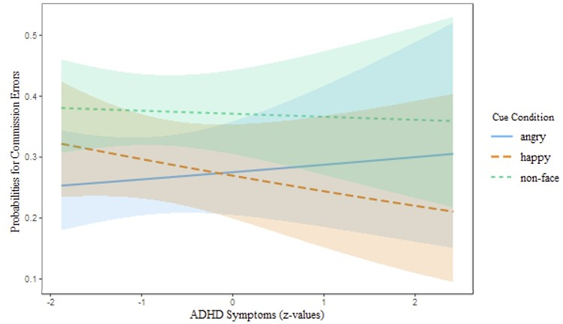
(Description: Predicted probabilities from the Generalised Linear Mixed Effects model results on the two-way interaction between ADHD-C symptoms and cue condition on the number of commission errors.)

Figure 3: Saccade latency as a function of ADHD symptoms and cue condition (angry faces, happy faces and non-face stimuli) on Go trials. Shaded bands represent 95% confidence intervals.
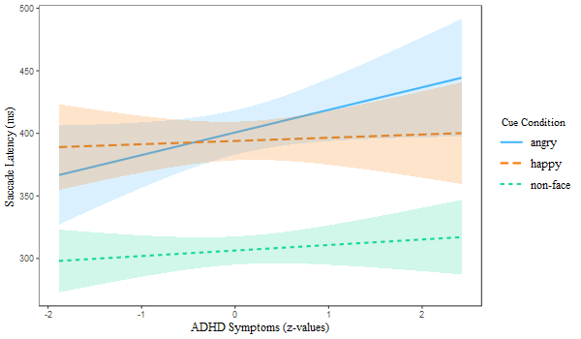
(Description: Saccade latency from the Linear Mixed Effects model results on the two-way interaction between ADHD-C symptoms and cue condition.)

Figure 4: Saccade latency as a function of anxiety and cue condition (angry faces, happy faces and non-face stimuli) on Go trials. Shaded bands represent 95% confidence intervals.
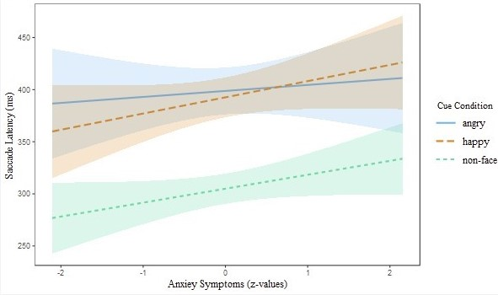
(Description: Saccade Latency from the Linear Mixed Effects model results on the two-way interaction between anxiety symptoms and cue condition.)

Figure 5: Saccade latency as a function of ADHD, anxiety and cue condition (angry faces, happy faces and non-face stimuli) on Go trials. For better visualisation anxiety symptoms were divided into low and high groups based on -1 and +1 standard deviation. Shaded bands represent 95% confidence intervals.

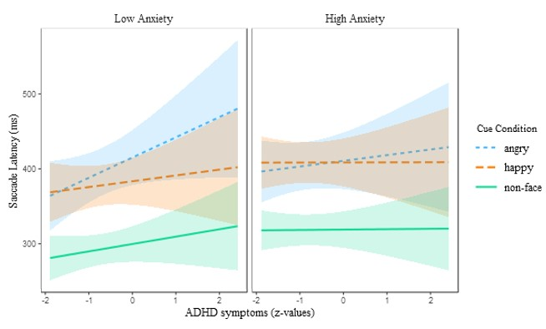
(Description: Saccade Latency from the Linear Mixed Effects model results on the three-way interaction between symptoms of ADHD-C, anxiety and cue condition.)

