IKEA: sustainable cotton initiative in China
It was mid-September 2015, Tony Dai, more sustainable cotton project manager of IKEA China, was sitting on his chair starring at a complex cotton-textile supply chain map. He was quite happy that recently the IKEA Group announced that all IKEA textile products were 100% sourcing from more sustainable cotton sources. The map on his hand was part of the outcome, IKEA’s cotton-textile was much more transparent than before, not to mention that positive changes were happening at the cotton farms. Achieved the result of course was a big milestone for Tony, however, he knew that it was not the end, how to maintain the figure and let the supply chain truly apply the sustainable cotton sources all the way to the final products were a bigger challenge. His thoughts were flying back, back to the years’ working with various supply chain partners to implement the sustainable cotton-textile supply chain initiative.

1 Background information

1.1 Background of IKEA
IKEA was the world’s largest furniture retailer in 2015. It was founded more than seven decades ago by 17 year old Ingvar Kamprad. The name of IKEA was an acronym that consists of the initials of the founder, Elmtaryd (the farm where he grew up), and Agunnaryd (his hometown in Småland in South Sweden).

As of FY15, IKEA operated in 43 countries with 155,000 co-workers. It had 328 stores in 28 countries, 27 trading service offices in 23 countries, 33 distribution centres and 15 customer distribution centres in 17 countries, and 43 IKEA industry production units in 11 countries. It achieved total sales of 31.9 billion Euros and a net profit of 3.5 billion Euros (IKEA Group Sustainability Report FY15).

By the end of FY15, IKEA had 978 home furnishing suppliers in 50 countries with around one-quarter of the suppliers based in China. IKEA emphasizes on long-term relationships lasting for an average of 11 years with its suppliers (IKEA Group Sustainability Report FY15).

The vision of IKEA was to create a better life for the many people and it adopted a ‘People & Planet Positive’ strategy to work toward this vision. The strategy focused on three aspects: inspiring and enabling millions of customers to live a more sustainable life at home; striving for resource and energy independence as well as taking a lead in creating a better life for the people and communities impacted by its business (IKEA Group Sustainability Report FY15).

In terms of natural resources IKEA has applied a ‘going all-in’ approach. For example, as of August 2015, all of the cotton that IKEA used for its products came from more sustainable sources including cotton grown according to the Better Cotton Standard, by farmers working towards Better Cotton, and more sustainable cotton from the USA.

1.2 Cotton production in China
Cotton was grown in around 80 countries over the world. However, it was also well-known for its associated sustainability issues, such as the excessive use of water and pesticides, bad labour conditions, and being a cause of farmers’ indebtedness and poverty.

China was an extremely important contributor to the global cotton industry. It was the largest cotton producer, importer and consumer in the world. In 2013, the area allocated to cotton plantation in China was 4.35 million hectares with a total output of 6.30 million tonnes (National Bureau of Statistic of China, 2015).

There were three major cotton growing areas in China – the northwest inland cotton region (e.g. Xinjiang), the Yellow River valley region (e.g. Shandong, Hebei) and the Yangtze River valley region (e.g. Hubei, Anhui) – while downstream textile production was mainly located in the east coast regions (See Exhibit 1).

Exhibit 2 lists the figures of the top five cotton growing regions in China by 2013. The top five regions (Xinjiang, Shandong, Hubei, Hebei, Aihui) in 2013 accounted for 84.2% of the total cotton growing areas in China. Xinjiang has shown consecutive increases in recent years, accounting for almost 56% of the total in 2013 due to geographic conditions as well as Chinese governmental policy. In January 2014, the Chinese government’s cotton reserve policy (2011–2013) which aimed to provide a guiding price for cotton purchasing and selling was withdrawn, limiting price support only provided to farmers in Xinjiang.

Dai and Dong (2014) claim that China accounts for about 30% of world’s cotton output with only 15% of the world’s cotton land. The unit yield (output/planting area) was 85% higher than the global average due to the adoption of a series of intensive farming technologies such as seeding transplanting, plastic mulching, double cropping, and super-high plant density technique.

However, even with these techniques, cotton production was a very labour-intensive activity and involves large input of chemical products such as fertilizers, pesticides and plastic films. There were more than 40 procedures during cotton’s whole growth period with the amount of labour input for cotton being 3.5 and 3 times that for wheat and corn (Dai and Dong, 2014). This demand for labour was especially high during the harvest stage. Xinjiang has the highest mechanization cotton production rate compared to other regions, with about 15% of the cotton area harvested with machinery, while harvesting is still completely done manually in the Yellow River and Yangtze River Valley (Dai and Dong, 2014). Together with China’s rapid urbanization, the shortage of labour in cotton production has become even more serious.

China was the largest producer and consumer of fertilizer in the world. It was also the largest producer and exporter and the second largest consumer of pesticides in the world. Cotton was also the largest plastic film mulched crop in China, with about 70% of cotton field covered with plastic film which cannot be easily degraded. All these factors contribute to soil pollution which results in dysfunctional soil and quality degradation.

Thus China was facing increasing challenges from soil pollution and labour shortages (reflected in Exhibit 3 by a decrease in cotton output and sowing area). Meanwhile, as cotton-growing regions in China were also the main food crop-growing regions, the competition for land between grain crops and cotton has become increasingly serious.

1.3 Cotton-textile supply chain
Cotton picking in the fields was a labour-intensive activity – done by hand or machine – with small farmers doing this normally by hand. The cotton directly picked from the fields was called seed cotton, which was then ginned to remove the seeds and waste (dirt, stems and leaves) leaving the fibre which was known as lint. The lint was further processed in a spinner for yarn and a textile producer for weaving and dyeing. Then it processed by the manufacturer for cutting and sewing. The final products then can be put on sale by retailers.

Exhibit 4 presents the typical cotton-textile supply chain. Before cotton finished products reach the consumers it went through several stages – farmer cultivation, ginner fibre extraction, spinner yarn production, textile producer weaving, dyeing, manufacturer cutting and sewing and finally retailing (WWF and IKEA, 2014). Multiple suppliers in different countries were involved in the long processes with some carrying out part of the functions and some covering multiple functions.

2. IKEA’s sustainable cotton practice
Cotton was the second most important raw material at IKEA after timber. It was a renewable source and it has excellent comfort quality as it is soft and breathable. It was widely used in IKEA’s home furnishing products, such as sofas, cushions, bed sheets and lampshades. Although IKEA did not directly purchase cotton, its upstream suppliers purchased large amounts. It was estimated that each year IKEA used around 0.6% to 0.7% of the world’s cotton supply. In FY14, IKEA products consumed 178,000 tonnes of cotton, which was 0.68% of the global production of around 26 million tonnes.

IKEA has been working on cotton sustainability issues for more than a decade. As early as 2002, the IKEA Material Risk Council carried out a study on the global cotton industry to strengthen its understanding of the industry and formulate policies for the company’s cotton consumption (Rai, 2011). The study identified that cotton has major environmental and social effects and it recommended several approaches for IKEA to tackle the issues.

In 2005, IKEA and WWF extended their former global partnership in responsible forestry started in 2002, to sustainable cotton cultivation in India and Pakistan (the largest cotton sourcing zone for IKEA). It aimed to enable farmers to reduce their environmental impact, improve efficiency, maintain cotton crop yields and increase their gross margins. Around 2,000 farmers in Pakistan and 500 farmers in Indian participated the project through Farmer Field Schools which provided hands-on training and support.

Also in the same year, IKEA, together with other world leading brands and organizations launched a global platform, the Better Cotton Initiative (BCI), which aimed to make cotton production better for the people who produce it, better for the environment it grows in, and better for the sector’s future. It aimed to develop a new commodity, ‘Better Cotton’, as a mainstream commodity in the market that would make up to 30% of global cotton production in 2020. Unlike organic cotton and Fairtrade, Better Cotton did not give a price premium to farmers. Instead, it reduced the costs of agricultural inputs to increase farmers’ income and final consumers don’t have to pay extra for this commodity. This philosophy was in line with IKEA’s belief in “making sustainability affordable for all”.

BCI has tried to develop globally accepted criteria for Better Cotton. In 2009, it launched a draft set of criteria, tested in some regional pilot projects. After several years of monitoring and evaluation now it has six major principles covering both environmental and social aspects, outlined in Exhibit 5. Better Cotton (cotton produced under BCI standards) was traceable to bale level and farmers were selected at random to be audited by a third party.

In 2009, BCI, Dutch funding agencies (the Dutch Sustainable Trade Initiative (IDH), the Interchurch Organization for Development (ICCO), and Rabobank Foundation), implementing NGOs (WWF and Solidaridad), and global retailers (Adidas, H&M, IKEA, Levi Strauss & Co, Marks & Spencer) founded ‘Better Cotton Fast Track Programme’ (BCFTP). It established a fund to build up and accelerate farmers’ capability to produce Better Cotton. IKEA and other retailers co-financed the project and were committed to buying Better Cotton from the participating famers.

The joint cotton projects in Pakistan and Indian achieved big success. In total, around 43,000 farmers in India and Pakistan adopted the more sustainable farming practices (working towards the BCI standards) (WWF and IKEA, 2014). With the cumulative capacity, IKEA also met its commitments to purchase these more sustainable sources. In order to avoid creating premium prices and to speed up the process of making the cotton a commodity available and affordable to all, IKEA only bought part of the volume it creates, with farmers free to sell the products to other brands or sale as conventional cotton. Currently, IKEA was the largest consumer of Better Cotton in the world (IKEA Group Sustainability Report FY12). The share of cotton from these sustainable sources in IKEA products was 34% in FY12 with this figure increasing sharply to 72% in FY13 and to 76% in FY14. In August 2015 IKEA achieved its goal of sourcing 100% of its cotton from more sustainable sources (see the amount and the ratio in Exhibit 6).

Besides the sustainable cotton practices, IKEA was also finding ways to use cotton more efficiently. For example through standardizing the way fabric was constructed, reducing the amount of cotton by up to 15%, and reducing the use of cotton by blending it with other textiles and replacing it with alternative materials such as cellulose fibres.

3. IKEA’s sustainable cotton practice in China
IKEA purchased products through its 27 ‘trading service offices’ which operated in 23 producer countries (IKEA Group Sustainability Report FY15). Its cotton products were manufactured primarily in South Asia (India 23.1%, Pakistan 19.5%), Turkey (15.0%), USA (8.8%) and China (7.0%) as of FY14.

IKEA sourced approximate 9,000 tonnes of cotton from China in FY12, 3,850 tonnes in FY13 and 12,460 tonnes in FY14 (IKEA Group Sustainability Report FY12, FY13, FY14). It was about 0.13% of China’s cotton production on average over the three years (author’s calculation). Although this ratio was smaller than the global rate, inspired by the success practices of South Asia, IKEA would also like to have a positive influence on the cotton industry in China. According to Hammad Naqi Khan, WWF’s Global Cotton Leader:

“Many big companies give money to a cause and that’s it. IKEA sets a good example by being directly involved in the field and learning about every step in the supply chain. Few companies bother to do that, but IKEA was willing to dig deep into the complex details of cotton production, which helped them to bring sustainability into their textile supply chain.” (Quotation from IKEA Group Sustainability Report FY13, p.28).

In cooperation with BCFTP, three projects were initiated in China in FY11 based in Xinjiang province, where farms were often large and specialized cooperatives with big landholdings and many employees. The trading service office in China applied various steps in implementing a sustainable cotton initiative in China. In three years, 100% of its cotton was sourced from more sustainable cotton sources, one year ahead of the IKEA Group target.

3.1 Motives for implementing sustainable cotton initiative
In China, a dedicated sustainable cotton manager Tony Dai was looking after the whole project. He worked closely with different business development teams with cotton as raw materials. The project logic were straight forward: it was something must be done and business leading.

Kevin Liu, business development manager of IKEA home textile products said,

“We know very clear why we are doing this, normally we do things you need to ask why, what, how questions, we are very clear in the three Ws. Why do we do this? Because cotton is one of the largest raw materials for IKEA. Actually you could see this from our CEO, the senior executives, and the senior board of the purchasing team that it is our vision and we are clear the path for this blueprint. So this strategy, this vision, penetrates to the purchasing team and even to the front lines of the purchasing specialists of the business team. It is very easy for us to understand why we are doing this. I could consider the earth, could consider the green issues of our company, and the long term development and competitive advantage… so easily we achieved alignment. We spend less time on why and what, because IKEA is one of the founders of BCI, so IKEA is very clear about what needs to be done. So at the beginning, we very easily went through the first two steps and we spend more time on how to do it. At this stage, we then have many interactives with the sustainability team.”

Although the sustainable cotton manager has more knowledge on the cotton perspectives than the business development team, it was clear that business development teams have bigger impact on IKEA’s suppliers. IKEA China adopted a business leading approach. Kevin Liu commented,

“I think that IKEA is comparable to other brands, but one of the big differences is that our sustainable development is being led by the business development team. Some companies’ business development teams only care about business and purchasing products and nothing about sustainable development, which is only driven by sustainable development department … I am surprised about this, then I ask them how can they drive the business with no voice on whether the suppliers are good or bad, no understanding of their situations and tell them how to do this, how to do that, from my point of view, they have jumped the why and what part as … they lack the motivation, lack of why and what, which is driven by the business.”

3.2 Implementation stages
IKEA China adopted four steps in implementing the initiative: supply chain mapping, awareness building, creating capacity and securing the supply chain.

3.2.1 Supply chain mapping
To have a clear picture on the existing cotton-textile supply chain, IKEA China first conducted a supply chain mapping exercise.

With long term relationships and frequent contacts with suppliers, IKEA China was familiar with its fabric, even yarn suppliers. However, sustainable cotton initiatives required it to go even further and gain knowledge on its upstream cotton suppliers. Tony Dai had made it clear to the suppliers that the mapping was only to help analyse the whole supply chain and not by passing them and doing business directly with their lower tier suppliers.

The pilot supply chain mapping exercise was first conducted with suppliers which have large shares in cotton consumption. Together with the business development team they traced the final products back to suppliers of fabric, yarns and cotton. The deputy sustainability manager of IKEA China and former sustainable cotton manager, Helen Fu, paid visits to all the big production sites. The mapping helped the sustainable development team to understand the original sources of cotton and identify some big cotton farming companies or ginners. IKEA China obtained details of their requirements in terms of cotton quality and quantity.

Their study found that in 2011, around half of the cotton sourced in China was mainly from traditional cotton production regions like Xinjiang, Shandong and Hubei provinces. Another half of the cotton was sourced from overseas markets such as the United States, Australia and Brazil.

3.2.2 Awareness building
Along with the supply chain mapping, IKEA China worked internally and externally to create awareness on the sustainable cotton initiative. Helen Fu said,

“Besides the external stakeholders of the supply chain, awareness building is also promoted internally. What is the difficulty of this project? The difficulty is that as cotton is a raw material, it has wide applications from the normal known sheets, covers and curtains to the ones you won’t think about such the decorations for Christmas – the clothes for the Santa hanging on the Christmas trees.”

In IKEA, different business teams were looking for certain product categories. What Helen Fu suggests was the sustainability team needs to collaborate with various business development teams. As Kevin Liu said previously, the business development team quickly achieved alignment with the sustainable cotton team, and made sure that they gave a consistent message to suppliers at various levels.

The business development team also adopted a top down approach to promote awareness among suppliers. Kevin Liu said,

“Because business development team is leading the development and business of the suppliers ... so for us the biggest task is how to align IKEA’s strategy and vision with the suppliers, that is what the most important.”

“We approached at least the suppliers’ president or general manager level, and we could sit down and have a deep discussion on the topic, including what is the meaning of this strategy for IKEA and for the suppliers … suppliers soon realize it is a win-win situation, because if IKEA wants to be a global sustainable cotton retailer and a leading brand, then if the suppliers achieve the agreement and together we work on it, in fact the supplier become a leading company in China or even globally. It is not just about little economic profit, but it brings more value to the company brand and core competitiveness.”

The sustainable cotton team explained to the suppliers that the targets are achievable through continuous communication. Tony Dai said,

“We emphasis on communication at the first beginning and we did lots of detailed analysis with the suppliers with some trainings on what is the whole project, our target and the steps. We do it slowly as you can’t explain clearly by just once… We have also invited Tier 2 suppliers, because in the end it’s them to implement.”

After achieved agreement with the Tier 1 suppliers, IKEA then indicated the requirements of sourcing from more sustainable cotton sources in their annual contract with these suppliers. By converting the quantity of final products, the total amount of cotton could be calculated. Then IKEA agreed a progress status with each Tier 1 suppliers. Different Tier 1 suppliers were agreed with a different roadmap with IKEA, as vertical integrated Tier 1 suppliers had a closer relationship with cotton suppliers, thus they were encouraged to move ahead of the less integrated Tier 1 suppliers. However, all the Tier 1 suppliers need to meet IKEA Group target by the end of FY15.

3.2.3 Creating capacity
After supply chain mapping and awareness building, IKEA China’s sustainable development team mainly worked on ‘creating capacity’. This refered to working with the final end of the cotton-textile supply chain to create enough cotton sources for consumption. IKEA China itself developed several cotton farms, it then worked with BCI China, and at the same time IKEA China linked the sources with its Tier 1 suppliers.

3.2.3.1 Identifying cotton farms through existing supply chain

Through its supply chain mapping exercise, IKEA China has been able to find out several big cotton farms and big ginners that have influence on the cotton farms. Through its existing network and through the introduction of its suppliers, IKEA identified three cotton farms in 2011 to initiate the sustainable cotton farming in Xinjiang province. Solidaridad, a NGO was funded by BCFTP and engaged to help implement the sustainable cotton practices with the BCI criteria.

In order to create more capacity, Tony Dai also tried to develop more resources. He intended to find cotton farms in other regions as an insurance against natural disasters. The potential cotton farms should be of a large scale and be efficient. After contacted several cotton farms, he found it was very difficult to persuade the cotton farm managers. One main reason was due to the Chinese government cotton reserve policy, through which the government purchased cotton at a high price, thus the managers lack the motivation to develop new sales channels or take part in such initiative. The other reason was that cotton produced under IKEA sustainable standards (adopted from BCI standards) could not be sold at a premium. Tony Dai said,

“With the policy it was very difficult for us to approach the farmers. They think our project is very good, but what benefits can they get? They cannot see it immediately. After they achieve the standards, buyers won’t buy the cotton with a price higher than the government guidance price.”

Besides the above reasons, IKEA didn’t sign a direct purchasing contract with the cotton farms. They signed agreements to provide the farms with technical support and sustainable cotton knowledge, in addition, indicated them in the preferred cotton supplier list (the certified IKEA sustainable sources and BCI channel) to be sourced by their supply chain network, however without guaranteed quantity.

Again by way of introduction through its suppliers, Tony Dai found a cotton ginner named Yinzhou Cotton in Songzi Town, Hubei province in early 2012. Lei Xiao, the general manager of the national owned farm also ran a ginner factory. Lei Xiao was described by Tony Dai as an open minded person who cared about sustainability and had a long term view, while believing that the government policy was a temporary solution and would not last long.

Tony Dai talked about the project to Lei Xiao and shared the standards and principles with him. Although both Helen Fu and Tony Dai were not agriculture experts, they believed that the principles were applicable and could made changes to cotton farming. Helen Fu said,

“We could only say we promote the better cotton principles as the farmers have grown cotton for decades, they have more knowledge than us. They may just need to change their mindset on some principles like how to save water, use less fertilizer and pesticides, and how to apply more biological preventions.”

Lei Xiao started to share the principles with his farm. He commented,

“Before it was normal farming, but after (Tony Dai) told us about the principles, we shared them with the farmers. In the second year IKEA compared our performance to the first year’s… their method are once you made progress they recognize you, so we are more active with our work. At the same time they point out the problems, and you must make changes later… I quite admire IKEA’s approach, it won’t happen overnight to truly change an idea and carry it out… To change people’s mind, I think it is a gradual process… firstly they recognize our progress and secondly point out the problems, so in the second year I am quite clear what should I do in order to achieve my target. If it is not good in the first year and not good again in the second year, then we can only give up. Without cooperating with IKEA we could still sell cotton. Cooperation with IKEA just means I have another sales channel.”

IKEA China hired external partners such as SGS to verify the sustainable cotton farming activities. Yinzhou cotton, together with the farms in Xinjiang, were first recognized as IKEA’s sustainable cotton producers (recognized as cotton working towards the BCI standards) with their names included in the preferred cotton sourcing list by IKEA.

3.2.3.2 Working with BCI China
In May 2012, the BCI Representative Office was registered in Shanghai to promote better cotton practices in China. Tony Dai encouraged the IKEA sustainable cotton farms to apply for BCI’s certification. With more than 40 world famous brands, BCI platform was more attractive for these cotton farms.

BCI China had helped these farms to set up the organization structure which was a better way to promote better cotton knowledge. Normally BCI China worked with an implementation partner, in this case, Huitong Textile, in Shandong Province, who looked after a production units, and a production unit could be further divided into smaller units with each having several study groups (see an example in Exhibit 7). One production unit was called Nongxi cooperative. BCI invited experts to provide training to production units’ managers, and these managers then passed the training to smaller production units or agronomists, with smaller production unit managers or agriculture technicians providing training to study group members.

In 2014, in order to meet BCI China’s farm land requirement, Lei Xiao persuaded the local government and the region as a whole to apply better cotton certification standards. The training provided was in the structured manner as outlined above and paper materials were also distributed to cotton farmers. Each of them received a field manual with the BCI information on it and which is also a field notebook which could be used for recording their farming activities. A supervisory team was also set up to constantly check whether farmers had implement the activities as required.

Each of IKEA’s sustainable cotton farm was also thinking about new ways to promote better cotton knowledge to the cotton farmers. Xinjiang Luthai Fengshou Cotton Industry (Luthai) had its own TV station which broadcasts programs on Better Cotton to the farmers. Songzi Town had linked the Better Cotton training with a national training program, whenever the local agriculture department had training missions from the government they added Better Cotton into it. Better Cotton was also promoted in the local agriculture newspaper with a holistic introduction given at the beginning, followed by detailed requirements for the corresponding growing seasons. They had also spent lots of time on preparing for the training materials. Lei Xiao said,

“To be honest, we think a lot on the training materials. With a few words we can quickly understand when we receive training. However we need to bear in mind when we provide training to the farmers, such as the videos and the cartoons we made, we need to make sure they are something that the farmers can easily understand just by seeing them.”

By the end of 2015, all the IKEA sustainable cotton farms had been awarded the Better Cotton certificate. Besides IKEA China’s support, BCI China itself developed fast in China, in 2014 its Implementing Partners worked with 7,028 farmers organized into 10 Producer Units, and nine large farms, 6,458 farmers in China earned a Better Cotton license. The areas under Better Cotton cultivation reached 54,000 hectares and Better Cotton production reached 121,000 MT lint (BCI, 2014).

3.2.3.3 Linking the resource with the Tier 1 suppliers
After awareness building, the business development team also made sure that the strategy had a strong link with the suppliers’ business, especially for the products with cotton as the main raw material. Kevin Liu said,

“From the business development perspective, we link all the aspects with what we call a supplier positioning, so we make sure that the sustainable development capacity it is not just a statement or it doesn’t matter if you do not do it. We create a strong link with the suppliers’ development and business, so the suppliers would realize better do it early than late unless they do not want the business, do not want to develop with IKEA.”

“We highlight it at the very beginning, to suppliers which have the sustainable cotton platform and channel and are doing their best, such that we could give priority for product development. If you left behind, you won’t have the chance to develop new cotton related products … we send a strong signal that sustainable development is our core focus.”

This communication had been well received by the suppliers. Beginning in 1997, Supplier N is one of the earliest of IKEA’s suppliers in China, IKEA accounts approximately 90% of Supplier N’s sales revenue. Purchasing manager of Supplier N said,

“We have cooperated with IKEA for a long time, so we actively respond to any calls or initiatives from IKEA. Because the better you do, the early you do, the fast you do, you could definitely gain more opportunities and grow. While we also know that IKEA is a world leading company in environment and social aspects, our CEO is also quite agree with the philosophies…So for us, we are definitely willing to take part no matter from a business development perspective or a social responsibility perspective.”

Another Supplier D expressed similar opinions. The purchasing manager said,

“Firstly we have cooperated with IKEA for more than ten years, secondly we have employees between 8,000 to 9,000, we need such project to support our business, so when IKEA told us about this project we think it is feasible, and as a Top 500 Shanghai private company we need to take the corresponding responsibility, so we eagerly take part.”

The development of the cotton farms in China, the oversea IKEA sustainable cotton sources and BCI cotton had made sure that suppliers have somewhere to purchase the raw materials. Kevin Liu said,

“We create the resources and platform at the first beginning…it may just not the most optimized.”

IKEA China organized various activities to help suppliers understand and be able to purchase sustainable cotton. Supplier N said,

“IKEA first introduced their target and told us about sustainable cotton, it should be that time they have set some key time node (milestone), to be what percentage at what time, when is the deadline for 100%. We feel difficult at that time, because no one in China have done this, at the same time we are not familiar with cotton…not enough resources in China. IKEA then organized several events, they invited the suppliers in Indian and Pakistan, and introduced some big international cotton traders…through IKEA we get in touch with these companies.”

In the middle of 2013, Helen Fu led a team of managers from Supplier N and its suppliers to visit the sustainable cotton farms in Xinjiang province. The meaning of the field visit was twofold: to let the cotton farms meet with the final customers; and let suppliers gain an understanding of sustainable cotton farming and that upstream suppliers may directly purchase from these farms.

Suppliers also made efforts to be familiar with sustainable cotton themselves. Purchasing Manager of Supplier N said,

“In the end of 2013, together with our CEO, we went to Indian and wanted to have a look how IKEA worked in India. We visited some suppliers recommended by IKEA and also visited some suppliers through our own network.”

After Tier 1, 2 suppliers got the information, they passed on the requirements to upstream suppliers. Some of them even purchased the sustainable cotton on behalf of their suppliers. Take Supplier N for example, it purchased 100 tonnes of lint cotton from Indian for spinners to trial, this was a way to show IKEA that it was working on the project and a chance to test the cotton quality from the new channel.

Compared with the Tier 1 suppliers, IKEA China spent less time and invested less resources with the middle tier suppliers by sharing with them more explicit information such as the sustainable cotton sourcing list. Similar to the contract with Tier 1 suppliers, IKEA China required the Tier 1 suppliers to indicate the requirements of purchasing more sustainable cotton sources in their contract with Tier 2 suppliers and then pass on to the lower tier suppliers.

After the establishment of the BCI office in China, the BCI annual conference had also became a channel for suppliers to be familiar with Better Cotton. The middle tier suppliers were recommended to take part in the conference, some of them even joined the BCI membership with a membership fee according to their scale. This helped these companies be able to join a wider network and gain more business opportunities. The conference also worked as a bridge for middle tier suppliers to get the chance to meet with IKEA.

Along with the development of BCI China, IKEA’s suppliers had more choices for ginner and spinner suppliers. Kevin Liu said,

“If the sub suppliers originally not work on sustainable cotton, they have no channels, even after our supplier have communicated with them, they showed no interest or can’t understand, then these companies actually be eliminated. Because for the sub tier suppliers, we don’t have much time to work with them one by one as Tier 1 suppliers. So basically it is very simple, you can’t understand and do not want to do it then you out of game…we have many resources ourselves and even more with BCI…these resources may already BCI members or have worked on it for some years, they are mature enough. So if you are an upstream supplier and do not do it, then many others will fight to do it.”

Supplier N made a summary on IKEA China’s approach for driving a sustainable cotton-textile supply chain,

“I think IKEA actually managed the two ends, one is like me as IKEA’s direct supplier, they need me to push the sub suppliers, but I am too far away to the final end…they also act as BCI to managed the cotton field…so they managed the two ends, when the two ends link together, then the project is smooth.”

3.2.4 Securing the supply chain
IKEA China signed contracts with the Tier 1 suppliers and required them to purchase the products made from sustainable cotton sources. It also signed agreements with the sustainable cotton farms to grow cotton according to IKEA’s requirements. Tier 1 suppliers then passed on the requirements to their sub suppliers also in the contracts. Supplier D said,

“IKEA provides training to us every year. They let us know the requirements and we then pass these requirements to our suppliers…we first make constraints in the contract and make it clear that IKEA’s fabric need to use IKEA recognized sustainable cotton, before this we send them the information of IKEA recognized cotton farms and traders (for foreign cottons, by author), then they could directly contact…some of them may change their suppliers, but on the other hand it is just a raw material, so they could ask their suppliers directly to purchase the raw material.”

After IKEA China linked the cotton sources with its final end, IKEA China monitored the implementation process in two ways – by checking BCI ODF (Output Declaration Forms), and followed through the contracts and invoices. For Better Cotton and Better Cotton members, BCI could provide the ODF which proved its origin while suppliers could then pass on the ODF with each tier across the supply chain. Whilst for IKEA sustainable sources, or companies that were not BCI members, Tony Dai asked them to provide the related documents to check its reliability.

After achieving 100% sourcing from more sustainable resources, IKEA China started piloting the traceability projects with some suppliers. These required the suppliers not only to purchase more sustainable cotton but to truly apply the sources in the products. BCI monitored the input and output of the better cotton quantity, but did not require suppliers apply the real better cotton in their products. Debate still remains as to whether there was a need to track whether sustainable cotton has truly applied in the products.

3.3 Impact of the sustainable cotton initiative on the supply chain

3.3.1 Impact on Tier 1 suppliers
Suppliers met lots of difficulties in implementing the project at the beginning. One problem was the quality issue. A cotton purchasing manager at Supplier Y said,

“It is definitely difficult at the beginning, because you have a small choice, the majority of sources are based in Africa and Indian. The better cotton quality have a serious problem in mixing fibres, but all the IKEA products have very strict requirements on mixed fibre…we have added lots of aiding machines to detect.”

Another problem was the related management issue. Sustainable cotton needed to be stocked separately with the traditional cotton and had a longer stock period than conventional cotton. For spinners, this added more recording work than before in order to track any production problems. These management issues all added cost to the final end product, IKEA Tier 1 suppliers had to consider the sustainable issues, cost issues and quality issues simultaneously.

Anyhow, Kevin Liu strongly believed that IKEA played a leader role on its Tier 1 suppliers. He said,

“IKEA’s many principles, standards and methods are more advanced and ahead than many other brands, or more holistic and comprehensive, so once the suppliers achieved alignment in the ideas and strategies, IKEA will be guiding these suppliers heading towards industry leadership in terms of sustainable development and social responsibility. They will be leaders in their industry and gain first mover advantage.”

“It may not be clear at the beginning, but more obvious afterwards. For example, we may share the supplier with other brands, and when they almost finish, other brands may come and ask whether they have the channels? They soon realize, that IKEA is really advanced, they have almost done or done by half, others just start to ask the possibility. Soon the suppliers could turn the advantage into two aspects – one is the long term competitive advantage as a green company in terms of survive and develop and the other one it has first mover advantages … So it may have difficulty at the beginning, but if we make a little effort, it would be more smooth and smooth.”

By taking part in IKEA’s sustainable cotton initiative, IKEA’s direct suppliers gained sustainability and supply chain management capabilities. They had a more transparent view on their supply chains.

3.3.2 Impact on the middle tier suppliers
Although IKEA China did not want to force suppliers to make changes to their existing cotton-textile supply chain, sustainable cotton initiatives do have an impact on the middle tier suppliers. Supplier N said,

“This initiative actually is a shuffle to our supply chain, some suppliers cannot collaborate then they drop off. Some of them cannot meet the target in a short time under IKEA’s time requirements and so we cannot purchase from them anymore.”

“If the suppliers can recognize the strategic target the same as our business, if they could collaborate, no matter what are their current quantity, we place more orders on them. Suppliers previously working with us may place less orders or without any orders; while the ones with less order may get more orders…we have a new supplier coming in, it is not because of its price is cheaper or it is quality, quality is worse than our current suppliers, but we are willing to give time for it to develop, this is because the opportunity of sustainable cotton initiative.”

The initiative also had an impact on the previous middle tier suppliers. Those suppliers left behind started to join BCI membership and learn Better Cotton practices in order to re-join the IKEA supply chain network.

3.3.3 Impact on cotton farmers
Due to changeable weather conditions it was hard to measure the financial impacts on the cotton farmers who took part in IKEA China’s sustainable cotton initiative or Better Cotton projects. However, the participants did reflect the positive impact on them: a more scientific approach in growing cotton, more environmentally friendly and the farmers had more safety awareness. The cotton farms and ginners got the chance to meet with their final customer. They also got the opportunity to receive international sustainable farming knowledge.

4. Case summary
IKEA China played a supply chain leadership role in transforming its cotton-textile supply chain. It had worked closely with its Tier 1 suppliers and the cotton farms or ginners. Through both a push and pull method, in only three years it achieved purchasing 100% of its cotton from more sustainable cotton sources which was one year ahead of the group target.

Starring at the cotton-textile map, Tony was joyful for the achievement. However he knew that it was not the destiny, bigger challenges were waiting for him, how to maintain the 100% in a dynamics supply chain network without technology to distinguish sustainable cotton from conventional cotton? How to truly apply the sustainable cotton sources all the way to the final products? He stood up and went to the door, a new journey was in front of him.

Exhibits

Exhibit 1 Distribution and cotton-growing and textile production in China
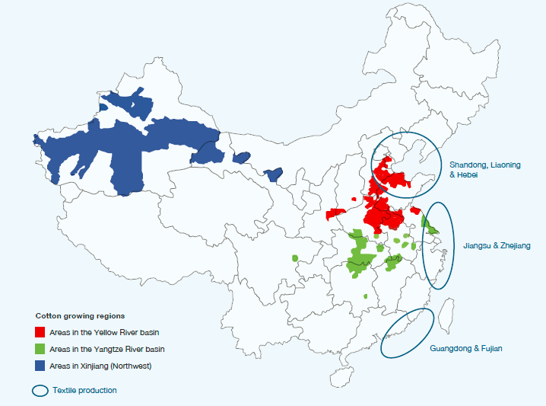
(Source: CottonConnect, 2015)

Exhibit 2 Top five cotton production regions in China

(Source: by authors, data from National Bureau of Statistic of China, 2015)

Exhibit 3 Output of cotton cultivation and sowing area in China

(Source: by authors, data from National Bureau of Statistic of China, 2015)

Exhibit 4 Cotton textile supply chain

Farmer Cultivation
Ginner Fiber Extraction
Spinner Yarn Production

Textile Producer Weaving & dyeing

Manufacturer Cutting & Sewing
Retailer
Selling

(Source: WWF and IKEA, 2014)

Exhibit 5 Better Cotton production principles

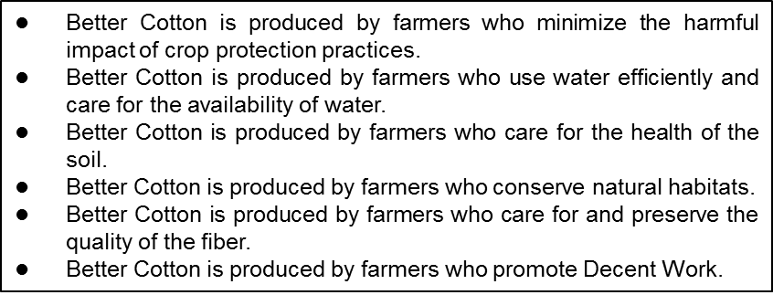
(Source: BCI website, accessed October 1st, 2017, http://bettercotton.org/about-better-cotton/better-cotton-standard-system/production-principles-and-criteria/,)

Exhibit 6 Cotton usage in IKEA products

(Source: IKEA Group Sustainability Report FY12, 13, 14, 15, 16)

Exhibit 7 An example of the supply chain learning structure coordinated by BCI

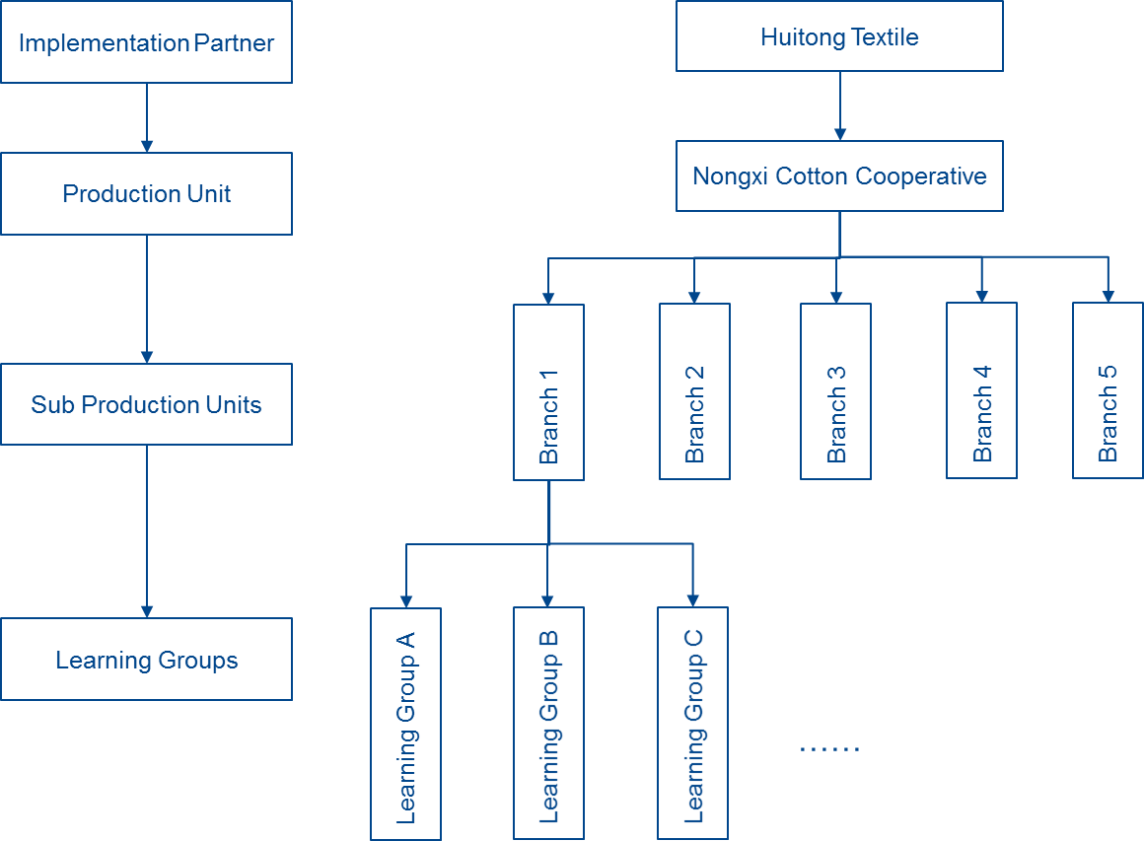

(Source: Compiled based on interviews)

FY is short for financial year, FY15 covered from September 1st, 2014 to August 31th, 2015
IKEA, IKEA Group Sustainability Report FY2015, accessed October 10th, 2018, http://www.ikea.com/ms/en_US/img/ad_content/2015_IKEA_sustainability_report.pdf.
National Bureau of Statistic of China (2015), China Statistical Yearbook, accessed March 25, 2019 http://www.stats.gov.cn/tjsj/ndsj/2015/indexch.htm (In Chinese).
Jianlong Dai and Hezhong Dong, “Intensive cotton farming technologies in China: achievements, challenges and countermeasures”, Field Crops Research, 155 (2014): 99-110, accessed July 10, 2019, https://core.ac.uk/download/pdf/81114687.pdf.
Rai, K.J. (2011), “The IKEA experience in moving towards a Better Cotton supply chain”, Dutch Sustainable Trade Initiative (IDH), accessed July 14, 2019 https://www.idhsustainabletrade.com/uploaded/2016/08/Ikea-booklet-def.pdf.
WWF and IKEA (2014), WWF and IKEA Project Report April 2014, accessed March 25, 2019, https://bettercotton.org/wp-content/uploads/2014/07/wwf_ikea_sustainable_cotton_initiative_201404_final_web_1.pdf.
IKEA, IKEA Group Sustainability Report FY2012, accessed October 10th, 2018, http://www.ikea.com/ms/en_US/pdf/sustainability_report/sustainability_report_2012.pdf.
IKEA, IKEA Group Sustainability Report FY2013, accessed October 10th, 2018, http://www.ikea.com/ms/en_US/pdf/sustainability_report/sustainability_report_2013.pdf.
IKEA, IKEA Group Sustainability Report FY2014, accessed October 10th, 2018, http://www.ikea.com/ms/en_US/pdf/sustainability_report/sustainability_report_2014.pdf.
CottonConnect (2015). China’s cotton: A growing market opportunity, accessed July 10, 2019, http://cottonconnect.wpengine.com/wp-content/uploads/cottonconnect_china_report_final.pdf.
IKEA, IKEA Group Sustainability Report FY2016, accessed October 10th, 2018, http://www.ikea.com/ms/en_US/img/ad_content/IKEA_Group_Sustainability_Report_FY16.pdf.

