An Evolutionary Game Model analysis on Emission Control Areas in China

ABSTRACT
To improve the atmospheric environment of coastal areas, it is important to coordinate the accomplishment of the Emission Control Areas (ECAs) program development. However, it is difficult to achieve this objective to align the conflict interest between the government and shipping companies. This paper analyzes the differences in the benefits of the two main subjects in the implementation of China's ECA supervision. Then, based on a non-perfect rational hypothesis, this paper constructs an evolutionary game model to analyze and test the dynamic changes of participants' decision-making. Furthermore, we contrast the effects of the interfering elements (e.g., uncooperative penalty, external benefits, the shipping company cost, and third-party report rate) on their decisions under various terms, by applying simulation analysis method. The paper’s outcomes demonstrate that, to inspire shipping companies to comply with ECA regulations, the government should apply a strategy, which is following dynamic penalty, to make shipping companies more willing to execute the ECA regulation within less time. Additionally, enhancing the external benefits of cooperative shipping companies and encouraging the participation of third-parties including non-governmental organizations and individuals in monitoring ECAs, are effective ways of stimulating shipping companies to comply with ECA regulations.

Keywords: Emission Control Areas, Evolutionary game, System dynamics theory, Behavior decisions

1. Introduction
When a ship is operating at sea or in a port, due to the use of fuel in the internal combustion engine, it will emit various air pollutants. Internal combustion engine pollutants may come from two main sources: (1) Soot, such as volatile organic compounds (VOCs), nitrogen oxides (NOx) and particulate matter (PM), which is related to the use of inefficient engine technology by ships; (2) The carbon dioxide rich fuels, if the ships use this kind of fuel they will emit large amount of carbon dioxide (CO2), sulfur dioxide (SO2), heavy metals and PM (EEA, 2009). More seriously, under the environmental impact of NOx, SO₂ and PM, they may cause serious cardiovascular and some respiratory problems to human beings, like asthma and so on (Spiegler et al., 2012).
As for the serious health harm for local and regional populations, they have compelled governments to adopt environmental regulations such as Emission Control Area (ECA) to control the emission of harmful gases from ships (Chang et al., 2018). ECA policy first came into force in the Baltic in 2006, and then implemented in the North Sea in 2007. The International Maritime Organization (IMO) set ECA in the United States and east & west coasts of Canada, the Hawaiian Islands, and areas around Puerto Rico and the Virgin Islands in the United States in 2012 (IMO, 2012). Trang and Nicole (2012) examined the advantages of the suggested North American ECA for air quality improvement along the Alaska coasts and corroborated that with the reduction of ship emissions, the findings suggest that the concentrations of sulfur and nitrogen compounds decrease significantly along the Gulf of Alaska.
As China’s economy has maintained a rapid growth over the past 40 years and became the second largest economy since 2010, foreign trade had an important role in driving its economic growth (Whalley and Xin, 2010) especially in 2013-2015 when China became the largest trading nation worldwide (Ministry of Commerce of the People’s Republic of China, 2013-2015). Accompanied by the development of trade and increases in ocean transportation volumes, China is also facing increasingly severe marine environmental risks. Consequently, in order to reduce sulfur emissions from ships and ameliorate the coastal environment, the Ministry of Transport of China issued the Ship and Port Pollution Prevention Special Action Plan (2015-2020) in September 2015, which aims to reduced nitrogen oxide and sulfur dioxide emissions from major port areas by 65% until 2020.
For this purpose, the Maritime Safety Administration of the People’s Republic of China specified the limits of China’s ECAs including Bohai Sea Region, Yangtze River Delta and Pearl River Delta, to adjust sulfur emission gradually. The latest regulations of ECA came into effect in January 2016 and requires the vessels docking at a port use fuel with sulfur content less than 0.5% in the regulated area. However, the regulated regions are to be expanded in January 2019 and fuel sulfur content reduces to less than 0.1% by January 2020.
There are two ways that shipping companies are considered to be the most economically viable to comply with ECA regulations in the market: (1) differentiating if the vessels carrying low or high sulfur fuels in ECA and non-ECA areas, separately; (2) in order to reduce the high sulfur content of fuel, a scrubber is installed on the ship to treat waste gas (Stasko and Gao, 2010; Yang et al., 2012; Acciaro, 2014; Brynolf et al., 2014; Cullinane and Bergqvist, 2014; Jiang et al., 2014; Schinas and Stefanakos, 2014). Obviously, the operating cost of ships will increase sharply if alternatives are applied (Gu and Wallace, 2017). Lahteenmaki-Uutela et al. (2017) predicted that the total operational costs of a ship would increase by 20-40% to comply with ECA regulation. These increasing costs arising from ECA regulations rule can make shipping companies reluctant in following the regulations. Particularly, as the global shipping market have been depressed continually, the shipping company’s business and revenues keep shrinking. Therefore, shipping companies may carry out illegal actions and ignore the ECA regulation even if this behavior may be punished by the government.
The government plays an important role in how to supervise shipping companies to abide by the ECA regulation. For example, it needs government to set up specialized regulatory agencies, purchase advanced equipment for collecting emission data and train official supervisors for better inspection. However, it is still insufficient for government to guarantee ECA regulation achieve an ideal effect, because shipping companies often change their behavior (or strategy) according to the government inspection measures. Therefore, without considering the shipping companies behavior will lead to the failure of government policies. For instance, Xie et al. (2018) found out that Chinese government has not realized the behavior of farmer is the main reason why the cultivated land protection policy did not achieve the desired effect. Therefore, the key solution of this problem might lie in identifying the game relationship between government and shipping companies.
In the process of ECA policy implementation, what kinds of measures should the government take to improve the regulatory capacity is the key problem to be solved. Punishment and reward are most commonly in promoting policy implementation, but the government should also grasp the enforcement intensity of punishment and reward regulation to avoid counterproductive consequences. For example, Attila et al. (2012) pointed out that rewards can improve our aspiration to cooperate, but since rewards come at cost for it necessarily and more elusive and unstable. On the other hand, Matjaž et al. (2012) discussed that punishment should not be dismissed and we need to established game theoretical models to identify the most effective mechanisms. The government can make appropriate regulatory measure from the learning of game process to encourage and ensure shipping companies obey ECA regulations.
However, as for static games, it requires that participants are rational that they can realize the profit maximization when they make decisions at the beginning. However， in reality participants are unlikely to be completely rational, and often commit a blunder and come to grief. Therefore, the game for decisions making between participants are not static but a changing process. Applying dynamic game theory can help us to analyze the process more intuitive and realistic, it will focus more on the process changes to draw up better development measures. As far as we know, there is no comprehensive analysis has been conducted on ECAs by using a dynamic game theory to propose appropriate regulatory measures, which is the main purpose of this research.
This study makes a major contribution on advancing ECA regulation implementation in China. We discussed the game between the government and shipping companies in the process of China’s ECAs regulations implementation by applying evolutionary game theory. The paper uses the simulation analysis to illustrate the dynamic changes in the government’s and shipping companies’ strategies and inform the games. At last, we propose appropriate regulatory measures for the government to implement ECA regulations effectively.
The rest part of this paper is arranged as follows. Section 2 carries out a comprehensive literature review. Section 3 presents the behavior decisions of government and shipping companies. Section 4 constructs the evolutionary game model between the government and shipping companies and carries out an analysis on the model. Section 5make a discussion based on the results and provide policy recommendations. Finally, section 6 provides a conclusion and point out the limitations and future research direction.

2. Literature review
With the development of ECA regulations in Europe and the United States, numerous scholars have put efforts on ECAs, leading to a solid body of literature which can be classified into four groups: (1) selection of sulfur emission reduction technology to respect the ECA regulations (Balland et al., 2013; Ren and Lutzen, 2015; Patricksson et al., 2015; Schinas and Stefanakos, 2014; Yang et al., 2012); (2) studies on the speed and route optimization in ECA and non-ECA areas (Doudnikoff and Lacoste, 2014; Fagerholt et al., 2015; Gu and Wallace, 2017; Linying Chen et al., 2017); (3) selection of transport modes in ECA areas (Ng, 2009); (4) evaluation the economic and environmental impacts of the ECA regulation (Chang et al., 2018). However, little research has been carried out on how the government formulates appropriate regulatory measures to ensure that the ECA regulation has been implemented to achieve the expected effect.
Although lack of research on the application of game theory to shipping sector, there are literatures on the dynamic games for behavior decisions between the Chinese government and other stakeholders in the implementation of environmental protection policies. For instance, May and Jun (2012) analyzed games between the government and oil companies on oil spill, and Ye et al. (2016) games between the government and enterprises on the emission trading scheme. Yu and Zhu (2011) illustrated the dynamic decision between the major parties on the electrical market, referring to the government and enterprises using a system dynamic model, and proposed policy advices for the stability of the electrical market. Similarly, Zhao et al. (2016) described the dynamic game between the government and manufacturing enterprise for putting forward better regulatory measures on improving the current carbon reduction labeling policies in China.
The games used to analyze the behavior decisions between the government and related stakeholders can be divided into two categories: static games and dynamic games. As previously mentioned, in the game, participants will make use of their advantages of being good at learning and constantly learn from others' advanced strategies to maximize their own interests. In other words, a participant's decision may change due to other parties’ behavior (Xie et al., 2017). Therefore, a dynamic game is more suitable for analyzing the relationship between the government and related stakeholders, especially when we want to determine reasonable countermeasures and develop policy suggestions.
As a main branch of dynamic game, evolutionary games theory has been applied to discuss the dynamic relationships between different stakeholders. Under Zhu and Dou (2007) research, the evolutionary game model of the government and some principal enterprises is established, which is based on the analysis of the cost-benefit of the government and the principal enterprises in the green supply chain. Their work shows that Green Supply Chain Management diffusion around principal enterprises is influenced by the costs and benefits of implementing GSCM, in addition to government subsidies and penalties. Zhang et al. (2014) also established an evolutionary game model between the government and enterprises that emit pollutants. Their study showed that it is effective to hold back enterprises’ illegal behaviors in case the government proposes different policies during the game.
The above studies suggest that we can obtain reasonable countermeasures and policy suggestions by applying a dynamic game model. In summary, several studies built theoretical or empirical analysis model based on game theory and provided targeted regulatory measures for the government based on the game result which can be applied in the ECA policy decision making.

3. Behavior decisions of the government and shipping companies
3.1. Strategies of the government and shipping companies
As the initiator of ECA program, Chinese government makes rigorous plans according to the overall welfare of the country. However, it is difficult to supervise the behavior of ships within the ECA areas. The government always needs to balance the costs and regulatory effects to choose the most appropriate regulatory strategy. In this paper, we assume that the government carries out two strategies including “Active Performance” strategy and “Passive Performance” strategy. When it executes the Active strategy, the government takes the initiative to inspect the ships sailing at the ECA. At this point, the government has to invest more in personnel and necessary equipment. When the “Passive Performance” strategy is selected by the government, instead of taking more proactive regulatory measures, it does not invest much but only takes action according to third-party reporting and punishes the shipping companies which violate regulations.
As has been said in foregoing, the shipping company is not aware of the specific regulation for example the proportion of sample inspection by the government. Therefore, a shipping company usually has two strategies: “Implement” and “Non-Implement”. When shipping companies select the former strategy, they comply with ECA regulations and need to invest more, for instance, they either buy more costly low-sulfur fuels, or fix washing appliance on their ships. Conversely, when they choose the Non-Implement strategy, they do not have to bear the costs of complying with ECA rules. However, they may face penalties from the government, especially when the government adopts a strict regulatory strategy. Therefore, governmental regulatory measures and punishment efforts are vital to shipping companies’ behavior decisions on “Implement” or “Non-Implement” ECA regulations.

3.2. Evolutionary game model establishment
Based on the bounded rationality assumption of game participants, it is difficult for a party to choose a perfect strategy to maximize their benefits at the beginning of the game. However, the participants can emulate the experience and exchange with others, constantly correcting mistakes and adjusting their strategies. Consequently, their ultimate strategies can maximize their interests (Shahi and Kant, 2007).
During the implementation of ECA policy, the Chinese government starts to announce emission standards and has the specific inspection on ships’ emission. For the ships with excessive emissions, the government will charge the punishment fee according to former issued regulation. Subsequently, the shipping companies will obtain the evidences for their decision-making according to lessons learnt from governmental inspection behavior such as proportion of sample inspection, the degree of punishment and so on. However, the specific inspection from government is not changeless. Instead, the government will use data including inspected data and the atmospheric environment data in ECA areas, which are collected and published by Environment Division of China to evaluate the implement effectiveness of current regulation, will make decisions on whether need to adjust the current regulations for better results. As a response, the shipping company will relearn and adjust its decisions. The government and shipping companies adjust their decisions based on each other’s behavior and there is an evolutionary game between them. In this study, we thus construct an evolutionary game model between the Chinese government and shipping companies, to explore real parameters such as third-party reporting probability, shipping companies’ external benefits which have not been considered in the evolutionary literature.

4. Evolutionary games between government and shipping companies
4.1. Evolutionary game model and parameters setting
In the model, we assume government officials obtain benefits $π_{G}$including environmental benefits and political performance when the government regulates ship sailing in ECAs. When the Active strategy government is adopted by the government and the shipping companies selects the Implement strategy, government officials will get $π_{G}$ but have to bear certain cost $C_{GA}$ for personnel and equipment. When the shipping companies choose the Non-Implement strategy, the government can also get penal sum $P_{E}$ from the shipping companies. Moreover, when the Passive strategy is chosen by the government and the shipping companies selects the Implement strategy, at the same time, the government will gain $π_{G}$ and disburse costs $C_{GP}$ which is less than $C_{GA}$ , because it needs less personnel and equipment in the regulatory process. Of course, the government does not have to pay rewards $C_{TI}$ to third parties owing to that it is not a “real” report. However, the shipping companies choosing the Non-Implement strategy is a “real” report and the government needs to pay rewards to reporters. At the moment, the government’s revenue is related to probability $λ$ that the shipping companies’ lack of implementation behavior is reported. If reported, the government would obtain $π_{G}$ and $P_{E}$ while losing $C_{GP}$ and $C_{TI}$, conversely, the government obtains $π_{G}$ at no cost.
When the shipping companies choose the Implement strategy, they will make profit $π_{RE}$ from shipping and afford expense $C_{EA}$ to reduce sulfur emissions. Moreover, the shipping companies’ behaviors for complying with ECA regulations will be endorsed by the government and society and may result in more orders and relevant supported policies. We define the shipping companies’ external benefits $π_{rE}$. Furthermore, when a shipping company selects the Non-Implement strategy, while the government selects the Active strategy, the shipping company has to pay fine $P_{E}$ and cannot get the $π_{rE}$, does not have to bear $C_{EA}$. Meanwhile, if the shipping company selects the Non-Implement strategy, while the government selects the Passive strategy, the shipping company’s revenue is also related to probability $λ$ that its non-implementing behavior is reported. If reported, the shipping company would obtain $π_{RE}$ and cannot get $π_{rE}$ and $P_{E}$, conversely, the government obtain $π_{RE}$ at no loss. Just like table 1 shown, Table 1 shows the revenue matrix of the games between the government and shipping companies.
As for the game model, we propose the probabilities that the Active or Passive strategies’ are chosen by the government can be $y$ ($0≤y≤1$) or $1-y$ , separately. The probabilities of the Implement and Non-Implement strategies for shipping companies are $x$ ($0≤x≤1$) and $1-x$ , separately.
Table 1
Revenue matrix between the government and shipping companies of the game theory
Shipping Companies | Government
 | Active $y$ | Passive (1-$y$)
Implement $x$ | $∏s_{1}$，$\prod{g_{1}}$ | $\prod{s_{2}}$，$\prod{g_{2}}$
Non-Implement ($1-x$) | $\prod{s_{3}}$，$\prod{g_{3}}$ | $\prod{s_{4}}$，$\prod{g_{4}}$

where
$\prod{s_{1}=π_{RE}}-C_{EA}+π_{rE}$ (1)
$\prod{g_{1}=π_{G}}-C_{GA}$ (2)
$\prod{s_{2}=π_{RE}}-C_{EA}+π_{rE}$ (3)
$\prod{g_{2}=λ\left(π_{G}-C_{GP}\right)+(1-λ)π_{G}}$ (4)
$\prod{s_{3}=π_{RE}-P_{E}-π_{rE}}$ (5)
$\prod{g_{3}=π_{G}+P_{E}-C_{GA}}$ (6)
$\prod{s_{4}=λ\left(π_{RE}-P_{E}-π_{rE}\right)+(1-λ)π_{RE}}$ (7)
$\prod{g_{4}={λ(π}_{G}+P_{E}-C_{GP}}-C_{TI})+(1-λ)π_{G}$ (8)

4.2. Dynamic equation of evolutionary game model
First, $U_{GC}$ means that if the government chooses the Active strategies, the prospective benefits can be calculated as follows:
$U_{GC}=x\left(π_{G}-C_{GA}\right)+\left(1-x\right)\left(π_{G}+P_{E}-C_{GA}\right)=π_{G}-C_{GA}+\left(1-x\right)P_{E}$ (9)
Secondly, $U_{GD}$ intends that the prospective benefits under the government making the Passive strategies:
$U_{GD}=x\left(π_{G}-λC_{GP}\right)+\left(1-x\right)\left[λ\left(π_{G}+P_{E}-C_{GP}-C_{TI}\right)+\left(1-λ\right)π_{G}\right]=π_{G}-λC_{GP}+λ\left(1-x\right)\left(P_{E}-C_{TI}\right)$ (10)
Therefore, under the government’s Active strategy, we can get the replicated equation
$$f_{g}=\frac{dy}{dt}=y{(U}_{GC}-U_{G})=y(1-y)(U_{GC}-U_{GD})=y(1-y)\left[λC_{GP}-C_{GA}+\left(1-λ\right)\left(1-x\right)P_{E}+λ\left(1-x\right)C_{TI}\right]$$
(11)
where ${\overline{U}}_{G}$ represents the average prospective returns under the government’s Active and Passive strategies and $\frac{d_{y}}{d_{t}}$ is the rate of changes of government chooses the Active strategy probability along with time going. When$f_{g}=0$, there are three types game system of stable states in the duplicated dynamic equations $y_{1}=0$, $y_{2}=1$and $x=1-\frac{C_{GA}-λC_{GP}}{\left(1-λ\right)P_{E}+λC_{TI}}$.
Next, $U_{EC}$ and $U_{ED}$are the prospective benefits of the shipping companies under selecting the Implement and Non-Implement strategies. And formula is showed as
$U_{EC}=y\left(π_{RE}-C_{EA}+π_{rE}\right)+\left(1-y\right)\left(π_{RE}-C_{EA}+π_{rE}\right)=π_{RE}-C_{EA}+π_{rE}$ (12)
$U_{ED}=y\left(π_{RE}-P_{E}-π_{rE}\right)+\left(1-y\right)\left[λ\left(π_{RE}-P_{E}-π_{rE}\right)+\left(1-λ\right)π_{RE}\right]=π_{RE}-[y+λ(1-y)](P_{E}+π_{rE})$ （13）
Therefore, for the shipping companies, they choose Implement strategy the replicated equation can be shown as
$$f_{s}=\frac{dx}{dt}=x({(U}_{EC}-U_{E})=x(1-x)(U_{EC}-U_{ED})=x\left(1-x\right)\left\{π_{rE}+\right.\left[y+λ\left(1-y\right)\right]\left(P_{E}+π_{rE}\right)-C_{EA}\}$$
(14)
where ${\overline{U}}_{E}$ is the average prospective benefits that the shipping company different profits get from the Implement and Non-Implement strategies and $\frac{d_{x}}{d_{t}}$ is the rate of changes of shipping companies under choosing the Implement strategy probability along with time going. When $f_{s}$=0, there are three types game system of stable states in the duplicated dynamic equation $x_{1}=0$, $x_{2}=1$and $y=1-\frac{\frac{C_{EA-π_{rE}}}{P_{E}+π_{rE}}-λ}{1-λ}$.
We integrate both the government and shipping companies’ replication equations to set up the evolutionary game system equation, and the equation just shown as follows:
$\left\{\begin{aligned}f_{g}=\frac{dy}{dt}=y(1-y)\left[λC_{GP}-C_{GA}+\left(1-λ\right)\left(1-x\right)P_{E}+λ\left(1-x\right)C_{TI}\right] \\ f_{s}=\frac{dx}{dt}=x\left(1-x\right)\left\{π_{rE}+\right.\left[y+λ\left(1-y\right)\right]\left(P_{E}+π_{rE}\right)-C_{EA}\}\end{aligned}\right.$ (15)

4.3. Simulation analysis of evolutionary game model
4.3.1. Analyzing the system dynamics model
Applying Vensim PLE software, the paper makes a system dynamics model of evolutionary game based on the relationship between government and shipping enterprises. Fig. 1 shows the construction of the model, $y$ represents the probability that the Active strategy is chosen by the government and $x$ represents the probability that the Implement strategy is chosen by shipping companies. As for the following equation, we explain the model in Section 4.2 more distinctly.
Between the government and shipping companies’ games, the government’s benefits that it chooses different strategies just as following:
the Active strategy = the probability the shipping company chooses the Implement strategy × (environmental benefits and political achievement obtains from successful regulation of ECA - cost of government chooses Active strategy) + the probability the shipping companies select the Non-Implement strategy × (environmental benefits and political achievement obtained from successful regulation of ECA + economic penalty imposed on uncooperative shipping companies-cost if Active strategy is selected by the government).
In the meantime, the government’s prospective benefits of selecting:
the Passive strategy = the probability the shipping companies select the Implement strategy × (environmental benefits and political achievement got from the prosperous regulation of ECA-the probability the shipping companies’ non-implementation behavior is reported × cost of government selecting Passive strategy) + the probability the shipping companies chooses the Non-Implement strategy × [the probability the shipping companies’ non- implementation behavior is reported × (environmental benefits and political achievement obtained from successful regulation of ECA + economic penalty imposed on uncooperative shipping companies-cost that the Active strategy is selected by the government - cost of government pays for the third-party) + the probability shipping companies’ non- implementation behavior is not reported × environmental benefits and political achievement obtained from successful regulation of ECA].
Additionally, the shipping companies’ expected benefits of selecting:
Implement strategy = the probability that the Active strategy is selected by the government × (profits of shipping companies + external benefits of shipping companies selecting Implement strategy - cost of shipping companies complying with ECA regulation) + the probability that the Passive strategy is selected by the government × (profits of shipping companies + external benefits of shipping companies selecting Implement strategy - cost of shipping companies comply with ECA regulations).
Meanwhile, shipping companies’ expected benefits of selecting:
Non-Implement strategy = the probability that the Active strategy is selected by the government × (profits of shipping companies - external benefits of shipping companies selecting Implement strategy - economic penalty shipping company pay to the government) + the probability that the Passive strategy is selected by the government × [the probability shipping companies’ non-implementation behavior is reported (profits of shipping companies - external benefits of shipping companies selecting Implement strategy - economic penalty shipping company pay to the government) + the probability shipping companies’ non- implementation behavior is not reported × commercial profits of shipping companies].
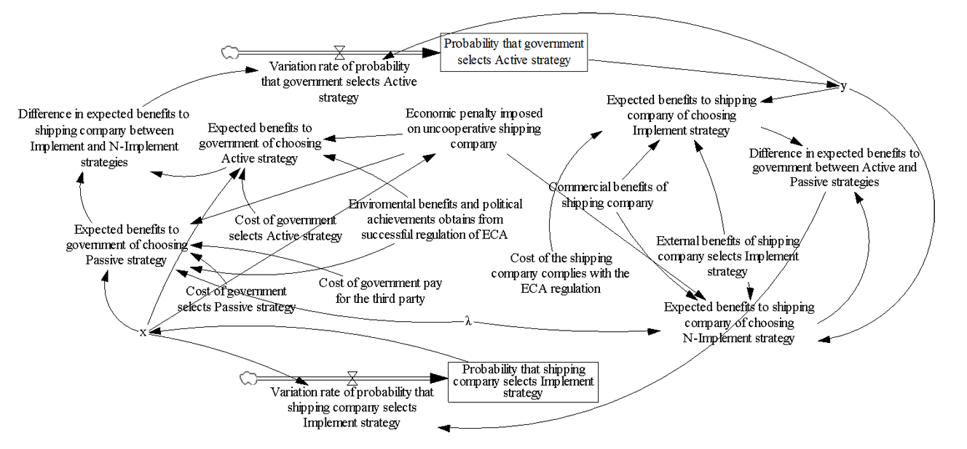

Fig. 1. Government and shipping company system dynamics model (SD model) of evolutionary game under fixed ECA penalty strategy

4.3.2. Bohai ECA area and Simulation data
Proposing appropriate policy recommendations to encourage the implementation of ECA, we chose Bohai area (Fig. 2) as a representative district with serious pollution of the marine environment. The Bohai Bay Area includes Beijing City, Tianjin City, Liaoning Province, Shandong Province, and Hebei Province. The territorial area of the region is 1.12 million square kilometers, with a total population of 260 million, accounting for 12% of China’s territory and 20% of its population. This region has a total of 157 cities, accounting for about one-fourth of all cities in the country, of which 13 cities with a population above one million. Furthermore, the gross domestic product (GDP) of Bohai Bay Area in 2016 was 16,590 billion yuan (about 2,498 billion US dollars) accounting for about 22.4% of the country’ GDP, while foreign trade dependence reached 30%. As a result, the Bohai Sea is one of the busiest areas for marine transportation with over 25 ports, among them, the port throughput of Tianjin Port and Dalian Port are both among top 20 worldwide in 2017. The closed sea area and busy marine transportation pollute the Bohai Sea and the atmospheric environment of coastal cities. Therefore, the government sets it as an ECA and will require vessels shipping in this region to use less than 0.5% sulfur fuel in the ‘Notice issued by the Ministry of Transport on the implementation plan of the ship's atmospheric pollutant ECA’ from January 1, 2019.
Through the investigation to shipping companies and Shandong Province Maritime Department, we obtained the following parameters’ information. Simultaneously, to facilitate the simulation analysis, we standardized the parameters. All the parameter values are relative values of the shipping company’s revenue. A container ship about 4,000 TEU from Dalian to Tianjin obtains 10 units of revenue and has to pay 4.2 units for purchasing the low sulfur oil to comply with the ECA regulation. The figure is consistent with the study of Gu and Wallace (2017) and Lahteenmaki-Uutela et al. (2017). If the ship company complies with the ECA regulations, it will be recognized by the government, port and society and receive an external benefit of 2.5 units. Conversely, it will lose that and be punished 1 unit by government. Similarly, the government will obtain 4 units of benefits including environmental benefits and political achievement whether it takes active or passive supervision measures. However, as mentioned in 4.1, the cost for the government can differ. The cost of the government’s Active strategy is 2.2 units while that of the Passive strategy is 1.4 units and the government has to pay 0.3 units to third-parties as a reward for reporting the violations of ships. In this process, the probability the third-party reports the shipping companies’ implemented behavior is 0.5 as a neutral role.

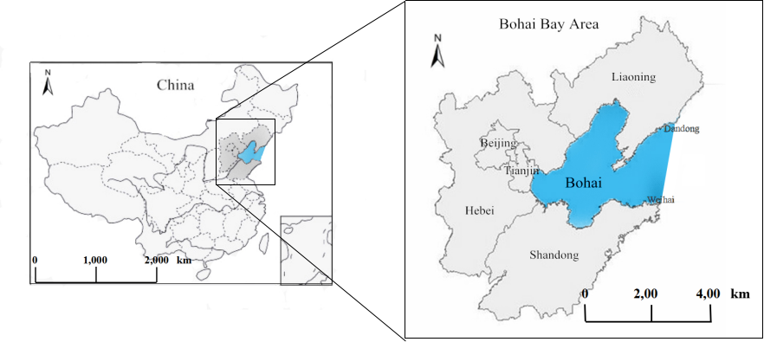

Fig. 2. Location of Bohai Emission Control Area in China

4.3.3. Simulation analysis
Using the method of simulation analysis, this paper analyzes the dynamic influence of several key indexes on the implementation strategy selection of shipping enterprises in the evolutionary game process. According to the actual situation, we selected the following indicators:
- cost of the shipping companies complying with the ECA regulation ($C_{EA}$);
- economic penalty imposed on uncooperative shipping companies ($P_{E}$);
- probability that shipping companies’ not-implementation behavior is reported by third-parties ($λ$);
- shipping companies’ external benefits when implementing ECA regulations ($π_{rE}$).
Owing to the shipping companies did not have a strong incentive to comply with the ECA regulations at the beginning, we presume that the initial probability of the shipping company chooses the Implement strategy is 0.1. Due to the changing strategies of participants, achieving the expected equilibrium is difficult. Consequently, by using simulation analysis’ method, the effective measures to balance the game are discussed. Fig. 3 demonstrates the dynamic changes in the probability that the shipping companies choosing the Implement strategy under fixed supervision strategy.
- Impact of the penalty imposed on the strategic choice of non-cooperative shipping companies
From the fig. 3 (a), we can see that when the initial value of $P_{E}$ is 1, the strategy of shipping companies is stable as the Implement strategy about 7 years during the evolutionary game process, and the probability the shipping companies select Implement strategy is 1. Additionally, when $P_{E}$ increases to 2, the game system quickly reaches a stable condition during less than 7 years and the probability that shipping companies select the Implement strategy is 1. Moreover, when $P_{E}$ decreases to 0, the game system cannot constrict to the ideal stable state in 10 years. Therefore, it is valid to increase the penalty compelled on the strategic choice of non-cooperative shipping companies for encouraging shipping companies to comply with ECA regulations. However, establishing an appropriate penalty rate is important, that it may mean, a lower penalty cannot effectively encourage shipping companies to implement ECA regulations, while a higher penalty rate will have a negative impact on the shipping market, thus affecting shipping prices (Sibande et al., 2017). Therefore, in Section 4.4, we increase the penalty mode to improve shipping companies to comply with ECA and avoid excessive penalty.
- Impact of external benefits on shipping companies’ strategy choice
Fig. 3 (b) illustrates the initial value of $π_{rE}$ is 2.5, the evolutionary game system achieves a desired stable state. Moreover, when $π_{rE}$ increases to 3, the evolutionary game process is identical with that $π_{rE}$ is 2.5. However, when $π_{rE}$ decreases to 1, the shipping companies’ strategy is not stabilized as the Implement strategy until 10 years later than that when $π_{rE}$ is 2.5 or 3. Therefore, increasing the external benefits of the shipping companies that comply with ECA regulations is helpful in driving the shipping companies to select the Implement strategy. Of course, this measure is not continuously effective. When the external benefits exceed 2.5, increasing external benefits will lose their incentive effect on shipping companies’ behaviors.
- Impact of cost when the shipping companies comply with the ECA regulation on their strategy choice
Fig. 3 (c) illustrates the initial value of $C_{EA}$ is 4.2, the evolutionary game system achieves an ideal stable situation after about 9 years in the evolutionary game process, and the shipping companies choosing the Implement strategy probability is 1. When $C_{EA}$ decreases to 4, the game system quickly reaches a stable situation at around 6.5 years less than 9 years. In turn, when $C_{EA}$ increases to 5, the game system fleetly reaches a stable situation in less than 6.5 years, but the probability the shipping companies select the Implement is less than 1 and always on 0.1. This shows that reducing cost especially the cost of low-sulfur oil for shipping companies complying with the ECA regulations is effective in encouraging shipping companies to adopt environmental friendly behaviors.
- Impact of the third-party report rate on shipping companies’ strategy choice
For comparison, we changed the initial value of $λ$ from 0.5 to 0.4. Fig. 3 (d) illustrates that if initial value in the model of $λ$ is 0.4, the strategy of shipping companies’ is stable in the Implement strategy at around 9 years in the evolutionary game process, and the probability they select the Implement strategy is 1. When $λ$ goes back to 0.5, the game system still achieves an ideal stable situation and the probability of shipping companies selecting the Implement is 1 units of time faster. Moreover, when $λ$ decreases to 0.3, the game system cannot reach an ideal stable situation within 10 years. Therefore, increasing the participation rate of third-party regulators including non-governmental organizations (NGOs) or individuals is effective for urging shipping companies to comply with ECA regulations.
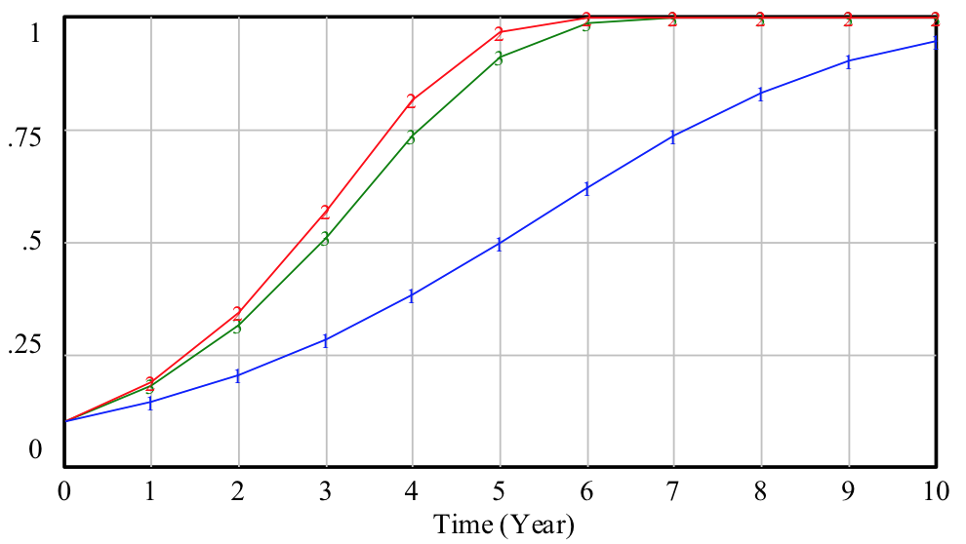 | 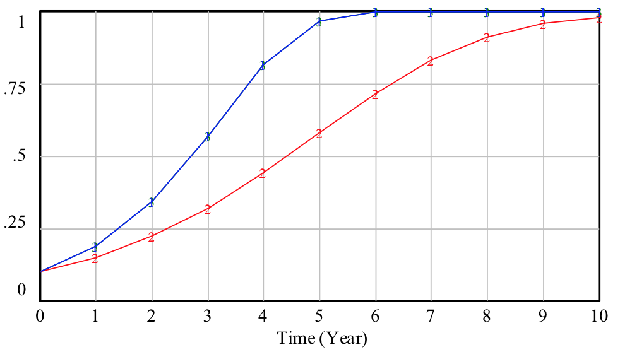
(a) | (b)
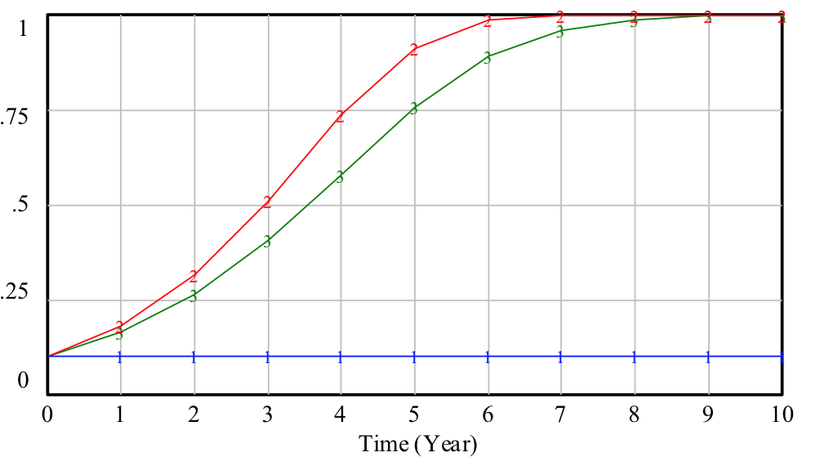 | 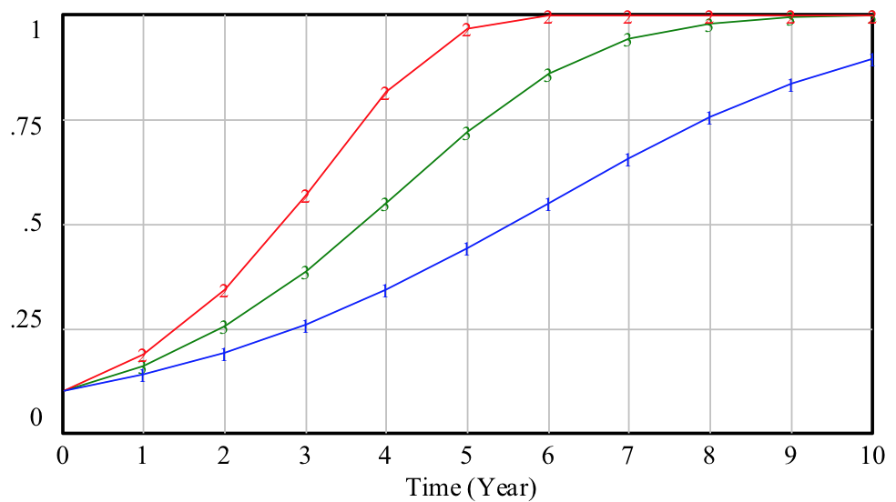
(c) | (d)
Fig. 3. Dynamic change of probability of the shipping company selects the ‘Implement strategy’ under fixed ECA penalty strategy.
Note: Y-axis = ‘probability that shipping company selects implement strategy’;
In part (a), Line 1: $P_{E} =0$; Line 2: $P_{E} = 2 ;$Line 3:${ P}_{E} =1$;
In part (b), Line 1: $π_{rE}=3$; Line 2: $π_{rE}= 1 ;$Line 3: $π_{rE}=2.5$;
In part (c), Line 1: $C_{EA}=5$; Line 2: $C_{EA}= 4 ;$ Line 3: $C_{EA}=4.2$;
In part (d), Line 1: $λ = 0.3$; Line 2: $λ. = 0.5 ;$ Line 3: $λ =0.4$.

Special explanation: With penalty increasing (a), shipping companies’ external benefits increasing (b), shipping companies’ cost decreasing (c) and third-party report rate increasing (d) will use less time to reach ECA regulations condition.
4.4. Dynamic penalty strategy of ECA regulation from the Chinese government
4.4.1. System construction dynamic model base on dynamic penalty
In fact, in the practice of regulation, environmental regulators are given greater discretionary power, and they often dynamically adjust the penalty according to the quality of regional environmental quality. When regional environmental quality is good, the illegal behaviors are subject to normalized penalties; and when the regional environmental quality is worrying, regulators are more inclined to create a shock through more severe punishment on corporate violations, and to communicate to the community the strength and determination of pollution control. This dynamic punishment mechanism is more prominent in China’s regional environmental governance practices (Jin et al., 2017). Moreover, flexible environment regulation is conducive to achieving a win-win situation between the government and stakeholders (Ramanathan et al., 2017). Therefore, we propose to apply dynamic penalty pattern to replace the current fixed penalty pattern, in order to effectively encourage shipping companies to choose the Implement strategy. In this kind of dynamic penalty mode, the penalty rate is negatively correlated with the probability of shipping companies choosing the Implementation strategy and positively correlated with the maximum penalty (Zhu et al., 2014). Therefore, the dynamic penalty can be calculated as:
${P_{E}}^{*}=k(1-x) P_{Emax}$ (16)
where ${P_{E}}^{*}$ is the dynamic penalty intensity; and $k$ is the coefficient of dynamic penalty, so the greater the coefficient is, the higher as the penalty that can be received from the government is. $P_{Emax}$ refers to the maximum penalty from government. The positive relationship resides between ${P_{E}}^{*}$and $(1-x)$ is noticeable. From the analysis, it indicates that the higher (lower) probability shipping companies will choose the Implement strategy, the less (more) penalty they will receive.
Fig. 4 illustrates the model of evolutionary game system dynamics of the government and shipping companies constructed based on the Vensim PLE software, where $y$ is the government choosing the Active strategy probability and $x$ is the shipping companies choosing the Implement strategy probability.
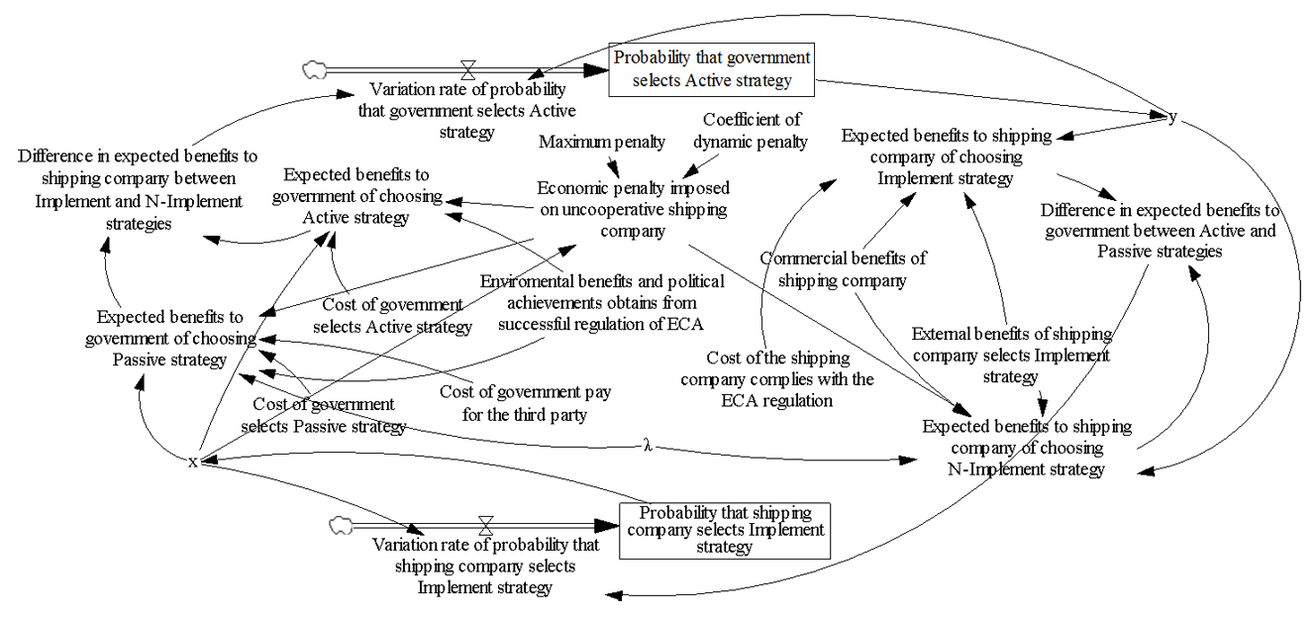

Fig. 4. Government and shipping company system dynamics model (SD model) of evolutionary game under dynamic ECA penalty strategy

4.4.2. Simulation analysis
Fig. 5 demonstrates the dynamic change in the shipping companies selecting the Implement strategy probability under a dynamic penalty strategy. Similarly, we presume the probability initial values of shipping company chooses the Implement strategy is 0.1. Considering shipping companies need to pay operating costs, including labor costs, fuel costs and others from their Revenue of 10 units, we assume the maximum penalty is 4 units. As we can see in Fig. 5, when the dynamic coefficient is 1.175 and the shipping companies select the Implement strategy with probability 0.1, the shipping companies receive 4.23 units penalty and the evolutionary game process quickly reaches a stable state and the shipping companies choosing the Implement strategy probability is 1. Unlike in the static penalty pattern in Section 4.3, the evolutionary game in the dynamic penalty pattern reaches the desired stable situation in less time. Moreover, when the probability the shipping companies select the Implement strategy is 0.5 at the beginning and the dynamic coefficient is 0.865, the simulation result is the same as before while the shipping companies from government is reducing to 1.73 units. Therefore, dynamic penalties are more conducive to incentives for shipping companies to adopt the Implement strategy than static penalties. In this process, shipping companies must give sufficient attention to regulation to avoid excessive punishment.
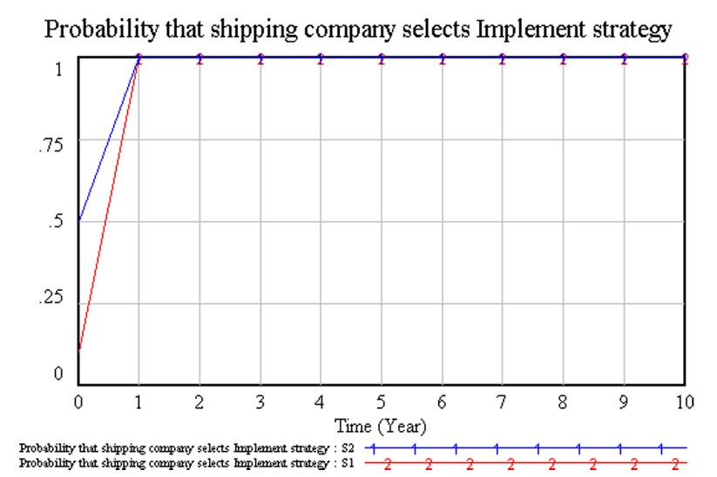
Fig. 5. Dynamic change of probability of the shipping company selecting the Implement strategy under a dynamic penalty in Emission Control Area

Note: S1: $x_{initial value}=0.1, k=1.175$, S2: $x_{initial value}=0.5, k=0.865$

Special explanation: Dynamic penalties are more acceptable for shipping companies to adopt the Implement strategy than static penalties.
- Discussion and policy implications
According to the data from the Environmental Monitoring Center of Shanghai, ship emissions have become one of the major sources of Shanghai air pollution, with emissions of SO2, NOx, and PM2.5 accounting for 12.4%, 11.6%, and 5.6%, respectively. As an important way to alleviate this situation, ensuring the ECA regulations can be implemented well becomes very important. In this process, the behavior of the shipping companies directly affects the effectiveness of ECA regulations. Therefore, how to stimulate shipping companies to comply with ECA regulations becomes a vital task for the government. Our results show that third-party, penalty and external benefits are determinants of shipping companies complying with ECA regulations. Based on that, we make the following policy implications.
(1) Encourage non-governmental organizations and individuals to participate in the regulatory process
As a main finding that encouraging the participation of third-parties such as NGOs or individuals, is necessary and effective in encouraging shipping companies to carry out ECA regulations. Therefore, governmental funds can be used to encourage the establishment of NGOs to protect the environment. In this process, the government can provide advisable economic or technical support to preserve the function properly of NGOs and improve the professional level of their functionary. Furthermore, the government can collect information of shipping companies’ behaviors in complying with ECA regulations in due course. Additionally, NGOs can conduct multiple heavy section publicity campaign to enhance public understanding of marine environmental protection (Austin and Eder, 2007) and encourage more organizations or individuals to participate in the regulatory process of ECA implementation.
(2) Establish a dynamic rather than a fixed punishment mechanism
Another result of the analysis is that appropriate economic penalty on uncooperative shipping companies being helpful to motivate them to apply ECA regulations. This policy is widely used in various environmental regulation projects in China, for example, cultivated land and forest projections (Shahi and Kant, 2007; Xie et al., 2018). However, inappropriate punishment cannot achieve sufficient incentives for uncooperative shipping companies, a low penalty will not be valid in encouraging them to carry out ECA regulations, and the high penalty will have the bad influence on the shipping market, thus affecting shipping prices (Sibande et al., 2017). Therefore, we suggest to cancel the fixed penalty strategy and replace it with the dynamic penalty strategy. Particularly, the penalty rate ought to have negative correlation with the chance of shipping companies choosing the Implement strategy. Moreover, the dynamic coefficient should be set according to the initial probability of the Implement strategy is selected by shipping companies. As the simulation results show, the lower the initial probability the shipping companies choose to implement ECA rules, the higher the penalty that the companies will face. Therefore, shipping companies should pay attention to the new regulation to avoid excessive punishment at the beginning. Nonetheless, the government could reach its ideal goal during less time and set a penalty on shipping companies within a reasonable range.
(3) Devise a reasonable behavior assessment mechanism of shipping companies
The external benefits of cooperative shipping companies can also be identified from our research results. The literature, for instance Jia et al. (2016), finds the fulfillment of corporate community responsibility will help to enhance company value. This value is called by many scholars social benefit and refers to the public and society’s recognition on the enterprise’s behaviors, which brings certain economic effect to the company (Wang et al., 2018). Similarly, shipping companies’ behaviors of compliance with ECA regulations will obtain social benefits and rewards from the government, which will encourage them to comply with ECA regulations. Therefore, the government should increase publicity to enhance the public awareness of environmental protection and create a favorable social environment to influence shipping companies’ behavior decisions. Under the China Corporate Social Responsibility Monitoring and Evaluation System driving, the government devise the reasonable assessment mechanism to evaluate the shipping companies’ behaviors by learning from successful cases. For a shipping company with a good evaluation results, the government can give appropriate rewards or exemptions from inspection. By contrast, in addition to identifying the penalties to be imposed on shipping companies, the government must impose a credible threat on the uncooperative shipping companies, such as levying a nitrogen oxide tax or canceling shore power subsidies.

- Conclusions
After the ECA regulation was introduced, research on how to regulate the behavior of shipping companies becomes extremely urgent. However, limited literature has considered the game between the government and shipping companies in this process. In this paper, we construct an evolutionary game model which can overcome the defect of the perfectly rational assumption of the traditional game to discuss if their decisions occur dynamic changes. Furthermore, under different conditions, we also discuss the impacts of some external factors (e.g., uncooperative penalty, external benefits, the shipping company cost, and third-party report rate) on their decisions by using the simulation analysis. We further simulate the dynamic penalties instead of fixed penalties. Based on the above studies, we propose the relevant policy implications.
From the game model we used in preceding text between the government and shipping companies, we conclude that compared with static penalties, dynamic penalties are more conducive to incentivize shipping companies to comply with ECA regulations in a shorter period of time. Additionally, the outcomes of the simulation results show that improving the external benefits of the cooperative shipping companies, reducing the cost for complying with ECA regulations especially the cost of low sulfur oil and encouraging the participation of third-parties such as NGOs and individuals, are necessary and effective ways to stimulating shipping companies to compliance the ECA regulations.
These results are crucial for designing policies focused on successfully reducing sulfur emissions from marine transport in ECA areas. As such, they should be aimed especially at establishing a dynamic penalty mechanism but also at encouraging the NGOs and individuals to join the regulatory process. Simultaneously, the government should design a shipping companies’ behavior evaluation system and propose appropriate incentives or punitive measures according to the evaluation results.
In future research, we will add more players who are the major stakeholders in the game model such as ports and freight forwarders, we can discuss the interest conflicts between them, and explore the relationship around different stakeholders. Besides, there are some limitations in our model. By applying the evolutionary game model, it does solve the trend of measurements improvement in the dynamic situation of both sides, but it can't answer what is the degree of measurements improvement，which is our major research topic in the future study. We will make a full study of the strength of punishment and reward to better promote ECA regulations development considering multiple interests. Then we will get a more holistic advice for pushing forward the policy implementation. In addition, we will explore other shipping companies’ strategies interfering factors, such as governmental subsidies. Therefore, we will proceed to conduct the research by using empirical research that we can try to find more effective solutions that is based on different complex situations. As Matjaž et al. (2017) mentioned we must learn how to create a harmonious platform that organizations, governments, and societies are more cooperative and more egalitarian to advance common development. It may also promote cooperation across fields, since such applications span the whole of social and natural sciences, and they would further strengthen the approach as sound and applicable. It may also promote cooperation across fields, since such applications span the whole of social and natural sciences, and they would further strengthen the approach as sound and applicable.

References
Acciaro, M., 2014. Real option analysis for environmental compliance: LNG and emission control areas. Transportation Research Part D. 28(2), 41-50.
André, F. J., Sokri, A., Georges Zaccourc., 2011. Public disclosure programs vs. traditional approaches for environmental regulation: green goodwill and the policies of the firm. European Journal of Operational Research. 212(1), 199-212.
Attila, S., Matjaž, P., 2012. Evolutionary advantages of adaptive rewarding. New Journal of Physics.14,093016.
Austin, R. L., Eder, J. F., 2007. Environmentalism, development, and participation on Palawan island, Philippines. Society & Natural Resources. 20(4), 363-371.
Balland, O., Fagerholt, K., Wallace, S. W., 2013. Planning vessel air emission regulations compliance under uncertainty. Journal of Marine Science & Technology. 18(3), 349-357.
Brynolf, S., Magnusson, M., Fridell, E., Andersson, K., 2014. Compliance possibilities for the future eca regulations through the use of abatement technologies or change of fuels. Transportation Research Part D. 28, 6-18.
Chang, Y. T., Park, H., Lee, S., Kim, E., 2018. Have emission control areas (ECAs) harmed port efficiency in Europe. Transportation Research Part D. 58, 39-53.
Chen, L., Yip, T. L., Mou, J., 2017. Provision of emission control area and the impact on shipping route choice and ship emissions. Transportation Research Part D. 58, 280-291.
Cheung, M., Zhuang, J., 2012. Regulation games between government and competing companies: oil spills and other disasters. Decision Analysis. 9(2), 156-164.
Cullinane, K., Bergqvist, R., 2014. Emission control areas and their impact on maritime transport. Transportation Research Part D. 28(May 2014), 1-5.
Doudnikoff, M., Lacoste, R., 2014. Effect of a speed reduction of containerships in response to higher energy costs in Sulphur emission control areas. Transportation Research Part D. 28(5), 51-61.
EEA, E., 2009. EEA air pollutant emission inventory guidebook—2009. European Environment Agency (EEA), Copenhagen.
Fagerholt, K., Gausel, N. T., Rakke, J. G., Psaraftis, H. N., 2015. Maritime routing and speed optimization with emission control areas. Transportation Research Part C. 52, 57-73.
Francesca M., Lourdes T., 2010. Short-sea shipping: an analysis of its determinants. Maritime Policy & Management. 37(3), 285-303.
Gu, Y., Wallace, S. W., 2017. Scrubber: a potentially overestimated compliance method for the emission control areas: the importance of involving a ship’s sailing pattern in the evaluation. Transportation Research Part D. 55, 51-66.
IMO, International Maritime of Organization Website, 2012. <http://www.imo.org/en/OurWork/Environment/PollutionPrevention/AirPollution/Pages/AirPollution.aspx>
Jia X. P., Liu Y., Liao H.Y.., 2016. Stakeholders Pressure, Corporate Social Responsibility, and Firm Value. Chinese Journal of Management. 13(2), 267-274.
Jiang, J., Xie, D., Ye, B., Shen, B., Chen, Z., 2016. Research on China’s cap-and-trade carbon emission trading scheme: overview and outlook. Applied Energy. 178, 902-917.
Jiang, L., Kronbak, J., Christensen, L.P., 2014. The costs and benefits of sulphur reduction measures: sulphur scrubbers versus marine gas oil. Transportation Research Part D. 28, 19–27.
Jin S., Zhang Y., Meng Q. F., 2017. Evolutionary Dynamics of Firm’s Environmental Compliance Behavior under Dynamic Punishment. Journal of Systems & Management. 26 (7), 1122-1130.
Lähteenmäki-Uutela, A., Repka, S., Haukioja, T., Pohjola, T., 2017. How to recognize and measure the economic impacts of environmental regulation: the sulphur emission control area case. Journal of Cleaner Production. 154, 553-565.
Li, J., Rodriguez, D., Tang, X., 2017. Effects of land lease policy on changes in land use, mechanization and agricultural pollution. Land Use Policy. 64, 405-413.
Liu, T., Liu, H., Qi, Y., 2015. Construction land expansion and cultivated land protection in urbanizing china: insights from national land surveys, 1996–2006. Habitat International. 46, 13-22.
Matjaž, P., Attila, S., 2012. Self-organization of punishment in structured populations. New Journal of Physics. 14, 043013 (13pp)
Matjaž , P., Jillian, J. J, David, G.R., Zhen, W., Stefano, B., Attila, S. Statistical physics of human cooperation. Physics Reports. 678, 1-51.
Ng, A. K. Y., 2009. Competitiveness of short sea shipping and the role of port: the case of north Europe. Maritime Policy & Management. 36(4), 337-352.
Patricksson, Ø. S., Fagerholt, K., & Rakke, J. G., 2015. The fleet renewal problem with regional emission limitations: case study from Roll-on/Roll-off shipping. Transportation Research Part C: Emerging Technologies, 56, 346-358.
Ramanathan, R., Ramanathan, U., Bentley, Y., 2017. The debate on flexibility of environmental regulations, innovation capabilities and financial performance – a novel use of DEA. Omega. 75, 131-138.
Ren, J., Lützen, M., 2015. Fuzzy multi-criteria decision-making method for technology selection for emissions reduction from shipping under uncertainties. Transportation Research Part D. 40, 43-60.
Schinas, O., Stefanakos, C.N., 2014. Selecting technologies towards compliance with MARPOL Annex VI: the perspective of operators. Transportation Research Part D. 28, 28–40.
Shahi, C., Kant, S., 2007. An evolutionary game-theoretic approach to the strategies of community members under joint forest management regime. Forest Policy & Economics. 9(7), 763-775.
Sibande L., Bailey A., Davidova S.,2017. The impact of farm input subsidies on maize marketing in Malawi. Food Policy.69, 190-206.
Stasko, T.H., Gao, H.O., 2010. Reducing transit fleet emissions through vehicle retrofits, replacements, and usage changes over multiple time periods. Transportation Research Part D. 15, 254–262.
Spiegler, V. L., Naim, M. M., & Wikner, J., 2012. A control engineering approach to the assessment of supply chain resilience. International Journal of Production Research, 50(21), 6162-6187.
Tang, X., Pan, Y., Liu, Y., 2017. Analysis and demonstration of investment implementation model and paths for china’s cultivated land consolidation. Applied Geography. 82, 24-34.
Tran, T. T., Mölders, N., 2012. Potential impacts of an emission control area on air quality in Alaska coastal regions. Atmospheric Environment. 50(4), 192-202.
Wang, N., Wan-Ming, L. I., Guo, W. D., 2018. Research on the economic effect of corporate social responsibility implementations under the context of China’s transition. On Economic Problems. (3), 66-77.
Whalley, J., Xin, X., 2010. China’s FDI and non-FDI economies and the sustainability of future high Chinese growth. China Economic Review. 21(1), 123-135.
Xie, H., Cheng, L., & Lv, T., 2017. Factors influencing farmer willingness to fallow winter wheat and ecological compensation standards in a groundwater funnel area in Hengshui, Hebei Province, China. Sustainability, 9(5), 839.
Xie, H., Wang, W., Zhang, X., 2018. Evolutionary game and simulation of management strategies of fallow cultivated land: a case study in Hunan province, China. Land Use Policy. 71, 86-97.
Xu, X., Zhang, W., He, P., & Xu, X., 2017. Production and pricing problems in make-to-order supply chain with cap-and-trade regulation. Omega, 66, 248-257.
Yang, Z. L., Zhang, D., Caglayan, O., Jenkinson, I. D., Bonsall, S., & Wang, J., et al., 2012. Selection of techniques for reducing shipping NOx and SOx emissions. Transportation Research Part D. 17(6), 478-486.
Yu, Y., Zhu, J., 2011. A SD model for the electrical market considering inflation and regulation strategies. Proc. IEEE Int. Syst. Conf. 395–400. (Available from: http://dx.doi.org/10.1109/SYSCON.2011.5929082., Accessed August 12 2015).
Zhang, N., Xie, H., 2014. Toward green it: modeling sustainable production characteristics for Chinese electronic information industry, 1980–2012. Technological Forecasting & Social Change. 96, 62-70.
Zhao, R., Zhou, X., Han, J., Liu, C., 2016. For the sustainable performance of the carbon reduction labeling policies under an evolutionary game simulation. Technological Forecasting & Social Change. 112, 262-274.
Zhu, L. L., Guo, P. F., Business, S. O., University, S. N., Management, S. O., University, S., 2016. Cold-chain food quality and safety supervision game analysis between government and cold-chain food enterprise. Chinese Journal of Management Science. 24(11), 644-649.
Zhu, Q. H., Wang, Y. L., Tian, Y. H., 2014. Analysis of an evolutionary game between local governments and manufacturing enterprises under carbon reduction policies based on system dynamics. Operations Research & Management Science. 23(3), 71-82.
Zhu, Q. H., Dou, Y. J., 2007. Evolutionary game model between governments and core enterprises in greening supply chains. Systems Engineering - Theory & Practice. 27(12), 85-89.

This information is obtained in the following website. http://www.stats.gov.cn/tjsj/ndsj/2017/indexch.htm (in Chinese).
The average exchange rate in 2016 is 1 US dollar = 6.6423 yuan. This information is obtained in the following website. http://finance.sina.com.cn/roll/2017-02-28/docifyavwcv9195284.shtml (in Chinese).
Foreign trade dependence=Gross domestic product/Total value of imports and exports of goods. This information is obtained in the following website. http://www.stats.gov.cn/tjsj/ndsj/2017/indexeh.htm (in Chinese).

