3.9 μm emission and energy transfer in ultra-low OH⁻, Ho³⁺ /Nd³⁺ co-doped fluoroindate glasses

Abstract: Ho³⁺/Nd³⁺ co-doped fluoroindate glass samples were prepared by melt-quenching. The absorption and emission spectra, and the differential thermal analysis (DTA) curve were measured and used to evaluate the spectroscopic parameters and thermal properties. An intense ~3.9 μm emission, ascribed to the transition Ho³⁺:⁵I₅ →⁵I₆, was observed under the excitation of a 808 nm laser diode and was ascribed to the efficient energy transfer process from Nd³⁺: ⁴F_{3/2} to Ho³⁺: ⁵I_{5,} showing the Nd³⁺ role as a sensitizer. The optimal concentration ratio of Ho³⁺ and Nd³⁺ for ~3.9 μm emission was estimated to be 1:1. The spectroscopic performance suggests that the Ho³⁺/Nd³⁺ co-doped fluoroindate glass is a potential gain material for ~3.9 μm laser applications.

Keywords: fluoroindate glass, 3.9 μm emission, Ho³⁺/Nd³⁺ co-doped

1. Introduction
Lasers operating in the mid-infrared wavelength region (λ=3-5 μm) have been a research hotspot due to their wide applications in national defense, medical treatment, pollution detection, industrial processes and scientific research [1-8]. In comparison with other types of lasers, fiber lasers have the comprehensive advantages of diffraction-limited beam quality, superior thermal management and compactness, and have become a mainstream technology in the near-infrared wavelength region. At present, the output power of Tm³⁺ doped silica fiber lasers (λ~2 μm) have reached kilowatt levels when pumped by laser diodes, and benefited from the excellent mechanical and thermal performance of silica fibers [9]. Because of the large energy phonon (~1100 cm⁻¹) and limited infrared transmission range (λ<2.5 μm) of silica, it is impossible to obtain lasers in silica fibers operating at λ~3-5 μm. Fluoride fibers have the advantages of low phonon energy and wide transmission widow, which can be used for mid-infrared lasers [10-15]. Among them, ZBLAN fibers showed superior performance and achieved laser output covering the range λ~2.7-3.9 μm [16-26]. In 2018, Aydin et al. demonstrated erbium-doped fluoride fiber laser at λ~2824 nm with an average output power of 41.6 W, which is the highest average output power achieved in a mid-infrared fiber laser [17]. In 2017, Mace et al. reported the first monolithic erbium-doped fluorozirconate fiber laser, which obtained a λ~3.55 μm laser with an output power of 5.6 W [27]. In 2019, luo et al. confirmed that the gain switch fiber laser had a maximum average power of 1.04 W at λ~3.46 μm [28]. In 1997, Schneider et al. presented room-temperature fluorescence at 3.9 μm in Ho³⁺ doped ZBLAN fibers with a output power of 11 mW in liquid nitrogen [29]. However, the λ~3.9 μm emission efficiency is strongly dependent on the host material phonon energy because of the small energy gap ΔE between the level of Ho³⁺: ⁵I₅ and ⁵I₆ according to the multi-phonon relaxation process which could be described by $W_{MPR}\left(T\right)=W_{MPR}\left(0\right){[1-exp⁡(-ℏω_{max}/KT)]}^{-p}$, where $ℏω_{max}$ is the maximum phonon energy of the host material, $p=∆E/ℏω_{max}$, $W_{MPR}\left(0\right)=C\exp^{-α∆E}$, C and α are the constants associated with the host material. Yet, λ~3.9 μm is close to the edge of the ZBLAN glass transparency window and the fibers loss increases accordingly. Fluoroindate glass is an alternative fluoride glass matrix with lower phonon energy than ZBLAN, and in 2018 it was used by Maes et al. to produce the longest wavelength room temperature fiber laser: a fluoroindate fiber doped with 10 mol % Ho³⁺ produced a λ~3.9 μm laser with ∼200 mW of output power when pumped by a λ~888 nm laser diode [30]. As the absorption coefficient of Ho³⁺: ⁵I₅ is small, pumping at λ~888 nm is not efficient. The introduction of other rare earth ions is an efficient method to sensitize Ho³⁺ and enhance the pumping absorption efficiency. Recently, we introduced Nd³⁺ into the Ho³⁺ doped glass samples and observed an intense λ~3.9 μm emission, which has been attributed to the efficient sensitization effect of Nd³⁺ to Ho³⁺ under the excitation of λ~808 nm LD. Nd³⁺ can be excited to the (⁴F_{5∕2}, ²H_{9∕2}) level and then relax to the ⁴F_{3∕2} level, to transfer energy to the Ho³⁺: ⁵I₅ level. Subsequently, the λ~3.9 μm emission was produced thanks to the radiative transition from the ⁵I₅ level to the ⁵I₆ level of Ho³⁺. The λ~3.9 μm emission is a self-terminated process, because the lifetime of the ⁵I₆ level (~6.2 ms) is much longer than that of the ⁵I₅ level (~135 μs) [30], thus population inversion cannot be directly achieved and depopulation of the ⁵I₆ level is necessary to achieve lasing. The ⁵I₆ level depopulated can be achieved through the energy transfer process of Ho³⁺: ⁵I₆→Nd³⁺: ⁴I_{15/2}.
In this work, we observed an intense emission at λ~3.9 μm and investigated the energy transfer mechanisms in Ho³⁺/Nd³⁺ co-doped fluoroindate glasses. The intense emission was attributed to the efficient energy transfer process from Nd³⁺ to Ho³⁺ and the deactivation effect relative to the process of Ho³⁺:⁵I₆ to Nd³⁺: ⁴I_{15/2}, showing that Ho³⁺/Nd³⁺ co-doped fluoroindate glasses are an excellent gain material for mid-IR μm laser applications.

2. Experiment
Glass samples with the molar compositions of 26InF₃-14ZnF₂-19BaF₂-11GaF₃-8SrF₂-12PbF₂-5LiF-(4-x)LaF₃-xHoF₃-1NdF₃ (x=0.2, 0.5, 1,2, 3, 4, named as xHo-1Nd) and 26InF₃-14ZnF₂-19BaF₂-11GaF₃-8SrF₂-12PbF₂-5LiF-4LaF₃-1HoF₃ (named as 1Ho) were prepared from high purity (99.9%) raw materials by using the conventional melt-quenching method. The powders were put into a platinum crucible and then melted in a furnace at the temperature T~850 °C in a glove box, and then poured onto a preheated copper plate with annealing at T~240 °C for 3 h, after which they were slowly cooled to room temperature. The annealed samples were polished to the same thickness of 1.85 mm for subsequent optical measurements. The thermal characteristic was determined by differential thermal analysis (DTA) with a Seiko TG/DTA6200 analyzer at a heating rate of 10 K/min. The Perkin Elmer Lambda 750 UV-VIS-NIR spectrophotometer and Perkin Elmer FTIR infrared Fourier spectrometer were used to measurement the absorption spectrum in the range λ~200-1000 nm and the transmission spectrum in the range f λ~1-11 μm, respectively. Fluorescence spectra were recorded with a computer controlled Zolix Omni-λ300i Monochromators and Spectrographs with an InGaAs detector or a liquid nitrogen cooled InSb detector. The decay characteristics of the excitation levels were measured using a tunable optical parametric oscillator (OPO). OPO was tuned to λ~808 nm and λ~880 nm, in order to excited Nd³⁺: ⁴F_{5/2}+²H_{9/2} and Ho³⁺: ⁵I₅ levels, respectively. All measurements were performed at room temperature.

3．Results and Discussions
Fig. 1 shows the transmission spectrum in the range λ~1000-11000 nm and the images of the obtained glass samples with different Ho³⁺ doping compositions. Fig. 2 shows the absorption spectrum in the range λ~200-1000 nm. Nine strong absorption bands of Ho³⁺ can be observed at λ~354, 416, 449, 483, 536, 641, 889, 1152, and 1946 nm, which correspond to the transitions starting from the ground state to higher levels ³H₆, ⁵G₅, ⁵G₆, ⁵F₃, ⁵F₄, ⁵F₅, ⁵I₅, ⁵I₆ and ⁵I₇, respectively. Due to the strong absorption of Nd³⁺ at λ~796nm, the λ~808 nm laser diode can be used to pump the Ho³⁺/Nd³⁺ co-doped fluoroindate glass. As shown in the Fig. 1, the glass transmittance at 3.9 μm is about 92%, while the transmission window ends at λ~11 μm.
In addition, it can be seen that there is no obvious absorption of OH⁻ near λ~3 μm and the absorption coefficient of OH⁻ can be calculated by Equation:
$α_{OH}=\ln\left(\frac{T_{0}}{T}\right)/l$ (1)
which is calculated from the transmission spectrum of a 2 cm thick polished fluoroindate glass block and is about 0.0032 cm⁻¹, where T₀ is the maximum transmittance, T is the transmittance at λ~3 μm, and l is the thickness of the glass. It was much lower than the OH⁻ absorption coefficient of PbF₂ crystal (0.03 cm⁻¹) [31], fluorozirconate (0.031 cm⁻¹) [32], fluoroaluminate (0.12 cm⁻¹) [10] and fluoroindate (0.06 cm⁻¹) [33] glasses.
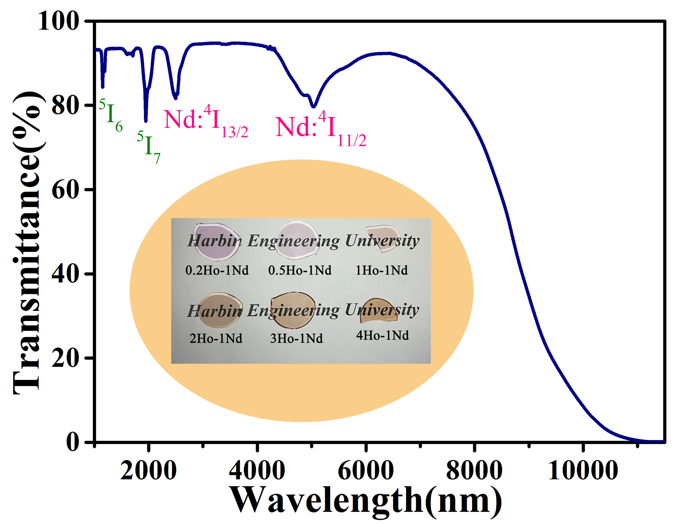
Fig. 1. IR transmission spectrum in the λ~1-11 µm range. Inset: image of the obtained glass samples with different Ho³⁺ doping compositions.
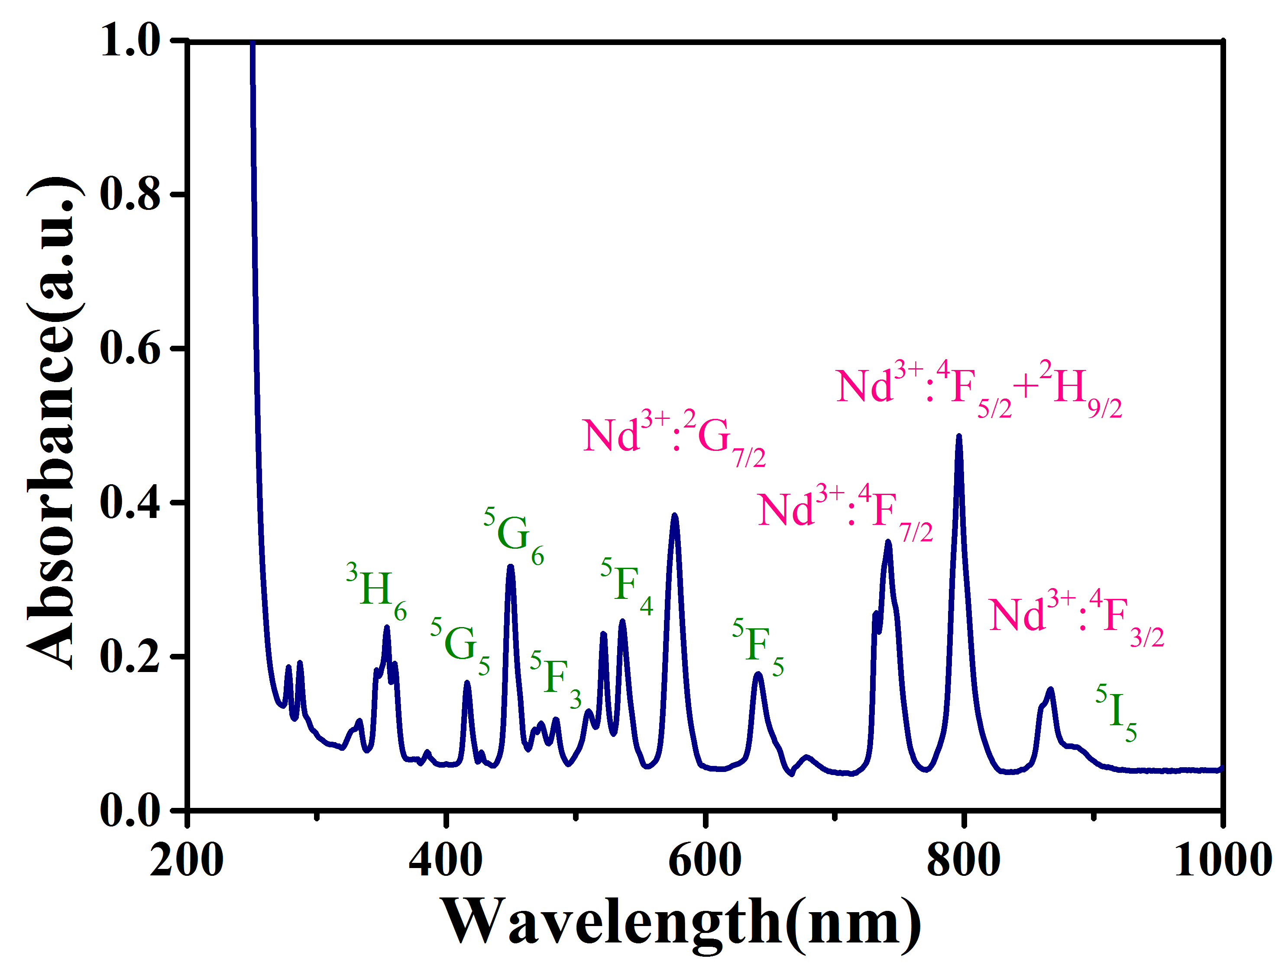
Fig. 2. Absorption spectrum of 1 mol % Ho³⁺/1 mol % Nd³⁺ co-doped fluoroindate glass in the range λ~200–1000 nm.
According to the simplified energy level diagram of Ho³⁺/Nd³⁺ co-doping shown in Fig. 3, it can be seen that under λ~808 nm laser excitation, Nd³⁺ transitioned from the ground state level ⁴I_{9/2} to the ⁴F_{5/2}+²H_{9/2} level and then relaxed to the ⁴F_{3/2} level by non-radiative relaxation, then energy was transferred to the ⁵I₅ level of Ho³⁺. Radiative transitions correspond to emission at λ~3.9 μm (⁵I₅→⁵I₆), λ~2.9 μm (⁵I₆→⁵I₇), 2 μm (⁵I₇→⁵I₈) and λ~1.2 μm (⁵I₆→⁵I₈), respectively. Since the lifetime of the upper level ⁵I₅ is shorter than that of the lower level ⁵I₆, the emission at λ~3.9 μm is self-terminating. Through the energy transfer from the ⁵I₆ level of Ho³⁺ to the ⁴I_{15/2} level of Nd³⁺, the lifetime of the ⁵I₆ level of Ho³⁺ could be shortened, thereby improving the λ~3.9 μm fluorescence efficiency. Besides, Nd³⁺ also have transitions at λ~1.9 μm (⁴F_{3/2}→⁴I_{15/2}), λ~1.6 μm (⁴I_{15/2}→⁴I_{9/2}), λ~1.33 μm (⁴F_{3/2}→⁴I_{13/2}), λ~1.06 μm (⁴F_{3/2}→⁴I_{11/2}) and λ~888 nm (⁴F_{3/2}→⁴I_{9/2}).
Fig. 3. Energy level diagram.
Fig. 4 shows the differential thermal analysis (DTA) curve of the fluoroindate glass samples: the transition and crystallization temperatures were T_{g}~259 ℃ and T_{x}~355 ℃, respectively. ΔT=T_{x}-T_{g}, which is an important parameter used to characterize the glass resistance to crystallization and ease of fiberization, was 96 ℃, showing that this glass has relatively good thermal stability and can be used as a material for drawing fibers.
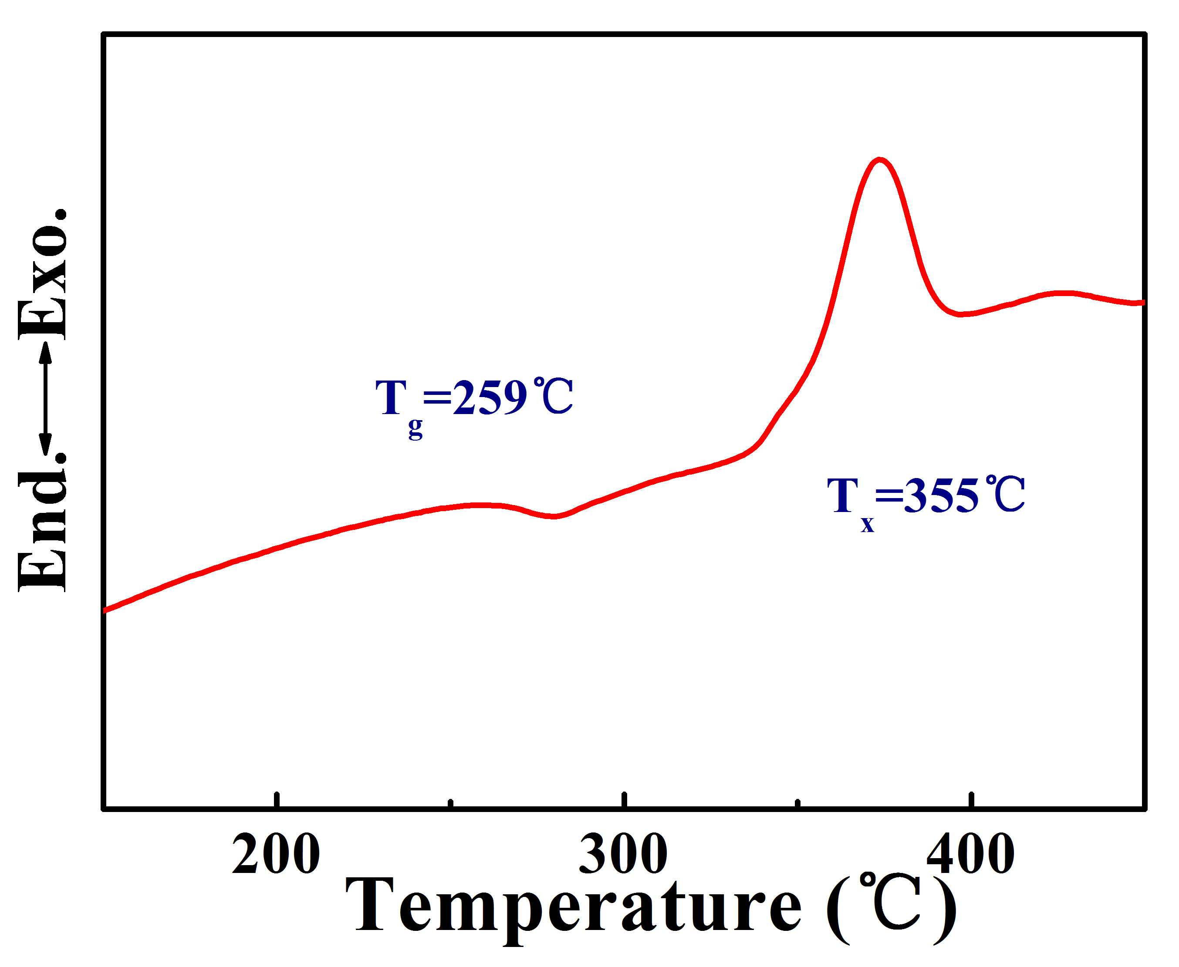
Fig. 4. DTA curve.
The emission spectra of the Ho³⁺/Nd³⁺ co-doped fluoroindate glasses around λ~3.9 μm, λ~2.9 μm, λ~2 μm and λ~1.2 μm, pumped by λ~808nm diode laser, are shown in Fig. 5 for various Ho³⁺ concentrations. When the Nd³⁺ concentration was fixed at 1 mol %, the luminescence intensity at λ~3.9 μm, λ~2.9 μm, λ~2 μm and λ~1.2 μm increased gradually with the Ho³⁺ concentration because of the efficient energy transfer from the Nd:⁴F_{3/2} to the Ho: ⁵I₅ level. However, as the Ho³⁺ concentration continues to increase from 1 to 4 mol%, the luminescence intensity decreases due to concentration quenching.
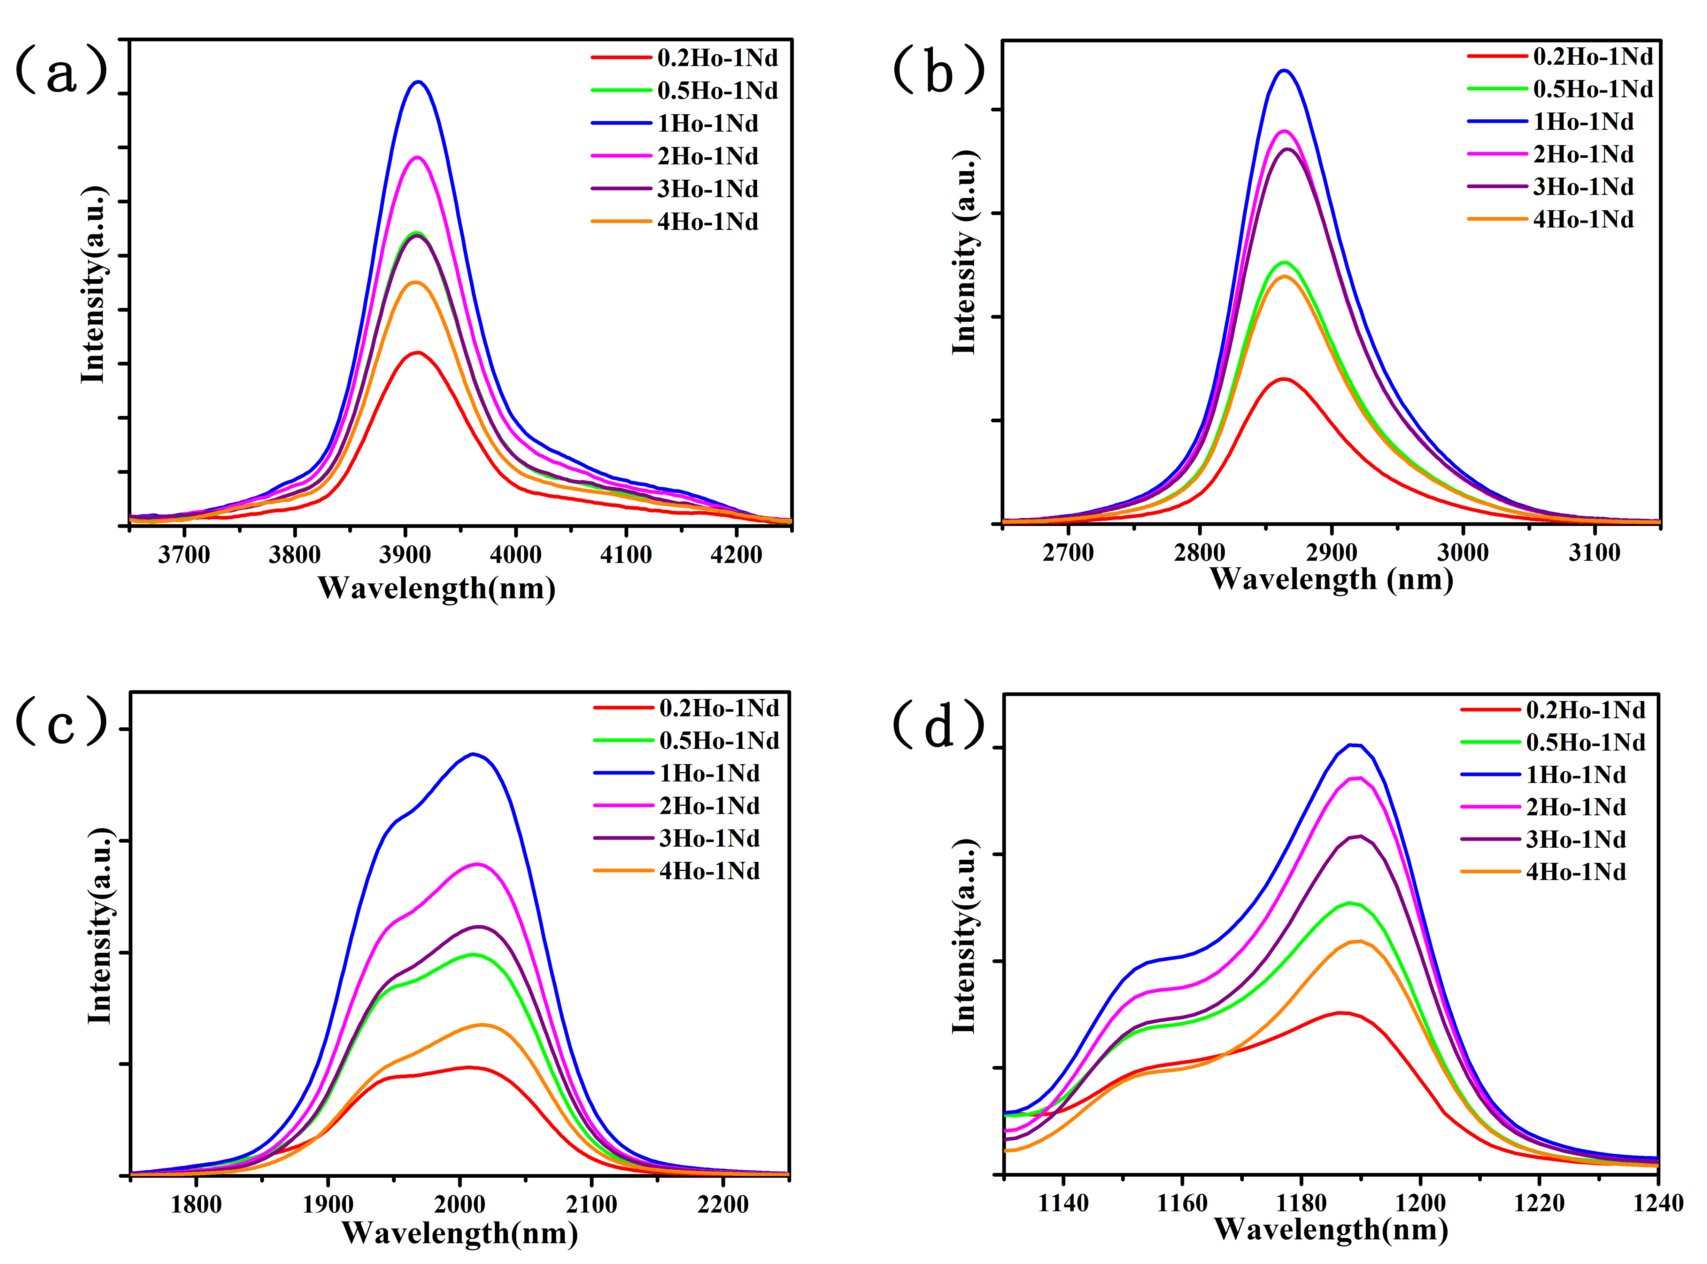
Fig. 5. Emission spectra of the Ho³⁺ /Nd³⁺ co-doped fluoroindate glasses at (a) λ~3.9 μm, (b) λ~2.9 μm, (c) λ~2 μm, (d) λ~1.2 μm for different Ho³⁺ concentrations under λ~808 nm laser diode excitation. The Nd³⁺ concentration is fixed at 1 mol%.
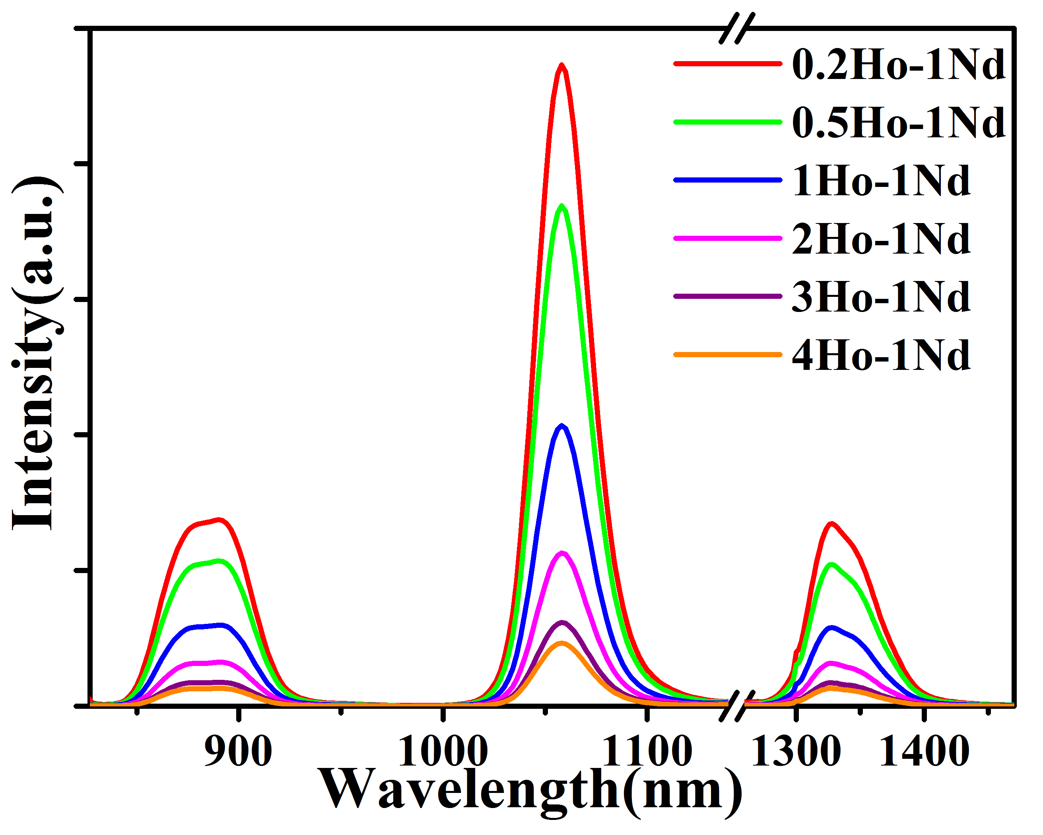
Fig. 6. Emission spectra of the Ho³⁺/Nd³⁺ co-doped fluoroindate glasses at λ~888 nm, λ~1.06 μm and λ~1.33 μm for different Ho³⁺ concentrations under λ~808nm laser diode excitation. The Nd³⁺ concentration is fixed at 1 mol %.
Fig. 6 shows the emission at λ~888 nm, λ~1.06 μm, λ~1.33 μm of Nd³⁺ under the pumping of an λ~808 nm laser. The peaks are associated to radiative transitions from the same ⁴F_{3/2} level, and are weakened monotonously as Ho³⁺ concentration increases from 0.2 to 4 mol%, confirming the efficient energy transfer from the Nd³⁺:⁴F_{3/2} to the Ho³⁺: ⁵I₅ level.
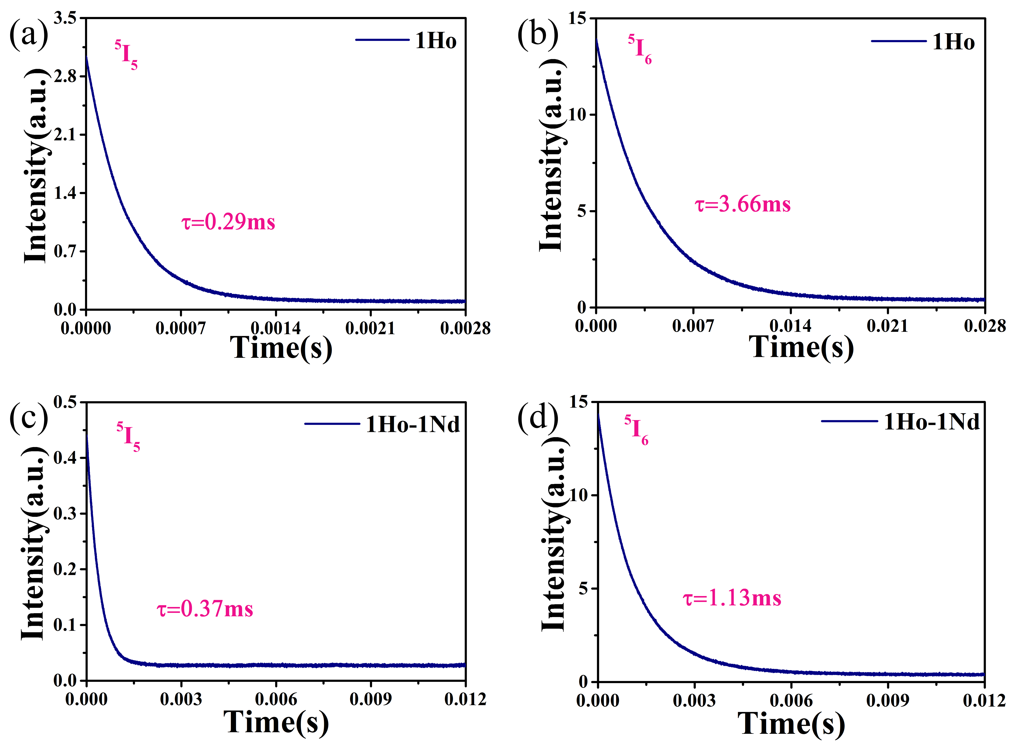
Fig. 7. Fluorescence decay curves of Ho³⁺: fluoroindate and Ho³⁺∕Nd³⁺: fluoroindate glasses for the ⁵I₅ and ⁵I₆ mainfold.
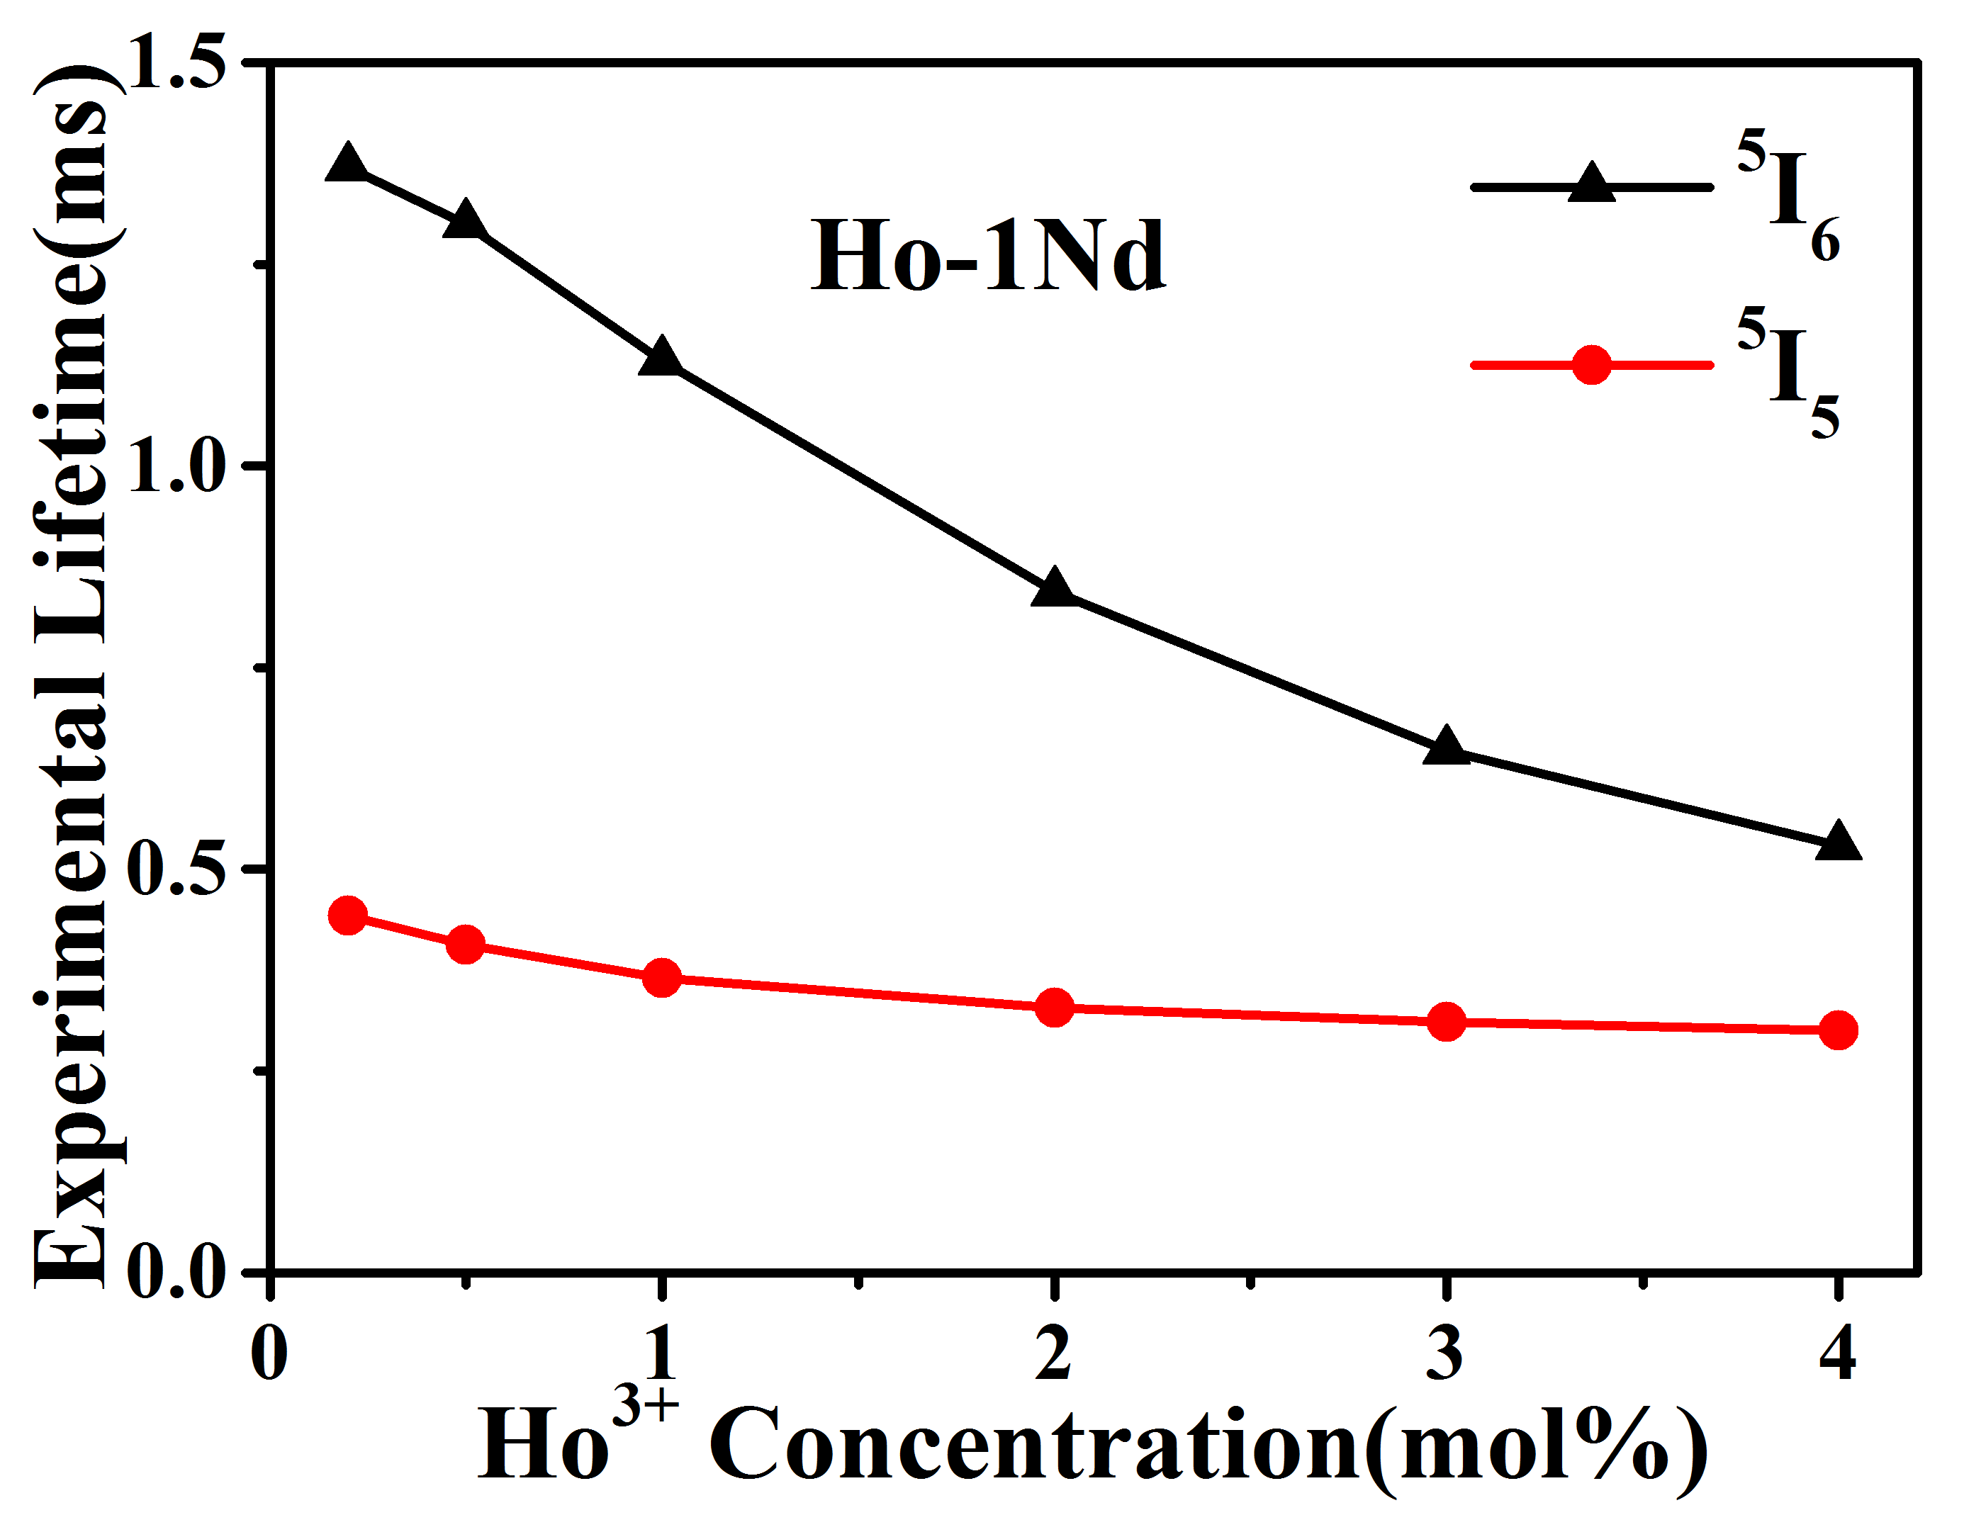
Fig. 8. Experimental lifetimes of ⁵I₅ and ⁵I₆ levels of Ho³⁺ in the Ho³⁺/Nd³⁺ doped fluoroindate glasses at different Ho³⁺ concentrations.
In order to compare the effect of doped Nd³⁺ on the energy level of Ho³⁺, we measured the fluorescence decay of Ho³⁺ doped and Ho³⁺/Nd³⁺ co-doped fluoroindate glasses, as shown in Fig. 7. Fig. 7 shows that Nd³⁺codoping increases the lifetime of the Ho³⁺ ⁵I₅ energy level from 0.29 ms to 0.37 ms, which indicates an efficient energy transfer from Nd³⁺ to Ho³⁺ . At the same time, Nd³⁺ codoping reduces the lifetime of the Ho³⁺⁵I₆ level from 3.66 ms to 1.13 ms, which confirms the occurrence of the ET2 process: Ho³⁺: ⁵I₆→Nd³⁺: ⁴I_{15/2} in Fig. 3, thereby improving the luminous efficiency of 3.9 μm. Fig. 8 shows the effect of varying Ho³⁺ concentration on the lifetimes of the Ho³⁺: ⁵I₅ and ⁵I₆ levels. In the Ho³⁺/Nd³⁺ co-doped fluoroindate glasses, as the Ho³⁺ concentration increased, the lifetimes of the ⁵I₅ and ⁵I₆ levels gradually decreased.
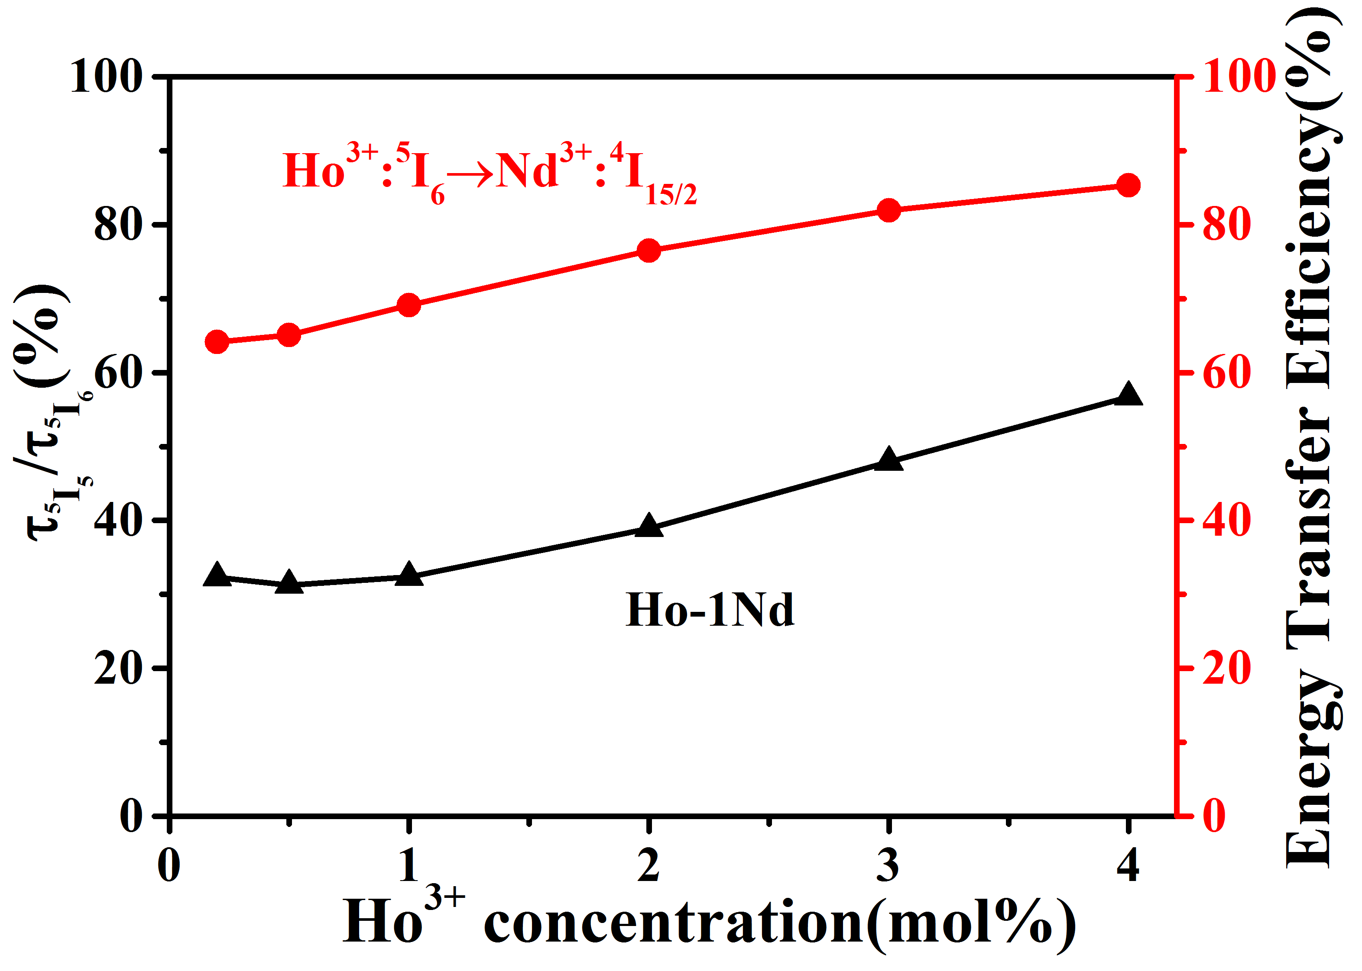
Fig. 9. Ratio of τ⁵I₅ / τ⁵I₆ and Ho³⁺: ⁵I₆→Nd³⁺: ⁴I_{15/2} energy transfer efficiency in the Ho³⁺/Nd³⁺ co-doped fluoroindate glasses at different Ho³⁺ concentrations.
The energy transfer efficiency can be calculated by formula:
$η=1-\frac{τ}{τ_{0}}$ (2)
where τ₀ is the ⁵I₆ energy level lifetime of Ho³⁺ in Ho³⁺ doped fluoroindate glass, and τ is the ⁵I₆ energy level lifetime of Ho³⁺ in Ho³⁺/Nd³⁺ co-doped fluoroindate glass. As the concentration of Ho³⁺ increased, the energy transfer efficiency of Ho³⁺: ⁵I₆→Nd³⁺: ⁴I_{15/2} increased from 64% to 85%, as shown in Fig. 9.
Fig. 9 shows the ratio of the ⁵I₅ to the ⁵I₆ energy level lifetimes of the Ho³⁺/Nd³⁺ co-doped fluoroindate glasses. The ratio of τ⁵I₅ / τ⁵I₆ in Ho³⁺ single doped fluoroindate glass was calculated from results presented in Fig. 7 as 0.079. The ratio Ho³⁺/Nd³⁺ in co-doped fluoroindate glasses increases from 32 % to 57 % as the Ho³⁺ concentration increases from 0.2mol% to 4mol%. Results indicate that both the Nd³⁺ introduction and Ho³⁺ concentration increase could result to a greater depletion of the laser lower level population, which would decrease the pump intensity necessary to get population inversion.

4. Conclusion
In summary, Ho³⁺/Nd³⁺ co-doped fluoroindate glass samples with different Ho³⁺ concentrations were prepared by the melt-quenching method. Nd³⁺ could act as sensitizers, effectively absorbing the energy of the λ~808 nm laser and transmitting it to Ho³⁺, thereby producing fluorescence at λ~3.9 μm, through the energy transfer Nd³⁺: ⁴F_{3/2} → Ho³⁺: ⁵I₅. The λ~3.9 μm luminescence intensity was highest for Ho³⁺ and Nd³⁺ concentrations of 1 mol %, showing that the Ho³⁺/Nd³⁺ co-doped fluoroindate glass could be as a gain material for λ~3.9 μm laser applications.

Funding
National Natural Science Foundation of China (NSFC) (61575050); National Key R&D Program (2016YFE0126500); The Fundamental Research Funds of the Central Universities (HEUCFG201841, 3072019CF2506); Key Program for Natural Science Foundation of Heilongjiang Province of China (ZD2016012); Open Fund of the State Key Laboratory on Integrated Optoelectronics (IOSKL2016KF03); 111 Project (B13015); Recruitment Program for Young Professionals (The Young Thousand Talents Plan).

References
1. Majewski M.R., Woodward R.I. and Jackson S.D., Dysprosium-doped ZBLAN fiber laser tunable from 2.8 μm to 3.4 μm, pumped at 1.7 μm. Optics Letters, 2018.43(5):p.971-974.
2. Aydin Y. O., Fortin V., Maes F., et al. Diode-pumped mid-infrared fiber laser with 50% slope efficiency. Optica, 2017.4(2):p.235-238.
3. Bernier M., Faucher D, Caron N, et al., Highly stable and efficient erbium-doped 2.8 μm all fiber laser. Optics Express, 2009.17(19):p.16941-16946.
4. Chen R., Tian Y, Li B, et al., Thermal and luminescent properties of 2 μm emission in thulium-sensitized holmium-doped silicate-germanate glass. Photonics Research, 2016.4(6):p.214-221.
5. Bawden N, Matsukuma H, Henderson-Sapir O, et al., Actively Q-switched dual-wavelength pumped Er³⁺ :ZBLAN fiber laser at 3.47 µm. Optics Letters, 2018.43(11):p.2724-2727.
6. Qin Z, Hai T, Xie G, et al., Black phosphorus Q-switched and mode-locked mid-infrared Er: ZBLAN fiber laser at 3.5 μm wavelength. Optics Express, 2018.26(7):p.8224-8231.
7. Jackson S. D. Continuous wave 2.9 μm dysprosium-doped fluoride fiber laser. Applied Physics Letters, 2003.83(7):p.1316-1318.
8. Fortin V, Maes F, Bernier M, et al., Watt-level erbium-doped all-fiber laser at 3.44 μm. Optics Letters, 2016.41(3):p.559-562.
9. Lu Y., Feng G. F., Wang M., et al., Tm³⁺-doped silica-glass fiber for similar to 2 μm fiber laser. Applied Optics, 2019.58(7):p.1747-1751.
10. Wang S.B., et al., Ho³⁺-doped AlF₃-TeO₂-based glass fibers for 2.1 μm laser applications. Laser Physics Letters, 2017.14(5):p.4.
11. Jia S., et al., 2875 nm Lasing From Ho³⁺-Doped Fluoroindate Glass Fibers. IEEE Photonics Technology Letters, 2018.30(4):p.323-326.
12. Huang F.F., L.L. Hu and D.P. Chen, Observation of 2.8 μm emission from diode-pumped Dy³⁺-doped fluoroaluminate glasses modified by TeO₂. Ceramics International, 2014.40(8):p.12869-12873.
13. Lai X., et al., High power passively Q-switched Er³⁺-doped ZBLAN fiber laser at 2.8 μm based on a semiconductor saturable absorber mirror. Laser Physics Letters, 2018.15(8):p.5.
14. Falconi M.C., et al., Design of an Efficient Pulsed Dy³⁺: ZBLAN Fiber Laser Operating in Gain Switching Regime. Journal of Lightwave Technology, 2018.36(23):p.5327-5333.
15. Yang L.Y., et al., Towards a Supercontinuum Generation in an All-Fiberized Holmium-Doped ZBLAN Fiber Amplifier. Journal of Lightwave Technology, 2018.36(16):p.3193-3197.
16. Majewski M.R. and S.D. Jackson. Recent progress in 3 micron class dysprosium-doped fluoride fiber lasers. in Conference on Fiber Lasers XIV - Technology and Systems. 2017. San Francisco, CA.
17. Aydin Y.O., et al., Towards power scaling of 2.8 μm fiber lasers. Optics Letters, 2018.43(18):p.4542-4545.
18. Allain J.Y., M. Monarie, and H. Poignant, Erbium-doped fluorozirconate single-mode fibre lasing at 2.71 μm. Electronics Letters, 1989.25(1):p.28-29.
19. Fortin V., et al., 30 W fluoride glass all-fiber laser at 2.94 μm. Optics Letters, 2015.40(12):p.2882-2885.
20. Shigeki T., et al., 12W Q-switched Er:ZBLAN fiber laser at 2.8 μm. Optics letters, 2011.36(15):p.2812-2814.
21. Xiushan Z. and J. Ravi, 10-W-level diode-pumped compact 2.78 μm ZBLAN fiber laser. Optics letters, 2007.32(1):p.26-28.
22. Crawford S., D. D. Hudson, and S. D. Jackson. 3.4 W Ho³⁺, Pr³⁺ Co-Doped Fluoride Fibre Laser. 2014 Conference on Lasers and Electro-Optics (CLEO)-Laser Science to Photonic Applications. IEEE.
23. Zhu G., et al., Fe²⁺:ZnSe and graphene Q-switched singly Ho³⁺-doped ZBLAN fiber lasers at 3 μm. Optical Materials Express, 2013.3(9):p.1365-1377.
24. Jianfeng L., H. Tomonori, and S. D. Jackson, Dual wavelength Q-switched cascade laser. Optics Letters, 2012.37(12):p.2208-10.
25. Li J., T. Hu, and S. D. Jackson, Q-switched induced gain switching of a two-transition cascade laser. Optics Express, 2012.20(12):p.13123-8.
26. Jianfeng L., D. D. Hudson, and S. D. Jackson, High-power diode-pumped fiber laser operating at 3 μm. Optics Letters, 2011.36(18):p.3642-4.
27. Maes F., et al., 5.6 W monolithic fiber laser at 3.55 μm. Optics Letters, 2017.42(11):p.2054-2057.
28. Luo H. Y., et al., Watt-level gain-switched fiber laser at 3.46 μm. Optics Express, 2019.27(2):p.1367-1375.
29. Schneider J., C. Carbonnier and U.B. Unrau, Characterization of a Ho³⁺-doped fluoride fiber laser with a 3.9-μm emission wavelength. Applied Optics, 1997.36(33):p.8595.
30. Maes F., et al., Room-temperature fiber laser at 3.92 μm. Optica, 2018.5(7):p.761-764.
31. Zhang P., et al., Intense 2.8 μm emission of Ho³⁺ doped PbF₂ single crystal. Optics Letters, 2014.39(13):p.3942-5.
32. Huang F. F., et al., Ho³⁺/Er³⁺ co-doped fluoride glass sensitized by Tm³⁺ pumped by a 1550 nm laser diode for efficient 2.0 μm laser applications. Optics Letters, 2015.40(18):p.4297-4300.
33. Gomes L., et al., The basic spectroscopic parameters of Ho³⁺ -doped fluoroindate glass for emission at 3.9 μm. Optical Materials, 2016.60:p.618-626.

