Figures
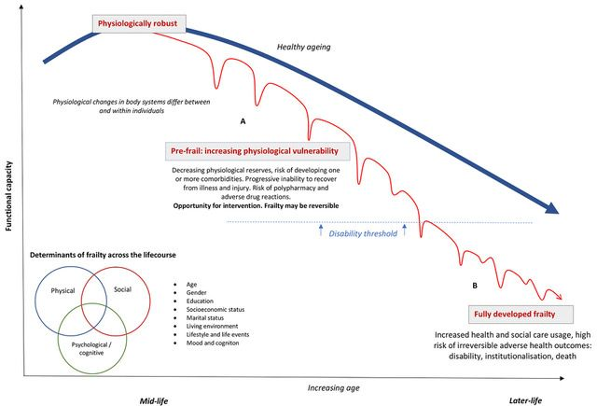
Figure 1. Determinants and development of frailty
The ideal healthy ageing paradigm, free of illness and physiological vulnerability, is represented by the thick line (blue). Frailty, represented by the thin line (red), develops as a continuum from a state of being physiologically robust and independent to being at risk of disability and dependency and, ultimately, to being hospitalised institutionalised or at risk of dying.
In younger robust individuals (A) rapid recovery after an injury or illness that leads to reduced functional capacity is more likely. Later in the lifecourse, cumulative physiological decline across multiple body systems leads to episodic functional, psychological or cognitive decompensation. At this stage, recovery after these stressor events takes longer as physiological and cognitive reserves are depleted. Eventually, a transition point in later life is crossed when the individual cannot compensate adequately and the ability to perform daily activity diminishes. This increases the likelihood of disability, healthcare service use or hospitalisation as a consequence of a relatively minor stresses or insults. Ultimately, the accumulation of these homeostatic insults results in further disability, healthcare dependency, recurrent hospitalisation, institutionalisation and risk of dying (B). Adapted from Patel et al. ⁸⁶.

