# Supplementary Information: Solute Movement through Ridged and Flat Plant Systems

# Supplementary Text

## Soil Bulk Density and Plant Mass

Soil Bulk Density

Soil bulk density was recorded for all of the columns by measuring the mass of all the column components, including sand, sanding paper and mesh, prior to the addition of the soil and then subtracting this value from the mass recorded once the soil had been added. The volume was calculated using the known internal diameter of the uPVC tubing and depth of soil. The mean soil bulk density was calculated as was the standard deviation presented in text as: mean ± standard deviation.

The mean soil bulk density recorded for the columns at setup was 1.01 g / cm3 ± 0.013. This soil bulk density is within the normal range for a sand-textured Eutric Cambisol field soil containing organic matter (Soane, 1990; Li *et al.*, 2002). A full table of soil bulk density values is presented in **Supplementary** **Table S1**.

Plant Mass

After the imaging experiments had concluded, the plants were immediately harvested and weighed for a fresh mass value. The harvested plants were then dried in an oven at 60 °C for three days and the dry mass was recorded. The mean mass was calculated for plants from flat systems, plants from ridge and furrow systems and the overall mean of all plants. Standard deviation is reported alongside the mean in the format: mean ± standard deviation. A one tailed student’s t-test assuming unequal variance was used to assess significant difference between the mass of plants from flat or ridge and furrow systems where significant difference was considered P < 0.05.

The harvested fresh and dry plant mass was recorded for all of the planted columns. The overall mean mass of fresh plant material, dry plant material and water content was 16.69 ± 3.60 g, 2.72 ± 0.79 g and 13.90 ± 2.88 g, respectively. The student’s t-test to assess significant difference between plants from flat systems and from ridge and furrow systems did not indicate there was significant difference for fresh plant mass (P = 0.84), dry plant mass (P = 0.57) or mass of water content (P = 0.81). A full table of plant mass values is presented in **Supplementary** **Table S2**.

## Contrast Assessment

A contrast assessment was undertaken to ascertain the quantity and concentration of contrast media that would need to be applied to columns for sufficient contrast. This assessment also provided the XCT parameters used for the column imaging. All XCT and radiography imaging was accomplished using the Custom 450kVp Hutch at the µ-VIS X-ray Imaging Centre, University of Southampton, UK. The contrast assessment column was set up in the same system as the main experimental treatments. The contrast media used for these experiments was Niopam 370 (Bracco, UK), an iopamidol based contrast medium containing 370 mg iodine / mL. A dilution series of the contrast media with distilled water was produced at milligrams of iodine per millilitre of solution concentrations of: 370 (100% of as supplied concentration), 333 (90%), 277.5 (75%), 185 (50%), 92.5 (25%) and 37 (10%). These concentrations were decanted into 2mL Eppendorf tubes (Eppendorf, Germany). For each contrast assessment image three tubes containing the contrast media and one tube of distilled water were embedded into the soil of the contrast assessment column in a ring. The tube containing water acted as a reference value. The depth of the tubes was such that the tube caps were level with the soil surface. The first contrast assessment featured the 370, 33 and 277.5 mg iodine / mL concentrations and the second contrast assessment featured the 185, 92.5 and 37 mg iodine / mL concentrations.

## Fluid Mass Density

The fluid mass density of the contrast media was also recorded at the concentration determined to be most appropriate during the contrast assessment. This was achieved by recording the mass of 1 mL of the contrast media solution. This was recorded to assess whether this was substantially different to water and thus likely to influence preferential flow. The fluid mass density of the contrast media (1.0732 g / mL) was similar to that of water (1.0021 g / mL). It is important to note that large differences in mass density between solutions in porous media can induce preferential flow and displacement fronts. Therefore if agrochemical solutions applied to soil possess a significantly different mass density to soil water then it is possible that flow behaviour may differ from that observed of the contrast media solution in this investigation.

## Pore Size Distribution Image Analysis

To ensure that there was no formation of preferential contrast media flow paths due to the presence of edge effect induced macropores, the pore size distribution (PSD) was calculated for each sample. The method used to determine PSD utilised the Fiji distribution of the image processing software ImageJ (Schindelin *et al.*, 2012; Rueden *et al.*, 2017) and was similar to the protocol developed by Koebernick *et al.* (2017). Firstly, the control image for each sample was cropped to the region inside the column using the same method described in the section “Segmentation of Contrast Media” above. The stack was then sub sampled to only include regions containing soil unaffected by artefacts –discarding the top and basal slices which contain cone beam artefacts. Analysis was also undertaken at the maximum infiltration depth fronts (using the image slice from each image stack found at the deepest point of solute infiltration according to the infiltration depth analysis. A mean threshold (Glasbey, 1993) was applied to the sub sampled stack which segmented the pore space within the image. The ‘Local Thickness’ tool from the ImageJ plugin ‘BoneJ’ (Doube *et al.*, 2010) was used. This tool evaluates the diameter of the largest sphere that fits inside the object and contains the point at each pixel location. A pore size map is then generated from these assigned pixel values. As Koebernick *et al.* (2017) notes, the definition of PSD applied here closely relates to the hydraulic behaviour of pores (Vogel *et al.*, 2010), which is an important factor in determining fluid flow paths through soil.

A correlation analysis of contrast media position and PSD was undertaken to ensure that there were no anomalous macro pores created by an edge effect which could have influenced contrast media flow. The image used to represent contrast media position was the final image taken four hours after the addition of the contrast media. This correlation analysis was completed using the ImageJ plugin ‘Image CorrelationJ 1o’ (Chinga & Syverud, 2007). Using this plugin, grey values in the final position image were compared to those of the pore size map for that sample. Following the comparison between the pore size map and the final position image, a correlation plot was produced for each image slice which included R2 correlation values.

Pore Size Distribution Results

It was important to assess the influence of pore size distribution on contrast media flow patterns before relationships could be identified between the pattern and depth of contrast media infiltration for each treatment. It was necessary to ensure there was no significant presence of macropores resulting from column assembly which may have induced deeper localised infiltration. The image correlation analysis of grey values in pore size maps and the final position of the contrast media indicated that there was no clear evidence for a linear relationship between pore size and the presence of contrast media. The correlation plots displayed a large cluster of points with with no discernible trend (**Supplementary Figure S5**). The r2 values remained below 0.5 for up to 130 image slices beneath the soil surface, the region which contained the majority of the contrast media in each treatment. In the individual slices found at the deepest point of solute infiltration, the r2 value remained below 0.4 for every image stack. Additionally, it should be noted that such correlation plots containing a spread of large clusters of points will often mislead quantitative statistical tests – for example, Anscombe’s quartet (Anscombe, 1973). Therefore it appears that trends or patterns in contrast media infiltration are more likely the result of the treatments rather than soil porosity inducing preferential flow.

## Image Processing for Root Surface Area Density

Image processing was undertaken on replicate one of the planted flat system with ponding to segment the roots and to quantify the density of the surface area of the roots with distance from the column centre. This image processing was undertaken using the FIJI distribution of the software ImageJ (Schindelin *et al.*, 2012; Rueden *et al.*, 2017). This data was then used to parameterise the density of root surface area in an additional model simulation rather than the homogenous root distribution used in all other simulations of this investigation. The purpose of this image processing and parameterised simulation was to demonstrate that discrepancies between infiltration patterns observed in the imaging experiments and patterns observed in the other modelling simulations could partly be a result of the implementation of homogenous root distribution.

Root Segmentation

To segment the roots the ‘control’ image stack (without contrast media) was first changed from 32bit to 8bit in order to reduce computational time. The image stacks were then cropped such that only the inside of the columns remained. This was achieved by using the ‘make oval’ tool to place an oval around the inside of the wall of the uPVC column followed by the ‘crop’ and ‘clear outside’ tools. Slices outside of the range 498 to 731 were removed as slices outside this range did not contain roots as they were either above the soil or beneath the nylon mesh. A grey value threshold between 1 and 71 was applied which captured the roots in soil. The ‘remove outliers’ tool was applied with a radius of 3 pixels to remove some soil particles which had also been segmented by the threshold. Following this, some over-segmented soil particles remained and these had to be manually removed from the images using the ‘paint brush’ tool. Given the elements of manual segmentation involved, it was not possible to apply this labour intensive image processing to all twelve columns containing plants. For the other imaged columns the nylon mesh would constrain the root growth to only the top region of the soil and this would control the maximum region of root growth without requiring this labour intensive process of segmenting the root systems.

Quantification of Density of Root Surface Area

A new image stack was created with every pixel value set to zero and the same dimensions as the cropped segmentation image of the roots using the ‘new image’ tool. A single pixel in the centre of each image slice of this new stack was set to a value of 255. A Euclidean distance transform was then applied from the central pixels set to 255 outwards using the tool ‘3D Distance Map’ from the ‘3D ImageJ Suite’ of plugins (Ollion *et al.*, 2013). The resulting distance transform stack was duplicated three times. A grey value threshold of 0 to 58 was applied to the first duplicate stack which created a central circle in each slice of the stack with a radius of 16.66 mm. A threshold of 59-118 was applied to the second duplicate stack which created a ring with an internal radius of 16.66 mm and an external radius of 33.33 mm. A threshold of 119-178 was applied to the third duplicate stack which created an outer ring with an internal diameter of 33.33 mm and an external diameter of 50 mm. Essentially in each of these duplicate stacks were concentric rings of equal thickness to one another (16.66 mm).

The segmentation image stack of the roots was then multiplied by each of these distance transform concentric ring image stacks. This produced three image stacks containing: only the roots present between the centre of the column and 16.66 mm out, only the roots present within a ring between 16.66 and 33.33 mm out from the centre and only the roots present within a ring between 33.33 mm from the centre to the very outer edge of the column, respectively. The plugin ‘3D Objects Counter’ (Bolte & Cordelieres, 2006) was then applied to each of these three concentric ring image stacks of segmented roots to record the surface area of the roots present. The total surface area of roots present within each ring was then divided by the total volume of the ring to provide data for the density of root surface area with distance from the centre of the column. The root surface area density values were as follows: 0.063 mm2 / mm3 in the central volume (with a radius of 16.66 mm), 0.015 mm2 / mm3 in the middle ring between the central volume and outer ring (with an internal radius of 16.66 mm and an external radius of 33.33 mm) and finally 0.004 mm2 / mm3 in the outer ring.

## Resistance Sensors for Spatial Soil Moisture

Resistive soil moisture sensing (RSMS) is a technique used to assess soil moisture (Zazueta *et al.*, 1994) and was applied here to assess spatial variation in soil moisture. Duplicate columns were made for the RSMS experiments as RSMS probes are physical structures that could create macro pores in the soil. RSMS-related macro pores could act as preferential pathways which would enable faster movement of contrast media compared with the rest of the soil and bias the measured distances in the images. The columns used for the RSMS experiments featured the same combination of treatments as the imaged columns (**Table 1**). The custom built RSMS system consisted of a Raspberry Pi Zero W (Raspberry Pi Foundation, UK) connected to a soil moisture probe (The Pi Hut, UK) via an analogue to digital converter (ADS1015, Adafruit, USA) that recorded analogue voltage impedance between forks of the probe as a proxy for soil moisture. In each column were three soil moisture probes which each had a total width of 2 cm and functional probe fork length of 3 cm. The first probe was placed into the centre of column, the second halfway to the outside of the column and the third 1 cm in from the column edge. Each probe was placed vertically down through the soil surface so that the soil just covered the top of the probe fork.

The Raspberry Pi-based system was constructed from the design given by The Pi Hut (The Pi Hut, 2019) and the Python code (Python version 2.7) used for recording the voltage impedance values was based upon the Python code ‘Adafruit_ADS1x15’ (Adafruit, USA) which is open source and available on GitHub (Fried *et al.*, 2013). The same and similar methodologies have been used numerous times for soil moisture sensing applications (Chate & Rana, 2016; Jadhav & Hambarde, 2016; Ishak *et al.*, 2017). The published Python code was however modified for this experiment in order to take five voltage recordings on the hour – each recording separated by five seconds. The times when these voltage recordings were taken were recorded and the mean and standard deviation of the five recordings were calculated. These hourly voltage recordings were taken for a full five days, four weeks after the transplanting of the seedlings into the columns for planted treatments (equivalent to the first XCT imaging time point in the imaged columns).

The device was calibrated to ensure the accuracy of the recordings and to correspond the measured voltage values to soil moisture values. The soil used in the RSMS columns was the same soil type as used in the imaged columns. This soil for the RSMS columns was oven dried at 110 °C for five days. The soil calibration samples were wetted using distilled water to volumetric water contents ranging from 0 to 50% at 5% increments. The voltage data recorded by the probes was linearly correlated with the known soil water percentage. The slope of this correlation was -1.0817, the intercept was 1.2079 and the r2 value for the correlation fit was 0.966. The standard deviation is reported alongside the mean in the format: mean ± standard deviation. A one tailed t-test assuming unequal variance was used to assess significant difference where significant difference was considered P < 0.05.

## Inverted Ridge and Furrow

There was an inverted ridge and furrow surface geometry featuring no plant and no ponding for which the purpose was to assess the significance of an edge effect in the ridge and furrow geometry. For this surface geometry the experimental soil columns were setup in much same manner as the other soil columns **(Supplementary Figure S4)**. Where this surface geometry differed from the flat and ridge and furrow surface geometries was the structure of the top 6 cm of soil above the nylon mesh. For the inverted ridge and furrow system soil was added to a depth of 6 cm above the nylon mesh. The soil in the centre of the column was then removed to a depth of 6 cm. This soil surface setup is displayed in **(Supplementary Figure S4)**. There were three replicates for the inverted ridge and furrow surface geometry which underwent the same XCT imaging and image analysis as the flat and ridge and furrow soil columns.

The results of the inverted ridge and furrow imaging experiments indicated that the dominant influence over infiltration pattern was the treatment applied to the ridge and furrow columns and not an edge effect. In these inverted ridge and furrow experiments there was no evidence that the contrast media had infiltrated to a greater depth at the edges compared with the centre (**Supplementary Figure S4)**. The contrast media should have been greater at the edge instead had there been a significant edge effect. This indicated that experimental observations regarding infiltration depth at the edge of the ridge and furrow columns are the most likely the result of the experimental treatment rather than an edge effect.

## Implementation of Model

We used the water-solute-pond model developed in Duncan *et al*. (2018), which is used to study water and solute movement in a cross section of a ridge and furrow (or flat) soil surface geometry. The model consists of a coupled system of Partial Differential Equations (PDEs) and Ordinary Differential Equations (ODEs) that describe water and solute movement, and surface ponding in a ridge and furrow system.

Within the model the movement of water in soil is described by the effects of capillary forces, pressure gradients and gravity, all of which is coupled via a feedback loop to the pond depth on the soil surface. The pond depth is described by a combination of surface runoff, rainfall and infiltration into the soil. Furthermore, the transport of solutes, *i.e.*, contrast media in soil under the influence of water movement is also included. The mechanisms driving solute movement are described by the processes of diffusion and advection, which are influenced by the movement of water and the resulting pressure gradients that form in the soil. This allows for a coupled system of equations to describe the simultaneous movement of water and solutes in soil. It should be noted that we assume solutes do not create osmotic pressure gradients influencing fluid flow, *i.e.,* water movement influences solute movement, but not *vice versa*.

The model described is developed for generalised curved soil surface, *i.e.*, to account for the ridge and furrow geometry. However, this can be easily adapted for a flat surface. For a full derivation and validation, see Duncan *et al*. (2018).

Water Movement in Variably Saturated Soil

The movement of water in soil is described by the effects of capillary forces, pressure gradients and gravity. Variably saturated soil is described by Richards’ equation (Bear, 2012). Richards’ equation in mixed form is given by (Richards, 1931; Kavetski *et al.*, 2001),

|  |  |  |
| --- | --- | --- |
|  | $ϕ\frac{∂S}{∂t}+∇∙\left[-\frac{κ\left(S\right)}{μ}\left(∇p+ρg\hat{k}\right)\right]=-F_{w}, x∈Λ$, | (1) |

where $ϕ$ is the soil porosity, $S$ is the relative saturation (*i.e., $S=ϕ_{l}/ϕ$*,where $ϕ_{l}$ is the volumetric water content), $κ\left(S\right)$ is the unsaturated permeability, $μ$ is the viscosity of the fluid, *i.e.*, water, $p$ is the soil water pore pressure, $ρ$ is the density of the fluid, $g$ is the acceleration due to gravity, $\hat{k}$ is a unit vector in the upwards direction, $Λ$ is a generalised ridge and furrow geometry (**Supplementary Figure S3a**), and $F_{w}$ is a sink term that describes water uptake via plant roots.

Richards’ equation (1) can be written in terms of soil water pore pressure $p$ using two van Genuchten formulae (van Genuchten, 1980); one for the suction characteristic,

|  |  |  |
| --- | --- | --- |
|  | $S\left(p\right)={\left[{\left(\frac{p_{a}-p}{p_{c}}\right)}^{\frac{1}{1-m}}+1\right]}^{-m}$, | (2) |

and one hydraulic permeability,

|  |  |  |
| --- | --- | --- |
|  | ${κ\left(S\right)=κ}_{s}S^{\frac{1}{2}}{\left[1-{\left(1-S^{\frac{1}{m}}\right)}^{m}\right]}^{2}$, | (3) |

where $p_{c}$ is the characteristic suction pressure, $m$ is a van Genuchten parameter, $κ_{s}$ is the saturated soil water permeability and $p_{a}$ is the atmospheric pressure. Substituting (3) – (4) into (1) gives Richards’ equation in the pressure form.

The domain used to describe a general ridge and furrow system $Λ$ (**Supplementary Figure Sa**) is split into two regions $Λ_{U}$ and $Λ_{A}$. $Λ_{U}$ is the region of soil in which roots take up water and $Λ_{A}$ is the region in which there are no roots. $F_{w}$ is assumed to be active only where roots are present. Hence, we write,

|  |  |  |
| --- | --- | --- |
|  | $F_{w}=\left\{\begin{matrix}λ_{c}\left(p-p_{r}\right), \\ 0,\end{matrix} \begin{matrix}x∈Λ_{U} \\ x∈Λ_{A}\end{matrix}\right.$, | (4) |

whered $p_{r}$ is the pressure in the root xylem and $λ_{c}$ is the product of the root surface area density and water conductivity of the plant root cortex described as:

|  |  |  |
| --- | --- | --- |
|  | $λ_{c}=k_{r}l_{d}(t)$, | (5) |

where (10-9 [m2s-1MPa-1]) is radial conductivity of the root cortex per unit of root length, and $l_{d}\left(t\right)$ is the root length density, which we describe as:

|  |  |  |
| --- | --- | --- |
|  | $l_{d}\left(t\right),={10}^{3}t, 0≤t<30 days$. | (6) |

Thus, 310-4 [MPa-1s-1] after 30 days. Root xylem pressure was not explicitly measured in the experiments of this investigation. Instead to parameterise the water uptake rate values for rice root xylem pressure from the literature were used. The root xylem pressure was assumed to be 0.1 MPa. This is a conservative value given that root xylem pressure can be up to 2 MPa, though both are well within the range of realistic values. The water uptake rate in the model changes with root surface area density over time and in accordance with fluctuations in soil moisture. The root xylem hydraulic conductivity value used in this model, m3m-2s-1MPa-1 , is within bounds given by Henry *et al.,* (2012).

An additional simulation for the flat surface geometry was undertaken to investigate discrepancies between the imaging results and the results of the simulations which feature homogenous root distribution. Implementation of the root region $Λ_{U}$ in this additional simulation of the flat system explicitly considered the spatially resolved root surface distribution obtained from the XRCT images. The measured root surface area density was defined as,

|  |  |  |
| --- | --- | --- |
|  | $$\tilde{γ}\left(r_{i}\right)=\frac{A_{s}\left(r_{i}\right)}{π\left(r_{i}^{2}-r_{i-1}^{2}\right)Δz},$$ | (7) |

where $r_{i}$ and $r_{i-1}$ are the inner and outer annulus radii respectively, $Δz$ is the experimental depth of the control volume where the root area is measured, and $A_{s}(r_{i})$ is the root surface area in in the control volume (between $r_{i-1}$ and $r_{i}$). To induce the spatial component of the root surface distribution without changing the magnitude of $λ_{c}$, the spatially dependent root surface area density $\tilde{γ}$ is normalized with respect to its spatial mean. The total root surface area in the pot is defined as,

|  |  |  |
| --- | --- | --- |
|  | $$A_{s,tot}=\sum_{i=1}^{n}{A_{s}\left(r_{i}\right),}$$ | (8) |

where $n$ is the final annulus control volume index. Substituting 5 into 6 yields,

|  |  |  |
| --- | --- | --- |
|  | $$A_{s,tot}=\sum_{i=1}^{n}{π\tilde{γ}\left(r_{i}\right)Δz\left(r_{i}^{ }+r_{i-1}^{ }\right)\left(r_{i}^{ }-r_{i-1}^{ }\right).}$$ | (9) |

Since $A_{s,tot}$ is constant for an domain arbitrary partitioning, (7) could be re-written as,

|  |  |  |
| --- | --- | --- |
|  |  | (10) |

which is equivalent to,

|  |  |  |
| --- | --- | --- |
|  | $$A_{s,tot}=2πΔz\int_{r_{0=0}}^{r_{n}}{\tilde{γ}\left(r\right)rdr.}$$ | (11) |

The mean root surface area density across the full domain is described as,

|  |  |  |
| --- | --- | --- |
|  | $$〈\tilde{γ}〉=\frac{A_{s,tot}}{πΔzr_{n}^{2}},$$ | (12) |

which is equivalent to,

|  |  |  |
| --- | --- | --- |
|  | $$〈\tilde{γ}〉=\frac{2πΔz\int_{0}^{r_{n}}{\tilde{γ}\left(r\right)rdr}}{2πΔz\int_{0}^{r_{n}}{rdr}}.$$ | (13) |

Thus, the normalized root surface density is expressed as:

|  |  |  |
| --- | --- | --- |
|  | $$γ\left(r_{i}\right)=\frac{\tilde{γ}\left(r_{i}\right)}{〈\tilde{γ}〉}.$$ | (14) |

As the expression above is only defined for discrete data points, the data was fit to an analytic distribution that is continuous with respect to $r$.

|  |  |  |
| --- | --- | --- |
|  | $$γ\left(r\right)≈αe^{-βr},$$ | (15) |

where $α$ and $β$ are fitting coefficients and cofactors respectively. As such, the root water uptake term is changed to the following,

|  |  |  |
| --- | --- | --- |
|  | $F_{w}=\left\{\begin{matrix}λ_{c}\left(p-p_{r}\right)γ\left(r\right), \\ 0,\end{matrix} \begin{matrix}x∈Λ_{U} \\ x∈Λ_{A}\end{matrix}\right.$, | (16) |

where the total magnitude of the water uptake term is preserved while considering the explicit spatial dependence of the system.

Soil Surface Boundary Condition

To form a complete description of the ridge and furrow system, we derive boundary conditions that are imposed on the edges of the soil domain Λ, and a model for dynamic water ponding on the soil surface coupled to Richards’ equation for water movement in soil (see Duncan *et al*. (2018) ).

To represent surface ponding, the surface $∂Λ_{S}$ (see **Supplementary Figure S**a) is split into two distinct regions. This is shown in **Supplementary Figure Sb**, where $∂Λ_{R}$ is the surface of soil that is not ponded, *i.e.*, where rainfall infiltrates the soil directly, and $∂Λ_{P}$ is the ponded region. The interface between the two regions is defined by the moving boundary point $x_{0}\left(t\right)$ (**Supplementary Figure Sb**).

On the soil surface directly under the pond $∂Λ_{P}$ we apply the hydrostatic pressure that is a result of the height of the water column in the pond above it, *i.e.,*

|  |  |  |
| --- | --- | --- |
|  | $$p=ρgh\left(x,t\right), x∈∂Λ_{P},$$ | (17) |

where $h\left(x,t\right)$ [m] is the depth of the pond.

Precipitation landing on the bare soil $∂Λ_{R}$ enters the soil domain via a combination of capillary forces and gravitational effects. Hence, we implement a normal fluid flux condition on $∂Λ_{R}$ (Yang *et al.*, 1996), *i.e.*,

|  |  |  |
| --- | --- | --- |
|  | $n∙\left\{\frac{κ\left[S\left(p\right)\right]}{μ}\left(∇p+ρg\hat{k}\right)\right\}=ω\left(t\right), x∈∂Λ_{R}$, | (18) |

where [m s-1] is the volume flux of water entering the soil per unit soil surface area, [m s-1] is the volume flux of water per unit soil surface area, *i.e.,* application of ponding water, [m s-1] is the infiltration capacity of the soil. The value for this infiltration capacity of the soil was 1.6 × 10−6 m s-1 (Morin & Benyamini, 1977).

We denote $χ\left(x\right)$ to be the generalised curve of the surface $∂Λ_{S}$, which takes the form of the function,

|  |  |  |
| --- | --- | --- |
|  | $$χ\left(x\right)=A\cos\left(Bx\right)+C,$$ | (19) |

where $A$ is the variation in soil depth, $B$ is the ridge wave number, and $C$ is the average soil depth (**Supplementary Figure S3**). It should be noted that for the flat geometry $χ\left(x\right)$ is constant with the average soil depth, *i.e.*, $χ\left(x\right)=C$.

The position of the interface between the ponded and un-ponded regions ${ x}_{0}\left(t\right)$ along the soil surface is then given as a function of rainfall landing directly into the pond $R_{F}\left(t\right)$, infiltration of water from the pond into the soil $I_{f}\left(t\right)$, and surface runoff $R_{o}\left(t\right)$ (see Duncan *et al*. (2018) for details), *i.e.*,

|  |  |  |
| --- | --- | --- |
|  | $\frac{dx_{0}\left(t\right)}{dt}=f\left(R_{F}\left(t\right),I_{f}\left(t\right),R_{0}\left(t\right)\right)$. | (20) |

Lateral Boundary Condition

For the lateral boundaries $∂Λ_{E}$ and $∂Λ_{W}$, we set a zero flux boundary condition to emulate the soil column, *i.e.,*

|  |  |  |
| --- | --- | --- |
|  | $n∙\left\{\frac{κ\left[S\left(p\right)\right]}{μ}\left(∇p+ρg\hat{k}\right)\right\}=0, x∈∂Λ_{E}∪∂Λ_{W}$. | (21) |

Hence, there is no lateral water movement into or out of $Λ$.

Boundary Condition at the Base of the Soil

The base of the domain is submerged in water. For the boundary on the base of the domain $∂Λ_{B}$, we set a Dirichlet boundary condition (Feddes *et al.*, 1988; Banti *et al.*, 2011), *i.e.*,

|  |  |  |
| --- | --- | --- |
|  | $$p=p_{0}, x∈∂Λ_{B}.$$ | (22) |

Initial Conditions

For the initial pressure condition ${\left.p\right|}_{t=0}$, we impose the steady state pressure profile that forms when roots are not present, *i.e.*,

|  |  |  |
| --- | --- | --- |
|  | . | (23) |

Furthermore, we implement no surface ponding present on $∂Λ_{S}$ at $t=0$, *i.e.*,

|  |  |  |
| --- | --- | --- |
|  | , | (24) |

such that the pond depth is $0$, where $η$ is the edge of the geometry $Λ$ (**Supplementary Figure S3**).

Solute Movement in Variably Saturated Soil

In this section, we introduce a model for solute movement in soil. It is coupled with the water movement model, thereby constructing a model for simultaneous water and solute movement in soil.

To model the movement of solutes in soil, we use the advection-diffusion-reaction equation (Guerrero *et al.*, 2009), *i.e.,*

|  |  |  |
| --- | --- | --- |
|  | $\frac{∂}{∂t}\left[\left(ϕ_{l}+b\right)c\right]+∇∙\left(cu\right)=∇∙\left(ϕ_{l}D∇c\right)$, | (25) |

where $D$ is the solute diffusion coefficient in the soil pore water, $ϕ_{l}$ is the volumetric water content, $c$ is the solute concentration in the pore water, $u$ is the volume flux of water and $b$ is the buffer power of the solute, *i.e.*, the ratio of the solute adsorption and desorption rates. It should be noted, consistent with the experimental assay given the time scale of the imaging experiments, we assume that there is no solute uptake by plant roots.

The volumetric water content $ϕ_{l}$ is related to $p$ by the suction characteristic ${ ϕ}_{l}=ϕS\left(p\right)$. In addition, we state that $u$ is described by Darcy’s law, *i.e.*,

|  |  |  |
| --- | --- | --- |
|  | $u=-\frac{κ\left[S\left(p\right)\right]}{μ}\left(∇p+ρg\hat{k}\right)$. | (26) |

Finally, we assume $D$ can be expressed by the power law,

|  |  |  |
| --- | --- | --- |
|  | $D=D_{f}ϕ^{d}{S\left(p\right)}^{d}$, | (27) |

where $D_{f}$ is the diffusion coefficient in free liquid and $d$ is the impedance factor of the solute that accounts for the tortuosity of the solute moving through the pore space (Reddy & Doraiswamy, 1967; Nye & Tinker, 1977).

Combining equations (13) - (15), and using the governing water movement equations (1) - (4), the model for solute movement is given by,

|  |  |  |
| --- | --- | --- |
|  | $$\frac{∂c}{∂t}\left[b+S\left(p\right)ϕ\right]+\frac{∂p}{∂t}\left\{\frac{∂S\left(p\right)}{∂p}ϕc\right\}+∇∙\left[-D_{f}ϕ^{d+1}{S\left(p\right)}^{d+1}∇c\right]+$$ $∇∙\left\{-\frac{cκ\left[S\left(p\right)\right]}{μ}\left(∇p+ρg\hat{k}\right)\right\}=-Γ_{c}, x∈Λ$. | (28) |

The solute model (16) is coupled to the water movement model (1) – (4) to achieve a system of PDEs that describes simultaneous water and solute movement in soil.

Soil Surface Boundary Condition

On the boundary of the soil $∂Λ_{S}$ we impose a solute flux condition such that,

|  |  |  |
| --- | --- | --- |
|  | $n∙\left(\left[D_{f}ϕ^{d+1}{S\left(p\right)}^{d+1}∇c\right]+\left\{\frac{cκ\left[S\left(p\right)\right]}{μ}\left(∇p+ρg\hat{k}\right)\right\}\right)=c_{m}\left(t\right), x∈∂Λ_{S}$, | (29) |

where $c_{m}\left(t\right)$ is the volume flux of solute per unit soil surface area per unit time entering the soil domain.

Lateral Boundary Condition

For the boundaries $∂Λ_{E}$ and $∂Λ_{W}$, we set a zero flux boundary condition, *i.e.,*

|  |  |  |
| --- | --- | --- |
|  | $n∙\left(\left[D_{f}ϕ^{d+1}{S\left(p\right)}^{d+1}∇c\right]+\left\{\frac{cκ\left[S\left(p\right)\right]}{μ}\left(∇p+ρg\hat{k}\right)\right\}\right)=0, x∈∂Λ_{E}∪∂Λ_{W}$. | (30) |

Hence, there is no lateral solute movement into or out of $Λ$.

Boundary Condition at the Base of the Soil

On the boundary $∂Λ_{B}$ we impose a Dirichlet boundary condition that it set to the initial concentration of the solute contained in the two geometries, *i.e.*,

|  |  |  |
| --- | --- | --- |
|  | . | (31) |

Initial Condition

We model solute movement in previously solute free soil. Hence, we impose a uniform zero initial concentration across $Λ$, *i.e.*,

|  |  |  |
| --- | --- | --- |
|  | . | (32) |

Estimation of Transpiration

The water flux through the rooting zone is defined as,

|  |  |
| --- | --- |
| $${u_{r}=k}_{r}\frac{p-p_{r}}{2 π r_{root} }$$ | (33) |

and we assume that all of the water taken up by the root is transpired. We define $r_{root}$ as the approximate average radius of the roots extracted from the columns (0.5 mm). In systems containing a plant and ponding with flat or ridge and furrow surface geometries, we observe that transpiration is approximately 80% greater in the flat geometry than in the ridge and furrow geometry (**Supplementary Figure S8**). This is possibly because of the volume of soil occupied by the ‘root zone’ in the flat geometry is greater and therefore there is a greater volume of liquid for the plant to draw in for transpiration.

# Supplementary Tables

**Supplementary** **Table S1.** Soil bulk density information recorded for all 24 of the columns. RF = ridge and furrow, F = flat, PL = planted, NPL = no plant, NP = no ponding, P = ponding, number = replicate number. For example the second replicate of the planted ridge and furrow system with ponding would be: RF_PL_P_2

|  |  |  |  |  |  |
| --- | --- | --- | --- | --- | --- |
| **Column** | **Empty Column Mass (g)** | **Sand Column Mass (g)** | **Full Column Mass (g)** | **Soil Mass (g)** | **Soil Bulk Density (g / cm3)** |
| RF_PL_NP | 638.2 | 1293.9 | 9117.02 | 7823.12 | 1.024763986 |
| RF_PL_P | 653 | 1285.3 | 9102.72 | 7817.42 | 1.024017333 |
| RF_NPL_NP | 641.3 | 1290.7 | 9113.5 | 7822.8 | 1.024722068 |
| RF_NPL_P | 644.8 | 1316.8 | 9100.96 | 7784.16 | 1.019660548 |
| F_PL_NP | 642.9 | 1319 | 9082.26 | 7763.26 | 1.016922821 |
| F_PL_P | 645 | 1299.8 | 9139.24 | 7839.44 | 1.026901771 |
| F_NPL_NP | 645.5 | 1287.3 | 9227.68 | 7940.38 | 1.040124075 |
| F_NPL_P | 646 | 1305.4 | 9093.48 | 7788.08 | 1.020174036 |
| RF_PL_NP_2 | 648.8 | 1348 | 9002.62 | 7654.62 | 1.00269188 |
| RF_PL_P_2 | 643.5 | 1315.5 | 8917.26 | 7601.76 | 0.995767657 |
| RF_NPL_NP_2 | 638.3 | 1359.6 | 8902.3 | 7542.7 | 0.988031286 |
| RF_NPL_P_2 | 655.1 | 1329.9 | 8966.76 | 7636.86 | 1.000365467 |
| F_PL_NP_2 | 645.5 | 1308 | 9069.28 | 7761.28 | 1.016663457 |
| F_PL_P_2 | 651.8 | 1397.5 | 8898.56 | 7501.06 | 0.982576791 |
| F_NPL_NP_2 | 653.2 | 1346.3 | 8902.74 | 7556.44 | 0.989831112 |
| F_NPL_P_2 | 673.6 | 1363 | 8895.92 | 7532.92 | 0.986750187 |
| RF_PL_NP_3 | 641.3 | 1315.3 | 9035.23 | 7719.93 | 1.01124695 |
| RF_PL_P_3 | 644.8 | 1340.7 | 8973.51 | 7632.81 | 0.99983495 |
| RF_NPL_NP_3 | 646 | 1334.2 | 8986.62 | 7652.42 | 1.002403698 |
| RF_NPL_P_3 | 638.3 | 1307.2 | 9024.25 | 7717.05 | 1.010869693 |
| F_PL_NP_3 | 638.2 | 1320.5 | 8996.64 | 7676.14 | 1.005510822 |
| F_PL_P_3 | 653 | 1317.3 | 9006.78 | 7689.48 | 1.007258251 |
| F_NPL_NP_3 | 642.9 | 1327.5 | 9012.45 | 7684.95 | 1.006664859 |
| F_NPL_P_3 | 645 | 1332.1 | 8998.66 | 7666.56 | 1.004255921 |
| RF_INV_01 | 645.5 | 1331.8 | 9025.62 | 7693.82 | 1.007826756 |
| RF_INV_02 | 651.8 | 1328.7 | 8993.89 | 7665.19 | 1.004076462 |
| RF_INV_03 | 648.8 | 1338.2 | 9006.68 | 7668.48 | 1.004507425 |

**Supplementary** **Table S2.** Plant mass information collected for the plants from planted treatments. RF = ridge and furrow, F = flat, PL = planted, NP = no ponding, P = ponding, number = replicate number. For example the second replicate of the planted ridge and furrow system with ponding would be: RF_PL_P_2.

|  |  |  |  |
| --- | --- | --- | --- |
| **Column** | **Wet Plant Mass (g)** | **Dry Plant Mass (g)** | **Water Content at Harvest (g)** |
| RF_PL_NP | 16.64 | 2.831 | 13.809 |
| RF_PL_P | 13.676 | 2.27 | 11.406 |
| RF_PL_NP_2 | 22.405 | 4.333 | 18.072 |
| RF_PL_P_2 | 15.296 | 2.185 | 13.111 |
| RF_PL_NP_3 | 17.365 | 2.456 | 14.909 |
| RF_PL_P_3 | 15.036 | 2.174 | 12.862 |
| F_PL_NP | 10.1216 | 2.908 | 7.2136 |
| F_PL_P | 19.58 | 1.467 | 18.113 |
| F_PL_NP_2 | 16.295 | 2.567 | 13.728 |
| F_PL_P_2 | 19.585 | 3.189 | 16.396 |
| F_PL_NP_3 | 14.068 | 2.354 | 11.714 |
| F_PL_P_3 | 16.829 | 2.593 | 14.236 |

# Supplementary Figures

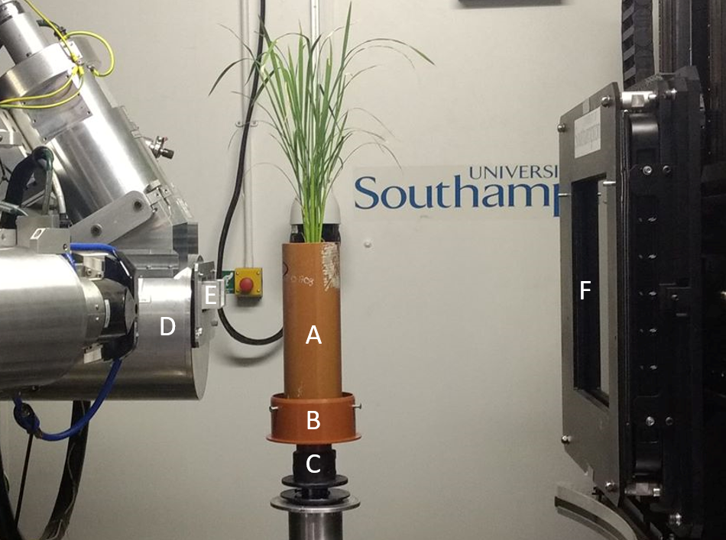

**Supplementary Figure S1.** Planted soil column (A) in a base holder (B) affixed to the XCT scanner stage using a 3 jaw chuck (C). X-ray source (D), including aluminium bow tie filter (E), and flat panel detector (F) are visible.

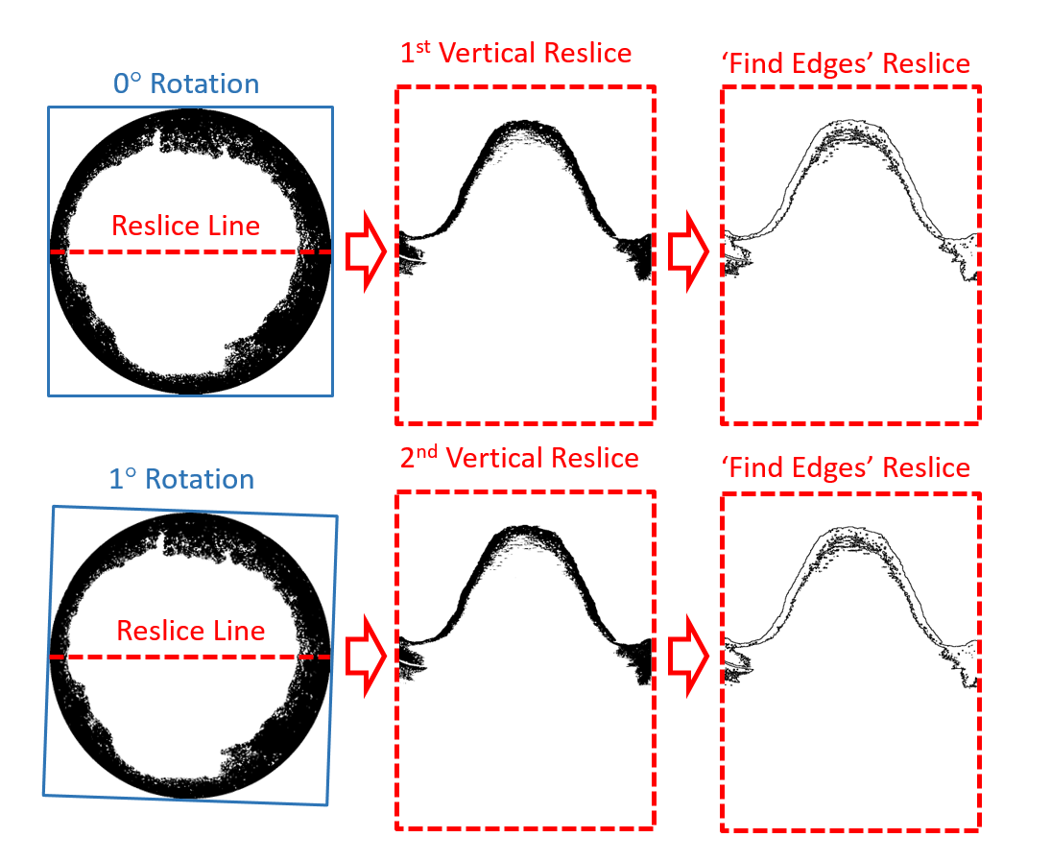

**Supplementary Figure S2.** A diagram demonstrating the vertical reslice and find edges operations performed during the image analysis. The top row are the initial images before rotation. The bottom row is the images after the first rotation of 1°. The resliced images are produced by performing a ‘reslice’ operation along a central horizontal line through the image stacks. This is demonstrated by red dashed lines in the images on the left which represents the line along which the resliced operation is performed.

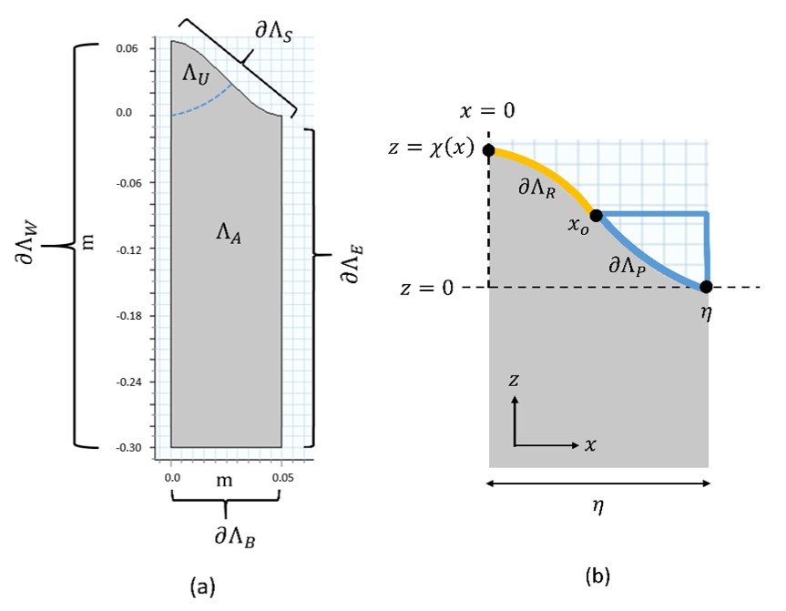

**Supplementary Figure S3.** (a) Half a ridge and furrow period, where $Λ$ is the total soil domain such that $Λ=Λ_{A}∪Λ_{U}$, $Λ_{A}$ is the region of soil absent of roots, $Λ_{U}$ is the region of soil where roots are present, $∂Λ_{S}$ is the soil surface boundary, $∂Λ_{B}$ is the base of the domain, $∂Λ_{W}$ is the left boundary adjacent to the ridge and $∂Λ_{E}$ is the right boundary adjacent to the furrow. The curve $∂Λ_{S}$ is generated from the values $A=C=\frac{1}{6}m$ and $B=2π m^{-1}$ used in the periodic function $χ\left(x\right)$, *i.e.*, equation (7), where $A$ is the variation in soil depth, $B$ is the ridge wave number, and $C$ is the average soil depth. (b) Half a ridge and furrow period, where $∂Λ_{P}$ is the soil surface boundary on which ponding occurs, $∂Λ_{R}$ is the soil surface that is not ponded, $x_{0}$ is the point on the soil surface $∂Λ_{S}$ where the pond begins, $η$ is the width of the half period of ridged domain, and $χ\left(x\right)$ is the curve for the soil surface $∂Λ_{S}$.

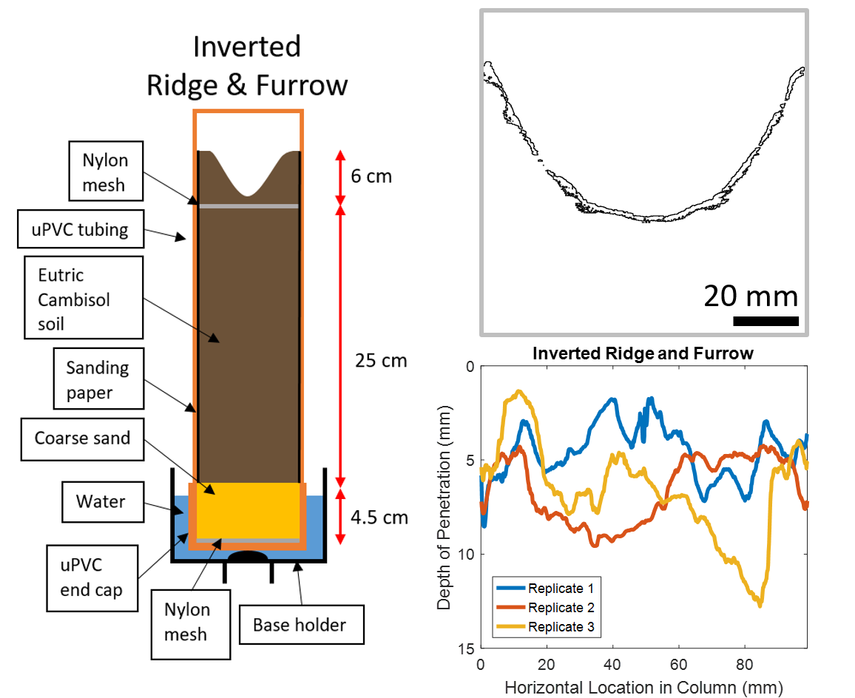

**Supplementary Figure S4.** The distance moved by the contrast media vertically down the non-planted and non-ponded inverted ridge and furrow columns after 4 hours. On the left is a schematic of the inverted ridge and furrow column. The image on the top right is the segmented vertical-reslice image of the final contrast media position (this final position is the region outlined in black). On the bottom right are the resulting plots from the Matlab script which display distance moved vertically downward by the contrast media in the adjacent reslice image.

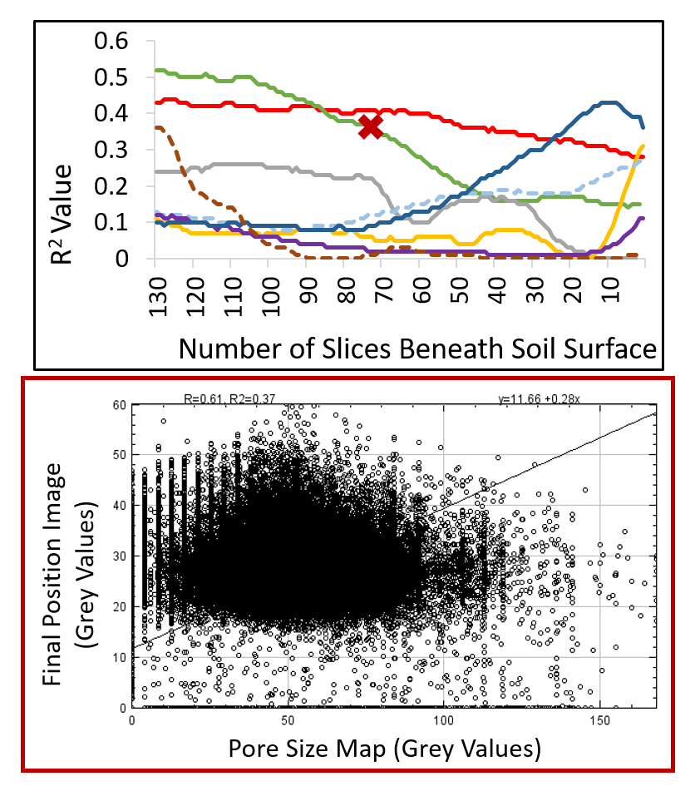

**Supplementary Figure S5. Top:** a plot displaying the R2 values resulting from image correlation analysis of the pore size map and final SICM position for example image stacks of each of the eight treatments. The non-planted flat system with no ponding is the solid dark blue line. The non-planted flat system with ponding is the solid red line. The planted flat system with ponding is the pale blue dashed line. The planted flat system with ponding is the solid green line. The non-planted ridge and furrow system without ponding is the purple line. The non-planted ridge and furrow system with ponding is the grey solid line. The planted ridge and furrow system without ponding is the yellow solid line. The planted ridge and furrow system with ponding is the dashed dark red line. This plot contains the R2 values for up to 130 slices beneath the soil surface – the region which contained the majority of the SICM in each treatment. Given that the R2 values for all three samples remain below 0.52 it can be said that there is no evidence of a linear correlation between pore size and SICM presence. **Bottom:** an example correlation plot for Treatment 4 from location of the red cross (**X**) in the top plot. There is no clear trend present within the data hence the R2 value for this plot is 0.37.

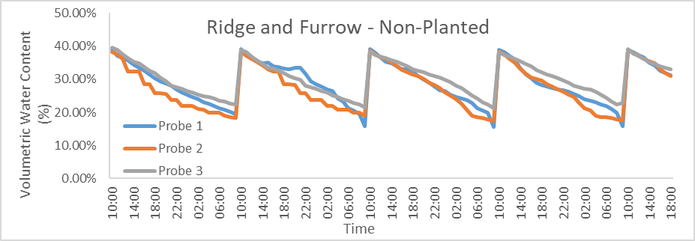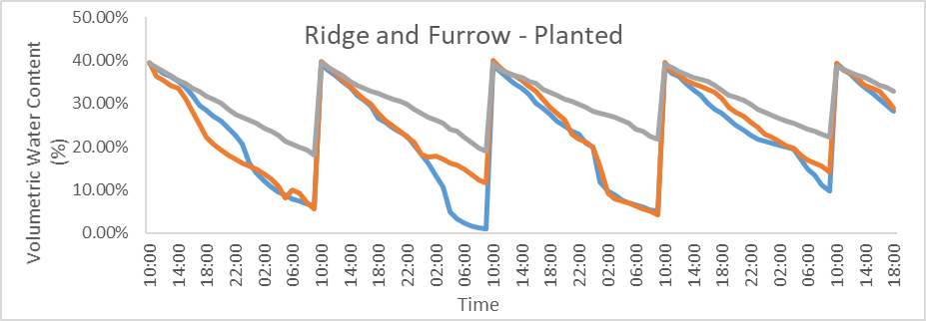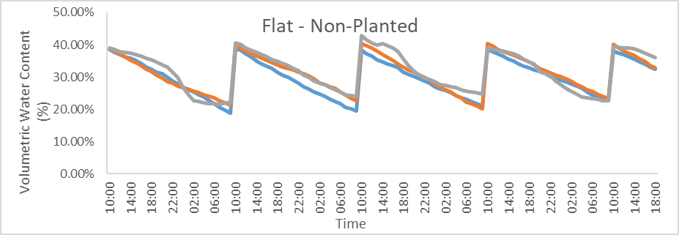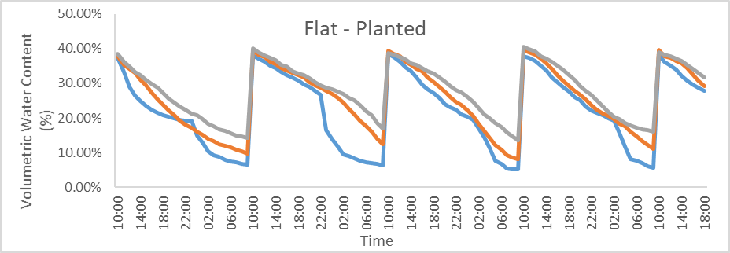

**Supplementary Figure S6.** Volumetric water content recorded as a percentage using a Raspberry Pi based resistive soil moisture sensing system. Probe One was in the centre of the column, Probe Two was halfway to the edge of the column and Probe Three was at the outer edge of the column.

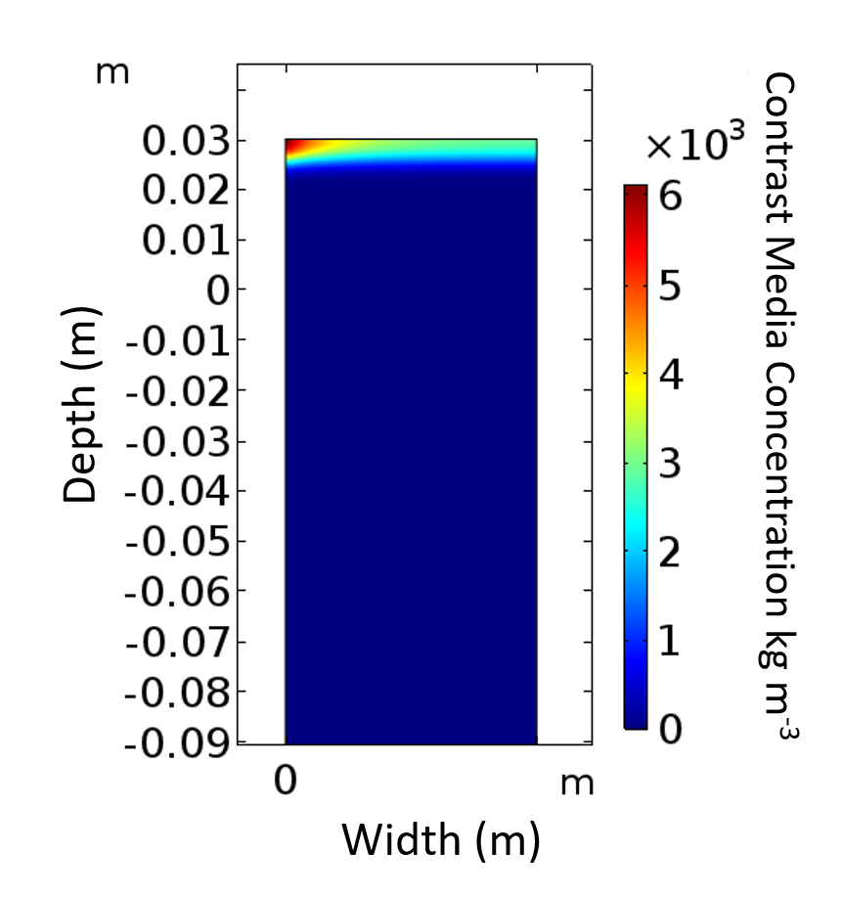

**Supplementary Figure S7.** Model simulation results for the additional simulation of planted flat geometry without ponding after four hours. This additional simulation featured a root surface area distribution extracted from XCT imaging results whereas all other simulations in this investigation featured a homogenous root distribution. The concentration of contrast media is represented by a colour gradient. The infiltration depth and concentration of the solute is observably greater in the root-dense centre of the column (0 m in width).

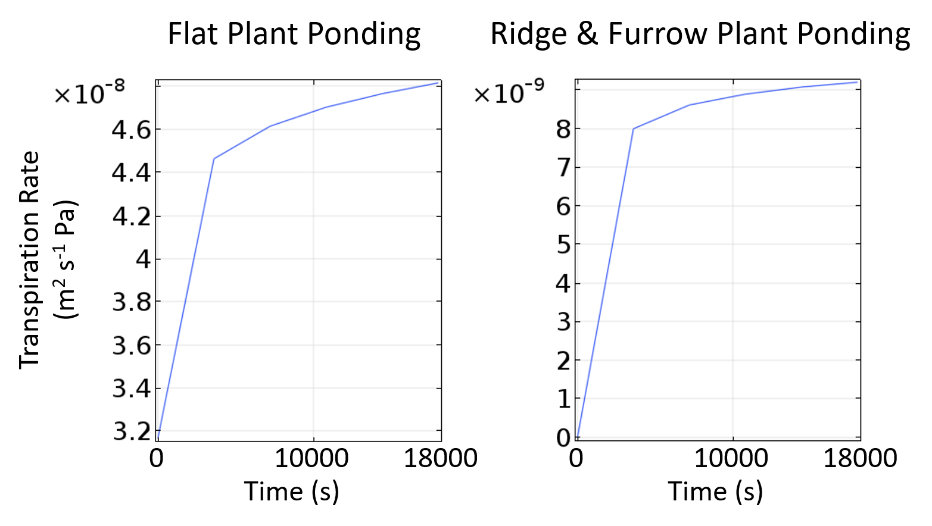

**Supplementary Figure S8.** Model derived estimates for transpiration in systems containing a plant and ponding with flat (left) or ridge and furrow (right) soil surfaces. The estimated transpiration rate in the flat geometry is approximately 80% greater than in the ridge and furrow geometry. This is possibly because of the volume of soil occupied by the ‘root zone’ in the flat geometry is greater and therefore there is a greater volume of liquid for the plant to draw in for transpiration.

# References for Supplementary Information

Anscombe, F.J. (1973). Graphs in Statistical-Analysis. *American Statistician*, **27,** 17-21. DOI: Doi 10.2307/2682899

Banti, M., Zissis, T. & Anastasiadou-Partheniou, E. (2011). Furrow Irrigation Advance Simulation Using a Surface–Subsurface Interaction Model. *Journal of Irrigation and Drainage Engineering*, **137,** 304-314. DOI: doi:10.1061/(ASCE)IR.1943-4774.0000293

Bear, J. (2012). *Hydraulics of groundwater*. Courier Corporation

Bolte, S. & Cordelieres, F.P. (2006). A guided tour into subcellular colocalization analysis in light microscopy. *Journal of Microscopy-Oxford*, **224,** 213-232. DOI: DOI 10.1111/j.1365-2818.2006.01706.x

Chate, B.K. & Rana, J. (2016). Smart irrigation system using Raspberry pi. *International Research Journal of Engineering and Technology (IRJET)*, **3,** 247-249.

Chinga, G. & Syverud, K. (2007). Quantification of paper mass distributions within local picking areas. *Nordic Pulp & Paper Research Journal*, **22,** 441-446.

Doube, M., Klosowski, M.M., Arganda-Carreras, I., Cordelieres, F.P., Dougherty, R.P., Jackson, J.S., Schmid, B., Hutchinson, J.R. & Shefelbine, S.J. (2010). BoneJ Free and extensible bone image analysis in ImageJ. *Bone*, **47,** 1076-1079. DOI: 10.1016/j.bone.2010.08.023

Duncan, S.J., Daly, K.R., Sweeney, P. & Roose, T. (2018). Mathematical modelling of water and solute movement in ridge plant systems with dynamic ponding. *European Journal of Soil Science*, **69,** 265-278. DOI: 10.1111/ejss.12503

Feddes, R.A., Kabat, P., Van Bakel, P., Bronswijk, J. & Halbertsma, J. (1988). Modelling soil water dynamics in the unsaturated zone—state of the art. *Journal of Hydrology*, **100,** 69-111.

Fried, L., Townsend, K. & Sklar, M. (2013). Adafruit library code for Raspberry Pi. Retrieved from: <https://github.com/adafruit/Adafruit-Raspberry-Pi-Python-Code/tree/legacy> [accessed on 01 August, 2018]

Glasbey, C.A. (1993). An Analysis of Histogram-Based Thresholding Algorithms. *Cvgip-Graphical Models and Image Processing*, **55,** 532-537. DOI: DOI 10.1006/cgip.1993.1040

Guerrero, J.P., Pimentel, L.C.G., Skaggs, T. & van Genuchten, M.T. (2009). Analytical solution of the advection–diffusion transport equation using a change-of-variable and integral transform technique. *International Journal of Heat and Mass Transfer*, **52,** 3297-3304.

Henry, A., Cal, A.J., Batoto, T.C., Torres, R.O. & Serraj, R. (2012). Root attributes affecting water uptake of rice (Oryza sativa) under drought. *Journal of Experimental Botany*, **63,** 4751-4763. DOI: 10.1093/jxb/ers150

Ishak, S.N., Abd Malik, N.N.N., Latiff, N.M.A., Ghazali, N.E. & Baharudin, M.A. (2017). Smart Home Garden Irrigation System Using Raspberry Pi. *2017 Ieee 13th Malaysia International Conference on Communications (Micc)***,** 101-106.

Jadhav, S. & Hambarde, S. (2016). Android based Automated Irrigation System using Raspberry Pi. *International Journal of Science and Research*, **5,** 2345-2351.

Kavetski, D., Binning, P. & Sloan, S. (2001). Adaptive time stepping and error control in a mass conservative numerical solution of the mixed form of Richards equation. *Advances in Water Resources*, **24,** 595-605.

Koebernick, N., Daly, K.R., Keyes, S.D., George, T.S., Brown, L.K., Raffan, A., Cooper, L.J., Naveed, M., Bengough, A.G., Sinclair, I., Hallett, P.D. & Roose, T. (2017). High-resolution synchrotron imaging shows that root hairs influence rhizosphere soil structure formation. *New Phytologist*, **216,** 124-135. DOI: 10.1111/nph.14705

Li, C.H., Ma, B.L. & Zhang, T.Q. (2002). Soil bulk density effects on soil microbial populations and enzyme activities during the growth of maize (Zea mays L.) planted in large pots under field exposure. *Canadian Journal of Soil Science*, **82,** 147-154. DOI: Doi 10.4141/S01-026

Morin, J. & Benyamini, Y. (1977). Rainfall Infiltration into Bare Soils. *Water Resources Research*, **13,** 813-817. DOI: DOI 10.1029/WR013i005p00813

Nye, P.H. & Tinker, P.B. (1977). *Solute movement in the soil-root system*. Univ of California Press

Ollion, J., Cochennec, J., Loll, F., Escude, C. & Boudier, T. (2013). TANGO: a generic tool for high-throughput 3D image analysis for studying nuclear organization. *Bioinformatics*, **29,** 1840-1841. DOI: 10.1093/bioinformatics/btt276

Reddy, K. & Doraiswamy, L. (1967). Estimating liquid diffusivity. *Industrial & Engineering Chemistry Fundamentals*, **6,** 77-79.

Richards, L.A. (1931). Capillary conduction of liquids through porous mediums. *Journal of Applied Physics*, **1,** 318-333.

Rueden, C.T., Schindelin, J., Hiner, M.C., DeZonia, B.E., Walter, A.E., Arena, E.T. & Eliceiri, K.W. (2017). ImageJ2: ImageJ for the next generation of scientific image data. *Bmc Bioinformatics*, **18** DOI: 10.1186/s12859-017-1934-z

Schindelin, J., Arganda-Carreras, I., Frise, E., Kaynig, V., Longair, M., Pietzsch, T., Preibisch, S., Rueden, C., Saalfeld, S., Schmid, B., Tinevez, J.Y., White, D.J., Hartenstein, V., Eliceiri, K., Tomancak, P. & Cardona, A. (2012). Fiji: an open-source platform for biological-image analysis. *Nature Methods*, **9,** 676-682. DOI: 10.1038/Nmeth.2019

Soane, B.D. (1990). The Role of Organic-Matter in Soil Compactibility - a Review of Some Practical Aspects. *Soil & Tillage Research*, **16,** 179-201. DOI: Doi 10.1016/0167-1987(90)90029-D

The Pi Hut. (2019). Raspberry Pi Plant Pot Moisture Sensor. Retrieved from: <https://thepihut.com/blogs/raspberry-pi-tutorials/raspberry-pi-plant-pot-moisture-sensor-with-email-notification-tutorial> [accessed on 01 August, 2018]

van Genuchten, M.T. (1980). A Closed-form Equation for Predicting the Hydraulic Conductivity of Unsaturated Soils1. *Soil Sci. Soc. Am. J.*, **44,** 892-898. DOI: 10.2136/sssaj1980.03615995004400050002x

Vogel, H.J., Weller, U. & Schluter, S. (2010). Quantification of soil structure based on Minkowski functions. *Computers & Geosciences*, **36,** 1236-1245. DOI: 10.1016/j.cageo.2010.03.007

Yang, B., Blackwell, P.S. & Nicholson, D.F. (1996). A numerical model of heat and water movement in furrow‐sown water repellent sandy soils. *Water Resources Research*, **32,** 3051-3061.

Zazueta, F.S., Xin, J., Smajstrla, A.G. & Carrillo, M. (1994). Comparison of Soil-Moisture Sensors and Rainfall Shutoff Devices for Computer-Based Irrigation Control. *Computers in Agriculture 1994 - Proceedings of the 5th International Conference***,** 864-869.