Breaking the cycle of frustration: Applying Neisser’s Perceptual Cycle Model to drivers of semi- autonomous vehicles.
Kirsten M.A.Revellª,∗, JoyRichardsonª, PatLangdon^{b}, MikeBradley^{b}, IoannisPolitis^{b}, SimonThompson^{c},
LeeSkrypchuck^{c}, JimO'Donoghue^{c}, AlexMouzakitis^{c}, Neville A.Stantonª
a University of Southampton, United Kingdom b University of Cambridge, United Kingdom c Jaguar Land Rover, United Kingdom

Abstract
Semi-autonomous cars are already on the road and highly autonomous cars will soon be with us. Little is understood about how drivers will adapt to the changing relationship with their vehicle, but to ensure safety and consumer acceptance, this insight is vital. To this end, an on-road study in a semi-autonomous vehicle was undertaken with six UK drivers. The ‘think aloud’ technique was employed and video and audio footage of their interaction with the vehicle was captured. Neisser’s (1976) Perceptual Cycle Model (PCM) was used to analyse the data and three case studies are presented to highlight how poor synergy between driver and semi-autonomous vehicles can occur from the lens of Schema, Action or World information. Seven key design considerations are proposed to ensure a more positive and safer interaction between driver and autonomous vehicle to guide focus by manufacturers. Further evidence for the existence of a ‘counter cycle’ (Plant & Stanton, 2015) within the PCM is found and how this relates to the challenges of using verbal protocals expressed during a fast moving dynamic task is discussed.
Keywords: Perceptual Cycle Model; Semi-autonomous Vehicles; Interaction Design; Usability;

Introduction
Self-driving cars have been predicted for some time (Stanton & Marsdon, 1996), and are nearly with us. Semi-automated cars SAE Level 2 ( SAE J3016, 2016) are already on public roads and within 10 years, highly automated SAE Level 3+ cars ( SAE J3016, 2016) will be a reality. The largest gap in our understanding of vehicle automation is how drivers will react to this new technology and how best to design the driver-automation interaction. With high profile accidents such as the Tesla Model S fatality (NHTSA, 2017), it is clear that more work is needed to enhance safety and improve user acceptance. To this end, the authors believe it is highly relevant to adopt the approach by Stanton & Walker (2011) to collect and apply Human Factors (HF) analysis data from routine journeys in order to identify and mitigate for potential issues ‘before the event’.
Whilst the roles of driver and automation for each of the different SAE levels of automation continues to evolve, there is clarity that for SAE levels 0-2 the driver is firmly in command of the vehicle and retains the need to monitor the vehicle status, the road ahead and other road vehicles at all times. For SAE Level 0, the driver must perform all driving tasks without assistance. When vehicle assistance such as power steering, collision warning, lane detection warnings or cruise control etc. are present, this is classed as SAE Level 1 automation. SAE Level 2 automation is represented when more than one SAE Level 1 features are combined to allow both lateral control (e.g. through steering assist) and longitudinal control (i.e. adaptive cruise control) through automation. There is similar clarity that for levels 3-5 the automation is firmly in command of the vehicle when activated. In SAE Levels 3 and 4, the automation can only operate effectively when certain environmental conditions are met that allow full functioning of road and vehicle sensors. The key distinction between these levels is that drivers are required to intervene when requested for SAE Level 3 vehicles, whereas SAE Level 4 vehicles can function without driver intervention if there is an incident of system failure or the automation reaches its boundaries of operation (e.g. through a safe stop). For SAE Level 5 vehicles, the need for human intervention is eliminated and manual driving controls, such as steering wheel and pedals, are not required (SAE J3016, 2016).
On-road studies focusing on combined SAE level 2 systems such as that found in the Tesla Model S, are beginning to gain prominence in the literature (Banks and Stanton 2015; 2016, Naujoks et al, 2016, Endesley, 2017, Stapel et al., 2017, Heikoop et al. 2017) with an increasingly naturalistic approach demonstrating new insights into the challenges of semi-autonomous vehicles (Banks et al. 2018). On-Road studies provide a ‘real life’ context of use for usability testing. The presence of other road users, varying weather conditions and changes in lighting, offer unpredictably with genuine consequences to the driver and vehicle that cannot easily be replicated in a simulator setting. Whilst test track studies can offer some of these conditions, the reduced complexity ultimately threatens the ecological validity of the results (Carsten, Kircher, & Jamson, 2013 de Winter, van Leeuwen, & Happee, 2012).
The safety measures required to be in place to ensure ethical on-road studies with prototype SAE L3 vehicles include additional safety cars and restricted road access, both increasing the cost and amount of logistical arrangements necessary, as well as reducing ecological validity. Banks et al (2018) highlight how, with the exception of the need for the driver to monitor the environment, SAE L2 vehicles reflect the driver experience proposed for SAE L3. For example, a number of existing on-road vehicles have a combination of driver assist features that allow drivers to surrender longitudinal and lateral control through Adaptive Cruise Control combined with Steering Assist lane centring technology (e.g BMW 7 series, Honda Acura, Jaguar F-Pace, LandRover Discovery, Mazda 6, Mercedes Benz S-Class, Infinity Q60, Tesla Model S, Lexus GS, Audi A4, Volvo S90). Whilst the ability to perform a secondary task (e.g. being eyes and mind off the road, and neglecting the monitoring task), is not possible in these cars, key interactions such as activating and deactivating automation, monitoring of mode state and embracing a partnership with the automation features, are transferrable to SAE L3 requirements (Banks et al., 2018). In addition, design changes in automobiles are typically iterative since existing real estate is utilised to provide driver input and displays for new features. The authors propose that by evaluating the current interaction design for SAE L2 vehicles, insights for transferable interactions for SAE L3+ vehicles will help improve the User Experience (UX) and safety in the design of vehicles with higher levels of automation.
Previous on-road studies using SAE Level 2 interaction have been focused on understanding differences between novices and expert drivers (Banks & Stanton, 2015; Stapel et al, 2017), particularly in relation to workload and stress. Whilst these provide insights in terms of the impact of automation on the driver and the appropriateness of their interaction, they do not provide specific design direction to aid manufacturers. Other road studies have considered driver behaviour, in terms of level of monitoring or secondary task engagement (Banks & Stanton, 2018; Naujocks et al., 2016). Banks et al (2018) highlights design issues linked to four areas of non-optimal driver behaviour (system warnings, mode confusion, testing the limits, and engaging in non-driving secondary tasks) using thematic analysis of video observations. This work provided clear evidence of the risks of relying on drivers to provide a ‘monitoring role’ during a semi-automated drive.
However, despite these risks, it is clear that industry is forging ahead with greater levels of automation, evidenced by the first commercial offering of SAE L3 functionality with the Audi A7. The authors believe it is essential that manufacturers prioritise key design principles to minimise safety concerns and improve the UX for vehicles that share control of between driver and automation. This paper describes a study to examine, in a realistic ‘context of use’, how users interact with current semi-autonomous interaction designs available from a leading manufacturer, to inform best practice for the design of higher levels of automation. To gain a deep understanding of how the driver interacts with semi-autonomous vehicles in a routine on-road setting, the authors propose framing the analysis within the structure of Neisser’s (1976) Perceptual Cycle Model (PCM). PCM has been used to account for accidents in safety critical domains, including rail (Stanton & Walker, 2011; Salmon et al., 2013), road (Salmon et al., 2014; Banks et al., 2016) and aviation (Plant and Stanton, 2012). It reinforces the ‘systems view’ of human failure, with strong emphasis on the context and an evolving situation to understand behaviour.

The Perceptual Cycle Model
Neisser (1976) presented the view that human thought is closely coupled with a person’s interaction in the world, both informing each other in a reciprocal, cyclical relationship (Plant and Stanton, 2012; 2016). By considering the operator and environment together, the interaction ‘in context’ can be better understood. The PCM is depicted in figure 1 within the context of semi-autonomous vehicles, as a relationship between World, Schema, and Actions. Schemata, as a concept, were first popularized in Psychology by Bartlett (1932). They can be thought of as mental ‘templates’ in long-term memory based on common features of similar experiences. These templates are used to interpret information in the world, predict events and focus attention and behaviour. According to Neisser (1976), the relationship between World, Schema and Actions are interrelated through a serious of top down (TD) and bottom up (BU) processing. TD processing occurs when a schema is triggered, and particular types of information are then anticipated. BU processing often follows, whereby actions are directed to seek particular information, and are interpreted within the framework of the existing schema. When what is perceived in the world, contradicts expectations driven by an existing schema, modifications to schemata or selection of an alternative can occur. The actions undertaken, and the types of information sought from the world, are then directed by the new, or amended, schemata. Banks, Plant & Stanton (2018) applied the PCM to the Tesla collision to show how the drivers’ schema of reliable and trustworthy autopilot was a contributory factor. Plant and Stanton (2015) have validated the Perceptual Cycle Model (PCM) with real world data. They found compelling evidence through post incident interviews and verbal protocols of significant events in aviation (studies of both fixed and rotary wing aircraft), of the existence of a ‘counter cycle’ (CC). Particularly for highly skilled pilots, information in the World informed action directly, without articulation of the Schema (CC BU processing). Similarly, examples of Schema sampling the World (CC TD processing) and Actions modifying the Schema (CC BU) were also found. This counter cycle is represented as the inner ring of figure 1. In their study 42% of the data were examples of counter cycle activity with 27% reflecting World influencing Actions and 8% and 7% respectively accounting for Action influencing Schema, and Schema sampling World. Plant and Stanton (2015) described how the prevalence of the counter cycle varied depending of which stage of an incident they were discussing. More examples of counter cycle activity were evident during discussions covering pre-incident, the onset of the problem and subsequent actions. This was considered to be due to pilots focusing on describing the problem rather than reflecting on prior experience, so omitting reference to the Schema. When describing immediate actions or decision making the prevalence of counter cycle examples reduced, as pilots reflected more on past experience so completing the traditional cycle between World and Action data. As the majority of counter examples reflected ‘mini-cycles’ between World-Action-World-Action, Plant and Stanton (2015) focused on this relationship to understand the cognitive processes involved in the counter cycle. They hypothesized that the phenomenon of the World-Action counter cycle could be understood through
Rasmussen’s (1983 ) skill-, rule- and knowledge-based behaviour taxonomy (SRK). They believed what they elicited was evidence of Skill Based Behaviour, where there is no conscious monitoring of the behaviour, rather it is ‘automatic’ and ‘recognition primed’ (Klein, Calderwood, and Macgregor; 1989) with key World information enabling the appropriate Actions to be selected directly without conscious refence to the Schema. This type of behaviour is typically demonstrated by those with considerable experience with the scenario under investigation (Bartlett, 1932), which reflects the expert participant pool used in their study. Plant and Stanton (2015) did not offer explanation of the cognitive processes that could account for the other examples of counter-cycle behavior reflecting the early stages of the theory of the counter cycle.

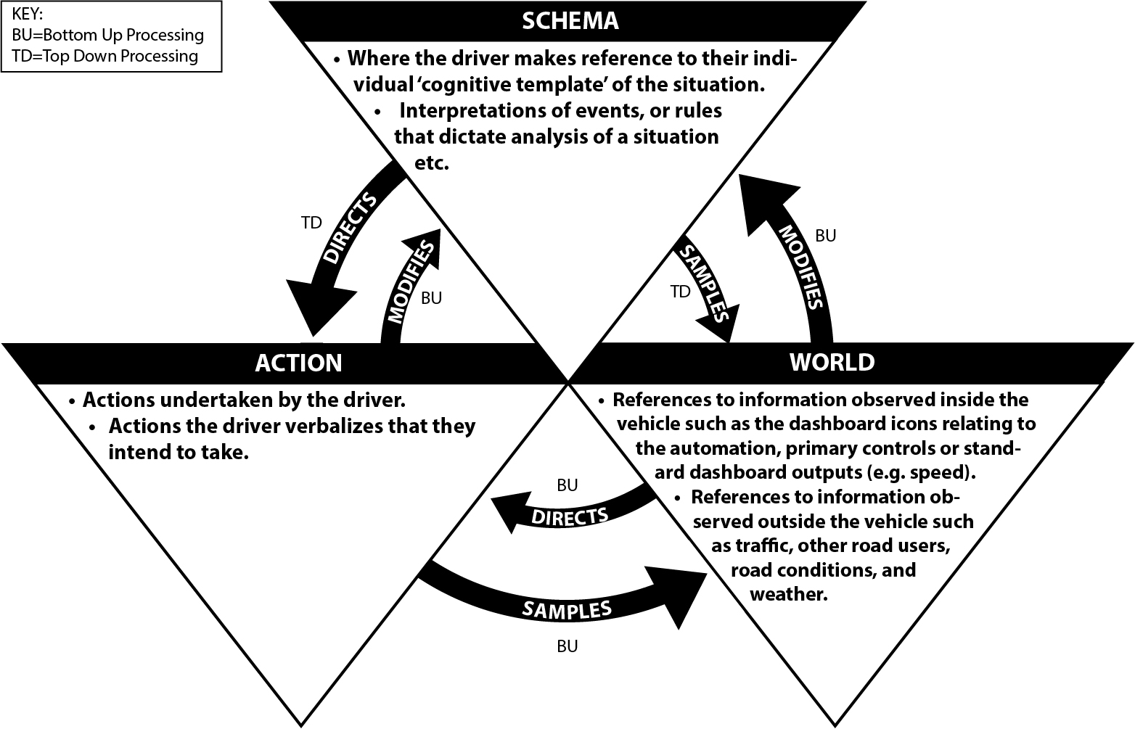
Figure 1 - Simplified representation of the Perceptual Cycle Model based on Neisser (1976) and further amended by Plant and Stanton (2015). Now in the context of semi-autonomous vehicles.
The aim of this paper is to demonstrate the benefits of Neisser’s (1976) PCM as an effective framework to understand interaction between driver and semi-autonomous vehicle for on-road studies as well as the challenges of applying the method when verbal protocols are generated concurrently with the event, rather than posthumously in a post incident interview or accident transcripts. Further it intends to show how generalised recommendations for improvements in designs can be generated, inspired from different parts of the PCM triad (Schema, World, Action), recognising that their effectiveness is ultimately dependent on the interdependency of all three parts of the cycle. Finally, this paper takes the opportunity to further explore the PCM counter cycle introduced by Plant & Stanton (2015), demonstrating how it can be aid understanding in the analysis of on-road studies.

Method

Participants
Six participants (five male and one female), aged between 26 and 56 participated in part one of this study. The participants formed two equal groups undertaking the study on separate days following the same route and protocol. Ethical approval was granted by the University of Southampton (ERGO 21090) for participation.

Equipment
The study was undertaken in a Mercedes S Class with pilot assist features comprising ‘Distronic Plus’ and ‘Steering Assist’. Distronic Plus consists of two short range sensors and a long range radar used to provide Adaptive Cruise Control (ACC) to automatically maintain a safe headway from the vehicle in front by braking when necessary and accelerating again when the traffic conditions permit (Daimler AG, 2016), Steering Assist uses stereo cameras to identify lane markings and passes the signal to the electric steering which maintains the position between lane markings. It keeps the vehicle in the centre of the lane on straight roads and around bends (Mercedes Benz, 2012) This combined function approach (NHTSA 2013) of two SAE L2 features such as Distronic Plus and Steering Assist result in a driver experience that is conceptually ‘hands and feet free’ from control as there is no need to make inputs to control lateral (steering) or longitudinal (accelerator and brake) locomotion (Banks et al, 2014a). This feature does not allow ‘eyes free’ control of the vehicle (available from SAE L3+) however, as the driver is still required to monitor the road and automation status and capability. Drivers are also not ‘mind free’ as they must be ready to take manual control of the vehicle at short notice when the car reaches the limits of its operational design (Banks et al., 2014b; 2018).
The drivers’ actions and verbalisations were recorded using two hand held digital video cameras operated by experimenters. One camera focussed on the view through the windscreen and recorded the voice of the driver. The second camera was focussed over the right shoulder of the driver allowing a view of the steering wheel, the hands of the driver and the Distronic display. A head mounted GoPro video camera was used to identify the broad direction of gaze. For redundancy, a head mounted microphone connected to a digital Dictaphone was used to capture driver verbalisations. Salmon et al., (2017) have demonstrated that driver behaviour was comparable with and without concurrent verbal protocols.

Procedure
Prior to the experiment all participants were trained on the ‘think aloud’ technique and were requested to read a participant information sheet and complete a consent form. A safety driver conducted a 20 minute training session on a test track to familiarise each participant with the Mercedes S Class and the Distronic Plus and Steering Assist features. Whilst drivers who purchase a vehicle with SAE Level 2 capability will not be required to undergo training prior to use, it is reasonable to expect that they will have trials the features during a test driver or on familiar routes before using the combined features in earnest. The safety driver was present throughout the study to provide continued advice on the route and verify that conditions were suitable for activation of the automation features.
Following directional instruction from the safety driver the participant then drove two pre-determined routes of approximately 20 minutes duration. One route comprised predominantly of motorway, with the second route featuring urban roads through a small town. Order of driving condition was counterbalanced such that half the drivers drove each route manually then in semi-autonomous mode, and the other half of drivers drove in semi-autonomous mode followed by manual mode. Throughout each route, the drivers were required to use the ‘Think Aloud’ method in order to generate verbal protocols (VP: Stanton et al, 2013) data for PCM analysis. Whilst further papers will focus on comparisons between manual and automated driving, for this paper, our interest is on how the PCM can provide insights into how to improve interaction design following incidents during semi-autonomous mode. As such, incidents during manual mode will not be described.

Data Analysis
VP data was transcribed and entered into NVivo software for qualitative data analysis. The content was coded according to Neisser’s (1976) PCM using the criteria in figure 1. During coding, verbalisations of driver frustration, confusion or panic, which demonstrated a lack of synergy between driver and vehicle were identified. The video data for each incident was then examined in detail to populate the PCM with observation and context data following the process adopted by Plant and Stanton (2012). These elements were identified with [square brackets] to distinguish them from the VP strings in figures 3,4 & 5 and used to populate diagrams based on figure 1. Any inferences made, particularly regarding schema content, were verified with the participant in question in a follow up session in person. VP strings, observational and inferred data were numbered according to sequence of occurrence (e.g. 1, 2, 3 etc.). However, if a VP segment for an incident contained evidence of more than one ‘Schema’, these were distinguished by a decimalised numbering system for clarity (e.g., Schema 1 - 1.1,1.2; Schema 2 - 2.1, 2.2 etc.). As distinguishing between schemata hinders the reader from understanding the sequential order of VP strings, the full VP transcript from each instance is also supplied. The combination of observed, inferred and VP content is presented both in diagram and table form. The former to emphasise the interrelation between the three triads, that latter to emphasise the sequence of content over time.

Results and Discussion: Three Case Studies of driver frustration
This section presents three case studies relating to frustrations originating in the drivers’ schema, driver actions and drivers’ observation of the world. These demonstrate not only the flexibility of the PCM framework to explore driver-vehicle interaction from on-road studies, but also its utility in generating insights that can inform the development of design recommendations for semi-autonomous vehicles. This section demonstrates how each verbal protocols can easily be allocated according to one of the three PCM triads (World, Action, Schema). By exploring how each triad links with the others, and if the sequence follows the traditional PCM cycle or counter cycle proposed by Plant & Stanton (2015) the analysis is encouraged to embrace a ‘systems perspective’. The inclusion of World data, in particular, allows non-optimal behaviour to be understood in in terms of a context beyond the user. The interaction between all three triads emphases their interdependency.

Case Study 1: “That was scary….” - the risk of an inappropriate schema.
The first case study relates to top down processing from the ‘Schema’ triad of PCM during use of the Distronic Plus in the Mercedes S Class on a UK motorway. It occurred when the participant was in the centre lane behind two cars (one red, one white) and a lorry. The red car directly ahead of the Mercedes S Class car indicated and moved to the right hand lane to overtake the lorry (figure 2, top). The participant decided that he also wanted to manually overtake the lorry so activated the indicator. During this time the white car directly behind the lorry also indicated and moved to the right hand lane proceeding to overtake the lorry. Whilst waiting for a clear gap in the right hand lane to pull out, the participant noticed his car accelerating (figure 2, middle). In confusion and panic, he braked suddenly to counter the acceleration that he attributed to an error in the automation (figure 3, bottom). He then continued with the (manual) overtake procedure and verbalised his fear that the automated car had been on course to drive into the back of the lorry in the central lane. Figure 2 shows three screen shots of the incident describing the scene. Figure 2 (top) depicts the scene just after the red car has moved into the right lane, and before the white car starts to indicate. The Distronic Plus dashboard clearly shows the white car has been sensed (car ahead icon is present) but the headway has not yet been reduced to the prescribed setting (gap evident between headway line and the car ahead icon). Following is the VP transcript excerpt for the incident:

“And there’s vehicles all around me. It feels quite heavy traffic. So, we’ve dropped down to – another bit of input, it won’t – okay, just given it. I’m thinking about doing an overtake now. So, I get past this lorry and I’ll try indicating. Check behind me. But we’re speeding up – oh, no. Blimey! Brake. And I didn’t trust it. And so, I’m pulling out now. And – no, that was scary. So, I think I’m going to have put that back on again. We’re doing 60, hands off the wheel. But generally, if I hadn’t had grabbed then it would have ploughed into that lorry.”

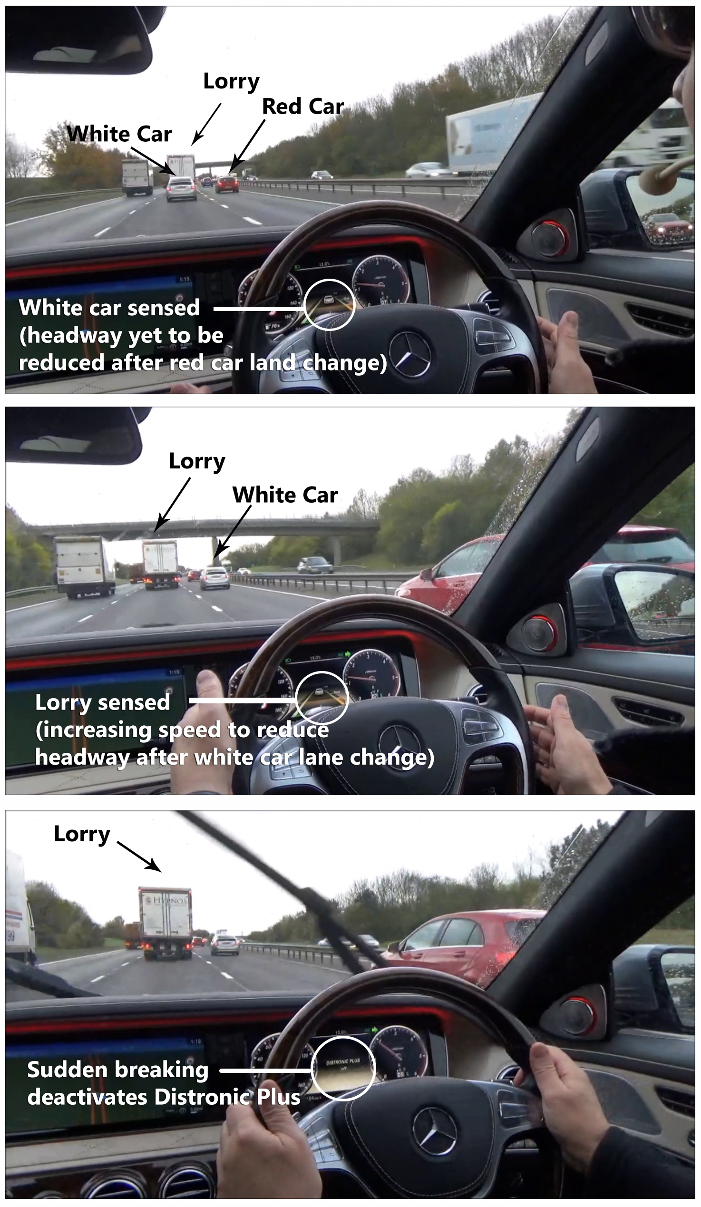
Figure 2 – Screen shots from the scenario show the Distronic Plus is correctly representing the outside world but is yet to reduce the headway to the standard setting following 2 cars behind a lorry change lanes in quick succession. A manual lane change is initiated by the driver as the car automatically increases speed to reduce headway, resulting in panic breaking.
The VPs during the incident were broken down and numbered in order of occurrence then categorized by relevance to Schema, Action or World in figure 3. Two different schemata were identified: Schema 1- relating to undertaking a manual overtake from semi-automated drive; Schema 2 – relating to undertaking a manual overtake from manual drive. Here it can be seen that the lead up to the incident (VP 1.1-1.9) is relatively calm with attention being focused mainly on the ‘World’ in terms of outside traffic conditions, the speed status, and the alert (dashboard icon) to remind the driver to keep his hands on the wheel. Before the distance between the Mercedes S Class and the white car can be reduced to maintain the set headway, the white car also moves into the right hand lane extending the headway between the Mercedes S Class and the lorry ahead (figure 2, centre). Both the video and audio data provide no evidence that the driver has paid attention to ‘World’ data relating to the status of headway maintenance shown on the dashboard. Reductions in awareness can increase the occurrence of mode errors (Sarter and Woods, 1995; Stanton et al, 2011) and automation surprises (Sartar et al, 1997). The Distronic Plus accelerated to bridge the gap between the Mercedes S Class and the lorry ahead.

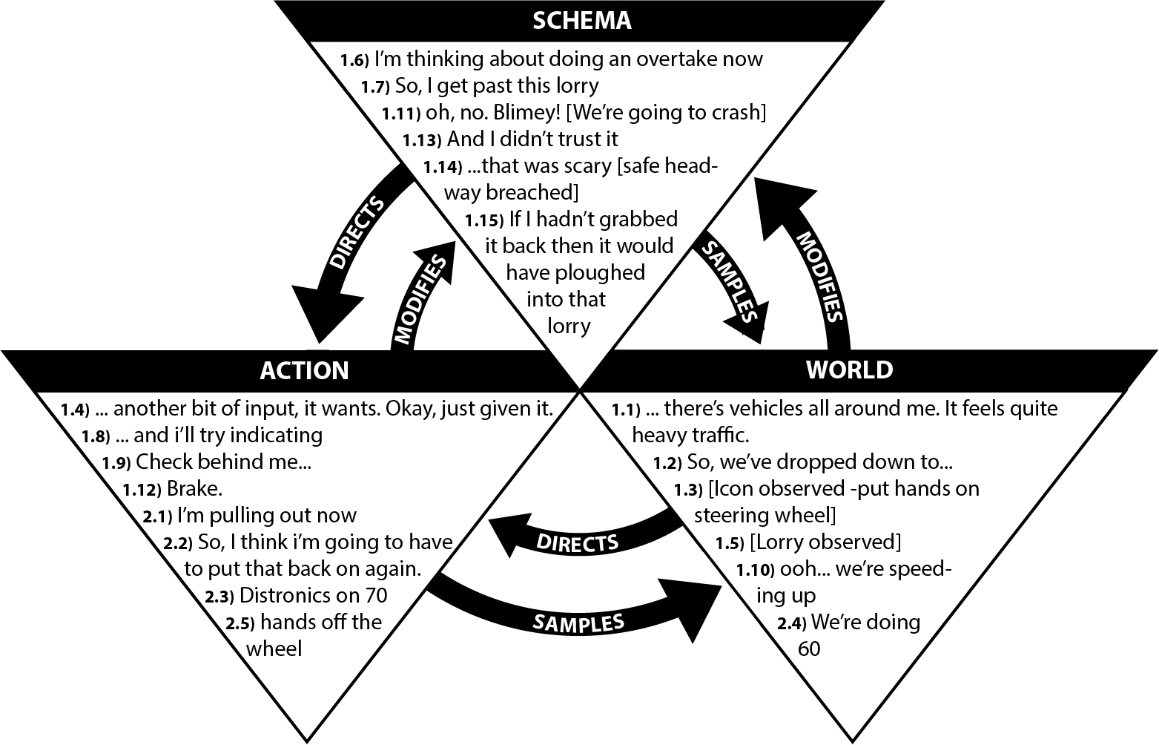
Figure 3 - Verbal protocols from case study 1 arranged according the Neisser’s (1979) Perceptual Cycle Model
This acceleration, however, was noticed by the participant who senses the change in the ‘World’ in (VP 10, figure 3) “ooh.. we’re speeding up”. Without checking the headway status to help interpret the situation, the participant assesses the situation on incomplete data from the world triggering an alternate ‘Schema’ that dictates the ‘Action’ of sudden braking (figure 2, bottom) as a means of preventative action to avoid an accident (VP 1.11-12, figure 3). These, and the statements “And I didn’t trust it..” (VP 1.13, figure 3) and “that was scary [safe headway breached]” (VP 1.14, figure 3) highlight the fear and lack of trust experienced during the incident.
There was clearly a ‘mismatch’ between the ‘expected’ and ‘observed’ behaviour of the vehicle experienced by the driver. After resuming the manual takeover from manual drive (VP 2.1-2.5, figure 3), the reflection (VP 1.15, figure 3) “..If I hadn’t grabbed it back then, it would have ploughed into that lorry..!” clearly indicates that the participants’ existing schema could not reconcile the automated acceleration of the vehicle at that point in his manual manoeuvre, with correct functioning of the Distronic Plus. To understand the reason for this it is necessary to consider the context of the incident in terms of a manual overtake of a large vehicle, and how this differs from that of a small vehicle. When overtaking a small vehicle, if the lane to the right is clear and there is visibility ahead of the vehicle for re-entry into the lane, it is appropriate to accelerate towards the vehicle to adopt ‘overtake position’, allowing the overtake to occur immediately (Roadcraft 2013). In the scenario described, traffic was present in the right hand lane preventing an immediate start to the manoeuvre, and the large vehicle obscured the view of the road ahead. In this situation it is prudent to drop back to a following positioning until a gap in the right hand lane is imminent. This also allows greater visibility of the road ahead of the vehicle, and avoids positioning your own vehicle in its blind spot for any extended period of time (Roadcraft 2013).
If the driver had been in manual control of the longitudinal locomotion, he is unlikely to have accelerated at the point chosen by the Distronic Plus. As he was about to engage in a manual manoeuvre, it is not surprising that a schema for manual control was in place that interfered with appropriate interpretation of events. A key issue relates to the automatic systems’ lack of awareness that the driver had changed his goal from ‘automated cruise’ to ‘vehicle overtake’. Although the driver did activate an indicator that would necessitate manual lateral control, this input is not integrated with the performance of the Distronic Plus, preventing a more appropriate rule to be modelled by the automated system (e.g. wait until lane change is complete before adjusting speed to maintain set headway). In the same way, the driver was unaware of the intention of the Distronic Plus to reduce the leading headway between the Mercedes S Class and the Lorry in front in order to keep the prescribed setting. A key factor for the incident clearly arose out of a conflict of goals between the vehicle and the driver, and obstacles to communicating each other’s intentions. We are not suggesting that there was a serious safety breach with Mercedes Distronic Plus, rather there was a mismatch between the expectations of the driver and the behaviour of the vehicle. Ideally this apparent mismatch could be addressed in the design of vehicle automation. There may also have been a ‘gap’ between the driver’s ‘device model’ of the function of ACC as a feature that maintains headway, rather than speed, (which is more applicable to the functioning of standard cruise control) (Norman 1986). This incident reflects findings relating to ACC by Kazi et al., (2007), and Stanton et al (2011) who identified cognitive mismatch leading to mode confusion (Woods, 1988, Baxter et al, 2007), particularly where insufficient monitoring of the system was observed. A poor conceptual model in the driver impacted levels of trust with ACC supporting Lee and See (2004)’s view that appropriateness of trust should be considered in relation to the context of the environment and goals of the user. Norman (1990) also emphases that ACC is not considered to be sufficiently intelligent to cope with high demand situation. The changing goals of the driver observed in this study could be considered a high demand situation for the current capabilities of semi-autonomous vehicles. With interrelated nature between schema, action and world information, recognition that the poor conceptual model of the driver was likely to have resulted from a poor ‘device image’ by the system points to design strategies to improve the partnership between driver and automated vehicle (Chapanis, 1999; Banks et al., 2018).

Evidence of counter cycle in Case Study 1
To better understand where examples of counter cycle are found, the same data has been arranged in table form showing the sequence of verbalisations over time as well as by PCM category. For clarity, the grey shading represents VPs belong to a second schema introduced in the case study. Counter cycle examples are highlighted in black for both schemas and inferred or video observed data (rather than VP data) is distinguished by [square brackets]. Traditional PCM cycle flows in direction of Schema-Action-World-Schema. Counter cycle PCM will conversely flow Schema-World-Action-Schema.

Table 1 - Verbal protocols for Case Study 1 shown in table format to demonstrate sequence of verbalisations.
Schema |  | Action | World
 |  |  | 1.1 … there’s vehicles all around me. It feels like quite heavy traffic.
 |  |  | 1.2 So we’ve dropped down to…
 |  |  | 1.3 [Icon observed – put hands on steering wheel]
 |  | 1.4 … another bit of input it wants. Okay, just given it.
 |  |  | 1.5 [Lorry observed]
1.6 I’m thinking about doing an overtake now
1.7 So, I get past this lorry
 |  | 1.8 … and I’ll try indicating
 |  | 1.9 Check behind me…
 |  |  | 1.10 Ooh we’re speeding up
1.11 Oh no. Blimey! [We’re going to crash]
 |  | 1.12 Brake.
1.13 And I didn’t trust it
2.1 And so I’m pulling out now
1.14 And – no, that was scary [safe headway breached]
2.2 So, I think I’m going to have to put that back on again.
2.3 Distronics on 70
 |  | 2.4 We’re doing 60
2.5 Hands on wheel
1.15 If I hadn’t grabbed it back then it would have ploughed into that lorry
Key: | Schema 1 content | Schema 2 content | Example of counter cycle

From table 1 three examples of counter cycle sequence between VPs showing 2 different types of activity. An example of each type will be described. The first between VP1.3 [icon observed] and VP1.4 ‘Another bit of input it wants. OK just given it’ reflects the World-Action relationship found frequently by Plant & Stanton (2015) suggesting skill based behaviour . However, although this participant had considerable experience driving, their experience with the interface and interaction design was limited. Another interpretation may be that the icon advising steering wheel input was sufficiently intuitive to be self explanatory or easily learnt, so reference to the Schema was unnecessary. The second example is between VP1.12 ‘Brake’ and VP 1.13 ‘And I didn’t trust it’ which provide an example of Actions influencing the Schema. Video footage showed the driver focusing ‘eyes out’ during this area to ensure safety, so no observations related to the icons or interface that could have helped add ‘observed / inferred’ content to the ‘World’ column to complete the traditional direction of the PCM cycle and link to ideas relating to trust. The cognitive processes between these two triads is not clear but one hypothesis to consider is that having undertaken avoiding action, the driver is justifying this behaviour by reflecting on his changed schema of the automation following unexpected vehicle behaviour.

Case Study 2: “Oh, I’ve just done the Distronic again ….” - impeding intended actions.
The second case study provides an example of bottom up processing relating to the ‘Action’ triad in the PCM. It depicts the accidental activation of Distronic Plus in a Mercedes S Class when leaving a car park on an urban road. Following is the VP transcript excerpt for the incident:
“You can see there’s a van coming in sight, because we’re coming more away to the left, then to the right, and over to me... Oh, I’ve just done the distronic again, when I’m meant to indicate right. I’ve done that twice now. Absolutely ridiculous levels of complexity in the controls of this car.”
The VPs are depicted in figure 4 where the driver observes other road users in the ‘World’, before describing his ‘Actions’ when manoeuvring around the car park (VP 1-3, figure 4). The participants’ schema identifies the need to indicate using the stalk control (VP 4, figure 4) and video footage verified the action “[stalk pushed]” (VP5, figure 4) informing other road users the intention to turn and prompting the seeking out of ‘World’ information to verify the action has been completed. He notices from the dashboard interface that the Distronic system has been activated (VP 6, figure 4) and states in frustration “Oh I’ve just done the Distronic again, when I’m meant to indicate right” “I’ve done that twice now…” (VP 6-7, figure 4) before complaining about the complexity of the car interface (VP 8, figure 4).

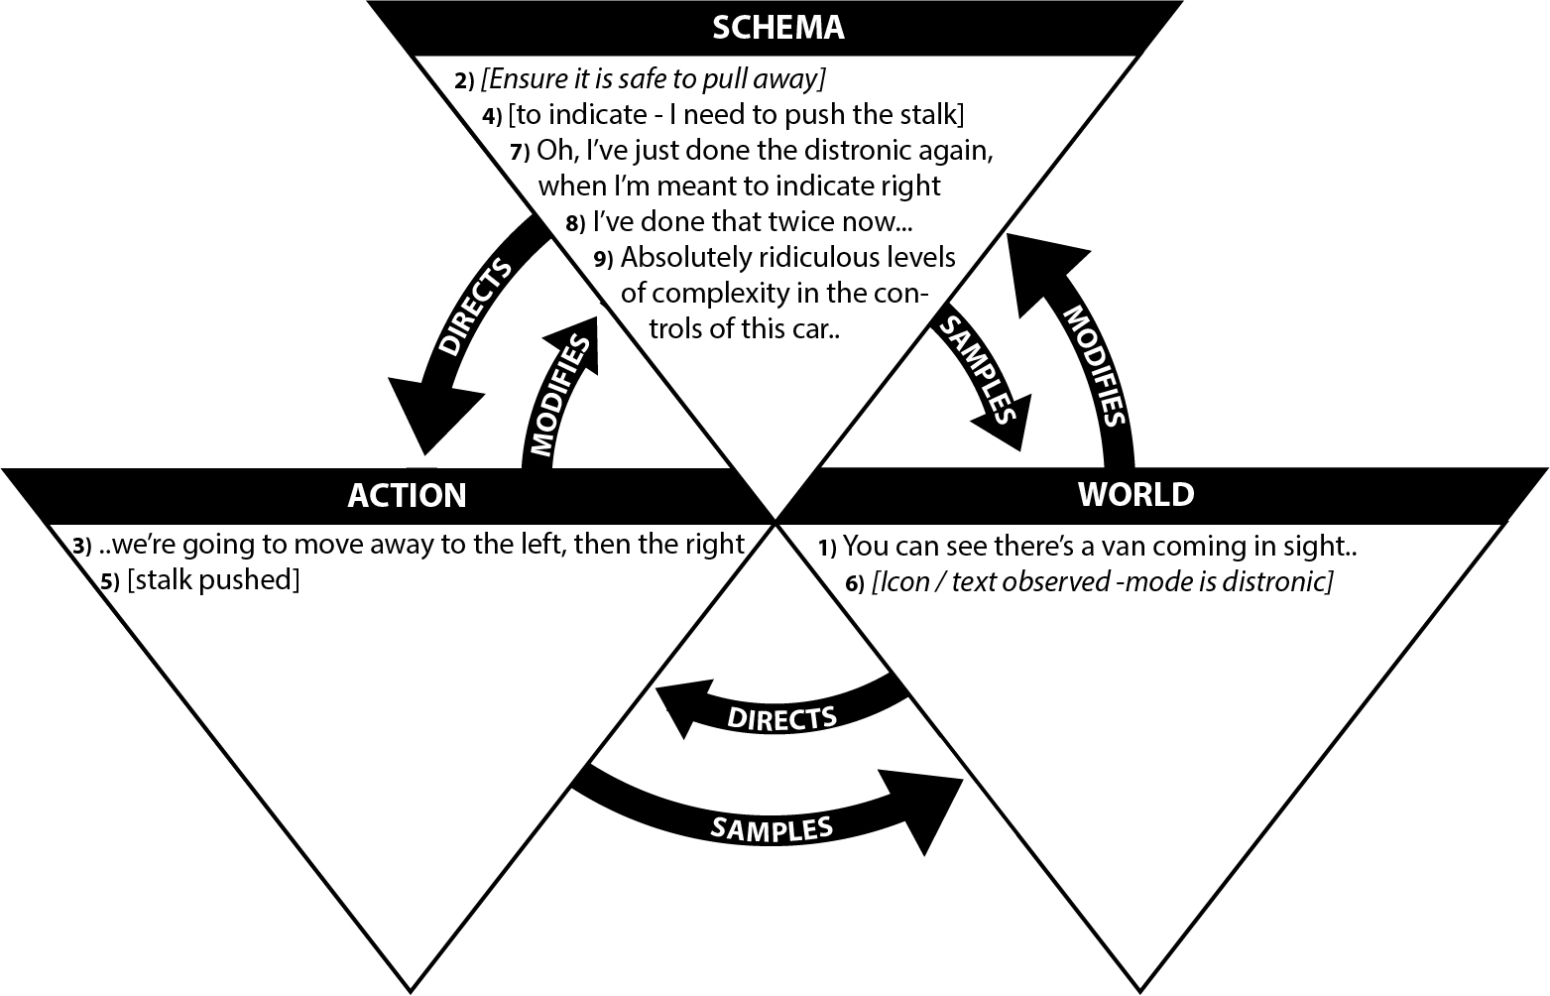
Figure 4 - Verbal protocols from case study 2 arranged according the Neisser’s (1979) Perceptual Cycle Model
By viewing the controls it is clear why the frustration occurs: activation of Distronic mode, and activation of the indicator, both require a stalk to the left of the steering wheel to be nudged and are designed to be activated ‘eyes out’. The stalks are difficult to distinguish by feel, are activated by the same hand and are in a similar location with similar visual appearance. Similar to the indicator stalk, the Distronic plus can be activated both by tilting upwards as well as downwards (these same movements are then used to increase/decrease the ACC speed setting). Figure 5 shows close proximity, similar style and method of activation of disparate controls.
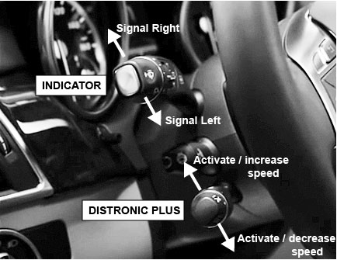
Figure 5 - Showing similar proximity and design of indicator stalk and Distronic plus stalk.
Confusion between controls with different functions, can have serious consequences. In SAE L2 automation, the role of changing lanes is achieved manually and can occur whilst still in Distronic mode. This means that control confusion could result in the absence of indicating when intended (as in this case study). In a Motorway context, this would prevent other road users from understanding the driver’s intentions, resulting at best in surprise if a manoeuvre is completed without the control error being identified, or at worst a collision if a car speeds up or over-takes a vehicle that suddenly changes lanes. In addition, if the car is already in Distronic mode and the same stalk is adjusted, this would have the impact of unintentionally changing the speed value for ACC compromising drivers’ situation awareness of vehicle state (Stanton et al, 2011; Stanton et al, 2017). Whilst not demonstrated in this particular example, the reverse control confusion could also occur (evident by other participants in the study) where the drivers intention is to activate Distronic plus, but accidently activate the indicator. Confusion to other road users may still occur when a manoeuvre doesn’t occur but the consequences are less serious in this case. If the driver had not checked world information however, and incorrectly assumed ACC was then active, this Schema would be triggered providing incorrect expectations of vehicle behaviour. This could influence driver actions, such as failing to manually operate brakes, or operating brakes late when approaching vehicles (resulting in potential for collisions). Accidental deactivation of combined SAE L2 features have also been observed in Banks et al. (2018) due to torque input via the steering wheel in a Tesla Model S. Mode errors can have potentially disastrous outcomes (Stanton et al., 2011; Reason, 1990; Norman, 1990; Woods et al.,1994). The problem found between control stalks is similar to that found in aviation cockpit design. After a series of runway crashes of the Boeing B-17, it was found that certain cockpit controls (flaps and landing gear) were confused with each other, due partly to their proximity and similarity of shape. Design principles such as shape coding was used to disambiguate controls to improve safety (Chapanis, 1999). Automotive manufacturers often implement new features, and particularly optional extra ones, by overlaying their functionality onto extant controls for good engineering and cost reasons, however in some contexts, the usability cost of this reuse can be very high.

Evidence of counter cycle in Case study 2
The data for case study 2 has been arranged in table form showing the sequence of verbalisations and inferred content over time as well as by PCM category. A far simpler incident, VPs from a single schema are evident so no grey shading is required. A single counter cycle example is shown between VP 3 ‘We’re going to move away to the left, then the right’ and VP 4 [To indicate I need to push the stalk] representing another example of Actions to Schema processing. It is noteworthy that this counter cycle example relates to inferred content distinguished by [square brackets]. From a cognitive processing perspective, it is reasonable to see how the intention to take action triggers a ‘sub schema’ relating to the process for indicating. The nature of the indicating task being carried out ‘eyes free’ explains why no verbal protocol describing viewing the indicator in the ‘World’ before activating it, was evident. Since the driver will be highly skilled in using the indicator to pull away, the schema they are accessing is likely to be implicit impeding verbalisation. However it is clear that without the inferred and observed content in VP 4-6, the sequence from VP 3 ‘Were going to move away to the left, then the right’ and VP 7 “Oh, I’ve just done the distronic again, when I’m meant to indicate right” fails to illuminate either the control in question used in the ‘Action’ triad, nor the feedback mechanism in the ‘World’ triad to focus strategies for reducing error or improving design.

Table 2 - Verbal protocols for Case Study 2 shown in table format to demonstrate sequence of verbalisations.
Schema | Action | World
 |  | 1 You can see there’s a van coming in sight because…
2 [Ensure it is safe to pull away]
 | 3 We’re going to move away to the left, then the right.
4 [To indicate I need to push the stalk]
 | 5 [Stalk pushed]
 |  | 6 [Icon/text observed – mode is distronic]
7 Oh, I’ve just done the distronic again, when I’m meant to indicate right.
8 I’ve done that twice now.
9 Absolutely ridiculous levels of complexity in the controls of this car.
Key: | Example of counter cycle

Case Study 3: “I think it’s green now, …no it’s not!” – ineffective world information
This final case study considers the impact of the ‘World’ triad in the PCM with driver VPs depicted in figure 6. It highlights the influence of environmental factors that limit how information in the world can be perceived. This specific driver was more experienced than some of the other participants in terms of both a conceptual understanding of Distronic Plus and its method of activation. However, he found himself in the position of non-optimal driving on a UK Motorway due to the performance of the interface in a typical context of use (bright sunshine). Following is the VP transcript excerpt for the incident:
Again re-engage, just drive closer behind the lorry, increase my speed to 70. Green steering wheel which looks like we have. Oh it’s gone grey and now it’s gone grey again. It’s very difficult to see with this sunlight in my sunglasses. Definitely both on. I think it’s green now, no it’s not. It is really difficult to see with the… I’ll take my sunglasses off because they’re making it harder for me to see. Lots of traffic so just keeping the set distance for the vehicle in front. The speed is 58 miles an hour. Still no steering. It’s turned green now. I’ll just take my hands off. Spending too much time looking at the green steering wheel rather than the traffic around me.

Figure 6 represents this interaction with two schemas relating to: Schema 1 – engaging automation and monitoring (mode status and other road users); Schema 2 – troubleshooting issues with interpreting the mode status. The participant activates Distronic plus which initiates the ACC allowing him to be ‘feet free’ (VP 1.1, figure 6). To also be ‘hands free’ he identifies from the ‘World’ interface icon “green steering wheel” (VP 1.2, figure 6) that conditions for auto steering are available. Unlike the participant in case study 1, whose attention on the road ahead led to an ‘eyes out’ focus, this participant spends a considerable amount of attention ‘eyes down’ trying to determine the status of the vehicle automation features (e.g. “oh its gone grey….” (VP 1.4, figure 6), “definitely both on” (1.6, figure 6), “I think its green now, …no its not” (1.7, figure 6), “Still no steering” (1.11, figure 6), “its turned green now” (1.12, figure 6) with only 1 out of 8 VPs in this triad focused on other road users (VP 1.17, figure 6). His awareness of the imbalance in his attention on the world is clear in VP 2.5 (figure 6) “Spending too much time looking at the green steering wheel rather than the traffic”. This represents an example of BU processing whereby the visual issues triggers the second schema relating to difficulties with visibility. Figure 6 shows that most of the verbalisations categorized in the ‘Schema’ triad are focused on the understanding that bright outside light conditions and associated aids such as sunglasses, whilst improving visibility ‘eyes out’ diminish visibility ‘eyes in’ when viewing the dashboard interface “It’s very difficult to see with this sunlight in my sunglasses” (VP 2.1, figure 6), “It is really difficult to see with the [sunlight]” (VP 2.2, figure 6). This influences the driver’s actions to remove them “…I’ll take my sunglasses off” (VP 2.3, figure 6) to improve visibility ‘eyes down’ (despite the negative impact on visibility ‘eyes out’).

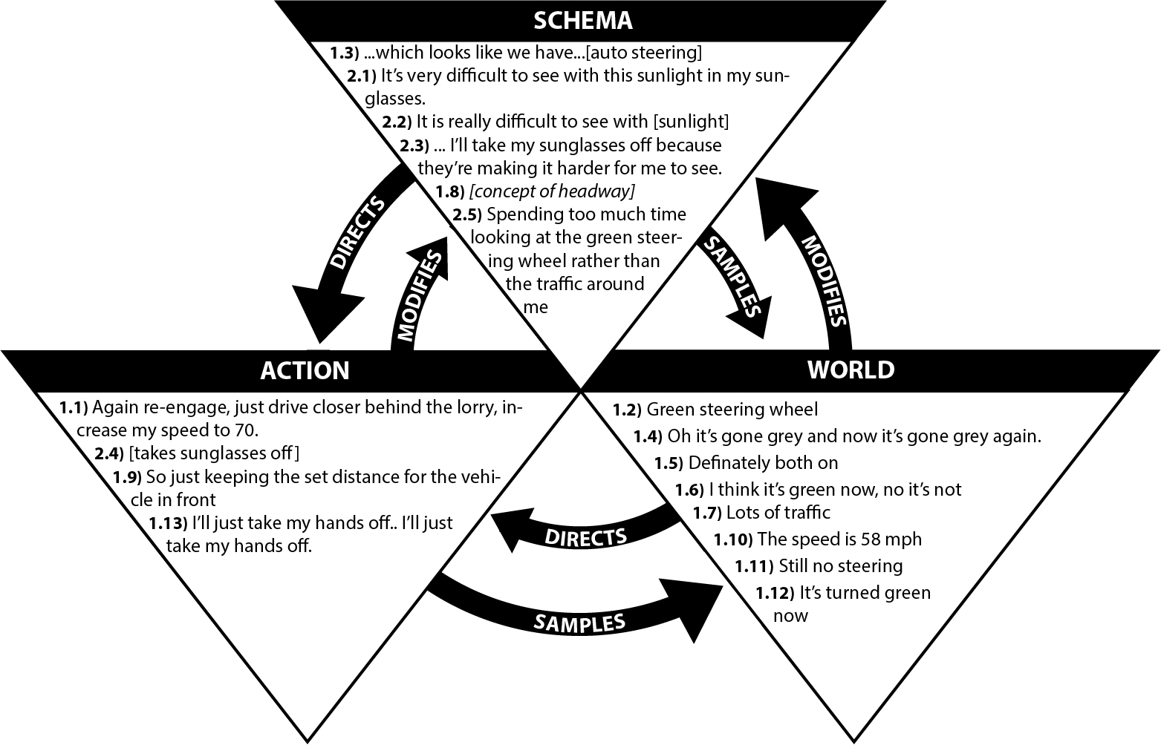
Figure 6 - Verbal protocols from case study 3 arranged according the Neisser’s (1979) Perceptual Cycle Model
The diagram in figure 7 shows a representation of the Mercedes interface with the auto-steering icon in active (green) and inactive (grey) modes placed side by side for comparison (the interface shows a single icon that lights up green when auto steering conditions are met). Whilst the green coding of the icon follows western colour coding conventions it does not employ redundancy to take account of issues with colour as a primary distinguisher of mode. Whilst this standard ergonomics advice for interface design is intended to take into account colour blindness, the benefits would also be reaped in circumstances such as bright sunlight when colour changes are more difficult to distinguish (Stanton et al., 2010). The consequences of misunderstanding auto-steering mode status is also not reflected in the hierarchy of information on the interface. Figure 7 shows the auto-steering icon as considerably smaller than primary information such as speed and rpm. It could be argued that automation status is one of the primary system states that should be communicated in semi-autonomous vehicles and warrants far greater prominence than currently shown by the industry. The current relatively low-salience implementation of this autonomous mode display in the instrument cluster is, however, consistent with this feature being treated as an ‘optional extra’ and therefore an add-on to an instrument cluster design optimised for multiple versions of the vehicle that may not offer this functionality.
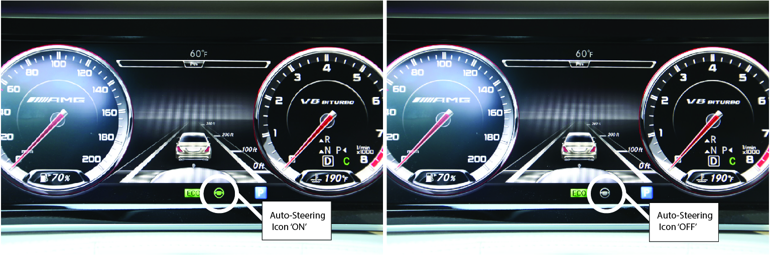
Figure 7 – Mercedes S Class interface highlighting the mode status shown (with ‘off’ mode duplicated by the side of the green ‘on’ steering wheel icon) by icon colouring and minimal priority compared to other types of car status information (see colour version of this figure on the online resource).

Evidence of counter cycle in Case study 3
The data for case study 3 has been arranged in table form showing the sequence of verbalisations and inferred content over time as well as by PCM category. Similar to Case Study 1, the VPs refer to two different schemas and have been shaded to reflect this with Schema 1 represented with a white background, and Schema 2 with a grey background. As before, examples of counter cycle activity are highlighted in black and inferred or video observed data (rather than VP data) is distinguished by [square brackets].

Table 3 - Verbal protocols for Case Study 3 shown in table format to demonstrate sequence of verbalisations.
Schema |  | Action | World
 |  | 1.1 Again re-engage, just drive closer behind the lorry, increase my speed to 70
 |  |  | 1.2 Green steering wheel
1.3 Which looks like we’re having ..[autosteering]
 |  | 1.4 oh it’s gone grey now and its gone grey again
2.1 Its really difficult to see with this sunlight in my sunglasses.
 |  | 1.5 Definitely both on
 |  | 1.6 I think it’s green now, no it’s not
2.2 It is really difficult to see with the [sunlight]
2.3 I’ll take my sunglasses off because they’re making it harder for me to see
 |  | 2.4 [removes sunglasses]
 |  |  | 1.7 lots of traffic
 |  | 1.8 so just keeping a set distance for the vehicle in front
 |  |  | 1.9 The speed is 58 mph
 |  |  | 1.10 Still no steering
 |  |  | 1.11 It’s turned green now
 |  | 1.12 I’ll just take my hands off
2.5 Spending too much time looking at the green steering wheel rather than the traffic around me
Key: | Schema 1 content | Schema 2 content | Example of counter cycle

Two examples of counter cycle activity are seen in case study 3. The World-Action sequence in Schema 1 between VP 1.7 “lots of traffic” and VP 1.8 “so just keeping a set distance for the vehicle in front” is another example of skilled based behaviour where driving experience sees a direct link between observing in the World the busyness of the road subsequent Action to prioritise headway. The implicit schema relates to safety and a greater likelihood for traffic incidence in busy traffic conditions than more sparsely populated roads. The other example of counter cycle processing is from Action-World for Schema 2. Observed data VP 2.4 [removes sunglasses] and Schema data VP 2.5 “Spending too much time looking at the green steering wheel rather than the traffic around me” clearly identifies the balance of visual attention is inappropriate for the driving task for SAE Level 2 (where monitoring the road ahead and other road users is essential). As with Case study 1 this reflection directly follows an action that was not anticipated had the original expectation and of the interface would allow the driver to decipher the automation mode and capability in typical environmental conditions. Unlike Case study 1, however, this reflection represents a genuine limitation of the interface, rather than a misunderstanding of automation function.

Implications for interaction design
Semi-automated cars (e.g. anything below SAE level 5) require input from drivers where the road, infrastructure, surroundings, or environmental conditions prevent full automation (also where the driver choses to drive manually). High levels of synergy between driver and automation is required for performance and safety, but this synergy relies on trust and understanding on both sides (Walker et al, 2016; Stanton et al, 2017). Hancock et al. (2009) argued that individual case representations are increasingly relevant for the design of human-machine systems, and generalisations can be derived. From the case studies described in this paper, the goals to be achieved through interaction design can be summarised as follows:
- Design for conflicting intentions between driver and automation. For example, when the driver begins or ends a manual manoeuvre, there needs to be a means for this to be communicated to the existing assistive technologies so alternate models of autonomous behaviour can be activated, or where necessary, autonomous assistance is disabled until the manual manoeuvre is complete [case study 1].
- Design for reassurance. Such as when an atypical change in longitudinal or lateral locomotion is initiated by the automation, the action and its reason needs to be successfully communicated to the driver to avoid unnecessary or potentially risky manual intervention by the driver. Visual dashboard displays may be insufficient if the driver is focused ‘eyes out’ of the windscreen, observing potential hazards, so Head Up Displays (HUDs) or alerts may be more appropriate. Eriksson et al (2017) concluded that visual and vocal displays should be used to convey semantics to the driver to support cognitive processing and decision selection, a key stage of automation as defined by Parasuraman et al. (2000) [case study 1].
- Design for appropriate mental models. By ensuring the function of any assistive automation is effectively understood by the driver and does not conflict directly with their existing mental models to promote a positive transfer of knowledge. Without an appropriate schema or mental model of automation function, the predictability of vehicle behaviour and appropriate human response is diminished (Revell & Stanton 2014; 2015; 2016; 2017). At worst, safety is compromised, and at best user trust and commercial adoption is diminished (Banks et al., 2018; Walker et al., 2016) [case study 1 & 2]
- Design for context. For example, recognize that the expected behaviour by a car when following a large vehicle will differ from that when following a standard vehicle. Interaction design should either appropriately set the drivers’ expectations in a range of contexts, or the automation should be programmed to adjust to differing expectations based on context [case study 1].
- Design for the variety of human capabilities and the variety of environmental conditions of use. The interface elements should be designed to accommodate the visual, hearing, cognitive, reach and dexterity capabilities of the potential user population (Waller et al., 2015). Where automation sensors (radar etc.) experience limitations in sensing the road, drivers also have limitations in sensing the low contrast or diminutive display icons in non-ideal weather conditions (e.g. bright sunshine). Digital displays provide the flexibly to offer redundancy in presentation and traditional ergonomic guidelines should be adhered to and tested against the variety of relevant capabilities in the user population [case study 3]
- Design an adequately prominent mode state. Whilst occurring from different causes in different contexts and relating primarily to different triads of the PCM, each case study ultimately resulted in mode errors. This supports the extensive body of literature investigating human interaction with automated systems (Andre & Degani, 1997; Degani et al, 1995; Leveson, 2004; Norman, 2983; Ruchby et al, 1999; Sarter and Woods, 1995, Sheridan, 1995). The importance of an explicit mode state and feedback which are detectable and interpretable by the user population’s capabilities when modes changes cannot be understated [case studies 1, 2 & 3]
- Disambiguate controls of different function Disambiguate two very different actions by changing the design of controls. For example, by using different shape and activation of controls (Chapanis, 1999), or by positioning controls in distinct locations, or requiring different hands or methods of activation [case study 3].

Evaluation of applying PCM to on-road concurrent VP dialogue
Three case studies presenting concurrent verbal protocols during an on-road study of non-optimal interaction between a driver and semi-autonomous vehicle were successfully explored within the framework of the PCM. Whilst this method of thematically analysing verbal protocols takes a deductive rather than grounded theory approach, the benefits in terms of providing a theoretical framework that directs the analyst to systematically seek out links between triads and ensures consideration of context based interdependency from a systems perspective. Whilst other usability methods have much to contribute, traditional usability questionaires (e.g. the System Usabilty Scale; The System Acceptance Scale) provide only high level understanding of the user experience and cannot target where change is needed. Other more in depth methods such as product walk throughs are difficult to implement in a fast moving dynamic demonstration. The authors acknowledge, however, that for more simplistic case studies such as 2 and 3, observations of behaviour without the PCM framing would also have successfully captured the issues identified. However that the PCM framework may be more appropriate for more complex sociotechnical systems, that it can be easily applied and reveal both complex and more simple cause of non-optimal system behaviour, highlights its advantage over a method that can only cope with more basic issues.

Both the tradition direction of the PCM proposed by Neisser (1976) and the countercycle presented by Plant & Stanton (2015) were evident in the verbal protocols.
Using inferred content (through observation of video footage, or post study discussions) ultimately had an impact on whether a sequence of VPs followed a traditional or counter cycle.. For example, in case study 3, VP 1.7-1.9 demonstrates traditional BU followed by TD processing. However, without the ‘inferred’ content ‘[concept of headway]’ (VP 1.8, figure 6) could have be classed as CC BU processing, going straight from ‘lots of traffic’ (World) to ‘just keeping the set distance from the vehicle in front’ (Action). This change in direction is compatible with Plant & Stanton’s (2015) description of skilled behaviour where schema content is not verbalised as it is implicitly, rather than explicitly understood. The schema element remains part of the cognitive processing, therefore, but cannot be captured directly from the transcript. The pace of the changing road context also impacted the ability of the driver to express all perceptions, thoughts and actions, particularly during manual manoeuvres. In case study 2, four out of nine elements in the figure 4 are inferred, with three of these taken from video footage. The process of indicating was completely omitted in the VPs (VP 4 & 5, figure 4) ‘To indicate, I need to push the stalk’ (Schema) and ‘Stalk pushed’ (Action) are both key aspects to understanding the incident where the incorrect stalk was operated, so warranted inclusion. It is important to note, therefore, that VPs alone may be insufficient for deep understanding of non-optimal interaction. Framing dialogue using the PCM, and considering whether sequential strings follow the traditional cycle, counter cycle provide a systematic way by which the analyst or practitioner can deeply understand the interaction and gain insights for focus. These insights could be used to inform interventions to improve UX and safety through design, training, or legislation.

Conclusions
This paper set out to highlight the benefit of applying Neisser’s (1976) PCM to explain non-optimal interaction between drivers and semi-autonomous vehicles. Three naturalistic case studies were presented that highlight how driver frustration and lack of synergy can occur when interacting with semi-autonomous vehicles and the potential impact on safety. Seven design recommendations were generated and the benefits of gaining deep understanding through the PCM in contrast to categorisation by codes were discussed. Further evidence of Plant & Stanton’s (2015) counter-cycle was found and aided interpretation of non-optimal interaction. The ability to interrogate the evidence from the perspective of ‘World’, ‘Schema’ and ‘Action’ proved useful in deriving generalizable recommendations for interaction design to improve safety and break the cycle of frustration for drivers when interacting with semi-autonomous vehicles.

Acknowledgments.
This work was supported by Jaguar Land Rover and the UK-EPSRC grant EP/011899/1 as part of the jointly funded Towards Autonomy: Smart and Connected Control (TASCC) Programme.

References
Andre, A., Degani, A., 1997. Do you know what mode you’re in? An analysis of mode error in everyday things. Human-Automous Interaction: Res. Pract., 19–28.
Banks, V. A., Stanton, N. A., Harvey, C. 2014a Sub-systems on the road to vehicle automation: Hands and feet free but not ‘mind’ free driving. Safety Science 62, 505-514.
Banks, V.A., Stanton, N.A., Harvey, C., 2014b. What the drivers do and do not tell you: using verbal protocol analysis to investigate driver behaviour in emergency situations. Ergonomics 57 (3), 332–342.
Banks, V.A., Stanton, N.A., 2015. Discovering driver-vehicle coordination problems in future automated control systems: evidence from verbal commentaries. Procedia Manuf. 3, 2497–2504.
Banks, V.A., Stanton, N.A., 2016. Keep the driver in control: automating automobiles of the future. Appl. Ergon. 53 (B), 389–395.
Banks, V.A., Eriksson, A., O'Donoghue, J. and Stanton, N.A., 2018. Is partially automated driving a bad idea? Observations from an on-road study. Applied Ergonomics, 68, pp.138-145.
Banks, V.A., Plant, K.L. and Stanton, N.A., 2018. Driver error or designer error: using the Perceptual Cycle Model to explore the circumstances surrounding the fatal Tesla crash on 7th May 2016. Safety science, 108, pp.278-285.
Baxter, G., Besnard, D., Riley, D., 2007. Cognitive mismatches in the cockpit: will they ever be a thing of the past? Applied Ergonomics 38, 417-423.
Chapanis, A., 1999. The Chapanis chronicles: 50 years of human factors research, education and design. Aegean Publishing Company.
Daimler AG 2016, DISTRONIC PLUS, Viewed 29th September 2017, http://techcenter.mercedes-benz.com/en/distronic_plus/detail.htmlGasser, T.M. and Westhoff, D., 2012, July. BASt-study: Definitions of automation and legal issues in Germany. In Proceedings of the 2012 Road Vehicle Automation Workshop.
Degani, A., Shafto, M., Kirlik, A., 1995. Mode usage in automated cockpits: some initial observations. Paper presented at the International Federation of Automatic Control.
Endsley, M.R., 2017. Autonomous driving systems: a preliminary naturalistic study of the Tesla Model S. Journal of. Cognitive Engineering and Decision Making http://dx.doi.org/10.1177/1555343417695197.
Eriksson, Stanton, 2017a. The Chatty Co-Driver: a linguistics approach applying lessons learnt from aviation incidents. Safety Science 99, 94–101.
Eriksson, A., Stanton, N.A., 2017b. Take-over time in highly automated vehicles: noncritical transitions to and from manual control. Hum. Factors 59 (4), 689–705.
Hancock, P. A., Hancock, G. M. & Warm, J. S. 2009. Individuation: the N=1 revolution. Theoretical Issues in Ergonomics Science, 10 (5), 481-488.
Kazi, T.A., Stanton, N.A., Walker, G.H. and Young, M.S., 2007. Designer driving: drivers' conceptual models and level of trust in adaptive cruise control. International journal of vehicle design, 45(3), pp.339-360.
Leveson, N., 2004. A new accident model for engineering safer systems. Safety Science 42 (4), 237–270.

Lee, J.D. and See, K.A. (2004) Trust in automation: designing for appropriate reliance, Human Factors, Vol. 46, No. 1, Spring, pp.50–80.
Mercedes-Benz 2012, DISTRONIC PLUS with Steering Assist - Mercedes-Benz original, Viewed 29th September 2017, https://www.youtube.com/watch?v=lpIddjyHHVs
National Highway Traffic Safety Administration, 2013. Preliminary Statement of Policy Concerning Automated Vehicles.
Naujoks, F., Purucker, C., Neukum, A., 2016. Secondary task engagement and vehicle automation–Comparing the effects of different automation levels in an on-road experiment. Transportation Research Part F Traffic Psychol. Behav. 38, 67–82.
Neisser, U. 1976. Cognition and Reality. San Francisco: W. H. Freemand
Norman, D.A., 1983. Design rules based on analyses of human error. Commun. ACM 26 (4), 254–258.
Norman, D.A., 1990. The “problem” with automation: inappropriate feedback and interaction, not “overautomation”. Philosophical Transaction of the Royal Society of London B327, 585e593
Norman, D.A., 1986. Cognitive engineering. User centered system design, 31, p.61.
Parasuraman, R, Sheridan T. B., and Wickens, C. D. A model for types and levels of human interaction with automation, IEEE Trans Syst Man Cybern A Syst Hum, vol. 30, no. 3, pp. 286-97, May, 2000.
Plant, K.L. and Stanton, N.A., 2012. Why did the pilots shut down the wrong engine? Explaining errors in context using Schema Theory and the Perceptual Cycle Model. Safety science, 50(2), pp.300-315.
Plant, K.L. and Stanton, N.A. 2015. The process of processing: exploring the validity of Neisser's perceptual cycle model with accounts from critical decision-making in the cockpit. Ergonomics, 58 (6), 909-923.
Plant, K.L. and Stanton, N.A., 2016. Distributed cognition and reality: How pilots and crews make decisions. CRC Press: Boca Rata, USA
Reason, J., 1990. Human Error. Cambridge University Press, Cambridge.
Revell, K. M. A. & Stanton, N. A. 2014. Case studies of mental models in home heat control: Searching for feedback, valve, timer and switch theories. Applied Ergonomics, 45 (3), 363-378.
Revell, K. M. A. & Stanton, N. 2015. When energy saving advice leads to more, rather than less, consumption. International Journal of Sustainable Energy.
Revell, K. M. A. & Stanton, N. A. 2016. Mind the gap - Deriving a compatible user mental model of the home heating system to encourage sustainable behaviour. Applied Ergonomics, 57, 48-61.
Revell, K. M. A., & Stanton, N. A. (2017). Mental model interface design: putting users in control of home heating. Building Research & Information, 1-21. DOI: 10.1080/09613218.2017.1377518
Roadcraft, 2013 The Police Driver’s Handbook. London. The Stationary Office.
Rushby, J., Crow, J., Palmer, E., 1999. An automated method to detect potential mode confusions. Paper presented at the Digital Avionics Systems Conference.
SAE J3016. (2016). Taxonomy and definitions for terms related to driving automation systems for on-road motor vehicles, J3016_201609. Warrendale, PA: SAE International.
Salmon, P.M., G.J.M. Read, N.A. Stanton, and M.G. Lenne. 2013a. The Crash at Kerang: Investigating Systemic and Psychological Factors Leading to Unintentional Non-compliance at Rail Level Crossings. Accident Analysis and Prevention 50: 1278!1288.
Salmon, P.M., M.G. Lenne, G.H. Walker, N.A. Stanton, and A. Filtness. 2014. Exploring Schema-Driven Differences in Situation Awareness Between Road Users: An On-road Study of Driver, Cyclist and Motorcyclist Situation Awareness. Ergonomics 57 (2): 191-209.
Salmon, P.M., Goode, N., Spiertz, A., Thomas, M., Grant, E. and Clacy, A., 2017. Is it really good to talk? Testing the impact of providing concurrent verbal protocols on driving performance. Ergonomics, 60(6), pp.770-779.
Sarter, N.B., Woods, D.D., 1995. How in the world did we ever get into that mode? Mode error and awareness in supervisory control. Hum. Factors 37, 5–19.
Sarter, N.B., Woods, D.D., Billings, C.E., 1997. Automation surprises. In: Salvendy, G.(Ed.), Handbook of Human Factors & Ergonomics, second ed. Wiley.
Sheridan, T.B., Parasuraman, R., 2005. Human-Automation Interaction. Rev. Hum.Fact. Ergon. 1 (1), 89–129.
Stanton, N.A., Salmon, P., Walker, G.H. and Jenkins, D., 2009. Human factors in the design and evaluation of central control room operations. CRC Press: Boca Ratan, USA.

Stanton, N.A., Dunoyer, A. and Leatherland, A., 2011. Detection of new in-path targets by drivers using Stop & Go Adaptive Cruise Control. Applied ergonomics, 42(4), pp.592-601.
Stanton, N.A. and Marsden, P., 1996. From fly-by-wire to drive-by-wire: safety implications of automation in vehicles. Safety Science, 24(1), pp.35-49
Stanton, N. A., Salmon, P. M., Rafferty, L. A., Walker, G. H., Baber, C. and Jenkins, D. (2013) Human Factors Methods: A Practical Guide for Engineering and Design (second edition). Ashgate: Aldershot.
Stanton, N. A., Salmon, P. M., Walker, G. H., Salas, E. and Hancock, P. A. (2017) State-of-science: Situation awareness in individuals, teams and systems. Ergonomics, 60 (4), 449-466.
Stanton, N. A. and Walker, G. H. (2011) Exploring the psychological factors involved in the Ladbroke Grove rail accident. Accident Analysis & Prevention, 43 (3), 1117-1127.
Walker, G.H., Stanton, N.A., Salmon, P.M., 2015. Human Factors in Automotive Engineering and Technology. Ashgate, Aldershot, UK.
Walker, G. H., Stanton, N. A. and Salmon, P. M. (2016) Trust in vehicle technology. International Journal of Vehicle Design, 70 (2), 157-182.
Waller, S.D., Bradley, M.D., Hosking, I.M. and Clarkson, P.J. (2015) Making the case for inclusive design. Applied ergonomics, 46, pp.297-303
Woods, D.D., 1988. Coping with complexity: the psychology of human behaviour in complex systems. In: Goodstein, L.P., Andersen, H.B., Olsen, S.E. (Eds.), Tasks, Errors and Mental Models. Taylor & Francis, London.
Woods, D.D., Johannesen, L.J., Cook, R.I., Sarter, N.B., 1994. Behind Human Error: Cognitive Systems, Computers and Hindsight. CSERIAC, Ohio.

