Global change in microcosms: environmental and societal predictors of land cover change on the Atlantic Ocean Islands
Authors: Sietze J. Norder^{1,2,3*}, Ricardo F. de Lima¹, Lea de Nascimento^{4,5}, Jun Y. Lim⁶, José María Fernández-Palacios⁴, Maria M. Romeiras^{1,7}, Rui Bento Elias², Francisco J Cabezas⁸, Luís Catarino¹, Luis M. P. Ceríaco^{9,10}, Alvaro Castilla-Beltrán¹¹, Rosalina Gabriel², Miguel Menezes de Sequeira¹², Kenneth F. Rijsdijk³, Sandra Nogué¹¹, W. Daniel Kissling³, E. Emiel van Loon³, Marcus Hall¹³, Margarida Matos¹, Paulo A.V. Borges²

*To whom correspondence should be addressed:
Sietze J. Norder
Centre for Ecology, Evolution and Environmental Changes (cE3c)
Faculdade de Ciências
Universidade de Lisboa
1749-016, Lisboa
Portugal
Email: sjnorder@fc.ul.pt

¹ Centre for Ecology, Evolution and Environmental Changes (cE3c), Faculdade de Ciências, Universidade de Lisboa, 1749-016, Lisboa, Portugal.
² Centre for Ecology, Evolution and Environmental Changes (cE3c) / Azorean Biodiversity Group and Universidade dos Açores – Faculty of Agriculture and Environment, Rua Capitão João d’Ávila, São Pedro, 9700-042 Angra do Heroísmo, Terceira, Açores, Portugal.
³ Institute for Biodiversity and Ecosystem Dynamics (IBED), University of Amsterdam, Science Park 904, 1098 XH, Amsterdam, The Netherlands.
⁴ Island Ecology and Biogeography Group, Instituto Universitario de Enfermedades Tropicales y Salud Pública de Canarias (IUETSPC), Universidad de La Laguna (ULL), La Laguna 38200, Canary Islands, Spain.
⁵ Long-term Ecology Laboratory, Manaaki Whenua ¬– Landcare Research, Lincoln 7640, New Zealand.
⁶ School of Biological Sciences, Nanyang Technological University, 60 Nanyang Drive, Singapore 637551
⁷ Linking Landscape, Environment, Agriculture and Food (LEAF), Instituto Superior de Agronomia, Universidade de Lisboa, Tapada da Ajuda, 1349-017 Lisbon, Portugal.
⁸ Departamento de Biodiversidad, Ecología y Evolución. Facultad de Ciencias Biológicas, Universidad Complutense de Madrid. José Antonio Novais 12, Ciudad Universitaria, Madrid, Spain.
⁹ Villanova University, 800 Lancaster Avenue, Villanova, PA 19085, United States of America.
¹⁰ Museu Nacional de História Natural e da Ciência (MUHNAC), Rua da Escola Politécnica 58, 1250-102 Lisboa, Portugal.
¹¹ School of Geography and Environmental Science, University of Southampton, Highfield, Southampton SO17 1BJ, United Kingdom
¹² Grupo de botânica da Madeira, Life Sciences Centre, University of Madeira, Campus da Penteada, 9000-390, Funchal, Portugal.
¹³ Department of Evolutionary Biology and Environmental Studies, University of Zurich, Rämistrasse 71, CH-8006 Zürich, Switzerland.

ABSTRACT
Islands contribute enormously to global biodiversity, but their species and ecosystems are highly threatened and often confined to small patches of remaining native vegetation. Islands are thus ideal microcosms to study the local dimensions of global change. While human activities have drastically transformed most islands, the extent to which societal and environmental conditions shape differences in land cover remains unclear. This study analyses the role of contrasting environmental and societal conditions in affecting the extent of native vegetation cover on 30 islands in five Atlantic Ocean archipelagos (Azores, Madeira, Canary Islands, Cape Verde, Gulf of Guinea Islands). We adopt a mixed-method approach in which we combine a statistical analysis of environmental and societal variables with a qualitative reconstruction of historical socioeconomic trends. Statistical results indicate that terrain ruggedness predominantly shapes the extent of remaining native vegetation cover, suggesting that topography constrains human impacts on biodiversity. Overall, environmental variables better explain differences in native vegetation cover between islands than societal variables like human population density. However, throughout history, islands experienced large changes in demography and socioeconomic trends, and therefore modern patterns of native vegetation might also partly reflect these past conditions. While anthropocene narratives often present humans as a global geophysical force, the results show that local environmental context strongly mitigated the degree of human impact on biodiversity. These findings call for integrative approaches to understand the contributions of local human-environment interactions to ongoing global change.
Global biodiversity change; social-ecological systems; Macaronesian Islands; topographic ruggedness; deforestation; qualitative-quantitative mixed-methods

Introduction
Human settlement of previously uninhabited lands has converted native vegetation cover to agricultural and other land uses. This conversion has reduced and fragmented the habitat of many native species and contributed to the extinction of species and the degradation of biotic communities (Boivin et al., 2016; Nogué et al., 2017). By understanding the drivers of land cover change, predicting which areas have a high risk of conversion, and where this coincides with high native and endemic biodiversity, might be possible. Global scale studies on land cover change have focused almost exclusively on changes in forest cover (Lambin and Meyfroidt, 2011; Meyfroidt et al., 2010; Rudel et al., 2005), however, often disregarding the differences between native and exotic-dominated forests and the ecological value of non-forest ecosystems (Tropek et al., 2014). While it is clear that present-day native vegetation cover is the outcome of both environmental and societal factors, the study of their relative importance and interactions is rarely integrated. This lack of integration is partly due to contrasting methodological approaches across the social and natural sciences (Magliocca et al., 2018), which tend to attribute a priori relevance to a limited set of factors. On the one hand, approaches that synthesize a large number of qualitative case-studies have emphasized the potential role of economic, institutional, technological, cultural, and demographic variables in land use change but overlook topographic and climatic variables (Geist and Lambin, 2006; Lambin et al., 2001). On the other hand, quantitative studies that rely on statistical models have shown the importance of environmental variables (Rolett and Diamond, 2004; Sandel and Svenning, 2013), but often do not consider contrasting regional contexts and historical trends. Hence, a need exists for interdisciplinary approaches that analyse environmental and societal aspects in their regional and historical context (Biermann et al., 2016; Brondizio et al., 2016; Costanza et al., 2007; Dearing et al., 2015; Haldon et al., 2018; Kotchen and Young, 2007).
Islands are ideal model systems for studying local human-environment interactions within their regional and historical context because of their clearly defined boundaries, relative isolation, and discernible onset of human settlement (Dinapoli and Leppard, 2018; Kirch, 1997; Russell and Kueffer, 2019; Vitousek, 2002; Warren et al., 2015). Furthermore, islands deserve particular attention in light of global change because the current biodiversity crisis disproportionally affected them. Although islands make up less than 8% of the global land surface (Sayre et al., 2018), more than 60% of known extinctions were species endemic to islands (Tershy et al., 2015; Whittaker et al., 2017). Moreover, the remaining island biodiversity is disproportionally threatened (Cardillo et al., 2006; Ricketts et al., 2005): 41% of all globally endangered terrestrial vertebrates live on islands (Spatz et al., 2017). Much of the native biodiversity on islands is contained within remaining patches of native vegetation. The clearance of native vegetation — together with the impact of invasive species and overexploitation — is a major cause of biodiversity loss on islands (Braje and Erlandson, 2013a; Fordham and Brook, 2010; Graham et al., 2017; Wood et al., 2017). While the impact of land use/land cover change on biodiversity is higher on islands than on continents (Kier et al., 2009; Sanchez-Ortiz et al., 2019), and native vegetation cover across islands worldwide has vastly reduced following human colonization, why some islands are more affected than others is still not fully understood. It could be that certain island societies have a larger impact, or that environmental conditions on some islands increase the likelihood of native vegetation cover to be reduced. This study tests these hypotheses by analysing the impact of both environmental and societal factors in shaping native vegetation cover on 30 oceanic islands across five archipelagos in the Eastern Atlantic: Azores, Madeira, Canary Islands, Cape Verde (i.e. the Macaronesian Islands), and Gulf of Guinea Islands (Fig. 1). The central research question we address in this paper is: what is the relative importance of environmental and societal drivers in explaining differences in native vegetation cover across islands?
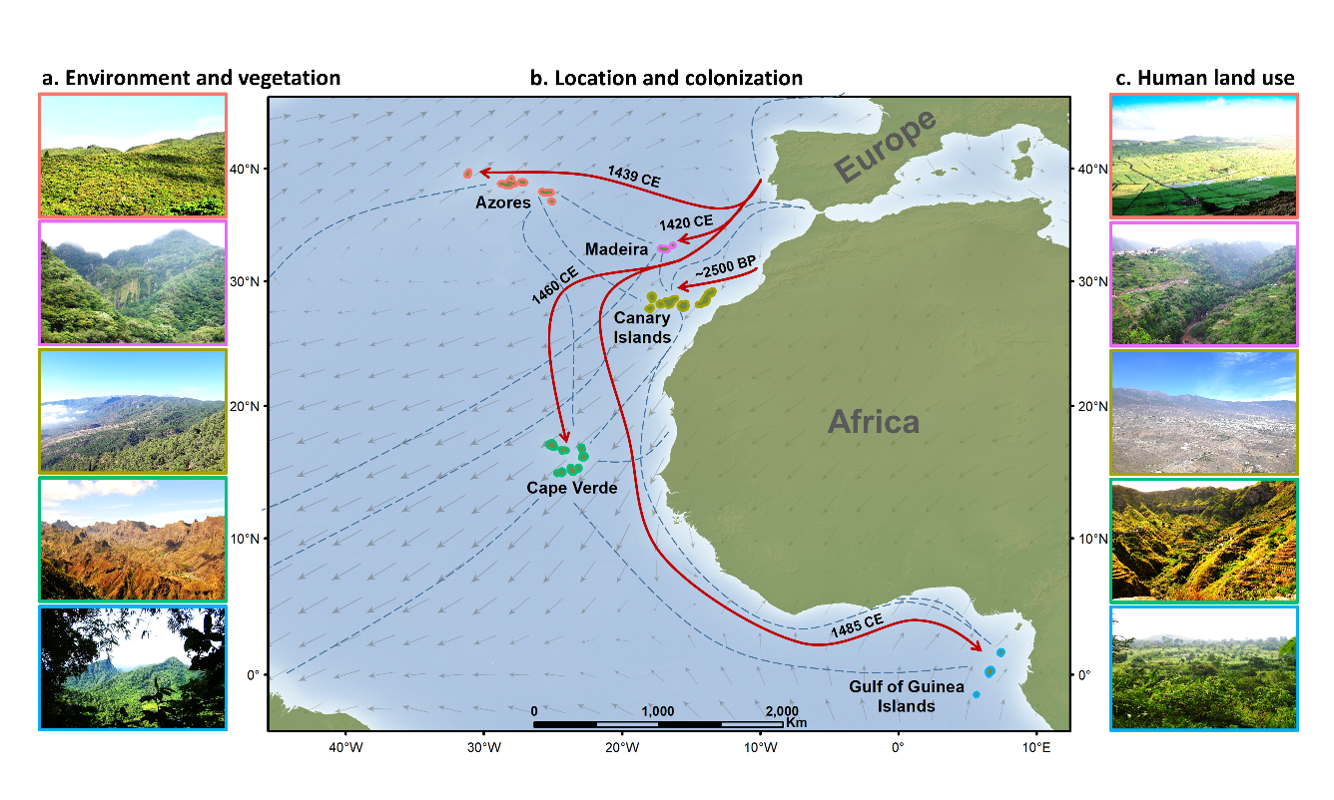
[Fig. 1. Contrasting environmental and societal conditions, and location of 30 Eastern Atlantic Islands within five Archipelagos (Azores, Madeira, Canary Islands, Cape Verde, Gulf of Guinea Islands) off the coasts of Africa and southern Europe. a) Environmental context and vegetation cover of the five archipelagos. For each archipelago we selected one island as an example (from top to bottom: Terceira for the Azores, Madeira Island for Madeira, Tenerife for the Canary Islands, Santo Antão for Cape Verde, and São Tomé for the Gulf of Guinea Islands). b) Location of the archipelagos, their colonization history and trade connections. Red arrows indicate the year of first human settlement and approximate colonization route. The Canary Islands were first colonized from northwest Africa (Fregel et al., 2019; Navarro, 1997), the remaining archipelagos were initially colonized from the Iberian Peninsula (Fernández-Palacios et al., 2016a). Blue stippled lines indicate historical connections between different localities (travel, trade, transport), illustrating that the Eastern Atlantic Islands were at the nexus of the emerging transatlantic trade networks. Grey arrows indicate prevailing wind direction and speed; although ocean currents and wind regimes may have shifted over much longer timescales (Fernández-Palacios et al., 2016b), for the period considered here the direction of the trade winds was similar to the present-day (Dartnell, 2018). Prevailing wind direction and speed in panel b were calculated with R (version 3.5.3) (R Core Team, 2019) from data on long-term monthly means of the u and v component (obtained from https://www.esrl.noaa.gov/). CE = Common Era, BP = Before Present. c) Differences in human land use across the archipelagos (islands are the same as in panel a). Although prior to the 15th century, the Atlantic had been extensively navigated by the Vikings (Dugmore et al., 2012), who possibly colonized some of the Eastern Atlantic Islands (Gabriel et al., 2015), we did not consider this due to the uncertainty in the onset and impact of possible Viking settlements. All photos in panel A and C were taken by the authors.
The human-environment interactions that evolved on the Eastern Atlantic islands were microcosmic experiments that shaped subsequent interactions in other islands and in mainland locations across the globe (Crosby, 1984; Moore, 2015). This microcosm is illustrated by the global history of sugar, for example, whereby the islands acted as testing grounds for sugar colonies that were later established in the Caribbean, Brazil and elsewhere around the world (Galloway, 1989; Mann, 2011; Mintz, 1986). Of the five archipelagos included in this study, as far as we know only the Canary Islands had a human population when Europeans arrived in the 15th century. The conquest of these islands by the Castilians started in 1402 and decimated the native population (Crosby, 1984). Whereas the native population of the Canary Islands had a notable impact on the islands (Morales et al., 2009), the conquest of these islands and colonization of the previously uninhabited Eastern Atlantic Islands by Europeans in the 15th century caused further transformations of the islands’ landscapes and ecosystems (Fernández-Palacios et al., 2016a). During the Age of Exploration (early 15th century to mid-17th century), these islands became stepping stones in emerging maritime trade routes, and facilitated the transport of plants, people, and materials between Europe, the Americas, Africa, and Asia (Crosby, 1972). Despite their pivotal role in propelling human-induced changes to a global scale, these islands have not received much attention as microcosms of global change.

Material and methods

Island-level data on environment and society
To test the relative importance of environmental and human drivers of native vegetation cover across islands, we considered several topographic, climatic, and societal variables. As proxies for island topography, we compiled data on island area (km²) and maximum elevation (m), and calculated the island-level mean of the Terrain Ruggedness Index (Riley et al., 1999) from NASA Shuttle Radar Topography Mission (SRTM) data. We downloaded void filled data from the United States Geological Survey (https://earthexplorer.usgs.gov/) at the highest available resolution (1-arcsecond, or approximately 30 meters). While island topography is constantly changing as a result of geomorphological processes like volcanic eruptions and erosion, the effect of these processes on island-wide topography is negligible at the timescale of centuries considered in this study. For climate variables, we used the long-term annual mean temperature (°C) and precipitation (mm/year) from the WorldClim 2 database (http://worldclim.org/version2) (Fick and Hijmans, 2017), calculated over the period 1970-2000 (see map in Fig A.1 for Köppen-Geiger classification per archipelago). While climate fluctuations between 1500 and 1800 had serious repercussions for socioeconomic developments in continental Europe (Zhang et al., 2011), their impact was likely smaller on the Eastern Atlantic islands, due to the buffering effect of the surrounding ocean (Cronk, 1997). In addition, while temperatures in the Eastern Atlantic were approximately 3 °C lower during the Little Ice Age (1400-1700 CE) compared to recent years, the anomalies are relatively consistent across the islands considered in this study (Mann et al., 2009). Therefore, using modern topographic and climatic variables for understanding human-environment interactions over the last centuries will not change patterns across islands.
As potential societal drivers of native vegetation cover, we included modern population density and used an index of human landscape modification (Kennedy et al., 2019). We calculated average population densities by dividing modern human population size (see Table A.1 for sources) by island area. The index of human landscape modification was obtained from a global spatially explicit dataset on cumulative human modification of terrestrial lands at 1km² resolution (Kennedy et al., 2019). The index is based on spatial patterns of human settlement, agriculture, transportation, mining, energy production, and electrical infrastructure (Kennedy et al., 2019). Calculating the island-level mean from this database therefore reflects both the extent and intensity to which human activities transformed the landscape of a particular island. Data pre-processing for these quantitative variables was performed with R (version 3.5.3) (R Core Team, 2019). Table A2 provides the full dataset.

Island-level data on native vegetation cover
We defined native vegetation cover as the total land area of an island that is predominantly covered by native plants (species that were present on the islands prior to human arrival). Total native vegetation cover can therefore include both forest and non-forest vegetation, and can consist of primary as well as secondary vegetation. Introduced plants are widespread across all Eastern Atlantic Islands (Castro et al., 2010; Jardim and Menezes de Sequeira, 2008) and it can be challenging to determine the chorological status for individual species (van Leeuwen et al., 2008). Therefore, we compiled data on native vegetation cover for each island from different sources. For islands that had land use/land cover maps available, we assumed the extent of native vegetation to be delimited by areas labelled as ‘native vegetation’ or ‘natural vegetation’. In other cases, we determined which labels most closely matched the definition. For the Azores we used the area classified as ‘natural vegetation’ from the land cover map of the regional council (Secretaria Regional do Ambiente e do Mar, 2007). This category includes secondary forests and non-forest areas that largely consist of native species but also grasslands that are relatively poor in terms of native communities. As a consequence, the map for the Azores likely overestimates native vegetation cover (Connor et al., 2012). To see if this would affect our results, we re-ran our analyses with an alternate, more conservative definition of native vegetation for the Azores, where only the extent of remnant patches of native forest was included (Gaspar et al., 2011). For Madeira, we obtained data from the European Nature Information System database (European Environment Agency, 2018), which included a mix of vegetation types consisting of native shrubs and secondary vegetation, but also contained an unknown percentage of exotic vegetation. For the Canary Islands, we summed the total cover of the areas classified as ‘actual natural vegetation’ (Table 1 in del Arco Aguilar et al., 2010), which included secondary vegetation types. We did not include: nitrophilous herb communities, of which the spread is mainly a result of grazing (del Arco Aguilar et al., 2010), secondary vegetation with a high proportion of exotic species, or plantations of Canary pine. For Cape Verde, we digitized maps of the agro-ecological zones per island (Diniz and de Matos, 1999, 1994, 1993, 1988, 1987, 1986) and made an overlay with a global land use land cover map (ESA, 2017) in a Geographic Information System (ArcGIS version 10.6.1). The resulting maps were classified into different land use/land cover classes. Within the arid zones, grasses (Poaceae) are most common in terms of species richness and we assumed that 50% of the vegetation cover in these zones is predominantly native. For the Gulf of Guinea Islands, we obtained data for São Tomé and Príncipe from Jones and Tye (2006) and sources therein; these data include both primary and secondary forest. For Annobón, we made an overlay of the island’s vegetation map (Heras et al., 2002) and the land cover map of Equatorial Guinea (Ministerio de Agricultura y Bosques, 2013) to assess the percentage of native vegetation cover. To complement these quantitative data on native vegetation cover per island, we did a more in-depth qualitative assessment of the biodiversity changes during human contact (Table A.3), including the vegetation cover around the time of first human colonization as a reference point (Braje et al., 2017; Nogué et al., 2017) as well as the current biodiversity status of each archipelago.

Statistical Analyses
We used native vegetation cover as the response variable and evaluated the relative importance of seven environmental and societal variables: terrain ruggedness, island area, maximum elevation, mean annual temperature, mean annual precipitation, human landscape modification, and population density. We first calculated the variance inflation factors (VIF) to assess collinearity among predictor variables, including only variables with VIF < 3 (Zuur et al., 2010). To understand how islands are clustered in terms of environmental and societal variables in relation to the response variable native vegetation cover, we did a partial least squares regression analysis (Frank and Friedman, 1993; Hastie et al., 2009). This method combines the principles of a principal component analysis and multiple linear regression to decompose the matrix of several predictor variables into components, or latent variables, which predict the response variable. The latent variables are formed such that these explain the maximum amount of variance in the response variable. We used the kernel algorithm (Dayal and Macgregor, 1997) to fit the model. A permutation approach was used to select the appropriate number of components in the model (Hastie et al., 2009). We carried out the partial least squares regression analysis using functions from the R-package pls (Mevik and Wehrens, 2007). To assess whether islands are clustered by archipelago in terms of environmental and societal variables (regardless of native vegetation cover), we plotted the results of a principal component analysis. Finally, to identify the most important environmental and societal variables that contributed to the response variable native vegetation cover, we did a multiple linear regression analysis using all seven predictor variables (the ‘full model’). As a complementary approach to fitting the full model, we also followed a model averaging approach. All statistical analyses were performed within the R statistical programming environment (version 3.5.3) (R Core Team, 2019).

Historic socioeconomic trends at the archipelago-level
The quantitative societal variables which we used in our statistical analyses represent modern conditions and can aid in discerning spatial patterns across islands. However, societal conditions on individual islands and archipelagos may have changed irregularly over time. For example, population density on some archipelagos during past periods may have been higher than today. Therefore, we compiled demographic data for each archipelago to explore historical fluctuations in population density (see Table A.1 for sources). Similarly, modern patterns of landscape modification are the ultimate outcome of historical human-environment interactions. To understand the historical context of the archipelagos, we made a qualitative reconstruction of past socioeconomic trends based on information from historical descriptions and academic articles. We placed emphasis on 1) the economic importance of agricultural production for local consumption within the archipelago, relative to 2) the export and trade of food crops, commodities, and slaves. For each archipelago this resulted in a summary of the main socioeconomic developments per century (see Tables A.4-A.8 in the appendix). To facilitate a comparison across archipelagos, we made a visualization of the main historical socioeconomic trends in each of them. We did this by scoring the relative importance of both categories on a scale ranging from ‘low’ to ‘high’. A century was divided in four sections of 25 years, and a score was assigned to the closest interval (e.g. if historical descriptions indicate a peak around the year 1506, we assigned a score between 1500 and 1525). These importance scores were subsequently plotted over time with a smooth line connecting the points. We added icons to the timeline to indicate major crops or activities (e.g. a peak in sugar cane production). These visualizations were made to gain insight in differences across archipelagos regarding the timing and direction of historical socioeconomic developments, not for a quantitative comparison in terms of the magnitude of events.

Results
The first and second axes of the partial least squares regression analysis explain nearly 70% of the variation in native vegetation cover, of which more than 60% by the first axis alone, which is mainly correlated with terrain ruggedness and elevation (Fig. 2). This suggests that native vegetation cover is more influenced by topographic conditions of individual islands than by societal and climatic variables. In addition, islands within an archipelago did not seem to be strongly clustered. A principal component analysis of socio-environmental variables (without native vegetation cover) confirms this pattern: islands within the same archipelago are not strongly clustered along the first and second axes (Fig. A.2), but show some grouping along the third axis, mainly related to climatic differences (Fig. A.3).
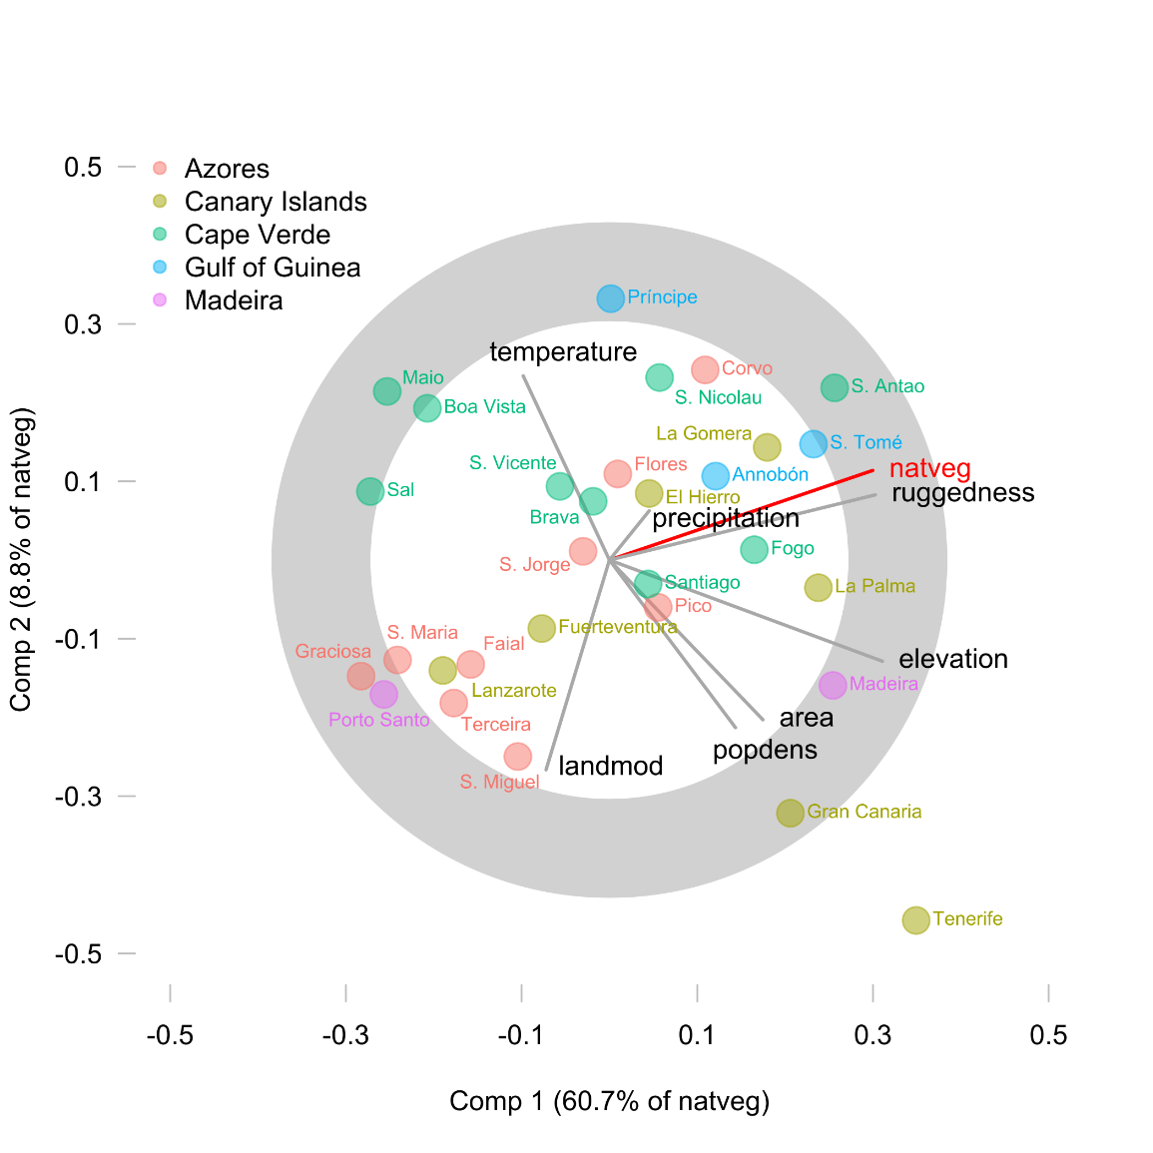
[Fig. 2. Covariation of topographic, climatic and societal variables, as obtained from the partial least squares regression analysis (see Methods), to explain variation in native vegetation cover (natveg) across the 30 Eastern Atlantic Islands. Latent variables are constructed based on variables related to topography (ruggedness, area, elevation), climate (temperature, precipitation), and society (human landscape modification, population density). The length of the grey lines is indicative of the importance of each predictor in constructing the latent variables. The grey band indicates that the correlation of a predictor variable or the response variable with the first and second latent variable is higher than 50%. See Table A.10 for coefficients of the partial least square regression model.]
The variance inflation factors of each of the seven topographic, climatic, and societal variables in the full model were below 3 (Table A.9), suggesting that collinearity did not strongly affect the model. The regression analysis shows that terrain ruggedness (Fig. 3a) explains over 45% of the variance in native vegetation cover across the 30 Eastern Atlantic islands. In addition to terrain ruggedness, maximum elevation and degree of landscape modification also play a role. Island area and temperature also explained some of the variance, while the effect of population density and precipitation was negligible. The partial response of native vegetation cover to ruggedness, while controlling for the effect of other variables in the full model, highlights the importance of this key explanatory variable (Fig. 3b). We ran additional analyses for a second dataset in which for the Azores we only considered native forest as native vegetation. While individual parameter values changed, the overall trends remained the same (Fig. A.4). Finally, model averaging yielded comparable results to those of fitting the full model (Fig. A.5).
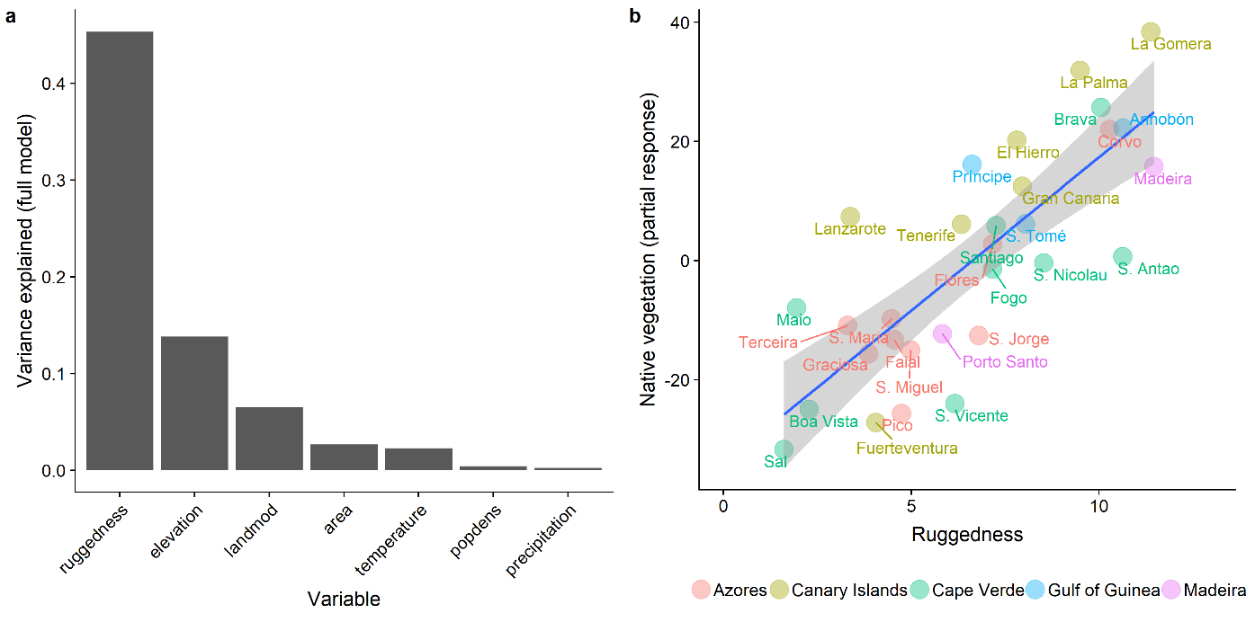
[Fig. 3. The effect of environmental and societal variables on native vegetation cover across 30 Eastern Atlantic Islands. Results were obtained by fitting a multiple linear regression model consisting of seven topographic, climatic and societal variables (‘full model’), using native vegetation cover as a response. a) Contribution of each predictor in the full model to the explained variance in native vegetation cover. The full model could explain 71.3% (R²) of the variance, 45.3% of which is explained by ruggedness alone. b) Partial residual plot showing the relationship between ruggedness and the partial response of native vegetation cover in the full model.]
In our statistical analyses, societal variables appear to be of lesser importance than topographic variables in shaping native vegetation cover. While human landscape modification had some influence, population density had a negligible effect. However, modern population density is not representative of the entire period since initial human settlement. While in some archipelagos human population density grew steadily, others witnessed steep fluctuations (Fig. 4a). For most of the last five centuries population density of the Azores was higher than in the Canary Islands and Gulf of Guinea Islands, but this was reversed halfway through the 20th century. In the Azores and Madeira population density is currently below its peak in the 20th century. In addition to these demographic changes we also find strong differences across archipelagos regarding their historical socioeconomic developments (Tables A.4-A.8; Fig. 4b-f). For example, sugar cane has been introduced to islands of all five archipelagos, but the extent to which the crop affected the local economy and environment differed. Sugar cane production was produced at a large scale especially in Madeira and later in the Gulf of Guinea Islands (Fig. 4c,f; Tables A.5 and A.8). When the importance of sugar production dwindled in these archipelagos, the sugar cane commodity frontier moved away from the Eastern Atlantic to other parts of the world such as the Caribbean and Latin America (Galloway, 1989). Subsequently, the economies of Madeira and the Gulf of Guinea switched to other forms of income but kept their focus on exports; such as wine in Madeira and slaves, coffee and cocoa in the Gulf of Guinea. The socioeconomic histories of Madeira and the Gulf of Guinea contrast with that of the Azores, and to a lesser extent also that of the Canary Islands (Fig. 4b,d; Tables A.4 and A.6), which likely retained a larger degree of food self-sufficiency. On Cape Verde, crop cultivation was of little importance and its economy was centred on activities that were less bound to the land, such as salt export, and commercial exchanges, being an important entrepôt for ship fuelling and for the slave trade (Fig. 4e; Table A.7).
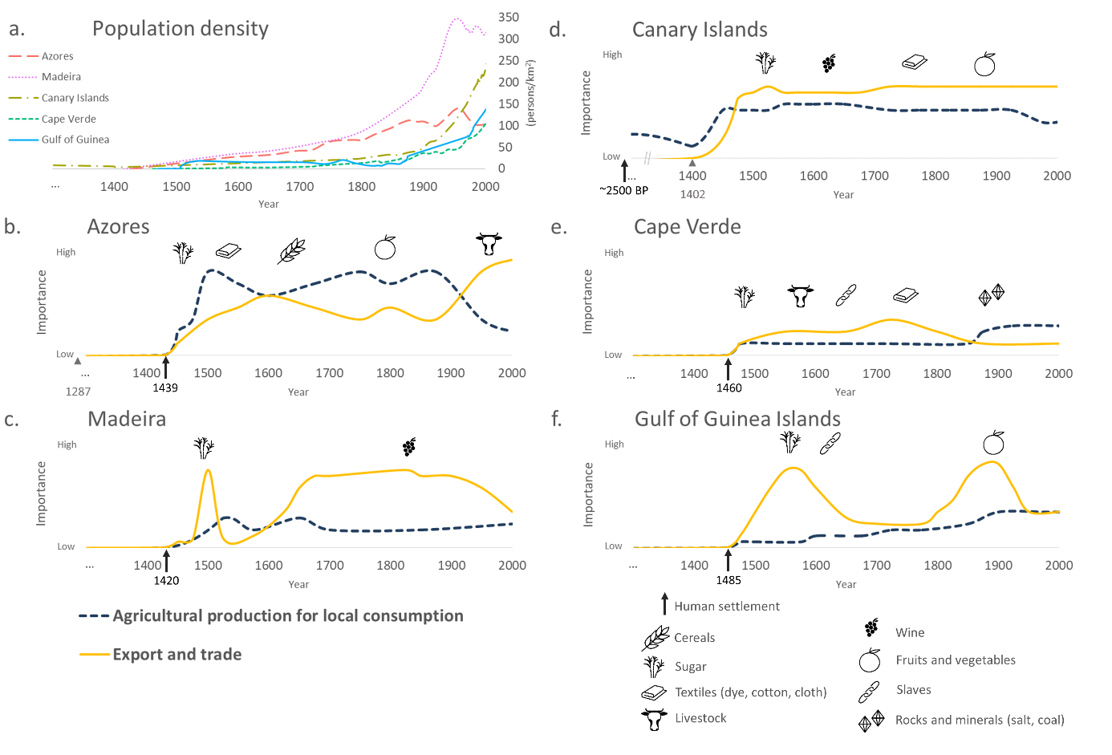
[Fig. 4. Historical demographic and socioeconomic changes in the Eastern Atlantic archipelagos (ordered from North to South). a) Changes in population density per archipelago. Population density was estimated from the sources in Table A.1; those years for which no census data were available were interpolated. b-f) Visualization of changes in export and trade, and in agricultural production for local consumption for each archipelago. The X-axes indicate the years (CE), while the Y-axes show the relative economic importance of agricultural production for local consumption, and of export and trade of food crops, commodities, and slaves. The visualizations are based on the historical descriptions in Tables A.4-A.8. The icons illustrate crops and events of major importance. Black arrows indicate years of first human settlement (Tables A.4-A.8), grey arrows indicate other colonization events: possible earlier settlement year in the Azores (Rull et al., 2017) and start of the Castilian conquest in the Canary Islands.]

Discussion

Island ruggedness, land use decisions and native vegetation
Results of the statistical analysis indicate that terrain ruggedness plays a key role in shaping native vegetation cover. A possible explanation for this observed relationship is that on rugged islands, people actively cleared native vegetation and implemented agriculture mostly in the more accessible – less rugged – areas. The fact that ruggedness holds an inverse relationship with human landscape modification lends further support to this interpretation (Fig. 2; Fig. A.6). The results are in line with Sandel and Svenning (2013) who found that topographic slope over broad spatial scales (500 m – 32 km resolution) drives human impact on tree cover globally. While ruggedness and slope represent different aspects of a landscape, topographic variables are often strongly correlated (Amatulli et al., 2018), and therefore suggest that topography is an important determinant of vegetation cover across spatial scales. A rugged landscape might help to conserve areas of native vegetation cover by limiting their accessibility, a phenomenon known as de facto conservation (Joppa et al., 2008). In addition, rugged areas likely have shallower soils, which could affect agricultural suitability. A more rugged landscape not only prevents land use change and deforestation, other studies suggest that it could also affect other biodiversity aspects, such as extinction rates and the spread of introduced species (Borges et al., 2006; Duncan et al., 2013; Jardim and Menezes de Sequeira, 2008; Steadman, 1995; Steadman and Martin, 2003). Therefore, to ensure the conservation of island biodiversity and native habitats, regional conservation policies should prioritize biodiversity hotspots in accessible locations. Furthermore, because islands are leading loci of the global sixth mass extinction (Barnosky et al., 2011; Kier et al., 2009), they deserve strong international support while developing, implementing, and monitoring such conservation policies.

Human impacts and population density in the past
While some studies have used human population density to predict future global biodiversity changes (McKee et al., 2004) and suggested it is an important factor in guiding global conservation efforts (Ceballos et al., 2017; Cincotta et al., 2000; Tilman et al., 2017), others have cautioned about placing too much emphasis on population density as a driver of land cover change (Geist and Lambin, 2006; Lambin et al., 2001). On islands, the relationship between population density and native vegetation could be expected to be particularly strong, since they are clearly constrained by physical boundaries. In contrast to this expectation, we find that human density on the 30 Eastern Atlantic Islands was a poor predictor of the amount of native vegetation remaining on those islands. One explanation for this discrepancy is that the link between human population density and biodiversity change at local and regional scales might be less straightforward than at the global scale as environmental impacts can be exported offshore. In addition, we used modern population density as predictor in our statistical models, while much of the transformation of island ecosystems has already happened in the past when population density of an island and local resource use were arguably more closely intertwined (Norder et al., 2017). On Hawaii, for example, rapid historical population growth was closely linked with agricultural intensification in the past (Kirch, 2007). Native vegetation cover on islands in the Eastern Atlantic might therefore better reflect past demographic fluctuations, rather than modern population density. For example, modern population density of the Canary Islands and Gulf of Guinea exceeds that of the Azores, while for most of the previous five centuries this pattern was the opposite.
Similar to historical changes in demography, modern patterns of landscape modification also deviate from those in the past. We did not incorporate any measure of past landscape modification as potential predictor in our statistical models. Because historical land use has strong legacies on present-day biodiversity patterns (Foster et al., 2003), for future studies it would be relevant to include historical land use data as well. However, while an existing spatially explicit database of historical land use (Klein Goldewijk et al., 2011) could allow for such analyses on a global scale, its resolution is currently too coarse for many islands. With the development of global databases at finer resolutions such analyses might become increasingly feasible. Another approach for future comparative studies like ours could be to include categorical variables that classify the history of an island. For example, regarding subsistence strategies (Rick et al., 2013), or if an island was later colonized by Europeans, the type of colony that was established (Lightfoot et al., 2013). However, while such an approach could help discerning patterns across islands, it ‘flattens’ history; there seems to be a trade-off between historical depth and geographical generalizability. While mixed-method approaches that integrate qualitative written historical evidence with quantitative statistical approaches (Haldon et al., 2018), could enhance our understanding of human-environment interactions across spatial and temporal scales, such integration should not necessarily be achieved in a single study. In this study, we compared islands in terms of modern socio-environmental variables and used historical reconstructions to contextualize statistical findings. Future studies could explore the extent to which historical socioeconomic developments match the timing of environmental changes stored in pollen diagrams or charcoal records (de Nascimento et al., 2009; Gosling et al., 2017; Nogué et al., 2017).

Local human-environment interactions in the anthropocene
The loss of native habitat is just one aspect of the ecological changes in the Eastern Atlantic Islands following human colonization. The islands have further been transformed due to the introduction of exotic species, extinction of natives and endemics, and abiotic changes, such as soil erosion (Table A.3). The Eastern Atlantic Islands are not unique in this regard, other islands worldwide have been transformed by human activities in similar ways (Boivin et al., 2016; Braje et al., 2017; Graham et al., 2017; Rick et al., 2013). In the Eastern Atlantic Islands, the ecological outcomes of human activities appear to be strongly influenced by the local environmental context, with island topography playing a major role. Similar findings have been reported for other islands worldwide. In the Caribbean, for example, prehistoric people transformed island environments, but also adapted to them (Fitzpatrick and Keegan, 2007). In the Pacific, deforestation was found to be the outcome of environmental drivers as well as cultural responses shaped by environmental constraints (Atkinson et al., 2016). In many places around the world, including many islands, people have altered their surroundings for hundreds to thousands of years (Stephens et al., 2019). These local changes have accumulated and are now driving changes at a planetary scale. The recognition that human activities have become key drivers of global change in ecosystems and environments is key to the proposed “Anthropocene” epoch (Crutzen and Stoermer, 2000; Steffen et al., 2007). Anthropocene narratives tend to present humanity as the single driving force of global change, with nature as a passive receiver, while neglecting the preceding local-and regional scale interactions between societies and environments (Braje, 2015; Braje and Erlandson, 2013b; Rick et al., 2013). In the Eastern Atlantic islands, human impacts are shaped by and situated within environmental contexts. This underscores that although human impacts have become a major force in planetary change, the Anthropocene is not only the product of anthropogenic drivers, but is co-produced by many local societies and environments.

Conclusions
The aim of this study was to understand to what extent environmental and societal drivers explain differences in present-day native vegetation cover across islands in the Eastern Atlantic. There are two main conclusions that emerge from this paper. First, the results of our statistical analyses indicate that environmental variables explain a large part of the variance in native vegetation cover across islands. Of all variables considered, terrain ruggedness was the predominant driver of native vegetation cover, which suggests that topography influences human decisions about land conversion. Second, although all Eastern Atlantic islands have been strongly transformed by human activities, differences between islands regarding native vegetation cover were weakly explained by modern societal variables such as human population density. However, these modern societal variables might not accurately represent past developments, as indicated by the qualitative reconstructions of past socioeconomic trends. Therefore, modern biodiversity patterns on islands should be viewed in the context of how human-environment interactions that have evolved over the last centuries to millennia. While in the recent literature much emphasis has been placed on global modelling approaches and on the analysis of iconic cases, studies that compare human-environment interactions across different locations might be particularly suitable for exploring potential pathways towards sustainable futures in the Anthropocene.

References
Amatulli, G., Domisch, S., Tuanmu, M.N., Parmentier, B., Ranipeta, A., Malczyk, J., Jetz, W., 2018. Data Descriptor: A suite of global, cross-scale topographic variables for environmental and biodiversity modeling. Sci. Data 5, 1–15. doi:10.1038/sdata.2018.40
Atkinson, Q.D., Coomber, T., Passmore, S.H., Greenhill, S.J., Kushnick, G., 2016. Cultural and environmental predictors of pre-European deforestation on Pacific Islands. PLoS One 1–15. doi:10.1371/journal.pone.0156340
Barnosky, A.D., Matzke, N., Tomiya, S., Wogan, G.O.U., Swartz, B., Quental, T.B., Marshall, C., McGuire, J.L., Lindsey, E.L., Maguire, K.C., Mersey, B., Ferrer, E. a, 2011. Has the Earth’s sixth mass extinction already arrived? Nature 471, 51–57. doi:10.1038/nature09678
Biermann, F., Bai, X., Bondre, N., Broadgate, W., Arthur Chen, C.T., Dube, O.P., Erisman, J.W., Glaser, M., van der Hel, S., Lemos, M.C., Seitzinger, S., Seto, K.C., 2016. Down to Earth: contextualizing the Anthropocene. Glob. Environ. Chang. 39, 341–350. doi:10.1016/j.gloenvcha.2015.11.004
Boivin, N.L., Zeder, M.A., Fuller, D.Q., Crowther, A., Larson, G., Erlandson, J.M., Denham, T., Petraglia, M.D., 2016. Ecological consequences of human niche construction: Examining long-term anthropogenic shaping of global species distributions. Proc. Natl. Acad. Sci. U. S. A. 113, 6388–96. doi:10.1073/pnas.1525200113
Borges, P.A.V., Lobo, J.M., De Azevedo, E.B., Gaspar, C.S., Melo, C., Nunes, L. V., 2006. Invasibility and species richness of island endemic arthropods: A general model of endemic vs. exotic species. J. Biogeogr. 33, 169–187. doi:10.1111/j.1365-2699.2005.01324.x
Braje, T.J., 2015. Earth systems, human agency, and the Anthropocene: planet Earth in the human age. J. Archaeol. Res. 23, 369–396. doi:10.1007/s10814-015-9087-y
Braje, T.J., Erlandson, J.M., 2013a. Human acceleration of animal and plant extinctions: A Late Pleistocene, Holocene, and Anthropocene continuum. Anthropocene 4, 14–23. doi:10.1016/j.ancene.2013.08.003
Braje, T.J., Erlandson, J.M., 2013b. Looking forward, looking back: humans, anthropogenic change, and the Anthropocene. Anthropocene 4, 116–121. doi:10.1016/j.ancene.2014.05.002
Braje, T.J., Leppard, T.P., Fitzpatrick, S.M., Erlandson, J.M., 2017. Archaeology, historical ecology and anthropogenic island ecosystems. Environ. Conserv. 44, 286–297. doi:10.1017/S0376892917000261
Brondizio, E.S., O’Brien, K., Bai, X., Biermann, F., Steffen, W., Berkhout, F., Cudennec, C., Lemos, M.C., Wolfe, A., Palma-Oliveira, J., Chen, C.T.A., 2016. Re-conceptualizing the Anthropocene: a call for collaboration. Glob. Environ. Chang. 39, 318–327. doi:10.1016/j.gloenvcha.2016.02.006
Cardillo, M., Mace, G.M., Gittleman, J.L., Purvis, A., 2006. Latent extinction risk and the future battlegrounds of mammal conservation. Proc. Natl. Acad. Sci. U. S. A. 103, 4157–4161. doi:10.1073/pnas.0510541103
Castro, S.A., Daehler, C.C., Silva, L., Torres-Santana, C.W., Reyes-Betancort, J.A., Atkinson, R., Jaramillo, P., Guezou, A., Jaksic, F.M., 2010. Floristic homogenization as a teleconnected trend in oceanic islands. Divers. Distrib. 16, 902–910. doi:10.1111/j.1472-4642.2010.00695.x
Ceballos, G., Ehrlich, P.R., Dirzo, R., 2017. Biological annihilation via the ongoing sixth mass extinction signaled by vertebrate population losses and declines. Proc. Natl. Acad. Sci. U. S. A. 114, E6089–E6096. doi:10.1073/pnas.1704949114
Cincotta, R.P., Wisnewski, J., Engelman, R., 2000. Human populations in the biodiversity hotspots. Nature 404, 990–992.
Connor, S.E., van Leeuwen, J.F.N., Rittenour, T.M., van der Knaap, W.O., Ammann, B., Björck, S., 2012. The ecological impact of oceanic island colonization - a palaeoecological perspective from the Azores. J. Biogeogr. 39, 1007–1023. doi:10.1111/j.1365-2699.2011.02671.x
Costanza, R., Graumlich, L., Steffen, W., Crumley, C., Dearing, J., Hibbard, K., Leemans, R., Redman, C., Schimel, D., 2007. Sustainability or collapse: what can we learn from integrating the history of humans and the rest of nature? Ambio 36, 522–527. doi:10.1579/0044-7447(2007)36[522:SOCWCW]2.0.CO;2
Cronk, Q.C.B., 1997. Islands: stability, diversity, conservation. Biodivers. Conserv. 6, 477–493. doi:10.1023/A:1018372910025
Crosby, A.W., 1984. An ecohistory of the Canary Islands: a precursor of European colonization in the New World and Australasia. Environ. Rev. 8, 214–235.
Crosby, A.W., 1972. The columbian exchange: biological and cultural consequences of 1492. Greenwood Publishing.
Crutzen, P.J., Stoermer, E.F., 2000. The Anthropocene. Glob. Chang. Newsl. 41, 17–18.
Dartnell, L., 2018. Origins: how the Earth made us. The Bodley Head, London.
Dayal, B.S., Macgregor, J.F., 1997. Improved PLS Algorithms. J. Chemom. 11, 73–85.
de Nascimento, L., Willis, K.J., Fernández-Palacios, J.M., Criado, C., Whittaker, R.J., 2009. The long-term ecology of the lost forests of la Laguna, Tenerife (Canary Islands). J. Biogeogr. 36, 499–514. doi:10.1111/j.1365-2699.2008.02012.x
Dearing, J.A., Acma, B., Bub, S., Chambers, F.M., Chen, X., Cooper, J., Crook, D., Dong, X.H., Dotterweich, M., Edwards, M.E., Foster, T.H., Gaillard, M.J., Galop, D., Gell, P., Gil, A., Jeffers, E., Jones, R.T., Anupama, K., Langdon, P.G., Marchant, R., Mazier, F., McLean, C.E., Nunes, L.H., Sukumar, R., Suryaprakash, I., Umer, M., Yang, X.D., Wang, R., Zhang, K., 2015. Social-ecological systems in the Anthropocene: The need for integrating social and biophysical records at regional scales. Anthr. Rev. 2, 220–246. doi:10.1177/2053019615579128
del Arco Aguilar, M.-J., González-González, R., Garzón-Machado, V., Pizarro-Hernández, B., 2010. Actual and potential natural vegetation on the Canary Islands and its conservation status. Biodivers. Conserv. 19, 3089–3140. doi:10.1007/s10531-010-9881-2
Dinapoli, R.J., Leppard, T.P., 2018. Islands as model environments. J. Isl. Coast. Archaeol. 13, 157–160. doi:10.1080/15564894.2017.1311285
Diniz, A.C., de Matos, G.C., 1999. Carta de zonagem agro-ecológica e da vegetação de Cabo Verde IV. Ilha de Santo Antão & Ilha de S. Nicolau & Ilha Brava. Garcia de Orta, Série de Botânica 14, 1–82.
Diniz, A.C., de Matos, G.C., 1994. Carta de zonagem agro-ecológica e da vegetação de Cabo Verde VII. Ilha de Santa Luzia & Ilha de S. Vicente. Garcia de Orta, Série de Botânica 12, 69–100.
Diniz, A.C., de Matos, G.C., 1993. Carta de zonagem agro-ecológica e da vegetação de Cabo Verde IV. Ilha do Sal. Garcia de Orta, Série de Botânica 11, 9–30.
Diniz, A.C., de Matos, G.C., 1988. Carta de zonagem agro-ecológica e da vegetação de Cabo Verde IV. Ilha de Maio & Ilha da Boavista. Garcia de Orta, Série de Botânica 10, 19–72.
Diniz, A.C., de Matos, G.C., 1987. Carta de zonagem agro-ecológica e da vegetação de Cabo Verde II. Ilha do Fogo. Garcia de Orta, Série de Botânica 9, 35–70.
Diniz, A.C., de Matos, G.C., 1986. Carta de zonagem agro-ecológica e da vegetação de Cabo Verde VII. Ilha de Maio. Garcia de Orta, Série de Botânica 8, 39–82.
Dugmore, A.J., McGovern, T.H., Vesteinsson, O., Arneborg, J., Streeter, R., Keller, C., 2012. Cultural adaptation, compounding vulnerabilities and conjunctures in Norse Greenland. Proc. Natl. Acad. Sci. U. S. A. 109, 3658–3663. doi:10.1073/pnas.1115292109
Duncan, R.P., Boyer, A.G., Blackburn, T.M., 2013. Magnitude and variation of prehistoric bird extinctions in the Pacific. Proc. Natl. Acad. Sci. U. S. A. 110, 6436–6441. doi:10.1073/pnas.1216511110
ESA, 2017. climate change initiative land cover map v2.07 for year 2015.
European Environment Agency, 2018. EUNIS - European Nature Information System [WWW Document]. URL https://eunis.eea.europa.eu/
Fernández-Palacios, J.M., Nogué, S., Criado, C., Connor, S., Góis-Marques, C., Sequeira, M., de Nascimento, L., 2016a. Climate change and human impact in Macaronesia. Past Glob. Chang. Mag. 24, 68–69. doi:10.22498/pages.24.2.68
Fernández-Palacios, J.M., Rijsdijk, K.F., Norder, S.J., Otto, R., de Nascimento, L., Fernández-Lugo, S., Tjørve, E., Whittaker, R.J., 2016b. Towards a glacial-sensitive model of island biogeography. Glob. Ecol. Biogeogr. 25, 817–830. doi:10.1111/geb.12320
Fick, S.E., Hijmans, R.J., 2017. WorldClim 2: new 1-km spatial resolution climate surfaces for global land areas. Int. J. Climatol. 37, 4302–4315. doi:10.1002/joc.5086
Fitzpatrick, S.M., Keegan, W.F., 2007. Human impacts and adaptations in the Caribbean Islands: An historical ecology approach. Earth Environ. Sci. Trans. R. Soc. Edinburgh 98, 29–45. doi:10.1017/S1755691007000096
Fordham, D.A., Brook, B.W., 2010. Why tropical island endemics are acutely susceptible to global change. Biodivers. Conserv. 19, 329–342. doi:10.1007/s10531-008-9529-7
Foster, D., Swanson, F., Aber, J., Burke, I., Brokaw, N., Tilman, D., Knapp, A., 2003. The importance of land-use legacies to ecology and conservation. Bioscience 53, 77–88. doi:10.1641/0006-3568(2003)053[0077:TIOLUL]2.0.CO;2
Frank, I.E., Friedman, J.H., 1993. A statistical view of some chemometrics regression tools. Technometrics 35, 109–135. doi:10.2307/1269658
Fregel, R., Ordóñez, A.C., Santana-Cabrera, J., Cabrera, V.M., Velasco-Vázquez, J., Alberto, V., Moreno-Benítez, M.A., Delgado-Darias, T., Rodríguez-Rodríguez, A., Hernández, J.C., Pais, J., González-Montelongo, R., Lorenzo-Salazar, J.M., Flores, C., Cruz-de-Mercadal, M.C., Álvarez-Rodríguez, N., Shapiro, B., Arnay, M., Bustamante, C.D., 2019. Mitogenomes illuminate the origin and migration patterns of the indigenous people of the Canary Islands. PLoS One 14, 1–24. doi:10.1371/journal.pone.0209125
Gabriel, S.I., Mathias, M.L., Searle, J.B., 2015. Of mice and the “Age of Discovery”: The complex history of colonization of the Azorean archipelago by the house mouse (Mus musculus) as revealed by mitochondrial DNA variation. J. Evol. Biol. 28, 130–145. doi:10.1111/jeb.12550
Galloway, J.H., 1989. The sugar cane industry: an historical geography from its origins to 1914. Cambridge University Press, Cambridge, UK. doi:10.2307/635470
Gaspar, C., Gaston, K.J., Borges, P.A. V, Cardoso, P., 2011. Selection of priority areas for arthropod conservation in the Azores archipelago. J. Insect Conserv. 15, 671–684. doi:10.1007/s10841-010-9365-4
Geist, H.J., Lambin, E.F., 2006. Proximate Causes and Underlying Driving Forces of Tropical Deforestation. Bioscience 52, 143. doi:10.1641/0006-3568(2002)052[0143:pcaudf]2.0.co;2
Gosling, W.D., de Kruif, J., Norder, S.J., de Boer, E.J., Hooghiemstra, H., Rijsdijk, K.F., McMichael, C.N.H., 2017. Mauritius on fire: Tracking historical human impacts on biodiversity loss. Biotropica 49, 778–783. doi:10.1111/btp.12490
Graham, N.R., Gruner, D.S., Lim, J.Y., Gillespie, R.G., 2017. Island ecology and evolution: challenges in the Anthropocene. Environ. Conserv. 44, 1–13. doi:10.1017/S0376892917000315
Haldon, J., Mordechai, L., Newfield, T.P., Chase, A.F., Izdebski, A., Guzowski, P., Labuhn, I., Roberts, N., 2018. History meets palaeoscience: consilience and collaboration in studying past societal responses to environmental change. Proc. Natl. Acad. Sci. U. S. A. 115, 3210–3218. doi:10.1073/pnas.1716912115
Hastie, T., Tibshirani, R., Friedman, J., 2009. The elements of statistical learning: data mining, inference, and prediction (second edition). Springer Series in Statistics, New York.
Heras, P., Infante, M., Ondó, C.O., Gascoigne, A., 2002. Vegetación de la isla de Annobón (República de Guinea Ecuatorial). Estud. del Mus. Ciencias Nat. Álava 17, 115–123.
Jardim, R., Menezes de Sequeira, M., 2008. The vascular plants (Pteridophyta and Spermatophyta) of the Madeira and Selvagens Archipelagos, in: Borges, P.A.V., Abreu, C., Aguiar, A.M.F., Carvalho, P., Jardim, Roberto, Melo, I., Oliveira, P., Sérgio, C., Serrano, A.R.M., Vieira, P. (Eds.), A List of the Terrestrial Fungi, Flora and Fauna of Madeira and Selvagens Archipelagos. pp. 157–178.
Jones, P., Tye, A., 2006. The Birds of Príncipe, São Tomé and Annobón. An annotated Checklist. Br. Ornithol. Union.
Joppa, L.N., Loarie, S.R., Pimm, S.L., 2008. On the protection of “protected areas.” Proc. Natl. Acad. Sci. U. S. A. 105, 6673–6678. doi:10.1073/pnas.0802471105
Kennedy, C.M., Oakleaf, J.R., Theobald, D.M., Baruch-Mordo, S., Kiesecker, J., 2019. Managing the middle: a shift in conservation priorities based on the global human modification gradient. Glob. Chang. Biol. 1–17. doi:10.1111/gcb.14549
Kier, G., Kreft, H., Lee, T.M., Jetz, W., Ibisch, P.L., Nowicki, C., Mutke, J., Barthlott, W., 2009. A global assessment of endemism and species richness across island and mainland regions. Proc. Natl. Acad. Sci. U. S. A. 106, 9322–9327. doi:10.1073/pnas.0810306106
Kirch, P. V., 1997. Microcosmic histories: island perspectives on “global” change. Am. Anthropol. 99, 30–42. doi:10.1525/aa.1997.99.1.30
Kirch, P. V, 2007. Hawaii as a model system for human ecodynamics. Am. Anthropol. 109, 8–26. doi:10.1525/AA.2007.109.1.8.Kirch
Klein Goldewijk, K., Beusen, A., Van Drecht, G., De Vos, M., 2011. The HYDE 3.1 spatially explicit database of human-induced global land-use change over the past 12,000 years. Glob. Ecol. Biogeogr. 20, 73–86. doi:10.1111/j.1466-8238.2010.00587.x
Kotchen, M.J., Young, O.R., 2007. Meeting the challenges of the anthropocene: Towards a science of coupled human-biophysical systems. Glob. Environ. Chang. 17, 149–151. doi:10.1016/j.gloenvcha.2007.01.001
Lambin, E.F., Meyfroidt, P., 2011. Global land use change, economic globalization, and the looming land scarcity. Proc. Natl. Acad. Sci. U. S. A. 108, 3465–3472. doi:10.1073/pnas.1100480108
Lambin, E.F., Turner, B.L., Geist, H.J., Agbola, S.B., Angelsen, A., Bruce, J.W., Coomes, O.T., Dirzo, R., Fischer, G., Folke, C., George, P.S., Homewood, K., Imbernon, J., Leemans, R., Li, X., Moran, E.F., Mortimore, M., Ramakrishnan, P.S., Richards, J.F., Skånes, H., Steffen, W., Stone, G.D., Svedin, U., Veldkamp, T.A., Vogel, C., Xu, J., 2001. The causes of land-use and land-cover change: moving beyond the myths. Glob. Environ. Chang. 11, 261–269. doi:10.1016/S0959-3780(01)00007-3
Lightfoot, K.G., Panich, L.M., Schneider, T.D., Gonzalez, S.L., 2013. European colonialism and the Anthropocene: a view from the Pacific Coast of North America. Anthropocene 4, 101–115. doi:10.1016/j.ancene.2013.09.002
Magliocca, N.R., Ellis, E.C., Allington, G.R.H., de Bremond, A., Dell’Angelo, J., Mertz, O., Messerli, P., Meyfroidt, P., Seppelt, R., Verburg, P.H., 2018. Closing global knowledge gaps: producing generalized knowledge from case studies of social-ecological systems. Glob. Environ. Chang. 50, 1–14. doi:10.1016/j.gloenvcha.2018.03.003
Mann, C.., 2011. 1493: How Europe’s discovery of the Americas revolutionized trade, ecology and life on Earth. Granta Books, London.
Mann, M.E., Zhang, Z., Rutherford, S., Bradley, R.S., Hughes, M.K., Shindell, D., Ammann, C., Faluvegi, G., Fenbiao, N., 2009. Global signatures and dynamical origins of the Little Ice Age and Medieval Climate Anomaly. Science 326, 1256–1260. doi:10.1126/science.1166349
McKee, J.K., Sciulli, P.W., David Fooce, C., Waite, T.A., 2004. Forecasting global biodiversity threats associated with human population growth. Biol. Conserv. 115, 161–164. doi:10.1016/S0006-3207(03)00099-5
Mevik, B.-H., Wehrens, R., 2007. The pls package: principal component and partial least squares regression in R. J. Stat. Softw. 18, 1–23.
Meyfroidt, P., Rudel, T.K., Lambin, E.F., 2010. Forest transitions, trade, and the global displacement of land use. Proc. Natl. Acad. Sci. U. S. A. 107, 20917–20922. doi:10.1073/pnas.1014773107
Ministerio de Agricultura y Bosques, 2013. Atlas Forestal Interactivo de la República de Guinea Ecuatorial (Versión 1.0).
Mintz, S.W., 1986. Sweetness and power: the place of sugar in modern history. Penguin Books.
Moore, J.W., 2015. Capitalism in the web of life: ecology and the accumulation of capital. Verso, London. doi:10.5840/gfpj201637226
Morales, J., Rodríguez, A., Alberto, V., Machado, C., Criado, C., 2009. The impact of human activities on the natural environment of the Canary Islands (Spain) during the pre-Hispanic stage (3rd–2nd Century BC to 15th Century AD): an overview. Environ. Archaeol. 14, 27–36. doi:10.1179/174963109X400655
Navarro, J.F., 1997. Arqueología de las islas Canarias. Espac. Tiempo y Forma. Ser. I, Prehist. y Arqueol. 0, 447–478.
Nogué, S., De Nascimento, L., Froyd, C.A., Wilmshurst, J.M., De Boer, E.J., Coffey, E.E.D., Whittaker, R.J., Fernández-Palacios, J.M., Willis, K.J., 2017. Island biodiversity conservation needs palaeoecology. Nat. Ecol. Evol. 1. doi:10.1038/s41559-017-0181
Norder, S.J., Seijmonsbergen, A.C., Loon, E.E. Van, Tatayah, V., Kamminga, A.T., Rijsdijk, K.F., 2017. Assessing temporal couplings in social–ecological island systems: historical deforestation and soil loss on Mauritius (Indian Ocean). Ecol. Soc. 22, 29–45. doi:https://doi.org/10.5751/ES-09073-220129 Research
R Core Team, 2019. R: A language and environment for statistical computing. R Foundation for Statistical Computing, Vienna, Austria. doi:10.1007/978-3-540-74686-7
Rick, T.C., Kirch, P. V., Erlandson, J.M., Fitzpatrick, S.M., 2013. Archeology, deep history, and the human transformation of island ecosystems. Anthropocene 4, 33–45. doi:10.1016/j.ancene.2013.08.002
Ricketts, T.H., Dinerstein, E., Boucher, T., Brooks, T.M., Butchart, S.H.M., Hoffmann, M., Lamoreux, J.F., Morrison, J., Parr, M., Pilgrim, J.D., Rodrigues, A.S.L., Sechrest, W., Wallace, G.E., Berlin, K., Bielby, J., Burgess, N.D., Church, D.R., Cox, N., Knox, D., Loucks, C., Luck, G.W., Master, L.L., Moore, R., Naidoo, R., Ridgely, R., Schatz, G.E., Shire, G., Strand, H., Wettengel, W., Wikramanayake, E., 2005. Pinpointing and preventing imminent extinctions. Proc. Natl. Acad. Sci. U. S. A. 102, 18497–18501.
Riley, S.J., DeGloria, S.D., Elliot, R., 1999. A terrain ruggedness index that quantifies topographic heterogeneity. Intermt. J. Sci. doi:citeulike-article-id:8858430
Rolett, B., Diamond, J., 2004. Environmental predictors of pre-European deforestation on Pacific islands. Nature 431, 443–446. doi:10.1038/nature02801
Rudel, T.K., Coomes, O.T., Moran, E., Achard, F., Angelsen, A., Xu, J., Lambin, E., 2005. Forest transitions: towards a global understanding of land use change. Glob. Environ. Chang. 15, 23–31. doi:10.1016/j.gloenvcha.2004.11.001
Rull, V., Lara, A., Rubio-Inglés, M.J., Giralt, S., Gonçalves, V., Raposeiro, P., Hernández, A., Sánchez-López, G., Vázquez-Loureiro, D., Bao, R., Masqué, P., Sáez, A., 2017. Vegetation and landscape dynamics under natural and anthropogenic forcing on the Azores Islands: A 700-year pollen record from the São Miguel Island. Quat. Sci. Rev. 159, 155–168. doi:10.1016/j.quascirev.2017.01.021
Russell, J.C., Kueffer, C., 2019. Island biodiversity in the Anthropocene. Annu. Rev. Environ. Resour. 44, 101718–033245. doi:10.1146/annurev-environ-101718-033245
Sanchez-Ortiz, K., Gonzalez, R.E., Palma, A. De, Newbold, T., Hill, S.L.L., Tylianakis, J.M., Börger, L., Lysenko, I., Purvis, A., 2019. Land-use and related pressures have reduced biotic integrity more on islands than on mainlands. bioRxiv 576546. doi:10.1101/576546
Sandel, B., Svenning, J.C., 2013. Human impacts drive a global topographic signature in tree cover. Nat. Commun. 4, 1–7. doi:10.1038/ncomms3474
Sayre, R., Noble, S., Hamann, S., Smith, R., Wright, D., Breyer, S., Butler, K., Graafeiland, K. Van, Frye, C., Hopkins, D., Stephens, D., Kelly, K., Basher, Z., Burton, D., Cress, J., Atkins, K., Sistine, D.P. Van, Friesen, B., Allee, R., Allen, T., Aniello, P., Asaad, I., Costello, M.J., Goodin, K., Harris, P., Kavanaugh, M., Lillis, H., Manca, E., Muller-karger, F., Nyberg, B., Parsons, R., Saarinen, J., Steiner, J., Reed, A., Sayre, R., Noble, S., Hamann, S., Smith, R., Wright, D., Breyer, S., Butler, K., Graafeiland, K. Van, Frye, C., Karagulle, D., Hopkins, D., Stephens, D., Kelly, K., Basher, Z., Burton, D., Cress, J., Atkins, K., Paco, D., Sistine, V., Friesen, B., Allee, R., Allen, T., Aniello, P., Asaad, I., John, M., Goodin, K., Harris, P., Kavanaugh, M., Lillis, H., Manca, E., Nyberg, B., Parsons, R., Saarinen, J., Steiner, J., Reed, A., 2018. A new 30 meter resolution global shoreline vector and associated global islands database for the development of standardized ecological coastal units. J. Oper. Oceanogr. 0, 1–10. doi:10.1080/1755876X.2018.1529714
Secretaria Regional do Ambiente e do Mar, 2007. Carta de ocupação do solo da região autonoma dos Açores. Direcção Reg. do Ordenam. do Territ. e dos Recur. hídricos.
Spatz, D.R., Zilliacus, K.M., Holmes, N.D., Butchart, S.H.M., Genovesi, P., Ceballos, G., Tershy, B.R., Croll, D.A., 2017. Globally threatened vertebrates on islands with invasive species. Sci. Adv. 3, e1603080. doi:10.1126/sciadv.1603080
Steadman, D.W., 1995. Prehistoric extinctions of Pacific island birds: biodiversity meets zooarchaeology. Science 267, 1123–1131.
Steadman, D.W., Martin, P.S., 2003. The late Quaternary extinction and future resurrection of birds on Pacific islands. Earth-Science Rev. 61, 133–147. doi:10.1016/S0012-8252(02)00116-2
Steffen, W., Crutzen, P., McNeill, J.R., 2007. The Anthropocene: are humans now overwhelming the great forces of nature? AMBIO A J. Hum. Environ. 36, 614–621. doi:10.1579/0044-7447(2007)36[614:TAAHNO]2.0.CO;2
Stephens, L., Fuller, D., Boivin, N., Rick, T., Gauthier, N., Kay, A., Marwick, B., Armstrong, C.G.D., Barton, C.M., Denham, T., Douglass, K., Driver, J., Janz, L., Roberts, P., Rogers, J.D., Thakar, H., Altaweel, M., Johnson, A.L., Vattuone, M.M.S., Ulm, S., Ellis, E., 2019. Archaeological assessment reveals Earth’s early transformation through land use. Science 365, 897–902. doi:doi.org/10.1126/science.aax1192
Tershy, B.R., Shen, K.W., Newton, K.M., Holmes, N.D., Croll, D.A., 2015. The importance of islands for the protection of biological and linguistic diversity. Bioscience 65, 592–597. doi:10.1093/biosci/biv031
Tilman, D., Clark, M., Williams, D.R., Kimmel, K., Polasky, S., Packer, C., 2017. Future threats to biodiversity and pathways to their prevention. Nature 546, 73–81. doi:10.1038/nature22900
Tropek, R., Sedláček, O., Beck, J., Keil, P., Musilová, Z., Šímová, I., Storch, D., 2014. Comment on “High-resolution global maps of 21st-century forest cover change.” Science 344, 981. doi:10.1126/science.1248817
van Leeuwen, J.F.N., Froyd, C. a, van der Knaap, W.O., Coffey, E.E., Tye, A., Willis, K.J., 2008. Fossil pollen as a guide to conservation in the Galapagos. Science 322, 1206. doi:10.1126/science.1163454
Vitousek, P.M., 2002. Oceanic islands as model systems for ecological studies. J. Biogeogr. 29, 573–582. doi:10.1046/j.1365-2699.2002.00707.x
Warren, B.H., Simberloff, D., Ricklefs, R.E., Aguilée, R., Condamine, F.L., Gravel, D., Morlon, H., Mouquet, N., Rosindell, J., Casquet, J., Conti, E., Cornuault, J., Fernández-Palacios, J.M., Hengl, T., Norder, S.J., Rijsdijk, K.F., Sanmartín, I., Strasberg, D., Triantis, K.A., Valente, L.M., Whittaker, R.J., Gillespie, R.G., Emerson, B.C., Thébaud, C., 2015. Islands as model systems in ecology and evolution: prospects fifty years after MacArthur-Wilson. Ecol. Lett. 18, 200–217. doi:10.1111/ele.12398
Whittaker, R.J., Fernández-Palacios, J.M., Matthews, T.J., Borregaard, M.K., Triantis, K.A., 2017. Island biogeography: taking the long view of nature’s laboratories. Science 357, eaam8326. doi:10.1126/science.aam8326
Wood, J.R., Alcover, J.A., Blackburn, T.M., Bover, P., Duncan, R.P., Hume, J.P., Louys, J., Meijer, H.J.M., Rando, J.C., Wilmhurst, J.M., 2017. Island extinctions: processes, patterns, and potential for ecosystem restoration. Environ. Conserv. 1–11. doi:10.1017/S037689291700039X
Zhang, D.D., Lee, H.F., Wang, C., Li, B., Pei, Q., Zhang, J., An, Y., 2011. The causality analysis of climate change and large-scale human crisis. Proc. Natl. Acad. Sci. U. S. A. 108, 17296–17301. doi:10.1073/pnas.1104268108
Zuur, A.F., Ieno, E.N., Elphick, C.S., 2010. A protocol for data exploration to avoid common statistical problems. Methods Ecol. Evol. 1, 3–14. doi:10.1111/j.2041-210X.2009.00001.x

