Hydraulic Control on the Development of Megaflood
Runup Deposits

Paul A. Carling^{1,2}, Patricio Borhorquez³, Xuanmei Fan^{1*}
¹State Key Laboratory of Geohazard Prevention and Geoenvironment Protection, Chengdu University of Technology, Chengdu, Sichuan 610059, China
²Geography & Environment, University of Southampton, Highfield, Southampton, SO17 1BJ, UK
³ Centro de Estudios Avanzados en Ciencias de la Tierra (CEACTierra), Universidad de Jaén, Campus de las Lagunillas, 23071 Jaén, Spain
* Corresponding author: email: fxm_cdut@qq.com

Abstract
Runup deposits are veneers of alluvium that drape floodway valley side walls above the height of giant bars deposited during megafloods. Given sufficient sediment supply, the highest giant bars, deposited in re-entrants along the flood margins, tend to grow to close to the maximum time-averaged water level of the flood. However, considerable fluctuations in the water level, caused by sediment-charged floodwaters surging over shorter time-scales, are responsible for the higher runup deposits. Here, the theoretical calculations of the expected maximum runup heights are compared with surveyed heights of six runup deposits in the Chuja Valley, Altai, Siberia. The limitations and strengths of the theoretical approach are identified and modified parameters proposed that can be used to provide partial explanation for the differences between theory and observation. Conceptually, surging can be viewed as caused by four interrelated elements: (1) propagation of undular weir flow; (2) macroturbulence; (3) flow separation; and (4) standing, reflection and interference waves. The heights of the observed runup deposits primarily are related to the depth of the flood water above the bar tops and, to a lesser extent, the Froude number, but tend to lie below the maximum surge heights of the modelled flow. Changes in the effective geometry of the flow re-entrant, mediating flow patterns, as water depth increases is likely the cause of mismatch between theory and observation. Runup deposits may also lie at lower elevations than predicted because of sediment supply considerations and the return flow of surges ‘combing’ down deposits. Nonetheless, the difference between observed and predicted runup heights is often only a few tens of meters such that, for deep floods, runup deposits potentially are useful palaeostage indicators. The analysis also indicates that upper-stage plane beds do not dominate bar tops, rather bar top deposition was primarily to lower-stage plane beds, from dense-suspensions.

Key words: Megaflood; Giant bars; Runup deposits; Flood hydraulics

- Introduction
Sediment-charged megafloods in confined mountain valleys commonly deposit large, coarse-gravel bars in re-entrants of the valley sides along their courses, usually where flow separation occurs. These giant bars must have grown in height as the water levels rose during the flood hydrographs. Gradually-varied flow flume experiments and field studies of river bars suggest that the final elevation of such deposits is close to the peak stage of the flood (Kochel and Ritter, 1987; Baker and Kochel, 1988; Alexander et al., 2019) and so the elevations commonly are used to constrain flood model water depths. However, several studies of large modern floods suggest that the height of the flood deposits can be lower than the actual peak stage such that flow models may under-estimate the peak discharge (e.g., Greenbaum et al., 2001). The final height of a giant bar will be proportional to the maximum water depth as long as the flux of sediment to the aggrading bar top is sustained during the rising stage. Otherwise, the bar might stop growing or begin to lower because of erosion (Alexander et al., 2019). In similar vein, the bar top could be eroded during falling stage, although the decreases in energy as the water level is lowered make this less likely. Some bars may stop aggrading because of changes in the circulation patterns within re-entrants as stage changes, so flood models usually make use of the highest flood bar surfaces to constrain the maximum flood depth. A significant issue is whether such understanding of flood water-level indicators can be refined further. In this respect, this paper considers the value of so-called flood ‘runup deposits’ (Carling et al., 2002), which are found above the elevation of some bar tops, in furthering understanding of flood dynamics.

Figure 1: (A) Location of runup deposit at Little Yaloman, Katun Valley, Altai. A megaflood (blue arrow) crossed the top of the giant bar on which the photographer is standing and flowed around a tight valley bend. On the outside of the bend a giant bar (A – A’) infilled the lower course of a tributary valley. The tributary (white arrow) has now cut through the bar. Above the bar, on the flanks of the out valley side (C), runup deposits veneer the mountain slopes. (B) Examples of runup deposits above giant bars in the Chuja Valley, Altai. In all cases flood flow was from right to left approximately and red lines show height of runup deposits (H) above the neighbouring bar tops.

Runup deposits are thin veneers of fine alluvial gravel found locally blanketing the rock walls of the valleys above giant bars (Herget, 2005) (Fig. 1). Having thicknesses of a few decimetres to a few metres they largely ‘smooth’ and conform to, rather than significantly modify, the local valley wall morphology. They are most noticeably developed on slopes facing the on-coming flow such as the downstream side of valley re-entrants, the downstream flanks of tributary streams, suitable locations on rock ridges and the outside of valley bends (Herget, 2005). Substantial valley re-entrants are also the loci of giant bars and often runup deposits occur at elevations immediately above bars. Carling et al. (2002) first termed these latter features runup deposits, assuming that considerable flow instability during a large flood, in the Altai Mountains of Siberia, would result in periodic surging of water levels above the bar heights, thus depositing the thin layers of sediment. Thus, the height of the highest bars might be used to indicate a minimum peak water level, whereas the highest points on runup deposits delimit the maximum possible surge heights of sediment-charged flood waters. Herget (2005) noted that runup deposits in the Altai are finer than the associated bar-top deposits. In Patagonia, Benito and Thorndycraft (2019) mapped thin (0.5 m to 3 m thick) high-elevation fine-grained slack-water deposits, which seem comparable to runup deposits. These deposits consist of both parallel laminae and cross-laminated thin bedding with evidence for both up slope and down slope flow (Benito and Thorndycraft, 2019).

Herget (2005) identified seven runup locations in the Chuja Valley of the Altai Mountains, Siberia, which are labelled in this study as Runups 1 to 7 from upstream to downstream (Fig. 2A). These deposits lie at elevations above giant bars deposited by a large Quaternary ice-dam outbreak flood (Baker et al., 1993; Herget, 2005; Carling et al., 2010; Huang et al., 2014, 2015; Bohorquez et al., 2016; 2019). The runup locations are all highlighted in green in the plan view (Fig. 2A) and in a flood modelling profile (Fig. 2B). The Runup 3 deposit is not related to a specific flood bar and is not considered further. The remaining six runup deposits are used in this paper to explore the flow dynamics associated with their deposition. The basic hypothesis is that quantifiable aspects of the runup deposits reflect the flow conditions during surging of a megaflood close to the maximum water stage.

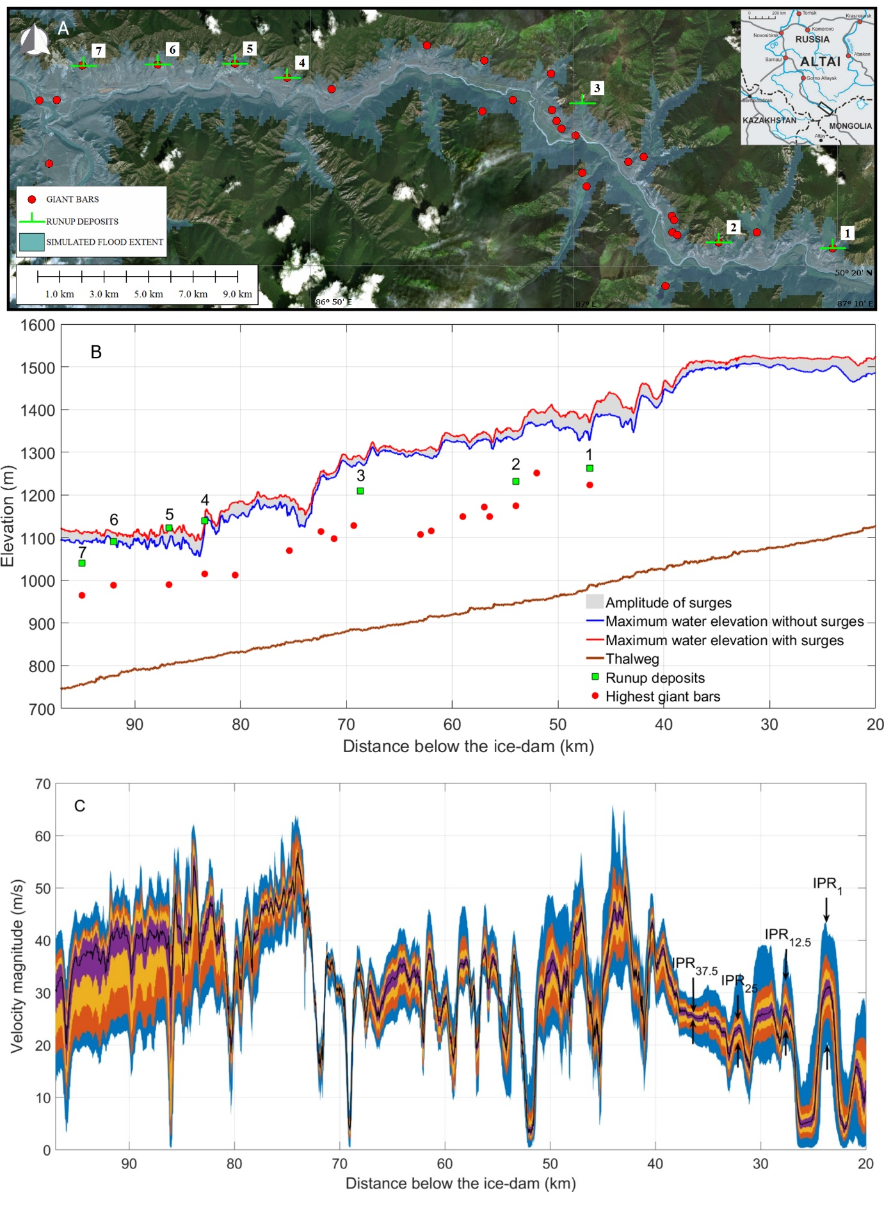

Fig. 2: (A) Planview of locations of the giant bars (red dots) and runup deposits (green lines). (B) Maximum elevation of the water surface with surges (red curve) and without surges (blue curve) downstream of the ice-dam in scenario I of Borhorquez et al. (2019); i.e., rapid dambreak and flood down the Chuja Valley. The green squares highlight the runup deposits that served as high-water palaeo-stage indicators in the flood simulation model. Solid red dots are the highest giant bar elevations in the Chuja Valley. The brown solid curve is the base of the Chuja Valley. (C) Median value of the velocity magnitude above the thalweg (black line) and interpercentile ranges (IPR) showing the spread of the velocity during the period of formation of the runup deposits. The IPR 1, 12.5, 25 and 37.5 are coloured in blue, orange, yellow and purple as indicated in the labels. Recall that IPR_{i} delimits the range of values between the i^{th} and (100-i)^{th} percentiles of the probability distribution function of the velocity magnitude. Simulated flood flow from right to left.

Bohorquez et al. (2019) simulated the hydrograph of the flood that deposited the Chuja Valley bars and runup deposits noted above. The simulations showed that the flood was gradually-varied through time but progression of the flood flow along the Chuja Valley was largely independently of the instant in time and the magnitude of the discharge, though it varied with time. This behaviour is that of a kinematic wave (Lighthill and Whitham, 1955; Singh, 2002; Bohorquez, 2010). Thus, at the time-scale of the complete flood, the variation in discharge is relatively smooth for both the rising and falling limbs of the hydrograph. However, at lesser time-scales, water levels and velocities were very unsteady, especially either side of the peak discharge. The Reynolds numbers were high: the mean value was 4.2 x 10⁹ and the maximum was 1.15 x 10¹⁰, implying exceedingly high levels of turbulent energy and mixing of fully-suspended sediment throughout the water column. The velocity magnitude changed significantly along the thalweg (Fig. 2C), highlighting the control of the Chuja Valley side wall topography on the hydraulic conditions during the inundation stage of the runup deposits. The optimal flood-simulated water surface inundated all the bar tops and six of the seven runup deposits. For example, the simulated flood water surface reached the associated bar tops below runup deposits 6 and 7 by ~5 h into the flood hydrograph, and water level was at a maximum around 10.5 h, at which time Runup deposits 6 and 7 were inundated (Fig. 2B; see also Bohorquez et al., 2019). By 18 h the water level had fallen well below the elevation of the runup deposits. Consequently, in the following analysis only the rising flood hydrograph is considered further.

- Methods
In the method outlined below it is assumed that a vector component of the downstream flood velocity (Fig. 3A) above the bar top will impinge on the sloping rocky valley side wall, causing flow to runup the slope above the incident flood water level as the flood stage rises. As the flood is sediment charged, deposition will occur between the bar top and the maximum height of the runup deposits as detailed in Fig. 3. In those cases where all the momentum of the incoming flow is transferred up slope, a form of the smooth momentum flux Bernouli equation:
$\frac{H}{{U^{2}}/g }= \frac{1+ \frac{k}{2} \frac{\cos^{3}θ}{{Fr}^{2}}}{1+\frac{\tan{ϕ_{e}}}{\tan{θ}}}$ (1)
defines the runup height (H) in term of the velocity (U), acceleration due to gravity (g) and Froude number (Fr) of the main flow, the slope of the runup deposit (θ) and the effective basal friction angle (φ_{e}) of the runup deposit; the latter subject to porewater pressure variations (Fig. 3B). The variable angles θ and φ_{e} thus are unknown during the subaqueous growth of the runup deposit. Nevertheless, θ of a static slope will increase as sediment is deposited, but avalanching causes the slope eventually to stabilize at the dynamic friction angle (c. 29º to 30 º for submerged fine gravel; Kleinhans et al., 2011). Setting θ = φ = 30º, Eq. (1) reduces to:

$\frac{H}{h}= \left(1+ {Fr}^{2}\right) B$ (2)
which defines the ratio of the relative runup height (H) to the local water depth (h) as proportional to the square of the Froude number (Iverson et al., 2016); the latter accounting for changes in flow regimen, and the friction angle is not considered further. The coefficient B is defined and considered further below.
The pressure coefficient k in Eq. (1) can be calculated for known vertical velocity distributions (Chow, 1959; Henderson, 1966). The value k =1 applies if normal stresses are isotropic, but the full-scale range of plausible k values ranges from 0.2 to 2 (Herget, 2005; his Table 10). Increasing the value of k leads to increased estimates of runup heights in Eq. (1). Where, as here, the complexity of the flow structure is unknown, k is usually set to unity (Chow, 1959; Barnes and Davidian, 1978). Here we take a slightly different approach. As the flow model is based upon a depth-averaged logarithmic velocity profile for gradually-varying flow, setting k = 1 is appropriate. For deep flows the main flow resistance is from the geometry of the embayment and not the grain resistance of the bar top. Consequently, we introduce a coefficient B in Eq. (2) to account for large-scale local flow distortion that will further affect the ratio of the longitudinal to vertical normal stresses. This distortion includes sediment high-concentration effects, additional macroturbulence caused by obstacles to the local flow (Chow, 1959), shoreline morphology more generally (Ahrens and Seelig, 1997) and surface interference wave effects, that are not accounted by k, as described subsequently. Eqs. (1) and (2) are equivalent when k = 1 and B = 1.

In the present application, the hydraulic parameters required as input to Eqs. (1) and (2) are derived from the flow modelling data for gradually-varying non-uniform flow (Bohorquez et al., 2019). For a location 0 10 m above the top of each of the six bars, the water depth (h, in metres), the depth-averaged velocity (U_{x} m s⁻¹) and the Froude number $= {U_{x}}/{\sqrt{gh}}$ ) were recorded at 10 s intervals during the flood wave. Eq. (2) indicates that the runup height above each bar tends to be directly proportional to the water depth when Fr is small and B = 1. For B =1, if the Froude number increases significantly, e.g., Fr ~ 1.0, then H can be greater than twice the water depth in transcritical flow and significantly greater in supercritical flow. Thus, if Fr increases systematically with h (i.e., the flow speed U is systematically greater than the increment in water depth, h), then H can grow faster than the water depth.
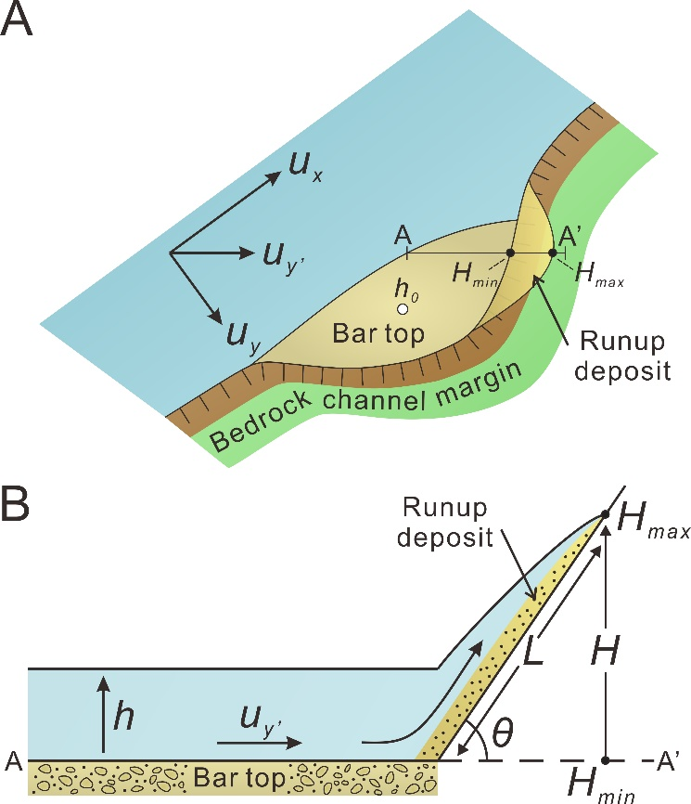
Fig. 3: (A) Planview cartoon of flow past a re-entrant in the rock side wall of a megaflood channel. The downstream velocity (U_{x}) is assumed to be greater than the transverse velocity (U_{y} ) or vector quantity (U_{y}’) that drives runup . Rising flood water forms a giant bar in the embayment and inundates the bar top with an initial depth (h ≥ ho = 0). As soon as the bar top begins to inundate, the runup deposit begins to grow in height from H_{min}= 0 to H_{max} the final height of the runup deposit. (B) Section cartoon from A to A’ of smooth momentum flux model of runup development.

The difference between the elevation of the developing runup deposit and the elevation of the associated bar top is defined as H (Fig. 3B). Consequently, a variable degree of fit between Eq. (2) and field observations might be expected and the fit will vary if the water depth and Froude number above a bar top fluctuates during an otherwise rising stage to peak discharge. Such a mismatch between theory and observation can be used to explore the dynamics and interpretation of runup deposits and the utility of Eqs. (1) and (2) in palaeoflood analysis.
The concept of the parameter B requires explanation. For initial rising flow above the bar top there may be no obstruction to the flow other than the slope of the valley side wall, so the ratio of the longitudinal to vertical normal forces is balanced. In this condition, the runup deposit can develop steadily as no flow perturbations, such as bathymetric steering of the flow, can reduce the predicted value of H. For this condition, B = 1 and H is a simple function of h and Fr where k = 1. However, if a change in re-entrant wetted geometry or a change in the main flow causes a flow perturbation in the depositional embayment, the values of k and B will depend of the strength of the perturbation. As an example of a B-perturbation, the value of the velocity U defining the Froude number in Eqs. (1) and (2) is the downstream depth-averaged velocity (U_{x}). However, the runup deposit likely is constructed by a vector deviation of the flow towards the channel margin because of re-entrant geometry, which usually has a velocity (U_{y}’) less than the downstream flow component but greater than the transverse component (Fig. 3B). In this case, the parameter B must be less than unity, reducing the predicted value of H. In a similar manner if the sediment load, especially any bedload, is high, this will extract flow momentum reducing U_{y}’ still further (Coleman, 1986; Cao et al., 2003; Mendicino and Colosimo, 2019), thus reducing runup height. However, as the water rises, at some stage H stabilizes as H_{max} above the bar top and H/h ≤ 1 if the water depth continues to increase above H_{max}.
In the simulated flood, the flow is depth-averaged with flow parallel streamlines. Nevertheless, in the natural flow, as noted above, flow distortion in both time and space can be conceptualized as consisting of four interrelated elements: (1) water discharge and water depth fluctuations that result from propagation of undular weir flow from the dam location (light grey region in Fig. 2B); (2) macroturbulence induced by unsteady flow interacting with the roughness of the irregular boundary; (3) physical modification of flow upstream of a re-entrant in the valley wall alignment, which typically results in flow separation, and the associated Kelvin-Helmholtz flow instabilities within the re-entrant; (4) significant divergences of the flow vectors within the main channel towards the valley walls that lead to major standing waves along the channel margins, including reflection and interference waves (see the abrupt transitions in the downstream velocity in Fig. 2C). Singly, or in combination, these processes may lead to surging within embayments, with water levels intermittently falling below or exceeding the mean water level by many metres, such that B can be greater than or less than unity. These processes will further modify the runup height defined by Eqs. (1) and (2). On the rising limb of the hydrograph, the bar has to be inundated (h > h_{o} = 0) for the runup deposits to start to form from a minimum height (H_{min}) and for flow distortion to occur (Fig. 3B). It is assumed falling water levels do not significantly reduce the height of the runup deposit by erosion, and this point is reconsidered in Section 4. Thus in each case, we consider only the rising limb of the hydrograph for water depths that inundate the elevation of each giant bar that is located below each of the runup deposits.

Although ice-dams can fail because of several mechanisms including tunnelling, Carling et al. (2010) and Bohorquez et al. (2016, 2019), amongst others, concluded that the most probable failure mechanism for the Altai ice-dam was caused by over-topping and steady incision of the ice because of thermal erosion caused by the overflow. For a condition of overflow, the presence of undular weir flow was expected from theory and confirmed in preliminary simulations. As will be shown in Section 3, quasi-cyclic flow behaviour was observed in the modelled data. To corroborate that these initial oscillations propagate downstream along the Chuja Valley, the flow depths derived from the Bohorquez et al. (2019) model along the thalweg were decomposed as the sum of the "main flow depth" (i.e., the filtered signal and the "fluctuation flow depth"). The period and the wavelength of the water depth oscillations along the Chuja Valley were determined accurately by computing the 2-D fast Fourier transform.

- Results
  - Flow conditions
All bar tops exhibited an initial steady increase in water depth (Fig. 4) and mean flow velocity (not shown) once the bar tops began to inundate. However, later the flow became increasingly unsteady with quasi-cyclic variability in the depth and velocity occurring through time as discharge continued to increase steadily (Fig. 4). The reciprocal relationship between depth and velocity resulted in significant fluctuations in the Froude number for some bar tops, although not all (Fig. 4). Although some records are truncated initially, generally the Froude number was relatively high as the shallow flow invaded the bar top and then it decreased steadily through time before increasing again during the period of quasi-cyclic variation (Fig. 4). Nevertheless, the Froude number was sub-critical, only occasionally reaching unity at the bar top 1 (Fr = 1.0). The cyclic variation in flow parameters is caused by the development of undular flow across the eroding ice-dam crest (Govinda Rao and Muralidhar, 1963; Hager and Schwalt, 1994). It is well-known that this phenomenon propagates downstream such that the water depth downstream fluctuates periodically in this type of flow and this issue is reported on fully later in Section 3.3.
  - Predicted runup heights
Figure 5 displays the relationship between the increase in water depth (h) during the rising limb of the flood and the values of the predicted height (H) of the runup deposit. The upper brown curve for Runup 1 in Fig. 5A represents Eq. (1) with k = 1.2 and B = 1; this location being only 47 km below the failed ice-dam. The data trend deviates from the upper curve between h = 58 m and 74 m such that for higher values of h, k = 1.0 and B = 1 and a lower trending brown curve applies. However, both curves are linear and represent the growth in the maximum height of a runup deposit above the bar top if the Froude number is very low. Scattered points above the curve represent higher Froude number excursions for any given water depth. Note, however, that during the initial increase in water depth

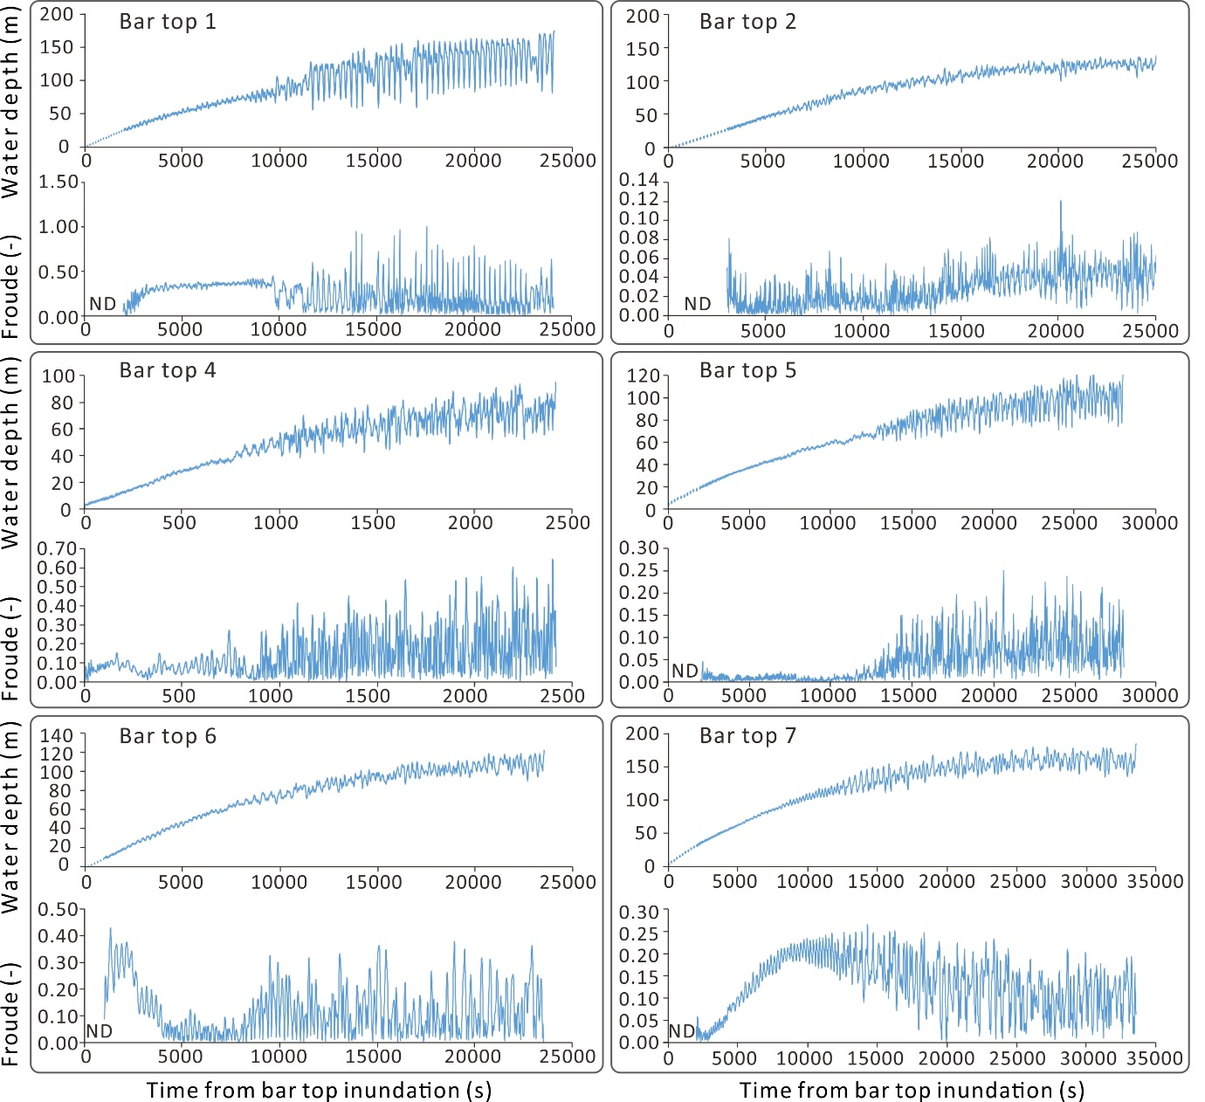
Figure 4: Variation in water depths and Froude numbers above the bar tops from initial inundation until peak stage.
the growth of the runup deposit follows a trend where H:h > 1 and k = 1.2, indicating a weak but persistent Froude dependency as stage increases (Fig. 5). Once the quasi-cyclic flow instability begins to develop the basal limit follows closely H:h = 1 where k = 1 and there is no persistent Froude dependency. For illustrative purposes, the blue curve represents Eq. (2) with k = 1 and B = 0.3, that reflects a hypothetical 70% degree of flow distortion that reduces the growth of the runup deposit through time. It may be appreciated that a series of ‘fan-shaped’ curves might be constructed for different values of B. Although the geometry of the rocky re-entrant in which each bar and runup deposit is effectively fixed, the wetted geometry changes as the water level rises, and this will influence the circulation patterns and flow strength within the re-entrant.

These flow instabilities are quasi-cyclic and, in principle, the growth of the developing runup deposit can shift from one B-curve to another as stage rises. For Fig. 5A, and for B = 1, the maximum runup height is reached when h ~33 m, whereas if B = 0.3, then maximum runup height is achieved when the maximum water depth occurs and Hmax/h = 0.30. Fig. 5B and 5C represent Runups 2 and 4, respectively, for which the notable feature is the lack of flow variability as reflected in minimal variation in the Froude number such that H/h is close to unity. Runup 2 is inundated whereas this is not the case for Runup 4. Fig. 5D, 5E and 5F represents Runups 5, 6 and 7, respectively, and the runups (excepting Runup 5) are inundated by the flow. Fig. 5E exhibits scatter caused by Froude number variation as was noted for Runup 1, but the basal curve is not segmented. In Fig. 5F there is some scatter in the Froude numbers and a break in the basal curve (as was more prominent for Runup 1) around h = 75 m. The
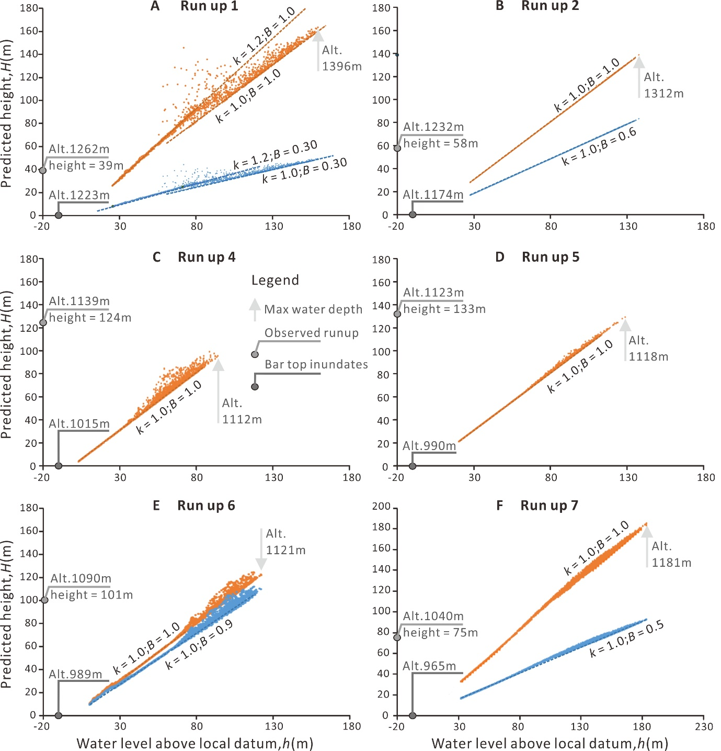
Figure 5: Variation in predicted runup heights and observed runup heights.
implications of these results are considered in Section 4.
  - The role of undular flow in mediating runup heights
The flow over the downwasting ice-dam corresponds to a "long-crested weir" following the classification by Govinda Rao and Muralidhar (1963). The order of magnitude of the simulated water depth is h_{s} = 100 m over the dam. The streamwise length of the ice-dam is of the order of L_{w} = 10 km. Hence, the relative length of the weir is: h_{s}/L_{w} = 0.01. When the relative length of weir is lower than 0.1, the motion of the flow is termed "undular weir flow" (Hager and Schwalt, 1994; Govinda Rao and Muralidhar, 1963) and such flows are illustrated by Madadi et al. (2013). It is well-known that the water discharge fluctuates in this type of flow and these fluctuations are promulgated downstream as oscillations in the flow depth. For the location of Runup 1, the period of the waves is 4.3 min according to the frequency analysis of the water depth at this location.

The period and the wavelength of the water depth oscillations along the Chuja Valley indicated that there are two relevant periods in the 12-25 km wavelength range: 4.5 min and 8.3 min. The first one is the dominant mode at the foot of the dam (i.e., 4.5 min and 12 km). The surges exhibit a non-linear evolution as they propagate downstream of the undular weir flow because of the highly non-uniform velocity of the flood flow (Fig. 2C). Downstream waves coarsen; a more energetic 25 km wavelength was observed downstream of Runup 2 with a characteristic period of 8.3 min. The oscillatory motion corresponds with a long (i.e., shallow-water) wave given that the average flow depth is 369 m in the Chuja Valley. The surges propagate with a well-defined wave speed of 47 ± 3 m·s⁻¹, of the same order of magnitude as the flood flow velocity (Fig. 2C).

The wave motion occurs not only along the thalweg but also across the cross sections onto the bar tops, as is evident in Fig. 4. The wavelength of the bar top water depth variations (Fig. 4) is considerable in the cases of Runups 1, 4 and 5, exceeding several tens of metres. These frequent excursions do not exceed the maximum water depth and so cannot affect the predicted maximum value of H, H_{max} , but they will induce additional high-frequency sediment-charged additional ‘mini-runup’ events during the rising hydrograph enhancing the sediment supply to the runup deposits. In contrast, there are important draw-down effects of the ‘mini-runup’ events on the runup deposits other than that related to the falling stage of the main hydrograph. Draw-down effects include variation in the pore-water pressure affecting the basal friction angle (φ_{e}) of the runup deposit and consequent transport of sediment down slope, with return flow from the runup flow ‘combing’ the runup deposits down slope, thus reducing the slope of the runup deposit (θ) as well as the observed maximum height. Thus, the runup and return flow of the mini-events almost certainly cancel out in terms of the effect on runup morphology.

- Discussion

The Froude numbers above all the bar tops were sub-critical, only occasionally reaching unity at bar top 1 (Fr = 1.0). Until further flood modelling for bar top locations has been completed it is unclear if such a condition is usual. However, flood modelling by Benito and Thorndycraft (2019) for a bar top in Patagonia returned depth and velocity data that indicate Froude numbers between 0.3 and 0.5, which is consist with the current results. The shear stress on the Patagonian bar top was only 75 Pa. Such flow conditions have consequences for the interpretation of bar top stratigraphy. Although Carling et al. (2002) indicated that upper-stage plane beds (USPB) might dominate bar tops, it is now evident that deposition on most megaflood bar tops was primarily to lower-stage plane beds, from dense suspensions, with only occasional incorporation of USPB lamination (Carling, 2013).

Whereas Herget (2005) used runup heights to estimate the cross section averaged flow velocities for the Chuja megaflood, here the expected maximum runup heights were estimated from the local hydraulically-modelled flow field on the top of the neighbouring bars, as the bars are increasingly submerged. This procedure was used to obtain additional insight into the dynamics of runup deposits and to examine their value as palaeostage indicators. Only in the case of Runup 5 did the predicted runup height reasonably match the observed runup height using k = 1 and B = 1, the observed elevation being only 5 m above the maximum water level. In a similar manner, Runup 4 was only 24 m above the predicted height. In the case of Runup 6, B only need to be reduced to 0.9 to obtain a good match. The observed elevations of Runups 1, 2 and 7 fall well below the expected values, requiring B-values of 0.3, 0.6 and 0.5, respectively, to obtain reasonable matching. Note also that U_{y}’ is likely less than U_{x}, which will reduce predicted runup heights. For computational simplicity, it was assumed in Section 2 that waning flows would have no effect on the maximum height of the runup deposits. Nevertheless, the particularly low elevations of Runups 1, 2 and 7 might indicate either that the deposits failed to grow to match the water depths, or later they were combed down by flow oscillations and the waning hydrograph. The variability in the Froude number increases as flow stage increases (especially for Runups 1, 4 and 6), potentially increasing runup height. However as the maximum predicted runup height for the Froude number excursions always remains less than that for maximum flow depth, it unlikely that such flow variability increases runup height, quite the contrary. The possibility of significant combing-down is especially the case in relation to Runup 1, which is close to the dam location and subject to highly variable water depths, highly variable Froude numbers (including transcritical flows) and a significant over-prediction of runup height. In this context the sedimentary structures noted in the Patagonian runup deposits indicated both up slope and down slope flow directions that Benito and Thorndycraft (2019) ascribed to rising and falling flood stage, respectively, although surging cannot be ruled out.

The poor prediction of the runup height compared with the observed height in some cases should not be seen as disappointing, as it would be unrealistic to expect close matching. Such differences can be ascribed to the limitations of flow modelling, the complexity of flow and the complexity of the local geometries of the re-entrants (Dodet et al., 2018) or the fact that reflection and interference waves and high sediment concentrations might have had a further influence on runup height, which is not considered here in a quantitative sense. For runup deposits to exist at all it is evident that the surging Altai flood waters were highly sediment-charged. Despite the high-elevation with respect to the total flood depth (Fig. 2B), concentrations of finer sediments in the upper water column can remain high. For example, for a catastrophic palaeoflood in Patagonia, Benito and Thorndycraft (2019) calculated that the suspended sediment concentration had to be at least 36 g l⁻¹ to build a giant eddy bar within a period of inundation of 39 h, which assumes a 100% trap efficiency. Similarly, in the case of modern small outburst floods, determinations of near-surface suspended sediment concentrations indicate high loads (>35 g l⁻¹: Tómasson et al., 1980; 71 g l⁻¹: Beecroft, 1983; >121 g l⁻¹; Snorrason et al., 2002) and concentrations in the Altai megaflood would have been no less. Although the concentrations of sediment in the surging flows against the Altai Valley walls must remain an unknown, the high elevation means the sediment must have been primarily a suspension load with a possible further bedload component derived from the neighbouring bar top, which would reduce runup velocities (Coleman, 1986; Cao et al., 2003; Mendicino and Colosimo, 2019) and consequently reduce runup heights (Arens and Seelig, 1996), as is noted in Fig. 5. The significance of these various controls on runup heights can only be determined through numerical modelling and physical experimentation of sediment-charged flood waters above bar tops.

- Conclusions
Comparison of the height of the six runup deposits in the Chuja Valley with theory indicates that the elevations of the top of the runup deposits are likely below the maximum surge heights that occurred above the modelled megaflood incident water level. However, this discrepancy usually is only a matter of tens of metres, such that the elevations of runup deposits remain useful palaeostage indicators, being related to maximum water level through hydraulic controls. High Froude number excursions may enhance the height of runup deposits whilst they are developing but, in these examples, the excursions did not occur at maximum water level and so they have no effect on the final runup elevation. The effects of changes in relative channel geometry in the vicinity of the runup deposits as stage rises is likely a major factor influencing complex flow patterns, reducing the channel transverse flow velocity, and so limiting runup elevations, as indicated by the parameter B. Runup deposits may fail to increase in height at the same rate as water levels increase. In addition, surging in the flow related to undular flow across a down-wasting ice-dam, or because of reflection and interference waves reaching the channel margins, may equally enhance runup heights as well as combing-down deposits. In this respect, the possibility that runup deposits cease to grow during rising water levels requires further attention as does the effects of short-period surging.

Acknowledgements
This work was supported by the Spanish Ministry of Science, Innovation and Universities (MICINN/FEDER, UE) under Grant CGL2015-70736-R and by the National Science Fund for Outstanding Young Scholars of China (Grant No. 41622206), the Funds for Creative Research Groups of China (Grant No. 41521002), the State Key Laboratory of Geo-hazard Prevention and Geo-environment Protection Independent Research Project (SKLGP2019Z002). Lanxin Dai is thanked for drafting Figs. 3, 4 and 5.

References
Ahrens, J.P., Seelig, W.N., 1996. Wave Runup on Beaches. Chapter 77, In: Coastal Engineering 1996, 25th International Conference on Coastal Engineering September 2-6, 1996 | Orlando, Florida, United States, pp. 981-993.
Alexander, J.S., McElroy, B., Huzurbazar, S., Elliott, C., , Murr, M.L., 2019. Deposition potential and flow-response dynamics of emergent sandbars in a braided river. Water Resources Research, 56, e2018WR024107. https:// doi.org/10.1029/2018WR024107

Baker, V.R., Benito, G., Rudoy, A.N., 1993. Paleohydrology of late Pleistocene superflooding,
Altay mountains, Siberia. Science, 259, 348–350. https://doi.org/10.1126/
science.259.5093.348.

Baker, V.R., Kochel, R.C. 1988. Flood sedimentation in bedrock fluvial systems. In: Baker, V.R., Kochel, R.C., Patton, P.C., eds. Flood geomorphology. Wiley, New York, pp. 123–128.

Barnes, H.H., and Davidian, J., 1978, Indirect methods, in Herschy, R.W., ed., Hydrometry—Principles and practises: Chichester, Wiley, 149–204.

Beecroft, I., 1983. Sediment transport during an outburst from Glacier De Tsidjiore Nouve,
Switzerland, 16–19 June 1981. Journal of Glaciology, 29, 185-190.
Benito, G., Thorndycraft, V., 2020. Catastrophic glacial-lake outburst flooding of the Patagonian Ice Sheet. Earth-Science Reviews, 200, 102996.
Bohorquez, P., Carling, P.A., Herget, J., 2016. Dynamic simulation of catastrophic late
Pleistocene glacial-lake drainage, Altai Mountains, Central Asia. International Geology Reviews, 58, 1795–1817. https://doi.org/10.1080/00206814.2015.1046956.

Bohorquez, P., Jimenez-Ruiz, P.J., P.A. Carling, P.A. 2019. Revisiting the dynamics of catastrophic late Pleistocene glacial-lake drainage, Altai Mountains, central Asia. Earth-Science Reviews, 197, https://doi.org/10.1016/j.earscirev.2019.102892.

Bohorquez, P., 2010. Competition between kinematic and dynamic waves in floods on steep slopes. Journal of Fluid Mechanics, 645, 375–409.

Cao, Z., Egashira, S., Carling, P.A. 2003. Role of suspended-sediment particle size in modifying velocity profiles in open-channel flows, Water Resources Research, 39, 1029, doi:10.1029/2001WR000934

Carling, P.A., 2013. Freshwater megaflood sedimentation: What can we learn about generic processes? Earth-Science Reviews, 125, 87-113.

Carling, P.A., Kirkbride, A.D., Parnachov, S., Borodavko, P.S. and Berger, G.B., 2002. Late-glacial catastrophic flooding in the Altai Mountains of south-central Siberia: a synoptic overview and introduction to flood deposit sedimentology. In: Flood and Megaflood Processes and Deposits: Recent and Ancient Examples. (Eds I.P. Martini, V.R. Baker and G. Garzon) Special Publication 32 of the IAS, Blackwell Science, Oxford, 17-35.
Carling, P.A., Villanueva, I., Herget, J., Wright, N., Borodavko, P., Morvan, H., 2010. Unsteady 1D and 2D hydraulic models with ice dam break for Quaternary megaflood, Altai Mountains, southern Siberia. Global Planetary Change, 70, 24–34. https://doi. org/10.1016/j.gloplacha.2009.11.005.

Chow, V.T., 1959. Open-channel Hydraulics: Tokyo, McGraw-Hill, 679pp.
Coleman, N.L., 1986. Effects of suspended sediment on the open-channel velocity distribution. Water Resources Research, 22, 1377-1384.

Greenbaum, N., Enzel, Y., Schick, A.P., 2001. Magnitude and frequency of paleofloods and historical floods in the Arava basin, Negev Desert, Israel. Israel Journal of Earth Sciences, 50: 159–186.

Dodet, G., Leckler, F., Sous, D., Ardhuin, F., Filipot, J.-F., & Suanez, S. (2018). Wave runup over steep rocky cliffs. Journal of Geophysical Research: Oceans, 123. https://doi.org/10.1029/2018JC013967

Govinda Rao, N. S., and Muralidhar, D., 1963. Discharge characteristics of finite-crest width. La Houille Blanche, 18: 537- 545.

Hager, W.H., Schwalt, M., 1994. Broad-crested weir. Journal of Irrigation and Drainage Engineering, 120:13-26.

Henderson, F.M., 1966. Open Channel Flow: New York, Macmillan, 544pp.

Herget, J., 2005. Reconstruction of Pleistocene ice-dammed lake outburst floods in the Altai Mountains, Siberia. Special Paper of the Geological Society of America, 386: 1–118. https://doi.org/10.1130/0-8137-2386-8.1.

Huang, W., Cao, Z.-X., Carling, P.A., Pender, G., 2014. Coupled 2D hydrodynamic and sediment transport modeling of megaflood due to glacier dam-break in Altai Mountains, Southern Siberia. Journal of Mountain Science, 11, 1442–1453. https://doi.org/10.1007/s11629-014-3032-2.

Huang, W., Cao, Z.X., Pender, G., Liu, Q.Q., Carling, P.A., 2015. Coupled flood and sediment transport modelling with adaptive mesh refinement. Science China Technological Sciences, 58, 1425–1438. https://doi.org/10.1007/s11431-015-5880-6.

Iverson, R.M., George, D.L., Logan, M. Debris flow runup on vertical barriers and adverse slopes. J. Geophysical Research: Earth Surface, 121: 2333–2357.

Kleinhans, M.G., Markies, H., de Vet, S.J., in ’t Veld, A.C., Postema, F.N. 2011. Static and dynamic angles of repose in loose granular materials under reduced gravity. Journal of Geophysical Research, 116, E11004, doi:10.1029/2011JE003865.

Kochel, R.C., Ritter, D.F. 1987. Implications of flume experiments on the interpretation of slackwater paleoflood sediments. In: Singh, V.J., ed. Regional flood frequency analysis. Reidel, Boston, pp. 365–384.

Lighthill, M.J., Whitham, G.B., 1955. On kinematic waves. Part I: flood movement in long rivers. Part II: a theory of traffic flow on long crowded roads. Proceedings of the Royal Society, A 229 (1178), 281–345.

Madadi, M.R., Dalir, A. H., Farsadizadeh, D., Control of undular weir flow by changing of weir geometry. Flow Measurement and Instrumentation, 34, 160-167.
Mendicino, G., Colosimo, F., 2019. Analysis of flow resistance equations in gravel‐bed rivers with intermittent regimes: Calabrian fiumare data set. Water Resources Research, 55, 7294–7319. https://doi.org/10.1029/2019WR024819

Singh, V.P., 2002. Is hydrology kinematic? Hydrological Processes, 16, 667–716.

Snorrason, Á., Jónsson, P., Sigurđsson, O., Pálsson, S., Árnason, S., Víkingsson, S., Kaldal, I. 2002. November 1996 Jökulhlaup on Skeiðarársandur Outwash Plain, Iceland. In: Martini, P.I., Baker, R.V., Garzón, G. (Ed.), Flood and Megaflood Processes and Deposits: Recent and Ancient Examples. Wiley, pp. 55-65.

Tómasson, H., Pálsson, S., Ingólfsson, P., 1980. Comparison of sediment load transport in the
Skei∂ará Jökulhlaup in 1972 and 1976. Jökull, 30, 21-32.

