Short title:
Managing Consumer Conflicts Online

Full title:
Consumer Responses to Conflict Management Strategies on Non-profit Social Media Fan Pages

This research did not receive any specific grant from funding agencies in the public, commercial, or not-for-profit sectors.
Declarations of interest: none

Accepted Manuscript Journal of Interactive Marketing, May 2020

Authors’ details:

Corresponding author: Dr. Denitsa Dineva
Affiliation: Cardiff Business School, Cardiff University, UK
Postal address: B17, Aberconway Building, Colum Road, Cathays, Cardiff, CF10 3EU
Phone: +44 (0)29 2087 6407
Email: DinevaD@cardiff.ac.uk
Biographical note: Denitsa Dineva is a Lecturer in Marketing and Strategy at Cardiff Business School, Cardiff University (UK). Her research interests include conflict management, aggressive consumer-to-consumer communication, online communities and digital marketing in for-profit and non-profit contexts.

Second co-author: Dr. Jan Breitsohl
Affiliation: Adam Smith Business School, University of Glasgow, UK
Postal address: University Ave, Glasgow, G12 8QQ
Phone: +44 (0)141 330 3993
Email: Jan.Breitsohl@glasgow.ac.uk
Biographical note: Jan Breitsohl is an Associate Professor (Senior Lecturer) in Digital Marketing at Adam Smith Business School, University of Glasgow (UK). His academic interests focus on the dark side of digital marketing, in particular, consumer aggression, social media scandals and corporate response strategies.

Third co-author: Professor Brian Garrod
Affiliation: Swansea University School of Management, Swansea University, UK
Postal address: Bay Campus, Fabian Way, Swansea, SA1 8EN
Email: brian.garrod@swansea.ac.uk
Phone: +44 (0)179 260 4211
Biographical note: Brian Garrod is a Professor in Marketing at Swansea University School of Management, Swansea University (UK). His research interests span all aspects of tourism but focus particularly on sustainable tourism, ecotourism and heritage tourism. He has written widely in the area of tourism management, including seven text books, and he is Co-Editor-in-Chief of the Journal of Destination Marketing & Management.

Fourth co-author: Dr. Philip Megicks
Affiliation: Southampton Business School, University of Southampton, UK
Postal address: 2/6033 Southampton Business School, University of Southampton, Highfield, Southampton SO17 1BJ, UK
Email: P.R.Megicks@soton.ac.uk
Phone: + 44 (0)23 8059 6716
Bibliographical note: Phil Megicks is an Associate Professor in Marketing Southampton Business School, University of Southampton (UK). His research interests lie in the fields of marketing strategy and consumer behavior in small service sector organizations, particularly retailing. He has also developed strands of research in ethical marketing and sustainable supply chain management. His research has been published in a range of internationally recognized marketing, retailing, tourism, and production management journals.

Consumer Responses to Conflict Management Strategies on Non-profit Social Media Fan Pages

Abstract: Past research has demonstrated that consumer-to-consumer (C2C) conflicts, here defined as uncivil social interactions between consumers, can have a negative impact on consumers’ engagement in social media fan pages (SMFPs). Little is known, however, about how best to manage such conflicts, and this is particularly true for the non-profit context. This paper follows a mixed-method approach in order to address this research gap. Study 1 uses a netnography of a non-profit organization (NPO) to examine how it manages C2C conflicts on its SMFP. Five different conflict management strategies are identified: non-engaging, censoring, bolstering, educating, and mobilizing. These findings inform Study 2, an online experiment to test how different strategies affect consumers’ attitudes towards the conflict management approach itself and towards the NPO’s social responsibility. Study 2 also accounts for the moderating effect of the conflict content, differentiating between whether a conflict relates to a consumer’s self-benefit or the benefit to others. Our results offer insights for practitioners into preferable content management strategies when consumers engage in different types of conflict on social media platforms.
Keywords: conflict management; customer misbehavior; uncivil consumer-to-consumer communication; social media fan pages; non-profit organizations; self and others benefits;

- Introduction
Non-profit organizations (NPOs) have fan pages on social media sites such as Facebook to facilitate consumer-to-consumer (C2C) interactions and encourage social action (Nah & Saxton, 2012; Saxton & Waters, 2014). These permit NPOs to promote an ethical cause to a global audience in an interactive way (Waters, Burnett, Lamm & Lucas, 2009). Recent studies have shown that non-profit social media fan pages (SMFPs) successfully attract and engage individuals who wish to contribute to the welfare of society by engaging in behaviors that support the NPO’s cause (Guo & Saxton, 2014; Saxton & Wang, 2014). Such behaviors include giving (i.e. donations and volunteering) (Liu & Aaker, 2008); activism (i.e. signing petitions, lobbying and spreading word-of-mouth) (Lee, Kim, Kim & Choi 2014); and ethical purchase behaviors (i.e. buying ethical products or refraining from buying unethical ones) (Sudbury-Riley & Kohlbacher, 2016).
While non-profit fan pages attract participants who appear to support the same cause, disagreements frequently occur due to the global reach of SMFPs. Previous research has suggested that these may be a result of SMFP users’ dissimilar backgrounds and personal values (de Almeida et al., 2014; Shaw & Newholm, 2002), or because they have different opinions about what the NPO’s mission involves or how it should be pursued (Carrington, Neville & Whitwell, 2014; Freestone & McGoldrick, 2008). Such disagreements can take the form of one consumer verbally attacking another consumer, who then reciprocates in kind (Chan & Li, 2010; Ilhan, Kübler & Pauwels, 2018). We term this phenomenon ‘C2C conflict’. As noted by others, C2C conflicts can range from being mild in tone, e.g. name-calling, teasing and provocation, to being very strong, e.g. harassment and threats (Breitsohl, Roschk & Feyertag, 2018; Ewing, Wagstaff & Powell, 2013). To illustrate this, the excerpt shown in Figure 1 demonstrates a typical C2C conflict resulting from one consumer questioning the validity of another consumer’s beliefs regarding veganism. The excerpt also illustrates how an NPO may choose to intervene in the conflict by affirming a supporter’s comment.
Insert Figure 1 here
Previous research suggests that similar conflicts can have a negative impact on both consumers (Gebauer, Füller & Pezzei, 2013; Thomas, Price & Schau, 2013) and organizations (Fisk et al., 2010). C2C conflicts can cause consumers psychological and emotional distress (Pew, 2017), making them less likely to continue to interact on the SMFP and obtain functional benefits (e.g. cause-related information) from it (Gebauer et al., 2013). The NPOs concerned could, meanwhile, experience a loss of credibility, especially if they are deemed to have failed to manage the C2C conflict effectively (Pfeffer, Zorbach & Carley, 2014).
Despite these negative outcomes for both consumers and organizations, the marketing literature presently lacks research on how NPOs should manage C2C conflicts when they arise, as evidenced by calls of de Valck (2007) and Husemann, Ladstaetter and Luedicke (2015). To date, only a few studies have examined what strategies organizations use to address C2C conflicts (Bacile, Wolter, Allen & Xu 2018; Dineva, Breitsohl & Garrod, 2017; Hauser, Hautz, Hutter & Fuller, 2015). It is noteworthy that these studies focus exclusively on the for-profit context. We argue here that the non-profit context is different and deserves specific attention. Compared with for-profit, commercially oriented SMFPs, NPOs pursue value-laden causes that are largely dependent on engaged consumer interactions in order to encourage action towards a social/ethical cause (Lovejoy & Saxton, 2012; Waters et al., 2009). Moreover, in comparison with for-profit SMFPs, which are characterized by weaker member commitment, members of non-profit SMFPs frequently display extreme commitment in the form of brand/cause defense and a deeper level of participation in the community (de la Peña, Amezcua & Sepúlveda, 2018). Such extreme commitment, in turn, can amplify the frequency and severity of conflicts when they occur, which necessitates a better understanding of the specific conflict management practices adopted in these non-profit fan pages.
The first contribution of the present study is therefore to investigate the kind of conflict management strategies an NPO uses on social media. To this end, the purpose of Study 1 is to uncover strategies used by PETA (‘People for the Ethical Treatment of Animals’) in their Facebook fan page to manage C2C conflict, following a three-month netnography of the fan page. To gain a more complete understanding of the context in which conflict management takes place, our analysis further distinguishes between two main types of conflict content: self-oriented, which refers to conflict content revolving around issues related to the self, and other-oriented, which refers to conflict content revolving around issues related to others.
The extant knowledge on social media conflict management strategies is further limited to observational studies, with a need for more quantitative research. In particular, authors have called for experimental studies that are able to measure how such strategies are perceived by consumers (Gensler, Völckner, Liu-Thompkins & Wiertz, 2013; Ilhan et al., 2018; Johnson & Lowe, 2015). Consequently, our second contribution relates to the investigation of which strategy leads to the most favorable consumer attitudes. Study 2 thus employs our observations from Study 1 in an experimental design that compares how different conflict management strategies, taking into account the types of conflict, affect consumers’ attitudes towards the NPO and its organizational social responsibility. We chose these two outcome variables since previous research suggests, but has not yet verified, that consumers regard the governance of interactions in SMFPs, and particularly those that are hostile in nature (Illia et al., 2017; Pew, 2017), to be the responsibility of organizations (Felix, Rauschnabel & Hinsch, 2017). Therefore, we aim to establish how an organization’s perceived social responsibility is affected by different management strategies, as well as consumers’ attitudes towards the management of conflicts itself. Taken together, the two studies aim to provide new insights into conflict management practices adopted in an online non-profit context.
- Literature Review
  - C2C Conflicts in a Non-profit Context
Previous research has found C2C conflicts in a non-profit context to occur between supporters of the cause the NPO is promoting (Schröder & McEachern, 2004). Pro-social consumers consider a range of ethical issues when making consumption-related decisions (Shaw & Newholm, 2002). Hence, opinions about these ethical issues, what the cause constitutes and how it should be pursued often differ, causing C2C conflict to occur. In contrast, due to the global reach of fan pages in the social media, C2C conflict can also take place between supporters and non-supporters of the NPO’s stated cause (Minson & Monin, 2012; Zane, Irwin & Reczek, 2015). Reasons for such conflicts may stem from differences in personal values, a lack of information, skepticism or cynicism towards ethical behavior (Bray, Johns & Kilburn, 2011; Burke, Eckert & Davis, 2014), or simply from the joy of provoking others (i.e. ‘trolling’) (Buckels, Trapnell & Paulhu, 2014). Bray et al.’s (2011) study, for example, suggests that some consumers dismiss the positive impact of ethical consumption on humans, animals and the environment on the grounds of it essentially being little more than a marketing strategy, designed to enable companies to charge premium prices for ordinary products. In addition, Zane et al. (2015) confirm that less ethical consumers sometimes denigrate supporters of ethical consumption. Such denigration, which can take the form of online C2C conflict, is said to arise from the self-threat inherent to making social comparisons when encountering opinions and values different from one’s own.
More recently, research has started to focus on the negative outcomes of C2C conflicts. Studies suggest that C2C conflicts can deter individuals from engaging in constructive discussions with other like-minded users and the company host (Anderson et al., 2014; Seraj, 2012). Decreased levels of involvement in the fan page can in turn make it more difficult for NPOs to encourage people to commit to actions concerning the causes they are promoting (Lovejoy & Saxton, 2012). Such activism could be private, for example making ethical consumption choices or donating money, or social, for example protesting, lobbying or spreading word-of-mouth about the cause.
  - Extant Knowledge on Conflict Management
Ensari, Camden-Anders and Schlaerth (2015) define conflict management as a collection of practices used by organizations to intervene in disputes. Few studies have empirically examined conflict management in online settings; fewer still have focused on NPOs, as demonstrated in Figure 2. The extant literature on the management of (uncivil) social interactions in online environments focuses on providing conceptual recommendations, examines for-profit or small-scale, consumer-hosted communities, and offers preliminary findings based on conflict management theories and typologies designed for offline (organizational) conflict management. Table 1 synthesizes notable studies that fall into this domain.
Insert Figure 2 here
Some early conceptual insights into the roles that companies choose to adopt when managing social interactions between consumers in online settings are offered by Godes et al. (2005). The authors distinguish between four roles that a company may adopt: observer, mediator, moderator and participant. These are not considered to be mutually exclusive and which particular option or combination of options is chosen will depend on the type of C2C interaction (positive versus negative) and the context. Likewise, more recently, Homburg, Ehm and Artz (2015) identified two generic company roles in managing C2C discussions in an online community setting: passive and active. In choosing passive engagement, the company offers users a platform to interact and does not engage in conversations among them, whereas active participation involves direct interactions to stimulate user-generated content (Gensler et al., 2013).
Specifically in the context of for-profit SMFPs, Dineva et al. (2017) demonstrated that across six product and service categories, most firms adopted a passive role during C2C conflicts. The remainder of the strategies proposed by Dineva et al. (2017) comprise providing corporate or product information to rectify what are perceived to be incorrect consumer comments, affirming consumers who defend the brand, pacifying conflict through asking one or more consumers to adjust their communication style and censoring consumer comments. These findings are supported by a study examining consumer incivility, which demonstrated that in 11 SMFPs companies generally did not intervene in uncivil C2C communication (Bacile et al., 2018).
Others have put forward the concept of community-governing mechanisms (Mathwick, Wiertz & De Ruyter, 2008; Schau, Muñiz & Arnould, 2009). These mechanisms involve articulating expectations of acceptable behavior, comprised of, for instance, keeping criticism constructive, challenging negative comments, and realigning interactions to maintain a positive community environment. Similarly, based on an in-depth review of the literature, Sibai et al. (2015) differentiate between two C2C conflict moderation roles of online community moderators: interaction maintenance and interaction termination. Interaction maintenance is intended to ensure that C2C interactions remain functional and involves monitoring and pacifying interactions through rewarding positive behaviors and sanctioning negative behaviors. Interaction termination occurs when C2C interactions become dysfunctional and entails ignoring members or excluding them from the online community.
In line with maintaining or terminating hostile interactions, an observational study outlined the behavioral strategies used in a feminist online forum to deal with flaming (i.e. hostile expression of strong emotions) among its members (Lee, 2005). The proposed strategies can be categorized into three groups: competitive-dominating, cooperative-integrating and avoiding. The competitive-dominating strategy involves threats, persuasion and realignment through requesting compliance. Cooperative-integrating strategies suggest an overall consideration of others, including compromising, offering concessions, apologizing and showing solidarity. Avoiding strategies, in contrast, comprise of activities that aim to ignore the conflict, including making jokes, being silent and withdrawal.
Matzat and Rooks (2014) drew a contrast between positive (reward) and negative (punishment) conflict management strategies. According to the authors, positive conflict management involves rewarding desirable behaviors (e.g. public appreciation for appropriate community engagement), while negative conflict management describes punishing undesirable behavior (e.g. public disapproval of unwanted community engagement behaviors). In a study on addressing public scandals in online settings, Hauser et al. (2017) continued this debate by comparing the effects of assertive versus cooperative strategies. Assertive conflict management is represented by competing, obliging, and avoiding, while cooperative conflict management involves accommodating, yielding and integrating strategies.
Lastly, a netnographic study on different types of consumer conflicts in a user-hosted online community offers findings into conflict management practices as a sub-theme (Husemann et al., 2015). The authors divide C2C conflicts into routinized (i.e. positive for the community) and transgressive (i.e. negative for the community) and recommend different practices depending on the type of conflict. The authors argue that routinized conflicts warrant nurturing because they are seen as beneficial for the community, while transgressive conflicts should be dealt with by excluding members from the online community due to their negative impact on the welfare of its members.
Insert Table 1 here
  - The For-profit versus Not-for-profit Context
While some of these strategies may also apply in non-profit fan pages, the different characteristics of non-profit and for-profit fan pages suggest that the nature of conflict – and hence what needs to be done, if anything, to manage it – is likely to differ (Aaker, Vohs & Mogilner, 2010; Bernritter, Verlegh & Smit 2016; Thach & Thompson, 2007). Hosts of for-profit SMFPs pursue monetary goals and the main objective is to stimulate interactions between users, and ultimately increase their consumption expenditure (Habibi, Laroche & Richard, 2014; Naylor, Lamberton & West, 2012). When such interactions turn hostile, hosts of for-profit fan pages have a responsibility to pacify these in order to maintain constructive discussions and continued consumer engagement and participation in the fan page (Van Noort & Willemsen, 2012). Past studies have shown that such management will include requesting consumers to adjust their communication behavior (Dineva et al., 2017), correcting/disagreeing with consumers (Habel, Alavi & Pick, 2017) or using more authoritative styles (e.g. sanctioning undesirable behaviors) to resolve the conflict (Matzat & Rooks, 2014; Sibai et al., 2015).
In contrast, non-profit SMFPs measure their success by how far their efforts contribute to improving the welfare of their target group (Hassay & Peloza, 2009). Thus, the host of a non-profit SMFP has ideological motives to increase interactions on the fan page, which can create further discussions around the ethical issue that is being promoted (Waters & Jamal, 2011). Consequently, NPOs are likely to use more inspirational, value-laden conflict management strategies (Chen, Lune & Queen, 2013; Thach & Thompson, 2007). In fact, some NPOs aim to generate public controversy around their promoted cause in order to encourage activism (Botner, Mishra & Mishra, 2015; Kronrod, Grinstein & Wathieu, 2012). Thus, strategies that suppress the creation of controversy around the ethical issues that are promoted may be seen as counterproductive and, therefore, unlikely to take place. These contentions have, however, not been thoroughly tested.
- Study 1
  - Method
Study 1 aimed to address the following research question:
What strategies are used by NPOs to manage C2C conflict on their SMFPs?
Following Ertimur and Gilly (2012), we conducted a non-participatory netnographic study of a Facebook fan page hosted by PETA: an American NPO with over 5.5 million fan page members (https://www.facebook.com/official.peta). Topics discussed in the community revolve around animal rights, including vegan lifestyles, animal testing and the use of animals for the purpose of entertainment. We chose a non-participatory approach to studying the online environment, because it allowed for more naturalistic and unobtrusive research (Wu & Pearce, 2013). Moreover, community members tend to alter socially undesirable behavior if they know they are being observed (Jerolmack & Khan, 2014). Since hostile C2C interactions are often deemed to be socially undesirable, we considered it essential not to participate in any of the discussions, but merely to monitor them. Figure 3 illustrates the research procedure undertaken in Study 1.
Insert Figure 3 here
Prior to the data collection, the lead researcher spent a month observing the page as part of the entrée stage (Kozinets, 2002, 2015). This was done to ensure that: (1) there is familiarity with the organization and its context, (2) there is presence of between-member interactions of the type required for the present study (i.e. C2C conflicts), and (3) there is evidence of content moderation by the organization. Furthermore, as part of the entrée stage, the lead researcher was able to develop a set of semantics related to the examined online environment and context, as demonstrated in Table 2. These allowed the researcher to differentiate between negative (hostile/counterproductive) and positive (constructive) C2C conflicts as well as distinguish these from other types of interactions with the former (i.e. negative C2C conflict) being of interest in this study. It was further confirmed that the majority of the C2C conflict that occurred on the fan page was between groups of supporters and non-supporters of the organization (as opposed to in-group conflict), suggesting that such conflict was the result mainly of the different values and belief systems held by the members of the two groups.
Insert Table 2 here
During three months of observing a total of 194 organizational posts and 165,275 individual comments, the researchers agreed that no new insights were emerging from the data; a case of theoretical saturation (Strauss & Corbin, 1998; Fusch & Ness, 2015). A total of 343 conflict episodes (3,468 individual comments) and 78 organizational interventions had been recorded by this time.
  - Data Analysis
To analyze the data, we followed a six-stage thematic analysis approach, as recommended by Braun and Clarke (2006, 2014). The first phase involved familiarization with the dataset for the purpose of identifying relevant data. Next, the data were analyzed in order to generate initial data-driven codes. The codes were then subsumed based on their unifying features, which generated our themes, i.e. conflict management strategies. The themes were reviewed in relation to the coded data and the entire data set, while labels were assigned and definitions developed to describe the underpinning meaning of each theme. Given that previous studies have identified that organizations adjust their communication strategies in accordance with particular characteristics of a C2C conflict (e.g. (Barcelos, Dantas & Sénécal, 2018; Husemann et al., 2015; Schröder & McEachern, 2004), we further analyzed whether these conflict management strategies would vary in relation to the content of the content. This led to the development of an additional theme (i.e. conflict content orientation).
Investigator triangulation was employed to enhance the study’s validity (Reeves, Kuper & Hodges, 2008). This process involved researchers comparing and discussing their codes and interpretations of the data over several rounds of analysis. More specifically, three researchers independently coded 86 conflict scenarios from the total dataset and upon completion of the triangulation excluded 11 conflict scenarios. This resulted in an acceptable inter-rater reliability index of .87, calculated using proportional agreement (i.e. the proportion of total pairwise agreements between coders) (Rust & Cooil, 1994). The names in the examples provided here were all changed to ensure anonymity.
  - Results
Our analysis yielded five conflict management strategies, as illustrated in Table 3. Non-engaging is a conflict management strategy wherein the organization does not intervene in a conflict. This was the most commonly used strategy, irrespective of the intensity and length of the C2C conflict. In contrast, a more active and authoritative strategy is censoring, which involves the organization removing certain comments. Censoring was observed in two C2C conflicts, both of which involved the users specifically requesting for the content to be removed. Unlike censoring, bolstering involves the organization actively posting comments to affirm views expressed by like-minded users. This strategy broadly involves the organization thanking supporters of the organization’s cause (e.g. users who follow a vegan lifestyle) or agreeing with their comments in support of issues relating to the cause the organization is promoting. Educating, in comparison, refers to providing consumers with additional information about an ethical issue. During our observations, the organization used educating in C2C conflicts where one or more users partly or wholly disagreed with the organization’s views on a given ethical issue. Lastly, mobilizing involves the organization encouraging users to take action with regard to the ethical issue that caused the C2C conflict to happen. This strategy enables the organization to further promote its views on certain ethical issues and thus, arguably, to promote the organization’s objectives. In our observations, mobilizing was frequently complemented by the provision of additional information (e.g. an external link), possibly to strengthen the impact of the message.
Insert Table 3 here
Our analysis of the conflict content also identified two main orientations: conflict content revolving around the self (e.g. a vegan lifestyle as a personal choice, vegan diet’s implications on personal health) and conflict content revolving around others (i.e. the implications of personal or collective consumption choices for animal welfare and animal rights) with the latter accounting for the majority of conflicts, as shown in Table 3. However, we did not uncover any patterns in the data to support that PETA differentiated between these and adjusted their conflict management strategies accordingly.
  - Discussion
The findings of Study 1 provide insight into our research question by identifying strategies that an NPO employs to manage C2C conflicts on their SMFP and thus contribute to the interactive marketing literature. First, we identify mobilizing: a strategy that has not previously been discussed in studies on consumer conflict management. Mobilizing represents one of the key functions of NPOs that utilize online communities in the social media (Guo & Saxton, 2014; Lovejoy & Saxton, 2012): requesting individuals to take action. In our observations, mobilizing is often used in combination with an informative statement, arguably to align the organization’s mission and objectives to the requested action (Vázquez, Álvarez & Santos, 2002). In line with previous studies (Lovejoy & Saxton, 2012; Saxton & Wang, 2014), we propose that such an approach is meant to empower consumers to be more self-directed in their decisions regarding ethical consumption and participation in advocacy programs.
An additional insight is that the remaining conflict management strategies (i.e. non-engaging, censoring, educating and bolstering) were similar to the ones uncovered by others in a for-profit context (Dineva et al., 2017; Sibai e al., 2015). Thus, these strategies complement the scarce findings of the extant literature. Non-engaging is the most passive and frequently used of all strategies observed. The strategy is similar to what Godes et al. (2005) calls taking the ‘observer’ role, whereby the organization simply observes interactions and collects information about fan page users (see also Homburg et al., 2015). While other studies have confirmed the regular use of non-engaging in for-profit settings (e.g. Bacile et al., 2018), the absence of moderation in a non-profit context does appear to be contradictory as NPOs typically endorse communal interactions (Hassay & Peloza, 2009). NPO community moderators are thus expected to take action with respect to uncivil C2C communication, rather than to ignore it.
Censoring, in contrast, is an active and authoritative strategy. As noted in studies on both non-profit (Husemann et al., 2015) and for-profit contexts (Sibai et al., 2015), censoring is a means of sanctioning undesirable user behavior. It is not surprising that this strategy was used infrequently and exclusively in situations where users demand it. Past research has demonstrated that NPOs actively promote their commitment to the diversity of opinions (Guo & Saxton, 2014; Van Noort & Willemsen, 2012), and thus censoring may appear controversial in this context.
Educating is a less-intrusive strategy in this regard because it involves the company providing educational information about an ethical issue. Similar to Dineva et al.’s (2017) findings with respect to for-profit brand fan pages, the organization uses educating to address those users who possess incomplete information on the organization or issues of animal rights or only partly agree with the organization’s opinion about an ethical issue. This strategy can be further related to Lovejoy and Saxton’s findings (2012) who demonstrate that information-sharing is a key function of non-profits’ communication on Twitter, covering information about the organization’s activities and news with the purpose to educate consumers on ethical issues. The final strategy, bolstering, represents a more relationship-oriented strategy. Our findings demonstrate that bolstering is often used as a strategy to invoke positive feelings among users and encourage them to continue doing what they are being praised for (de Hooge, Verlegh & Tzioti, 2014; Schamari & Schaefers, 2015). This is crucial in the present context because continued support through taking action, donations and word-of-mouth is considered to be key to enhancing animal welfare (Lovejoy & Saxton, 2012).
Our findings further show that the majority of C2C conflicts revolve around content that discusses collective action and benefits (i.e. other-oriented) as opposed to personal gains (i.e. self-oriented). Past studies provide support for these orientations in a non-profit context and show that while one highlights that a certain ethical action is performed to benefit the self solely, the other posits that the same action is invariably socially-oriented (Fisher, Vandenbosch & Antia, 2008; Green & Peloza, 2014). Scholars have further demonstrated that consumers’ attitudes are more strongly influenced when organizational communications emphasize the benefit to the self (as opposed to the benefit to others) (Ye et al., 2015). It is thus a somewhat surprising finding that other-oriented content dominates the fan page given that the goal of the NPO is to change or reinforce certain individual behaviors. Since research has demonstrated that the two orientations have a potentially differential impact on consumers’ attitudes towards organizational communication (management) (Green & Peloza, 2014; Yang et al., 2015; Ye et al., 2015), we included these in Study 2 in order to test whether this is relevant in a conflict management context, and whether it may be useful for NPOs such as PETA.
- Study 2
Study 2 is guided by the following research question:
Which conflict management strategy is the most effective?
We explored effectiveness through two consumer outcomes (i.e. dependent variables), namely consumers’ attitudes towards the conflict management (ATCM) itself and attitudes towards the organization’s social responsibility (ATOSR). These were deemed important, since previous research suggests that consumers distinguish between different styles of organizational communication on social media (Amatulli et al., 2017; Gretry, Horváth, Belei & van Riel, 2017), and that such communication, whether perceived appropriate or not by consumers, directly influences an organization’s reputation (Wang, Yu & Wei, 2012). Thus, assessing attitudes towards the conflict management approach itself, as well as towards the organization’s social responsibility, provides an understanding of the level of appropriateness of different strategies used by an NPO to address C2C conflict. Given the lack of quantitative findings on the effect of the strategies under investigation, and the explorative nature of this study, a research question was favored over providing specific hypotheses, following others (e.g. Roschk & Kaiser, 2013; Waters, 2007).
  - Research Design and Sample
Based within an online survey, we conducted a randomized 2 (content orientation) x 6 (management strategies) between-subjects scenario experiment. Subjects were recruited through a Qualtrics online panel and consisted of 512 US individuals (68% female, M_{Age} = 44 years) with an average income of over $2,000 per month, and aged 18 to 65. All subjects visited SMFPs at least once a week and, on average, posted comments two or three times per month.
  - Scenario Development
The 12 experimental scenarios were developed in close relation to our observations in Study 1. In the beginning, participants were asked to read a Facebook post by a fictitious NPO called the World Society for Ethical Food Consumption (WSEFC) about the implications of consuming dairy products. In the comments section below the organization’s post, respondents were shown a C2C conflict which consisted of two conditions related to the content of the conflict (Manipulation 1 – Conflict content orientation: Self vs Other) (Appendix A). The first condition showed a conflict about personal health and was meant to activate respondents’ self-focus, i.e. considering the implications of an issue directly related to their own health. The second condition showed a conflict about animal welfare and intended to activate respondents’ focus on others, i.e. considering the implications of a consumption issue related to the welfare of animals.
Subsequently, each subject was randomly allocated to one of six conditions, each portraying a different management strategy in response to the C2C conflict (Manipulation 2 – Conflict management strategy) (see Appendix B). The six conditions included the five strategies identified in Study 1, and one additional strategy, ‘realignment’. We added a realignment strategy for two reasons. First, studies in the for-profit literature suggest that realignment in the form of enforcing the company rules leads to favorable customer attitudes and perceptions (Habel et al., 2017; Skålén, Pace & Cova, 2015). Second, there is evidence from past research that realignment is frequently employed as a strategy to manage online environments (Hauser et al., 2017; Matzat & Rooks, 2014). Based on our observations of PETA’s approach to conflict management, we suggest that realignment may represent an additional, beneficial strategic option that is worth exploring. Moreover, including realignment allowed us to compare our results to findings from research on for-profit communities. We therefore included realignment based on its potential to positively affect consumers’ attitudes in the present context. We define realignment as ‘asking one or more users in a SMFP to adjust their communication style or behavior’ (Skålén et al., 2015).
  - Pre-tests and Pilot Study
We conducted a pre-test (n=16), in which subjects were presented with different excerpts of conflicts and strategies that we took from Study 1. Subjects were asked to identify: (a) the conflict content orientation (‘The comments are mostly about: Animal welfare/Personal health’) and (b) the type of conflict management strategy (‘Please read each comment carefully and match the statement that best describes it’, where the comment was a type of conflict management strategy, and the statement provided was the definition of the strategy), with 81% doing so correctly. Furthermore, 75% agreed that the scenarios were realistic (i.e. ‘This could have happened on Facebook’). A subsequent pilot study (n=20) of the complete survey further confirmed the manipulations, while minor wording alternations were made in accordance with respondent feedback.
  - Measures
Table 4 provides an overview of our construct measurements, based on five-point Likert scales (1 = strongly agree, 5 = strongly disagree). To further evaluate the psychometric properties of the two dependent variables - attitudes towards the conflict management (ATCM) and attitudes towards the organization’s social responsibility (ATOSR) - we performed a confirmatory factor analysis, which revealed a well-fitting measurement model (χ²/df = 22.66/10 =2.27; CFI =.99; TLI = .99; RMSEA = .05) (Hu & Bentler, 1999). Composite reliability values for the management strategy and social responsibility scales were .93 and .91 respectively, well above the recommended .7 threshold suggested by Hair et al. (2010). The average variance extracted (AVE) for the two scales was .79 and .74, above the .5 threshold, and therefore convergent validity was deemed acceptable (Fornell & Larcker, 1981). Discriminant validity was also acceptable, with the square root of the AVE scores for each construct (.89 and .86) being higher than the correlation between them (.53).
Since studies indicate that the perceived importance of an ethical issue (Kronrod et al., 2012), the perceived severity of the discussion (Coyne, Archer & Eslea, 2006) and expectations of discussion moderation (McCollough, Leonard & Manjit, 2000) have an influence on the tested variables, we also included these as control variables (see Table 4). However, when including these in our analyses, the effects remained the same.
Insert Table 4 here
  - Manipulation Checks
To assess the validity of our conflict manipulations, participants rated the conflict content orientation on an eight-point semantic differential scale (‘The comments are mostly about:’ 1 = ‘animal welfare’, 8 = ‘personal health’). Realism of the conflict management strategy (‘The way WSEFC reacted is realistic; it could have happened on Facebook’) was rated on a five-point Likert scale (1 = strongly agree, 5 = strongly disagree). We used cross-tabulation employing a χ² test to assess whether respondents correctly identified that the simulated C2C conflict revolves around either personal health or animal welfare. The results showed that respondents correctly distinguished between the C2C conflict content orientation χ²(7, 512) = 512.00, p<.01 and confirm that the respondents mostly agreed to the scenarios’ realism χ²(35, 512) = 46.15, p<.05.

  - Findings
Table 5 shows the cell means for our two dependent variables, attitudes towards the conflict management (ATCM) and attitudes towards the organization’s social responsibility (ATOSR). As summarized in Table 6, we conducted two two-way analyses of variance (ANOVAs) on ATCM and ATOSR as a function of conflict content orientation and conflict management strategies.
Insert table 5 here

    - Attitude Towards Conflict Management (ATCM)
Results revealed that the two independent variables (conflict content orientation and conflict management strategy), had a significant main effect (F_{(5, 512)} = 8.43, p<.01, η2=.08) on ATCM, while the main effect of content orientation was not significant (F_{(1, 512)} = .8, p>.05). Results of Tukey HSD post-hoc multiple comparison tests identified that participants exposed to the realignment (M=1.73, SD=.73) and mobilizing (M=2.02, SD=.9) strategies were significantly more positive in their ATCM compared to bolstering (M=2.14, SD=.97), educating (M=2.31, SD=1.02), censoring (M=2.51, SD=1.08), and non-engaging (M=2.51, SD=.98). There were no significant differences between any of the other conditions. We further found a significant interaction effect between conflict content orientation and conflict management strategy (F_{(5, 512)} = 2.42, p<.05, η2=.02).
Follow-up one-way ANOVAs to test for simple effects indicated that in the self-oriented condition (F_{(5, 216)} = , p<.00), respondents’ ATCM was significantly less positive when exposed to non-engaging (M=2.61, SD=1.09) as compared to mobilizing (M=1.69, SD=.7) or realignment (M=1.73, SD=.76). Similarly, ATCM was significantly less positive when exposed to censoring (M=2.41, SD=1.11) than mobilizing and realignment. There were no significant differences between any of the other conditions. In the other-oriented condition (F_{(5, 296)} = 5.45, p<.01), ATCM was significantly less positive when exposed to non-engaging (M=2.43, SD=.88) as compared to realignment (M=1.73, SD=.72). Similarly, ATCM was also less positive when subjects saw the education strategy (M=2.44, SD=1.07) as compared to the realignment strategy. Finally, ATCM was significantly less positive for those exposed to censoring (M=2.57, SD=1.07) as compared to realignment and bolstering (M=2.01, SD=.94). There were no significant differences between any of the other conditions.
    - Attitude Towards the Organization’s Social Responsibility (ATOSR)
A two-way ANOVA revealed a significant main effect (F_{(5, 512)} = 2.45, p<.05, η2=.02) from conflict management strategy (independent variable) on ATOSR (dependent variable), but no significant effect from the other independent variable (conflict content orientation) on ATOSR (F_{(1, 512)} = .00, p>.05). No significant interaction effects were identified. Follow-up post-hoc tests using Tukey HSD for the one significant main effect revealed that subjects exposed to realignment (M=2.08, SD=.83) perceived the organization to be more socially responsible than those exposed to censoring (M=2.47, SD=.91, p<.05). No significant differences were found between any of the other conditions.
Insert table 6 here
  - Discussion
Our findings help to answer our research question and are among the first to offer quantitative, experimental insights into consumers’ attitudes towards a non-profit organization’s conflict management strategy in their SMFP. We address the lack of research in the for-profit and non-for profit literature, both in which authors have called for more studies to explore the effectiveness of managing consumers conflicts in the online sphere (Gensler et al., 2013; Ilhan et al., 2018; Johnson & Lowe, 2015). In doing so, we contribute to the knowledge on the importance of understanding organizational content management on social media, and show that consumer conflicts and how they are managed impact on attitudes towards an organization’s social responsibility efforts.
It appears that, in the present context, realignment is the conflict management strategy most likely to generate favorable user attitudes under both of the conflict content orientations (personal health and animal cruelty), and most likely leads to favorable attitudes towards the organization’s social responsibility efforts. In line with past research suggesting that the company requesting compliance is seen as favorable by consumers (Habel et al., 2017), our results show that users prefer this strategy when moderating consumer conflicts.
In addition to realignment, we further demonstrate that mobilizing is appropriate when self-benefit-related conflicts occur, whereas bolstering is best suited to managing other-benefit-related conflicts. Hence, while urging individuals to take action is effective in conflicts around issues that relate to the self, positively affirming users’ comments (i.e. bolstering) is favored in moderating conflicts about issues that relate to others. Indeed, de Hooge et al. (2014) confirmed that individuals are more likely to change their attitudes when they are positively reinforced. In contrast, mobilizing and bolstering do not have an effect on the fan page users’ attitudes toward the organization’s social responsibility efforts. Perhaps, this reflects Du, Bhattacharya and Sen (2010) and Skarmeas and Leonidou (2013) view, who argue that when an organization’s social responsibility-related communication has an evident self-interest (i.e. mobilizing action relating to the organization’s mission, and encouraging behaviors that support the organization’s objectives), consumers’ attitudes and behaviors may remain unaffected due to their suspicion about the trustworthiness of the organizations’ social responsibility motives.

- General discussion
Our knowledge of managing C2C conflicts in SMFPs is limited (Johnson & Lowe, 2015; Labrecque et al., 2013; Matzat & Rooks, 2014), and this is particularly true for the non-profit context (Husemann et al., 2015). This article observes and uncovers five types of strategies an NPO uses to manage C2C conflicts on a Facebook fan page, and thus contributes to this under-researched paradigm. Moreover, studies so far have been limited to observational evidence of conflict management strategies, and quantitative insights on the effects of such strategies are missing. We employ an experiment to show what types of strategy elicit the most favorable consumer attitudes toward an organization’s social responsibility and the conflict management approach itself, and to find out whether this further depends on whether a conflict is about an issue that relates to something that will benefit the consumer or others. Overall, our article is among the first to offer empirically informed guidance on conflict management strategies for NPOs operating fan pages on social media sites.
  - Implications for research
Our findings offer specific contributions to research knowledge. First, we show that when C2C conflicts occur in non-profit fan pages, ensuring that these interactions remain civil through the use of a realignment strategy leads to enhanced outcomes for the organization. This is surprising given that NPOs operating in the social media are expected to support the right to free expression in order to nurture a popular counter-narrative (Botner et al., 2015). Nonetheless, realignment is the most favorable conflict management strategy for NPOs to employ, irrespective of the content of the conflict (i.e. whether it revolves around issues related to the self or others). Our findings provide further empirical support that realignment generates favorable social responsibility attitudes among fan page users, complementing past studies on the general positive effects of organizations’ verbalizing their perceived responsibility (Becker-Olsen, Cudmore & Hill, 2006; Du et al., 2010).
Instead of sanctioning or suppressing fan page users’ hostile C2C communication, as recommended in past studies (e.g. Sibai et al., 2015), our results demonstrate that NPOs that arbitrate such interactions in a way that ensures they remain within the boundaries of civil engagement are perceived favorably. This extends past research that confirms the potent role of requesting compliance when managing flaming in online forums (Lee, 2005). Imposing civility as a condition for participation in non-profit SMFPs is important since the choice of conflict management strategy has the potential not only to influence hostile online interactions, but also to prevent their spillover into offline environments. This is because realignment represents the online equivalent of the management of conflict in offline settings and when/if online deviant behaviors are ineffectively managed it can translate into face-to-face environments due to their contagiousness (Plé & Demangeot, 2019).
Considering that we did not observe this preferable strategy in our netnography, it can be speculated that NPOs do not use realignment because they want to encourage a wide range of opinions and views (Guo & Saxton, 2014), rather than to appear restrictive. However, we demonstrate that users of Facebook non-profit fan pages actually favor such a strategy. Since the use of realignment may vary in relation to the behavioral standards set out by the community host (Matzat, 2009), we recommend future research to investigate such variations.
A second implication of our findings pertains to the conflict content orientations. Specifically, when self-benefit versus other-benefit content orientations are activated, two additional conflict management strategies come into play too. Contrary to Yoon, Choi and Song (2011), who suggest that individuals may perceive it as a breach of their freedom of choice, we found that mobilizing is an appropriate strategy for managing self-benefit C2C conflicts. Our findings support previous studies that highlight mobilizing as one of the key functions of NPOs’ fan pages (Guo & Saxton, 2014; Lovejoy & Saxton, 2012), and we show that it may in fact be a highly effective means of managing C2C conflicts as well. When managing other-benefit conflicts between fan page users, bolstering elicits favorable consumer attitudes. Our findings thereby offer a quantitative verification of previous research suggestions (de Hooge, et al., 2014; Schamari & Schaefers, 2015) and puts forward that bolstering is a conflict management strategy whereby the organization encourages users to continue to support the organization’s mission and related activities through affirming their opinions. Our findings support prior research which proposes that bolstering may further be linked to the concept of consumer empowerment and is effective in reducing consumer aggression (Ben-Zur & Yagil, 2005; Labrecque et al., 2013).
A third implication from the findings is that there are two strategies less preferred by consumers – non-engaging and censoring. In Study 1, we showed that non-engaging is the most passive and frequently occurring strategy in the observed fan page. Similarly to the present non-profit context, recent research found that the most frequently utilized strategy by for-profits is non-engaging (Bacile et al., 2018; Dineva et al., 2017). Our experimental results in Study 2 are among the first to offer experimental evidence that non-engaging is perceived unfavorably by consumers, independent of the conflict content. Although it can be speculated that organizations aim to avoid alienating users through their frequent use of non-engaging (Homburg et al., 2015), non-intervention may be disliked by organizations because it can lead to undesirable outcomes for them. These include negative user attitudes towards the organization’s ability to effectively moderate uncivil content and may further result in public scandals and firestorms, as demonstrated by Hauser et al. (2017). In contrast, more active strategies, specifically aimed at demanding civility when C2C conflict occurs, are preferred by the users of non-profit fan pages.
Furthermore, our experimental results offer a new insight on censoring, which we found to generate unfavorable user attitudes across both conflict content orientations. Our netnography indicates that this strategy was used infrequently and exclusively in situations where consumers request it. While some past studies found that deleting user comments may be seen as impeding freedom of expression, which in turn results in damaging the organization’s credibility (Cohen-Almagor, 2012), others put forward that NPOs actively promote their commitment to diverse comments and opinions (Guo & Saxton, 2014; Van Noort & Willemsen, 2012), and our findings appear to support this notion.
An interesting observation with regards to the conflict content orientations is that other-benefit content dominates the fan page, but is not as effective (compared with self-benefit orientation) in influencing favorable consumer attitudes towards organizational communication (Ye et al., 2015). This represents a nuanced difference in the mission of the NPO, that is, to reinforce desired individual behaviors. It can be speculated that self-benefit content is minimized since the topics promoted by the NPO are linked to animal welfare and rights and thus naturally the majority of C2C communication will revolve around others’ benefits.
  - Implications for practice
Since fan page users’ attitudes vary depending on which conflict management strategy is used, NPOs are advised to carefully consider their choice of strategy. Our observations suggest that NPOs may be inclined not to get involved in C2C conflicts. However, our findings also show that fan page users do not hold favorable attitudes towards non-engaging strategies. Our experimental results allow us to recommend a few alternatives instead.
We suggest that NPOs ask users who are involved in a C2C conflict to adjust their communication behavior or style (i.e. realignment). Our experiment shows that this will lead to favorable consumer attitudes toward the strategy itself and the organization’s social responsibility. Our observations indicate that realignment may not currently be employed by NPOs, yet we urge managers to consider realignment as a highly effective choice for managing C2C conflicts. In addition, we recommend that NPOs employ a mobilizing approach when the content revolves around ethical issues relevant to the self (e.g. the consequences of dairy consumption on personal health). Mobilizing not only generates favorable user attitudes toward an organization’s conflict management practices, but it also has the potential to encourage users to take action with regard to an ethical issue that the organization already promotes. For C2C conflicts that stem from ethical issues relevant to others (e.g. the consequences of dairy consumption on animal welfare), we recommend that NPOs follow a bolstering approach. Non-profit community moderators should however be aware that bolstering is used in the presence of consumers who are already involved with the organization’s cause and consequently this strategy could further encourage like-minded consumers to voice their opinions.
Finally, we recommend not to use censoring as a means of managing C2C conflicts. Censoring does not yield favorable user attitudes towards an organization’s social responsibility. Unless users request to censor content, which we observed to occasionally happen, other strategies such as realignment, mobilizing or bolstering are preferable.
- Conclusion, Limitations and Future Research
This research set out to identify the strategies adopted by NPOs in managing conflicts in their SMFPs, and differences in fan page users’ attitudes in regard to those strategies. The findings across both studies undertaken reveal that strategies vary across a range of active and passive approaches, but it is generally apparent that those most-often-adopted involve the organization not intervening directly in the conflict. However, findings generally with respect to users’ attitudes about the different strategies suggest that a more proactive approach, involving a realignment strategy in particular, can promote a more favorable attitudinal response from consumers with regards to the organization’s conflict management practice and social responsibility efforts. In addition, there is evidence of some variation of attitudes across the two conflict orientation types which emphasizes the desirability of different strategies and their effect on attitudes towards the organization’s social responsibility. This is particularly important in a non-profit context, as perceptions about social responsibility efforts has been highlighted in the public relations literature as being critical in influencing stakeholders’ attitudes which in turn can affect the organization’s reputation, legitimacy, purchase intention, and loyalty (see Waters & Ott, 2014).
The limitations of our research suggest avenues for further research. These are linked to the strategies adopted by the NPO and the nuances of conflict management. Our findings demonstrate the potency of realignment in generating enhanced outcomes and we recommend that future research investigates whether this is confirmed in other contexts such as advertising and political forums. We were further able to demonstrate that mobilizing is not only a novel strategy uncovered in the context of conflict management, but also an appropriate strategy for managing C2C conflict. A viable extension of our study is examining the effect of different mobilization strategies as a way to diffuse conflict in SMFPs. Moreover, the overuse of a non-engaging strategy is counterintuitive for an NPO that strives to encourage communal action and is not perceived favorably by fan page users. Thus, we suggest that future studies examine the motivations behind using non-engaging further. Another finding that is worthy of further attention by researchers is the differential impact of the two conflict orientations on user attitudes towards the management strategies and specifically how the dominance of other-oriented conflicts influences the organization’s ability to encourage individual behaviors and actions.
Although Study 1 is the first to examine conflict management on an NPO’s SMFP, the strategies were obtained from a single fan page and social network. This form of purposive sampling is common in exploratory research when a new phenomenon is being studied and generalization is not the primary purpose of research (Teddlie & Yu, 2007). Future research should therefore attempt to calibrate the present findings using several SMFPs from different NPO backgrounds and hosted on additional social media channels such as Twitter or Instagram (Smith, Fischer & Yongjian, 2012).
Another opportunity for further research concerns the examination of the current topic in more realistic settings. Even though the manipulations were based on real-world examples, Study 2 was conducted in a controlled experimental setting. Future researchers may wish to study the phenomenon in a realistic environment (e.g. by conducting a field experiment) in order to enhance external validity. Lastly, some of the participants’ demographic characteristics may have influenced their preference over certain conflict management strategies. We studied a US sample, which necessitates the replication of the current study across different (e.g. more collectivistic) cultures.

Appendix A. Manipulation 1 - Conflict Content Orientation
A.1 Self-benefit (personal health)-oriented organizational post and C2C conflict
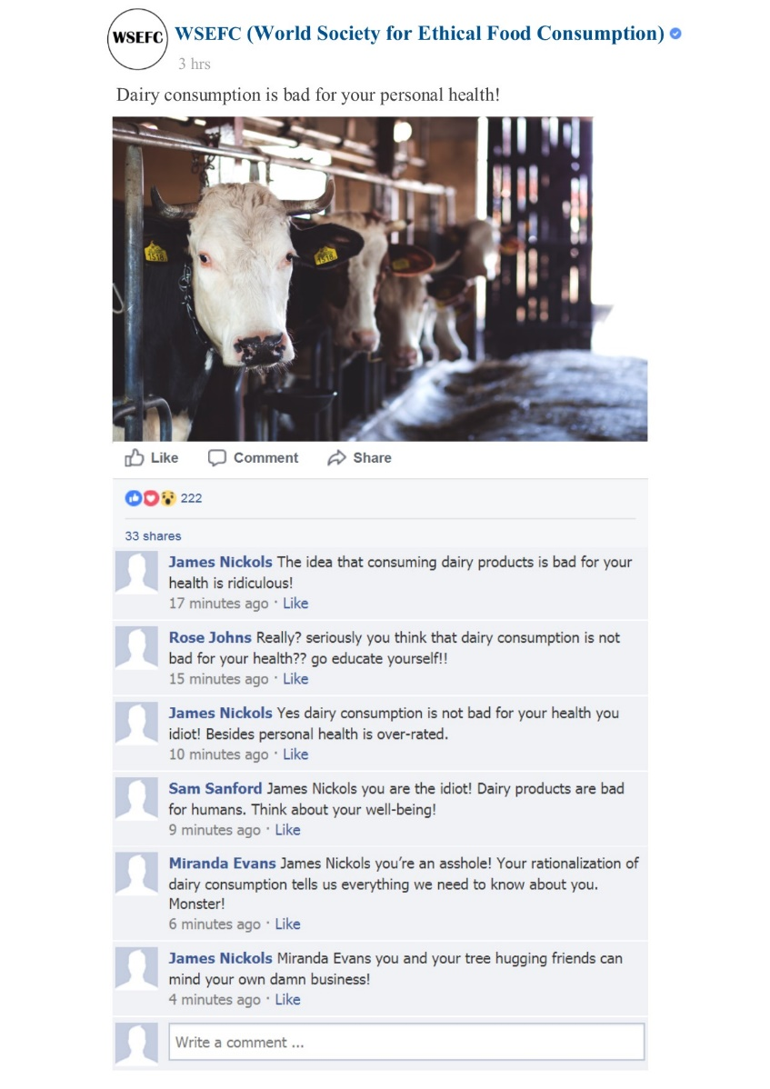

A.2 Other-benefit (animal welfare)-oriented organizational post and C2C conflict
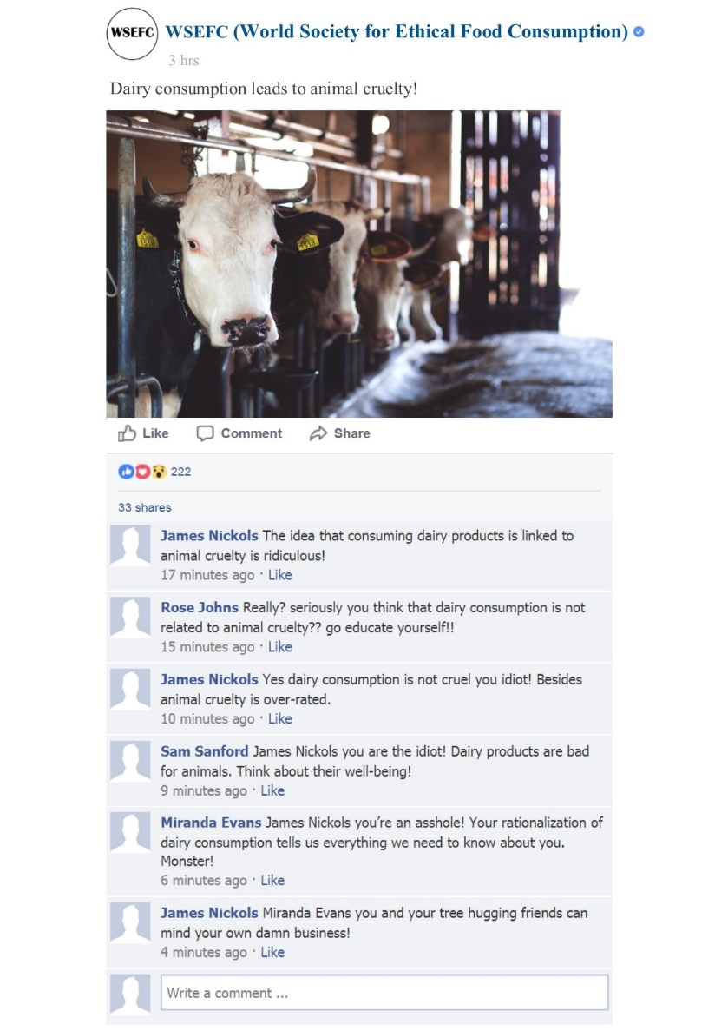

Appendix B. Manipulation 2 - Conflict Management Strategies
B.1 Non-engaging and Censoring
Note: Subjects exposed to the non-engaging strategy were told that the organization ignored the comments and made a new, unrelated post instead, shown below.
In the censoring condition, subjects were told that the organization deleted the comments that infringe the fan page’s rules and made a new, unrelated post, shown below.
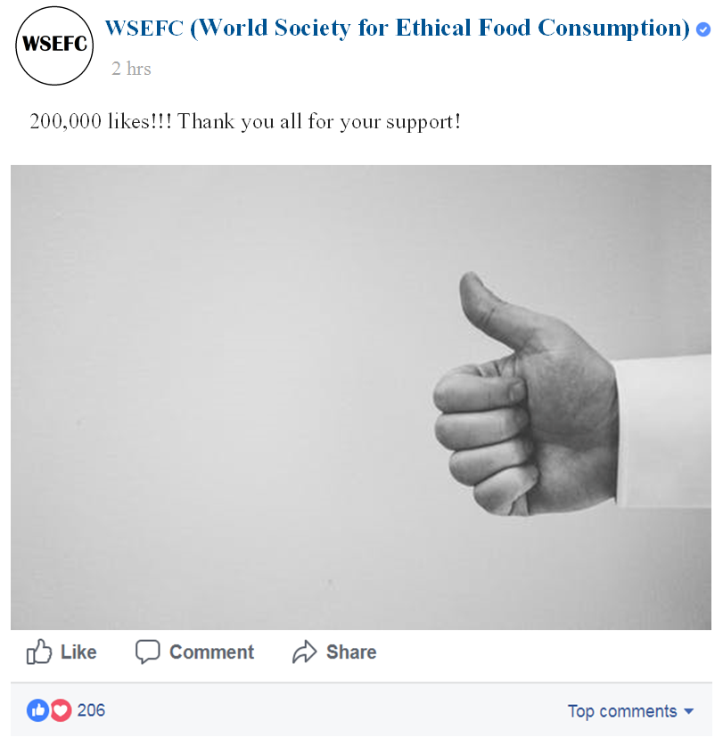

B.2 Realignment (same for both conflict content orientations)
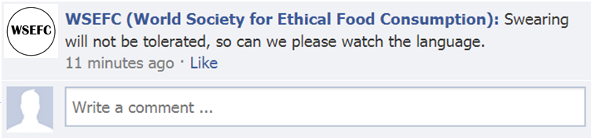
B.3 Bolstering (same for both conflict content orientations)
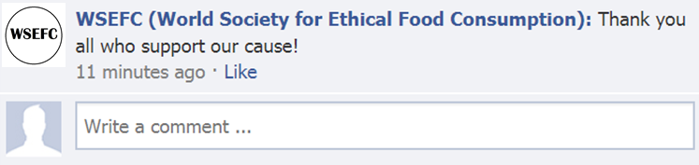
B.4 Educating (self-benefit content orientation)
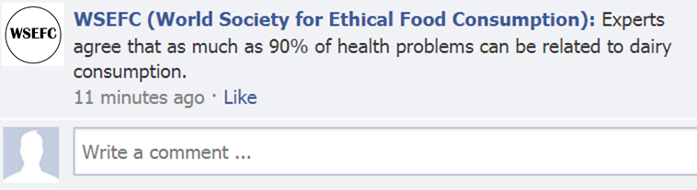
B.5 Educating (other-benefit content orientation)
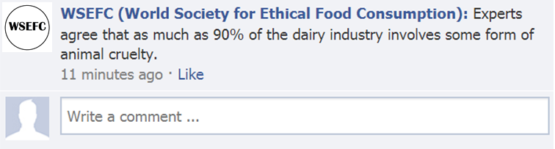
B.6 Mobilizing (self-benefit content orientation)
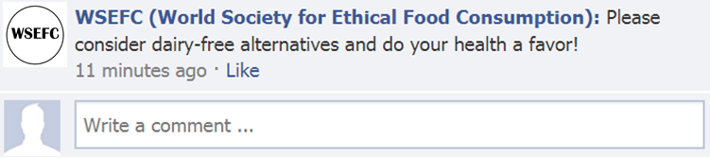
B.7 Mobilizing (other-benefit content orientation)
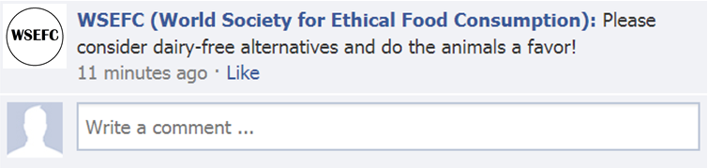

Manuscript Tables and Figures

Table 1 Main literature on conflict management (CM) in online environments
Author, year | Focus of investigation | CM strategies | Type of community | Context | Method | CM Theory
Godes et al. (2005) | The firm’s management of (positive and negative) social interactions between consumers | Observer, moderator, mediator, participant | Company-hosted,  Traditional online community | For-profit | Conceptual | No
Lee (2005) | Characteristic features of flaming and conflict management styles | Competitive-dominating, cooperative-integrating and avoiding | User-hosted, online forum | Feminist | Online ethnography | Rahim (1983) typology of CM (integrating, compromising, dominating, obliging, avoiding)
Mathwick, Wiertz & De Ruyter (2008) | Relational norms and social structures within problem-solving virtual communities | Articulating expectations of positive comments, constructive discussions and reciprocity | User-hosted, online forum | Peer-to-peer support | Survey, netnography | No
Schau, Muñiz & Arnould (2009) | Value creation practices in online brand communities | Explicit and implicit governing mechanisms | Company-hosted, traditional online communities | For-profit | Naturalistic observations, netnography, interviews | No
Matzat and Rooks (2014) | Styles of moderation in online support communities | Positive (reward) and negative (punishment); direct (influencing direct benefits from performing a behaviour) and indirect (pre-defined norms of acceptable behaviour) moderation styles | User-hosted, traditional online communities | Healthcare support | Experimental | Relational signalling theory for conflict moderation
Sibai, de Valck, Farrell and Rudd (2015) | Social control and moderation practices in online communities | Interaction initiation, interaction maintenance, interaction termination | Consumer- and company-hosted | Miscellaneous | Conceptual | No
Husemann, Ladstaetter and Luedicke (2015) | Conflict culture, types of conflicts and their management | Conflict cultivation for routine (constructive) conflicts, member exclusion for transgressive (dysfunctional) conflicts | Consumer-hosted, traditional online community | Non-profit | Netnography | No
Homburg, Ehm and Artz (2015) | Managing consumer discussions in online communities | Passive and active moderation | Company-hosted, online forums | For-profit | Sentiment analysis | No
Dineva, Breitsohl and Garrod (2017) | Conflict management strategies in SMFPs | Non-engaging, Censoring Bolstering, Pacifying, Informing | Company-hosted, social-media based communities | For-profit | Direct observation | No
Hauser, Hautz, Hutter and Fuller (2017) | Conflict management of public scandals and firestorms | A range of cooperative and assertive strategies - accommodating, collaborating, competing, avoiding | Company-hosted, social-media based communities | For-profit | Agent-based modelling | Blake and Mouton (1964) CM typology
Bacile, Wolter, Allen and Xu (2018) | The impact of consumer incivility in service recovery on social media channels | Non-engaging | Company-hosted, social media-based | For profit | Netnography, experiment | No

Table 2 Linguistic characteristics of negative (counterproductive) C2C conflict
Linguistic characteristic | Definition | References | Examples
Two-way exchange | A two-way episode where the originator (aggressor/victim) looks for/receives a verbal response from another person. | Breitsohl et al. (2018) | "I have zero respect for the Asian culture. They are fucking sick."  "not all asian do that you bitch"
Profanity | The use of obscene words and language. | Al-garadi et al. (2016); Wang et al. (2014) | “fucking”, “bullshit”, “cunt”, “asshole”, “racist fucks”
Rude or insulting diatribe | (Vicious) personal attacks towards a person who posts a comment. | Bourgonje et al. (2017); Bogolyubova et al. (2018) | “despicable excuse for human being”, “are you an ass?”,  “your an idiot”, “you sure are special…high school drop out” , “you make yourself look like a fool”
Emoticons and acronyms | The use of emoticons and acronyms to reinforce the content intensity. | Runions et al. (2013) | middle finger emoji, face with rolling eyes emoji;  “Ffs” (“for fuck’s sake”), “stfu” (“shut the fuck up”), “wtf” (“what the fuck”), “af” (“as fuck”)
Capitalized words and sentences | The deliberate use of capitalized words/sentences to emphasize a point/ express the emotion of anger. | Byron & Baldridge (2005); Tuzovic (2010) | “For someone that’s so patriotic you know NOTHING about freedom of speech DOUCHEBAG”,  “SHITTY VEGAN PROPAGANDA PAGE”
Multiple punctuation marks | The deliberate use of multiple punctuation marks to express an emotion (typically anger). | Byron & Baldridge (2005); Tuzovic (2010) | “!!!”, “???”, “?!?!”, “….”

Table 3 Conflict management strategies, conflict content types and sample comments
 | Codes | Themes | Observed | Definition | Excerpt
Conflict management  strategy | No intervention in the conflict  Avoiding engaging in the conflict  Missing comments  Thanks cause supporter(s)  Agrees with cause supporter(s)  Further clarification about an issue causing the conflict  Explaining an issue to conflicting parties  Providing additional information about an issue  An appeal to take action  Urging conflicting parties to change their behavior | Non-engaging  Censoring  Bolstering  Educating  Mobilizing | 265  2  14  21  30 | The organization does not take any action to moderate a conflict.  The organization permanently removes consumer comments.  The organization affirms a consumer comment.  The organization provides educational information about an ethical issue.  The organization urges consumers to take action towards an ethical issue. | [comment was removed]  “Thank you for choosing compassion! (heart emoji) #FriendsNotFood #TheYearOfVegan”  “@Lisa thanks for explaining supply & demand. (winking face emoji)”  “Zoos claim to provide educational opportunities, but most visitors spend only a few minutes at each display, seeking entertainment rather than enlightment [sic].”  “Keeping animals in cages does nothing to foster respect for animals since all children learn is that animals will spend their lives behind bars for people's fleeting distraction and amusement.”  “Please tell everyone you know to go vegan to help stop this! http://www.peta.org/living/food/free-vegan-starter-kit/”  “Unfortunately, a majority of dairy farms use practices like the ones seen in this video. Please consider ditching dairy and going vegan: http://features.peta.org/how-to-go-vegan/”
Conflict content | Vegan lifestyle as a personal choice  Implications of vegan diet on personal health  Testing on animals/using animals for entertainment for the benefit of humans  Implications of personal/collective consumption choices on animal welfare/rights | Self-oriented  Other-oriented | 29  144 | Conflict content revolving around issues related to the self.  Conflict content revolving around issues related to others. | "We have EVOLVED!!! We can live and live WELL on plant-based protein sources!"  "If you or your loved one gets cancer, you'll expect the best cancer chemo drugs. How do you think they came up w/ these drugs?? Say we ban animal trials, ok, so how do we test drugs then?"  "Vegan diet isn't for everyone especially those who need protein like me it has shown that 90%+ vegans are nutrients deficient in a way"  "Yeah I'm still gonna eat it..while I wish animals were treated better and killed more humanely.. Animals killing other animals is a fact of life. Humans are no different."  "You do realize that animals don't have souls right? They are magnificent creatures. One of the great pieces of Gods creation. However, they are not equal to humans and they do not have souls."  "Oh for goodness sake...some of these comments must me a joke right? You think that stealing dolphins from their homes and subjecting them to short lives of misery is justified to help a child that had a few minutes of "connection"?"  "@David come on, just because it's lawful and has a "Kennel Club" stamp of approval doesn't make it right. They may be looked after and treated well but ultimately the puppies are being breed for profit."

Table 4 Measurement Constructs
Construct | Items
Attitude towards the conflict management strategy (α = .94; from Nan and Heo, 2007) | The organization’s reaction is fair.  The organization’s reaction is justified.  The organization’s reaction is appropriate.  The organization’s reaction is acceptable.
Attitudes towards the organization’s social responsibility (α = .90; from Wagner, Lutz and Weitz, 2009) | WSEFC is a socially responsible organization.  WSEFC is concerned to improve the well-being of others.  WSEFC follows high ethical standards.
Perceived importance of an ethical issue (from Kronrod et al., 2012)  Perceived severity of the discussion (from Coyne et al., 2006)  Expectations of discussion moderation (from McCollough et al., 2000) | Animal cruelty is important to me.  My personal health is important to me.  I think that comments like these are upsetting.  I expect that WSEFC will take some action to moderate similar discussions.

Table 5 Cell means by experimental condition
Conflict Management Strategy | Conflict content | ATCM |  |  | ATOSR
 |  | Mean | Std. Dev. |  | Mean | Std. Dev.
Non-engaging | Self-oriented | 2.61 | 1.09 |  | 2.35 | 1.07
 | Other-oriented | 2.43 | .88 |  | 2.16 | .89
Censoring | Self-oriented | 2.41 | 1.11 |  | 2.48 | 1.00
 | Other-oriented | 2.57 | 1.07 |  | 2.46 | .87
Mobilizing | Self-oriented | 1.7 | .7 |  | 1.89 | .66
 | Other-oriented | 2.26 | .95 |  | 2.34 | .91
Realignment | Self-oriented | 1.73 | .76 |  | 2.09 | .9
 | Other-oriented | 1.73 | .72 |  | 2.07 | .78
Bolstering | Self-oriented | 2.35 | .98 |  | 2.47 | .8
 | Other-oriented | 2.01 | .94 |  | 2.25 | .83
Educating | Self-oriented | 2.16 | .95 |  | 2.3 | .84
 | Other-oriented | 2.44 | 1.08 |  | 2.33 | .69
Note. All items were measured using Likert-type scales ranging from 1 = Strongly agree to 5 = Strongly disagree

Table 6 Summary results of two-way ANOVAs
Dependent variable | df | Mean square | F | Sig.
ATCM
Conflict content | 1 | .81 | .9 | n.s.
Conflict management | 5 | 7.58 | 8.43 | < .01
Conflict management x conflict content | 5 | 2.18 | 2.42 | < .05
Error | 500 | .9
Total | 512
ATOSR
Conflict content | 1 | .00 | .00 | n.s.
Conflict management | 5 | 1.8 | 2.45 | < .05
Conflict management x conflict content | 5 | 1.16 | 1.58 | n.s.
Error | 500 | .74
Total | 512

Figure 1 C2C conflict excerpt

Figure 2 Conflict management research gap

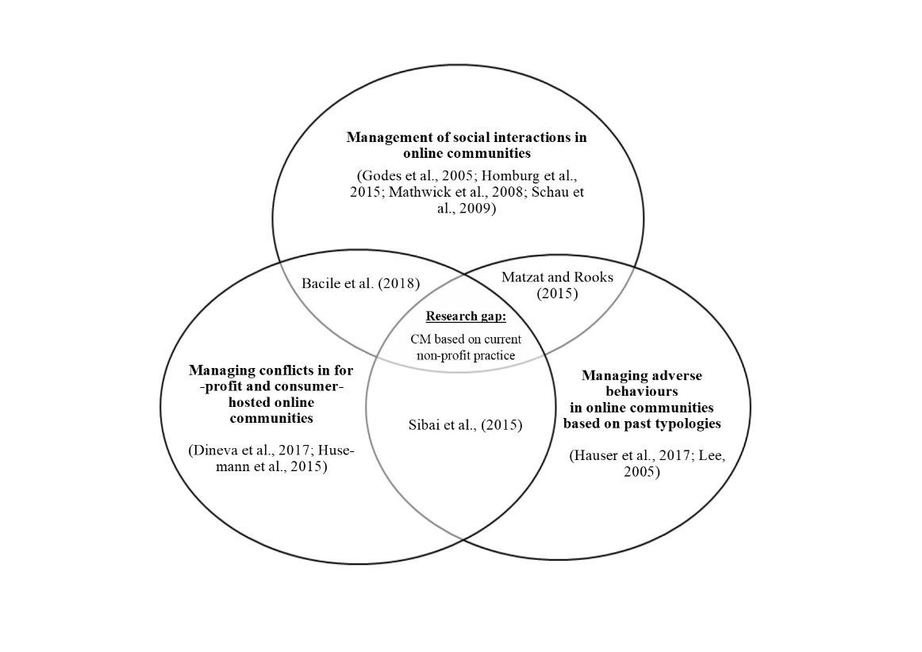

Figure 3 Study 1 Research procedure
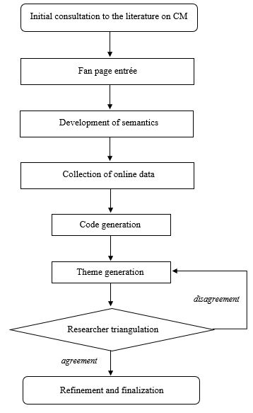

References
Aaker, Jennifer, Kathleen D. Vohs, and Cassie Mogilner (2010), “Nonprofits are seen as warm and for-profits as competent: Firm stereotypes matter,” Journal of Consumer Research, 37, 2, 224-237, doi:10.1086/651566
Al-garadi, Mohammed Ali, Kasturi Dewi Varathan, and Sri Devi Ravana (2016), “Cybercrime detection in online communications: The experimental case of cyberbullying detection in the Twitter network,” Computers in Human Behavior, 63, 433-443, doi:10.1016/j.chb.2016.05.051
Amatulli, Cesare, Matteo De Angelis, Alessandro M. Peluso, Isabella Soscia, and Gianluigi Guido (2017), “The Effect of Negative Message Framing on Green Consumption: An Investigation of the Role of Shame,” Journal of Business Ethics, 157, 1-22, doi:10.1007/s10551-017-3644-x
Anderson, Ashley A., Dominique Brossard, Dietram A. Scheufele, Michael A. Xenos, and Peter Ladwig (2014), “The “nasty effect:” Online incivility and risk perceptions of emerging technologies,” Journal of Computer‐Mediated Communication, 19, 3, 373-387, doi:10.1111/jcc4.12009
Bacile, Todd J., Jeremy S. Wolter, Alexis M. Allen, and Pei Xu (2018), “The effects of online incivility and consumer-to-consumer interactional justice on complainants, observers, and service providers during social media service recovery,” Journal of Interactive Marketing, 44, 60-81, doi:10.1016/j.intmar.2018.04.002
Barcelos, Renato Hübner, Danilo C. Dantas, and Sylvain Sénécal (2018), “Watch your tone: How a brand's tone of voice on social media influences consumer responses,” Journal of Interactive Marketing, 41, 60-80, doi:10.1016/j.intmar.2017.10.001
Becker-Olsen, Karen L., B. Andrew Cudmore, and Ronald Paul Hill (2006), “The impact of perceived corporate social responsibility on consumer behaviour,” Journal of Business Research, 59, 1, 46-53, doi:10.1016/j.jbusres.2005.01.001
Ben-Zur, Hasida, and Dana Yagil (2005), “The relationship between empowerment, aggressive behaviours of customers, coping, and burnout,” European Journal of Work and Organizational Psychology, 14, 1, 81-99, doi:10.1080/13594320444000281
Bernritter, Stefan F., Peeter WJ Verlegh, and Edith G. Smit (2016), “Why nonprofits are easier to endorse on social media: The roles of warmth and brand symbolism,” Journal of Interactive Marketing, 33, 27-42, doi:10.1016/j.intmar.2015.10.002
Blake, Robert Rogers, and Jane Srygley Mouton (1964), “The managerial grid,” Houston: Gulf Publishing.
Bogolyubova, Olga, Polina Panicheva, Roman Tikhonov, Viktor Ivanov, and Yanina Ledovaya (2018), “Dark personalities on Facebook: Harmful online behaviors and language,” Computers in Human Behavior, 78, 151-159, doi:10.1016/j.chb.2017.09.032
Botner, Keith A., Arul Mishra, and Himanshu Mishra (2015), “What's in a message? The longitudinal influence of a supportive versus combative orientation on the performance of nonprofits,” Journal of Marketing Research, 52, 1, 39-55, doi:10.1509/jmr.13.0211
Bourgonje, Peter, Julian Moreno-Schneider, Ankit Srivastava, and Georg Rehm (2017), “Automatic classification of abusive language and personal attacks in various forms of online communication,” International Conference of the German Society for Computational Linguistics and Language Technology (pp. 180-191). Springer, Cham.
Braun, Virginia, and Victoria Clarke (2006), “Using thematic analysis in psychology,” Qualitative Research in Psychology, 3, 2, 77-101, doi:10.1191/1478088706qp063oa
Braun, Virginia, and Victoria Clarke (2014), “Thematic analysis”. In H. Cooper (Ed.), APA Handbook of Research Methods in Psychology (Vol. 2, pp. 57–71). Washington, DC: American Psychological Association.
Bray, Jeffery, Nick Johns, and David Kilburn (2011), “An exploratory study into the factors impeding ethical consumption,” Journal of Business Ethics, 98, 4, 597-608, doi:10.1007/s10551-010-0640-9
Breitsohl, Jan, Holger Roschk, and Christina Feyertag (2018), “Consumer brand bullying behaviour in online communities of service firms,” In, Bruhn, Manfred and Hadwich, Karsten: Service Business Development (pp. 289-312). Springer Gabler, Wiesbaden.
Buckels, Erin E., Paul D. Trapnell, and Delroy L. Paulhus (2014),“Trolls just want to have fun,” Personality and Individual Differences, 67, 97-102, doi:10.1016/j.paid.2014.01.016
Burke, Paul F., Christine Eckert, and Stacey Davis (2014), “Segmenting consumers’ reasons for and against ethical consumption,” European Journal of Marketing, 48, 11/12, 2237-2261, doi:10.1108/EJM-06-2013-0294
Byron, Kristin, and David C. Baldridge (2005), “Toward a model of nonverbal cues and emotion in email,” Academy of Management Proceedings, B1-B6, doi:10.5465/ambpp.2005.18781269
Carrington, Michal J., Benjamin A. Neville, and Gregory J. Whitwell (2014), “Lost in translation: Exploring the ethical consumer intention–behavior gap,” Journal of Business Research, 67, 1, 2759-2767, doi:10.1016/j.jbusres.2012.09.022
Chan, Kimmy Wa, and Stella Yiyan Li (2010), “Understanding consumer-to-consumer interactions in virtual communities: The salience of reciprocity,” Journal of Business Research, 63, 9-10, 1033-1040, doi:10.1016/j.jbusres.2008.08.009
Chen, Katherine K., Howard Lune, and Edward L. Queen (2013), “How values shape and are shaped by nonprofit and voluntary organizations: The current state of the field,” Nonprofit and Voluntary Sector Quarterly, 42, 5, 856-885, doi:10.1177/0899764013480273
Cohen-Almagor, Raphael (2012), “Freedom of expression, internet responsibility, and business ethics: The Yahoo! saga and its implications,” Journal of Business Ethics, 106, 3, 353-365, doi:10.1007/s10551-011-1001-z
Coyne, Sarah M., John Archer, and Mike Eslea (2006), ““We're not friends anymore! Unless…”: The frequency and harmfulness of indirect, relational, and social aggression,” Aggressive Behavior: Official Journal of the International Society for Research on Aggression, 32, 4, 294-307, doi:10.1002/ab.20126
De Almeida, Stefânia Ordovás, Utpal M. Dholakia, José Mauro C. Hernandez, and José Afonso Mazzon (2014), “The mixed effects of participant diversity and expressive freedom in online peer-to-peer problem solving communities,” Journal of Interactive Marketing, 28, 3, 196-209. doi:10.1016/j.intmar.2014.02.003
De Hooge, Ilona E., Peeter WJ Verlegh, and Stefanie C. Tzioti (2014), “Emotions in advice taking: The roles of agency and valence,” Journal of Behavioral Decision Making, 27, 3, 246-258, doi:10.1002/bdm.1801
d de la Peña, Alicia, Bernardo Amezcua, and César Sepúlveda (2018), “Cause-brand community: Toward consumer citizenship,” Journal of Nonprofit & Public Sector Marketing, 30, 1, 1-36, doi:10.1080/10495142.2017.1326334
De Valck, Kristine (2007), “The war of the e-tribes: Online conﬂicts and communal consumption,” In Cova, Bernard, Kozinets, V. Robert and Shankar, Avi (Eds.), Consumer tribes (pp. 260–275). Oxford: Elsevier.
Dineva, Denitsa Petrova, Jan Christian Breitsohl, and Brian Garrod (2017), “Corporate conflict management on social media brand fan pages,” Journal of Marketing Management, 33, 9/10, 679-698, doi:10.1080/0267257X.2017.1329225
Du, Shuili, Chitrabhan B. Bhattacharya, and Sankar Sen (2010), “Maximizing business returns to corporate social responsibility (CSR): The role of CSR communication,” International Journal of Management Reviews, 12, 1, 8-19, doi:10.1111/j.1468-2370.2009.00276.x
Ensari, Nurcan, Camden-Anders, Sherry, and Schlaerth, Andrea (2015), “Constructive management and resolution of conflict,” In Friedman, Howard (Ed.), Encyclopedia of mental health (Vol. 1, pp. 340-349). Amsterdam: Elsevier.
Ertimur, Burçak, and Mary C. Gilly (2012), “So whaddya think? Consumers create ads and other consumers critique them,” Journal of Interactive Marketing, 26, 3, 115-130, doi:10.1016/j.intmar.2011.10.002
Ewing, Michael T., Peter E. Wagstaff, and Irene H. Powell (2013), “Brand rivalry and community conﬂict,” Journal of Business Research, 66, 1, 4–12, doi:10.1016/j.jbusres.2011.07.017
Felix, Reto, Philipp A. Rauschnabel, and Chris Hinsch (2017), “Elements of strategic social media marketing: A holistic framework,” Journal of Business Research, 70, 118-126, doi:10.1016/j.jbusres.2016.05.001
Fisher, Robert J., Mark Vandenbosch, and Kersi D. Antia (2008), “An empathy-helping perspective on consumers' responses to fund-raising appeals,” Journal of Consumer Research, 35, 3, 519-531, doi:10.1086/586909
Harris, Lloyd, Rebekah Russel‐Bennett, Ray Fisk, Stephen Grove, Lloyd C. Harris, Dominique A. Keeffe, Kate L. Daunt, Rebekah Russell‐Bennett, and Jochen Wirtz (2010), “Customers behaving badly: A state of the art review, research agenda and implications for practitioners,” Journal of Services Marketing, 24, 6, 417-429, doi:10.1108/08876041011072537
Fornell, Claes, and David F. Larcker (1981), “Evaluating structural equation models with unobservable variables and measurement error,” Journal of Marketing Research, 18, 1, 39-50, doi:3151312
Freestone, Oliver M., and Peter J. McGoldrick (2008), “Motivations of the ethical consumer,” Journal of Business Ethics, 79, 4, 445-467, doi:10.1007/s10551-007-9409-1
Fusch, Patricia I., and Lawrence R. Ness (2015), “Are we there yet? Data saturation in qualitative research,” The Qualitative Report, 20, 9, 1408-1416. Retrieved from: https://nsuworks.nova.edu/tqr/vol20/iss9/3
Gebauer, Johannes, Johann Füller, and Roland Pezzei (2013), “The dark and the bright side of co-creation: Triggers of member behavior in online innovation communities,” Journal of Business Research, 66, 9, 1516-1527, doi:10.1016/j.jbusres.2012.09.013
Gensler, Sonja, Franziska Völckner, Yuping Liu-Thompkins, and Caroline Wiertz (2013), “Managing brands in the social media environment,” Journal of Interactive Marketing, 27, 4, 242-256, doi:10.1016/j.intmar.2013.09.004
Godes, David, Dina Mayzlin, Yubo Chen, Sanjiv Das, Chrysanthos Dellarocas, Bruce Pfeiffer, Barak Libai, Subrata Sen, Mengze Shi, and Peeter Verlegh (2005), “The firm's management of social interactions,” Marketing Letters, 16, 3-4, 415-428, doi:10.1007/s11002-005-5902-4
Green, Todd, and John Peloza (2014), “Finding the right shade of green: The effect of advertising appeal type on environmentally friendly consumption,” Journal of Advertising, 43, 2, 128-141, doi:10.1080/00913367.2013.834805
Gretry, Anaïs, Csilla Horváth, Nina Belei, and Allard CR van Riel (2017). ““Don't pretend to be my friend!” When an informal brand communication style backfires on social media,” Journal of Business Research, 74, 77-89, doi:10.1016/j.jbusres.2017.01.012
Guo, Chao, and Gregory D. Saxton (2014), “Tweeting social change: How social media are changing nonprofit advocacy,” Nonprofit and Voluntary Sector Quarterly, 43, 1, 57-79, doi:10.1177/0899764012471585
Habel, Johannes, Sascha Alavi, and Doreén Pick (2017), “When serving customers includes correcting them: Understanding the ambivalent effects of enforcing service rules,” International Journal of Research in Marketing, 34, 4, 919-941, doi:10.1016/j.ijresmar.2017.09.002
Habibi, Mohammad Reza, Michel Laroche, and Marie-Odile Richard (2014) “The roles of brand community and community engagement in building brand trust on social media,” Computers in Human Behavior, 37, 152-161, doi:10.1016/j.chb.2014.04.016
Hair, Joseph F., William C. Black, Barry J. Babin, and Rolph E. Anderson (2010), “Multivariate Data Analysis”. Pearson, NJ: Pearson Education.
Harris, Lloyd, Rebekah Russell‐Bennett, and Sven Tuzovic (2010), “Frequent (flier) frustration and the dark side of word-of-web: exploring online dysfunctional behavior in online feedback forums,” Journal of Services Marketing, 24, 6, 446-457, doi:10.1108/08876041011072564
Hassay, Derek N., and John Peloza (2009), “Building the charity brand community,” Journal of Nonprofit & Public Sector Marketing, 21, 1, 24-55, doi:10.1080/10495140802111927
Hauser, Florian, Julia Hautz, Katja Hutter, and Johann Füller (2017), “Firestorms: Modeling conflict diffusion and management strategies in online communities,” The Journal of Strategic Information Systems, 26, 4, 285-321, doi:10.1016/j.jsis.2017.01.002
Homburg, Christian, Laura Ehm, and Martin Artz (2015), “Measuring and managing consumer sentiment in an online community environment,” Journal of Marketing Research, 52, 5, 629-641, doi:10.1509/jmr.11.0448
Hu, Li‐tze, and Peter M. Bentler (1999), “Cutoff criteria for fit indexes in covariance structure analysis: Conventional criteria versus new alternatives,” Structural Equation Modeling: A Multidisciplinary Journal, 6, 1, 1-55, doi:10.1080/10705519909540118
Husemann, Katharina C., Florian Ladstaetter, and Marius K. Luedicke (2015), “Conﬂict culture and conﬂict management in consumption communities,” Psychology & Marketing, 32, 3, 265-284, doi:10.1002/mar.20779
Ilhan, Behice Ece, Raoul V. Kübler, and Koen H. Pauwels (2018), “Battle of the brand fans: impact of brand attack and defense on social media,” Journal of Interactive Marketing, 43, 33-51, doi:10.1016/j.intmar.2018.01.003
Illia, Laura, Stefania Romenti, Belén Rodríguez-Cánovas, Grazia Murtarelli, and Craig E. Carroll (2017), “Exploring corporations’ dialogue about CSR in the digital era,” Journal of Business Ethics, 146, 1, 39-58, doi:10.1007/s10551-015-2924-6
Jerolmack, Colin, and Shamus Khan (2014), “Talk is cheap ethnography and the attitudinal fallacy,” Sociological Methods and Research, 43, 2, 1-32, doi:10.1177/0049124114523396
Johnson, Devon S., and Ben Lowe (2015), “Emotional support, perceived corporate ownership and skepticism toward out-groups in virtual communities,” Journal of Interactive Marketing, 29, 1-10, doi:10.1016/j.intmar.2014.07.002
Kozinets, Robert V. (2002), “The ﬁeld behind the screen: Using netnography for marketing research in online communities,” Journal of Marketing Research, 39, 1, 61-72, doi:10.1509/jmkr.39.1.61.18935
Kozinets, Robert V. (2015), “Netnography,” The International Encyclopaedia of Digital Communication and Society, 1-8, doi:10.1002/9781118767771.wbiedcs067
Kronrod, Ann, Amir Grinstein, and Luc Wathieu (2012), “Go green! Should environmental messages be so assertive?,” Journal of Marketing, 76, 1, 95-102, doi:10.1509/jm.10.0416
Labrecque, Lauren I., Jonas vor dem Esche, Charla Mathwick, Thomas P. Novak, and Charles F. Hofacker (2013), “Consumer power: Evolution in the digital age,” Journal of Interactive Marketing, 27, 4, 257-269, doi:10.1016/j.intmar.2013.09.002
Lee, Hangwoo (2005), “Behavioural strategies for dealing with flaming in an online forum,” The Sociological Quarterly, 46, 2, 385-403, doi:10.1111/j.1533-8525.2005.00017.x
Lee, Yong-ki, Sally Kim, Min-seong Kim, and Jeang-gu Choi (2014), “Antecedents and interrelationships of three types of pro-environmental behavior,” Journal of Business Research, 67, 10, 2097-2105, doi:10.1016/j.jbusres.2014.04.018
Liu, Wendy, and Jennifer Aaker (2008), “The happiness of giving: The time-ask effect,” Journal of Consumer Research, 35, 3, 543-557, doi:10.1086/588699
Lovejoy, Kristen, and Gregory D. Saxton (2012), “Information, community, and action: How nonprofit organizations use social media,” Journal of Computer‐Mediated Communication, 17, 3, 337-353, doi:10.1111/j.1083-6101.2012.01576.x
Matzat, Uwe (2009), “A theory of relational signals in online groups”. New Media & Society, 11, 3, 375-394, doi:10.1177/1461444808101617
Matzat, Uwe, and Gerrit Rooks (2014), “Styles of moderation in online health and support communities: An experimental comparison of their acceptance and effectiveness,” Computers in Human Behavior, 36, 65-75, doi:10.1016/j.chb.2014.03.043
Mathwick, Charla, Caroline Wiertz, and Ko De Ruyter (2008), “Social capital production in a virtual P3 community,” Journal of Consumer Research, 34, 6, 832-849, doi:10.1086/523291
McCollough, Michael A., Leonard L. Berry, and Manjit S. Yadav (2000), “An empirical investigation of customer satisfaction after service failure and recovery,” Journal of Service Research, 3, 2, 121-137, doi:10.1177/109467050032002
Mele, Cristina (2011), “Conflicts and value co-creation in project networks,” Industrial Marketing Management, 40, 8, 1377-1385, doi:10.1016/j.indmarman.2011.06.033
Minson, Julia A., and Benoît Monin (2012), “Do-gooder derogation: Disparaging morally motivated minorities to defuse anticipated reproach,” Social Psychological and Personality Science, 3, 2, 200-207, doi:10.1177/1948550611415695
Nah, Seungahn, and Gregory D. Saxton (2012), “Modeling the adoption and use of social media by nonprofit organizations,” New Media & Society, 15, 2, 294-313, doi:10.1177/1461444812452411
Nan, Xiaoli, and Kwangjun Heo (2007), “Consumer responses to corporate social responsibility (CSR) initiatives: Examining the role of brand-cause fit in cause-related marketing,” Journal of Advertising, 36, 2, 63-74, doi:10.2753/JOA0091-3367360204
Naylor, Rebecca Walker, Cait Poynor Lamberton, and Patricia M. West (2012), “Beyond the “like” button: The impact of mere virtual presence on brand evaluations and purchase intentions in social media settings,” Journal of Marketing, 76, 6, 105-120. doi:10.1509/jm.11.0105
Pew Research Center, (2017), “Online harassment,” (Accessed: 5 May 2020), Available at: http://www.pewinternet.org/2017/07/11/online-harassment-2017/
Pfeffer, Jürgen, Thomas Zorbach, and Kathleen M. Carley (2014), „Understanding online firestorms: Negative word-of-mouth dynamics in social media networks,” Journal of Marketing Communications, 20, 1-2, 117-128, doi:10.1080/13527266.2013.797778
Plé, Loïc, and Catherine Demangeot (2019, in press), "Social contagion of online and offline deviant behaviors and its value outcomes: The case of tourism ecosystems," Journal of Business Research, doi.org/10.1016/j.jbusres.2019.06.002
Rahim, M. Afzalur (1983), “A measure of styles of handling interpersonal conflict,” Academy of Management Journal, 26, 2, 368-376, doi:10.5465/255985
Reeves, Scott, Ayelet Kuper, and Brian David Hodges (2008), “Qualitative research methodologies: Ethnography,” British Medical Journal, 337, 7668, 512-514, doi:10.1136/bmj.a1020
Roschk, Holger, and Susanne Kaiser (2013), “The nature of an apology: An experimental study on how to apologize after a service failure,” Marketing Letters, 24, 3, 293-309, doi:10.1007/s11002-012-9218-x
unions, Kevin, Jennifer D. Shapka, Julian Dooley, and Kathryn Modecki (2013), “Cyber-aggression and victimization and social information processing: Integrating the medium and the message,” Psychology of Violence, 3, 1, 9-26, doi: 10.1037/a0030511
Rust, Roland T., and Bruce Cooil (1994), “Reliability measures for qualitative data: Theory and implications,” Journal of Marketing Research, 31, 1, 1-14. doi:10.1177/002224379403100101
Saxton, Gregory D., and Lili Wang (2014), “The social network effect: The determinants of giving through social media,” Nonprofit and Voluntary Sector Quarterly, 43, 5, 850-868, doi:10.1177/0899764013485159
Saxton, Gregory D., and Richard D. Waters (2014), “What do stakeholders like on Facebook? Examining public reactions to nonprofit organizations’ informational, promotional, and community-building messages,” Journal of Public Relations Research, 26, 3, 280-299, doi:10.1080/1062726X.2014.908721
Schamari, Julia, and Tobias Schaefers (2015), “Leaving the home turf: how brands can use webcare on consumer-generated platforms to increase positive consumer engagement,” Journal of Interactive Marketing, 30, 20-33, doi:10.1016/j.intmar.2014.12.001
Schau, Hope Jensen, Albert M. Muñiz Jr, and Eric J. Arnould (2009), “How brand community practices create value,” Journal of Marketing, 73, 5, 30-51, doi:10.1509/jmkg.73.5.30
Schröder, Monika JA, and Morven G. McEachern (2004), “Consumer value conflicts surrounding ethical food purchase decisions: A focus on animal welfare,” International Journal of Consumer Studies, 28, 2, 168-177, doi:10.1111/j.1470-6431.2003.00357.x
Seraj, Mina (2012), “We create, we connect, we respect, therefore we are: intellectual, social, and cultural value in online communities,” Journal of Interactive Marketing, 26, 4, 209-222, doi:10.1016/j.intmar.2012.03.002
Shaw, Deirdre, and Terry Newholm (2002), “Voluntary simplicity and the ethics of consumption,” Psychology & Marketing, 19, 2, 167-185, doi:10.1002/mar.10008
Sibai, Olivier, Kristine De Valck, Andrew M. Farrell, and John M. Rudd (2015), “Social control in online communities of consumption: A framework for community management,” Psychology & Marketing, 32, 3, 250-264, doi:10.1002/mar.20778
Skarmeas, Dionysis, and Constantinos N. Leonidou (2013), “When consumers doubt, watch out! The role of CSR scepticism,” Journal of Business Research, 66, 10, 1831-1838, doi:10.1016/j.jbusres.2013.02.004
Skålén, Per, Stefano Pace, and Bernard Cova (2015), "Firm-brand community value co-creation as alignment of practices," European Journal of Marketing, 49, 3/4, 596-620, doi.org/10.1108/EJM-08-2013-0409
Smith, Andrew N., Eileen Fischer, and Chen Yongjian (2012), “How does brand-related user-generated content differ across YouTube, Facebook, and Twitter?,” Journal of Interactive Marketing, 26, 2, 102-113, doi:10.1016/j.intmar.2012.01.002
Strauss, Anselm, and Juliet Corbin (1998). “Basics of qualitative research techniques,” Thousand Oaks, CA: Sage publications.
Sudbury-Riley, Lynn, and Florian Kohlbacher (2016), “Ethically minded consumer behavior: Scale review, development, and validation,” Journal of Business Research, 69, 8, 2697-2710, doi:10.1016/j.jbusres.2015.11.005
Teddlie, Charles, and Fen Yu (2007), “Mixed methods sampling: A typology with examples,” Journal of Mixed Methods Research, 1, 1, 77-100, doi:10.1177/2345678906292430
Thach, Elizabeth, and Karen J. Thompson (2007), “Trading places: Examining leadership competencies between for-profit vs. public and non-profit leaders,” Leadership & Organization Development Journal, 28, 4, 356-375, doi:10.1108/01437730710752229
Chalmers Thomas, Tandy, Linda L. Price, and Hope Jensen Schau (2013), “When differences unite: Resource dependence in heterogeneous consumption communities,” Journal of Consumer Research, 39, 5, 1010-1033, doi:10.1086/666616
Van Noort, Guda, and Lotte M. Willemsen (2012), “Online damage control: The effects of proactive versus reactive webcare interventions in consumer-generated and brand-generated platforms,” Journal of Interactive Marketing, 26, 3, 131-140, doi:10.1016/j.intmar.2012.01.003
Vázquez, Rodolfo, Luis Ignacio Álvarez, and María Leticia Santos (2002), “Market orientation and social services in private non-profit organisations,” European Journal of Marketing, 36, 9/10, 1022-1046, doi:10.1108/03090560210437316
Yoon, Sukki, Yung Kyun Choi, and Sujin Song (2011), “When intrusive can be likable,” Journal of Advertising, 40, 2, 63-76, doi:10.2753/JOA0091-3367400205
Wagner, Tillmann, Richard J. Lutz, and Barton A. Weitz (2009), “Corporate hypocrisy: Overcoming the threat of inconsistent corporate social responsibility perceptions,” Journal of Marketing, 73, 6, 77-91, doi:10.1509/jmkg.73.6.77
Wang, Wenbo, Lu Chen, Krishnaprasad Thirunarayan, and Amit P. Sheth (2014), “Cursing in English on twitter,” In Proceedings of the 17th ACM conference on Computer Supported Cooperative Work & Social Computing (pp. 415-425), Retrieved from: https://dl.acm.org/citation.cfm?id=2531734
Wang, Xia, Chunling Yu, and Yujie Wei (2012), “Social media peer communication and impacts on purchase intentions: A consumer socialization framework,” Journal of Interactive Marketing, 26, 4, 198-208, doi:10.1016/j.intmar.2011.11.004
Waters, C. Kenneth (2007), “The nature and context of exploratory experimentation: An introduction to three case studies of exploratory research,” History and Philosophy of the Life Sciences, 29, 3, 275-284, doi:23334262
Waters, Richard D., Emily Burnett, Anna Lamm, and Jessica Lucas (2009), “Engaging stakeholders through social networking: How nonprofit organizations are using Facebook,” Public Relations Review, 35, 2, 102-106, doi:10.1016/j.pubrev.2009.01.006
Waters, Richard D., and Jia Y. Jamal (2011), “Tweet, tweet, tweet: A content analysis of nonprofit organizations’ Twitter updates,” Public Relations Review, 37, 3, 321-324, doi:10.1016/j.pubrev.2011.03.002
Waters, Richard D., and Holly K. Ott (2014), “Corporate social responsibility and the nonprofit sector: Assessing the thoughts and practices across three nonprofit subsectors,” Public and Non-profit Administration, 8, 3, 1-18. Retrieved from: http://www.prsa.org/intelligence/prjournal/vol8/no3/#.VXC2Lkbis8A
White, Katherine, and John Peloza (2009), “Self-benefit versus other-benefit marketing appeals: Their effectiveness in generating charitable support,” Journal of Marketing, 73, 4, 109-124, doi:10.1509/jmkg.73.4.109
Wu, Mao-Ying, and Philip L. Pearce (2013), “Appraising netnography: Towards insights about new markets in the digital tourist era,” Current Issues in Tourism, 17, 5, 463-474, doi:10.1080/13683500.2013.833179
Yang, Defeng, Yue Lu, Wenting Zhu, and Chenting Su (2015), “Going green: How different advertising appeals impact green consumption behaviour,” Journal of Business Research, 68, 12, 2663-2675, doi:10.1016/j.jbusres.2015.04.004
Ye, Nan, Lefa Teng, Ying Yu, and Yingyuan Wang (2015). ““What's in it for me?”: The effect of donation outcomes on donation behaviour,” Journal of Business Research, 68, 3, 480-486, doi:10.1016/j.jbusres.2014.09.015
Zane, Daniel M., Julie R. Irwin, and Rebecca Walker Reczek (2016), “Do less ethical consumers denigrate more ethical consumers? The effect of willful ignorance on judgments of others,” Journal of Consumer Psychology, 26, 3, 337-349, doi: 10.1016/j.jcps.2015.10.002

