Title: Correlative fluorescence and atomic force microscopy to advance the bio-physical characterisation of co-culture of living cells

Authors:
Catarina Costa Moura ª*
Adelaide Miranda ª
Richard O. C. Oreffo ^{b}
Pieter De Beule ª

Affiliations:
ª INL – International Iberian Nanotechnology Laboratory, Avenida Mestre José Veiga, 4715-330 Braga, Portugal
^{b} Bone and Joint Research Group, Centre for Human Development, Stem Cells and Regeneration, Institute of Developmental Sciences, University of Southampton, Tremona Road, Southampton, SO16 6YD, UK

*corresponding author – catarina.moura@inl.int

Abstract:
An understanding of the cell mechanical properties involved in numerous cellular processes including cell division, cell migration/invasion, and cell morphology, is crucial in developing and informing cell physiology and function. Atomic force microscopy (AFM) offers a powerful biophysical technique that facilitates the imaging of living cells under physiological buffer conditions. However, AFM in isolation cannot discriminate between different cell types within heterogeneous samples for example in a solid biopsy. The current studies we demonstrate the potential of AFM in combination with correlative fluorescence optical sectioning microscopy for live cell imaging. Furthermore, this work establishes the advantage of fluorescence-AFM imaging to distinguish and analyse single-cell bio-physical properties in mixed human cell populations, in real-time. Critically, our results show that correlative fluorescence-AFM imaging allows the simultaneous co-localised detection of fluorescence coupled with nano-mechanical mapping. The findings from this work contribute to the promotion and dissemination of correlative multimodal imaging in life sciences, providing a platform for further investigations in biological and pre-clinical research.

Keywords:
AFM; atomic force microscopy; fluorescence; correlative microscopy; cell mechanical properties; nano-mechanical imaging
1.1 Introduction
A number of studies have been shown that cells can sense and transduce mechanical forces from neighbouring cells and their environment into biochemical and electrical signals [1–5]. However, our current understanding of the specific mechanism(s) involved in cell sensing and transduction remain limited, and yet the mechanism at play have a profound effect on cell proliferation, adhesion, migration and fate [1,3–7]. It is known that mechanical cues have a significant impact on cell function, intracellular signalling regulation [4,5,8], and on a number of biological processes including processes involved in tissue regeneration or cancer progression [9]. As previously published in Nature Cell Biology [2], “much remains to be discovered in this stimulating field at the crossroads of biology, biophysics, bioengineering” [7].
Single-cell analysis enables significant knowledge to be derived on cellular mechanisms, offering new insights on cell biology and significant impact for new developments in medicine. Atomic force microscopy (AFM) is a powerful tool for single-cell characterisation and has been has been applied to study cell mechanical properties. AFM has the ability to image in comparable physiological conditions, with high-resolution [10,11], and has provided valuable insights into quantitative live-cell mechanical mapping (reviewed in Li et al. [12]). However, to date, all single-cell studies have been performed using homogeneous samples [13,14], i.e. single cells that have not been isolated/discriminated and studied in mixed cell populations, co-culture systems or whole tissue samples. Crucially, human co-culture systems provide an important platform to study the interactions between different cell populations and are fundamental for studying cell–cell interactions [15], providing a more representative human in vivo-like tissue model.
The integration of two imaging techniques into a single instrument, produces a more powerful tool that overcomes some of the current limitations in standard microscopy, resulting in multi-dimensional information concerning the structure, dynamics, function and chemical composition of a sample. Correlative AFM imaging with fluorescence offers complementary information on different cellular characteristics leading to a more comprehensive analysis [16,17]. For example, AFM has been correlated with fluorescence microscopy to study the mechanical properties between normal and transformed epithelial cells [18], and correlated with confocal fluorescent microscopy to identify the initial binding events of a virus on the surface receptor of animal cells [19]. Chacko et al. analysed cytoskeletal structures in fixed cells by coupling optical super resolution (stimulated emission depletion – STED and stochastic optical reconstruction microscopy – STORM) and AFM techniques to deliver a correlative approach, to obtain high-resolution structural information on the cells of interest [20]. Current AFM techniques combining optical and super-resolution fluorescence imaging typically acquire successive measurements and subsequently superimpose the images obtained from the separate acquisitions, as imaging in a simultaneous mode causes perturbations in the AFM cantilever operation due to fluorescence excitation light.
In a previous work, AFM was combined with a differential spinning disk (DSD) microscope system for simultaneous real-time imaging [21]. The main advantage of integrating a DSD optical sectioning fluorescence microscopy over confocal microscopy is the provision of time-independent illumination of the AFM cantilever, resulting in the simultaneously acquisition of fluorescence and nano-mechanical mapping in the absence of cantilever disruption and/or heating.
There have been major advancements in AFM imaging, including bio-image analysis focusing on the quantitative measurement of biological systems by processing multidimensional image data [22]. However, there remains a gap between the imaging development community and the applied biology field. With this work, we seek to bridge this gap, highlighting a demonstration of real-time imaging with living cells, as an exemplar for this biological field.
The current studies demonstrate, for the first time the application of correlative DSD optical sectioning fluorescence-AFM for live cell imaging. The work details the advantages of simultaneous fluorescence-AFM to characterise a heterogeneous human skeletal cell population, retrieving information on single-cell population mechanics that would otherwise not be possible. While a number of studies using AFM to analyse mixed cell populations and co-culture systems or whole tissue samples have been undertaken [23], none of these studies detail the individual Young’s modulus of a single cell population in a co-culture system, but rather show the average of all cells present in the sample. In this proof-of-concept demonstration, we confirm the mechanical profile of the whole sample and, significantly, of the cell population of interest.

1.2 Methods
1.2.1 Saos-2 and GFP⁺ MG-63 cell culture
Saos-2 human osteosarcoma cells (passages 24 to 34) and GFP⁺ MG-63 cells (passages 16 to 19) were cultured in α-MEM and DMEM, respectively, supplemented with 10% (v/v) fetal calf serum, 100 U ml⁻¹ penicillin and 100 µg ml⁻¹ streptomycin. GFP⁺ MG-63 cells were established in previous work by transduction with a retroviral pMX-GFP vector (Cell Biolabs Inc., VPK-302) containing a green fluorescent protein insert and using polybrene as a transduction enhancer [24]. Cells were maintained in a humidified chamber at 37 ℃ and 5 % CO₂. Cell culture media was replenished every 2–3 days and the cells were routinely sub-cultured assuring a maximum confluence of 70%, being detached using 0.025% (w/v) Trypsin–EDTA with 0.05% glucose for 5 min at 37° C.
1.2.2 AFM imaging
Saos-2 and GFP⁺ MG-63 cells were cultured at a cell density of 5x10³ cells cm⁻² in 35 mm ibidi tissue culture-treated polymer µ-dishes for 48 hours. Live cells were imaged in cell culture media at 37° C using an atomic force microscope (JPK Nanowizard III, Bruker Nano GmbH), loaded on an inverted optical microscope (TI-S/L100, Mikon Instruments Europw B.V).
All AFM measurements were performed in an advanced force-spectroscopy based mode, referred to as a QITM Advanced Imaging, with a qp-BioAC-CI-CB3 AFM probe (NanoSensors), with force constant values ranging between 0.03 - 0.09 N m⁻¹. The cantilever has a gold coating layer on the detector side and a circular symmetric tip with 30-nm radius curvature. The cantilevers were calibrated using the contact-free method in liquid immediately before imaging.
AFM images were acquired with the following settings: set point at 1.1 nN, z-length of 2400 nm, and pixel time of 20 ms.
1.2.3 Combined DSD-AFM imaging
Saos-2 and GFP⁺ MG-63 cells were cultured at a cell density of 5x10³ cells cm⁻² in 35 mm ibidi tissue culture-treated polymer µ-dishes for 48 hours. Live cells were imaged in cell culture media at 37° C using a combined microscopy platform integrating DSD fluorescence (DSD generation-1, Andor Technology) and atomic force microscope (JPK Nanowizard III, Bruker Nano GmbH) which was loaded on an inverted optical microscope (TI-S/L100, Mikon Instruments Europw B.V). The combined system development was previously described by Miranda et al [21], and is shows in Supplementary Figure S1. For fluorescence light collection, a high numerical aperture microscope objective (CFI Plan Apo VC 60×/1.4 oil, Nikon Instruments Europe B.V.) was used.
1.2.4 AFM image registration
QITM Advanced Imaging mode was used for all AFM acquisitions, with a Z-cantilever 300 μms⁻¹ at a max Z-length of 2400 nm, resulting in an acquisition time of 22 min for each image.
Image registration was performed as previously described by Miranda et al [21]. Briefly, images acquired with the DSD and the AFM are combined using a software module (DirectOverlay, JPK BioAFM, Bruker Nano GmbH) to calibrate the optical image. The AFM cantilever is displaced to a set of predefined coordinated in a of 3x3 grid pattern to register an optical image at each position. From these images a transform function between both images is calculated and the overlaying of the DSD and the AFM images is possible.
1.2.5 AFM data analysis
For each AFM image, one force curve was acquired for each pixel (256x256 pixel-images corresponding to 65536 force curves per single image). AFM data was processed using the JPKSPM Data Processing software (version 6.1.131). All results were obtained from at least three independent biological samples, with a minimum of 25 single cells and 3 measurements each. Each single measurement was performed by averaging the elasticity values of the cytoplasm within the cell. The Young’s modulus of live cells was determined using the Hertz model, with a pre-defined algorithm available in the JPK Data Processing software. All operations were applied to the extend curve, after removing any offset or tilt from the curve, and considering a paraboloid shape of the cantilever tip. Control experiments (AFM analysis of Saos-2 cells and GFP⁺ MG-63 cells cultured alone) were also included, and the results are presented in the Supplementary Information (Supplementary Figures S2 – S3).
1.2.6 Confocal fluorescence microscopy for control experiment
Saos-2 and GFP⁺ MG-63 cells were cultured for 72 hours at a cell density of 5x10³ cells cm⁻² in ibidi 8-well tissue culture-treated polymer µ-slides. Cells were fixed with a 4% (v/v) paraformaldehyde (PFA) solution for 10 minutes at room temperature, followed by incubation with Phalloidin-TRITC (P1951 Sigma-Aldrich) diluted 1:1000 in 0.5 % (v/v) bovine serum albumin solution, for 1 hour at 37° C. The cells were finally incubated with 0.2 µg mL⁻¹ DAPI (D1306 Invitrogen) in phosphate-buffered saline, for 10 minutes, mounted using Fluoromount™ mounting medium. Cell imaging was performed using an inverted laser scanning confocal microscope (Zeiss LSM780), with a 63x/1.4 oil immersion objective, using two diode laser lines at 405nm and 561 nm, to excite DAPI and TRITC respectively, and an Argon laser at 488nm to excite GFP.
1.2.7 Statistical analysis
All results were obtained from at least three independent biological replicates. Statistical analyses were performed using GraphPad Prism 8. Data distributions were tested for normality and lognormality using the Shapiro-Wilk test. Young’s modulus data displayed lognormal distribution, and a lognormal fit was performed to determine mean and standard deviation values (mean ± SD). Statistical significance was tested using the nonparametric Mann-Whitney U-test.

1.3 Results & Discussion
AFM was combined with differential spinning disk fluorescence for simultaneous real-time imaging of live cells, as shown in Supplementary Figure S1. The combination of the two imaging tools in one system, facilitated the simultaneous retrieval of the elastic properties and topography of cells, and the use fluorescence to distinguish between the two different cell populations.
For this study, two distinct human bone osteosarcoma cell lines, Saos-2 and green fluorescent protein expressing MG-63 (GFP⁺ MG-63), were cultured and characterised using quantitative imaging mode (QITM) with AFM. Information on the elastic properties and topography of mixed Saos-2 and GFP⁺ MG-63 cells were obtained from AFM force measurements, collected for every pixel of the image.
Figure 1-a shows a representative force curve of an AFM acquisition of living bone cells. For each AFM image we obtained 65,536 force curves, each corresponding to a single pixel of the image (256x256 pixel-images). Figure 1-b shows a representative AFM topographic image of living human bone cells. The nucleus was the most prominent cellular structure at approximately 5 µm height, in this example. The Young’s modulus of the sample can extracted from each measurement of the force map, using an algorithm available in the JPK Data Processing software. The Young’s modulus values mapped in Figure 1-c also provide a matched analysis of the cell height and the cell elasticity. Figure 1-c indicated the nucleus was the mechanically softer part of the cell, with a lower Young’s modulus value (approximately 3 kPa). The cytoskeleton was observed to be more elastic than the nuclei. It is known that the acto-myosin cytoskeleton of cells needs to be sufficiently elastic as eukaryotic cells have the unique capacity to adapt and change shape in response to intrinsic or environmental cues [25]. The Young’s modulus of the ibidi tissue culture dish was observed to match the manufacturer’s values (>1 GPa).
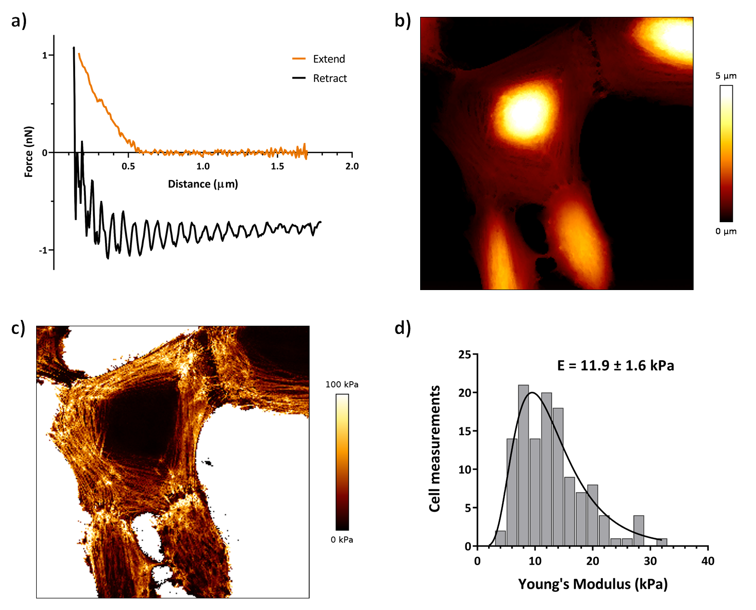
Figure 1 – Representative AFM quantitative data of Saos-2 and GFP⁺ MG-63 live cells in co-culture. a) Representative force curve obtained while scanning a live bone cell with AFM; b) representative AFM topographic image of bone live cells (colour bar from 0 to 5 µm); c) corresponding map of Young’s modulus values (colour bar from 0 to 100 kPa); d) Each single cell measurement was performed by averaging the elasticity values of the cytoplasm within a cell. Young’s modulus (E) of Saos-2 and GFP⁺ MG-63 living cells in co-culture was 11.9 ± 1.6 kPa (mean ± SD). All results were obtained from at least three independent biological samples (N=124).
The Young’s modulus of mixed Saos-2 and GFP⁺ MG-63 cells was calculated at 11.9 ± 1.6 kPa, following a lognormal distribution (Figure 1-d). The apparent cell stiffness was influenced by mechanical (tension / compression), hydrostatic and osmotic forces, and has been reported to range between 1 – 100 kPa [8,26]. Importantly, from the quantitative imaging AFM measurements alone one cannot attribute Young’s modulus values to the two different human bone osteosarcoma cell lines alone. AFM imaging alone does not provide access to the mechanical properties of single cell populations in complex systems, such as a co-culture model.
To validate the efficiency of the correlative imaging for life science applications and to demonstrate the potential of fluorescence-AFM imaging for live-cell characterisation, the Saos-2 and GFP⁺ MG-63 cells were mixed and co-cultured. Fixed cells were imaged using a confocal laser scanning microscope to verify the GPF expression of the cell mixture. To confirm the MG-63 cell population was GFP⁺, and the Saos-2 cell population GFP⁻. In Figure 2, GFP⁺ MG-63 cells, with distinct green cytoplasm, cam be observed. Supplementary Figure S4 shows the control experiments, including GFP⁺ MG-63 cells and Saos-2 cells, in mono-cultures. Actin filaments, key constituents of the cytoskeleton that support cell shape, cell migration and cell division, were stained with Phalloidin-TRITC (red). Figure 2 demonstrates that actin fibres display a distinct configuration in Saos-2 and GFP⁺ MG-63 cells. The actin filaments in Saos-2 cells were clearly defined and displayed enhanced organisation in comparison to MG-63 cell populations. These results are in keeping with previous observations that Saos-2 cells contain a more highly developed actin cytoskeleton, associated with a more differentiated osteoblastic phenotype [27,28].
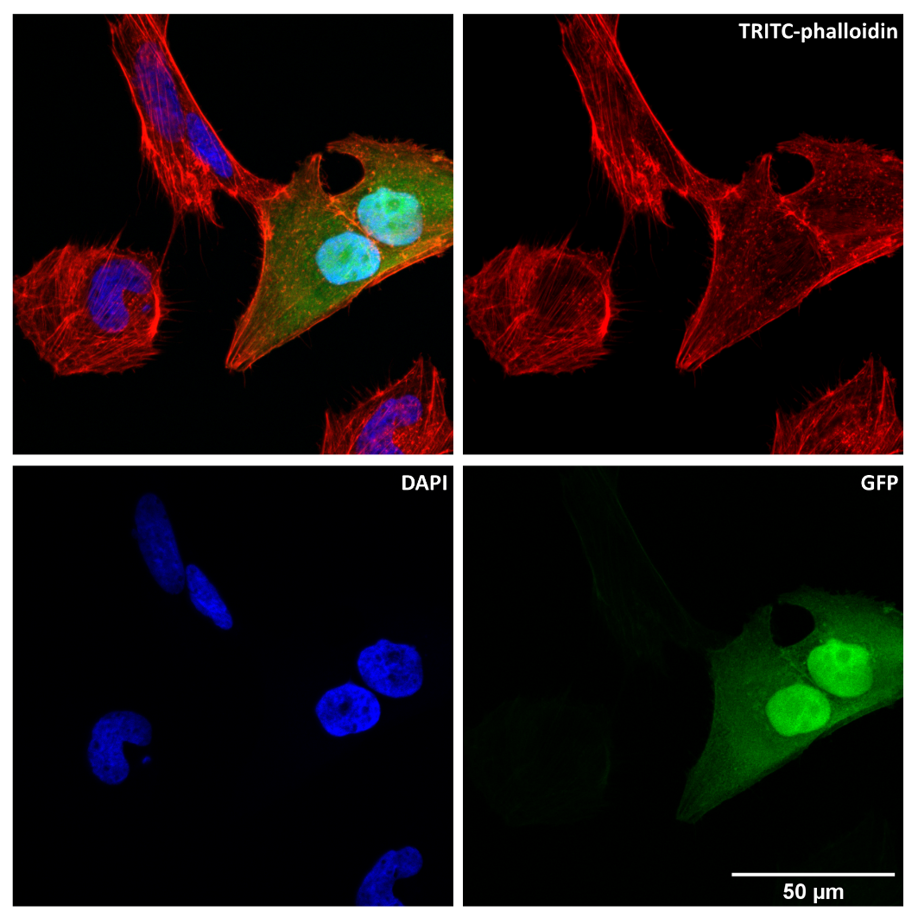
Figure 2 – Representative fluorescent confocal microscopy image of fixed GFP⁺ MG-63 (green) and Saos-2 cells, in co-culture. Cell nuclei stained with DAPI (blue) and actin filaments stained with TRITC-phalloidin (red). Scale bar corresponds to 50 µm.
The key goal of this study was to demonstrate the potential of correlative fluorescence-AFM for the simultaneous real-time imaging of living cells, and to acquire knowledge on single-cell morphology and single-cell mechanics within complex heterogeneous cell populations. Figure 3 provides representative images of correlative fluorescence-AFM microscopy of Saos-2 and GFP+ MG-63 cells.
Using the differential spinning disk, the fluorescent signal of interest can be detected at the same time as the AFM acquisition. Here, the GFP⁺ MG-63 cell population could be distinguished from their fluorescence in green. As previously discussed, AFM provides information regarding cell topography and elastic properties. The simultaneous detection of fluorescence and nano-mechanical mapping provided an approach to distinguish and analyse the bio-physical properties of single cell populations in a mixed culture.
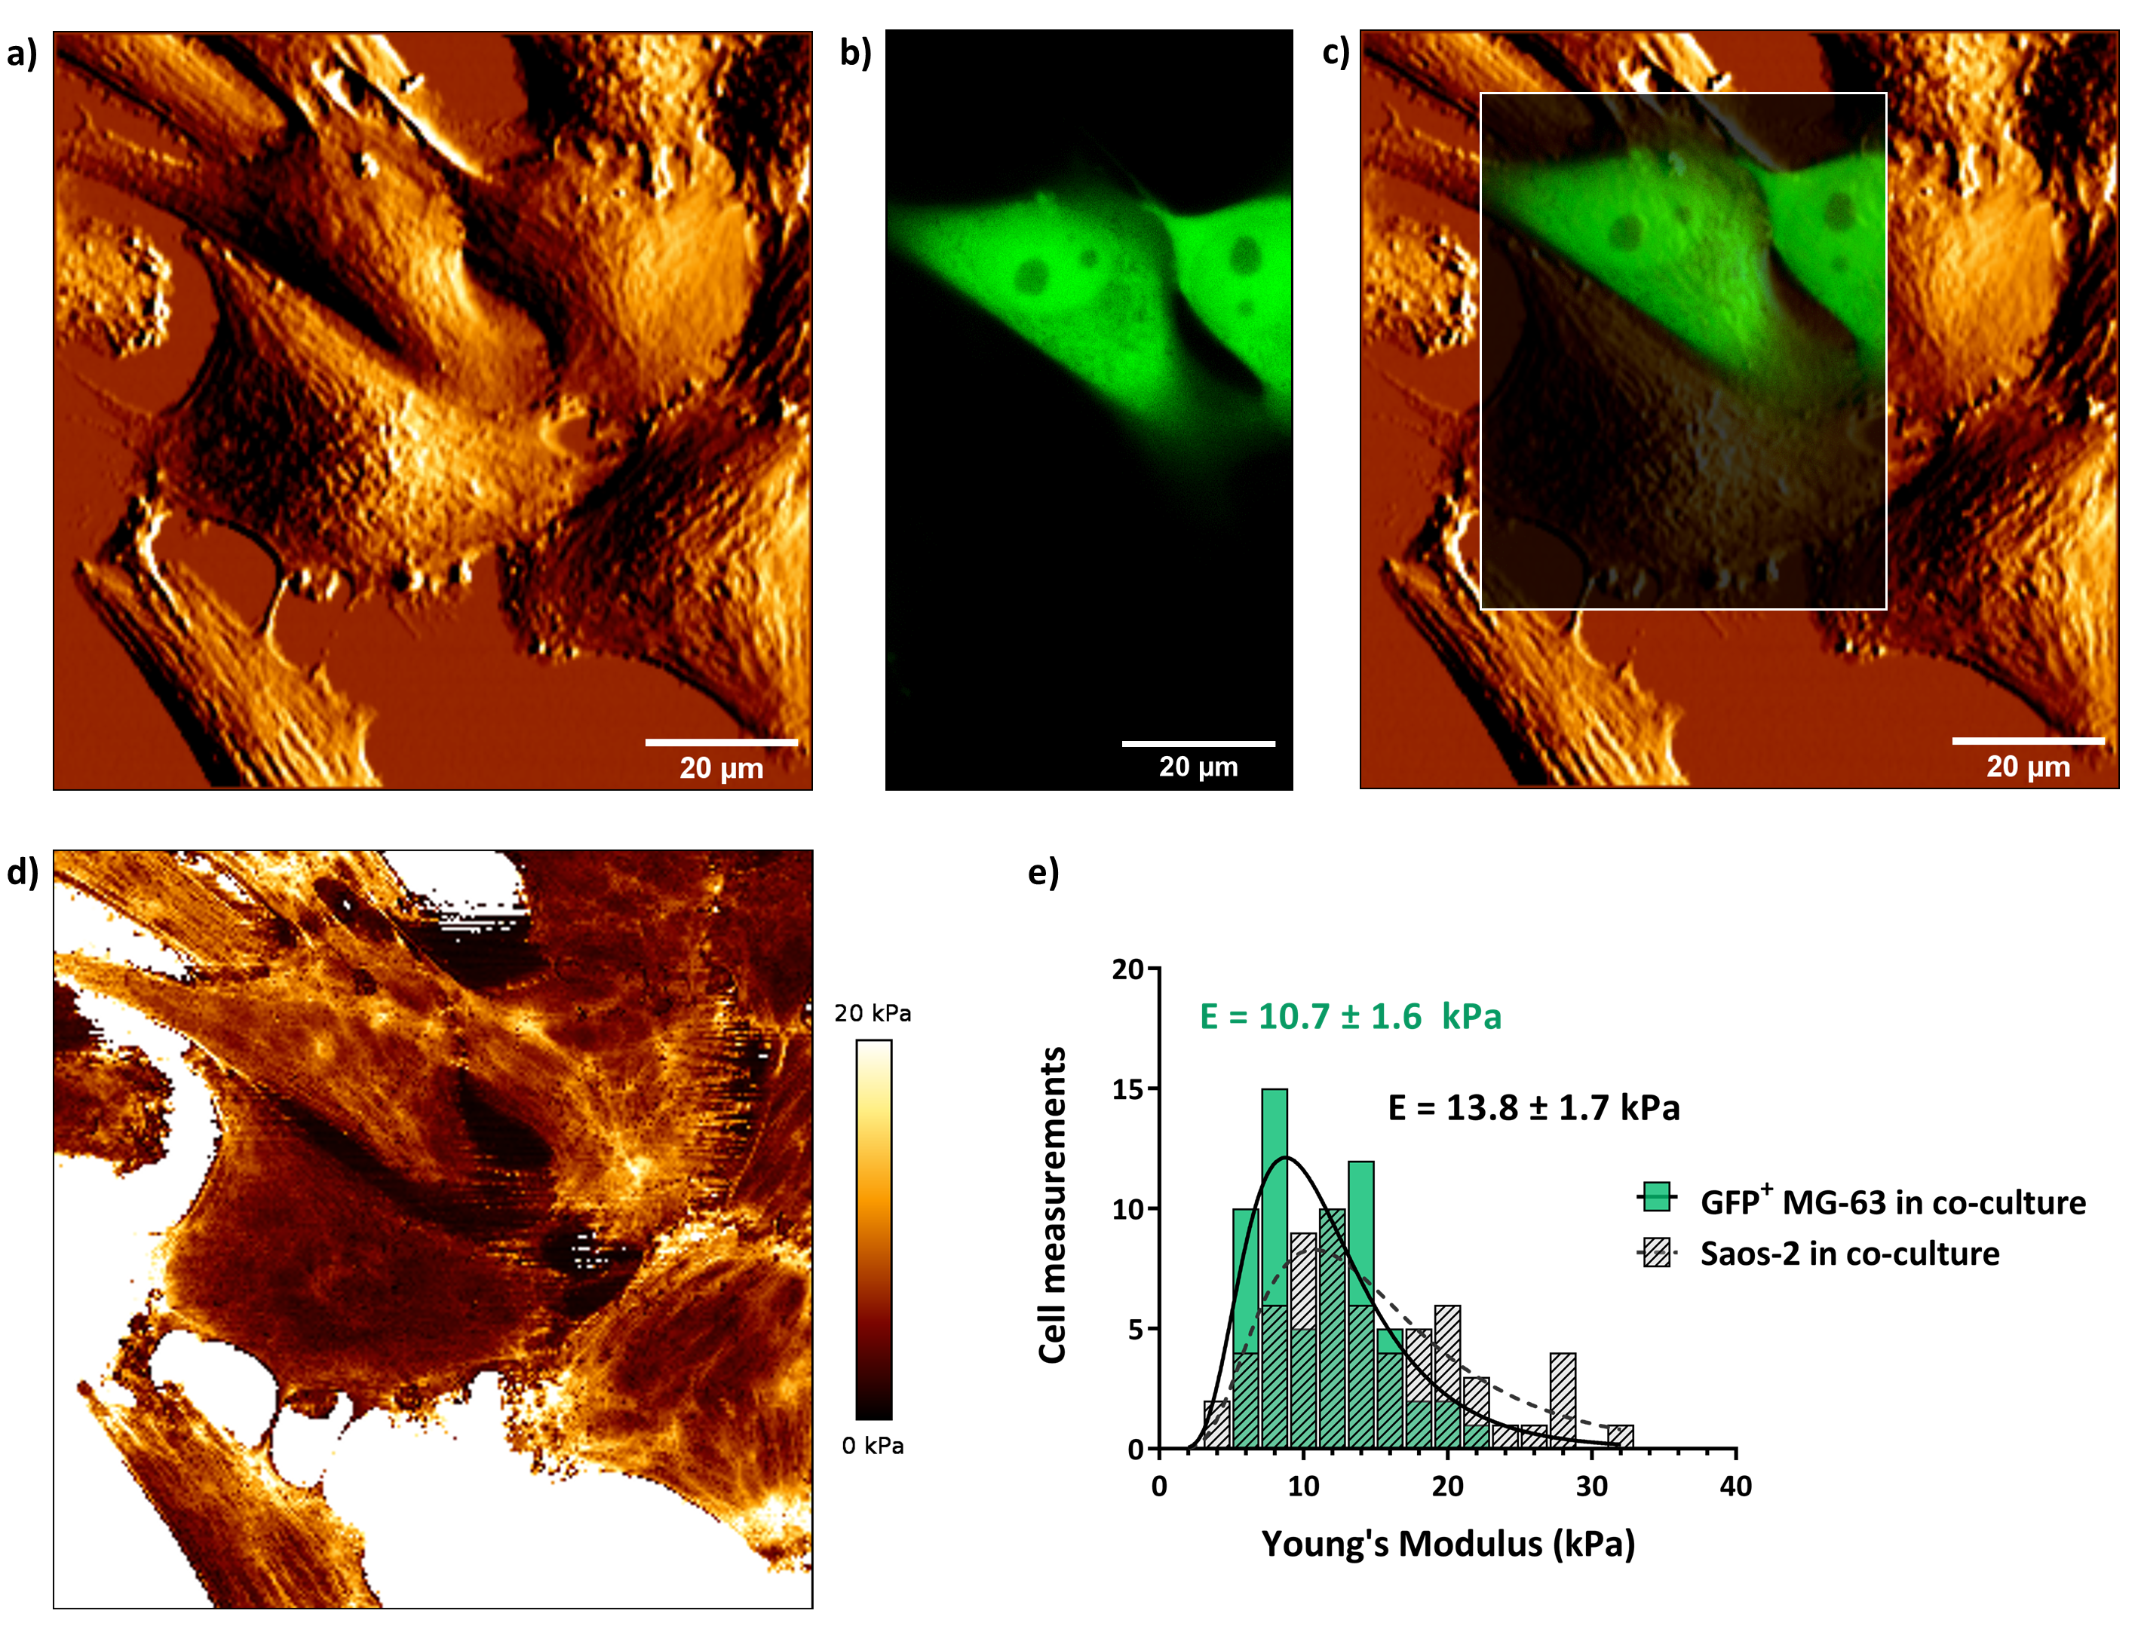
Figure 3 – Representative correlative DSD-AFM imaging of Saos-2 and GFP⁺ MG-63 cells. a) the AFM channel shows the topography of living bone cells (co-culture of Saos-2 and GFP+ MG-63 cells; b) the fluorescence channel shows the GFP⁺ signal from the MG-63 cell population; c) using the DSD, the fluorescent signal of interest can be detected at the same time as the AFM acquisition, and we can analyse the bio-physical properties of single cell populations (in this case GFP⁺ MG-63 cells) in a mixed sample. Scale bar corresponds to 20 µm; d) corresponding map of Young’s modulus values (colour bar from 0 to 20 kPa); e) the Young’s modulus of each cell population can be discriminated using the combined imaging platform, and the elasticity values of the two cell populations are statistically different (P=0.0054). All results were obtained from at least three independent biological samples (N=124).
Interestingly, the Young’s modulus of the single cell populations was different to the Young’s modulus calculated for mixed cells (11.9 ± 1.6 kPa). Saos-2 cells were significantly stiffer than GFP⁺ MG-63 (P = 0.0054), with a Young’s modulus of 13.5 ± 1.6 kPa and 10.9 ± 1.5 kPa respectively (Figure 3-e). This result is coherent given that MG-63 cells are representative of an earlier bone cell population (less differentiated skeletal cell phenotype), and Saos-2 cells display an enhanced maturation (greater differentiated) phenotype [29]. Furthermore, MG-63 cells, which display a mechanically softer phenotype than Saos-2, are associated with a more proliferative and less differentiated osteoblastic phenotype [28].
The current results highlight the capacity for fluorescence-AFM to analyse cell populations that could not be distinguished by AFM alone. Interestingly, analysis of the Saos-2/GFP⁺-MG-63 co-culture by AFM in isolation produced a result that was close to the average of the Young’s modulus of the two cell types but does not represent the mechanical phenotype of either of the cell populations.
The current studies demonstrate relevant complementary information on mixed cells can be retrieved using correlative imaging, combining differential spinning disk fluorescence and AFM. This technique could be used as a platform to distinguish different cell populations and, crucially, to accurately determine cell mechanical properties. This work opens the possibility to study the mechanical phenotype of individual cell populations in heterogeneous samples that cannot be classified and discriminated using morphology alone (such as shape, structure, form and size). Such approaches to facilitate cell discrimination, are increasingly important in complex samples, where 100% cell purity cannot be achieved (e.g. the culture of skeletal stem cells from human bone marrow [30]), and in scenarios where the interplay between different cell types alters the mechanical properties of individual cells (e.g. the mediation of the mechanical properties of microvasculature endothelial cells by metastatic cancer cells [2]).
Using an interdisciplinary approach, harnessing physics, optics and cell biology, this work provides new insights into the application of correlative imaging to assess the bio-physical properties of mixed living cell populations. While AFM has been used to image and characterise live cells, this simultaneous imaging platform allows the assessment and discrimination of different cells in one sample, and for the accurate analysis of single-cell mechanical properties. This study paves the way to further investigations using living cells to address a raft of other biological and clinically relevant questions as well as studies on cellular dynamics in real-time that will inform cell biology.

Author contributions
CCM performed cell culture, immunocytochemistry, confocal fluorescence microscopy, combined fluorescence-AFM imaging, data analysis, image processing and analysis, statistical analysis, and writing of the main manuscript. AM participated in the combined DSD-AFM data acquisition. CCM and ROCO conceptualised and designed the study. ROCO and PDB coordinated the study. All authors contributed to the writing of the manuscript and gave final approval for publication.

Competing interests: The authors declare no competing interests.

Funding: This work was supported by the Fundação para a Ciência e a Tecnologia project SAM – [PTDC/NAN-OPT/31596/2017]. Funding to ROCO from the UK Regenerative Medicine Platform Acellular / Smart Materials – 3D Architecture [MR/R015651/1], and a grant from the UK Regenerative Medicine Platform [MR/L012626/1] Southampton imaging is gratefully acknowledged.
References
[1] C.T. Mierke, The matrix environmental and cell mechanical properties regulate cell migration and contribute to the invasive phenotype of cancer cells, Rep Prog Phys. 82 (2019) 64602. https://doi.org/10.1088/1361-6633/ab1628.
[2] C.T. Mierke, Cancer cells regulate biomechanical properties of human microvascular endothelial cells, J. Biol. Chem. 286 (2011) 40025–40037. https://doi.org/10.1074/jbc.M111.256172.
[3] M. Uroz, S. Wistorf, X. Serra-Picamal, V. Conte, M. Sales-Pardo, P. Roca-Cusachs, R. Guimerà, X. Trepat, Regulation of cell cycle progression by cell–cell and cell–matrix forces, Nat. Cell Biol. 20 (2018) 646–654. https://doi.org/10.1038/s41556-018-0107-2.
[4] M. Radmacher, Studying the mechanics of cellular processes by atomic force microscopy, Methods Cell Biol. 83 (2007) 347–372. https://doi.org/10.1016/s0091-679x(07)83015-9.
[5] K.H. Vining, D.J. Mooney, Mechanical forces direct stem cell behaviour in development and regeneration, Nat Rev Mol Cell Biol. 18 (2017) 728–742. https://doi.org/10.1038/nrm.2017.108.
[6] C.L. Ives, S.G. Eskin, L. V McIntire, Mechanical effects on endothelial cell morphology: In vitro assessment, Vitr. Cell. Dev. Biol. 22 (1986) 500–507. https://doi.org/10.1007/BF02621134.
[7] Forces in cell biology, Nat. Cell Biol. 19 (2017) 579. https://doi.org/10.1038/ncb3552.
[8] K. Haase, A.E. Pelling, Investigating cell mechanics with atomic force microscopy, J R Soc Interface. 12 (2015) 20140970. https://doi.org/10.1098/rsif.2014.0970.
[9] B. Ladoux, R.M. Mege, Mechanobiology of collective cell behaviours, Nat Rev Mol Cell Biol. 18 (2017) 743–757. https://doi.org/10.1038/nrm.2017.98.
[10] P.K. Viji Babu, C. Rianna, U. Mirastschijski, M. Radmacher, Nano-mechanical mapping of interdependent cell and ECM mechanics by AFM force spectroscopy, Sci Rep. 9 (2019) 12317. https://doi.org/10.1038/s41598-019-48566-7.
[11] F. Rico, E.P. Wojocikiewicz, V.T. Moy, Atomic Force Microscopy Studies of the Mechanical Properties of Living Cells, in: M. Tomitori, B. Bhushan, H. Fuchs (Eds.), Appl. Scanning Probe Methods IX Charact., Springer Berlin Heidelberg, Berlin, Heidelberg, 2008: pp. 89–109. https://doi.org/10.1007/978-3-540-74083-4_4.
[12] M. Li, N. Xi, Y. Wang, L. Liu, Advances in atomic force microscopy for single-cell analysis, Nano Res. 12 (2019) 703–718. https://doi.org/10.1007/s12274-018-2260-0.
[13] S. Barns, M.A. Balanant, E. Sauret, R. Flower, S. Saha, Y. Gu, Investigation of red blood cell mechanical properties using AFM indentation and coarse-grained particle method, Biomed Eng Online. 16 (2017) 140. https://doi.org/10.1186/s12938-017-0429-5.
[14] T.-H. Nguyen, R. Palankar, V.-C. Bui, N. Medvedev, A. Greinacher, M. Delcea, Rupture Forces among Human Blood Platelets at different Degrees of Activation, Sci. Rep. 6 (2016) 25402. https://doi.org/10.1038/srep25402.
[15] L. Goers, P. Freemont, K.M. Polizzi, Co-culture systems and technologies: taking synthetic biology to the next level, J. R. Soc. Interface. 11 (2014) 20140065. https://doi.org/10.1098/rsif.2014.0065.
[16] S. V Bhat, T. Sultana, A. Körnig, S. McGrath, Z. Shahina, T.E.S. Dahms, Correlative atomic force microscopy quantitative imaging-laser scanning confocal microscopy quantifies the impact of stressors on live cells in real-time, Sci. Rep. 8 (2018) 8305. https://doi.org/10.1038/s41598-018-26433-1.
[17] J. Caplan, M. Niethammer, R.M. Taylor 2nd, K.J. Czymmek, The power of correlative microscopy: multi-modal, multi-scale, multi-dimensional, Curr Opin Struct Biol. 21 (2011) 686–693. https://doi.org/10.1016/j.sbi.2011.06.010.
[18] C. Hogan, S. Dupre-Crochet, M. Norman, M. Kajita, C. Zimmermann, A.E. Pelling, E. Piddini, L.A. Baena-Lopez, J.P. Vincent, Y. Itoh, H. Hosoya, F. Pichaud, Y. Fujita, Characterization of the interface between normal and transformed epithelial cells, Nat Cell Biol. 11 (2009) 460–467. https://doi.org/10.1038/ncb1853.
[19] D. Alsteens, R. Newton, R. Schubert, D. Martinez-Martin, M. Delguste, B. Roska, D.J. Müller, Nanomechanical mapping of first binding steps of a virus to animal cells, Nat. Nanotechnol. 12 (2016) 177. https://doi.org/10.1038/nnano.2016.228.
[20] J.V. Chacko, F.C. Zanacchi, A. Diaspro, Probing cytoskeletal structures by coupling optical superresolution and AFM techniques for a correlative approach, Cytoskeleton. 70 (2013) 729–740. https://doi.org/10.1002/cm.21139.
[21] A. Miranda, M. Martins, P.A. De Beule, Simultaneous differential spinning disk fluorescence optical sectioning microscopy and nanomechanical mapping atomic force microscopy, Rev Sci Instrum. 86 (2015) 93705. https://doi.org/10.1063/1.4931064.
[22] K. Miura, P. Paul-Gilloteaux, S. Tosi, J. Colombelli, Workflows and Components of Bioimage Analysis, in: K. Miura, N. Sladoje (Eds.), Bioimage Data Anal. Work., Springer International Publishing, Cham, 2020: pp. 1–7. https://doi.org/10.1007/978-3-030-22386-1_1.
[23] A. Stylianou, M. Lekka, T. Stylianopoulos, AFM assessing of nanomechanical fingerprints for cancer early diagnosis and classification: from single cell to tissue level, Nanoscale. 10 (2018) 20930–20945. https://doi.org/10.1039/C8NR06146G.
[24] E.M. Czekanska, In vitro cell and culture models for osteoblasts and their progenitors, Cardiff University, 2014.
[25] E. Moeendarbary, L. Valon, M. Fritzsche, A.R. Harris, D.A. Moulding, A.J. Thrasher, E. Stride, L. Mahadevan, G.T. Charras, The cytoplasm of living cells behaves as a poroelastic material, Nat. Mater. 12 (2013) 253. https://doi.org/10.1038/nmat3517.
[26] S.-Y. Tee, A.R. Bausch, P.A. Janmey, The mechanical cell, Curr. Biol. 19 (2009) R745–R748. https://doi.org/10.1016/j.cub.2009.06.034.
[27] A.K. Born, M. Rottmar, S. Lischer, M. Pleskova, A. Bruinink, K. Maniura-Weber, Correlating cell architecture with osteogenesis: first steps towards live single cell monitoring, Eur Cell Mater. 18 (2009) 49–60, 61–2; discussion 60.
[28] M. Vandrovcova, I. Jirka, K. Novotna, V. Lisa, O. Frank, Z. Kolska, V. Stary, L. Bacakova, Interaction of Human Osteoblast-Like Saos-2 and MG-63 Cells with Thermally Oxidized Surfaces of a Titanium-Niobium Alloy, PLoS One. 9 (2014) e100475. https://doi.org/10.1371/journal.pone.0100475.
[29] E.M. Czekanska, M.J. Stoddart, R.G. Richards, J.S. Hayes, In search of an osteoblast cell model for in vitro research, Eur Cell Mater. 24 (2012) 1–17. https://doi.org/10.22203/ecm.v024a01.
[30] M. Xavier, R.O.C. Oreffo, H. Morgan, Skeletal stem cell isolation: A review on the state-of-the-art microfluidic label-free sorting techniques, Biotechnol Adv. 34 (2016) 908–923. https://doi.org/10.1016/j.biotechadv.2016.05.008.

