Article
Using high-pressure torsion to achieve superplasticity in an AZ91 magnesium alloy
Roberto B. Figueiredo ^{1,*}, Terence G. Langdon ^{2,3}
¹ Department of Metallurgical and Materials Engineering, Universidade Federal de Minas Gerais, Belo Horizonte, MG 31270-901 Brazil; figueiredo@demet.ufmg.br
² Materials Research Group, Department of Mechanical Engineering, University of Southampton, Southampton SO17 1BJ, U.K.; T.G.Langdon@soton.ac.uk
³ Departments of Aerospace & Mechanical Engineering and Materials Science, University of Southern California, Los Angeles, CA 90089-1453, U.S.A.; langdon@usc.edu
* Correspondence: figueiredo@demet.ufmg.br; (R.B.F.)
Received: date; Accepted: date; Published: date
Abstract: An AZ91 magnesium alloy (Mg-9% Al-1% Zn) was processed by high-pressure torsion (HPT) after a solution heat treatment. Tensile tests were carried out at 423, 523 and 623 K in the strain rate range of 10-5 – 10-1 s-1 to evaluate the occurrence of superplasticity. The results show that HPT processing refines the grain structure in this alloy and grain sizes smaller than 10 µm are retained up to 623 K. Superplastic elongations were observed at low strain rates at 423 K and at all strain rates at 523 K. An examination of the experimental data shows good agreement with the theoretical prediction for grain boundary sliding which is the rate-controlling mechanism for superplasticity. Elongations in the range of 300% - 400% were observed at 623 K and this is attributed to a combination of grain boundary sliding and dislocation climb mechanisms. Keywords: creep; high-pressure torsion; magnesium; superplasticity

1. Introduction
Superplasticity refers to the ability of a polycrystalline material to undergo large stable deformation in tension and to thereby achieve a high elongation prior to failure. Formally, it is defined as elongations larger than 400% and a strain rate sensitivity of ~0.5 [1]. It is now recognized that the deformation mechanism associated with superplasticity is grain boundary sliding in which the grains slide over each other with little or no change in their overall shape [2]. In practice, sliding along grain boundaries is caused by movement of grain boundary dislocations which then pile up at obstacles such as triple junctions and activate slip in a neighboring grain as an accommodating mechanism [3]. This leads to a pile up of dislocations at the opposite grain boundary and the rate of deformation is then controlled by the rate of climb of these dislocations at the head of the pile up. The two requirements for superplasticity are a fine-grained structure, with average grain sizes typically smaller than ~10 µm, and a high homologous temperature, typically larger than ~0.5 of the absolute melting temperature [4].
Small grain sizes, in the range of a few microns, are usually obtained through conventional thermo-mechanical processing operations such as extrusion and rolling. More recently, the development of severe plastic deformation (SPD) [5] techniques such as equal-channel angular pressing (ECAP) [6] and high-pressure torsion [7] offered the possibility to produce metallic materials with ultrafine grains (<1 µm) or even nanostructured grains (<100 nm). This significant decrease in structural size compared to conventional thermo-mechanical processing allowed the introduction of superplastic behavior into a very wide range of different alloys and also affected the temperature and strain rate range associated with the superplastic process. In practice, it is now recognized that superplastic behavior is observed at lower temperatures and/or faster strain-rates when the grain size is decreased. Moreover, it is also clear that a decrease in grain size may also increase the maximum elongations achieved under superplastic deformation.
Early reports showed ECAP processing introduces superplastic properties in many different magnesium alloys including Mg-0.6% Zr [8], Mg-9% Al [9] and the commercial alloys AZ31 [10-12], AZ91 [13-17] and ZK60 [15,18-22]. It also leads to the highest elongation reported to date in a superplastic magnesium alloy [23]. Despite the outstanding ability to develop superplasticity in magnesium alloys, the ECAP processing of these alloys is generally highly demanding. This is due to their limited formability and restricted slip systems which tend to prevent easy processing at ambient temperature and invariably leads to cracking, inhomogeneities and segmentation within the gauge section [24]. In practice, therefore, heating of the dies and the samples is time consuming and limits the overall effectiveness of grain refinement.
By contrast, the high hydrostatic compressive stresses developed in HPT provide an opportunity for delaying or even effectively suppressing the advent of early sample failure [25-27]. Furthermore, HPT processing has the advantage that it is possible to apply severe plastic deformation in magnesium alloys at room temperature and thereby achieve exceptionally fine grain structures. A recent review on HPT processing of magnesium alloys [28] demonstrated that there are only a limited number of reports of the development of superplasticity in these alloys. In addition, although the as-processed grain structures are finer in HPT-processed magnesium alloys, the inherent high density of crystalline defects may serve to reduce overall thermal stability of these materials. As a consequence, grain growth may take place in the temperature range associated with superplasticity and thus prevent the occurrence of high superplastic elongations. Furthermore, this deficiency may be critical if it is planned to use these alloys in industrial superplastic forming operations [29].
The present paper was prepared with the objective of evaluating the high temperature behavior of an AZ91 magnesium alloy processed by HPT with special emphasis on the ranges of temperature and strain rate ranges associated with the development of superplastic flow. As will be demonstrated, it is feasible to use HPT processing to achieving excellent superplastic properties in the AZ91 alloy with elongations up to and exceeding 1000%.

2. Materials and Methods
The material used in the present investigation was an AZ91 magnesium alloy (Mg-9% Al-1% Zn) provided by Rima (Bocaiuva/MG, Brazil) as a cast slab. A piece in the shape of a cylinder of 10 mm diameter and 60 mm length was machined from the as-cast material and subjected to solution treatment at 693 K for 24 hours followed by water quenching. Discs with thicknesses of ~0.9 mm were cut from the solution treated cylinder and ground to ~0.85 mm. HPT processing was carried out at room temperature using a quasi-constrained facility [27,30]. The rotation rate was 2 rpm and the discs were processed to 10 turns under an applied pressure of 6.0 GPa. A detailed characterization of the processed material is given elsewhere [31].
Miniature tensile specimens with 1 mm gauge length were cut from the processed discs using spark erosion. Tensile tests were carried out at temperatures of 423, 523 and 623 K using a furnace adapted to a universal testing machine. The samples were heated with the testing grips and temperature homogenization was achieved by holding at the testing temperature for 30 minutes before starting the test. Testing was carried out at a constant rate of cross-head displacement with initial strain rates in the range of 10⁻⁵ ~ 10⁻¹ s⁻¹. The load and displacement data were converted into stress and strain. The elastic portions of the stress-strain curves were associated with the elastic modulus of magnesium to minimize the distortion of the testing machine and tensile grips. In order to estimate the grain growth due to the high temperature exposure, the microstructure at the grip areas of the samples tested at the highest strain rates were examined using conventional metallographic techniques. These areas do not undergo straining during tensile testing and the exposure time is only slightly longer than for the samples subjected to testing. Therefore, the grain structures in these areas are considered as representative of the initial grain structures in the gauge area. The spatial grain sizes, d, were determined using the relationship d = 1.74 × $\overline{L}$, where $\overline{L}$ is the mean linear intercept length [32].

3. Results
The true stress vs true strain curves obtained from tensile tests at different temperatures and strain rates are shown in Fig. 1. The flow stresses decrease with decreasing testing strain rate and with increasing temperature. All curves display a large initial portion in which the stress increases with increasing strain. This strain hardening behavior was observed earlier in a superplastic magnesium alloy and attributed to grain growth during deformation [33]. It is worth noting that the sample pulled in tension with an initial strain rate of 10⁻² s⁻¹ at 423 K failed without noticeable deformation which suggests a brittle behavior. Therefore, the curve associated with this condition is not included in Fig. 1.

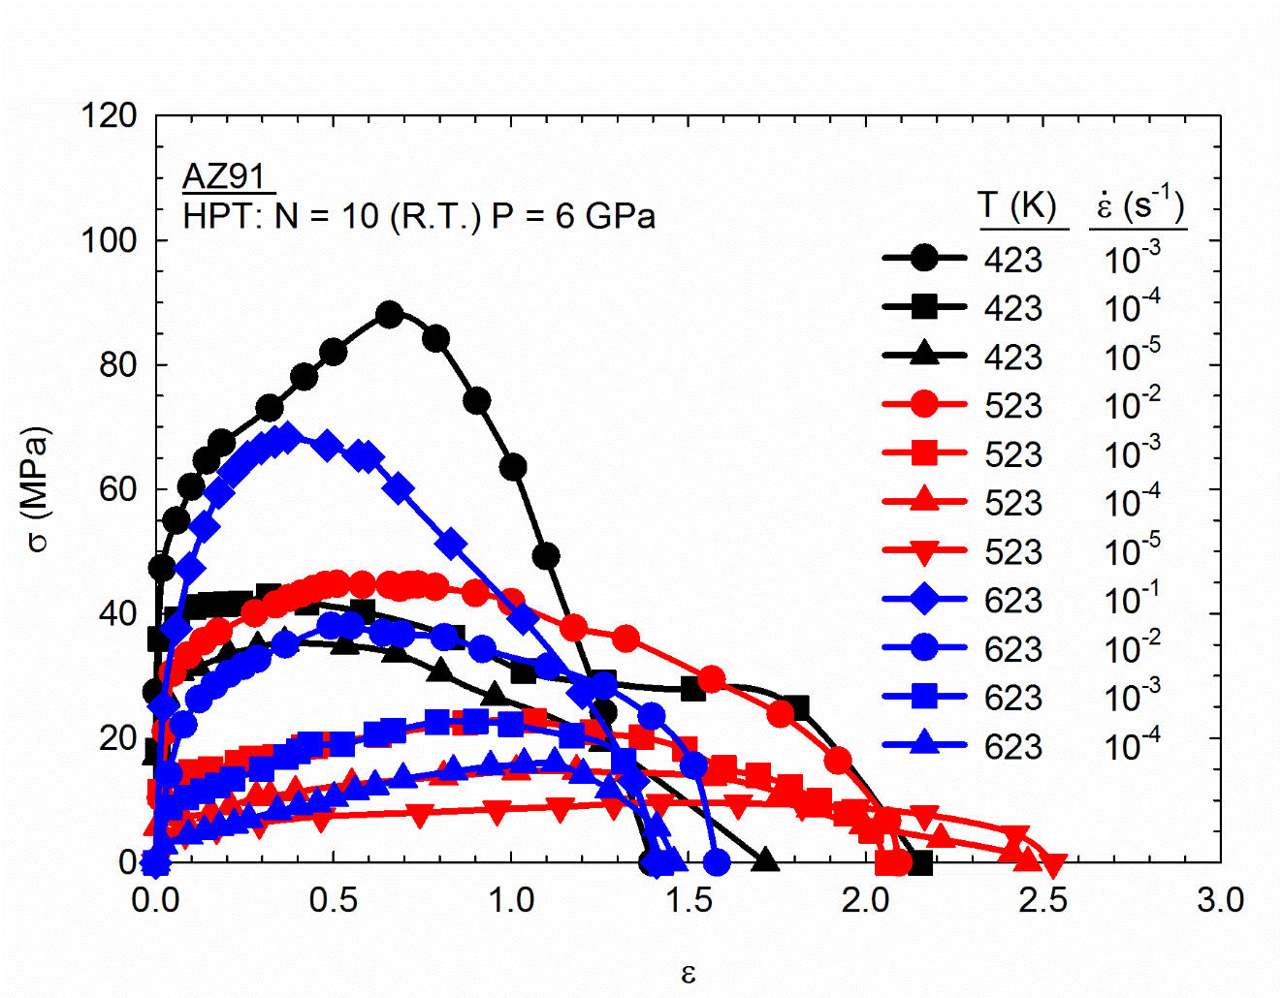
Figure 1. True stress vs true strain curves obtained at different testing temperatures and different strain-rates.

Figure 2 shows the appearance of the specimens pulled to failure at the different temperatures and strain rates with an untested specimen shown at the top for comparison purposes. The final elongations to failure are listed to the right of each sample. Superplastic elongations, defined as elongations >400%, were observed at 423 K at strain rates of 10⁻⁴ s⁻¹ and slower and at all strain rates tested at 523 K. The report of superplasticity at 423 K is considered as representative of low-temperature superplasticity as this temperature is lower than 0.5 T_{m} where T_{m} is the absolute melting temperature. Also, a superplastic elongation was observed at 10⁻² s⁻¹ at 523 K which is considered as representative of high strain rate superplasticity [34]. Although superplastic elongations were not observed at 10⁻³ s⁻¹ at the lower testing temperature of 423 K and at the highest testing temperature of 623 K, the final elongations were in the range of ~300% - 400% for these conditions and this is exceptionally high for magnesium alloys. It should be noted that the specimens pulled under superplastic conditions exhibited no evidence for any localized necking within the gauge area and this is consistent with the expectations for true superplastic flow [35].

The grain structures observed in the grip area are shown in Fig. 3 for samples heated to the testing temperatures of (a) 423, (b) 523 and (c) 623 K, respectively, where it should be noted that the image at 623 K is taken at a lower magnification. The average grain sizes were recorded as ~1.3, ~3.3 and ~9.6 µm, respectively. This shows that the grain structure is not stable in this temperature range but nevertheless all grain sizes remain within the conventional upper limit of ~10 µm for superplasticity [4]. An earlier report showed that the grain size obtained in a similar alloy processed by HPT using similar processing parameters was ~100 nm [31]. Therefore, significant grain growth takes place even at the lowest testing temperature of 423 K. It is also important to note that the highest elongations, including an evidence for high strain-rate superplasticity, were observed at 523 K and precipitation of second phase is observed at this temperature. Many grain boundaries appear decorated with second phase particles at 523 K. The formation of a Zn-rich film along the grain boundaries of aluminum has been associated with improved strain rate sensitivity [36]. Also, these precipitates might aid in impeding grain growth. Therefore, the excellent superplastic behavior observed at 523 K can be associated in part with the precipitation of second phase particles along grain boundaries.

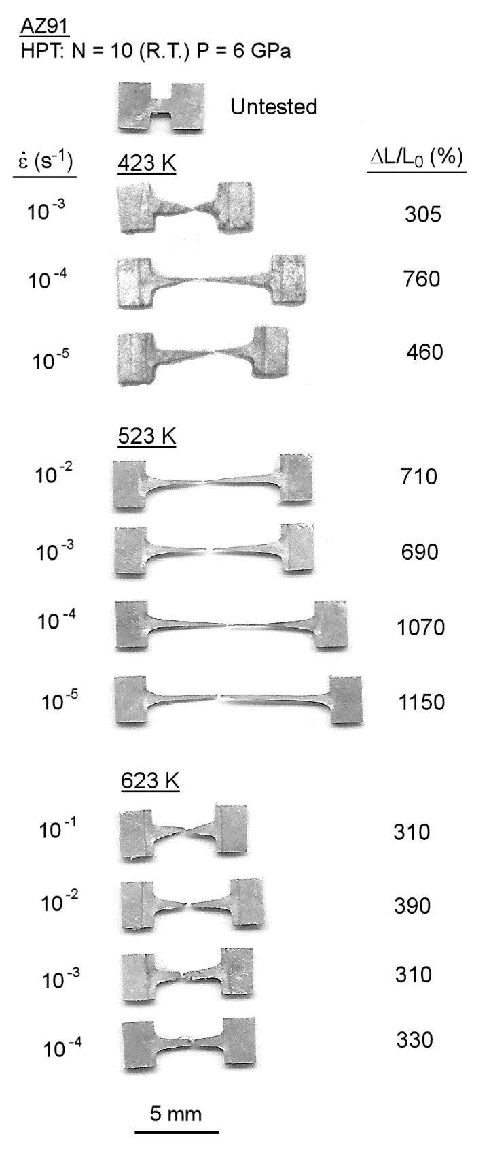
Figure 2. Appearance of tensile specimens pulled to failure at different temperatures and strain-rates.

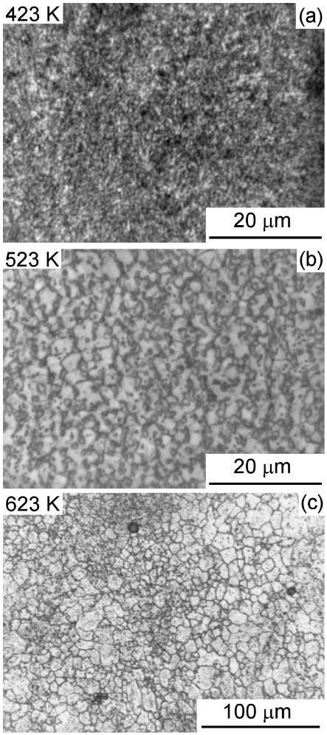
Figure 3. Grain structure at the grip area in samples heated to (a) 423 K, (b) 523 K and (c) 623 K.

4. Discussion
The present results show that the grain sizes obtained in the AZ91 alloy after HPT processing followed by heating to the temperature range of 423 to 623 K are smaller than the limiting grain sizes for superplasticity (~10 µm). In practice, superplastic elongations of up to and over 1000% were achieved in these experiments. An analysis of the deformation behavior shows a significant difference between the fine-grained and coarse-grained AZ91 alloy in this temperature range.
Figure 4 shows plots of the flow stress as a function of the strain rate observed in the present experiments and in experimental data collected from published reports [14,37-41] for the testing temperatures of (a) 423, (b) 523 and (c) 623 K: the grain sizes reported in the various experiments are also recorded. It is clearly observed that the present data, and other data from fine-grained AZ91 alloy, exhibit lower flow stresses and/or faster strain rates than for their coarse-grained counterparts. For example, creep testing of the cast AZ91 alloy [37,39] gave strain rates of over 3 orders of magnitude slower than that observed in the present experiments for similar levels of flow stress at 423 K. The present data agree fairly well with the other reports of high temperature testing of AZ91 processed by ECAP [14] and HPT [38] in which the range of grain sizes is similar. It is worth noting also that a coarse-grained (~85 µm) AZ91 alloy [40] exhibited much larger flow stresses at 523 and 623 K within a similar strain rate range than the flow stresses observed in the present experiments. An analysis showed that the deformation mechanism operating under these conditions in the coarse-grained alloy is dislocation climb.

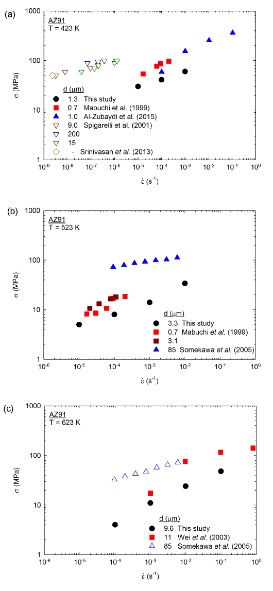
Figure 4. Plots of stress vs strain-rate for the AZ91 alloy with different grain sizes and tested at (a) 423 K, (b) 523 K and (c) 623 K. Data from the literature [14,37-41] is also included.

It is known that the deformation mechanism associated with superplasticity is grain boundary sliding and the strain rate for this mechanism is given by an equation of the form
, (1)
where δ is the grain boundary width which is considered as 2b where b is the Burgers vector modulus, D_{gb} is the grain boundary diffusion coefficient, G is the shear modulus, k is Boltzmann`s constant, T is the absolute temperature and σ is the flow stress.
Previous investigations [11,42] showed that this equation predicts well the behavior of the AZ31 magnesium alloy in conditions where superplasticity was observed. In order to evaluate whether the equation also reasonably predicts the behavior of the AZ91 alloy, the present data and other results from the literature reporting superplasticity in this alloy [14,38,41,43] are compared to the theoretical prediction in Fig. 5 where the strain rate was normalized by the effect of grain size and temperature and plotted as a function of the stress normalized by the shear modulus. It is apparent that the data in Fig. 5, which correspond to various processing techniques including HPT [38], ECAP and ECAP + Annealing [14], extrusion [43] and rolling [41], show good agreement with the theoretical prediction and therefore confirm the mechanism of grain boundary sliding as the rate-controlling mechanism for the AZ91 alloy. The only set of results which tends to fall below the prediction is associated with the material processed by ECAP. However, an as-processed grain size of ~0.7 µm was reported for this condition and the subsequent occurrence of grain growth before the high temperature testing was not taken into account. Therefore, it is reasonable that the datum points are not fully consistent with the predictions.
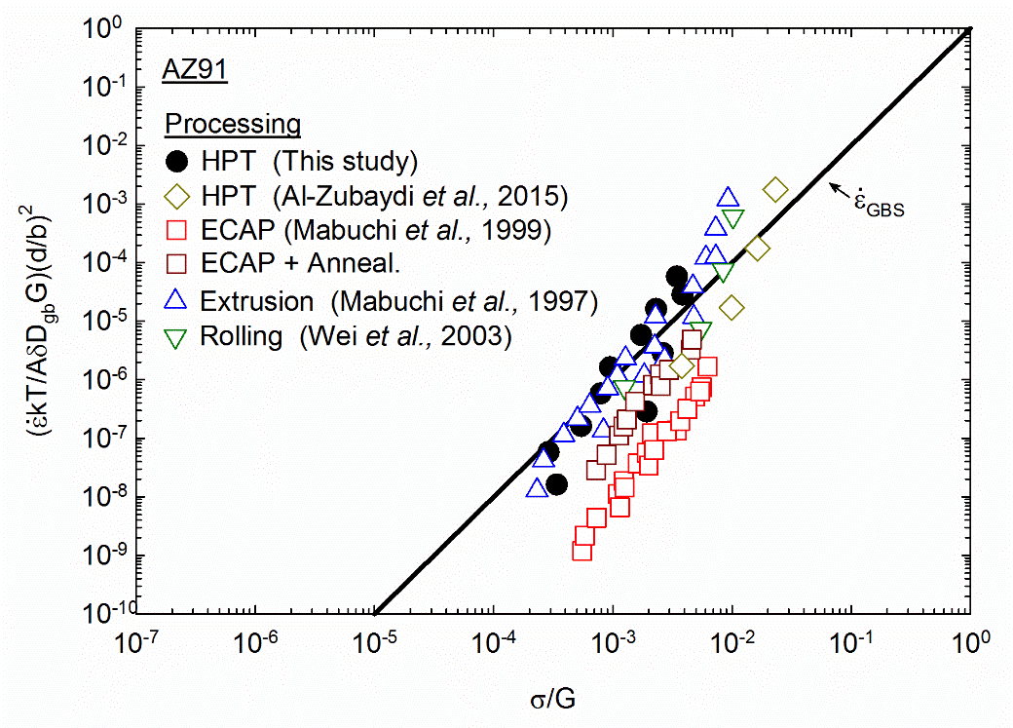
Figure 5. Strain-rate normalized by the effect of temperature and grain size and plotted as a function of the stress normalized by the shear modulus. Data from the literature [14,38,41,43] is also included.

It is especially interesting to note that different thermo-mechanical processing operations introduce superplasticity in the AZ91 alloy. In Fig. 5 the data are collected from various processing methods but the largest elongations were associated with processing by SPD. Thus, maximum elongations of 425% [43] and 455% [41] were reported after extrusion and rolling, respectively whereas elongations of 956% [14] and 1308% [38] were reported after ECAP and HPT, respectively. The present results also confirm that SPD is the optimum processing technique to introduce superplasticity in this alloy as elongations over 1000% were observed at 523 K at strain rates of 10⁻⁵ s⁻¹ and 10⁻⁴ s⁻¹. Also, elongations over 400%, which is considered a limiting threshold for superplasticity, were not reported at temperatures below 0.5 T_{m} or at strain-rates of 10⁻² s⁻¹ or faster after extrusion or rolling. However, low temperature superplasticity at T = 423 K was obtained in the present experiments and in the material processed by ECAP [14] and HPT [38]. High strain rate superplasticity was observed in the present experiments and this has been reported only after HPT processing [38].
Finally, it is important to note that the samples tested at 10⁻³ s⁻¹ at 423 K and at all strain rates at 623 K display elongations in the range of 300% - 400%. Although these elongations are below the conventional limiting threshold for superplasticity, they are much larger than the elongations expected for coarse-grained material. It is interesting to note that the stress and strain rate data observed in these conditions agree well with the prediction for grain boundary sliding. A recent report outlined an analysis of the creep deformation behavior of the fine-grained AZ31 alloy and developed deformation mechanism maps for this alloy [44]. It was shown that there is a region between the mechanisms of grain boundary sliding and climb where both mechanism appear to operate. The reason for this overlap is the formation of subgrain structures within grains at large stresses which affect the operation of grain boundary sliding. Thus, the elongations between 300% and 400% observed in the present experiments are attributed to a combination of both grain boundary sliding and conventional dislocation climb mechanisms. The combination of these deformation mechanisms was observed experimentally in the AZ31 alloy [45]. Although the alloying content in the AZ31 alloy differs from the AZ91 used in the present experiments, it is reasonable to anticipation that this difference will have no significant effect on the operative creep mechanisms.

5. Conclusions

1- An AZ91 alloy was processed by HPT and then tested in tension in the temperature range of 423 to 623 K. Superplastic elongations were observed including evidence for low temperature superplasticity and high strain rate superplasticity.

2- Grain refinement changed the deformation mechanism in this alloy and the experimental data agrees well with the theoretical predictions for the grain boundary sliding mechanism.

3- Severe plastic deformation through HPT introduces superplastic properties at lower temperatures and/or at faster strain rates and also it produces higher elongations than for samples prepared using conventional thermo-mechanical processing.

4- Elongations between 300% and 400% were observed at temperatures of 423 and 623 K and this is attributed to the occurrence of a combination of grain boundary sliding and dislocation climb mechanisms.
Author Contributions: Conceptualization, R.B.F. and T.G.L.; methodology, R.B.F. and T.G.L.; writing—review and editing, R.B.F. and T.G.L.; All authors have read and agreed to the published version of the manuscript.”,
Funding: The authors acknowledge support from FAPEMIG, CNPq and the European Research Council under ERC Grant Agreement No. 267464-SPDMETALS.
Conflicts of Interest: The authors declare no conflict of interest.

References

1. Kawasaki, M.; Figueiredo, R.B.; Langdon, T.G. The requirements for superplasticity with an emphasis on magnesium alloys. Advanced Engineering Materials 2016, 18, 127-131, doi:10.1002/adem.201500068.
2. Langdon, T.G. An evaluation of the strain contributed by grain boundary sliding in superplasticity. Materials Science and Engineering: A 1994, 174, 225-230, doi:https://doi.org/10.1016/0921-5093(94)91092-8.
3. Langdon, T.G. A unified approach to grain boundary sliding in creep and superplasticity. Acta Metallurgica et Materialia 1994, 42, 2437-2443, doi:http://dx.doi.org/10.1016/0956-7151(94)90322-0.
4. Langdon, T.G. The mechanical properties of superplastic materials. Metallurgical Transactions A 1982, 13, 689-701, doi:10.1007/bf02642383.
5. Valiev, R.Z.; Islamgaliev, R.K.; Alexandrov, I.V. Bulk nanostructured materials from severe plastic deformation. Progress in Materials Science 2000, 45, 103-187.
6. Valiev, R.Z.; Langdon, T.G. Principles of equal-channel angular pressing as a processing tool for grain refinement. Progress in Materials Science 2006, 51, 881-981.
7. Zhilyaev, A.P.; Langdon, T.G. Using high-pressure torsion for metal processing: Fundamentals and applications Progress in Materials Science 2008, 53, 893-979.
8. Horita, Z.; Matsubara, K.; Makii, K.; Langdon, T.G. A two-step processing route for achieving a superplastic forming capability in dilute magnesium alloys. Scripta Materialia 2002, 47, 255-260, doi:https://doi.org/10.1016/S1359-6462(02)00135-5.
9. Matsubara, K.; Miyahara, Y.; Horita, Z.; Langdon, T.G. Developing superplasticity in a magnesium alloy through a combination of extrusion and ECAP. Acta Materialia 2003, 51, 3073-3084, doi:https://doi.org/10.1016/S1359-6454(03)00118-6.
10. Lin, H.K.; Huang, J.C.; Langdon, T.G. Relationship between texture and low temperature superplasticity in an extruded AZ31 Mg alloy processed by ECAP. Materials Science and Engineering: A 2005, 402, 250-257, doi:https://doi.org/10.1016/j.msea.2005.04.018.
11. Figueiredo, R.B.; Langdon, T.G. Developing superplasticity in a magnesium AZ31 alloy by ECAP. Journal of Materials Science 2008, 43, 7366-7371, doi:10.1007/s10853-008-2846-0.
12. Lapovok, R.; Estrin, Y.; Popov, M.V.; Langdon, T.G. Enhanced superplasticity in a magnesium alloy processed by equal-channel angular pressing with a back-pressure. Advanced Engineering Materials 2008, 10, 429-433, doi:10.1002/adem.200700363.
13. Mabuchi, M.; Iwasaki, H.; Yanase, K.; Higashi, K. Low temperature superplasticity in an AZ91 magnesium alloy processed by ECAE. Scripta Materialia 1997, 36, 681-686, doi:https://doi.org/10.1016/S1359-6462(96)00444-7.
14. Mabuchi, M.; Ameyama, K.; Iwasaki, H.; Higashi, K. Low temperature superplasticity of AZ91 magnesium alloy with non-equilibrium grain boundaries. Acta Materialia 1999, 47, 2047-2057, doi:https://doi.org/10.1016/S1359-6454(99)00094-4.
15. Chuvil’deev, V.N.; Nieh, T.G.; Gryaznov, M.Y.; Sysoev, A.N.; Kopylov, V.I. Low-temperature superplasticity and internal friction in microcrystalline Mg alloys processed by ECAP. Scripta Materialia 2004, 50, 861-865, doi:https://doi.org/10.1016/j.scriptamat.2003.12.003.
16. Mabuchi, M.; Iwasaki, H.; Higashi, K. Low Temperature Superplasticity of Magnesium Alloys Processed by ECAE. Materials Science Forum 1996, 243-245, 547-552, doi:10.4028/www.scientific.net/MSF.243-245.547.
17. Mabuchi, M.; Nakamura, M.; Ameyama, K.; Iwasaki, H.; Higashi, K. Superplastic Behavior of Magnesium Alloy Processed by ECAE. Materials Science Forum 1999, 304-306, 67-72, doi:10.4028/www.scientific.net/MSF.304-306.67.
18. Watanabe, H.; Mukai, T.; Ishikawa, K.; Higashi, K. Low temperature superplasticity of a fine-grained ZK60 magnesium alloy processed by equal-channel-angular extrusion. Scripta Materialia 2002, 46, 851-856, doi:https://doi.org/10.1016/S1359-6462(02)00064-7.
19. Watanabe, H.; Mukai, T.; Ishikawa, K.; Higashi, K. Superplastic Behavior of an ECAE Processed ZK60 Magnesium Alloy. Materials Science Forum 2003, 419-422, 557-564, doi:10.4028/www.scientific.net/MSF.419-422.557.
20. Lapovok, R.; Cottam, R.; Thomson, P.F.; Estrin, Y. Extraordinary superplastic ductility of magnesium alloy ZK60. Journal of Materials Research 2005, 20, 1375-1378, doi:10.1557/JMR.2005.0180.
21. Figueiredo, R.B.; Langdon, T.G. The development of superplastic ductilities and microstructural homogeneity in a magnesium ZK60 alloy processed by ECAP. Materials Science and Engineering A 2006, 430, 151-156, doi:10.1016/j.msea.2006.05.056.
22. Figueiredo, R.B.; Langdon, T.G. Strategies for achieving high strain rate superplasticity in magnesium alloys processed by equal-channel angular pressing. Scripta Materialia 2009, 61, 84-87, doi:10.1016/j.scriptamat.2009.03.012.
23. Figueiredo, R.B.; Langdon, T.G. Record superplastic ductility in a magnesium alloy processed by equal-channel angular pressing. Advanced Engineering Materials 2008, 10, 37-40, doi:10.1002/adem.200700315.
24. Cetlin, P.R.; Aguilar, M.T.P.; Figueiredo, R.B.; Langdon, T.G. Avoiding cracks and inhomogeneities in billets processed by ECAP. Journal of Materials Science 2010, 45, 4561-4570, doi:10.1007/s10853-010-4384-9.
25. Pereira, P.H.R.; Figueiredo, R.B. Finite Element Modelling of High-Pressure Torsion: An Overview. Materials Transactions 2019, 60, 1139-1150, doi:10.2320/matertrans.MF201906.
26. Figueiredo, R.B.; Aguilar, M.T.P.; Cetlin, P.R.; Langdon, T.G. Analysis of plastic flow during high-pressure torsion. Journal of Materials Science 2012, 47, 7807-7814, doi:10.1007/s10853-012-6506-z.
27. Figueiredo, R.B.; Cetlin, P.R.; Langdon, T.G. Using finite element modeling to examine the flow processes in quasi-constrained high-pressure torsion. Materials Science and Engineering A 2011, 528, 8198-8204, doi:10.1016/j.msea.2011.07.040.
28. Figueiredo, R.B.; Langdon, T.G. Processing Magnesium and Its Alloys by High-Pressure Torsion: An Overview. Advanced Engineering Materials 2019, 21, 1801039, doi:doi:10.1002/adem.201801039.
29. Barnes, A.J. Superplastic Forming 40 Years and Still Growing. Journal of Materials Engineering and Performance 2007, 16, 440-454, doi:10.1007/s11665-007-9076-5.
30. Figueiredo, R.B.; Pereira, P.H.R.; Aguilar, M.T.P.; Cetlin, P.R.; Langdon, T.G. Using finite element modeling to examine the temperature distribution in quasi-constrained high-pressure torsion. Acta Materialia 2012, 60, 3190-3198, doi:10.1016/j.actamat.2012.02.027.
31. Silva, C.L.P.; Soares, R.B.; Pereira, P.H.R.; Figueiredo, R.B.; Lins, V.F.C.; Langdon, T.G. The Effect of High-Pressure Torsion on Microstructure, Hardness and Corrosion Behavior for Pure Magnesium and Different Magnesium Alloys. Advanced Engineering Materials 2019, 21, 1801081, doi:10.1002/adem.201801081.
32. Mohamed, F.A.; Langdon, T.G. Creep at low stress levels in the superplastic Zn-22% Al eutectoid. Acta Metallurgica 1975, 23, 117-124, doi:https://doi.org/10.1016/0001-6160(75)90076-0.
33. Figueiredo, R.B.; Langdon, T.G. Influence of number of passes in ECAP on superplastic behavior in a magnesium alloy. Materials Science Forum 2008, 584-586, 170-175.
34. Higashi, K.; Mabuchi, M.; Langdon, T.G. High-Strain-Rate Superplasticity in Metallic Materials and the Potential for Ceramic Materials. ISIJ International 1996, 36, 1423-1438, doi:10.2355/isijinternational.36.1423.
35. Langdon, T.G. Fracture processes in superplastic flow. Metal Science 1982, 16, 175-183, doi:10.1179/030634582790427208.
36. Chinh, N.Q.; Valiev, R.Z.; Sauvage, X.; Varga, G.; Havancsák, K.; Kawasaki, M.; Straumal, B.B.; Langdon, T.G. Grain Boundary Phenomena in an Ultrafine-Grained Al–Zn Alloy with Improved Mechanical Behavior for Micro-Devices. Advanced Engineering Materials 2014, 16, 1000-1009, doi:10.1002/adem.201300450.
37. Spigarelli, S.; Regev, M.; Evangelista, E.; Rosen, A. Review of creep behaviour of AZ91 magnesium alloy produced by different technologies. Materials Science and Technology 2001, 17, 627-638, doi:10.1179/026708301101510483.
38. Al-Zubaydi, A.S.J.; Zhilyaev, A.P.; Wang, S.C.; Reed, P.A.S. Superplastic behaviour of AZ91 magnesium alloy processed by high-pressure torsion. Materials Science and Engineering: A 2015, 637, 1-11, doi:https://doi.org/10.1016/j.msea.2015.04.004.
39. Srinivasan, A.; Ajithkumar, K.K.; Swaminathan, J.; Pillai, U.T.S.; Pai, B.C. Creep Behavior of AZ91 Magnesium Alloy. In 6th International Conference on Creep, Fatigue and Creep-Fatigue Interaction, Chetal, S.C., Jayakumar, T., Sandhya, R., Laha, K., Mathew, M.D., Eds. 2013; Vol. 55, pp. 109-113.
40. Somekawa, H.; Hirai, K.; Watanabe, H.; Takigawa, Y.; Higashi, K. Dislocation creep behavior in Mg–Al–Zn alloys. Materials Science and Engineering: A 2005, 407, 53-61, doi:https://doi.org/10.1016/j.msea.2005.06.059.
41. Wei, Y.H.; Wang, Q.D.; Zhu, Y.P.; Zhou, H.T.; Ding, W.J.; Chino, Y.; Mabuchi, M. Superplasticity and grain boundary sliding in rolled AZ91 magnesium alloy at high strain rates. Materials Science and Engineering a-Structural Materials Properties Microstructure and Processing 2003, 360, 107-115, doi:10.1016/s0921-5093(03)00407-6.
42. Figueiredo, R.B.; Langdon, T.G. Evaluating the superplastic flow of a magnesium AZ31 alloy processed by equal-channel angular pressing. Metallurgical and Materials Transactions A: Physical Metallurgy and Materials Science 2014, 45, 3197-3204, doi:10.1007/s11661-013-1920-7.
43. Mabuchi, M.; Asahina, T.; Iwasaki, H.; Higashi, K. Experimental investigation of superplastic behaviour in magnesium alloys. Materials Science and Technology 1997, 13, 825-831, doi:10.1179/mst.1997.13.10.825.
44. Figueiredo, R.B.; Langdon, T.G. Analysis of the creep behavior of fine-grained AZ31 magnesium alloy. Materials Science & Engineering A 2020, In press.
45. Dessolier, T.; Lhuissier, P.; Roussel-Dherbey, F.; Charlot, F.; Josserond, C.; Blandin, J.-J.; Martin, G. Effect of temperature on deformation mechanisms of AZ31 Mg-alloy under tensile loading. Materials Science and Engineering: A 2020, 775, 138957, doi:https://doi.org/10.1016/j.msea.2020.138957.

© 2020 by the authors. Submitted for possible open access publication under the terms and conditions of the Creative Commons Attribution (CC BY) license (http://creativecommons.org/licenses/by/4.0/).

