The sound diffusion in Italian Opera Houses: some examples

Lamberto Tronchin, Francesca Merli
University of Bologna
lamberto.tronchin@unibo.it
francesca.merli8@unibo.it

Massimiliano Manfren
University of Southampton
M.Manfren@soton.ac.uk

Benedetto Nastasi
TU Delft University of Technology,
benedetto.nastasi@outlook.com

Abstract
Sound-field diffuseness in rooms is considered a fundamental aspect of a high-quality room acoustics. Since early studies by Hodgson up to more recent studies of Shtrepi and Embrechts it was shown that high levels of sound diffuseness could guarantee blending of music, as well as spatial sound perception by listeners, and this could enhance the global indoor acoustic quality. Conversely, Italian-style Opera houses represent an important architectural place, in which the special features of the rich decorations, and the specific characteristics of the volume, give a unique atmosphere, including a peculiar psycho-acoustics impression. However, some geometric properties of the opera houses could influence the global acoustic perception. The shape of the marmorino wall on the stalls, as well as the parallelism of the lateral walls in the boxes, often causes a lack of spaciousness and sometimes in the worst cases provokes focalisation. This phenomenon leads to design special devices that could be inserted in the theatres, to avoid focalisation, even if they are rarely accepted.
This article deals with the design of some acoustic diffusing panels and their functioning in three different theatres, combining both acoustics needs with architectural constraints. The article starts analyzing and commenting on the issues that resulted from the measurements conducted in an Italian opera house. In the following step, three examples of the design of diffusing panels are proposed. Finally, the results of diffusion and scattering coefficient of panels realized in the last theatre here considered, are reported.
Keywords: sound diffusion; acoustic panels; scattering; room acoustic; Italian Opera Houses

1. Introduction
The acoustic properties of concert halls are extremely relevant for improving the design of spaces for music and for evaluating the experience of the listeners [1,2]. Furthermore, the acoustic properties of historical opera houses are considered one of the most important cultural heritage of Italian history [3]. Since the paper of Hodgson, [4,5] the acoustic properties of opera houses are considered at the same importance of ancient musical instruments [6,7,8,9]. However, their acoustics often represents an issue due to their specific shape and the characteristics of the materials. Since 17th Century several architects and scientists like Athanasius Kircher, Pierre Patte, Enea Arnaldi, Giordano Riccati, Francesco Milizia and others, commented and discussed about sound perception in theatres. Most of them were aware of the risk of having poor sound quality, and proposed several solutions for improving the acoustics. Kircher [10] studied sound effects especially in enclosures and rooms, whilst Milizia [11] proposed an ideal theatre having special acoustic characteristics. However, only recently the renovation of these important buildings includes the analysis of their acoustics, and sound diffusion is rarely considered, especially in Italian style opera houses.
2. Acoustic variability in opera houses
Even though the diffuse field theory is still applicable, there are evidences that in several cases it is not properly correct. This means that the uniform distribution of sound pressure level and reverberation time invariance are hardly ever found, based on actual measurements in several different spaces. In Opera houses, where two different volumes exist, sound absorption is unevenly distributed since rooms are not proportionate to each other, and the typical horseshoe shape worst the sound diffusion. Nevertheless, diffuse-field theory still represents an important way to understand sound propagation in enclosed spaces. In further measurements conducted recently [12], this not uniform distribution of soundfield was also resulted depending on sound focalisation, which increase this inhomogeneity, especially in the stalls in Opera houses, even more, when moving the position of the sound source.

3. Inhomogeneity and sound diffusion in opera houses
In Italian styled opera houses, an important issue is the lack of homogeneity of sound distribution in stalls, boxes and orchestra pit. This effect was known since the Renaissance period and confirmed in several recent papers [12].
The theatre "Comunale" in Bologna is one of the most remarkable opera houses existing in Italy, which has been extensively studied for its acoustics. The theatre was designed by the architect Antonio Galli Bibiena, a component of the well-known theatre architects dynasty, and it was inaugurated in 1763. The architect thought of a different shape for the theatre of the native town of his family (even if he was born in Parma), i.e. a bell shape and it presents a specific characteristic: balconies are realized with different shapes and materials if compared with the classical Italian opera houses. The Bolognese Theatre has other specific characteristics: to avoid the burning of the theatre, the main hall was built using bricks instead of wood. Moreover, the boxes were designed to allow the holders to customize the walls, adding their coat of arms, tissues, etc.
Galli Bibiena believed that the movement of the floor could enhance the intelligibility of speech of actors and the singers, as reported by Milizia and other acousticians (e.g. Riccati and Algarotti). For this reason, he equipped the pavement of the stalls with a special device: the pavement could be lifted until the stage by a mechanism (Figure 1). This device was active until 1820 [13].
The special feature of balconies provokes some effects in the listening conditions that are depending on the position of sound sources in the stage and in the orchestra pit, which are well-known among the audience. These characteristics increase the non-Sabinian behaviour of the sound distribution, causing a remarkable difference of the perceived sound between stalls and boxes, or even simply moving the sound source.
To quantify these effects, a measurement campaign was undertaken to obtain information about the spatial sound characteristics of the hall. The measurements were conducted using an omnidirectional, pre-equalized sound source located in different positions in the orchestra pit and stage. The Test signal (exponential sine sweep) were recorded with a dummy head, and a B-format microphone. This array was located in many different listening positions in the balconies and the stalls.
(a)
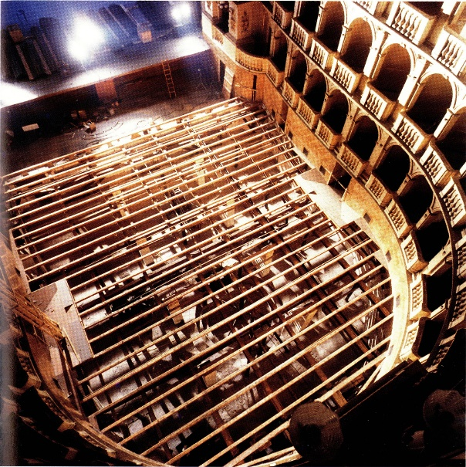
(b)
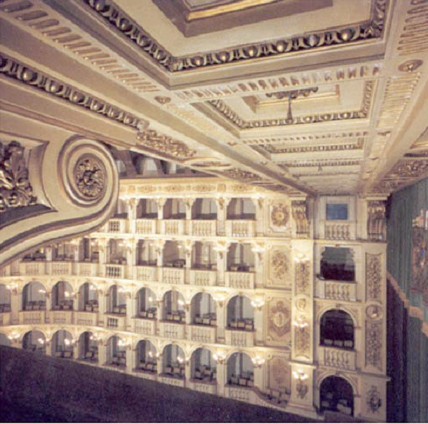
Figure 1 - (a) The mechanism below the pavement of the stalls and (b) the main hall.

3.1 Measurements Conditions

Firstly, a campaign of measurements was undertaken to describe spatial sound characteristics of the Teatro Comunale and especially the stage and orchestra pit, and their relations with the perception of sound in the stalls and balconies [14,15]. Secondly, acoustic parameters defined in the ISO 3382-1 [16] and spatial parameter, as ACF (autocorrelation function) and IACC (InterAural Cross Correlation), were measured experimentally.

The following instrumentations have been employed during the measurements:

- omnidirectional, frequency-equalized sound source (namely LookLine) was located in the stage and in the orchestra pit;
- dummy head (Neumann KU-100), which allowed the measurements of binaural impulse responses;
- B Format microphone (Soundfield MKV), which allowed the measurements of monoaural (W channel) and 3-D acoustic parameters, thanks to its 4 channels (A format) input.
A log sine sweep (chirp), which was 30 seconds long, was generated for measurements, and a 24 bit 96 kHz 8-channel soundboard was used to store the signals.
These signals were globally recorded 25 measuring points in stalls and balconies, whilst the sound source was placed on the stage and orchestra pit, as shown in Figure 2.

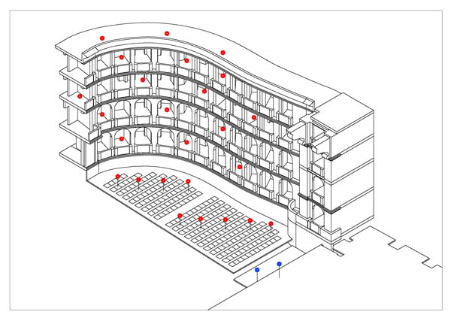
Figure 2 – Measuring points in the Teatro Comunale of Bologna.
The B-Format microphone was employed to measure B-Format impulse responses, and calculate parameters such as reverberation time, clarity, centre time, Lateral Efficiency, and Lateral Fraction (LF). The dummy head allowed the measurement of binaural Impulse responses, and consequently the IACC .

3.2 Results and Discussion

To analyse the influence of sound source position (the stage and orchestra pit) on the acoustic parameters, results for a specific measuring point in the stalls (14F) are presented in the following picture (Figure 3).

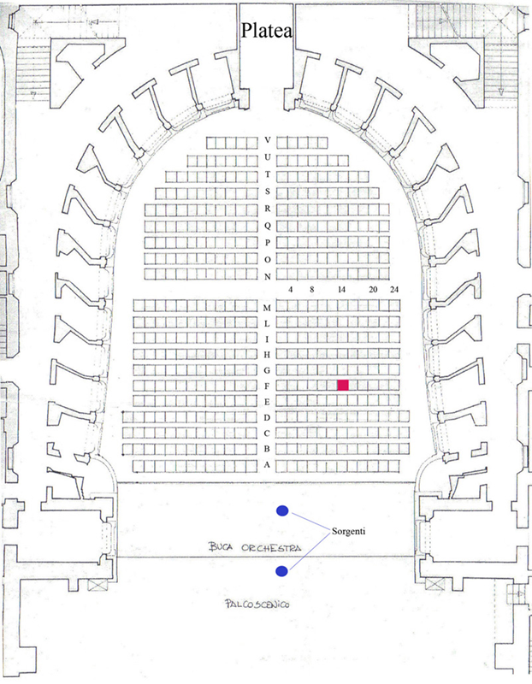
Figure 3 – The measuring point 14F in the Teatro Comunale of Bologna.
The values of clarity obtained with sound source on the stage are very different from results with sound source on the orchestra pit, where the fence induces sound field with no direct sound from the source to the receivers, particularly in the initial part of the IR (less than 100 ms) (Figure 4). The reverberation time (T₃₀) showed variations within just noticeable difference between the two positions of the sound source, except for low frequencies. The reverberation time at mid frequencies of Teatro Comunale in Bologna was approximately 1.6 s (Figure 5).

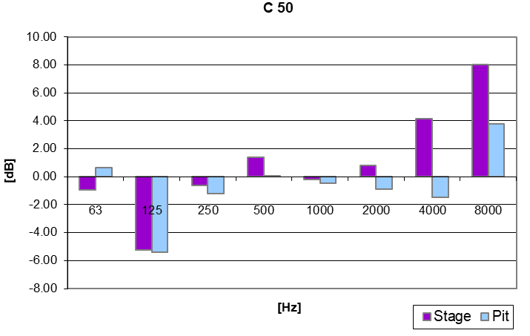
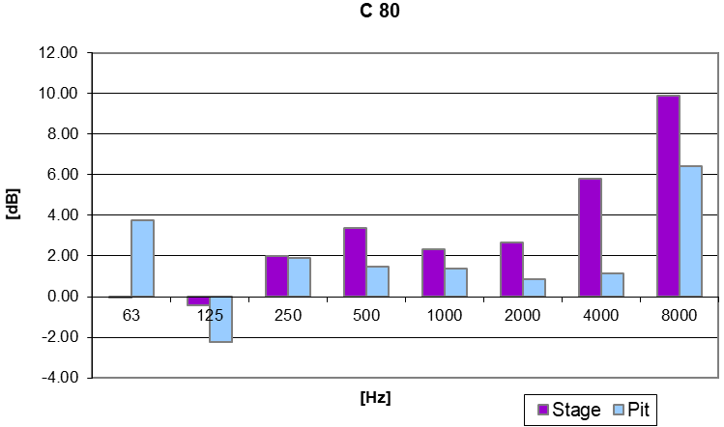
Figure 4 – Values of Clarity measured in stalls (14F), optimal value for listening music is between -2 and +2 dB.
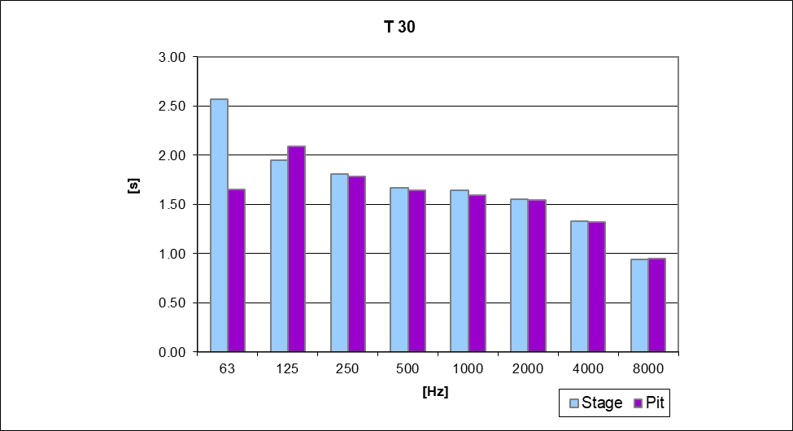Figure 5 – Values of Reverberation Time measured in stalls (14F), for symphonic music suggested values are between 1.8s and 2.6s, while for opera they are between 1.0s and 1.5s
The Early Decay Time (Figure 6) was more variable than the T₃₀, taking into account the longer decay time of T₃₀. The difference of EDT with the sound source on the stage and on the pit ranges from 0.35 s at low-frequencies to 0.16 s at high-frequencies.

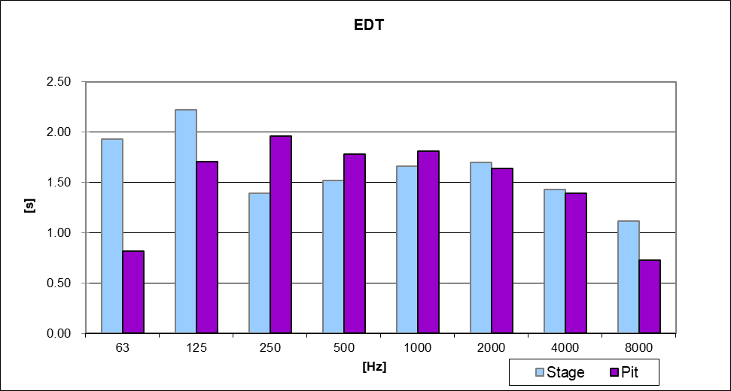
Figure 6 – Values of Early Decay Time measured in stalls (14F) optimal value for symphonic music is between 1.5 and 2.4 s.
To evaluate the spatial impression of the sound in the theatre, IACC and Lateral Fraction (LF) were calculated (Figure 7).

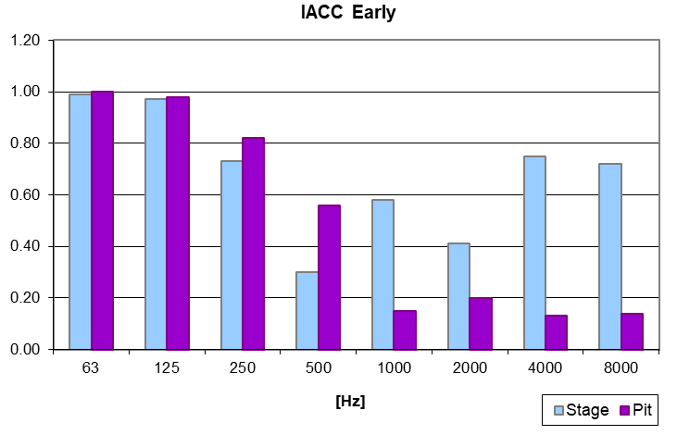
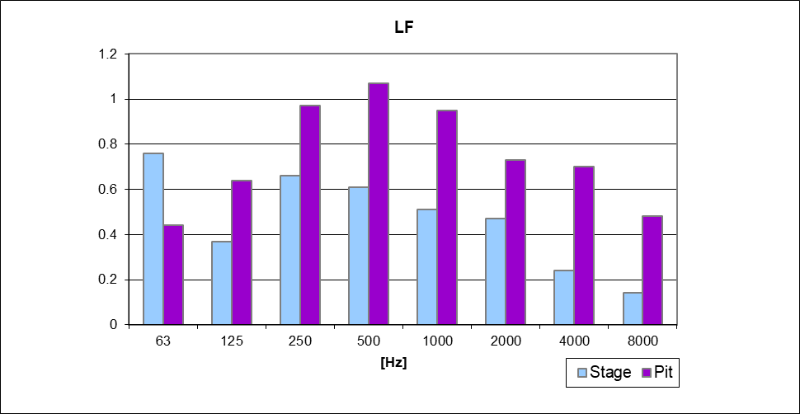
Figure 7 – Values of InterAural Cross-Correlation and Lateral Fraction measured in stalls (14F). Music halls with IACC values similar to 0.3 have excellent acoustics and optimal values of LF are 0.2 or 0.25.
Moreover, acoustic parameters were calculated to analyse the differences of direction patterns with a specific position of the sound source (on the stage) for all the positions (Figures 8 and 9). The values of LF were compared with the corresponding value of Just Noticeable Difference, JND [17] (Figure 10).
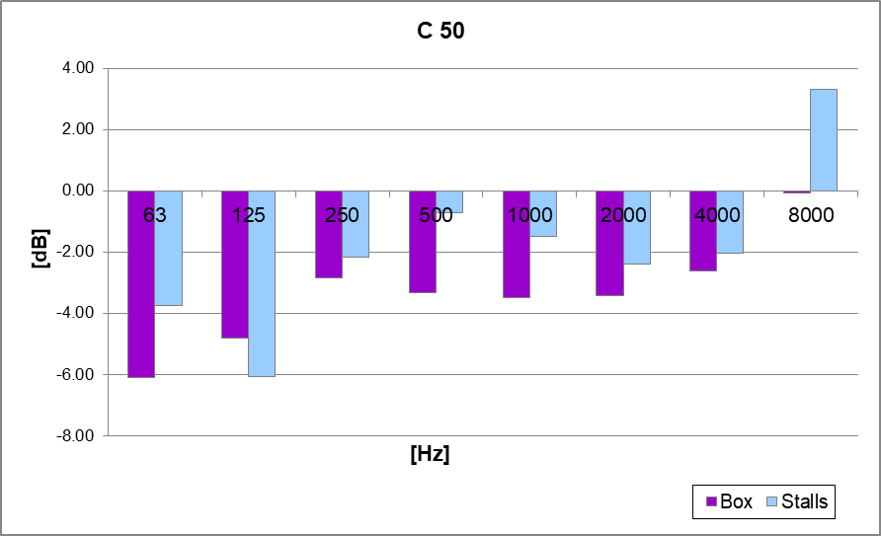 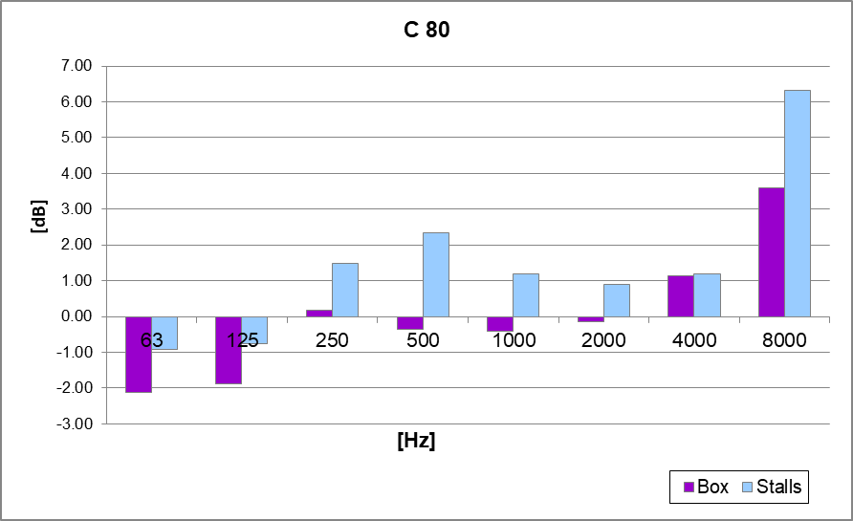Figure 8 – Values of Clarity measured in the stalls and boxes with the sound source in the stage.

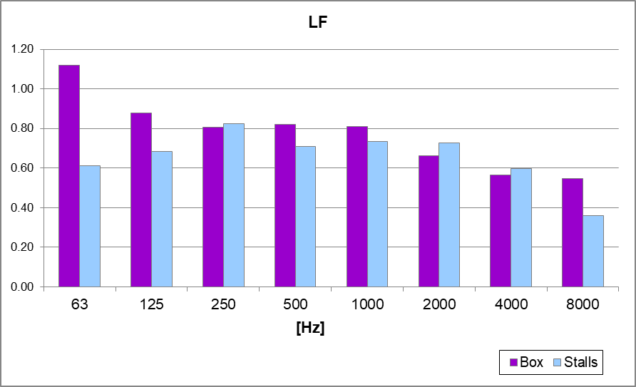Figure 9 – Values of Lateral Fraction measured in the stalls and boxes.

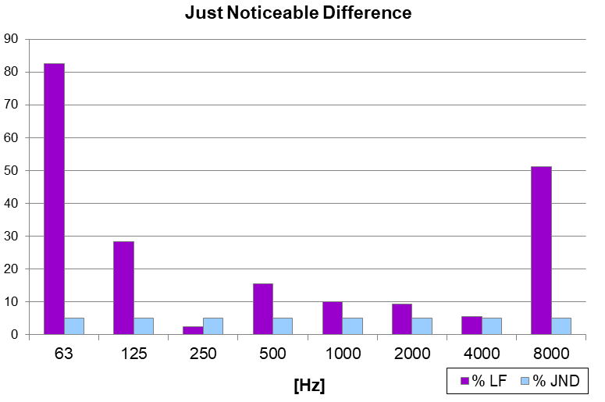
Figure 10 – Percentage variation between Lateral Fraction measured in the stalls and boxes, and Just Noticeable Difference - JND (5 %).

Based on the presented results, it was possible to state that the Teatro Comunale in Bologna has the typical sound characteristics of Italian-styled opera houses, including the remarkable difference between the acoustics of orchestra pit and stage.
The differences are particularly significant for acoustic parameters with the sound source in the stage and receivers in the stalls and boxes. It is noteworthy that the spatial parameter (LF) is more effected to variability than mono-aural parameters. Analysing the results of Figure 9, there are evidences that LF in the stalls and LF in the boxes are quite different from each other. This difference is close to 80% at low frequencies and 50% at high frequencies (Figure 9). Looking at the time energy representation of the impulse responses measured in the different positions, there is evidence that it is provoked by energy focalisation, which could be reduced with special devices that could be inserted in the theatre.

4 The acoustic design of sound diffusion in three Italian Opera Houses
In paragraph 3 we have reported the acoustic analysis in the Teatro Comunale in Bologna, which is considered one of the most relevant Italian style opera houses in Italy, in which focalisation could be found in some positions. We could extend this result stating that in Italian style opera houses there are very often problems of focalisation of the sound field especially in the stalls and in the boxes (mainly in the 1st order) Moreover, several authors found that diffusion and scattering in Opera Houses represent a fundamental issue [18,19, 20], to be measured [21, 22, 23] or simulated [24, 25]. This phenomenon leads to design special devices, as diffusing panels, that could be inserted in the theatres, to avoid focalisation and improve the acoustic quality.
Concerning Teatro Comunale in Bologna, actually it is not possible to insert these acoustic devices due to aesthetic and conservation requirements, but it might be feasible if some further renovation works are planned in the future.
Therefore, in the following paragraphs we present some examples of designed diffusing panels for Italian style opera houses, occurred in the last 15 years, located in the main hall and on the stage.

4.1 Teatro Comunale in Treviso

The first example of an opera house that hosts diffusing panels is the Teatro Comunale in Treviso (Northern Italy). Firstly, the Teatro Comunale in Treviso was built by Fiorino d’Onigo in 1692; then in 1763 with the architectural plan of Antonio Galli Bibiena (the same of Teatro Comunale in Bologna), the theatre was restored and amplified. In 1836, the theatre burned partially, and in 1846 it was re-opened. In 1869 the theatre burned again and it was again restored and reopened. After 1868, only little restorations of the theatre were carried out [26]. The theatre has the main hall in horse-shoe shape, the balconies are all made of wood and pretty statues are decorating the walls.
In 2000 the theatre closed, and a general restoration of the hall was planned. The enhancements mainly regarded structural parts of the main hall of the theatre, and acoustic improvement.
The acoustic design involved main hall, orchestra pit and stage. Specifically, in the boxes and balconies some spectators reported acoustic difficulties, that probably were flutter-echoes. Intelligibility was very high, but the reverberation was low. The spatial impression of the audience was very good, but strength could have been enhanced.
To reduce echoes and focalisation phenomenon, an acoustic panel was specifically designed and inserted in each box. Other specific diffusing panels were designed for the space between corridors and balconies at the last level (Figure 11).
The measurements showed that these solutions strongly enhanced early reflections and diffusing sound field (Figure 12). In addition, lateral reflection and Inter-Aural Cross correlation resulted improved, and compensated the short reverberation time, which represents a well-known limit of Italian style opera houses.

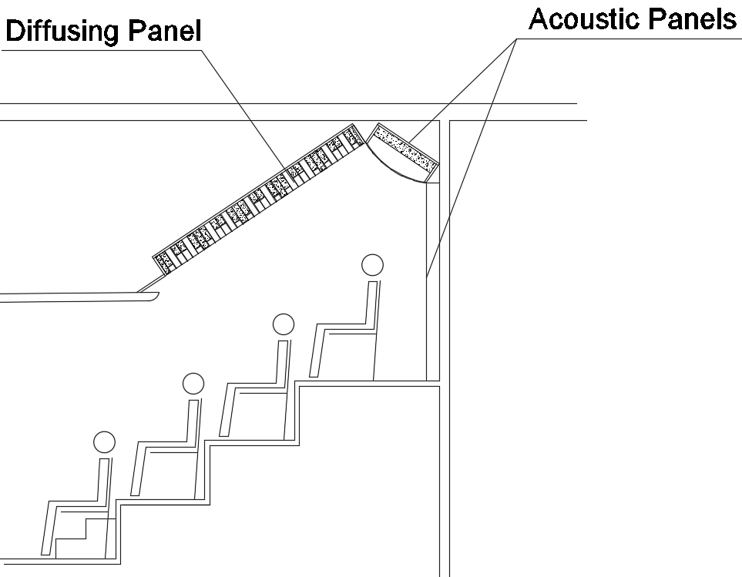
Figure 11 – Design of acoustic panels in the gallery.

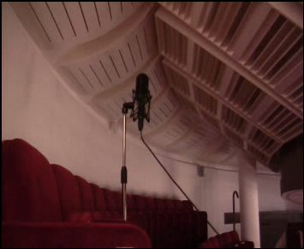
Figure 12 – Measurements in the gallery with acoustic panels on the ceiling.

The theatre reopened in 2006, and the audience reported a strong improvement in the acoustics.

4.2 Teatro Vittorio Emanuele in Messina

The second example is represented by the Teatro Vittorio Emanuele in Messina. This theatre was built in the 19th century. In the early 20th century, after a tremendous earthquake and the 1st World War, it was consistently refurbished. During the restoration, the main hall was completely modified: the theatre lost its typical shape which characterise the opera houses, and the 5 orders of boxes were substituted with two huge galleries. The proscenium was redesigned.
More recently, some listeners and musicians started to complain about the acoustic, perhaps thanks to the increase of the awareness of the importance of the acoustics in the theatre. The musicians complained about the presence of focalisation and sound weakness in the stage and in the orchestra pit. They found that a special reflecting surfaces improved the sound quality. Therefore, an acoustic design was planned, to improve musical performance, perception and to reinforce the sound distribution.
The acoustic project consisted in a set of diffusing panels mainly located in the stage and in the lateral walls of the orchestra pit (figures 13 and 14).
Regarding the stage, the great dimensions allowed the design of large modular diffusing panels, tuned at low frequency.

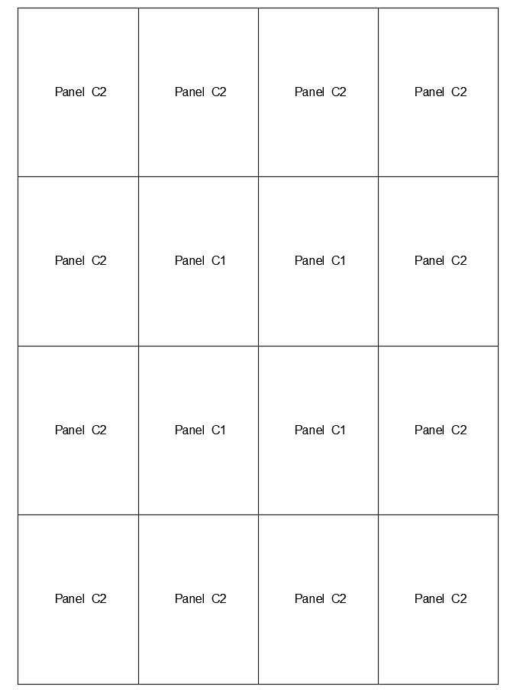

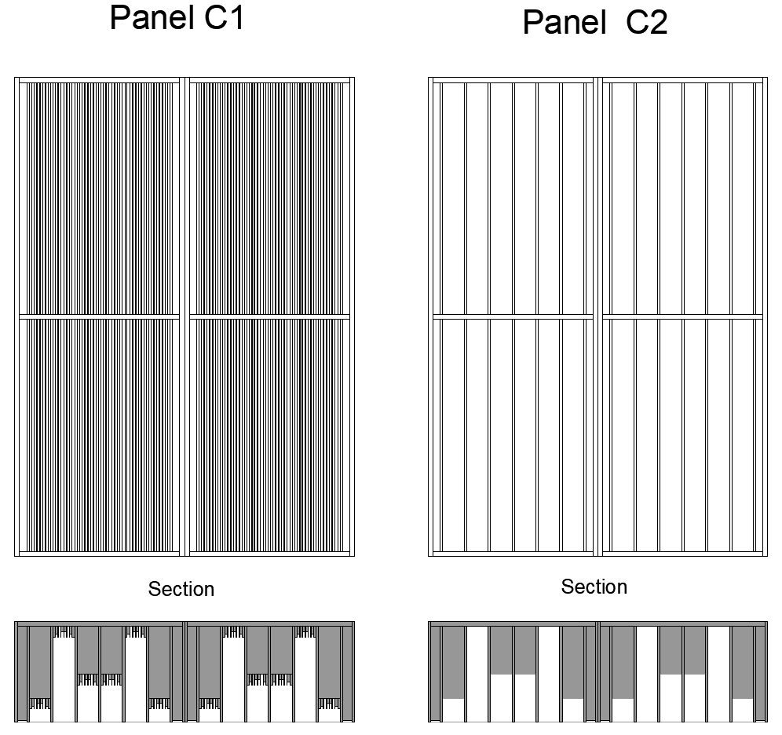
Figure 13 – Diffusing panels on the stage.
In the orchestra pit, a set of other panels were added.

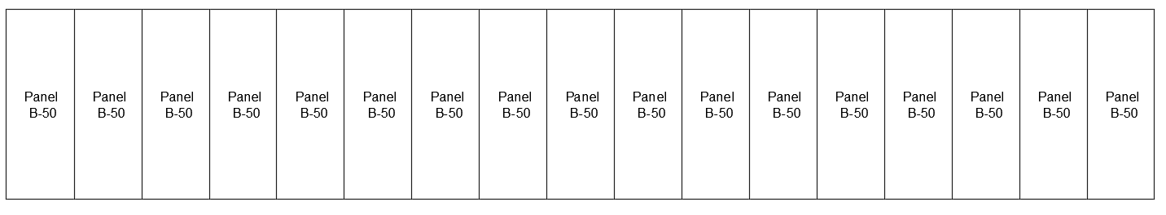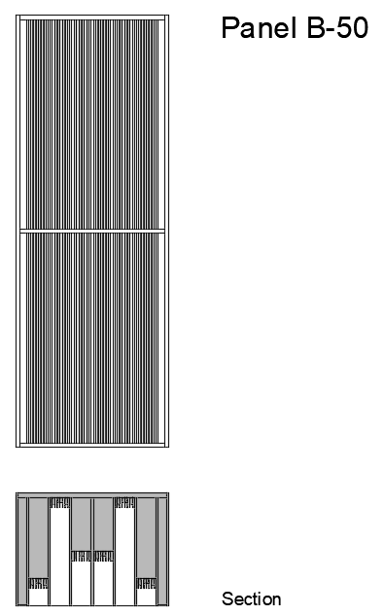
Figure 14 – Diffusing panels in the orchestra pit.
The appropriate location of panels was found using Ramsete [27], a pyramid-tracing software, which properly could take into account diffusion.
The ultimate distribution of the diffusing surface was determined considering the energetic decay of the computed impulse response, accordingly with the architect.
The final location of panels in the stage is shown in Figure 15.

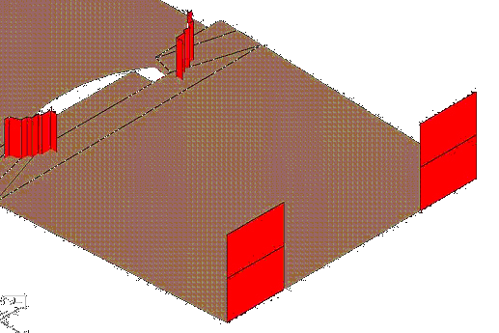
Figure 15 – Location of diffusing panels on the stage.

The change in acoustic characteristics of walls and spatial properties of the theatre, designing special diffusing surfaces, have enhanced the sound strength and improved musical performance and perception [28,29].

4.3 Teatro Amintore Galli in Rimini

The last (and more recent) example is the Teatro Amintore Galli in Rimini. The original theatre was designed by Luigi Poletti and opened in 1857. It had a horse-shoe shape, five different levels and it could contain about 1400 people. In 1944 the theatre was damaged by an airstrike and afterwards it was demolished. After a long debate among the town which lasted more than 60 years, the reconstruction of the new theatre (Figure 16) was designed following the idea “where it was, as it was”, following the examples of the Teatro la Fenice in Venice and Petruzzelli in Bari.
The acoustic design concerned some aspect:
- attention to materials and shapes;
- positioning of acoustic panels in the boxes and walls;
- creation of the orchestra pit with variable acoustics;
- realization of acoustic shell in the stage area.

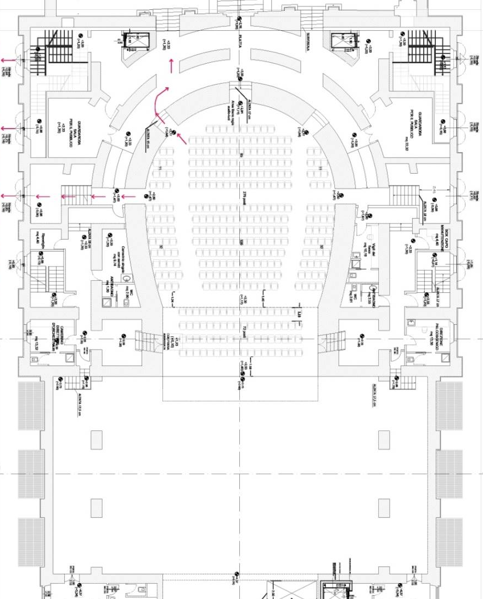
Figure 16 – Plan of Teatro Galli in Rimini

Especially, the Teatro Galli has been designed paying attention to the sound quality of the cavea. Therefore, diffusing panels were located above the doors of boxes and on five entering doors in the cavea, to obtain a condition of a diffused sound field, that is particularly desired in concert halls and theatres, and avoid the focalisation found in Italian-style Opera Houses as seen in paragraphs 2 and 3. Figure 17 and 18 report fronts and sections of diffusing panels designed for the main hall. The diffusing panels, made by MDF, were located above the entrance of each box, for the three levels, whilst the panels positioned on the entering doors were realized in oak (QRD components) and cherry (remaining part).

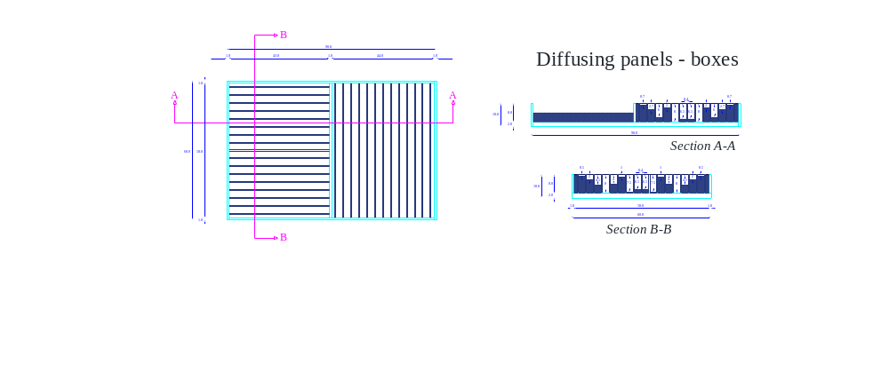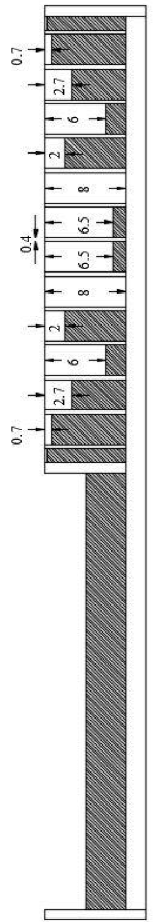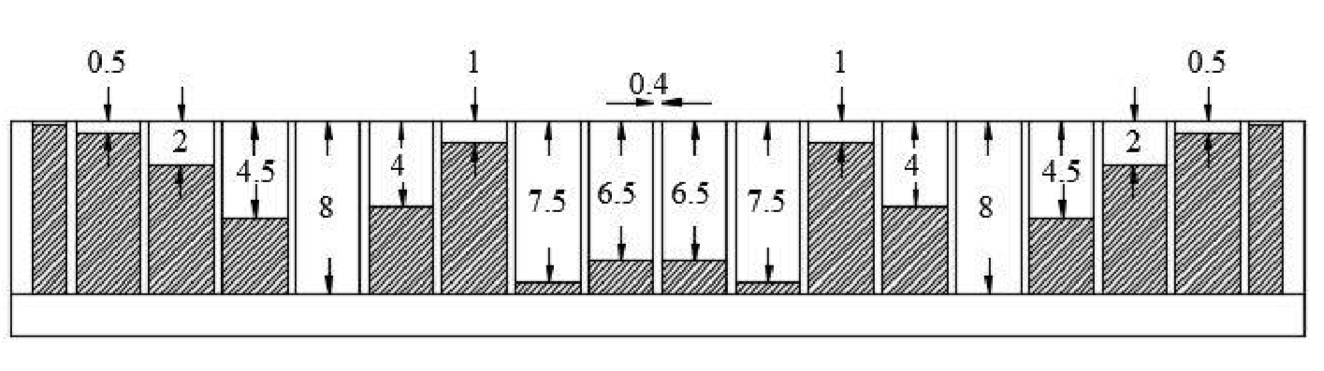
Figure 17 – Diffusing panels in the boxes (Section A-A on the left, section B-B on the right).

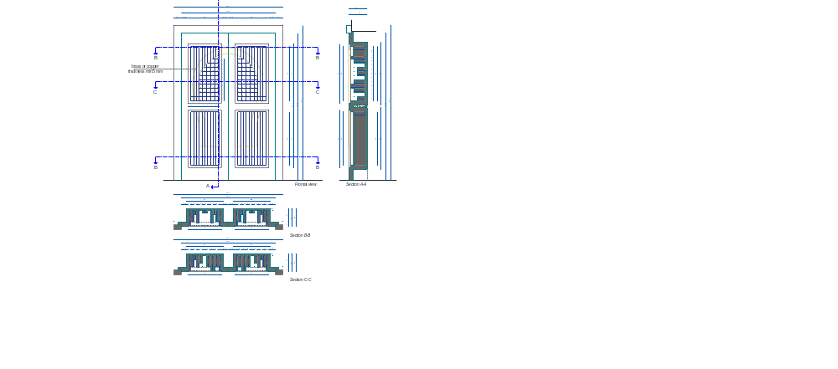

Figure 18 – Diffusing panels on the main entrance doors (Section A-A on the left, section C-C on the right).

The diffusing panels located in the boxes allow containing the flutter echo between the parallel walls, whilst those positioned in the internal part of the entrance doors of the cavea, give back a clear response of the reflected sound, and diffuse the sound energy in all directions thanks to their profile.
On 28th October 2018, the new Teatro “Amintore Galli” re-opened. The impressions of both musicians and listeners were of a “sounding theatre” with an excellent acoustics.

5. Measurements of sound diffusion and scattering on a panel of Teatro Galli

The reconstruction of the Teatro Galli allowed employing acoustic measurements of diffusion and scattering on the diffusing panels designed for the main hall. The measurements were conducted in two different rooms: the semi-anechoic room available at the laboratory of SCM in Rimini, and the laboratory of the University of Parma. Due to the physical characteristics of the SCM room, those measurements were not considered enough reliable, and therefore discarded. In the following, only the measurements conducted in the Parma lab are considered.
A further campaign has been planned to check the effectiveness of the insertion of the diffusing panels in the hall, by comparing the acoustic quality in the hall with and without the diffusing panels (i.e. covering the panels with some tissues).

5.1 Measurements Conditions
The measurements in the Parma lab followed the ISO 17497:2 [30] standards and the setting is reported in Figure 19.
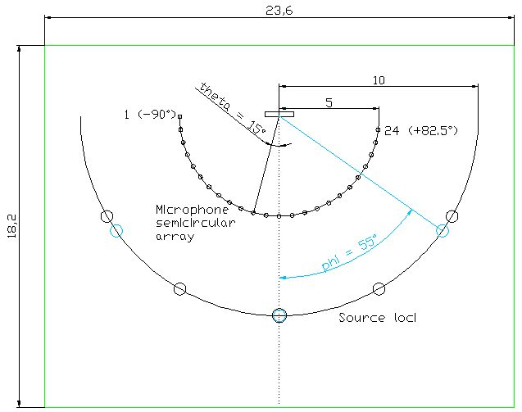

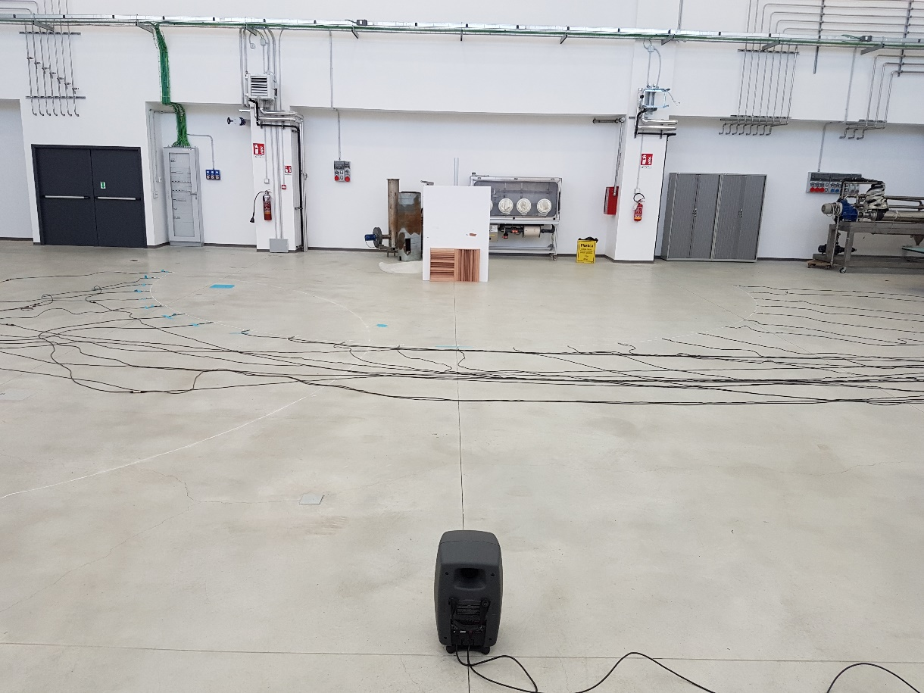
Figure 19 – The setting of measurements in the lab on diffusing panels

The following instrumentation was used for measurement campaign in the lab:
- 1 Loudspeaker Genelec 8351A SAM Studio Monitor;
- 4 8-channels Behringer AD-DA 8000 Converters;
- 1 audio interface firewire M-Audio “Profire Lightbridge”;
- a set of 25 microphones (BK 4188).
The impulse responses ware generated using the Aurora plug-ins and ranged between 50 and 20000 Hz. The recording was limited to 25 microphones instead of 32, because 7 microphones were not available during the measurements.
The following measurements were performed:
- IR with test surface (h₁);
- IR without test surface (h₂).
The reflection due to the presence of our test surface was obtained by subtracting the two impulse responses h₁-h₂. Then, the diffusion coefficient was obtained using the equation reported in [31].

Conversely, the following instrumentation has been employed during measurements in the theatre:
- omnidirectional pre-equalized sound source (LookLine);
- monoaural microphone (BK 4189);
- dummy head (Neumann KU100);
- B-format microphone (Sennheiser Ambeo).
The output captured by microphones was recorded on 8 channel portable system (Zoom F8). The recorded impulse responses were elaborated with the software Aurora, and several acoustic parameters defined in the ISO 3382-1, were analyzed.

5.2 Results and Discussion

Throughout the lab campaign, four different positions of the panels were compared, plus on measurement without the diffusing panel, as reported in Figure 20.
a)
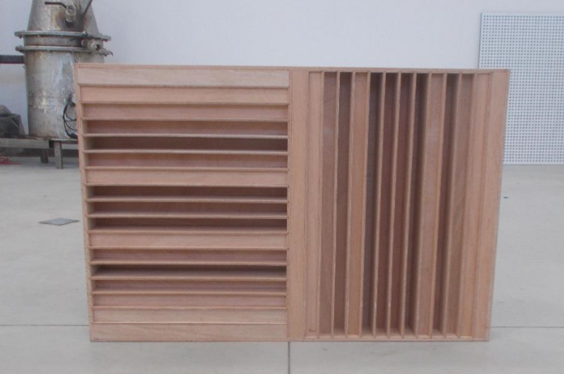
b) c)
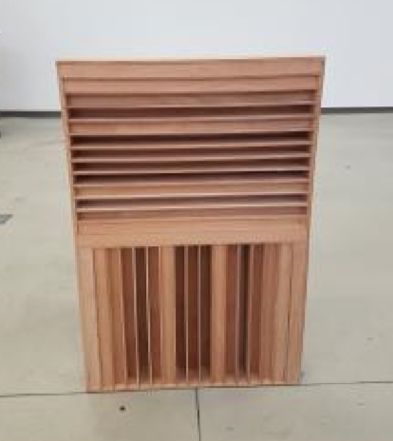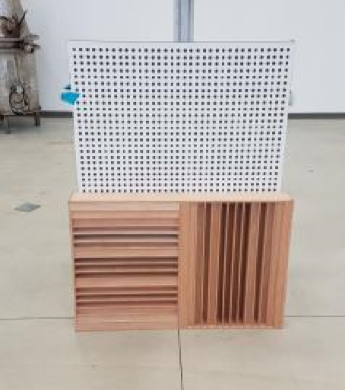
d) e)
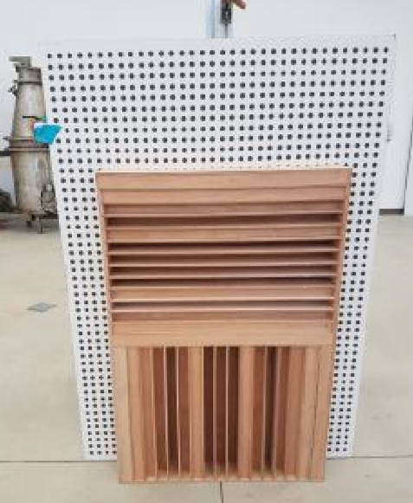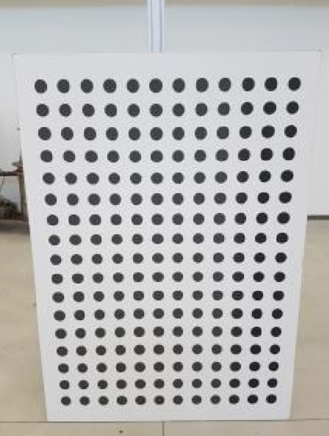
Figure 20 – The five configurations.

For each position, scattering and diffusion coefficients were elaborated according to [30] and [31].

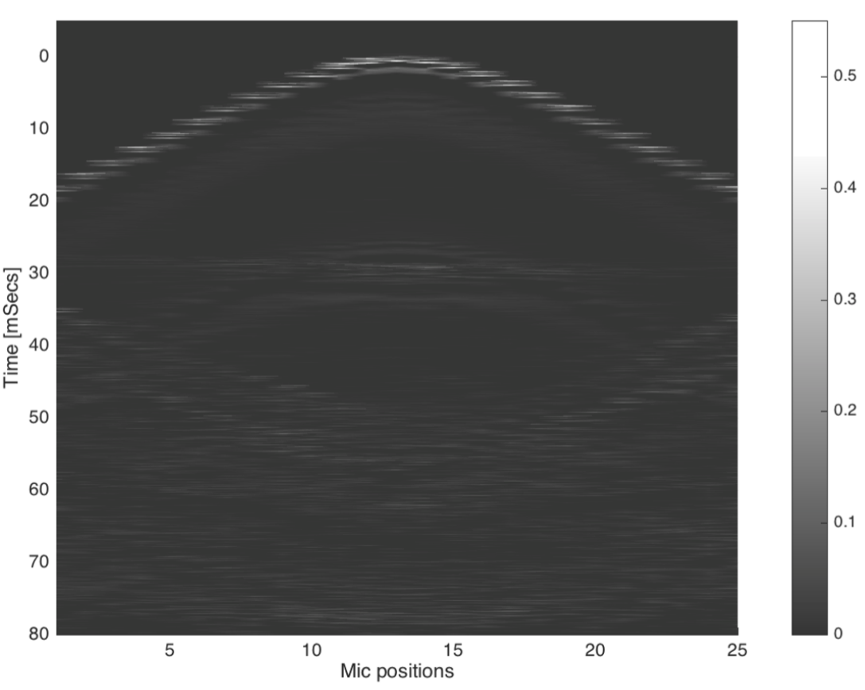
Figure 21 – Sound radiated by the panel with a source placed in front. Direct and reflected components of the signal.

Figure 20 reports the different components of sound radiated from the panel with a sound source located in the front, Figure 22 and Figure 23 report the scattering and diffusion coefficients obtained for each tested position.
The scattering coefficient results high for all frequencies except for 250 and 500 Hz, and it might be due to the presence of the wall behind the panel.

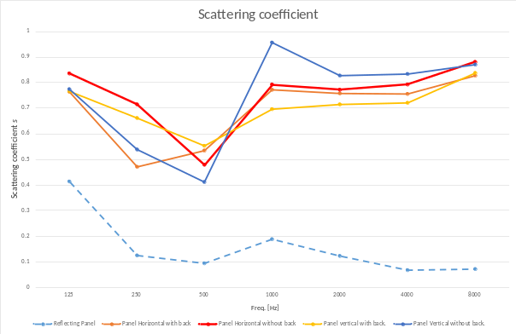Figure 22 – Results for scattering coefficient (the dotted line is configuration (e), the orange line is configuration (c), the red line is configuration (a), the yellow line is configuration (d), the blue line is configuration (b)).

Figures 22 and 23 report the values obtained from the measurements without subtracting the background level (without the diffusing panel), which is represented by the dotted line (e).
Analyzing the Figure 23, the efficacy of the diffusing panels appears starting from 1kHz.

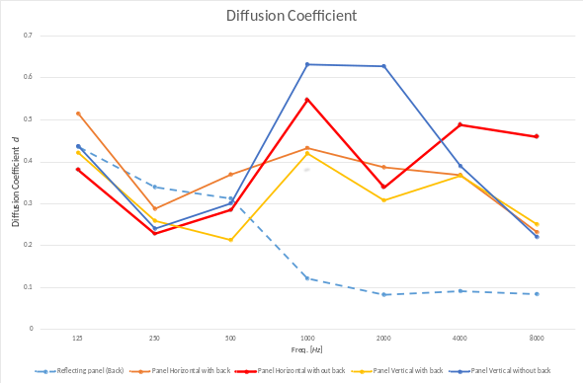
Figure 23 – Results for diffusion coefficient (the dotted line is configuration (e), the orange line is configuration (c), the red line is configuration (a), the yellow line is configuration (d), the blue line is configuration (b)).

The red line represents coefficient values with the panel in a horizontal position. This configuration was used in the Teatro Galli. Moreover, the tested diffusing panel seems to be an excellent device for sound diffusion in that it reaches high levels of diffusion, without absorbing the sound excessively.
This solution appeared as a good compromise for having a high level of diffusion also at 4k and especially 8k Hz.

Regarding the final campaign of measurements in the theatre, the results are reported in the following Table 1 and Figures 24 and 25.

Table 1 – Results of measurements in Teatro Galli
 | 125 | 250 | 500 | 1k | 2k | 4k
EDT | 1.73 | 1.67 | 1.31 | 1.24 | 1.23 | 1.14
T₁₀ | 1.85 | 1.66 | 1.32 | 1.24 | 1.25 | 1.16
T₂₀ | 1.8 | 1.62 | 1.38 | 1.26 | 1.24 | 1.14
T₃₀ | 1.7 | 1.57 | 1.42 | 1.27 | 1.23 | 1.14
CT | 155.27 | 135.75 | 99.11 | 95.44 | 93.74 | 92.04
C₅₀ | -6.3 | -3.86 | -1.97 | -2.00 | -1.51 | -2.02
C₈₀ | -2.84 | -1.73 | 0.88 | 0.71 | 1.04 | 0.90
D₅₀ | 19.3 | 27.80 | 38.26 | 38.25 | 40.25 | 37.04
LFC | 0.69 | 0.72 | 0.67 | 0.75 | 0.80 | 0.73
IACC | 0.98 | 0.95 | 0.87 | 0.77 | 0.72 | 0.73
RaSTI | 0.48 | 0.47 | 0.53 | 0.53 | 0.54 | 0.54

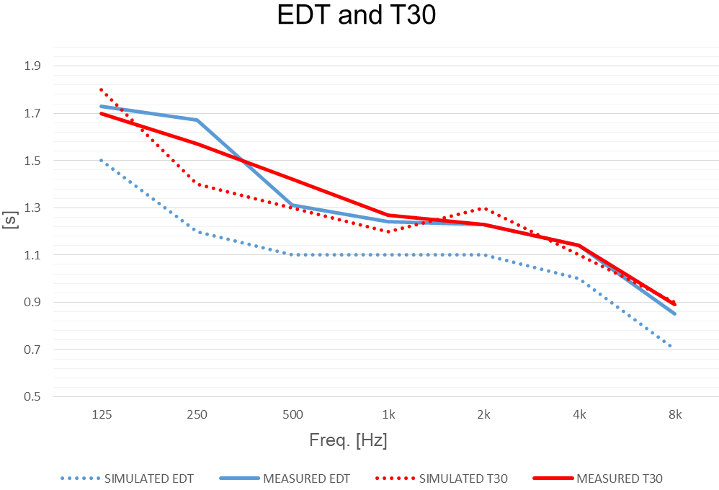
Figure 24 – Results of simulated EDT and T₃₀ obtained during the design process, and acoustic parameters resulted from the final campaign of measurements.

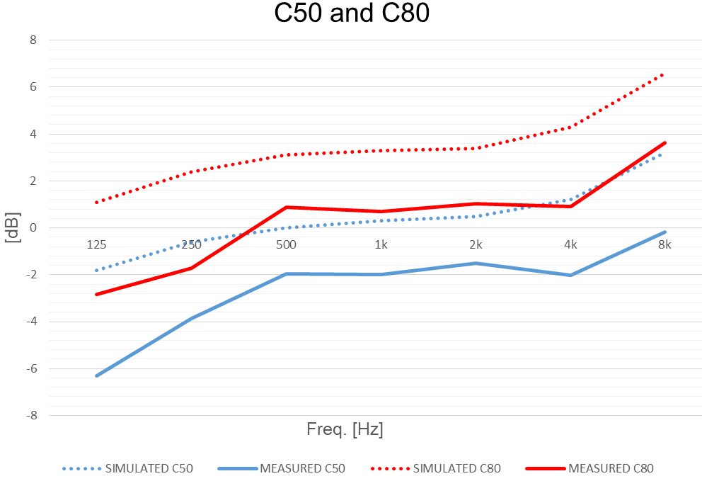
Figure 25 – Results of simulated C₅₀ and C₈₀ obtained during the design process, and acoustic parameters resulted from the final campaign of measurements.
The sound energy produced by the sound source is mainly dispersed in the cavea. Indeed, the values of Early Decay Time (EDT) are quite similar to Reverberation Time (T₃₀) values, and this is not a very frequent result for Italian style opera houses.
Furthermore, the results obtained for Centre Time (CT) and Clarity (C₅₀ and C₈₀), highlight that the main hall is suitable for music performance. Figures 24 and 25 report the simulated and measured results for several monaural parameters of the theatre. As can be seen from the graphs, there is a good correlation between simulated and measured T₃₀, whereas for clarity values trends are similar but simulated values are greater than measured ones.
Regarding spatial parameters (LF and IACC), the obtained values are optimal.
In the boxes and the cavea, despite the highly reflecting curved surfaces in the stalls, the analysis of the Impulse responses showed no evidences of focalisation, which was the purpose of the diffusing panels.

6. Conclusions
The theory of diffuse acoustic field is clear and functional, but it is difficult to apply experimentally, especially when the geometry of the building is irregular. Italian style opera houses have two different volumes, the stage area and the cavea, which are connected through the proscenium. The need of inserting diffusing panels in the Italian style opera Houses was confirmed in the acoustic measurement conducted in the Teatro Comunale of Bologna, a typical Italian style opera house, were focalisation effects were reported by some musicians and listeners. The results showed strong differences in the acoustic parameters measured in the stalls and boxes, moving the source, and keeping it in a fixed position. These differences were more relevant for spatial parameters due to focalisation of the sound energy and the lack of special devices for increasing the diffuseness. In the Teatro Comunale of Bologna, it was not possible to insert these acoustic devices due to aesthetic and conservation requirements.
Therefore, some examples of designed diffusing panels for Italian style opera houses (Teatro Comunale in Treviso, Teatro Vittorio Emanuele in Messina and Teatro Amintore Galli in Rimini) were proposed.
In the last theatre, it was possible to design some specific diffusing panels, and to perform acoustic measurements on them, following the ISO 17497:2 standard, obtaining their effectiveness for diffusion and scattering. The final measurements conducted in the reconstructed Teatro Galli to check its acoustic quality, showed no evidences of focalisation thanks to the realization of sound diffusers. The diffusing panels located in the cavea recreate a diffuse sound field and improve the listener's experience.
These experiments would contribute to increasing the awareness of acoustic diffusion in Italian style Opera Houses, which still suffer from focalisation effects which need specific diffusing device to be solved.

Acknowledgment
The authors wish to thank Giorgio Guidotti, Enrico Reatti, Pietro Fiumana, and Angelo Farina for their help during the measurement and design of the diffusing panels. The work described in this paper was carried out within the project “Research for SEAP: a platform for municipalities taking part in the Covenant of Mayors”, financed by Italian Government in the framework of PRIN 2015

References
- Pompoli, R.; Prodi, N. 2000 “Guidelines for acoustical measurements inside historical opera houses: Procedures and validation“, J. Sound Vib. 2000, 232, 281–301. doi . 10.1006/jsvi.1999.2821
- Farina, A. 2001 “Acoustic quality of theatres: Correlations between experimental measures and subjective evaluations“. Appl. Acoust. 62, 899–916. doi ; 10.1016/S0003-682X(00)00082-7
- Prodi, N., 2019 “From Tangible to Intangible Heritage inside Italian Historical Opera Houses” . Heritage 2:1, 826-835 doi: 10.3390/heritage201005
- Hodgson, M. 1991 “Evidence of diffuse surface reflections in rooms“. The Journal of the Acoustical Society of America 89, 765; https://doi.org/10.1121/1.1894636.
- Hodgson, M. 1994 “On measures to increase sound‐field diffuseness and the applicability of diffuse‐field theory“. The Journal of the Acoustical Society of America 95, 3651 (1994); https://doi.org/10.1121/1.409933.
- Farina, A., Langhoff, A., and Tronchin, L., 1998. "Acoustic Characterisation of “virtual” Musical Instruments: Using MLS Technique on Ancient Violins." Journal of New Music Research 27 (4): 359-379. doi:10.1080/09298219808570753
- Tronchin, L. 2005. "Modal Analysis and Intensity of Acoustic Radiation of the Kettledrum." Journal of the Acoustical Society of America 117 (2): 926-933. doi:10.1121/1.1828552.
- Tronchin, L. and V. L. Coli. 2015. "Further Investigations in the Emulation of Nonlinear Systems with Volterra Series" AES: Journal of the Audio Engineering Society 63 (9): 671-683. doi:10.17743/jaes.2015.0065.
- Caniato, M., Favretto, S., Bettarello, F., Schmid, C. 2018 “Acoustic Characterization of Resonance Wood”, Acta Acustica United with Acustica 104 1030–1040, doi 10.3813/AAA.919269
- Tronchin, L., Knight, D.J., 2018, “Transmitting acoustic phenomena and aural illusions: Examples from Athanasius Kircher’s Phonosophia anacamptica”, Building Acoustics 25(2), 101-110 doi: 10.1177/1351010X18772709
- Tronchin, L., 2013, “Francesco Milizia (1725-1798) and the acoustics of his Teatro Ideale (1773)” Acta Acustica United with Acustica 99 (1): 91-97. doi : 10.3813/AAA.918592
- Tronchin, L., Merli, F., Manfren, M., Nastasi, B., Validation and application of 3D Auralization during concert hall renovation, accepted for publication, Building Acoustics, 2020.
- De Colle, F., Girati, L., 2008 "Cinquant'anni di musica. Storia dell'Orchestra del Teatro Comunale di Bologna", edizioni Pendragon.
- Farina, A., Tronchin, L. 2005 “Measurements and reproduction of spatial sound characteristics of auditoria“, Acoustical Science and Technology, 26 (2), pp. 193-199 doi: 10.1250/ast.26.193
- Farina, A. and L. Tronchin. 2013. "3D Sound Characterisation in Theatres Employing Microphone Arrays" Acta Acustica United with Acustica 99 (1): 118-125. doi:10.3813/AAA.918595
- ISO 3382-1 – “Acoustics — Measurement of room acoustic parameters — Part 1: Performance spaces”, 2009.
- Witew, I., Behler, G., Vorländer, M.. 2005. “About just noticeable differences for aspects of spatial impressions in concert halls“. Acoustical Science and Technology. 26. 185-192. 10.1250/ast.26.185.
- Prodi, N., Visentin, C., 2013, “An experimental evaluation of the impact of scattering on sound field diffusivity“, Journal of the Acoustical Society of America, 133, (2), 810-820 doi : 10.1121/1.4774289.
- Ryu, J.K.; Jeon, J.Y. 2008 “Subjective and objective evaluations of a scattered sound field in a scale model opera house“. J. Acoust. Soc. Am., 124, 1538–1549. doi : 10.1121/1.2956474
- Kim, Y.H.; Kim, J.H.; Jeon, J.Y. 2011 “Scale model investigations of diffuser application strategies for acoustical design of performance venues“. Acta Acust. United Acust. 97, 791–799. doi: 10.3813/AAA.918459
- Embrechts, J.-J., 2014 “A geometrical acoustics approach linking surface scattering and reverberation in room acoustics“. Acta Acustica united with Acustica Volume 100, Issue 5, 864-879 10.3813/AAA.918766.
- Embrechts, J.-J., 2019 “An analytical model for reverberation energy decays in rooms with specular and diffuse reflections“. The Journal of the Acoustical Society of America Volume 145, 4, 2724-2732 doi: 10.1121/1.5095873.
- Shtrepi, L. 2019, “Investigation on the diffusive surface modeling detail in geometrical acoustics based simulations“, Journal of the Acoustical Society of America Volume 145, (3), EL215-EL22 doi : 10.1121/1.5092821
- Shtrepi, L., Pelzer, S., Vitale, R., Rychtarikova, M., and Astolfi, A. 2015. “Objective and perceptual assessment of the scattered sound field in a simulated concert hall,” J. Acoust. Soc. Am. 138(3), 1485–1497. doi : 10.1121/1.4929743
- Robinson, P.; Pätynen, J.; Lokki, T. Suk Jang, H., Yong Jeon, J., Xiang, N., 2013 “The role of diffusive architectural surfaces on auditory spatial discrimination in performance venues“. J. Acoust. Soc. Am., 133, 3940–3950.
- Azzi Visentini, M., Lenzi, D., 2000 “Il teatro Onigo di Treviso di Antonio Galli Bibiena in un album di disegni inediti“, Edizioni il Polifilo, Milano
- Farina, A: 1995 “RAMSETE - a new Pyramid Tracer for medium and large scale acoustic problems“. Proc. of EURO-NOISE 95
- Tronchin, L. and Knight, D. J.,2016. "Revisiting Historic Buildings through the Senses Visualising Aural and Obscured Aspects of San Vitale, Ravenna" Int J of Historical Archaeology 20 (1): 127-145. doi: 10.1007/s10761-015-0325-2
- Shimokura, R., Tronchin, L., Cocchi, A., and Soeta, Y., 2011. "Subjective Diffuseness of Music Signals Convolved with Binaural Impulse Responses." Journal of Sound and Vibration 330 (14): 3526-3537. doi:10.1016/j.jsv.2011.02.014.
- ISO 17497-2 – “Acoustics - Sound scattering properties of surfaces - Part 2: Measurement of the directional diffusion coefficient in a free field”, 2004.
- Farina, A., 2000. “A new method for measuring the scattering coefficient and the diffusion coefficient of panels.” Acta Acustica united with Acustica. 86: 928-942.

