Flow Visualisation, Pressure Drop and Mass Transport at 2D Electrodes in a Rectangular Channel Electrochemical Flow Cell
L. Wu^{a,*}, L. F. Arenas^{b,†}, J. E. Gravesª, F. C. Walsh^{b}
ª Functional Materials Group, Institute for Future Transport and Cities, Coventry University, Coventry CV1 5FB, United Kingdom.
^{b} Electrochemical Engineering Laboratory, Energy Technology Group, Faculty of Engineering and Physical Sciences, University of Southampton, Southampton, SO17 1BJ, United Kingdom.
* Author for correspondence; L. Wu; ac3448@coventry.ac.uk
† Present address: Cuernavaca, Mexico.

Abstract
The reaction environment in a C-Flow Lab 5 × 5® laboratory-scale electrochemical flow cell was characterised in terms of fluid flow, hydraulic pressure drop and space averaged mass transport coefficient. The cell was studied in flow-by configuration with smooth, planar electrodes within its rectangular flow channels. The effect of a turbulence promoter (a polymer mesh with a volumetric porosity of 0.84) placed next to the working electrode was also evaluated. Electrolyte volumetric flow rates ranged from 0.3 to 1.5 dm³ min⁻¹, corresponding to mean linear velocities of 2 to 10 cm s⁻¹ past the electrode surface and channel Reynolds numbers of 53 to 265. The pressure drop was measured both over the electrode channel and through the whole cell as a function of mean linear velocity. The electrochemical performance was quantified using the limiting current technique, which was used to determine the mass transport coefficient over the same range of flow rate. Results were compared to well-characterised electrochemical flow reactors found in the literature. The mass transport enhancement factor due to the presence of the turbulence promoter was between 1.6 and 3.9 under the studied conditions. Reactant conversion in batch recirculation mode and normalised space velocity were predicted from the electrochemical plug flow reactor equation.
Keywords: Electrochemical engineering; electrolyte flow; pressure drop; turbulence promoter.

Nomenclature
Symbol Meaning Units
A Electrode area cm²
A_{e} Electrode area per unit electrode volume cm⁻¹
A_{x} Cross-sectional area of electrode channel cm²
B Electrode breadth cm
d_{e} Equivalent (hydraulic) diameter of channel (= 2BS/B+S) cm
e, h Empirical constants in equation (4) dimensionless
F Faraday constant C mol⁻¹
H Electrode height cm
I_{L} Limiting current mA
k_{m} Space averaged mass transport coefficient cm s⁻¹
Δp Pressure drop Pa
P_{pump} Power required for pumping W
Q Volumetric flow rate of electrolyte cm³ s⁻¹
s_{n} Normalised space velocity cm³ cm⁻³ s⁻¹
S Height of flow channel cm
t Time s
v Mean linear velocity of electrolyte cm s⁻¹
V_{R} Volume of cell (reactor) cm³
V_{T} Volume of tank cm³
z Electron stoichiometry dimensionless

Greek
ε Volumetric porosity of turbulence promoter dimensionless
φ_{pump} Pump efficiency dimensionless
ν Kinematic viscosity cm² s⁻¹
µ Dynamic viscosity g cm⁻¹ s⁻¹
τ_{R} Mean residence time in the cell (reactor) (= V_{R}/Q) s
τ_{T} Mean residence time in the tank (= V_{T}/Q) s

Dimensionless groups
B/H Working electrode breadth to height aspect ratio dimensionless
L/H Working electrode length to height aspect ratio dimensionless
γ Mass transport enhancement factor due to the TP dimensionless
Re Channel Reynolds number (= vd_{e}/ν) dimensionless
Sc Schmidt number (= ν/D) dimensionless
Sh Sherwood number (= k_{m}d_{e}/D) dimensionless

Abbreviations
CFL C-Flow Lab 5 × 5® cell
TP Turbulence promoter
LSV Linear sweep voltammetry
NSV Normalised space velocity
PFR Plug flow reactor
2D, 3D Two-dimensional, three-dimensional

1. Introduction
Electrochemical flow reactors are central to many electrochemical processes including organic electrosynthesis [1, 2], redox flow batteries [3], and some types of water treatment [4]. As a result, their importance for electrochemical technology has been recently highlighted [5]. Considerable attention has been given to the design and improvement of cell geometries, electrode materials and cell manufacture at different scales. This has sought to achieve an improved reaction environment with a more uniform distribution of current density and electrode potential, higher rates of mass transport to, or from, the electrode surface and lower capital and running costs [6].
The diversity of electrodes and applications in well-established rectangular channel laboratory cells has been the subject of extensive reviews, for instance, the uses in process development [7] and the significance of reaction environment and its characterisation [8] in the FM01-LC reactor (originally developed by ICI C & P). Meanwhile, developments over classical approaches can be found in the form of innovative manufacturing technology for flow frames, endplates, porous electrodes and turbulence promoters using additive manufacturing [9], the use of nanostructured porous electrodes [10], and the coupling of electrode processes with heterogeneous reactions [4].
However, as pointed out in a critique of recent developments in rectangular channel flow cells [9], insufficient attention has been given to characterising the reaction environment of new cells, particularly those offered as ready solutions for laboratory studies. For examples, some are intended for benchmarking of reactions in organic electrosynthesis [11, 12], the study of novel chemistries for flow batteries [13, 14], or multiple applications [15]. Naturally, these flow cells can actually be used for the development of entirely different electrochemical technologies. Nevertheless, we are not aware of any publication characterising the reaction environment in these or similar cells for which pressure drop and average mass transport coefficients (for a well-known reaction, for example) as a function of flow rate are essential parameters. Without such information, or the report of a normalized flow rate for that matter, comparison and translation of results among different cells becomes difficult, if not impossible. Researchers in this field must be aware of the necessity to have a well-defined experimental arrangement and a basic understanding of the practical considerations regarding flow, limiting current and pressure drop.
In order to incentivise activity towards this aim, this work puts forward an easy-to-reproduce basic characterisation of the hydrodynamic behaviour and electrochemical mass transport performance of the “C-Flow Lab 5 × 5®” laboratory-scale electrochemical cell (C-Tech Innovation Ltd.). Planar electrodes are used for convenience and the effect of a turbulence promoter in the flow channel is also investigated. The hydraulic flow pattern of a fluid through the channel, pressure drop over the reactor and space averaged mass transport to the electrode were examined at mean linear velocities in the range 2 < v < 10 cm s⁻¹. The cell, which is similar to other commercial products, can accommodate a wide range of coated and uncoated electrode materials and can be used in undivided or divided mode (with an ion exchange membrane or microporous separator between the two half-cells). Complete characterisation of the cell will allow us to better understand the effect of process parameters on electrochemical reactions such as ammonia electro-oxidation coupled with hydrogen evolution at planar coated electrodes.
Test platforms, being academic or commercial, offer different advantages and disadvantages at different cost and availability. Therefore, it is imperative that characterisation of cell performances are made available so as to allow researchers to make informed decisions and to remind the importance of fundamental concepts in electrochemical flow cells.

2. Experimental details
2.1 The flow cell
The studied cell has an active, projected electrode area, A = 25 cm² and a working volume of 25 cm³, which is typical in many laboratory studies. The configuration and cell components are shown in Figure 1. Brass current collectors, planar electrodes, gaskets, machined cPVC flow frames, flow distributors, and membrane gaskets were compressed between two stainless steel endplates. The two half-cells were separated by a proton exchange membrane Nafion 212 (Chemours Co.) having a dry thickness of 0.05 mm. The dimensions of the flow channel and working electrode, for the present rectangular channel cell, in comparison to other types of electrochemical cells are shown in Table 1. The flow frames of the studied cell have an overall dimension of 16 cm × 11 cm, both front and rear plate frames having a thickness of 0.7 cm. The flow channel has a length of 5 cm and a breadth of 5 cm.
Continuing with Figure 1, both the front and rear plate frames have an inlet and an outlet manifold, each of them containing 6 consecutive ports of identical cross-sectional area (6.25 mm²). Each port is at 90 deg to the axis of its respective manifold feeder. Electrolyte flow enters the compartment from the bottom inlet manifold, branches into separate streams through the ports, flows through the electrode compartment and travels towards the top outlet manifold. The front and rear plate frames have also two machined inserts each with flow distributor patters facing the consecutive ports.
A 1.6 mm thick nickel (99.0%, Goodfellow UK Ltd.) and a 1.6 mm thick pure carbon sheet (C-Tech Innovation Ltd.) were used as working electrode and counter electrode, respectively, each having dimensions of 5 cm × 5 cm and an active surface area of 25 cm². A chlorinated polyvinyl chloride (cPVC) mesh (C-Tech Innovation Ltd.) was mounted, as a turbulence promoter, TP, next to the planar electrode. The TP had overall dimensions of 6 cm × 6 cm × 0.1 cm and a volumetric porosity, $ε$ , of 0.84. The value of $ε$ was determined from the ratio of the weight of the mesh to the weight of a solid piece of cPVC of the same overall dimensions, by knowledge of its density. The structure of the TP is shown in Figure 2 and was characterised using a Leo 1530 VP (Carl Zeiss A.G.) field emission gun scanning electron microscope.

2.2 Flowing electrolytes
An alkaline, aqueous electrolyte with the hexacyanoferrate(II)/hexacyanoferrate(III), redox couple was used for measurements of limiting current density and it was also used for the pressure drop measurements. The solution had a composition of 1.0 × 10⁻³ mol dm⁻³ K₃[Fe(CN)₆] and 10.0 × 10⁻³ mol dm⁻³ K₄[Fe(CN)₆] in 1.0 mol dm⁻³ Na₂CO₃ (pH = 12.1). The excess of hexacyanoferrate(II) was used to ensure that the anodic reaction did not become rate limiting at the working electrode. The solution had a fluid density, ρ, of 1.12 g cm⁻³, a dynamic viscosity, µ, of 1.92 × 10⁻² g cm⁻¹ s⁻¹ and a kinematic viscosity, ν of 1.71 × 10⁻² cm² _{S}⁻¹. The viscosity of the solution was measured with a digital Rheometer (Bohlin Gemini 200) at 25 °C.

2.3 Flow visualisation
Flow visualisation studies were carried out in order to obtain a qualitative indication of the electrolyte flow dispersion as it passed through the cell. The colour intensity of the methylene blue dye changed as a function of the local flow velocity and direction, and was filmed using a 40 megapixel digital camera (Huawei P20 pro) mounted on a tripod. A volume of 1 cm³ of dye solution was quickly injected by syringe, at a point located approximately 1 cm before the cell inlet. The test was performed at a representative mean linear velocity of 6 cm s ⁻¹ and photographic images were taken at intervals of 0.25 s. For this procedure, one face of the cell was replaced with a transparent polymethyl methacrylate (PMMA) plate to enable the observation of the flow patterns.

2.4 Pressure drop measurements
The hydraulic pressure drop of the evaluated flow cell was measured with, and without, a TP present in the electrode channel. A 3D image showing the internal structure of the flow frame can be seen in Figure 3a. The experimental arrangement for pressure drop measurements within the electrode channel is shown in Figure 3b. Two holes of 2 mm diameter were drilled through the frame where pressure taps were inserted. One tap was positioned 5 mm above the top of the electrode and the other was 5 mm below the bottom of the electrode. The pressure drop of the fluid was also measured outside the frame to investigate the effect of manifolds, as shown in Figure 3c. For this, two T-piece connectors (Cole-Parmer UK Ltd.) were symmetrically positioned, each being 20 mm away from the inlet and outlet manifolds.

The pressure taps were connected to a Digitron 2023P digital manometer (RS Components UK Ltd.) via two PTFE tubes of 2.4 mm internal diameter (Cole-Parmer UK Ltd.). For both configurations, pressure drop measurements were recorded every 30 s for 10 min to obtain an average value. The temperature of the solution was 24 °C. During these procedures each cell compartment of the flow cell was connected to a peristaltic pump (Cole-Parmer Masterflex L/S) fitted with silicone rubber tubes (Masterflex L/S C-Flex Ultra), and to a reservoir (Duran GL 45) using silicone tubbing with an internal diameter of 6.4 mm.

2.5 Electrochemical mass transport studies
The electrochemical performance of the cell under a mass transport-controlled electrode reaction was quantified using the mass transport coefficient, $k_{m}$, obtained by measuring steady-state limiting currents, $I_{L}$, as a function of mean linear velocity, ranging from 2 to 10 cm s⁻¹. The reaction of interest at the nickel working electrode was the reduction of hexacyanoferrate(III) ion to hexacyanoferrate(II) ion:

Fe(CN)₆³⁻ + e⁻ ⇄ Fe(CN)₆⁴⁻ E° = 0.361 V vs. SHE (1)

Limiting current measurements for the reduction of hexacyanoferrate(III) ion were conducted by linear sweep voltammetry (LSV) between the potential limits of + 1.0 V and – 1.5 V vs. a saturated calomel reference electrode (SCE) at a linear sweep rate of 10 mV s⁻¹ using the carbon plate as counterelectrode. The scans were performed using a VoltaLab PZ1050 potentiostat (Radiometer Ltd.). As shown in Figure 3c, the working electrode potential was measured at its lateral, middle point through a Luggin capillary inserted in the flow frame and connected to an external reservoir containing the reference electrode. Experiments were carried out at a temperature of 24 °C.

3. Theory
3.1 Definition of a normalized flow rate and Re number
In order to enable the comparison of electrochemical flow cells across different scales and to define a simple normalized electrolyte flow rate, the mean linear velocity, $v$, of electrolyte past the electrode surface is calculated from its volumetric flow rate, Q, using the expression:

$v=\frac{Q}{A_{x}ε}$ (2)

where $A_{x}$ is the cross-sectional area of the electrode channel and $ε$ is the porosity of the flow channel ($ε$ = 1 for an empty channel with planar electrode; $ε$ < 1 for a porous electrode or mesh).
The fluid flow of the electrolyte can then be described using the channel Reynolds number, $Re$. It is normally considered that well developed flow in a smooth channel is laminar for $Re$ < 2100 and turbulent for $Re$ > 4000. The Reynolds number for the flow channel was determined from the mean linear velocity, $v$, by:

$Re=\frac{vL}{ν}$ (3)

where $L$ is the length of the channel and $ν$ is the kinematic viscosity. The range of solution flow evaluated in this work involved volumetric flow rates from 0.3 to 1.5 dm³ min⁻¹, corresponding to mean linear velocities of 2 to 10 cm s⁻¹ past the electrode surface and channel Reynolds numbers in the range 53-265.

3.1 Definition of an empirical power law for pressure drop
The hydraulic pressure drop, $Δp$, experienced by the electrolyte as it flows through the cell is caused by frictional losses and its value is determined by the difference in pressure between two points. A descriptor of the relationship between $Δp$ and the flow conditions for a particular flow cell, enabling methodologies for evaluating electrode materials and improving pumping efficiency, can be established by an empirical power law:

$Δp= {eRe}^{h}$ (4)

where the coefficient, e, and the $Re$ exponent, $h$, are empirical constants which characterise a particular electrode geometry and flow cell. The power required for pumping, $P_{pump}$ is related to the pressure drop, $Δp$ across the cell at a given volumetric flow rate, $Q$, by the expression:

$P_{pump}=\frac{∆pQ}{ϕ_{pump}}t$ (5)

where φ_{pump} is the pump efficiency and $t$ is time.

3.2 Limiting current density and mass transport rates
The steady-state limiting current is achieved at the electrode when the current of the electrochemical reaction passing through the cell is restricted by the diffusion rate of electroactive species to and from the electrode surface. For a smooth, planar electrode, the relationship between $k_{m}$and $I_{L}$ is:

$k_{m}A=\frac{I_{L}}{zFc}$ (6)

where $z$ is the electron stoichiometry, $F$ is the Faraday constant, $c$ is the bulk concentration of reactant.

3.3 The effect of the turbulence promoter
Promotion of mixing and increased local velocities within the channel by the presence of a polymer mesh TP gives rise to an increase in mass transport to a planar electrode, at a given flow velocity. The mass transport enhancement factor due to the presence of the TP, $γ$, can be quantified for a planar electrode by the ratio of the limiting current in the presence of the TP to that in the empty channel:

$γ=\frac{I_{L (ITP)}}{I_{L}}$ (7)

In this work, the ratio indicates how much the limiting current at the nickel cathode increased by the addition of the cPVC TP.

4. Results and Discussion
4.1 Flow visualisation
The results of flow visualisation studies in the unrestricted electrode compartment including manifolds and flow frames are shown in Figure 4 for a typical mean linear velocity of 6 cm s⁻¹. It can be seen that the dye initially flowed into the compartment through the left vertical ports. An asymmetrical flow was generated within 1.0 s and was dominant at this side of the compartment. The dye started to emerge through the middle ports when the time reached 1.25 s. After 2.0 s, the blue dye predominantly occupied the left side of the compartment, but dye can be observed entering the compartment through the right ports adjacent to the inlet manifold. It took approximately 4 s for the blue dye to fill up the whole compartment, suggesting a relatively high flow dispersion.
The flow maldistribution dominant at the left-hand side of the compartment is attributable to the geometry of the consecutive manifolds. This structure, consisting of multiple ports vertical to the manifold axis, is a widely used due to its simplicity but is prone to produce non-uniform flow distribution. Typically, lateral ports next to the opposite end of the inlet manifold have flow in excess, while others close to the inlet suffer from shortages of flow. A similar observation has been reported by Wang [16]. Parameters including the area ratio (the ratio of the sum of areas of all ports to manifold area), space between each two consecutive ports, curvature radius at the junction between manifold and ports, have a significant influence on flow distribution along the manifolds and can be improved to reduce the maldistribution effect [17]. For instance, by modifying the diameter of the ports as a function of their distance from the inlet. It must be noted that such flow maldistribution is much less significant when 3D porous electrodes with small pore size are present in the flow channel, such as carbon felt [18].

4.2 Pressure drop measurements
The hydraulic pressure drop as a function of mean linear velocity is presented in the logarithmic-logarithmic plot in Figure 5a. Both an unrestricted flow compartment with a planar nickel electrode and with a TP next to the planar electrode were considered. The impact of cell manifolds has also been established by measuring the hydraulic pressure drop outside the cell frame. It is apparent that $Δp$ increased as a function of the mean linear velocity. The use of the TP next to the planar electrode resulted in a slightly higher pressure drop through the flow cell. For the measurement taken within the cell frame, the highest pressure drop was obtained in the presence of the TP (max. 0.94 kPa at a mean linear velocity of 10 cm s ⁻¹). In the absence of the TP, the pressure drop obtained at a mean linear velocity of 10 cm s⁻¹ was slightly reduced to 0.86 kPa.
The cell manifolds had a significant effect on hydraulic pressure losses through the cell. The highest pressure drop measured outside the cell frame (max. 8.16 kPa at 10 cm _{S} ⁻¹) was nearly one order of magnitude higher than that measured within the cell frame (max 0.94 kPa at 10 cm s _{S}⁻¹). These observations suggest that the consecutive ports increased friction at the walls and resulted in a high resistance to fluid flow with increased pressure losses. Frias-Ferrer et al. [19] considered that, in small-scale electrochemical flow reactors, the flow reaction environment (e.g. flow pattern distribution, mass transport coefficients and current distribution) was largely dependent on the cell manifold geometry, position and number, rather than the flow channel characteristics. They proposed a geometrical manifold parameter, ψ, providing a simple but valuable statement of the importance of cell manifold design such as thickness, width, geometrical distribution of the open spaces, and the free area for the electrolyte entrance, which can result in significant entrance/exit effects on hydraulic pressure drops [19].
Pressure losses through the flow cell in the present study can be compared with those produced by other types of electrochemical flow reactors and turbulence promoters, also plotted in Figure 5a. For example, Arenas et al. [20] reported low pressure losses through a TP mesh next to a Pt/Ti planar electrode, even when subjected to relatively high mean linear velocities. The highest $Δp$ value observed was 1.03 kPa at a mean linear velocity of 17 cm s⁻¹. On the other hand, Griffiths et al. [21] have examined the mass transport and pressure drop characteristics of the FM01 reactor. They confirmed that the use of a TP improved mass transport coefficients at the expense of moderately higher pumping costs.
Other studies have discussed the use of porous electrodes. For instance, Brown et al. and Trinidad et al. [22, 23] reported the hydrodynamic behaviour of the FM01-LC reactor when using 3D porous electrodes and turbulence promoters. It was evident that the benefits of using turbulence promoters and 3D electrodes included a higher mass transport coefficient, more uniform current distribution, and reduced entrance effects near the inlet manifold. Arenas et al. [20] compared the pressure losses over various porous electrodes (a mesh, a micromesh and a felt) through an in-house built electrochemical flow reactor. They reported that the felt electrode (with $ε$ = 0.80) yielded the highest$Δp$values (up to 259.5 kPa at 12 cm s⁻¹), whilst the lowest $Δp$ value (max. 264.4 Pa at 8 cm s⁻¹) was observed at the mesh electrode (with $ε$ = 0.71).
Pressure losses inside flow compartments have been extensively researched for many years []. However, much less attention has been given to the other causes of partial pressure drops in a flow reactor (e.g. distribution ducts, branches, connecting beams, sudden section expansion). Pawlowski et al. considered all significant partial pressure drops of fluid flow inside a reverse electrodialysis (RED) stack and they reported that the partial pressure drops in the distribution duct and the branches had a dominant contribution to the cause of a non-uniform distribution inside the stack [24].
A logarithmic-logarithmic plot can be used to establish the relationship between the pressure losses and the electrode channel, Re, in the form of an empirical power law [25, 26]. The Reynolds number was calculated from mean linear velocities based on Equation (3) -see Figure 5b. Following the typical behaviour [27], $Δp$ is linearly proportional to the Reynolds number in these conditions. For the C-flow cell, it can be seen that the Reynolds number was relatively low in the flow channel (Re < 300). The correlations for the flow cell in the present study can be compared with those for various porous electrodes in an in-house electrochemical flow reactors by Arenas et al. [23] and by Colli et al. []

4.3 Limiting current and mass transport measurements
Hydrodynamic voltammetry was carried out to determine an electrochemical performance factor, i.e., the mass transport coefficient, $k_{m}$, and to evaluate the impact of the implementation of turbulence promoters. A logarithmic-logarithmic plot, shown in Figure 6, is used to show the limiting current for reduction of ferricyanide ions in the flow cell as a function of the mean linear velocity in the absence and presence of the TP. The limiting current values increased from 4.5 to 20 mA as the mean linear velocity increased from 2 to 10 cm s⁻¹, which suggests enhanced convective-diffusion of electroactive species to and from the electrode surface in the flow channel. More importantly, the degree of enhancement in the limiting current was more pronounced when the TP was incorporated, contributing to an approximately four-fold increase in the limiting current at the lowest mean linear velocity studied (2 cm s⁻¹). Previous studies have reported that the employment of a mesh TP contributed to an increase in the mass transport coefficient by up to two times, and also a more uniform distribution of mass transport over the electrode surface [28].
Figure 7 shows the mass transport coefficient in the electrode section as a function of the mean linear velocity in the absence and presence of the turbulence promoter, according to Equation (6). The mass transport coefficient increased as the mean linear velocity increased. The incorporation of the TP enhanced the rate of mass transport to the electrode surface. Figure 8 shows the mass transport enhancement factor as a function of the mean linear rate. The employment of the TP showed an enhancement factor of up to 3.9 compared with the empty flow channel, which is slightly higher than those values reported by other researchers for different turbulence promoters, up to 2.2 [27], and 3.5 [29]. Similar mass transport enhancement effects take place at metal mesh electrodes [30]. The enhanced mass transport obtained in the present research is associated with the high volumetric porosity of the mesh promoter ($ε$ is 0.84). Incorporation of a mesh promoter in the fluid flow path significantly improved the rate of mass transport to the electrode surface and hence its productivity over time. Furthermore, the TP can ameliorate the current and potential distribution at the electrode, reduce localised pH changes and decrease voltage efficiency losses [31].
It is noteworthy that the enhancement effect induced by the employment of the TP was more pronounced at a low mean linear rate and gradually decreased with increasing mean linear velocity. Previous studies have also reported this trend when assessing the mass transport enhancement factor of various electrode materials and they partly attributed this to the internal flow bypass (also called channelling) in the electrode compartment due to more intense manifold flow jets at higher mean linear velocities [32].

5. Cell Performance
5.1 Mass transport performance vs. pumping power
The implications of the data can be illustrated by plotting mass transport coefficient vs. pressure drop in the electrode section of the channel over a range of mean electrolyte flow velocities. Such a plot, shown in Figure 9, considers the electrochemical performance of an electrode and/or cell in relation to the associated pressure drop, indicating its suitability for scale-up. The observed behaviour is similar to that found in a 24 cm² cell with planar Pt/Ti and a TP [20]. It is also possible to establish empirical power laws to describe the relationship between mass transport coefficient and pressure drop [20, 29]. Moreover, since pumping power is a function of pressure drop, Figure 9 provides also an example of a simple cost-benefit approach which is useful for improving the technology readiness level of cells, and moving from the laboratory towards industrial processing.

5.2 Predicted batch recirculation performance
Considering a 2e⁻ reduction under complete mass transport control in the batch recirculation flow mode via a 1000 cm³ catholyte tank provides a means of illustrating the cell performance under the experimental conditions in laboratory studies. The time taken by the cell to achieve a fractional conversion of 90% for the reactant in a well-mixed tank is described by the electrochemical plug flow reactor (PFR) equation for batch recirculation [33]:

$\log\left(\frac{c_{(t)}}{c_{(0)}}\right)=2.3\frac{t}{τ_{T}}\left[1-\exp\left(\frac{k_{m}A}{Q}\right)\right]$ (8)

and setting the ratio of reservoir concentration at time $t$, compared to time zero, $c_{(t)}$/$c_{(0)}$ = 0.90.
In equation (8), $A$, $k_{m}$, $τ_{T}$, $c$ and $Q$ are the electrode area, mass transport coefficient, mean residence time in the tank, reactant concentration and volumetric flow rate, respectively. The term in square parenthesis on the right-hand side of equation (8) represents the fractional reactant conversion in a single pass through the reactor while $t$/$τ_{T}$ represents the number of recycles of electrolyte through the tank. The term in square brackets represents the fractional conversion of reactant in a single pass through the cell.
Considering a 1000 cm³ catholyte tank, the results are plotted as the time taken to achieve a fractional conversion of 90% as a function of the mean flow velocity of electrolyte in Figure 10. The time was inversely proportional to the mean linear velocity and the application of the TP had a positive influence over the conversion rate. In the absence of the TP, the time decreased from 7 min to less than 2 min as the mean linear velocity increased from 2 to 10 cm s⁻¹. When the TP was incorporated, the time significantly dropped to 1.8 min at the lowest mean linear velocity and further reduced to 1 min as the mean linear velocity increased to 10 cm s⁻¹.
5.3 Normalised space velocity vs. mass transport performance
The cell performance under the experimental conditions can be quantified by considering the normalised space velocity (NSV), $s_{n}$, (dm³ dm⁻³ h⁻¹) for 90% removal of a soluble contaminant for a mass transport-controlled reaction in the batch recirculation mode with a 1000 cm³ reservoir volume. The NSV can be calculated using the expression [34]:

$s_{n}=\frac{k_{m}A}{2.3 V_{R}}$ (9)

where A is the electrode area, $k_{m}$ is the mass transport coefficient, and $V_{R}$ is the reservoir volume. The NSV values for a fully mass transport-controlled reaction at various mean linear velocities, with and without a TP are shown in Figure 11. The values increased as a function of the mean linear velocity, since a higher rate of the electrolyte flow contributed to an increased mass transport coefficient. The employment of the TP further enhanced the mass transport in the flow channel and hence increased the NSV. The lowest value (0.073 dm³ dm⁻³ h⁻¹) was observed at the lowest mean linear velocity of 2 cm s⁻¹ without the TP. A mean linear velocity of 10 cm s⁻¹ with the presence of the TP yielded the highest NSV, 0.516 dm³ dm⁻³ h⁻¹.

6. Conclusions
The reaction environment in a laboratory rectangular channel flow cell, the C-Flow Lab 5 × 5® cell, using planar electrodes has been studied as a plug flow reactor, using a variety of techniques. The following conclusions can be drawn from the present studies:
1. Flow visualisation using methylene blue dye injection was conducted using a simple digital camera. An asymmetric flow was generated and dominant at one side of the compartment due to the geometry of multiple ports at 90 deg to the manifold axis.
2. The pressure drop increased as a function of the mean linear velocity and the channel Reynolds number. The values for the pressure losses obtained at a mean linear velocity of 10 cm s ⁻¹ were increased from 0.86 kPa to 0.94 kPa as the TP was incorporated next to the planar nickel electrode. The cell manifolds had a significant influence on the hydraulic pressure drop through the flow channel. The consecutive structure with multiple, consecutive ports at 90 deg to the axis of the manifold significantly increased pressure losses. The highest pressure drop measured outside the cell frame (max. 8.16 kPa at 10 cm _{S} ⁻¹) was nearly one order of magnitude higher than that measured within the cell frame (max 0.94 kPa at 10 cm s⁻¹).
3. The electrochemical performance of the flow cell was quantified from the limiting current and mass transport coefficient measurements. As mean linear velocities increased from 2 to 10 cm s⁻¹, the values for the limiting current were increased from 4.5 to 20 mA and for the mass transport coefficient were increased from 1.87 to 8.31 10⁻³ cm s¹, respectively. The incorporation of a turbulence promoter further enhanced the mass transport in the electrode channel. The enhancement factor due to the presence of the TP was between 1.6 and 3.9 at mean linear velocities in the range 2 < v < 10 cm s⁻¹.
4. The implications of the data have been illustrated by plotting mass transport performance (k_{m}) vs. pressure drop in the electrode section of the channel over a range of mean electrolyte flow velocities. The correlation was typical for a flow-through cell using a 2D electrode and a TP. The plot of mass transport vs. pressure drop considers an aspect of electrochemical performance under mass transport control as a function of pumping power, useful for an informed scale-up of electrode materials ,TP meshes, and cell designs.
5. The cell performance under the experimental conditions has been illustrated by calculating the time required to recirculate a fixed batch of electrolyte through the cell at controlled flow velocities in order to achieve a fractional reactant conversion of 90%, the reaction being completely mass transport controlled. In the absence of the TP, the time was decreased from 7 min to less than 2 min as the mean linear velocity increased from 2 to 10 cm s⁻¹. When the TP was incorporated, the time was significantly decreased to 1.8 min at the lowest mean linear velocity of 2 cm s⁻¹ and further reduced to 1 min as the mean linear velocity increased to 10 cm s⁻¹.
6. The cell performance under the experimental conditions has also been illustrated by considering the normalised space velocity (dm³ dm⁻³ h⁻¹) for 90% removal of a soluble contaminant via a mass transport controlled reaction in the batch recycle mode with a 1000 cm³ reservoir volume. In the absence of the TP, the NSV values increased from 0.073 to 0.324 dm³ dm⁻³ h⁻¹ with increasing the mean linear velocity from 2 to 10 cm s⁻¹. The employment of the TP further increased the NSV values from 0.284 to 0.516 dm³ dm⁻³ h⁻¹.
7. Further work will study the pressure drop and electrochemical performance in the CFL cell when using 3D, porous electrodes, such as metal mesh, metal foams, reticulated vitreous carbon, and carbon felt.

Acknowledgments
The authors from Coventry University would like to acknowledge Innovate UK and EPSRC for funding through the Energy Catalyst 4 Call under grant agreement No. EP/P03070X/1 and the Engineering Workshop at Coventry University for manufacturing transparent cell components.

References
- A. Wiebe, T. Gieshoff, S. Möhle, E. Rodrigo, M. Zirbes, S.R. Waldvogel, Electrifying organic synthesis, Angew Chem Int Ed. 57 (2018) 5594.
- M. Atobe, H. Tateno, Y. Matsumura, Applications of flow microreactors in electrosynthetic processes, Chem Rev. 118 (2017) 4541.
- X. Wei, W. Pan, W. Duan, A Holla, Y. Zhang, Z. Yang, B. Li, Z. Nie, J. Liu, D. Reed, W. Wang, V. Sprenkle, Materials and systems for organic redox flow batteries: Status and challenges, ACS Energy Lett. 2 (2017) 2187.
- F.C. Moreira, R.A.R. Boaventura, E. Brillas, V.J.P. Vilar, Electrochemical advanced oxidation processes: A review on their application to synthetic and real wastewaters, App Catal B: Environ. 202 (2017) 217.
- K. Scott, Process intensification: An electrochemical perspective, Renew Sust Energ Rev. 81 (2018) 1406.
- S. Bebelis, K. Bouzek, A. Cornell, G.H. Kelsall, M.G.S. Ferreira, F. Lapicque, C. Ponce de León, M.A. Rodrigo, F.C. Walsh, Highlights during the development of electrochemical engineering, Chem. Eng. Res. Des. 91 (2013) 1998.
- F.F. Rivera, C. Ponce de León, F.C. Walsh, J.L. Nava, The filter-press FM01-LC laboratory flow reactor and its applications, Electrochim. Acta, 163 (2015) 338.
- F.F. Rivera, C. Ponce de León, F.C. Walsh, J.L. Nava, The reaction environment in a laboratory filter-press flow cell: The FM01-LC, Electrochim. Acta, 161 (2015) 436.
- F.C. Walsh, L.F. Arenas, C. Ponce de León, Developments in plane parallel flow channel cells, Curr Opin Electrochem, 16 (2019) 10.
- M.J. Kim, M.A. Cruz, F. Yang, B.J. Wiley, Accelerating electrochemistry with metal nanowires, Curr Opin Electrochem, 16 (2019) 19.
- C. Gütz, A. Stenglein, S.R. Waldvogel, Highly modular flow cell for electroorganic synthesis, Org Process Res Dev. 21 (2017) 771.
- R.A. Green, R.C.D. Brown, D. Pletcher, B. Harji, A microflow electrolysis cell for laboratory synthesis on the multigram scale, Org Process Res Dev. 19 (2015) 1424.
- C-Flow 5×5 Electrochemical Cell Brochure. C-Tech Innovation Ltd., 2019. https://www.ctechinnovation.com/product/c-flow-5x5/
- Flow Battery Lab-Cell. Pinflow energy Storage, S.R.O., 2019. http://pinflowes.com/assets/img/ProductsResearch/LabCellTechSpec.pdf
- Micro Flow Cell Technical Data. ElectroCell A/S., 2019. https://www.electrocell.com/media/1215/micro-flow-cell_technical-data.pdf
- J. Wang, Theory of flow distribution in manifolds, Chem. Eng. J. 168 (2011) 1331.
- J.M. Hassan, A. AbdulRazzaq, B.K. Kamil, Flow distribution in manifolds, J. Eng. and Dev. 12 (2008) 159.
- J. González-García, P. Bonete, E. Expósito, V. Montiel, A. Aldaz, R. Torregrosa-Maciá, Characterization of a carbon felt electrode: structural and physical properties, J. Mater. Chem. 9 (1999) 419
- A. Frías-Ferrer, J. González-García, V. Sáez, C. Ponce de León, F.C. Walsh, The effects of manifold flow on mass transport in electrochemical filter-press reactors, AIChE J. 54 (2008) 811.
- L.F. Arenas, C. Ponce de León, F.C Walsh, Pressure drop through platinized titanium porous electrodes for cerium-based redox flow batteries, F.C. Walsh, AIChE J. 64 (2018) 1135.
- M. Griffiths, C. Ponce de Leon, F.C. Walsh, Mass transport in the rectangular channel of a filter-press electrolyzer (the FM01-LC reactor), AIChE J. 51 (2005) 682.
- C.J. Brown, D. Pletcher, F.C. Walsh, J.K. Hammond, D. Robinson, Studies of three-dimensional electrodes in the FM01-LC laboratory electrolyser, J. Appl. Electrochem. 24 (1994) 95.
- P. Trinidad, F.C. Walsh, Hydrodynamic behaviour of the FM01-LC reactor, Electrochim. Acta. 41 (1996) 493.
- S. Pawlowski, J.G. Crespo, S. Velizarov, Pressure drop in reverse electrodialysis: Experimental and modeling studies for stacks with variable number of cell pairs, J. Membr. Sci. 462 (2014) 96
- C.J. Brown, D. Pletcher, F.C. Walsh, J.K. Hammond, D. Robinson, Studies of space-averaged mass transport in the FM01-LC laboratory electrolyser, J. Appl. Electrochem. 23 (1993) 38.
- T.R. Ralph, M.L. Hitchman, J.P. Millington, F.C. Walsh, Mass transport in an electrochemical laboratory filter-press reactor and its enhancement by turbulence promoters, Electrochim. Acta, 41 (1996) 591.
- A.N. Colli, R. Toelzer, M.E.H. Bergmann, J.M. Bisang, Mass-transfer studies in an electrochemical reactor with a small interelectrode gap, Electrochim. Acta, 100 (2013) 78
- W.M. Taama, R.E. Plimley, K. Scott, Mass transfer rates in a DEM electrochemical cell, Electrochim Acta, 41 (1996) 543.
- C.J. Brown, F.C. Walsh, D. Pletcher, Mass transport and pressure drop in a laboratory filterpress electrolyser, Trans IChemE, 73 (1995) 196.
- F. Leroux, F. Coeuret, Flow-by electrodes of ordered sheets of expanded metal—I. Mass transfer and current distribution. Electrochim Acta. 30 (1985) 159.
- L. Castañeda, R. Antaño, F.F. Rivera, J.L. Nava, Computational fluid dynamic simulations of single-phase flow in a spacer-filled channel of a filter-press electrolyzer, Int J Electrochem Sci. 12 (2017) 7351.
- A. R. Da Costa, F.G. Fane. Net-type spacers: Effect of configuration on fluid flow path and ultrafiltration flux. Ind Eng Chem Res. 33 (1994):1845.
- A. Walker, A.A. Wragg, The modelling of concentration—time relationships in recirculating electrochemical reactor systems, Electrochim Acta. 22 (1977) 1129.
- G. Kreysa, Performance criteria and nomenclature in electrochemical engineering, J Appl Electrochem, 15 (1985) 175.

Tables

Parameter | This work, C-Flow Lab cell | Griffiths et al. FM01-LC cell [9] | Ralph et al. in-house cell [23] | Arenas et al. in-house cell [13]
Flow channel length, $L$ / cm | 5 | 16 | 15 | 6
Flow channel breath, B / cm | 5 | 4 | 15 | 4
Flow channel height, S / cm | 0.5 | 0.45 | 1.0 | 0.6
Active electrode area, A / cm² | 25 | 64 | 225 | 24
Hydraulic (equivalent) diameter, d_{e} / cm (= 2BS / B+S) | 0.91 | 0.81 | 1.88 | 1.04
W.E. breadth to height  aspect ratio  (= B/S) | 10 | 8.89 | 15 | 6.67
W.E. length to height  aspect ratio  (=L/S) | 10 | 35.56 | 15 | 10
Typical surface roughness of channel walls / μm | 1 | 1 | 1 | 1

Table 1. Geometrical dimensions of the flow channel and working electrode for the present rectangular channel cell, in comparison to others.

Figure captions

Fig. 1. Expanded view of the configuration of the C-Flow Lab (CFL) electrochemical cell. 1) Rear plate assembly (304 stainless steel); 2) current collector (Brass); 3) electrodes (nickel or carbon); 4) electrode gaskets (expanded EPDM); 5) flow frames (cPVC); 6) flow distributor inserts (cPVC); 7) membrane gaskets (EPDM); 8) membrane (Nafion 212); 9) front plate assembly (304 stainless steel); 10) compression thumb screws (304 stainless steel). Courtesy of C-Tech Innovation Ltd.

Fig. 2. SEM image showing the structure of the turbulence promoter (electrochemically inert cPVC mesh), showing its average pitch dimensions.

Fig. 3. Electrochemical cell and experimental arrangement for pressure drop measurements. a) 3D images showing the internal structure of the flow distribution frame. Courtesy of C-Tech Innovation. b) Arrangement for measurements within the electrode channel, c) Arrangement for measurements outside the cell frame using T-piece connectors.

Fig. 4. Flow visualisation images of the flow channel, following the injection of methylene blue dye into the inlet, at time, t = 0 at a representative mean linear velocity of 6 cm s ⁻¹. Image capture by a digital camera, at 0.25 s intervals until t = 3.75 s.

Fig. 5. Pressure drop experienced by the flowing electrolyte as it passes through the electrode compartment and whole electrochemical flow cell both in for an unrestricted channel with a planar electrode and the same electrode plus a TP. Pressure drop vs. a) electrolyte mean linear velocity, and b) Reynolds number. Electrolyte composition: 1.0 × 10⁻³ mol dm⁻³ K₃[Fe(CN)₆] and 10.0 × 10⁻³ mol dm⁻³ K₄[Fe(CN)₆] in 1.0 mol dm⁻³ Na₂CO₃.

Fig. 6. Limiting current density measurements for reduction of ferricyanide ions at a planar cathode in a channel in the absence and presence of a turbulence promoting mesh over a range of controlled mean linear velocity. Electrolyte composition: 1.0 × 10⁻³ mol dm⁻³ K₃[Fe(CN)₆] and 10.0 × 10⁻³ mol dm⁻³ K₄[Fe(CN)₆] in 1.0 mol dm⁻³ Na₂CO₃. Linear sweep voltammetry (LSV) performed between the potential limits of + 1.0 V and – 1.5 V vs. SCE at a linear sweep rate of 10 mV _{S}⁻¹ at 24°C. Mean linear velocities in the range 2 < v < 10 cm s⁻¹.

Fig. 7. Mass transport coefficient measurements for reduction of ferricyanide ions at a planar cathode in a channel containing a turbulence promoting mesh over a range of controlled mean linear velocity in the range 2 < v < 10 cm s⁻¹. Electrolyte composition: 1.0 × 10⁻³ mol dm⁻³ K₃[Fe(CN)₆] and 10.0 × 10⁻³ mol dm⁻³ K₄[Fe(CN)₆] in 1.0 mol dm⁻³ Na₂CO₃. Linear sweep voltammetry (LSV) performed between the potential limits of + 1.0 V and – 1.5 V vs. SCE at a linear sweep rate of 10 mV _{S}⁻¹ and at 24 °C.

Fig. 8. Mass transport enhancement factor to the planar nickel electrode due to the presence of a turbulence promoter over a range of electrolyte mean linear velocity. Electrolyte composition: 1.0 × 10⁻³ mol dm⁻³ K₃[Fe(CN)₆] and 10.0 × 10⁻³ mol dm⁻³ K₄[Fe(CN)₆] in 1.0 mol dm⁻³ Na₂CO₃. Temperature 24 °C.

Fig. 9. Mass transport coefficient vs. pressure drop in the electrode section of the channel over mean electrolyte flow velocities in the range 2 < v < 10 cm s⁻¹. Electrolyte composition: 1.0 × 10⁻³ mol dm⁻³ K₃[Fe(CN)₆] and 10.0 × 10⁻³ mol dm⁻³ K₄[Fe(CN)₆] in 1.0 mol dm⁻³ Na₂CO₃. Temperature 24 °C.

Fig. 10. Expected time taken to achieve a fractional conversion of 90% for an idealised two-electrode reaction as a function of mean linear velocity of electrolyte, according to Equation (8).

Fig. 11. Predicted normalised space velocity as a function of mean linear velocity for an idealized two-electrode reaction, in the absence and presence of a TP in the flow channel, according to Equation (9).

Figures

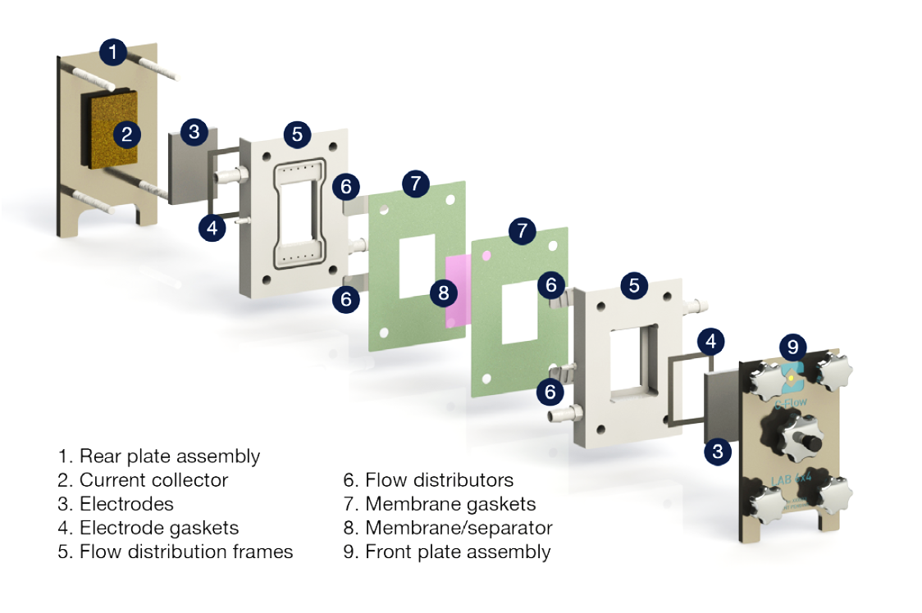

10
Electrolyte inlet
Electrolyte outlet
Electrolyte inlet
Electrolyte outlet

Fig. 1

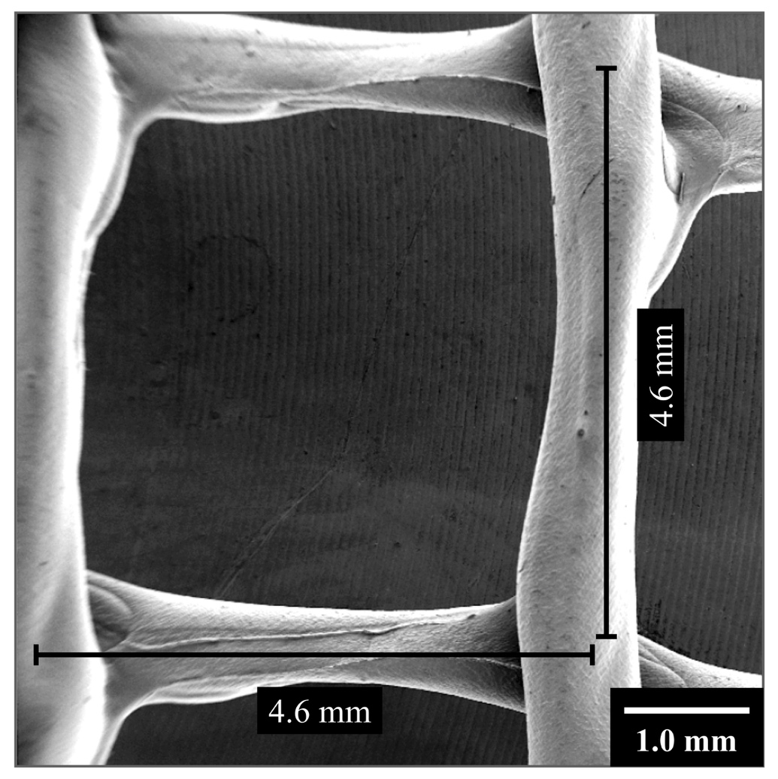

Fig. 2

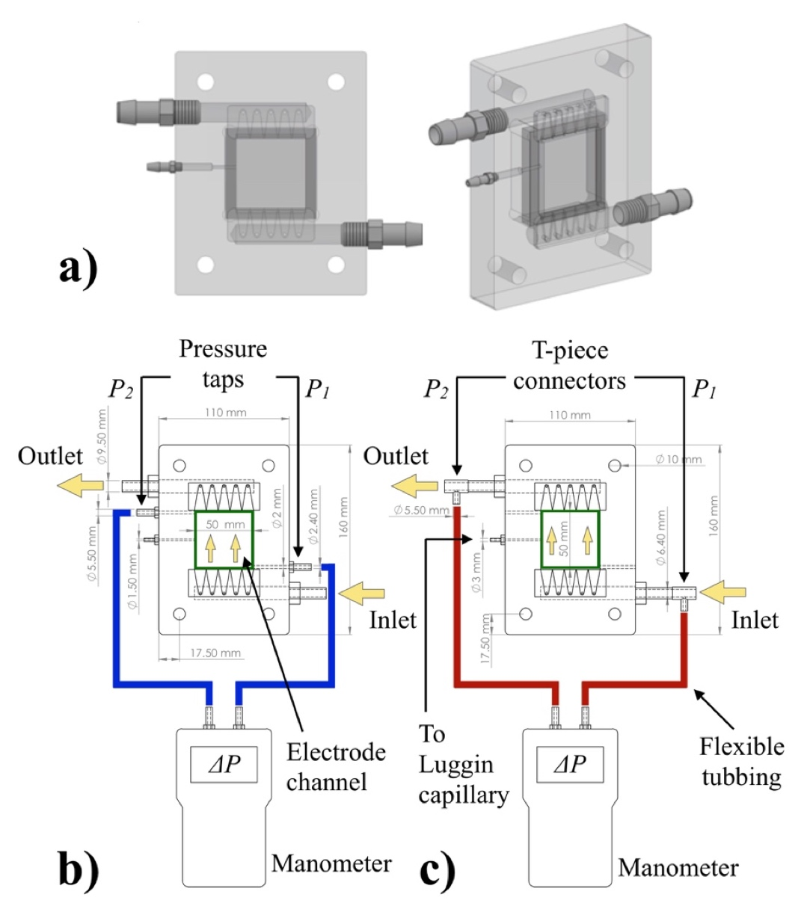

Fig. 3

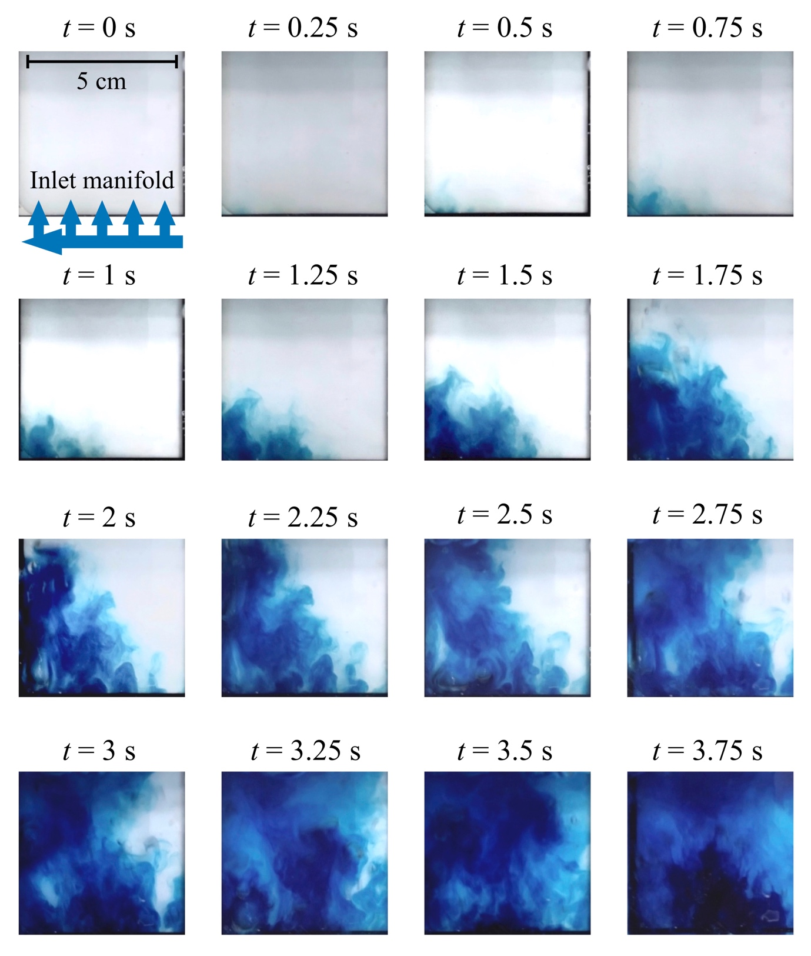
Fig. 4

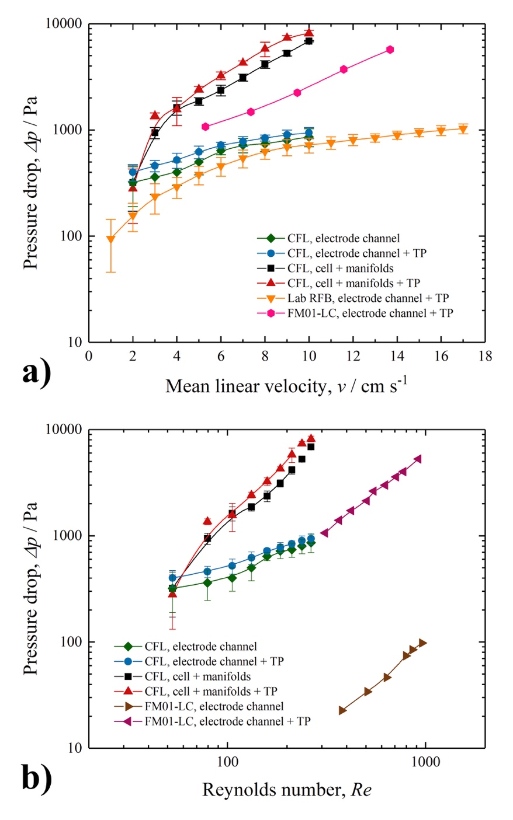

Fig. 5

CFL, electrode channel + TP
CFL, electrode channel
Limiting current, I_{L} / mA

Mean linear velocity, ν / cm s⁻¹

Fig. 6

Fig. 6

CFL, electrode channel + TP
CFL, electrode channel
Mean linear velocity, ν / cm s⁻¹
Mass transport coefficient, k_{m}, / 10⁻³ cm s⁻¹

Fig. 7

Mean linear velocity, ν / cm s⁻¹
Mass transport enhancement factor, γ

Fig. 8

Fig. 8

CFL, electrode channel + TP
CFL, electrode channel
Mass transport coefficient, K_{m}, / 10⁻³ cm s⁻¹
Pressure drop, $Δp$/ Pa

Fig. 9

CFL, electrode channel + TP
CFL, electrode channel
Mean linear velocity, ν / cm s⁻¹
Time, t / min.

Fig. 10

CFL, electrode channel + TP
CFL, electrode channel
Mean linear velocity, ν / cm s⁻¹
Normalised space velocity, s_{n} / dm³ dm⁻³ h⁻¹

Fig. 11

