Received 00th January 20xx,
- Centre of Molecular and Macromolecular Studies of Polish Academy of Sciences, Sienkiewicza 112, 90-363 Lodz, Poland.
- Department of Drug Form Technology, Wroclaw Medical University, Borowska 211A, 50-556 Wroclaw, Poland
- Computational Systems Chemistry, School of Chemistry, University of Southampton, SO17 1BJ, UK
Electronic Supplementary Information (ESI) available: solid-state NMR spectra for epicatechin and catechin form M3, numerical data from CSP and CASTEP calculations for all considered systems and a cif file with the proposed crystal structure of catechin methanol solvate – hydrate. See DOI: 10.1039/x0xx00000x
Accepted 00th January 20xx
DOI: 10.1039/x0xx00000x
www.rsc.org/
Crystal structure determination of an elusive methanol solvate - hydrate of catechin using crystal structure prediction and NMR crystallography
Marta K. Dudek,*^{,a} Piotr Paluch,ª Justyna Śniechowska,ª Karol P. Nartowski,^{b} Graeme M. Day^{c} and Marek J. Potrzebowskiª
Experimental screening for new crystalline forms of a flavan-3-ol derivative, catechin, yielded several new solvates and solvate–hydrates of this polyphenol, among which a new methanol-containing crystalline solid was identified. This form was found to be different from the previously described 2:1 methanol solvate of catechin. It contains one molecule of water and 0.5 molecules of methanol per catechin molecule in the asymmetric unit. To determine the crystal structure of this form, NMR crystallography and crystal structure prediction (CSP) calculations were used, as every attempt to obtain a single crystal of sufficient quality to perform single crystal X-Ray diffraction failed. To deal with a system containing five independent components in the CSP search (due to the necessity of treating whole molecules), in addition to the intramolecular flexibility of catechin with 68 viable conformers, we developed a useful short-cut, which allows for limiting the number of conformations considered in such demanding calculations. In this work, we show that it is possible to use the simulated NMR data for CSP-generated crystal structures of a simpler, yet similar system, to indicate the likely molecular conformation present in a more complex system. This approach allowed us to determine the experimental crystal structure of catechin methanol hemisolvate – monohydrate.

Introduction
NMR crystallography^{1,2} combines experimental data from solid-state NMR and powder X-Ray diffraction measurements with theoretical properties calculated for viable candidate crystal structures to solve structurally challenging issues associated, for example, with de novo crystal structure elucidation of polycrystalline powders,³⁻⁵ structure refinement^{6,7} and identification of intermolecular interactions present in the investigated solids.⁸⁻¹¹ The success of this approach depends mainly on whether we can build appropriate structural models, which can then be validated against experimental data.¹²⁻¹⁵ This requirement can significantly limit the scope of its potential applications, as in some cases building probable structural models from experimental data is very challenging or even impossible (for example because of difficult-to-index powder X-Ray diffractograms and/or unresolved crucial resonances in solid-state NMR spectra). However, these obstacles can be overcome by crystal structure prediction (CSP) calculations, which in principle do not require any prior experimental knowledge to be able to generate candidate crystal structures.^{16,17}
Unfortunately, when dealing with flexible, multicomponent systems the number of degrees of freedom that have to be accounted for in CSP calculations can be overwhelming and associated with a prohibitively high computational cost.¹⁸ Furthermore, there is no guarantee of the final success of the approach, as the experimentally observed structure can be absent from the results of a CSP search if all degrees of freedom are not sampled sufficiently.^{19,20} This is especially the case of molecules with a significant number of low energy conformers able to build viable crystal structures, as then each of these conformers have to be accounted for in the search, in each of the crystallographic space groups that are considered. To add to the number of degrees of freedom, rotations and translations of every symmetry independent component in a crystal system are treated individually. All this together leads to a discouragingly high number of possibilities which can be narrowed down using experimental data.
For example, in a recent contribution, structural constraints extracted from ¹H-¹³C HETCOR NMR spectra were used to limit the scope of possible conformers of ampicillin present in the determined crystal structure.²¹ Interestingly, these constraints were based on the analysis of the absence of particular correlation signals. In another example, the presence of selected correlation signals in the ¹H-¹³C HETCOR NMR spectra were used to gain a two-fold reduction in the number of considered conformers of furazidine.²² Interesting tools to determine molecular conformation present in the investigated solids, based on ¹³C-¹³C coupling constants, were also proposed by Thureau et al.^{23,24}
To add to the existing methods, in this work another approach is proposed to limit the number of regarded conformations in the CSP-NMR based crystal structure determination. An object of this study is an elusive crystal structure of methanol solvate – hydrate of (+)-catechin (Figure 1), a naturally occurring flavan-3-ol derivative, possessing multiple interesting biological activities.²⁵⁻²⁷ Catechin is known to form two hydrates and one methanol solvate, but to date, no neat crystal structure of this molecule has been described.²⁸⁻³⁰ Our experimental screening in the search for its as-yet-undetermined crystalline forms indicated that there is at least one more methanol-containing form of this polyphenol. In this work, to determine its crystal structure, we examine the possibility of using theoretical NMR data obtained for a simpler system containing catechin to indicate the correct conformation present in a more complex system of the same molecule. Our approach is based on the fact that NMR parameters are sensitive primarily to the conformation of a molecule in a crystal,³¹ and that a molecule often forms similar supramolecular synthons in different crystal structures, and solvates in particular. As a result, it should be possible to use experimental NMR data obtained for the analyzed methanol solvate – hydrate to indicate the molecular conformation of catechin present in this complex crystal system. We do this by looking at the agreement of experimental and theoretical data obtained for a simpler system (e.g. methanol solvate of catechin). To that purpose, candidate crystal structures of this latter system retrieved from the crystal energy landscape of the methanol solvate of catechin generated in our previous work were used.³²
Experimental
Materials and preparation of catechin solvates.
Catechin hydrate was purchased from Sigma Aldrich and used as is for crystallization experiments. The level of hydration of the starting material was less than a half molecule of water per catechin molecule. All solvents used (methanol, ethanol, acetone, n-butanol, isopropanol, n-propanol) were of analytical grade, purchased from POCh (Poland).
To prepare catechin solvates, three different methods were used: classic crystallization from solution, mechanochemical grinding in a ball mill with different amounts of the tested solvents, and diffusion experiments. In the case of mechanochemical grinding, 100 mg was ground with stoichiometric amounts of each solvent in 1:1, 1:0.5, and 2:1 ratio, and in the case of water also in 1:4.5 ratio, in a ball mill set to 25 Hz for 1h. After the grinding, each sample was left for drying and analyzed with ¹³C CPMAS NMR measurements. For diffusion experiments, catechin was placed in a Petri dish in a closed beaker filled with a given solvent, avoiding direct contact of catechin with this solvent and left for 10 – 60 minutes, depending on the solvent (10 minutes for acetone, 30 min and 1h for methanol, 1h for all remaining solvents).
All ¹³C CP MAS spectra of the obtained solvates, together with the discussion of the obtained results, including the comparison of the outcome of different preparation methods of the solvates can be found in Supporting Information, Figure S1 and discussion therein.
NMR measurements.
¹³C CP MAS NMR spectra for catechin solvates and hydrates were acquired on a Bruker Avance III spectrometer, operating at 400.13 and 100.92 MHz for ¹H and ¹³C, respectively. In each experiment, a sample was placed in a 4 mm ZrO₂ rotor and spun with 8 kHz spinning speed, using contact time of 2 ms, repetition rate of 4 s, and 44 ms acquisition time. The recorded spectra can be found in Figures 1 and S1.
Solid-state NMR spectra of form M2 of catechin (the newly obtained methanol-containing form) were measured on a Bruker Avance Neo spectrometer, operating at 800.13 and 201.21 MHz for ¹H and ¹³C, respectively, equipped with a ¹H/BB 3.2 mm CP MAS probe head. Spinning speed equal to 20 kHz was precisely stabilized by a MAS-III unit. For both 1D CP MAS and 2D FSLG-HETCOR experiments the RF power for ¹³C during contact time was set to 100 kHz. The RF power for ¹H during the contact time was linearly ramped from 70 to 100% with the highest RF value equal to 90 kHz. Homonuclear decoupling in an indirect dimension in the FSLG-HETCOR experiment was accomplished utilizing FSLG decoupling with ¹H RF power equal to 100 kHz. The length of a single FSLG period was equal to 4 x 8.17 μs (32.68 μs), which corresponds to a spectral window of 53 kHz after scaling using a scaling factor of the chemical shift evolution during FSLG equal to 0.578. To remove possible artefacts at the centre of a spectrum, an LG offset was shifted by -5 kHz, so that the frequency was switched from +65.7 kHz to -75.7 kHz with a simultaneous phase switch by 180°. In both ¹H-¹³C FSLG-HETCOR experiments (with contact times equal to 50 and 2000 μs) 128 complex t1 points were collected with 40 scans per one point and a repetition rate of 3 s. Quadrature detection in F1 was realized through States-TPPI and 100 kHz SPINAL64 decoupling was used during acquisition lasting 40 ms. The FSLG-HETCOR spectra for form M2 can be found in Figure 4.
PHORMAT experiments to determine principal components of ¹³C chemical shift tensors (δ₁₁, δ₂₂, δ₃₃) were measured using a sequence proposed by Grant,³³ at 2 kHz spinning speed. A spectral window in an indirect dimension was set to 30 kHz and 148 complex t1 points were acquired with an echo-antiecho frequency discrimination method, collecting 256 scans per increment with a repetition rate equal to 2 s. The 90° ¹³C pulse was precisely calibrated (with an error of less than 0.1 μs) on the measured sample to be equal to 3.3 μs. SPINAL64 decoupling was applied during acquisition with ¹H RF equal to 75 kHz. The acquired spectra were analyzed with the TopSpin 3.1 software, including the simulations of the shapes of ¹³C chemical shift tensors to determine δ₁₁, δ₂₂, δ₃₃ values. The PHORMAT spectrum for catechin form M2 is shown in Figure 5, while for epicatechin in Figure S5, Supporting Information.
Solid-state NMR spectra for form M3 of catechin were measured on a Bruker Avance III 400 spectrometer, operating at 400.13 and 100.92 MHz for ¹H and ¹³C, respectively, using a 4 mm ZrO₂ rotor. Due to the thermal instability of this form, the maximum spinning speed used for registering the spectra was equal to 8 kHz (hence 4 mm rotor). The same pulse sequences as in the case of form M2 were used to register ¹³C CP MAS and FSLG-HETCOR spectra with CP contact times equal to 100 μs and 1 ms. The recorded spectra can be found in Figure S2, Supporting Information.
Solid-state NMR spectra for epicatechin, a diastereoisomer of catechin (Figure S3),³⁴ were measured on a Bruker Avance III 600 spectrometer, equipped with a ¹H/¹³C/¹⁵N 1.3 mm CP MAS probe head, operating at 150.90 and 600.13 MHz for ¹³C, and ¹H respectively. Samples were spun with a 42 kHz spinning speed, using 1.3 mm Bruker ZrO₂ rotors. ¹H-¹³C invHETCOR experiment was performed using a pulse sequence described by Pruski.^{35,36} Two experiments with different second contact times equal to 75 μs or 1000 μs were measured, while the first contact time was kept at a duration of 2000 μs. In the case of the first experiment, only direct one-bond ¹H-¹³C correlations were observed, while in the second experiment correlations between atoms separated in space by up to 4 Å were also visible. In both cases, 200 complex points were collected with a spectral window in an indirect dimension of 27 kHz, giving the maximal evolution time in an indirect dimension equal to 7.36 ms. In a direct dimension, the acquisition time was set to 1.4 ms with a spectral window equal to 300 kHz. 24 and 8 scans were coherently added per one t1 point for the experiments with short and long second mixing times, respectively. For 1D ¹³C CP MAS experiments and ¹H-¹³C invHETCOR, a ramp shape from 90 to 100 % was applied on a proton channel during CP with a precisely optimized peak RF of 146 kHz (the optimization was done directly on the measured sample). On a ¹³C channel, an RF equal to 114 kHz was applied during CP and $π/2$ pulses. All experiments were performed with a low power swept-frequency two-pulse phase modulation (SWf-TPPM) decoupling sequence³⁷ with an RF equal to 10 kHz. The repetition time was set to 10 s. The acquired spectra can be found in Supporting Information, Figure S3.
To determine the content of water and methanol inside the crystals of the obtained methanol-containing forms of catechin, solution NMR experiments in anhydrous acetone-d₆ were performed with a Bruker Avance III spectrometer, operating at a ¹H resonating frequency of 500 MHz, and equipped with a 5 mm probe head. For water and methanol content determination, all proton signals were integrated and the integral values of a signal resonating at ca. 2.90 ppm (originating from water protons) and two signals resonating at 3.30 and 3.15 ppm (originating from methanol CH₃ and OH groups, respectively) were referenced to ¹H NMR signals of catechin, in particular to a well-resolved H-2 signal resonating at 4.56 ppm. The recorded solution spectrum can be found in the Supporting Information, Figure S4.
Powder X-Ray diffraction experiments.
The PXRD patterns of methanol-containing forms of catechin were acquired using a D2 PHASER diffractometer (Bruker AXS, Karlsruhe, Germany) with a LynxEye detector using Cu Kα radiation (1.5418 Å). A 0.016° 2θ step size was used with an irradiation time of 1 s/step. The freshly prepared, wet methanol-containing form of catechin was placed in a low background sample holder and analyzed directly after preparation and at the following time points from crystallization: 30 minutes, 3 h, 5 h, 24 h, 48 h, 72 h and 8 days. Between the analyses, the sample was stored intact in a PXRD sample holder at ambient conditions (21-23 °C and 30-40 % RH). The catechin forms were independently prepared by MKD and KPN in the laboratories in Lodz and Wroclaw and cross analyzed between the laboratories using solid-state NMR and PXRD. This was done to ensure that the same crystalline form was analyzed each time by both methods and that the same results are obtained, regardless of the laboratory. The data were collected with a Bragg–Brentano (θ/2θ) horizontal geometry between 6° to 36° in 2θ. The diffractometer optics was a Soller slit module system with 2.5°, a divergence slit with 0.2 mm, an air-scatter screen with 1 mm, and a Ni filter. The X-ray tube operated at 30 kV and 10 mA. The diffractograms for indexing were acquired in the 3° to 60° 2θ range. The indexing of the obtained powder X-Ray diffractogram performed for form M2 with a Reflex tool included in Materials Studio package indicated two possible crystal systems, giving the best agreement with the observed pattern, namely monoclinic and orthorhombic systems, with the most probable space groups being C2 and P2₁2₁2₁. Similar results were obtained independently using EXPO2014 software.³⁸ Unfortunately, we were not able to solve heavy atom positions from these experimental data.
Theoretical calculations
Crystal structure prediction calculations.
A conformational search which yielded 68 different conformers of catechin was described in our previous work.³² Crystal structure prediction (CSP) was performed for subsets of these conformers, as described in the text. For each CSP search, theoretical crystal structures were generated using the Global Lattice Energy Explorer code,³⁹ followed by energy minimization at a force field level with the DMACRYS (version 2.2.1.0) software.⁴⁰ The force field used for energy minimization comprised an atom-centered multipole model for intermolecular electrostatics, combined with an empirically parameterized exp-6 repulsion-dispersion model. Atomic multipoles were calculated with the GDMA 2.2.11 software^{41,42} for each conformer independently, using electron densities obtained from Gaussian09⁴³ calculations performed at a B3LYP⁴⁴/6-311G** level of theory. To model repulsion-dispersion intermolecular interactions, the FIT potential⁴⁵ with a 25 Å cut-off at the van der Waals interactions was used. Ewald summation was used for charge-charge, charge-dipole, and dipole-dipole interactions, with direct summation (up to a 25 Å cut-off) for all higher-order electrostatics. Intramolecular geometries were kept rigid during force field energy minimization. After each CSP search, simulated powder X-ray diffractograms, density, and energy data for each structure were compared to remove duplicates. For density and energy comparison, a threshold of 0.02 g/cm³ and 0.1 kJ/mol were used.
Three independent CSP searches were performed for methanol-containing forms of catechin. The first search was performed for the 1:1:1 methanol solvate – hydrate of catechin, which is a simpler system than our main target structure, as it contains 3 symmetry independent molecules in the asymmetric part of a unit cell, in contrast to 5 symmetry independent molecules necessary to account for in the final CSP search. In this search, the number of the CSP-generated and successfully lattice energy minimized structures in each of the three tested space groups (P2₁, C2, and P2₁2₁2₁) was equal to 30000 for each of the 35 conformers considered. The number of the conformers considered in this search was limited from the original 68 to 35, as the remaining conformers of catechin were not able to form energetically favourable structures with MeOH. In the next CSP search performed for the final system, i.e. the 1:2:2 methanol solvate – hydrate of catechin, the number of the CSP-generated and successfully lattice energy minimized structures in space groups C2 and P2₁2₁2₁ for each of the selected 5 conformers was equal to 70000. Finally, the last CSP search was performed for the same 1:2:2 methanol solvate – hydrate, this time generating 140000 successfully lattice energy minimized structures for one selected conformer in space group P2₁2₁2. This last CSP search was done to test the convergence of the previous CSP search with a smaller number of generated candidate crystal structures. Comment on the comparison of these two CSP searches is given in Supporting Information.
The space group selection was based on the frequency with which chiral organic compounds crystallize in particular space groups (1:1:1 search) and on the indexing of the experimental powder X-Ray diffractogram (1:2:2 search).
CASTEP calculations.
All low energy structures from each CSP search performed in this work were geometry optimized under periodic boundary conditions using the CASTEP code,⁴⁶ the PBE functional⁴⁷ with D2 dispersion correction scheme,⁴⁸ ultrasoft pseudopotentials, a plane wave basis set energy cut-off of 600 eV and a maximum k-points separation of 0.07 Å⁻¹. Each optimization was performed in two steps: in the first step unit cell parameters were kept fixed, while all atomic positions were allowed to relax, and in the second step cell parameters were also allowed to relax. The total number of the DFT-geometry optimized crystal structures retrieved from the crystal energy landscapes from 1:1:1 and 1:2:2 CSP searches was equal to 51 and 140, respectively. After each successful optimization, NMR parameters were calculated using the GIPAW approach^{49,50} and compared with the assigned experimental values. Calculated shielding constants were converted to chemical shifts using linear regression of calculated vs. experimental values, determined for each crystal structure separately. Root-mean-square deviation (RMSD) values were then calculated for each set of data. NMR calculations were also performed for each of the low energy structures retrieved from DFT-D2 energy landscapes of epicatechin (40 crystal structures) and the 2:1 methanol solvate of catechin (35 crystal structures), obtained by us in a previous work.³² In this latter case, the selected 35 crystal structures were all found in the lowest energy region of the crystal energy landscape and are built by 35 different conformers.
Results & Discussion
Experimental data for new methanol-containing forms of catechin
In the experimental screening performed in the search for new crystalline forms of catechin, two methanol-containing solids, designated as M2 and M3, were obtained (for details on their preparation see Supporting Information). Their ¹³C CPMAS NMR spectra can be found in Figure 1. In both, the ¹³C resonance at ca. 51 ppm, originating from methanol, is clearly distinguishable. Also, both solvates contain one catechin molecule in the asymmetric part of the crystallographic unit cell, which is evidenced from single ¹³C resonances visible for each site. The differences between the two structures concern mainly resonances originating from aromatic carbon atoms substituted with oxygen atoms (C5, C7, C9, C13, and C14), as well as two neighbouring aromatic carbon atoms, C6 and C8. This suggests that structural differences between both solvates are associated with hydrogen bonding networks, in which hydroxyl groups substituted to the mentioned carbon atoms are engaged. Form M3 was found to be metastable and converted within a day into form M2 when subjected to ambient conditions (23°C, 50% RH), but was stable for up to 4 days when placed in a sealed container.
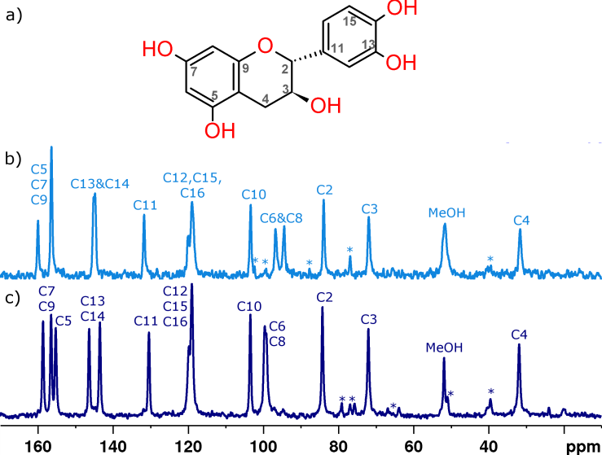
Figure 1. Structure and carbon atom numbering of (+)-catechin (a) and ¹³C CPMAS NMR spectra of two methanol-containing crystalline forms of catechin: form M3 (b), and form M2 (c). Asterisks mark spinning sidebands.
To date, one methanol solvate of catechin has been described,³⁰ designated here as M1, and containing two molecules of methanol per catechin molecule. Powder X-Ray diffraction (PXRD) measurements were performed to clarify whether M1 is identical to either of the methanol containing forms obtained in this work (M2 or M3). Figure 2 presents powder X-Ray diffractograms obtained for catechin samples immediately after crystallization from anhydrous methanol in the same conditions as those used in the original crystallization procedure of form M1,³⁰ as well as for the same sample stored for 1 to 8 days. While the first diffractogram obtained for the wet sample is not identical with the one simulated for form M1 (CSD refcode OZIDOR),³⁰ the observed differences could be attributed to the differences in the temperatures between PXRD measurements (room temperature) and single-crystal X-ray diffraction experiment (100 K). The latter PXRD data indicate that this freshly crystallized form is highly unstable and quickly converts into a different crystalline form (possibly M2 or M3). The final form (after 8 days of storage) has a noticeably different powder X-Ray diffractogram, and the possible conversion process from M1 seems to have at least two stages. The ¹³C CPMAS NMR spectrum of this sample after 8 days of storage at ambient conditions (23 ± 2 °C and 40-50% RH) was identical with the spectrum of form M2, presented in Figure 1. In addition, the same spectral picture was observed for the sample containing the M3 form stored for only 1 day at ambient conditions (23°C, 50% RH). Therefore, M2 is a new methanol-containing form of catechin, while form M3 is either identical with M1 or corresponds to an intermediate state observed in the PXRD experiment. To clarify the relative content of catechin and MeOH in both materials, solution NMR experiments in anhydrous acetone-d₆ were performed. Surprisingly, both experiments indicate that neither of the forms, M2 and M3, contains two molecules of methanol per catechin molecule, as seen in form M1. Instead, both forms have half a molecule of methanol per catechin molecule, in addition to one molecule of water per catechin molecule. As a result, it is possible that form M1 is highly unstable and rapidly loses 1.5 methanol molecules, while one water molecule enters its crystal structure, leading to form M3, which subsequently undergoes reorganization of its crystal structure to yield the more stable form M2 (see Figure 3 for graphical representation of the possible conversion process). The rest of this work describes the combined experimental and computational approach for the crystal structure determination of this stable methanol solvate – hydrate of catechin (M2).
Solid-state NMR data for form M2 of catechin
¹H-¹³C HETCOR NMR spectra of form M2, acquired with short and long contact times, are shown in Figure 4, while the ¹³C PHORMAT NMR spectrum, together with 1D slices showing the shapes of the powder patterns representing the ¹³C chemical shielding tensors are given in Figure 5. These experiments allowed for unambiguous assignment of the ¹H and ¹³C resonances, also included in Figure 4, with numerical values given in Table S1, Supporting Information. The results of the ¹³C PHORMAT experiment allowed for the determination of the principal components (δ₁₁, δ₂₂, δ₃₃) of ten ¹³C resonances, excluding those originating from aliphatic carbon atoms (due to too small anisotropy of these tensors). The obtained values are given in Table S2, Supporting Information.
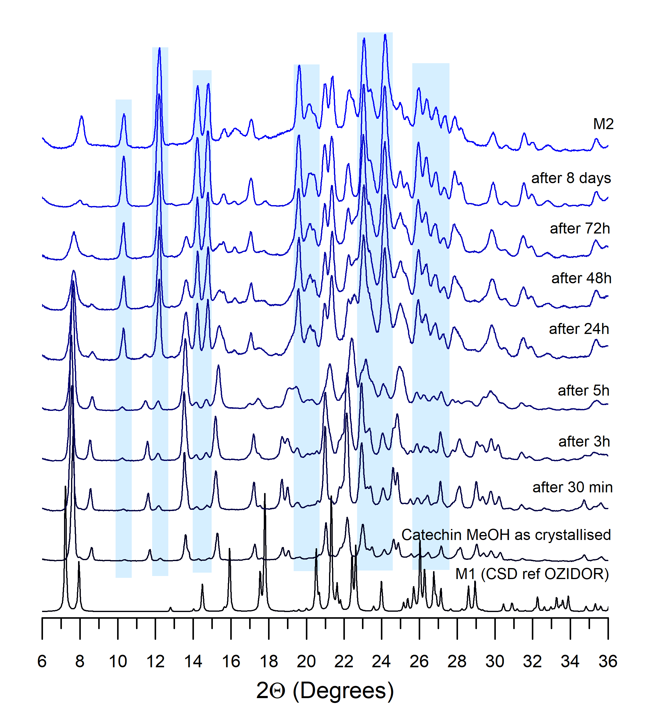
Figure 2. Powder X-ray diffractograms for catechin samples immediately after crystallization from methanol and after 30 minutes to 8 days of storage. The most pronounced new peaks are highlighted in blue rectangles.
Unfortunately, the correlations observed in the NMR spectra did not allow for the direct determination of the conformation of catechin present in the crystals of form M2. The 68 distinct conformers of catechin differ mainly in the positions of hydrogen atoms from hydroxyl groups. The chemical environment around each of these OH sites is similar, with their resonating frequencies tending to overlap each other, which additionally hinders the identification of the crucial correlations. As a result, no viable structural model could be built from the obtained spectroscopic data.
To examine possible structural similarities between forms M2 and M1, for which the crystal structure is known, calculations of ¹H and ¹³C NMR shielding constants under periodic boundary conditions were made for form M1. As expected, the level of agreement in terms of ¹H NMR data with the ¹H RMSD value equal to 0.76 ppm shows that the structures M1 and M2 are not identical, but suggests that they might share some structural similarities.¹⁶
Crystal structure determination of form M2 of catechin
Learning from epicatechin: evaluation of the level of agreement in terms of NMR parameters for different theoretical crystal structures of epicatechin. Since the spectroscopic data alone did not help reduce the set of possible conformers of catechin which could be present in the crystal structure of form M2, we turned to CSP calculations to

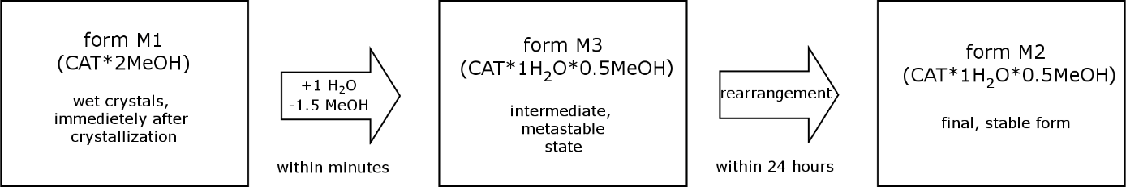
Figure 3. Schematic representation of the possible conversion and stability of methanol solvates of catechin.

Figure 4. ¹H-¹³C HETCOR NMR spectra recorded at 20 kHz spinning speed for methanol solvate – hydrate of catechin (form M2), together with signal assignments.
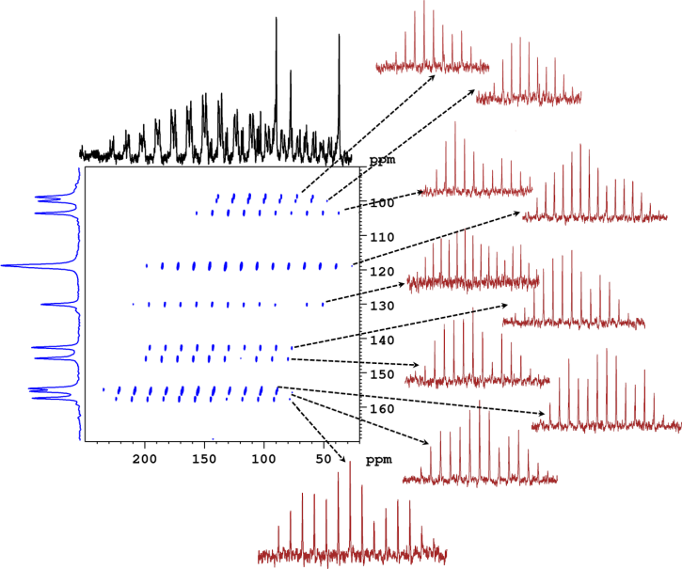
Figure 5. ¹³C PHORMAT NMR spectrum recorded at 2 kHz spinning speed, for methanol solvate – hydrate of catechin (form M2). Red 1D slices show shapes of the powder patterns representing tensors for each of the ¹³C resonances.
build probable structural models for this solid. This task, however, poses serious difficulties, due to the number of possible conformers (68) and, above all, the necessity of accounting for five independent molecules whose positions and orientations in the asymmetric unit cell must be sampled. This is because form M2 contains 1 H₂O molecule and 0.5 molecule of methanol per catechin molecule. Since CSP requires whole molecules, the smallest asymmetric unit required for the calculations contains two molecules of water, two molecules of catechin and one molecule of methanol. To include all possible conformers and at the same time to cover the entire crystal packing space for a five-component system would require a prohibitively large amount of computational time and resources.
In a search for a solution, we decided to use the CSP results from our previous work on neat epicatechin, a diastereoisomer of catechin, to establish the level of agreement in terms of various NMR parameters between the experimental structure and different low-energy candidate crystal structures showing various levels of structural similarity with the experimental structure. The experimental parameters were established from solid-state NMR spectra registered for epicatechin, which can be found in Figures S3 and S5, Supporting Information, while the assignment of ¹H and ¹³C resonances, together with the values of the principal components of the ¹³C chemical shift tensors can be found in and Tables S1 and S2, Supporting Information. In this analysis, all structures with DFT-D2 final energies of up to 40 kJ/mol above the global minimum were accounted for, which made a total of 39 predicted crystal structures. Among these, the lowest energy structure is identical to that observed experimentally, as described previously.³²
Figure 6 presents the ¹H, ¹³C(δ_{iso}) and ¹³C(δ₂₂) RMSD values obtained after comparison of the experimental NMR data for crystalline epicatechin and the theoretical NMR data for the first 10 out of the 39 predicted structures (for RMSD and energy values for all calculated structures see Supporting Information, Table S5). As expected, for each of the regarded NMR parameters the lowest RMSD values, equal to 0.43, 1.79, and 1.90 ppm for δ_{iso}(¹H), δ_{iso}(¹³C) and δ₂₂(¹³C), respectively, were found for the predicted structure that is known to correspond to the experimental crystal structure. In terms of ¹H chemical shifts, there are three other crystal structures with an RMSD below 1 ppm. These are the 2nd, 3rd, and 7th structures according to their DFT-D2 energy rank, with the respective RMSD values of 0.66, 0.81 and 0.76 ppm. Interestingly, all these structures, including the experimental one, are built by very similar conformers of epicatechin (Figure 6d), in particular with respect to the value of the torsion angle between the chromane moiety and the dihydroxyphenyl ring (C3-C2-C11-C12 torsion), which is one of the most important structural features of this molecule. Also, in all these conformers the same arrangement of the proton positions in the OH5 and OH7 groups is observed, and only one structure (with 3rd rank in energy) is built by a conformer with an opposite orientation of the hydroxyl protons from OH13 and OH14 groups in respect to the experimental structure. At the same time, this structure has the poorest ¹H RMSD (0.81 ppm) among the four considered structures, as well as the largest residual for the RMSD values at OH13 site equal to 2.21 ppm. On the other hand, in terms of molecular packing, these four structures are not very similar, with the best of them being the 7th structure; using the Crystal Packing Similarity Tool⁵¹, this structure has 13 out of 20 molecules in common with the experimental structure with an RMSD for atomic positions equal to 0.13 Å. The 2nd and 3rd ranked structures have only 6 and 2 out of 20 molecules in common with the experimental structure, respectively. Thus, it seems that it is the molecular conformation, rather than molecular packing, that has the greatest influence on the agreement with the experiment in terms of ¹H NMR data.
As expected, the δ_{iso}(¹³C) parameter was found to be significantly less sensitive than δ_{iso}(¹H). The two next best of the predicted structures in terms of ¹³C RMSD yielded values of 1.85 and 1.87 ppm for the 7th and 6th energy-ranked structures, respectively, in comparison to the ¹³C RMSD of 1.79 ppm obtained for the experimental crystal structure. Such differences in RMSD are below the experimental error of the determination of ¹³C chemical shifts in the solid-state and, as such, are negligible. Much more sensitive is δ₂₂(¹³C), which is one of the principal components of the ¹³C chemical shift tensor (CST). This component is aligned parallel to the plane of an aromatic ring, and therefore is very sensitive to the formation of hydrogen bonds via OH groups directly attached to the ring, resulting in significant changes to the charge distribution in this ring.⁵² In terms of this parameter, there are 5 structures with appreciably low RMSD values: the experimental, 2nd, 3rd, 6th, and 7th structures by energy rank. It is worth noting that all of these structures apart from the 6th structure also displayed good agreement in terms of ¹H RMSD below 1 ppm. The comparison of structural features of these five crystal structures reveals that low δ₂₂(¹³C) RMSD values are indicative of similarities in hydrogen bonding networks (see Supporting Information, Table S4 for the hydrogen bonds with their O•••O distances present in these structures). The other two principal components of the ¹³C CST, i.e. δ₁₁ and δ₃₃, were found to be much less sensitive to changes in the crystal structures (for RMSD values obtained for these parameters see Supporting Information, Table S5), and as such will not be considered in further evaluation.

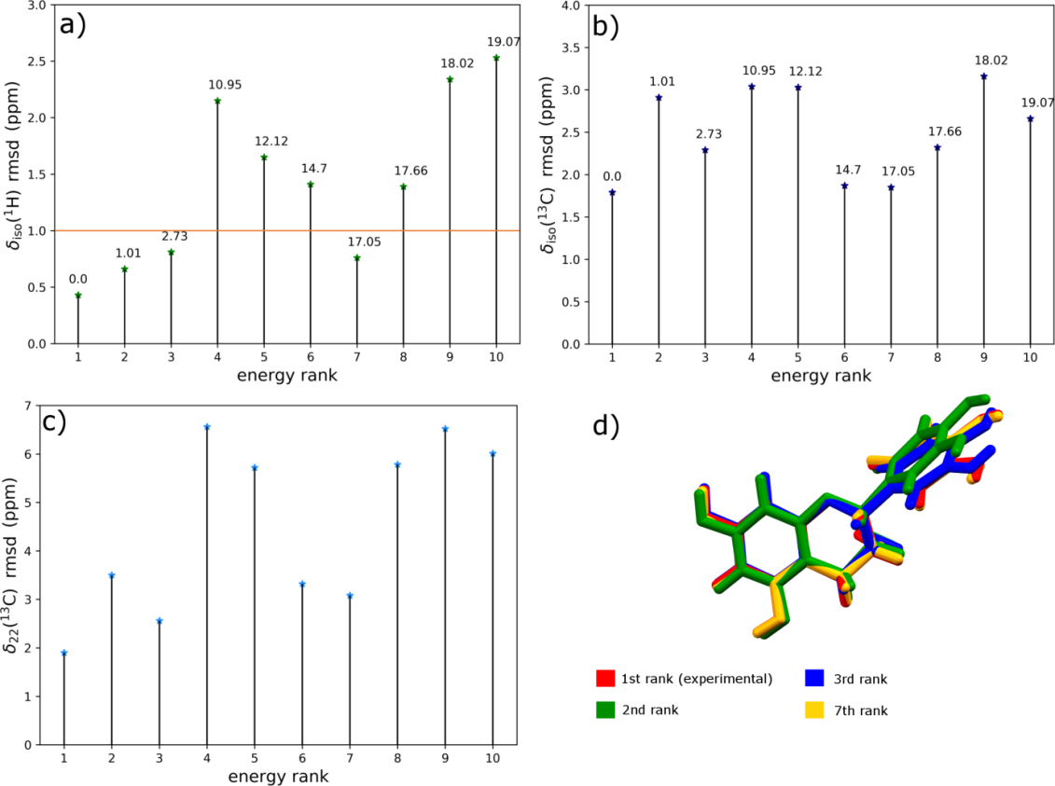
Figure 6. δ_{iso}(¹H) (a), δ_{iso}(¹³C) (b) and δ₂₂(¹³C) (c) RMSD values obtained after comparison of the experimental and theoretical chemical shifts for the CSP generated structures of epicatechin, and overlay of molecular conformation found in four crystal structures giving the best agreement with the experiment in terms of δ_{iso}(¹H) RMSD. Numbers in (a) and (b) beside each point denote relative DFT-D2 energies (in kJ/mol of molecules) with respect to the global energy minimum found for each structure. The orange line indicates a 1 ppm cut-off for δ_{iso}(¹H) RMSD values.

To summarize this part, it should be noted that the parameter which was found to be the most sensitive to changes in the conformation of molecules in a crystal structure is δ_{iso}(¹H), while δ₂₂(¹³C) was found to be more indicative of the differences in the hydrogen bonding network around particular atoms in the crystal structures. All these data provide an indication as to the level of agreement in terms of NMR parameters, which can be expected from the comparison of the experimental and candidate crystal structures. According to these results, there is a high probability that the conformation of a molecule present in the experimental crystal structure is also present in one of the candidate crystal structures that have ¹H RMSD less than 1 ppm. Subsequently, structure selection from amongst the candidate structures can be made provided that there is a large enough ¹H RMSD difference between the members of the set. This knowledge will be exploited in the crystal structure determination of form M2 of catechin.

Narrowing down the number of candidate conformations of catechin. The results obtained for epicatechin indicate that it should be possible to determine the molecular conformation of catechin present in the crystal structure of form M2 by looking at the agreement in terms of ¹H NMR experimental data for this form and calculated ¹H NMR shielding constants for the predicted crystal structures of form M1 built by different conformers. Due to compositional differences, we do not expect a perfect agreement with the experimental data, as none of the calculated structures can be identical with the experimental structure of form M2. The obtained δ_{iso}(¹H) RMSD values from the comparison of theoretical data for form M1 and experimental data for form M2 are shown in Figure 7, while all numerical data (energies and ¹H RMSD values) are shown in Table S6, Supporting Information. The first obvious difference between these results and those obtained for neat epicatechin is the number of structures with δ_{iso}(¹H) RMSD lower than 1 ppm. In the latter case, only four structures fulfilled this condition, while here almost half of the regarded structures did (17 out of 35). This is probably because, for neat structures (in the case of epicatechin), not all possible hydrogen bonding sites are saturated and this mainly depends on the conformation of this molecule, thus giving significant differences in terms of ¹H NMR data for crystal structures built by different conformers. In contrast, for solvated structures containing catechin, it is possible to saturate the majority (or all) of the OH sites by the smaller solvent molecules, regardless of the conformation of a molecule. This in turn results in similar chemical environments of the considered ¹H atoms, as was also observed previously for procyanidins A-2 dihydrate.³¹ Such a similarity of intermolecular interactions observed for different conformers of the same molecule hampers to a certain extent the possibility of narrowing down the number of conformers, which should be accounted for in the next step. Still, some selection can be made, narrowing the set of conformers considered from 35 to 17, based on the earlier established level of agreement in terms of ¹H NMR data (below 1 ppm).
To further narrow down the number of the regarded conformers in the final CSP search for 1:2:2 methanol solvate – hydrate, in the next step a preliminary set of CSP calculations was performed, still for a simpler, but this time more alike system to that of form M2, i.e. the 1:1:1 methanol solvate – hydrate. Only the 17 conformers selected from the previous step were considered. This time, we looked not only at the agreement in terms of the ¹H NMR parameters (RMSD below 1 ppm), but also at the ability of a given conformer to form low energy crystal structures with H₂O and methanol molecules. Figure 8 features the δ_{iso}(¹H) RMSD values obtained for the structures with relative total DFT-D2 energy of up to 35 kJ/mol of formula unit above the lowest energy structure. We set an energetic cutoff of 25 kJ/mol of formula unit above the lowest energy structure in this set, below which we find only 7 structures that also yield ¹H RMSD lower than 1 ppm when compared to the experimental data. Out of these 7 crystal structures, there are two pairs built by the same conformer, which yields 5 final conformers of catechin that are considered most promising, based on both ¹H RMSD and their ability to form low energy crystal structures with methanol and water (for numerical values see Table S7, Supporting Information). These conformers were considered in the CSP search for 1:2:2 methanol solvate – hydrate of catechin. Interestingly, all these conformers have very similar values of the torsion angle between the chromane moiety and the dihydroxyphenyl ring (C3-C2-C11-C12 torsion), as also observed for epicatechin.

Final CSP search for form M2 of catechin. Figure 9 presents the lowest energy region (within the lowest 20 kJ/mol of formula unit above the CSP energy minimum) of the crystal energy landscape of 1:2:2 methanol solvate – hydrate of catechin obtained with the force field and after DFT re-optimization. The inspection of these landscapes reveals significant differences in the energy rankings from both methods. In the force field landscape, all structures found within the first 10 kJ/mol, which is usually regarded as the most important region of interest, originate from only two conformers and are all in space group P2₁2₁2₁. The DFT landscape is much more diverse, with all conformers and both

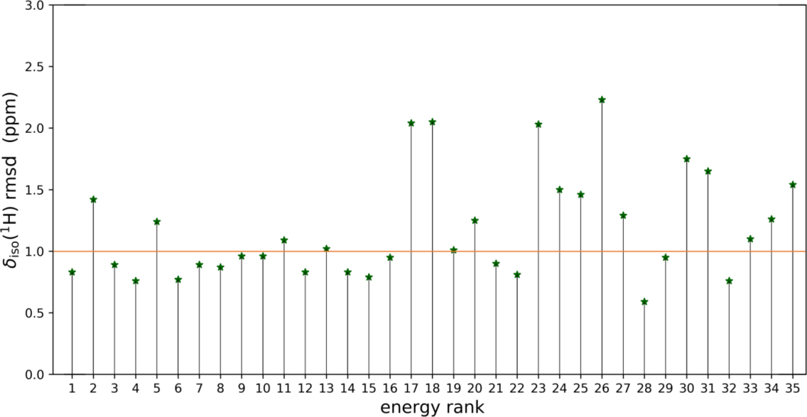
Figure 7. δ_{iso}(¹H) RMSD values obtained after comparison of the experimental NMR data for form M2 of catechin and theoretical chemical shifts for the CSP generated structures of form M1 of catechin built by 35 different conformers. The orange line indicates a 1 ppm cut-off for δ_{iso}(¹H) RMSD values.
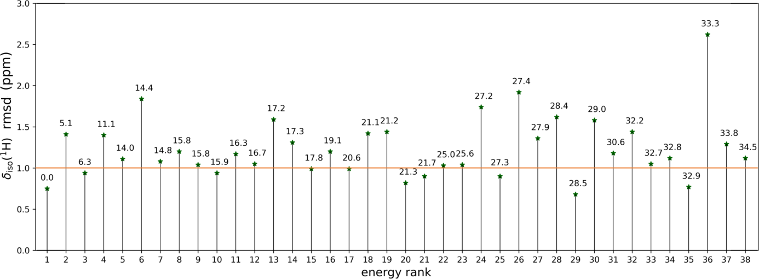
Figure 8. δ_{iso}(¹H) RMSD values obtained after comparison of the experimental NMR data for form M2 of catechin and theoretical chemical shifts for the CSP generated structures of 1:1:1 methanol solvate – hydrate of catechin. Numbers beside each point denote relative DFT-D2 energies (in kJ/mol of molecules) found for each structure with respect to the lowest energy structure in this set. The orange line indicates a 1 ppm cut-off for δ_{iso}(¹H) RMSD values.
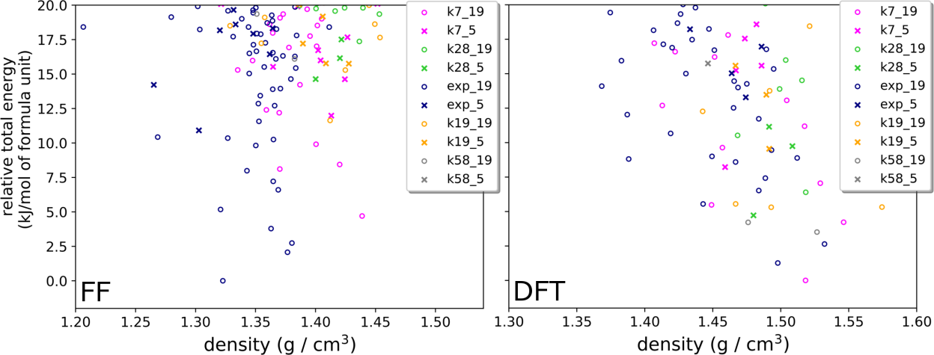
Figure 9. The lowest energy region of the force field (FF) and DFT energy landscapes from a CSP search for 1:2:2 methanol solvate – hydrate of catechin performed in space groups C2 and P2₁2₁2₁. Different colors mark distinct conformers named consecutively according to their gas-phase energy rank obtained after conformational search performed for catechin, and ‘exp’ conformer is a conformer found in the crystal structure of form M1. The final numbers in each structure name refer to the space group number (5 for C2, 19 for P2₁2₁2₁).

tested space groups having representative crystal structures in the lowest 10 kJ/mol energy region. Out of 25 structures found in this energy region, the relative energy of 8 of them changed by more than 10 kJ/mol after DFT re-optimization, with the highest change being equal to 19.9 kJ/mol. These larger changes in relative stabilities than are usually observed are probably because even a small change in the solvent molecule positions upon DFT optimization can significantly influence hydrogen bonding networks, affecting at the same time the energy of the optimized structures. On the other hand, it should be mentioned that energy differences given here are calculated per formula unit, which consists of a catechin molecule, a water molecule, and a half of a methanol molecule. The 20 kJ/mol of formula units energy range corresponds to a range of only 8 kJ/mol of molecules, which is more typical of the low energy regions considered to be important on CSP energy landscapes for neat crystal structures. The energy range of interest in CSP of neat crystal structures is guided by the known energetic range of polymorphism in organic molecular crystals.⁵³ However, there is less available data on the possible range of metastability for hydrate and solvate crystal structures that can guide the choice of what is the relevant energy region in such cases. It is also less clear whether to consider relative energies with respect to each molecule or for the entire formula unit (including solvent molecule(s)), which depends on whether the limits of observable metastability increase with the number of molecules in a crystal structure’s formula unit. We decided on a value of 20 kJ/mol per formula unit above the global minimum in this work, but it is possible that expanding the selected force field energy region would result in finding other low energy structures after DFT optimization.
To find the experimentally observed crystal structure of form M2 among the low energy ones generated in the CSP search, a comparison of theoretical and experimental NMR and PXRD data was performed. Figure 10 shows colormaps obtained after plotting ¹H or δ₂₂(¹³C) RMSD data on the calculated DFT crystal energy landscape of the 1:2:2 methanol solvate – hydrate of catechin, while Figure 11 features Rwp values (in %) obtained after performing Pawley refinement for all low energy candidate crystal structures against the experimental PXRD diffractogram. The colormaps featuring RMSD in the remaining NMR parameters (δ_{iso}(¹³C), δ₁₁(¹³C), and δ₃₃(¹³C)) can be found in Figure S6, Supporting Information.
In the case of ¹H chemical shifts, the lowest obtained value of RMSD was equal to 0.56 ppm, and was found for the 16th structure, according to the DFT-D2 energy rank. This structure has P2₁2₁2₁ space group symmetry and is built by the exp conformer, i.e. the conformer found also in the experimental crystal structure of form M1. Apart from this structure, seven other predicted crystal structures give a reasonably good agreement with the experiment in terms of δ_{iso}(¹H), that is having ¹H RMSD lower than 0.7 ppm (the DFT-D2 energy ranks of these structures are 4th, 10th, 14th, 67th, 74th, 102nd and 107th). According to our analysis of the epicatechin case, the observed agreement with the experiment in terms of ¹H NMR data should indicate primarily the conformation of catechin present in the analyzed crystal structure. Interestingly, six out of eight crystal structures having the lowest ¹H RMSD values, including the structure yielding the best agreement (¹H RMSD of 0.56 ppm) are all built by the exp conformer, while the remaining two structures are built by conformers k7 and k58 (numbering of conformers is taken from the gas phase energy ranking obtained after the conformational search, see Supporting Information, Table S3). This suggests that catechin adopts the same conformation in form M2 as in form M1.

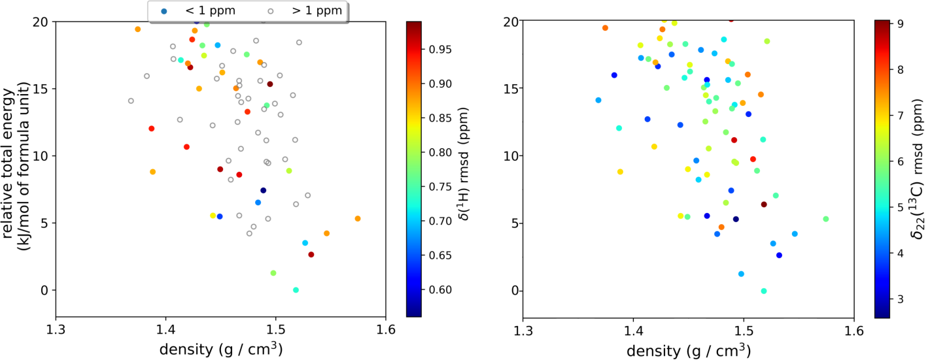
Figure 10. DFT CSP energy landscape for 1:2:2 methanol solvate – hydrate of catechin with color-coded δ_{iso}(¹H) and δ₂₂(¹³C) RMSD values obtained from the comparison of experimental NMR data for form M2 of catechin and theoretical NMR data calculated for the DFT-optimized lowest-energy crystal structures obtained from the CSP search for the 1:2:2 methanol solvate – hydrate of catechin.

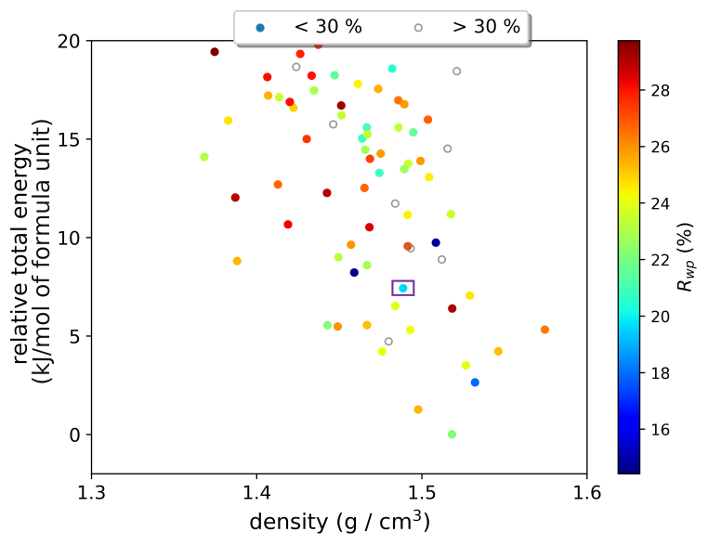
Figure 11. DFT CSP energy landscape for 1:2:2 methanol solvate – hydrate of catechin with color-coded R_{wp} values obtained after Pawley refinement of the CSP generated structures against experimental PXRD diffractogram. The purple square marks the best candidate structure (16th).
Of the eight crystal structures having the lowest ¹H RMSD values, only the 16th structure (the best one in terms of ¹H RMSD value) also shows good agreement with NMR experiment in terms of δ₂₂(¹³C) data (RMSD equal to 3.86 ppm), with the next best structure among these eight structures (ranked 4th in energy) having δ₂₂(¹³C) RMSD equal to 4.43 ppm. Note that the lowest RMSD obtained for δ₂₂(¹³C) is 2.58 ppm, found for a structure with a relatively high ¹H RMSD of 1.33 ppm. As a result, we conclude that the NMR data point to the 16th structure as being the best candidate to be designated as the experimental crystal structure of form M2.
As for the results obtained from Pawley refinement of all 120 viable candidate crystal structures, only four of them: the 3rd, 16th, 17th and 25th structures (in terms of their DFT-D2 energy ranks) yielded a good agreement with the experiment, expressed as R_{wp} below 20%. Two of these structures had been found in space group C2 and two in P2₁2₁2₁. Among these four structures, the only one which was also in a very good agreement with the NMR experiment was the 16th structure, indicated already as the best candidate in terms of agreement of NMR parameters. The δ_{iso}(¹H) RMSD values found for the remaining three structures are equal to 0.97, 1.12, and 1.24 ppm for the 3rd, 17th, and 25th structures, respectively.
The proposed crystal structure of form M2 of catechin (the 16th structure) is shown in Figure 12 and is compared with the crystal structure of form M1 of catechin. The similarities between both structures are apparent, with the mutual arrangement of catechin molecules being the same. This was expected from the results of the comparison of the NMR data obtained for form M2 with the ones calculated for form M1 (with ¹H RMSD obtained from this comparison being equal to 0.76 ppm). As shown in Figure 12c, water and methanol molecules are arranged in separate cavities in the proposed structure of form M2, and the presence of smaller water molecules enables tighter packing of catechin molecules in this crystal in comparison to that of form M1.
Finally, we comment on the energy rank of the structure indicated as the experimental structure of form M2. Its energy was found to be 7.4 kJ/mol above the global minimum. At first glance, this large relative energy may raise some doubts because experimental crystal structures are expected to be observed at or near the global minimum on the crystal energy landscape. Recall, however, that this value is given per formula unit of a crystal, that is per molecule of catechin, a molecule of water, and a half of molecule of methanol. Expressing the relative energy per molecule, it is only 2.96 kJ/mol above the global minimum, which is well within the error limits of the DFT-D2 method, in particular in the case of hydrated systems. Additionally, one may expect a significant entropic contribution to the total energy of solvates and hydrates due to vibrational motion and often encountered disorder of the solvent molecules, which is not accounted for in the calculations performed as part of the CSP study.
Conclusions
In favorable circumstances, the NMR crystallography approach can be successfully used to determine the crystal structure of a polycrystalline powder. Similarly, crystal structure prediction calculations alone can be used to generate the complete crystal energy landscape of a molecule, provided that the entire space of all degrees of freedom is sufficiently explored. While for simpler crystalline systems both these approaches can work amazingly well, this is not necessarily the case for flexible, multicomponent systems. One of the solutions to the limitations of both techniques can be their joint application: experimental techniques limit the search space covered by CSP calculations, while CSP delivers viable candidate crystal structures. In this work, a new approach to limit the number of conformers considered in CSP calculations is presented. By examining a number of the CSP-generated structures of epicatechin giving good agreement with the experiment in terms of ¹H NMR parameters, but at the same time not being the experimentally observed structures, we were able to conclude that the molecular conformation in the crystal structure is the structural feature which influences this agreement to the greatest extent. Similarities in the hydrogen

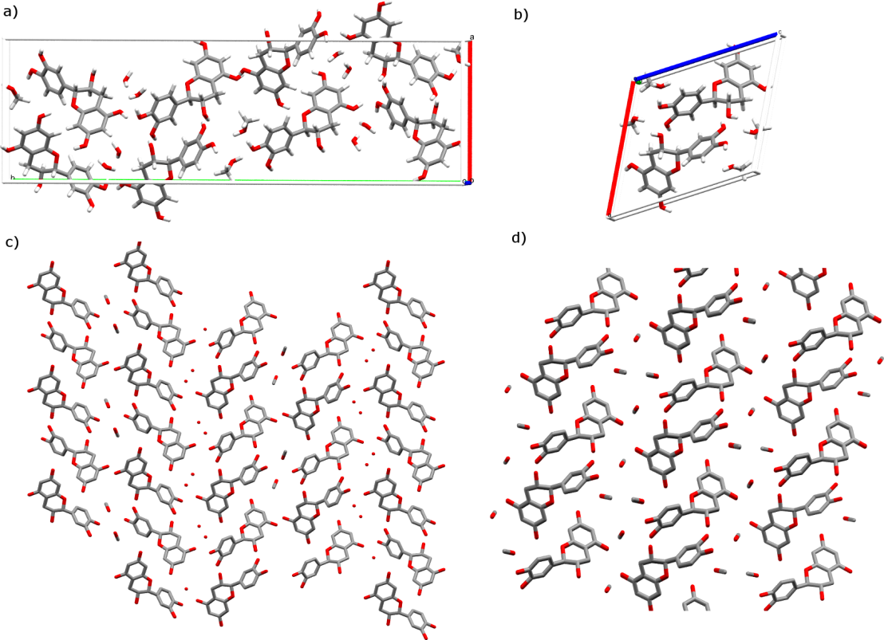
Figure 12. Molecular packing of the proposed structure of form M2 of catechin (1:2:2 methanol solvate – hydrate of catechin), corresponding to the 16th structure found in a CSP search (a), and of catechin form M1 (methanol solvate) (b), as well as the arrangement of molecules in M2 (c) and M1 (d) along the selected plane.

bonding network reflect themselves mainly in the RMSD for δ₂₂(¹³C). Having recognized the capability of ¹H NMR data to indicate primarily a plausible conformer found within a crystal structure, we developed a useful shortcut to determine the crystal structure of a methanol hemisolvate – monohydrate of catechin. According to our results, when dealing with multi-component systems containing flexible molecules, it is possible to find a plausible conformer of the studied system based on the CSP search performed for a simpler system, thus significantly limiting the searched space for a more complex system, comprising the same molecule.
We also find that multiple structural models can yield good agreement with individual NMR parameters and, so, multiple NMR parameters are needed as proof of the correctness of a validated structural model. In this study, ¹H chemical shifts and δ₂₂(¹³C) provide complementary structural information, which increases confidence in the proposed structure.
Conflicts of interest
There are no conflicts to declare.
Acknowledgments
This work was financially supported by the Polish National Science Centre under Sonata 14 grant No. UMO-2018/31/D/ST4/01995. Part of the work was carried out with the kind financial support of the Polish Ministry of Science and Higher Education, during the fellowship ‘Mobility Plus’ (grant No 1664/MOB/V/2017/0). The Polish Infrastructure for Supporting Computational Science in the European Research Space (PL-GRID) and the IRIDIS High Performance Computing Facility, with associated support services at the University of Southampton are gratefully acknowledged for providing computational resources. We are also grateful to the UK Materials and Molecular Modelling Hub for computational resources, which is partially funded by EPSRC (EP/P020194/1). This project has received funding from the European Union’s Horizon 2020 research and innovation program under grant agreement No E180600113 (EUSMI). KPN would like to acknowledge Wroclaw Medical University for financial support during his stay at Prof. Potrzebowski’s group at the Centre of Molecular and Macromolecular Studies PAS in Lodz. Many thanks to Jochem Struppe from Bruker for providing us with the PHORMAT pulse sequence and to Julien Trebosc from the Chevreul Institute for help running NMR experiments at the University of Lille NMR platform.
Notes and references
- D. L. Bryce, IUCrJ, 2017, 4, 350–359.
- D. L. Bryce and F.Taulelle, Acta Cryst., 2017, C73, 126–127.
- D. Lüdeker and G. Brunklaus, Solid State Nucl. Magn. Reson., 2015, 65, 29–40.
- E. Salager, R. S. Stein, C. J. Pickard, B. Elena and L. Emsley, Phys. Chem. Chem. Phys., 2009, 11, 2610–2621.
- C. J. Pickard, E. Salager, G. Pintacuda, B. Elena and L. Emsley, J. Am. Chem. Soc., 2007, 129, 8932–8933.
- P. Paluch, T. Pawlak, M. Oszajca, W. Lasocha and M. J. Potrzebowski, Solid State Nucl. Magn. Reson., 2015, 65, 2–11.
- H. E. Kerr, L. K. Softley, K. Suresh, P. Hodgkinson and I. R. Evans, Acta Cryst., 2017, C73, 168–175.
- X. Filip, I.-G. Grosu, M. Miclăuş and C. Filip, CrystEngComm, 2013, 15, 4131–4142.
- L. Mafra, S. M. Santos, R. Siegel, I. Alves, F. A. Almeida Paz, D. Dudenko and H. W. Spiess, J. Am. Chem. Soc., 2012, 134, 71–74.
- X. Filip and C. Filip, Solid State Nucl. Magn. Reson., 2015, 65, 21–28.
- G. Mollica, M. Dekhil, F. Ziarelli, P. Thureau and S. Viel, Solid State Nucl. Magn. Reson., 2015, 65, 114–121.
- B. Elena and L. Emsley, J. Am. Chem. Soc., 2005, 127, 9140–9146.
- R. K. Harris, Solid State Sci., 2004, 6, 1025–1037.
- S. E. Ashbrook and D. McKay, Chem. Commun., 2016, 52, 7186–7204.
- C. Martineau, J. Senker and F. Taulelle, Annual Rep. NMR Spectr., 2014, 82, 1–57.
- M. Baias, C. M. Widdifield, J.-N. Dumez, H. P. G. Thompson, T. G. Cooper, E. Salager, S. Bassil, R. S. Stein, A. Lesage, G. M. Day and L. Emsley, Phys. Chem. Chem. Phys., 2013, 15, 8069–8080.
- M. Baias, J.-N. Dumez, P. H. Svensson, S. Schantz, G. M. Day and L. Emsley, J. Am. Chem. Soc., 2013, 135, 17501–17507.
- G. M. Day, Crystallogr. Rev., 2011, 17, 3–52.
- S. L. Price, Acta Crystallogr., 2013, B69, 313–328.
- J. Nyman and S. M. Reutzel-Edens, Faraday Discuss., 2018, 211, 459-476
- A. Hofstetter, M. Balodis, F. M. Paruzzo, C. M. Widdifield, G. Stevanato, A. C. Pinon, P. J. Bygrave, G. M. Day and L. Emsley, J. Am. Chem. Soc., 2019, 141, 16624–16634
- M. K. Dudek, P. Paluch and E. Pindelska, Acta Cryst, 2020, B76 https://doi.org/10.1107/S205252062000373X.
- P. Thureau, I. Carvin, F. Ziarelli, S. Viel and G. Mollica, Angew. Chem. Int. Ed., 2019, 58, 16047–16051.
- P. Thureau, S. Sturniolo, M. Zilka, F. Ziarelli, S. Viel, J. R. Yates, G. Mollica. Magn. Reson. Chem. 2019, 57, 256–264.
- C. A. Rice-Evans, N. J. Miller and G. Paganga, Free Radic. Biol. Med., 1996, 20, 933–956.
- M. N. Ghayur, H. Khan and A. H. Gilani, Arch. Pharm. Res., 2007, 30, 970–975
- T. P. T. Cushnie and A. J. Lamb, Int. J. Antimicrob. Agents, 2005, 26, 343–356.
- J. K. Harper, J. A. Doebbler, E. Jacques, D. M. Grant and R. B. Von Dreele, J. Am. Chem. Soc., 2010, 132, 2928–2937
- M. K. Dudek, A. Jeziorna and M. J. Potrzebowski, CrystEngComm, 2016, 18, 5267–5277.
- H. Tsutsumi, Y. Kinoshita, T. Sato and T. Ishizu, Chem. Pharm. Bull., 2011, 59, 1008.
- M. K. Dudek, G. Bujacz and M. J. Potrzebowski, CrystEngComm, 2017, 19, 2903–2913.
- M. K. Dudek and G. M. Day, CrystEngComm, 2019, 21, 2067–2079.
- J. Z. Hu, W. Wang, F. Liu, M. S. Solum, D. W. Alderman, R. J. Pugmire and D. M. Grant, J.Magn. Reson. A, 1995, 113, 210–222.
- F. R. Fronczek, G. Gannuch, W. L. Mattice, F. L. Tobiason, J. L. Broeker and R. W. Hemingway, J. Chem. Soc., Perkin Trans. 2, 1984, 1611–1616.
- K. Mao, W. Wiench, V. S. Y. Lin and M. Pruski, J. Magn. Reson., 2009, 196, 92−95.
- S. M. Althaus, K. Mao, J. A. Stringer, T. Kobayashi, and M. Pruski, Solid State Nucl. Magn. Reson., 2014, 57-58, 17−21.
- V. C. Chandran, P. K. Madhu, N. D. Kurur and T. Brauniger, Magn. Reson. Chem., 2008, 46, 943−947.
- A. Altomare, C. Cuocci, C. Giacovazzo, A. Moliterni, R. Rizzi, N. Corriero and A. Falcicchio, J. Appl. Cryst., 2013, 46, 1231−1235.
- D. H. Case, J. E. Campbell, P. J. Bygrave and G. M. Day, J. Chem. Theory Comput., 2016, 12, 910–924.
- S. L. Price, M. Leslie, G. W. A. Welch, M. Habgood, L. S. Price, P. G. Karamertzanis and G. M. Day, Phys. Chem. Chem. Phys., 2010, 12, 8478–8490.
- A. J. Stone, J. Chem. Theory Comput., 2005, 1, 1128–1132.
- A. J. Stone, Distributed multipole analysis of Gaussian wavefunctions. GMDA version 2.2.11.
- M. J. Frisch, G. W. Trucks, H. B. Schlegel, G. E. Scuseria, M. A. Robb, J. R. Cheeseman, G. Scalmani, V. Barone, B. Mennucci, G. A. Petersson, H. Nakatsuji, M. Caricato, X. Li, H. P. Hratchian, A. F. Izmaylov, J. Bloino, G. Zheng, J. L. Sonnenberg, M. Hada, M. Ehara, K. Toyota, R. Fukuda, J. Hasegawa, M. Ishida, T. Nakajima, Y. Honda, O. Kitao, H. Nakai, T. Vreven, J. A. Montgomery Jr., J. E. Peralta, F. Ogliaro, M. Bearpark, J. J. Heyd, E. Brothers, K. N. Kudin, V. N. Staroverov, R. Kobayashi, J. Normand, K. Raghavachari, A. Rendell, J. C. Burant, S. S. Iyengar, J. Tomasi, M. Cossi, N. Rega, N. J. Millam, M. Klene, J. E. Knox, J. B. Cross, V. Bakken, C. Adamo, J. Jaramillo, R. Gomperts, R. E. Stratmann, O. Yazyev, A. J. Austin, R. Cammi, C. Pomelli, J. W. Ochterski, R. L. Martin, K. Morokuma, V. G. Zakrzewski, G. A. Voth, P. Salvador, J. J. Dannenberg, S. Dapprich, A. D. Daniels, Ö. Farkas, J. B. Foresman, J. V. Ortiz, J. Cioslowski and D. J. Fox, GAUSSIAN 09 (Revision D.01), Gaussian, Inc., Wallingford, CT, 2010.
- A. D. Becke, J. Chem. Phys., 1993, 98, 5648–5652.
- D. S. Coombes, S. L. Price, D. J. Willock and M. Leslie, J. Phys. Chem., 1996, 100, 7352–7360.
- S. J. Clark, M. D. Segall, C. J. Pickard, P. J. Hasnip, M. J. Probert, K. Refson and M. C. Payne, Z. Kristallog., 2005, 220, 567–570.
- J. P. Perdew, K. Burke and M. Ernzerhof, Phys. Rev. Lett., 1996, 77, 3865–3868.
- S. Grimme, J. Comput. Chem., 2006, 27, 1787–1799.
- C. J. Pickard and F. Mauri, Phys. Rev., 2001, B63, 245101.
- J. R. Yates, C. J. Pickard and F. Mauri, Phys. Rev., 2007, B76, 024401.
- J. A. Chisholm and S. Motherwell, J. Appl. Cryst., 2005, 38, 228–231.
- M. Babinský, K. Bouzková, M. Pipíška, L. Novosadová and R. Marek., J. Phys. Chem. A, 2013, 117, 497–503.
- J. Nyman and G. M. Day, CrystEngComm, 2015, 17, 5154–5165.

