Back to Normal: An Old Physics Route To Reduce SARS-CoV-2 Transmission in Indoor Spaces

F. Javier García de Abajo,^{1,2,*} Rufino Javier Hernández,³ Ido Kaminer,⁴
Andreas Meyerhans,^{2,5} Joan Rosell-Llompart,^{2,6} and Tilman Sanchez-Elsner⁷

¹ICFO-Institut de Ciencies Fotoniques, The Barcelona Institute of Science and Technology, 08860 Castelldefels (Barcelona), Spain
²Institució Catalana de Recerca i Estudis Avançats (ICREA), 08010 Barcelona, Spain
³Calidad de Vida en Arquitectura (CAVIAR), Universidad del País Vasco UPV/EHU, 20018 San Sebastián, Spain
⁴Faculty of Electrical Engineering, Technion – Israel Institute of Technology, Haifa 3200003, Israel
⁵Infection Biology Laboratory, Department of Experimental and Health Sciences (DCEXS), Universitat Pompeu Fabra, 08003 Barcelona, Spain
⁶Universitat Rovira i Virgili, Department of Chemical Engineering, 43007 Tarragona, Spain
⁷Clinical and Experimental Sciences, Faculty of Medicine, University of Southampton, Southampton SO16 6YD, United Kingdom
*javier.garciadeababajo@nanophotonics.es

We advocate the widespread use of UV-C light as a short-term, easily deployable, and affordable way to limit virus spreading in the current SARS-CoV-2 pandemic. Radical social distancing with the associated shutdown of schools, restaurants, sport clubs, workplaces, and traveling has been shown to be effective in reducing virus spreading, but its economic and social costs are unsustainable in the medium term. Simple measures like frequent handwashing, facial masks, and other physical barriers are being commonly adopted to prevent virus transmission. However, their efficacy may be limited, particularly in shared indoor spaces, where, besides airborne transmission, elements with small surface areas such as elevator buttons, door handles, and handrails are frequently used. We argue that additional measures are necessary to reduce virus transmission when people resume attending schools and jobs that require proximity or some degree of physical contact. Among the available alternatives, UV-C light satisfies the requirements of rapid, widespread, and economically viable deployment. Its implementation is only limited by current production capacities, an increase of which requires swift intervention by industry and authorities.

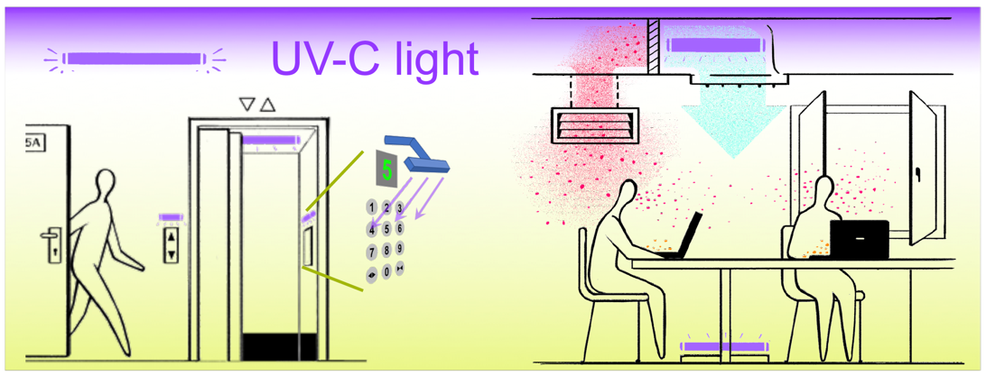

Pandemics created by novel viruses from animal reservoirs have become recurrent events in our globalized world. The recent outbreak of severe acute respiratory syndrome coronavirus 2 (SARS-CoV-2) is a reminder that once a virus emerges in the human population for the first time, it can rapidly spread worldwide and put our wellbeing in danger, if it is not contained from the very beginning. Viral spread is particularly probable if the virus can be transmitted through the air, has a short incubation time, and is highly infectious. Our highly interconnected society has a large fraction of the population concentrated in megacities hosting millions of inhabitants with frequent human interactions. In addition, our society has access to efficient travel systems that enable reaching even remote places within hours, thus fostering dissemination of diseases. Consequently, managing pandemics is indeed a huge challenge for any government or social organization.

The recent SARS-CoV-2 pandemic has shown that initial measures of temporary confinement of citizens can be effective in curbing the spread of the virus and preventing the collapse of health systems. However, confinement causes a huge burden on national and global economies, negatively impacting businesses and individuals’ physical and mental health. In addition, developing countries cannot assume such burdens, and are instead forced to endure the pandemic. Consequently, in both developing and developed economies, there is strong motivation to end confinement and, instead, to implement measures that enable some degree of physical proximity between individuals, enabling them to have long interactions in indoor spaces. To contain the spread of SARS-CoV-2 and to limit similar outbreaks in the future, prevention measures that can be rapidly adopted are an excellent investment in shared environments. Moreover, such prevention measures should be planned as part of future infrastructure in workplaces, public buildings, and mass transit systems.

Air-transmittable viruses such as influenza viruses, the common-cold rhinoviruses, or the new SARS-CoV-2 virus are emitted from an infected individual during coughing, sneezing, talking, or even breathing.– These physiological actions produce aerosols made of droplets of various sizes that may carry infectious viruses and initiate new infection events when inhaled by others. Importantly, the specific size of the droplets determines their airborne lifetimes and, thus, the duration over which passing individuals may be exposed to the virus. Droplets larger than ~100–200 µm settle down rapidly under the action of gravity and rarely reach distances beyond a few meters from the release point,^{8,,} whereas droplets smaller than 10 µm (5 µm) with settling speeds below 3 mm/s (0.8 mm/s) can stay airborne for $\sim 10$ min ($>30$ min in still air), or longer if they shrink by water evaporation and/or get dispersed by air currents.^{11,} Droplets emitted in the intermediate size range (~10–100 µm) can also shrink due to evaporation and be equally dispersed.¹³ Factors such as airflow speed, temperature, and humidity can also affect the transmission rate associated with infectious aerosols.,

Recent studies indicate that weather conditions do not strongly affect SARS-CoV-2 spreading., Nevertheless, temperature and humidity influence virus survival on surfaces, which, together with the type of supporting material, affect the measured persistence times of viral genetic material, ranging from hours to days., Humidity plays an important role in viral transmission and is an especially important factor in relation to social and working environments because cold humid air from outdoors suffers a significant drop in humidity when entering indoor spaces. Consistent with this finding, animal models show that respiratory droplet transmission of influenza in ferrets is more efficient in a 30% relative humidity environment and least efficient above 50%. Relative humidity has been hypothesized to play a role in the determination that aerosols are the most efficient chain of transmission in temperate regions, although this parameter may also be responsible for a different transmission preference in humid and warm regions, where heavier, water-laden, airborne virus-containing droplets tend to settle on surfaces, thus favoring contact transmission.

The ability of SARS-COV-2 to be transmitted a few days before infected individuals feel any symptoms and also by undiagnosed asymptomatic individuals further complicates prevention, and demands intervention in all frequented indoor spaces. Reducing exposure to air-transmittable viruses requires inactivation of both (i) airborne viruses in aerosols and (i) viruses deposited on actively used surfaces.

A simple rate-equation model that accounts for susceptible (S), infected (I), and resistant (R) individuals, formulated nearly a century ago,, quantifies epidemics by the so-called reproduction number $R$. The latter reflects how many new infections are produced on average by every infected person. An epidemic grows or decays roughly exponentially if $R>1$ or $R<1$, respectively. The initial phase of the current SARS-CoV-2 pandemic was characterized by a high $R$ value $\sim 2.5$ when no mitigation measures were implemented and all individuals were susceptible to the virus. With an increasing number of resistant individuals that have successfully defeated the virus by their immune responses, the epidemic will naturally slow down and terminate once so-called herd immunity is reached. This state would require at least a fraction $1-1/R\sim 60\%$ of the population to be immune to the virus, although a straightforward solution of the SIR model actually predicts higher values depending on the dynamical evolution of the pandemic, with 20% of people simultaneously infected at the peak of contagions. More sophisticated models taking into account social habits as well as geographical distribution and interconnections of the population also predict similarly large numbers of infections.– Further elaboration of the simple SIR model explains the benefits of containment measures^{2,} and forecasts subsequent waves if those measures are relaxed.^{30,31},, These models and forecasts, therefore, emphasize the need for economically sustainable mitigation actions to either bring $R$ below 1 (suppression strategy), or at least reduce its value so that a high peak of infections can be averted (mitigation strategy).

The recommended measures of social distancing,² frequent handwashing, adoption of physical barriers such as surgical masks and other personal-protection equipment,^{3,35–} travel restrictions, and frequent direct disinfection of surfaces are effective in reducing the risk of contagion, so they are recurrently recommended in influential surveys., However, within indoor spaces, such as shared offices, classrooms, healthcare facilities, and public transport vehicles, these methods may not reduce viral transmission rates to a sufficiently low level to prevent exponential growth of the pandemic. Specifically, with its relatively high $R$ number $\sim 2.5$, the SARS-CoV-2 pandemic requires the adoption of additional measures to supplement those mentioned above. The need for such additional measures is particularly acute in hospitals, where the high densities of infected individuals have already led to high rates of infection among healthcare professionals in epidemic hotspots, and, consequently, new protocols are being tested.

In this Perspective, we discuss additional measures to reduce SARS-CoV-2 transmissions in the workplace. Due to the urgency to act on a global scale, we advocate for one measure that is particularly efficient, easily deployable, and economically affordable: virus inactivation by ultraviolet (UV) light. Nevertheless, the production of a sufficient number of source elements might be a limiting factor that requires fast intervention by industry and government authorities in order to address the foreseeable demand.

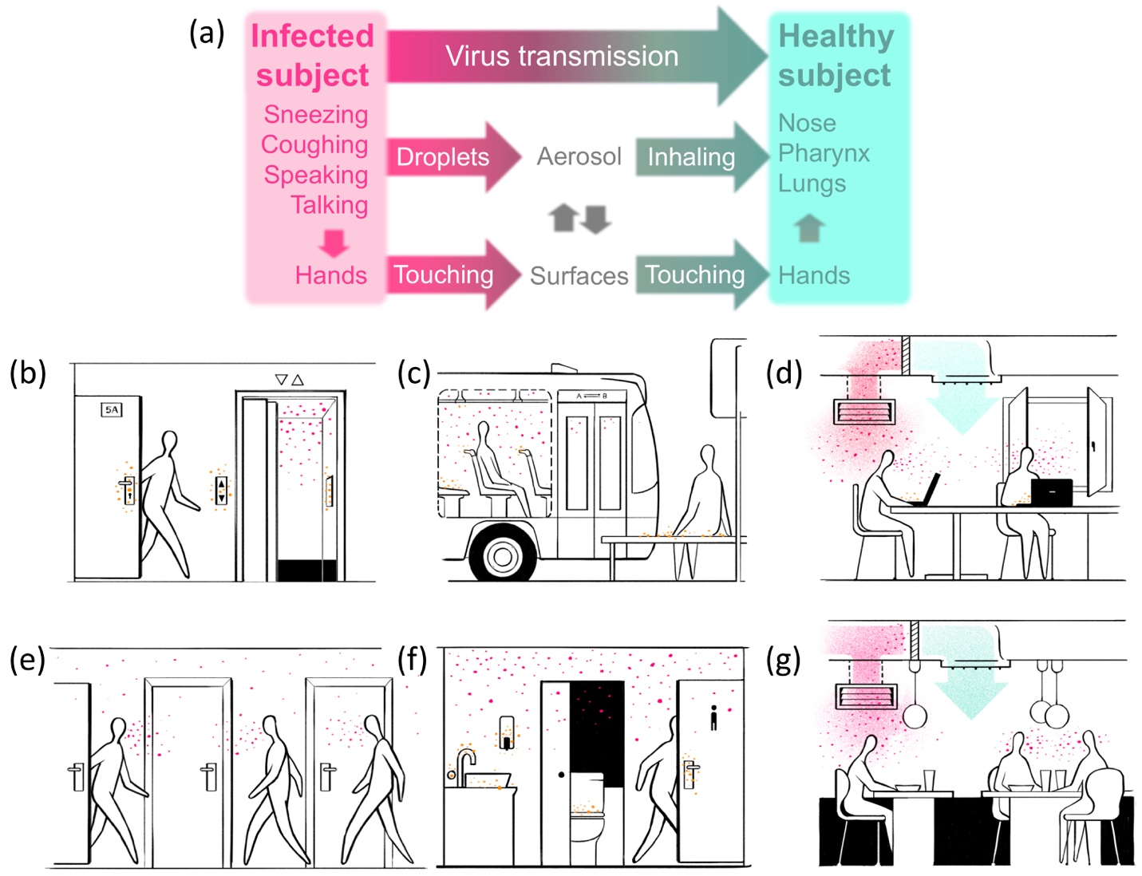

Figure 1. Pathways of viral infection in everyday life. (a) Simplified scheme of aerosol and contact pathways for virus transmission. (b–g) Pictorial description of exposure to virus in everyday activities when (b) using elevators; (c) taking public transportation; (d) spending time in shared indoor spaces such as workplaces, schools, and centers for other social activities; (e) walking through corridors; (f) using common facilities such as toilets, office pantries, and storerooms; and (g) dining at restaurants or accessing other public services with high customer turnover. Colored items indicate airborne viruses (red dots), surface-deposited viruses (orange dots), contaminated-air flow (reddish arrows), and fresh/cleaned-air flow (blueish arrows).

Pathways of Infection in Daily Life

Figure 1a illustrates different pathways of virus transmission classified into two distinct categories: (1) air transmission of viruses in droplets exhaled by infected individuals and inhaled by healthy individuals; and (2) surface transmission of viruses deposited on surfaces from either exhalations or hand contact. Infected individuals may spread viruses through coughing and sneezing but also through breathing and speaking in the presence of healthy, susceptible individuals. A long series of studies has revealed a relation between ventilation in buildings and the rate of infection of air-transmittable diseases, therefore prompting recommendations on the use of ventilation systems to minimize the risk of infection., In addition, recent research has conclusively shown rapid spreading of airborne pathogens in indoor spaces within a few minutes using methods that include fluid-dynamics simulations, and experimental measurements of aerosol emission during speech,^{4,5,7,10} coughing,^{4,8} and sneezing.⁸ Analyses in hospitals have recently provided in situ evidence supporting this conclusion.⁹ Incidentally, the level of loudness while talking determines the size of the emitted droplets,^{4,7} which in turn plays a decisive role on the rate of transmission. Coughing, sneezing, and talking in confined air volumes therefore pose a real risk when several individuals, some of whom may potentially be infected, have to share the same room for hours. Obviously, the density of people inside buildings is a critical factor that determines the rate of transmission. Contact with surfaces that are frequently used by many people and on which the virus can survive for hours,¹⁹ such as door bells, door handles, and handrails, may also represent another efficient source of transmission.

In Figure1b–g, we sketch common scenarios in which airborne and surface-mediated virus transmission can take place during daily life activities. When leaving an apartment building or entering indoor workplaces, elevator buttons and door handles (Figure 1b) offer surfaces of reduced area that are likely touched by many individuals and, thus, facilitate virus transmission. In addition, airborne viruses exhaled from infected individuals can be dispersed and effectively transmitted to healthy people in confined spaces such as elevators (Figure 1b), office pantries, and shared toilets (Figure 1f). The latter can additionally be contaminated by transfers of microorganisms to the air during flushing., Buses and other means of public transportation (Figure 1c) also involve many individuals sharing confined air in small spaces as well as frequent hand contact with small area surfaces such as handrails. Although often involving larger volumes, the work environment in shared offices (Figure 1d) and workshops can foster virus transmission as well because people spend long working hours inside of them. Similarly, public indoor spaces such as shops, restaurants, and cafeterias (Figure 1g) involve a high turnover of customers and, thus, represent another likely scenario for efficient virus transmission.

Social distancing measures such as limiting the density of people in confined spaces like those sketched in Figure 1 can help reduce virus transmission, but these measures come at a high cost in the long run because they give rise to a considerable reduction in economic activity. Additional measures for preventing viral spread are required in order to enable a sustainable level of activity while reducing the negative economic impact of the ongoing pandemic.

Preventing Viral Spread

Simple physical barriers (handwashing, facial masks, etc.) are being strongly encouraged, because they are efficient, easily deployable, and inexpensive means to reduce viral spread.^{2,35,36,38–42} Still, each of these measures presents specific problems, and it is questionable as to whether they are sufficient to reduce the reproduction number $R$ below 1 without maintaining social distancing, because their efficacy depends on the fraction of the population that fully comply with them. With the graphics in Figure 1b–g, we illustrate everyday scenarios in which these measures can have limited efficiency, particularly in preventing the spread of airborne viruses in frequently used confined spaces (e.g., toilets, elevators) and surface-deposited viruses in small-area surfaces such as handles, buttons, and handrails.

Additional measures to reduce virus propagation can be adopted at three different levels: (1) by redesigning the future infrastructure of shared spaces such as offices, toilet rooms, buses, and trains; (2) by emphasizing further compliance from people with the aforementioned measures; and (3) by deploying measures that will inactivate viruses that are emitted in indoor environments and become airborne or that are deposited on surfaces. Level (1) requires long-term planning and might be an excellent option for future pandemics but it does not address the acute needs of the current SARS-CoV-2 situation. Level (2) depends strongly on political and social considerations that may vary across countries, and therefore does not provide a complete solution on the global scale. We focus here on level (3) measures such as washing and wiping surfaces, spraying disinfectants, or illumination with UV-C (200–280 nm wavelength) light sources. The efficiency of each depends on how much they fulfill the following requirements:

- Fast implementation. The financial burden of sustaining the level of social distancing required to prevent exponential growth of the pandemic is immense. Particularly after the first wave, the possibility of recurring waves of infection and potential changes in virus pathogenicity triggered by mutations is of major concern. Timeliness is paramount to address these concerns.
- Scalability. The implementation of new measures involves massive economical, geographical, and social scales, affecting billions of workers in possibly hundreds of millions of shared workspaces, and therefore requires similarly high numbers of physical units to be handled and produced at unprecedented rates.
- Affordability. The investment needed to act on a sufficient fraction of workspaces worldwide may quickly reach multibillion-dollar figures, a demand that many countries are not prepared to spend, unless these measures can be made sufficiently inexpensive.

Preventing airborne virus transmission requires frequent air renewal and/or exposure to conditions that are lethal for the virus but innocuous to humans. Disinfection methods as simple as continuous renewal of air through opening windows can be efficient, but this is not a reasonable option in many climates. Air conditioning (AC) and central heating systems provide continuous access to circulating air (100% room volume circulation every 10–20 min^{45,46} with fresh air replacement every 40–60 min, and higher rates in sensitive environments such as research labs and operating rooms), incorporating sophisticated methods to control air flow and ventilation in multi-zone spaces.

Contaminated particles can be filtered out from air circulating in ventilation systems, and viruses can be directly inactivated by using chemicals– or by exposing them to UV-C light. In particular, air filters have proven to be efficient in substantially reducing the concentration of >1-µm-sized particles from air, while existing electrostatic precipitators eliminate even smaller particles down to <0.1 µm with ~90% efficiency;⁵⁶ however, these methods involve costly and time-consuming installations, which are suitable for large volumes but require long-term planning. Similar considerations apply to virus inactivation through plasma devices. In addition, ozone,⁵⁸ hydrogen peroxide,^{59,60} and other chemicals⁶¹ have been proven to be efficient means of virus disinfection in indoor spaces, but these substances are harmful to humans, so they can only be used while people are outside, subject to strict limits of concentration (e.g., >200 ppb ozone is required to inactivate RNA viruses, but >75 ppb exposure for hours becomes harmful, particularly for individuals with asthma⁵⁸).

With filters and chemicals requiring long-term planning and/or the evacuation of people while in use, certain wavelengths of UV-C light emerge as the most promising solution to act swiftly on the SARS-CoV-2 pandemic because UV-C light meets the aforementioned requirements of fast, scalable, and affordable implementation. Direct comparison between UV-C light and hydrogen peroxide cleaning reveals similarly high efficiencies, yet with certain pros and cons: although UV-C light acts faster, access to shadowed areas can be a problem,⁶⁰ which could be mitigated through intensive use of ventilation systems.

UV-C Protection and its Implementation

UV-C light has been applied in sterilization for over a century, including in the treatment of the disease lupus vulgaris, for which Niels Ryberg Finsen received the Nobel Prize in Medicine in 1903. This spectral range of light lies right at the edge of the UV water transparency window, where water is transparent enough to prevent light attenuation inside micron-sized exhaled droplets, so that the illumination can inactivate viruses contained in them. Early studies have already shown the benefits of using UV-C irradiation to prevent the spread of measles in rural schools. Currently, UV-C light is commonly used in water disinfection and its use has been proven to reduce air transmission of tuberculosis and airborne viruses.⁶²,, Specifically, fluorescence lamps are widely used sources to produce light at a wavelength of 254 nm, which inactivates pathogens through efficient absorption by their DNA or RNA (Figure 2g). The inactivation efficiency grows exponentially with the dose, which is proportional to both the exposure time and the light intensity.⁶² The fraction of inactivated viruses is roughly given by
$1-{10}^{-F/F_{0}}$, where $F$ is the applied fluence (in units of energy per area), whereas $F_{0}$, which stands for the fluence needed to inactivate 90% of viruses, is dependent on the light wavelength and the type of pathogen. In particular, values in the $F_{0}=3-12$ J/m² range were found using 254 nm light to inactivate airborne viruses with efficiencies depending on whether they contained RNA or DNA with single or double strands. For H1N1 influenza, a value below $F_{0}=15$ J/m² was obtained at a wavelength of 222 nm. In a more relevant study to SARS-CoV-2, Walker and Ko found $F_{0}=6.6$ J/m² in murine hepatitis virus (MHV), a coronavirus, using 254 nm light. More recently, a different study reported close to 100% inactivation of MHV-A59 and MERS-COV coronaviruses after 5–10 min exposure, but unfortunately without referring details on the fluence used. Importantly for the present survey, the germicide action of UV-C light acting on AC ducts has been already demonstrated. These results support the use of UV-C disinfection to mitigate the SARS-CoV-2 pandemic,⁴¹ for which the treatise by Kowalski⁶² provides an excellent summary of the state-of-the-art in this technology.

UV-C light can produce eye damage when exceeding the recommended and experimentally validated limit of ~60 J/m² fluence exposure over several hours. In addition, despite its relatively short skin penetration depth (~2 µm at 250 nm wavelength), UV-C irradiation produces carcinogenic effects because it is absorbed by human DNA (Figure 2g), as well as by the cytoplasm of cells. Paradoxically, this problem is less severe for more energetic light at shorter wavelengths, and recent studies have concluded that 207 nm and 222 nm, wavelengths are less damaging for humans than 254 nm but have similar efficiency to inactivate pathogens. Unfortunately, the lower the wavelength of UV-C light, the more effective it is at generating harmful ozone. Recent studies promote the prospects of far UV-C light (wavelengths of ~200–230 nm) as a regime of low risk to human health, yet still with low ozone production.^{77–79}

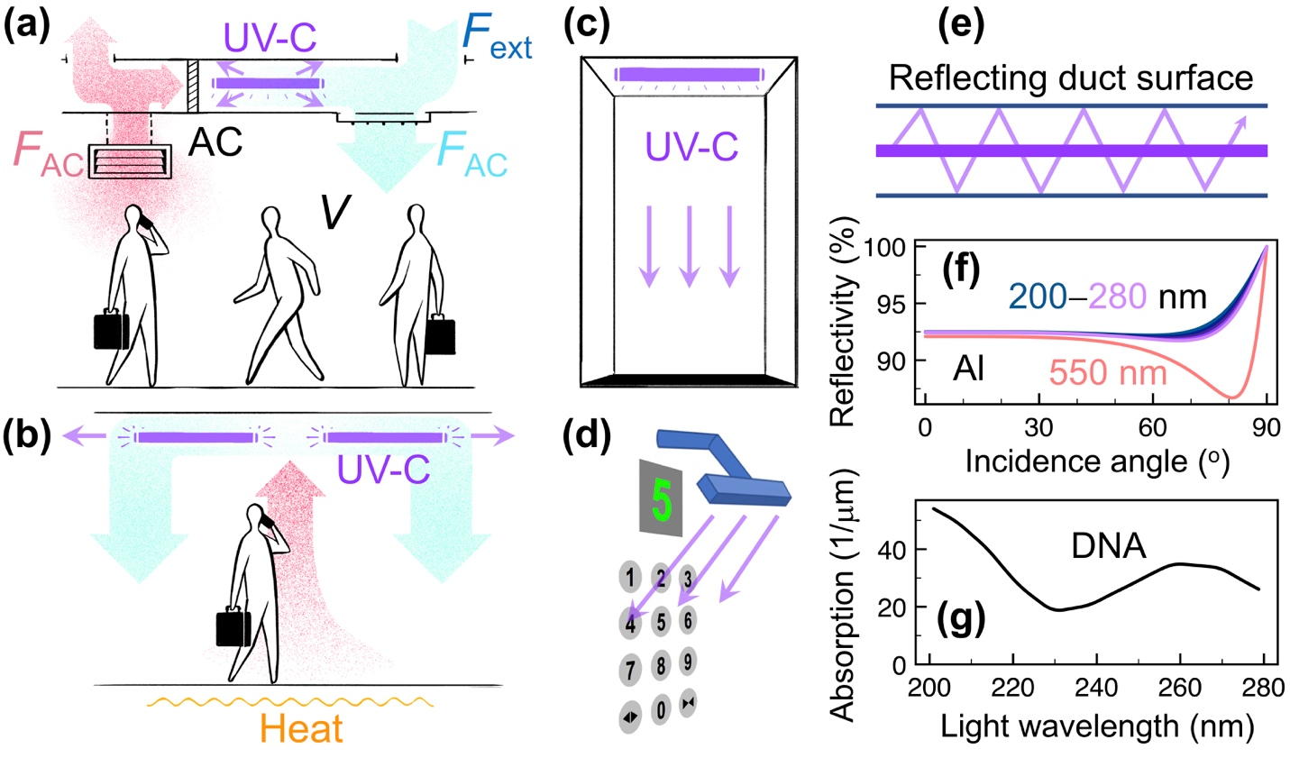

Figure 2. Reduction of viral spread through UV-C light. (a) UV-C sources placed inside air-conditioning (AC) ducts. (b) UV-C collimated wallpaper ceiling illumination combined with temperature-driven air circulation. (c) Direct UV-C exposure of toilets, elevators, doorways, and other small-volume spaces while not in use. (d) Local UV-C light applied to frequently used contact elements (buttons, handles, and handrails). (e) Reflecting surfaces placed near UV-C sources in ducts can create multiple light passages through the same volume of air, thus optimizing the efficiency. (f) Reflectivity of aluminum in the 200–280 nm UV-C range obtained from optical data; the reflectivity at a visible wavelength of 550 nm is shown for comparison. (g) Optical absorption of DNA obtained from optical data in the UV-C range; RNA has a similar spectral profile of absorption.

Providing the conditions to resume work with a higher degree of safety in the current SARS-CoV-2 pandemic requires implementing protection measures while people are oftentimes present in the workplace. For this purpose, UV-C light sources could be distributed with no direct optical path to humans in the ducts of ventilation systems (Figure 2a).⁶² As an alternative, one could instead use horizontally collimated illumination of a fraction of the room height near either the ceiling or the floor, adding air circulation through temperature-controlled elements such as heaters placed near or beneath the floor (Figure 2b). Commercial solutions for these possibilities already exist.⁶² Standalone systems consisting of UV-C elements hidden inside a pipe combined with fans to produce intense airflow through them could be a standalone option, although the associated turbulent air dynamics could have unknown consequences on the dispersion of exhaled droplets. These solutions could be adequate to increase protection against virus transmission in office spaces, classrooms, and restaurants (Figures 1d,g and 3).

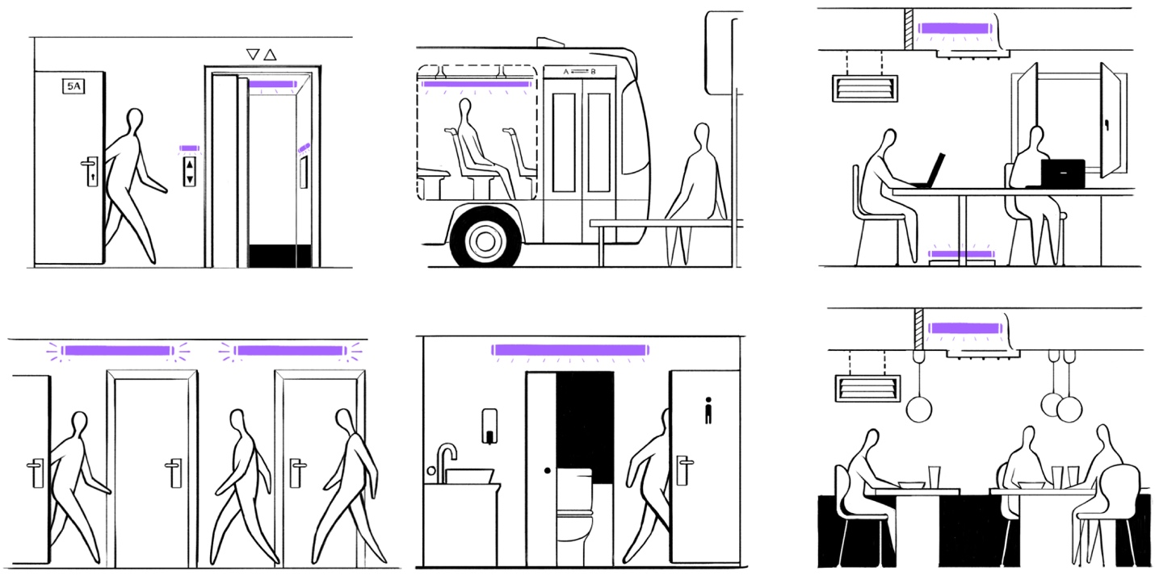

Figure 3. UV-C light in everyday life scenarios. We reproduce Figure 1b–g with placements of UV-C light sources to reduce virus propagation.

Smaller spaces such as toilets, elevators, and office pantries (Figures 1b,f and 3) are used only intermittently and involve a high turnover of people. These spaces could be protected by safely exposing them to a high intensity of UV-C radiation while not in use, which could guarantee a virus-free space when a new user enters. In addition, their usable time could be automatically allocated in order to reserve a dwell time during which UV-C irradiation is applied. This approach could be equally practical in public transportation, with periodic irradiation cycles after a certain number of stops or time of continuous use. A similar concept could be applied to motion-inactivated UV-C illumination that would serve as a protective barrier in passageways and corridors (Figures 1e and 3). We also note that frequently touched surfaces, such as buttons (Figures 2d and 3), handles, and specific segments of handrails, could be directly and continuously exposed to weak UV-C sources aimed at them, as they involve minor risk from eye irradiation or a limited exposure time on hands. Handheld UV-C devices could be used as well for quick disinfection of these elements, and of surfaces in public transportation vehicles (Figures 1c and 3) as an alternative to cleaning through more time-consuming conventional methods.

We can estimate the UV-C power needed to clean air through typical ventilation systems by considering a few of their relevant characteristics extracted from American⁴⁵ and European⁴⁶ standards. These systems generally inject a volume of virus-free exterior air inside the building equivalent to 1–1.5 times the building volume per h (i.e., $F_{ext}/V=$1–1.5/h, see Figure 2a); such fresh air is mixed with 2–3 times its share of recycled air (i.e., $F_{AC}/F_{ext}=$2–3); disinfecting the latter can thus bring the rate of clean-air replacement to $\sim$3–6 times per h at the cost of cleaning a volume of air per h equal to 2–4.5 times the building volume. At full occupation, the building volume per person is $\sim$30 m³, thus requiring $V_{p}\sim$60–140 m³ of recycled air disinfection per h per person. Taking standard air circulation speeds $v\sim$1–2 m/s in ventilation systems and a representative duct of length $L_{d}=5 m$ and cross-section area $A_{d}=1$ m² with an optical path to a single UV-C light source, we can achieve 90% virus inactivation in the recycled air with an output UV-C power of the order of $\sim {vA_{d}F}_{0}/L_{d}$, which yields 2–4 W per person when plugging the 1/10-attenuation fluence $F_{0}\sim 10$ J/m² discussed above. In this rough estimate, we assume illumination collimated along the duct, but the actual light power demand is of course dependent on the geometry of the ventilation system. In fact, the illumination efficiency can be increased by creating multiple reflections in ducts coated with aluminum or simply covered with aluminum foil (Figure 2e,f),⁶² as this material offers a reflectivity $r>90\%$ that can thus reduce the UV-C power demand by a factor $1/(1-r)>10$ (upper bound estimate) because all the reflected light is available for virus inactivation. For future designs, more sophisticated dielectric-based duct coatings could push $r$ closer to 100% and thus reduce the light power demand even further, while also minimizing the potential damage of stray light reaching people’s eyes and skin. In brief, ventilation systems operating at their maximum fresh-air injection capabilities can renew air at a rate of 1–1.5 times per hour, but this rate can be increased 2–3-fold with a modest investment of 2–4 W output UV-C power per person, or even lower power of $\sim 1$ W per person if we optimize multiple reflections in the ventilation ducts.

Upper- or lower-room UV-C illumination (Figure 2b) can also be an efficient means of virus inactivation, but this approach requires more careful analysis of potentially hazardous stray light, thus making it less amenable to short-term implementation. The efficiency then depends on the fraction of illuminated to total air volume, the use of multiple reflections, and the existence of vertical air circulation. However, we expect similar efficiencies as in the ventilation systems discussed above.

Disinfection of small confined spaces such as toilets and elevators (Figure 2c) could be achieved by shining UV-C light while they are not in use, requiring an illumination power inversely proportional to the dwell time between uses. Because of their small share of total volume in buildings, their share of power demand should still represent a relatively minor investment. In turn, disinfecting such spaces could have huge health protection impact in view of their high frequency of use.

We further identify surfaces of small objects such as elevator buttons (Figure 2d), which are touched at intervals of >10 s by many individuals, as a suitable target for UV-C protection. They would require a UV-C intensity <1 mW/m² to accumulate a fluence $F_{0}\sim 10$ mJ/m² necessary to achieve 90% disinfection (see above). Thus, a typical element of surface area ~0.01 m² could be continuously disinfected using just a marginal <10 µW UV-C power, aimed at it, for example, from a small light-emitting diode (LED).

A pertinent question is whether industry can satisfy the demand for UV-C sources for massive protection at a global scale. Currently, low-density fluorescence lamps are commonly used to generate UV-C light with 30–40% power efficiencies at 254 nm wavelength. However, LEDs have emerged as an alternative capable of emitting light down to wavelengths as low as 210 nm, although the efficiencies of LEDs in the UV-C range are comparatively poor (~1–2%), still small compared with fluorescence tubes. Nevertheless, their faster and more versatile operation have pushed LED sources to take >40% of the UV market. To cover large volumes, high-power sources are needed, such as microcavity plasmas, which have been shown to be capable of delivering >20% efficiency at a 172 nm emission wavelength. Importantly, low-density fluorescence lamps are by far cheaper per watt (~$5/W rough estimate based upon inspection of current Amazon.com listings) than LEDs or high-density fluorescence lamps (~$100/W). The harmful effects that fluorescence lamps have on human health demand avoiding direct exposure of eyes and skin, as discussed above. Putting together the above figures, disinfection with fluorescence lamps could be implemented at a cost of a few dollars per person with minimum changes in infrastructure. Thus, a global capital investment of a few billion dollars could protect on the order of ~10⁹ indoor workers worldwide. However, the global market for UV-C light barely reaches one billion dollars per year currently, so it may have difficulty coping with the expected rise in demand originated by the SARS-CoV-2 pandemic.

New Approaches to UV-C Light Generation

The need for compact and efficient UV-C light sources clearly demands the investigation of alternative approaches besides traditional low-density discharge tubes, high-density plasmas, and the more recent LED devices. An alternative may be offered by relying on energetic free electrons as a source of excitation. Specifically, crystalline samples of hexagonal boron nitride (hBN) were shown to produce intense cathodoluminescence (CL) emission at a wavelength ~215 nm upon bombardment by 20 keV electrons, which could even result in lasing when using an optical cavity. Initially thought to be associated with a direct bandgap of this material, a subsequent study confirmed that the emission was related to the presence of an indirect bandgap in which phonons provide the required momentum compensation during radiative de-excitation. This method was verified using field emission sources with electron energies down to 8 keV, which resulted in UV-C generation at a wavelength of 225 nm from hBN powder, although the efficiency was <1%. Other materials with suitable bandgaps may offer more efficient paths to UV-C generation through similar incoherent CL processes.

While all of the aforementioned methods rely heavily on the electronic characteristics of a selection of high-purity materials (e.g., Hg and Xe in tubes, AlGaN in LEDs, and hBN in CL), the Smith-Purcell effect provides another method to generate UV-C radiation that is less sensitive to the nature of the material employed and can lead to highly directed and coherent emission. Light is emitted due to the passage of a free electron near a periodic grating, whereby the electromagnetic interaction between the electron and each groove results in a coherent source that results in the emission of light with a well-defined relation between wavelength and emission direction. This effect, whose analogues have been extensively exploited to generate x-ray radiation in synchrotrons and free-electron lasers employing relativistic electron beams, has been speculated for a long time to serve as a mechanism for the efficient generation of UV radiation using gratings with periods of 10s of nm. Recently, Smith-Purcell emission down to 230 nm wavelength has been demonstrated, while a strong reduction in the grating period has been shown to provide a promising way of generating UV-C radiation with few keV electrons.

Further investigation into these alternative mechanisms of UV-C light generation demands an effort from the research community, which can certainly benefit from the latest advances in nanofabrication and compact electron sources.

Concluding Remarks

The SARS-CoV-2 outbreak is posing an extraordinary challenge that requires swift worldwide action for the massive deployment of affordable and ready-to-apply measures to abate transmission in indoor spaces, such as work settings. Physical means of reducing transmission should require relatively low costs and virtually no alteration of working conditions. In addition to massive monitoring and follow up of contacts of new infections, widely advertised measures such as wearing masks²⁵ and frequent handwashing are proving useful, but can still fall short of preventing the spreading of the SARS-CoV-2 virus. Additional preventive measures also need to adapt to different regions and environments on which transmission routes for SARS-CoV-2 depend. Our succinct analysis of such possible measures leads us to argue that UV-C light stands out as a promising candidate that satisfies the above criteria and, in particular, that can be deployed in the short run with an affordable capital investment. The efficiency of this measure should be extensively monitored by studying correlations with the outcome of widespread testing.

Although we focus on work/public spaces such as offices and shopping areas, the effectiveness of UV-C light may require additional considerations in schools or other environments where social distancing is more difficult to maintain. In particular, pre-vaccination-era studies showed that UV light could reduce spreading of viruses such as measles, chickenpox, and mumps among school children,⁶⁴ but with an effectiveness that was very dependent on the afterschool environment (e.g., crowded accommodations and public transport). UV-C light can also be kept in place for the long term, as it should help reduce infections by pathogens, but should not preclude children from entering into contact with those microorganisms that are thought to be important in the development of the immune system (the so-called hygiene hypothesis).

Coping with the SARS-CoV-2 pandemic demands that we use every affordable measure, and should probably involve mixed solutions adapted to each environment. The fast evolution of this crisis also requires that these measures be continuously monitored for effectiveness. Nevertheless, even when the SARS-CoV-2 pandemic has passed, it will be important to maintain the generated knowledge and resources to deal with similar pandemics in the future. The global, high interconnectivity of human societies makes them inevitable.

Notes

Views expressed in this editorial are those of the authors and not necessarily the views of the ACS.

Acknowledgments

We thank Nacho Gaubert for the realization of sketches for Figures 1b–g, 2a–c, and 3, and Gary Eden for insightful suggestions and information on microplasmas and market production capabilities.

References

- Mangili, A.; Gendreau, M. A. Transmission of Infectious Diseases During Commercial Air Travel. Lancet 2005, 365, 989–996.
- Maier, B. F.; Brockmann, D. Effective Containment Explains Subexponential Growth in Recent Confirmed COVID-19 Cases in China. Science 2020, 6492, 742–746.
- Tellier, R. Review of Aerosol Transmission of Influenza A Virus. Emerg. Infect. Dis. 2006, 12, 1657–1662.
- Xie, X.; Li, Y.; Sun, H.; Liu, L. Exhaled Droplets Due to Talking and Coughing. J. R. Soc. Interface 2009, 6, S703–S714.
- Johnson, G. R.; Morawska, L.; Ristovski, Z. D.; Hargreaves, M.; Mengersen, K.; Chao, C. Y. H.; Wan, M. P.; Li, Y.; Xie, X.; Katoshevski, D.; Corbett, S. Modality of Human Expired Aerosol Size Distributions. J. Aerosol Sci. 2011, 42, 839–851.
- Asadi, S.; Wexler, A. S.; Cappa, C. D.; Barreda, S.; Bouvier, N. M.; Ristenpart, W. D.. Aerosol Emission and Superemission During Human Speech Increase with Voice Loudness. Sci. Rep. 2019, 9, 2348.
- Asadi, S.; Wexler, A. S.; Cappa, C. D.; Barreda, S.; Bouvier, N. M.; Ristenpart, W. D. Effect of Voicing and Articulation Manner on Aerosol Particle Emission During Human Speech. PLoS One, DOI: 10.1371/journal.pone.0227699.
- Bourouiba, L.; Dehandschoewercker; Bush, J. W. M. Violent Expiratory Events: On Coughing and Sneezing. J. Fluid Mech. 2014, 745, 537–563.
- Liu, Y.; Ning, Zhi; Chen, Y.; Guo, M.; Liu, Y.; Gali, N. K.; Sun, L.; D. Y.; Cai, J.; Westerdahl, D.; Liu, X.; Xu, K.; Ho, K-F.; Kan, H.; Fu, Q.; Lan, K. Aerodynamic Analysis of SARS-CoV-2 in Two Wuhan Hospitals. Nature 2020, DOI: 10.1038/s41586-020- 2271-3.
- Stadnytskyi, V.; Bax, C. E.; Bax, A.; Antinrud, P. The Airborne Lifetime of Small Speech Droplets and Their Potential Importance in SARS-CoV-2 Transmission. Proc. Natl. Ac. Sci. U. S. A. 2020, DOI: 10.1073/pnas.2006874117.
- Xie, X.; Li, Y.; Chwang, A. T. Y.; Ho, P. L.; Seto, W. H. How Far Droplets Can Move in Indoor Environments—Revisiting the Wells Evaporation-Falling Curve. Indoor Air 2007, 17, 211–225.
- Hamburger Jr., M.; Robertson, O. H. Expulsion of Group A Hemolytic Streptococci in Droplets and Droplet Nuclei by Sneezing, Coughing and Talking. Am. J. Med. 1948, 4, 690–701.
- Nicas, M.; Nazaroff, W. W.; Hubbard, A. Toward Understanding the Risk of Secondary Airborne Infection: Emission of Respirable Pathogens. J. Occup. Environ. Hyg. 2005, 2, 143–154.
- Tang, J. W. The Effect of Environmental Parameters on the Survival of Airborne Infectious Agents. J. R. Soc. Interface 2009, 6, S737–S746.
- Kudo, E.; Song, E.; Yockey, L. J.; Rakib, T.; Wong, P. W.; Homer, R. J.; Iwasaki, A. Low Ambient Humidity Impairs Barrier Function and Innate Resistance Against Influenza Infection. Proc. Natl. Ac. Sci. U. S. A. 2019, 116, 10905–10910.
- Wang, J.; Tang, K.; Feng, K.; Lin, X.; Lv, W.; Chen, K.; Wang, F. High Temperature and High Humidity Reduce the Transmission of COVID-19. DOI: 10.2139/ssrn.3551767. https://ssrn.com/abstract=3551767 (Accessed March 9, 2020).
- Luo, W.; Majumder, M. S.; Liu, D.; Poirier, C.; Mandl, K. D.; Lipsitch, M.; Santillana, M. The Role of Absolute Humidity on Transmission Rates of the COVID-19 Outbreak. medRxiv 2020, DOI: 10.1101/2020.02.12.20022467.
- Casanova, L. M.; Jeon, S.; Rutala, W. A.; Weber, D. J.; Sobsey, M. D. Effects of Air Temperature and Relative Humidity on Coronavirus Survival on Surfaces. Appl. Environ. Microbiol. 2010, 76, 2712–2717.
- van Doremalen, N.; Bushmaker, T.; Morris, D. H.; Holbrook, M. G.; Gamble, A.; Williamson, B. N.; Tamin, A.; Harcourt, J. L.; Thomburg, N. J.; Gerber, S. I.; Lloyd-Smith, J. O.; de Wit, E.; Munster, V. J. Aerosol and Surface Stability of SARS-CoV-2 as Compared with SARS-CoV-1. N. Engl. J. Med. 2020, 382, 1564–1567.
- Kampf, G.; Todt, D.; Pfaender, S.; Steinmann, E. Persistence of Coronaviruses on Inanimate Surfaces and Their Inactivation with Biocidal Agents. J. Hosp. Infect. 2020, 104, 246–251.
- Moriyama, M.; Hugentobler, W. J.; Iwasaki, A. Seasonality of Respiratory Viral Infections. Annu. Rev. Virol. 2020, 7, 2.1–2.19.
- Gustin, K. M.; Belser, J. A.; Veguilla, V.; Zeng, H.; Katz, J. M.; Tumpey, T. M.; Maines, T. R. Environmental Conditions Affect Exhalation of H3N2 Seasonal and Variant Influenza Viruses and Respiratory Droplet Transmission in Ferrets. PLoS One 2015, 10, e0125874.
- Lowen, A.; Palese, P. Transmission of Influenza Virus in Temperate Zones is Predominantly by Aerosol in the Tropics by Contact: A Hypothesis. PLoS Curr. 2009, 1, RRN1002.
- Huff, H. V.; Singh, A. Clin. Infect. Dis. 2020, DOI: 10.1093/cid/ciaa654.
- Asadi, S.; Bouvier, N.; Wexler, A. S.; Ristenpart, W. D. The Coronavirus Pandemic and Aerosols: Does COVID-19 Tansmit Via Expiratory Particles? Aerosol Sci. Tech. 2020, 54, 635–638.
- Kermack W. O.; McKendrick, A. G. A Contribution to the Mathematical Theory of Epidemics. Proc. R. Soc. A 1927, 115, 700–721.
- Hethcote, H. W. The Mathematics of Infectious Diseases. SIAM Rev. 2000, 42, 599–653.
- García de Abajo, F. J. Simple Mathematics on Covid-19 Expansion. medRxiv 2020, DOI: 10.1101/2020.03.17.20037663.
- Hellewell, J.; Abbott, S.; Gimma, A.; Bosse, N. I.; Jarvis, C. I.; Russell, T. W.; Munday, J. D.; Kucharski, A. J.; Edmunds, W. J.; Funk, S.; Eggo, R. M. Feasibility of Controlling COVID-19 Outbreaks by Isolation of Cases and Contacts. Lancet 2020, 8, e488–e496.
- Ferguson, N. M.; Laydon, D.; Nedjati-Gilani, G.; Imai, Natsuko; Ainslie, K.; Baguelin, M.; Bhatia, S.; Boonyasiri, A.; Cucunubá, A.; Cuomo-Dannenburg, G.; Dighe, A.; Dorigatti, I.; Fu, H.; Gaythorpe, K.; Green, W.; Hamlet, A.; Hinsley, W.; Okell, L. C.; van Elsland, S.; Thompson, H.; et al. Report 9: Impact of Non-Pharmaceutical Interventions (NPIs) To Reduce COVID- 19 Mortality and Healthcare Demand. Imperial College COVID-19 Response Team. https://www.imperial.ac.uk/media/imperial-college/medicine/sph/ide/gida-fellowships/Imperial-College-COVID19-NPI-modelling-16-03-2020.pdf (Accessed March 16, 2020).
- Flaxman, S.; Mishra, S.; Gandy, A.; Unwin, H. J. T.; Coupland, H.; Mellan, T. A.; Zhu, H.; Berah, T.; Eaton, J. W.; Guzman, P. N. P.; Schmit, N.; Callizo, L.; Ainslie, K. E. C.; Baguelin, M.; Bl;ake, I.; Boonyasiri, A.; Boyd, P.; Cattarino, L.; et al. Report 13: Estimating the Number of Infections and the Impact of Non- Pharmaceutical Interventions on COVID-19 in 11 European Countries. Imperial College COVID-19 Response Team. https://www.imperial.ac.uk/mrc-global-infectious-disease-analysis/covid-19/report-13-europe-npi-impact/ (Accessed March 30, 2020).
- Castro, M.; Ares, S.; Cuesta, J. A.; Manrubia, S. Predictability: Can the Turning Point and End of an Expanding Epidemic Be Precisely Forecast? arXiv 2020, https://arxiv.org/pdf/2004.08842.
- Adam, D. Modelling the Pandemic. Nature 2020, 580, 316–318.
- Kissler, S. M.; Tedijanto, C.; Goldstein, E.; Grad, Y. H.; Lipsitch, M. Projecting the Transmission Dynamics of SARS-CoV-2 Through the Postpandemic Period. Science 2020, 368, 860–868.
- Milton, D. K.; Fabian, M. P.; Cowling, B. J.; Grantham, M. L.; McDevitt, J. J. Influenza Virus Aerosols in Human Exhaled Breath: Particle Size, Culturability, and Effect of Surgical Masks. PLoS One 2013, 9, e1003205.
- Prather, K. A.; Wang, C. A.; Schooley, R. T. Reducing Transmission of SARS-CoV-2. Science 2020, DOI: 10.1126/science.abc6197.
- Lam, S. C.; Lee, J. K. L.; Yau, S. Y.; Charm, C. Y. C. Sensitivity and Specificity of the User-Seal-Check in Determining the Fit of N95 Respirators. J. Hosp. Infect. 2011, 77, 252–256.
- Leung, N. H. L.; Chu, D. K. W.; Shiu, E. Y. C.; Chan, K.-H.; McDevitt, J. J.; Hau, B. J. P.; Yen, H.-L.; Li, Y.; Ip, D. K. M.; Peiris, J. S. M.; Seto, W.-H.; Leung, G. M.; Milton, D. K.; Cowling, B. J. Respiratory Virus Shedding in Exhaled Breath and Efficacy of Face Masks. Nat. Med. 2020, 26, 676–680.
- Ma, Q-X.; Shan, H.; Zhang, H.-L.; Li, G.-M.; Yang, R.-M.; Chen, J.-M. Potential Utilities of Mask-Wearing and Instant Hand Hygiene for Fighting SARS-CoV-2. J. Med. Virol. 2020, DOI: 10.1002/jmv.25805.
- Chinazzi, M.; Davis, J. T.; Ajelli, M.; Gioannini, C.; Litvinova, M.; Merler, S.; Pastore y Piontti, A.; Mu, K.; Rossi, L.; Sun, K.; Viboud, C.; Xiong, X.; Yu, H.; Halloran, M. E.; Longini, I. M.; Vespignani, A. The Effect of Travel Restrictions on the Spread of the 2019 Novel Coronavirus (COVID-19) Outbreak. Science 2020, 368, 395–400.
- Dietz, L.; Horve, P. F.; Coil, D. A.; Fretz, M.; Eisen, J. A.; Van Den Wymelenberga, K. 2019 Novel Coronavirus (COVID-19) Pandemic: Built Environment Considerations To Reduce Transmission. msystems.asm.org 2020, 5, e00245-20.
- World Health Organization. Non-Pharmaceutical Public Health Measures for Mitigating the Risk and Impact of Epidemic and Pandemic Influenza. 2019. https://apps.who.int/iris/bitstream/handle/10665/329438/9789241516839-eng.pdf?ua=1 (Accessed June 2, 2020).
- Cheung, J. C.-H.; Lap Tin Ho, L. T.; Cheng, J. V.; Cham, E. Y. K.; Lam, K. N. Staff Safety During Emergency Airway Management for COVID-19 in Hong Kong. Lancet 2020, 8, e19.
- Li, Y.; Leung, G. M.; Tang J. W.; Yang, X.; Chao, C. Y. H.; Lin, J. Z.; Lu, J. W.; Nielsen, P. V.; Niu, J.; Qian, H.; Sleigh, A. C.; Su, H.-J. J.; Sundell, J.; Wong, T. W.; Yuen, P.L. Role of Ventilation in Airborne Transmission of Infectious Agents in the Built Environment – A Multidisciplinary Systematic Review. Indoor Air 2007, 17, 2–18.
- Schoen, L. J.; Hodgson, M. J.; McCoy, W. F.; Miller, S. L.; Li, Y.; Olmsted, R. N.; Sekhar, C.; Parsons, A. S.; Wargocki, P.ASHRAE Position Document on Airborne Infectious Diseases. https://www.ashrae.org/file%20library/about/position%20documents/airborne-infectious-diseases.pdf (Accessed May 22, 2020).
- Federation of European Heating, Ventilation and Air Conditioning Associations (REHVA). https://www.rehva.eu (Accessed June 2, 2020).
- Wang B.; Zhang, A.; Sun, J. L.; Liu, H.; Hu, J.; Xu, L. X. Study of SARS Transmission Via Liquid Droplets in Air. Trans. ASME 2005, 127, 32–38.
- Mui, K. W.; Wong, L.T.; Wu, C.L.; Lai, A. C.K. Numerical Modeling of Exhaled Droplet Nuclei Dispersion and Mixing in Indoor Environments. J. Hazard. Mater. 2009, 167, 736–744.
- Gralton, J.; Tovey, E.; McLaws, M. L.; Rawlinson, W. D.. The Role of Particle Size in Aerosolised Pathogen Transmission: A Review. J. Infection 2011, 62, 1–13.
- Hospodsky, D.; Qian, J.; Nazaroff, W. W.; Yamamoto, N.; Bibby, K.; Rismani-Yazdi, H.; Peccia, J. Human Occupancy as a Source of Indoor Airborne Bacteria. PLoS One 2012, 7, e34867.
- Johnson, D. L.; Mead, K. R.; Lynch, R. A.; Hirst, D. V. L. Lifting the Lid on Toilet Plume Aerosol: A Literature Review with Suggestions for Future Research. Am. J. Infect. Control 2013, 41, 254–258.
- Barker, J.; Jones, M. V. The Potential Spread of Infection Caused by Aerosol Contamination of Surfaces after Flushing a Domestic Toilet. J. Appl. Microbiol. 2005, 99, 339–347.
- Brown, A.; St-Onge, A. S.; Beck, C. R.; Nguyen-Van-Tam, J. S. The Roles of Transportation and Transportation Hubs in the Propagation of Influenza and Coronaviruses: A Systematic Review. J. Travel Med. 2016, 23, 1–7.
- Escombe, A. R.; Oeser, C. C.; Gilman, R. H.; Navincopa, M.; Ticona, E.; Pan, W.; Martínez, C.; Chacaltana, J.; Rodríguez, R.; Moore, D. A. J.; Friedland, J. S.; Carlton, A.; Evans, C. A. Natural Ventilation for the Prevention of Airborne Contagion. PLoS Med. 2007, 4, 309–317.
- Kim, H.-J.; Cho, Y.-H. A Study on a Control Method with a Ventilation Requirement of a VAV System in Multi-Zone. Sustainability 2017, 9, 2066.
- Fisk, W.J.; Faulkner, D.; Palonen, J.; Seppanen, O. Performance and Costs of Particle Air Filtration Technologies. Indoor Air 2002, 12, 223–234.
- Sippola, M. R.; Nazaroff, W. W. Modeling Particle Loss in Ventilation Ducts. Atmos. Environ. 2003, 37, 5597–5609.
- U. S. Environmental Protection Agency. Policy Assessment for the Review of the Ozone National Ambient Air Quality Standards. Document EPA-452/R-14-006, 2014.
- Elgujja, A. A.; Altalhi, H. H.; Ezreqat, S. Review of the Efficacy of Ultraviolet C for Surface Decontamination. J. Nat. Sci. Med. 2020, 3, 8–12.
- Weber, D. J.; Rutala, W. A.; Anderson, D. J.; Chen, L. F.; Sickbert-Bennett, E. E.; Boyce, J. M. Effectiveness of Ultraviolet Devices and Hydrogen Peroxide Systems for Terminal Room Decontamination: Focus on Clinical Trials. Am. J. Infect. Control 2016, 44, e77–e84.
- Kariwa, H.; Fujii, N.; Takashima, I. Inactivation of SARS Coronavirus by Means of Povidone-Iodine, Physical Conditions and Chemical Reagents. Dermatology 2006, 212, 119–123.
- Kowalski, W. Ultraviolet Germicidal Irradiation Handbook; Springer: New York, 2009.
- Xia, T.; Kleinheksel, A.; Lee, E. M.; Qiao, Z.; Wigginton, K. R.; Clack, H. L. Inactivation of Airborne Viruses Using a Packed Bed Non-Thermal Plasma Reactor. J. Phys. D: Appl. Phys. 2019, 42, 255201.
- Perkins, J. E.; Bahlke, A. M.; Silverman, H. F. Effect of Ultra-Violet Irradiation of Classrooms on Spread of Measles in Large Rural Central Schools. Am. J. Public Health 1947, 37, 529–537.
- Beck, S. E.; Ryu, H.; Boczek, L. A.; Cashdollar, J. L.; Jeanis, K. M.; Rosenblum, J. S.; Lawal, O. R.; Linden; K. G. Evaluating UV-C LED Disinfection Performance and Investigating Potential Dual-Wavelength Synergy. Water Res. 2017, 109, 207–216.
- Mphaphlele, M.; Dharmadhikari, A. S.; Jensen, P. A.; Rudnick, S. N.; van Reenen, T. H.; Pagano, M. A.; Leuschner, W.; Sears, T. A.; Milonova, S. P.; van der Walt, M.; Stoltz, A. C.; Weyer, K.; Nardell, E. A. Institutional Tuberculosis Transmission. Controlled Trial of Upper Room Ultraviolet Air Disinfection: A Basis for New Dosing Guidelines. Am. J. Respir. Crit. Care Med. 2015, 192, 477–484.
- Jensen, M. M. Inactivation of Airborne Viruses by Ultraviolet Irradiation. Appl. Microbiol. 1964, 12, 418–420.
- Miller, S. L.; Linnes, J.; Luongo, J. Ultraviolet Germicidal Irradiation: Future Directions for Air Disinfection and Building Applications. Photochem. Photobiol. 2013, 89, 777–781.
- Tseng, C.-C.; Li, C.-S. Inactivation of Virus-Containing Aerosols by Ultraviolet Germicidal Irradiation. Aerosol Sci. Tech. 2005, 39, 1136–1142.
- Welch, D.; Buonanno, M.; Grilj, V.; Shuryak, I.; Crickmore, C.; Bigelow, A. W.; Randers-Pehrson, G.; Johnson, G. W.; Brenner, D. J. Far-UVC Light: A New Tool To Control the Spread of Airborne-Mediated Microbial Diseases. Sci. Rep. 2018, 8, 2752.
- Walker, C M; Ko, G. Effect of Ultraviolet Germicidal Irradiation on Viral Aerosols. Environ. Sci. Technol. 2007, 41, 5460–5465.
- Bedell, K.; Buchaklian, A. H.; Perlman, S. Efficacy of an Automated Multiple Emitter Whole-Room Ultraviolet-C Disinfection System Against Coronaviruses MHV and MERS-CoV. Infect. Control Hosp. Epidemiol. 2016, 37, 598–599.
- Menzies, D.; Popa, J.; Hanley, J. A.; Rand, T.; Milton, D. K. Effect of Ultraviolet Germicidal Lights Installed in Office Ventilation Systems on Workers’ Health and Wellbeing: Double-Blind Multiple Crossover Trial. Lancet 2003, 362, 1785–1791.
- Nardell, E. A.; Bucher, S. J.; Brickner, P. W.; Wang, C.; Vincent, R. L.; Becan-McBride, K.; James, M. A.; Michael, M. Wright, J. D. Safety of Upper-Room Ultraviolet Germicidal Air Disinfection for Room Occupants: Results from the Tuberculosis Ultraviolet Shelter Study. Public Health Rep. 2008, 123, 52–60.
- Anderson, R. R.; Parish, J. A. The Optics of Human Skin. J. Invest. Dermatol. 1981, 77, 13–19.
- Schwarz, T. UV Light Affects Cell Membrane and Cytoplasmic Targets. J. Photoch. Photobio. B 1988, 44, 91–96.
- Buonanno, M.; Stanislauskas, M.; Ponnaiya, B.; Bigelow, A. W.; Randers-Pehrson, G.; Xu, Y.; Shuryak, I.; Smilenov, L.; Owens, D. M.; Brenner, D. J. 207-nm UV Light—A Promising Tool for Safe Low-Cost Reduction of Surgical Site Infections. II: In-Vivo Safety Studies. PLoS One 2016, 11, e0138418.
- Buonanno, M.; Ponnaiya, B.; Welch, D.; Stanislauskas, M.; Randers-Pehrson, G.; Smilenov, L.; Lowy, F. D.; Owensb, D. M.; Brenner, D. J. Germicidal Efficacy and Mammalian Skin Safety of 222-nm UV Light. Radiat. Res. 2017, 187, 493–501
- Narita, K.; Asano, K.; Morimoto, Y.; Igarashi, T.; Nakane, A. Chronic Irradiation with 222-nm UVC Light Induces Neither DNA Damage nor Epidermal Lesions in Mouse Skin, Even at High Doses. PLoS One 2018, 13, e0201259.
- Palik, E. D. Handbook of Optical Constants of Solids; Academic Press: San Diego,1985.
- Inagaki, T.; Hamm, R. N.; Arakawa, E. T. Optical and Dielectric Properties of DNA in the Extreme Ultraviolet. J. Chem. Phys. 1974, 61, 4246–4250.
- Taniyasu, Y.; Kasu, M.; Makimoto, T. An Aluminium Nitride Light-Emitting Diode with a Wavelength of 210 Nanometres. Nature 2006, 441, 325–328.
- Hirayama, H.; Fujikawa, S.; Kamata, N. Recent Progress in AlGaN-Based Deep-UV LEDs. Electr. Commun. Jpn. 2015, 98, 1443–1448.
- Mukish, P. UV LED Market and Industry Trends. LED Taiwan – IR+UV Summit 2016.
- Park, S.-J.; Herring, C. M.; Mironov, A. E.; Cho, J. H.; Eden, J. G. 25 W of Average Power at 172 nm in the Vacuum Ultraviolet from Flat, Efficient Lamps Driven by Interlaced Arrays of Microcavity Plasmas. APL Photon. 2017, 2, 041302.
- Nardell, E.; Nathavitharana, R. Air Disinfection in Measles Transmission Hotspots. Lancet 2019, 394, 1009–1010.
- Bloomfield, S. F.; Stanwell-Smith, R.; Crevelz; R. W. R.; Pickup, J. Too Clean, or Not Too Clean: The Hygiene Hypothesis and Home Hygiene. Clin. Exp. Allergy 2006, 36, 402–425.

Suggested Pull Quotes
Due to the urgency to act on a global scale, we advocate for a measure that is particularly efficient, easily deployable, and economically affordable: virus inactivation by ultraviolet light.

Additional measures for preventing viral spread are required in order to enable a sustainable level of activity while reducing the negative economic impact of the ongoing pandemic.

With filters and chemicals requiring long-term planning and/or the evacuation of people while in use, certain wavelengths of UV-C light emerge as the most promising solution to act swiftly on the SARS-CoV-2 pandemic because UV-C light meets the aforementioned requirements of fast, scalable, and affordable implementation.

A global capital investment of a few billion dollars could protect on the order of ~10⁹ indoor workers worldwide.

The SARS-CoV-2 outbreak is posing an extraordinary challenge that requires swift worldwide action for the massive deployment of affordable and ready-to-apply measures to abate transmission in indoor spaces, such as work settings.

Watanabe, K.; Taniguchi, T.; Kanda, H. Direct-Bandgap Properties and Evidence for Ultraviolet Lasing of Hexagonal Boron Nitride Single Crystal. Nat. Mater. 2004, 3, 404-409.
Cassabois, G.; Valvin, P.; Gil, B. Hexagonal Boron Nitride is an Indirect Bandgap Semiconductor. Nat. Photon. 2016, 10, 262-266.
Watanabe, K.; Taniguchi, T.; Niiyama, T.; Miya, K.; Taniguchi, M. Far-Ultraviolet Plane-Emission Handheld Device Based on Hexagonal Boron Nitride. Nat. Photon. 2009, 3, 591-594.
Smith S. J.; Purcell, E. M. Visible Light from Localized Surface Charges Moving across a Grating. Phys. Rev. 1953, 92, 1969.
García de Abajo, F. J. Interaction of radiation and fast electrons with clusters of dielectrics: A multiple scattering approach. Phys. Rev. Lett. 1999, 82, 2776-2779.
Ye, Y.; Liu, F.; Wang, M.; Tai, L.; Cui, K.; Feng, X.; Zhang, W.; Huang, Y. Deep-Ultraviolet Smith–Purcell radiation. Optica 2019, 6, 592-597.
Massuda, A.; Roques-Carmes, C.; Yang, Y.; Kooi, S. E.; Yang, Y.; Murdia, C.; Berggren, K. K.; Kaminer, I.; Soljačić, M. Smith−Purcell Radiation from Low-Energy Electrons. ACS Photonics 2018, 5, 3513-3518.

