Recovery of an urbanised estuary: clean-up, de-industrialisation and restoration of redundant dock-basins in the Mersey

Hawkins, S.J.^{a,b,c,d}, O’Shaughnessy, K.A.^{b,e*}, Adams, L.A.^{b}, Langston, W.J.^{b}, Bray, S.^{f,g}, Allen, J.R.^{d}, Wilkinson, S.^{d,h}, Bohn, K.^{a,j}, Mieszkowska, N.^{b,i} and Firth, L.B.^{c}

ªOcean and Earth Science, University of Southampton, National Oceanography Centre, Southampton, SO17 3ZH, United Kingdom
^{b}The Marine Biological Association of the UK, The Laboratory, Citadel Hill, Plymouth, PL1 2PB, United Kingdom
^{c}School of Biological and Marine Sciences, University of Plymouth, Plymouth, PL4 8AA, United Kingdom
^{d}Department of Environmental and Evolutionary Biology, University of Liverpool, Liverpool, L69 7ZB, United Kingdom
^{e}School of Geography, Earth and Environmental Sciences, University of Plymouth, Plymouth, PL4 8AA, United Kingdom
^{f}School of Biological Sciences, Life Sciences Building 85, University of Southampton, SO17 1BJ, United Kingdom
^{g}AQASS Ltd Unit 16, Sidings Industrial Estate, Netley Abbey, Southampton, SO31 5QA, United Kingdom
^{h}Joint Nature Conservation Committee, Peterborough, PE1 1JY, United Kingdom
^{i}School of Environmental Sciences, University of Liverpool, Liverpool L69 3BX, United Kingdom
^{j}Natural England, Nottingham, NG2 4LA, United Kingdom

*Corresponding author: oshaug3@gmail.com

Declarations of interest: none

Abstract
For much of the 20th century, the Mersey in North West England was one of the worst polluted estuaries in Europe. Water from a range of polluting industries plus domestic sewage was discharged into the Mersey Catchment and Estuary. Recovery came through a concerted clean-up campaign and tightening environmental regulations, partly driven by European Commission Directives, coupled with de-industrialisation from the 1970s onward. Recovery of oxygen levels in the Estuary led to the return of a productive ecosystem. This led to conservation designations, but also concerns about transfer of pollutants to higher trophic levels in fish, birds and humans. As part of urban renewal, ecosystems in disused dock basins were restored using mussel biofiltration and artificial de-stratification, facilitating commercial redevelopment and creation of a tourist destination. The degradation and recovery of the Mersey from peak-pollution in the mid-20th century is put in the context of wider environmental change and briefly compared to other systems to develop a hysteresis model of degradation and recovery, often to novel ecosystems.

Keywords: Conservation, pollution, contamination, disused docks, Liverpool, biodiversity

Introduction
From the 1930s to 1980s, the Mersey Estuary had the reputation of being one of the most polluted estuaries in the United Kingdom and Europe (Clark, 1989; NRA, 1995; Jones, 2000). Its catchment drained the industrial heartlands of Lancashire and Cheshire, especially the urban conglomerations of Manchester and Liverpool (Fig. 1), which grew rapidly throughout the 18th, 19th and early 20th centuries, peaking before the Second World War (Fig. 2). Thus the estuary was fed by highly polluted rivers, canalised rivers and canals including the Manchester Ship Canal (Porter, 1973). All of these waterways were used as open sewers and as conduits for much industrial waste with little treatment and regulation (Porter, 1973). The freshwater stretches were particularly foul. A report made in 1874 on a survey of the River Mersey in 1869 under the direction of three Commissioners appointed by Queen Victoria reported:

“When taking samples at Throstlenest Weir below Manchester at 5 a.m. on 21 July 1869, we saw the whole water of the River Irwell, there 46 yards wide, caked over with a thick scum of dirty froth, looking like a solid sooty crusted surface. Through this scum here and there, at intervals of 6 to 8 yards, heavy bursts of bubbles were continually breaking, evidently rising from the bottom and, where every yard or two of the scum was cleared away, the whole surface was seen shimmering and sparkling with a continuing effervescence of smaller bubbles rising from various depths in the midst of the water, showing that the whole river was fermenting and generating gas. The air was filled with the stench of this gaseous emanation many yards away. The temperature of the water was 76 °F (24 °C) and that of the air 54 °F (12 °C).” (report quoted in NRA, 1995).

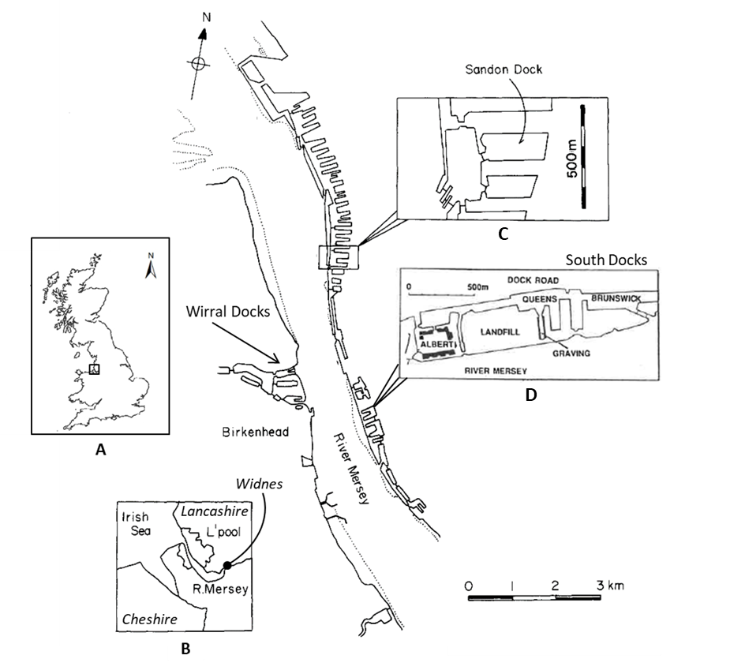
Figure 1. Map of the outer estuary of the River Mersey showing the North, Central and South Dock complexes. Inset map A. shows the location of the Mersey Estuary (black box) within Great Britain. Inset map B. shows the location of the River Mersey within North West England with approximate locations of Cheshire, Lancashire and Widnes indicated. “L’pool” represents Liverpool. Inset map C. shows Sandon Dock within the North Dock complex. Inset map D. shows the docks within the South Dock. Map is modified from Russell et al. (1983) and Hawkins et al. (1992a).

Textiles, coal mining, soap and detergent manufacturing, ship-building, glass-making, the chemical industry, petro-chemicals, car factories, tanneries, food-processing, sugar refining and much else were on the banks of the rivers in the catchment, the canalised lower reaches (Manchester Ship Canal) and the Estuary and its associated docks (Ritchie-Noakes, 1984). Much of the UK’s growing chemical industry was located on the interface of the Cheshire salt-fields and Lancashire coal-fields on the banks of the Mersey Estuary (Allison, 1949; Ritchie-Noakes, 1984). There was also much domestic sewage, both partially-treated and raw, discharged to the rivers and Estuary (Porter, 1973; Jones, 2000). Recovery of the highly polluted waterway eventually came through a concerted clean-up campaign, on top of a century of tightening environmental regulations, in part latterly spurred-on by Directives from the European Commission (NRA, 1995). De-industrialisation also made a major contribution as some heavy industries were privatised (i.e., coal, power generation, ports, car-making, shipbuilding), and along with those already in the private sector, down-sized or shut down as they became increasingly redundant, uncompetitive or environmentally undesirable (e.g., putting lead in petrol/gasoline; Needleman and Gee, 2013).
We describe the recovery of the Mersey from peak-pollution in the mid-20th century by summarising unpublished data and published work, much of which is in the grey literature, often from now-defunct government agencies. This is prefaced by a brief history of the development of the Mersey catchment in terms of industry and population, describing how this led to pollution of the Estuary. We illustrate how metal pollutants have peaked historically and how levels have subsequently declined in response to stricter environmental standards and de-industrialisation. We then provide a similar description of persistent organic compounds. Domestic sewage pollution rose in parallel with industrialisation and is considered alongside nutrient enrichment. Many of the industries of the Mersey also supplied organic waste to the river, contributing to Biological Oxygen Demand (BOD), and hence, very low oxygen levels. Recovery from hypoxic and occasionally anoxic conditions, following sewage treatment, was critical to the recovery of the Estuary, eventually leading to conservation designations, especially for birds. We then consider how, with the Estuary recovering, pollutants began to pass from the productive benthos to higher trophic levels leading to bird mortalities and concerns about contamination of angler-caught fish.
In parallel to clean-up and recovery of the Mersey Estuary, pioneering work using biofiltration and artificial de-stratification helped restore ecosystems of redundant Liverpool dock basins as part of urban renewal programmes. This work is topical because of the recent resurgence in interest in using biofiltration in restoring degraded areas (e.g., the Billion Oyster Project in New York; Billion Oyster Project, 2019). Finally, the recovery of the Mersey and restoration of docks is put in the broader context of global environmental change, emphasising that local and regional pollution needs to be managed in relation to other local, regional and global drivers (see also Hawkins et al., 2017).

Development and decline in the Mersey Catchment in North West England
The North West of England was a key area of industrial development in the 18th and 19th centuries (Figs. 1, 2; Allison, 1949; Ritchie-Noakes, 1984). The juxtaposition of Lancashire’s coal with Cheshire’s salt provided the core ingredients for power and chemical industries, as well as being exported themselves as commodities (Allison, 1949; Ritchie-Noakes, 1984). The development of the first commercial enclosed dock basin in the modern world in Liverpool in the early 1700s (Porter, 1973; Ritchie-Noakes, 1984), and subsequent port expansion facilitated the triangular trade between England (salt and manufactured goods), Africa (slaves) and the Americas (sugar, tobacco, cotton), leading to rapid growth of Liverpool in the 18th century (Allison, 1949; Ritchie-Noakes, 1984). A network of canals (e.g., Bridgewater, Leeds-Liverpool, Trent and Mersey, Macclesfield, Shropshire Union) and navigable rivers (Rivers Mersey, Dee and Weaver) in the 18th century facilitated onward transfer of imports – especially raw materials for manufacturing such as cotton – into the hinterland of the Mersey and Weaver catchments, including industrial Manchester, its satellite towns and beyond to the north Midlands, Yorkshire and North Wales (Ritchie-Noakes, 1984). Exports of finished goods flowed in the opposite direction (Ritchie-Noakes, 1984). This was accelerated by rail links in the early and mid-19th century, epitomised by the first passenger railway link in the world between the burgeoning industrial town of Manchester and the port town of Liverpool in the 1830s (Kellett, 2012). In the late 19th century, Manchester became a port in its own right with the building of the Manchester Ship Canal (incorporating part of the River Mersey; Struthers, 1993; Williams et al., 2010), which prompted further industrial growth along its tidal and freshwater reaches. The ship canal was also treated as an open sewer by many industries along its banks (Porter, 1973; Jones, 2000; Burton, 2003).

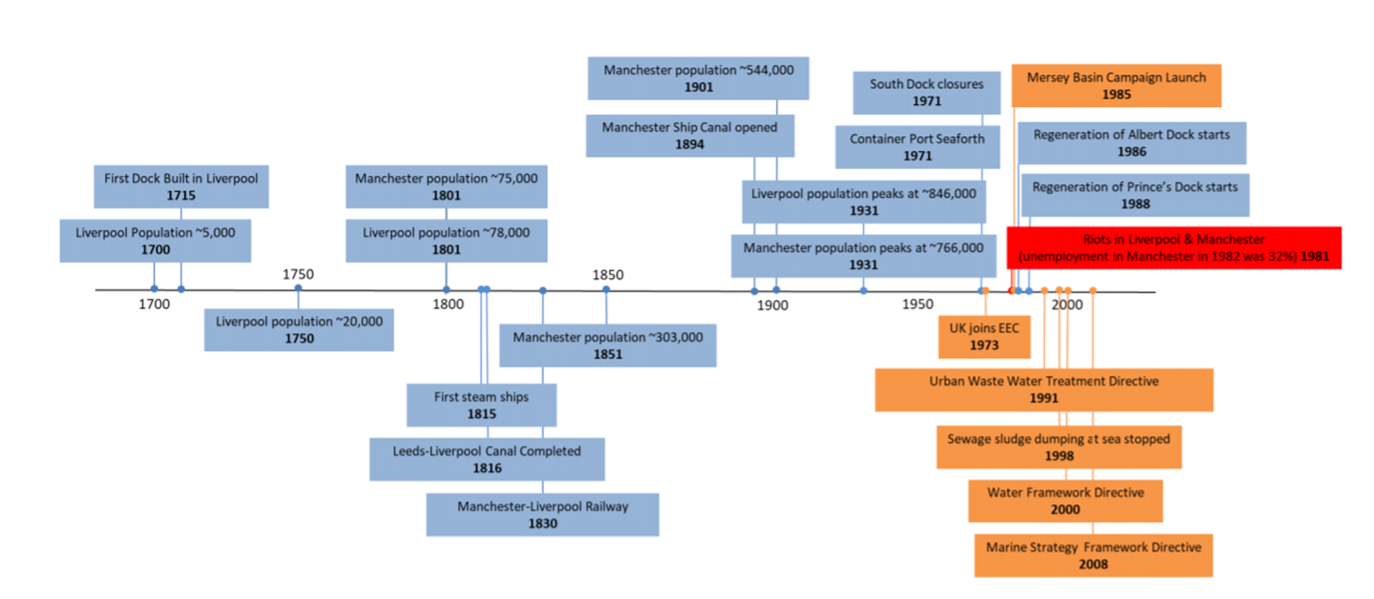
Figure. 2 History of the development of the Mersey from 1700s to 2000s, with key developments driving pollution in blue boxes, steps in urban regeneration in orange boxes and major civil unrest in 1981 shown in red.
Populations in Liverpool and Manchester, plus their satellites, grew rapidly from humble beginnings in 1700, reaching around 75,000 in both towns by 1800, around 300,000 in 1851 and 750,000 by 1901 (Fig. 2; Ritchie-Noakes, 1984; Jones, 2000). A second wave of chemical, textile and light and heavy engineering industries flourished in the second half of the 19th century and continued to grow in the first half of the 20th century (Ritchie-Noakes, 1984; Jones, 2000). The population of the region peaked in the 1930s and has been slowly declining since; especially with the flight to suburbs following post World War II reconstruction, as both the centres of Manchester and Liverpool were heavily bombed (Adey, 2016; The History Press, 2019).
Post-war, many industries declined after a short boom in the 1950s and early 1960s (Jones, 2000). Thus, rapid de-industrialisation occurred, accelerating in the 1980s and 1990s, with privatisation of many nationalised industries (i.e., cars, ship building, steel, rail, utilities), which in many instances resulted in their closure (Hudson and Sadler, 1990; Hudson et al., 1992). Textiles in particular declined rapidly in Lancashire in the 1960s and 1970s in the face of cheaper global competition (Walsh, 1991). Coal mining ceased in the mid-1980s following de-nationalisation (Glyn and Machin, 1997). There was a sharp decline in the chemical industry and ship building (Lorenz, 1991). The decline and closure of many of these old ‘dirty’ industries occurred in parallel with tighter environmental standards (MECG, 1995; NRA, 1995). Social deprivation from mass unemployment led to major unrest in both Liverpool and Manchester (Fig. 2). In response, major urban renewal schemes were funded by central government (Law and Grime, 1993; Williams et al., 2010), leading to re-purposing and redevelopment of disused docklands in both port cities. Such renewal was supported by research on active water quality restoration and management of the Salford Docks in Greater Manchester (Hendry et al., 1993; Law and Grime, 1993; Williams et al., 2010), being summarised for the Liverpool Docks below. Prompted by greater environmental awareness, new legislation evolved, and new institutions were formed (e.g., the National Rivers Authority, subsequently the Environment Agency) to enforce stricter standards and monitor the environment. From the early 1980s onwards, environmental directives from the European Economic Community, the European Community and eventually the European Union drove much change throughout Europe, greatly influencing domestic policy in the UK (NRA, 1995; Byatt, 1996; for comments on the consequences of Brexit for the marine environment, see Hawkins (2017)). Surprisingly, very little formal monitoring of the Mersey Estuary was undertaken before the 1960s (Jones, 2000). The history of scientific research and environmental monitoring in the region are considered in the following sections.

Chemical Contamination
Background inputs and data sources
Since the advent of the Industrial Revolution in the early 18th century, the Mersey Estuary and its catchment has been subjected to chemical wastes from cotton and silk production, port activities, metal ore refining, slag dumping, bleaching, dying and printing of textiles, soap and margarine manufacture, and various chemical processes, including caustic soda production and petrochemical refining (Porter, 1973; Langston et al., 2006). The increase in both industrial and urban development resulted in increases in sewage discharges with the accompanying loadings of pollutants, peaking just before the commencement of the post-industrial era some fifty to sixty years ago. Much of the pollution load became entrained in sediment as a result of physical, chemical and biological processes. Despite the recovery process, this contaminant burden has continued to impinge on the ecological status of the Estuary, highlighted in recent years because of its designation as nationally/internationally important habitat for conservation of saltmarsh plants, invertebrates, fish and birds following recovery of the Estuary (Langston et al., 2006).
Published information on water and sediment quality for the Estuary, and consequences for biota in terms of bioaccumulation and biological condition was heavily reliant on data collected between the late 1970s and early years of the current century by the Environment Agency (EA) and its predecessors and subcontractors, including the Marine Biological Association of the UK (MBA). The latter undertook a series of axial surveys, reviewed published literature and unpublished reports, and interrogated data sets provided by the EA in order to produce a status report on the Estuary (Langston et al., 2006). Despite the paucity of recent data, the main conclusions are still relevant.
Major initiatives at the end of the 20th century such as the Mersey Basin Campaign, coupled with changing industrial practices, have led to improved water quality (NRA, 1995). The threat of harmful sewage and eutrophication-induced dissolved oxygen depletion in the upper estuary is now much reduced as a result. However, the long-term contaminant legacy in the Mersey was reflected in fine sediment loadings, and depth profiles in undisturbed sediment cores reflected the timeline of historical inputs (Fig. 3). Thus, sediments now represented a source as well as a sink for contaminants, with the Estuary remaining one of the most contaminated in the UK; establishing precise links between cause and effects on loading was, however, difficult since many chemicals present co-vary displaying comparable distributions.

Metals
Metals have been toxicologically important in the Mersey because of the wide range of inputs from chemical industries and Waste Water Treatment Works (WWTWs; Fig. 3). Depth profiling and dating in cores can reveal the past history of metal inputs and illustrate how deposited sediment could be a secondary source for bioaccumulation following re-suspension events – whether anthropogenic (e.g., dredging; Fig. 3, 4), or natural (e.g., migration of the main channel or erosion which could be enhanced in the future by climate-induced sea level rise).
Between-core comparison of contaminant profiles is made difficult because of differences in granulometry and accretion rates. Nevertheless, estimates of sediment chronologies in undisturbed cores from Ince and Widnes Warth (an older saltmarsh established at least 120 years ago) clearly demonstrated a sharp rise in metals at depths corresponding to the late 19th/early 20th centuries. This rise was associated with the advent of major industrial processes such as smelting (Arsenic (As), Copper (Cu)), production of chlorine (Mercury (Hg)), and galvanising/paint products (Zinc (Zn); Fig. 3; NRA, 1995; Fox et al., 1999). Commencement of anthropogenic enrichment of Cu, Zn and Lead (Pb) at depth was also evident in sediment cores at Garston (located approx. mid-Estuary; Ridgway et al., 2012). Most cores showed evidence of lowered concentrations in uppermost horizons, indicative of recent declines in pollution. Hence, incorporation of Hg into recently deposited sediments (top 10 cm) has been falling as a result of regulatory measures and industry closures, though most recent values may still exceed 1 µg/g; compared to pre-industrial levels of approximately 0.2 µg/g (Pope et al., 1998; Vane et al., 2009; Ridgway et al., 2012). An estimated 135 tonnes of Hg were held in sediments of the Ince Banks, which were subject to erosion, and as such, represented a potential ‘new’ input to the Estuary.
Data from the 1970s and 1980s showed that metal concentrations were elevated (NRA, 1995; Fox et al., 1999), and may have contributed to adverse biological effects (NRA, 1995). Since then, dissolved metals have declined in tidal waters of the Mersey and seldom posed an acute threat (risk of Environment Quality Standards failure is medium to low), although concentrations were still above background and increased consistently upstream (dominated largely by the freshwater loading of the River Mersey). Highest concentrations in sediments were associated with fine fractions deposited intertidally in the inner Estuary, with inputs derived from metal and chemical industries past and present.
Despite significant recent improvements, Hg, Cu, Zn and to a lesser extent, Chromium (Cr), Cadmium (Cd) and Pb still represent a potential concern (particularly in sediments) – at least in terms of chronic, in-combination effects, if not from acute toxicity. Elevated concentrations of Hg, Zn and Pb have sometimes exceeded Probable Effects Levels (PEL) in surface sediments of the mid-upper estuary.
Birds are vulnerable to the bioaccumulation of pollutants because they occupy a higher trophic level (Burger and Gochfeld, 2004). Between 1979 - 1983 lead levels were a particular concern, following extensive mortality amongst over-wintering estuarine birds (Bull et al., 1983). Even after de-industrialisation and clean-up efforts began, invertebrates in the Estuary were still exposed to a cocktail of metals and persistent organic pollutants from industrial effluents and input from the mixed sewers (Burton et al., 2002), which were biomagnified up the food chain (Bull et al., 1983). This resulted in a major bird kill in the middle reaches of the Mersey in 1979, with smaller mortalities occurring in 1980 and 1981, in which approximately 2,500 waders, gulls and wildfowl died (Bull et al., 1983; Wilson et al., 1986; NRA, 1995). Mortalities were attributed to bioaccumulation of alkyl lead compounds, released into the Estuary via the Manchester Ship Canal from the Associated Octel plant at Stanlow that manufactured them as an additive for use in petrol (Bull et al., 1983; Wilson et al., 1986). This plant eventually closed in 1984 when lead in petrol was phased out following global legislation (Lovei, 1998; Needleman and Gee, 2013).
Results of long-term MBA bioaccumulation surveys indicated that total Pb levels in Mersey biota dropped significantly following identification of the problem, cessation of alkyl lead production and removal of Pb from petrol (Langston et al., 2006). Since 1987 there has been a 'steady state' in biota at reduced Pb levels (Pope et al., 1998).
Much of the Hg in the inner estuary originated from the Castner-Kellner plant near Runcorn, which used a flowing mercury cathode in the production of caustic soda and bleach. Concentrations > 6 µg Hg/g were recorded in surface sediment in the early 1980s – exceptionally high for estuarine deposits (Langston et al., 2006). Hg has a strong affinity for fine-grained organic-rich particulate matter, which provides an integrated record of contamination history and a source of accumulation by deposit feeders and other infauna, representing a pathway to waders which feed upon them (Wilson et al., 1986; Einoder et al., 2018). As with Pb, there have been substantial declines in Hg body burdens in benthic organisms and fish, particularly during the early 1980s, following implementation of control measures; since then, Hg bioaccumulation appears to have attained a quasi-steady state (Pope et al., 1998). In view of the toxicological and regulatory importance of Hg, and the large quantities locked in sediments and saltmarshes, updates and characterisation of sources, distributions and bioaccumulation would be useful (along with that of other metals; see Table 1 for a summary of studies on metal contaminants in the Mersey).
As a general rule, metal contamination once associated with fine sediment, tends to be dispersed over a large area in this tidally dynamic estuary, leading to a degree of homogeneity in surface mud concentrations, rather than reflecting the position of point sources. Many metals thus showed similar distributions, largely a function of grain size and organic content (Pope et al., 1998).
With the possibility of biological effects in mind, data for metals in intertidal sediments may be compared with sediment guidelines (Threshold and Probable Effects levels; TELs and PELs). Levels of most metals were moderate throughout the Estuary, and for As, Cu, Cr and Nickel (Ni), most values fell between the TEL and PEL values (effects may occur) and seldom exceeded the upper threshold where effects would be expected. Pb, Zn and especially Hg, however, exceeded PEL values at a number of sites, particularly within the mid- and upper sections of the Estuary; outside the mouth of the Estuary, levels dropped noticeably (Langston et al., 2006). It is stressed that these are guideline assessments only. Where sediments exceeded the PEL, it was generally by a relatively small margin, rather than by orders of magnitude. Effects due to these metals would largely be chronic rather than acute. Furthermore, many of these comparisons were based on data that were almost 20 years old and may not be representative of conditions now.
Metal bioaccumulation data in invertebrates and fish recorded that body burdens of Hg, Pb, As and Zn were declining in the region, mirroring the trends in sediment loadings in response to extensive clean-up measures and declining industry (Fig. 3; NRA, 1995; Pope et al., 1998). However, changing conditions in the sediment (e.g., pH, redox) can sometimes cause a dramatic and unpredictable increase in bioavailability of metals such as Ag, Cu and Hg to infauna, even though overall sediment loadings remain unchanged (e.g., Langston et al., 1994; Pope et al., 1998; Wang et al., 2015; Tack, 2016). This aspect of the legacy of sediment-bound contaminants is poorly understood.
Fish are not renowned bioaccumulators of metals compared with many invertebrates, other than perhaps for Hg. Nevertheless, long term monitoring of Cd, Pb and Hg in the common dab (Limanda limanda) at two sites in Liverpool Bay revealed a decreasing trend in Pb and Hg between 2007 - 2012, consistent with trends in the Estuary, but an increase in Cd in Burbo Bight samples (Nicolaus et al., 2016). There are few statutory Environmental Assessment Criteria (EAC) for fish, though temporary guidelines (OSPAR) exist for Cd and Pb in bivalves and Hg in fish muscle. Compared to these guidelines there were no exceedances for Hg or Cd; Pb exceedances in Morecambe Bay dab could be linked to the elevated Pb levels observed in the Mersey Channel, although as yet there is no clear justification to link any deleterious effect on fish to specific metals or mixtures.

Persistent Organic Pollutants
Most reports on hydrocarbon (HC) contamination in the Mersey related to past transient oil spill incidents, although in addition to shipping, sources also included river-borne discharges (including road runoff and licensed and unlicensed discharge to sewers), diffuse discharges from industrialised areas, oil production sites (e.g., Stanlow and Ellesmere Port refineries) and the atmosphere (pyrogenic Polycyclic Aromatic Hydrocarbons (PAHs) from traffic and burning of fossil fuels; Langston et al. 2006). One of the more significant oil spill incidents occurred in 1989, when a fractured refinery pipeline spilled over 150t of crude oil into the Estuary at Ellesmere Port (Hall-Spencer, 1989; Davies and Wolff, 1990), and though raising concerns, effects on HC levels in sediments were found to be minimal due to the elevated background levels already present here (approx. 400 µg/g; Davies and Wolff, 1990). Despite apparent reductions since (Rogers, 2002), total HC in tidal waters of the Mersey were amongst the most elevated in the UK (up to 30 - 40 µg/l; Kirby et al., 1998), mirroring the enrichment in sediments – notably those in organic rich intertidal muds at the margins of the Estuary. These contained up to 3766 µg/kg total PAH, which sometimes exceeded sediment quality guidelines and Probable Effects Thresholds (Ridgway et al., 2012). The composition of PAHs suggested a mixed source profile due to a combination of pyrogenic PAHs (dominated by a high proportion of high molecular weight PAHs), supplemented by lower levels of petrogenic components of varying composition, coupled with tidally-driven re-suspension of historically contaminated sediments (Rogers, 2002).
Organic contaminants such as PAHs, PCBs and DDT residues from historical inputs, as with metals, have sometimes appeared enriched in subsurface layers in dated Mersey sediment cores, possibly correlated with organic content of fine particles or slow deposition rates (Vane et al., 2007; Ridgway et al., 2012). Nevertheless, profiles in dated saltmarsh cores at Ince and Widnes reflected peak DDT inputs in the mid-1960s following their initial manufacture twenty years earlier. Similar timescales were evident for PCBs which peaked around 1970, before subsequently declining in more recent sediments following the ban on manufacture and sales in 1977 (Fox et al., 2001). A consolidated sediment core at Garston also reflected the initiation (at 0.8 m), peak (at 0.5 m) and subsequent decline in PCB use. Across the Estuary at Ellesmere Port, however, a uniform down-core distribution of PCBs was indicative of more extensive vertical sediment mixing. Similar variance in core profiles attributable to mixing dynamics has been observed for PAHs and Hg (Vane et al., 2007; Vane et al., 2009). Thus, as with metals, subsurface peaks in loadings of organic contaminants may represent only temporary immobilisation. Natural erosion (tidal/storm-induced) and dredging can re-expose these layers; which act both as a sink and source of legacy contaminants, still potentially available to organisms.
PCB concentrations in fine sediments from the Mersey Estuary ranged from 36 - 1406 ng/g (mean 123 ng/g). These values were 30-fold higher than those in Liverpool Bay, and higher than most UK estuaries with comparable industrial backgrounds, which was a concern in the context of OSPAR ecotoxicological guidelines (Vane et al., 2007; Ridgway et al., 2012). PCBs in L. limanda sampled at two sites in Liverpool Bay exceeded OSPAR Ecotoxicological Assessment Criteria and were among the highest in the UK (Nicolaus et al., 2016); but over a five-year period up to 2012, exhibited a downward trend. As with metals, there is as yet no evidence to link PCBs, in isolation, with any specific effect, though they are capable of immunosuppression and reproductive impairment (Nicolaus et al., 2016).
Concentrations and risks from other measured water-borne contaminants appeared to be mostly low, although few sites have been monitored comprehensively. TBT in tidal waters have in the past (data for 2004) exceeded the Environmental Quality Standard (EQS) benchmark (2 ng/l), widely, with highest values upstream. Sources included the Manchester Ship Canal, docks and shipyards, and the River Mersey itself. Sediment hotspots in docks and mid-upper estuarine sites such as Stanlow (0.4 - 2.41 µg/g), were often above action limits for safe disposal (0.1 µg/g, lower limit; 1 µg/g, upper limit; CEFAS, 2005). Remobilisation of these sediments must be considered a continuing issue to the biological condition of the Mersey given that TBT concentrations in biota often exceeded OSPAR Ecotoxicological Assessment Criteria (0.001 - 0.01 µg/g dry weight for mussels) and the fact that TBT has a long half-life, particularly in anoxic sediment. The threat of TBT as an endocrine disruptor is diminished by the fact that highly sensitive gastropods are not a major component of the Mersey ecosystem (although imposex has been observed in the past in dog-whelks from Hilbre Island near the mouth of the Estuary in Liverpool Bay; Langston et al., 2006). Within sedentary invertebrate communities, however, high levels of intersex severity and frequency have been observed in clams, Scrobicularia plana, from the Estuary (W.J. Langston, unpublished data), contrasting with the low levels of intersex in S.plana typical of uncontaminated sites (Langston et al., 2007). Causes of this reproductive anomaly are not yet known. Vitellogenin induction and intersex levels in male flounder from the Mersey were elevated in the 1990s, raising concerns over links between endocrine disruption and environmental quality (Lye et al., 1997; Kirby et al., 2004). The influence of hormone-containing sewage wastes and the presence of ubiquitous persistent organic compounds such as alkylphenols (considered by the EA as being at medium or high risk of EQS failure in the Mersey) are both possible causes. However, time series data indicated declining levels of egg-yolk protein in male flounder (Kirby et al., 2004).
Other forms of biological effects monitoring in fish (metallothionein, ethoxyresorufin-O-deethylase (EROD), DNA adducts, bile metabolites, pathology and disease prevalence) indicated that the Mersey displayed moderate-to-high level responses when compared with other UK estuaries (in line with chemical contamination). Nevertheless, ecological surveys suggested that, whilst abundance may be low in some areas, the diversity of invertebrate and fish communities has increased in the post-industrial-era, including some re-colonisation upstream, and a substantial increase in birds in the mid-1990s coincided with improved water quality. However, the overall favourable trend in bird numbers has been marred subsequently by an increasing number of British Trust for Ornithology (BTO) Alerts (often contrasting with both regional and national trends); causes of declines in bird numbers, and possible links to changing water quality, require investigation. Despite the lowered risk of acute toxic effects, the Mersey Estuary remains chronically contaminated over much of its area (generally increasing upstream), and it is possible that combined pressures and remobilisation of legacy contaminants could impair performance of sensitive species and benthic communities. Given the scarcity of recent biological response information and water quality data, a programme of harmonised chemical and biological effects monitoring should be re-instigated at the earliest opportunity.

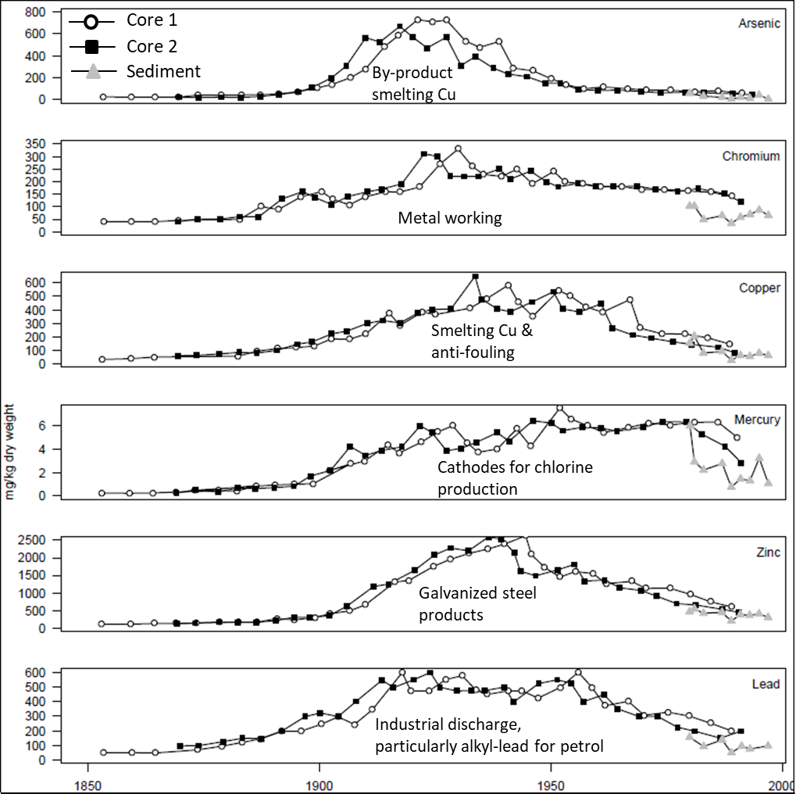
Figure 3. Historical concentration of metals in two dated cores (open circles and black squares) from Widnes Warth (1850s - 1990s). Recent levels of metals in surface sediment (grey triangles) from Widnes Warth are included (1980 - 1996). Sources of each contaminant are also included as text within the graph. Historical core data were sourced from work done by The Industrial Ecology Centre, Liverpool University and The Westlakes Research Institute in Cumbria, and published in Fox et al. (1999). More recent surface sediment data were sourced from Pope et al. (1996).
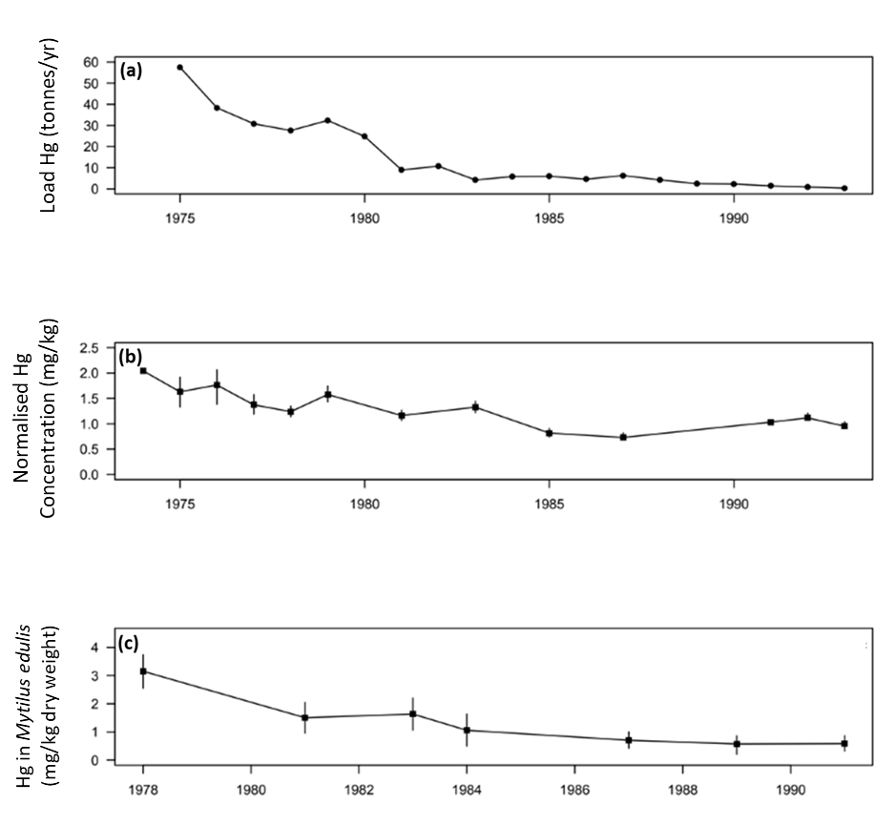
Figure 4. (a) Load of Mercury to estuary from Chlor-Alkali Plants. (b) Mercury in sediments. (c) Mercury in Mytilus edulis (lower reaches of the Estuary). Modified from: NRA (1995). Source: Langston et al. (2006).
Table 1. Summary of selected published and grey literature on metal pollutants in the Mersey Estuary and adjacent coast of inner Liverpool Bay.
Focal topic | Location | Period | Reference
(A) Water
Entire estuary
Nickel | Upper, middle, lower | early 1970s, early 2000s | Abdullah and Royle (1973); Langston et al. (2006)
Zinc | Upper, middle, lower | early 1970s, early 2000s | Abdullah and Royle (1973); Langston et al. (2006)
Lead | Upper, middle, lower | early 1980s, early 2000s | Riley and Towner (1984); Langston et al. (2006)
Mercury | Upper, middle, lower | 1980s-1990s, early 2000s | Harland et al. (2000); Langston et al. (2006)
Arsenic, Boron, Cadmium, Chromium, Copper, Iron | Upper, middle, lower | 1980s-1990s, early 2000s | Langston et al. (2006)
Docks
Copper, Lead, Zinc | Sandon Docks | 1980s | Hawkins et al. (1992b)
(B) Sediment
Entire estuary
Silver, Iron, Selenium, Arsenic, Tin, Cadmium, Manganese, Chromium, Nickel | Upper, middle, lower | 1980s-1990s |  | Langston (1986); Pope et al. (1996); Environment Agency (1997); Langston et al. (2006)
Zinc, Copper | Upper, middle, lower | 1980s-1990s |  | Langston (1986); NRA (1995); Pope et al. (1996); Environment Agency (1997); Langston et al. (2006)
Mercury, Lead | Upper, middle, lower | 1980s-1990s |  | Langston (1986); NRA (1995); Pope et al. (1996); Environment Agency (1997); Fox et al. (1999); Langston et al. (2006)
Caesium, Americium, Copper | Upper | early 1990s |  | Fox et al. (1999)
Arsenic, Chromium | Upper | early-mid 1990s |  | NRA (1995); Fox et al. (1999)
Mercury | - | early 2000s |  | Vane et al. (2009)
Docks
Lead, Copper, Zinc | Sandon, Collingwood, South Docks | 1970s, 1980s |  | James and Gibson (1980); Environmental Services Ltd. (1988); Hawkins et al. (1992b)
Iron | Collingwood | 1970s |  | James and Gibson (1980)
Cadmium, Mercury | South docks | late 1980s |  | Environmental Services Ltd. (1988)
(C) Organisms
Entire estuary
Silver, Cadmium, Chromium, Copper, Iron, Manganese, Nickel, Lead, Zinc, Mercury, Arsenic, Tin, Selenium | Upper, middle, lower | 1980s-1990s | Langston (1986); Langston et al. (1995, 2006); NRA (1995); Pope et al. (1996)
Flatfish
Mercury | Middle, lower | 1980s-early 2000s | Edwards (1994); NRA (1995); CEFAS (2005); Langston et al. (2006)
Cadmium, Arsenic, Zinc, Copper, Chromium | Middle, lower | early 1990s | Edwards (1994)
Lead | Middle, lower | early 1990s | Edwards (1994); NRA (1995)
Roundfish
Mercury, Lead | Middle, lower | early 1990s | Edwards (1994); NRA (1995)
Cadmium, Arsenic, Zinc, Copper, Chromium | Middle, lower | early 1990s | Edwards (1994)
Eel
Mercury, Lead, Cadmium |  | 1990s | NRA (1995); Langston et al. (2006)
Docks
Mussels
Lead, Copper, Zinc | Sandon Dock | 1980s | Russell et al. (1983); Hawkins et al. (1992b)
Cadmium, Mercury, Arsenic | Sandon Dock | 1980s | Russell et al. (1983)
Sea squirts
Lead, Copper, Zinc | Sandon Dock | 1980s | Hawkins et al. (1992b)
Fish
Lead, Copper, Zinc, Cadmium | Sandon, Preston Docks | late 1980s | Hawkins et al. (1993)
Eels
Mercury | Albert Dock | 1980s | Johnston et al. (1991); Langston et al. (2006)

Sewage pollution, Biological Oxygen Demand (BOD) and Dissolved Oxygen Levels
“The whole of the sewage is still thrown into the river, much of it indeed, into the basins and all of it at such points as to act very prejudicially on the health of the town” - The Borough Engineer of Liverpool, 1848 (cited in NRA, 1995; Jones, 2006).
In response to the cholera epidemic in the rapidly growing and crowded town of Liverpool in the 1840s and 1850s, sewers were installed which then discharged raw sewage into the Estuary and also into the dock basins themselves (Porter, 1973; Jones, 2006). As the towns of North West England rapidly grew, they all developed systems that discharged raw sewage into the Mersey and its tributaries, the Manchester Ship Canal (post 1894) and directly into the Mersey Estuary itself (Porter, 1973; Hendry et al., 1993; Jones, 2006). Additionally, various industries discharged their waste into combined sewers including effluents with high BOD (e.g., tanning, sugar refining, brewing, soap manufacture, food processing; Porter, 1973). With the rapid growth in population of North West England, the sewage of around 2.5 million people found its way directly or indirectly into the Mersey (Jones, 2006), mostly subject to only preliminary treatment - if at all - from around 83 outfalls into the estuary itself, 49 of which were in the Narrows (25 from Liverpool and Bootle and 24 from the Wirral; Porter, 1973). In the 1930s, the Water Pollution Research Board (1938) estimated that 80,000 kg per day of organic carbon entered the estuary as sewage – nearly 68% of the total organic carbon load, with tannery effluents being the next biggest input (13%; Water Pollution Research Board, 1938; Porter, 1973). This load led to the lowering of oxygen in the upper reaches of the estuary above Widnes, but levels were generally above 60% in the middle and lower estuary (Porter, 1973). Thus, the estuary was already severely polluted.
Matters worsened after the Second World War. Diversification of industry with government backing led to considerable growth of food processing (especially animal and vegetable fats and oils), paper and board production all discharging BOD loading into the Estuary, plus unsightly faecal material and large balls of fat or grease fouling the foreshore (Mersey and Weaver River Authority, 1971; Porter, 1973; Alexander, 1982; Burton, 2003; see Fig. 2 for a list of significant events affecting water quality in the Mersey). Regular and systematic monitoring of the Estuary was given impetus by the foundation of the Mersey and Weaver River Authority in 1965. Reporting on the state of the estuary in the late 1960s showed much lower oxygen levels than in the 1930s, with levels less than 40% in the middle reaches and less than 50% even in the outer Estuary (Mersey and Weaver River Authority, 1971). During this period there was no control of discharge pre-dating 1960 into tidal waters, with consents at that time only being required for new discharges (Porter, 1973). Since then, greater environmental awareness and tightening national and European legislation, plus de-industrialisation (Porter, 1973; Jones, 2006; O'Hara, 2017), has led to reduction in BOD and ammonia, as well as improvements in oxygen levels entering the estuary over Howley Weir (Fig. 5a; NRA, 1995). The BOD loading has been steadily reduced with much sewage increasingly being subject to treatment leading to lower BOD and higher oxygen levels (Fig. 5b; Jones, 2006). This has been driven by government policy and investment supported by institutional change starting with a patchwork of river boards being aggregated into the North West Water Authority (NNWA) in the early 1970s, with responsibilities for both sewage dispersal and water quality management and regulation in rivers and estuaries (Jones, 2000). With subsequent privatisation of water utilities in the late 1980s to form North West Water PLC, the water authority’s combined role as sewage discharger (“poacher”) and regulator (“gamekeeper”) was split with the formation of National Rivers Authority (Burton, 2003) with responsibilities out to 3 nautical miles from the coast for monitoring and enforcement. The Environment Agency (EA) was formed in 1996 through subsequent mergers with other environmental regulatory bodies as a consequence of the Environment Act (1995). By the early 2000s virtually no raw sewage was entering the Mersey Estuary; additionally organic waste from industry was much reduced (Jones, 2006). Very low oxygen levels that were apparent on spring tides in the mid and upper reaches of the Estuary in the 1970s, still apparent in the upper reaches in the mid-1990s, had now disappeared (Jones, 2006; Langston et al., 2006).

Nutrients in the Mersey
Inadequate sewage treatment and discharges from sewer overflows all contributed to excess nutrients in the Mersey as well as oxygen demand (NRA, 1995). It is widely recognised, however, that diffuse urban and agricultural runoff are additional nutrient sources leading to further impacts on river catchments, not least the Mersey (e.g., Rothwell et al., 2010), possibly leading to eutrophication.
Earlier research placed the nutrient loading in the Mersey – and influence outward into Liverpool Bay – providing context against which to judge later improvement (see Jones, 2006). One of the earliest references to raising nutrient levels appears to be related to farming which increased in intensity from the mid-19th century and led to “nitrates, phosphates and drainage from cow sheds” (Burton, 2003). Abdullah and Royle (1973) noted that during data collection in 1970 - 1971 to establish mixing within Liverpool Bay, there was a marked input of nutrients and “chemical salts”, but that at that time little was known of the chemical composition of Mersey waters. However, the work clearly showed high levels of silicates and nitrates strongly associated with the input of a plume from the Mersey into Liverpool Bay. Further work by Foster et al. (1978) considered dissolved ammonia in Liverpool Bay, and data collected during a cruise in 1975 showed a northerly transport of effluents associated with industrial, agricultural and domestic sources. Foster et al. (1978) noted that although other waters discharged into Liverpool Bay (Ribble and Alt Estuaries and River Dee), the Mersey was clearly identified as the “major contributor of dissolved ammonia to Liverpool Bay”, presumably reflecting the reducing environment with low oxygen levels.
Rothwell et al. (2010) showed that monitoring sites for nutrient loading on the Mersey River Catchment and basin were highly variable in land cover with some at > 40% arable and others at > 60% urban. Their research highlighted that the Mersey Catchment was highly “flashy” with low permeability; thus runoff was ejected relatively rapidly into Liverpool Bay. The highest mean nitrate and phosphate levels were recorded in the freshwater part of the Mersey Basin. Using regression modelling, Rothwell et al. (2010) showed that arable land explained 40% of variance in mean nitrate; whereas for phosphate, variance was not well explained with only 23% of variance explained, and of that circa 15% was attributable to urban land cover. They noted, however, that some of the highest site levels recorded were associated with point source sewage discharges in more urban areas; thus, whilst arable land was the major factor, despite efforts to control point source discharges, high associated nitrate and phosphate levels were still recorded until relatively recently. Rothwell et al. (2010) commented that more work was required to consider nutrient input to rivers in the region (including the Mersey), particularly in the face of growing housing pressure and sewage treatment needs.
The Mersey Basin Campaign was begun in 1985 as a cooperation between government bodies, water companies and other partners, with nutrients being a specific target in efforts to improve water quality (Jones, 2000). In a review of marine dead zones, Diaz and Rosenberg (2008) commented that work to improve and eliminate dead zones included the Mersey, through management of nutrients. This view was based largely on work by Jones (2000, 2006) who noted that in 1999 the Mersey Basin Campaign “won the inaugural prize as the World’s Best River Management Initiative” (Jones, 2006). However, as Jones (2000) stated, there was no room for complacency despite the notable improvements in nutrient levels and other pollutants and broadly within this period analysis of mid 1990s data showed that the Mersey still had one of the highest nutrient loads of 93 sites considered (Nedwell et al., 2002).
Encouragingly, subsequent work has shown a decrease in ammonium, dissolved inorganic phosphate and nitrite in the Mersey. But the relative contribution of nitrate from the Mersey to Liverpool Bay had increased, probably reflecting higher oxygen levels. Nitrate was also correlated with freshwater inflow, suggesting run-off from agricultural land in the catchment, although not as strongly as the River Thames (Greenwood et al., 2019). Testing in relation to the Water Framework Directive (WFD) and OSPAR targets showed that the mouth of the Mersey and Liverpool Bay plume “passed the OSPAR DIN [dissolved inorganic nitrogen] assessment, but exceeded the WFD salinity-normalized threshold”.
Greenwood et al. (2019) reported that the general improvement in freshwater nutrient loading (for the Mersey and Thames) was associated with improved phosphorus stripping at sewage treatment works, but also highlighted that efforts to reduce nutrients had been less effective for DIN. It was concluded that “effective measures” were needed to target DIN reduction.
Upstream of the narrows, high levels of nutrients did not lead to excessive phytoplankton blooms typical of eutrophic waters because of the turbidity of the Estuary caused by sediment load and tidal re-suspension (NRA, 1995). Plankton blooms were, however, reported from the middle reaches of the Estuary, occurring on neap tides when suspended sediment load and concomitant light attenuation declined. These conditions temporarily allowed healthy phytoplankton growth, with both ammonia and silicate levels significantly declining and with dissolved oxygen becoming supersaturated (NRA, 1995). Clearly, the nutrient-rich water of the Mersey presented problems for enclosed dock basins, with lower sediment loads and stratification leading to extreme blooms of phytoplankton as described in a later section (Allen et al., 1992; Wilkinson et al., 1996; Wanstall, 1997). The nutrient plume from the Mersey no doubt contributed to algal blooms in Liverpool Bay (Jones and Haq, 1963) and the high nutrient status of the Irish Sea (Allen et al., 1998).

Recovery of benthos, fish and birds plus pollutants at higher trophic levels
Invertebrate communities in intertidal sediment in the Mersey were frequently studied during the late 19th and early 20th centuries (Herdman, 1895; Herdman, 1920; Fraser, 1932; Bassindale, 1938); yet no extensive ecological studies were made again until the early 1970s (Mills, 1998). Although there have been many studies, it is difficult to compare results because survey methods, taxonomic expertise, site locations, sediment type (e.g., mud, sand, stone) and analyses differed among studies. For example, Bassindale (1938) found 68 species among his sampling sites, which numbered just over 100 and spanned the inner, middle and outer Estuary. During the same time period, Fraser (1932), however, found fewer than 20 species at his 23 sampling sites that spanned approximately 1 mile located in the middle of the Estuary. Forty years later, Ghose (1979) recorded 135 species from intertidal sampling sites located in the inner, middle and outer Estuary. Results from Ghose (1979) and more recent surveys (ERL, 1993; Environment Agency, 2002), in combination with a review of studies done by the NRA in 1989, suggested that the invertebrate fauna was recovering as a result of declines in anoxia with decreased BOD loads from the 1970s (Fig. 5a; Holland, 1989; NRA, 1995; Jones, 2006). Moreover, with de-industrialisation and the subsequent decline of input of metals into the Estuary, body burdens of metals in benthic invertebrates have dropped since the 1980s, with concentrations of metals in biota reaching a ‘steady state’ condition in the 1990s (Pope et al., 1998; Langston et al., 2006).
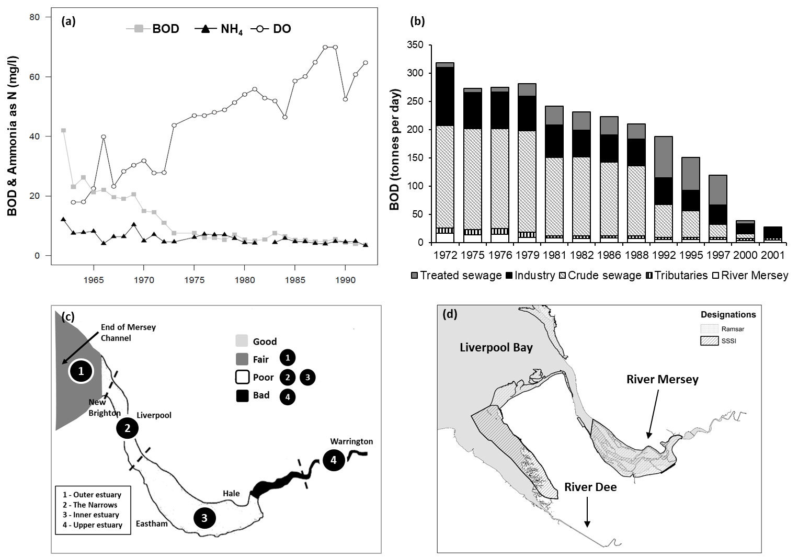
Figure 5. (a) Improvements in water quality at Howley Weir (top of Mersey Estuary). (b) BOD load discharges to the Estuary. (c) Water quality assessment conducted by the Department of the Environment and the National Water Council (1990s). Dashed lines and numbers (1-4) delineate the different sections of the Mersey. (d) Conservation Designations for the Mersey Estuary. Ramsar sites are wetland areas designated as internationally important under the Ramsar Convention. SPA = Special Protection Area and is a designation under the European Union Directive on the Conservation of Wild Birds (79/409/EEC) adopted in 1979. SSSI = Site of Special Scientific Interest, which were set up by the National Parks and Access to the Countryside Act 1949 and represents a protected area in the UK. Source: modified and updated from NRA (1995).

Better oxygenation also encouraged the return of fish into the upper and middle reaches (Wilson et al., 1988; Environment Advisory Unit, 1991; Fielding, 1997). Historically the Mersey had supported rich fisheries in the 18th and early to mid-19th centuries (Cunningham and Lankester, 1896; Dunlop, 1927; Wilson et al., 1988; NRA, 1995), and along with the other estuaries entering Liverpool (Rivers Dee and Ribble) and Morecambe Bays (Rivers Wyre and Lune), has been a rich nursery ground for many juvenile fish such as herring, plaice and gadoids (Hardy, 1995; Natural England, 2012). In particular, salmonids were once a common migrant into the Mersey, relying heavily on its freshwater catchment for spawning (Jones, 2006). Although poor water quality drove all salmonids from the Mersey catchment at the peak of pollution in the 20th century, in 2001, a single salmon was caught at Woolston Weir – the first in the Mersey in nearly 50 years (Jones, 2006). Since then, salmonids have been frequently observed in the Mersey during spawning season (Ikediashi et al., 2012).
Trawl surveys of the Mersey were initiated in the 1980s with the aim of recording fish species and temporal trends in the estuary (Hering, 1998). This trawling programme recorded 40 species – up from the 25 species recorded in the mid-1970s from cooling water intake screens at Runcorn and Ince (D'Arcy and Pugh-Thomas, 1978; D'Arcy and Wilson, 1978). In the early 1990s, data obtained from surveys made by ERL (1992) were used to compare the fish assemblage of the Mersey to other large estuaries in the UK. Their study found that the structure of the Mersey fish assemblage was similar to that of comparable UK estuaries (Elliott and Dewailly, 1995), indicating the Mersey was once again becoming a healthy estuary.
In part, the eutrophic nature of the Estuary with considerable organic inputs must have fuelled production of invertebrates. In turn, large numbers of birds began to return to the estuary with growing populations (Fig. 6; MECG, 2019), making the Mersey an important destination for overwintering (e.g., Dunlin, Redshank, Teal) and resident wildfowl (e.g., Cormorant, Grey Heron; Thomason and Norman, 1995; Lawson et al., 2015; Ross-Smith et al., 2015). Water quality assessments (Fig. 5c) and various conservation designations followed (Fig. 5d) because of the large numbers of birds that began to use the estuary (Fig. 6). In particular, the sand and mudflats of the Estuary provided critical feeding grounds, while the adjacent saltmarshes, sand dunes and grasslands acted as essential breeding or roosting habitat for many species of birds (MECG, 1995; NRA, 1995). The Mersey is particularly critical for waterfowl of Arctic, Subarctic and temperate regions during the non-breeding winter season (the Mersey accounts for approx. 10% of total wintering population in the British Isles), as well as for populations needing a resting staging post during travel from the Arctic to Europe or even as far south as Africa (MECG, 1995; NRA, 1995). The Mersey Estuary was classified as a SPA (Special Protection Area) under the European Union Directive on the Conservation of Wild Birds, as well as a SSSI (Site of Special Scientific Interest; Fig. 5d) in 1995 and 2004, respectively (Natural England, 2019).
Estuarine birds are sensitive to external factors and are therefore good indicators of the health of the Estuary and changes in climate. For example, during the cold winters of the mid-1960s, 1970s and early 1980s it is suspected by the authors that shorebirds preferred milder west coast estuaries to the harsher east coast, especially during North Atlantic Oscillation negative winters typified by colder, continentally driven weather of the 1960s to early 1980s (Kendall et al., 2004). As a result, the Mersey saw greater populations of shorebirds during these years.

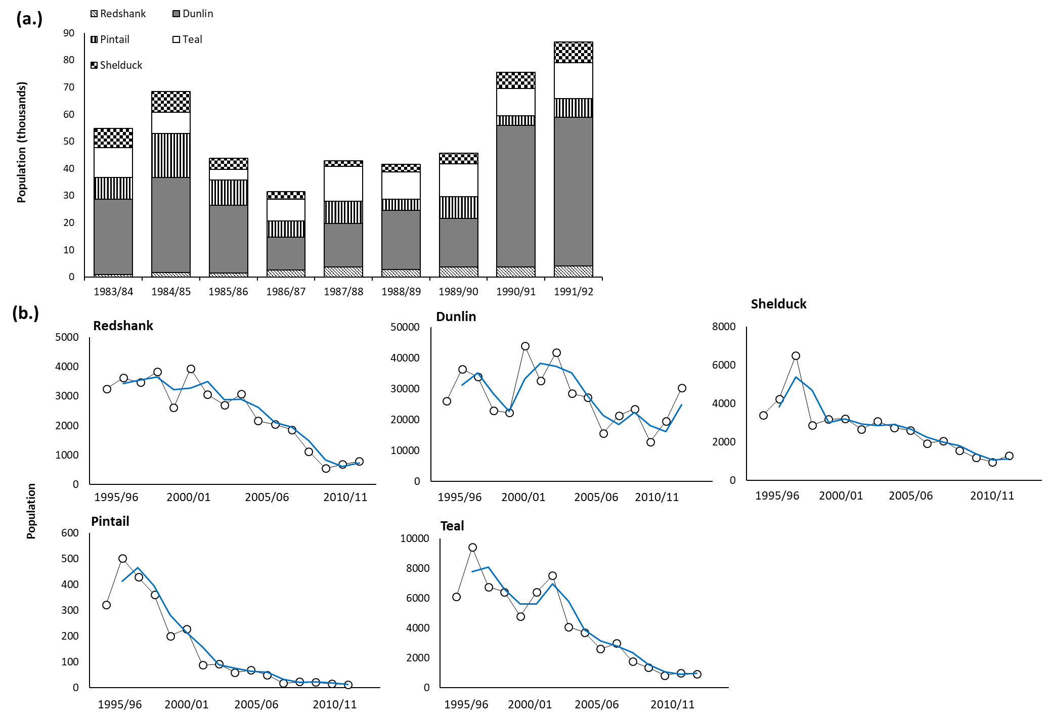
Figure 6. (a) Use of the Mersey Estuary by birds (1983 - 1992) prompting Conservation Designations. These data were obtained after the 1979/80/81 mass mortality of birds in the middle reaches of the Estuary. Source: NRA (1995). (b) Recent populations of the same birds from 1995 - 2011. The solid blue lines represent the moving averages of the observations. The authors suspect the decline in populations is attributed to changes in local climate. Source: Natural England (2015).

As fish gradually returned to the Mersey starting in the 1960s (NRA, 1995), there was greater recreational fishing for eels and flounders in the middle and upper reaches of the Estuary, in addition to that in the lower reaches for a variety of species including dab, cod and whiting (Wilson et al., 1988; NRA, 1995; Collings et al., 1996). There were concerns, however, that health risks associated with the consumption of fish from the Estuary were possible (NRA, 1995; Leah et al., 1997a, b; Matthiessen and Law, 2002). Thus in May 1991, the Ministry of Agriculture, Fisheries and Food (MAFF) issued a warning to anglers advising against consumption of fish from the polluted rivers of the estuary (Edwards, 1994; NRA, 1995). Surveys of metals in angler-caught eels and flounder (Fig. 7) showed high levels of metals approaching or exceeding the then EQS levels set by the European Commission (NRA, 1995; Collings et al., 1996; Jones, 2000).
Concerns were also expressed about persistent organic compounds such as dichlorodiphenyltrichloroethane (DDT), Bisphenol A (BPA), polychlorinated biphenyls (PCBs) and tributyltin chloride (TBT), which have been suggested to be linked to birth defects, reproductive dysfunction, endocrine disruption and changes in hormones and the immune system (Grun et al., 2006; Carwile et al., 2009; Nicolopoulou-Stamati et al., 2013; Darbre, 2015). Many of these compounds are insecticides and pesticides (e.g., TBT, PCBs, DDT) that leach from anti-foulants or run off agricultural land and across impermeable urbanised surfaces into receiving rivers and estuaries (Fernandez et al., 1999; Chau, 2005; Guan et al., 2009). Although many of these are no longer in production due to regulations that emerged in the 1970s (e.g., DDT, PCBs) and 1980s (e.g., TBT), they are environmentally persistent compounds, and therefore may still be present in the flora and fauna of the Mersey Estuary (Darbre, 2015; US EPA, 2018). These compounds may be transferred to fish through the food chain as well as through other media such as sediment and water (NRA, 1995; Lopes et al., 2012; Darbre, 2015; US EPA, 2018). In fact, a study from the early 1990s found that levels of DDT and PCBs in fish and shellfish from the Mersey Estuary were still elevated, with higher levels detected in the inner estuary (NRA, 1995).

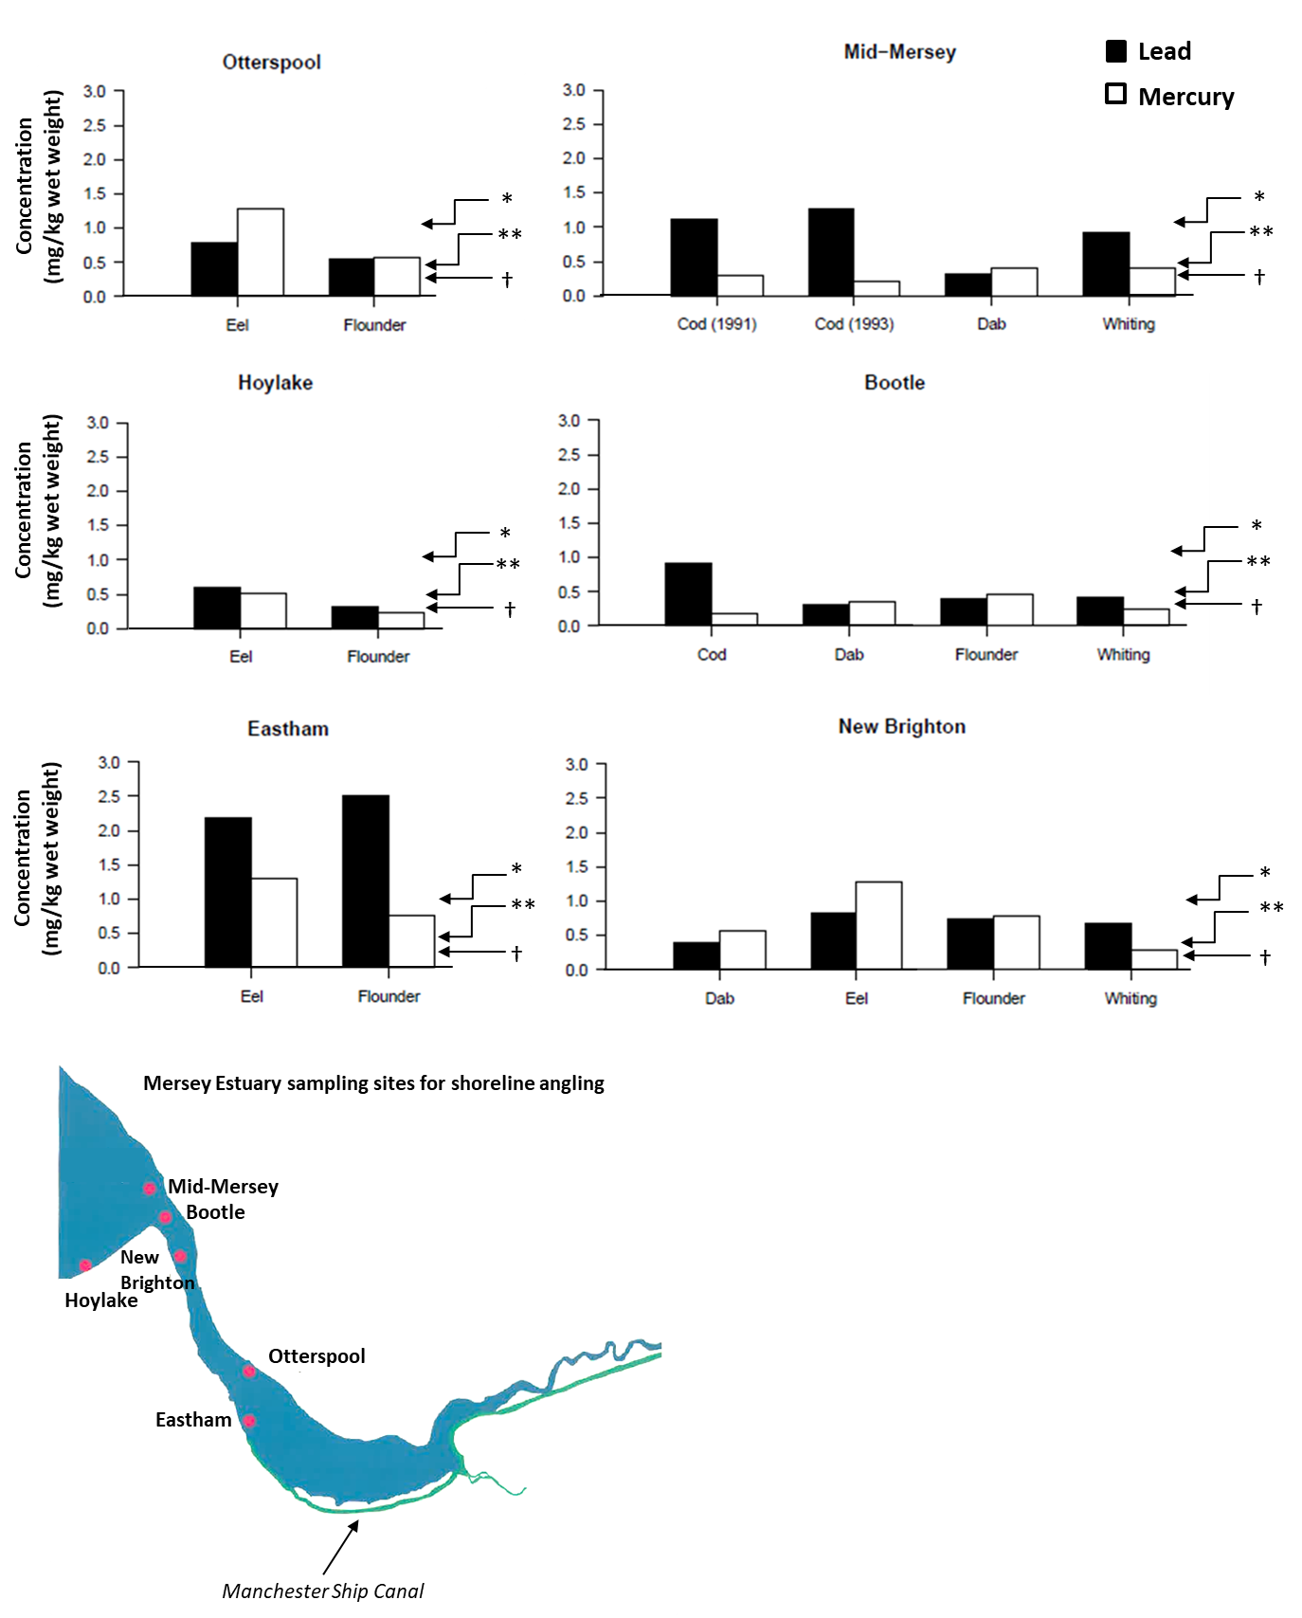
Figure 7. Lead and mercury in angler caught fish. The Environmental Quality Standard (EQS) for *eels is 1.0 mg/kg of mercury; **fish is 0.5 mg/kg of mercury; and †eels and fish is 0.3 mg/kg of lead. The map shows Mersey Estuary sampling sites depicted in the graphs above. Figure modified from NRA (1995), with data from Edwards (1994).

Restoring disused docks
The growth of the global shipping trade in the 16 - 17th centuries resulted in development of major commercial maritime docks in harbour cities worldwide, and the associated modification and destruction of natural shoreline habitats (Hawkins et al., 1999a, b; Chou, 2006). Here we use the example of the Liverpool, UK docks – the world’s first mercantile dock system from the early 18th century (Ritchie-Noakes, 1984; Hawkins et al., 1999b) – to describe ecological rehabilitation efforts.
The first enclosed dock basin was built in Liverpool in 1710 to combat the large tidal range of around 10 m (Allison, 1949; Ritchie-Noakes, 1984; Hawkins et al., 1999b). Eventually Liverpool had > 100 docks that stretched 10 km from the sea up the River Mersey during its peak in the early 20th century (Ritchie-Noakes, 1984; Hawkins et al., 1999b). These hard artificial structures replaced soft sediment and salt marsh (Hawkins et al., 1992a; 1999b). Many enclosed dock basins built in British macro-tidal estuaries fell into decline and disuse from the 1970s with the onset of containerisation (McConville, 1977; Hawkins et al., 1992a). Following building in Liverpool of a container terminal at Seaforth at the entrance to the Mersey Estuary, the South Dock system was abandoned in the 1970s (Ritchie-Noakes, 1984). The dock gates were left open and the docks silted up (Hawkins et al., 1992a; Hawkins et al., 1999a). When the gates were restored and water re-introduced as a precursor to urban renewal schemes in the mid-1980s (Hawkins et al., 1999a), the docks had stagnant and oxygen-poor, heavily-polluted shallow water (Hendry et al., 1988a; Allen et al., 1992, 1995; Hawkins et al., 1992a). Some of the docks only had intermittent exchange of water with the outer estuary on spring tides (Hawkins et al., 1992a).
Such disuse provided opportunities to test novel ecological engineering (eco-engineering) approaches for urban waterfront regeneration with ecological and societal benefits (Hawkins et al., 1992a). But urban renewal was retarded by eutrophic, anoxic, smelly, polluted waters with unsightly algal blooms and reduced biodiversity that were aesthetically displeasing (Russell et al., 1983; Allen et al., 1992; Hawkins et al., 1992a; Hawkins et al., 1999a). Thus, interventions were undertaken with the aim of improving water quality to increase biodiversity and ecosystem functioning (i.e., biofiltration, nutrient cycling) and create an environment amenable to urban renewal.
The first lessons learnt came from an experimental salmonid farm established in the 1970s in Sandon Dock. This tested the potential for disused docks to be used for aquaculture as part of an early diversification effort by the Mersey Dock and Harbour Company (Russell et al., 1983; Hawkins et al., 1992b; Hawkins et al., 1999b). An airlift water circulation and aerator system was installed to promote oxygenation and mixing of the water column (Fig. 8; Russell et al., 1983). Although the salmonid farm failed due to a red-tide event when dinoflagellate resting stages were re-suspended (Russell et al., 1983; Hawkins et al., 1992a), the water circulation/aerator improved water quality significantly to allow for colonisation of the dock walls by mussels and their rope cultivation using natural settlement (Russell et al., 1983; Hawkins et al., 1992a, b; Allen and Hawkins, 1993). In addition, there was substantial colonisation of the docks by a diverse benthic biological community (Russell et al., 1983; Hawkins et al., 1992b; Hawkins et al., 1999b). The dense mussel population in Sandon was probably facilitated by the artificial water circulation to act as a biofiltration system at all depths in the dock leading to clear water (Russell et al., 1983; Hawkins et al., 1992b).
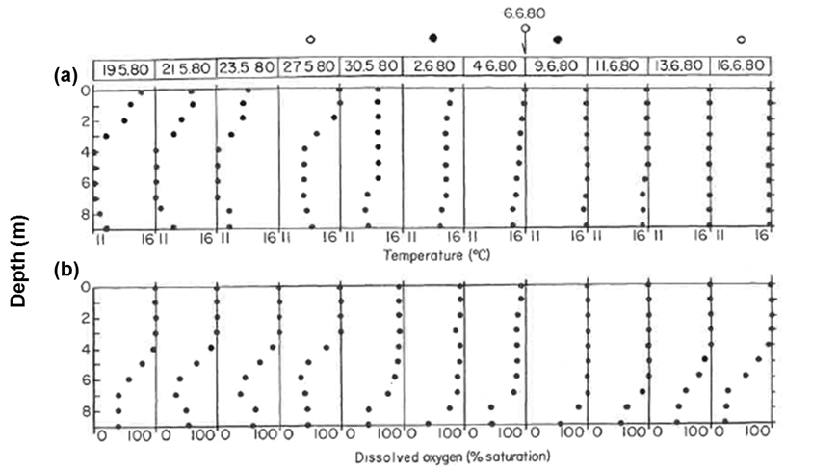
Figure 8. The effects of air-lift pump mixing on (a) temperature and (b) dissolved oxygen depth profiles in Sandon Dock. Sampling dates are given above. Empty circles above the profiles represent when pump was turned on, while dark circles denote when pump was switched off. Temperature range was 11 - 16 °C, while oxygen saturation range was 0 - 100% Figure was obtained from Russell et al. (1983).

To improve water quality in the Albert Dock complex in the South Docks, an airlift pump for mixing was installed in the mid-1980s on advice of the University of Liverpool on the basis of experience in Sandon Dock. Mussels were subsequently experimentally transplanted into the former Graving Dock in the South Docks to trial a biofiltration system (Allen et al., 1992; Allen and Hawkins, 1993). Initially, 600 kg of mussels contained within mesh-tubing were purchased from a mussel fishery in the Menai Strait, North Wales and suspended from buoyed lines in the Graving Dock, which at the time, supported very low abundances of filter feeders (Allen and Hawkins, 1993). Fortunately, however, a large natural settlement of mussels occurred in the Albert Dock and many others in the South Dock complex during extensive locking of water during the Tall Ships Race of 1988 (Allen et al., 1992; Hawkins et al., 1999a). The progress of this initial colonising cohort can be seen in Fig. 9: density decreased as biomass increased and stabilised (Fig. 9a); the dominant cohort was still apparent five years later. Subsequent recruitment to the dock walls was much slower, presumably due to intraspecific competition for space and possible filtration of larvae. Dense settlement still occurred on new material put in the docks, such as floating pontoons.

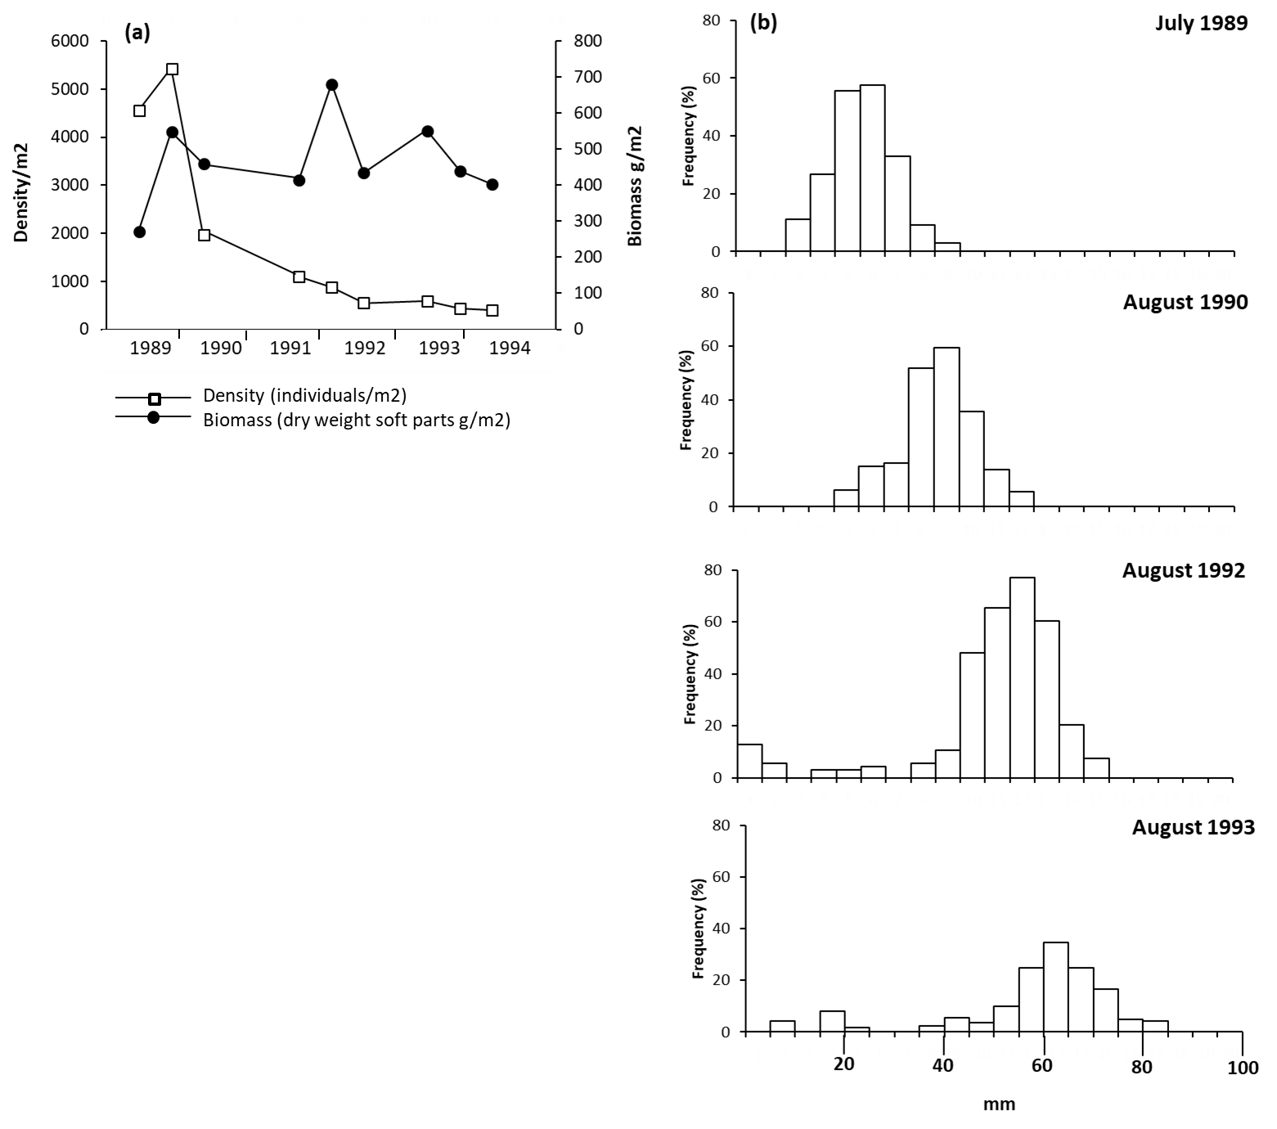
Figure 9 (a) Recruitment and stabilisation of mussel (Mytilus edulis) populations in Albert Dock. Source: unpublished data from Wilkinson, Allen and Hawkins. (b) Mussel size population structure from 1989 - 1993 at 1 - 2 m depth in Albert Dock. Figure redrawn from Wilkinson et al. (1996).

The increase in abundance of mussels led to rapid filtration of the water in the dock (measured as the time taken for one dock volume of water to pass through the mussel population), with the fastest filtration rate estimated to be in the Albert Dock, at 1 - 3 days (Allen et al., 1992; Allen and Hawkins, 1993; Hawkins et al., 1999a). Subsequently, water clarity improved markedly owing to a decline in phytoplankton biomass; this was attributed to increase in biofiltration, controlling populations of phytoplankton (see also Dame et al., 1980; Officer et al., 1982). The dock was also oxygenated throughout the water column by artificial mixing breaking down any thermocline formation. Ultimately, the combination of artificial mixing via airlift pump and natural biofiltration by mussels led to significant water quality improvements in both the Sandon and South Dock complexes (Fig. 10; Russell et al., 1983; Allen et al., 1992).

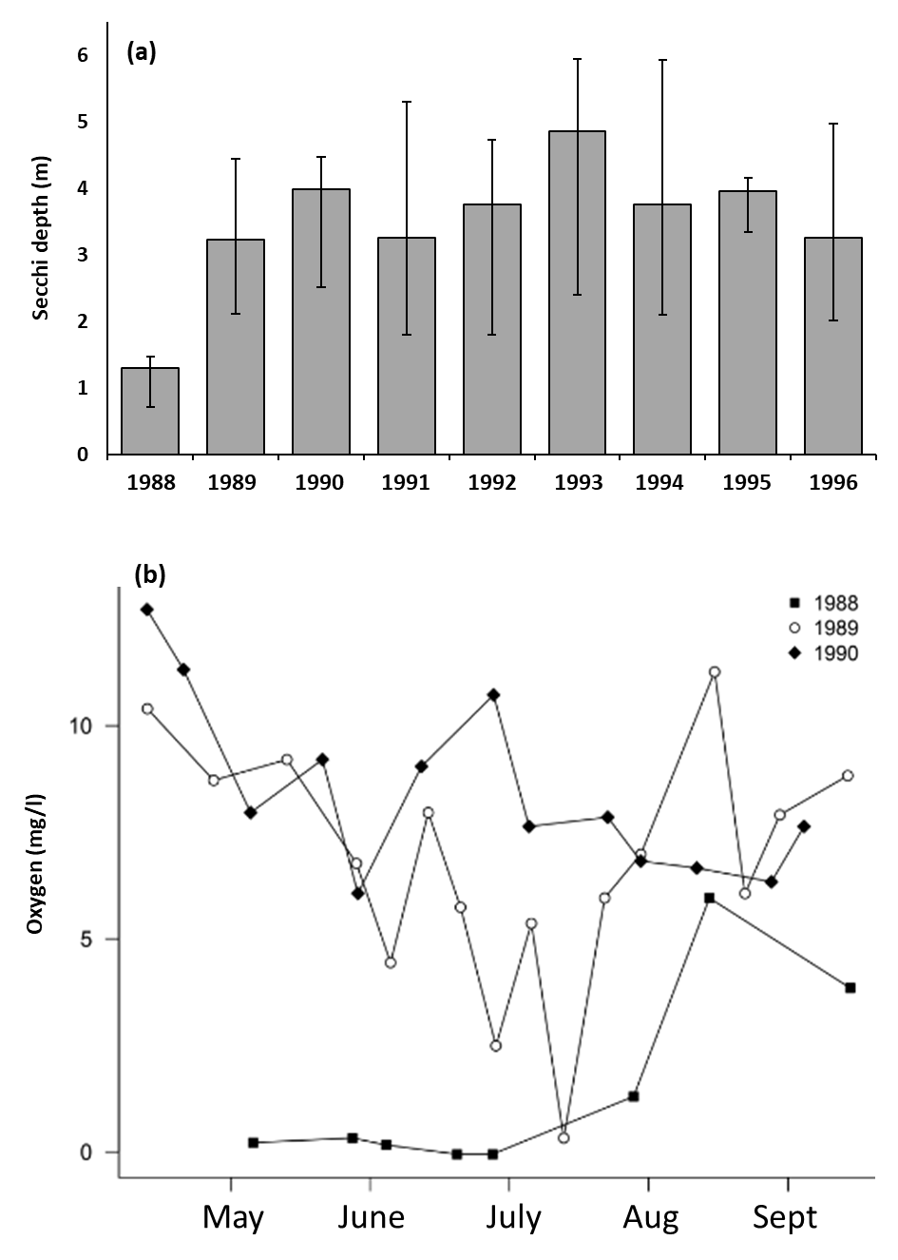
Figure 10. (a) Water clarity (Secchi depth) in Albert Dock between June and August 1988 - 1996. Redrawn from Hawkins et al. (1999b). (b) Oxygen concentrations in Albert Dock, showing improvement over time (1988 - 1990).

Considerable improvements in water quality coupled with a large cover of dense mussels allowed a diverse assemblage of benthic invertebrates to colonise the dock walls (Fig. 11; Hawkins et al., 1993; Wilkinson et al., 1996; Fielding, 1997). Barnacles and bryozoans were followed by mussels from natural settlement, which not only helped improve water quality but also provided complex habitat for associated fauna and flora, including tunicates and sponges, as well as smaller organisms such as amphipods and polychaetes (Allen et al., 1995; Wilkinson et al., 1996). De-stratification of the water column in the docks allowed algae to live deeper in clearer water, and bivalves and other benthic invertebrates were able to colonise the dock walls at all depths down to the sediment (Hawkins et al., 1993; Allen et al., 1995). There was, however, less colonisation of the sediments that still consisted of glutinous, anoxic mud. Overall, a diverse but totally novel community resulted.
With a rich assemblage of benthic organisms in the docks and high oxygen levels, fish returned to the area. The assemblage of fish caught in docks reflected those in the Estuary – with locking in and out, the dock system acted as a giant fish trap. Those caught or observed in the docks include migratory fish in passage through estuaries (e.g., eels from freshwater to the ocean; salmonids from the ocean to freshwater), resident fish (e.g., sticklebacks), fish that spend most of their time in estuaries but migrate to the sea to spawn (e.g., flounder), typical inshore species that stray into the outer reaches of estuaries (e.g., dab, cod) and those using estuaries as nursery grounds (e.g., herring, sprat, gadoids). Over time, surprisingly diverse fish species were caught in multi-mesh gill nets (Table 2). The most noteworthy being the sea trout (Salmo trutta), an indicator species providing evidence of clean-up of the estuary and catchment (Salmon & Trout Conservation of the UK, 2019).
In 2012, a follow-up survey was made to establish whether a stable ecosystem was present in the docks. Despite a slight reduction in salinity due to connection with the freshwater Leeds-Liverpool Canal to promote recreational boating, the assemblages were remarkably stable and were still dominated by mussels (Firth et al., unpublished). A few starfish (Asterias rubens) had settled naturally in Albert Dock but were in insufficient numbers to have much impact on the mussels. A diverse and stable ecosystem with high quality clear water had persisted for over 20 years.
Due to the significant ecological improvements, the Albert Dock Complex has successfully been developed for luxury housing, museums and office space, now being a major English tourist attraction and are frequently used for water sports including swimming (Hawkins et al., 1992a). The docks also serve as ‘artificial lagoonoids’ (Allen et al., 1995), supporting diverse and abundant biological communities in addition to providing habitat for some endangered lagoon species (see Table 3 for a summary of studies done on the flora and fauna of the Mersey Estuary and dock complexes).
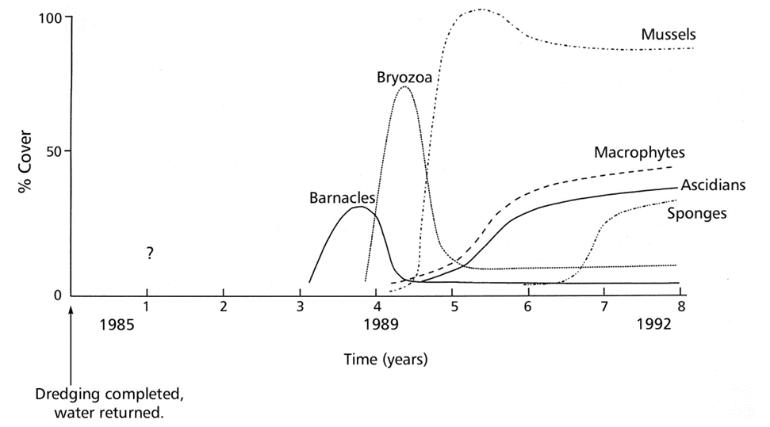
Figure 11. Colonisation of major biotic groups on the walls in the Albert Dock following dredging and refilling with water. Dredging and replacement with water occurred between 1981 - 1985. Water quality remained relatively poor until a dense natural settlement of mussels occurred in late summer and autumn of 1988. ‘?’ represents no data. Figure from Hawkins et al. (1999b), which was modified from Allen (1992).
Table 2. List of species of fish caught in the South Docks, Liverpool in the late 1980s - mid-1990s following substantial improvements in water quality due to restoration work initiated in the 1980s.
Species | Common name | Reference
Trisopterus luscus (Linnaeus, 1758) | Bib | Allen (1992); Fielding (1997)
Gadus morhua Linnaeus, 1758 | Atlantic Cod | Allen (1992); Zheng (1995); Fielding (1997)
Limanda limanda (Linnaeus, 1758) | Common Dab | Allen (1992); Zheng (1995); Fielding (1997)
Platichthys flesus (Linnaeus, 1758) | Eurpoean Flounder | Allen (1992); Zheng (1995); Fielding (1997)
Melanogrammus aeglefinus (Linnaeus, 1758) | Haddock | Fielding (1997)
Clupea harengus Linnaeus, 1758 | Atlantic Herring | Allen (1992); Fielding (1997)
Pleuronectes platessa Linnaeus, 1758 | European Plaice | Allen (1992); Zheng (1995); Fielding (1997)
Pollachius pollachius (Linnaeus, 1758) | Pollack | Fielding (1997)
Taurulus bubalis (Euphrasen, 1786) | Long spined sea scorpion | Allen (1992); Zheng (1995); Fielding (1997)
Salmo trutta Linnaeus, 1758 | Sea Trout | Zheng (1995); Fielding (1997)
Myoxocephalus scorpius (Linnaeus, 1758) | Short spined sea scorpion | Fielding (1997)
Solea solea (Linnaeus, 1758) | Common Sole | Allen (1992); Fielding (1997)
Sprattus sprattus (Linnaeus, 1758) | European sprat | Allen (1992); Fielding (1997)
Chelidonichthys lucerna (Linnaeus, 1758) | Tub Gernard | Fielding (1997)
Merlangius merlangus (Linnaeus, 1758) | Whiting | Allen (1992); Zheng (1995); Fielding (1997)
Anguilla anguilla (Linnaeus, 1758) | European Eel | Allen (1992); Zheng (1995)
Chelon labrosus (Risso, 1827) | Thick-lipped grey mullet | Allen (1992); Zheng (1995)
Ciliata mustela (Linnaeus, 1758) | Five bearded rockling | Allen (1992)
Gasterosteus aculeatus Linnaeus, 1758 | Three-spined stickleback | Allen (1992); Fielding (1997)
Pomatoschistus microps (Krøyer, 1838) | Common Goby | Allen (1992); Fielding (1997)
Syngnathus rostellatus Nilsson, 1855 | Pipefish | Allen (1992); Fielding (1997)

Table 3. Summary of selected published and grey literature on (A) benthos, (B) fish and (C) plankton in the Mersey Estuary and adjacent coast of inner Liverpool Bay. A dash (-) in any column represents unknown information. Mixed bottom sediment includes sand, silt and gravel. MSC = Manchester Ship Canal.
Focal topic | Location | Period | Reference
(A) Benthos
Entire estuary
soft sediment fauna | Upper and lower | 1930s | Fraser (1932); Bassindale (1938)
 | Upper and lower | 1970s | Miller-Moore (1975); Moore (1978); Ghose (1979); Pugh-Thomas (1980)
 | Upper, middle, lower | 1980s | NNWA; Bamber (1988); Holland (1989); NRA (1995)
 | Upper and lower | early 1990s | ERL (1993)
 | Upper, middle, lower | early 2000s | Environment Agency (2002)
salt marsh fauna | Upper | 1980s | Yasin (1987)
mixed bottom sediment fauna | Upper | 1930s | Fraser (1932)
Docks
fouling flora and fauna | Sandon, Preston Docks | 1980s | Russell et al. (1983); Conlan et al. (1992)
 | Sandon, South, Graving, Queens, Albert, Princes Docks | late 1980s-early 1990s | Allen (1992); Hawkins et al. (1992a); Allen et al. (1995); Wilkinson et al. (1996); Wilkinson et al. (unpublished)
 | Upper MSC, South Docks | mid 1990s-early 2000s | Fielding (1997); Nash et al. (2003)
soft sediment fauna | Collingwood Docks | 1970s | James and Gibson (1980)
 | South Docks | late 1980s-early 1990s | Allen (1992); Allen et al. (1995)
 | MSC Turning Basin, South Docks | 1990s-mid 2000s | Fielding (1997); Nash et al. (2003); Williams et al. (2010)
 | Upper MSC | 1998 - 2000 | Nash et al. (2003)
filtering fauna (mussels) | South Docks | late 1980s-early 1990s | Allen (1992); Allen et al. (1992); Hawkins et al. (1992a); Hawkins et al. (1992b)
mixed bottom sediment fauna | Collingwood Docks | 1970s | James and Gibson (1980)
experimental mussel culture | Sandon Docks | late 1970s | Hawkins et al. (1992a); Hawkins et al. (1992b)
(B) Fish
Entire estuary
nektonic and demersal | upper, middle, lower | late 1980s-early 1990s | Environment Advisory Unit (1991); Collings et al. (1996)
flounder | upper | Late 1800s; 1920s | Cunningham and Lankester (1896); Dunlop (1927)
Docks - subtidal
nektonic and demersal | MSC | Late 1970s | D'Arcy and Pugh-Thomas (1978); D'Arcy and Wilson (1978)
 | Preston, Sandon Docks | 1980s | Russell et al. (1983); Conlan et al. (1988); Hendry et al. (1988b)
 | South Docks | late 1980s-mid 1990s | Allen (1992); Allen et al. (1995); Zheng (1995); Fielding (1997)
 | Mid-upper MSC | 1977 - 1987 | Wilson et al. (1988)
 | Upper MSC, MSC Turning Basin | late 1990s-mid 2000s | Nash et al. (2003); Williams et al. (2010)
 | South docks | early 1990s | Fielding (1997)
 | - | early 2010s | APEM (2014)
experimental salmonid farm | Sandon Docks | late 1970s | Hawkins et al. (1992a); Hawkins et al. (1992b)
(C) Plankton
Entire estuary
zooplankton | Liverpool Bay | 1970s-1980s | Williamson (1975a)
phytoplankton | Liverpool Bay | 1970s-1980s | Sharples (1972); Burrows (1975); Voltolina et al. (1986)
Docks
phytoplankton | Preston, Graving, Albert, Queens Docks | late 1980s-early 1990s | Conlan et al. (1988); Allen (1992); Conlan et al. (1992)
 | Preston Dock | late 1980s | Conlan et al. (1992)
 | South, Central and Wirral Docks | 1990s | Fielding (1997); Wanstall (1997)
zooplankton | Saldon, Albert, Queens, Princes, South Docks | early-mid 1990s | Wilkinson et al. (1996); Fielding (1997); Williams et al. (2010); Wilkinson et al. (unpublished)
 | Saldon Dock | mid 2000s | Williams et al. (2010)

Overview and synthesis
Recovery of the Mersey has been influenced by wider contextual changes and far field impacts (Fig 12a). Atmospheric inputs of nitrogen and nutrient enrichment of the catchment due to agricultural intensification can both lead to eutrophication (Bennett et al., 2001; Ulén et al., 2007; Oberholster et al., 2019) in addition to the nutrient loading from sewage treatment (Lapointe and Clark, 1992; Braga et al., 2000). There were also impacts in Liverpool Bay such as dumping of sewage sludge, industrial waste and dredge aggregate in the 1970s (Hawkins et al., 1999a) which tended to have primarily localised impacts (“Out of sight, Out of mind”; Department of the Environment, 1972). At the Irish Sea scale, much over-fishing has occurred, in turn, influencing the spawning stock biomass of fish using the inshore waters and estuaries of Liverpool and Morecambe Bays as nursery grounds (e.g., plaice, herring, gadoids; The Irish Sea Study Group, 1990). Superimposed on these regional scale impacts are the pervasive effects of climate fluctuations (e.g., greater use of west coast than east coast by migratory birds during the colder winters of the 1960s, 1970s and early 1980s; see Williamson, 1975b). Additionally, there are effects from more recent warming driven by anthropogenic climate change, such as northern cold water species such as herring (Clupea harengus) and cod (Gadus morhua) doing less well once warming began from the late 1980s (Planque and Frédou, 1999; Drinkwater, 2005; Fogarty et al., 2008). There is now recreational fishing for the warmer-water sea bass (Dicentrarchus labrax) at the mouth of the Mersey, unheard of before the 1990s (Hawkins, pers. obs.). Fish such as flounder (Platichthys flesus) have been shown to respond to climate fluctuations in terms of phenology (Sims et al., 2004), with evidence of declines further south in their range (Martinho et al., 2010; Morais et al., 2011; Jokinen et al., 2015).
Furthermore, society is adapting to climate change, especially rising and stormier seas, by building sea defences to protect property and coastal infrastructure such as roads and railways (Airoldi et al., 2005; Firth et al., 2016). The shoreline of the mouth of the Mersey has numerous sea defences built since the 1980s (Millard et al., 1990). These not only created new rocky habitat for marine life (Moschella et al., 2005), but also had impacts on the soft sediment community creating a mosaic of coarse and muddy habitat patches (Martin et al., 2005). These defences have recently been shown to provide habitat for the southern warm-water reef-building worm Sabellaria alveolata (Firth et al., 2015), which is listed under the EU Habitats Directive and is a UK Biodiversity Action Plan Habitat. This species was formerly very common on Hilbre Island (Frost et al., 2004) and along the North Wales coast, but disappeared in the 1960s after the extremely cold winter of 1962/1963 (Crisp, 1964; Cunningham et al., 1984). It was observed to have re-colonised Hilbre Island and the North Wales coast in the early 2000s, probably using the sea defences on the Wirral as stepping-stones. It has even been observed living on dumped tyres and supermarket trolleys on the west side of the Mersey Estuary (Firth et al., 2015).
Recovery of the Mersey needs to be put in the wider context of regional and global change, as well as extensive local modification of coastal habitat by land-claim, residential development and construction of port installations (such as container terminals at Seaforth) and other transport infrastructure – plus the proliferation of renewable energy via offshore wind generation in Liverpool. Thus recovery will never occur to the pre-industrialisation state (Hawkins et al., 1999b), because of extensive changes in coastal morphology due to development and wider regionally and globally driven change, as well as the creation of “Novel Ecosystems” never before seen in nature (Hobbs et al., 2006; Morse et al., 2014; Bulleri et al., in press), such as the redundant dock basins (Hawkins et al., 1992a, 1999a; Allen et al., 1995), which are now the focus of tourism, residential and amenity use.
The above caveat aside, it is worth looking at a conceptual model of the hysteresis of degradation and recovery of the Mersey (Fig. 12a) and trying to generalise about the underlying processes and key targets for monitoring and management (Fig. 12b). Since Neolithic times, the Estuary would have been impacted by land-use changes (Cowell, 1999) as agriculture was developed. The Estuary has a long history of artisanal fishing and land-claim for agriculture by draining marshes and some polderisation to form grazing meadows. In this respect, the adjacent Dee and Ribble Estuaries have suffered far more than the Mersey (The Irish Sea Study Group, 1990). Once docks were installed and population rapidly expanded with world trade and industrialisation of the catchment and hinterland, the whole Mersey Estuary became polluted from the early 19th century onwards, culminating in widespread hypoxia in the upper and middle reaches in the 1950s - 1970s (Jones, 2000; Jones, 2006). In parallel with ecosystem collapse (Fig. 12b), many other pollutants were present. Water quality could be monitored by gross indicators (BOD, oxygen, water clarity; Jones, 2000). Once widespread episodic anoxia was dealt with by sewage treatment, recovery was rapid, occurring in parallel with stricter environmental regulations (NRA, 1995) and de-industrialisation, especially closure of older, dirtier mills, plants and factories. This was reflected in declining contaminant burdens. Sub-lethal effects included trophic-transfer to charismatic wildlife leading to kills (birds; Bull et al., 1983; Wilson et al., 1986) and recreationally exploited fish led to human health concerns (Leah et al., 1997; Allen et al., 1999). At this stage in recovery of any system, molecular and cellular indicators coupled with surveys to examine population and community ecology are required (see similar work in Hong Kong; Hodgkiss and Chan, 1983; Xu et al., 2004). Once recovery gathers pace, continued vigilance is essential. For example, endocrine disruptors in the 1970s and 1980s (e.g., TBT in antifouling paints; Alzieu, 2000; Morcillo and Porte, 2000; Grun et al., 2006) and possible effluents from sewage treatment plants derived from pharmaceuticals (Kinney et al., 2006; Zhou et al., 2009) such as birth control pills (Körner et al., 2001) can have lasting effects on organisms and ecosystems (Jobling et al., 1998) plus consequences for human health (Howard, 2003; Malchi et al., 2014; but see Cunningham et al., 2009). Such vigilance will manage risks via the human food chain.
Once recovery is underway, active management of pollution is still required to keep on top of emerging pollutants such as nano-materials (e.g., in food packaging; Moore, 2006) and flame retardants (e.g., Tetrabromodiphenyl ether, Hexabromocyclododecane; Darbre, 2015). Moreover, pollution needs to be considered in the wider context of conservation and integrated coastal zone management aided by marine spatial planning and an ecosystem-based approach. In the Mersey, the national, European and international conservation designations place priority on maintenance of ecological status and continued supply of ecosystem services to society (NRA, 1995).
Ultimately, the Mersey Estuary as a whole consists of a range of natural and novel ecosystems; the latter include totally artificial and highly modified shorelines on both sides of the Narrows and into Liverpool on the Wirral and Lancashire shores. The docks are an exemplar of a completely novel ecosystem maintained by a combination of artificial de-stratification (in Albert Dock) with natural biofiltration by mussels and other filter feeders in the whole South Docks complex (Allen, 1992; Hawkins et al., 1992b; Allen and Hawkins, 1993). In addition to being considered as urban coastal ‘cubist lagoonoids’ providing habitat for rare lagoonal species from a EU priority habitat at risk (Allen et al., 1995), the docks also fulfil an important role in urban nature conservation by providing a window on the marine world for the local population (Hawkins et al., 1992a). High quality water aids amenity use, water sports and boosts the attractiveness of the tourist-hubs that the Albert Dock Complex provides. High quality water thus enhances commercial and residential use plus tourism (Hawkins et al., 1992a).
Similar trajectories have been observed in other degraded estuaries such as the well-studied Thames (for reviews see Wheeler, 1979; Andrews, 1984; Attrill, 1998). The Thames estuary has been heavily modified by embankments, weirs and bridges in its upper reaches since the Middle Ages (Attrill, 1998). Proliferation of enclosed dock basins has followed since the 18th century down to the middle reaches of the estuary and beyond, along with rapid industrialisation and huge population growth leading to massive untreated sewage discharge (Andrews, 1984). Extensive land-claim has occurred in the outer estuary. Inevitably water quality and ecosystems were severely degraded along with major impacts on public health. The River Thames in London was known as an “open sewer” from the late 1800s. But from the early 1960s to the late 1970s, the Thames ecosystem was able to recover through the modernisation of sewage treatment works (Andrews, 1984). From the early 1900s up to the mid-1960s, fish did not enter the inner Thames due to its severely polluted state (Wheeler, 1979). In the late 1800s, pollution in the Thames generally moved east to the Barking area, where sewage sludge built up along the banks of the river. To address this, by 1891, sewage solids were transferred by ships to the sea, resulting in marked increases in dissolved oxygen in the estuary. But following the First World War, the Thames ecosystem was again in decline as a consequence of a rise in population in London. Over the next few decades, sewage treatment works were constructed along the Thames, and in 1954 and 1959 a primary sedimentation plant and a modern diffused air activated sludge plant were constructed at Beckton. Finally, in 1964, Crossness works was completely rebuilt with the then largest mechanized aeration plant in the UK (Andrews, 1984). Since the opening of the aeration plant in 1964, the Thames has not experienced anaerobic conditions (Wood, 1980). Extensive improvements to sewage treatment lead to a decrease in pollution load discharge to the estuary of nearly 80%, with a trend of increasing dissolved oxygen levels from 1960-1980. As a result, the macrofaunal community stabilised in the late 1970s (Andrews, 1984). Flounder (Platichthys flesus) and eel (Anguilla anguilla) were the first to recolonise the Thames (Andrews and Rickard, 1980). A significant increase in commercial fishermen on the Thames was observed in the early 1980s (Andrews and Rickard, 1980). The Thames ecosystem has also been influenced by wider climatic and environmental fluctuations (Attrill, 1998; Power et al., 2000). The brackish salinity of much of the London docks system has, however, meant that water quality improvement by biofiltration by benthic bivalves was not possible as none could live there (as in Preston Docks on the upper Ribble Estuary in the North of England (Conlan et al., (1992)).
San Francisco Bay, USA provides an excellent example of a highly modified estuary which has suffered from rapid urban development, canalisation (Kondolf, 2000), much sewage input leading to eutrophication and harmful algal blooms (Cloern, 2001), as well the intensive agriculture in its catchment leading to changes in sediment and freshwater input (Luoma and Cloern, 1982; Cloen and Jassby, 2012). Similar to the Mersey (and many large estuaries globally), San Francisco Bay provides vital habitat for resident and migratory fish (Leitwein et al., 2017; Cloen and Jassby, 2012) and shorebirds and ducks (Takekawa et al., 2001). As a result of The Clean Water Act of 1972 passed by the US Congress, The Bay ecosystem has since recovered to some extent (Jaworski, 1990; Hornberger et al., 2000; Cloen and Jassby, 2012). Interestingly it has been pushed to an alternative clear water state by the intensive filter feeding by a proliferating invasive bivalve (Corbula amurensis), which whilst improving water quality by removing phytoplankton (Greene et al., 2011), has considerably disrupted the ecosystem – perhaps the ultimate example of a novel estuarine ecosystem.
The Mersey, along with the Thames, illustrates the intrinsic capability of marine and estuarine ecosystems to recover (Hawkins et al., 1999b; Hawkins et al., 2002; Thompson et al., 2002), once pressures have been removed. This is mainly due to their open nature with supply of planktonic propagules and mobile juvenile and adult fish and other nekton from adjacent unimpacted areas (Geist and Hawkins, 2016). Rehabilitation or restoration can speed recovery in more enclosed areas such as lagoons or docks by both physical (bottom-up; e.g., mixing) and biological (top-down; e.g., biofiltration) interventions (Hawkins et al., 2002) if conditions allow. Thus, the aims of the Mersey Basin Campaign have largely been realised. The only missed opportunity has been that the final stages of recovery have not been monitored in detail; resources dried-up and were directed elsewhere as the problem was seen to have been solved. Therefore, a real chance has been missed to intercalibrate means of assessing pollutants at different levels of biological organisation from molecules and cells through individuals, to populations and communities up to whole ecosystems (see comments in Hawkins et al., 2002).
Nonetheless, the Mersey has shown considerable resilience and recovery powers despite what 300 years of industrial and urban development has thrown at it. Along with the Mersey, most highly modified estuaries worldwide – given their extensive fringing habitat and upstream catchment modification and far field impacts such overfishing and climate change plus invasive species – will never return to near pristine states. Hence the hysteresis loop in Fig. 12a has been not closed. However, clean-up will enable recovery. Targeted restoration and rehabilitation can also put back biodiversity, functioning but novel ecosystems with their services, in the midst of teeming conurbations.
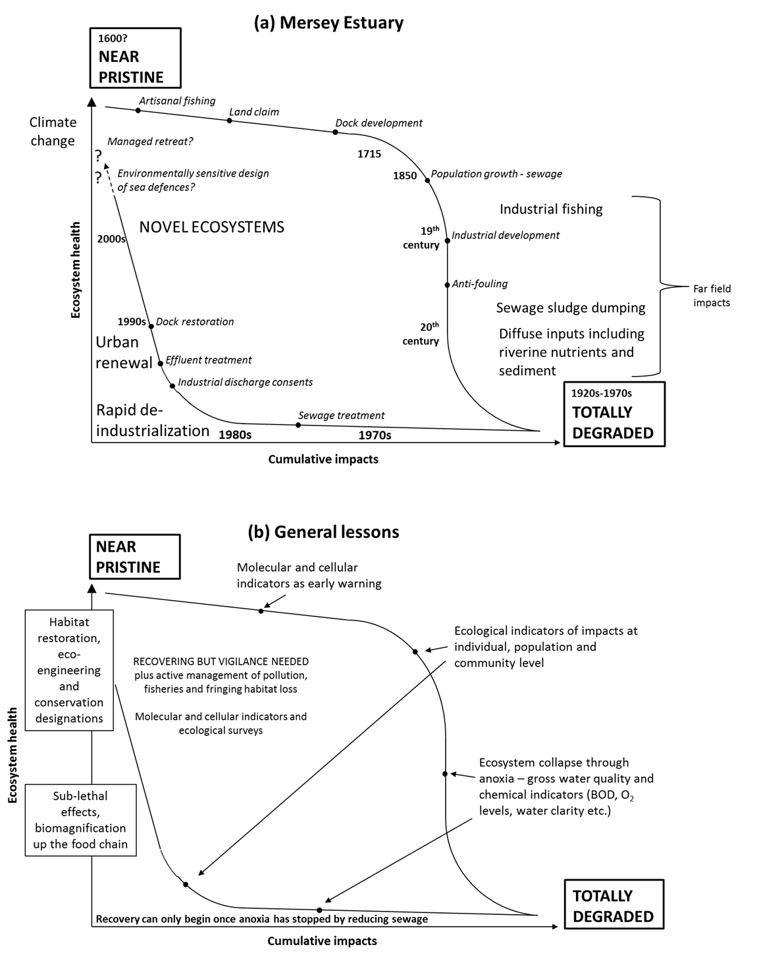
Figure 12. Hysteresis of degradation and recovery: (a) the Mersey Estuary and (b) generalised for any heavily impacted enclosed system with comments on processes and monitoring strategies.

Referees
1. Peter Jonas peterandlynne@blueyonder.co.uk
2. Rudolf Wu – The Education University of Hong Kong rudolfwu@eduhk.hk
3. Andrew Wither – National Oceanography Centre, Liverpool awith@noc.ac.uk

Funding
Work was supported in the 1970s and 1980s by Mersey Dock and Harbour Company, as well as the Merseyside Development Corporation,and the UK Nature Conservancy Council in the 1980s and 1990s. Work by W J Langston was supported by the National Rivers Authority and the Environment Agency. Recent work was supported by Esmée Fairbairn Foundation (Urbane project) and English Nature in the 2000s and 2010. Write up was supported by a bursary from the MBA to KAO.

Acknowledgements
Much of the early work on Sandon Dock was started by Dr Ken O’Hara of the University of Liverpool. Hugh Jones, Keith White and George Russell also played a key role in the work on Sandon and in the South Docks. The late Dr Rick Leah of Liverpool University led much of the work on pollution in the Estuary

References
Abdullah, M. & Royle, L. (1973). Chemical evidence for the dispersal of River Mersey run-off in Liverpool Bay. Estuarine and Coastal Marine Science, 1, 401-409. 10.1016/0302-3524(73)90029-7
Adey, P. (2016). Protecting the Population: Bureaucracy, Affectivity and Governing the Liverpool Blitz. Ordnance: War+ Architecture & Space. Routledge. 73-88.
Airoldi, L., Abbiati, M., Beck, M.W., Hawkins, S.J., Jonsson, P.R., Martin, D., Moschella, P.S., Sundelöf, A., Thompson, R.C. & Åberg, P. (2005). An ecological perspective on the deployment and design of low-crested and other hard coastal defence structures. Coastal Engineering, 52, 1073-1087. 10.1016/j.coastaleng.2005.09.007
Alexander, B. (1982). Future improvements to the Mersey Estuary. Royal Society of Health Journal, 102, 211-215. 10.1177/146642408210200507
Allen, J., Slinn, D., Shummon, T., Hartnoll, R. & Hawkins, S. (1998). Evidence for eutrophication of the Irish Sea over four decades. Limnology and Oceanography, 43, 1970-1974. 10.4319/lo.1998.43.8.1970
Allen, J.R. (1992). Hydrography, ecology and water quality management of the South Docks, Liverpool. University of Liverpool.
Allen, J.R. & Hawkins, S.J. (1993). Can biological filtration be used to improve water quality? Studies in the Albert Dock Complex, Liverpool. Urban Waterside Regeneration: Problems and Prospects, 377-385.
Allen, J.R., Hawkins, S.J., Russell, G.R. & White, K.N. (1992). Eutrophication and urban renewal: problems and perspectives for the management of disused docks. Science of the Total Environment, 1283-1295.
Allen, J.R., Wilkinson, S.B. & Hawkins, S.J. (1995). Redeveloped docks as artificial lagoons: The development of brackish‐water communities and potential for conservation of lagoonal species. Aquatic Conservation: Marine and Freshwater Ecosystems, 5, 299-309.
Allen, Y., Matthiessen, P., Scott, A.P., Haworth, S., Feist, S. & Thain, J.E. (1999). The extent of oestrogenic contamination in the UK estuarine and marine environments—further surveys of flounder. Science of the Total Environment, 233(1-3), 5-20. 10.1016/S0048-9697(99)00175-8
Allison, J. (1949). The Mersey Estuary, Liverpool, The University Press of Liverpool.
Alzieu, C. (2000). Impact of tributyltin on marine invertebrates. Ecotoxicology, 9, 71-76. 10.1023/A:1008968229409
Andrews, M.J. (1984). Thames Estuary: pollution and recovery. In Sheehan, P.J., Miller, D.R., Butler, G.C., and Bourdeau P.H. (eds) Effects of pollutants at the ecosystem level, pp.195-228. SCOPE, published by John Wiley & Sons Ltd.
Andrews, M.J. and Rickard, D.G. (1980). Rehabilitation of the inner Thames estuary. Marine Pollution Bulletin, 11(11), 327-332.
APEM (2014). Manchester Ship Canal: Summary of Known Data and Relevant Information. United Utilities, February 2015 Final.
Attrill, M.J. (Ed.) (1998). A rehabilitated estuarine ecosystem: The environment and ecology of the Thames estuary. Springer Science & Business Media.
Bamber, R.N. (1988). A Survey of the Intertidal Soft-sediment Fauna of the Mersey Estuary: March 1987. Leatherhead Central Electricity Research Laboratories.
Bassindale, R. (1938). The intertidal fauna of the Mersey estuary. Journal of the Marine Biological Association of the United Kingdom, 23, 83-98.
Bennett, E.M., Carpenter, S.R. & Caraco, N.F. (2001). Human impact on erodable phosphorus and eutrophication: a global perspective: increasing accumulation of phosphorus in soil threatens rivers, lakes, and coastal oceans with eutrophication. BioScience, 51, 227-234. 10.1641/0006-3568(2001)051[0227:HIOEPA]2.0.CO;2
Billion Oyster Project. 2019. Available: https://billionoysterproject.org/ [Accessed 01 September 2019].
Braga, E.S., Bonetti, C.V., Burone, L. & Bonetti Filho, J. (2000). Eutrophication and bacterial pollution caused by industrial and domestic wastes at the Baixada Santista Estuarine System–Brazil. Marine Pollution Bulletin, 40, 165-173. 10.1016/S0025-326X(99)00199-X
Bull, K., Every, W., Freestone, P., Hall, J., Osborn, D., Cooke, A. & Stowe, T. (1983). Alkyl lead pollution and bird mortalities on the Mersey Estuary, UK, 1979–1981. Environmental Pollution Series A, Ecological and Biological, 31, 239-259.
Bulleri, F., Batten, S., Connell, S., Benedetti-Cecchi, L., Gibbons, M., Nugues, M.M., & Gribben, P. Human pressure and the emergence of novel marine ecosystems. Oceanography and Marine Biology: an Annual Review, In press.
Burger, J. & Gochfeld, M. (2004). Marine birds as sentinels of environmental pollution. EcoHealth, 1, 263-274. 10.1007/s10393-004-0096-4
Burrows, E. (1975). Phytoplankton studies in Liverpool Bay. Liverpool Bay, an assessment of present knowledge compiled by memebers of the Liverpool Bay Study Group. Natural Environment Research Council. 46-48.
Burton, L. (2003). The Mersey Basin: an historical assessment of water quality from an anecdotal perspective. Science of the Total Environment, 314, 53-66. 10.1016/S0048-9697(03)00094-9
Burton, N., Paipai, E., Armitage, M., Maskell, J., Jones, E., Struve, J., Hutchings, C. & Rehfisch, M. (2002). Effects of reductions in organic and nutrient loading on bird populations in estuaries and coastal waters of England and Wales Phase 1 Report March 2002. BTO Research Report.
Byatt, I. (1996). The impact of EC directives on water customers in England and Wales. Journal of European Public Policy, 3, 665-674. 10.1080/13501769608407059
Carwile, J.L., Luu, H.T., Bassett, L.S., Driscoll, D.A., Yuan, C., Chang, J.Y., Ye, X., Calafat, A.M. & Michels, K.B. (2009). Polycarbonate bottle use and urinary bisphenol A concentrations. Environmental Health Perspectives, 117, 1368-1372. 10.1289/ehp.0900604
CEFAS (2005). Monitoring of the quality of the aquatic environment 2002-2003. In: Aquatic Environment Monitoring Report.
Chau, K. (2005). Characterization of transboundary POP contamination in aquatic ecosystems of Pearl River Delta. Marine Pollution Bulletin, 51, 960-965. 10.1016/j.marpolbul.2005.02.028
Chou, L.M. (2006). Marine habitats in one of the world’s busiest harbours. The Environment in Asia Pacific Harbours. Springer. 377-391.
Clark, R. (1989). Marine Pollution, Oxford, Clarenden Press.
Cloern, J.E. (2001). Our evolving conceptual model of the coastal eutrophication problem, Marine Ecology Progress Series, 210, 223-253. 10.3354/meps210223
Cloern, J.E. & Jassby, A.D. (2012). Drivers of change in estuarine‐coastal ecosystems: Discoveries from four decades of study in San Francisco Bay. Reviews of Geophysics, 50(4). 10.1029/2012RG000397
Collings, S.E., Johnson, M.S. & Leah, R.T. (1996). Metal contamination of angler-caught fish from the Mersey Estuary. Marine Environmental Research, 41, 281-297. 10.1016/0141-1136(95)00020-8
Conlan, K., Hendry, K., White, K. & Hawkins, S. (1988). Disused docks as habitats for estuarine fish: a case study of Preston Dock. Journal of Fish Biology, 33, 85-91.
Conlan, K., White, K. & Hawkins, S. (1992). The hydrography and ecology of a re-developed brackish-water dock. Estuarine and Coastal Shelf Science, 35, 435-452.
Cowell, R. (1999). The human influence to the Norman Conquest. Ecology and Landscape Development: a History of the Mersey Basin. Conference Proceedings. Liverpool University Press.
Crisp, D.J. (Ed.) (1964). The effects of the severe winter of 1962-63 on marine life in Britain. Journal of Animal Ecology, 33(1), 165-210.
Cunningham, J.T. & Lankester, E.R. (1896). The natural history of the marketable marine fishes of the British Islands, Macmillian and Company.
Cunningham, P., Hawkins, S., Jones, H. & Burrows, M. (1984). The geographical distribution of Sabellaria alveolata (L.) in England, Wales and Scotland, with investigations into the community structure of, and the effects of trampling on Sabellaria alveolata colonies. Report to the Nature Conservancy Council from the Department of Zoology, Manchester University, Manchester, 1-38.
Cunningham, V.L., Binks, S.P. & Olson, M.J. (2009). Human health risk assessment from the presence of human pharmaceuticals in the aquatic environment. Regulatory Toxicology and Pharmacology, 53, 39-45. 10.1016/j.yrtph.2008.10.006
D'Arcy, B. & Pugh-Thomas, M. (1978). The occurrence and numbers of fish in screenings from a cooling tower intake on the Manchester Ship Canal. Bulletin of the Estuaries and Brackish Water Science Association, London, 20, pp.2-7.
D'Arcy, B. & Wilson, K. (1978). Fish surveys on the Manchester Ship Canal - the implecations for routine chemical sampling. Technical Report. NWWA (Rivers Division). (unpublished).
Dame, R., Zingmark, R., Stevenson, H. & Nelson, D. (1980). Filter feeder coupling between the estuarine water column and benthic subsystems. Estuarine Perspectives. Academic Press, 521-526.
Darbre, P.D. (2015). What are endocrine disrupters and where are they found? Endocrine Disruption and Human Health. What are endocrine disrupters and where are they found? Endocrine Disruption and Human Health, 3-26.
Davies, N.J. & Wolff, G.A. (1990). The Mersey oil spill, August, 1989 A case of sediments contaminating the oil? Marine Pollution Bulletin, 21, 481-484. 10.1016/0025-326X(90)90068-J
Department of the Environment (1972). Out of sight, out of mind. Report of a working party on sludge disposal in Liverpool Bay. London: HMSO.
Diaz, R.J. & Rosenberg, R. (2008). Spreading dead zones and consequences for marine ecosystems. Science, 321, 926-929. 10.1126/science.1156401
Drinkwater, K.F. (2005). The response of Atlantic cod (Gadus morhua) to future climate change. ICES Journal of Marine Science, 62, 1327-1337. 10.1016/j.icesjms.2005.05.015
Dunlop, G. (1927). Early Warrington Fisheries: an historical sketch, Warrington, J. Walker & Co. Ltd.
Edwards, G. (1994). Heavy metal contaminants in fish caught from the Mersey Estuary and inshore Liverpool Bay. Bristol: Environment Agency.
Einoder, L., Macleod, C. & Coughanowr, C. (2018). Metal and isotope analysis of bird feathers in a contaminated estuary reveals bioaccumulation, biomagnification, and potential toxic effects. Archives of Environmental Contamination and Toxicology, 75, 96-110. 10.1007/s00244-018-0532-z
Elliott, M. & Dewailly, F. (1995). The structure and components of European estuarine fish assemblages. Netherland Journal of Aquatic Ecology, 29, 397-417. 10.1007/BF02084239
Environment Advisory Unit (1991). The Mersey Oil Spill Project 1989-90. A summary report of the studies undertaken into the longterm environmental impacts of the August, 1989 oil-spill into the Mersey Estuary. Environment Advisory Unit of Liverpool.
Environment Agency (1997). Trace Metals in Biota from the Mersey Estuary - 1997.
Environment Agency (2002). Mersey Estuary baseline biological survey - Analysis of macroinfaunal samples, literature review and database production. Final report prepared for EA Warrington by Young Associates.
Environmental Services Ltd. (1988). Liverpool Docks. Assessment of the Sediment Quality: Physico-chemical and Biological Properties.
ERL (1992). Environmental Resources Ltd. Stage IIIa. Environmental Studies-E3. Fish Studies in the Mersey Estuary. Report for the Mersey Barrage Company, Liverpool.
ERL (1993). Environment Resources Limited. Stage IIIa Environmental Studies: E4 Intertidal Invertebrates in the Mersey Estuary. Report to Mersey Barrage Company, January 1993.
Fernandez, M., Alonso, C., González, M.J. & Hernandez, L. (1999). Occurrence of organochlorine insecticides, PCBs and PCB congeners in waters and sediments of the Ebro River (Spain). Chemosphere, 38, 33-43. 10.1016/S0045-6535(98)00167-2
Fielding, N.J. (1997). Fish and benthos communities in regenerated dock systems on Merseyside. University of Liverpool.
Firth, L.B., Knights, A.M., Bridger, D., Evans, A.J., Mieszkowska, N., Hawkins, S.J., Moore, P.J., O’Connor, N.E., Sheehan, E.V. & Thompson, R.C. (2016). Ocean sprawl: challenges and opportunities for biodiversity management in a changing world. Oceanography and Marine Biology: an Annual Review, 54, 189-262. 10.1201/9781315368597
Firth, L.B., Mieszkowska, N., Grant, L.M., Bush, L.E., Davies, A.J., Frost, M.T., Moschella, P.S., Burrows, M.T., Cunningham, P.N. & Dye, S.R. (2015). Historical comparisons reveal multiple drivers of decadal change of an ecosystem engineer at the range edge. Ecology and Evolution, 5, 3210-3222. 10.1002/ece3.1556
Fogarty, M., Incze, L., Hayhoe, K., Mountain, D. & Manning, J. (2008). Potential climate change impacts on Atlantic cod (Gadus morhua) off the northeastern USA. Mitigation and Adaptation Strategies for Global Change, 13, 453-466. 10.1007/s11027-007-9131-4
Foster, P., Pugh, K. & Hunt, D. (1978). Ammonia distributions in the surface waters of Liverpool Bay. Estuarine and Coastal Marine Science, 7, 71-78. 10.1016/0302-3524(78)90058-0
Fox, W.M., Connor, L., Copplestone, D., Johnson, M.S. & Leah, R.T. (2001). The organochlorine contamination history of the Mersey Estuary, UK, revealed by analysis of sediment cores from salt marshes. Marine Environmental Research, 51, 213-227. 10.1016/S0141-1136(00)00093-3
Fox, W.M., Johnson, M.S., Jones, S.R., Leah, R.T. & Copplestone, D. (1999). The use of sediment cores from stable and developing salt marshes to reconstruct historical contamination profiles in the Mersey Estuary, UK. Marine Environmental Research, 47, 311-329. 10.1016/S0141-1136(98)00123-8
Fraser, J.H. (1932). Observations on the fauna and constituents of an estuarine mud in a polluted area. Journal of the Marine Biological Association of the United Kingdom, 18, 69-86.
Frost, M., Leaper, R., Mieszkowska, N., Murua, J., Smyth, C. & Hawkins, S. (2004). Recovery of a biodiversity action plans species in northwest England: possible role of climate change, artificial habitat and water quality amelioration. Occasional Publication of the Marine Biological Association, 16.
Geist, J. & Hawkins, S.J. (2016). Habitat recovery and restoration in aquatic ecosystems: current progress and future challenges. Aquatic Conservation: Marine and Freshwater Ecosystems, 26, 942-962. 10.1002/aqc.2702
Ghose, R. (1979). An ecological investigation of the invertebrates of the Mersey Estuary, University of Salford.
Glyn, A. & Machin, S. (1997). Colliery closures and the decline of the UK coal industry. British Journal of Industrial Relations, 35, 197-214. 10.1111/1467-8543.00048
Greene, V.E., Sullivan, L.J., Thompson, J.K. & Kimmerer, W.J. (2011). Grazing impact of the invasive clam Corbula amurensis on the microplankton assemblage of the northern San Francisco Estuary. Marine Ecology Progress Series, 431, 183-193. 10.3354/meps09099
Greenwood, N., Devlin, M.J., Best, M., Fronkova, L., Graves, C.A., Milligan, A., Barry, J. & Van Leeuwen, S.M. (2019). Utilizing Eutrophication Assessment Directives From Transitional to Marine Systems in the Thames Estuary and Liverpool Bay, UK. Frontiers in Marine Science, 6. 10.3389/fmars.2019.00116
Grun, F., Watanabe, H., Zamanian, Z., Maeda, L., Arima, K., Cubacha, R., Gardiner, D.M., Kanno, J., Iguchi, T. & Blumberg, B. (2006). Endocrine-disrupting organotin compounds are potent inducers of adipogenesis in vertebrates. Molecular Endocrinology, 20, 2141-2155. 10.1210/me.2005-0367
Guan, Y.-F., Wang, J.-Z., Ni, H.-G. & Zeng, E.Y. (2009). Organochlorine pesticides and polychlorinated biphenyls in riverine runoff of the Pearl River Delta, China: assessment of mass loading, input source and environmental fate. Environmental Pollution, 157, 618-624. 10.1016/j.envpol.2008.08.011
Hall-Spencer, J. (1989). Pipeline leak into the Mersey. Marine Pollution Bulletin, 20: 480.
Hardy, E. (1995). An Introduction to the Natural History of the Mersey Estuary. In: Curtis, M., Norman, D. & Wallace, I. (Eds.) The Mersey Estuary - Naturally Ours. Warrington: Mersey Estuary Conservation Group.
Harland, B., Taylor, D. & Wither, A. (2000). The distribution of mercury and other trace metals in the sediments of the Mersey Estuary over 25 years 1974–1998. Science of the Total Environment, 253, 45-62.
Hawkins, S., Allen, J., Fielding, N., Wilkinson, S. & Wallace, I. (1999a). Liverpool Bay and the estuaries: human impact, recent recovery and restoration. In: Greenwood, E.F. (Ed.) Ecology and Landscape Development: a History of the Mersey Basin. Conference Proceedings. Liverpool University Press. 155-165.
Hawkins, S., Allen, J., Russell, G., Eaton, J., Wallace, I., Jones, K., White, K. & Hendry, K. (1993). Former commercial docks as a resource in urban conservation and education. Urban Waterside Regeneration Problems and Prospects, Ellis Horwood, UK, 386-399.
Hawkins, S.J. (2017). Ecological processes are not bound by borders: Implications for marine conservation in a post-Brexit world. Aquatic Conservation: Marine and Freshwater Ecosystems, 27, 904-908. 10.1002/aqc.2838
Hawkins, S.J., Allen, J.R. & Bray, S. (1999b). Restoration of temperate marine and coastal ecosystems: nudging nature. Aquatic Conservation: Marine and Freshwater Ecosystems, 9, 23-46. 10.1002/(SICI)1099-0755(199901/02)9:1<23::AID-AQC324>3.0.CO;2-C
Hawkins, S.J., Allen, J.R., Ross, P.M. & Genner, M. (2002). Marine and coastal ecosystems. Handbook of Ecological Restoration. Restoration in Practice. 121e148.
Hawkins, S.J., Allen, J.R., Russell, G., White, K.N., Conlan, K., Hendry, K. & Jones, H.D. (1992a). Restoring and managing disused docks in inner city areas. In: Thayer, G. (Ed.) Restoring the Nation’s Marine Environment. 473-542.
Hawkins, S.J., Cunningham, P.N., Dolan, B., Evans, L.C., Holmes, G.D., O’Hara, K., Russell, G., Walmsley, A. & White, K.N. (1992b). Culture of mussels in Sandon dock, a disused dock basin in Liverpool. Journal of Medical and Applied Malacology, 4, 165-178.
Hawkins, S.J., Evans, A., Mieszkowska, N., Adams, L., Bray, S., Burrows, M., Firth, L., Genner, M., Leung, K. & Moore, P. (2017). Distinguishing globally-driven changes from regional-and local-scale impacts: the case for long-term and broad-scale studies of recovery from pollution. Marine Pollution Bulletin, 124, 573-586. 10.1016/j.marpolbul.2017.01.068
Hendry, K., Conlan, K., White, K., Bewsher, A. & Hawkins, S. (1988a). Disused docks as a habitat for estuarine fish: a nationwide appraisal. Journal of Fish Biology, 33, 239-241. 10.1111/j.1095-8649.1988.tb05582.x
Hendry, K., Webb, S., White, K. & Parsons, A. (1993). Water quality and urban regeneration–a case study of the Central Mersey Basin. In: White, K., Bellinger, E., Sual, A., Symes, M. & Hendry, K. (Eds.) Urban Waterside Regeneration, Problems and Prospects. 271-82.
Hendry, K., White, K., Conlan, K., Jones, H., Bewsher, A., Proudlove, G., Porteous, G., Bellinger, E. & Hawkins, S. (1988b). Investigation Into the Ecology and Potential Use for Nature Conservation of Disused Docks, Nature Conservancy Council.
Herdman, W.A. (1895). Report Upon the Fauna of Liverpool Bay and the Neighboring Seas, Longmans, Green.
Herdman, W.A. (1920). Summary of the history and work of the Liverpool Marine Biology Committee. Proceedings and Transactions of the Liverpool Biological Society, 23-74.
Hering, R. (1998). The fish of the Mersey Estuary from 1981 to 1997 caught using a 2 m. beam trawl: an analysis of results and review of sampling procedures. Unpublished thesis., University of Wales, Cardiff.
Hobbs, R.J., Arico, S., Aronson, J., Baron, J.S., Bridgewater, P., Cramer, V.A., Epstein, P.R., Ewel, J.J., Klink, C.A., Lugo, A.E., Norton, D., Ojima, D., Richardson, D.M., Sanderson, E.W., Valladares, F., Vilà, M., Zamora, R. & Zobel, M. (2006). Novel ecosystems: theoretical and management aspects of the new ecological world order. Global Ecology and Biogeography, 15, 1-7. 10.1111/j.1466-822x.2006.00212.x
Hodgkiss, I.J. & Chan, B. (1983). Pollution studies on Tolo Harbour, Hong Kong. Marine Environmental Research, 10, 1-44. 10.1016/0141-1136(83)90015-6
Holland, D. (1989). Alive and kicking: the fish and invertebrates of the Mersey Estuary. Proceedings of the Mersey Barrage Symposium. North of England Zoological Society. 42-63.
Hornberger, M.I., Luoma, S.N., Cain, D.J., Parchaso, F., Brown, C.L., Bouse, R.M., Wellise, C. & Thompson, J.K. (2000). Linkage of bioaccumulation and biological effects to changes in pollutant loads in south San Francisco Bay. Environmental Science & Technology, 34(12), 2401-2409. 10.1021/es991185g
Howard, V. (2003). Organic food—the view of a medical toxico-pathologist. British Journal of Midwifery, 11, 272-275. 10.12968/bjom.2003.11.5.11221
Hudson, R. & Sadler, D. (1990). State policies and the changing geography of the coal industry in the United Kingdom in the 1980s and 1990s. Transactions of the Institute of British Geographers, 435-454. 10.2307/622851
Hudson, R., Sadler, D. & Townsend, A. (1992). Employment change in UK steel closure areas during the 1980s: Policy implications and lessons for Scotland. Regional studies, 26, 633-646. 10.1080/00343409212331347271
Ikediashi, C., Billington, S. & Stevens, J.R. (2012). The origins of Atlantic salmon (Salmo salar L.) recolonizing the River M ersey in northwest England. Ecology and Evolution, 2, 2537-2548. 10.1002/ece3.353
James, C.J. & Gibson, R. (1980). The distribution of the polychaete Capitella capitata (Fabricius) in dock sediments. Estuarine and Coastal Marine Science, 10, 671-683.
Jobling, S., Nolan, M., Tyler, C.R., Brighty, G. & Sumpter, J.P. (1998). Widespread sexual disruption in wild fish. Environmental Science & Technology, 32, 2498-2506. 10.1021/es9710870
Johnston, P., Stringer, R. & French, M. (1991). Pollution of UK estuaries: historical and current problems. Science of the Total Environment, 106, 55-70. 10.1016/0048-9697(91)90020-F
Jokinen, H., Wennhage, H., Lappalainen, A., Ådjers, K., Rask, M. & Norkko, A. (2015). Decline of flounder (Platichthys flesus (L.)) at the margin of the species' distribution range. Journal of Sea Research, 105, 1-9. 10.1016/j.seares.2015.08.001
Jones, P. (2000). The Mersey Estuary–back from the dead? Solving a 150‐year old problem. Water and Environment Journal, 14, 124-130.
Jones, P. (2006). Water quality and fisheries in the Mersey estuary, England: a historical perspective. Marine Pollution Bulletin, 53, 144-154. 10.1016/j.marpolbul.2005.11.025
Jones, P. & Haq, S.M. (1963). The distribution of Phaeocystis in the eastern Irish Sea. ICES Journal of Marine Science, 28(1), 8-20.
Kellett, J.R. (2012). The impact of railways on Victorian cities, Routledge.
Kendall, M.A., Burrows, M.T., Southward, A.J. & Hawkins, S.J. (2004). Predicting the effects of marine climate change on the invertebrate prey of the birds of rocky shores. Ibis, 146, 40-47. 10.1111/j.1474-919X.2004.00326.x
Kinney, C.A., Furlong, E.T., Werner, S.L. & Cahill, J.D. (2006). Presence and distribution of wastewater‐derived pharmaceuticals in soil irrigated with reclaimed water. Environmental Toxicology and Chemistry: An International Journal, 25, 317-326. 10.1897/05-187R.1
Kirby, M., Blackburn, M., Thain, J. & Waldock, M. (1998). Assessment of water quality in estuarine and coastal waters of England and Wales using a contaminant concentration technique. Marine Pollution Bulletin, 36, 631-642. 10.1016/S0025-326X(98)00051-4
Kirby, M.F., Allen, Y.T., Dyer, R.A., Feist, S.W., Katsiadaki, I., Matthiessen, P., Scott, A.P., Smith, A., Stentiford, G.D. & Thain, J.E. (2004). Surveys of plasma vitellogenin and intersex in male flounder (Platichthys flesus) as measures of endocrine disruption by estrogenic contamination in United Kingdom estuaries: temporal trends, 1996 to 2001. Environmental Toxicology and Chemistry: An International Journal, 23, 748-758. 10.1897/03-166
Kondolf, G.M. (2000). Historical changes to the San Francisco Bay-delta watershed: Implications for ecosystem restoration. In Nijland, H.J. and Cals, M.J.R. (Eds.) River Restoration in Europe, p.327.
Körner, W., Spengler, P., Bolz, U., Schuller, W., Hanf, V. & Metzger, J.W. (2001). Substances with estrogenic activity in effluents of sewage treatment plants in southwestern Germany. 2. Biological analysis. Environmental Toxicology and Chemistry: An International Journal, 20, 2142-2151. 10.1002/etc.5620201002
Langston, W., Burt, G. & Chesman, B. (2007). Feminisation of male clams Scrobicularia plana from estuaries in Southwest UK and its induction by endocrine-disrupting chemicals. Marine Ecology Progress Series, 333, 173-184. 10.3354/meps333173
Langston, W.J., Burt, G.R and Pope, N.D., (1995). Bioaccumulation of methylmercury (Mersey estuary, 1995). PML Miscellaneous Publications, 79, 47pp
Langston, W., Chesman, B. & Burt, G. (2006). Characterisation of European Marine Sites. Mersey Estuary SPA. Marine Biological Association of the United Kingdom. Occasional Publications, 18, 185pp.
Langston, W.J. (1986). Metals in sediments and benthic organisms in the Mersey Estuary. Estuarine, Coastal and Shelf Science, 23, 239-261.
Langston, W.J., Pope, N.D. & Burt, G.R. (1994). A survey of trace metals in the biota of the Mersey Estuary - 1993. PML Miscellaneous Publications, 42, 137pp.
Lapointe, B.E. & Clark, M.W. (1992). Nutrient inputs from the watershed and coastal eutrophication in the Florida Keys. Estuaries, 15, 465-476. 10.2307/1352391
Law, C. M. and Grime, E. K. (1993) Salford Quays 1: the context. In: Urban Waterside Regeneration: Problems and Prospects (Eds. K.N. White, E.G. Bellinger, A.J. Saul, A.J. Symes & K. Hendry), Chapter 9. Ellis Horwood, London.
Lawson, J., Kober, K., Win, I., Allcock, Z., Black, J., Reid, J.B., Way, L. & O’Brien, S.H. (2015). An assessment of the numbers and distributions of wintering waterbirds and seabirds in Liverpool Bay/Bae Lerpwl area of search. Joint Nature Conservation Committee Report 576.
Leah, R., Johnson, M., Conner, L. & Levene, C. (1997a). DDT group compounds in fish and shellfish from the Mersey Estuary and Liverpool Bay. Environmental Toxicology and Water Quality: An International Journal, 12, 223-229. 10.1002/(SICI)1098-2256(1997)12:3<223::AID-TOX4>3.0.CO;2-A
Leah, R.T., Johnson, M.S., Connor, L. & Levene, C. (1997b). Polychlorinated biphenyls in fish and shellfish from the Mersey Estuary and Liverpool Bay. Marine Environmental Research, 43, 345-358. 10.1016/S0141-1136(96)00096-7
Leitwein, M., Garza, J.C. & Pearse, D.E. (2017). Ancestry and adaptive evolution of anadromous, resident, and adfluvial rainbow trout (Oncorhynchus mykiss) in the San Francisco Bay area: application of adaptive genomic variation to conservation in a highly impacted landscape. Evolutionary Applications, 10(1), 56-67. 10.1111/eva.12416
Lopes, C., Persat, H. & Babut, M. (2012). Transfer of PCBs from bottom sediment to freshwater river fish: A food-web modelling approach in the Rhône River (France) in support of sediment management. Ecotoxicology and Environmental Safety, 81, 17-26. 10.1016/j.ecoenv.2012.04.007
Lorenz, E.H. (1991). An evolutionary explanation for competitive decline: the British shipbuilding industry, 1890-1970. The Journal of Economic History, 51, 911-935. 10.1017/S002205070004016X
Lovei, M. (1998). Phasing out lead from gasoline: worldwide experience and policy implications, The World Bank.
Luoma, S.N. & Cloern, J.E. (1982). The impact of waste-water discharge on biological communities in San Francisco Bay. San Francisco Bay: use and protection, Kockelman, W.J., Conomos, T.J. and Leviton, A.E. (Eds.), pp.137-160.
Lye, C., Frid, C., Gill, M. & Mccormick, D. (1997). Abnormalities in the reproductive health of flounder Platichthys flesus exposed to effluent from a sewage treatment works. Marine Pollution Bulletin, 34, 34-41. 10.1016/S0025-326X(96)00061-6
Malchi, T., Maor, Y., Tadmor, G., Shenker, M. & Chefetz, B. (2014). Irrigation of root vegetables with treated wastewater: evaluating uptake of pharmaceuticals and the associated human health risks. Environmental Science & Technology, 48, 9325-9333. 10.1021/es5017894
Martin, D., Bertasi, F., Colangelo, M.A., De Vries, M., Frost, M., Hawkins, S.J., Macpherson, E., Moschella, P.S., Satta, M.P. & Thompson, R.C. (2005). Ecological impact of coastal defence structures on sediment and mobile fauna: evaluating and forecasting consequences of unavoidable modifications of native habitats. Coastal Engineering, 52, 1027-1051. 10.1016/j.coastaleng.2005.09.006
Martinho, F., Dolbeth, M., Viegas, I., Baptista, J., Cabral, H. & Pardal, M. (2010). Does the flatfish community of the Mondego Estuary (Portugal) reflect environmental changes? Journal of Applied Ichthyology, 26, 843-852. 10.1111/j.1439-0426.2010.01486.x
Matthiessen, P. & Law, R.J. (2002). Contaminants and their effects on estuarine and coastal organisms in the United Kingdom in the late twentieth century. Environmental Pollution, 120, 739-757. 10.1016/S0269-7491(02)00175-6
McConville, J. (1977). The shipping industry in the United Kingdom. Research Series No. 26. International Institute for Labour Studies.
MECG (1995). The Mersey Estuary Conservation Group. The Mersey Estuary: Naturally Ours. In: Curtis, M., Norman, D. & Wallace, I. (Eds.).
MECG (2019). Mersey Estuary Conservation Group. Dunlins on the River Mersey [Online]. Available: www.merseyestuary.org [Accessed 31 July 2019].
Mersey and Weaver River Authority (1971). Report on the Condition of the River Mersey Estuary and Adjacent Coastline.
Millard, S., Davies, C. & Bungey, J. (1990). Behaviour of steel-reinforced concrete armour units used in coastal defences. Coastal Engineering, 14, 57-81. 10.1016/0378-3839(90)90010-T
Miller-Moore, D. (1975). The distribution of the intertidal macrofauna of the east bank of the lower Mersey Estuary. Unpublished M.Sc. Thesis. University of Salford.
Mills, D. (1998). Liverpool Bay to the Solway (Rhôs-on-Sea to the Mull of Galloway)(MNCR Sector 11). Marine Nature Conservation Review. Benthic marine ecosystems of Great Britain and the north-east Atlantic, 315-338.
Moore, D. (1978). Seasonal changes in distribution of intertidal macrofauna in the lower Mersey Estuary, UK. Estuarine and Coastal Marine Science, 7, 117-125.
Moore, M. (2006). Do nanoparticles present ecotoxicological risks for the health of the aquatic environment? Environment International, 32, 967-976. 10.1016/j.envint.2006.06.014
Morais, P., Dias, E., Babaluk, J. & Antunes, C. (2011). The migration patterns of the European flounder Platichthys flesus (Linnaeus, 1758)(Pleuronectidae, Pisces) at the southern limit of its distribution range: ecological implications and fishery management. Journal of Sea Research, 65, 235-246. 10.1016/j.seares.2010.11.001
Morcillo, Y. & Porte, C. (2000). Evidence of endocrine disruption in clams—Ruditapes decussata—transplanted to a tributyltin-polluted environment. Environmental Pollution, 107, 47-52. 10.1016/S0269-7491(99)00133-5
Morse, N.B., Pellissier, P.A., Cianciola, E.N., Brereton, R.L., Sullivan, M.M., Shonka, N.K., Wheeler, T.B. & McDowell, W.H. (2014). Novel ecosystems in the Anthropocene: a revision of the novel ecosystem concept for pragmatic applications. Ecology and Society, 19. 10.5751/ES-06192-190212
Moschella, P.S., Abbiati, M., Åberg, P., Airoldi, L., Anderson, J.M., Bacchiocchi, F., Bulleri, F., Dinesen, G.E., Frost, M. & Gacia, E. (2005). Low-crested coastal defence structures as artificial habitats for marine life: using ecological criteria in design. Coastal Engineering, 52, 1053-1071. 10.1016/j.coastaleng.2005.09.014
Nash, K., White, K.N. & Hendry, K. (2003). Effects of Water Quality on Coarse Fish Productivity and Movement in the Lower River Irwell and Upper Manchester Ship Canal: A Watercourse Recovering from Historic Pollution. Manchester, UK: APEM.
Natural England (2012). Liverpool Bay. The Conservation of Habitats and Species Regulations 2010. Version 6.5.
Natural England (2015). Waterbird population trend analysis of the Mersey Estuary SPA, Mersey Narrows & North Wirral Foreshore pSPA and Ribble & Alt Estuaries SPA. Natural England Commissioned Report NECR172.
Natural England. 2019. Natural England Conservation Advice for Marine Protected Areas: Mersey Estuary SPA [Online]. Available: https://designatedsites.naturalengland.org.uk/ [Accessed 23 August 2019].
Nedwell, D., Dong, L., Sage, A. & Underwood, G. (2002). Variations of the nutrients loads to the mainland UK estuaries: correlation with catchment areas, urbanization and coastal eutrophication. Estuarine, Coastal and Shelf Science, 54, 951-970. 10.1006/ecss.2001.0867
Needleman, H. & Gee, D. (2013). Lead in petrol makes the mind give way. Late lessons from early warnings: science, precaution, innovation. Copenhagen: European Environment Agency.
Nicolaus, E.M., Wright, S.R., Bolam, T.P., Barber, J.L., Bignell, J.P. & Lyons, B.P. (2016). Spatial and temporal analysis of the risks posed by polychlorinated biphenyl and metal contaminants in dab (Limanda limanda) collected from waters around England and Wales. Marine Pollution Bulletin, 112, 399-405. 10.1016/j.marpolbul.2016.07.048
Nicolopoulou-Stamati, P., Hens, L., & Howard, V. C. (Eds.). (2013). Endocrine disrupters: environmental health and policies (Vol. 18). Springer Science & Business Media
NNWA. North West Water Authority. Invertebrate monitoring programme (1985-1988).
NRA (1995). National Rivers Authority. The Mersey Estuary: A Report on Environmental Quality. Water Quality Series. No. 23.
O'Hara, G. (2017). River Pollution. The politics of water in post-war Britain, Springer.
Oberholster, P.J., Madlala, T., Blettler, M.C.M., Amsler, M.L., Eberle, E.G. & Botha, A.M. (2019). An eutrophication index for lowland sandy rivers in Mediterranean coastal climatic regions of Southern Africa. River Research and Applications, 35, 414-429. 10.1002/rra.3414
Officer, C., Smayda, T. & Mann, R. (1982). Benthic filter feeding: a natural eutrophication control. Marine Ecology Progress Series, 9: 203-210.
Planque, B. & Frédou, T. (1999). Temperature and the recruitment of Atlantic cod (Gadus morhua). Canadian Journal of Fisheries and Aquatic Sciences, 56, 2069-2077. 10.1139/f99-114
Pope, N., Langston, W., Burt, G. & Chesman, B. (1998). A Survey of Trace Metals in Biota of the Mersey Estuary – 1995. PML Miscellaneous Publications.
Pope, N.D., Langston, W.J., Burt, G.R. & Mcevoy, J. (1996). A Survey of Trace Metals in Biota of the Mersey Estuary – 1995. PML Miscellaneous Publications 81, 158.
Porter, E. (1973). Pollution in four industrialised estuaries: studies in relation to changes in population and industrial development: four case studies undertaken for the Royal Commission on Environmental Pollution. Her Majesty's Stationery Office.
Power, M., Attrill, M.J. & Thomas, R.M. (2000). Environmental factors and interactions affecting the temporal abundance of juvenile flatfish in the Thames Estuary. Journal of Sea Research, 43(2), 135-149. 10.1016/S1385-1101(00)00010-1
Pugh-Thomas, M. (1980). The Ecology of the Mersey Estuary. Unpublished report to the North West Water Authority.
Ridgway, J., Bee, E., Breward, N., Cave, M., Chenery, S., Gowing, C., Harrison, I., Hodgkinson, E., Humphreys, B., Ingham, M., Jarrow, A., Jenkins, G., Kim, A., Lister R, Milodowski, A., Pearson, S., Rowlands, K., Spiro, B., Strutt, M., Turner, P. & Vane, C. (2012). The Mersey estuary: sediment geochemistry. In: British Geological Survey Research Report.
Riley, J. & Towner, J. (1984). The distribution of alkyl lead species in the Mersey Estuary. Marine Pollution Bulletin, 15, 153-158. 10.1016/0025-326X(84)90237-6
Ritchie-Noakes, N. (1984). Liverpool's historic waterfront. The world's first mercantile dock system, London, Her Majesty's Stationery Office.
Rogers, H.R. (2002). Assessment of PAH contamination in estuarine sediments using the equilibrium partitioning–toxic unit approach. Science of the Total Environment, 290, 139-155. 10.1016/S0048-9697(01)01079-8
Rohwer, Y. & Marris, E. (2016). Renaming restoration: conceptualizing and justifying the activity as a restoration of lost moral value rather than a return to a previous state. Restoration Ecology, 24, 674-679. 10.1111/rec.12398
Ross-Smith, V., Calbrade, N., Wright, L. & Austin, G. (2015). Waterbird population trend analysis of the Mersey Estuary SPA, Mersey Narrows and North Wirral Foreshore pSPA and Ribble and Alt Estuaries SPA. BTO Research Report No. 640. British Trust for Ornithology.
Rothwell, J., Dise, N., Taylor, K., Allott, T., Scholefield, P., Davies, H. & Neal, C. (2010). Predicting river water quality across North West England using catchment characteristics. Journal of Hydrology, 395, 153-162. 10.1016/j.jhydrol.2010.10.015
Russell, G., Hawkins, S.J., Evans, L.C., Jones, H.D. & Holmes, G.D. (1983). Restoration of a disused dock basin as a habitat for marine benthos and fish. Journal of Applied Ecology, 20, 43-58.
Salmon & Trout Conservation of the UK. 2019. Trout [Online]. Available: https://www.salmon-trout.org [Accessed 06 August 2019].
Sharples, E. (1972). The use of phytoplankton for indication of the effect of waste disposal on water quality in Liverpool Bay. Liverpool Univ., Liverpool(UK). 168, 1972.
Sims, D.W., Wearmouth, V.J., Genner, M.J., Southward, A.J. & Hawkins, S.J. (2004). Low‐temperature‐driven early spawning migration of a temperate marine fish. Journal of Animal Ecology, 73, 333-341. 10.1111/j.0021-8790.2004.00810.x
Struthers, T. (1993). The Greater Manchester experience. In: White, K., Bellinger, E., Saul, A., Symes, M. & Hendry, K. (Eds.) Urban Waterside Regeneration, Problems and Prospects. 61-71.
Tack, F.M. (2016). 11 Metal Bioavailability in Land-Disposed Dredged Sediments. Trace Elements in Waterlogged Soils and Sediments. Rinklebe, J., Knox, A.S. & Paller, M. (Eds.)
Takekawa, J.Y., C.T. Lu & R.T. Pratt (2001). Avian communities in baylands and artificial salt evaporation ponds of the San Francisco Bay estuary, Hydrobiologia, 466, 317-328. 10.1023/A:1014546524957.
The History Press. 2019. Available: https://www.thehistorypress.co.uk [Accessed 24 July 2019].
The Irish Sea Study Group (1990). The Irish Sea: An Environmental Review. Introduction and Overview, Liverpool, Liverpool University Press.
Thomason, G. & Norman, D. (1995). Wildfowl and waders of the Mersey Estuary. In: Curtis, M., Norman, D. & Wallace, I. (Eds.) The Mersey - Naturally Ours. Warrington: Mersey Estuary Conservation Group.
Thompson, R., Crowe, T. & Hawkins, S. (2002). Rocky intertidal communities: past environmental changes, present status and predictions for the next 25 years. Environmental Conservation, 29, 168-191. 10.1017/S0376892902000115
Ulén, B., Bechmann, M., Fölster, J., Jarvie, H. & Tunney, H. (2007). Agriculture as a phosphorus source for eutrophication in the north‐west European countries, Norway, Sweden, United Kingdom and Ireland: a review. Soil use and Management, 23, 5-15. 10.1111/j.1475-2743.2007.00115.x
US EPA. (2018). United States Environmental Protection Agency. Polychlorinated Biphenyls (PCBs) [Online]. Available: https://www.epa.gov [Accessed 06 August 2019].
van Geen, A. & Luoma, S.N. (1999). The impact of human activities on sediments of San Francisco Bay, California: An overview, Marine Chemistry, 64, 1-6. 10.1016/S0304-4203(98)00080-2
Vane, C., Harrison, I. & Kim, A. (2007). Polycyclic aromatic hydrocarbons (PAHs) and polychlorinated biphenyls (PCBs) in sediments from the Mersey Estuary, UK. Science of the Total Environment, 374, 112-126. 10.1016/j.scitotenv.2006.12.036
Vane, C., Jones, D. & Lister, T. (2009). Mercury contamination in surface sediments and sediment cores of the Mersey Estuary, UK. Marine Pollution Bulletin, 58, 940-946.
Voltolina, D., Beardall, J. & Foster, P. (1986). The phytoplankton of Liverpool Bay (1977-1978). 4. Geographic distributions and seasonal variations. Nova Hedwigia, 43, 11-28.
Walsh, J. (1991). The performance of UK textiles and clothing: recent controversies and evidence. International Review of Applied Economics, 5, 277-309. 10.1080/758535467
Wang, Z., Wang, Y., Zhao, P., Chen, L., Yan, C., Yan, Y. & Chi, Q. (2015). Metal release from contaminated coastal sediments under changing pH conditions: Implications for metal mobilization in acidified oceans. Marine Pollution Bulletin, 101(2), 707-715. 10.1016/j.marpolbul.2015.10.026
Wanstall, V.C. (1997). Monitoring, manipulation and mangement of the Liverpool Docks. Master in Philosophy, University of Liverpool.
Water Pollution Research Board (1938). Estuary of the River Mersey: the Effect of the Discharge of Crude Sewage into the Estuary of the River Mersey on the Amount and Hardness of the Deposit in the Estuary, Technical Paper no. 7. Department of Scientific and Industrial Research. HMSO.
Wheeler, A. (1979). The Tidal Thames. The History of a River and Its Fishes, 228 pp. Routledge & Kegan Paul, London, Boston and Henley
Wilkinson, S., Allen, J.R. & Hawkins, S.J. (unpublished). Flora And Fauna Of The Mersey Estuary, A Survey Of Seven Merseyside Docks And New Brighton Marine Lake: With Some Information On The Zooplankton Of The Lower Mersey. University of Liverpool Department of Environmental and Evolutionary Biology.
Wilkinson, S.B., Zheng, W., Allen, J.R., Fielding, N.J., Wanstall, V.C., Russell, G. & Hawkins, S.J. (1996). Water quality improvements in Liverpool docks: the role of filter feeders in algal and nutrient dynamics. Marine Ecology, 17, 197-211. 10.1111/j.1439-0485.1996.tb00501.x
Williams, A.E., Waterfall, R.J., White, K.N. & Hendry, K. (2010). Manchester Ship Canal and Salford Quays: industrial legacy and ecological restoration. Ecology of Industrial Pollution.–Cambridge University Press, Cambridge, 276.
Williamson, D. (1975a). The zooplankton of Liverpool Bay. An assessment of present knowledge compiled by members of the Liverpool Bay study group: The National Environment Research Council.
Williamson, K. (1975b). Birds and climatic change. Bird Study, 22, 143-164.
Wilson, K., D'Arcy, B. & Taylor, S. (1988). The return of fish to the Mersey Estuary. Journal of Fish Biology, 33, 235-238. 10.1111/j.1095-8649.1988.tb05581.x
Wilson, K., Head, P. & Jones, P. (1986). Mersey Estuary (UK) Bird mortalities–causes, consequences and correctives. Water Science and Technology, 18, 171-180.
Wood, L.B. (1980). The rehabilitation of the tidal River Thames. The Public Health Engineer, 8, 112-120.
Xu, F., Lam, K., Zhao, Z., Zhan, W., Chen, Y.D. & Tao, S. (2004). Marine coastal ecosystem health assessment: a case study of the Tolo Harbour, Hong Kong, China. Ecological Modelling, 173, 355-370. 10.1016/j.ecolmodel.2003.07.010
Yasin, Z.N. (1987). The effects of Spartina control procedures on the ecology of saltmarshes. Unpublished Ph.D. Thesis. University of Salford.
Zheng, W. (1995). Water quality problems of the Liverpool Dock system in relation to the adjacent estuary. University of Liverpool.
Zhou, J., Zhang, Z., Banks, E., Grover, D. & Jiang, J. (2009). Pharmaceutical residues in wastewater treatment works effluents and their impact on receiving river water. Journal of Hazardous Materials, 166, 655-661. 10.1016/j.jhazmat.2008.11.070

