The impact of regional 99mTc-HMPAO single photon emission computed tomography (SPECT) imaging on clinician diagnostic confidence in a mixed cognitive impairment sample

Prosser, AMJ ¹^{, 2}., Tossici-Bolt, L ³., and Kipps CM ^{1, 4, 5}
¹ NIHR ARC Wessex, University of Southampton, UK
² Faculty of Health Sciences, University of Southampton, UK
³ Medical Physics and bioengineering, University Hospital Southampton NHS Foundation Trust, UK
⁴ Clinical and Experimental Sciences, Faculty of Medicine, University of Southampton, UK
⁵ Wessex Neurological Centre, University Hospital Southampton NHS Foundation Trust, UK

Corresponding author:
Angus Prosser, University Hospital Southampton NHS Foundation Trust, Academic Geriatric Medicine, MP807, Tremona Road, Southampton, Hampshire, SO16 6YD, UK

Email: Angus.Prosser@soton.ac.uk
Telephone: +44(0)2381 206132
Fax: +44(0)2381 205023
Orcid ID: 0000-0003-2705-1222

Funding and Acknowledgements: This report is independent research funded by the National Institute for Health Research Applied Research Collaboration Wessex (NIHR ARC Wessex). The views expressed in this publication are those of the author(s) and not necessarily those of the National Institute for Health Research or the Department of Health and Social Care.

Disclaimer: The authors declare no conflict of interest.

Abstract
AIM: To assess the clinical impact of regional cerebral blood flow (rCBF) single-photon-emission computed tomography (SPECT) imaging on diagnosis and clinician diagnostic confidence in a cohort of individuals with cognitive impairment.
MATERIALS AND METHODS: Forty-one clinicians who referred 79 patients for a [99mTc]-hexamethylpropyleneamine oxime (HMPAO) SPECT for cognitive complaints completed a two-part questionnaire to determine the diagnosis and diagnostic confidence (using a 0-100 visual analogue scale [VAS]) before and after imaging. SPECT images were analysed using statistical parametric mapping and interpreted semi-quantitatively. Clinicians were also asked directly for their opinion on whether the imaging contributed to their diagnostic process.
RESULTS: Diagnosis changed after imaging in 44% of cases, and confidence was significantly improved (VAS score change= +26.3 ± 22.2) after imaging in cases where the pre-imaging confidence was low (p<0.001). Clinician confidence was not significantly different (VAS score change= +6.6 ± 25.5) after imaging when pre-imaging confidence was moderate to high. Interestingly, a proportion of clinicians with the highest confidence levels became less certain about their diagnosis following imaging results. When asked directly, 96% of clinicians stated that the imaging contributed to the diagnostic process.
CONCLUSIONS: In a mixed clinical cognitive impairment cohort, perfusion SPECT is valued by referring clinicians and contributes to diagnostic decision making. Imaging is of particular value when diagnostic confidence is low prior to imaging.

Keywords: SPECT, 99mTc-HMPAO, Dementia, Impact, Diagnostic confidence

Introduction
Brain perfusion single photon emission computed tomography (SPECT) is an ageing technology; however, it is still frequently used and is included in UK National Institute for Health and Care Excellence (NICE) guidelines on dementia diagnosis and assessment [1]. Although dementia subtype diagnostic guidelines recommend the use of positron emission tomography (PET) imaging over perfusion SPECT due to improved resolution and signal to noise ratio, whether this can provide a significant advantage in clinical use is a contentious issue [2,3]. Additionally, perfusion SPECT brain imaging is cheaper and more widely available than metabolic PET in the UK.
With the development of statistical methods of imaging analysis (such as voxel based morphometry), perfusion SPECT imaging has been shown to have improved diagnostic accuracy over clinical assessment and structural imaging alone in dementia diagnosis [4,5]. Semi-quantitative methods of analysis have also been shown to provide a significant increase in diagnostic accuracy and inter-rater reliability over visual assessment [4,6–9]. Despite the benefits of semi-quantitative analysis, it is rarely used clinically to aid reporting. Additionally, although there is extensive literature on perfusion SPECT imaging accuracy in dementia diagnosis [8,10], research has been limited as to its actual ability to change diagnosis and alter diagnostic confidence in clinical situations. Prior studies investigating the influence of perfusion SPECT imaging on diagnosis and diagnostic confidence in clinical samples are now dated in methods of acquisition, analysis and reporting [11–13], and we are unaware of any recent studies exploring the utility of the technology to alter diagnostic confidence using semi-quantitative methods. Clinician opinion on the usefulness of perfusion SPECT imaging using individual against control group analysis and reporting in aiding dementia diagnosis is also unknown, despite this being recently investigated in other imaging modalities such as FP-CIT SPECT (DaTSCAN) imaging, fluorodeoxyglucose positron emission tomography (FDG-PET), amyloid PET, and magnetic resonance imaging (MRI) hippocampal atrophy [14–18].
Knowledge of the utility of perfusion SPECT imaging is essential to determine whether the technology provides added value beyond standard clinical workup, and to provide evidence for its continued use in dementia diagnosis. This study was designed not to assess the accuracy of perfusion SPECT imaging in dementia, which has previously been investigated, but to assess the impact of the technique on the diagnostic process and determine its clinical usefulness using semi-quantitative methods of analysis for the individual. Clinician opinion on how perfusion SPECT imaging aids the diagnostic process was also investigated.

Materials and methods

Sample
Clinicians who referred patients with cognitive complaints to University Hospital Southampton NHS Foundation Trust for a perfusion SPECT scan between November 2015 and September 2017 were assessed by questionnaire. All patients were referred for a HMPAO SPECT scan due to diagnostic doubt at the time of scanning and referral criteria was in accordance with National Institute of Clinical Excellence guidelines available at the time of the study [19]. Questionnaires were sent to all clinicians referring for perfusion SPECT imaging across the Wessex region in the South of England, U.K. Approval was provided by the Nuclear Medicine and Medical Physics and Bioengineering departments at University Hospital Southampton NHS Foundation Trust. The study was completed as part of clinical service improvement and evaluation and did not directly involve patient participants. Clinician consent was implied with return of the questionnaires.

Perfusion SPECT imaging and analysis
Perfusion SPECT imaging was completed as per normal clinical care using a ^{99m}Tc-hexamethylpropyleneamine oxime (HMPAO) tracer on a GE INFINIA 3/8 HK4 dual head gamma camera equipped with low-energy, high resolution collimators. A circular orbit was used with the radius minimised for each patient. The total number of projections was 120, each acquired for 25 seconds, with a 20% symmetrical energy window centred on the 140keV photopeak; the matrix size was 128x128 and the applied zoom was 1.33, which resulted in a pixel size of 3.32 mm. Images were checked for movement and the raw projections were reconstructed using a filtered back projection method without any smoothing filter and attenuation corrected with a two-iterations Chang algorithm.
Reconstructed images underwent spatial normalisation and smoothing with a 16mm Gaussian kernel using statistical parametric mapping 8 (SPM) software [20]. Cerebellar count normalisation and age correction was completed using in-house MATLAB code. Single-subject voxel based hypoperfusion maps were created for each individual when compared to 31 age-matched controls using SPM. Control images were reconstructed and processed with the same protocol used for patient images. A significance threshold of p<0.001 (uncorrected for multiple comparisons) with 100 voxel cluster threshold was used. In cases where scans were indeterminate at p<0.001 (uncorrected for multiple comparisons), the threshold was reduced to p<0.01 (uncorrected for multiple comparisons) to assess extent of perfusion deficits. In these cases the report to the referring clinician was detailed as not diagnostic. Image analysis was also carried out using an automated 3D surface projections (3D-SSP) software by EXINI diagnostics (brain v3.7.3), with further information detailed by Hagerstrom et al [21].
Images were read based on both the SPM maps and 3D surface projections by a consultant physician practiced in reporting perfusion SPECT images (C. M. Kipps). The reader has 8 years of experience of clinical reporting of HMPAO SPECT scans for dementia using the semi-quantitative methods outlined above. University Hospital Southampton NHS Foundation Trust completes around 250-400 brain perfusion SPECT scans per year. Perfusion SPECT scans were interpreted as either normal or likely neurodegenerative and suggestive of Alzheimer’s disease (AD), Frontotemporal dementia (FTD), Dementia with Lewy bodies (DLB), Vascular, or Other dementia. At the time of image interpretation, the reporting clinician was aware of imaging request details, including any prior investigations and pre-test diagnosis if available and included in the referral request, as per normal clinical procedures. Patterns of perfusion reported were based on clinical expertise and current literature.

Assessment of clinical impact
To assess the impact of the perfusion SPECT imaging on clinician diagnosis and diagnostic confidence, clinicians were assessed by questionnaire both before and after patient imaging. At the time of imaging referral (pre-SPECT imaging), the referring clinician was sent an invitation to participate letter, an initial pre-imaging questionnaire and the original referral request. The clinician was asked to indicate their provisional diagnosis for the patient from a list of diagnoses, confidence in that diagnosis ranked on a 0-100 visual analogue scale (VAS) ranging from not confident at all (0) to extremely confident (100), and up to three other potential diagnoses. Diagnoses given were AD, FTD, DLB, Vascular dementia, Mild cognitive impairment (MCI), Psychiatric, Dementia–other and Neurology–other. After completion, the clinicians were asked to return the questionnaire in a stamped addressed envelope which was included in the original letter.
After imaging was completed and reported, the imaging report was sent back to the referring clinician with a second questionnaire. Clinicians were asked again to indicate their provisional diagnosis from the same list as previously, confidence in diagnosis and other potential diagnoses. Furthermore, in order to determine the perceived usefulness of the perfusion SPECT scan, the second questionnaire asked the clinicians to indicate how helpful they thought the imaging was in aiding their diagnosis on a 0-100 VAS scale from not helpful at all (0) to extremely helpful (100), whether they thought the imaging contributed to their diagnostic process (binary yes / no), and whether they thought the imaging improved, did not contribute to, or confused, their understanding of the patient’s disease. Clinicians were not provided with their pre-imaging questionnaire answers at the time of completing the post-imaging questionnaire.
To remove the risk of order effects in the questionnaires, six versions of each questionnaire were produced where diagnostic options were reordered. Questionnaires were subsequently sent out in order of questionnaire version (A,B,C,D,E,F) to minimise order bias.

Statistical analysis
Descriptive analysis was completed to assess sample demographics and questionnaire variables before and after perfusion SPECT imaging. Paired t-tests and ANOVA were used to determine change in diagnostic confidence between pre- and post-imaging questionnaire for both all individuals combined and by clinician pre-imaging confidence, divided into very low (0-25), low to moderate (26-50), moderate to high (51-75) and very high (76-100) confidence on VAS assessment.
To assess the influence of perfusion SPECT imaging on change in diagnosis, both provisional diagnoses and SPECT result were grouped into neurodegenerative (AD, DLB, FTD or dementia-other) or non-neurodegenerative (normal, vascular, psychiatric or Neurology-other) and compared.
Results were analysed both including and excluding those diagnosed with MCI. This was due to some clinicians using the term MCI as an intermediate for individuals with cognitive symptoms but no evidence of a dementia subtype (a functional concept), while others used it as a pre-cursor to Alzheimer’s disease (a neuropathological concept).

Results

Questionnaires
In total, 212 pre-imaging questionnaires and 141 post-imaging questionnaires were sent to clinicians. Of the pre-imaging questionnaires, 147 questionnaires were returned (74% completion rate), with 13 scans cancelled before the return of the questionnaire. Eight patients had their imaging cancelled after return of the pre-imaging questionnaire. After those with cancelled scans were removed, a total of 139 returned pre-imaging questionnaires remained. Of the post-imaging questionnaires, 89 were returned (63% completion rate), with 80 of these having matching pre-imaging questionnaires. One of these was deemed invalid due to the pre-imaging and post-imaging questionnaires being completed by different clinicians. A total of 79 matching valid questionnaires remained for the analysis (Figure 1).
The pre-imaging questionnaire was received on average 15.3 days (mean, S.D = 20.8) before imaging, with the post-imaging questionnaire received on average 40.7 days (mean, S.D = 23.5) after imaging was completed.

Sample

Clinicians
The 79 matching questionnaires were returned by 41 clinicians, consisting of 30 psychiatrists, 9 neurologists and 2 stroke physicians. All referring clinicians were either at consultant or associate specialist level at the time of completion of the questionnaire.

Patients
The age of patients at time of scanning ranged from 43 to 90 years old (mean = 66.8, S.D = 10.7), with the sample consisting of 39 males and 40 females. The pre-imaging diagnoses for all patients were as follows: AD (N = 29), MCI (N = 14), FTD (N = 15), DLB (N = 2), Dementia – other (N = 7), Vascular (N = 2), Psychiatric (N = 5) and Neurology – other (N = 5).

Perfusion SPECT reports and change in diagnosis
Diagnosis between pre-imaging and post-imaging questionnaires changed in 49% of cases, which included changes between MCI and other diagnoses including specific dementia subtypes (e.g. MCI to AD or vice versa). In particular, the diagnosis changes for those with Alzheimer’s disease and Frontotemporal dementia are shown in Figure 2.
After exclusion of MCI cases (N = 22), post-imaging diagnosis changed in 25/57 (44%) of cases in this sample. Of these, 16 moved between a neurodegenerative and non-neurodegenerative diagnosis category.
When diagnoses were grouped into neurodegenerative and non-neurodegenerative categories (excluding MCI cases), and pre- and post-imaging diagnosis were compared, SPECT agreed with the pre-imaging diagnosis in 61% and disagreed in 39% of cases. When SPECT agreed with the pre-imaging diagnosis, diagnosis remained unchanged in 34/35 (97%) and changed in one case (3%). When SPECT disagreed with the pre-imaging diagnosis, clinician diagnosis changed in 15/22 (68%) and remained unchanged in 7/22 (32%).

Diagnostic confidence change
Diagnostic confidence was unchanged between pre-imaging (mean VAS score = 57.2, S.D = 18.9) and post-imaging (mean VAS score = 61.6, S.D = 22.5) questionnaires when compared en masse using a paired t-test (p > 0.05).
When subjects were grouped by pre-imaging diagnostic confidence, clinician confidence was significantly increased (mean VAS change = +26.3, S.D = 22.2, p<0.001) after imaging in the 26 cases where the pre-imaging confidence was low (VAS score<50). Clinician confidence was not significantly different after imaging when pre-imaging confidence was moderate to high (N = 53, VAS score > 50; mean VAS change = -6.6, S.D = 25.5) p > 0.05 (Figure 3, Table 1). Those with very high pre-imaging confidence (N = 10, VAS score > 75) showed an overall reduction in confidence after imaging (mean VAS change = -26.8, S.D = 36.3, p < 0.05), with high variation in individual responses (Table 2).
There was no significant difference in diagnostic confidence change between clinician speciality groups [F(2,76) = 1.68, p = 0.193], nor between consultants and speciality doctors [t(77) = 0.077, p = 0.939]. Clinicians were less diagnostically certain for male patients (mean VAS score = 51.9, S.D = 19.5) than female patients (mean VAS score = 62.4, S.D = 17.0) before imaging (p < 0.05), however no significant difference was found in diagnostic confidence between the two genders after imaging (p > 0.05). The change in diagnostic confidence between questionnaires for genders was also not significant (p > 0.05).

Clinician opinion
When clinicians were asked for their opinion on the usefulness of the imaging, 96% (N = 76) thought perfusion SPECT contributed towards the diagnostic process, while 4% (N = 3) said it did not contribute. On a 0-100 VAS scale, from 0 (not helpful at all) to 100 (extremely helpful), clinicians rated perfusion SPECT on average to be helpful (mean VAS score = 75.3, S.D = 2.18).
Of the 79 pre- and post-imaging matching questionnaires, 67 provided information regarding how the perfusion SPECT influenced their understanding of the patient’s disease. 94% (N = 63) of clinicians felt that the imaging improved their understanding of the patient’s disease, with 5% noting that it either confused (N = 2) or did not contribute (N = 2) to their understanding.

Discussion
This study has investigated the utility of perfusion SPECT imaging in aiding diagnosis and diagnostic confidence in a large clinical sample of patients with cognitive complaints. The results show that perfusion SPECT imaging provides added value over standard clinical diagnostic workup alone, as demonstrated by a change in diagnosis after imaging in 44% of cases in our sample. Perfusion SPECT was most useful in cases where there was high diagnostic uncertainty, with a large increase in confidence seen when a clinician was uncertain about diagnosis (VAS confidence score<50 before imaging). Clinicians with moderately high pre-imaging confidence in the diagnosis did not change confidence levels, and interestingly, a number of clinicians with the highest confidence levels became less certain about the diagnosis following imaging results. Overall, the majority of clinicians found that the perfusion SPECT imaging contributed to the diagnostic process (96%) and improved their understanding of their patient’s disease (87%).
We found over 40% of cases changed diagnosis after imaging in our sample. Previous studies investigating change in diagnosis after diagnostic investigations have shown varying results, with diagnosis changing in 9% to 27% of all cases after FDG-PET, amyloid PET and Alzheimer’s disease CSF biomarkers [15,16,22,23]. Where it was recorded, mean diagnostic confidence before investigation in these studies was however higher than in our sample, and change in diagnosis increased to 38% in diagnostic ‘dilemmas’ [16] and to 45% in individuals where clinicians were less than 60% confident before imaging [22]. Our results are in keeping with this literature, however direct comparison of confidence change in separate studies is difficult due to differences in investigation type, clinician experience, reason for imaging and patient selection.
We also found a large discrepancy between imaging result and clinical diagnosis in our sample. Similarly poor correspondence has been found when clinical diagnosis was compared to FDG-PET disease patterns [22]. The discordance seen could be due to several factors. Our sample was relatively young (average age 67 years old), with younger dementia patients known to show atypical presentations that can overlap diagnostic subtype categories and take longer to diagnose than late onset dementia [24,25]. Significant diagnostic uncertainty was also present in the sample despite prior clinical investigations, and although clinicians involved were all at associate specialist or consultant level, clinician skill and experience in dementia diagnosis will vary.
Difficulty in diagnosis was most notable in suspected frontotemporal dementia, where a diagnosis of FTD remained after imaging in only 40% of individuals (Figure 2). Difficulty in making an FTD diagnosis is well described in the literature, with clinical criteria for distinguishing FTD from AD previously criticised [26], although these criteria have since been revised [27]. Additionally, individuals with AD can present with psychiatric and behavioural symptoms [28–30] and may not always present with memory complaints [24,31,32], making AD difficult to distinguish from FTD in the early stages of the disease when regional atrophy may not be present [33]. Phenocopy syndrome of behavioural variant FTD, where patients present with behavioural and cognitive symptoms that fulfil the ‘possible’ diagnosis criteria but show no functional decline, can further confuse diagnosis [34,35].
Although there was a large conflict between pre-imaging diagnosis and SPECT results, clinicians tended to align their diagnosis with the imaging. When perfusion SPECT disagreed with original diagnosis, diagnosis changed in over two thirds of individuals. When it agreed, diagnosis remained stable in all but one case.
We found that imaging was most effective in aiding clinician diagnostic confidence when there was substantial uncertainty (i.e. less than 50% prior confidence). Similar findings with FDG and amyloid PET imaging [22] suggest that functional imaging techniques can provide information beyond standard diagnostic workup that can aid diagnosis in particularly difficult cases. Additionally, we found that imaging destabilised the confidence of some clinicians who were very confident pre-imaging, with an average decrease in confidence in this group. The decrease in confidence for those with high pre-imaging confidence may not be a negative aspect of the imaging, but an effect of making the clinician reassess their diagnosis when their prior diagnostic expectation was not upheld by the imaging.
In this sample, we do not have post-mortem or long-term follow up to verify the diagnosis of those individuals where clinical diagnosis and imaging conflicted, although a number of these patients are involved in a separate ongoing longitudinal research study to monitor functional decline. This study was not however designed to validate the accuracy of perfusion SPECT reporting, which has previously been studied extensively, but to investigate the influence of perfusion SPECT reports on clinician confidence and actual clinical diagnosis. Prior studies investigating the ability of perfusion SPECT imaging to directly influence diagnostic confidence in clinical situations are sparse. A study from 1995 by Van Gool et al assessing usefulness of perfusion SPECT found that clinicians rated that SPECT imaging influenced their level of confidence in only 8% of subjects [11]. Our study results directly conflict with these findings, with perfusion SPECT imaging significantly improving diagnostic confidence on average by over 25% in those with the largest diagnostic doubt. The increase in confidence change and utility seen in comparison to the Van Gool (1995) study is likely due to differing methods related to technological advancements made since the study was published. The present study used an individual against control group semi-quantitative analysis, compared to the visual and manual region of interest analysis seen in the Van Gool (1995) study. Additionally, knowledge on functional imaging patterns and dementia subtypes have grown considerably over the past twenty years since the Van Gool (1995) study was published, with extensive literature aiding image reporting accuracy.
There are limitations to this study. As information on confidence was collected during normal clinical care across multiple sites, we were unable to ascertain if other tests were completed between the time of pre-imaging and post-imaging questionnaire completion. Although this is a single centre test, patients were referred from a wide geographical area, therefore information was gained from a large number of clinicians, with different levels of experience, across different disciplines providing a representative sample to determine clinician opinion. Additionally, although referring clinicians were not provided with their pre-imaging answers when completing the post-imaging questionnaire to try to minimise bias, they may recall their previous responses if only referring a small number of patients. Finally, although SPM has been shown to be a useful method of analysis to aid diagnosis by identifying dementia disease patterns, in clinical practice these patterns still require an experienced clinician to report on the images. Imaging accuracy in diagnosis is therefore limited by current dementia pattern knowledge in both the current literature and of the reporting clinician.
In conclusion, perfusion SPECT imaging shows additional value beyond standard diagnostic workup and improves clinician confidence in diagnosis. Perfusion SPECT can provide a diagnosis, aid specification of individual dementia subtype where dementia is suspected, and confirm dementia diagnostic subtype for individuals in whom diagnosis is already certain. Perfusion SPECT is especially useful in cases where clinicians have lower diagnostic confidence, however it can also aid clinicians with the highest diagnostic confidence by both confirming diagnosis and prompting a reassessment of diagnosis when prior expectation is not upheld by the imaging. In our sample the vast majority of clinicians found that the imaging contributed towards the diagnostic process and the clinicians understanding of the patient’s disease, even when the imaging conflicted with their original diagnosis. Results from this study validate the use of HMPAO SPECT to aid dementia diagnosis and support the current NICE recommendations for use of brain perfusion SPECT imaging in cases where diagnostic uncertainty exists [1]. Perfusion SPECT imaging with semi-quantitative methods of analysis is valued by clinicians and contributes to diagnostic decision making in actual clinical practice.

References
1. National Institute for Health and Care Excellence. Dementia: assessment, management and support for people living with dementia and their carers. NICE guideline 97 [NG97]. London; 2018. Available from: https://www.nice.org.uk/guidance/ng97
2. O’Brien JT, Firbank MJ, Davison C, Barnett N, Bamford C, Donaldson C, et al. 18F-FDG PET and Perfusion SPECT in the Diagnosis of Alzheimer and Lewy Body Dementias. J Nucl Med. 2014;55(12):1959–65.
3. Ebmeier KP. Is there Still a Place for Perfusion SPECT in the Diagnosis of Dementia? Open Nucl Med J. 2010;2(2):40–5.
4. Kubota T, Ushijima Y, Yamada K, Okuyama C, Kizu O, Nishimura T. Diagnosis of Alzheimer’s disease using brain perfusion SPECT and MR imaging: which modality achieves better diagnostic accuracy? Eur J Nucl Med Mol Imaging. 2005;32(4):414–21.
5. Jagust W, Thisted R, Devous M. SPECT perfusion imaging in the diagnosis of Alzheimer’s disease A clinical-pathologic study. Neurology. 2001;56:950–6.
6. Kemp PM, Hoffmann SA, Holmes C, Bolt L, Ward T, Holmes RB, et al. The contribution of statistical parametric mapping in the assessment of precuneal and medial temporal lobe perfusion by 99mTc-HMPAO SPECT in mild Alzheimer’s and Lewy body dementia. Nucl Med Commun. 2005;26(12):1099–106.
7. Honda N, Machida K, Matsumoto T, Matsuda H, Imabayashi E, Hashimoto J, et al. Three-dimensional stereotactic surface projection of brain perfusion SPECT improves diagnosis of Alzheimer’s disease. Ann Nucl Med. 2003;17(8):641–8.
8. Dougall NJ. Systematic Review of the Diagnostic Accuracy of 99mTc-HMPAO-SPECT in Dementia. Am J Geriatr Psychiatry. 2004;12(6):554–70.
9. Frisoni GB, Bocchetta M, Chételat G, Rabinovici GD, de Leon MJ, Kaye J, et al. Imaging markers for Alzheimer disease: which vs how. Neurology. 2013;81(5):487–500.
10. Yeo JM, Lim X, Khan Z, Pal S. Systematic review of the diagnostic utility of SPECT imaging in dementia. Eur Arch Psychiatry Clin Neurosci. 2013;263(7):539–52.
11. Van Gool W a, Walstra GJ, Teunisse S, Van der Zant FM, Weinstein HC, Van Royen E a. Diagnosing Alzheimer’s disease in elderly, mildly demented patients: the impact of routine single photon emission computed tomography. J Neurol. 1995;242(6):401–5.
12. Smith FW, Besson JA, Gemmell HG, Sharp PF. The use of technetium-99m-HM-PAO in the assessment of patients with dementia and other neuropsychiatric conditions. J Cereb Blood Flow Metab. 1988;8(6):S116-22.
13. Archer HA, Smailagic N, John C, Holmes RB, Takwoingi Y, Coulthard EJ, et al. Regional Cerebral Blood Flow Single Photon Emission Computed Tomography for detection of Frontotemporal dementia in people with suspected dementia. Cochrane database Syst Rev. 2015;6(6):CD010896.
14. Walker Z, Moreno E, Thomas A, Inglis F, Tabet N, Rainer M, et al. Clinical usefulness of dopamine transporter SPECT imaging with 123I-FP-CIT in patients with possible dementia with Lewy bodies: randomised study. Br J Psychiatry. 2015;206(2):145–52.
15. Frederiksen KS, Hasselbalch SG, Hejl A-M, Law I, Højgaard L, Waldemar G. Added Diagnostic Value of 11C-PiB-PET in Memory Clinic Patients with Uncertain Diagnosis. Dement Geriatr Cogn Dis Extra. 2012;2(1):610–21.
16. Sánchez-Juan P, Ghosh PM, Hagen J, Gesierich B, Henry M, Grinberg LT, et al. Practical utility of amyloid and FDG-PET in an academic dementia center. Neurology. 2014;82(3):230–8.
17. Bosco P, Redolfi A, Bocchetta M, Ferrari C, Mega A, Galluzzi S, et al. The impact of automated hippocampal volumetry on diagnostic confidence in patients with suspected Alzheimer’s disease: A European Alzheimer’s Disease Consortium study. Alzheimer’s Dement. 2017;13(9):1013–23.
18. Cerami C, Dubois B, Boccardi M, Monsch AU, Demonet JF, Cappa SF, et al. Clinical validity of delayed recall tests as a gateway biomarker for Alzheimer’s disease in the context of a structured 5-phase development framework. Neurobiol Aging. 2017;52:153–66.
19. National Institute for Health and Care Excellence. Dementia: Supporting People with Dementia and their Carers in Health and Social Care. Clinical guideline 42 [CG42]. London; 2006.
20. Friston KJ. Statistical parametric mapping. In: Functional neuroimaging: Technical foundations. San Diego, CA, US: Academic Press; 1994. p. 79–93.
21. Hägerström D, Jakobsson D, Stomrud E, Andersson AM, Ryding E, Londos E, et al. A new automated method for analysis of rCBF-SPECT images based on the active-shape algorithm: Normal values. Clin Physiol Funct Imaging. 2012;32(2):114–9.
22. Ossenkoppele R, Prins ND, Pijnenburg Y a L, Lemstra AW, van der Flier WM, Adriaanse SF, et al. Impact of molecular imaging on the diagnostic process in a memory clinic. Alzheimers Dement. 2013;9(4):414–21.
23. Mouton-Liger F, Wallon D, Troussière A-C, Yatimi R, Dumurgier J, Magnin E, et al. Impact of cerebro-spinal fluid biomarkers of Alzheimer’s disease in clinical practice: a multicentric study. J Neurol. 2014;261(1):144–51.
24. Koedam ELGE, Lauffer V, Van Der Vlies AE, Van Der Flier WM, Scheltens P, Pijnenburg YAL. Early-versus late-onset Alzheimer’s disease: more than age alone. J Alzheimer’s Dis. 2010;19(4):1401–8.
25. Van Vliet D, De Vugt ME, Bakker C, Pijnenburg YAL, Vernooij-Dassen MJFJ, Koopmans RTCM, et al. Time to diagnosis in young-onset dementia as compared with late-onset dementia. Psychol Med. 2013;43(2):423–32.
26. Varma AR, Snowden JS, Lloyd JJ, Talbot PR, Mann DMA, Neary D. Evaluation of the NINCDS-ADRDA criteria in the differentiation of Alzheimer’s disease and frontotemporal dementia. J Neurol Neurosurg Psychiatry. 1999;66(2):184–8.
27. Dubois B, Feldman HH, Jacova C, DeKosky ST, Barberger-Gateau P, Cummings J, et al. Research criteria for the diagnosis of Alzheimer’s disease: revising the NINCDS-ADRDA criteria. Lancet Neurol. 2007;6(8):734–46.
28. Mega MS, Cummings JL, Fiorello T, Gornbein J. The spectrum of behavioral changes in Alzheimer’s disease. Neurology. 1996 Jan;46(1):130–5.
29. Haupt M, Kurz A, Jänner M. A 2-year follow-up of behavioural and psychological symptoms in Alzheimer’s disease. Dement Geriatr Cogn Disord. 2000;11(3):147–52.
30. Lyketsos CG, Lopez O, Jones B, Fitzpatrick AL, Breitner J, Dekosky S. Prevalence of Neuropsychiatric Symptoms Results From the Cardiovascular Health Study. Jama. 2002;288(12):1475–83.
31. Mendez F, Lee A, Joshi A, Shapira J. Nonamnestic Presentations of Early-Onset Alzheimer’s Disease. Am J Alzheimer Dis Other Dement. 2012;27(6):413–20.
32. McMonagle P, Deering F, Berliner Y, Kertesz A. The cognitive profile of posterior cortical atrophy. Neurology. 2006;66(3):331–8.
33. Perry RJ, Graham A, Williams G, Rosen H, Erzinçlioglu S, Weiner M, et al. Patterns of frontal lobe atrophy in frontotemporal dementia: A volumetric MRI study. Dement Geriatr Cogn Disord. 2006;22(4):278–87.
34. Gossink FT, Dols A, Kerssens CJ, Krudop WA, Kerklaan BJ, Scheltens P, et al. Psychiatric diagnoses underlying the phenocopy syndrome of behavioural variant frontotemporal dementia. J Neurol Neurosurg Psychiatry. 2016;87(1):64–8.
35. Piguet O, Hornberger M, Mioshi E, Hodges JR. Behavioural-variant frontotemporal dementia: Diagnosis, clinical staging, and management. Lancet Neurol. 2011;10(2):162–72.
Tables
Table 1
Change in diagnostic confidence as measured by a 0-100 visual analogue scale, from 0 (not confident at all) to 100 (extremely confident), grouped by pre-imaging confidence into very low (0-25), low-moderate (26-50), moderate-high (51-75) and very high (76-100) confidence groups.
Pre-imaging Confidence  (VAS score) | N | Confidence change  Mean ± SD | P
0-25 | 6 | 47.2 ± 14.5 | .001 | < .001
26-50 | 20 | 20.1 ± 20.3 | .0002
51-75 | 43 | -1.8 ± 20.0 | .545 | .066
76-100 | 10 | -26.8 ± 36.3 | .045
Table 2
Information on the 10 individuals for whom clinicians had high diagnostic confidence before imaging (VAS score > 75). AD = Alzheimer’s disease, FTD = Frontotemporal dementia, MCI = Mild cognitive impairment, NAD = No appreciable disease
ID | Diagnosis (pre-imaging) | Confidence (pre-imaging VAS score) | Diagnosis (post-imaging) | Confidence (post-imaging VAS score) | Confidence change (change in VAS score) | SPECT result
1 | FTD | 81 | FTD | 100 | +19 | FTD
2 | AD | 85 | AD | 100 | +15 | AD
3 | AD | 100 | AD | 100 | 0 | AD
4 | AD | 78 | AD | 74 | -4 | AD
5 | MCI | 77 | MCI | 51 | -26 | NAD
6 | FTD | 78 | AD | 50 | -28 | AD
7 | AD | 82 | AD | 49 | -33 | AD (not diagnostic)
8 | AD | 93 | AD | 49 | -44 | AD (not diagnostic)
9 | AD | 80 | MCI | 10 | -79 | Vascular
10 | MCI | 93 | AD | 5 | -88 | Vascular
Figures
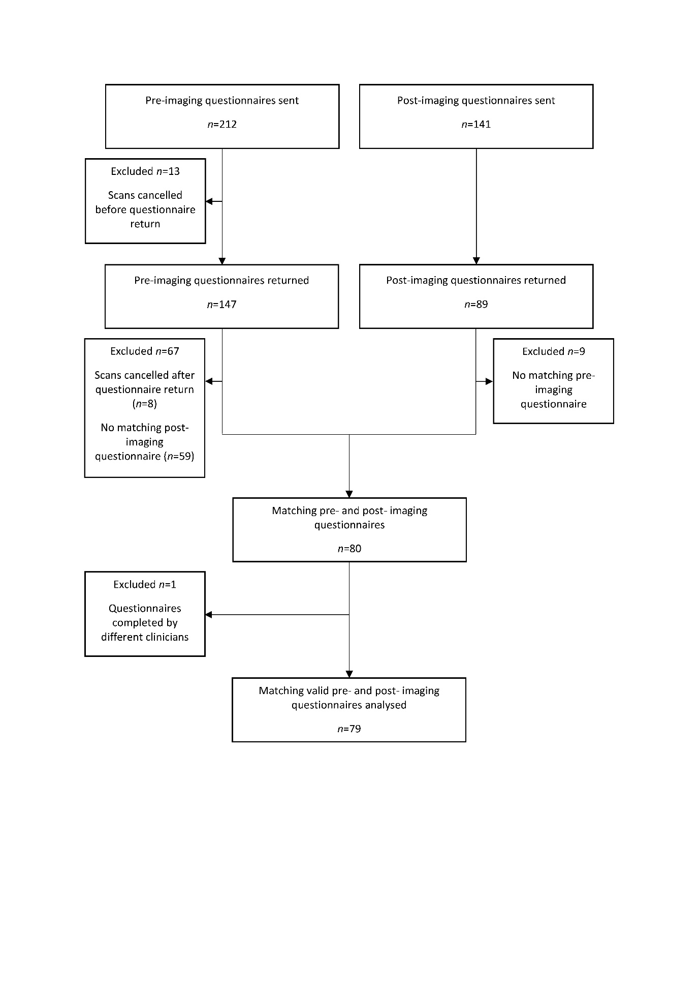
Figure 1
Flow diagram showing the number of pre-imaging and post-imaging questionnaires sent, received and excluded to arrive at the final sample size.
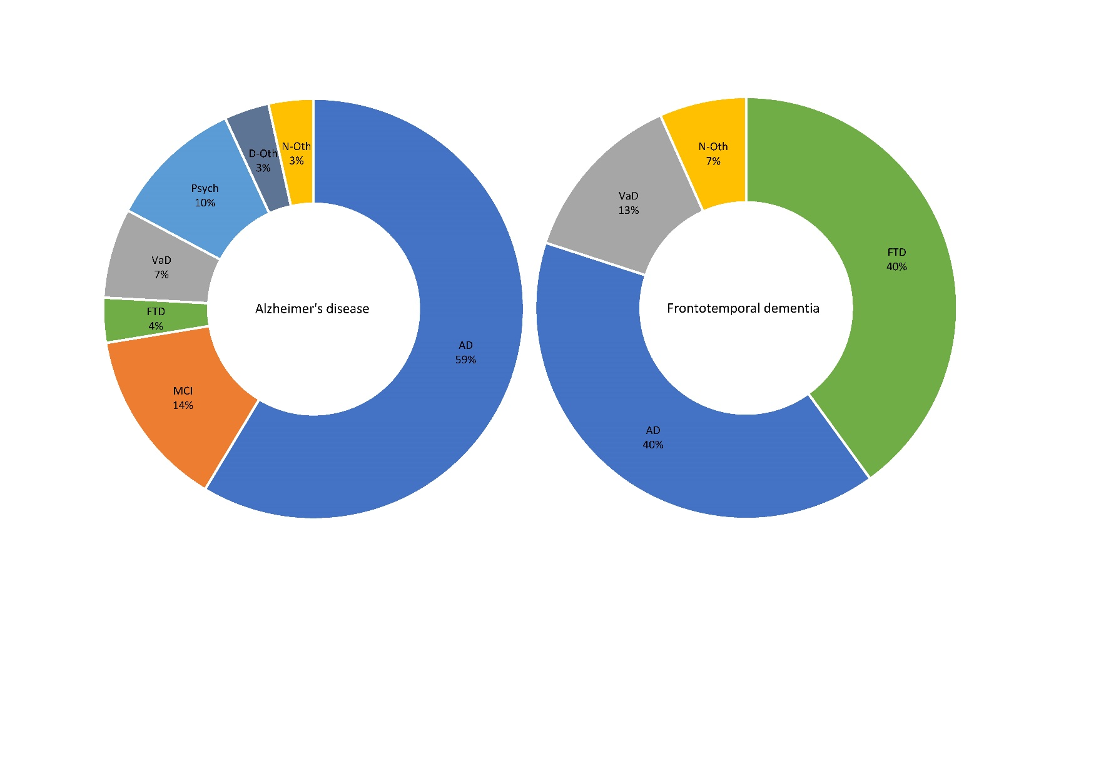
Figure 2
Pie charts showing post-imaging diagnoses for participants with a pre-imaging diagnosis of Alzheimer’s disease (N = 29) and frontotemporal dementia (N = 15). Percentages for each group are presented. Diagnosis changed after imaging in 41% of cases with a pre-imaging diagnosis of AD and 60% of cases with a pre-imaging diagnosis of FTD. AD, Alzheimer’s disease; FTD, frontotemporal dementia; MCI, mild cognitive impairment; VaD, vascular dementia; Psych, psychiatric; D–Oth, other dementia; N–Oth, other neurological disorder.
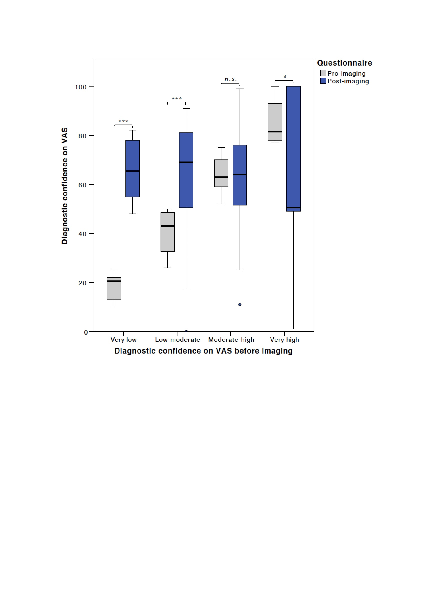
Figure 3
Box plot showing change in diagnostic confidence after perfusion SPECT imaging as measured by a visual analogue scale (VAS) from 0 (not confident at all) to 100 (extremely confident), grouped by pre-imaging confidence into very low (0-25), low-moderate (26-50), moderate-high (51-75) and very high (76-100) confidence groups. *p < 0.05, ***p < 0.001, n.s.= not significant.

