Nanoclay-polyamine composite hydrogel for topical delivery of nitric oxide gas via innate gelation characteristics of laponite
Kyungtae Parkª, Richard O. C. Oreffo^{b}, Jonathan I. Dawson^{b}, Yang-Hee Kim^{b,*} and Jinkee Hong^{a,} *
ª School of Chemical & Biomolecular Engineering, Yonsei University, 50 Yonsei Ro, Seodaemun Gu, Seoul 03722, Republic of Korea
E-mail: jinkee.hong@yonsei.ac.krª
Tel: +82-2-2123-5748
^{b}Bone and Joint Research Group, Centre for Human Development, Stem Cells and Regeneration, Institute of Developmental Sciences, University of Southampton, SO16 6YD, United Kingdom
E-mail: Yanghee.Kim@soton.ac.uk
Tel: +44-23-8120-3293

Keyword
Laponite, nitric oxide, topical delivery, controlled release.
ABSTRACT
Because nitric oxide (NO) gas is an endogenously produced signaling molecule which is related to numerous physiological functions, numerous studies have been conducted to develop the NO delivery systems to take advantages for potential biomedical applications. However, NO is a reactive radical gas molecule which has very short life time and easy to transform to nitrogen oxide species by reaction with oxygen species. Therefore, it is necessary to develop the NO delivery carrier that releases NO gas to a topical area for the specific applications. In this study, laponite clay was introduced to fabricate the NO delivery carrier by the formation of a laponite-polyamine (LP-PAn) composites. The laponite clay and pentaethylenehexamine (PEHA) formed macromolecular structure by electrostatic interaction. And the nitric oxide donor, N-diazeniumdiolate (NONOates), was synthesized into the LP-PAn composite. We investigated the conformation of the LP-PAn composite structure and the NO donor formation by zeta potential, x-ray diffraction UV-vis and fourier transform infrared (FT-IR) spectroscopy. Then, we analyzed the NO release profile. Additionally, we confirmed the applicability in biomedical applications via cell viability test and in vitro tube formation assay.

1. Introduction
Nitric oxide (NO) is a radical gas molecule that is produced endogenously by nitric oxide synthase (NOS) in the human body. ^{1, 2,} ³ NO is a vital signaling molecule related to various physiological functions such as angiogenesis, ⁴⁻⁷ immune response, ^{8, 9} neurotransmitters, ^{10,} ¹¹ cell proliferation, ¹²⁻¹⁴ apoptotic effects, ¹⁵⁻¹⁷ and antibacterial effects. ^{18,} ¹⁹ The different functions of NO in the physiological system are derived at the certain level of NO gas depending on its concentration thus, different concentrations (ranging from nM to μmol) of NO are produced by three different types of NOS from L-arginine in the body. At a low concentration of NO (<100 nM), the NO protects cells and promotes the proliferation effect. ²⁰ In contrast, at a high concentration (>1 μM), NO has apoptotic and antimicrobial effects. ²⁰ To utilize the significant therapeutic potential of NO in biomedical applications, many studies have been performed for the exogenous delivery of NO. Because the function of NO is highly dependent on the concentration, previous studies have focused on controlling the NO concentration via not only NO donors but also various NO-delivery carriers. However, NO is a reactive radical gas molecule which has very short life (<5 s) ²¹ and can be reacted with reactive oxygen species in the human body to form nitrogen oxide species. Therefore, for an enhanced efficiency and the proper function of NO gas in biomedical applications, it is essential to deliver the NO gas to a topical area to be functioned properly.
To localize the NO release in the target area, a hydrogel scaffold has been investigated as a NO-delivery carrier with a combination of NO donors. In previous studies, a small S-Nitrosoglutathione (GSNO) molecule was used as an NO donor in a polyethylene glycol (PEG) hydrogel matrix ²² and an F-127 matrix. ^{23,} ²⁴ However, because these systems have limitations such as fast leaching and scattering of NO, it is difficult to localize the NO release in the target area. Recently, Thi et al. ²¹ published the paper of in situ formation of an NO release hydrogel based on S-nitrosylated gelatin. However, the gelation mechanism was complex and required the peroxide and horseradish peroxidase enzymes, which could be a limitation for practical applications. Gao et al. reported an enzyme-controllable NO release hydrogel ²⁵, but the heating and cooling process must be conducted for gelation, thus unstable NO donors can hardly be used for the system. Additionally, the b-galactosidase-responsive NO donor has limited application diversity. Thus, the development of a hydrogel system for localized NO delivery remains a challenge.
Laponite—a synthetic smectite—has been investigated as a carrier for the delivery of biomolecules, such as growth factors, antibiotics, and drugs. Because of its high biocompatibility and innate gel-forming property, laponite has great potential as a delivery carrier in the biomedical field. It has a large surface area, with a diameter of 25 nm and a thickness of approximately 1 nm ²⁶ (see Scheme 1), thereby providing a large absorption surface. When laponite clays are dispersed in water, owing to the difference in charge between the surface and the edge (see Scheme 1a), they are stacked, forming a “house of cards” hydrogel structure which is also called “face-edge” aggregation. ²⁶ Because the laponite has the permanent negatively charged surface and positively charge edge (<pH 9.0), once the laponite particles are dispersed in water, they started to stick randomly by forming weak bonds between the face and edge. And then, the aggregates grew in size and spread filling up the whole space where they dispersed. ²⁷ Also, the bonds of laponite hydrogel are easily broken and restored the gel form by mechanical stress. Therefore, biocompatible laponite clay can be a effective option for the delivery of positively charged small molecules with an innate gel-forming property. N-diazeniumdiolates (NONOates) are well-known NO donors with a proton-responsive NO release mechanism, which can be synthesized on the secondary amine via a certain reaction under high-pressure NO gas. Thus, once the laponite surface is incorporated with the secondary amine abundant material, it is possible to incorporate the NO donor into the laponite composite and utilize it as a NO-delivery carrier. However, there is no previous study for introducing the laponite as a NO delivery carrier, the factors that must be considered for incorporating the amine-abundant material into laponite clays for NO delivery application should be studied.
In this study, we developed laponite–polyamine (LP-PAn) composites to overcome the limitation of localized NO delivery systems for the topical utilization of NO in the purpose of biomedical applications. Based on the intrinsic gelation property of laponite, we introduced pentaethylenehexamine (PEHA), which has four secondary amine functional groups on its backbone, to the laponite surface as NO donors. In the specific interaction condition, PEHA had a positively charged amine group that allowed an electrostatic interaction with the negatively charged laponite surface. From the face-edge aggregation property of laponite, this composite structure could retain the hydrogel-forming ability. We designed this composite structure for the NO release from the hydrogel to the target site avoiding the NO donor leaching from the macrostructure carrier. Because the NO donor reagent has been retained in the hydrogel by the interaction with laponite, the composite structure can take advantage of preventing the NO donor from leaching to the unwanted area. We investigated the structure and performed a conformation study on the LP-PAn composites. In terms of topical delivery of NO gas, utilization of the NO-delivery carrier should focus on the NO loading efficiency and the retention property of the gel state. Thus, we examined the correlation between the reaction concentrations of PEHA and laponite to enhance the NO delivery efficiency. Finally, we confirmed the intrinsic gelation property of the final NO-loaded LP-PAn composites and performed a rheology study, followed by application as an in vitro angiogenesis effect. This work contributes to the current understanding of smectite nanoclay as a NO gas delivery carrier and expands the applicability of laponite.2. Experimental Details
2.1 Materials
Laponite XLG (Na_{h}(Mg_{3-h}Li_{h})Si₄O₁₀(OH)₂∙nH₂O) was obtained from BYK-ALTANA. All reagents and solvents, including PEHA and methanol anhydrous, were purchased from Sigma–Aldrich (St. Louis, MO, USA). Sodium methoxide was obtained from Acros Organics (Geel, Belgium) (Widnes, UK). Human umbilical vein endothelial cells (HUVECs) were purchased from Lonza (Basel, Switzerland).
2.2 Preparation of LP-PAn composites with different molar ratios
First, we dissolved the laponite clays in deionized water (DW) with vigorous stirring (1500 rpm) for 1 h with a concentration of 10 mg/mL. PEHA was added to the laponite solution, with laponite:PEHA molar ratios of 1:3, 1:5, and 1:10, followed by stirring overnight at 1500 rpm for perfect mixing. The samples were denoted as LP-PA3, LP-PA5, and LP-PA10. We achieved an LP-PAn composite suspended in the DW without pH adjustment.
2.3 Characterization of LP-PAn composites
To investigate the LP-PAn, we centrifuged the LP-PAn solution at 10000 rpm for 15 min twice. Subsequently, the mixture was freeze-dried to obtain LP-Pan powder.
Fourier transform infrared (FT-IR) spectroscopy (FT/IR-4700, Jasco, Oklahoma City, OK, USA) was performed to confirm the formation of the LP-PAn composite. To measure the powder state of LP-PAn, we analyzed the LP-PAn samples via the attenuated total reflectance (ATR) mode of FT-IR spectroscopy. A conformational study of the laponite and polyamine in the LP-PAn composite was performed via zeta-potential measurement (SZ-100; Horiba, Japan) and X-ray diffraction (XRD) analysis (Ultima IV, Rigaku, Japan). The zeta potential of the LP-PAn composite was measured to examine the coverage of laponite clay by positively charged PEHA in DW.
2.4 N-Diazeniumdiolates(NONOates) synthesis into LP-PAn composites
NONOates were synthesized as NO donors for the LP-PAn composite. The reaction process was conducted under high-pressure NO gas. We prepared LP-PAn composites dissolved in DW and added sodium methoxide (as a catalyst) with an equimolar ratio to the number of secondary amine groups in the PEHA molecules. We placed the solution in a high-pressure reactor (custom-made, Hanwoul Engineering Co., Ltd., Gyeonggi-do, Korea). The chamber was purged with Ar gas (10 bar), immediately followed by flushing, three times. Then, we purged the reactor with Ar gas (10 bar) for 10 min and completely removed the gas. After repeating the process three times, we emptied the chamber and filled the reactor with NO gas (10 bar). The reaction was conducted for 3 d under vigorous stirring. We removed all the gas and washed the chamber three times with Ar gas (10 bar). The solution was centrifuged with 10000 rpm for 15 min. Next, the pellet was resuspended in methanol to remove the sodium methoxide residue. After being washed twice, the pellet was resuspended in pH-adjusted DW (pH 9.0). The basic conditions of the DW kept the NO donor stable. As a final step, the solution was freeze-dried to obtain LP-Pan powder.
2.5 Analysis of NO release profile
After the high-pressure reaction (HPR), the NO release profile of the LP-PAn-NO sample was analyzed using an NO analyzer (Sievers NOA 280i, GE Analytical Instruments, Little Chalfont, UK) in phosphate-buffered saline (PBS) at a pH of 7.4 and a temperature of 37 °C. Ar gas was used as a carrier gas. The NO release profile was measured until the concentration of NO was <1 pmol. The measurement was carried out with 1mg of each powder sample.
2.6 Gelation characteristics and rheological measurements
After the synthesis of LP-PAn-NO, we compared its gelation characteristics and rheological properties with those of the bare laponite gel. We dissolved the LP-PAn-NO and bare laponite in DW at a concentration of 2.5% (w/v). A photograph was taken of each gel in the glass vial. Then, rheological measurements were performed using a rotational rheometer (MCR 302, Anton Paar Physica). The storage modulus and (G’) and loss modulus (G”) were investigated via the frequency-sweep method to analyze the viscoelastic properties in the angular-frequency range of 0.1–100 rad/s at a strain of 1%. The measurements were performed at room temperature, and the strain was selected to ensure that the oscillatory deformation was in a linear region. The top plate had a diameter of 25 mm, and the loading volume was given by a 1-mm height of the hydrogel in a 1-mL syringe. Using the modulus data, we calculated the loss factor via the following equation:
$Loss factor=\tan{δ}=\frac{G"}{G'}$. (1)
2.7 Human umbilical vein endothelial cell (HUVECs) culture and cell-viability test
The cell viability was evaluated to prove the biocompatibility of the synthesized LP-PAn-NO. HUVECs were used for testing the viability against LP-PAn-NO. HUVECs were cultured in accordance with the protocol from the cell supplier and seeded in 24-well plates at 37 °C, with a concentration of 2 × 10⁴ cells/well. We selected the LP-PA3-NO sample to analyze the toxicity against the HUVECs, because LP-PA3-NO exhibited a moderate NO release amount in the range of 50–100 nmol, which can have tube-formation and cell-protection effects. To compare the toxicities of LP-PA3-NO in the laponite gel and powder, we used trans-well permeable support (Corning Incorporated, NY, USA). We seeded the cell on the bottom of a 24-trans-well plate, followed by 24 h of incubation at 37 °C under humidified CO₂ (5%). Then, we loaded the laponite gel in the hanging insert. The laponite gel was prepared via a method used in a previous study, with a concentration of 2.5% w/v in DW. ²⁶ After the gel was formed, we sterilized it via an autoclave process. Then, we dissolved LP-PA3-NO in DW (20 mg/mL), followed by serial dilution to obtain the specific concentration of LP-PA3-NO in the laponite gel. For the powder sample of LP-PA3-NO, we directly diluted the high-concentration LP-PA3-NO solution in the cell growth medium (EGM-2, Lonza) to obtain various gel concentrations. After 1 d of treating the LP-PA3-NO, the hanging well was removed and washed with 1× PBS. Then, 800 μL of growth medium and 80 μL of the CCK-8 reagent (Dojindo, Kumamoto, Japan) were added, followed by incubation for 2 h. The medium was collected, and the absorbance at a wavelength of 450 nm was measured using a plate reader (SpectraMax 340 PC; Molecular Devices, San Jose, CA, USA).
2.8 In vitro tube-formation assay with green fluorescence protein-labeled HUVECs (GFP-HVC)
To confirm the angiogenic effect of LP-PAn-NO, an in vitro angiogenesis assay, i.e., a tube-formation assay, was conducted using GFP-HVC (ANGIO-PROTEOMIE, passage under P6). Laponite gel was loaded into the 24-well plates as the substrate for the tube formation of GFP-HVC. We prepared 2.5% w/v laponite gels loaded with 0.1, 0.5, and 1.0 mg/mL LP-PA3-NO. 300 μL of each gel was loaded in 24-well plates via the same process described in the cell-viability test section (section 2.7), followed by quick centrifugation to obtain an even surface. Then, the plate was incubated for 1.5 h at 37 °C for further gelation. After the formation of the laponite gel substrate, the GFP-HVC was resuspended in the growth medium and seeded in each well at a density of 1.0 × 10⁵ cells/well. After 17 h of incubation, the tube formation was analyzed using a fluorescence microscope at a magnification of 40×, and the tube formation of GFP-HVC was quantitatively investigated using a freely distributed analysis program for ImageJ called “Angiogenesis Analyzer” (Gilles Carpentier. Contribution: Angiogenesis Analyser, ImageJ News, 5 October 2012, http://image.bio.methods.free.fr/ImageJ/?Angiogenesis-Analyser-for-ImageJ#nb1). We followed a recent study with regard to the two-dimensional tubular network analysis process. ²⁸
2.9 Statistical analyses
Two-sample t-test (Microsoft excel software) was conducted to evaluate the statistical validity of the cell experiment results. The significance of the difference in mean values between the control and sample groups was evaluated by this statistical analysis. The symbol * (P-value < 0.05), ** (P-value < 0.01), and *** (P-value < 0.001) were used to indicate each level of significance.

3. Results and discussion
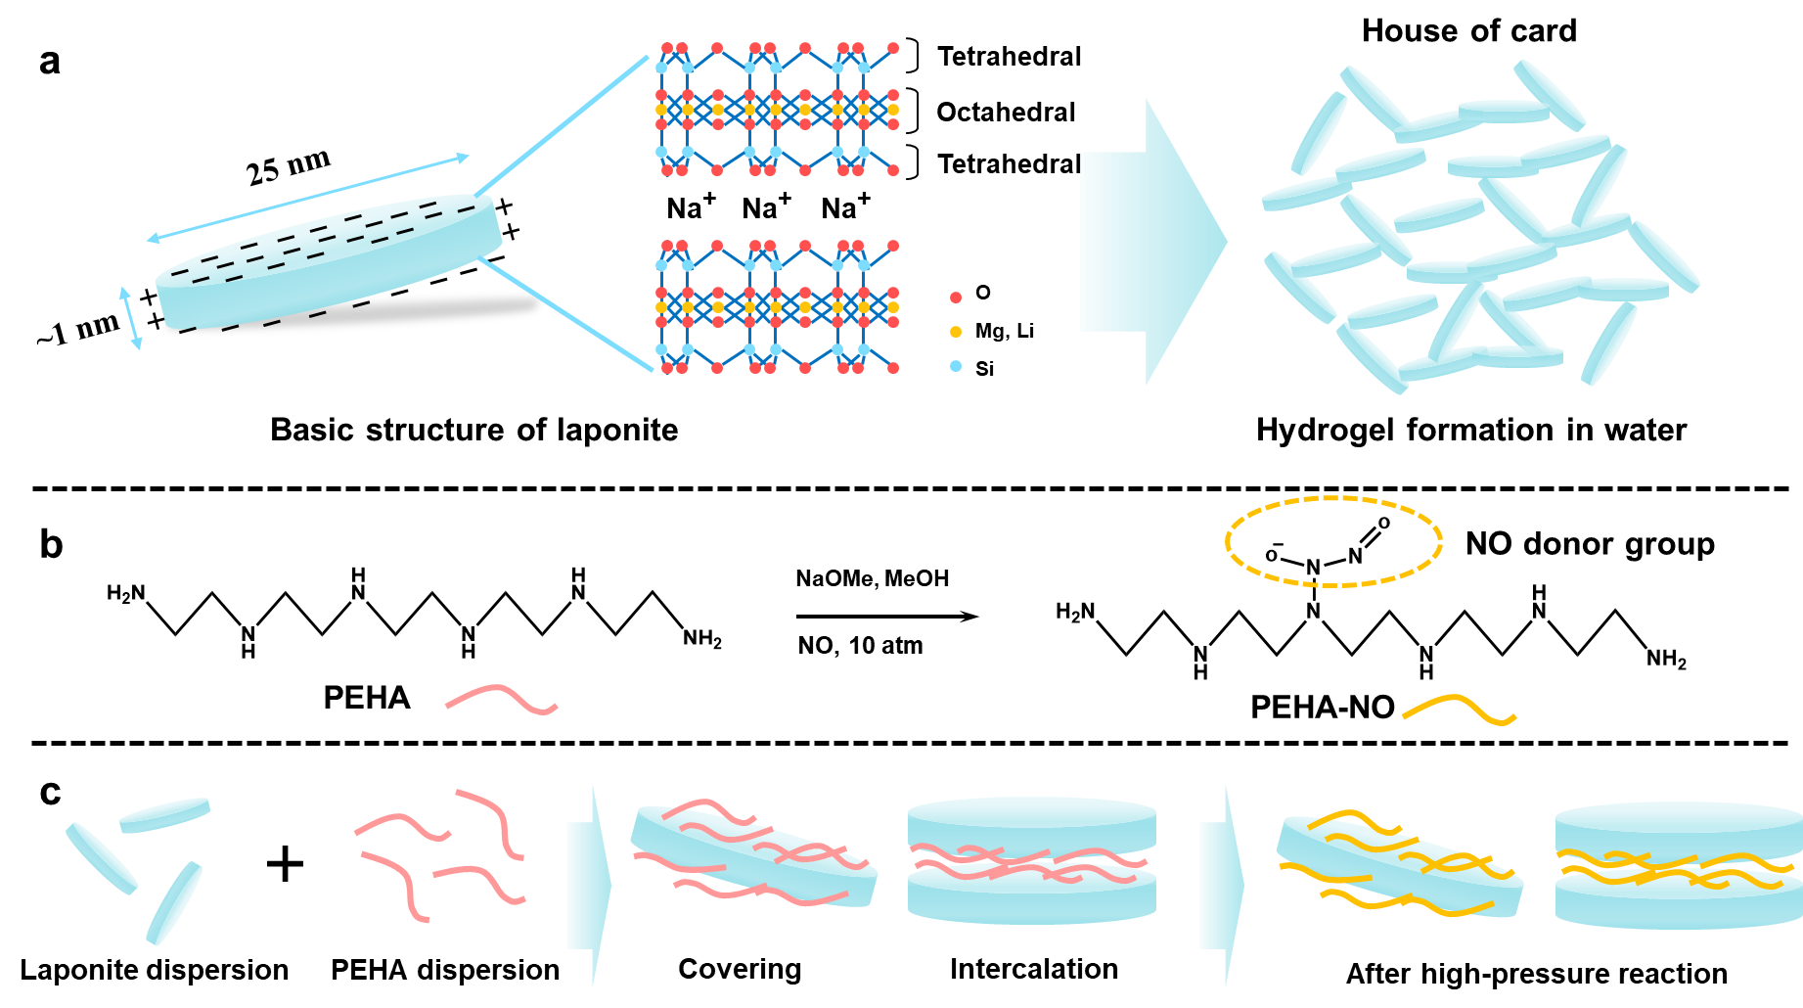

Scheme 1 Illustration of the overall concept of the research. (a) The molecular structure of laponite and the hydrogel formation mechanism. The laponite dispersed in water showed face-edge aggregation to form a gel; (b) NO-donor synthesis in PEHA via the high-pressure reaction, the yellow dotted line indicates the NO donor group (NONOates); (c) described the possible conformation structure of the LP-PAn composite as followed the reaction step.

LP-PAn composite formation. We fabricated the laponite and polyamine complex though a simple mixing process in glass vials. The laponite clays were dissolved in the deionized water DW with vigorous stirring (1500 rpm) for 1 h. Then, we added the PEHA with the molar ratio of laponite:PEHA 1:3, 1:5, 1:10 followed by stirring overnight. Subsequently, we freeze-dried the composite solution to obtain powder state. To investigate the characteristics of each sample, we performed FT-IR spectroscopy, zeta-potential measurements, and XRD analysis of each sample.
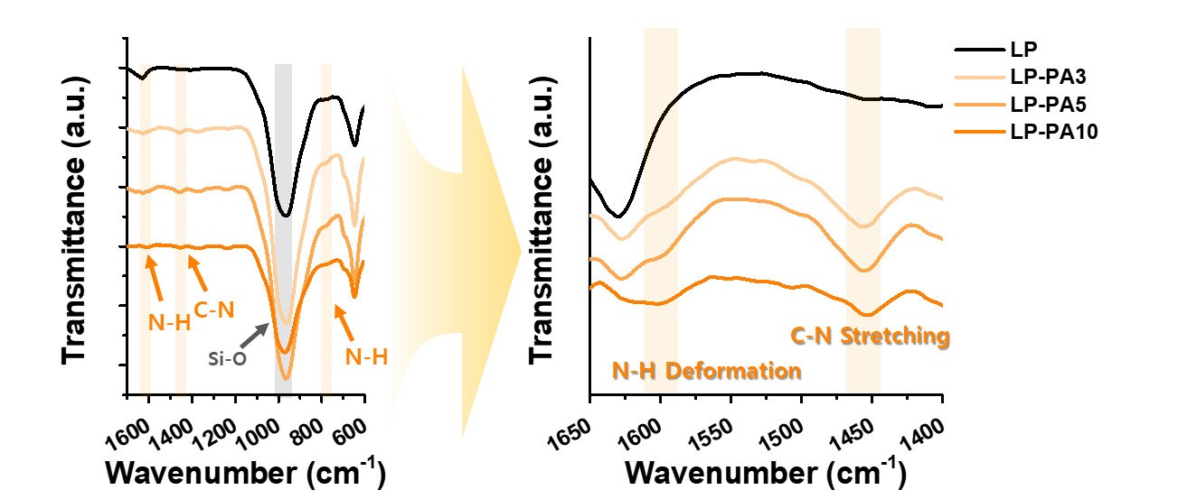

Figure 1 FT-IR spectra analysis of the LP-PAn composite. Black line corresponds to bare laponite (LP), and yellow corresponds to the laponite–PEHA composites with different blending ratios (LP-PA3, LP-PA5, LP-PA10). The specific peaks of laponite and polyamine are assigned in the graph.

FT-IR spectroscopy. After forming the composite of laponite nanoclay with PEHA, we performed FT-IR spectroscopy in the ATR mode to confirm the formation of the composite of PEHA and laponite clay. As shown in Figure 1, the bare laponite powder (black line) exhibited distinctive absorption bands at approximately 1000 cm⁻¹ and 700 cm⁻¹, which are attributed to Si-O stretching and Si-O-Si bending vibrations, respectively. ²⁹ The molecular structure of the laponite, which contained Si-O and Si-O-Si covalent bonds in tetrahedral assigned the dominant peak. However, compared with the bare laponite, the LP-PAn composite (LP-PAn, n: relative molar ratio of polyamine to laponite) exhibited the specific peaks of PEHA. At 1589 and 768 cm⁻¹, an in-plane deformation peak and an out-of-plane deformation peak corresponding to N-H bonding were observed after the composite formation. ³⁰ Additionally, a C-N stretching peak at 1456 cm⁻¹ was detected after the formation of the LP-PAn composite. Because the LP-PAn composite had well-assigned peaks corresponding to the laponite structure, the FT-IR spectra indicate the successful formation of the composite containing PEHA and laponite clays. Considering the washing step of composite synthesis, the well-assigned PEHA peaks indicate the LP-PAn was composed of the interaction between laponite and PEHA. This could contribute for the NO donor formation site, which enables the NO release from the composites without leaching of NO donors.
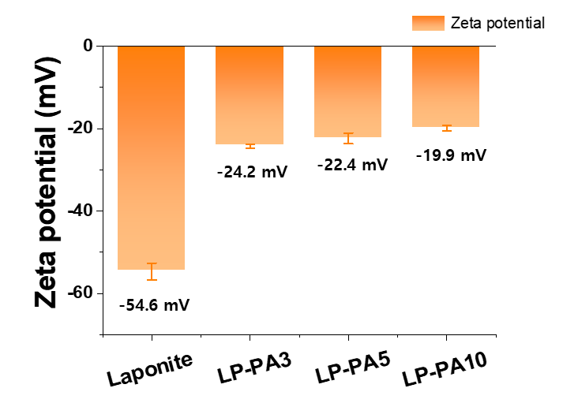

Figure 2 Zeta-potential measurement results for laponite and the LP-PAn composites, indicating the charge shift in a positive direction resulting from LP-PAn composite formation.

Zeta potential. After the analysis of composite formation via FT-IR, we performed the zeta-potential measurements investigate the LP-PAn structure. All the samples were dissolved in DW, and the concentration of laponite was 1 mg/mL. For the LP-PAn composite samples, the concentration of laponite was fixed at 1 mg/mL with the addition of PEHA to the solution. As shown in Figure 2, the zeta potential of the bare laponite clays suspended in DW was –54.6 mV (negatively charged). Because the surface of the laponite clay was induced to negative charges by ionized oxygen atoms, this value is consistent with a previously reported value. ³¹ However, the zeta potential exhibited a positive shift with the formation of the laponite–PEHA complex. The measured values were –25.6, –22.4, and –19.9 mV for the LP-PA3, LP-PA5, and LP-PA10 samples, respectively. This can be explained by the adsorption of the positively charged PEHA onto the laponite in the DW solution. The pH of the DW was in the range of 6.0–6.5 (data not shown), and the pK_{a} value of the PEHA was approximately 10.0. ³² This led to the protonation of secondary and primary amine groups in the PEHA molecules, yielding a positive charge in the DW solution. Therefore, the laponite clays and PEHA could form the composite via the electrostatic interaction in the DW solution. As a result, the surface charge could be shifted to more positive direction and it induced the change of zeta potential. From the results, we could identify the structure of LP-PAn is basically based on the covering of the laponite clays by positively charged PEHA.
$2d \sin{θ}=nλ$ (2)
X-ray diffraction XRD. However, we could not clarify the conformation of the laponite–PEHA complex with only zeta-potential data. Because the conformation of the laponite–PEHA complex could be in the way of covering the single laponite clay with PEHA or the formation of a complex structure with intercalated PEHA between two laponite clays. According to the zeta-potential data, the increase in the zeta potential of LP-PAn was proportional to the molar ratio of PEHA to the laponite clays. This result indicates that the coverage of the laponite surface was increased by the PEHA. Thus, the adsorption of PEHA onto the laponite surface could be proportionally controlled by simply changing the molar ratio. To further investigate the conformation of the laponite–PEHA composite via intercalation, we performed an XRD analysis of the LP-PAn composites. Figure 3 shows XRD patterns of laponite and the LP-PAn composite. Because of the low crystallinity of laponite, a broad XRD peak was observed. ³³ From the total angle 2θ range of laponite composite, it was found that (001) basal plane reflection peak at 2θ = 6.3° , corresponding to the face-to-face planar structure of laponite clay. ²⁹ However, the (001) basal plane spacing peak was shifted to 2θ = 5.8° (LP-PA3), 2θ = 5.78° (LP-PA5), and 2θ = 5.72 ° (LP-PA10), as shown in Figure 3. This shift corresponds to the d-spacing of the laponite interlayer. The d-spacing was 14.018 Å for bare laponite, 15.225 Å for LP-PA3, 15.278 Å for LP-PA5, and 15.438 Å for LP-PA10. The increase of d-spacing could be interpreted as the intercalation of positively charged PEHA between laponite interlayers. Because the mechanism of intercalation into smectite such as laponite is mainly attributed to cation exchange.^{29, 34} In the DW pH range of 6.0–6.5, the PEHA might have been fully protonated as a cationic species. The XRD results indicated the cationic exchange of PEHA into the interlayer structure of laponite. Even though the difference was not significant, the increase in the interlayer separation distance was proportional to the PEHA concentration (molar ratio).
Thus, considering the zeta-potential data and XRD results, the structure of the LP-PAn composite could be consisted of both intercalation of polyamine into the laponites and covering with electrostatic interaction of the outer surface. Furthermore, it should be mentioned that the relative molar ratio of PEHA to laponite clay could affect the intercalation and covering ratio, which is agreement with data from figure 2, 3.
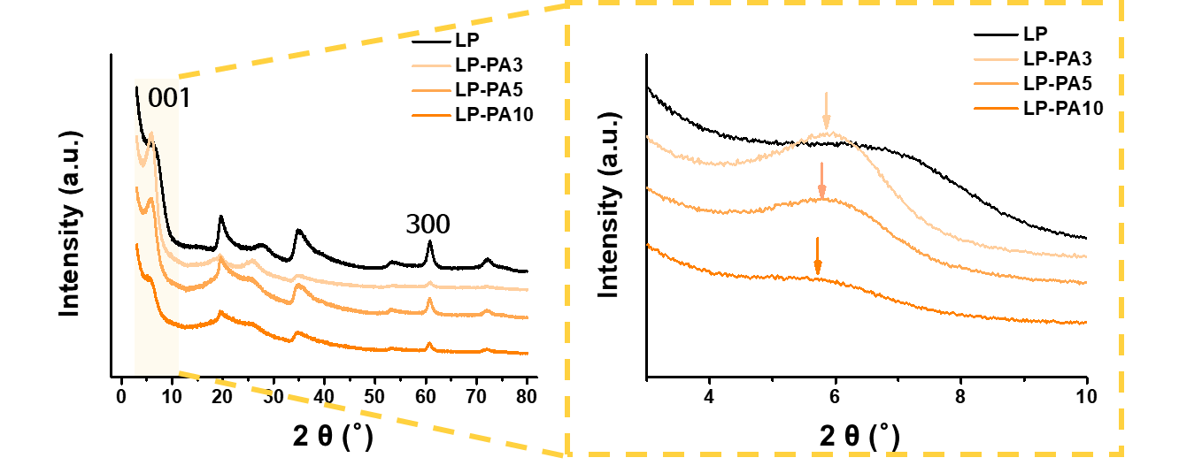

Figure 3 XRD patterns of powdered bare laponite and LP-PAn composite with different blending ratios (LP-PA3, LP-PA5, LP-PA10). The enlarged XRD data indicates the crystalline structure of laponite and the interlayer distance between adjacent clay.
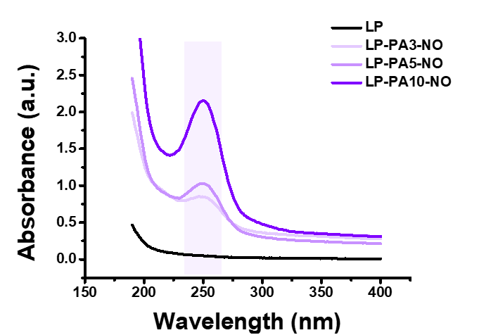

Figure 4 UV–vis spectra for laponite and the LP-PAn composite, indicating the NO-donor incorporation after the HPR. The specific peak of NO donor is identified at 250 nm wavelength

NO-donor formation and NO release profile
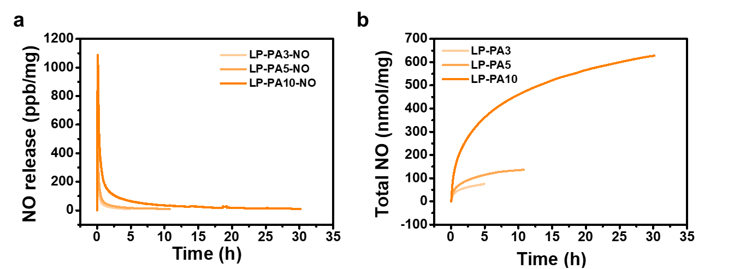

Figure 5 The real-time NO release profile analysis using NOA 280i. (a) Real-time NO release profile; (b) the total amount of accumulated NO over time.

According to the foregoing results, we could control the PEHA ratio of the LP-PAn composite by simply adjusting the concentration of PEHA in the mixture. This point of view, we expected the control of nitric oxide (NO) donor amount which would be formed into the LP-PAn composite via high-pressure reaction. We selected the N-diazeniumdiolates NONOates as NO donors owing to their relatively high stability to heat and light compared with other NO donors such as RSNO.³⁵ Additionally, the proton-triggering decomposition mechanism of NONOates can produce NO gas spontaneously in a water-based environment, e.g., under physiological conditions.¹⁸ When we synthesized the NONOates for the NO-releasing component, the amount of secondary amine in the certain delivery carrier was very important for controlling the NO concentration in the target region. Although it was difficult to control the exact amount of secondary amine functional groups, by controlling the amount of PEHA molecules, which had secondary amine and primary amine groups in the backbone structure, we could adjust the amount of possible NO donor sites in the delivery carrier.
Table 1 The result of NO release analysis through the NO analyzer (NOA 280i)
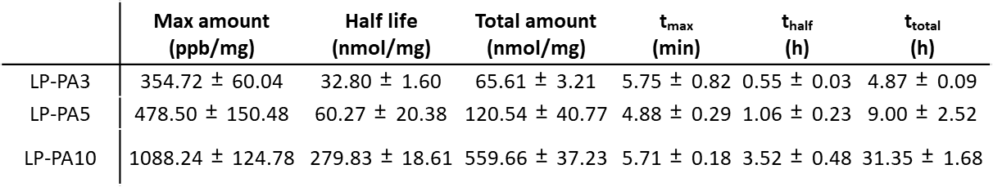

To synthesize the NONOates (NO donors) for the LP-PAn composites, we followed previous papers. We dissolved the LP-PAn powder into a methanol solvent with sodium methoxide (NaOMe) as a catalyst. Because the NONOate synthesis chemistry is based on the deprotonation of amine groups, the NaOMe catalyst functions as a deprotonating agent toward amine groups, inducing the nucleophilic attack of NO gas. ³⁶ Next, we placed the solution in the reaction chamber, followed by 15 min of stirring to make it perfectly mixed. The reaction was conducted for 3 d under NO gas (10 bar) with magnetic stirring (at 800 rpm). Subsequently, we washed the final product and freeze-dried it via a lyophilizer to obtain a light-yellow powder. We confirmed the NONOate functional group using ultraviolet–visible (UV–vis) absorbance data, as shown in Figure 4. As previously reported, the NONOates exhibited a specific absorbance peak at a wavelength of 250 nm under UV irradiation. ³⁵ ¹⁹ As shown in Figure 4, compared with the bare laponite, the specific peak of the NONOates was observed after the HPR. Otherwise, the LP-PAn composite without high-pressure reaction have no significant absorbance peak at approximately 250 nm (see Supplementary Figure S1a). Additionally, the bare PEHA molecule did not exhibit any specific peaks (see Supplementary Figure S1b). The results indicate the successful synthesis of the NONOate group in the LP-PAn composites. Especially, the absorbance at 250nm of each LP-PAn sample was found proportional increase depending on the relative molar ratio of PEHA to laponite. This is consistent with the zeta-potential data and XRD results. Therefore, we successfully controlled the NO donor loading amount by simply changing the PEHA concentration. Considering the complicated NO loading chemistry and efficiency, this LP-PAn composite has many advantages as an NO-delivery carrier.
Based on this point of view, we analyzed the NO release profile to determine the correlation between the NO-donor amount and the amount of NO gas release from each sample. We investigated the real-time NO release and accumulated NO amount using an NO analyzer, which detected the NO gas via the chemiluminescence method. This analyzer only detects NO gas precisely, in contrast to other methods such as the Griess assay for detecting sodium nitrite. The LP-PAn release profile is presented in Figure 5. The LP-PAn composite exhibited a burst release profile, which is typical release profile of small molecule NO donors. Table 1 presents a quantitative summary of the NO release. The total amount of NO released from each LP-PAn sample was approximately 65, 120, and 560 nmolfor LP-PA3, LP-PA5 and LP-PA10. As indicated by the UV–vis data in Figure 4, the total amount of NO is relying to the UV absorbance at a wavelength of 250 nm, which indicated the NO-donor groups. However, considering the concentration difference among the samples, this is a notable result. Even though the PEHA concentration of LP-PA10 was approximately three times higher than that of LP-PA3, the total NO release amount of LP-PA10 was approximately nine times higher than that of LP-PA3. This result can be explained by the intercalation. As confirmed by the increase in the XRD d-spacing, increasing the concentration of PEHA affected the intercalation ratio of PEHA into the inner plane of the laponite clays. Thus, the amount of PEHA between neighboring laponite clays increased, and the intercalated PEHA became an NO donor in the LP-PAn composite. This made it possible to adjust the NO loading amount from the unit mass of the LP-PAn composite. Furthermore, the intercalation of the NO donor affected the duration of NO release. As shown in Figure 5 and Table 1, the LP-PA10 sample exhibited a long-term release profile (up to 31 h), whereas LP-PA3 and LP-PA5 released NO for 5 and 9 h, respectively. These results could be explained as follows: the larger amount of PEHA intercalated in LP-PA10 caused the slow decomposition of NO donors for the release of NO gas. Therefore, the loading amount of PEHA into the LP-PAn composite can be adjusted by changing the concentration of PEHA because of the intercalation, which allows the NO release from the LP-PAn composite to be controlled. According to this finding, LP-PAn composites can be novel carriers for exogeneous application of NO with a controlled concentration and release profile. Thus, the LP-PAn carrier system can be used in bothbiomedical applications that require high doses, such as antimicrobial applications and anticancer therapy, and low doses, such as angiogenesis and wound healing.
Gelation characteristics of LP-PAn-NO gel and rheological study
After the successful synthesis of the NO-releasing LP-PAn (LP-PAn-NO), the investigation of gelation property and a rheology study was proceeded. As we mentioned in the introduction section, the NO delivery carrier should be retained at the specific area to achieve the localized NO delivery. Thus, it is essential to verify that the gel formation ability of newly synthesized LP-PAn-NO. Figure 6a presents photographs of the laponite gel, LP-PA3-NO composite gel, and LP-PA3-NO in the laponite gel (1 mg/mL).
The gelation property was confirmed via the upside-down test method, and each sample was prepared with a concentration of 2.5% w/v. As shown in the figure 6a, the laponite gel (LP in Figure 6a) and LP-PA3-NO composite both exhibited successful gel formation after being dissolved into DW at a specific concentration.
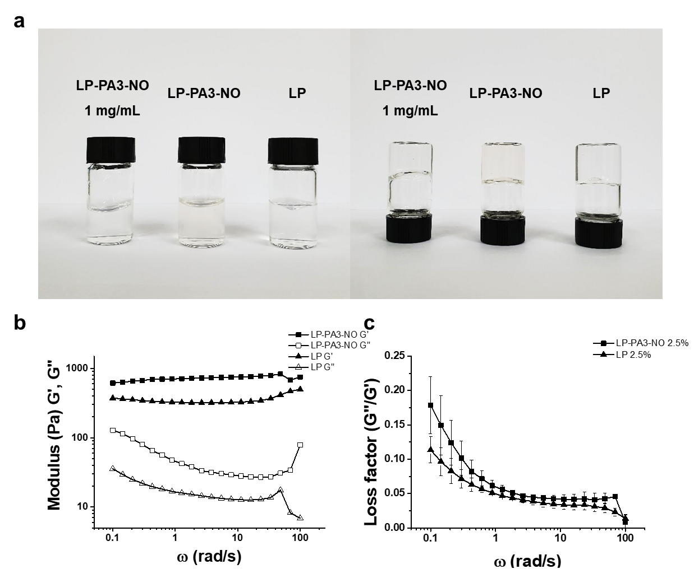

Figure 6 (a) Photographs showing the gelation characteristics of bare laponite gel, LP-PA3-NO, and LP-PA3-NO (1 mg/mL in laponite gel). Each sample had the same concentration dispersed in DW: 2.5% (w/v): (b) Rheological analysis of frequency-sweep-mode for modulus measurement and (c) loss factor tan δ. LP indicates the laponite gel, LP-PA3-NO indicates the gelation of LP-PA3 after high-pressure reaction and the LP-PA3-NO 1 mg/mL represents the LP gel with the addition of LP-PA3-NO in the concentration of 1 mg/ml.
These results indicate that the innate gelation characteristic of laponite was maintained after the formation of the LP-PA composites and the HPR. Additionally, after the high-pressure reaction of the bare laponite, the laponite solution dispersed in the water is still able to form the hydrogel. Because the mechanism of laponite gelation is face-edge aggregation forming a network structure, ^{26,} ³⁷ the successful gelation of the LP-PAn-NO composite could be derived by the well-dispersed clay composites in the solvent and become a hydrogel forming the network structure. We compared the rheological properties of the LP and LP-PA3-NO gels, as shown in Figures 6b and c. Both samples showed gel-like properties. The storage modulus of each sample which is higher value than loss modulus (Figure 6b) and loss factor value under 1 (figure 6c) indicated the gel-like structures. From the data, we concluded that the gelation characteristics of LP were maintained after the reaction, which emphasizes the potential of LP-PAn-NO as a topical NO-delivery carrier.
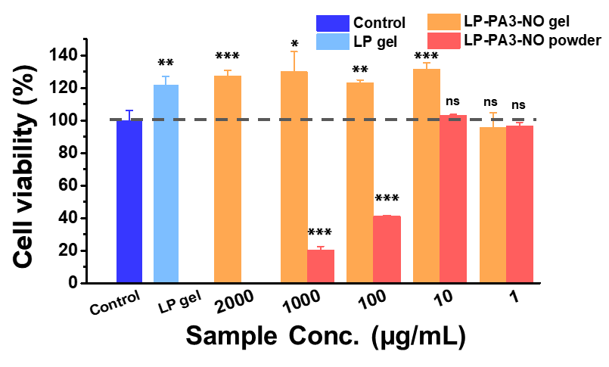

Figure 7 In vitro cell cytotoxicity test of bare laponite and LP-PA3 composites with HUVECs. The control indicates the cell growth medium, LP gel indicates only bare laponite gel and LP-PA3-NO gel represents the gel state of LP-PA3-NO powder. All the gel were prepared by dispersing in DW with a concentration of 2.5 % w/v. *P-value < 0.05, **P-value < 0.01, ***P-value < 0.001 for significance.

In vitro cell-viability test of LP-PA3-NO against HUVECs
To evaluate the suitability othe LP-PAn-NO composite for bio-applications, the toxicity of the LP-PAn-NO was evaluated through a cell-viability assay using the CCK-8 reagent. We selected the LP-PA3-NO sample for testing the cell viability because the NO amount was <100 nmol, which could induce the angiogenic effect and protect the cells. We tested different concentrations of LP-PA3-NO in the 2.5% w/v laponite gel and powder-type LP-PA3-NO suspended in the cell growth medium. As shown in Figure 7, the bare laponite gel (LP gel) and LP-PA3-NO samples in the LP gel in the concentration range of 1–2000 μg/mL exhibited no toxicity compared with the control. The LP gel and LP-PA3-NO composite in the gel exhibited a slightly increased cell viability compared with the control. Considering that the total amount of NO release from 1 mg of LP-PA3-NO was 65 nmol, the NO amount of <100 nmol indicated no toxicity. However, the powder-type LP-PA3-NO, which had a consistent NO amount, in the LP gel exhibited a very low cell viability above 10 μg/mL. Microscope observations revealed that aggregation of laponite occurred when it was suspended in the medium (data not shown). This is because of the the cell growth medium containing abundant proteins and excessive salt concentration. Thus, we conclude that the LP-PA3-NO composite did not have any toxicity of the NO effect. However, the laponite can be easily aggregated in the growth medium; thus, the gel form is necessary to be used.

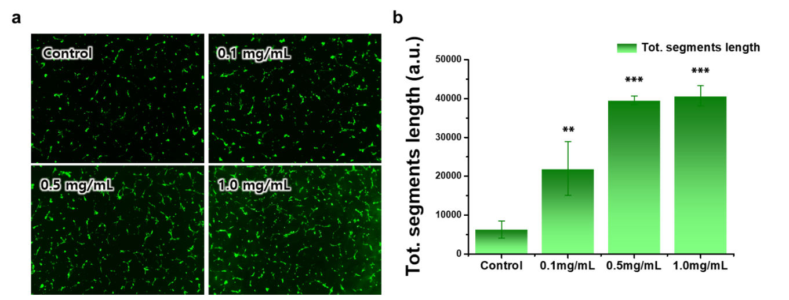

Figure 8 In vitro tube-formation assay of the LP-PA3-NO composite in laponite gel (2.5% (w/v)) with HUVECs. (a) Fluorescence microscope images of LP-PA3 NO samples with different concentrations and (b) quantitative analysis of the total segment length based on the images. *P-value < 0.05, **P-value < 0.01, ***P-value < 0.001 for significance.

In vitro tube-formation assay with GFP-labeled HUVECs
To evaluate the applicability of the LP-PA3-NO composite, we investigated the angiogenic property of NO via an in vitro tube-formation assay. We introduced the LP-PA3-NO composite (as the NO-release material) diluted in 2.5% w/v laponite gel. The NO concentration was selected as <100 nmol, which is consistent with the concentrations (0.1, 0.5, and 1.0 mg/mL) of LP-PA3-NO in the laponite gel. With consideration of the laponite gel as not only an NO-delivery carrier but also a scaffold for angiogenesis, the laponite gel was applied as scaffold instead of the other basement membrane matrix. The fluorescence microscope image in Figure 8a shows the network formation of GFP-labeled HUVECs. The control sample exhibited the fewer and shorter branch arising from the cell junction, whereas the NO-releasing sample exhibited a longer branch segment to form the network structure. The quantified value described in Figure 8b also represented a significant difference between the control and NO-releasing samples. The 0.5- and 1.0-mg/mL samples, which released approximately 32 and 65 nmol of NO per milliliter, respectively, exhibited similar results and this suggested that over 30 nmol of NO showed similar ability of angiogenic inducement. Therefore, the concentration of NO must be precisely adjusted depending on the specific application. For precise adjustment, the LP-PAn-NO composite can be easily controlled by changing the LP and NO donor ratio when forming the composites. Additionally, the LP-PAn-NO concentration in the bare laponite gel can be controlled for certain concentration without losing the innate gelation property.
Conclusion
In this work, we developed LP-PAn composites as novel NO-delivery carriers for topical delivery. To achieve topical delivery, we employed laponite nanoclay as a scaffold to utilize its innate gel-forming property. We incorporated the PEHA into laponite via electrostatic interaction to act as an amine-donating reagent for NO-donor synthesis. This method is based on the direct interaction between laponite and pre-NO-donor material. Also, the hydrogel formation is derived spontaneously without additional chemical reaction. Compared to the previous study, this strategy of the system enabled the simple process of hydrogel formation and prevent the leaching of NO donor from the hydrogel. Additionally, to control the amount of NO released from the LP-PAn composite, we adjusted the concentration ratio of LP to PEHA. The conformation of the LP-PAn composite was confirmed via FT-IR spectroscopy, zeta-potential measurements, and XRD analysis. As the concentration of PEHA increased, the coverage of the composite became saturated, and the intercalation of PEHA increased. We investigated the NO-donor formation via UV–vis analysis, followed by NO-release analysis using a NO analyzer. We confirmed different NO release amount depending on the ratio of LP and PEHA. Additionally, the innate gelation characteristics of the laponite were examined via the upside-down method and a rheological study. Finally, by performing a cell-viability test for HUVECs and evaluating the tube-formation abilities, we confirmed that the LP-PAn-NO composite has potential for biomedical applications. This study contributes to the utilization of laponite clay as a novel NO-delivery carrier for topical delivery.
Supporting Information
UV-vis spectra of LP-PAn composite and PEHA solution before high-pressure reaction
Acknowledgement
This work was supported by the Korea Health Technology R&D Project through the Korea Health Industry Development Institute (KHIDI), funded by the Ministry of Health & Welfare, Republic of Korea (HI18C2021) and Basic Science Research Program through the National Research Foundation of Korea (NRF) funded by the Ministry of Science and ICT (NRF-2017R1E1A1A01074343). This work was supported by the UK-Korea Partnering Award jointly funded by the UK Medical Research Council (MRC) and the Korea Health Industry Development Institute (KHIDI). Jonathan Dawson gratefully acknowledges fellowship funding from the EPSRC (grant number EP/L010259/1).

References
1. Moncada, S., Nitric oxide: physiology, pathophysiology, and pharmacology. Pharmacol. rev. 1991, 43, 109-142.
2. Moncada, S.; Higgs, E., Endogenous nitric oxide: physiology, pathology and clinical relevance. Eur. J. Clin. Invest. 1991, 21, (4), 361-374.
3. Beckman, J. S.; Koppenol, W. H., Nitric oxide, superoxide, and peroxynitrite: the good, the bad, and ugly. Am. J. Physiol.: Cell Physiol. 1996, 271, (5), C1424-C1437.
4. Murohara, T.; Asahara, T.; Silver, M.; Bauters, C.; Masuda, H.; Kalka, C.; Kearney, M.; Chen, D.; Symes, J.; Fishman, M., Nitric oxide synthase modulates angiogenesis in response to tissue ischemia., J. Clin. Invest. 1998, 101, (11), 2567-2578.
5. Ridnour, L. A.; Isenberg, J. S.; Espey, M. G.; Thomas, D. D.; Roberts, D. D.; Wink, D. A., Nitric oxide regulates angiogenesis through a functional switch involving thrombospondin-1. Proc. Natl. Acad. Sci. U. S. A. 2005, 102, (37), 13147-13152.
6. Ziche, M.; Morbidelli, L.; Masini, E.; Amerini, S.; Granger, H. J.; Maggi, C. A.; Geppetti, P.; Ledda, F., Nitric oxide mediates angiogenesis in vivo and endothelial cell growth and migration in vitro promoted by substance P. J. Clin. Invest. 1994, 94, (5), 2036-2044.
7. Papapetropoulos, A.; García-Cardeña, G.; Madri, J. A.; Sessa, W. C., Nitric oxide production contributes to the angiogenic properties of vascular endothelial growth factor in human endothelial cells. J. Clin. Invest. 1997, 100, (12), 3131-3139.
8. Lundberg, J. O.; Weitzberg, E.; Gladwin, M. T., The nitrate–nitrite–nitric oxide pathway in physiology and therapeutics. Nat. Rev. Drug Discovery 2008, 7, (2), 156.
9. Bogdan, C., Nitric oxide and the immune response. Nat. Immunol. 2001, 2, (10), 907
10. Sanders, K. M.; Ward, S. M., Nitric oxide as a mediator of nonadrenergic noncholinergic neurotransmission. Am. J. Physiol.: Gastrointest. Liver Physiol. 1992, 262, (3), G379-G392.
11. Rajfer, J.; Aronson, W. J.; Bush, P. A.; Dorey, F. J.; Ignarro, L. J., Nitric oxide as a mediator of relaxation of the corpus cavernosum in response to nonadrenergic, noncholinergic neurotransmission. N. Engl. J. Med. 1992, 326, (2), 90-94.
12. Ignarro, L. J.; Buga, G. M.; Wei, L. H.; Bauer, P. M.; Wu, G.; del Soldato, P., Role of the arginine-nitric oxide pathway in the regulation of vascular smooth muscle cell proliferation. Proc. Natl. Acad. Sci. U. S. A. 2001, 98, (7), 4202-4208.
13. Napoli, C.; Paolisso, G.; Casamassimi, A.; Al-Omran, M.; Barbieri, M.; Sommese, L.; Infante, T.; Ignarro, L. J., Effects of nitric oxide on cell proliferation: novel insights. J. Am. Coll. Cardiol. 2013, 62, (2), 89-95.
14. Villalobo, A., Nitric oxide and cell proliferation. FEBS J. 2006, 273, (11), 2329-2344.
15. Albina, J. E.; Cui, S.; Mateo, R. B.; Reichner, J. S., Nitric oxide-mediated apoptosis in murine peritoneal macrophages. J. Immunol. 1993, 150, (11), 5080-5085.
16. Blanco, F. J.; Ochs, R. L.; Schwarz, H.; Lotz, M., Chondrocyte apoptosis induced by nitric oxide. Am. J. Pathol. 1995, 146, (1), 75.
17. Chung, H.-T.; Pae, H.-O.; Choi, B.-M.; Billiar, T. R.; Kim, Y.-M., Nitric oxide as a bioregulator of apoptosis. Biochem. Biophys. Res. Commun. 2001, 282, (5), 1075-1079.
18. Carpenter, A. W.; Schoenfisch, M. H., Nitric oxide release: Part II. Therapeutic applications. Chem. Soc. Rev. 2012, 41, (10), 3742-3752.
19. Hetrick, E. M.; Shin, J. H.; Stasko, N. A.; Johnson, C. B.; Wespe, D. A.; Holmuhamedov, E.; Schoenfisch, M. H., Bactericidal efficacy of nitric oxide-releasing silica nanoparticles. Acs Nano 2008, 2, (2), 235-246.
20. WEI, Y.; QIAN, M.; MIDGLEY, A. C.; KONG, D.; ZHAO, Q., Progress in the development of nitric oxide-releasing biomaterials and their biomedical applications. SCIENTIA SINICA Vitae 2019, 49, (9), 1109-1118.
21. Thi, T. T. H.; Lee, Y.; Le Thi, P.; Park, K. D., Nitric oxide-releasing injectable hydrogels with high antibacterial activity through in situ formation of peroxynitrite. Acta Biomater. 2018, 67, 66-78.
22. Seabra, A. B.; de Souza, G. F. P.; da Rocha, L. L.; Eberlin, M. N.; de Oliveira, M. G., S-nitrosoglutathione incorporated in poly (ethylene glycol) matrix: potential use for topical nitric oxide delivery. Nitric Oxide 2004, 11, (3), 263-272.
23. Seabra, A.; Fitzpatrick, A.; Paul, J.; De Oliveira, M.; Weller, R., Topically applied S‐nitrosothiol‐containing hydrogels as experimental and pharmacological nitric oxide donors in human skin. Br. J. Dermatol. 2004, 151, (5), 977-983.
24. Pelegrino, M.; de Araujo Lima, B.; do Nascimento, M.; Lombello, C.; Brocchi, M.; Seabra, A., Biocompatible and Antibacterial Nitric Oxide-Releasing Pluronic F-127/Chitosan Hydrogel for Topical Applications. Polymers 2018, 10, (4), 452.
25. Gao, J.; Zheng, W.; Zhang, J.; Guan, D.; Yang, Z.; Kong, D.; Zhao, Q., Enzyme-controllable delivery of nitric oxide from a molecular hydrogel. Chem. Commun. (Cambridge, U. K.) 2013, 49, (80), 9173-9175.
26. Dawson, J. I.; Kanczler, J. M.; Yang, X. B.; Attard, G. S.; Oreffo, R. O., Clay gels for the delivery of regenerative microenvironments. Adv. Mater. (Weinheim, Ger.) 2011, 23, (29), 3304-3308.
27. Mongondry, P.; Tassin, J. F.; Nicolai, T., Revised state diagram of Laponite dispersions. J. Colloid Interface Sci. 2005, 283, (2), 397-405.
28. Page, D. J.; Clarkin, C. E.; Mani, R.; Khan, N. A.; Dawson, J. I.; Evans, N. D., Injectable nanoclay gels for angiogenesis. Acta Biomater. 2019, 100, 378-387.
29. Ghadiri, M.; Hau, H.; Chrzanowski, W.; Agus, H.; Rohanizadeh, R., Laponite clay as a carrier for in situ delivery of tetracycline. RSC Adv. 2013, 3, (43), 20193-20201.
30. Sayın, M.; Can, M.; İmamoğlu, M.; Arslan, M., 1, 3, 5-Triazine-pentaethylenehexamine polymer for the adsorption of palladium (II) from chloride-containing solutions. React. Funct. Polym. 2015, 88, 31-38.
31. Zhang, S.; Lan, Q.; Liu, Q.; Xu, J.; Sun, D., Aqueous foams stabilized by Laponite and CTAB. Colloids Surf., A 2008, 317, (1-3), 406-413.
32. Bui, T. Q.; Khokarale, S. G.; Shukla, S. K.; Mikkola, J.-P., Switchable aqueous pentaethylenehexamine system for CO2 capture: An alternative technology with industrial potential. ACS Sustainable Chem. Eng. 2018, 6, (8), 10395-10407.
33. Li, H.; Li, M.; Wang, Y.; Zhang, W., Luminescent hybrid materials based on laponite clay. Chem. - Eur. J. 2014, 20, (33), 10392-10396.
34. Li, Z.; Chang, P.-H.; Jean, J.-S.; Jiang, W.-T.; Wang, C.-J., Interaction between tetracycline and smectite in aqueous solution. J. Colloid Interface Sci. 2010, 341, (2), 311-319.
35. Park, K.; Jeong, H.; Tanum, J.; Yoo, J.-c.; Hong, J., Developing regulatory property of gelatin-tannic acid multilayer films for coating-based nitric oxide gas delivery system. Sci. Rep. 2019, 9, (1), 8308.
36. Riccio, D. A.; Schoenfisch, M. H., Nitric oxide release: Part I. Macromolecular scaffolds. Chem. Soc. Rev. 2012, 41, (10), 3731-3741.
37. Nicolai, T.; Cocard, S., Structure of gels and aggregates of disk-like colloids. Eur. Phys. J. E: Soft Matter Biol. Phys. 2001, 5, (2), 221-227.

Table of Contents Graphic
