**Impact of attachment imagery on paranoia and mood: Evidence from two single case studies**

Cathryn Pitfielda*

Tess Maguirea

Katherine Newman-Taylora&b

aPsychology Department, University of Southampton, Shackleton Building, Highfield Campus, Southampton, SO17 1BJ, UK.

bPsychology Department, Southern Health NHS Foundation Trust, College Keep, Terminus Terrace, Southampton, SO14 3DT, UK.

*Corresponding author: Cathryn Pitfield, Psychology Department, University of Southampton, Shackleton Building, Highfield Campus, Southampton, SO17 1BJ, UK. Tel: +44 (0)23 8059 5108. E-mail: [cp19g15@soton.ac.uk](mailto:cp19g15@soton.ac.uk).

Word count (excl. title page, references and tables): 4117

Running head: Attachment imagery for paranoia

**Impact of attachment imagery on paranoia and mood: Evidence from two single case studies**

**Abstract**

***Background***. CBT for psychosis currently yields modest outcomes and must be improved. Attachment imagery may be an effective means of reducing severity of paranoid beliefs and associated affect. Experimental studies have demonstrated these effects in non-clinical groups. The impact in clinical populations remains untested.

***Aims.*** This study assessed the impact of a brief attachment imagery task on paranoia and mood, in two people with a diagnosis of schizophrenia.

***Method.*** Two single case studies are presented. Both participants were working age adults with persecutory delusions. The study utilised an A-B-A design. Participants were recruited for a six-week period, with a two and three-week baseline respectively, one-week intervention phase, and follow-up phase matched to duration of baseline. Trait paranoia and attachment were measured at the start of the baseline. State paranoia and affect were measured daily over the six-week period.

***Results.*** For both participants, the baseline phase was characterised by high and variable levels of paranoia, which reduced during the intervention phase, with a return to baseline scores at follow-up. We found a similar pattern for negative affect, and the reverse pattern for positive affect.

***Conclusions.*** Attachment imagery may function as an effective emotion regulation strategy for people with psychosis. Continued use is likely to be needed to maintain gains. This brief task could prove valuable to people needing skills to manage paranoia and mood, and give clinicians confidence that people can manage short-term distress in CBT for psychosis, for example when addressing past trauma.

**Keywords:** attachment; imagery; paranoia; mood; single case; emotion regulation

# Introduction

***CBT for psychosis is not good enough***

The National Institute for Health and Care Excellence (2014) recommends CBT for all people with a diagnosis of schizophrenia (CBTp), and the Access and Waiting Times Standards (2014) specify timeframes for delivery of services to people with first episode psychosis, to be achieved by 2020. These are welcome guidelines and set clear expectations for parity of esteem. While national policy demands have increased access, clinical and quality of life outcomes for CBTp remain modest, and may be no better than other less sophisticated and less expensive psychosocial interventions (Jones et al., 2018). There are likely to be a number of reasons for this. Psychosocial interventions are undoubtedly beneficial and should arguably be routinely available. Additionally, we need to improve the effectiveness of CBTp. The intensity of distress associated with paranoia, voices and other anomalous experience often makes it hard for people to apply therapeutic insights and skills when in the grip of psychosis. Incorporating emotion regulation skills into CBTp may be one way to improve outcomes. Attachment theory provides a model for understanding how emotion regulation can become problematic, and means of addressing this.

***How might attachment theory be relevant?***

Attachment theory (Bowlby, 1973; 1988) assumes that we are predisposed to form bonds with caregivers to manage distress and stay safe. Repeated interactions early in life generate mental representations or ‘internal working models’ – cognitive-affective systems, which include memories as well as beliefs about self, others and relationships, and initiate congruent behaviours, including emotion regulation responses (Dykas & Cassidy, 2011). In this way, our attachments act as a homeostatic system for emotion regulation and interpersonal safety.

Secure attachments are most likely to result from consistent and responsive caregivers. Insecure anxious attachments and ‘activating strategies’ (such as increasing distress to regain proximity) may result from unreliable or unavailable caregivers. Insecure avoidant attachments and ‘deactivating strategies’ (such as avoiding close relationships) may result from punitive or rejecting caregivers (Shaver & Mikulincer, 2002). The now well-recognised link between psychosis and childhood adversity is relevant here; people with psychosis are more likely to have experienced early trauma and neglect than those in the general population (Varese et al., 2012). These interpersonal patterns will be familiar to clinicians, and are typically formulated in cognitive behavioural terms – as beliefs about self and others derived from early social learning, and corresponding affective and behavioural responses. We have perhaps paid less attention to emotion regulation difficulties.

Attachment insecurity has been linked with psychosis in cross-sectional (Berry, Barrowclough, & Wearden, 2007; Gumley, Taylor, Schwannauer, & MacBeth, 2014) and prospective (Gumley, Schwannauer, et al., 2014) studies, and with paranoia specifically in non-clinical (Ciocca et al., 2017; Darrell-Berry, Bucci, Palmier-Claus, Emsley, Drake, & Berry, 2017), at-risk (Russo et al., 2017) and clinical populations (Korver-Nieberg, Berry, Meijer, de Haan, & Ponizovsky, 2015; Ponizovsky, Vitenberg, Baumgarten-Katz, & Grinshpoon, 2013; Wickham, Sitko, & Bentall, 2015). There is also evidence that attachment insecurity fluctuates more in clinical groups, and predicts paranoia even when controlling for hallucinations (but not vice versa) (Sitko, Varese, Sellwood, Hammond, & Bentall, 2016).

The exact nature of these relationships, and whether attachment insecurity constitutes a general or specific vulnerability to psychopathology (Davila, Ramsay, Stroud, & Steinberg, 2005), remain unclear. What is clear is that people with psychosis are more likely to report cognitive, affective and behavioural patterns associated with early interpersonal adversity, as predicted by attachment theory.

***Attachment imagery as a means of regulating emotion in psychosis***

If an insecure attachment style is associated with increased risk for psychopathology, then secure attachment may be associated with mental wellbeing and recovery. In a systematic review of attachment styles in psychosis, Gumley and colleagues found that attachment security was linked to fewer symptoms and interpersonal difficulties, and better engagement with services (Gumley, Taylor, et al., 2014).

Facilitating a secure attachment style may therefore have an impact on cognition and affect associated with distressing psychosis or psychotic-type experience. Preliminary experimental studies have used imagery tasks to prime interpersonal safety or ‘felt security,’ and compared this with interpersonal threat primes, in analogue groups (or sub-samples) with high levels of non-clinical paranoia. This research indicates that secure attachment imagery reduces state paranoia and anxiety, and improves mood compared with insecure attachment imagery (Bullock, Newman-Taylor & Stopa, 2016; Newman-Taylor, Kemp, Potter, & Au Yeung, 2017). These results are promising but limited by a lack of follow-up data. By contrast, a study of the potential buffering effects of secure attachment priming prior to a paranoia induction task found no benefits compared with positive affect and neutral primes (Hutton, Ellet, & Berry, 2017). However, the primes may not have been effective in this study, and the general student sample may have masked specific effects.

These preliminary attachment imagery studies build on a growing body of work demonstrating the prevalence of intrusive images in psychosis (Schulze, Freeman, Green, & Kuipers, 2013), and benefits of therapeutic imagery for this group (Morrison, 2004; Ison, Medoro, Keen, & Kuipers, 2014; Paulik, Steel, & Arntz, 2019; Sheaves, Onwumere, Keen, & Kuipers, 2015; Taylor, Bee, Kelly, & Haddock, 2019). There is also evidence that people with psychosis report positive imagery which might be developed in therapy (Laing, Morland, & Fornells‐Ambrojo, 2016), and that imagery interventions impact the same cognitive and emotional processes as are affected in other presentations (Newman-Taylor, McSherry, & Stopa, 2019).

The present study aimed to examine the impact of a secure attachment imagery task on paranoia and mood using a single case design, for two people with diagnoses of schizophrenia.

**Method**

***Design***

The study used an A-B-A design with matched follow-up length (following Morley, 2017). Participants were recruited for a six-week period. One participant completed a two-week baseline (pre-intervention), one-week intervention, and three-week follow-up phase. The other participant completed a three-week baseline (pre-intervention), one-week intervention, and two-week follow-up phase. The independent variable was use of secure attachment imagery, and the dependent variables were state paranoia and state affect, measured daily over the six-week period.

***Participants[1]***

Participant A was a 52-year-old white English man with a history of early interpersonal adversity. He had 12 years’ formal education, and was unemployed and single at the time of the study. He had a diagnosis of schizophrenia, and presented with persecutory delusions, voices, visual hallucinations and chronic pain. He described these experiences as having a considerable impact on his life, and rarely left the house. He was taking a range of medications including anti-psychotics (paliperidone and amisulpride), an anti-depressant (sertraline) and pain killers (pregabalin). Participant A had had no previous psychological input.

Participant B was a 49-year-old, Pakistani woman who also had a history of early interpersonal adversity. She had 25 years’ formal education, and was unemployed and single at the time of the study. Participant B had a diagnosis of schizophrenia, characterised persecutory delusions, voices and unusual physical sensations, which she described as affecting her ability to ‘feel like myself.’ Participant B had engaged in six months of CBT for psychosis (completed four years previously) and over two years of counselling (20 years previously). She had found these helpful but remained highly distressed by her paranoia and voices. She did not recall using any imagery exercises in previous therapies. Participant B was not taking any medication at the time of the study.

***Measures***

*State paranoia – Paranoia Checklist (5-item state version) (PC-5; Schlier, Moritz, & Lincoln, 2016).* This brief version of the PC was developed to keep participant burden low. Items are rated on a 5-point scale (1=not at all, 5=very strongly), with higher scores indicating greater levels of state paranoia. The 5-item PC has good internal consistency (α=.83).

*State affect – Positive and Negative Affect Scale (PANAS; Watson, Clark, & Tellegen, 1988).* The 20-item PANAS measures positive (10 items) and negative (10 items) affect ‘right now.’ Items are rated on a five-point scale (1=very slightly, 5=extremely), with higher scores indicating stronger emotion. Both scales have good internal consistency (PA α=.89; NA α=.85) (Crawford & Henry, 2004).

*Trait paranoia – Green Paranoia Thoughts Scale (GPTS; Green et al., 2008).* The 32-item GPTS assesses trait paranoia in clinical populations, and yields two subscales – social reference and persecution. Items are rated on a five-point scale with respect to the previous month (1=not at all, 5=totally), with higher scores indicating greater levels of trait paranoia. The scale has excellent internal consistency for social reference (α=.90), persecution (α=.90) and total scores (α=.90).

*Trait attachment – Psychosis Attachment Measure (PAM;* *Berry, Wearden, Barrowclough, & Liversidge, 2006).* The 16-item PAM was developed to assess attachment style in adults with psychosis, and yields two sub-scales – insecure anxious and insecure avoidant. Items are rated on a four-point scale (0=not at all, 3=very much), with higher scores indicating greater levels of attachment insecurity. The sub-scales show acceptable to good internal consistency (anxiety: α=.82; avoidance: α=.75).

***Procedure and intervention***

The two participants were recruited through the local community mental health team (CMHT). Inclusion criteria were: to meet diagnostic criteria for schizophrenia (as assessed by the participant’s psychiatrist); to be experiencing current paranoia; not to be at high risk of harm to self or others (as assessed by their care co-ordinator); to have the ability to consent and complete daily measures in English; and not to be currently engaged in psychological therapy.

CMHT clinicians were informed of the study and asked to approach people on their caseloads who met criteria and might be interested in participating. Once participants had agreed to be approached, the first author (CP) made contact and sought informed consent. Participants initially completed the trait measures. They were then randomised to baseline (using an online randomiser) and completed state measures daily over this period. Following baseline, they met with the first author (CP) to develop a personalised attachment-based imagery recording. Participants were asked to recall an interpersonal memory of a time when they felt relaxed, safe, secure and trusting. The researcher then used a standard script adapted from Bullock et al. (2016) to develop an individualised audio-clip of between four and five minutes, designed to evoke the secure attachment image simply and vividly. Participants were asked to listen to the guided imagery recording each day for seven days, and continue to complete the daily state measures. Following the intervention phase, participants completed the daily state measures for the follow-up period (of three or two weeks dependent on baseline length, to give a total of six weeks’ involvement in the study). They then met the first author (CP) once more to complete their final set of measures and debriefing. Participants were reimbursed for their time and travel expenses.

***Data analysis strategy***

We used standard visual and statistical analyses for single-case designs (following Morley, 2017): visual exploration, Mood’s Median Test and Tau-U. The Tau-U was calculated using the online calculator at www.singlecaseresearch.org (Vannest, Parker, & Gonen, 2011).

**Results**

***Methodological rigour***

Methodological quality was assessed using the Single-Case Experimental Design (SCED) Scale (Tate, Mcdonald, Perdices, Togher, Schultz, & Savage, 2008), an 11-item measure completed by two independent raters. Method scores of 8/8 and 7/8 (two items were not applicable) and inter-rater agreement of 87.5%, indicated a robust study design.

***Participant characteristics***

Participant A was randomised to a baseline length of three weeks and matched follow-up of two weeks. Participant B was randomised to a baseline length of two weeks and matched follow-up of three weeks. Table 1 gives descriptive statistics for the trait measures. These show that participant A had a predominantly insecure anxious attachment style and high level of trait paranoia, and that participant B had a predominantly insecure avoidant attachment style and a high level of paranoia.

Table 1 about here

***Impact of attachment imagery on paranoia and affect***

Figures 1 and 2 illustrate participants’ daily paranoia and affect scores over the six week period. The trimmed ranges are recommended to reduce the impact of extreme scores (Morley, 2017).

Figures 1 and 2 about here

Visual analysis of the data indicates high and variable levels of paranoia over the baseline, a reduction in paranoia during the intervention phase, and a return to baseline scores at follow-up. Negative affect shows a similar pattern across phases. Positive affect scores are high and variable over the baseline, increase over the intervention phase, and a return to baseline at follow-up.

***Statistical comparison of phases: Participant A***

Mood’s Median Test and the Tau-U were used to compare differences across phases. The Mood’s Median Test indicated no difference between baseline and intervention (χ2=2.45(1), p=0.118), and a difference between intervention and follow-up (χ2=3.88(1), p=0.049) for state paranoia. Visual inspection suggests a possible upwards trend in baseline data, which can affect the validity of this test. The Tau-U was therefore preferred, and showed a difference between baseline and intervention (u=-0.82, z=-3.21, p=0.001), controlling for baseline trend. The Tau-U also allows for comparison of non-adjacent phases, and showed no evidence of difference between baseline and follow-up (u=-0.14, z=-0.69, p=0.49). Consistent with the visual inspection of data, this pattern of results indicates a reduction in paranoia from baseline to intervention, and subsequent increase in paranoia from intervention to follow-up.

In terms of negative affect, the Mood’s Median Test showed no difference between baseline and intervention (χ2=2.45(1), p=0.118), and a difference between intervention and follow-up (χ2=7.00(1), p=0.008. To control for possible trend within phases, the Tau-U was calculated and showed a non-significant trend between baseline and intervention (u=-0.48, z=-1.88, p=0.060), a difference between intervention and follow-up (u=0.91, z=3.32, p<0.001), and a difference between baseline and follow-up (u=0.42, z=2.09, p=0.037). Taken together with the visual inspection of data, these results indicate a possible reduction in negative affect from baseline to intervention, and an increase from intervention to follow-up phase.

For positive affect, the Mood’s Median Test showed differences between baseline and intervention (χ2=7.00(1), p=0.008), and between intervention and follow-up (χ2=10.07(1), p=0.002). To control for possible trend within phases, the Tau-U was calculated and showed a non-significant trend for difference between baseline and intervention (u=0.48, z=1.86, p=0.063) and a difference between intervention and follow-up (u=-0.84, z=-3.06, p=0.002), but not between baseline and follow-up (u=-0.16, z=-0.77, p=0.439). Together with visual inspection, these results indicate a possible increase in positive affect from baseline to intervention, and a decrease from intervention to follow-up.

***Statistical comparison of phases: Participant B***

Participant B continued to use the imagery intervention for five days beyond the seven-day intervention phase, reducing the follow-up period to 16 days. She reported that this was for two reasons: she had forgotten to stop the intervention, and had found the intervention helpful.

The Mood’s Median Test indicated a difference between baseline and intervention (χ2=6.69(1), p=0.01), and a difference between intervention and follow-up (χ2=109.11(1), p<0.001), for state paranoia. Given possible trend within phases, the Tau-U was preferred and showed a difference between baseline and intervention (u=-0.97, z=-0.419, p<0.001), between intervention and follow-up (u=0.75, z=3.34, p<0.001) and between baseline and follow-up (u=-0.88, z=-4.07, p<0.001). This pattern of results indicates a reduction in paranoia from baseline to intervention, and an increase from intervention to follow-up.

The Mood’s Median Test showed a difference between baseline and intervention (χ2=5.257(1), p=0.022) for negative affect, and a difference between intervention and follow-up (χ2=9.33(1), p=0.002). The Tau-U showed a difference between baseline and intervention (u=-0.80, z=-3.45, p<0.001), between intervention and follow-up (u=0.52, z=2.32, p=0.02), and between baseline and follow-up (u=-0.51, z=-2.37, p=0.018). Together with the visual inspection, these results indicate a reduction in negative affect from baseline to intervention, and an increase from intervention to follow-up.

For positive affect, the Mood’s Median Test showed a non-significant trend between baseline and intervention (χ2=3.16(1), p=0.075), and a difference between intervention and follow-up (χ2=12.44(1), p<0.001). Given possible trend within phases, the Tau-U was preferred and showed a difference between baseline and intervention (u=0.95, z=4.11, p<0.001) and between baseline and follow-up (u=-0.77, z=-3.44, p<0.001), but no difference between baseline and follow-up (u=0.05, z=0.23, p=0.819). Together with the visual inspection, these results indicate an increase in positive affect from baseline to intervention, and a decrease from intervention to follow-up.

***Additional comments***

Subjective feedback received from participants support the visual and statistical analyses, indicating that the task had notable though transient effects. Participant A “[n]oticed a temporary difference for a couple of hours. I felt more relaxed and settle[d] and felt less paranoid … Probably will continue using the imagery task every few days mainly when I feel really bad. It might be useful just before I go out.” Similarly, participant B “noticed that the intrusive behaviour of some of the neighbours became less noticeable after completing the imagery task … It was very helpful during the actual task. The effects did not last long unfortunately. But I am considering doing it again in the future, maybe more than once a day.”

There were no adverse effects reported during the study.

**Discussion**

This study utilised a single case A-B-A design to assess the impact of an attachment-based imagery task on self-reported paranoia and mood, in two people with a diagnosis of schizophrenia. For both participants, the baseline phase indicated high and variable levels of paranoia. Visual inspection of the data and statistical comparisons across phases show that paranoia reduced during the intervention phase, and then increased again at follow-up. This is supported by participants’ subjective feedback. The data indicate a similar pattern for negative affect. Following high and variable levels over baseline, negative affect reduced over intervention (with partial evidence of this for participant A), and then increased again over follow-up. A reverse pattern was seen for positive affect; following high and variable levels over baseline, we found an increase during intervention and subsequent decrease over the follow-up phase (again, with partial evidence for participant A).

The results support the hypothesis that secure-attachment imagery reduces paranoia and negative mood, and increases positive mood. Participants described the task as easy to use, and there was no evidence of adverse effects. These findings are consistent with analogue studies showing that secure attachment priming reduces paranoia and distress (Bullock et al., 2016; Newman-Taylor et al., 2017), and is the first to demonstrate the impact of attachment imagery in clinical participants.

Importantly, these gains were not maintained once practice ceased. Further studies are needed to examine the feasibility and impact of continued use, to prevent a return to baseline. It is also of note that for both participants, paranoia and affect changed from the first intervention session. Qualitative exploration of participants’ experience of the task would be valuable to understand this more fully.

These results add to the growing body of literature demonstrating the impact of imagery for people with psychosis, within a broadly cognitive behavioural framework (Ison, et al., 2014; Morrison, 2004; Paulik et al., 2019; Sheaves, et al, 2015; Taylor, et al., 2019), and shows that a task designed to facilitate interpersonal safety was beneficial to people with a diagnosis of schizophrenia characterised by persecutory delusions.

Attachment theory proposes that repeated priming can activate secure working models of self and others (Bowlby, 1973, 1988), which in cognitive theory terms we would understand as beliefs about the self and others, and associated affective and behavioural responses, including emotion regulation. For people with psychosis who report cognitive, affective and behavioural patterns associated with early adversity, repeated and vivid recall of safe relationships may be an effective emotion regulation strategy.

Attachment imagery might augment trauma interventions, cognitive behavioural therapies more broadly, and facilitate access to wider services. Trauma interventions are currently recommended but infrequently offered to people with psychosis, possibly due to clinicians’ concerns about triggering short-term distress (cf Sin, Spain, Futura, Murrelis, & Norman, 2017); improved emotion regulation through attachment-based imagery may give us the confidence to offer trauma work safely. In terms of augmenting CBTp more broadly, we would recommend a formulation based approach to determining when attachment imagery might be utilised. This would involve eliciting and naming any emotion dysregulation in the formulation (e.g. ‘difficulty managing my feelings’ or ‘feeling overwhelmed by fear / despair / fury), and incorporating the imagery task in the treatment plan. It is likely that this would be an early task in therapy, which might also facilitate behavioural and cognitive interventions designed to tackle feared situations and reconsider distressing appraisals of the self and others, for example. We also know that many with psychosis struggle to access services. This makes sense when we consider people’s beliefs about others (unfortunately, too often compounded by past experiences of mental healthcare); further research might examine the impact of the imagery task on attachment-congruent behaviours such as help-seeking and thus engagement with services (cf Gumley, Taylor, et al., 2014).

Finally, it is interesting to note that both participants, one of whom presented with a predominantly anxious attachment style and one with an avoidant style, were able to make use of the imagery task. Future research might compare the impact of the task between groups, including those who are securely attached, to examine whether different attachment styles lead to differential effects.

***Limitations***

The study is limited by the lack of stable baselines, extended intervention period for participant B, and including just two people. Establishing a stable baseline is desirable in single-case research (Gast, 2010), but not always possible with clinical participants. This may be particularly difficult in psychosis given frequent fluctuations in symptoms (Bak, Drukker, Hasmi, & van Os, 2016) and attachment insecurity (Sitko et al., 2016). While we did not achieve stability over these phases, we did ensure baselines of at least the gold-standard minimum of five data points (Kratochwill et al., 2010).

Participant B found the intervention helpful and continued the intervention for longer than seven days, and we need to be cautious about drawing firm conclusions from a study involving just two people. Although participant B’s extended intervention phase was unplanned, and the generalisability of the results from two participants cannot be assumed, a great strength of single case methodology is that participants act as their own controls and so comparisons between phases remain legitimate – we can have confidence in the changes observed for the participants involved (cf Morley, 2017). A sample size of two is also consistent with previous single-case publications (e.g. Townend, 2003; Wain, Kneebone, & Cropley, 2011) including psychosis studies (e.g. Ellett, 2013; Newman-Taylor, Harper, & Chadwick, 2009).

***Conclusions***

This is the first study to examine secure attachment imagery in people with psychosis. The robust single-case design provides rich data and allows for close monitoring of change over time in small and ecologically valid samples. We found that a brief attachment-based imagery task was effective in reducing paranoia and improving mood. Continued use is likely to be needed to maintain gains. We suggest that the task may function as a safe and effective emotion regulation skill for people with psychosis characterised by persecutory delusions.

**Ethical statements**

The authors have abided by the Ethical Principles of Psychologists and Code of Conduct as set out by the APA http://www.apa.org/ethics/code/. Ethical approval for the study was granted by the University of – (Study ID: …), NHS Research Ethics Committee (Study ID: …), and the Health Research Authority (Study ID: …).

**Conflict of interest**

The authors have no conflict of interest with respect to this publication.

**Financial support**

This research received no specific grant from any funding agency, commercial or not-for-profit sectors.

**References**

Bak, M., Drukker, M., Hasmi, L., & van Os, J. (2016). An n=1 clinical network analysis of symptoms and treatment in psychosis. *PLoS ONE*, *11*(9), 1–15. https://doi.org/10.1371/journal.pone.0162811

Berry, K., Barrowclough, C., & Wearden, A. (2007). A review of the role of adult attachment style in psychosis: Unexplored issues and questions for further research. *Clinical Psychology Review*, *27*(4), 458–475. https://doi.org/10.1016/j.cpr.2006.09.006

Berry, K., Wearden, A., Barrowclough, C., & Liversidge, T. (2006). Attachment styles, interpersonal relationships and psychotic phenomena in a non-clinical student sample. *Personality and Individual Differences*, *41*(4), 707-718. https://doi.org/10.1016/j.paid.2006.03.009

Bullock, G., Newman-Taylor, K., & Stopa, L. (2016). The role of mental imagery in non-clinical paranoia. *Journal of Behavior Therapy and Experimental Psychiatry, 50,* 264-268.

Bowlby, J. (1973). *Attachment and loss, Vol. 2: Separation*. New York, NY: Basic Books.

Bowlby, J. (1988). *A Secure Base: Clinical Applications of Attachment Theory*. London, England: Routledge.

Bullock, G., Newman-Taylor, K., & Stopa, L. (2016). The role of mental imagery in non-clinical paranoia. *Journal of Behavior Therapy and Experimental Psychiatry*, *50*, 264–268. https://doi.org/10.1016/j.jbtep.2015.10.002

Ciocca, G., Collazzoni, A., Limoncin, E., Franchi, C., Mollaioli, D., Di Lorenzo, G., … Jannini, E. A. (2017). Defence mechanisms and attachment styles in paranoid ideation evaluated in a sample of non-clinical young adults. *Rivista Di Psichiatria*, *52*(4), 162–167.

Crawford, J. R., & Henry, J. D. (2004). The Positive and Negative Affect Schedule (PANAS): Construct validity, measurement properties and normative data in a large non-clinical sample. *British Journal of Clinical Psychology*, *43*(3), 245–265. https://doi.org/10.1348/0144665031752934

Darrell-Berry, H., Bucci, S., Palmier-Claus, J., Emsley, R., Drake, R., & Berry, K. (2017). Predictors and mediators of trait anger across the psychosis continuum: The role of attachment style, paranoia and social cognition. *Psychiatry Research*, *249*, 132–138. https://doi.org/10.1016/j.psychres.2017.01.007

Davila, J., Ramsay, M., Stroud, C. B., & Steinberg, S. J. (2005). Attachment as vulnerability to the development of psychopathology. In B. L. Hanklin & J. R. Z. Abela (Eds.), *Development of psychopathology: A vulnerability-stress perspective* (Eds, pp. 215–242). Thousand Oaks, CA, US: Sage Publications, Inc.

Dykas, m. J., & Cassidy, J. (2011). Attachment and the Processing of Social Information Across the Life Span: Theory and Evidence. *Psychological Bulletin*, *137*(1), 19–46. https://doi.org/10.1037/a0021367

Ellett, L. (2013). Mindfulness for paranoid beliefs: Evidence from two case studies. *Behavioural and cognitive psychotherapy, 41*(2), 238-242.

Gast, D. L. (2010). *Single Subject Research Methodology in Behavioral Sciences*. New York, NY: Routledge.

Green, C. E. L., Freeman, D., Kuipers, E., Bebbington, P., Fowler, D., Dunn, G., & Garety, P. A. (2008). Measuring ideas of persecution and social reference: The Green et al. Paranoid Thought Scales (GPTS). *Psychological Medicine*, *38*(1), 101–111. https://doi.org/10.1017/S0033291707001638

Gumley, A. I., Schwannauer, M., Macbeth, A., Fisher, R., Clark, S., Rattrie, L., … Birchwood, M. (2014). Insight, duration of untreated psychosis and attachment in first-episode psychosis: Prospective study of psychiatric recovery over 12-month follow-up. *British Journal of Psychiatry*, *205*(1), 60–67. https://doi.org/10.1192/bjp.bp.113.126722

Gumley, A. I., Taylor, H. E. F., Schwannauer, M., & MacBeth, A. (2014). A systematic review of attachment and psychosis: Measurement, construct validity and outcomes. *Acta Psychiatrica Scandinavica*, *129*(4), 1–18. https://doi.org/10.1111/acps.12172

Hutton, J., Ellett, L., & Berry, K. (2017). Adult attachment and paranoia: an experimental investigation. *The Cognitive Behaviour Therapist*, *10*, e4. https://doi.org/10.1017/S1754470X17000058

Ison, R., Medoro, L., Keen, N., & Kuipers, E. (2014). The use of rescripting imagery for people with psychosis who hear voices. *Behavioural and Cognitive Psychotherapy, 42,* 129-142.

Jones, C., Hacker, D., Meaden, A., Cormac, I., Irving, C. B., Xia, J., Zhao, S., Shi, C., & Chen, J. (2018). Cognitive behavioural therapy plus standard care versus standard care plus other psychosocial treatments for people with schizophrenia. Cochrane Database of Systematic Reviews 2018, Issue 11. Art. No.: CD008712. DOI: 10.1002/14651858.CD008712.pub3

Korver-Nieberg, N., Berry, K., Meijer, C., de Haan, L., & Ponizovsky, A. M. (2015). Associations between attachment and psychopathology dimensions in a large sample of patients with psychosis. *Psychiatry Research*, *228*(1), 83–88. https://doi.org/10.1016/j.psychres.2015.04.018

Kratochwill, T. R., Hitchcock, J., Horner, R., Levin, J., Odom, S. L., Rindskopf, D., & Shadish, W. R. (2010). Single-case technical documentation. http://www.behavior.org/resources/422.pdf

Laing, J., Morland, T., & Fornells‐Ambrojo, M. (2016). The phenomenology and generation of positive mental imagery in early psychosis. *Clinical Psychology & Psychotherapy, 23,* 523-532.

Morley, S. (2017). *Single-Case Methods in Clinical Psychology: A Practical Guide*. Abingdon: UK: Routledge.

Morrison, A. (2004). The use of imagery in cognitive therapy for psychosis: A case example. *Memory, 12,* 517-524.

National Institute for Health and Care Excellence. (2014). Psychosis and schizophrenia in adults: Treatment and management (NICE Clinical Guidance No. 178). https://www.nice.org.uk/guidance/cg178

Newman-Taylor, K., Harper, S., & Chadwick, P. (2009). Impact of mindfulness on cognition and affect in voice hearing: Evidence from two case studies. *Behavioural and Cognitive Psychotherapy*, *37*(4), 397–402. https://doi.org/10.1017/S135246580999018X

Newman-Taylor, K., Kemp, A., Potter, H., & Au-Yeung, S. K. (2017). An online investigation of imagery to attenuate paranoia in college students. *Journal of Child and Family Studies*, *27*(3), 853–859. https://doi.org/10.1007/s10826-017-0934-y

Newman-Taylor, K., McSherry, P., & Stopa, L. (2019). Imagery rescripting in non-clinical paranoia: a pilot study of the impact on key cognitive and affective processes. *Behavioural and Cognitive Psychotherapy,* 1-13.

Paulik, G., Steel, C., & Arntz, A. (2019). Imagery rescripting for the treatment of trauma in voice hearers: a case series. *Behavioural and Cognitive Psychotherapy,* 1-17.

Ponizovsky, A. M., Vitenberg, E., Baumgarten-Katz, I., & Grinshpoon, A. (2013). Attachment styles and affect regulation among outpatients with schizophrenia: Relationships to symptomatology and emotional distress. *Psychology and Psychotherapy: Theory, Research and Practice*, *86*(2), 164–182. https://doi.org/10.1111/j.2044-8341.2011.02054.x

Russo, D. A., Stochl, J., Hodgekins, J., Iglesias-Gonzalez, M., Chipps, P., Painter, M., … Perez, J. (2017). Attachment styles and clinical correlates in people at ultra high risk for psychosis. *British Journal of Psychology*, *109*, 1–18. https://doi.org/10.1111/bjop.12249

Sheaves, B., Onwumere, J., Keen, N., & Kuipers, E. (2015). Treating your worst nightmare: a case-series of imagery rehearsal therapy for nightmares in individuals experiencing psychotic symptoms. *The Cognitive Behaviour Therapist, 8,* e27.

Schlier, B., Moritz, S., & Lincoln, T. M. (2016). Measuring fluctuations in paranoia: Validity and psychometric properties of brief state versions of the Paranoia Checklist. *Psychiatry Research*, *241*, 323–332. https://doi.org/10.1016/j.psychres.2016.05.002

Schulze, K., Freeman, D., Green, C., & Kuipers, E. (2013). Intrusive mental imagery in patients with persecutory delusions. *Behaviour Research and Therapy, 51,* 7-14.

Shaver, P. R., & Mikulincer, M. (2002). Attachment-related psychodynamics. *Attachment and Human Development*, *4*(2), 133–161. https://doi.org/10.1080/14616730210154171

Sin, J., Spain, D., Futura, M., Murrelis, T., & Norman, I. (2017). Psychological interventions for PTSD in people with severe mental illness. *Cochrane Database of Systematic Reviews,* Issue 1.

Sitko, K., Varese, F., Sellwood, W., Hammond, A., & Bentall, R. (2016). The dynamics of attachment insecurity and paranoid thoughts: An experience sampling study. *Psychiatry Research*, *246*, 32–38. https://doi.org/10.1016/j.psychres.2016.08.057

Tate, R., Mcdonald, S., Perdices, M., Togher, L., Schultz, R., & Savage, S. (2008). Rating the methodological quality of single-subject designs and N-of-1 trials. *Neuropsychological Rehabilitation*, *18*(4), 385–401. https://doi.org/10.1080/09602010802009201

Taylor, C. D. J., Bee, P. E., Kelly, J., & Haddock, G. (2019) iMAgery focused therapy for persecutory delusions in PSychosis (iMAPS): A novel treatment approach. *Cognitive and Behavioural Practice, 25,* 575-88.

Townend, M. (2003). Cognitive therapy for driving phobia: Two single case studies. *Behavioural and Cognitive Psychotherapy*, *31*(3), 369–375. https://doi.org/10.1017/S1352465803003114

Vannest, K. J., Parker, R. I., & Gonen, O. (2011). Single case research: Web based calculators for SCR analysis (Version 1.0). www.singlecaseresearch.org

Wain, H., Kneebone, I. I., & Cropley, M. (2011). Attributional intervention for depression in two people with multiple sclerosis (MS): Single case design. *Behavioural and Cognitive Psychotherapy*, *39*(1), 115–121. https://doi.org/10.1017/S1352465810000536

Watson, D., Clark, L. A., & Tellegen, A. (1988). Development and validation of brief measures of positive and negative affect; the PANAS scales. *Journal of Personality and Social Psychology*, *47*, 1063–1070.

Wickham, S., Sitko, K., & Bentall, R. P. (2015). Insecure attachment is associated with paranoia but not hallucinations in psychotic patients: The mediating role of negative self-esteem. *Psychological Medicine*, *45*(7), 1495–1507. https://doi.org/10.1017/S0033291714002633

Varese, F., Smeets, F., Drukker, M., Lieverse, R., Lataster, T., Viechtbauer, W., et al. (2012). Childhood adversities increase the risk of psychosis: A meta-analysis of patient-control, prospective- and cross-sectional cohort studies. *Schizophrenia Bulletin, 38*(4), 661–671.

**Figure 1:** Daily state paranoia and affect scores for participant A (trimmed ranges)

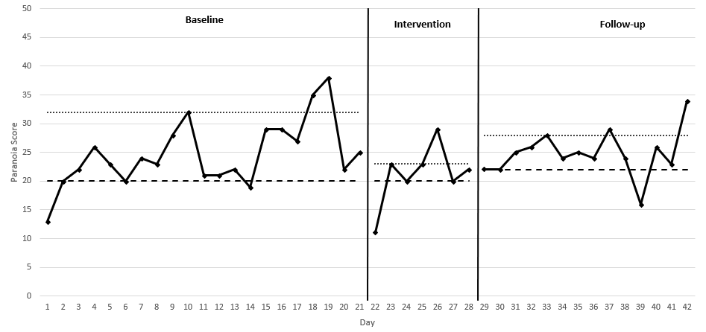

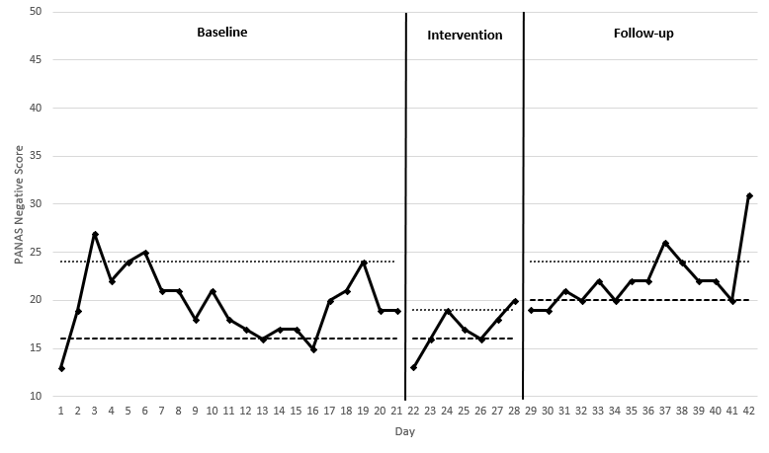

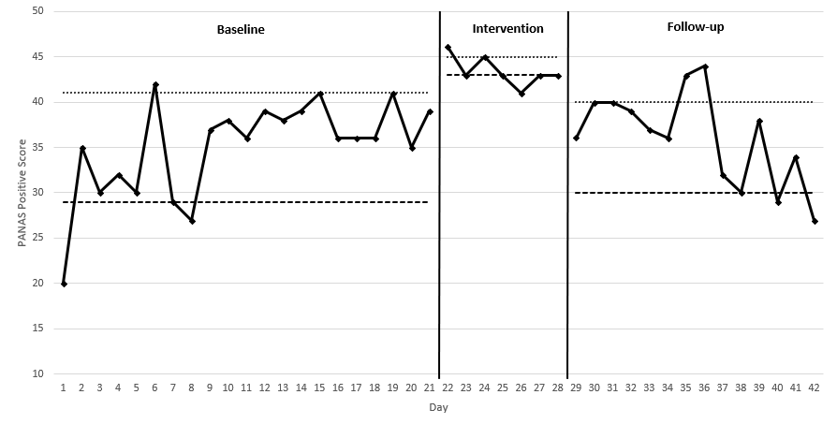

**Figure 2:** Daily state paranoia and affect scores for participant B (trimmed ranges)

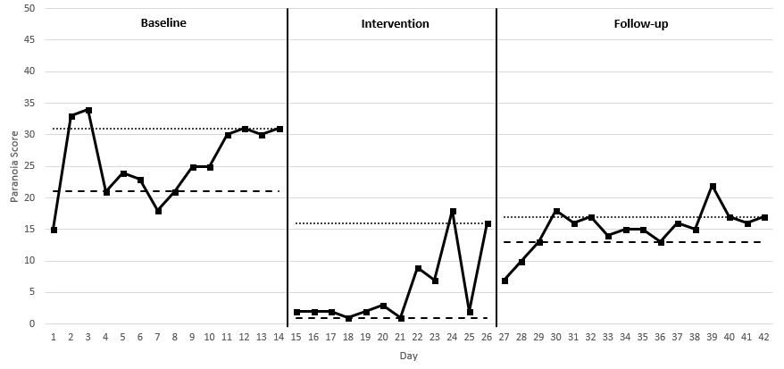

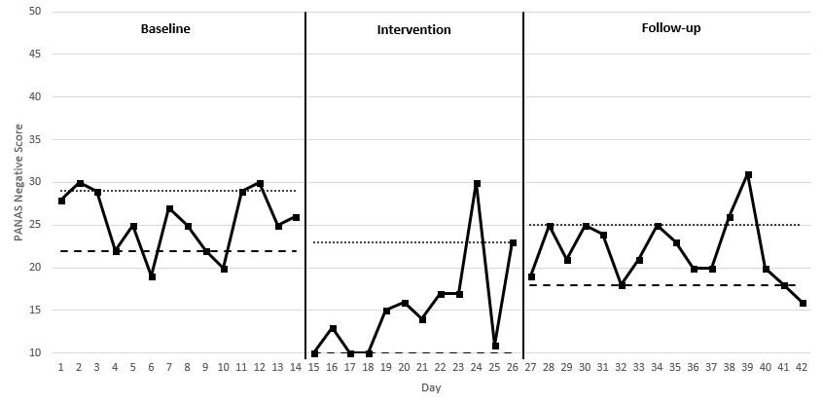

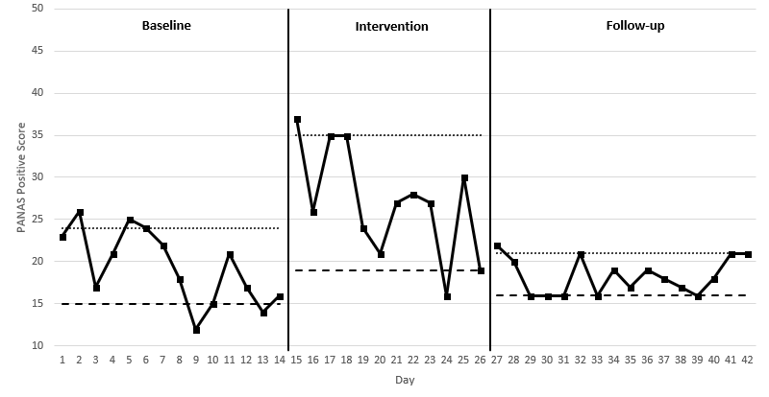

1. Some details have been changed to protect participants’ anonymity.