**Ecological responses to land use change in the face of European colonization of *Haytí* Island**

**Authors**

Alvaro Castilla-Beltrána,b,c*, Henry Hooghiemstraa, Menno L.P. Hooglandb, Timme H. Dondersd, Jaime R. Pagán-Jiménezb, Crystal N.H. McMichaela, Steven Marinus Francisco Rolefesd, Thomas Olijhoekd , Eduardo Herrera-Malatestab, Jorge Ulloa Hungb,e, Corinne L. Hofmanb

**Affiliations**

a. Department of Ecosystem and Landscape Dynamics, University of Amsterdam, Science Park 904, 1098XH Amsterdam, The Netherlands.

b. Faculty of Archaeology, Leiden University, The Netherlands.

c. School of Geography and Environmental Sciences, University of Southampton, UK.

d. Palaeoecology, Department of Physical Geography, Utrecht University, Princetonlaan 8a, 3584 CB, Utrecht, The Netherlands.

e. Instituto Tecnológico de Santo Domingo and Museo del Hombre Dominicano, Dominican Republic.

**Abstract**

Caribbean island ecosystems underwent significant landscape transformations in the centuries after Columbus landed in the archipelago in AD1492, but there is no agreement as to the degree and extent of pre-Columbian human impacts and the long-term trends of ecosystem disturbance and recovery. Here, we present an integrative analysis of three palaeoenvironmental records in the northern Caribbean island of *Haytí* (currently Dominican Republic and Haiti), to assess regional landscape transformation and human impacts in pre- and post-Columbian times. We examine biotic and abiotic indicators of landscape and ecosystem change along the Columbus’ Route, the first European extractive transport route built in the Americas. Our data show that indigenous populations transformed the landscape between 1000-450 cal yr BP through slash-and-burn agricultural practices. Depopulation and forced population displacement through relocation of indigenous people into Spanish mining areas triggered the recovery and expansion of forests in the valley, coastal plain and mountains. In contrast, mangroves near the first permanent European colonial outpost in the Americas (La Isabela) underwent no significant impacts related to climatic, indigenous, and early colonial pressures. All ecosystems studied have suffered degradation through deforestation during the last 200 years leading to the present fragmented landscapes. In islands with long histories of human settlement such as *Haytí*, reconstructing temporal and spatial aspects of human transformations and impacts on the environment is crucial to improving our understanding of the drivers and mechanisms of ecosystem degradation and recovery.

1. **Introduction**

The fragmentation, degradation and loss of ecosystems functions are key features of the Anthropocene Period (Lewis and Maslin 2015, Crutzen 2016) and especially critical in islands worldwide (Rick et al. 2013). An understanding of past ecological dynamics and historical responses to anthropogenic pressures is needed for the conservation of island ecosystems (Nogué et al. 2017). Both direct human impact (*e.g.* land use) and indirect perturbations (*e.g.* unintentional translocation of species) are primary drivers of the transformation of insular ecosystems (Whittaker et al. 2017, Froyd and Willis 2008). While some islands in the Americas were only settled in the last few centuries (e.g. Galápagos Islands), others, most notably in the Caribbean, have gone through millennia of human impacts and adaptation (Cooper 2012, Siegel et al. 2015). Thus, Caribbean island ecosystems have been subjected to varying rates and magnitudes of pressure depending on demographic shifts, cultural transitions and climatic variations since the middle Holocene (Fitzpatrick and Keegan 2007).

The invasion of the ‘New World’ by Europeans, which began in the Caribbean in AD 1492, instigated the introduction of non-native plants and animals and set the stage for the extraction and dispersal of indigenous resources (e.g. gold and plant domesticates like maize, tobacco and manioc) throughout the globe (Crosby 1972). In the Caribbean, and then the rest of the Americas, the suite of European arrival events caused the rapid spread of diseases that drastically affected indigenous communities (Dobyns 1966, Koch et al. 2019). Such changes were powerful drivers of landscape transformation, yet the degree and extent of pre- and post-Columbian human impacts and the resulting trends of change in Caribbean ecosystems are unclear. Integrating palaeoenvironmental sources of evidence in ‘natural archives’ (e.g. sediments accumulated in wetlands and lakes) is pivotal to develop reference points before and after socio-ecological developments. It can produce a long-term continuous view, or ‘moving baseline’ of ecosystem change related to abrupt and progressive anthropogenic changes. Here we assess pre-colonial (ca. 2000 to 450 cal yr BP; calibrated years before present, where ‘present’ is by definition AD 1950) and post-Columbian (the last 450 cal yr BP) landscape change by comparing the broad progression of ecological disturbance and recovery processes of three palaeoenvironmental records. These ‘chains of events’ are matched with other published records and put in a cultural context using published archaeological data in northern *Haytí*. We test the hypothesis that vegetation in the valley, mountain and coastal ecosystems of northern *Haytí* during the last 2000 yr BP underwent significant pre-colonial disturbance, colonial-era recovery and subsequent degradation.

*Haytí*, currently including the Dominican Republic and Haiti, is the second-largest island of the Caribbean (76,480 km2). The first arrival of human migrants occurred ca. 5500-5200 yr BP, which coincided with the extinction of mammals (*e.g.* giant sloths) (Cooke et al. 2017). These first inhabitants already introduced economic plants such as cassava (*Manihot esculenta*), maize(*Zea mays*) and sweet potato (*Ipomoea batatas*) to nearby islands such as Puerto Rico, a process that started during the peopling of the southern Caribbean islands from 7800 cal yr BP onwards (Pagán-Jimenez et al. 2015). In a second wave, migrants from the Lesser Antilles and Puerto Rico arrived in *Haytí* ca. 1500 yr BP (Late-Ceramic), associated to groups labelled the ‘Taínos’ (Rodriguez Ramos 2010, Rouse 1992). They practised agriculture in mounds and river terraces (Pagán-Jimenez et al. 2020). Archaeological research revealed that complex indigenous cultural interactions took place along the studied region before the European arrival (Ulloa Hung 2014, Hofman et al. 2018, Herrera Malatesta 2018, Herrera Malatesta and Hofman 2019). When Columbus landed in the northern coast of *Haytí*, he found the inland river valley well-populated (Moya Pons and Flores Paz 2013). This is strongly supported by the recent discovery of a high density of archaeological sites in northern *Haytí* (Ulloa Hung 2014, Hofman et al. 2018). Many of these indigenous communities were cultivating maize, tobacco, manioc and sweet potato (de Las Casas 1875, vol. 2). After the initial European incursions, La Isabela became the first successful colonial outpost in the New World. The Columbus Route (‘*Ruta de Colón’*) was the first transport infrastructure set by Europeans in the Americas and allowed communication between the coast and centre of the island where precious metals were sought (Ortega 1988, Guerrero and Veloz Maggiolo 1988; Fig 1). The first colonial settlers introduced cattle from Europe, and throughout colonial times proceeded to establish extensive plantations of cash-crops including tobacco, sugar cane and plantain (Hernández Gonzales 2007, Moreno del Río 2012).

1. **Material and Methods**

Our analysis assesses mainly three ecosystems: coastal and mangrove forests, forests on the valley floor, and mountain forests. We studied abiotic (granulometry and organic matter content) and biotic (fossil pollen, fungal remains, charcoal particles and phytoliths) indicators of environmental change in three sites. The site Estero Hondo (EH; 19º50’22.2” N, 71º11’04.4” W) is a basin situated in the coastal area near La Isabela, ca. 100 m in diameter, located in a mangrove area (Fig 1). Laguna Los Indios (LI; 19º43’18.8” N, 71º29’40.8” W) and Laguna Biajaca (BIA; 19º35’36.4’’N, 71º05’12.5’’W, 78 m asl) are situated in the Cibao Valley, and are cut-off river meanders filled with sediments (Fig 1) and were studied from a pure palaeoecological point before (Castilla-Beltran et al. 2018, Hooghiemstra et al. 2018). Simplified pollen records are shown in Supplementary figure 1.

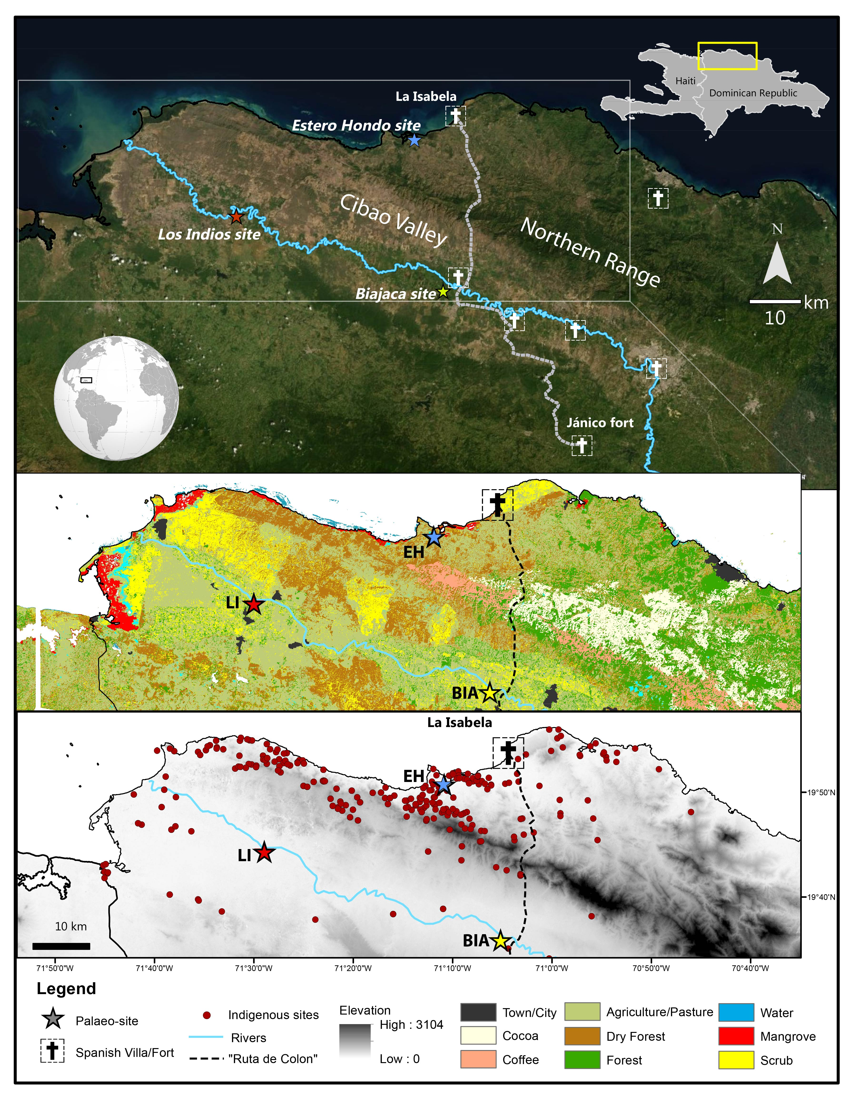

*Figure 1: Maps showing satellite images, vegetation distribution and elevation of northern Haytí showing the mangrove site Estero Hondo at the coast, and the sediment-filled meanders at Los Indios and Biajaca sites along the Yaque river. Archaeological indigenous sites, Spanish early settlements and the Columbus’ Route are shown.*

Half-cylindrical sediment cores of 50 cm length and 3 cm or 5 cm diameter (depending sediment resistance) were extracted from the three sites using a Russian Corer in a single fieldwork campaign in 2015. Multi-proxy palaeoecological analyses were carried out at the universities of Amsterdam, Utrecht and Leiden. We used pollen analysis to assess vegetation change, coprophilous fungal spores as evidence of the presence of herbivory and grazing. Charcoal particle area (> 100 µm) calculation provided evidence of local fire regimes, analysis of grain size distributions (GSD) to assess erosion processes, and loss-on-ignition (LOI) to show local production of organic matter (OM). Radiocarbon dates of macrofossils and bulk sediments were used to build the chronological models of the three sediment records. We used BACON software (Blaauw and Christen 2013) as a unifying method to generate comparable age-depth models for all records (Fig S3), defining the surface level of the cores as the year the fieldwork took place: -65 cal yr BP.

Percentage values of pollen and non-pollen palynomorphs (NPPs), and absolute values of charcoal, median grain size, OM were normalized (values range between 0 and 1) and plotted against calculated age to allow the comparison variations in trends between sites and data-visualization. Proxy-specific information of sites BIA and LI is provided in Castilla-Beltrán et al. (2018) and Hooghiemstra et al. (2018) respectively, and of EH site is shown as a summary in Supplementary figure 2.

We used the ‘Vegan’ package (Oksanen et al. 2013) in the R statistical software (R core team) to analyse our datasets using Detrended Correspondence Analysis (DCA) of pollen percentage data. We carried out Canonical Correspondence Analysis (CCA) analysis with ‘Vegan’, using pollen percentage data as a proxy for regional-to-local vegetation change, and four environmental variables representing phenomena at different scales:1) macro-charcoal particle concentration as a proxy for local fire regimes, 2) median grain size (a proxy for river valley erosion in valley sites and coastal erosion in the mangrove site), 3) organic matter, a proxy for local organic matter production, i.e. abundance of aquatic vegetation), and 4) percentages of coprophilous fungal spores relative to the pollen sum, a proxy for the local presence of herbivores, which may represent regional trends in grazing activity. We then ran CCAs with only one environmental variable and carried our PERMANOVA analysis to test the significance of each variable effect in the ecological assemblages. We used the ‘Strucchange’ package (Kleiber et al. 2002) in the R statistical software to carry out Multiple Breakpoint Analysis on the DCA axis-1 scores of the three sites to identify points of significant change of pollen assemblages through time.

1. **Results**

Between 2000 and 1000 cal yr BP, arboreal pollen (AP) proportions showed increases in the EH record (coastal plains, Fig 2a), and LI record (western Cibao valley; Fig 2b; age models based on radiocarbon ages in Fig S2). Significant shifts in pollen (Fig 2a), charcoal (Fig 2d) and grain size distributions (Fig 2f) took place between 1000 and 450 cal yr BP in all sites. AP percentages in the central (BIA) and eastern (LI) sites of the Cibao valley showed decline (Fig 2b). The disappearance of Proteaceae pollen (previously up to 7%), and a decrease of Myrtaceae pollen (from 14% to 3.5%) in BIA site took place in this period. In contrast, the 1000-450 cal yr BP period saw relative stability in the coastal area near La Isabela (EH site; Fig 2a). An increase in charcoal concentration between 800 and 500 cal yr BP did take place in EH, and was accompanied with higher abundance of pollen from dry forest taxa (Fig 2a, c).

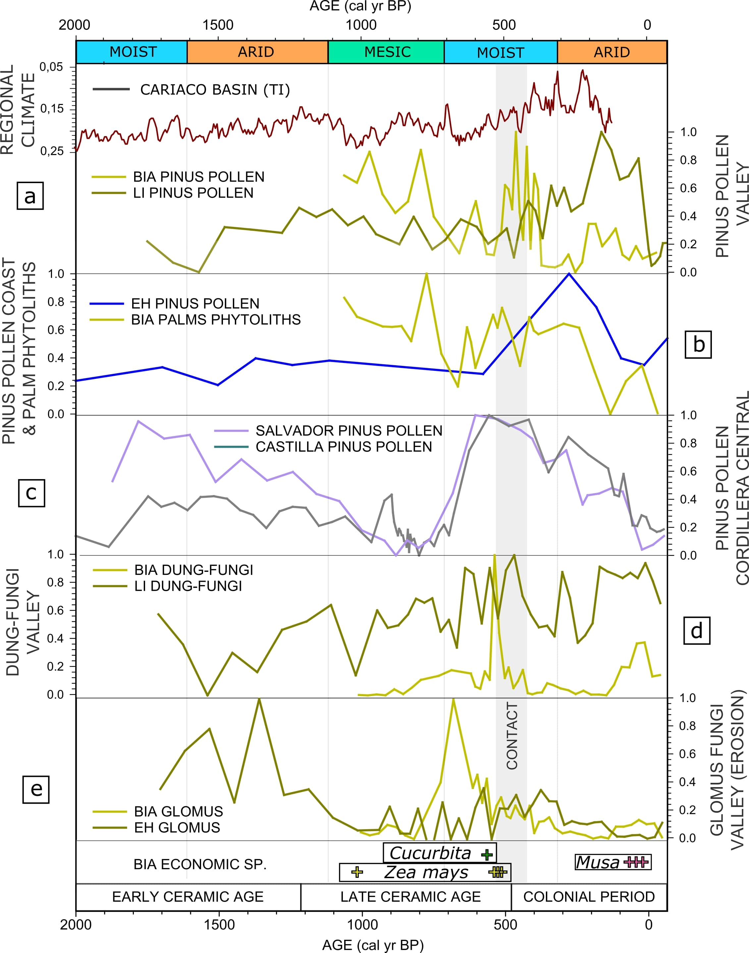

*Figure 2: Seven panels showing trends in different environmental proxies in the three studied sites along the Columbus’ Route, northern Haytí. A climatic characterisation of the last 2000 yr in Hispaniola (after Castilla-Beltrán et al. 2018) is given based on Cordillera Central sites (Lane et al. 2009), and trends from records with a regional relevance including the Cariaco Basin and Lake Chichancanab (Haug et al. 2001, Hodel et al. 2005). Measured values were normalized between 0 and 1. Stars refer to the map in panel 3.*

Pronounced increases in median grain sizes took place in coastal and meander valley records around 700 cal yr BP, and between 500 and 300 cal yr BP (Fig 2e). This mirrored by increases in *Glomus* spores in valley records, associated with soil erosion through the exposure of plant roots (van Geel and Aptroot 2006) (Fig 3e). Scattered peaks of AP in site BIA ca. 550 and 400 cal yr BP (Fig 2b) are due to input of *Pinus* pollen likely brought from the mountains by flooding. This suggests that meanders were still connected to the river system, as *Pinus* pollen peaks in BIA and LI site coincide with discrete peaks in grain size and low OM (Fig 2a), and are contemporary to highest proportions of *Pinus* pollen in Laguna de Salvador and Laguna de Castilla sites in the Cordillera Central (Fig 3a-c).

CCA analysis shows how fossil pollen assemblages associate with the two most influential gradients (CCA axes 1 and 2) derived from the combination of four environmental variables in the three sites: local fire (charcoal particle area), valley and coastal erosion (median grain size), local terrestrialization in the meanders, and local biomass in the coastal area shown by the abundance of OM and local to regional presence of herbivores (percentages of coprophilous fungal spores) (Tables S1 and S2). CCA analysis reveals that pre-colonial assemblages at the EH record are positively correlated to the erosion variable (Fig 4). In the BIA record, pre-colonial samples mostly plot in the negative axis-1, with fire, erosion and herbivore variables. In the LI record, most pre-colonial and contact period samples plot with erosion in the positive values of Axis-1. Multiple Breakpoint analysis (MBA) of DCA axis-1 highlights significant changes in the pollen assemblage in LI site between 800 and 600 cal yr BP.

Peaks in charcoal concentrations and spores of coprophilous fungi occurred in the BIA record between 550 and 450 cal yr BP (Fig 3d), and limited increases in coprophilous fungal spores occurred between 600 and 400 cal yr BP in LI site. Charcoal concentrations subsequently decreased in the LI and BIA records between 450 and 350 cal yr BP. Between 400-150 cal yr BP, a substantial increase in *Pinus* pollen and *Cyathea* tree-fern spores (up to 38% and 33%, respectively) was recorded in the LI record (western Cibao Valley), and *Croton* and Myrtaceae pollen percentages experienced a moderate increase (up to 2.5% and 5.3%, respectively, Fig S1). There was also the presence of other tropical tree taxa: Sapotaceae and *Warszewiczia*. In the BIA record, unprecedented increase in *Weinmannia* (up to 11.5%), *Myrica* (up to 4.5%) and Euphorbiaceae pollen (up to 6.5%), took place in the period between 300 and 200 cal yr BP. Also, *Hedyosmum,* Moraceae, *Clethra* (all up to 2.5%) and *Pinus* (up to 25%) pollen percentages increased, and pollen of Bombacaceae, *Croton* and *Alchornea* was present. The increases in *Pinus* pollen percentages in BIA and LI in this period are not mirrored by Cordillera Central records (Fig 3a, c). BIA and LI finer grain size distributions and increasing OM data suggest the meanders were closed-off from the river system. This suggests a more local origin of AP. MBA of DCA axis-1 of the BIA record suggests that significant vegetation changes between 450 and 200 cal yr BP. At the same time, the BIA phytolith record also showed an increase in palm phytoliths varying between 33% and 36% (Fig 3b). The combined valley sites and proxies indicate significant lowland forest regrowth 300-200 cal yr BP. Between 400 and 0 cal yr BP, AP percentages in the coastal plains near La Isabela (EH site) also showed increases: *Pinus* (up to 6.3%), Myrtaceae (up to 2%), Rubiaceae (up to 20%), Sapindaceae (up to 3%), Moraceae (up to 7.4%) and Euphorbiaceae (up to 8.3%), with the presence of *Cordia*, *Juglans* and Sapotaceae (Fig S1). Pollen percentages of mangrove taxa in EH site only saw narrow declines through this period.

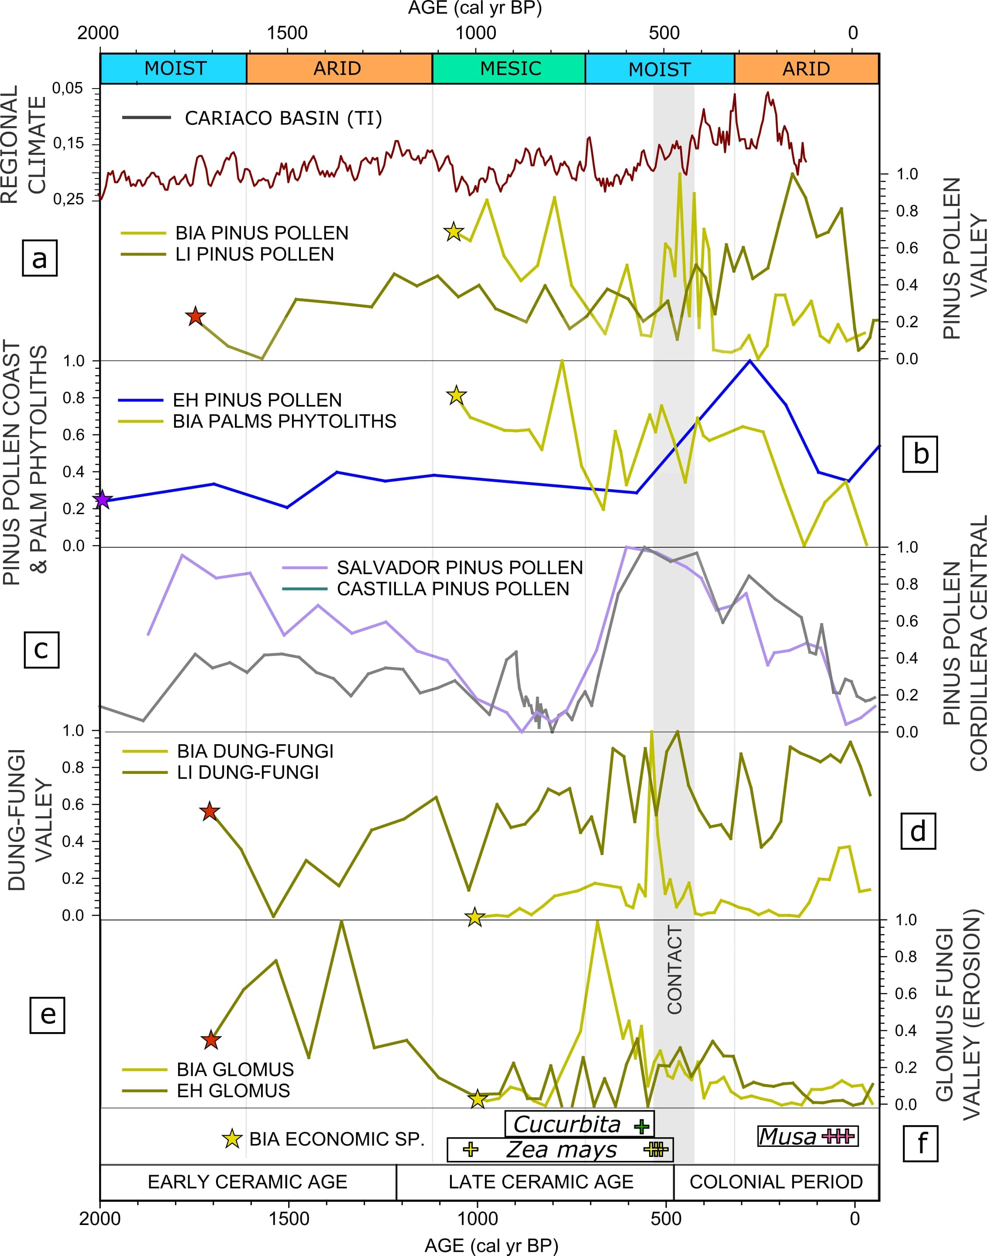

*Fig 3: Trends in different environmental proxies in northern and central Haytí. Panel c shows data from Laguna de Salvador and Laguna de Castilla, in the Cordillera central (Lane et al. 2009). All values were normalized between 0 and 1. The regional climatic characterisation is based on data from the Cariaco Basin and Lake Chichancanab (Haug et al. 2001, Hodel et al. 2015), Titanium concentration data from the Cariaco Basin downloaded from NOAA (Haug et al. 2001).*

Peaks in charcoal concentration occurred in LI record between 350- 150 cal yr BP and between 250- 150 cal yr BP in BIA (Fig 2d). Prominent charcoal peaks coincide with the cultivation of plantain (*Musa* sp., documented by phytoliths in the BIA record) (Fig 3). A decline of AP percentages between 100 and 0 cal yr BP took place in both valley records (BIA, LI; Fig 2b). In BIA record, late-colonial samples plot with OM, as they score positive values in Axis-1, and in the LI record CCA analysis, Late-colonial samples plot with OM and herbivores variables (Fig 4). A decline in pollen percentages of mangrove taxa in the EH record took place after 200 cal yr BP (Fig 2a). This trend is shown in the CCA analysis of the EH record, where Late-colonial samples plot with herbivores and fire variables (Fig 4).

1. **Discussion**

**4.1 Pre-colonial indigenous land use and its ecological impacts**

Comparing progressions of ecosystem disturbance and recovery between pre-colonial and post-Columbian periods in *Haytí* island shows the occurrence of multiple ecological responses to shifting human impacts. EH, LI and BIA study sites are archives of local ecological histories that were mainly shaped by socio-ecological interactions. The earliest hard evidence of agriculture in our records (*Zea mays* pollen) is associated with vegetation burning in BIA record ca. 900 cal yr BP (Castilla-Beltrán et al. 2018) and is contemporary to the first occurrence of *Zea mays* pollen in the Cordillera Central (Lane et al. 2008, 2009). Previous increases in charcoal concentration in the period between 1300 and 1000 cal yr BP in all sites (Fig 2c, d) coincide with an arid phase that brought about the Classic Maya collapse in Yucatan, so fires could reflect the arid conditions (Lane et al. 2014, Douglas et al. 2015). Increases in charcoal concentrations during regionally mesic and moist periods (900-500 cal yr BP) (Lane et al. 2009, Castilla-Beltrán et al. 2018, Fig 2c, d) indicate land use practice including fire. Burning was the result of slash-and-burn agricultural practices, commonly used by Caribbean (Pagán-Jiménez 2013) and Amazonian (Arroyo-Kalin 2012) indigenous communities. Phytolith analysis in archaeological mound deposits evidences the use of *Zea mays* and *Cucurbita* sp. in two archaeological sites situated in the southern slopes of the Northern Range (El Flaco and El Carril), dated between 924-798 cal yr BP (Pagán-Jiménez et al. 2020). Radiocarbon dating of archaeological remains confirms that most investigated sites in northern *Haytí* were actively occupied between 1000 and 450 cal yr BP (Hofman et al. 2018) (Fig S4). The integration of our three records reveals a spatial pattern of indigenous land use, which resulted in a mosaic-like pattern of forest clearances in the central and western Cibao valley and the Northern Range but, as far as we can see, not in the mangrove forests and coastal plains.

Data from Vieques, Puerto Rico, indicate the occurrence of prominent hurricane events ca. 500 BP (Donnelly and Woodruff 2007). Flooding and tropical storms in this humid phase explain the local erosion signals that coincide in both coastal and valley settings, suggesting they were regional episodes (Fig 2e, f). The reduction of forest area in the valley by indigenous land use (Fig 2b) could have contributed to flooding, and increased tree mortality, aggravating previous forest degradation. Increase abundance of coprophilous fungi in BIA and LI records coinciding with the introduction of Old World grazers between 600 and 400 cal yr BP could be the first evidence of European incursion in the study area. However, age probability distribution in the chronological model could support the interpretation that these processes took place shortly before Columbus’ landing. In that case, the spike in spores of coprophilous fungi could indicate the decay of wood structures or fallen trees, as some coprophilous fungi can also be saprophytic (van Geel and Aptroot 2006, Gelorini et al. 2011).

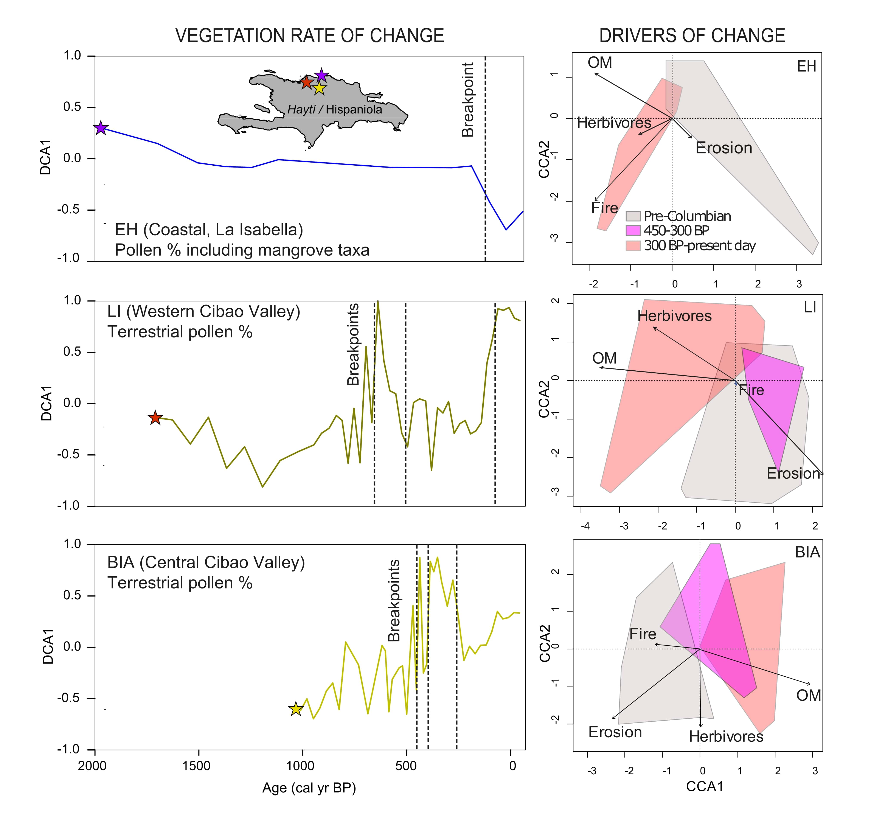

*Figure 4: Left side panels show DCA axis1 of pollen data from all sites and Multiple Breakpoints found in DCA axis-1. Right side panels show CCA of EH, LI and BIA sites, colored areas indicate the distribution of samples per period within the bidimensional space formed by CCA axis-1 and CCA axis-2 scores (Tables S1 and S2 show eigenvalues, percentage of variance explained by CCA axis 1 and CCA axis 2 axes and environmental variable scores).*

**4.2 Ecological responses to the European colonial invasion**

The integration of our three paleoenvironmental datasets indicates that the vegetation of the Cibao valley, surrounding mountainous regions and coastal plains underwent significant transitions from open ‘managed landscapes’ towards the formation and expansion of open gallery forests, wooded meadows and mountain forests (in the Northern Range) between 400 and 200 cal yr BP. These changes were most severe in the central Cibao valley due to abandonment of agricultural lands by former indigenous communities. Indeed burning decreased between 500 and 300 cal yr BP, and weeding processes by pioneer taxa (*e.g. Artemisia*) are evident in the BIA record after charcoal decline (Castilla-Beltrán et al. 2018). Between 350 and 200 cal yr BP, data from the BIA and LI records suggest the regrowth of secondary forests, formed by *Pinus caribea*, *Weinmannia*, *Myrica* and *Hedyosmum* in the mountainsand Euphorbiaceae, Moraceae, *Clethra, Alchornea,* Bombacaceae*, Croton,* Sapotaceae, palm species and tree ferns (*Cyathea*) in the mountainous margins and the central Cibao valley. An increase in dry forest taxa near La Isabela (EH site) after 400 cal yr BP indicates that forest growth also took place in the coastal plains. In contrast, the mangrove forest near La Isabela did not show significant change during the first centuries of the European take-over. This could be related to the low impact indigenous land-use practices had in mangroves during pre-colonial times.

The regionally emergent pattern of recovery and expansion of the valley-, coastal- and mountainous-forests was linked to the depopulation of northern *Haytí* driven by diseases that decimated the indigenous population (Dobyns 1976). Remaining communities were forcedly displaced to inland mining areas, a product of the imposition of new forced labour regimes (Cassá 2003). Recently, it has been hypothesized that the continental-scale depopulation of the Americas might have played a major role in global cooling during the Little Ice Age by lowering global atmospheric CO2 concentrations (Koch et al. 2019). Similarly, forest re-growth was hypothesized due to depopulation after the Black Death (Van Hoof et al. 2006). Rapid forest successional processes have been documented in tropical mountain forests in the Andean-Amazonian corridor between 250-150 cal yr BP (Loughlin et al. 2018). Relatively moist environmental conditions and depopulation between 450 and 350 cal yr BP could have produced a positive feedback loop that led the steady forest re-growth that took place in the northern *Haytí* between 400 and 200 cal yr BP. Our integrative approach reveals that in the Cibao valley, secondary forests structure may be partly a legacy of a process of regional depopulation and population displacement. However, these valley and mountainous secondary forests did not reach the full extent as the original forest held before the settlement of indigenous cultivation (ca. 1300 cal yr BP), and dissimilarities between pollen assemblages could be explained by the expansion of species with pioneering qualities. This exemplifies how in islands with a long history of human settlement, assessing the diverse relationships between ecological dynamics and socio-political change can reveal the emergence of transformed ecosystems.

**4.3 Late-colonial impacts and landscape degradation**

The population of western *Haytí* (French colony) increased during the 18th century AD and led to the implementation of extensive monoculture in the island. Under Spanish rule, the Cibao Valley became the powerhouse of livestock and agriculture for that region. This, together with the rise of tobacco production in the valley and the promotion of migration to sustain this activity, while avoiding French incursions into the area, caused the clearance of most of the newly formed forest of the Cibao Valley (Hernández Gonzales 2007). Between 300 and 200 cal yr BP, forest re-growth was taking place in the Cibao Valley, but a prominent increase in charcoal in the LI record ca. 300 cal yr BP suggests an increasing degree of management by humans in the west (Hooghiemstra et al. 2018). Between 200 yr BP and present-day, all studied ecosystems underwent severe degradation by deforestation, leading to the current agricultural landscape cleared from the last forest remnants. While forest cover in the Cibao Valley was reduced, river erosion was controlled, probably by putting in place of dams (yet nowadays the Yaque River continues to flood significant parts of the valley during the wet season). Growth of dry forest in the coastal plain continued until recent times (0 cal yr BP: ca. 70 yr ago) which is also recognised by increases in AP in the coastal lagoon Laguna Saladilla (Caffrey et al. 2015), ca. 75 km southwest from EH site. It declined in the second half of the 20th century likely due to deforestation for the production of charcoal. This is also documented in the highland ecosystems of the Cordillera Central (Kennedy et al. 2006) and coastal forests around Lake Migraone, southwestern *Haytí* (Higuera-Gundy et al. 1999). The integration of multiple paleoenvironmental records in this island suggests that the recent wave of anthropogenic pressures (ca. 150 cal yr BP-present day) affected all ecosystems, even those that had previously undergone minimal human impacts.

1. **Conclusion**

Comparing the progression of ecosystem disturbance and recovery between pre-colonial and post-Columbian periods by integrating paleoenvironmental records shows the occurrence of multiple responses to human impacts in the northern Caribbean island of *Haytí*. Biotic and abiotic indicators of landscape change along the Columbus’ Route reveal that centuries of indigenous slash-and-burn practices resulted in clearances of the forest, which caused transformations of the forest in the Cibao Valley and the Northern Range, but not in the mangrove and coastal plain. After European incursion on the island, depopulation driven by disease and forced population displacement triggered the recovery and expansion of the valley and mountainous forest. Between 200 yr BP and present-day, all studied ecosystems underwent severe degradation by deforestation, leading to the current agricultural landscape cleared from the last forest remnants. This study shows how in an island with a long history of human settlement, assessing the diverse relationships between ecosystem dynamics and socio-political change can reveal the local-to-regional mechanisms and drivers of ecosystem degradation and recovery.

1. **Acknowledgements**

The research was carried out as part of the NEXUS1492 project under the direction of prof. Corinne L. Hofman funded by the European Research Council under the European Union’s Seventh Framework Programme (FP7/2007-2013)/ERC grant agreement nº 319209. Fieldwork was carried out with the assistance of dr Pat Farrel, dr Michael Field and dr Peter Siegel. We thank prof Chad Lane for sharing his pollen data from the Laguna de Castilla and Laguna de Salvador, Cordillera Central. We thank Annemarie Philip for preparing the pollen samples, and dr. Bas van Geel, dr. Michael Field, dr. Maarten Prins and dr. William Gosling for their guidance and support during laboratory work.

1. **Author contributions**

CLH, MLPH and HH conceived the ideas. HH, MLPH, JUH and ACB carried out the fieldwork. TO, ACB and SR performed the proxy analyses under the supervision of HH (pollen), BvG (non-pollen palynomorphs), CHMM (charcoal), JPJ (phytoliths), TD (organic matter, grain size distributions), MLPH (14C ages). HH coordinated all analyses. ACB, HH, CHMM and TD drafted the manuscript and ACB, MLPH and EHM designed and created the figures. All authors significantly contributed to the final version.

Corresponding author: Alvaro Castilla-Beltrán (a.castilla-beltran@soton.ac.uk)

1. **Data availability statement**

The data on which this paper is based will be submitted to the open-access Latin American Pollen Database and Neotoma Database.

1. **References**

Arroyo-Kalin, M., 2012. Slash-burn-and-churn: Landscape history and crop cultivation in pre-Columbian Amazonia. Quaternary International 249, 4-18.

Blaauw, M., Christen, J.A., 2013. Bacon Manual e v2. 3.5. 387-394.

Caffrey, M.A., Horn, S.P., Orvis, K.H., Haberyan, K.A., 2015. Holocene environmental change at Laguna Saladilla, coastal north Hispaniola. Palaeogeography Palaeoclimatology Palaeoecology 436, 9-22.

Cassá, R., 2003. Historia social y económica de la República Dominicana (Vol. 1). Alfa y Omega, Santo Domingo.

Castilla-Beltrán, A., Hooghiemstra, H., Hoogland, M.L.P., Pagán-Jiménez, J., van Geel, B., Field, M.H., Prins, M., Donders, T., Herrera Malatesta, E., Ulloa Hung, J., McMichael, C.H., Gosling, W.D., Hofman, C.L., 2018. Columbus’ footprint in Hispaniola: A paleoenvironmental record of indigenous and colonial impacts on the landscape of the central Cibao Valley, northern Dominican Republic. Anthropocene 22, 66-80.

Cooke, S.B., Dávalos, L.M., Mychajliw, A.M., Turvey, S.T., Upham, N.S., 2017. Anthropogenic extinction dominates Holocene declines of West Indian mammals. Annual Review of Ecology, Evolution and Systematics 48, 301-327.

Cooper, J., 2012. Fail to prepare then prepare to fail: rethinking threat vulnerability and mitigation in the Precolumbian Caribbean, in: Cooper, J., Sheets, P. (Eds.), Surviving sudden environmental change: answers from archaeology. University of Colorado Press, Boulder, pp. 91-114.

Crosby, A.W., 1972. The Columbian exchange: biological and cultural consequences of 1492. Greenwood Publishing Group, USA.

Crutzen, P.J., 2016. Geology of mankind, Paul J. Crutzen: A Pioneer on atmospheric chemistry and climate change in the Anthropocene. Springer, pp. 211-215.

De Las Casas, B., 1875. Historia de las indias, tomo II. Edición del Marqués de la Fuensanta del Valle y D. José Sancho Rayon Imprenta de Miguel Ginesta, Madrid, Spain.

Dobyns, H.F., 1976. Native American historical demography, a critical bibliography. Indiana University Press, Bloomington, Indiana.

Donnelly, J.P., Woodruff, J.D., 2007. Intense hurricane activity over the past 5000 years controlled by El Niño and the West African monsoon. Nature 447, 465-468.

Douglas, P.M., Pagani, M., Canuto, M.A., Brenner, M., Hodell, D.A., Eglinton, T.I., Curtis, J.H., 2015. Drought, agricultural adaptation, and sociopolitical collapse in the Maya Lowlands. Proceedings of the National Academy of Sciences 112, 5607-5612.

Fitzpatrick, S.M., Keegan, W.F., 2007. Human impacts and adaptations in the Caribbean Islands: an historical ecology approach. Earth and Environmental Science Transactions of the Royal Science of Edinburgh 98, 29-45.

Froyd, C., Willis, K., 2008. Emerging issues in biodiversity & conservation management: the need for a palaeoecological perspective. Quaternary Science Reviews 27, 1723-1732.

Gelorini, V., Verbeken, A., van Geel, B., Cocquyt, C., Verschuren, D., 2011. Modern nonpollen palynomorphs from East African lake sediments. Review of Palaeobotany and Palynology 164, 143-173.

Haug, G.H., Hughen, K.A., Sigman, D.M., Peterson, L.C., Röhl, U., 2001. Southward migration of the intertropical convergence zone through the Holocene. Science 293, 1304-1308.

Hernández Gonzales, M., 2007. Expansión fundacional y desarrollo en el norte dominicano (1680-1795). El Cibao y la Bahía de Samaná. Archivo General de la Nación y Academia Dominicana de la Historia, Santo Domingo.

Herrera Malatesta, E., 2018. Una isla, dos mundos: estudio arqueológico sobre el paisaje indígena de Haytí y su transformación al paisaje colonial de La Española (1200-1550). Sidestone Press, Leiden, The Netherlands.

Herrera Malatesta, E., Hofman, C.L., 2019. Indigenous landscape transformation on Northern Haytí: an archaeological and environmental database of the Montecristi Coast. Journal of Open Archaeology Data 7.

Higuera, P., 2009. CharAnalysis 0.9: diagnostic and analytical tools for sedimentcharcoal analysis. User’s Guide, Montana State University, Bozeman, MT.

Higuera-Gundy, A., Brenner, M., Hodell, D.A., Curtis, J.H., Leyden, B.W., Binford, M.W., 1999. A 10,300 14 C yr record of climate and vegetation change from Haiti. Quaternary Research 52, 159–170.

Hodell, D.A., Brenner, M., Curtis, J.H., 2005. Terminal classic drought in the northern Maya lowlands inferred from multiple sediment cores in Lake Chichancanab (Mexico). Quaternary Science Reviews 24, 1413-1427.

Hofman, C.L., Ulloa Hung, J., Malatesta, E.H., Jean, J.S., Sonnemann, T., Hoogland, M., 2018. Indigenous Caribbean perspectives: archaeologies and legacies of the first colonised region in the New World. Antiquity 92, 200-216.

Hooghiemstra, H., Olijhoek, T., Hoogland, M., Prins, M., van Geel, B., Donders, T., Gosling, W., Hofman, C., 2018. Columbus’ environmental impact in the New World: land use change in the Yaque River valley, Dominican Republic. The Holocene 28, 1818-1835.

Keegan, W.F., 1994. West Indian archaeology. 1. Overview and foragers. Journal of Archaeological Research 2, 255-284.

Kennedy, L.M., Horn, S.P., Orvis, K.H., 2006. A 4000-year record of fire and forest history from Valle de Bao, Cordillera Central, Dominican Republic. Palaeogeography Palaeoclimatology Palaeoecology 231, 279-290.

Kleiber, C., Hornik, K., Leisch, F., Zeileis, A., 2002. strucchange: An R package for testing for structural change in linear regression models. Journal of Statistical Software 7, 1-38.

Koch, A., Brierley, C., Maslin, M.M., Lewis, S.L., 2019. Earth system impacts of the European arrival and Great Dying in the Americas after 1492. Quaternary Science Reviews 207, 13-36.

Lane, C.S., Horn, S.P., Kerr, M.T., 2014. Beyond the Mayan lowlands: impacts of the terminal classic drought in the Caribbean Antilles. Quaternary Science Reviews 86, 89-98.

Lane, C.S., Horn, S.P., Mora, C.I., Orvis, K.H., 2009. Late-Holocene paleoenvironmental change at mid-elevation on the Caribbean slope of the Cordillera Central, Dominican Republic: a multi-site, multi-proxy analysis. Quaternary Science Reviews 28, 2239–2260.

Lane, C.S., Horn, S.P., Orvis, K.H., 2008. The earliest evidence of Ostionoid maize agriculture from the interior of Hispaniola. Caribbean Journal of Science 44, 43-53.

Lewis, S.L., Maslin, M.A., 2015. Defining the Anthropocene. Nature 519, 171.

Loughlin, N.J., Gosling, W.D., Mothes, P., Montoya, E., 2018. Ecological consequences of post-Columbian indigenous depopulation in the Andean–Amazonian corridor. Nature Ecology & Evolution 2, 1233.

Moreno del Río, J.L., 2012. Ganadería, plantaciones y comercio azucarero antillano. Siglos XVI y XVIII. Academia Dominicana de la Historia, Santo Domingo.

Nogué, S., de Nascimento, L., Froyd, C.A., Wilmshurst, J.M., De Boer, E.J., Coffey, E.E.D., Whittaker, R.J., Fernández-Palacios, J.M., Willis, K.J., 2017. Island biodiversity conservation needs palaeoecology. Nature Ecology and Evolution 1, 1-9.

Ortega, E., 1988. La Isabela y la arqueología en la ruta de Cristobal Colón. Universidad Central del Este, San Pedro de Macoris.

Oviedo y Valdés, G.F.d., 1851. Historia general y natural de las indias, islas y tierra firme del mar océano. Imprenta de la Real Academia de la Historia, Madrid, Spain.

Pagán-Jiménez, J., Rodríguez Ramos, R., Hofman, C., 2019. On the way to the islands: the role of domestic plants in the initial peopling of the Antilles, Early settlers of the insular Caribbean. Dearchaizing the Archaic. Sidestone Press Leiden, The Netherlands, pp. 89-106.

Pagán-Jiménez, J.R., 2013. Human plant dynamics in the precolonial Antilles, in: Keegan, W.F., Hofman, C.L., Rodríguez Ramos, R. (Eds.), The Oxford handbook of Caribbean archaeology. Oxford University Press, New York, pp. 391-406.

Pagán-Jiménez, J.R., Ali, Z., Santiago-Marrero, C.G., Hofman, C.L., 2020. Plantscapes of dwelling: precolonial household mounds, phytocultural dynamics and the ensuing human ecosystems at El Flaco and El Carril (cal AD 990–1450), northern Dominican Republic. Review of Palaeobotany and Palynology 274, 104-160.

Pagán-Jiménez, J.R., Rodríguez-Ramos, R., Reid, B.A., van den Bel, M., Hofman, C.L., 2015. Early dispersals of maize and other food plants into the Southern Caribbean and Northeastern South America. Quaternary Science Reviews 123, 231-246.

Rick, T.C., Kirch, P.V., Erlandson, J.M., Fitzpatrick, S.M., 2013. Archeology, deep history, and the human transformation of island ecosystems. The Anthropocene 4, 33-45.

Rouse, I.B., 1992. The Tainos: rise and decline of the people who greeted Columbus. Yale University Press, New Haven, USA.

Siegel, P.E., Jones, J.G., Pearsall, D.M., Dunning, N.P., Farrell, P., Duncan, N.A., Curtis, J.H., Singh, S.K., 2015. Paleoenvironmental evidence for first human colonization of the eastern Caribbean. Quaternary Science Reviews 129, 275-295.

Ulloa Hung, J., 2014. Arqueología en la línea noroeste de la Española. Paisajes, cerámicas e interacciones. Instituto Tecnológico de Santo Domingo, República Dominicana.

van Geel, B., Aptroot, A., 2006. Fossil ascomycetes in Quaternary deposits. Nova Hedwigia 82, 313-329.

van Hoof, T.B., Bunnik, F.P.M., Waucomomt, J.G.M., Kürschner, W.M., Visscher, H., 2006. Forest re-growth on medieval farmland after the Black Death pandemic; implications for atmospheric CO2 levels. Palaeogeography Palaeoclimatology Palaeoecology 237, 396-411.

Whittaker, R.J., Fernández-Palacios, J.M., Matthews, T.J., Borregaard, M.K., Triantis, K.A., 2017. Island biogeography: taking the long view of nature’s laboratories. Science 357, 8326.

**Appendix (captions of supplementary figures and tables)**



Fig S1: Pollen percentage diagrams of cores Biajaca (BIA), Los Indios (LI), and Estero Hondo (EH) showing percentages of selected arboreal taxa and pollen assemblage zones.

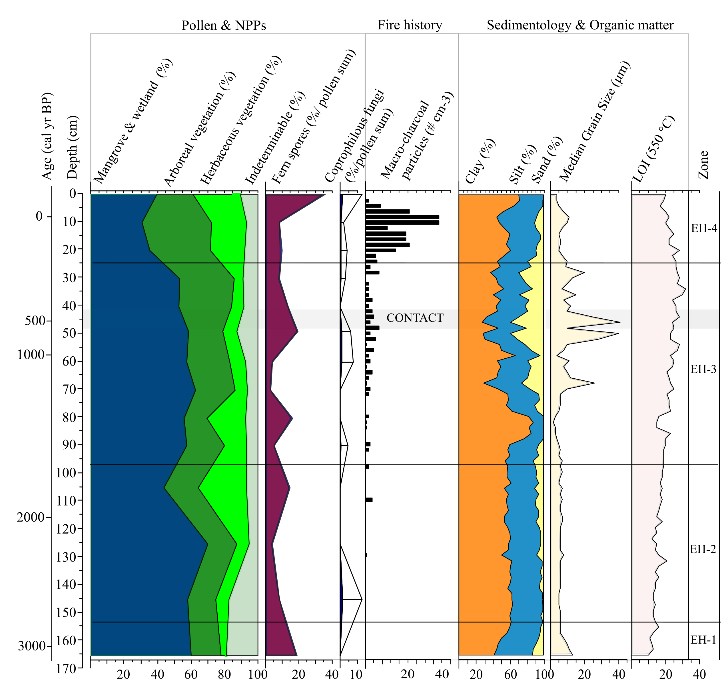

Fig S2: Summary diagram of palaeoenvironmental change in the Estero Hondo site (EH), northern *Haytí* island, including pollen, NPPs, charcoal and sedimentological data.

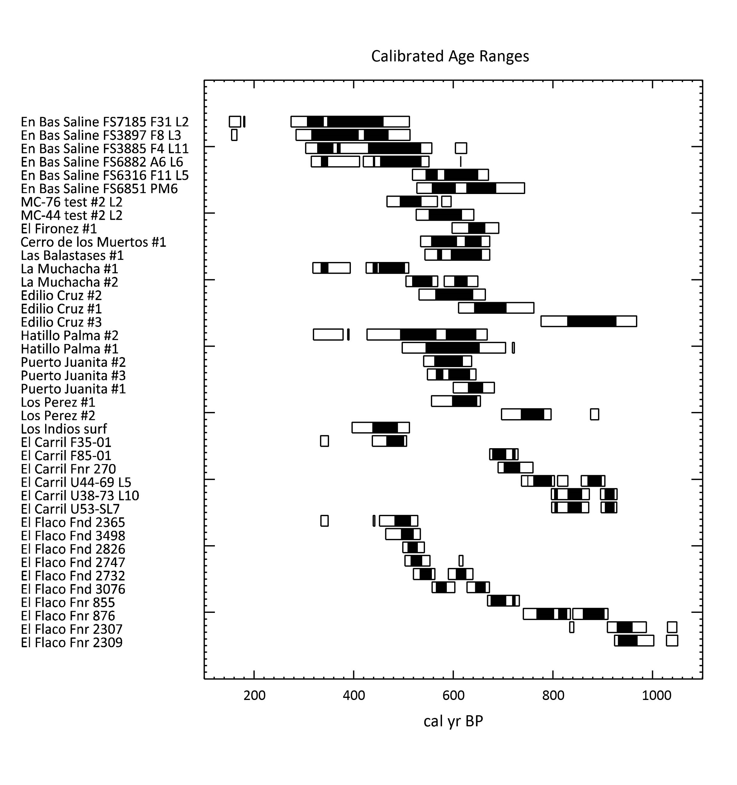

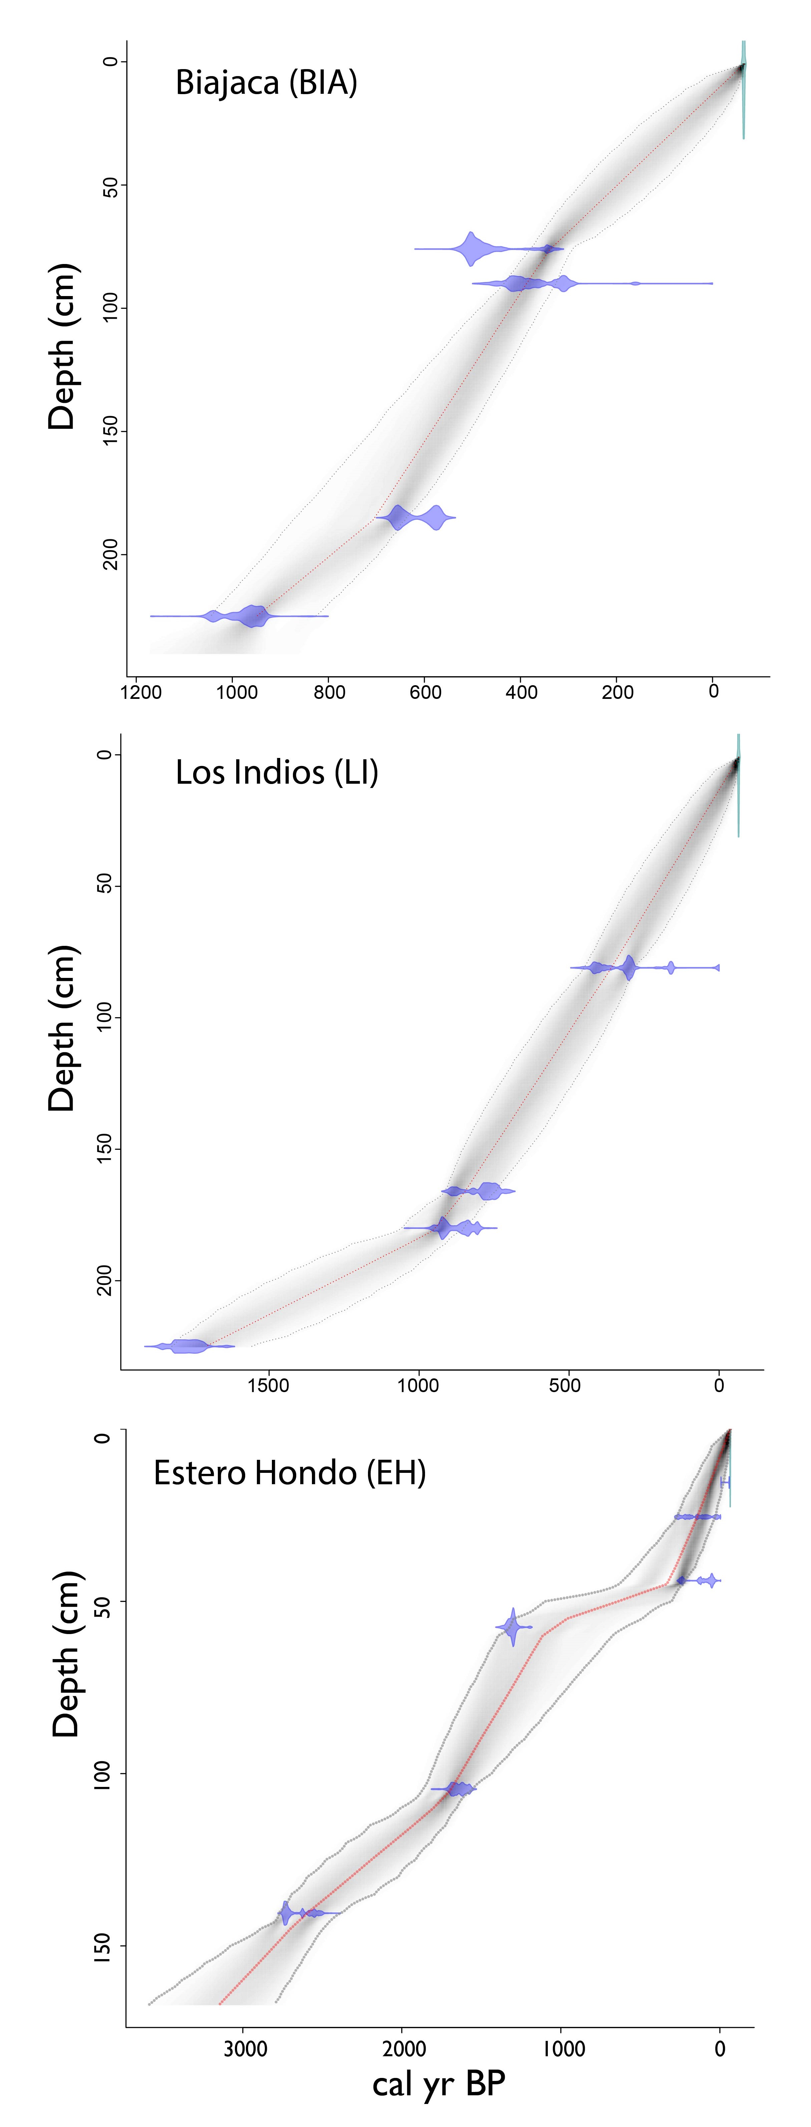

Fig S3: Age-depth models of the three sediment cores using BACON . Calibrated 14C dates shown in blue, and grey area shows 95% confidence intervals. All 14C dates of cores Biajaca and Los Indios are based on bulk sediments, whereas in sediment core Estero Hondo two bulk and four plant materials were dated.

Fig S4: Calibrated radiocarbon dates of 14 indigenous sites in the northern areas of *Haytí* island. The conventional radiocarbon dates were calibrated with CALIB 7.0.4 to obtain calibrated years before present (cal yr BP)..

Table S1: Canonical Correspondence Analysis scores of records Biajaca (BIA), Los Indios (LI) and Estero Hondo (EH).

Table S2: Canonical Correspondence Analysis and PERMANOVA scores of environmental variables of record Biajaca (BIA), Los Indios (LI), and Estero Hondo (EH).