**Optimized design of metal-coated optical fiber tips with embedded plasmonic slot nano-resonators for maximum field enhancement**

Afroditi Petropoulou*a,c, Michalis N. Zervasb, and Christos Riziotisa

aTheoretical and Physical Chemistry Institute, Photonics for Nanoapplications Laboratory, National Hellenic Research Foundation, 48 Vassileos Constantinou Ave., Athens, 116 35, Greece; bOptoelectronics Research Centre, University of Southampton, Highfield, Southampton, Hampshire, SO17 1BJ, United Kingdom;

cDepartment of Informatics and Telecommunications, University of Peloponnese, End of Karaiskaki Street, Tripolis, 22100, Greece

**ABSTRACT**

The integration of Plasmonic Nano-Resonators (PNRs) to optical fibers tips with thin metallic claddings forming plasmonic slot nano-resonators (PSNRs) is presented. It is shown that the placement of the PSNR at the cut-off radius of the fiber tip for a specific wavelength where the group velocity tends to zero and light slows down leads to an optimization of field's enhancement. Enhancement factors greater than 3x105 were calculated through Finite Element Method (FEM) simulations by placing the PSNR at the cut-off radius and by changing the geometrical characteristics in order to identify optimal conditions for loss minimization that can find many practical applications in nano-optics and sensing.

**Keywords**: Plasmonics, nano-resonators, fiber tips

**1. INTRODUCTION**

The need of high field confinement beyond the diffraction limit of light has led to a remarkable progress in the field of plasmonics over the last decades. Many different plasmonic structures that can confine and enhance the electromagnetic field by orders of magnitude by exploiting the coupling between light and conductive electrons have extensively been studied. Such structures have found applications in many research fields such as data storage1, microscopy2, surface-enhanced Raman spectroscopy3 and sensing4,5.

Plasmonic slot nano-resonators (PSNRs) are subwavelength apertures embedded in thin metal films that can provide high confinement and spatial resolution6,7. The plasmon resonances of such structures are determined by their geometrical characteristics, i.e., film thickness and aperture perimeter8. Also by changing the shape of the aperture or creating sharp edges by nano-patterning the metal film, field enhancement can be improved by orders of magnitude.

The integration of PSNRs to optical fibers provide ease of light coupling instead of using bulky and complex configurations for exciting the SPPs. In this paper tapered optical fibers coated with thin metal films with embedded PSNRs is discussed. By changing the shape of the PSNR as well as its position across the length of the tapered fiber the enhancement factor can be improved compared to previously demonstrated works. Furthermore tapered fibers with different semi-angles are examined in order to minimize the losses induced by the metal.

**\***apetropoulou@eie.gr; Riziotis@eie.gr; phone +30 210 7273843; www.eie.gr

**2. SIMULATIONS OF PSNRs EMBEDDED IN PLASMONIC FIBER TIPS**

The optimized position of wavelength for embedding a slot is at the tip radius where the light exhibits its highest confinement. The highest confinement is expected close to the cutoff radius which is different for each wavelength. For radii smaller than the cutoff the losses increase and the energy leaks out. Figure 1 shows real (a) and imaginary (b) part of the effective refractive index for silica core radius of 400nm and 30nm gold layer thickness. For λ>1622nm neff becomes less than unity leading to a rapid decrease of the transmissivity since the phase velocity becomes larger than the speed of light c. Hence the highest enhancement for a PSNR embedded at r=400nm is expected for λ≈1622nm.

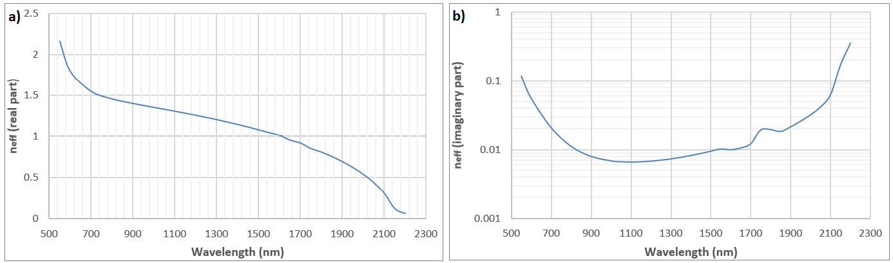

Figure 1. Real (a) and imaginary (b) part of the effective refractive index for core radius of 400nm and 30nm gold layer thickness.

Figure 2 shows group velocity as a function of the core radius for the cylindrical structure with a 30nm gold layer for λ=1650nm. As expected the group velocity decreases rapidly for radii smaller than 400nm and light gets totally blocked at r≈250nm where the neff for λ=1650nm approaches zero.

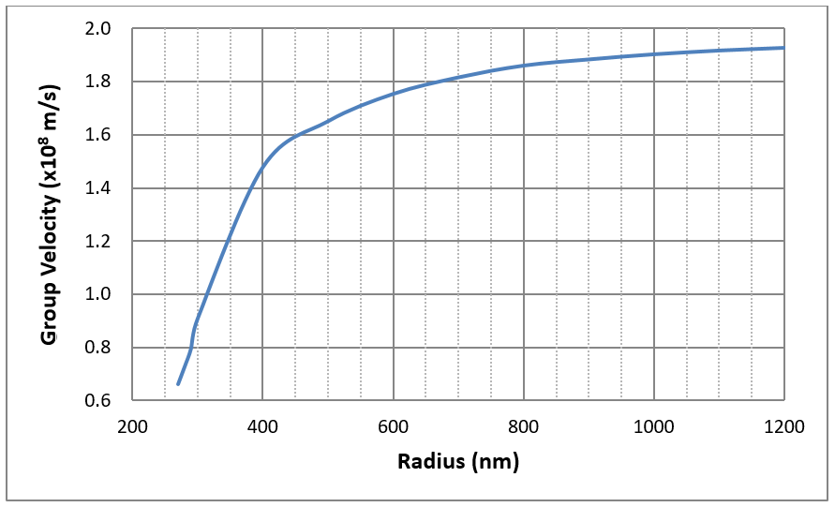

Figure 2. Group velocity versus core radius for the cylindrical structure with a 30nm gold layer for λ=1650nm.

Simulations through Finite Element Method (FEM) using COMSOL Multiphysics were performed in order to evaluate the performance of PSNRs embedded at different radii. The simulated structure is a gold-coated fiber tip with a 30nm gold layer, semi-angle a=5.33o and input radius of the silica core r=735nm, in order to compare it with previously published work6 (Figure 3 (a)). A rectangular PSNR of 400nm length and 200nm width is embedded at the x-z plane so the structure is symmetric with respect to the y – z plane and half of it was simulated. The launched mode is the fundamental core mode (m=1, r=1) with polarization along the x direction using Boundary Mode Analysis in order to excite the plasmon resonance at the PSNR. When the plasmon resonance is excited the current density is parallel to the perimeter of the slot. For y-polarized light the current density is perpendicular to the perimeter exciting the weaker Fabry-Perot like resonance9 (Figure 3b). Since the light is x-polarized and half of it is simulated the separatrix is set to be a perfect electric conductor (PEC), i.e., **n** x **E** = **0** on the y – z plane, in order to excite the x-polarized fundamental core mode.

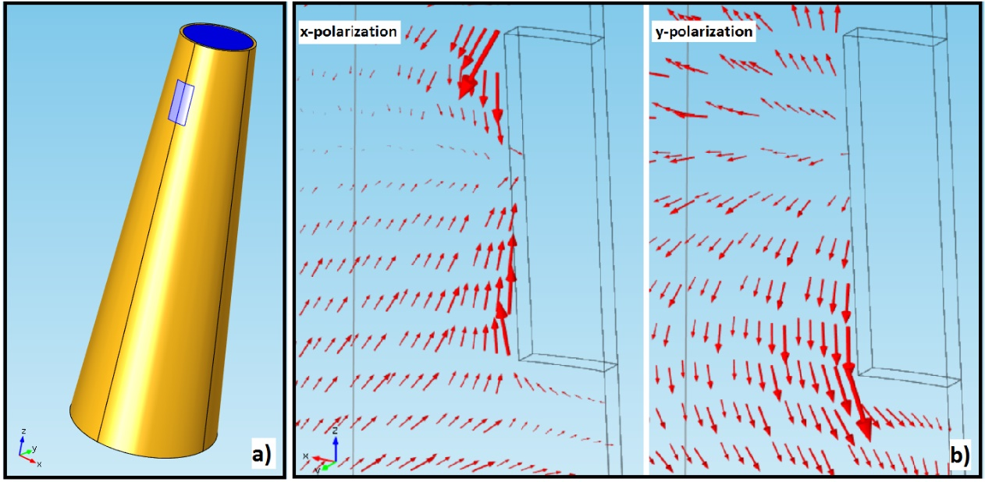

Figure 3. a) The simulated fiber tip. b) Current density for x-polarized (left) and y-polarized (right) launched mode.

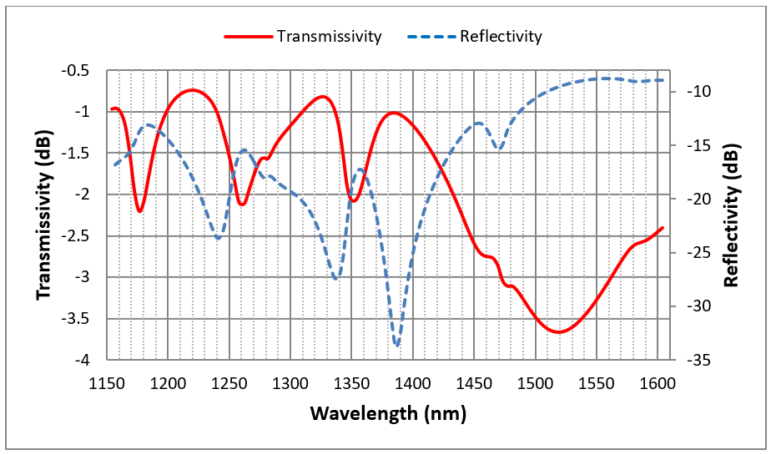

Figure 4. Transmissivity (red solid) and reflectivity (blue dash) of the rectangular PSNR embedded in the plasmonic fiber tip at r=400nm, for x-polarized light.

Figure 4 shows the transmissivity and reflectivity of the rectangular PSNR embedded in the plasmonic fiber tip at r=400nm. The main resonance wavelength is 1460nm, corresponding to the main resonance wavelength for the PSNR embedded at r=610nm6, since the perimeter of the slot is the same. The enhancement factor though, calculated as the maximum intensity *I* in the PSNR, divided by the intensity *Io* at the same point for the metal coated tip without a PSNR, is 1.4 x104 which is bigger by a factor of 2 compared to the one previously published6 (Ef: 7.4 x103), implying that at r= 400nm the field is indeed highly confined.

**3. MODELLING OF METAL-COATED TIPS OF DIFFERENT ANGLES**

By increasing the semi-angle of the fiber tip the losses can be reduced as far as the adiabaticity criterion is met. A taper is adiabatic when zt > zb10, where zt is the characteristic taper length defined as:

zt = r/tan(a)

and zb is the beat length between Mode 1 and Mode 2 defined as:

zb = λ/(neff, Mode 1 - neff, Mode 2).

The gold-coated tip is adiabatic for any wavelength up to 1800nm for semi-angles up to ~7˚. For higher semi-angles the adiabaticity is met for specific wavelength ranges, thus the structure should be carefully designed when working with specific wavelengths in order to get the maximum field enhancement. Enhancement factors of gold-coated fiber tips, having different semi-angles, with embedded PSNRs (400nm length and 200nm width) at r=335nm, were calculated. As shown in Table 1, as the semi-angle increases the Ef increases too, due to the reduced losses since light has to travel shorter distance in order to reach the PSNR.

|  |  |  |  |
| --- | --- | --- | --- |
| **Semi-angle (a)** | **Axial distance from input** | **Wavelength** | **Enhancement factor (Ef)** |
| 6.21˚ | 3.6μm | 1391nm | 1.41x105 |
| 6.73˚ | 3.4μm | 1337nm | 1.43x105 |
| 11.34˚ | 2μm | 1397nm | 1.70x105 |

Table 1. Geometrical parameters of plasmon tips and the corresponding calculated enhancement factors for PSNRs embedded at the same radius (r=335nm).

**4. MODELLING OF METAL-COATED TIPS WITH DIFFERENT PSNRs SHAPES**

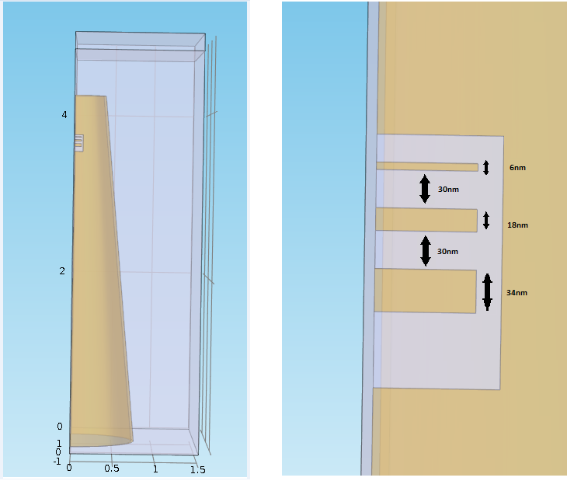

Figure 5. a) Plasmonic fiber tip with an embedded slot with three gold tapes, b) The slot with the three gold tapes. The tapes have widths 34, 18 and 6nm and the distance between them is 30 nm.

By nano-patterning the PSNR creating shapes with sharp edges the field intensity can be enhanced. Figure 5 shows a PSNR formed with three gold tapes in it. The width of the gold tapes decreases as the radius of the tip decreases. The position of the last gold tape (the one embedded at the smallest radius) is approximately at r=400nm.

Figure 6 shows the transmissivity and reflectivity of the rectangular PSNR with the three gold tapes embedded in the plasmonic fiber tip at r=400nm (a) and the maximum normalized electric field as a function of the wavelength (b). The enhancement factor at λ=1645nm is 3.27 x105 which is two orders of magnitude higher than the rectangular PSNR embedded in the plasmonic fiber tip at r=610nm for λ=1458nm. The minimum enhancement factor for the whole spectral range is 1.17 x104. For higher maximum electric field the space confinement increases.

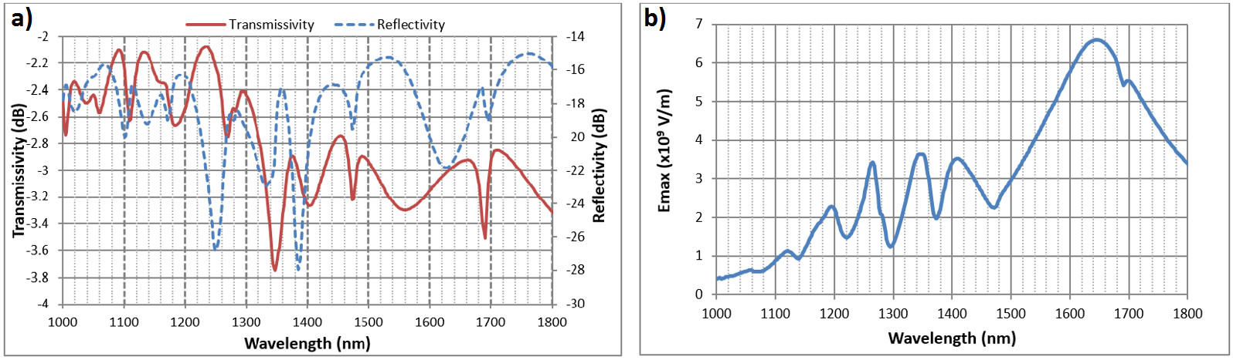

Figure 6. (a) Transmissivity (red solid) and reflectivity (blue solid) of the rectangular PSNR with three gold tapes embedded in the plasmonic fiber tip at r=400nm, for x-polarized light. (b) Maximum normalized electric field as a function of the wavelength.

Following the 2-D analysis of the structure presented above, we calculated that for r=400nm silica core and a 30nm gold layer, neff becomes less than unity for λ>1622nm. Figure 7 shows the normalized electric field for wavelengths of 1645nm and 1460nm. The high Ef for λ=1645nm corresponds to high spatial field confinement at the sharpest edge of the structure.

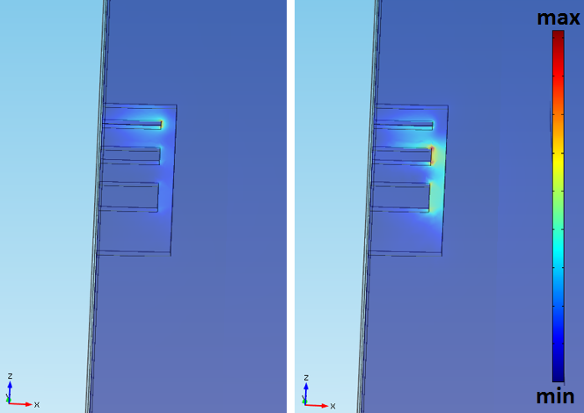

Figure 7. Normalized electric field for a) 1645nm and b) 1460nm.

**5. CONCLUSIONS**

In this paper, metal-coated tapered optical fibers of different geometrical characteristics with embedded PSNRs were studied in order to increase the field enhancement. By decreasing the radius where the PSNR is embedded we calculated an Ef of 1.4 x104, higher by a factor of 2 than the one previously reported. The highest Ef for a specific radius is expected at the wavelength corresponding to neff=1. Tapered fibers with higher semi-angles were simulated showing an increase of the Ef due to the reduced losses for PSNRs embedded at the same radius. PSNRs of different shapes were also studied for improving the Ef and field confinement. By creating structures with sharp edges inside the PSNR we calculated an Ef=3.27 x105 related to a high spatial confinement of the field. Further optimization of the structure can be achieved by matching the cut-off wavelength corresponding to a specific radius of the tapered fiber with the wavelength of the plasmon resonance by appropriately designing the shape of the PSNR.

Aknowlegments

This work was financially supported by the "Advanced Materials and Devices" Program (MIS: 5002409) funded by the Hellenic General Secretariat for Research and Technology - GSRT.

**REFERENCES**

1. Challener W. A., Peng C., Itagi A. V., Karns D., Peng W., Peng Y., Yang X., Zhu X., Gokemeijer N. J., Hsia Y. T., Ju G., Rottmayer R. E., Seigler M. A. and Gage E. C., "Heat-assisted magnetic recording by a near-field transducer with efficient optical energy transfer," Nat. Photon. 3(4), 220-224 (2009).
2. Wong C. L. and Olivo M., "Surface plasmon resonance imaging sensors: A review," Plasmonics 9(4), 809-824 (2014).
3. Huh Y. S., Chung A. J. and Erickson D., "Surface enhanced Raman spectroscopy and its application to molecular and cellular analysis," Microfluid. Nanofluidics 6(3), 285-297 (2009).
4. Anker J. N., Hall W. P., Lyandres O., Shah N. C., Zhao J. and Van Duyne R. P., "Biosensing with plasmonic nanosensors," Nat. Mater. 7(6), 442-453 (2008).
5. Petropoulou A., Antonopoulos G., Bastock P., Craig C., Kakarantzas G., Hewak D.W., Zervas M.N, Riziotis C., "Engineering of composite metallic microfibers towards development of plasmonic devices for sensing applications," IOP Conf. Series: Materials Science and Engineering 108, 012027 (2016).
6. Ding M., Zervas M. N. and Brambilla G., "Transverse excitation of plasmonic slot nano-resonators embedded in metal-coated plasmonic microfiber tips," Appl. Phys. Lett. 102(14), 141110 (2013).
7. Ding M., Brambilla G. and Zervas M. N., "Plasmonic slot nanoresonators embedded in metal-coated plasmonic microfibers," J. Lightwave Technol. 31(18), 3093-3103 (2013).
8. Lee B., Lee I. M., Kim S., Oh D. H. and Hesselink L., "Review on subwavelength confinement of light with plasmonics," J. Mod. Opt. 57(16), 1479-1497 (2010).
9. Guo H., Meyrath T. P., Zentgraf T., Liu N., Fu L., Schweizer H. and Giessen H., "Optical resonances of bowtie slot antennas and their geometry and material dependence," Opt. Express 16(11), 7756-7766 (2008).
10. Ravets S., Hoffman J. E., Kordell P. R., Wong-Campos J. D., Rolston S. L. and Orozco1 L. A., "Intermodal energy transfer in a tapered optical fiber: optimizing transmission," J. Opt. Soc. Am. A Opt. Image Sci. Vis. 30(11), 2361-2371 (2013).