Title
The allocation of US$ 105 billion in global funding for infectious disease research between 2000 and 2017: a content analysis of investments from funders in the G20 countries

Authors
Michael G Head PhD +,¹ Rebecca J Brown PhD, ¹ Marie-Louise Newell PhD, ^{2,3} J. Anthony G. Scott FRCP,⁴ James Batchelor BSc*,¹ Rifat Atun FRCP*⁵
* Joint senior author
+ Corresponding author
1. Clinical Informatics Research Unit, Faculty of Medicine, University of Southampton, Southampton, UK
2. School of Human Development and Health, Faculty of Medicine, University of Southampton, Southampton, UK
3. School of Public Health, Faculty of Health Sciences, University of the Witwatersrand, Johannesburg, South Africa
4. Department of Infectious Disease Epidemiology, London School of Hygiene and Tropical Medicine, London, UK
5. Department of Global Health and Population, Harvard Medical School, Harvard University, Boston MA, USA

+ Corresponding author – Michael Head, +44 (0)2382 027207; m.head@soton.ac.uk

Abstract
Background
Each year, billions of dollars are spent globally on infectious disease research and development (R&D). However, there is little systematic tracking of global R&D.
Methods
The study examined research awards made between 2000 and 2017 for infectious disease research from G20-based public and philanthropic funders. Research databases were searched using a range of keywords, and open data was extracted from funder websites. Awards were categorised by type of science, specialty, and disease/pathogen. Data collected included study title, abstract, award amount, funder, and year. Descriptive statistics and a correlation coefficient were used to investigate the relationship between research investment and disease burden, using Global Burden of Disease 2017 study data.
Findings
There was $104.9 billion (b) investment across 94 074 awards (annual range $4.1 to $8.4b). Pre-clinical research received $61.1b (58.2%) and public health research $29.5b (28.1%). HIV/AIDS received $42.1b (40.1%), tuberculosis $7.0b (6.7%), malaria $5.6b (5.3%) and pneumonia $3.5b (3.3%). Funding for Ebola ($1.2b), Zika ($0.3b), influenza ($4.4b) and coronavirus ($0.5b) was typically highest soon after a high-profile outbreak. There was a general increase in year-on-year investment between 2000 and 2006, with decline between 2007 and 2017. Funders based in the United States of America provided $81.6b (77.8%). On the basis of funding per 2017 disability-adjusted life years (DALYs), HIV/AIDS received greatest relative investment ($772/DALY), compared with tuberculosis ($156/DALY), malaria ($125/DALY), and pneumonia ($33/DALY). Syphilis and scabies received the least relative investment ($9/DALY). There was a weak positive relationship (Spearman’s correlation coefficient [r] 0.30) between investment and 2017 disease burden.
Interpretation
HIV research received highest amount of investment relative to DALY burden. Scabies and syphilis received lowest relative funding. Investments for high-threat pathogens (e.g. Ebola, Coronavirus) were often reactive, following outbreaks. There was little evidence that funding is proactively guided by global burden or pandemic risk. The study findings show how research investments are allocated currently and how these relate to disease burden and to conditions with pandemic potential.
Funding
Bill & Melinda Gates Foundation

Research in Context
Evidence before this study
In November 2019, we searched PubMed, internet search engines and global health stakeholder sites, such as WHO. We used the search terms “research investments”, “research funding”, “infectious disease funding”, ”global health investments” and “global health funding”, covering only English articles. Author MGH also searched a personal Mendeley literature database that includes published and grey literature around research funding. Previous investment analyses include Research Investments in Global Health study (ResIn) publications, the Policy Cures annual reports on product development research in infectious diseases and numerous national reviews, such as the UK Clinical Research Collaboration annual ‘Health Research Analysis’ of the UK R&D landscape.
Added value of this study
To our knowledge, this is the first study to describe in depth the global landscape for all infectious disease research from public and philanthropic funders. Our study covers 18 years of funding data, so captures long-term time trends and fluctuations. We combined and categorised awards using the classification system developed by the ResIn study. This strategy allowed us to provide a comprehensive overview of how infectious disease funding has been allocated, and compare findings with global burden of disease, an important variable to consider when setting research priorities. This information can be used by global health research funders in decision-making.
Implications of all the available evidence
The findings show that between 2000 and 2017, HIV has received significantly more research funding than similar diseases of high-burden such as tuberculosis, malaria and pneumonia. The USA provides much of the global funding, in particular the US National Institute for Health. There are also several infections that appear neglected compared to their burden of disease, such as syphilis and scabies. Thus, the global health community can use these findings to inform discussions, alongside other drivers for research prioritisation.

Introduction
Large amounts of funding are allocated each year to global health research in infectious diseases¹, spanning pre-clinical science, clinical trials, product development and public health including implementation research. These allocations involve numerous stakeholders across the global health community, including funders, researchers, policymakers and clinicians.
However, there is little systematic tracking or detailed analysis of investments in research and development (R&D) for infectious diseases to support decision-making around how to make the best funding decisions.² Nor is there a systematic co-ordination between stakeholders involved in funding R&D, despite efforts such as the World Health Organization (WHO) R&D Observatory to achieve better co-ordination.¹
Funders differ in their approaches to commissioning research, from the curiosity-driven approaches of the Wellcome Trust,³ to the focused data-driven strategies of the Bill & Melinda Gates Foundation⁴ which creates a heterogeneous landscape of research priorities. There is, thus, a need for an in-depth and comprehensive review of the global R&D landscape to identify what research has taken place, where the research was undertaken, and what institutions were involved in the research. Such ‘research on research’ is critical for priority-setting, informing funding decisions and improve efficiency in allocating funds.²
We present research undertaken by the Research Investments in Global Health (ResIn) Study Group on research investments in infectious diseases, from funders in the G20 countries across an 18-year time period spanning 2000-2017, comparing amounts invested for different conditions and considering their global burden of disease to identify potential areas of relative underfunding.
Methods
The study considered awards related to infectious disease research from 987 public and philanthropic funders in the G20 countries (appendix), for awards made between 2000 and 2017. The methods used are similar to those described in detail elsewhere.,^{5–8}
Data was manually collated from multiple sources. Awards to institutions in the United Kingdom (UK) 1997-2013 have been previously analysed.^{7,8} The majority of data (>90%) from 2016 and 2017 was sourced from the UberResearch Dimensions database (https://www.dimensions.ai/), which includes 4.9 million awards across health and non-health R&D sectors from 501 global funders. United States of America (USA) NIH data 2000-2015 was sourced directly from the Project Reporter database (https://projectreporter.nih.gov/reporter.cfm). Other data was sourced from websites of individual funders, funder databases such as the World Report, the UK National Research Register (a now-archived website owned by the UK’s Department of Health) or by contacting the funder directly and requesting data.
Keyword searches and filters (appendix) were applied to identify studies on human-related infectious disease. Awards purely focused on plant pathology or veterinary science were excluded, unless there was a clear zoonotic component. Excluded studies were manually reviewed to identify false negatives. The included awards were individually scrutinised to assess their relevance to infection.
Author MGH assessed all awards for inclusion and categorised the infection-related awards, applying any of the keyword labels as appropriate (appendix). Secondary checks on the included and excluded awards were made by co-authors RJB, JRF, and as per the study protocol^{7,8}. Approximately 15 000 (16%) awards in the final dataset were double-checked, focusing on their inclusion and labels applied to each award. Where there was disagreement, study information was provided to a third co-author for consensus.
Award amounts were adjusted for inflation in original currency and then converted to 2017 US dollars ($), , using the average exchange rate in the award year. Award amounts were missing for 6 072 awards (5.7%) from 13 funders (appendix). In these cases, estimates were made using maximum award amounts for that funding stream as per the funder’s website, by asking principal investigators for an approximate or exact award amount provided, or by asking in-country researchers who had knowledge of the R&D landscape for typical award amounts. Datasets and analysis were circulated to all authors for review and comment.
Included award types comprised project and programme grants, fellowships, and pump-priming or pilot projects. Award types excluded were conference and infrastructure grants, and funding focused on operational activities rather than research.
Labels applied to each award included pathogen, disease areas and specialty (e.g. antimicrobial resistance, respiratory, oncology, paediatrics), and type of science along the research continuum (pre-clinical, phase 1–3 clinical trials, phase 4 and product development research, public health (focusing on populations), and cross-disciplinary studies across multiple stages of the research continuum). A cross-disciplinary award is here defined as a study covering more than one stage of research continuum (for example pre-clinical research that progresses to a phase 1 study). Reference to antimicrobial resistance includes antibacterial, antiviral, antiparasitic and antifungal resistance. The diagnostics category includes research into screening. Sexually-transmitted infections (STI) excludes HIV, which has its own category. Neglected tropical diseases (NTDs) are based on WHO definition (as of 23 October 2019).⁹
Burden of disease data were sourced from the Global Burden of Disease study online tool.¹⁰ Disease burden data are reported from 2017 for all infectious diseases, and additional examples are presented using HIV/AIDS, malaria, tuberculosis and pneumonia from years 2005 and 2011 (six-year time intervals during the period covered by the investments dataset). Measures of disease burden analysed included mortality, disability-adjusted life years (DALYs) and years lived with disability (YLD). Comparison between awards and their associated observed disease burden were made by calculating investment per mortality, DALY or YLD observed. The investment relative to burden of infection was computed using the equation: cumulative research investment up to the year of burden measure / number of deaths, DALYs or YLD at time point. For example, for assessment of HIV DALYs in 2017, sum of HIV research investment 2000-2017 ($42.1 billion) was divided by 2017 DALYs (54 446 184), to get an ‘investment per DALY’ metric of $772. Data preparation was in Microsoft Excel 2016, and analysis used Stata SE V16.
Role of the funding source,
The Bill & Melinda Gates Foundation (OPP1127615) have funded the study. The funder had no role in study design, data collection and analysis, or interpretation of the data. They also had no role in the writing of this manuscript. It is the decision of the authors to submit this manuscript for publication.
Results
The final 2000-2017 dataset included 94 074 awards for infectious disease research, with sum investment of $104.9 billion (b) and a median awards size of $257,176 (IQR $62,562-770,661). Investments by type of science, disease area/co-morbidity, microbiology, disease/pathogen, year of award, geographical focus and funder data are in table 1.
By type of science, pre-clinical research received $61.1b (58.2%) across 70 337 awards (74.8%). Public health research received $29.5b (28.1%) from 19 197 awards (20.4%). Phase 1-3 trials received $9.2b (8.8%) across 2 440 (2.6%) awards.
Phase 1-3 awards had the largest median award size ($1.0 million, IQR 1.3 – 3.0), compared with a median award size of $0.2 million for each of pre-clinical (IQR 0.06-0.7m), product development (IQR 0.1-1.0), and public health research (IQR 0.06-1.0).
Funding for virology was $62.9b (60.0%), more than twice the amount for bacteriology ($27.3b, 26.0%), almost six-times that for parasitology ($11.5b, 11.0%) and almost forty-times that for mycology ($1.7b, 1.6%). By product type, therapeutics research ($18.3b, 17.4%) received more investment than vaccines ($16.0b, 15.3%) or diagnostics ($3.6%, 3.4%) (table 1).
HIV/AIDS was the pathogen/disease with the greatest amount of funding ($42.1b, 40.1%) across 21 403 (22.8%) awards. Funding for tuberculosis totalled $7.0b (6.7%) from 5 246 (5.6%) awards; for malaria was $5.6b (5.3%) from 4 437 (4.3%) awards; and for pneumonia was $3.5b (3.3%) from 2 748 (2.9%) awards. Funding for Ebola virus related research was $1.2b (1.1%); $0.8b (68.0%) of all Ebola virus related research investment was awarded between 2014-2017. There was a high-profile outbreak of Ebola Virus Disease in West Africa in 2014.¹¹ Similarly, $0.3b of funding was allocated to research on Zika virus, of which 96.0% was awarded in 2016 or 2017 following the Zika virus epidemic.¹² Of $4.4b (4.2%) of funding for influenza, $2.0b (45.0%) was awarded in 2006-2010, with the highest annual funding amount awarded in 2009 ($0.6, 12.8%). There were global outbreaks of ‘bird flu’ in 2005 and ‘swine flu’ in 2009.¹¹
Funding for coronavirus related research was $0.5b (0.4%) in 396 grants with a median award size of $2.0m (IQR $0.6-2.9m). The US NIH provided $381.0m (77.4% of all coronavirus-related funding), and $365.5m (77.4%) was awarded to USA-based research institutions. Pre-clinical research accounted for $467.4m (95.1%). The years with the greatest investment were 2004 ($149.5m, 30.5% of coronavirus-related funding), the year after the international SARS outbreak,¹³ and 2015 ($87.7m, 17.8%), the year after an outbreak was reported in the Kingdom of Saudi Arabia (KSA) and a revised case definition was produced by KSA and the WHO.¹⁴ Further coronavirus-related results are presented in the appendix.
By year of award, there was a general increase in year-on-year investment for infectious disease research between 2000 and 2006, but a general decline in the amount of annual investment between 2007 and 2017 (figure 1). Annual funding ranged from $4.1b (2001) to $8.4b (2006).
By disease area, $3.8b (3.6%) was awarded for AMR from 4 845 (5.2%) awards; $4.1b (3.9%) was awarded for neglected tropical diseases (NTDs), $1.1b (1.0%) for sepsis, and $1.4b (1.3%) for healthcare-associated infections (HCAI). In areas relating to hard-to-reach groups, $2b (1.9%) was awarded for infections related to drug use and addiction, and $0.2b (0.2%) for infectious disease in prison health. Awards for co-morbidities and non-communicable diseases included $0.3 billion (0.3%) for mental health, and $0.6b (0.6%) for cardiovascular disease.
Funders from the US provided $81.6 (77.8%) of the investment, which covered 42 926 (45.6%) of the awards. Within this, the US NIH was the largest funder providing $59.4b (56.6% of the total US funding) and the greatest number of individual awards (32 967, 35.0%). The Bill & Melinda Gates Foundation provided $9.2b (8.8%) in 2 317 (2.5%) awards. UK funders provided $8.3b (7.9%) in 8 358 (8.9%) awards. Where the awards had an explicit geographical focus, $9.2b (8.8%) of the funding was focused on Africa and $2.4b (2.3%) on Asia.
When ranking investment levels compared to burden of disease by DALYs across 34 infectious diseases (appendix), African trypanosomiasis ($9740/DALY) and genital herpes ($3101/DALY) were ranked 1st and 2nd, respectively. HIV ($772/DALY) was ranked 8th, tuberculosis ($156/DALY) was ranked 17th, malaria ($125/DALY) was ranked 21st, enteric infections were ranked 24th and pneumonia ($33/DALY) was ranked 28th. Scabies and syphilis were ranked joint last with $9/DALY.
When comparing investment for individual infections alongside 2017 DALYs (figure 2), Spearman’s correlation coefficient [r] was 0.30 (P=0.048), suggesting a weak positive relationship between level of research investment and global burden of disease in 2017. The infections within the shaded area showed a stronger correlation between investment and burden. Infections below the shaded area appear relatively underinvested, and infections above the shaded area appear relatively well-invested, compared to their 2017 DALYs burden.
When comparing investment by mortality (appendix), syphilis ($632/death) and tetanus ($749/death) ranked the lowest out of 27 infections where mortality data were available. The highest-ranked infections by investment per death were those where associated mortality is typically low, specifically chlamydia and African trypanosomiasis. HIV ranked 7th ($44 481/death), malaria 13th ($9 107/death), tuberculosis 15th ($5 936/death) and pneumonia 24th ($1 392/death).
Across different time points of the study period (figure 3), HIV-related research consistently received greater investment than malaria, tuberculosis or pneumonia. Pneumonia-related research consistently received far less funding in the study period compared to HIV, tuberculosis or malaria.
By type of science for these four diseases, (appendix), 35.5% of research funding for HIV was for pre-clinical research, 15.1% for phase 1-3 trials, and 45.9% for public health research. Pneumonia had the greatest proportion of funding allocated to pre-clinical science (55.7%) and the lowest amount for public health research (23.5%) compared with HIV, tuberculosis and malaria (appendix).

Table 1. Global investments for infectious disease research 2000-2017, by type of science, disease area/co-morbidity, disease/pathogen, and year of award

 |  | Number of awards | % of  total | Funding  ($, billions) | % of total | Median funding, $ (IQR) | Mean funding, $ (SD)
Total |  | 9 4074 | n/a | 104.9 | n/a | 257 176 (62 562-770 661) | 1 115 368 (5 282 231)
Type of science
Pre-clinical |  | 70 337 | 74.8% | 61.1 | 58.2% | 23 8124 (59 718-665 220) | 868 782 (3 312 616)
Clinical trials Phase 1 to 3 |  | 2 440 | 2.6% | 9.2 | 8.8% | 1 036 448 (312 765-2 961 159) | 3 783 039 (14 700 000)
Phase 4 and product development |  | 1 327 | 1.4% | 1.7 | 1.6% | 270 149 ( 100 000-989 758) | 1 252 575 (3 699 940)
Public health |  | 19 197 | 20.4% | 29.5 | 28.1% | 270 444 (62 155-1 035 850) | 153 7692 (7 601 680)
Cross-disciplinary |  | 773 | 0.8% | 3.4 | 3.2% | 589 476 (91 221-2 990 422) | 4 408 444 (14 736 094
Disease area/co-morbidity
AMR |  | 4 845 | 5.2% | 3.8 | 3.6% | 191 710 (52 869-539 858) | 781 036 (3 852 335)
Behavioural/social science |  | 5 112 | 5.4% | 5.3 | 5.1% | 349 160 (82 940-1 181 447) | 1 038 915 (2 183 452)
Cardiovascular |  | 969 | 1.0% | 0.6 | 0.6% | 155 638 (52 090-486 666) | 612 814 (1 364 824)
Chronic respiratory |  | 625 | 0.7% | 0.7 | 0.7% | 385 128 (114 265-876 590) | 1 073 074 (2 695 925)
Skin and soft tissue infections |  | 1 036 | 1.1% | 0.5 | 0.5% | 155 422 (50 000-453 216) | 528429 (1584877)
Drug use and addiction |  | 1 339 | 1.4% | 2 | 1.9% | 608 996 (171 625-2 143 382) | 1 484 758 (2 159 933)
Enteric |  | 9 268 | 9.9% | 6.5 | 6.2% | 167 454 (49 890-495 448) | 701 225 (2 375 207)
Gerontology |  | 314 | 0.3% | 0.3 | 0.3% | 292 985 (84 534-906 417 | 935 053 (2 220 080)
Healthcare-associated infections |  | 1 963 | 2.1% | 1.4 | 1.3% | 169 350 (47 423-548 100) | 724 103 (3 257 520)
Hepatology |  | 5 083 | 5.4% | 3.4 | 3.2% | 156 443 (50 703-498 827) | 660 781 (1 957 538)
Mental health |  | 235 | 0.2% | 0.3 | 0.3% | 523 201 (143 684-1 667 876) | 1 126 032 (1 565 351)
Neglected tropical diseases |  | 5 221 | 5.5% | 4.1 | 3.9% | 133 123 (44 880-470 796) | 744 922 (2 988 796)
Neurology |  | 3 389 | 3.6% | 3.3 | 3.1% | 358 106 (76 321-1 034 196) | 964 268 (2 319 882)
Obstetrics |  | 1 199 | 1.3% | 1.9 | 1.8% | 326 562 (80 943-1 003 175) | 1 604 117 (6 460 262)
Oncology |  | 4 018 | 4.3% | 3.5 | 3.3% | 179 238 (50 936-571 189) | 869 635 (5 450 843)
Ophthalmology |  | 376 | 0.4% | 0.3 | 0.3% | 245 986 (59 474-918 772) | 859 637 (1 632 761)
Oral |  | 1 037 | 1.1% | 0.6 | 0.6% | 111 136 (39 063-469 742) | 55 7466 (1 556 505)
Paediatrics |  | 3 690 | 3.9% | 5.6 | 5.3% | 251 997 (58 192-987 621) | 152 2432 (7 485 250)
Prison |  | 157 | 0.2% | 0.2 | 0.2% | 70 1645 (189 046-2 167 162) | 1 520 540 (1 977 350)
Respiratory |  | 15 998 | 17.0% | 18.5 | 17.6% | 277 916 (66 041-833 542) | 1 157 587 (4 478 451)
Sepsis |  | 1 490 | 1.6% | 1.1 | 1.0% | 212 161 (56 349-740 000) | 752 826 (1 961 561)
Sexually-transmitted |  | 4 584 | 4.9% | 3.7 | 3.5% | 133 404 (33 184-470 197) | 815 105 (4 991 830)
Urinary tract infections |  | 523 | 0.6% | 0.4 | 0.4% | 264 977 (83 762-675 493) | 695 571 (1 286 641)
Pathogen/disease
African trypanosomiasis |  | 650 | 0.7% | 0.8 | 0.8% | 315 433 (137 206- 827 480) | 1 183 651 (3 643 510)
Anthrax |  | 518 | 0.6% | 1 | 1.0% | 597 256 (181 356-1 979 251) | 1 867 789 (4 157 831)
Aspergillus |  | 446 | 0.5% | 0.3 | 0.3% | 180 468 (44 346-482 741) | 606 110 (1 666 160)
Buruli ulcer |  | 40 | 0.04% | 0.02 | 0.02% | 279 544 (101 659-46 4926) | 611 745 (1 148 503)
Campylobacter |  | 543 | 0.6% | 0.3 | 0.3% | 226 047 (54 100-465 336) | 490 094 (983 705)
Candida |  | 1 195 | 1.3% | 0.6 | 0.6% | 148 165 (45 671-463 142) | 541 166 (1 092 445)
Chagas |  | 666 | 0.7% | 0.4 | 0.4% | 51 385 (37 103-370 772) | 539 175 (1 471 485)
Chlamydia sp |  | 840 | 0.9% | 0.7 | 0.7% | 293 083 (75 000-680 691) | 890 560 (3 814 782)
Cholera |  | 547 | 0.6% | 0.4 | 0.4% | 237 436 (59 775-661 232) | 789 786 (1 597 530)
Clostridium sp |  | 825 | 0.9% | 0.7 | 0.7% | 268 621 (54 173-622 877) | 828 251 (1 874 362)
Coronavirus |  | 396 | 0.4% | 0.5 | 0.5% | 266 922 (58 552-923 845) | 1 241 720 (3 568 383)
Crimean-Congo |  | 45 | 0.05% | 0.05 | 0.05% | 350 278 (78 943-823 281) | 1 196 039 (2 840 648)
Cryptococcus |  | 340 | 0.4% | 0.3 | 0.3% | 305 917 (51 385-1 019 130) | 861 530 (1 488 494)
Cryptosporidium |  | 239 | 0.3% | 0.2 | 0.2% | 167 415 (45 888-558 922) | 648 857 (1 183 859)
Cytomegalovirus |  | 971 | 1.0% | 0.8 | 0.8% | 303 033 (89 039-751 988) | 834792 (1 730 354)
Dengue |  | 1 064 | 1.1% | 1.2 | 1.1% | 188 297 (50 000-645 390) | 1 087 023 (4 936 135)
E. coli (Enteric) |  | 1 261 | 1.3% | 0.7 | 0.7% | 152 385 (41 622-443 635) | 571 835 (2 667 729)
E. coli (UTI) |  | 214 | 0.2% | 0.1 | 0.1% | 314 020 (118 071-654 046) | 633 605 (938 300)
Ebola |  | 506 | 0.5% | 1.2 | 1.1% | 475 138 (118 066-1 810 583) | 2 436 055 (8 595 062)
Epstein-Barr virus |  | 887 | 0.9% | 0.6 | 0.6% | 167 755 (485 006-608 195) | 698 088 (1 730 021)
Gonorrhoea |  | 314 | 0.3% | 0.3 | 0.3% | 363 831 (95 463-1 134 027) | 995 488 (1 96 2463)
Hepatitis A |  | 57 | 0.1% | 0.04 | 0.04% | 162 420 (48 726-719 823) | 658 099 (1 144 165)
Hepatitis B |  | 1 769 | 1.9% | 0.9 | 0.9% | 85 500 (42 253-359 695) | 518 637 (1 655 673)
Hepatitis C |  | 3 054 | 3.2% | 2.4 | 2.3% | 204 678 (54 336-619 686) | 790 637 (2 231 365)
Hepatitis E |  | 122 | 0.1% | 0.04 | 0.0% | 79 699 (47 758-255 310) | 293 887 (723 976)
Herpes-simplex virus |  | 873 | 0.9% | 0.8 | 0.8% | 318 030 (88 100-791 155) | 878 981 (1 639 525)
HIV |  | 21 403 | 22.8% | 42.1 | 40.1% | 436 241 (110 709-1 497 634) | 1 963 488 (9 117 206)
HPV |  | 1 848 | 2.0% | 1.8 | 1.7% | 198 616 (51 385-616 615) | 6 912 483 (956 756)
Influenza |  | 3 920 | 4.2% | 4.4 | 4.2% | 244 943 (54 501-850 560) | 1 113 531 (3 360 834)
Leishmaniasis |  | 1 328 | 1.4% | 0.8 | 0.8% | 64 264 (38 656-358 861) | 567 952 (2 405 102)
Leprosy |  | 293 | 0.3% | 0.07 | 0.1% | 52 090 (35 984-148 619) | 248 623 (712 026)
Leptospirosis |  | 188 | 0.2% | 0.07 | 0.1% | 51 415 (39 132-259 724) | 372 127 (793 357)
Listeria |  | 466 | 0.5% | 0.03 | 0.03% | 176 172 (54 058-484 203) | 622 783 (1 136 613)
Lyme Disease |  | 586 | 0.6% | 0.4 | 0.4% | 315 166 (102 650-726 303) | 729 722 (1 329 885)
Lymphatic filariasis |  | 221 | 0.2% | 0.4 | 0.4% | 141 525 (75 000-453 183) | 1 822 870 (7 519 838)
Malaria |  | 4 437 | 4.7% | 5.6 | 5.3% | 337 462 (103 167-84 0520) | 1 272 258 (5 495 134)
Marburg |  | 154 | 0.2% | 0.3 | 0.3% | 671 443 (376 340-2 269 867) | 2 234 082 (4 777 032)
Measles |  | 208 | 0.2% | 0.3 | 0.3% | 223 931 (45 191-948 556) | 1 480 828 (4 522 464)
Meningitis |  | 777 | 0.8% | 0.6 | 0.6% | 262 555 (74 645-580 847) | 740 224 (1 751 265)
Norovirus |  | 324 | 0.3% | 0.2 | 0.2% | 158 784 (45 220-449 648) | 698 908 (2 054 341)
Onchocerciasis |  | 78 | 0.1% | 0.2 | 0.2% | 242 016 (75 000-1 603 700) | 2 201 094 (7 872 353)
Pertussis |  | 259 | 0.3% | 0.2 | 0.2% | 204 902 (53 615-595 021) | 793 653 (2 781 053)
Pneumonia |  | 2 748 | 2.9% | 3.5 | 3.3% | 227 570 (59 492-720 346) | 1 295 821 (2 562 365)
Polio |  | 200 | 0.2% | 0.4 | 0.4% | 401 766 (107 770-1 338 367) | 1 985 642 (4 738 529)
Poxviruses |  | 235 | 0.2% | 0.5 | 0.5% | 589 175 (205 723-1 629 883) | 2 179 542 (8 424 070)
Pseudomonas |  | 1 285 | 1.4% | 1 | 1.0% | 232 455 (72 782-600 924) | 800 226 (3 023 734)
Rabies |  | 205 | 0.2% | 0.1 | 0.1% | 80 380 (37 719-386 201) | 518 215 (1 557 300)
Respiratory Syncytial Virus |  | 556 | 0.6% | 0.7 | 0.7% | 389 191 (66 697-967 294) | 1 338 414 (5 915 870)
Rotavirus |  | 384 | 0.4% | 0.3 | 0.3% | 134 496 (44 924-487 928) | 1 039 924 (2 415 672)
Salmonella |  | 1 526 | 1.6% | 1 | 1.0% | 191 669 (51 228-554 356) | 634 310 (1 720 494)
Scabies |  | 38 | 0.04% | 0.04 | 0.04% | 426 115 (348 938-782 107) | 1 112 631 (2 769 472)
Schistosomiasis |  | 618 | 0.7% | 0.4 | 0.4% | 131 941 (47 323-458 392) | 636 016 (2 408 202)
Shigella |  | 246 | 0.3% | 0.3 | 0.3% | 184 518 (53 005-739 913) | 1 193 408 (4 627 473)
Staphylococcus sp |  | 2 357 | 2.5% | 1.4 | 1.3% | 171 442 (49 588-494 635) | 592 705 (1 657 958)
Streptococcus sp |  | 1 826 | 1.9% | 1.3 | 1.2% | 51 253 (205 875-590 096) | 742 304 (2 316 068)
Syphilis |  | 111 | 0.1% | 0.08 | 0.1% | 193 501 (60 049-588 229) | 765 455 (1 412 399)
Tetanus |  | 59 | 0.1% | 0.02 | <0.01% | 127 306 (41 216-418000) | 408 647 (774 471)
Toxoplasmosis |  | 554 | 0.6% | 0.4 | 0.4% | 184 921 (53 378-488 582) | 626 259 (1 250 402)
Trachoma |  | 28 | 0.03% | 0.08 | 0.1% | 505 246 (75 000-2 357 353) | 2 085 780 (3 463 632)
Trichomonas |  | 60 | 0.1% | 0.1 | 0.1% | 296 798 (120 867-682 461) | 2 327 692 (13 000 000)
Tuberculosis |  | 5 246 | 5.6% | 7 | 6.7% | 298 502 (82 120-885 678) | 1 339 356 (6 090 944)
Varicella zoster |  | 161 | 0.2% | 0.2 | 0.2% | 157 611 (48 506-687 311) | 956 010 (2 988 433)
Yellow fever |  | 118 | 0.1% | 0.09 | 0.1% | 310 704 (52 090-721 749) | 757 240 (1 215 103)
Zika |  | 491 | 0.5% | 0.3 | 0.3% | 201 447 (50 000-441 324) | 622 804 (2 292 758)
Year of awards
2000 |  | 2 493 | 2.7% | 4.9 | 4.7% | 541 368 (154 604-2039726) | 1 975 701 (4 905 516)
2001 |  | 2 500 | 2.7% | 4.1 | 3.9% | 419 108 (136 670-1640451) | 1 646 680 (5 570 833)
2002 |  | 2 647 | 2.8% | 4.4 | 4.2% | 534 528 (167 086-1688222) | 1 668 438 (4 341 362)
2003 |  | 2 961 | 3.1% | 5.7 | 5.4% | 499151 (158 408-1655190) | 1 940 271 (7 066 292)
2004 |  | 3333 | 3.5% | 6.7 | 6.4% | 517 408 (181 445-1412842) | 2 022 233 (10 100 000)
2005 |  | 3 712 | 3.9% | 5.6 | 5.3% | 381 815 (102 307-1223215) | 1 500 354 (8 736 730)
2006 |  | 4 575 | 4.9% | 8.4 | 8.0% | 256 724 (51 128-882079) | 1 844 582 (12 700 000)
2007 |  | 5 425 | 5.8% | 6.5 | 6.2% | 244 299 (47 387-700500) | 1 207 562 (5 107 707)
2008 |  | 5 693 | 6.1% | 6.2 | 5.9% | 244 030 (50 946-824902) | 1 090 595 (3 376 268)
2009 |  | 6 858 | 7.3% | 7.3 | 7.0% | 233 610 (61 690-729664) | 1 061 866 (3 927 947)
2010 |  | 6 861 | 7.3% | 7.4 | 7.1% | 217 586 (54 412-731519) | 1 084 433 (3 430 572)
2011 |  | 6 087 | 6.5% | 5.4 | 5.1% | 179 185 (57 092-603637) | 7 99 136 (2 291 067)
2012 |  | 6 383 | 6.8% | 6.5 | 6.2% | 254 484 (72 884-672866) | 1 019 646 (4 778 698)
2013 |  | 6 335 | 6.7% | 5.8 | 5.5% | 206 890 (52 090-625480) | 908 186 (4 011 321)
2014 |  | 6 070 | 6.5% | 5.4 | 5.1% | 216 119 (51 385-604136) | 897 432 (4 015 122)
2015 |  | 5 056 | 5.4% | 4.5 | 4.3% | 352 279 (102 650-730956) | 895 873 (3 951 852)
2016 |  | 8 135 | 8.6% | 5.6 | 5.3% | 158 778 (45 741-514817) | 683 117 (2 113 889)
2017 |  | 7 961 | 8.5% | 4.2 | 4.0% | 158 146 (50 000-460625) | 528 099 (1 772 225)

a)
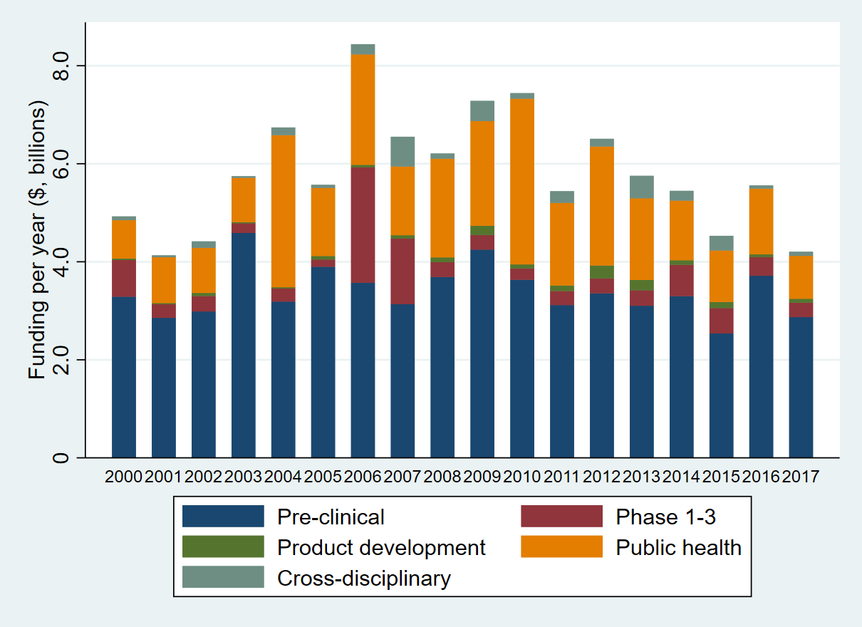

b)
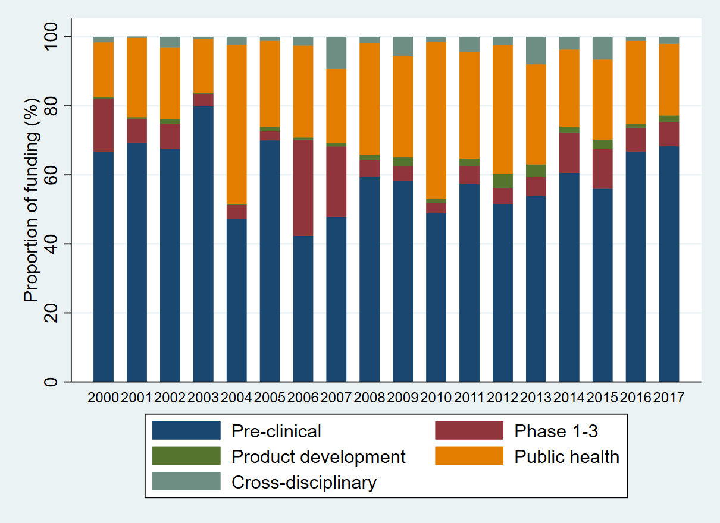
Figure 1. Funding per year, by type of science (a), and proportion of type of science by year (b)
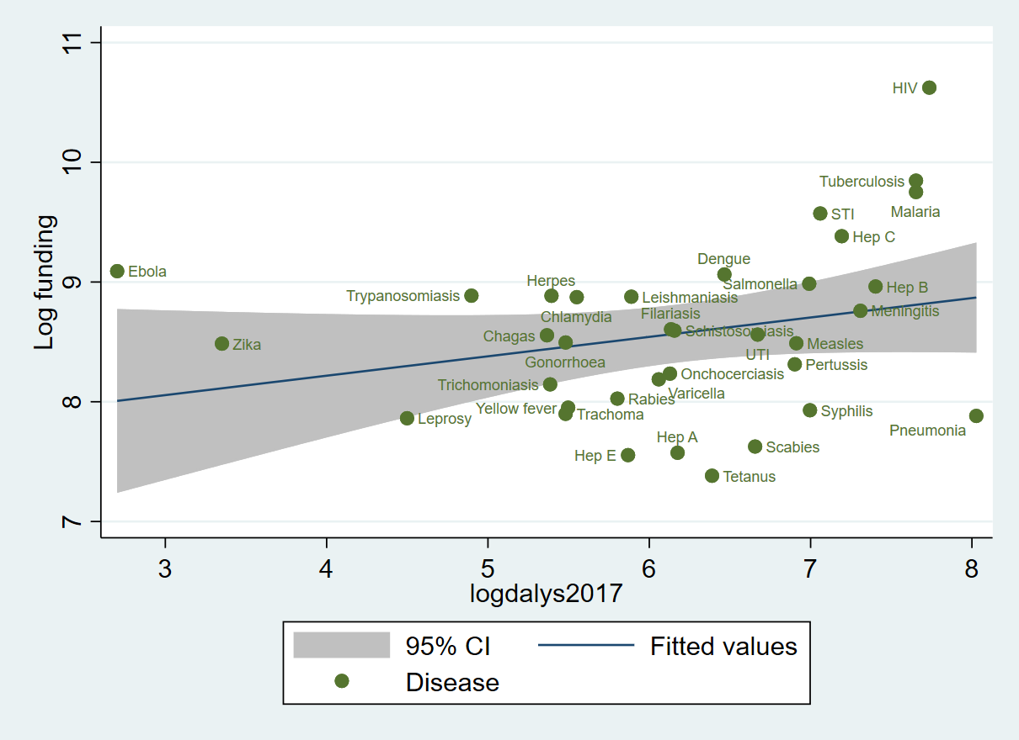
Figure 2. Association between investment and DALYs, using a logarithmic scale. Filariasis refers to lymphatic filariasis; Hep A, hepatitis A; Hep B, hepatitis B; hep C, hepatitis C; Hep E, hepatitis E; STI, sexually transmitted infections; Trypanosomiasis refers to African trypanosomiasis; UTI, urinary tract infections. P = 0.048

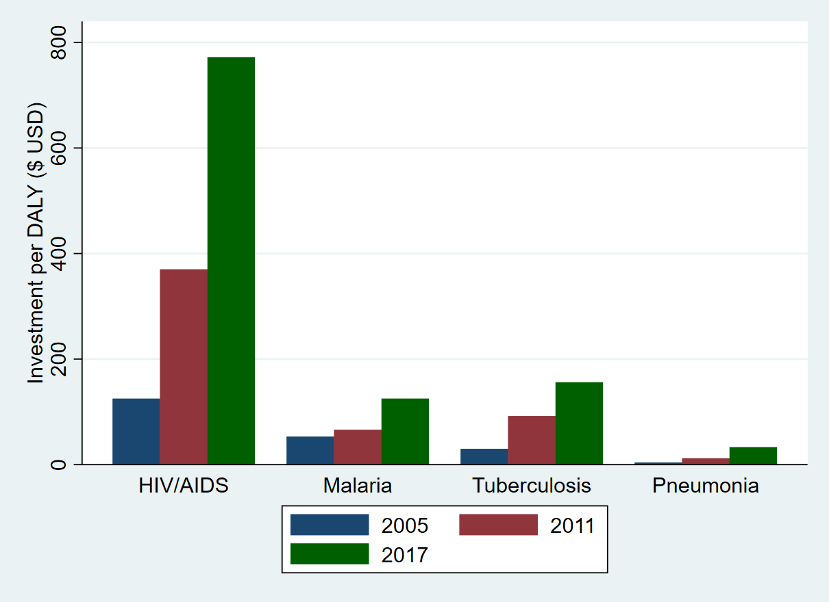
Figure 3. Level of research investment over time in three periods for HIV/AIDS, malaria, tuberculosis and pneumonia, relative to global burden of disease (as measured by disability-adjusted life years)

Discussion
We provide an analysis of $105b of research investment in 94 074 public and philanthropic awards for infectious disease research covering the years 2000-2017. Of this amount, 58% was for pre-clinical science and 28% for public health research. By type of infection, HIV-related research received 40.1% of funding, more than double the investment for tuberculosis, malaria and pneumonia combined. There was a weak association between research investment and global disease burden.
Infections that appear to be relatively less well-funded include some sexually-transmitted infections (syphilis and gonorrhoea), and neglected skin infections such as scabies. Funding for coronavirus-related research was $0.5b (0.4%) in 396 grants, of which 95.1% was for pre-clinical research.
There has been a huge reactive effort to support the COVID-19 response, which includes significant financing for research.¹⁵ Viral respiratory infections are known to be one of the most likely causes of a pandemic but despite both that and the existing huge levels of mortality in young children and the elderly, the ecosystem for pneumonia research and advocacy is less well established¹⁶. Confusion over the definition of pneumonia,¹⁷ fewer experienced researchers to make a strong case to funders, and few high-profile public figures championing the cause have led to pitifully low levels of funding compared to disease burden. One exception here is the Bill & Melinda Gates Foundation, which is guided by childhood deaths and is the main funder of pneumonia related research.⁵
The metrics used to compare investment by burden of disease are misleading for pathogens such as Ebola and Zika (appendix), which at first appear to be relatively well-funded compared to their burden of disease. However, for these conditions, which are public health emergencies, DALYs is not a fair metric to use. Outbreaks of this nature are not necessarily high-burden in terms of case numbers, but are high-risk given the potential for rapid spread to cause widespread outbreaks – an important factor that influences research investment decisions. As is illustrated by the evolving impact of COVID-19, there is a public health need to support outbreak response and research should very much be part of such a response. Such outbreaks create uncertainty and fear, with the media calling for ‘a need to do something’, and urging political circles to respond rapidly.^{18,19} The historical funding for coronavirus research was very low, given the high-profile outbreaks of severe acute respiratory syndrome, due to SARS-CoV, and the Middle-East respiratory syndrome (MERS-CoV) and the potential for the rapid spread of such infections.²⁰ Other analyses highlight how funding for neglected infectious disease research (distinct from NTDs) is increasing.²¹ Our analysis underpins that conclusion, for example showing that research on NTDs or with a focus on Africa, is increasing (appendix). There are significant declines in HIV funding, the majority of which is not focusing in LMIC settings (and thus not captured under neglected disease definitions).
The Coalition for Epidemic Preparedness Innovations (CEPI), founded in 2016, has received significant research investment from multiple funders to research into selected ‘high-threat’ pathogens.²² For example, there are several ongoing studies to develop a universal influenza vaccine that reduce pandemic risk, as well as vaccine development against Coronaviruses.²³ Antimicrobial resistance, which continues to be a serious worldwide threat,²⁴ has led to the introduction of the Global AMR R&D Hub with the remit to ‘address challenges and improve coordination and collaboration in global AMR R&D using a One Health approach’²⁵. AMR is also an important contributor to sepsis mortality, which is responsible for 11 million deaths annually with the majority of the burden in sub-Saharan Africa,²⁶ but receiving just 1.0% of the funding.

Research investment analyses can be a valuable audit of a system that has perhaps maximised scientific efficiency through peer review of curiosity driven research, and provide a steer for revision on under-investigated diseases and subject-based opportunities. The COVID-19 pandemic has shown the fragility of national and global infrastructures, and pandemic preparedness will surely in years to come be a focus for the high-profile global health research stakeholders. Sustainable tracking of how research funding is spent is vital to ensure that all priority areas and knowledge gaps are addressed, ¹⁵ and there must be adequate translation of that new knowledge into policy and practice, with findings that can be feasibly adopted in resource-poor settings. Multiple factors other than the current and projected burden of disease influence research funding decisions - such as political drivers of decision-making (notable here given the major funder is the USA government), advocacy and lobbying, emergency preparedness for emerging infectious diseases with pandemic potential, and public health research for conflicts and other humanitarian responses.
Applying a globally-recognised label to a disease can be important. The WHO oversees the designated list of NTDs,⁹ which helps to raise the profile of these conditions and this recognition supports the argument for research funding.²⁷ As an example, African trypanosomiasis, which has been at the forefront of efforts to tackle NTDs, has been described as an ‘extraordinary success story’, with a decline in the DALY burden by 93% between 2000 and 2017.²⁸ It has received twice the amount of research funding than either lymphatic filariasis or schistosomiasis, and more than non-NTDs such as meningitis or the respiratory syncytial virus. Researchers who study African trypanosomiasis have elimination and eradication in sight, although this would likely require substantial investments²⁸. Investment in other neglected areas may help produce similar effective responses, although the type of research investment must be appropriate. For example, this analysis highlights scabies and syphilis as particularly under-funded. There are effective treatments available for scabies, so the most useful research may be around an effective drug supply chain or addressing stigma
Other factors beyond the burden of disease also influence the direction and amount of investment. The geographical focus of research investments influences the likelihood of knowledge being translated into policy and practice, particularly in the country/sector where the research was undertaken.²⁹ It is important, when considering not just what research areas to prioritise and fund, but also to review where research capacity should be created or enhanced. The UK invests greater resources in former colonies, influenced by historic ties and a shared language.³⁰ Investments in different sectors will also be influenced by diplomatic considerations, for example, funding countries seeking cooperation from recipient countries or regions in response to security threats and terrorism.
This study has several limitations. There will be missing data, in particular where data could not be accessed from public and philanthropic funders. The impact of this should not be substantial and should not greatly influence the findings, as included data relates to 18 of the top 20 leading investors in research.^{31,32} The focus on the G20 means funders from countries who are not in the group but are proactive in global health research, such as Switzerland and Norway, are not included. A key challenge was integrating data that was presented in numerous different formats. Future analyses would be simplified considerably if funders could adopt a ‘minimum dataset’ of required information, perhaps recommended by the WHO R&D Observatory, which would require that applicants added standard labels (for example the type of science along the research pipeline) to their project at time of submission. Applying categories to an award retrospectively is time-consuming and subjective, though errors have been reduced with observations from a second author and consensus. Automated categorisation based on keyword searches is problematic, since the title and abstract of many awards contain references to diseases that are not the study areas of focus. It is also a subjective process to separate out awards that are operational or implementation research, and activities that are non-research based implementation (i.e. not generating new knowledge). The study lacks data from the private sector, particularly around tools and products such as vaccines, diagnostics and therapeutics. The analyses use GBD Study data, which are themselves modelled estimates and will on occasions be based on imputations because of missing data, and have been subject to criticism.³³ Selection of time points for research investments and disease burden will influence the findings as both of these change over time.
There has been more than $100 billion spent globally on infectious disease research between 2000 and 2017 but this funding is not correlated to current levels of burden or the level of risk posed by infections with pandemic potential. Since priority-setting for research must consider many different factors, this analysis should be viewed as evidence to support decision-making rather than one providing clear-cut answers. It is concerning that the funding allocated to infectious disease research is declining in a period when there are concerns around areas such as antimicrobial resistance and pandemic potential of many pathogens.
The study findings show where research funding resources are allocated currently and how these relate to disease burden and to conditions with pandemic potential. We anticipate that they will be an invaluable resource to global health stakeholders (for example, WHO, research funders or national governments) who define research strategy and make decisions about the allocation of limited R&D resources.

Acknowledgements
We like to acknowledge all funders who directly or indirectly provided data and those who provided information about and links to the funders. Much of the data awarded from 2013 onwards was sourced by accessing the Dimensions database, owned by UberResearch, https://www.dimensions.ai/ . We also acknowledge Dr Joseph Fitchett, for his previous help and support in data collection and analysis, Mr Pat Oxford, who provided support for developing the Power BI visualisations. JAGS is funded by a fellowship from the Wellcome Trust (214320). See https://www.the-ciru.com/resin-appendix for further study information and materials, referenced in the appendix.
The study received funding from the Bill & Melinda Gates Foundation (reference OPP1127615).
Declaration of interests
No conflicts of interest to declare
The corresponding author, Michael Head, confirms full access to all the data in the study and had final responsibility for the decision to submit for publication.

References
1 Adam T, Ralaidovy AH, Swaminathan S. Biomedical research; what gets funded where? Bull World Health Organ 2019; 97: 516-516A.
2 World Bank. Money and Microbes: Strengthening Research Capacity to Prevent Epidemics. 2018 http://www.worldbank.org/en/topic/pandemics/publication/money-and-microbes-strengthening-research-capacity-to-prevent-epidemics (accessed Oct 2, 2018).
3 Wellcome Trust. How we’ve defined what success looks like for Wellcome’s work. https://wellcome.ac.uk/news/how-weve-defined-what-success-looks-wellcomes-work (accessed Feb 2, 2020).
4 Bill & Melinda Gates Foundation. Global Health Strategy Overview. 2010 https://docs.gatesfoundation.org/documents/global-health-strategy-overview.pdf (accessed Feb 2, 2020).
5 Rebecca J Brown, Michael G Head. Sizing Up Pneumonia Investment. Southampton, 2018 DOI:https://doi.org/10.6084/m9.figshare.6143060.v1.
6 Head MG, Goss S, Gelister Y, et al. Global funding trends for malaria research in sub-Saharan Africa: a systematic analysis. Lancet Glob Heal 2017; published online June. DOI:10.1016/S2214-109X(17)30245-0.
7 Head MG, Fitchett JR, Nageshwaran V, Kumari N, Hayward AC, Atun R. Research investments in global health: a systematic analysis of UK infectious disease research funding and global health metrics, 1997-2013. EBioMedicine 2016.
8 Head MG, Fitchett JR, Cooke MK, Wurie FB, Hayward AC, Atun R. UK investments in global infectious disease research 1997-2010: a case study. Lancet Infect Dis 2013; 13: 55–64.
9 World Health Organization. Neglected Tropical Diseases. WHO. 2018. https://www.who.int/neglected_diseases/diseases/en/ (accessed Jan 21, 2020).
10 Institute for Health Metrics and Evaluation. GBD Results Tool. 2020. http://ghdx.healthdata.org/gbd-results-tool (accessed Jan 21, 2020).
11 Madhav N, Oppenheim B, Gallivan M, Mulembakani P, Rubin E, Wolfe N. Pandemics: Risks, Impacts, and Mitigation. 2017 http://www.ncbi.nlm.nih.gov/pubmed/30212163 (accessed Jan 27, 2020).
12 Fitchett JR, Lichtman A, Soyode DT, et al. Ebola research funding: a systematic analysis, 1997–2015. J Glob Health 2016; 6. DOI:10.7189/jogh.06.020703.
13 Hui D, A Z. Severe Acute Respiratory Syndrome: Historical, Epidemiologic, and Clinical Features. Infect Dis Clin North Am 2019; 33: 869–89.
14 Mackay IM, Arden KE. MERS coronavirus: diagnostics, epidemiology and transmission. Virol J 2015; 12: 222.
15 Brown RJ, Head MG. Monitoring investments in coronavirus research and development. The Lancet Microbe 2020; 1: e61.
16 Just Actions. The Missing Piece. Why Continued Neglect of Pneumonia Threatens the Achievement of Health Goals. New York, 2018 https://stoppneumonia.org/wp-content/uploads/2018/11/The-Missing-Piece_-0611_Spread.pdf (accessed Jan 21, 2020).
17 Mackenzie G. The definition and classification of pneumonia. Pneumonia 2016; 8: 14.
18 The Lancet T. Was DR Congo’s Ebola virus outbreak used as a political tool? Lancet (London, England) 2019; 393: 104.
19 Obeng-Odoom F, Bockarie MMB. The Political Economy of the Ebola Virus Disease. Soc Change 2018; 48: 18–35.
20 The Lancet T. Emerging understandings of 2019-nCoV. Lancet 2020; 0. DOI:10.1016/S0140-6736(20)30186-0.
21 Saha K, Mozumder S, Rampone D, et al. Neglected Disease Research and Development: Uneven Progress. 2019 https://s3-ap-southeast-2.amazonaws.com/policy-cures-website-assets/app/uploads/2020/02/11150341/G-Finder2019.pdf (accessed June 15, 2020).
22 Coalition for Epidemic Preparedness Innovations. CEPI Business Plan 2019-2022. 2019 https://cepi.net/wp-content/uploads/2019/10/CEPI-Business-Plan-2019-2022-1.pdf (accessed Jan 21, 2020).
23 Eisenstein M. Towards a universal flu vaccine. Nat 2019 5737774 2019; published online Sept 18.
24 World Health Organisation. Antimicrobial Resistance - A Manual for Developing National Action Plans. 2016 http://apps.who.int/iris/bitstream/handle/10665/204470/9789241549530_eng.pdf;jsessionid=8F65273599B5558BAD12DC1AA5B8B26B?sequence=1 (accessed Oct 25, 2018).
25 Global AMR R&D Hub. Global AMR R&amp;D Hub: work plan 2018-2021. 2018 https://globalamrhub.org/wp-content/uploads/2019/08/Work_Plan_2018-2021_Global_-AMR_-RD_Hub.pdf (accessed Jan 21, 2020).
26 Rudd KE, Johnson SC, Agesa KM, et al. Global, regional, and national sepsis incidence and mortality, 1990-2017: analysis for the Global Burden of Disease Study. Lancet (London, England) 2020; 395: 200–11.
27 London Declaration on Neglected Tropical Diseases. 2012 https://www.who.int/neglected_diseases/London_Declaration_NTDs.pdf (accessed Jan 21, 2020).
28 Barrett MP. The elimination of human African trypanosomiasis is in sight: Report from the third WHO stakeholders meeting on elimination of gambiense human African trypanosomiasis. PLoS Negl Trop Dis 2018; 12: e0006925.
29 Orem JN, Mafigiri DK, Marchal B, Ssengooba F, Macq J, Criel B. Research, evidence and policymaking: the perspectives of policy actors on improving uptake of evidence in health policy development and implementation in Uganda. BMC Public Health 2012; 12: 109.
30 Fitchett JR, Head MG, Atun R. Infectious disease research investments follow colonial ties: questionable ethics. Int Health 2014; 6: 74–6.
31 Viergever RF, Hendriks TCC, Røttingen J-A, et al. The 10 largest public and philanthropic funders of health research in the world: what they fund and how they distribute their funds. Heal Res Policy Syst 2016; 14: 12.
32 Health research funding organizations. https://www.healthresearchfunders.org/health-research-funding-organizations/ (accessed Jan 21, 2020).
33 Chen A, Jacobsen KH, Deshmukh AA, Cantor SB. The evolution of the disability-adjusted life year (DALY). Socioecon Plann Sci 2015; 49: 10–5.

