The risk of COVID-19 transmission in train passengers: an epidemiological and modelling study
Maogui Hu*, Hui Lin*, Jinfeng Wang, Chengdong Xu, Andrew J Tatem, Bin Meng, Xin Zhang, Yifeng Liu, Pengda Wang, Guizhen Wu, Haiyong Xie, Shengjie Lai*

State Key Laboratory of Resources and Environmental Information System, Institute of Geographic Sciences and Natural Resources Research, Chinese Academy of Sciences, Beijing, China (M Hu PhD, Prof J Wang PhD, C Xu PhD); China Academy of Electronics and Information Technology, Beijing, China (H Lin PhD, Y Liu PhD, P Wang PhD, Prof H Xie PhD); WorldPop, School of Geography and Environmental Science, University of Southampton, UK (Prof A J Tatem PhD, S Lai PhD); School of Public Health, Fudan University, Shanghai, China (S Lai); University of Science and Technology of China, Hefei, China (Prof H Xie PhD); Chinese Center for Disease Control and Prevention, Beijing, China (Prof G Wu PhD); Beijing Union University, Beijing, China (Prof B Meng PhD); Aerospace Information Research Institute, Chinese Academy of Sciences, Beijing, China (Prof X Zhang PhD).

*These authors contributed equally to this article.
Corresponding authors: Jinfeng Wang (wangjf@lreis.ac.cn), Institute of Geographic Sciences and Natural Resources Research, Chinese Academy of Sciences, China; Haiyong Xie (athxie@ustc.edu.cn), China Academy of Electronics and Information Technology; Guizhen Wu (wugz@ivdc.chinacdc.cn), Chinese Center for Disease Control and Prevention.

Main points: The transmission risk of COVID-19 in train passengers is heterogeneous by co-travel time and seat location, with the highest risk seen among passengers adjacent to an index patient. Measures should be taken to prevent the COVID-19 transmission on train.

Abstract
Background: Train is a common mode of public transport across the globe; however, the risk of COVID-19 transmission among individual train passengers remains unclear.
Methods: We quantified the transmission risk of COVID-19 on high-speed train passengers using data from 2,334 index patients and 72,093 close contacts who had co-travel times of 0–8 hours from 19 December 2019 through 6 March 2020 in China. We analysed the spatial and temporal distribution of COVID-19 transmission among train passengers to elucidate the associations between infection, spatial distance, and co-travel time.
Results: The attack rate in train passengers on seats within a distance of 3 rows and 5 columns of the index patient varied from 0 to 10.3% (95% confidence interval [CI] 5.3% – 19.0%), with a mean of 0.32% (95%CI 0.29% – 0.37%). Passengers in seats on the same row as the index patient had an average attack rate of 1.5% (95%CI 1.3% – 1.8%), higher than that in other rows (0.14%, 95%CI 0.11% – 0.17%), with a relative risk (RR) of 11.2 (95%CI 8.6 –14.6). Travellers adjacent to the index patient had the highest attack rate (3.5%, 95%CI 2.9% – 4.3%) of COVID-19 infections (RR 18.0, 95%CI 13.9 – 23.4) among all seats. The attack rate decreased with increasing distance, but it increased with increasing co-travel time. The attack rate increased on average by 0.15% (p = 0.005) per hour of co-travel; for passengers at adjacent seats, this increase was 1.3% (p = 0.008), the highest among all seats considered.
Conclusions: COVID-19 has a high transmission risk among train passengers, but this risk shows significant differences with co-travel time and seat location. During disease outbreaks, when travelling on public transportation in confined spaces such as trains, measures should be taken to reduce the risk of transmission, including increasing seat distance, reducing passenger density, and use of personal hygiene protection.
Keywords: COVID-19; SARS-CoV-2; train; co-travel time; spatial distance

Introduction
The novel coronavirus disease 2019 (COVID-19) was first identified in Wuhan, China, in early December 2019 ¹, with a subsequent spread across the globe. Population movements within and between regions and countries play a key role in seeding the virus and accelerating COVID-19 spread ^{2, 3, 4, 5}. For instance, the large-scale travel during the Lunar New Year (LNY) holiday facilitated the transmission of COVID-19 in China ^{6,7}. Meanwhile, cases related to domestic and international travel have been reported in many countries, such as Canada, France, and the US ⁸⁻¹¹. Based on air travel data, studies have assessed the risk of potential international spread of the disease in the early stages ^{5,7,12}. Additionally, significant correlations were found between case numbers and the volume of domestic transportation, including flights, trains, and buses ^{13,14}. Travel restrictions and social distancing measures have been introduced across countries to contain or mitigate COVID-19 transmission ^{15,16}. However, only meta-population level transportation data and models were used in those studies to measure the potential risk of seeding the virus between locations ¹⁷⁻²⁰, and how COVID-19 transmits between individual travellers on specific transportation modes remains unknown.
Trains are one of the most common and important modes of transportation in many countries, especially in European and Asian countries. In China, the high-speed train (G train) carried an estimated 2 billon passengers in 2018, which is 3.3 times of the number the passengers carried by airplanes. Additionally, G train is the most widely used train in China, transporting more passengers than any other type of train and accounting for more than 60% of the country’s rail passengers ^{21,22}. The 2020 LNY travel season in China started on January 10, 2020, at the early stage of COVID-19 outbreak. Approximately 150 million passengers travelled by train across China ²³, from January 10 through January 23, 2020, when the Chinese government imposed a full lockdown on Wuhan and other cities in Hubei province. At least 1058 COVID-19 cases might have travelled by train before Wuhan’s lockdown ²⁴. However, the risk and relevant factors of COVID-19 transmission among train passengers remain unclear.
Using itinerary data from anonymous passengers who were later diagnosed as COVID-19 cases and their close contacts on G trains during the outbreak from December 2019 through March 2020 in China, we attempted to quantify the individual-level risk of COVID-19 transmission during travel. We investigated the attack risk of COVID-19 in train travellers as well as the correlations between the risk of infection and seat locations, spatial distance and travel duration on trains. Findings from our study provide improved evidence to tailor intervention strategies to reduce the risk of COVID-19 transmission during travel.

Methods

Data sources
Epidemiological investigations of COVID-19 cases and their close contacts were conducted by the Chinese and local Centres for Disease Control and Prevention in China. We included a total of 2,568 confirmed cases who reported having travelled between 19 December 2019 and 6 March 2020 by G train across mainland China within the preceding 14 days before or during illness onset. Dates of symptom onset and diagnosis were available for cases. A close contact was defined as a person who had co-travelled on a train within a three-row seat distance of a confirmed case (index patient) within 14 days before symptom onset ²⁵. For this study, seat information (including seat number, and names of departure and destination stations) of cases and close contacts were obtained from the China State Railway Group (www.china-railway.com.cn). Railway timetables were queried from the China railway-booking website (www.12306.cn) to calculate travel time between each pair of departure–destination stations. Considering that the incubation period of COVID-19 is up to 14 days, the G train travel records were restricted to before February 25, 2020. Based on the date of symptom onset, finally, 2334 train passengers were included as index patients in different coaches, while 234 passengers among 72,093 close contacts, whose seat was within the distance of three rows to an index patient, have been subsequently confirmed as secondary COVID-19 cases.

Data analysis
Based on the close contact data, we calculated COVID-19 attack rates by different seat locations referring to the seat occupied by an index patient on a train, accounting for the effect of co-travel time (Figure 1). For each coach, the case with the earliest date of onset was considered as an index patient in that coach. The attack rate for each seat between 19 December 2019 and 6 March 2020 was defined as the number of passengers on this seat who were diagnosed as COVID-19 cases divided by the total number of passengers who were on the same seat and travel with index patients in a coach. Wilson binomial 95% confidence intervals (CI) were calculated for each point estimate of the attack rate.
Two variables, spatial distance and co-travel time on train, were selected as potential determinants of transmission risk. Spatial distance between an index patient and each close contact was measured as a row and column number-based difference from the index patient’s seat. A seat is approximately 0.5 meter in width. The distance between adjacent rows is approximate 0.4 meter. Co-travel time for an index patient and each close contact was calculated based on travel time between the shared departure and destination stations. Relative risk (RR) and Chi-square test were used to compare the attack rate between different seats. The spatial statistical index Moran’s I was used to measure the global spatial autocorrelation of the attack rates of seats ²⁶. A Moran’s I value approximating 1.0 indicates spatial clustering, while a value approximating -1.0 indicates spatial dispersion. Wang’s q index was applied to compare the differences in attack rates between rows and columns of seats ^{27,28}. A q value approximating 1.0 indicates a completely stratified heterogeneity of risk between regions, while a q value approximating 0.0 indicates weakly stratified heterogeneity. We also split the close contacts into two groups according to whether they had the same departure-destination stations as the index patients, and compared the attack rates between them. The first group contained the close contacts had the same departure–destination stations with the index patients, otherwise the close contacts belonged to the second group. We performed all the analyses in R software, version 3.6.3 (R Foundation for Statistical Computing, Vienna, Austria).

Ethics Approval
The collection and analysis of case and close contact data were determined by the National Health Commission of China to investigate and control the COVID-19 outbreak. This study was exempt from an institutional review board approval, and the participant consent was not required. All data were supplied and analysed in an anonymous format, without access to personal identifying information.

Results

Overall attack rate
Co-travel time varied from 0.13 to 13.8 hours with a mean of 2.1 hours (SD 1.8), and 99.2% of travel times were less than 8 hours. The overall attack rate of COVID-19 in train passengers with close contact with index patients was 0.32% (234/72,093, 95%CI 0.29% – 0.37%). The average attack rates of passengers per seat from A to F in each row as presented in Figure 1 with co-travel time less than 8 hours were as follows: A (window seat), 0.28% (41/14,394, 95%CI 0.21% – 0.39%); B (middle seat), 0.41% (51/12,496, 95%CI 0.31 – 0.54%); C (aisle seat), 0.34% (48/14,147, 95%CI 0.26% – 0.45%); D (aisle seat), 0.34% (51/14,921, 95%CI 0.26% – 0.45%); and F (window seat), 0.27% (43/16,135, 95%CI 0.20% – 0.36%), respectively. However, there was no significant difference among them (p = 0.26).
Considering the spatial distance and co-travel time on train, the attack rate varied significantly from 0 to 10.3% (8/78, 95%CI 5.3% – 19.0%) (Figure 2). Moran’s I index of the spatial distribution of attack rate within 1-hour co-travel time was 0.25 (p = 0.003), which decreased to 0.13 (p = 0.053) when the co-travel time was less than 3 hours. Additionally, the index increased rapidly and reached a maximum value of 0.38 (p = 0.003) at 7 hours. The q index was 0.89 (p = 0.001), taking the row number and hourly co-travel time as the unit of stratification.
The attack rate of COVID-19 among train passengers who immediately used the seats used previously occupied by index patients was 0.075% (1/1342, 95%CI 0.004%-0.42%). It had no significant difference with the average attack rate (0.072% [12/16751], 95%CI 0.04-0.13%) of the passengers who immediately used the seats within the distance of 3 rows and 6 columns to the seat used by index patients in the same routes.

Effect of spatial distance on attack rate
The average attack rate differed between rows (p < 0.001). Passengers on seats within the same row as the index patient had an average attack rate of 1.5% (142/9299, 95%CI 1.3% – 1.8%), approximately 10 times higher than that of seats that were 1 and 2 rows apart (Table 1). However, there was no significant difference (p = 0.36) in transmission risk between seats that were 1 and 2 rows apart. Although seats that were 3 rows apart were at risk of COVID-19 transmission, this attack rate was approximately half of the risk of infection at seats that were 1 and 2 rows apart (Figure 3).
Passengers on seats adjacent to an index patient had the highest attack rate at 3.5% (92/2605, 95%CI 2.9% – 4.3%), which was more than 2 times higher than that in the second most exposed seat and more than 10 times higher than the minimum rate within the same row. Compared to other seats, the seat adjacent to the patient was at high risk of infection (RR=18.0, 95%CI 13.9 – 23.4). The average attack rate for all rows decreased rapidly with an increase in the number of columns between them. For seats within the same row as the index patient, when the number of columns was less than 4, the attack rate decreased by 1.6% (p = 0.067, 90%CI 0.5% – 2.7%) per every column added. The average attack rate for all rows and for the seat within the same row as the index patient had a quadratic relationship to the number of columns from the index patient. The lowest attack rate was found for seats 4 columns apart for both curves (Figure 3). For the average result across all rows, the minimum rate of 0.12% (14/11,570, 95% CI 0.07%–0.20%) was less than one fifth of the maximum rate (RR 5.6, 95% CI 3.2–9.7).
In contrast to the seats within the same row as the index patient, for the seats that were a single row apart, there was a linear relationship between the attack rate and the number of columns. On average, the attack rate decreased by 0.045% (95% CI 0.018%–0.071%, p = 0.009) for every column of distance added. For the seats that were two rows apart from the index patient, there was a linear relationship between the attack rate and the number of columns; however, it was not significant (Figure 3).

Effect of co-travel time on attack rate
For all seats, the correlation between COVID-19 attack rate and the duration of co-travelling with an index patient followed a quadratic relationship (Figure 4). The average attack rate increased by 0.15% (p = 0.005) per hour of co-travel. From the quadratic fitted curve, the slope was larger when the co-travel time extended beyond 4 hours. However, the attack rate by seat location had a different relationship with co-travel time. A linear relationship was found for both adjacent seats and seats that were 3 rows apart, while a quadratic relationship was found for the other seats. For the adjacent seats, 1 additional hour co-travel with the index patient resulted in up to 1.26% (p = 0.008) increase in the attack rate, which was the highest among all considered seats, followed by other seats in the same row, with a rate increase of 0.26% (p = 0.004), and then seats 1, 2, and 3 rows away with rate increase of 0.10% (p = 0.068), 0.09% (p = 0.063), and 0.04% (p = 0.039), respectively.
The average attack rate for all considered seats in the first group (0.92% [194/21008], 95%CI 0.80%-0.11%) is significant higher (p < 0.01) than that in the second group (0.06% [33/50816], 95%CI 0.05%-0.09%). In the first group, the attack rate increased significantly (p = 0.05) with the increase of co-travel time, but it is not the case in the second group. Additionally, the attack rate in the second group had no significant difference (p = 0.71) with that of the passengers who immediately used the seats previously occupied by index patients.

Discussion
Revealing the risk of COVID-19 infection at the individual level for travellers has important public health implications for understanding the transmission mechanism and prevention of COVID-19 on public transportation (such as trains). Our study is the first to quantify the risk of COVID-19 transmission in public transportation based on data from epidemiological investigations of COVID-19 cases and close contacts on high-speed trains. We also found that the COVID-19 attack rate among train passengers is related to the spatial distance and co-travel time on train, and the attack rate distribution across seats within 3 rows and 5 columns of an index patient is heterogeneous. The risk of being infected is much higher in the seats within the same row as the index patient than in the seats in other rows.
There are several possible reasons for the heterogeneity of attack rate in train passengers. First, family members or friends who travelled together might stay in adjacent seats and have more close contact behaviour that would facilitate the spread of virus between them. Second, passengers within the same row might be easily infected by each other because, during a long journey, they tend to leave their seat for a drink, a trip to the washroom, or simply to move around and relax. When a passenger leaves a window or middle seat, the other passengers in the row need to let them pass, potentially increasing close face-to-face contact. Viruses attached on aerosols and droplets are also more likely to spread at close range ²⁹. Third, the backrests that separate rows might be a good barrier to slow the spread of virus-laden aerosols ^{30,31}.
The difference of attack rates between the two groups might be because passengers from the first group had a higher contact rate with nearby passengers/patients due to family members, friends, or even just strangers but shared same workplace/hometown anecdotes. In contrast, passengers from the second group might have a lower probability to communicate and contact with each other, which might reduce the risk of transmission. Additionally, restricting the interval of seat reuses, disinfecting the seat or improving hand hygiene may help reduce the risk of transmission.
Therefore, social distancing is an important method of reducing the risk of disease transmission on public transportation ^{32,33}. The allocation of passenger seats on a train should be carefully considered to reduce the risk of disease transmission. Given the attack rates estimated for passengers on the seats within the same row as the index patient, it follows that within 1 hour spent together, the safe social distance is more than 1 meter. After 2 hours of contact, a distance of less than 2.5 m can be insufficient to prevent transmission. To prevent COVID-19 spread during an outbreak, the recommended distance is at least 2 seats apart within the same row, with travel time limited to 3 hours. Our findings also highlight that passengers in confined spaces such as on train, airplane and bus might need to improve personal hand hygiene and use protective equipment, e.g. wearing a facemask. Increasing ventilation of fresh air, circulation and filtration would be also helpful to reduce the risk of transmission among passengers. Additionally, the screening of passengers' temperature before boarding could be carried out to minimize the risk of infection.
This study was based on several assumptions, and there are some methodological limitations that should be considered when interpreting its findings. First, the spatial extent of transmission in our analysis was limited to 7 rows (about 6 meters), i.e., 3 rows back and 3 rows ahead, plus the index row, but a longer distance of transmission might have occurred within the same coach. Second, although individuals with confirmed cases of COVID-19 had travelled on the train within 14 days of diagnosis, passengers infected with COVID-19 after their journey would result in an overestimate of attack rate on the train, as the exact times of infection were not available. Third, passengers and train crews might also spread the virus when they moved around on train, and passengers could have also changed their seats during the journey. Due to the availability of data, however, we could not include these factors in our study. Lastly, family members or friends of passengers might transmit viruses to each other before and after travel through close contact. As we cannot obtain data on social relationships and home or work locations among passengers to eliminate these potential biases, the risk of transmission on the train could be overestimated in our analysis. Nevertheless, the presented results provide an upper estimate of the attack rate on a high-speed train. Additionally, the study considered exclusively spatial distance and co-travel time, but it did not account for individual characteristics such as demographic features, medical history, personal hygiene behaviour, or wearing protective gear. All of these might also affect the rate of transmission and should be examined in future research.
In conclusion, using a large dataset of cases and contacts of train passengers, the present epidemiological and modelling analysis has explicitly measured the spatial and temporal distribution of COVID-19 attack rate and relevant risk factors for high-speed train passengers. Our findings can help inform policy on both travel duration, seat allocation, and personal protective behaviour to reduce the spread risk of COVID-19 for countries with community transmission, and to prevent resurgence for countries preparing to relax travel and social distancing interventions and reopen their economies.

Contributors
GW, HX designed the study, collected data. JW designed the study, interpreted the findings, and commented on the manuscript. MH collected data, built the model, finalised the analysis, interpreted the findings, and wrote the manuscript. HL, SL interpreted the findings, commented on and revised drafts of the manuscript. AJT commented on and revised drafts of the manuscript. CX, BM, XZ interpreted the findings and revised drafts of the manuscript. YL, PW processed the data, built the model. All authors read and approved the final manuscript.

Declaration of interests
We declare no competing interests.

Acknowledgments
This work was supported by the National Science and Technology Major Project (grant numbers 2017ZX10201302, 2016ZX10004222-009), and the National Natural Science Foundation of China (grant numbers 41771434, 41531179, 81773498). The views expressed in this article are those of the authors and do not represent any official policy. All the authors have declared no relationships or activities that could appear to have influenced this work. The funders had no role in study design, data collection and analyses, decision to publish, or preparation of the manuscript. We thank the anonymous reviewers for their great comments to improve the manuscript.

Figure 1. Distribution of second-class seats in a typical coach of high-speed train.

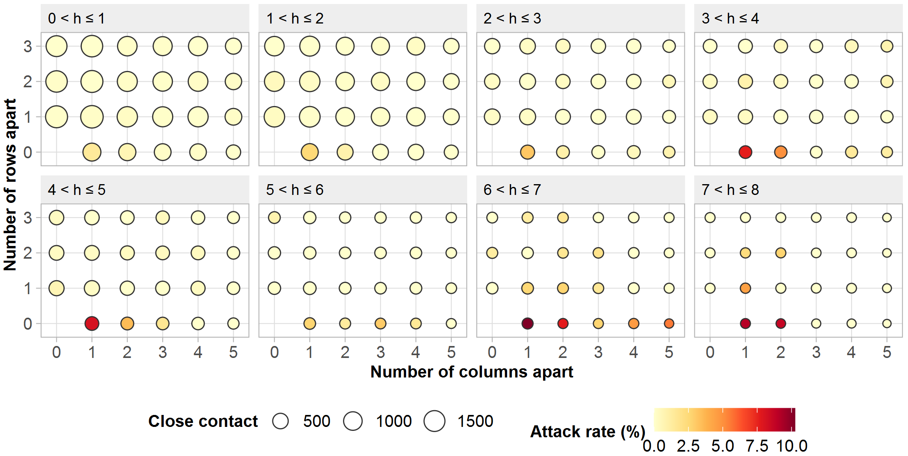

Figure 2. Attack rate of COVID-19 per different seats and co-travel time on a high-speed train.

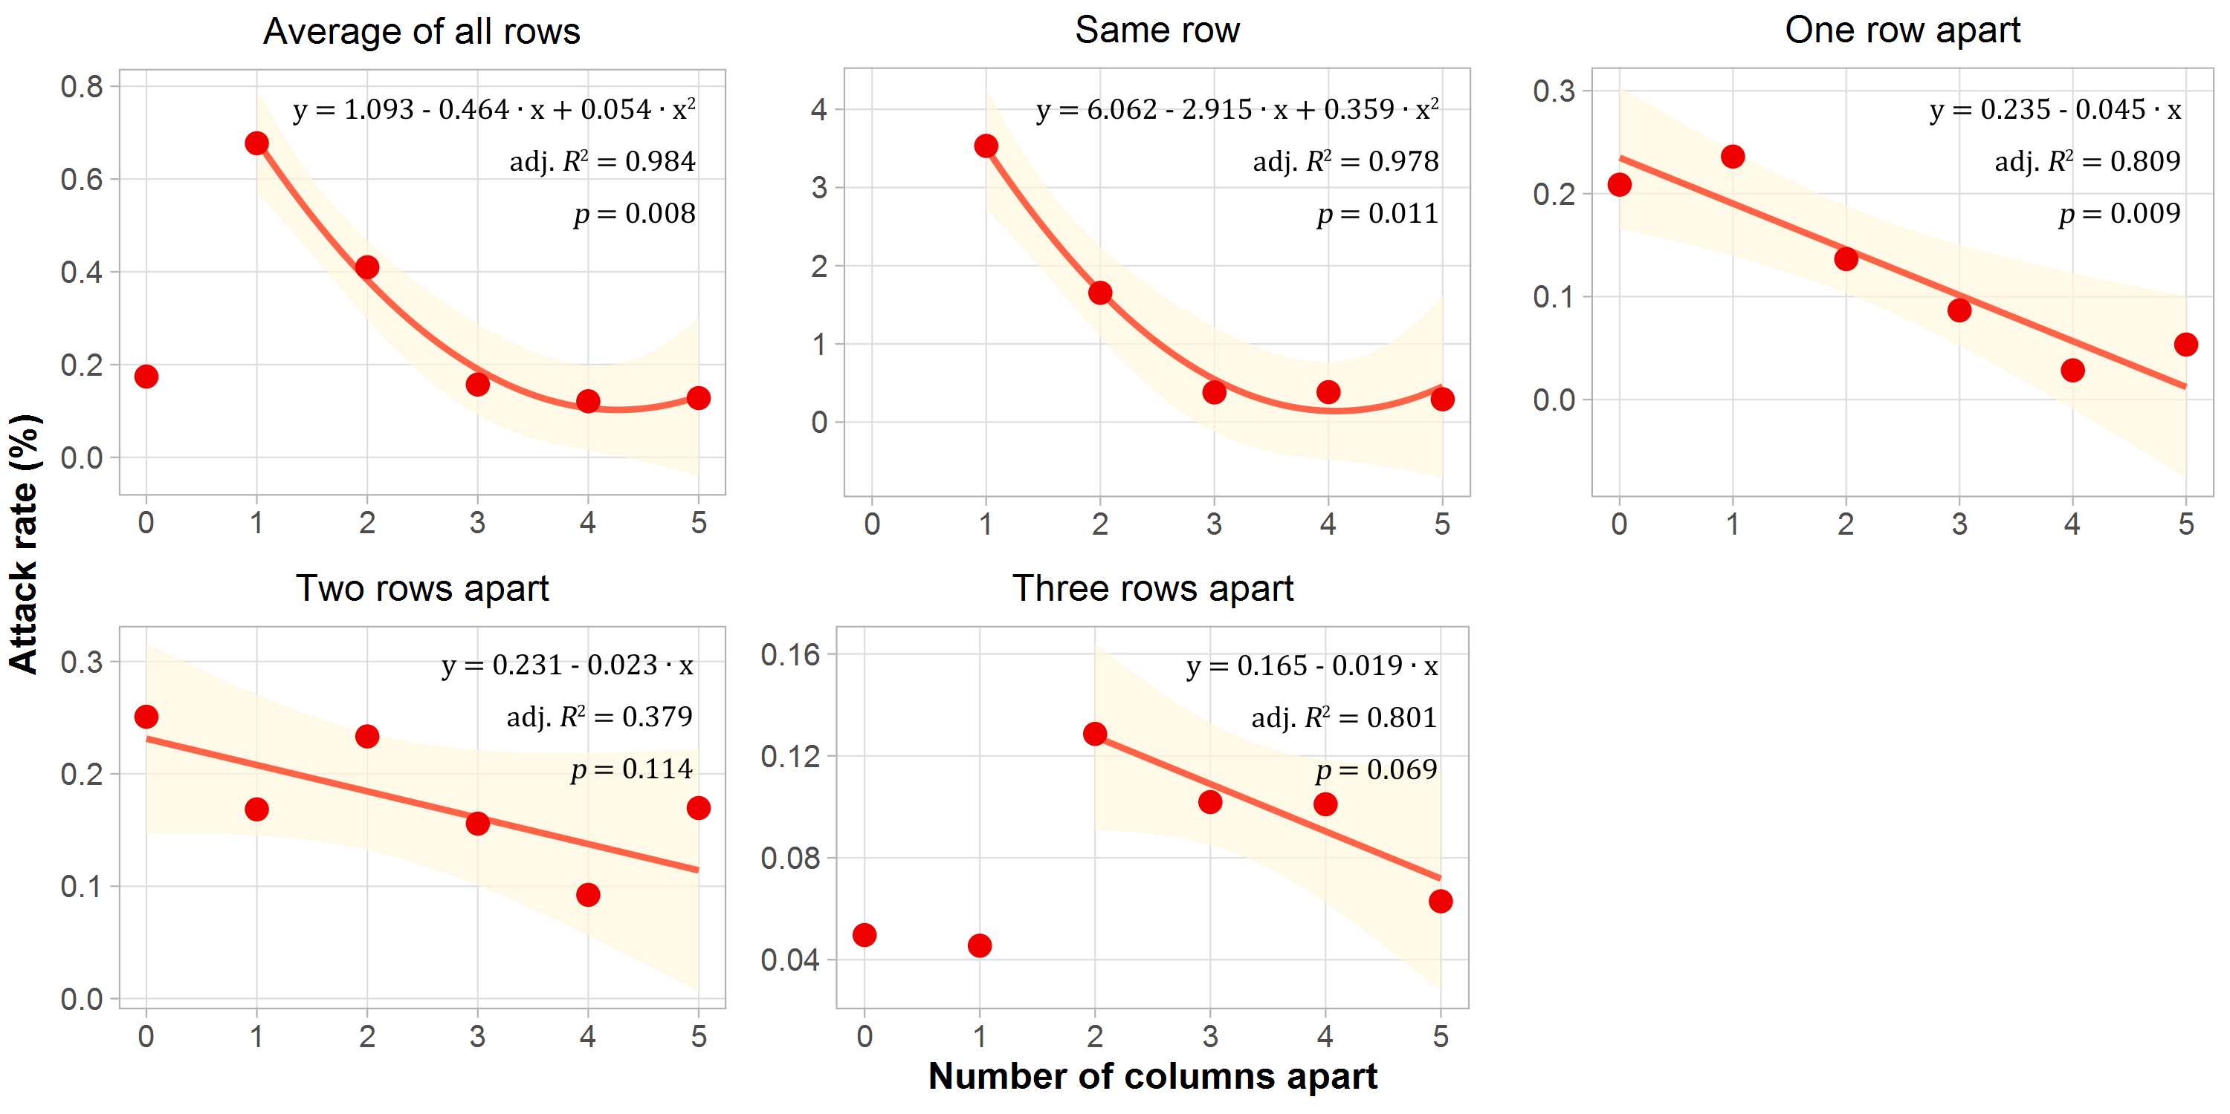

Figure 3. Relationships between COVID-19 attack rate and rows apart from the index patients.

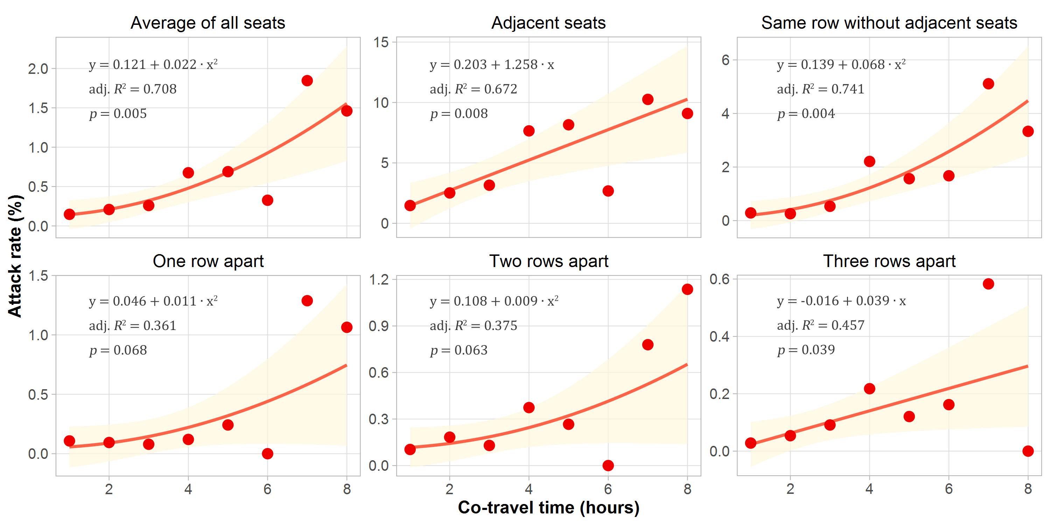

Figure 4. Relationships between COVID-19 attack rate and co-travel time with the index patient

Table 1. Comparisons of attack rate (%) between locations of seats.
Rows apart | Columns apart
 | Same column | 1 | 2 | 3 | 4 | 5 | Average
Same row | - | 3.53 (2.89-4.31) | 1.65 (1.18-2.31) | 0.38 (0.18-0.78) | 0.38 (0.19-0.79) | 0.29 (0.10-0.85) | 1.53 (1.30-1.80)
1 | 0.21 (0.11-0.38) | 0.24 (0.14-0.41) | 0.14 (0.06-0.32) | 0.09 (0.03-0.25) | 0.03 (0.00-0.16) | 0.05 (0.00-0.30) | 0.14 (0.10-0.20)
2 | 0.25 (0.14-0.45) | 0.17 (0.09-0.33) | 0.23 (0.12-0.46) | 0.16 (0.07-0.36) | 0.09 (0.03-0.27) | 0.17 (0.06-0.50) | 0.18 (0.13-0.25)
3 | 0.05 (0.01-0.18) | 0.05 (0.01-0.17) | 0.13 (0.05-0.33) | 0.10 (0.03-0.30) | 0.10 (0.03-0.30) | 0.06 (0.00-0.36) | 0.08 (0.05-0.13)
Average | 0.17 (0.12-0.26) | 0.68 (0.56-0.81) | 0.41 (0.31-0.54) | 0.16 (0.1-0.25) | 0.12 (0.07-0.20) | 0.13 (0.06-0.25) | 0.32 (0.28-0.36)
Note: The attack rate is defined as the percentage of COVID-19 cases in close contacts of index patients on train. The numbers in parentheses are presented as 95% confidence interval of the attack rate.

References
1. Guan WJ, Ni ZY, Hu Y, et al. Clinical Characteristics of Coronavirus Disease 2019 in China. N Engl J Med 2020; 382(18): 1708-20.
2. Chang D, Lin M, Wei L, et al. Epidemiologic and Clinical Characteristics of Novel Coronavirus Infections Involving 13 Patients Outside Wuhan, China. JAMA 2020; 323(11): 1092-3.
3. Tian H, Liu Y, Li Y, et al. An investigation of transmission control measures during the first 50 days of the COVID-19 epidemic in China. Science 2020; 368(6491): 638-42.
4. Chen S, Yang J, Yang W, Wang C, Bärnighausen T. COVID-19 control in China during mass population movements at New Year. The Lancet 2020; 395(10226): 764-6.
5. Wu JT, Leung K, Leung GM. Nowcasting and forecasting the potential domestic and international spread of the 2019-nCoV outbreak originating in Wuhan, China: a modelling study. The Lancet 2020; 395(10225): 689-97.
6. Hu M. Visualizing the largest annual human migration during the Spring Festival travel season in China. Environment and Planning A: Economy and Space 2019; 51(8): 1618-21.
7. Lai S, Bogoch I, Ruktanonchai N, et al. Assessing spread risk of COVID-19 within and beyond China, January-April 2020: a travel network-based modelling study. medRxiv 2020.
8. Holshue ML, DeBolt C, Lindquist S, et al. First Case of 2019 Novel Coronavirus in the United States. New England Journal of Medicine 2020; 382(10): 929-36.
9. Schwartz KL, Murti M, Finkelstein M, et al. Lack of COVID-19 transmission on an international flight. Canadian Medical Association Journal 2020; 192(15): E410.
10. Eldin C, Lagier J-C, Mailhe M, Gautret P. Probable aircraft transmission of Covid-19 in-flight from the Central African Republic to France. Travel Medicine and Infectious Disease 2020: 101643.
11. Silverstein WK, Stroud L, Cleghorn GE, Leis JA. First imported case of 2019 novel coronavirus in Canada, presenting as mild pneumonia. The Lancet 2020; 395(10225): 734.
12. Bogoch II, Watts A, Thomas-Bachli A, Huber C, Kraemer MUG, Khan K. Pneumonia of unknown aetiology in Wuhan, China: potential for international spread via commercial air travel. Journal of Travel Medicine 2020; 27(2): taaa008.
13. Zheng R, Xu Y, Wang W, Ning G, Bi Y. Spatial transmission of COVID-19 via public and private transportation in China. Travel medicine and infectious disease 2020; 34: 101626.
14. Zhao S, Zhuang Z, Ran J, et al. The association between domestic train transportation and novel coronavirus (2019-nCoV) outbreak in China from 2019 to 2020: A data-driven correlational report. Travel Medicine and Infectious Disease 2020; 33: 101568.
15. Devi S. Travel restrictions hampering COVID-19 response. The Lancet 2020; 395(10233): 1331-2.
16. Lai S, Ruktanonchai NW, Zhou L, et al. Effect of non-pharmaceutical interventions to contain COVID-19 in China. Nature 2020.
17. Wu Z, McGoogan JM. Characteristics of and important lessons from the coronavirus disease 2019 (COVID-19) outbreak in China: summary of a report of 72 314 cases from the Chinese Center for Disease Control and Prevention. JAMA 2020.
18. Kucharski AJ, Russell TW, Diamond C, et al. Early dynamics of transmission and control of COVID-19: a mathematical modelling study. The Lancet Infectious Diseases 2020; 20(5): 553-8.
19. Hellewell J, Abbott S, Gimma A, et al. Feasibility of controlling COVID-19 outbreaks by isolation of cases and contacts. The Lancet Global Health 2020; 8(4): e488-e96.
20. Bi Q, Wu Y, Mei S, et al. Epidemiology and transmission of COVID-19 in 391 cases and 1286 of their close contacts in Shenzhen, China: a retrospective cohort study. The Lancet Infectious Diseases 2020.
21. Phoenix New. China's high-speed rail train fleet sends 9 billion passengers: more than 60% in 2018. 2019. https://tech.ifeng.com/c/7j6hzuFRsF0 (accessed 14 March 2020).
22. CAAC News. A total of 610 million passengers traveled on Chinese civil aviation flights in 2018. 2019. http://caacnews.com.cn/1/1/201901/t20190107_1264347.html (accessed 2020.5.9 2020).
23. People's Daily. Railway Spring Festival sends more than 100 million passengers. 2020. http://finance.people.com.cn/n1/2020/0120/c1004-31556468.html (accessed 14 March 2020).
24. People's Daily. Querying tool for same itinerary as the patient diagnosed with COVID-19 (v1.3). 2020. https://h5.peopleapp.com/txcx/index.html (accessed May 12, 2020 2020).
25. Li Q, Guan X, Wu P, et al. Early transmission dynamics in Wuhan, China, of novel coronavirus–infected pneumonia. New England Journal of Medicine 2020; 382(13): 1199-207.
26. Gaetan C, Guyon X. Spatial statistics and modeling: Springer; 2010.
27. Wang J, Xu C. Geodetector: Principle and prospective. Acta Geographica Sinica 2017; 72(1): 116-34.
28. Wang J-F, Zhang T-L, Fu B-J. A measure of spatial stratified heterogeneity. Ecological Indicators 2016; 67: 250-6.
29. Morawska L, Milton DK. It is time to address airborne transmission of COVID-19. Clinical Infectious Diseases 2020.
30. China.org.cn. How to prevent aerosol transmission of COVID-19? 2020. http://www.china.org.cn/chinese/2020-03/02/content_75765535.htm (accessed 18 March 2020).
31. Yu ITS, Li Y, Wong TW, et al. Evidence of Airborne Transmission of the Severe Acute Respiratory Syndrome Virus. New England Journal of Medicine 2004; 350(17): 1731-9.
32. WHO. Coronavirus disease (COVID-19) advice for the public. 2020. https://www.who.int/emergencies/diseases/novel-coronavirus-2019/advice-for-public (accessed 19 March 2020).
33. Centers for Disease Control and Prevention U. Steps to Prevent Illness. 2020. https://www.cdc.gov/coronavirus/2019-ncov/about/prevention.html (accessed 12 March 2020).

