**Photocatalytic Degradation of Methylene Blue Dye on Reticulated Vitreous Carbon Decorated with Electrophoretically Deposited TiO2 Nanotubes**

Syed Z.J. Zaidi 1,Christian Harito 2,3,*, Dmitry V. Bavykin 1, Alysson S. Martins 1,4, Brian Yuliarto 5,6, Frank C. Walsh 1, Carlos Ponce de León 1

1 Energy Technology Research Group, Faculty of Engineering and Physical Sciences, University of Southampton, SO17 1BJ, Southampton, U.K.

2 Department for Management of Science and Technology Development, Ton Duc Thang University, Ho Chi Minh City, Vietnam.

3 Faculty of Applied Sciences, Ton Duc Thang University, Ho Chi Minh City, Vietnam.

4 National Institute of Alternative Technologies for Detection, Toxicological Evaluation and Removal of Micropollutants and Radioactive Substances (INCT-DATREM), Institute of Chemistry, São Paulo State University, Araraquara, 14800-900, São Paulo, Brazil

5 Advanced Functional Materials (AFM) Laboratory, Engineering Physics, Institut Teknologi Bandung, 40132, Bandung, Indonesia.

6 Research Center for Nanosciences and Nanotechnology (RCNN), Institut Teknologi Bandung, 40132, Bandung, Indonesia.

*Author for correspondence; christianharito@tdtu.edu.vn

**Graphical Abstract**

RVC

100 µm

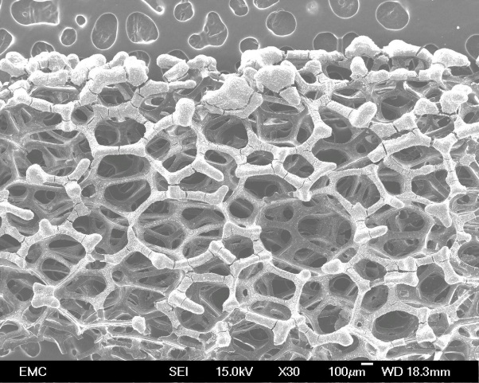

∙OH

H2O

h+

O2-

O2

CO2, H2O

e-

UV

dye

Nanotube

CB

VB

(Approx. 5000 words, 7 reactions/equations, 1 table, 9 figures and 51 references).

**Abstract**

Titanate nanotubes (TiNT) were deposited over the surface of 100 pores per inch (ppi) reticulated vitreous carbon (RVC) by anodic electrophoresis at a cell voltage of 15 V, in an undivided cell, from an ethanol/water suspension containing TiNT coated with tetrabutylammonium hydroxide (TBAOH) surfactant. Scanning electron microscopy showed the open cell porous structure of TiNT/RVC coated by an uniform *ca.* 30 µm thick layer of TiNT. Calcination at 450°C for 2 h in air improved the photocatalytic properties. The material was used as photocatalyst for the decolourisation of methylene blue (MB) dye. The 98% volumetric porosity of the RVC substrate provided good reactant access and large surface area for deposition of TiNT. The calcined TiNT/RVC substrate achieved a 91% dye degradation after 20 min, which was higher than uncoated, acid treated RVC and non-calcined TiNT/RVC substrate. The MB decolourisation improved at an increased thickness of 3D TiNT/RVC catalyst although the improvement was limited to 4 mm on 100 ppi RVC due to limited UV penetration.

**Keywords:** catalytic processes; composites; glassy carbon; ion assisted deposition; nanotubes

**Highlights**

● Anodic electrophoresis produced a stable TiNT film on 100 ppi RVC.

● SEM imaging showed uniform deposition of TiNT.

● The acid treatment of RVC increased the ratio of *ID*/*IG* as seen in Raman spectra.

● Decorated RVC was used as a photocatalyst for decolourisation of MB dye.

**Nomenclature**

**Symbol Meaning Units**

*A* Electrode area cm2

*c* Concentration of species mol cm-3

*d* Interelectrode gap cm

*ID* Disorder band arbitrary units

*IG* Graphitic band arbitrary units

*k* Apparent first order rate constant min-1

*t* Time min

**Abbreviations**

CFCarbon felt

DSA Dimensional stable anode

EPD Electrophoretic deposition

FTO Fluorine tin oxide

MB Methylene blue

OMR Organic matter residue

ppi Pores per linear inch

RVC Reticulated vitreous carbon

SEM Scanning electron microscopy

TBAOH Tetrabutylammonium hydroxide

TiNT Titanate nanotubes

UV-vis Ultraviolet-visible

1. **Introduction**

Water treatment technologies have been employed for the degradation of herbicides [1], pharmaceuticals [2], and dyes [3]. Azo dyes are a particular concern due to their intensive use in the textile, leather and paper processing sectors of industry. The colour and odour of azo dyes are strong and pose serious environmental and health issues [4]. Several methods have been employed to degrade azo dyes such as parallel plate flow reactor [5] and filter press flow cell [6]. However, these processes have many disadvantages, including difficulties in scaling-up and expensive electrode materials or reactor geometries. The selection of low cost, long life electrode materials that can achieve the complete mineralization of organics, is challenging, since many investigations have utilized expensive boron doped diamond (BDD) [7] or dimensionally stable anode (DSA) coatings of precious metal oxides [8]. The development of simple and cost-efficient electrochemical technologies is important to efficient dye degradation on the industrial scale.

Photocatalytic degradation of organic matter residue (OMR) using TiO2 can provide high efficiency with moderate costs [9]. Considerable research has been conducted on TiO2 nanoparticles as a photocatalyst for the remediation of OMR such as phenol [10], methylene blue [11], rhodamine B [12], and bisphenol-A (BPA) [13]. TiO2 has a band gap of 3.0-3.2 eV, corresponding to a UV-range of radiation, in which the hydrothermally synthesized TiO2 in acidic conditions has provided substantial results with a reported rate of reaction of 43×10-9 mol dm-3 s-1 for the photodegradation of 4-nitrophenol [14].

TiO2 can be obtained in several morphologies such as nanotubes, nanosheets, nanoflakes and nanowires [15,16]. Nanotubes derived from TiO2 exhibits particular interest since can provide greater surface area, improving the UV absorption and offering a better performance for degradation of OMR [17]. Titanate nanotubes (TiNT) can be synthesised by anodising [18] or hydrothermal treatment [19]. The surface modification of titanium substrate by nanotubes can enhanced the movement of the photo-illuminated electrons in the photocatalytic degradation process. It has been reported that 95% of 4-chlorophenol was efficiently degraded in a highly acidic (H2SO4) medium using TiNT [20].

More advanced films such as hierarchical and 3D structures are required in order to serve the purpose of an effective and larger surface area for photocatalytic degradation. In order to achieve this, TiNT can be coated by anodic electrophoretic deposition (EPD) over an electrically conductive substrate. In studies electrodeposited polypyrrole coated TiNT composite showed an increase in hardness of 53% compared to a polypyrrole coating [21]. The large surface area of TiNT is suitable for coating layers and can increase the OMR photodegradation efficiency up to 20% [22]. The selection of a substrate to deposit the TiNT should aim to provide a high volumetric porosity with a substantial accessible surface area and well-defined morphology.

Reticulated vitreous carbon (RVC) is an excellent substrate candidate due its open-pore, interconnected cell structure and moderate corrosion resistance under certain circumstances, good thermal and electrical conductivities [23] and low thermal expansion [24]. RVC can also be synthesised using biomass which is sustainable [25]. The surface area and void volume of RVC are high with low resistance to fluid flow in a closed loop reactors and filter press flow cells [26] and has already been applied for the degradation of azo dyes [27]. RVC has previously been used to produce hydrogen peroxide which subsequently oxidise formic acid by Fenton reaction [28] and to remove metal ions such as Cr(VI) in a parallel plate reactor with flow recirculation [29]. RVC electrodes were also used for removal of cupric ions where the hydrogen evolution was a secondary reaction decreasing the efficiency [30]. The proposed methodology for the deposition of TiNT on the RVC substrate produces an inexpensive electrode that can be used for advanced processes, such as photo-electro-degradation of organic compounds.

In this work, the focus was on the anodic electrophoretic deposition of TiNT on an RVC substrate that was subsequently used for the photocatalytic degradation of methylene blue (MB) dye. Scanning electron microscopy (SEM) was used to study the morphology of the deposit, while Fourier transform infrared spectroscopy (FTIR), X-ray diffractometer (XRD), and Raman spectroscopy were used for materials characterisation. Pseudo-first order batch kinetic concentration decay studies were used to evaluate the degradation of methylene blue by 3D catalyst.

**2. Experimental details**

Reagent grade tetrabutylammonium hydroxide (TBAOH), methylene blue dye, ethanol, and acetone were obtained from Sigma Aldrich, while ethanol 99.86% v/v and 70% nitric acid were purchased from Fischer Scientific. The TiNT preparation included an alkaline hydrothermal treatment of TiO2 in 10 mol dm-3 NaOH at 140ºC, as discussed elsewhere [31].

*2.1 Deposition process of anodic electrophoretic*

The Duocel® RVC foam substrate obtained from ERG Materials and Aerospace Corp. was immersed in 70% nitric acid for 1 hour at 110°C followed by several rinsing and immersed overnight in DI water then dried at 90°C overnight in an oven. Reticulated vitreous carbon (RVC) is an open-cell, glassy (i.e., vitreous) carbon foam [24,26], a linear porosity grade of 100 pores per inch (ppi) RVC with approx. 98% volumetric porosity was used in this work. The anodic electrophoretic deposition was carried out using a solution prepared as follows: 0.25 g of TiNT and 25 cm3 of 0.2 mol dm-3 TBAOH was stirred continuously over 2 days. The TBAOH-coated TiNT were separated by vacuum filtration and 0.1 g was transferred to a solution containing 60 cm3 ethanol (99.86% v/v) and stirred for 2 weeks. The solution was immediately used for EPD in a 60 cm3 cell that contained a graphite cathode (1.5 cm × 6 cm × 1.2 cm) in a planar configuration and 100 pores per inch (ppi) RVC (1.5 cm × 2 cm × 0.13 cm) anode with volumetric area of 66 cm2 cm-3 [32]. A cell voltage of 15 V was applied for 15 min with an interelectrode gap (*d*) of 1 cm. A dry electrical connection to the RVC was made by a stainless-steel alligator clip compressing a copper foil above the electrolyte level, in order to ensure good electrical conductivity.

*2.2 Heat treatment and titanate characterisation*

Following the EPD process, the TiNT/RVC samples were calcined for 2 hours at 450°C then allowed to cool down spontaneously in air. To determine the phase changes in the titanate during heat treatment, the titanate nanotubes were heated at a temperature of 140, 200, 300, 400, and 450oC. An X-ray diffractometer (XRD) was used to observe the stability/generation of crystalline phases in different temperatures of calcination. A Rigaku SmartLab XRD instrument was operated at 9 kW (i.e., 200 mA, 45 kV) withaCu target.

*2.3 Coated substrate characterization*

The TiNT/RVC samples were characterised by field emission scanning electron microscope (JEOL JSM-6500F, FESEM) at an accelerating voltage of 20 kV to observe the surface morphology. The depth of the outer and inner struts of the RVC could be determined by adjusting the SEM focus on different struts, enabling the first/outer, 2nd, 3rd, and 4th layer of RVC to be classified. A Raman spectroscopy confocal microscope (Renishaw, RM 2000) was used to observe functional groups. The laser source operated at a wavelength of 632.8 nm with a 10% intensity of laser radiation over a 30 s exposure time. A Fourier transform infrared spectrometer (FTIR) was used to characterise functional groups and chemical bonding using a Nicolet 380 FTIR Spectrometer, Thermo Scientific. The sample was crushed and ground for FTIR characterisation.

*2.4 Photocatalytic Activity*

The degradation of a 1.29 × 10-6 mol dm-3 concentration solution ofmethylene blue (MB) dye was observed under UV irradiation to examine the photocatalytic activity of the pretreated RVC, TiNT/RVC, and TiNT/RVC calcined samples. All of the samples were cut into a disc with a diameter of 0.5 cm and immersed in 10 cm3 deionized water containing MB. To generate dye adsorption on the samples, the solution was kept for 90 min in the dark condition. After adsorption of dye, the dye concentration was decreased to 1.03, 0.971, 1.01 × 10-6 mol dm-3 when using RVC, TiNT/RVC, and calcined TiNT/RVC, respectively. The loading of TiNT/RVC photocatalyst was 0.1037 mg cm-3, which did not change after UV exposure. The UV irradiation was conducted at 20 mW cm-2 UV lamp intensity on the sample after adsorption. The 300 W LuxteL’s CeraLuxTM xenon arc lamp CL300BUV-10F was used without filtration; the highest UV intensity occurred at an approximate wavelength of 400 nm. The absorbance was measured in a Hitachi U3010 UV-Vis spectrophotometer at a wavelength of 667 nm for methylene blue (MB) dye. A linear calibration curve was used to calculate the concentration of MB resulting in a molar extinction coefficient of 707.86 L mol-1 cm-1.

**3. Results and Discussion**

*3.1 Acid treatment effect over RVC surface*

Figure 1

Raman spectra of the RVC substrate before and after acid treatment are shown in Figure 1a. The degree of functional group formation over the substrate can be seen via the increasing ratio of disorder band to graphitic band *ID/IG*, corresponding to the number of defects in the carbon structure. The surface defects observed by Raman spectroscopy may be caused by the presence of functional groups over the surface of the RVC. The degree of functionalization for the formation of functional groups was due to the breathing mode of A1g of graphite molecule which [33] can be observed by D-band (*ID*) at Raman shift of 1300 cm-1 over G-band (*IG*) at Raman shift of 1590 cm-1 as shown in Figure 1b [34]. A1g mode was activated in the presence of functional groups which appear due to the pretreatment of RVC in acid media. The intensity of G-band at Raman shift of 1590 cm-1 was relevant to the E2g symmetry. The E2g symmetry involved the stretching of in-plane bonds present between pairs of sp2 atoms which can be seen in Figure 1c [33]. The acid treatment provided a lower intensity of the G-band due to the formation of more defects in RVC surfaces due to the oxidation by nitric acid. The peak intensities showed that the increase of *ID/IG* ratio for acid treated RVC compared to non-acid treated which was 1.75 and 1.59, respectively. The increment was due to more active carboxylic acid functional groups [34] over the surface of the RVC, which can attract the hydroxyl groups on the surface of the TiNT. The FTIR result in Figure 1d further confirmed the functional groups present on the RVC surface after acid treatment. The hydroxyl and carboxylic acid group were evident from absorption of O‒H at ≈3454 cm-1 while C=O and C‒OH absorption was seen at around 1600 cm-1. This result is in accordance with the behaviour expected at an oxidised glassy carbon electrode [35]. As a result, the pre-treatment of RVC surface with nitric acid increased the efficiency of TiNT coating. By using 70% nitric acid for 1 hour at 110°C, there was a noticeable increase in homogeneity of coated layer over the RVC surface. In comparison, samples without pretreatment produced lower deposition of coating over the surface of RVC.

*3.2 Surface characterization of TiNT coated RVC*

Figures 2a and b shows the samples before and after calcination which were taken by magnified camera exhibiting no significant difference in both the calcined and non-calcined samples of TiNT/RVC. The TiNT covered RVC samples were shown to be stable under temperature as high as 450oC. The TiNT film crystallised and covered the RVC substrate uniformly, before and after calcination.

Figure 2

Figure 3

Figure 3a-e show a detailed image of the morphology of such structures. The characteristic rigid honeycomb structure of the RVC coated with TiNT (non-calcined) with a uniform layer covering the front strands on the surface of the substrate is shown in Figure 3a. The strands of the RVC that were further deeper into the RVC structure were also uniformly coated but those behind the front strands might receive less amount of TiNT. Figure 3b shows agglomerated electrodeposited TiNT over a front strand of RVC which it completely covered. Figure 3c shows a deeper look inside the third layer of the RVC structure (high magnification), where TiNT agglomerates around 1 µm in diameter were scattered over the RVC surface. Figure 3d and 3e show deeper layers inside the fourth layer of RVC that contained fewer TiNT covering the RVC surface. The porosity of RVC helped to improve the deposition of TiNT and achieved a uniform, homogenous coating over the surface substrate whereas areas inside the RVC the coating were less uniform due to the blocking of upper strands of RVC. The sharp boundaries of agglomerates evidenced the presence of TiNT with regular structures of 30 µm in thickness in Figure 5a. Due to the reasonable bulk thermal conductivity of RVC (0.033 – 0.050 W m-1 K-1) [36], the deposited TiNT coatings are consistent and stable against environmental attack and high temperature calcination treatment.

Figure 4

Figure 4a and b show images of the RVC coated substrates after calcination at 450ºC for 2 hours. Figure 4a is a general image of the TiNT coated RVC after calcination while Figure 4b shows the TiNT layer in more detail. The delaminated part appeared due to heat treatment over RVC coated with TiNT. Despite the delamination, the Figure 4 shows that the layer of TiNT is uniform over the struts at the front of the RVC structure and they remained strongly attached to the surface after the heat treatment. Some uncoated areas of RVC thermally oxidised at high temperature and the carbon tended to disintegrate. In contrast, all of the coated areas remained intact, suggesting that the TiNT coating protected the mechanical integrity of the RVC structure. Also, the calcination produced few cracks over the TiNT coatings at 450ºC. After acid treatment, functional groups were formed as shown in Figure 1d; further decomposition took place on calcination to form CO/CO2 gas. Despite some cracking and delamination, the SEM images also showed that many nanotubes were in contact with the substrate, even after calcination at 450°C.

The cell voltage used for the EPD dictated the thickness of the layer of TiNT coating over the RVC substrate. However, the formation of OH- and H+ [37, 38] ions and gas evolution in the electrolyte occurred due to the electrolysis of residual water present in the ethanol decreasing the thickness of TiNT coating. Gas evolution over the RVC surface during EPD hampered the deposition of TiNT nanocrystals further within the pores. It should be possible to improve the functionality of RVC surface by nitric acid treatment. Oxidation in nitric acid resulted in hydroxyl and carboxylic group formation [34], which improves the electrodeposition of TiNT over the RVC substrate.

Figure 5

Figure 5a shows a closer detail of an RVC strand modified by TiNT before calcination. The cross-sectional view of modified RVC surface explained the film thickness of TiNT deposit on RVC, which appeared to be *ca.* 30 µm. The uniform film thickness was achieved due to surfactant (TBAOH) present in the TiNT which increased the electrical conductivity and the charge propagation in the electrolyte, reduced the surface tension and improved the wettability [39]. Figure 5b shows a view of the calcined coating on the RVC with a thickness layer of approximately *ca.* 7 m. The TiNT seemed to forms a more compact layer after calcination.

Figure 6

XRD characterization is an important technique to observe the stability/generation of crystalline phases at different calcination temperatures. Figure 6a shows XRD patterns of titanates. The diffractograms were poorly resolved with characteristics peaks of titanates at low calcination temperatures (<400oC) (as in JCPDS 44-0131). The wide diffraction feature between 24° and 36° is associated with the titanate phase and decreased at higher calcination temperatures. According to Morgado *et al.* [40] the titanates start to transform from the nanostructured trititanate into hexatitanate at 200°C, which could be due to a reduction of the interlayer distance. The diffractogram peaks did not exhibit the characteristic pattern of the anatase phase; rather, peaks were in accordance with the reported titanate phase (JCPDS 21-1272). At higher temperature, 450°C, the titanate showed characteristic peaks for the pure anatase TiO2 phase.

Raman spectroscopy was used to observe the phase changes associated with TiNT deposition over RVC substrate and the effects of calcination over the substrate. The Raman spectra of TiNT/RVC substrate before and after calcination are presented in Figure 6b. The spectrum that corresponds to the non-calcined TiNT/RVC shows a large peak at 148 cm-1 and smaller peaks at 278 and 447 cm-1, the former corresponds to the presence of the titanate phase of TiNT. The as synthesised titanate has different chemical properties from TiO2 in which the titanate has a negative surface charge [41], interlayer structure, and more hydroxyl groups [42] hence it can be easily deposited to RVC by electrophoretic deposition. After calcination, the anatase phase gave rise to Raman bands at 151, 185 cm-1, 390 cm-1 450 cm-1 and 629 cm-1 indicating that the heat treatment converted the substrate phase from titanate to anatase phase as reported in the literature [43]. Figure 6b shows the phase transformation of TiNT after calcination from the titanate to the anatase phase as indicated by the disappearance of the peak at 278 cm-1 and 447 cm-1 after calcination.

*3.3 Methylene blue photocatalytic degradation*

When kept in the dark for 90 min, the initial MB concentration (1.29 × 10-6 mol dm-3) slightly decreased to 1.03, 0.971, 1.01 × 10-6 mol dm-3 after using RVC, TiNT/RVC, and calcined TiNT/RVC, respectively. Hydroxyl groups in acid treated RVC and TiNT adsorbed the MB. Figure 7a shows the decolourisation of methylene blue dye due to UV irradiation on calcined TiNT/RVC. Significant decolourisation can be observed even at 5 min of UV degradation. Combination of UV and a TiO2 catalyst was known to be effective for photo-oxidation of methylene blue to colourless leuco-methylene blue [44]. Hence, the absorbance of blue dye at an approx. wavelength of 667 nm decreased. Figure 7b shows the normalised concentration of methylene blue dye after 20 min of photocatalytic degradation with RVC, RVC/TiNT, calcined RVC/TiNT, and control sample (i.e., MB dye). The electrophoretically deposited TiNT coating on the RVC facilitated the decolourisation of MB dye to 82% colour removal after 20 min of UV radiation. However, non-catalytic MB dye degradation by UV irradiation was dominant, with only 69% colour removal being shown for MB dye. The 0.1037 mg cm-3 loading of TiNT/RVC further increased the colour removal due to adsorption. The weight was constant and did not change after UV exposure. Similar experiments performed by Lin *et al.* for decolourisation of methylene blue using open-ended TiNT films under UV irradiation. Their results showed 100% mineralization after 250 min in addition to water splitting [45].

Figure 7

In the case of calcined TiNT/RVC, the percentage of dye decolourisation was about 91% in 20 min (Figure 7). This was due to the synergetic photocatalytic effect similar to the results reported in the literature for graphene/TiO2 (P25) under UV light irradiation for degradation of methylene blue dye [46]. With carbonaceous material as the electron sink, the synergism reduced the expected re-combination of holes and electrons thereby producing active photo induced charge separation which enhances the number of holes taking part in the active photo degradation process [47]. In another example, the decolourisation and mineralization of Blue V dye over the TiO2 based photo-catalyst deposited with noble metal particles was performed, such as Au over the TiO2 influenced the mineralisation by 67% and decolourisation efficiencies by 93% [48].

Figure 8

The time dependent profiles of *c*/*c*o for the photocatalytic degradation of dye using RVC, RVC/TiNT, RVC/TiNT (calcined), and control sample (i.e., MB dye) are shown in the semi logarithmic plot of Figure 8. The linear data for the degradation on different electrodes suggested a pseudo-first order reaction kinetics for the degradation of methylene blue dye according to the equation:

$\ln\left(\frac{c}{c_{0}}\right)= -kt$ (7)

Where *k* is the degradation rate constant, *t* is irradiation time, *c*o is initial concertation, and *c* is the final concentration.

Table 1

The comparison of rate constant *k* is presented in Table 1. The *k* values of the MB dye, RVC, TiNT/RVC and calcined TiNT/RVC were 0.06595 min-1,0.08861 min-1, 0.09414 min-1 and 0.12811 min-1, respectively. These values were found to be higher than the values reported for planar open ended TiNT and closed ended TiNT with constant rate values of 0.0035 min-1 and 0.0047 min-1 respectively [45]. These 3D catalyst also compared favourably with study regarding the photocatalytic degradation using TiNT on activated carbon fibre which reported degradation rate values of 0.0694 min-1 for methylene blue dye [47]. The improved rates of decolourisation were due to improved support provided by the 3D structure of RVC. Compared to an aqueous suspension of 30 nm anatase TiO2, the rate of degradation in this work was smaller [49]. However, the catalyst in this work was firmly attached on RVC, which provided a rigid catalyst support with an open-cell structure, offering a low resistance to electrolyte penetration and flow together with ease of handling.

The calcination of nanotubes increased the photocatalytic activity by around 35% in comparison to the non-calcined TiNT/RVC. This increase can be observed from the values of the rate constant *k*. The annealing converted the as synthesised TiNT to anatase phase which improved the photocatalytic activity in Figure 6. In the case of TiNT/RVC, the methylene blue decolourisation was 82% after 20 min. This number was lower compared to calcined substrate which was 91%. The difference in the photocatalytic activity of both substrates i.e. calcined and non-calcined TiNT/RVC ascribed to the recombination of electron hole pairs at defect sites on non-calcined TiNT, allowing a smaller number of electrons and holes to participate in the photocatalysis. The TiNT without annealing has less photocatalytic activity in comparison with annealed samples as shown from the photocatalysis results and similar study [50].

After 5 min of photocatalytic decolourisation on bare RVC, only 28.5% reduction in concentration of MB was obtained which was lower than the results obtained with calcined TiNT/RVC of approx.. 60% decolourisation. The decolourisation of MB using acid treated RVC was attributed to adsorption on functional group of RVC and the oxidation of MB into colourless leuco-MB by UV irradiation in air [51]. Meanwhile, the TiNT acted as an efficient catalyst for photo-oxidation of MB [44].

*3.4 Substrate thickness studies*

Figure 9

In order to investigate the response of UV radiation upon degradation activity using 3D structure, the 3D TiNT/RVC (calcined) samples with a thickness of 2 mm were stacked together up to six stacks i.e. 12 mm as shown in Figure 9a. The concentration of dye was measured after 5 min of UV irradiation for 1, 2, 3, 4, 5, and 6 stacks as shown in Figure 9b. The concentration of methylene blue dye was reduced to 20% after 5 min when two stacks was used, in which the thickness of TiNT/RVC (calcined) was 4 mm. No considerable change was observed in the concentration of MB dye during photocatalytic decolourisation for more than 2 stacks as shown in Figure 9. This shows that UV light may not be able to penetrate further than 4 mm in 100 pores per inch (ppi) RVC decorated with TiNT.

**4. Conclusions**

This work demonstrated the preparation of TiNT coatings over RVC substrates by using anodic electrophoretic deposition. The presence of active functional groups increased over the surface of the RVC after acid treatment resulting in the *ID/IG* ratio for acid treated RVC spectra increased. These functional groups assisted the deposition of TiNT and improved homogeneity. Raman studies revealed that upon calcination of TiNT/RVC coating the formation of anatase phase was observed at 450oC. These TiNT/RVC composites have been used to investigate the degradation kinetics of methylene blue solution. The calcined TiNT/RVC substrate showed the highest rate of MB degradation because the anatase phase of calcined TiNT contributed to the photocatalytic process. The rate of decolourisation due to anatase phase was 32.5% greater than the RVC alone. The usage of thicker 3D TiNT/RVC calcined substrate increased the rate of degradation up to the thickness of 4 mm and reached a plateau due to the limit of UV penetration through 100 ppi RVC. These TiNT/RVC composites could potentially to be used as low cost and flow-through electrodes material for wastewater decontamination.

**Acknowledgement**: S.Z.J. Zaidi gratefully acknowledges financial support from the Faculty of Engineering and the Environment at the University of Southampton for the Rayleigh studentship, to the European Commission Project H2020 CO2EXIDE, and to the Bestway Foundation, Charity No. 297178, UK.

**References**

[1] A.S. Martins, V.M. Vasconcelos, T.C.R. Ferreira, E.R. Pereira-Filho, M.R.V. Lanza, Simultaneous degradation of diuron and hexazinone herbicides by photo-fenton: Assessment of concentrations of H2O2 and Fe2+ by the response surface methodology, J. Adv. Oxid. Technol. 18 (2015) 9–14. https://doi.org/10.1515/jaots-2015-0101.

[2] E. Brillas, I. Sirés, Electrochemical removal of pharmaceuticals from water streams: Reactivity elucidation by mass spectrometry, TrAC - Trends Anal. Chem. 70 (2015) 112–121. https://doi.org/10.1016/j.trac.2015.01.013.

[3] E. Brillas, C.A. Martínez-Huitle, Decontamination of wastewaters containing synthetic organic dyes by electrochemical methods. An updated review, Appl. Catal. B Environ. 166–167 (2015) 603–643. https://doi.org/10.1016/j.apcatb.2014.11.016.

[4] K. Singh, S. Arora, Removal of synthetic textile dyes from wastewaters: A critical review on present treatment technologies, Crit. Rev. Environ. Sci. Technol. 41 (2011) 807–878. https://doi.org/10.1080/10643380903218376.

[5] S.Z.J. Zaidi, F.C. Walsh, C. Harito, Mass transport control of oxygen reduction at graphite felt with subsequent decolourisation of RB-5 dye in a parallel plate flow reactor, J. Taiwan Inst. Chem. Eng. 104 (2019) 123–129. https://doi.org/10.1016/j.jtice.2019.08.020.

[6] V.M. Vasconcelos, C. Ponce-De-León, J.L. Nava, M.R.V. Lanza, Electrochemical degradation of RB-5 dye by anodic oxidation, electro-Fenton and by combining anodic oxidation-electro-Fenton in a filter-press flow cell, J. Electroanal. Chem. 765 (2016) 179–187. https://doi.org/10.1016/j.jelechem.2015.07.040.

[7] L.A. Pereira, A.B. Couto, D.A.L. Almeida, N.G. Ferreira, Singular properties of boron-doped diamond/carbon fiber composite as anode in Brilliant Green dye electrochemical degradation, Diam. Relat. Mater. 103 (2020) 107708. https://doi.org/10.1016/j.diamond.2020.107708.

[8] V. Krstić, B. Pešovski, Reviews the research on some dimensionally stable anodes (DSA) based on titanium, Hydrometallurgy. 185 (2019) 71–75. https://doi.org/10.1016/j.hydromet.2019.01.018.

[9] J.M. Peralta-Hernández, Y. Meas-Vong, F.J. Rodríguez, T.W. Chapman, M.I. Maldonado, L.A. Godínez, In situ electrochemical and photo-electrochemical generation of the fenton reagent: A potentially important new water treatment technology, Water Res. 40 (2006) 1754–1762. https://doi.org/10.1016/j.watres.2006.03.004.

[10] M.T. Yilleng, E.C. Gimba, G.I. Ndukwe, I.M. Bugaje, D.W. Rooney, H.G. Manyar, Batch to continuous photocatalytic degradation of phenol using TiO2 and Au-Pd nanoparticles supported on TiO2, J. Environ. Chem. Eng. 6 (2018) 6382–6389. https://doi.org/10.1016/j.jece.2018.09.048.

[11] D. Laishram, K.P. Shejale, R. Gupta, R.K. Sharma, Heterostructured HfO2/TiO2 spherical nanoparticles for visible photocatalytic water remediation, Mater. Lett. 231 (2018) 225–228. https://doi.org/10.1016/j.matlet.2018.08.053.

[12] J. Chen, J. Shu, Z. Anqi, H. Juyuan, Z. Yan, J. Chen, Synthesis of carbon quantum dots/TiO2 nanocomposite for photo-degradation of Rhodamine B and cefradine, Diam. Relat. Mater. 70 (2016) 137–144. https://doi.org/10.1016/j.diamond.2016.10.023.

[13] A.S. Martins, P.J.M. Cordeiro-Junior, L. Nuñez, M.R. de V. Lanza, A Simple method for the electrodeposition of WO3 in TiO2 nanotubes: influence of the amount of tungsten on photoelectrocatalytic activity, electrocatalysis. 8 (2017) 115–121. https://doi.org/10.1007/s12678-016-0335-9.

[14] A. Di Paola, G. Cufalo, M. Addamo, M. Bellardita, R. Campostrini, M. Ischia, R. Ceccato, L. Palmisano, Photocatalytic activity of nanocrystalline TiO2 (brookite, rutile and brookite-based) powders prepared by thermohydrolysis of TiCl4 in aqueous chloride solutions, Colloids Surfaces A Physicochem. Eng. Asp. 317 (2008) 366–376. https://doi.org/10.1016/j.colsurfa.2007.11.005.

[15] C. Harito, D. V. Bavykin, B. Yuliarto, H.K. Dipojono, F.C. Walsh, Inhibition of polyimide photodegradation by incorporation of titanate nanotubes into a composite, J. Polym. Environ. 27 (2019) 1505–1515. https://doi.org/10.1007/s10924-019-01443-w.

[16] W. Tri Wahyuni, B. Riza Putra, C. Harito, D. V. Bavykin, F.C. Walsh, T.D. James, G. Kociok-Köhn, F. Marken, Electroanalysis in 2D-TiO2 nanosheet hosts: electrolyte and selectivity effects in ferroceneboronic acid – saccharide binding, Electroanalysis. 30 (2018) 1303–1310. https://doi.org/10.1002/elan.201700617.

[17] Y.B. Xie, X.Z. Li, Interactive oxidation of photoelectrocatalysis and electro-Fenton for azo dye degradation using TiO2-Ti mesh and reticulated vitreous carbon electrodes, Mater. Chem. Phys. 95 (2006) 39–50. https://doi.org/10.1016/j.matchemphys.2005.05.048.

[18] A.S. Martins, C. Harito, D. V. Bavykin, F.C. Walsh, M.R. V. Lanza, M.R. V Lanza, Insertion of nanostructured titanates into the pores of an anodised TiO*2* nanotube array by mechanically stimulated electrophoretic deposition, J. Mater. Chem. C. 5 (2017) 3955–3961. http://xlink.rsc.org/?DOI=C7TC00575J (accessed October 13, 2018).

[19] C. Harito, R. Porras, D.V. Bavykin, F.C. Walsh, Electrospinning of *in situ* and *ex situ* synthesized polyimide composites reinforced by titanate nanotubes, J. Appl. Polym. Sci. 134 (2017) 1–9. https://doi.org/10.1002/app.44641.

[20] N. Wang, X. Li, Y. Wang, X. Quan, G. Chen, Evaluation of bias potential enhanced photocatalytic degradation of 4-chlorophenol with TiO2 nanotube fabricated by anodic oxidation method, Chem. Eng. J. 146 (2009) 30–35. https://doi.org/10.1016/j.cej.2008.05.025.

[21] P. Herrasti, A.N. Kulak, D.V. Bavykin, C.P. de Léon, J. Zekonyte, F.C. Walsh, Electrodeposition of polypyrrole–titanate nanotube composites coatings and their corrosion resistance, Electrochim. Acta. 56 (2011) 1323–1328. https://doi.org/10.1016/j.electacta.2010.09.094.

[22] R. Savitha, R. Raghunathan, R. Chetty, Rutile nanotubes by electrochemical anodization, RSC Adv. 6 (2016) 74510–74514. https://doi.org/10.1039/c6ra16708j.

[23] R.S.R. da Silva, S.S. Oishi, E.C. Botelho, N.G. Ferreira, Carbon foam composites based on expanded graphite for electrochemical application, Diam. Relat. Mater. 103 (2020) 107730. https://doi.org/10.1016/j.diamond.2020.107730.

[24] J.M. Friedrich, C. Ponce-de-León, G.W. Reade, F.C. Walsh, Reticulated vitreous carbon as an electrode material, J. Electroanal. Chem. 561 (2004) 203–217. https://doi.org/10.1016/j.jelechem.2003.07.019.

[25] A.S. Yargic, N. Ozbay, Effect of chemical activation on the cellular structure of biopitch-derived green carbon foam, Diam. Relat. Mater. 96 (2019) 58–66. https://doi.org/10.1016/j.diamond.2019.04.032.

[26] F.C. Walsh, L.F. Arenas, C. Ponce de León, G.W. Reade, I. Whyte, B.G. Mellor, The continued development of reticulated vitreous carbon as a versatile electrode material: Structure, properties and applications, Electrochim. Acta. 215 (2016) 566–591. https://doi.org/10.1016/j.electacta.2016.08.103.

[27] G. Ramírez, F.J. Recio, P. Herrasti, C. Ponce-De-León, I. Sirés, Effect of RVC porosity on the performance of PbO2 composite coatings with titanate nanotubes for the electrochemical oxidation of azo dyes, Electrochim. Acta. 204 (2016) 9–17. https://doi.org/10.1016/j.electacta.2016.04.054.

[28] C.Ponce de Leon, D. Pletcher, Removal of formaldehyde from aqueous solutions via oxygen reduction using a reticulated vitreous carbon cathode cell, J. Appl. Electrochem. 25 (1995) 307–314. https://doi.org/10.1007/BF00249648.

[29] F. Rodriguez-Valadez, C. Ortiz-Éxiga, J.G. Ibanez, A.A. Ordaz, S. Gutierrez-Granados, Electroreduction of Cr(VI) to Cr(III) on reticulated vitreous carbon electrodes in a parallel-plate reactor with recirculation, Environ. Sci. Technol. 39 (2005) 1875–1879. https://doi.org/10.1021/es049091g.

[30] G.W. Reade, A.H. Nahle, P. Bond, J.M. Friedrich, F.C. Walsh, Removal of cupric ions from acidic sulfate solution using reticulated vitreous carbon rotating cylinder electrodes, J. Chem. Technol. Biotechnol. 79 (2004) 935–945. https://doi.org/10.1002/jctb.1076.

[31] D. V Bavykin, J.M. Friedrich, A.A. Lapkin, F.C. Walsh, Stability of aqueous suspensions of titanate nanotubes, Chem. Mater. 18 (2006) 1124–1129. https://doi.org/10.1021/cm0521875.

[32] F.C. Walsh, L.F. Arenas, C. Ponce de León, Developments in electrode design: structure, decoration and applications of electrodes for electrochemical technology, J. Chem. Technol. Biotechnol. 93 (2018) 3073–3090. https://doi.org/10.1002/jctb.5706.

[33] A. Ferrari, J. Robertson, Interpretation of Raman spectra of disordered and amorphous carbon, Phys. Rev. B - Condens. Matter Mater. Phys. 61 (2000) 14095–14107. https://doi.org/10.1103/PhysRevB.61.14095.

[34] M.N. Tchoul, W.T. Ford, G. Lolli, D.E. Resasco, S. Arepalli, Effect of mild nitric acid oxidation on dispensability, size, and structure of single-walled carbon nanotubes, Chem. Mater. 19 (2007) 5765–5772. https://doi.org/10.1021/cm071758l.

[35] W. Kautek, A. Conradi, C. Fabjan, G. Bauer, *In situ* FTIR spectroscopy of the Zn-Br battery bromine storage complex at glassy carbon electrodes, Electrochim. Acta. 47 (2001) 815–823. https://doi.org/10.1016/S0013-4686(01)00762-9.

[36] A. Czerwiński, Z. Rogulski, S. Obrȩbowski, H. Siwek, I. Paleska, M. Chotkowski, M. Łukaszewski, RVC as new carbon material for batteries, J. Appl. Electrochem. 39 (2009) 559–567. https://doi.org/10.1007/s10800-009-9791-8.

[37] L. Besra, M. Liu, A review on fundamentals and applications of electrophoretic deposition (EPD), Prog. Mater. Sci. 52 (2007) 1–61. https://doi.org/10.1016/j.pmatsci.2006.07.001.

[38] H. Negishi, K. Yamaji, T. Imura, D. Kitamoto, T. Ikegami, H. Yanagishita, Electrophoretic deposition mechanism of YSZ/n-propanol suspension, J. Electrochem. Soc. 152 (2005) J16. https://doi.org/10.1149/1.1845301.

[39] S. Ghasemi, F. Ahmadi, Effect of surfactant on the electrochemical performance of graphene/iron oxide electrode for supercapacitor, J. Power Sources. 289 (2015) 129–137. https://doi.org/10.1016/j.jpowsour.2015.04.159.

[40] E. Morgado, M.A.S. De Abreu, G.T. Moure, B.A. Marinkovic, P.M. Jardim, A.S. Araujo, Characterization of nanostructured titanates obtained by alkali treatment of TiO2-anatases with distinct crystal sizes, Chem. Mater. 19 (2007) 665–676. https://doi.org/10.1021/cm061294b.

[41] B.R. Putra, C. Harito, D. V. Bavykin, F.C. Walsh, W.T. Wahyuni, J.A. Boswell, A.M. Squires, J.M.F.F. Schmitt, M.A. Da Silva, K.J. Edler, P.J. Fletcher, A.E. Gesell, F. Marken, Processes associated with ionic current rectification at a 2D-titanate nanosheet deposit on a microhole poly(ethylene terephthalate) substrate, J. Solid State Electrochem. 23 (2019) 1237–1248. https://doi.org/10.1007/s10008-019-04199-4.

[42] W.T. Wahyuni, B.R. Putra, C. Harito, D. V Bavykin, F.C. Walsh, P.J. Fletcher, F. Marken, Extraction of hydrophobic analytes from organic solution into a titanate 2D-nanosheet host: Electroanalytical perspectives, Anal. Chim. Acta X. 1 (2019) 100001. https://doi.org/10.1016/j.acax.2018.100001.

[43] S.J. Kim, Y.U. Yun, H.J. Oh, S.H. Hong, C.A. Roberts, K. Routray, I.E. Wachs, Characterization of Hydrothermally prepared titanate nanotube powders by ambient and *in situ* Raman spectroscopy, J. Phys. Chem. Lett. 1 (2010) 130–135. https://doi.org/10.1021/jz900025r.

[44] W. Wang, M. Ye, L. He, Y. Yin, Nanocrystalline TiO2-catalyzed photoreversible color switching, Nano Lett. 14 (2014) 1681–1686. https://doi.org/10.1021/nl500378k.

[45] C.J. Lin, W.Y. Yu, Y.T. Lu, S.H. Chien, Fabrication of open-ended high aspect-ratio anodic TiO2 nanotube films for photocatalytic and photoelectrocatalytic applications, Chem. Commun. (2008) 6031–6033. https://doi.org/10.1039/b813937g.

[46] H. Zhang, X. Lv, Y. Li, Y. Wang, J. Li, P25-graphene composite as a high performance photocatalyst, ACS Nano. 4 (2010) 380–386. https://doi.org/10.1021/nn901221k.

[47] Q. Wang, X. Lei, F. Pan, D. Xia, Y. Shang, W. Sun, W. Liu, A new type of activated carbon fibre supported titanate nanotubes for high-capacity adsorption and degradation of methylene blue, Colloids Surfaces A Physicochem. Eng. Asp. 555 (2018) 605–614. https://doi.org/10.1016/j.colsurfa.2018.07.016.

[48] V. Vaiano, G. Iervolino, D. Sannino, J.J. Murcia, M.C. Hidalgo, P. Ciambelli, J.A. Navío, Photocatalytic removal of patent blue V dye on Au-TiO2 and Pt-TiO2 catalysts, Appl. Catal. B Environ. 188 (2016) 134–146. https://doi.org/10.1016/j.apcatb.2016.02.001.

[49] N. Xu, Z. Shi, Y. Fan, J. Dong, J. Shi, M.Z.C. Hu, Effects of particle size of TiO2 on photocatalytic degradation of methylene blue in aqueous suspensions, Ind. Eng. Chem. Res. 38 (1999) 373–379. https://doi.org/10.1021/ie980378u.

[50] S. Weon, W. Choi, TiO2 nanotubes with open channels as deactivation-resistant photocatalyst for the degradation of volatile organic compounds, Environ. Sci. Technol. 50 (2016) 2556–2563. https://doi.org/10.1021/acs.est.5b05418.

[51] S.K. Lee, A. Mills, Novel photochemistry of leuco-methylene blue, Chem. Commun. 3 (2003) 2366–2367. https://doi.org/10.1039/b307228b.

|  |  |  |
| --- | --- | --- |
| **Substrate** | ***k* / min-1** | **Reference** |
| RVC | 0.08861 | This study |
| TiNT/RVC | 0.09414 | This study |
| TiNT/RVC (Calcined) | 0.12811 | This study |
| Planar closed ended-TiNT/FTO glass | 0.0035 | [45] |
| Planar open ended-TiNT/FTO glass | 0.0047 | [45] |
| TiNT/activated carbon fibre | 0.0694 | [47] |

**Table 1.** Comparison ofrate constants for photocatalytic degradation of methylene blue dye by RVC, TiNT/RVC and calcined TiNT/RVC with literature studies.

**Figure captions**

**Figure 1** (a) Raman spectra of the modified RVC in nitric acid media: non-acid treated RVC (*ID/IG* = 1.59), acid treated RVC (*ID*/*IG* = 1.75). The normalised intensity of the D-band and G-band was taken at 1300 cm-1 and 1590 cm-1; (b) *A1g*, Breathing mode for disorder band after acid treatment of RVC; (c) *E2g* normal graphitic mode for G-band before acid treatment. (d) FTIR spectra of acid treated RVC and bare RVC.

**Figure 2** Photographic images of TiNT coatings over the RVC substrate obtained by (a) TiNT/RVC substrate after anodic electrophoretic deposition without calcination (b) TiNT/RVC after calcination at 450°C.

**Figures 3** SEM images of TiNT coatings over the RVC substrate obtained by anodic electrophoretic deposition (a) TiNT/RVC layers at low magnification, (b) TiNT/RVC first layer at high magnification (c) TiNT/RVC inside second layer at high magnification (d) TiNT/RVC inside the third layer at high magnification (e) TiNT/RVC inside the fourth layer at high magnification.

**Figure 4** SEM images of calcined TiNT/RVC substrate obtained by anodic electrophoretic deposition (a) TiNT/RVC at low magnification (b) TiNT/RVC at high magnification.

**Figure 5** SEM images of TiNT deposit over the RVC substrate obtained by anodic electrophoretic deposition (a) non-calcined TiNT/RVC layer thickness (b) calcined TiNT/RVC layer thickness.

**Figure 6** a) X-ray diffraction of titanates calcined for 2 hours at 140, 200, 300, 400 and 450°C, b) Raman spectra of the TiNT/RVC obtained by anodic electrophoretic deposition non-calcined and calcined at 450ºC. A = anatase TiO2 peaks.

**Figure 7** a) Evolution of the UV-vis absorption spectra of methylene blue (MB) dye degradation using calcined TiNT/RVC, b) Photocatalytic remediation of MB dye illuminated by UV radiation using ●) acid treated RVC, ▲) non-calcined TiNT/RVC, ⭘) calcined TiNT/RVC sample, and ▀) MB dye.

**Figure 8** Photocatalytic removal kinetics of methylene blue dye by ●) acid treated RVC, ▲) non-calcined TiNT/RVC, ⭘) calcined TiNT/RVC sample, and ▀) MB dye.

**Figure 9** a) The experimental arrangement to study the effect of TiNT/RVC thickness, b) Degradation of methylene blue at various thicknesses of calcined 3D TiNT/RVC catalyst.



Raman shift / cm-1

**Figure 1a**

**Figure 1b Figure 1c**



**Figure 1d**

**(a)** 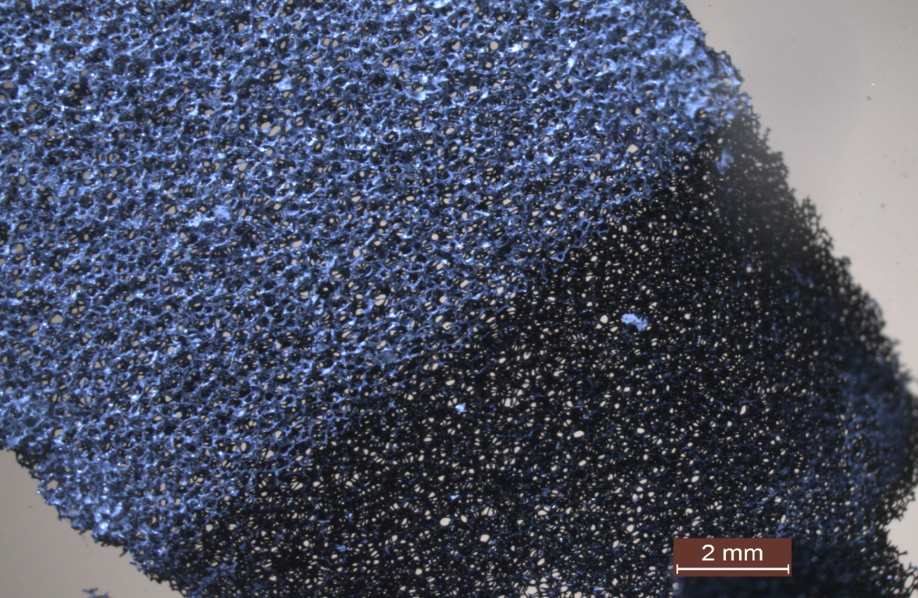

**(a)**

**Figure 2a**

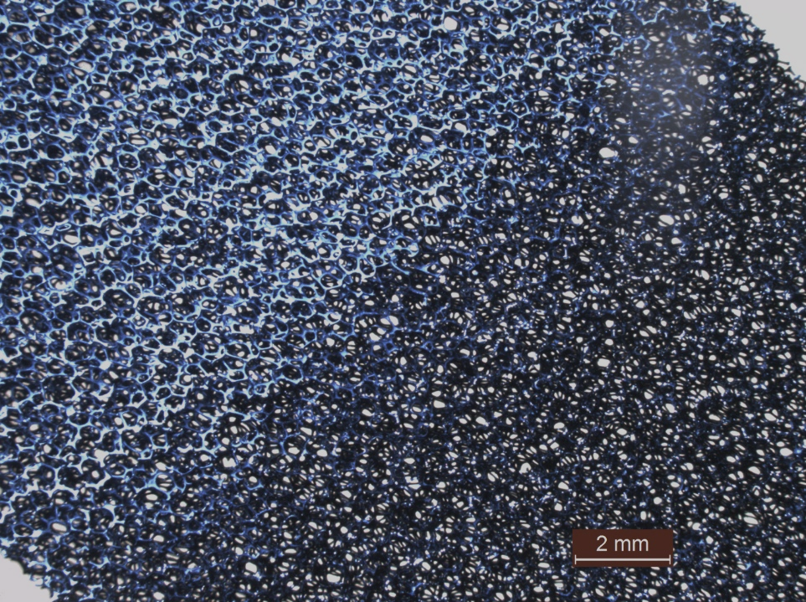

**(b)**

**(a)Figure 2b**

**1.5 cm**

**(a)**

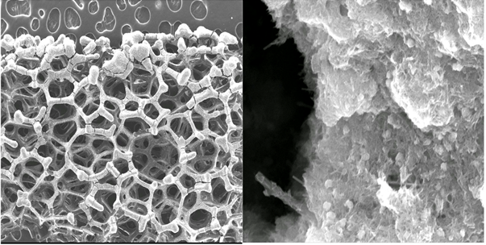

**(b)**

**(a)**

**100 m**

**1 m**

TiNT

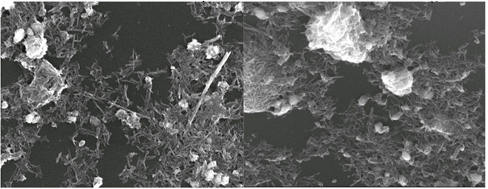

**1 m**

**1 m**

**(d)**

**(c)**

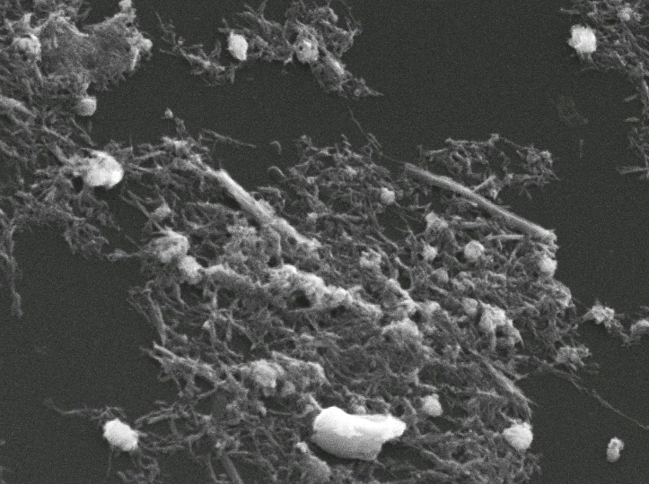

**1 m**

**(e)**

**(e)**

**Figure 3**

**Cracks**

**(c)**

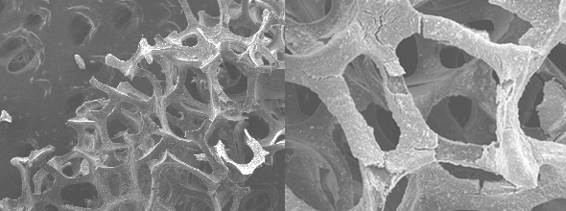

**Delaminated RVC**

**(a)**

**100 m**

**100 m**

**(b)**

**Cracks**

**TiNT after calcination**

**Figure 4**

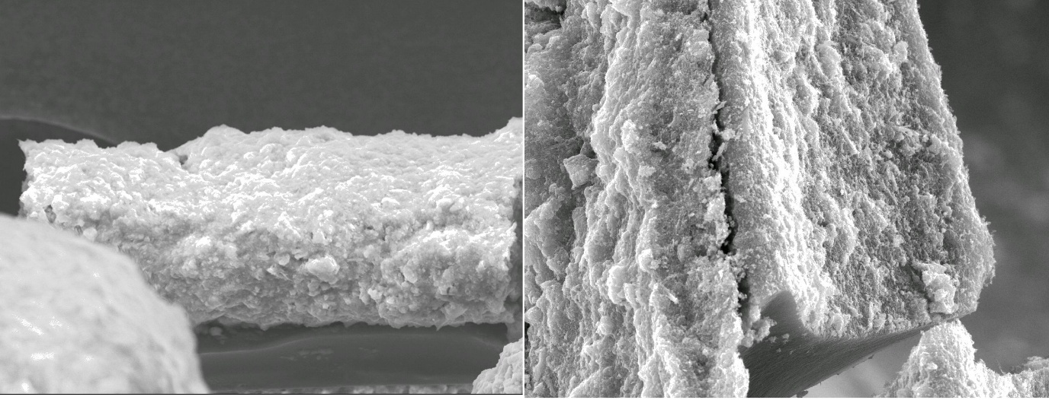

**10 m**

**7 m**

**30 m**

**10 m**

**(b)**

**(a)**

**Figure 5**



**Figure 6a**



Raman shift / cm-1

148

**A**

**A**

**A**

**A**

**A**

**Figure 6b**



**Figure 7a**



(c)

**Figure 7b**



**Figure 8**

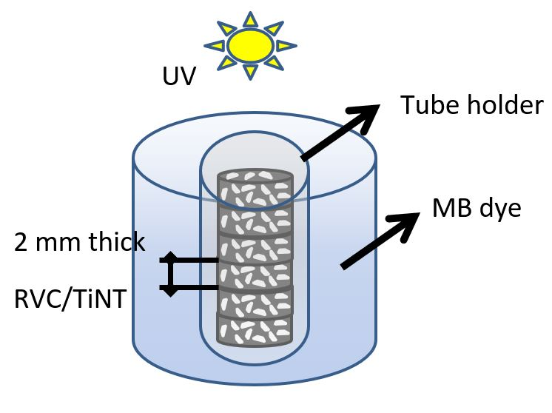

**Figure 9a**



**Figure 9b**