Healthcare-seeking behaviour in reporting of scabies and skin infections in Ghana – a review of reported cases

Authors – Dr Laud A Boateng, on behalf on the Ghana Southampton Scabies Research Partnership
(All authors to be considered equally)

Corresponding author – Dr Laud Boateng, Ghana Health Service, laud.boatengampomah@ghsmail.org +; 233 57 647 7456

Abstract

Background
Scabies is a Neglected Tropical Disease. In resource-poor settings, scabies and other skin infections are often unreported to a health centre, or misdiagnosed. Dermatological expertise and training is often lacking. Little is known about patient healthcare-seeking behaviour. This study reviewed diagnosed skin infections reported to urban (Greater Accra) and rural (Oti region) study health centres in Ghana over 6-months in 2019.
Methods
Study staff received classroom and clinical dermatology training. Skin infection diagnoses and anonymised patient information were recorded. Descriptive statistics and spatial analysis described patient demographics, and distance travelled to clinic, noting bypassing of their nearest centre.
Results
Overall, 385 cases of skin infections were reported across Greater Accra and Oti study clinics, with 45 scabies cases (11.6%). For scabies, 29 (64.4%) cases were in males. Scabies was the third most common diagnosis, behind bacterial dermatitis (102, 26.5%) and tinea (75, 19.5%).
In rural Oti region, 48.4% of patients bypassed their nearest clinic, travelling a mean 6.2km further than they theoretically needed to. Females travelled further in comparison to males.
Conclusions
There must be greater public and professional awareness of scabies and skin infections as high-burden but treatable conditions, along with assessment of their community burden.

Keywords – Dermatology, Ghana, Neglected Tropical Diseases, NTDs, Scabies, Skin infections
Introduction
Scabies, defined by the World Health Organisation (WHO) as a neglected tropical disease (NTD), is an intensely itchy skin condition due to the transmission (predominantly skin-to-skin) of the Sarcoptes scabiei mite, causing significant morbidity and loss of quality of life.¹ Female mites burrow into the skin and lay eggs, which creates an allergic reaction, often presenting as severe itch in those infected.
In resource-poor settings, scabies is both stigmatising and hard to diagnose, and thus there is significant underreporting and misdiagnosis of cases.^{1,2} There are an estimated 455 million cases globally each year, with 0.2% of global disability-adjusted life years associated with scabies (higher than most other NTDs such as African trypanosomiasis, dengue or schistosomiasis).³
Children are typically more likely to be infected than adults, and risk factors include overcrowding, population density, malnutrition, sharing of fomites (objects likely to transmit infection such as clothes, towels and sleeping mats), climate and rainfall.¹ Treatment is often a skin ointment, such as benzyl benzoate (most commonly used medicine in Ghana due to it being relatively cheap to purchase) or permethrin (main treatment in the UK). Oral ivermectin is also effective, but typically too expensive for routine use in the lower-middle income country (LMIC) setting despite ivermectin donations from pharmaceutical companies for use in Mass Drug Administrations against other NTDs such as lymphatic filariasis or onchocerciasis. The top-level numbers associated with scabies are likely the ‘tip of the iceberg’ when it comes to its overall impact and prevalence of secondary complications- for example, there are noted links with impetigo and emerging evidence of complications that may include cardiovascular and renal complications, rheumatic heart disease, and sepsis.²
Scabies is hard to distinguish from other skin conditions, especially if it does not present in its classical form and if the main symptom presented is an itch. In 2018, the International Alliance for Control of Scabies (IACS) developed a ‘Delphi consensus criteria’ for reliable and consistent approaches to diagnosis of scabies in a resource-poor setting (using clinical judgement and not reliant on microscopy or any other diagnostic tool).⁴ Outbreaks can be challenging to recognise and control, and infestations hard to clear.⁵
This study prospectively identified cases of skin infections reported to selected urban and rural healthcare centres in Ghana, with the aim of ascertaining patient demographics and healthcare-seeking behaviour, specifically travel distance to clinic.
Materials and Methods
The data collection took place between 1 June and 30 November 2019 (6 months). Study clinics were based in Kpone-Katamanso, a peri-urban district in the Greater Accra region in Ghana, and in Nkwanta South, a predominantly rural district in the Oti region (formerly Volta region, figure 1).
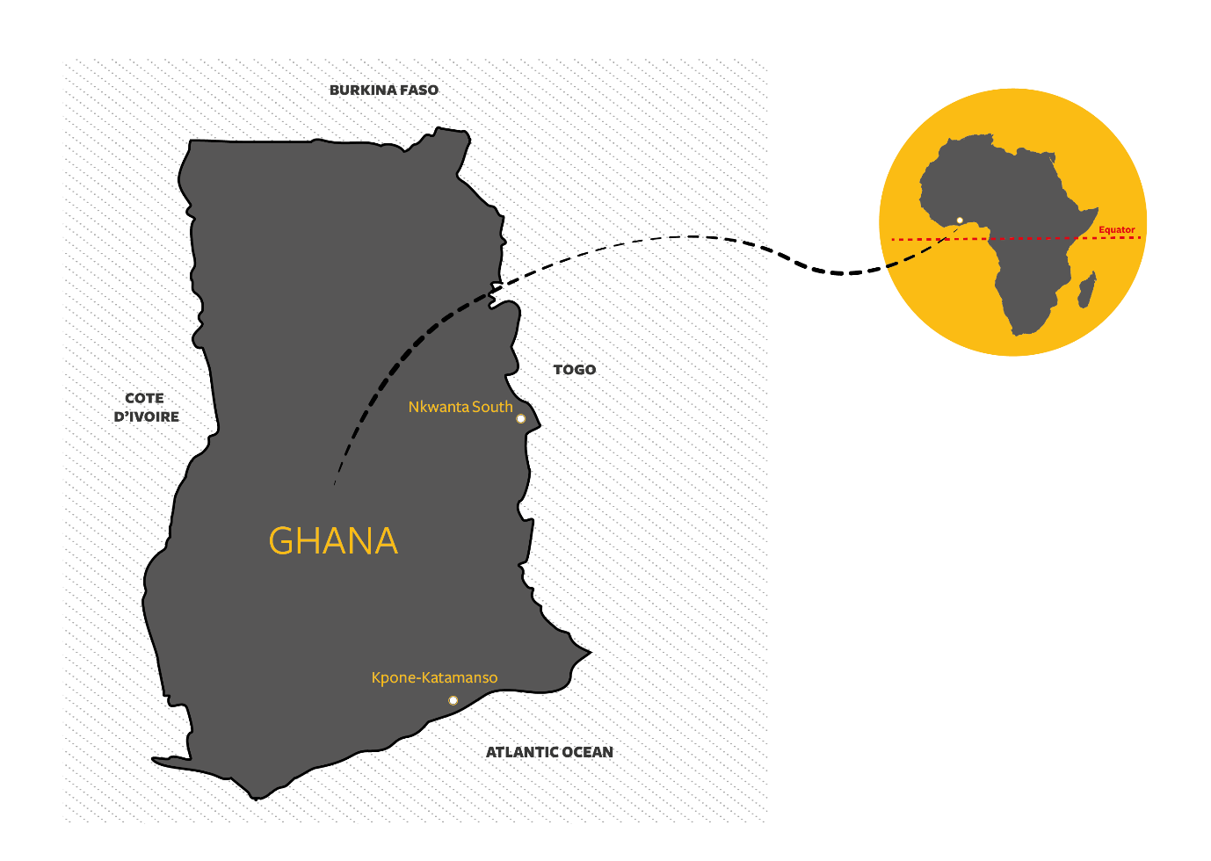
Figure 1. Study site locations. Nkwanta South in the Oti region of Ghana, and Kpone-Katamanso in Greater Accra
Study staff received a one-day classroom training session covering skin infections, conducted by three Dermatology Practitioners – two Dermatologists and a Physician Assistant specialising in dermatology. The trainees also participated in a one-day clinical training in the Accra-based Rabito Clinics (private sector health facilities specialising in dermatology). There, they reviewed cases presenting that day, alongside the attending dermatologist, and this included a range of infectious skin conditions including scabies. The training included presentations on, and exercises about, the IACS Consensus Criteria’ and the WHO manual ‘Recognizing neglected tropical diseases through changes on the skin - A training guide for front-line health workers’. See https://www.the-ciru.com/global-health-scabies for training materials and resources made available. Similar approaches were used in resource constrained areas to train health workers to diagnose and manage skin diseases in Mali, West Africa.⁶
Further cascading of this training programme was carried out by study colleagues to healthcare workers in Nkwanta South. Those trained were nurses, community health officers and physicians assistants, all individuals who would assess patients and prescribe treatment. It was these healthcare workers who reviewed the patients and used clinical judgement to make the diagnosis. The study focused on patients who self-reported to the study clinic, with a suspected skin infection, as part of routine health service activity.
There were 12 clinics and 1 hospital involved in the study. The clinics provide primary health care services such as treatment of minor ailments and refer complicated cases to a capable well-equipped hospital. The study health facilities, therefore, saw walk-in patients with different types of illnesses, including patients with all types of skin problems, but here only recorded those with suspected skin infections. There were no specialised skin clinics as part of the study. When a patient was diagnosed with a skin infection, this was recorded onto a separate form created specifically for this study (appendix). There was no microscopy available, so where scabies was diagnosed, this would be ‘clinical scabies’ or ‘suspected scabies’ (rather than ‘confirmed scabies’), as per the Delphi Consensus Criteria. However, in the patients healthcare records and on the study form, the diagnosis did not distinguish between suspected and clinical scabies. Data collected included the diagnosis, patient’s age, patient’s locality/neighbourhood, the name of the health facility where they reported, and medical prescription. Names and residential addresses of patients were not provided on the study form to ensure anonymity. Children were defined as individuals under 18 years old. There were several references to dermatitis on the study form with feedback from the study team, this refers to a diagnosis of a bacterial dermatitis (of unknown microbiology) where antibiotics were prescribed.
Paper forms were locally scanned (in Nkwanta) or transferred onto local Excel spreadsheets (Kpone-Katamanso). Once a month, data was securely transferred between the Ghana Health Service and the University of Southampton. Data was transferred from the scans of the study form or the Excel spreadsheet into software Stata SE version 16.0 and R v3.6 in RStudio v1.2 for analysis using descriptive statistics.
Percentages were used to describe the characteristics of the patients. Also, association between categorical variables was assessed using chi-square test. The median and interquartile ranges were reported due to the distribution patient ages. The mean and standard deviation of distance travelled to health facilities were reported for patient journeys. We analysed the count of cases by day and sex to investigate if there were any significant differences between males and females relative to the days they reported at a health facility. The analysis by day assessed the hypothesis that females might report more frequently at health facilities on market days (Monday and Tuesday) compared with the other days.
Two straight line distances were calculated: one was from the community of origin to the nearest health facility (theoretical distance), and the second was from the community of origin to the facility where treatment was sought. Where a patient did not seek care at the nearest health facility, they were classified as “bypassed“. Spatial analysis was performed for only Nkwanta South as there were no patterns of bypassing or longer travels in urban Kpone Katamanso.

Results
Overall, 385 cases of skin infections were reported across both Greater Accra and Oti region health facilities, with 45 (11.7%) scabies cases diagnosed (Table 1). For all skin infections, there were 197 cases (51.2%) in females, and 188 cases (48.8%) in males. For scabies infections, 29 (64.4%) of cases were in males, and 12 cases (46.7%) were in children below eleven years. By diagnosis, scabies was the third most common diagnosis, behind bacterial dermatitis (102 cases, 26.5%, including 11 diagnoses written as septic dermatitis) and tinea (81 cases, 21.04%; includes diagnoses of ringworm). Other specific infections recorded included Varicella (chicken pox), and impetigo (appendix). There were no recorded cases of encrusted scabies.
Table 1. Overall summary of data collected on skin infections, and scabies, including breakdown by gender. IQR, Interquartile range
 | Nkwanta (%) | Kpone Katamanso (%) | Total (n=385)
All skin infections | 225 | 160 | 385
Scabies | 37 (16.4) | 8 (0.05) | 45 (11.7)
Median age (IQR) | 7 (3-25) | 11 (2-24) | 8 (2-24)
All skin infections
Male | 108 (48.0) | 80 (50.0) | 188 (48.8)
Female | 117 (52.0) | 80 (50.0) | 197 (51.2)
0 – 10 | 111 (49.3) | 90 (56.3) | 201 (52.2)
11 – 20 | 50 (22.2) | 24 (15.0) | 74 (19.2)
21 – 30 | 30 (13.3) | 19 (11.9) | 49 (12.7)
31 – 40 | 9 (4) | 10 (6.3) | 19 (4.9)
41 – 50 | 9 (4) | 9 (5.6) | 18 (4.7)
51 – 60 | 2 (0.9) | 3 (1.9) | 5 (1.3)
>60 | 14 (6.2) | 4 (2.3) | 18 (4.7)
Scabies
Male | 22 (59.5) | 7 (87.5) | 29 (64.4)
Female | 15 (40.5) | 1 (12.5) | 16 (35.6)
0 – 10 | 18 (48.6) | 3 (37.5) | 21 (46.7)
11 – 20 | 12 (32.4) | 1 (12.5) | 13 (28.9)
21 – 30 | 3 (8.1) | 2 (25.0) | 5 (11.1)
31 – 40 | 0 (0.0) | 2 (25.0) | 2 (4.4)
41 – 50 | 1 {2.7) | 0 (0.0) | 1 (2.2)
51 – 60 | 0 (0.0) | 0 (0.0) | 0 (0.0)
>60 | 3 (8.1) | 0 (0.0) | 3 (6.7)

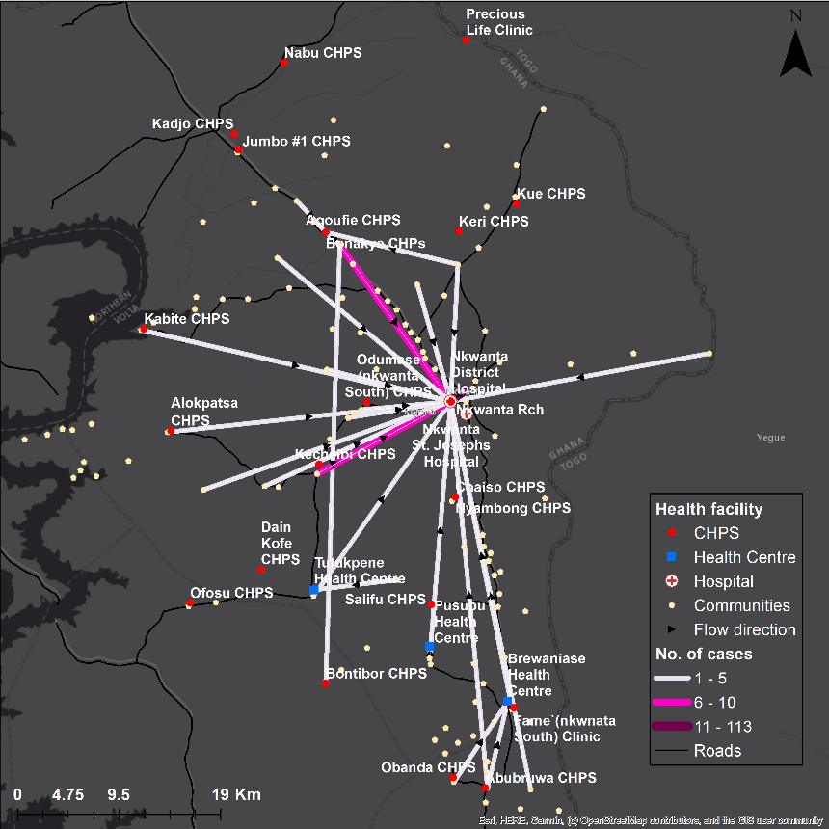
Figure 2: Movement of patients from residential locality to health facility, to seek care for skin infections. CHPS is the lowest tier of primary care facilities in Ghana
Considering healthcare-seeking behaviour in Nkwanta South, patients typically bypassed their nearest health facility (48.4%), travelling further than they theoretically needed to (table 2). For example, many cases in Nkwanta South were reported to Nkwanta District Hospital, as opposed to their local CHPS facility or health centre (figure 2). Whereas theoretical travel to the nearest health facility was 1.9km, the mean travel distance to seek treatment for skin infections was 8.1km. There was no significant difference in bypassing behaviour between males and females (chi square=0.12, p=0.724), though females typically travelled further overall than males.
By day of case being reported, more males at Kpone Katamanso sought care on Wednesday and Thursday, whereas in Nkwanta South, males were slightly more frequently reporting cases across Monday to Wednesday. Specifically, in Nkwanta South, 53 females were diagnosed with a skin infection on Monday or Tuesday (market days) compared with 63 females reported on the other five days, though there was no statistical significance (p=0.25) (figure 3).

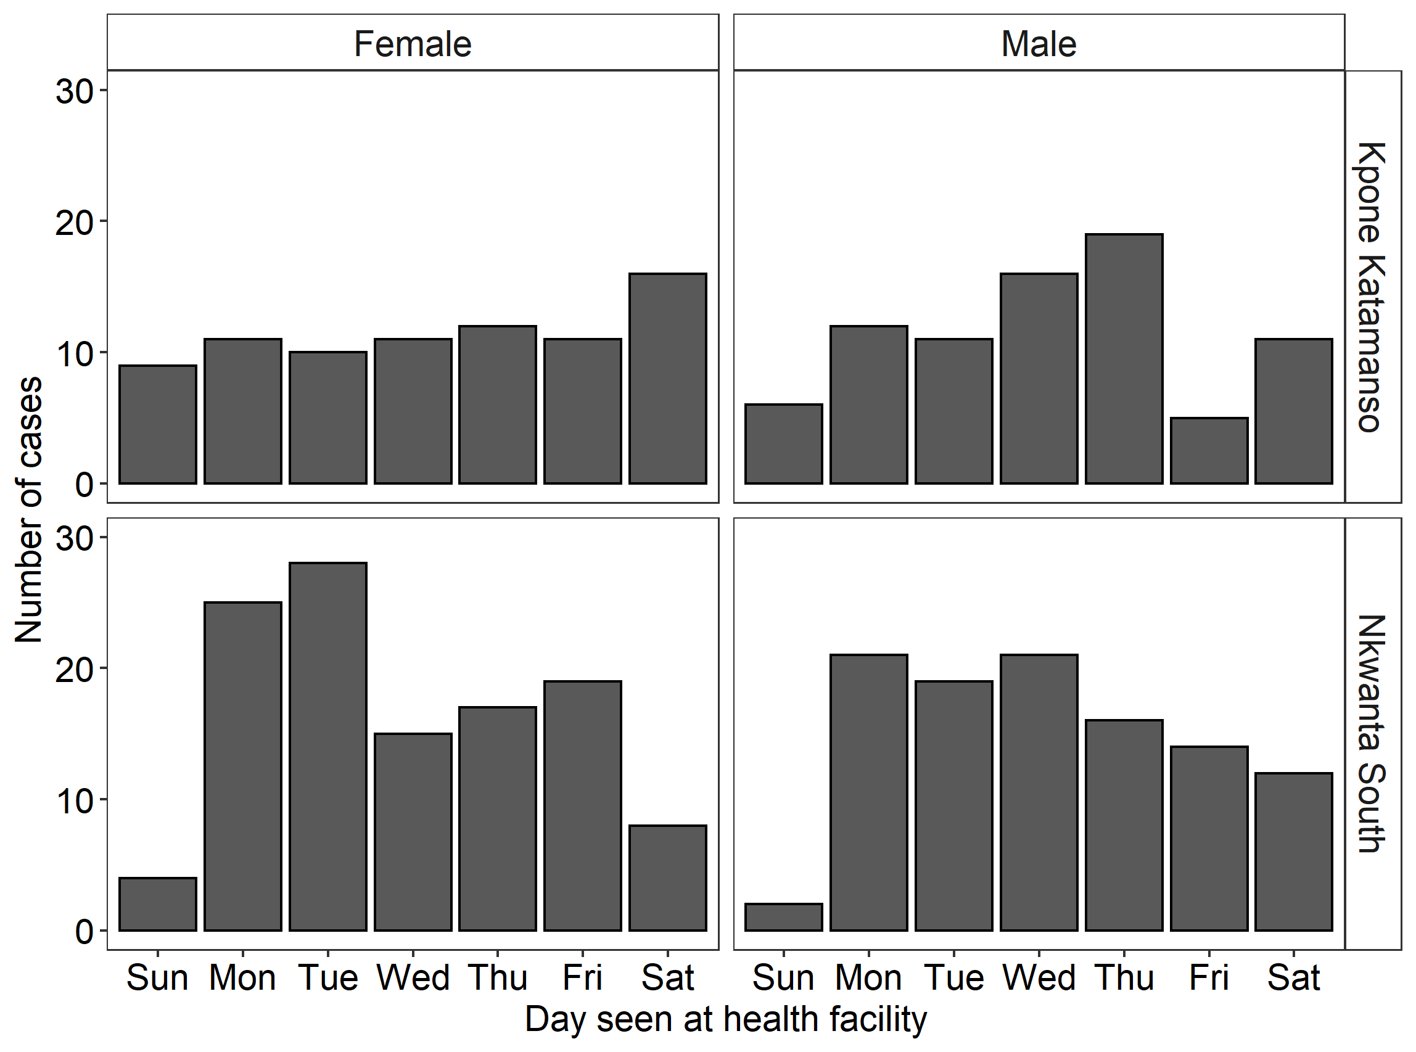
Figure 3: Days on which patients sought treatment compared by sex and location

Table 2: Summary information on distance to seek care and bypassing of nearby health facility, SD: Standard deviation
 | Male (%) | Female (%) | Total
Bypassed the nearest health facility | 51 (46.8) | 58 (53.2) | 109 (48.4)
Did not bypass the nearest health facility | 57 (49.1) | 59 (50.9) | 116 (51.6)
Theoretical travel distance in km | 1.9 (SD: 2.5) | 1.9 (SD: 1.2) | 1.9 (SD: 1.9)
Distance travelled in km | 7.5 (SD: 10.1) | 8.6 (SD: 11.3) | 8.1 (SD: 10.8)

Discussion
There were 385 skin infection cases recorded as part of this study, of which 45 were diagnosed as scabies. The most recorded diagnosis was bacterial dermatitis, for which an antibiotic was prescribed. Around half of recorded skin infection cases showed bypassing of the nearest healthcare facility. By day, the clearest pattern was observed by women in Nkwanta South, most commonly visiting the health facility on Monday or Tuesday, though these differences were not statistically significant.
From the findings here, it appears that patients may travel from their locality to Nkwanta District Hospital on a market day, thus potentially combining a visit to the hospital with other business in the larger settlement of Nkwanta. Anecdotally, discussions among study colleagues and other members of the Nkwanta community suggest this to be a plausible hypothesis relating to healthcare-seeking behaviour. If a larger study confirmed statistically-significant links between presentation at a health centre and attending market day, this could have implications for resource management at the larger health centres and hospital sites. Access to healthcare can be an issue in sub-Saharan Africa, and the patient may be in a position in having to decide whether to travel for potentially many hours to attend clinic. ^{7,8} Patients sometimes do not report their conditions where they are perceived to be stigmatised, along with considering the quality of the facilities available, confidence in accuracy of diagnosis, and access to treatment.⁹ Data produced privately from Kpone-Katamanso colleagues suggest that skin disease covers 0.04% of monthly attendances but is responsible for 1.25% of DALYs in Ghana (appendix). Further qualitative and quantitative research can identify care-seeking patterns and discern the reasons for them, alongside established the true burden of skin disease.
Public understanding of scabies is often limited. A massive outbreak of >6000 scabies cases occurred in the North-East region in Ghana in September 2019.¹⁰ Undiagnosed (and reportedly some misdiagnosed cases) and untreated, media coverage reported how infested members of the community were temporarily banished from their homes, and local elders slaughtered a goat to appease the gods and remove any evil spirits. To quote from the article - “we met face to face with the patients, mostly women and children, who looked tired with bloody open sores all over their bodies due to the excessive scratchings.”¹⁰
There has been anecdotal feedback from Ghana Community Health Officers (CHOs) that self-treatment of scabies and other skin infections includes the use of razor blades to remove the infected skin, followed by topical application of an unknown local (usually herbal) compound. There is known to be stigma associated with other skin NTDs, such as onchocerciasis, though there is evidence that stigma and misinformation can be reduced within community health programmes.¹¹ Findings from Guinea-Bissau showed there was some public awareness of scabies, but also misperceptions including personal hygiene that includes washing or bathing as an effective measure for scabies prevention.^{1,12} This misperception is also sometime raised in the scientific community,¹³ which has the potential for negative impact upon generation of high-quality guidance.
There are several limitations to this study. There may have been uncertainty in the diagnosis of some skin infections, which is hard for non-specialists to diagnose. This uncertainty was mitigated to some extent by the provision of training, accessibility of the training resources, and remote availability of dermatology expertise throughout the study. The study only considered reported cases, and there are thought to be large reservoirs globally of undiagnosed community cases. Additionally, the timeframe for data collection was just six months, and so seasonality could not be considered. Travel time and mechanised network distance are better measures of access compared with straight line distance. However, studies in Ghana have found these three measures of distance to be highly correlated and recommended the use of simpler straight line distance to save cost and time.^{14,15} It is not known if the observed bypassing occurred during the patients first visit to a health facility to report the skin infection (and therefore if previous reporting had taken place at their nearest compound or health centre).
Since the conclusion of this study, and based on the study group recommendations made during a meeting in Accra (December 2019), the Ghana Health Service has updated their mandatory ‘NTD monthly reporting form’ to include scabies. This provides aggregated data from each healthcare facility on numbers of scabies cases, stratified by age group and sex, and will give an insight into the reported burden of disease. The Ghana Health Service is preparing to more widely roll-out Etracker, an electronic patient information system that will work in addition to the District Health Information Management System (DHIMS2). Therefore, the GHS will be well placed to lead on longitudinal studies that incorporate qualitative research methods, to assess the patient journey and thus their healthcare-seeking behaviour, including each visit to a healthcare facility, case management and prescriptions of treatment.
Conclusions
There must be greater public and professional awareness of scabies and skin infections as high-burden but treatable infections, along with assessment of their community burden. As an NTD, scabies should be a notifiable disease in all countries (including high-income settings). The training materials developed as part of this study, plus resources being developed by IACS and others, can support community health workers in recognising and raising the awareness of neglected skin diseases. Scabies training, case search and control in low resource settings may benefit from leveraging resources from other skin NTD programs. Dermatology should become a higher priority for health systems, with increased opportunities for healthcare workers to specialise and receive training, to ensure accurate reporting. There needs to be greater understanding of the socio-economic burden of scabies, including any associated stigma, self-treatment and local prescribing. Health services in LMICs can generate knowledge to better understand their own local needs, and present evidence-informed decision-making around scabies and infectious skin disease.
Authors’ contributions
All authors have read and approved the final version. Authors LAB and MGH are guarantors of the paper.
Acknowledgements
The full study team list is as follows, in alphabetical order of family name/surname -
Frempong Adom, Ghana Health Service; Paul Angwaawie, Ghana Health Service; Laud Boateng, Ghana Health Service; Esther Danquah, Ghana Health Service; Winfred Dotse-Gborgborsti, University of Southampton, UK; Rita-Patricia Frimpong-Amenyo, Ghana Health Service; Michael Head, University of Southampton, UK; Rudolph Lamptey, Ghana Health Service; Abraham Lartey, Ghana Health Service; Margaret Lartey, University of Ghana; Roseline Osazuwa, Rabito Clinic; Bright Osei, Ghana Health Service; Ann Sena Patamia, Ghana Health Service; Emmanuel Kofi Sevor, Ghana Health Service; Adolph Sika, Ghana Health Service; Castro Yakubu, Rabito Clinic
The study team would like to acknowledge all GHS staff in Nkwanta South and Kpone-Katamanso who contributed to or supported the project. This includes Evans Attivor, Emmanuel Abgodogli and Kpemlie Christine from Nkwanta South. We would like to acknowledge the input of Dominic Atweam and the GHS NTD Office for their support around reporting of scabies.
We would also like to thank Ms Karen Hendrickson Chief Executive Officer of Rabito Clinics, dermatologist Dr Claudia Donkor and the Rabito Clinics for their support with the study, and hosting the clinic training day.
Funding
This work was supported by University of Southampton Strategic Development Fund (no reference number).
Competing interests
None to declare
Ethics
The study received ethical approval from the Ghana Health Service Ethics Review Committee (reference GHS-ERC002/03/19) and the University of Southampton ethics committee (reference 46472).

References
1 Engelman D, Cantey PT, Marks M, et al. The public health control of scabies: priorities for research and action. Lancet. 2019; 394: 81–92.
2 Thean LJ, Engelman D, Kaldor J, Steer AC. Scabies - New Opportunities for Management and Population Control. Pediatr Infect Dis J 2019; 38: 211–3.
3 Karimkhani C, Colombara D V, Drucker AM, et al. The global burden of scabies: a cross-sectional analysis from the Global Burden of Disease Study 2015. Lancet Infect Dis 2017; 17: 1247–54.
4 Engelman D, Fuller LC, Steer AC, panel for the IA for the C of SD. Consensus criteria for the diagnosis of scabies: A Delphi study of international experts. PLoS Negl Trop Dis 2018; 12: e0006549.
5 Cassell JA, Middleton J, Nalabanda A, et al. Scabies outbreaks in ten care homes for elderly people: a prospective study of clinical features, epidemiology, and treatment outcomes. Lancet Infect Dis 2018; 18: 894–902.
6 Faye O, Bagayoko C, Dicko A, et al. A Teledermatology Pilot Programme for the Management of Skin Diseases in Primary Health Care Centres: Experiences from a Resource-Limited Country (Mali, West Africa). Trop Med Infect Dis 2018; 3: 88.
7 Ouma PO, Maina J, Thuranira PN, et al. Access to emergency hospital care provided by the public sector in sub-Saharan Africa in 2015: a geocoded inventory and spatial analysis. Lancet Glob Heal 2018; 6: e342–50.
8 Hulland EN, Wiens KE, Shirude S, et al. Travel time to health facilities in areas of outbreak potential: Maps for guiding local preparedness and response. BMC Med 2019; 17: 232.
9 Kingau NW, Rhoda A, Mlenzana N. Barriers experienced by service providers and caregivers in clubfoot management in Kenya. Trop Doct 2015; 45: 84–90.
10 Myjoyonline.com. ‘We can’t sleep at night’ - How scabies outbreak in N/E region is spreading deep into villages. 2019. https://www.myjoyonline.com/news/2019/September-21st/we-cant-sleep-at-night-how-scabies-outbreak-in-ne-region-is-spreading-deep-into-villages.php (accessed Nov 14, 2019).
11 Tchounkeu YFL, Onyeneho NG, Wanji S, et al. Changes in stigma and discrimination of onchocerciasis in Africa. Trans R Soc Trop Med Hyg 2012; 106: 340–7.
12 Lopes MJ, Teixeira da Silva E, Ca J, et al. Perceptions, attitudes and practices towards scabies in communities on the Bijagós Islands, Guinea-Bissau. bioRxiv 2019; : 574327.
13 Middleton J, Cassell JA, Jones CI, Lanza S, Head MG, Walker SL. Scabies control: the forgotten role of personal hygiene - Authors’ reply. Lancet Infect Dis 2018; 18: 1068–9.
14 Nesbitt RC, Gabrysch S, Laub A, et al. Methods to measure potential spatial access to delivery care in low- and middle-income countries: A case study in rural Ghana. Int J Health Geogr 2014; 13: 25.
15 Dotse-Gborgbortsi W, Dwomoh D, Alegana V, Hill A, Tatem AJ, Wright J. The influence of distance and quality on utilisation of birthing services at health facilities in Eastern Region, Ghana. BMJ Glob Heal 2020; 4: e002020.

