Chloroantimonate Electrochemistry in Dichloromethane

Simon J. Reeves^{a*}, Yasir J. Noori^{b}, Wenjian Zhangª, Gillian Reidª and Philip N. Bartlett^{a*}
ªSchool of Chemistry, University of Southampton, Southampton SO17 1BJ, UK.
^{b}Electronics and Computer Science, University of Southampton, Southampton SO17 1BJ, UK.
*s.reeves@soton.ac.uk; p.n.bartlett@soton.ac.uk

Abstract
Antimony is a technologically relevant element, which is present in many semiconductor materials. Electrodeposition of such materials offers a potential route for cheaper and less wasteful manufacturing, and is especially suited for micro- and nano- feature sizes with complex geometries. Previous work has shown the applicability of electrodeposition of p-block metals and metalloids from the weakly coordinating solvent dichloromethane, using halometallate precursors. Here we more thoroughly investigate the behaviour of the tetrabutylammonium chloroantimonate precursor, [TBA][SbCl₄]. We use voltammetry at a stationary macroelectrode, rotating disc electrode and electrochemical quartz crystal microbalance, as well as microelectrodes and highlight the advantages of microelectrodes in this context. Using [TBA]Cl as a background electrolyte it is found that the diffusion coefficients calculated from the rotating disc electrode and microelectrodes are similar. Due to the possibility of mixed speciation with an excess of Cl⁻, tetrabutylammonium tetrafluoroborate, [TBA][TFB], is also used as a background electrolyte and it is found that the diffusion coefficient does not change. Using a modified form of the Stokes-Einstein equation, that takes into account the shape of the solute and the relative sizes of the solute and solvent, the diffusion coefficients of the antimony precursor and decamethylferrocene are consistent with their relative sizes. Electrodeposition onto large surface area platinum and titanium nitride substrates using either background electrolyte results in amorphous deposits of elemental antimony with similar morphology.

Keywords: weakly coordinating solvent, antimony, halometallate, microelectrode, electrodeposition

Introduction
Antimony is an important element for the production of semiconductor materials such as GeSbTe alloys for phase change memory and InSb for infrared sensors. As well as being a key element for alloy materials, elemental antimony can be used as phase change memory [1]. Producing materials at the nano scale e.g. nanowires, has a benefit allowing properties to be tuned by changing the critical dimension [2]. Electrodeposition has potential benefits over “top-down” methods (e.g. physical or chemical vapour deposition) for producing high aspect ratio nanostructured materials, as well as the potential to produce such materials at a lower cost.
Non-aqueous systems are desirable as they tend to have wider potential windows than aqueous systems which allows for deposition of elements with very negative potentials i.e. for deposition of germanium for GeSbTe [3]. Electrochemistry of antimony in non-aqueous solvents has been investigated in a variety of room temperature ionic liquids [4–10], inorganic molten salts [11] and ethylene glycol [12]. In all cases the antimony reactions show straightforward plating and stripping behaviour for the Sb(III) to Sb(0) reaction. In some cases it is also possible to oxidise Sb(III) to soluble Sb(V) [5,6,9,10], with the potential difference between the two reactions changing depending on the solvent system being used.
Previous work in this group has demonstrated the suitability of halometallate salts for deposition of p-block elements in dichloromethane (DCM) which is a weakly coordinating solvent [13]. Halometallate salts turn out to have several advantages over the corresponding binary metal halides. For example, typically they are powdered solids that can be easily purified, are more easily handled and are more resistant to hydrolysis. Also, by varying the counter-cation, good solubilities in weakly coordinating solvents can be achieved. Weakly coordinating solvents are an attractive option for the electrodeposition of alloys and compounds of the p-block elements because they allow the different p-block halometallates to be mixed in solution without the added complexity of ligand exchange with the solvent. The electrochemistry of antimony in weakly coordinating solvents has not been described in the literature. For the purposes of binary and ternary compounds, a more fundamental understanding of the electrochemistry of each halometallate salt is desirable to aid tuning the deposition conditions.

Experimental
Preparation of tetrabutylammonium chloroantimonate, [TBA][SbCl₄], was prepared as described previously [13]. Tetrabutylammonium chloride, [TBA]Cl, (Sigma-Aldrich, ≥99.0%) and tetrabutylammonium tetrafluoroborate, [TBA][TFB], (Sigma-Aldrich, ≥99.0%) were further dried before use by heating to 100 ºC under vacuum for a few hours. Dichloromethane (Fisherbrand) was purified by degassing and dried by reflux over CaH₂ followed by distillation. The water content of the dried DCM was ca. 20 ppm according to Karl-Fischer titration.
Platinum disc macroelectrodes, diameter 0.5 mm, and microelectrodes, 50, 25 and 10 μm diameter, sealed in glass were prepared in house. For rotating disc electrode experiments a Metrohm Autolab platinum rotating disc electrode, diameter 3 mm sealed in PEEK, was used with the associated motor controller unit. All electrodes were polished with alumina slurries of 1 μm and then 0.3 μm.
Electrochemical quartz microbalance (EQCM) measurements were performed with a Stanford Research Systems QCM2000 in a custom made glass cell. The crystals were 5 MHz, 1" diameter, AT-cut quartz crystal wafer with a Pt disc of diameter 1.3 cm. Crystals were used as supplied without any additional polishing.
The Pt and TiN disc macroelectrodes, diameter 4 mm, for electrodeposition were produced by plasma sputtering a layer of Pt or TiN (200 nm) over Si/SiO₂ wafers followed by the sputtering of a SiO₂ layer (200 nm), Figure 1. The top SiO₂ layer was patterned by photolithography techniques and etched using plasma dry etching in the case of Pt; while in the case of TiN, the SiO₂ layer was half etched by plasma dry etching and removed completely using a buffered oxide etchant (BOE). The SiO₂ was etched with BOE for TiN substrates because the resistivity of TiN was found to significantly increase following plasma dry etching, increasing the potential drop through the electrode. A Cr/Au 10/190 nm layer was deposited via thermal evaporation onto the contact area, as this significantly reduced, and decreased the variability in, contact resistance. No mechanical polishing was performed on microfabricated electrodes.
[Figure 1 here in colour]
For electrochemical measurements an Autolab μIII potentiostat with NOVA 1.11 software running on Windows XP was used. Data analysis was performed with Origin 2018b.
All electrochemical experiments were performed in an oxygen and moisture controlled (<5 ppm) glovebox (Belle Technology UK Ltd).
Scanning electron microscopy (SEM) was performed with a Philips XL30 ESEM using an acceleration voltage of 10 keV and a working distance of 10 mm. Energy dispersive X-ray spectroscopy (EDX) was performed with a Thermo Scientific NORAN System X-ray Microanalysis System in order to confirm the presence of electrodeposited antimony. X-ray diffraction (XRD) was performed with a Rigaku SmartLab diffractometer (Cu-K_{α}) with a 1º grazing incidence angle and a Hypix 3000 detector in 1D mode.

Results and Discussion

Macroelectrode Measurements
The background voltammetry of the Pt electrode in DCM and 0.1 M [TBA]Cl shows a potential window of approximately +1.2 to -1.8 V vs Ag/AgCl with a significant oxidation current beyond +1.2 V due to chloride oxidation, Figure 2. Upon addition of [TBA][SbCl₄] there is a clear plating peak at -0.3 V corresponding to a single step 3 electron reduction, and a corresponding stripping peak at +0.3 V. This stripping peak only occurs when antimony had been deposited on the platinum surface. The crossover potential (where the current passes through zero on the anodic scan between plating and stripping) is around -0.1 V vs Ag/AgCl. The ratio of the stripping and plating charges for antimony (Q_{ox}/Q_{red}) is around 0.5. This is consistent with the electrochemical quartz crystal microbalance (EQCM) data in the following section.
There is reduction seen on the forward scan negative of -0.9 V. The shape is similar to that of an adsorption based process, however EQCM measurements (SI Figure 1) indicate no extra mass gain in this potential region. For further experiments in this work the potential window is chosen to only analyse the electrochemistry of the main plating and stripping reactions, i.e. generally between +1 V and -1 V vs Ag/AgCl.
Unlike the study of antimony chloride based species in ionic liquids [5,6,9,10] there is no evidence for oxidation of Sb(III) to Sb(V) within the potential window in DCM.
[Figure 2 here in colour]
To investigate whether the reduction of antimony is controlled by solution kinetics or mass transport, voltammograms were recorded at different scan rates. There is a nucleation loop, as well as a pre-peak around -0.03 V which has a current density of <-0.5 mA cm⁻² for all scan rates except 500 mV s⁻¹, at which scan rate the pre-peak is most visible, Figure 3A. This pre-peak is not always observed when performing voltammetry of the antimony precursor on platinum electrodes, however it corresponds to the same charge at each scan rate. We will return to analysis of this pre-peak later on.
The main peak for the reduction of antimony is found to increase with the square root of scan rate as expected for a reaction controlled by planar diffusion [14], Figure 3B. For a fully reversible soluble-insoluble reaction [15]
$i_{p}=0.61{(nF)}^{3/2}AC\sqrt{\frac{νD}{RT}}$ (1)
where n is the number of electrons transferred, F is Faraday’s constant, A is the electrode area, C is the concentration, ν is the scan rate, D is the diffusion coefficient, R is the gas constant and T is the temperature.
There is a curvature to the i_{p} vs ν^{1/2} data, likely due to iR drop and some degree of irreversibility. The linear fit was forced through the origin by fitting only to the two slowest scan rates, which clearly lowers confidence in the accuracy of D determined from this method. Using Eq. 1 D of [SbCl₄]⁻ was calculated to be 2.5 x10⁻⁶ cm² s⁻¹, which is likely to be an underestimate with a high error.
[Figure 3 here in colour]
The voltammograms in Figure 3A were all performed sequentially in the glovebox on the same electrode, i.e. these are not the first scans on freshly polished electrodes. The ratio of stripping to plating charge (Q_{ox}/Q_{red}) was ~0.5 at all scan rates, and so there was likely a build-up of antimony over time, causing a change in surface area and nucleation kinetics on repeat scans. In addition there is iR drop and uncertainty in reversibility which causes the response to deviate from theory, therefore the value of D calculated with this data has a high associated error.

Electrochemical Quartz Crystal Microbalance Measurements
Electrochemical quartz crystal microbalance (EQCM) measurements were used to investigate the electrodeposition and stripping reactions. The mass changes were calculated from the frequency response of the quartz crystal using the Sauerbrey equation [16]. On the cathodic (forward) scan the mass increases during the reduction process starting at around -0.7 V vs. Pt (ca. -0.2 V vs. Ag/AgCl) and then decreases during the stripping reaction on the anodic (backward) scan starting from around -0.4 V vs. Pt, Figure 4.
There is reasonable agreement between the mass calculated from the change in frequency and the mass calculated from the charge passed which assumes a 3 electron reduction with 100% Faradaic efficiency to deposit antimony. The small deviation is likely due to roughness of the deposit [16].
[Figure 4 here in colour]
The decrease in mass is only around one half of the increase in mass during deposition. The observation of ~50 % loss of the deposited mass on the return cycle is consistent with the observed ratio of Q_{ox}/Q_{red} found for the cyclic voltammetry at the Pt disc electrode above. No change in the rate of mass deposition is observed on extending the scan beyond -1.0 V vs. Pt (SI Figure 1), thus the additional electrochemical process cathodic of -0.9 V vs. Ag/AgCl seen in Figure 2 is not associated with a change in mass.

Rotating Disc Electrode Measurements
A Pt rotating disc electrode was used to investigate the mass transport dependence of the reduction. Steady state currents are observed for all rotation rates, Figure 5A. However the potentials at which these steady state currents are reached increases from -0.51 vs. Ag/AgCl at 200 rpm to -0.80 V vs Ag/AgCl at 1000 rpm. This is most likely due to iR drop. The ratio of the charge passed in stripping to the charge passed to deposit antimony, Q_{ox}/Q_{red} is found to decrease from around 0.9 at low rotation rate (up to 400 rpm) to around 0.65 at 1000 rpm. The steady state reduction current at -1.0 V is found to be linearly dependent of the square root of the rotation rate, confirming that the process is mass transport limited, Figure 5B.
[Figure 5 here in colour]
The mass transport limited current at the RDE is given by the Levich equation [17]
$i_{SS}=0.201nFAcD^{2/3}υ^{{-1}/6}W^{1/2}$ (2)
where υ is the kinematic viscosity in cm² s⁻¹ (here assumed to be equal to that of pure DCM), W is the rotation rate in rpm and other symbols have the same meanings, was used to calculate the diffusion coefficient, D. Assuming a 3 electron reduction process we obtain a value for D for [SbCl₄]⁻ of (7.0 ± 0.7) x 10⁻⁶ cm² s⁻¹ which is an order of magnitude higher than the corresponding values in ionic liquids [4,7–9] and ethylene glycol [12] both of which have a higher viscosity than DCM, and roughly half the value found in LiCl-KCl eutectic at 400 ºC [11] which has a similar viscosity. This value is 2-3 times larger than the value obtained from stationary macroelectrode voltammetry which had a response that deviated significantly from theory, whereas this RDE data is described well by theory.
The pre-peak was independent from rotation rate, and was linearly dependant with scan rate on the stationary macroelectrode. From the charge passed on this electrode, and all others where it is observed, this pre-peak corresponds to the order of a few monolayers of antimony (assuming a perfectly flat electrode, which will not be the case), which suggests this is an underpotential deposition process.

Microelectrode Measurements
Although the rotating disc electrode is frequently used to study the electrochemistry of solution species it is reasonably complex to set up and use inside a glovebox. It required a moderate volume of solution and amount of reagent (typically a minimum of five times the volume and mass as required in our cells used for stationary electrodes), an additional feedthrough for the motor controller electrical connection and the installation of the motor controller itself inside the glovebox. In addition, although it is useful as a steady state technique, there can be significant iR drop when the electrolyte has a relatively low permittivity as is the case for DCM [18].
Microelectrodes have the benefit of achieving steady state voltammetry due to hemispherical diffusion, as well as having much lower iR drop (due to much lower current) and higher signal to noise compared to macroelectrodes. Microelectrodes can be readily fabricated by sealing commercial micron diameter wires in glass [17], or by other microfabrication methods. The microelectrodes used in the present work were produced by sealing platinum micro wires in glass and polishing with 1 μm and 0.3 μm alumina slurries, in the same manner as the larger 0.25 mm radius electrodes. Microelectrodes are simple to use within the glovebox, and do not require additional equipment beyond a suitable potentiostat for the measurement. Despite these advantages they have not been widely used to study electrodeposition baths.
At a microelectrode the voltammetry shows a steady state current at negative potentials beyond -0.2 V vs. Ag/AgCl which is broadly independent of scan rate (see below) and a stripping peak at positive potentials around +0.2 V that varies with scan rate, Figure 6. The voltammetry at the microdisc electrode is more clearly defined with a sharper peak due to the reduced effects of iR drop, compare Figures 3 and 6.
[Figure 6 here in colour]
On the first scan at the clean platinum microdisc, recorded at 200 mV s⁻¹ in this experiment, the onset of the reduction potential is shifted approximately 140 mV negative of the subsequent values. We attribute this decrease in the nucleation overpotential to the effects of residual antimony on the platinum surface (polishing the electrode inside the glovebox without contamination is difficult). While repeat voltammograms were also performed on the same microelectrode, the voltammetric behaviour is far more repeatable over multiple scans than for macroelectrodes.
There is also a peak in the reduction current at around -0.35 V before it settles to the steady state value at more negative potential. This peak occurs because at short times at the microdisc the mass transport limited current is controlled by linear diffusion to the electrode and only reaches a steady state, controlled by hemispherical diffusion, at longer times [14]. The time taken to attain hemispherical diffusion profile scales with scan rate and the square of electrode radius. Thus there is a limitation on the highest scan rate that can be used to record a steady state response. For scan rates 100 mV s⁻¹ and below, no reduction peak is observed.
There is also a limitation on the lowest scan rates that can be used. At 5 and 10 mV s⁻¹, the plateau currents are slightly larger than those recorded at higher scan rate, Figure 7. Two factors can contribute to this. First, possible effects of convection in the solution, although this cannot account for the differences between the currents at 5 and 10 mV s⁻¹. Second, the increase in electrode area caused by the growth of the antimony layer on the platinum disc. The latter is an inevitable consequence of electrodeposition. By measuring the reduction currents on the plateaux at different scan rates, and for electrodes of different radii, we find a clear trend that the currents are larger for scan rates below 25 mV s⁻¹, Figure 7.
[Figure 7 here in colour]
When using microelectrodes care must therefore be taken to select the appropriate range of scan rates to obtain steady state voltammetry; fast enough to avoid the effect of growth in electrode area due to deposition, slow enough to allow the steady state concentration profile to be established. In the present experiments that corresponds to scan rates between 25 and 200 mV s⁻¹ for all radii. Practically speaking, finding the appropriate scan rate range is best done by using a wide range of scan rates and observing where the steady states behave as expected.
The steady state, mass transport limited current at a planar disc microelectrode is given by [14]
$i_{SS}=4nFcDr$ (3)
where r is the radius of the microelectrode and the other symbols have their usual meanings. According to Eqn. (3) the steady state current at the microdisc should increase linearly with electrode radius. In order to determine the value of the diffusion coefficient from the steady state current at the microdisc electrode it is best use a set of electrodes with different radii, since this averages out any errors in electrode radius, and to plot the steady state currents against radius. Taking account of the considerations about choice of scan rate discussed above, scan rates of 200, 100, 50 and 25 mV s⁻¹ were used to make the plot, Figure 8.
[Figure 8 here in colour]
From the slope of the plot of steady state current against electrode radius, assuming n = 3, we obtain a value for D for [SbCl₄]⁻ of (9.2 ± 0.9) x10⁻⁶ cm² s⁻¹. This is similar to, but slightly larger than, that obtained from the RDE data. Note that for the microelectrode we do not need to assume (or measure) a value for the kinematic viscosity.
The diffusion coefficient is expected to vary with radius of the electroactive species and viscosity of the solvent according to the Stokes-Einstein equation.
$D=\frac{k_{B}T}{6πηr_{m}}$ (4)
This was originally developed for colloidal particles, which are spherical and significantly larger than the solvent molecules. When the molecules are non-spherical, and closer to the size of the solvent, the following version should be used [19–21]
$D= \frac{k_{B}T}{cπη{f_{c}r}_{m}}$ (5)
where k_{B} is the Boltzmann constant, T is the temperature, η is the viscosity of the solvent, r_{m} is the radius of the electroactive species, c is a correction factor based upon the relative sizes of the radii of the diffusing species and the solvent (for sufficiently large diffusing species, c tends towards 6) and f_{c} is a correction factor to account for the non-sphericity of the diffusing species (which depends on the major and minor axes a and b).
To test the model we have compared the diffusion coefficient obtained for [SbCl₄]⁻ with that for decamethylferrocene (DMFc) as a model system. DMFc is a reversible, 1 electron couple that is practically solvent independent and does not change size significantly upon oxidation [22]. Using the same rotating disc electrode under the same conditions (SI Figure 2) the diffusion coefficient for DMFc was found to be (1.5 ± 0.2) x 10⁻⁵ cm² s⁻¹, which agrees with the value we obtain from microelectrodes of (1.45 ± 0.15) x10⁻⁵ cm² s⁻¹ (SI Figure 3), and that found by Goldfarb [22]. This value for DMFc is around 1.5 times that found for [SbCl₄]⁻. The effective radius of DMFc is around ca. 400 pm in solution [22] and so with Eqn. (4), the original form of the Stokes-Einstein equation, this would suggest that the radius of the diffusing species in the case of antimony is 1.5 times larger than DMFc giving a radius of around 600 pm.
Computational studies suggest that [SbCl₄]⁻ has a distorted trigonal bipyramidal (C2v symmetry), with axial Sb-Cl bond lengths being longer than the equatorial Sb-Cl bond lengths and the electron lone pair occupying an equatorial position [23]. This C2v symmetry is supported by Raman spectroscopy of various tetra-alkylammonium tetrahalageno-antimony compounds in solid and solution states [24]. Based upon the computationally obtained bond lengths [SbCl₄]⁻ is a prolate spheroid with radii of ca. 340 pm and ca. 320 pm[23]. Therefore, based on a simplistic analysis using the Stokes-Einstein equation (4) we would conclude that the diffusing species is significantly larger than just [SbCl₄]⁻, and that there must be some effect of ion pairing or formation of dimeric species (dimers have been found in the solid state [25,26]). However this simple analysis is misleading because it does not take account of the shapes of the diffusing species or their relative sizes relative to the solvent molecules. To do this we should use Eqn. (5).
Based upon the solid state crystal structure, DMFc is an oblate spheroid with radii ca. 400 pm and ca. 550 pm [27]. The a/b ratios from the spheroid axes are thus 1.37 for DMFc and 1.1 for [SbCl₄]⁻. These correspond to values of f_{c} of 1.01 and 1.00 respectively [20,21]. Thus can both be treated as effectively spherical within error. Using a radius of 249 pm for dichloromethane, the c values for DMFc and [SbCl₄]⁻ are 5.36 and 4.46 respectively [20,28]. Thus the change in c is the more significant deviation from the simple Stokes-Einstein equation, as the molecules are of a similar size to the dichloromethane.
According to Eqn. (5) the ratio of D for each species should equal the ratio of cf_{c}r_{m}. Since both species are close to being spherical, we shall use the larger radius and assume that it is valid for the hydrodynamic radius. For [SbCl₄]⁻ compared to DMFc, the ratio of cf_{c}r_{m} is 0.52. For D of [SbCl₄]⁻ between 0.7 and 0.9 x 10⁻⁵ cm² s⁻¹, the ratio of D is between 0.47 and 0.62.
Thus using the corrected form of the Stokes-Einstein equation (5), which accounts for the size of the diffusing species being similar to the size of the solvent, the difference in diffusion coefficient between DMFc and [SbCl₄]⁻ can be explained purely by the difference in their sizes, given the associated errors. Therefore there is no clear evidence for the formation of ion pairs or dimers/oligomers of [SbCl₄]⁻, as would have been predicted erroneously based on application of the simple Stokes-Einstein equation.

The Effect of Chloride
The changes in the emission and absorption spectroscopy of [NEt₄][SbCl₄] in acetonitrile on addition of [NEt₄]Cl suggest that, in the presence of free Cl⁻, [SbCl₄]⁻ exists in equilibrium with [SbCl₆]³⁻ [29]. To investigate the effects of free Cl⁻ in our system we used tetrabutylammonium tetrafluoroborate, [TBA][TFB], to replace [TBA]Cl as the background electrolyte. With [TBA][TFB] as the background electrolyte the voltammetry of [TBA][SbCl₄] is much more complex with 4 reduction peaks and 3 oxidation peaks, Figure 9. At potentials more positive than +2 V vs Ag/AgCl the voltammetry also shows several oxidation peaks, which is likely to be oxidation of Cl⁻ coming from the antimony precursor salt. The different redox processes show a complex dependence on the scan rate, SI Figure 4, and the new reduction peaks are not always easily resolvable. However the oxidation peaks were investigated by performing CVs to differing cathodic reversing potentials, SI Figure 5. The oxidation peaks only occur when the potential is scanned to the most negative reduction peak i.e. the peak indicating mass transport limited electrodeposition. We postulate that the three oxidation peaks are stripping of antimony to the formation of different chloride complexes limited by the low concentration of free Cl⁻ in solution.
[Figure 9 here in colour]
Again experiments using microelectrodes are informative and give a clearer picture with a steady state wave for antimony deposition and two peaks for antimony stripping, Figure 10. The main antimony stripping peak is shift to +1.3 V, around 1 V positive of the value in the [TBA]Cl solution (compare Figures 6 and 10) due to the absence of Cl⁻ in solution to complex the Sb³⁺. The difference in stripping at the microelectrode, Figure 10, as compared to the larger electrode, Figure 9, seen here reflects the fast mass transport of Cl⁻, liberated during electrodeposition of antimony from the halometallate salt, away from the electrode surface to the bulk.
[Figure 10 here in colour]
The diffusion coefficient for the antimony complex in 0.1 M [TBA][TFB] was measured using three different microelectrode radii, SI Figure 6, and found to be (1.2 ± 0.1) x 10⁻⁵ cm² s⁻¹, similar to, but slightly larger than, that in the [TBA]Cl electrolyte.
For the [TBA][TFB] electrolyte the onset potential for the main plating reaction (on repeat cycles rather than the first cycle) and the crossover potential on the reverse scan shift ca. 170 mV positive compared to the [TBA]Cl solution consistent with the reduced Cl⁻ concentration. This is a reasonable shift based upon a change of 100 mM Cl⁻ in the Nernst equation. The shift is not due to changes in potential of the Ag/AgCl reference, as control experiments using 1 mM DMFc show less than 3 mV difference in the DMFc redox potential in the two electrolytes.

Electrodeposition
A significant motivation for studying the electrochemistry of [TBA][SbCl₄] is the significance of antimony as a component in semiconductors infrared detectors (InSb) and phase change memory (GeSbTe). Antimony was electrodeposited onto microfabricated 2 mm radius platinum and titanium nitride disc electrodes from DCM containing 2 mM [TBA][SbCl₄] and 100 mM [TBA]Cl. Electrodeposition was performed potentiostatically at -0.8 V for platinum and -1.2 V for titanium nitride, in both cases the charge passed was -100 mC. A more cathodic potential was chosen for the titanium nitride electrodes as voltammetry, SI Figure 7A, showed evidence of greater iR drop on these electrodes. The deposits were generally spherical/globular in shape with those on platinum generally of a similar size, whereas the deposits on titanium nitride show a much wider variation in size, Figure 11, probably due to the difference in the overpotential. Current transients were similar on each electrode material, with a higher current density on TiN, SI Figure 7B. EDX shows pure antimony deposits, with no evidence of Cl⁻ incorporation, as well as the underlying electrode material.
[Figure 11 here in black and white]
X-ray diffraction showed that the antimony is primarily amorphous, SI Figure 7. Antimony deposits near room temperature are amorphous from a 1-butyl-1-methylpyrrolidinium dicyanamide ionic liquid but some amount of crystallinity was observed for deposition from a 1-butyl-1-methylpyrrolidinium bis(trifluoromethanesulfonyl)imide ionic liquid which has a more weakly coordinating anion [7]. Deposition of antimony from a [TBA][TFB] electrolyte in this work, where [BF₄]⁻ is a more weakly coordinating anion than Cl⁻, showed no change in crystallinity for deposits on either platinum or titanium nitride.

Conclusions
The rotating disc and microelectrode results show that the electrodeposition of antimony from [TBA][SbCl₄] in DCM containing 0.1 M [TBA]Cl occurs by mass transport limited 3 electron reduction at high overpotential with no evidence for rate limiting chemical step. The diffusion coefficient was found to be (7.0 ± 0.7) x 10⁻⁶ cm² s⁻¹ using steady state measurements at an RDE and (9.2 ± 0.9) x 10⁻⁶ cm² s⁻¹ using a set of microelectrodes. In the absence of added chloride in 0.1 M [TBA][TFB] as background electrolyte the voltammetry of [SbCl₄]⁻ is more complex but still shows mass transport limited 3 electron reduction at high overpotentials. Using microelectrodes the diffusion coefficient was found to be (1.2 ± 0.1) x 10⁻⁵ cm² s⁻¹. Comparison of these diffusion coefficients to that of DMFc shows that the difference in diffusion coefficient can be explained purely by the difference in molecular sizes relative to the solvent, which is taken account of in the modified form of the Stokes-Einstein equation. Thus it is unlikely that [SbCl₄]⁻ is either strongly ion paired or forms a dimeric species in solution. The electrodeposition of antimony onto platinum and titanium nitride electrodes under mass transport control was shown to give amorphous antimony deposits of high purity.
From our results it is clear that [TBA][SbCl₄] is a useful reagent for antimony deposition from the weakly coordinating solvent, dichloromethane. In contrast to other p-block halometallates, such as those of germanium, tellurium, indium, etc. [3,13], the electrochemistry of [TBA][SbCl₄] with [TAB]Cl in DCM is much better behaved and free from obvious complications.
In addition, our results highlight the difficulties of using macroelectrodes measurements to study these systems because of the necessity to carry out measurements in a glovebox to exclude water, and because of the distortion caused by iR drop and the advantages of using microelectrodes. Although it is possible to make measurements inside the glovebox using rotating disc electrodes or the electrochemical quartz crystal microbalance this requires dedicated instrumentation installed within the glovebox. It is often not trivial to install such systems without breaking the maintained atmosphere. In contrast to the rotating disc, microelectrodes are easy to use inside the glovebox and require significantly lower volumes of solution. The microelectrode suffers much less from problems of iR drop, because the currents are smaller, and good measurements of diffusion coefficients can be obtained under mass transport limiting conditions using a set of microdisc electrodes with different radii. For the study of more complex electrolyte systems with multiple precursors the improved resolution of the voltammetry at the microdisc, and rapid mass transport of species to, and away from, the electrode is also a significant advantage.
Finally it is clear that the application of these techniques to studies of other p-block halometallate precursors will be important in designing and applying electrodeposition electrolytes for the deposition of binary and ternary p-block compounds and alloys.

Acknowledgements
This work was supported by EPSRC grants EP/N035437/1 and EP/K009877/1.

References
[1] M. Salinga, B. Kersting, I. Ronneberger, V.P. Jonnalagadda, X.T. Vu, M. Le Gallo, I. Giannopoulos, O. Cojocaru-Mirédin, R. Mazzarello, A. Sebastian, Monatomic Phase Change Memory, Nat. Mater. 17 (2018) 681–685. https://doi.org/10.1038/s41563-018-0110-9.
[2] J. Heremans, C.M. Thrush, Y. Lin, S.B. Cronin, M.S. Dresselhaus, Transport Properties Of Antimony Nanowires, Phys. Rev. B. 63 (2001) 085406. https://doi.org/10.1103/PhysRevB.63.085406.
[3] G.P. Kissling, R. Huang, A. Jolleys, S.L. Benjamin, A.L. Hector, G. Reid, W. Levason, C.H.K. De Groot, P.N. Bartlett, Electrodeposition Of A Functional Solid State Memory Material: Germanium Antimony Telluride From A Non-Aqueous Plating Bath, J. Electrochem. Soc. 165 (2018) D557–D567. https://doi.org/10.1149/2.0981811jes.
[4] M. Yang, I. Sun, Electrodeposition Of Antimony In A Water-Stable 1-Ethyl-3-Methylimidazolium Chloride Tetrafluoroborate Room Temperature Ionic Liquid, J. Appl. Electrochem. 33 (2003) 1077–1084.
[5] M. Lipsztajn, R.A. Osteryoung, Studies Of Antimony(III) in Ambient-Temperature Ionic Liquids, Inorg. Chem. 24 (1985) 3492–3494. https://doi.org/10.1021/ic00215a040.
[6] D.A. Habboush, R.A. Osteryoung, Electrochemical Studies of Antimony(III) And Antimony(V) In Molten Mixtures Of Aluminum Chloride And Butylpyridinium Chloride, Inorg. Chem. 23 (1984) 1726–1734. https://doi.org/10.1021/ic00180a018.
[7] Y. Hsieh, Y. Chen, I. Sun, 1-Butyl-1-Methylpyrrolidinium Dicyanamide Room Temperature Ionic Liquid For Electrodeposition Of Antimony, J. Electrochem. Soc. 163 (2016) D188–D193. https://doi.org/10.1149/2.0051606jes.
[8] A.C. Rastogi, N.R. Janardhana, Properties Of CuSbS₂ Thin Films Electrodeposited From Ionic Liquids As P-Type Absorber For Photovoltaic Solar Cells, Thin Solid Films. 565 (2014) 285–292. https://doi.org/10.1016/j.tsf.2014.06.031.
[9] W. Yang, H. Cang, Y. Tang, J. Wang, Y. Shi, Electrodeposition Of Tin And Antimony In 1-Ethyl-3-Methylimidazolium Tetrafluoroborate Ionic Liquid, J. Appl. Electrochem. 38 (2008) 537–542. https://doi.org/10.1007/s10800-007-9470-6.
[10] Y.-T. Hsieh, Y.-C. Liu, N.-C. Lo, W.-J. Lin, I.-W. Sun, Electrochemical Co-Deposition Of Gallium And Antimonide From The 1-Butyl-1-Methylpyrrolidinium Dicyanamide Room Temperature Ionic Liquid, J. Electroanal. Chem. 832 (2019) 48–54. https://doi.org/10.1016/j.jelechem.2018.10.034.
[11] S. Wei, M. Zhang, W. Han, Y. Yan, Y. Xue, M. Zhang, B. Zhang, Electrochemical Behavior Of Antimony And Electrodeposition Of Mg-Li-Sb Alloys From Chloride Melts, Electrochim. Acta. 56 (2011) 4159–4166. https://doi.org/10.1016/j.electacta.2011.01.104.
[12] M. Wu, K. Binnemans, J. Fransaer, Electrodeposition Of Antimony From Chloride-Free Ethylene Glycol Solutions And Fabrication Of Thermoelectric Bi₂Te₃/(Bi_{1-x}Sb_{x})₂Te₃ Multilayers Using Pulsed Potential Electrodeposition, Electrochim. Acta. 147 (2014) 451–459. https://doi.org/10.1016/j.electacta.2014.08.111.
[13] P.N. Bartlett, D. Cook, C.H. (Kees) de Groot, A.L. Hector, R. Huang, A. Jolleys, G.P. Kissling, W. Levason, S.J. Pearce, G. Reid, Non-Aqueous Electrodeposition Of P-Block Metals And Metalloids From Halometallate Salts, RSC Adv. 3 (2013) 15645–15654. https://doi.org/10.1039/c3ra40739j.
[14] R.G. Compton, C.E. Banks, Understanding Voltammetry, 2nd ed., Imperial College Press, 2014.
[15] I. Atek, S. Maye, H.H. Girault, M.A. Abed, P. Peljo, Semi-Analytical Modelling Of Linear Scan Voltammetric Responses For Soluble-Insoluble System: The Case Of Metal Deposition, J. Electroanal. Chem. 818 (2018) 35–43. https://doi.org/10.1016/j.jelechem.2018.04.021.
[16] A. Bund, O. Schneider, V. Dehnke, Combining AFM And EQCM For The In Situ Investigation Of Surface Roughness Effects During Electrochemical Metal Depositions, Phys. Chem. Chem. Phys. 4 (2002) 3552–3554. https://doi.org/10.1039/b204390d.
[17] A.J. Bard, L.R. Faulkner, Electrochemical Methods: Fundamentals And Applications, 2nd ed., John Wiley & Sons, Inc., 2001. https://doi.org/10.1016/B978-0-08-098353-0.00003-8.
[18] A. Borun, A. Bald, Ionic Association And Conductance Of Ionic Liquids In Dichloromethane At Temperatures From 278.15 To 303.15 K, Ionics (Kiel). 22 (2016) 859–867. https://doi.org/10.1007/s11581-015-1613-x.
[19] R. Evans, G.D. Poggetto, M. Nilsson, G.A. Morris, Improving The Interpretation Of Small Molecule Diffusion Coefficients, Anal. Chem. 90 (2018) 3987–3994. https://doi.org/10.1021/acs.analchem.7b05032.
[20] A. Macchioni, G. Ciancaleoni, C. Zuccaccia, D. Zuccaccia, Determining Accurate Molecular Sizes In Solution Through NMR Diffusion Spectroscopy, Chem. Soc. Rev. 37 (2008) 479–489. https://doi.org/10.1039/b615067p.
[21] P.F. Perrin, Mouvement Brownien D’un Ellipsoide Rotation Libre Et Depolarisation Des Fluoresences. Translation Et Diffusion De Molecules Ellipsoidales, Le J. Phys. Le Radium. 1 (1936) 1–11.
[22] D.L. Goldfarb, H.R. Corti, Steady-State Voltammetric Study Of The Reduction Of Decamethylferrocenium In Dichloromethane At Microelectrodes, J. Electroanal. Chem. 509 (2001) 155–162. https://doi.org/10.1016/S0022-0728(01)00530-7.
[23] B.W. Walker, C.E. Check, K.C. Lobring, C.A. Pommerening, L.S. Sunderlin, The Thermochemistry Of Group 15 Tetrachloride Anions, J. Am. Soc. Mass Spectrom. 13 (2002) 469–476.
[24] G.Y. Ahlijah, M. Goldstein, Far-Infrared And Raman Spectra Of Tetrahalogeno-Complexes Of Arsenic(III), Antimony(III), And Bismuth(III), J. Chem. Soc. A. (1970) 326–329. https://doi.org/doi.org/10.1039/J19700000326.
[25] U. Ensinger, W. Scwarz, A. Schmidt, Tetraalkylammonium-Tetrachloroantimonate(III). Struktur Und Schwingungsspektren, Z. Naturforsch. 37b (1982) 1584–1589.
[26] G.A. Fisher, N.C. Norman, The Structures Of The Group 15 Element (III) Halides and Halogenoanions, Adv. Inorg. Chem. 41 (1994) 233–271.
[27] D.P. Freyberg, J.L. Robbins, K.N. Raymond, J.C. Smart, Crystal And Molecular Structures Of Decamethylmanganocene and Decamethylferrocene. Static Jahn-Teller Distortion In A Metallocene, Am. Chem. Soc. 101 (1979) 892–897. https://doi.org/10.1021/ja00498a017.
[28] H. Chen, S. Chen, Diffusion Of Crown Ethers In Alcohols, J. Phys. Chem. 88 (1984) 5118–5121. https://doi.org/10.1021/j150665a063.
[29] H. Nikol, A. Vogler, Photoluminescence Of Antimony(III) And Bismuth(III) Chloride Complexes In Solution, J. Am. Chem. Soc. 113 (1991) 8988–8990. https://doi.org/10.1021/ja00023a081.

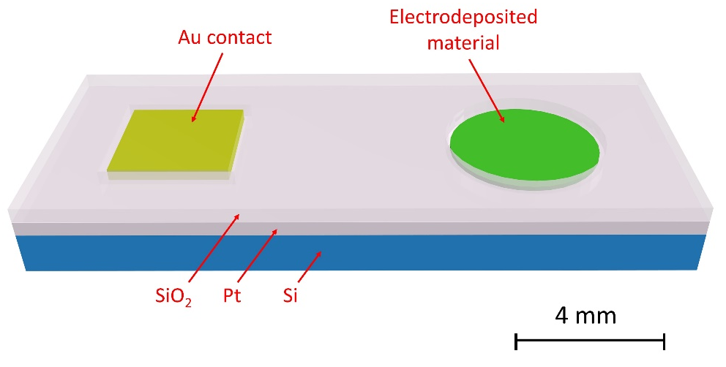
Figure 1: Schematic of the microfabricated Pt electrodes used in this work. Pt (200 nm) was sputtered on the SiO₂ covered Si single crystal substrate and then coated with sputtered SiO₂ (200 nm) as an insulating film. Electrode and contact areas were opened up using lithography. The contact pads are coated with Cr/Au (10/190 nm) to reduce the contact resistance.
Figure 2: Cyclic voltammograms of 2 mM [TBA][SbCl₄] and 100 mM [TBA]Cl in DCM on a Pt electrode, r = 0.25 mm, at 50 mV s⁻¹. The scan was started at +1 V and scanned in the anodic direction first. (A) Shows the entire voltammetric range. (B) Shows the same CVs but zoomed in to better highlight the major antimony plating and stripping reactions.
Figure 3: (A) Cyclic voltammograms of 3.8 mM [TBA][SbCl₄] and 100 mM [TBA]Cl in DCM on a Pt electrode, r = 0.25 mm. Scans were started at +0.5 V and scanned in the cathodic direction. A background correction was performed using linear subtraction on forward scan between +0.15 and +0.40 V. Inset shows the forward scan for 500 and 25 mV s⁻¹ to highlight the pre-peak. (B) Peak current density for the reduction reaction versus the square root of scan rate. The linear fit was performed using only the slowest two scan rates and the intercept was fixed to the origin.

Figure 4: Cyclic voltammetry of 2 mM [TBA][SbCl₄] and 100 mM [TBA]Cl in DCM on a Pt disc electrode, r = 0.65 cm, EQCM crystal at 50 mV s⁻¹. A Pt wire was used as a quasi-reference electrode. The scan was started at +0.5 V and scanned in the cathodic direction. The mass change is shown on the right axis and was calculated from the frequency response of the EQCM crystal as well as from the charge passed.

Figure 5: 2 mM [TBA][SbCl₄] and 100 mM [TBA]Cl in DCM on a Pt RDE, r = 1.5 mm. (A) Cyclic voltammograms at 50 mV s⁻¹. Scans were started at +0.5 V and scanned in the cathodic direction. Only one scan was performed at each rotation rate in order to minimise antimony build up over time. (B) Levich plot for steady states current obtained from potential step experiments at -1 V for 10 s at 100 to 100 rpm. A pulse of +1 V for 20 s was used after each deposition to remove the deposited antimony.

Figure 6: Sequential cyclic voltammograms of 2 mM [TBA][SbCl₄] and 100 mM [TBA]Cl in DCM on a Pt microelectrode, r = 25 μm. The scan started at +0.5 V and scanned in the cathodic direction.

Figure 7: Steady state currents obtained from cyclic voltammetry (averages of 3 scans) at each radius at each scan rate in Figure 6. 2 mM [TBA][SbCl₄] and 100 mM [TBA]Cl in DCM on Pt microelectrodes.
Figure 8: Steady state reduction currents from microelectrode experiments as a function of electrode radius from Figure 6. The averages for each scan rate are plotted individually. 2 mM [TBA][SbCl₄] and 100 mM [TBA]Cl in DCM on Pt microelectrodes.

Figure 9: Cyclic voltammetry of 2 mM [TBA][SbCl₄] and 100 mM [TBA][TFB] in DCM on a Pt electrode, r = 0.25 mm. Scans were started at +1.5 V and scanned in the cathodic direction. Scan shown is not at a fresh electrode surface.
Figure 10: Cyclic voltammetry of 2 mM [TBA][SbCl₄] and 100 mM [TBA][TFB] in DCM on a Pt microelectrode, r = 25 μm. Scans were started at +1.5 V and scanned in the cathodic direction.

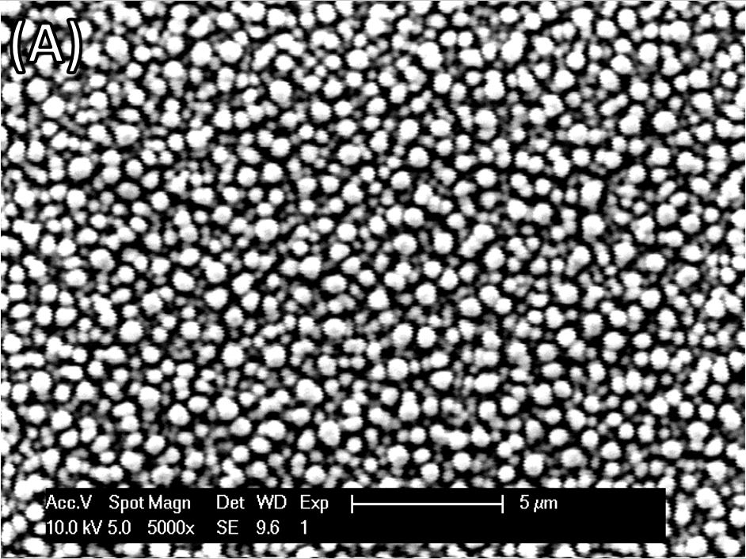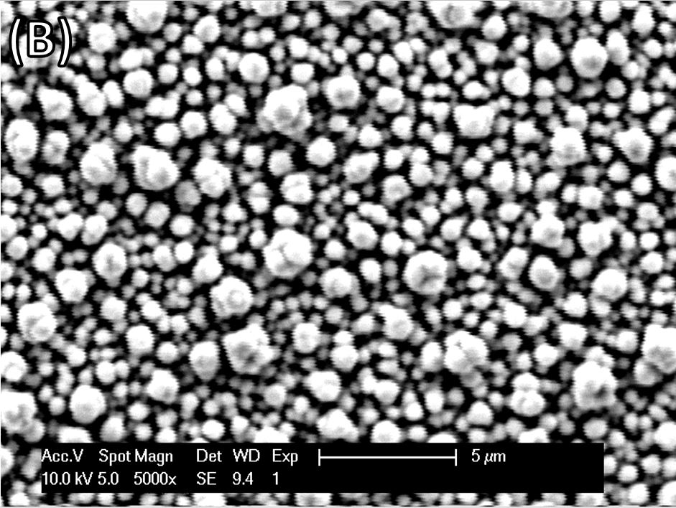
Figure 11: SEM images for deposits on 2 mm radius discs from 2 mM [TBA][SbCl₄] and 100 mM [TBA]Cl in DCM, charge passed -100 mC. (A) Pt at -0.8 V and (B) TiN at -1.2 V vs. Ag/AgCl.

