Investigation of Staphylococcus aureus aggregates on orthopedic materials under varying shear stress
Tripti Thapa Gupta¹, Niraj K. Gupta¹, Matthew J. Pestrak¹, Devendra H. Dusane¹, Janette M. Harro², Alexander R. Horswill^{3,} Paul Stoodley^{1,4,5*}
¹Department of Microbial Infection and Immunity, The Ohio State University, Columbus, Ohio, USA
²Department of Microbial Pathogenesis, School of Dentistry, University of Maryland – Baltimore, Baltimore, Maryland, USA
³Department of Immunology and Microbiology, University of Colorado School of Medicine, Aurora, Colorado, USA
⁴Department of Orthopedics, The Ohio State University, Columbus, Ohio, USA
⁵National Centre for Advanced Tribology at Southampton (nCATS) and National Biofilm Innovation Centre (NBIC), Mechanical Engineering, University of Southampton, Southampton, UK
Paul.Stoodley@osumc.edu

Abstract
Periprosthetic joint infections (PJI) occurring after artificial joint replacement is a major clinical issue requiring multiple surgeries and antibiotic interventions. Staphylococcus aureus is the common bacteria responsible for PJI. Recent in vitro research has shown that staphylococcal strains rapidly form aggregates in the presence of synovial fluid (SF). We hypothesize that these aggregates provide early protection to bacteria entering the wound site allowing the bacteria time to attach to the implant surface leading to biofilm formation. Thus, understanding attachment kinetics of these aggregates is critical in understanding the aggregates adhesion on various biomaterial surfaces. In this study, the number, size and surface area coverage of aggregates as well as of single cells of S. aureus were quantified at various conditions on different orthopedic materials relevant to orthopedic surgery ; Stainless steel (316L), Titanium (Ti), Hydroxyapatite (HA), and Polyethylene (PE). It was observed that, regardless of the material type, SF induced aggregation resulted in reduced aggregate surface attachment and greater aggregate size than the single cell populations under various shear stresses. Additionally, the surface area coverage of bacterial aggregates on PE was relatively high when compared to other materials, which could potentially be due to the rougher surface of PE. Furthermore, increasing shear stress to 78 mPa decreased aggregates attachment on Ti and HA while increasing the aggregates average size. Therefore, this study demonstrates that the SF induced inhibition of aggregates attachment on all materials suggesting that the biofilm formation is initiated by lodging of aggregates on the surface features of implants and host tissues.

Importance
Periprosthetic joint infections occurring after artificial joint replacement is a major clinical issue that require repeated surgeries and antibiotic interventions. Unfortunately, 26% of the patients die within 5 years of developing these infections. Staphylococcus aureus is the common bacteria responsible for this problem that can form biofilm to provide protection from antibiotics as well as the immune system. Although biofilms are evident on the infected implants, it is unclear how these are attached on the surface in the first place. Recent in vitro research investigations have shown that staphylococcal strains rapidly form aggregates in the presence of synovial fluid and provides protection to bacteria and, therefore, allows time to attach to the implant surface leading to biofilm formation. Thus, in this study, we investigated the attachment kinetics of Staphylococcus aureus aggregates on different orthopedic materials. The information presented in this article will add knowledge in surgical management and implant design.

- Introduction
Adherence of bacteria to implanted medical devices and adjacent tissue can lead to biomaterial-associated infections (BAIs), often resulting in life threatening diseases and implant failures [1]. Typical BAIs in the healthcare setting include those on dental implants, prosthetic joints, catheters, cardiac pacemakers, and heart valves [2-6]. Among these medical devices, infection of the prosthetic joint is one of the challenging complications after total joint arthroplasty [7]. Despite methods implemented to prevent this complication including antibiotic prophylaxis, patient risk stratification, detection and treatment of Staphylococcus aureus colonization, and clean operating room environment, there is a 1% infection rate for total joint arthroplasty [7]. Since the number of primary and revision total joint arthroplasties are rapidly increasing due to the growing size of the aging population, the number of periprosthetic joint infections (PJI) cases is expected to increase [8]. In the United States, there were 332,000 total hip and 719,000 total knee arthroplasties in 2010 and those numbers are expected to reach 572,000 and 3.48 million by 2030 for hips and knees, respectively [9, 10]. Therefore, PJIs are likely to become extremely problematic because their treatment frequently requires implant removal and multiple antibiotic courses and this process is often associated with increased patient morbidity and mortality [11]. PJIs also lead to higher healthcare costs because of repeated surgeries, extended hospitalization, rehabilitation, and antibiotic therapy. For example, a single prosthetic joint BAI has an average, estimated healthcare cost of at least $50,000 and up to $130,000 [12-14]. Furthermore, these costs underestimate the true impact to the patient, as they do not include the long-term physical and social impairments that the patients potentially endure [15, 16].
S. aureus is a gram-positive facultatively anaerobic bacterium and is one of the most common causes of PJI [7, 17]. It is also the most frequent pathogen associated with metal surfaces, and acute and chronic osteomyelitis [18]. During PJI, S. aureus biofilms and aggregates have been observed on the surface of implant prosthesis and the surrounding tissue [19] though it is not clearly understood how S. aureus biofilms become established in PJIs. Biofilms are the group of bacteria encased in a matrix containing polysaccharides, proteins, and extracellular DNA [20]. In vitro study shows staphylococcal strains exhibit rapid aggregation in the presence of human and bovine synovial fluid (SF), and develop into macroscopic colonies within 24h which eventually develop into an antibiotic resistant biofilm [21-23]. Previous research investigations have predominately analyzed the initial attachment of single cells to different biomaterial surfaces. The materials that are commonly implanted during orthopedic surgery include metals (stainless steel, chrome-cobalt and titanium alloys), polymers (polymethylmethacrylate, PMMA), high density polyethylene, and bioglass [18]. Joint implants are made from some of these materials which are then typically cemented into place with hydroxyapatite. Barth et al., showed that S. aureus and S. epidermidis colonize orthopedic implant materials such as titanium alloy discs, poly(methyl methacrylate) (PMMA) and ultra-high molecular weight polyethylene (UHMWPE) [24]. They found high numbers of S. aureus on metal and S. epidermidis on polymers. Furthermore, Oga et al. found greater S. epidermidis colonization on methyl methacrylate compared to stainless steel and aluminum [25]. Overall, these studies indicate that certain materials may promote infection by favoring colonization by specific pathogens. Another study quantified differences in bacterial adherence due to polymer chemical properties, surface roughness, and flow conditions. This study demonstrated a decrease in adherent bacteria on polyvinyl chloride with the increase of shear rate which indicates fluid shear rate plays a role in the attachment and detachment of bacteria to materials [26]. The bacterial adhesion force calculated by atomic force microscopy by one study showed that hydroxyapatite shows weak adhesion force whereas stainless steel showed strong adhesion force due to their surface energy and surface roughness [27].
Both host and bacterial factors can mediate bacterial aggregation. Several components of synovial fluid (a viscous substance in the joint space) such as fibrinogen, fibronectin and free DNA can induce bacterial aggregation that has been hypothesized to play a role in PJI [28]. The host protein fibronectin has also been shown to promote adhesion of S. aureus and S. epidermidis to stainless steel, pure titanium, or titanium-aluminum-niobium alloy [29]. Indeed, the presence of fibronectin on bone-implanted metallic devices such as titanium promoted attachment of S. aureus [30]. Bacterial adhesion studies normally assess the interaction of single planktonic cells interacting with surfaces. Therefore, in this study we analyzed the attachment of S. aureus bovine synovial fluid induced aggregates, compared to that of non-aggregated cells, to various orthopedic materials; stainless steel (316L), hydroxyapatite (HA), polyethylene (PE), and (Ti) under shear stresses of 15 and 78 mPa. Bacterial adherence was quantified by determining the number of attached particles, their surface area and average size. While the exact shear stress in the joint space is not known, we expect a range of stresses would be present depending on joint activity and the relative location within the joint. To replicate the conditions within the joint, the attachment in this study was examined under two different flow conditions with shear stress of 15 and 78 mPa. Out of the four materials, we limited testing of high shear stress of 78 mPa on bacterial attachment to Ti and HA because they are most used in clinical applications. Titanium is a material commonly used in orthopedics and dental implants [31, 32] on which biofilms can grow [33, 34] and hydroxyapatite has been used as a coating in the region where strong interface with the bone is required such as femoral components for the knee joints [35]. Hydroxyapatite coatings are also responsible in playing a role in accelerating the bone formation process in joint prosthesis [36].Therefore, studying the bacterial attachment on HA is important as this material covers the larger surface area in prosthetic implants. We investigated the effects of synovial fluid on S. aureus surface attachment via fluorescence microscopy and found that SF inhibits surface attachment to every material used in this study (Ti, 316L, HA, and PE) and at both shear stresses. We further concluded that materials with rougher surfaces such as HA and PE facilitate attachment of larger aggregates size and surface area coverage than the metals, Ti and 316L.
2. Materials and Methods
2.1 Bacterial strain and culture conditions
Bacterial stocks were maintained at -80 °C in 20% glycerol. A GFP expressing S. aureus strain (AH1726) [37] was stored and cultured in tryptic soy broth (TSB). A single bacterial colony from the streaked agar plate was used to inoculate 25 ml of tryptic soy broth (TSB) for each experiment. Culture tubes were incubated at 37 °C for 17-18 hours at 200 rpm.
2.2. Bacterial aggregate formation
5 ml of the overnight culture of S. aureus (10⁸ CFU/ml) was centrifuged at 21,000 xg for 1 min. The supernatant was removed, and the pellet was washed in PBS and then resuspended in 10% synovial fluid (500 µl) in 4.5 ml ringer’s solution (RS). The cells were then incubated in static conditions for 1 hour to allow aggregates formation at room temperature. For single cells suspension preparation, 5 ml of the overnight culture was centrifuged at 21,000 xg for 1 min and after removing supernatant, the pellet was washed and resuspended in 5 ml RS. Both aggregates and single cells suspension were diluted individually in 15 ml of RS and recirculated through a flow cell (schematic shown in Figure 1).

2.3 Biosurface flow cell
Attachment of S. aureus single cells and aggregates on stainless steel 316L, HA, PE, and Ti coupons (10 mm diameter and 2mm thickness, Biosurface Technologies) was observed in a flow cell (FC 270-AL, BioSurface Technologies, Bozeman, MT, USA). The ends of this flow cell were connected by silicone tubes and a recirculating loop fed from a mixing vessel was created (Figure 1). The circulation was run for 15 minutes using a peristaltic pump (IPC ISM932A, Cole-Parmer, Vernon Hills, IL, USA) and time lapse video was recorded at 30 frames-per-second using a digital camera (QIClick CCD, Teledyne QImaging, Surrey, BC, Canada) attached to a Leica DM2700 M upright materials microscope with a 20X objective.
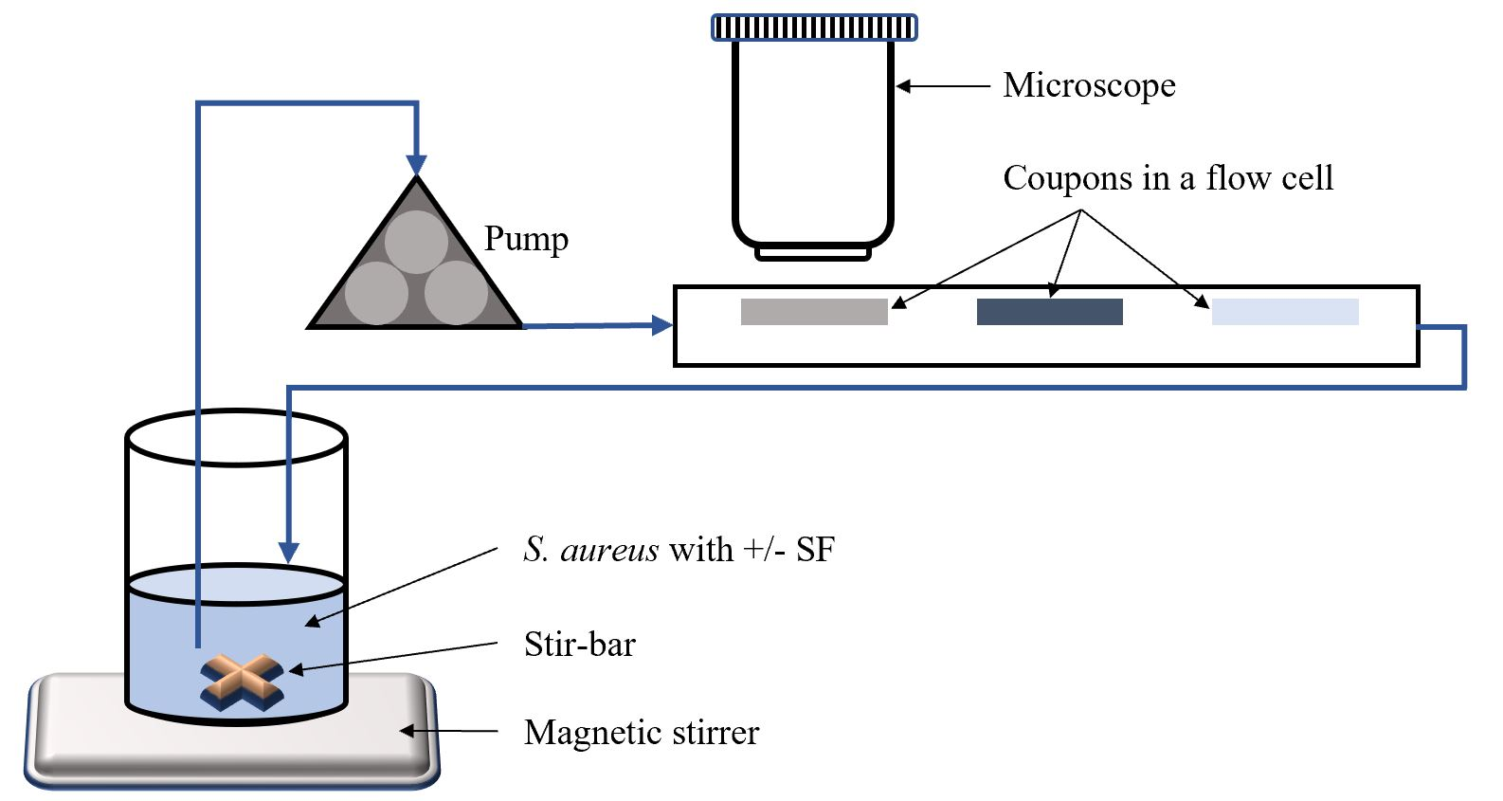

Figure 1: Flow system for aggregate attachment assay.
2.4 Image acquisition, processing and analysis
Time lapse videos were recorded at 30 fps using the Micro-Manager software (µManager v1.4, Vale lab, UCSF) and the acquisition was realized with a digital camera. Ten frames from near the center of each coupon from three independent experiments were analyzed for attachment after 5, 10 and 15 minutes of circulation using NIH ImageJ [38]. The average intensity of GFP signal was quantified across all frames. Particles with a low average intensity indicated the bacteria did not adhere and was present in the liquid phase and resulted in grey particles. Therefore, low intensity particles were excluded, and high intensity attached particles that appeared black were quantified to determine the number of particles, surface area coverage, and the average particles size of the bacteria present on the coupon via ImageJ. The number of particles attached is the representative of total number of particles distinctly separated from each other regardless of their sizes, surface area coverage is the total surface area covered by these particles, and the average size was determined by dividing the total surface area by the number of particles.
2.5 Coupon modification and characterization
Coupons were sanded using an aluminum oxide sanding sheet (436A38, Grainger P600, USA) for 4-5 minutes. The roughness of these coupons was measured using Zeta 20 Optical Profilometer and Ra value was calculated. An Ra value is the mean height as calculated over the entire measured area and is given by the arithmetic average of deviations from the mean. Ra is used for measuring the roughness of machined surfaces which dictates general variations in overall profile height characteristics [26]. Whereas the contact angle was measured manually by placing a water droplet on the surface and angle measured with an online protractor. Contact angles greater than 90° represent hydrophobic surfaces and a value less than 90° represent hydrophilic surfaces. The Ra and water contact angle values in Table I represent the mean ± SD of three measurements.
  - Qualitative Scanning Electron Microscopy (SEM) assessment of aggregates and single cells on different materials
For SEM images, coupons with single cells and aggregates were fixed according to a procedure described previously [11, 39] with some modifications. The following chemicals used for SEM were purchased from Thermo Fisher Scientific (Norwalk, IL, USA). Coupons were placed in a 24-well plate and soaked in a prefixing agent containing 2.5% Glutaraldehyde in 0.2M cacodylate buffer (pH 7.4) for 24 hours at room temperature. The coupons were then rinsed with cacodylate buffer three times for 5–10 minutes. After the final rinse, the coupons were dehydrated by placing them in increasing concentrations of ethanol (70%, 90%, and 100%) three times each for 5 minutes. Finally, the coupons were dried with 100% Hexamethyldisilazane (HMDS) two times each for 10 minutes, coated with gold-palladium and then viewed under a SEM (Quanta 200, FEI, Hillsboro, OR, USA) at an accelerating voltage of 10 kV.
- Statistical analysis
All experiments in this study were repeated three times. All the parameters obtained in this study, number of particles, average size, and surface area coverage, were statistically analyzed for the effects of the presence or absence of synovial fluid, various attachment times, shear stresses, and the materials used via SPSS (version 26, IBM, New York, NY, USA). The threshold for significance was set at p < 0.05. Statistical significance was determined by one-way ANOVA followed by Tukey post hoc multiple comparisons test. All error bars in the charts indicate standard error of the means.
- Results
  - Optical profilometry and contact angle measurement
The topography of various surfaces was examined by measuring the surface roughness (Ra) and contact angle. The Ra value and contact angle of each material is listed in Table I. The results indicate that there is a 5- and 8-fold increase in the Ra values of HA and PE respectively when compared with that of Ti and 316L. This demonstrates that HA and PE are significantly rougher than the Ti and 316L.
The contact angle of Ti and 316L were similar which indicates these are hydrophilic surfaces. With a contact angle of 33 deg, HA behaves as a hydrophilic material. PE on the other hand has the highest contact angle of the materials, and thus is the most hydrophobic surface among these materials.
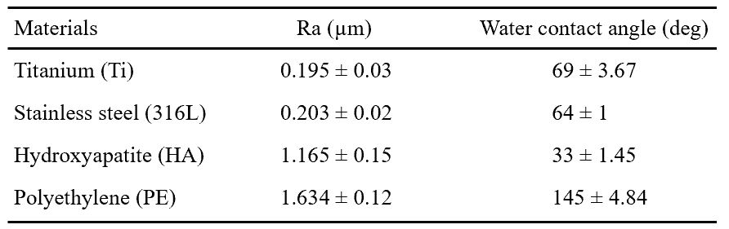
Table I: Average surface roughness (Ra) and water contact angle measurements (deg) on different materials.

4.2. SF induced aggregation inhibits bacterial attachment at 15 mPa shear stress on different orthopedic materials
To determine how synovial fluid affects bacterial adherence within the joint, we measured cell surface attachment on orthopedic materials under two different shear stresses, 15 and 78 mPa. The attachment kinetics of single cells and aggregates on different materials are shown in Figure 2 representing HA, Ti, 316L, and PE respectively. We quantified three different parameters: the number of attached particles, surface area covered by particles, and the average size of the particles (Figure 3). For all the materials tested, at 15 minutes, fewer number of aggregates (+SF) 194, 121, 94, and 48 were attached on HA, Ti, 316L, and PE, whereas the single cells (-SF) attached on the surface were 4494, 4441, 4629, 724 on HA, Ti, 316L, and PE respectively at 15 mPa shear stress. An analysis of variance (ANOVA) yielded significant variation (p < 0.05) between the +SF and -SF groups for each material at various attachment times as presented in Figure 3.
We also compared the total number, average size, and surface area of the attached particles within different materials in both +SF and -SF conditions at different attachment times. An analysis of variance (ANOVA) of these numbers yielded significant variation within the materials for the number of particles attached in both +SF and -SF groups except the results from +SF and 15 minutes attachment time. A post hoc Tukey test within the +SF group at 5 minutes attachment time results showed that the number of particles attached was significantly different in HA when compared with Ti, PE, and 316L for 5 minutes. For the 10 minutes attachment time and +SF group, it was significantly different in HA when compared with 316L and PE only. And for the 15 minutes and +SF group, it was significantly different in HA when compared with PE. In the experiments without synovial fluid, significant differences were only found between HA and 316L as well as PE for 5 minutes, and only between HA and PE for 10- and 15-minutes attachment time. For all other multiple comparisons, there were no significant difference as presented in Table II.
Furthermore, we analyzed the rates of change in the number of particles, surface area coverage and average size from 5 minutes to 15 minutes (Table III). There was an initial rapid increase between 0 and 5 minutes and then generally appeared linear as assessed by linear regression during 5 – 15 minutes (supplementary data). The rates of change in number of particles were about 11 – 80 times higher in the ‘-SF’ group for HA, Ti, and PE and approximately 4000 times higher for 316L when compared with ‘+SF’ group. Similarly, the rate of change of surface area coverage was found to be higher in ‘-SF’ group than in ‘+SF’ group. However, the rate of change of average size was higher in ‘+SF’ group than in the ‘-SF’ group (Table III). Although the rate of change in attached number of particles was less in SF, the average surface area was found to be higher. This could be due to the attachment of only larger aggregates in SF. On the other hand, without SF, numerous smaller particles are attached. Since a particle is counted as one irrespective of its size, we observed the rate of its change was higher without SF because of numerous smaller particles. Moreover, since the average size is a function of surface area over total number of particles, the rate of change of average size was higher in SF than without SF.
To determine the effect of synovial fluid on these rates of changes, an analysis of variance (ANOVA) of these rates yielded significant variation within the +SF and -SF groups (p < 0.05) for the rate of change in the number of particles and the surface area coverage. In the case of the rate of change of average size, significant difference was not found. This could be due to the dependency of this parameter on the total number of particles. In this study, the number of particles is the total sum of the number of distinctly separated particles irrespective of their sizes. This may yield variations in the calculated average size and, hence, significant difference could not be observed.

Table II: One way ANOVA and Tukey post-hoc multiple comparison results for the total number, average size, and surface area coverage of the attached particles compared within various materials at different conditions of synovial fluid (presence/absence), attachment durations (5, 10, and 15 minutes) and shear stresses (15mPa and 78mPa).
ANOVA
Variables | p-values from ANOVA conducted between groups
 | With SF (+SF) |  |  | Without SF (-SF)
 | 5min | 10min | 15min | 5min | 10min | 15min
No. of particles | 0 | 0.008 | 0.064 | 0 | 0 | 0
Surface area coverage | 0.274 | 0.128 | 0.077 | 0.003 | 0.001 | 0.003
Average size | 0.282 | 0.219 | 0.17 | 0.003 | 0 | 0.002

Tukey post-hoc multiple comparisons
Shear Stress | Material | Material | p-values
 |  |  | Number of particles |  |  |  |  |  | Average size |  |  |  |  |  | Surface area coverage
 |  |  | With SF (+SF) |  |  | Without SF (-SF) |  |  | With SF (+SF) |  |  | Without SF (-SF) |  |  | With SF (+SF) |  |  | Without SF (-SF)
 |  |  | 5min | 10min | 15min | 5min | 10min | 15min | 5min | 10min | 15min | 5min | 10min | 15min | 5min | 10min | 15min | 5min | 10min | 15min
15 mPa | HA | Ti | 0.00 | 0.19 | 0.42 | 0.06 | 0.67 | 1.00 | 1.00 | 1.00 | 1.00 | 0.16 | 0.55 | 0.83 | 0.91 | 0.91 | 0.91 | 0.94 | 0.98 | 0.93
 |  | 316L | 0.00 | 0.05 | 0.20 | 0.01 | 0.38 | 0.97 | 1.00 | 1.00 | 0.99 | 0.94 | 0.30 | 0.20 | 0.82 | 0.78 | 0.82 | 0.24 | 0.13 | 0.32
 |  | PE | 0.00 | 0.01 | 0.05 | 0.00 | 0.00 | 0.00 | 0.38 | 0.21 | 0.16 | 0.04 | 0.00 | 0.01 | 0.51 | 0.64 | 0.51 | 0.01 | 0.01 | 0.00
 | Ti | 316L | 0.99 | 0.77 | 0.93 | 0.57 | 0.95 | 0.92 | 1.00 | 1.00 | 1.00 | 0.07 | 0.05 | 0.06 | 1.00 | 0.99 | 1.00 | 0.11 | 0.07 | 0.14
 |  | PE | 0.06 | 0.11 | 0.43 | 0.00 | 0.00 | 0.00 | 0.37 | 0.18 | 0.11 | 0.00 | 0.00 | 0.00 | 0.23 | 0.31 | 0.23 | 0.00 | 0.00 | 0.00
 | 316L | PE | 0.09 | 0.41 | 0.75 | 0.00 | 0.00 | 0.00 | 0.33 | 0.17 | 0.10 | 0.09 | 0.05 | 0.19 | 0.18 | 0.22 | 0.18 | 0.11 | 0.02 | 0.04
78 mPa | HA | Ti | 0.01 | 0.01 | 0.03 | 0.05 | 0.03 | 0.03 | 0.34 | 0.13 | 0.31 | 0.08 | 0.03 | 0.02 | 0.00 | 0.07 | 0.29 | 0.10 | 0.03 | 0.11

Table III: Attachment rates of number of particles, surface area coverage, and average size on different materials and one-way ANOVA comparison between the attachment rates mediated by SF and without SF.
 | Number of particles |  | p-values | Surface area coverage |  | p-values | Average size |  | p-values
 | +SF | -SF |  | +SF | -SF |  | +SF | -SF
HA | -7.2 ± 1.55 | 72.66 ± 22.5 | 0.02 | 0.04 ± 0.02 | 0.44 ± 0.18 | 0.09 | 1.45 ± 0.46 | 0.15 ± 0.07 | 0.05
Ti | 2.23 ± 2.97 | 160.43 ± 25.01 | 0 | 0.02 ± 0.03 | 0.48 ± 0.02 | 0 | -0.16 ± 0.23 | 0.07 ± 0.01 | 0.36
316L | 0.06 ± 0.48 | 220.16 ± 25.85 | 0 | 0.01 ± 0.009 | 0.34 ± 0.09 | 0.02 | 0.21 ± 0.15 | 0.02 ± 0.01 | 0.27
PE | 1.93 ± 1.31 | 41.13 ± 11.34 | 0.02 | 0.42 ± 0.21 | 0.03 ± 0.09 | 0.14 | 3.67 ± 6.94 | 0.02 ± 0.01 | 0.62

In addition, the total surface area covered by the aggregates was less on HA (3%), Ti (1%), and 316L (0.56%) when compared with the surface coverage by single cells (10% HA, 11% Ti, and 7% 316L). Whereas, the opposite was observed on PE where the surface area covered by aggregates (7%) was greater than by single cells (0.48%), In addition, the average particle size of attached aggregates was greater than that of single cells for all the materials; in particular, PE had the largest aggregates. Thus, SF inhibited the attachment of bacteria on almost all materials when compared to the single cells. These data suggest that this phenotype is not specific to just one surface type and synovial fluid seems to inhibit attachment to the implant during PJI.
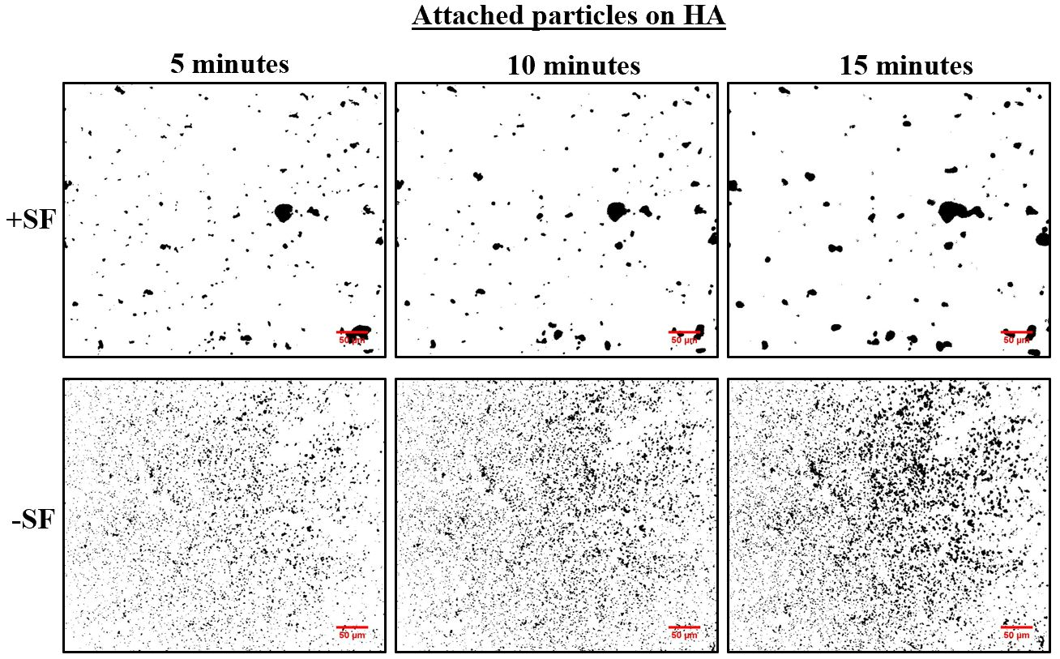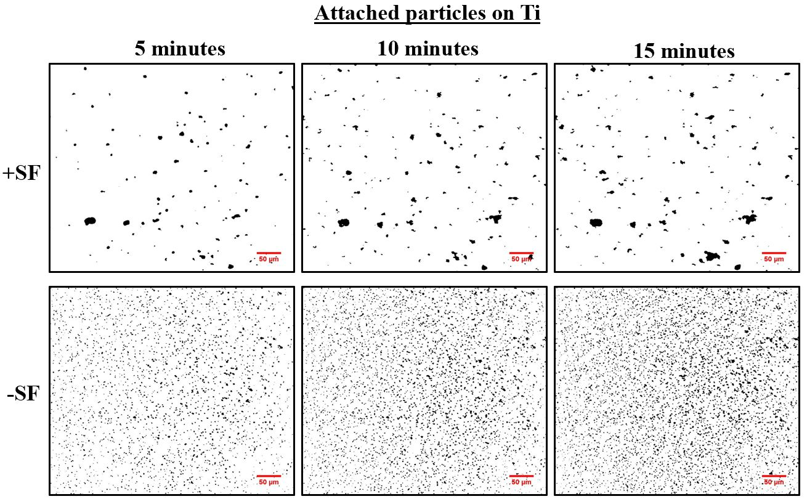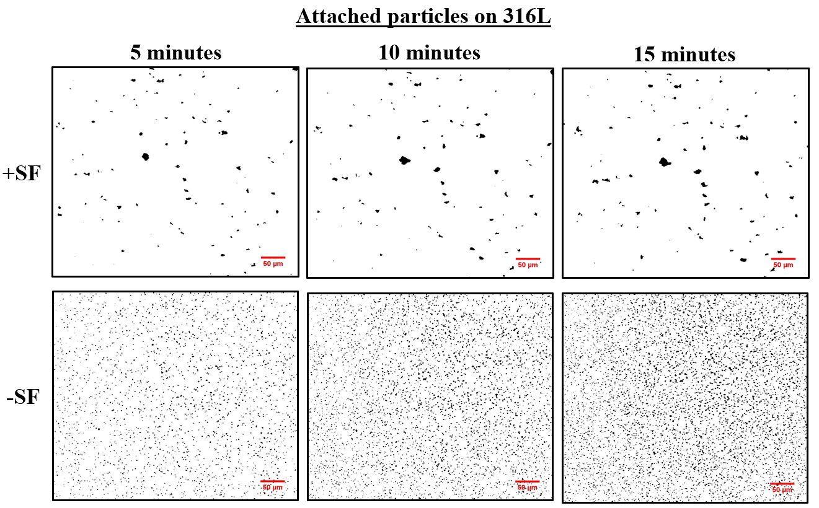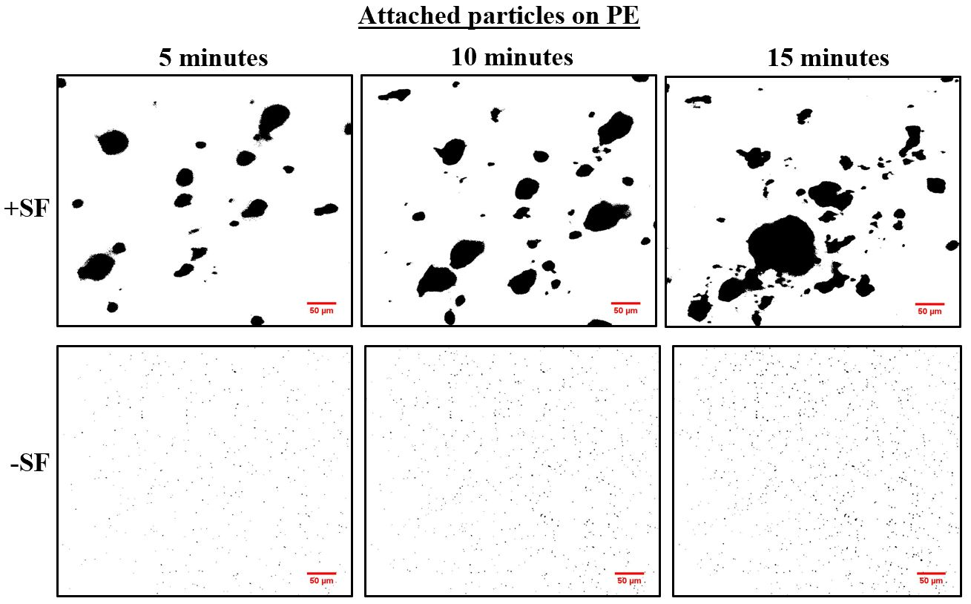
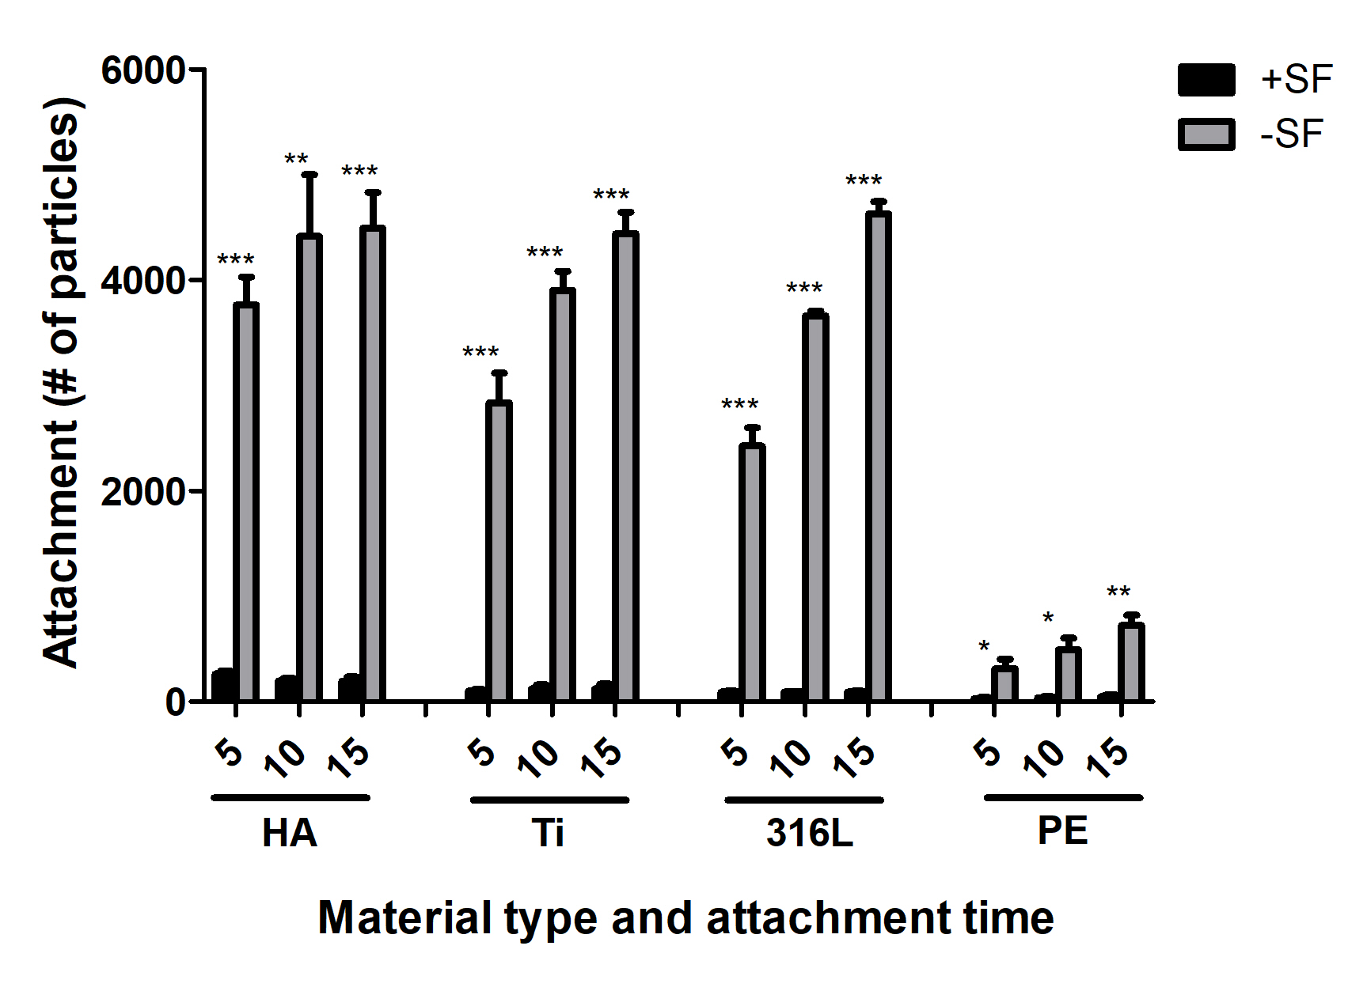
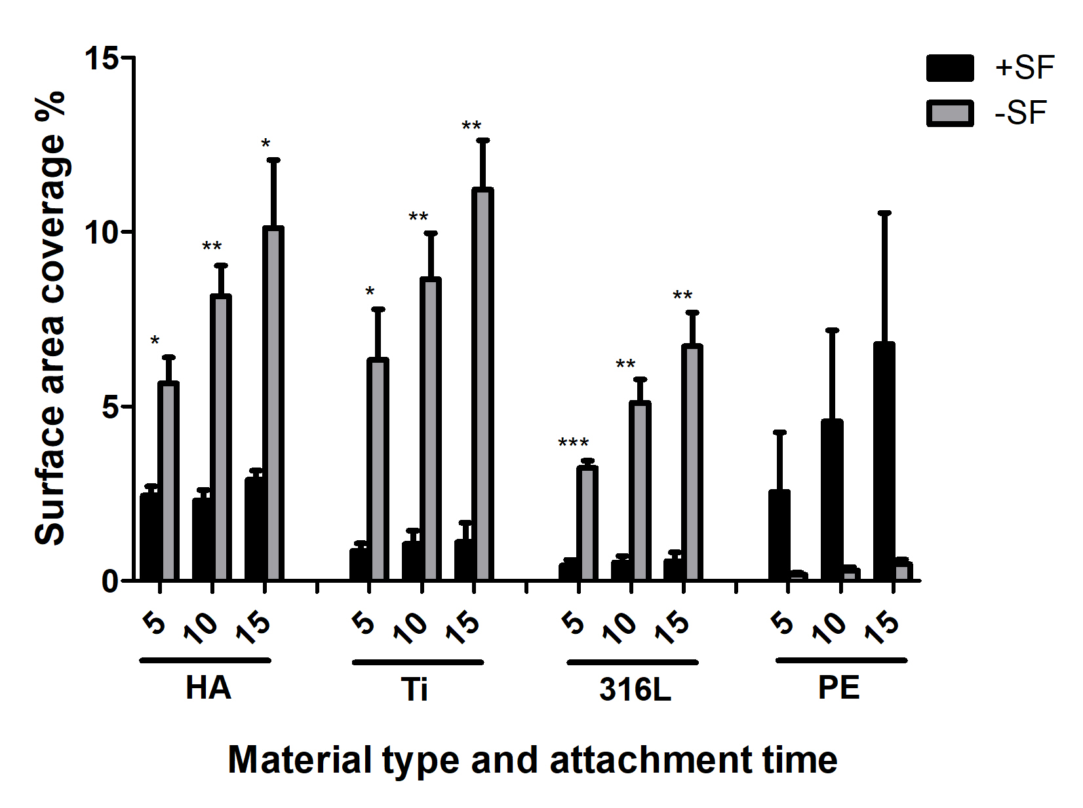
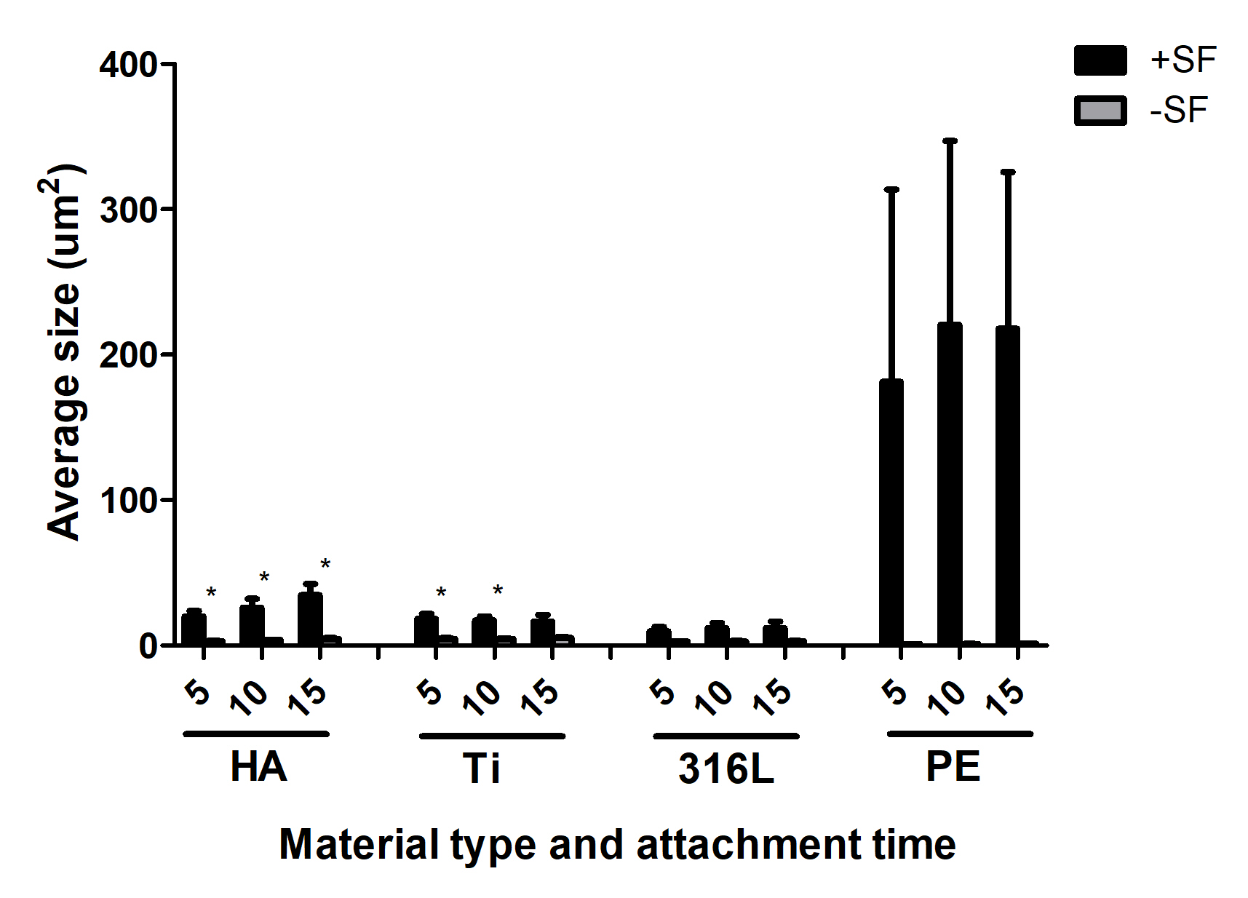
Figure 2: Bacterial attachment inhibition by SF on various orthopedic material. S. aureus surface attachment to HA, Ti, 316L, and PE was quantified after 5, 10, and 15 minutes under constant shear tress of 15 mPa. The black particles in the figures are the attached single cells and aggregates. Scale bar is 50 µm. +SF and -SF represents the SF induced aggregation and single cells in the absence of SF.
Figure 3: Synovial fluid aggregation inhibits bacterial surface attachment. Attachment quantification based on aggregates and single cells number [40], surface area coverage, and sizes at 15 mPa shear stress on hydroxyapatite (HA), titanium (Ti), stainless steel (316L), and polyethylene (PE) respectively. +SF and -SF represents the SF induced aggregation and single cells in the absence of SF. Error bars indicate mean ± SEM. Statistical significance was determined by One-way ANOVA. * p <0.05, ** p <0.01, *** p <0.001
4.3. Attachment of single cells and aggregates on HA and Ti under 78 mPa shear stress
The range of shear stress present in the joint likely varies based on numerous factors. Therefore, we tested S. aureus attachment kinetics at a higher shear stress of 78 mPa on Ti and HA (Figure 4 and 5). Particle number, surface coverage, and particle size were quantified for 5, 10, and 15 minutes of attachment duration at 78 mPa and 15 mPa. Through statistical analysis, significant difference was found in Ti and HA between 15 mPa and 78 mPa shear stress in terms of particles attached in aggregates (Figure 5). Similar to the low shear stress condition of 15 mPa, following synovial fluid exposure the number of attached aggregates is reduced (Figures 4 and 5). Interestingly, larger aggregates are observed on HA and Ti with higher shear stress than with the lower shear stress similar to the results published by another group [41] where aggregates or clusters appeared with increased size. Their shear stress values range from 0.09 to 7.3 Pa. However, our results did not find an increase in bacterial attachment with higher shear stress as shown in this study [41]. Rather, the number of attached aggregates decreased as shear stress was increased. This could be potentially because of the accumulation rate as described by the mass balance equation [42, 43] (accumulation = attachment rate + growth rate - detachment rate - decay rate) is very low assuming zero growth and decay rate since the duration of the experiments are relatively short. However, higher shear stresses tend to cause higher detachment rates from smooth surfaces compared to rougher surfaces as the aggregates could be protected in the uneven features of the rougher surfaces.
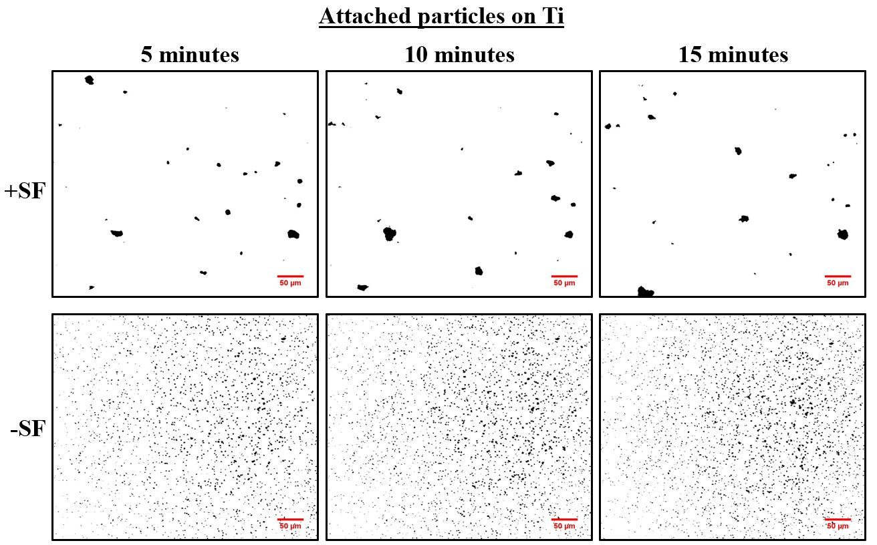
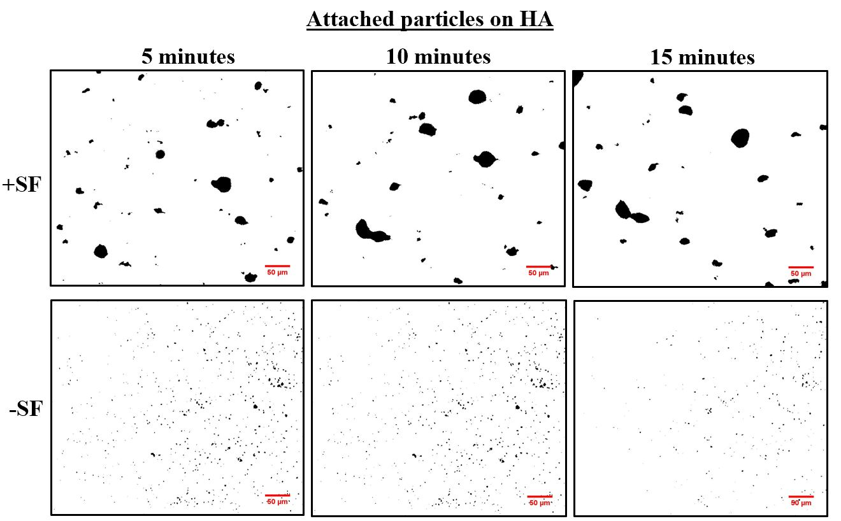
Figure 4: Bacterial attachment inhibition by SF on Ti and HA. S. aureus surface attachment to Ti and HA was quantified after 5, 10, and 15 minutes under constant shear tress of 78 mPa. The black particles in the figures are the attached single cells and aggregates. Scale bar is 50 µm. +SF and -SF represents the SF induced aggregation and single cells in the absence of SF.

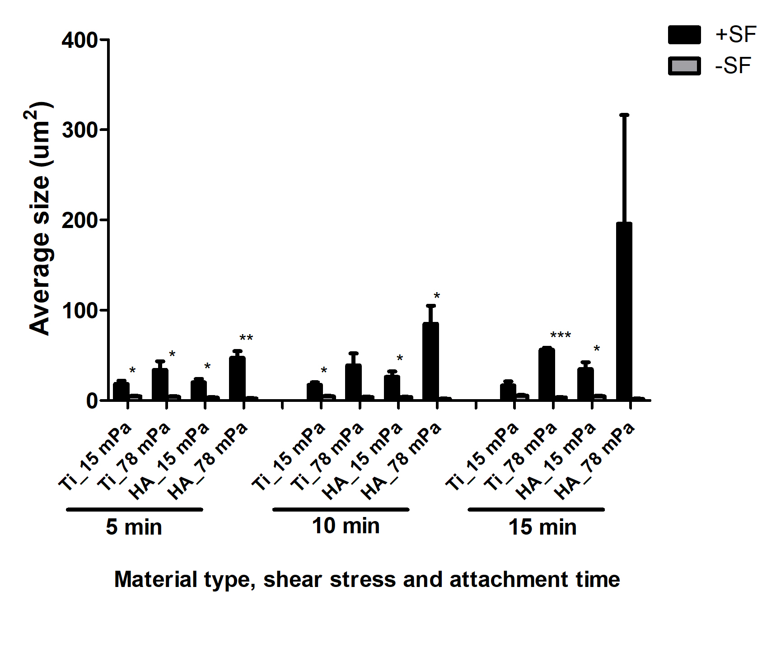
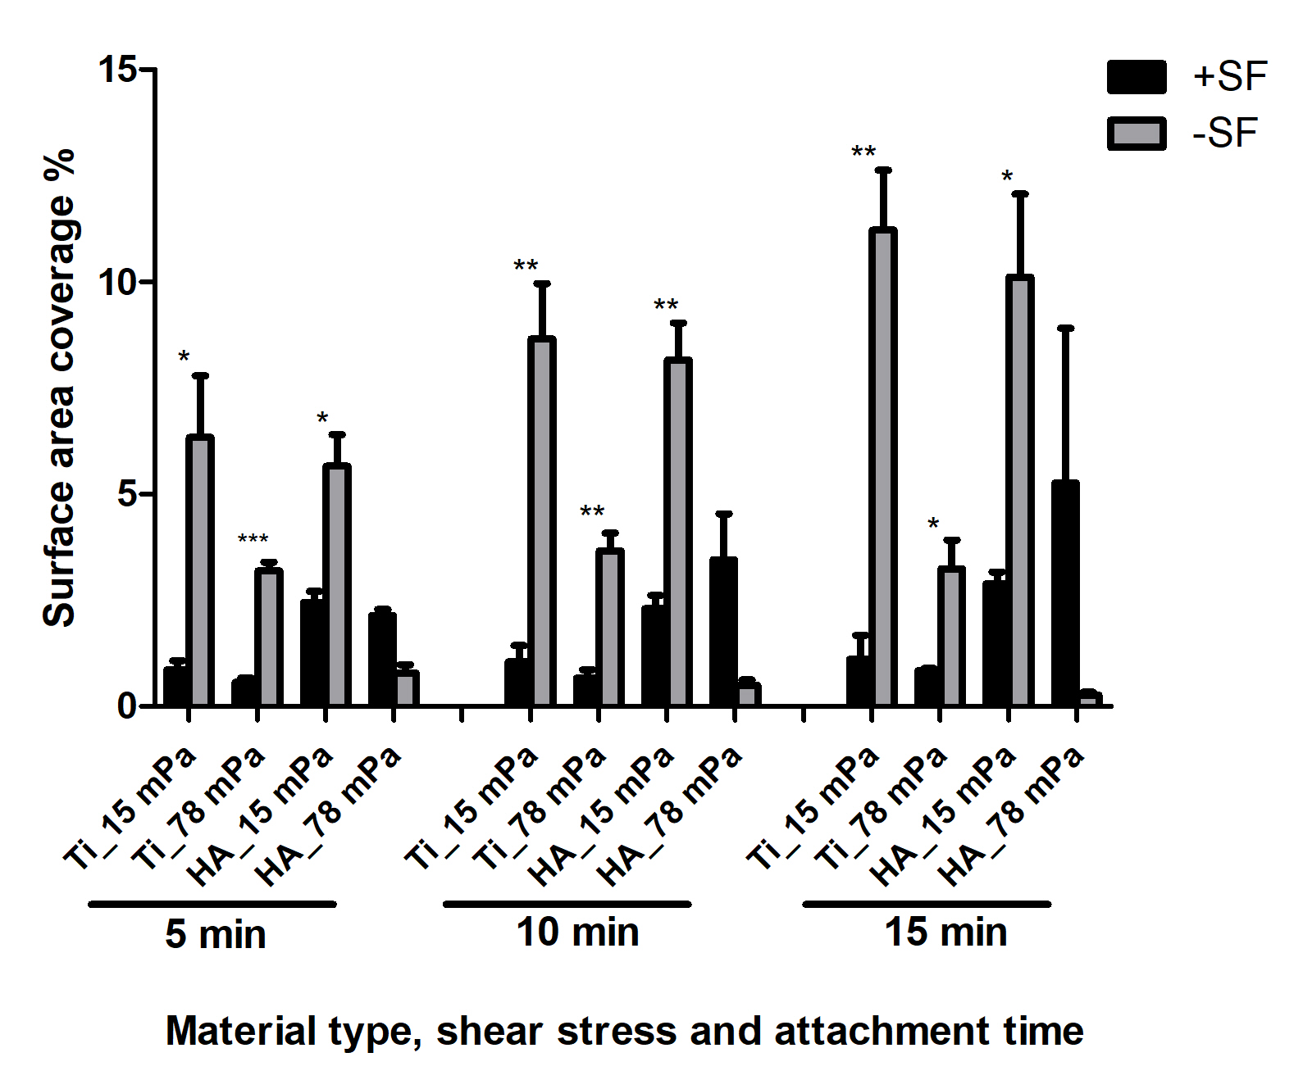
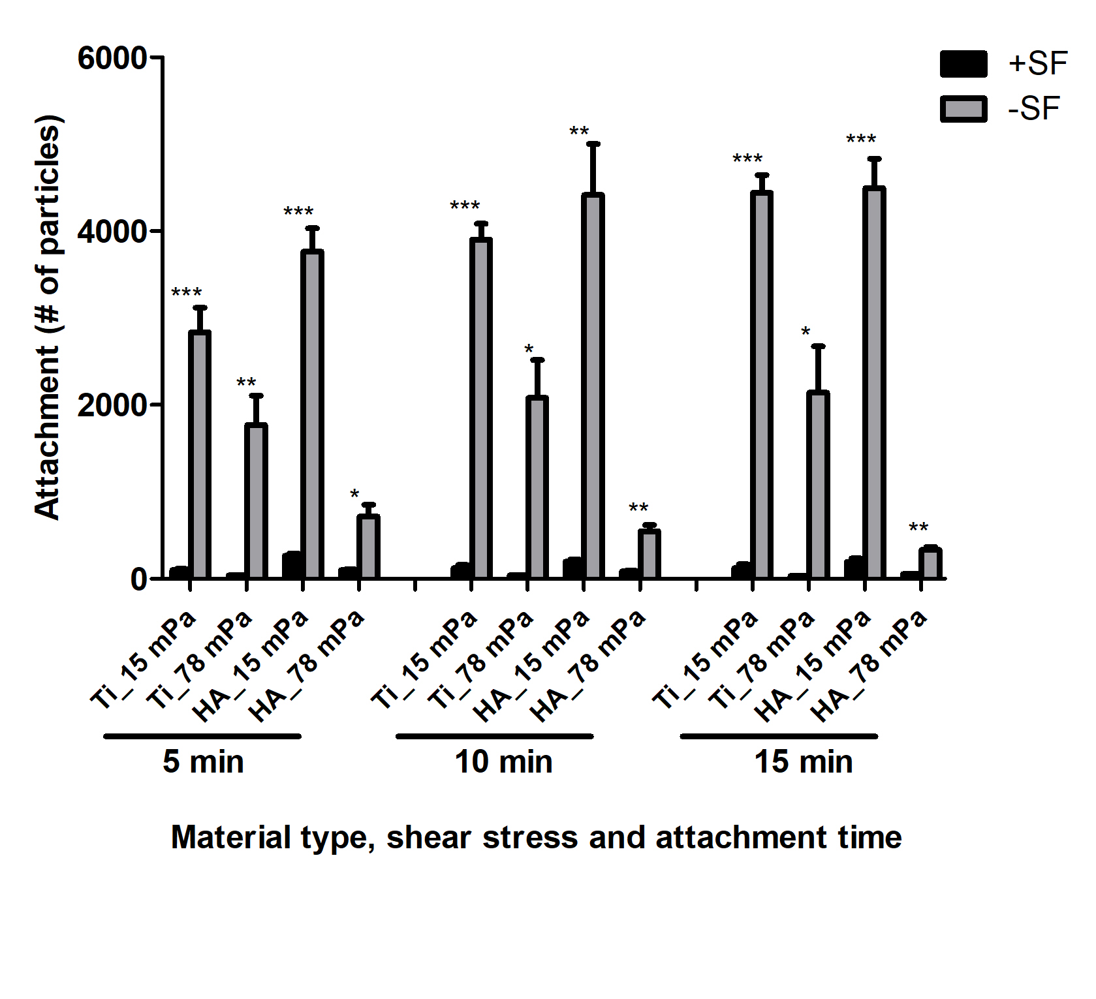

Figure 5: Synovial fluid aggregation inhibits bacterial surface attachment. Attachment quantification based on aggregates and single cells number, surface area coverage, and sizes at 78 mPa shear stress on titanium (Ti) and hydroxyapatite (HA). +SF and -SF represents the SF induced aggregation and single cells in the absence of SF. Error bars indicate mean ± SEM. Statistical significance was determined by One-way ANOVA. * p <0.05, ** p <0.01, *** p <0.001

4.4. Scanning electron microscopy (SEM) images of single cells and aggregates on different materials at 15 mPa and 78 mPa shear stress
Figure 6 shows the SEM images of aggregates and single cells on different materials under 15mPa and 78 mPa shear stress. Many adhered S. aureus aggregates of various sizes can be observed on Ti and 316L coupons following flow under 15 mPa of shear stress. The single cells without SF exposure seems to be uniformly distributed all over the surfaces in both Ti and 316L coupon. Similarly, in HA at 15mPa, larger bacterial aggregates can be observed following treatment with SF. Along with larger aggregates, many smaller aggregates can also be found, especially on the HA coupon. The single cells on HA are distributed all over the surface along with 3-5 cell clusters frequently forming at sites containing abnormal surface features. The PE which is the roughest among these materials retain larger aggregates compared to the other three materials tested. The single cells on PE surfaces were less in comparison to Ti, 316L, and HA coupon. Along with single cells, PE also contain smaller cluster of cells on the surfaces without SF. Although the number of aggregates at 78 mPa on Ti surfaces were less when compared to 15 mPa, the aggregates appeared larger than with 15mPa shear stress. Whereas, the number of single cells on the Ti surfaces were found to be less than what was observed at 78 mPa. In HA as well, the number of aggregates and single cells seems to be less than in 15 mPa, the aggregates size however, appears to be larger and appears like biofilm aggregates.
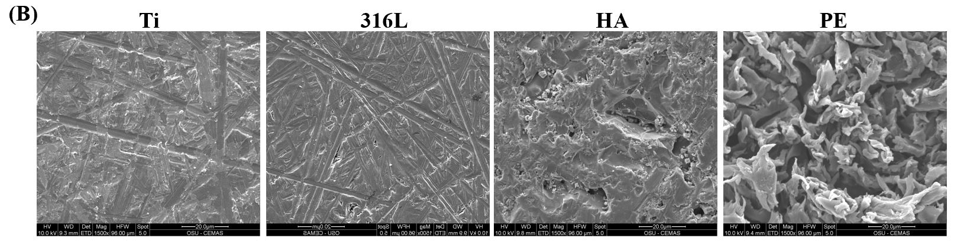
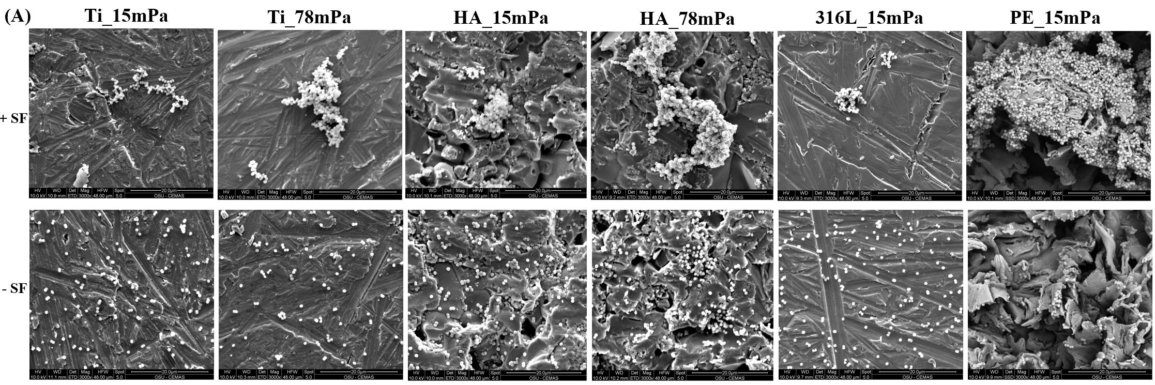
Figure 6: SEM images of aggregates and single cells on Ti, HA, 316L, and PE surfaces at 15 mPa and 78 mPa shear stress at 3000X magnification (Figure A). Figure B is blank images to show different surface structure with 1500X magnification. Scale bars are 20 µm. +SF and -SF represents the SF induced aggregation and single cells in the absence of SF.
Discussion
Our group has previously reported on bacterial aggregates during PJI [29]. S. aureus forms aggregates in human and bovine synovial fluid and grow into a macroscopic size in 24 hours [21-23]. The formation of aggregates provides the bacteria with enhanced tolerance to antibiotics and promotes surface colonization and biofilm formation [44, 45]. Therefore, we hypothesized that the aggregates that form in synovial fluid provide early protection to bacteria entering the surgical site, allowing them time to attach to the implant surface leading to biofilm formation. Thus, understanding the kinetics of aggregate attachment to different materials under defined shear stresses is important in better understanding bacterial colonization within the artificial joint during infection.
Multiple investigations of bacterial adhesion on orthopaedic materials have been conducted using planktonic bacteria. However, few studies have been published regarding SF induced bacterial aggregates which may provide critical insight into the development of chronic infections. Thus, this study tries to simulate the in vivo human joint conditions by exploring the attachment of SF induced aggregates on different surfaces. We found that the surface interaction of aggregates compared to single cells varied based on the surface chemistry of a given material. However, regardless of the material type, SF induced aggregation resulted in less particle attachment and greater aggregate size than the single cell populations in ringer’s saline in both low and high shear stress of 15 and 78 mPa respectively. However, in PE, the surface area coverage by the aggregates was relatively more, which could possibly be due to the rougher surface of PE. As the surface is rougher, the initial attachment of the aggregates is more bound to the surface and relatively difficult to detach. In contrary, the single cells attached on PE is less. The reason for this could be the increased surface roughness decreases the adhesion of gram positive bacteria as explained in one study [46]. It is possible that relatively smooth surfaces are infrequent sites of aggregate attachment and aggregate-surface interaction is more prevalent after becoming lodged within large scale surface features such as edges and tapped holes that are present on rougher surfaces. Furthermore, rougher surfaces promote bacterial adhesion due to increased surface area and depressions that provide more favorable and additional sites for colonization [47]. Besides roughness, other factor responsible for bacterial adhesion are surface chemical composition, surface configuration, flow conditions, surface hydrophobicity or wettability, serum or tissue proteins such as fibronectin, fibrinogen, albumin, laminin, and bacterial hydrophobicity [47, 48].
Furthermore, there was a high correlation (R²=0.92) between the roughness and the surface area covered by the aggregates but not with the hydrophobicity of the material (figure not shown). It was determined that the total surface area covered by the aggregates increased as the material roughness increased. Rougher surfaces tends to provide more favorable conditions for bacterial attachment via the material irregularities [26] However, there was no correlation between the roughness and the number, or the size of aggregates attached on different materials with varying roughness. It is because total number of aggregates attached is counted as a sum of all the aggregates irrespective of their sizes. Therefore, a correlation coefficient cannot be precisely determined between the roughness and the total number of aggregates based on the sum of aggregates of varying sizes. Similarly, the correlation between the material roughness and the average size of aggregates cannot be accurately determined as there is no fixed range of aggregates size taken to calculate the average size of the aggregates.
SF inhibited the attachment of biomass on almost all materials (Figure 2 and 4). We hypothesize that lodging within the surface features (i.e. screw holes, edges, corners etc.) of implants and host tissue may be an important factor in the establishment of PJI, not recognized by studies looking at the interaction of single planktonic cells with nano smooth flat surfaces, as is conventionally done. Even though these aggregates attach less frequently, there could be two potential pathways leading to biofilm formation. The first would be these aggregates becoming larger after recruiting other small aggregates or single cells and eventually forming biofilm (Figure 2 in HA and PE) provided that they remain attached on implant surfaces. Second, if the aggregates are detached, they may colonize other surfaces and follow the first pathway to form further aggregates or biofilm. In terms of host factors, our lab has also shown substantial aggregation in purified fibrinogen and fibronectin (components of synovial fluid) so these data (not shown) further provide evidence that S. aureus interaction with host factors has an important role in aggregate and biofilm formation during infection. As within 5 minutes, aggregates are seen attaching to the implant biomaterial, this indicates the process of biofilm formation during PJI may occur rapidly.
It has been demonstrated that bacterial adhesion decreases with higher flow rates and flow conditions are known to be an important parameter that influences bacterial attachment and detachment during the initial attachment stage [49]. The use of higher shear stress of 78mPa in our study resulted in a decreased bacterial attachment to both HA and Ti with exception at 10- and 15-minutes attachment time that showed increased area in HA. Our results agree with another study [26], which also resulted in a decreased number of adherent bacteria except for DLC (diamond-like carbon) material with increase of shear rate from 150 sec⁻¹ to 1500 sec⁻¹. Another study also showed decreased bacterial adhesion for several materials as shear rate increased from 50 to 500 or 1000 sec⁻¹ [50]. Therefore, higher shear rate causes higher detachment forces that results in a lower number of attached bacteria [50]. Similarly, in our study, applying higher shear stress increased the average size of aggregates on both Ti and HA. This could be potentially due to the fact that when a higher shear stress is applied for a longer period of time that is more than 12 minutes, the attached aggregates break from the substrate and start to move in the direction of flow [51]. Thus, they continue recirculating in the system until they stick to the surface or another aggregate that is strongly adhered to the surface. This phenomenon potentially decreases the total number of individual aggregates and increases the average size. The sticking of one aggregate with another could be mediated by different bacterial or host factors. We believe it is possible that fibronectin or other factors in SF could be attached to the outside of the aggregates which further stick to other aggregates via bridging. However, to demonstrate this, future study need to be done by either staining fibronectin or bacterial PNAG (poly N-acetylglucosamine).. The stronger adherence of attached aggregates could be due to their possible ability to regulate strength in response to the environmental factors [52].
The SEM images depict the morphology of the aggregates on different surfaces and how they are attached to it (Figure 6). The Ti and 316L have the same level of aggregates attachment to the surface. In contrast to Ti and 316L, PE and HA contained larger attached aggregates on their surfaces. It is most likely because of the roughness of the material. As seen on the blank coupon images in Figure 5B, Ti and 316L have smooth texture. In contrast, HA has small fissures and pits on the surface, and PE surface has the roughest surface with leaf like topography. The increase in shear stress is further causing aggregates to get bigger as seen on Figure 5 with Ti and HA surfaces similar to that mentioned in one study [53]. The SEM images show the attached aggregates and single cells at 15 minutes attachment time. In all the materials, different aggregate sizes can be seen with larger aggregates on PE. Future experiments are needed to claim this, however, we believe that these aggregates potentially act as a precursor to biofilm formation if they remain attached to the surfaces for longer time. On the other hand, if they are detached, they can further colonize other surfaces resulting the formation of more aggregates or biofilm. Therefore, this study is aimed at initial attachment and recruitment of aggregates to each other and not concerned about the growth. However, in future studies we are interested in longer time period where growth is also expected to play a significant role in biofilm accumulation. Therefore, we are currently undertaking longer time period beyond 15 minutes that includes both growth and attachment.
Conclusions
This study demonstrates that SF induced aggregation resulted in less particle attachment and greater aggregate size than the single cell populations under 15 mPa and 78 mPa of shear stress. However, on PE, the surface area coverage by the aggregates was relatively higher, which could be due to the rougher surface of PE. Furthermore, increasing shear stress to 78 mPa resulted in a decrease in bacterial attachment on Ti and HA but increased their relative size. Therefore, this study shows the inhibition of the attachment of biomass in SF induced aggregation on all materials suggesting the initiation in biofilm formation by lodging on the surface features of implants and host tissues. It further provides additional knowledge to the orthopedic field to understand the kinetics of bacterial adhesion and necessity to develop strategies to disrupt or inhibit the aggregates before them turning into biofilm.
Acknowledgements
This work was supported by the NIH grant R01GM124436 (PS) and NIH public health service grant AI083211 (ARH).
Competing Interests
The authors declare no competing interests.
References
1. Gupta, T.T. and H. Ayan, Application of Non-Thermal Plasma on Biofilm: A Review. Applied Sciences, 2019. 9(17): p. 3548.
2. Donlan, R.M., Biofilms and device-associated infections. Emerging infectious diseases, 2001. 7(2): p. 277.
3. McConoughey, S.J., et al., Biofilms in periprosthetic orthopedic infections. Future microbiology, 2014. 9(8): p. 987-1007.
4. Santos, A.P.A., E. Watanabe, and D.d. Andrade, Biofilm on artificial pacemaker: fiction or reality? Arquivos brasileiros de cardiologia, 2011. 97(5): p. e113-e120.
5. Subbiahdoss, G., et al., Microbial biofilm growth vs. tissue integration:“the race for the surface” experimentally studied. Acta biomaterialia, 2009. 5(5): p. 1399-1404.
6. Wu, H., et al., Strategies for combating bacterial biofilm infections. International journal of oral science, 2015. 7(1): p. 1.
7. Zmistowski, B., et al., Periprosthetic joint infection increases the risk of one-year mortality. JBJS, 2013. 95(24): p. 2177-2184.
8. Tsai, Y., et al., Different microbiological profiles between hip and knee prosthetic joint infections. Journal of Orthopaedic Surgery, 2019. 27(2): p. 2309499019847768.
9. National hospital discharge survey: 2010 table, procedures by selected patient characteristics. http://www.cdc.gov/nchs/data/nhds/4procedures/2010pro4_numberprocedureage.pdf; 2013, Centers for Disease Control and Prevention, Atlanta, GA.
10. Kurtz, S., et al., Projections of primary and revision hip and knee arthroplasty in the United States from 2005 to 2030. Jbjs, 2007. 89(4): p. 780-785.
11. Gupta, T.T., et al., Sterilization of biofilm on a titanium surface using a combination of nonthermal plasma and chlorhexidine digluconate. BioMed research international, 2017. 2017.
12. Darouiche, R.O., Treatment of infections associated with surgical implants. New England Journal of Medicine, 2004. 350(14): p. 1422-1429.
13. Lavernia, C., D.J. Lee, and V.H. Hernandez, The increasing financial burden of knee revision surgery in the United States. Clinical Orthopaedics and Related Research (1976-2007), 2006. 446: p. 221-226.
14. Peel, T., et al., Cost analysis of debridement and retention for management of prosthetic joint infection. Clinical Microbiology and Infection, 2013. 19(2): p. 181-186.
15. Bozic, K.J. and M.D. Ries, The impact of infection after total hip arthroplasty on hospital and surgeon resource utilization. JBJS, 2005. 87(8): p. 1746-1751.
16. Kurtz, S.M., et al., Infection burden for hip and knee arthroplasty in the United States. The Journal of arthroplasty, 2008. 23(7): p. 984-991.
17. Peel, T.N., et al., Microbiological aetiology, epidemiology, and clinical profile of prosthetic joint infections: are current antibiotic prophylaxis guidelines effective? Antimicrobial agents and chemotherapy, 2012. 56(5): p. 2386-2391.
18. Gracia, E., et al., Adherence of Staphylococcus aureus slime-producing strain variants to biomaterials used in orthopaedic surgery. International orthopaedics, 1997. 21(1): p. 46-51.
19. Stoodley, P., et al., Characterization of a mixed MRSA/MRSE biofilm in an explanted total ankle arthroplasty. FEMS Immunology & Medical Microbiology, 2011. 62(1): p. 66-74.
20. Hall-Stoodley, L., J.W. Costerton, and P. Stoodley, Bacterial biofilms: from the natural environment to infectious diseases. Nature reviews microbiology, 2004. 2(2): p. 95.
21. Dastgheyb, S.S., et al., Staphylococcal persistence due to biofilm formation in synovial fluid containing prophylactic cefazolin. Antimicrobial agents and chemotherapy, 2015. 59(4): p. 2122-2128.
22. Dastgheyb, S.S., et al., Role of phenol-soluble modulins in formation of Staphylococcus aureus biofilms in synovial fluid. Infection and immunity, 2015. 83(7): p. 2966-2975.
23. Perez, K. and R. Patel, Biofilm-like aggregation of Staphylococcus epidermidis in synovial fluid. The Journal of infectious diseases, 2015. 212(2): p. 335-336.
24. Barth, E., et al., In vitro and in vivo comparative colonization of Staphylococcus aureus and Staphylococcus epidermidis on orthopaedic implant materials. Biomaterials, 1989. 10(5): p. 325-328.
25. Oga, M., et al., Surgical biomaterials and differential colonization by Staphylococcus epidermidis. Biomaterials, 1988. 9(3): p. 285-289.
26. Katsikogianni, M., et al., Adhesion of slime producing Staphylococcus epidermidis strains to PVC and diamond-like carbon/silver/fluorinated coatings. Journal of Materials Science: Materials in Medicine, 2006. 17(8): p. 679-689.
27. Alam, F. and K. Balani, Adhesion force of staphylococcus aureus on various biomaterial surfaces. Journal of the mechanical behavior of biomedical materials, 2017. 65: p. 872-880.
28. Dastgheyb, S., et al., Effect of biofilms on recalcitrance of staphylococcal joint infection to antibiotic treatment. The Journal of infectious diseases, 2014. 211(4): p. 641-650.
29. Delmi, M., et al., Role of fibronectin in staphylococcal adhesion to metallic surfaces used as models of orthopaedic devices. Journal of orthopaedic research, 1994. 12(3): p. 432-438.
30. Fischer, B., et al., Novel animal model for studying the molecular mechanisms of bacterial adhesion to bone‐implanted metallic devices: Role of fibronectin in Staphylococcus aureus adhesion. Journal of orthopaedic research, 1996. 14(6): p. 914-920.
31. Van Noort, R., Titanium: the implant material of today. Journal of Materials Science, 1987. 22(11): p. 3801-3811.
32. Harris, L.G. and R.G. Richards, Staphylococci and implant surfaces: a review. Injury, 2006. 37(2): p. S3-S14.
33. Özcan, M. and C. Hämmerle, Titanium as a reconstruction and implant material in dentistry: advantages and pitfalls. Materials, 2012. 5(9): p. 1528-1545.
34. Fürst, M.M., et al., Bacterial colonization immediately after installation on oral titanium implants. Clinical Oral Implants Research, 2007. 18(4): p. 501-508.
35. Chevalier, J. and L. Gremillard, Ceramics for medical applications: A picture for the next 20 years. Journal of the European Ceramic Society, 2009. 29(7): p. 1245-1255.
36. Faig-Martí, J. and F. Gil-Mur, Hydroxyapatite coatings in prosthetic joints. Revista española de cirugía ortopédica y traumatología (English edition), 2008. 52(2): p. 113-120.
37. Chiu, I.M., et al., Bacteria activate sensory neurons that modulate pain and inflammation. Nature, 2013. 501(7465): p. 52.
38. Rasband, W.S., ImageJ. 1997, Bethesda, MD.
39. Gupta, T.T., J.S. Matson, and H. Ayan, Antimicrobial Effectiveness of Regular Dielectric-Barrier Discharge (DBD) and Jet DBD on the Viability ofPseudomonas aeruginosa. IEEE Transactions on Radiation and Plasma Medical Sciences, 2017. 2(1): p. 68-76.
40. Pestrak, M.J., et al., Investigation of synovial fluid induced Staphylococcus aureus aggregate development and its impact on surface attachment and biofilm formation. PloS one, 2020.
41. Saur, T., et al., Impact of wall shear stress on initial bacterial adhesion in rotating annular reactor. PloS one, 2017. 12(2): p. e0172113.
42. Characklis, W.G., Microbial fouling: A process analysis, in Microbial Fouling. 1981. p. 251-291.
43. Gupta, T.T., et al., Mathematical modelling of the effects of plasma treatment on the diffusivity of biofilm. Applied Sciences, 2018. 8(10): p. 1729.
44. Kurtz, S.M., et al., Economic burden of periprosthetic joint infection in the United States. The Journal of arthroplasty, 2012. 27(8): p. 61-65. e1.
45. Swearingen, M.C., et al., 16S rRNA analysis provides evidence of biofilms on all components of three infected periprosthetic knees including permanent braided suture. Pathogens and disease, 2016. 74(7).
46. Bagherifard, S., et al., The influence of nanostructured features on bacterial adhesion and bone cell functions on severely shot peened 316L stainless steel. Biomaterials, 2015. 73: p. 185-197.
47. Ribeiro, M., F.J. Monteiro, and M.P. Ferraz, Infection of orthopedic implants with emphasis on bacterial adhesion process and techniques used in studying bacterial-material interactions. Biomatter, 2012. 2(4): p. 176-194.
48. An, Y.H. and R.J. Friedman, Concise review of mechanisms of bacterial adhesion to biomaterial surfaces. Journal of biomedical materials research, 1998. 43(3): p. 338-348.
49. Siddiqui, S., et al., Microfluidic shear assays to distinguish between bacterial adhesion and attachment strength on stiffness-tunable silicone substrates. Langmuir, 2019.
50. Katsikogianni, M. and Y. Missirlis, Interactions of bacteria with specific biomaterial surface chemistries under flow conditions. Acta biomaterialia, 2010. 6(3): p. 1107-1118.
51. Rupp, C.J., C.A. Fux, and P. Stoodley, Viscoelasticity of Staphylococcus aureus biofilms in response to fluid shear allows resistance to detachment and facilitates rolling migration. Appl. Environ. Microbiol., 2005. 71(4): p. 2175-2178.
52. Stoodley, P., et al., Biofilm material properties as related to shear-induced deformation and detachment phenomena. Journal of Industrial Microbiology and Biotechnology, 2002. 29(6): p. 361-367.
53. Katsikogianni, M. and Y. Missirlis, Concise review of mechanisms of bacterial adhesion to biomaterials and of techniques used in estimating bacteria-material interactions. Eur Cell Mater, 2004. 8(3): p. 37-57.

Supplementary Information
Regression analysis of number of particles, surface area coverage, and average size over time
