Review of Current Progress in Non-Aqueous Aluminium Batteries

Ben Craig*+, Theresa Schoetz**, Andrew Cruden*, Carlos Ponce de Leon*+

*\*Faculty of Engineering and Physical Sciences; Mechanical Engineering Department*

*University of Southampton; Highfield Southampton SO17 1BJ; United Kingdom*

*\*\* Centre for Electronics Frontiers, Zepler Institute for Photonics and Nanoelectronics*

*University of Southampton; Highfield Southampton SO17 1BJ; United Kingdom*

+ Corresponding authors

Email addresses: [bc1g08@soton.ac.uk](mailto:bc1g08@soton.ac.uk): Ben Craig, [C.A.Ponce-de-Leon-Albarran@soton.ac.uk](mailto:C.A.Ponce-de-Leon-Albarran@soton.ac.uk): Carlos Ponce de Leon

# Contents

1. Contents 2

Abstract 2

Keywords 3

Symbols and abbreviations 3

1. Introduction 4

2. Mode of operation of non-aqueous aluminium batteries 6

3. Electrolytes for non-aqueous aluminium batteries 9

3.1 Room temperature ionic liquids (RTILs) 10

3.1.1 AlCl3-[EMIm]Cl chemistry 11

3.1.2 RTIL gel electrolytes 13

3.2 Deep Eutectic Solvents 14

4. Aluminium Deposition and Dissolution 15

5. Positive electrode materials for non-aqueous aluminium batteries 18

5.1 Positive electrodes storing chloroaluminate anions 19

5.1.1 Graphite 19

5.1.2 Conductive polymers 22

5.1.3 Iron chloride 26

5.2 Positive electrodes storing Al(III) 27

5.2.1 Sulphur 27

5.2.2 Vanadium-containing positive electrodes 28

5.2.3 Transition Metal Sulphides 29

5.2.4 Anthraquinone 31

6. Current collectors 31

7. Summary and future perspective 31

8. Acknowledgements 32

9. References 32

# Abstract

Research on aluminium batteries is rapidly gaining momentum as a potential alternative to established battery chemistries such as lithium ion. Aluminium is abundant, recyclable, and due to its three-electron redox reaction it offers the potential for high specific energy and power. It can also be used as a metal negative electrode due to its dendrite-free plating behaviour at relevant conditions in room temperature ionic liquid electrolytes. With these electrolytes, a battery made entirely of abundant elements can also be envisaged. However, in order to commercialise aluminium batteries, researchers must still overcome formidable challenges, because no positive electrode material has yet demonstrated efficient reversible storage of aluminium ions. This review paper provides a critical summary of the research to date. We present a discussion of the chemistry of the electrolytes, the deposition and dissolution behaviour of aluminium, and the various cathode materials that have been attempted. We also place non-aqueous aluminium batteries in context with other battery systems and provide an outlook of future research direction, and potential future applications. Using clear graphics to explain the various concepts, we intend this review to provide a broad and clear introduction to the field for researchers new to the area.

# Keywords

Aluminium; Battery; Ionic Liquid; Poly(3,4-ethylenedioxythiophene) (PEDOT); Rechargeable/Secondary; Sustainable

# Symbols and abbreviations

|  |  |  |  |
| --- | --- | --- | --- |
| [BP]Cl |  | Butylpyridinium chloride | |
| [EMIm]Cl |  | 1-ethyl-3-methylimidazolium chloride | |
| 6-31G* |  | Pople’s split valence double-ζ basis set with polarization functions | |
| AIMD |  | *Ab initio* molecular dynamics | |
| Al |  | Aluminium | |
| Al2Cl7- |  | Heptachlorodialuminate | |
| Al3+ |  | Trivalent aluminium ion | |
| AlCl3 |  | Aluminium chloride | |
| AlCl4- |  | Tetrachloroaluminate | |
| B3LYP |  | Becke’s hybrid 3-parameter DFT functional [1] | |
| C |  | C rate – the rate of discharge that discharges the capacity of the battery in 1 hour | |
| Ca |  | Calcium |  |
| Cl- |  | Chlorine anion | |
| Cl2 |  | Chlorine |  |
| COP |  | Conducting organic polymer | |
| DES |  | Deep eutectic solvent | |
| DFT |  | Density functional theory | |
| DMSO |  | Dimethylsulfone | |
| EDOT |  | 3,4-ethylenedioxythiophene | |
| EMIm+ |  | 1-ethyl-3-methylimidazolium cation | |
| EQCM |  | Electrochemical quartz crystal microbalance | |
| HCl |  | Hydrochloric acid | |
| IL |  | Ionic liquid | |
| LED |  | Light emitting diode | |
| LiCoO2 |  | Lithium cobalt oxide | |
| Li-ion |  | Lithium ion | |
| MDNO |  | Modified neglect of diatomic overlap | |
| MEIC/EMIC | | Pseudonyms of [EMIm]Cl | |
| Mg |  | Magnesium | |
| Na |  | Sodium |  |
| PEDOT |  | Poly(3,4-ethylenedioxythiophene) | |
| PPy |  | Polypyrrole | |
| PTFE |  | Polytetrafluoroethylene | |
| PVDF |  | Polyvinylidene fluoride | |
| RTIL |  | Room temperature ionic liquid | |
| RVC |  | Reticulated vitreous carbon | |
| SHE |  | Standard hydrogen electrode | |
| XAS |  | X-ray absorption spectroscopy | |
| XRD |  | X-ray powder diffraction | |
| Zn |  | Zinc |  |
| *ε* |  | Dielectric constant | |

# Introduction

In the effort to move away from fossil fuels, humanity urgently needs affordable, sustainable, long cycle life and high-performance energy storage. The integration of large percentages of intermittent renewable energy sources into electrical grids requires large scale storage to balance supply and demand [2]. Meanwhile, electric vehicles are creating demand for extremely high specific energy batteries to facilitate ranges comparable to current petrol and diesel vehicles (at least 320 km for about 50% of consumers to consider the range acceptable [3]**)**. These must also become more affordable, as approximately half of the current electric vehicle cost is the battery pack [4]. To date, only nations that heavily subsidise their purchase (i.e. Norway) have achieved widespread uptake of electric vehicles [5]. It has been estimated that for electric cars to become price competitive in 50% of the US market, battery pack cost would have to fall from around $230/kWh in 2017 to $150/kWh [3].

Lithium-ion batteries currently dominate for new-build grid storage, electric vehicles, and electronic devices due to their outstanding specific energy and acceptable specific power. This position is reinforced by economies of scale and technological maturity resulting from nearly four decades of development for electronic devices and more recently for electric vehicles [6]. A common fear is that lithium supplies will soon run out; this fear is misplaced as mineral deposits are plentiful. However, price is rising because demand is outstripping supply from the cheaper brine extraction methods. These brines are typically found in the Andes (Chile, Bolivia) and the USA, and provide around half of the world’s lithium, with increasing proportions coming from more expensive mineral deposits. Because this is making mineral deposits economic to mine, a lithium mining boom may subsequently drive down price [7].

Another major issue with lithium-ion batteries is the use of cobalt and nickel in the commonly used lithium-cobalt-oxide (LiCoO2), nickel-manganese-cobalt (NMC) and nickel-cobalt-aluminium NCA) positive electrodes. Lithium-ion batteries consume over 50% of the world’s primary cobalt production, of which around 66% is mined in the Democratic Republic of the Congo. There is a well-reported history of human rights abuses in the nation, including widespread use of child labour [8]**.** Additionally, despite the fact that lithium-ion batteries contain valuable quantities of cobalt, nickel, lithium, iron, copper and aluminium, and that failure to recycle them can lead to environmental damage due to leaching of the toxic components, the difficulty of extracting these elements is so great that significant research effort is still required to make recycling economically viable [9]. It is likely that improvements in recycling technology combined with rises in the price of the constituent elements of lithium-ion batteries will eventually cause recycling to become economically viable, however, and recycling might then provide a substantial proportion of the raw materials for new lithium-ion batteries.

Fire risk is another major issue with lithium-ion batteries. There is inherent flammability associated with lithium-ion and the organic solvents in the electrolyte [10, 11]. If the batteries experience an internal short circuit due to damage or dendrite formation, or are heated past a critical temperature, they may undergo exothermic breakdown, termed thermal runaway. This is a violent thermal event that often results in the destruction of the entire battery pack and associated device or vehicle [12]. This problem can be even worse for large scale recycling of lithium batteries where large quantities of cells are stored in one place and purposefully dismantled: a thermal runaway of a single cell can then trigger the destruction of the entire store [9].

All these reasons motivate research into alternative battery chemistry: even if alternatives cannot match lithium-ion on performance, perhaps they can offer cheaper, safer, more environmentally friendly and ethical alternatives for applications such as grid storage. Aluminium is an attractive metal for a battery system for several reasons. It is low density, affordable, and is the most abundant metal in the Earth’s crust [13]. It forms a trivalent cation (Al3+ or Al(III)), releasing three electrons per ion relative to monovalent lithium’s single electron [14]. As a result, aluminium has a specific energy of 3.0 Ah g-1, slightly lower than lithium metal at 3.9 Ah g-1, and also has an energy density of 8.0 Ah cm-3 [13], higher than lithium metal at 2.06 Ah cm-3 [15]. Additionally, aluminium can be repetitively stripped and deposited without forming dendrites that might cause short circuits [16], unlike lithium metal [17, 18]. The currently used electrolytes in aluminium batteries - room temperature ionic liquids (RTILs) – are non-flammable [19], and there is no need for rare elements. There would be a strong economic case for recycling: recycled aluminium requires only 5% of the energy needed for primary production [20], and disassembly would be straightforward due to the non-flammable electrolyte and a plain aluminium electrode that could be relatively easily removed.

Aluminium batteries naturally find themselves compared to other lithium-ion alternatives such as alkali-ion (sodium and calcium), and multivalent metal batteries (magnesium, zinc). Sodium-ion batteries currently attract the most research attention of any lithium alternative battery due to the similarity to lithium-ion battery operation and the abundance of sodium. However, the larger size of the sodium ion causes poor cycle life, rate capability, and specific energy/energy density. Sodium is also a reactive metal, and the electrolytes are generally organic, so are also flammable. The specific energy is worsened by the inferior potential of Na*|*Na+ compared to Li|Li+. The reversible and durable storage of sodium ions in the negative electrode is a major hurdle as sodium does not intercalate properly into graphite [21]. A prototype 18650 (18 mm diameter, 65 mm length – standard lithium-ion cell size) cylindrical sodium-ion cell has been demonstrated with an energy density of 90 Wh kg-1 compared to commercial lithium-ion at 200-250 Wh kg-1 [22, 23].

Beyond sodium-ion, calcium batteries are in their infancy. The current generation of electrolytes cause a solid electrolyte interphase (SEI) layer to form on the surface of the calcium negative electrode. This causes very slow calcium deposition and dissolution. Additionally, little progress has been made on positive electrode selection [24]. Zinc secondary batteries use a metallic zinc negative electrode, but despite great research effort still suffer from dendrite formation – a problem that can be avoided in batteries with a flowing electrolyte [25-29]. Finally, magnesium plates without dendrite formation, but the magnesium negative electrode causes extremely high internal resistance. No electrolyte with a full range of suitable properties has been found, and reversible positive electrode materials have yet to be identified [30]. As will be discussed, batteries with an aluminium negative electrode have been demonstrated that do not suffer from any of these issues.

This review is necessarily limited to non-aqueous aluminium batteries; however, it is worth mentioning research taking place on aluminium batteries outside this remit. Aluminium batteries with aqueous electrolytes are being explored (benefits include very high ionic conductivity and non-corrosive, non-toxic electrolytes). Conventional aqueous electrolytes where water is the solvent are not competitive on specific energy, partly because the deposition of aluminium occurs at a more negative potential than the evolution of hydrogen [31] (-1.76 V *vs.* standard hydrogen electrode (SHE) [32]), so an anodic intercalation reaction at a less negative potential must be used [33]. These aqueous systems perform more like supercapacitors, demonstrating specific energy of 15 Wh kg-1 and specific power of 300 W kg-1 based on positive and negative electrode masses [15].

A more promising system has recently been reported using super-saturated solutions of AlCl3 in water to allow deposition of Al3+ onto an aluminium negative electrode with a graphite positive electrode storing chloroaluminate species. The super-saturation of the electrolyte prevents the evolution of hydrogen and provides an operation and performance similar to aluminium-graphite batteries (see Section 5.1.1), while addressing the cost issue of ionic liquid electrolytes [34]. Similarly work continues on metal-air batteries including aluminium-air [35]. Metal-air batteries can be characterised by offering very good performance as a primary battery and theoretical specific energy and energy density that exceeds any existing secondary battery. However, all metal-air batteries face the same serious issues in recharging (including irreversible consumption of the electrodes), and so currently cannot be described as being rechargeable [36].

# Mode of operation of non-aqueous aluminium batteries

The most promising aluminium batteries work on a different principle to lithium-ion batteries. Lithium-ion batteries operate according to the well-known rocking-chair mechanism where lithium ions travel from the negative to the positive electrode as the battery is discharged [37] with the electrolyte acting only as a transport media. Ideally, aluminium batteries would work in a similar way because this would require minimal quantities of electrolyte. The positive electrode would largely determine the specific energy and energy density of the battery.However, attempts to store aluminium ions in a positive electrode have at best demonstrated unacceptably low discharge potential, capacity, coulombic efficiency and cycle life (see section ‘Proposed positive electrodes storing Al(III)’). This is due to the trivalency of the aluminium ion, causing aluminium to have a strong charge interaction with the host material, and preventing reversible charge storage [38-41].

The main approach taken to avoid this problem is to store monovalent AlCl4- and Al2Cl7- anions from the RTIL electrolyte in the positive electrode instead of Al(III). At partial charge a mix of species is stored, but as the battery is fully charged the Al2Cl7- is depleted, so only AlCl4- is stored [13, 42]. This leads to a fundamental difference in battery operation compared to lithium-ion batteries because these species are stored in the positive electrode during charge, not discharge [13]. Therefore, when aluminium batteries are charged, Al2Cl7- species in the electrolyte are split into aluminium ions, which are deposited, and AlCl4-, which is stored at the positive electrode. The full-cell equation is shown by Equation 1 [43]:

$\text{4}{\text{Al}}_{\text{2}}{\text{Cl}}_{\text{7}}^{\text{-}}\text{+}{\text{Cathode}}_{\text{x}}\text{⇌}{\text{Cathode}}_{\text{x}}\left[{\text{7AlCl}}_{\text{4}}^{\text{-}}\right]\text{+Al}$ Equation 1

The mechanism of a battery with an aluminium negative electrode, graphite positive electrode and a Lewis acidic AlCl3-[EMIm]Cl electrolyte is shown in Figure 1. In the ratios used in aluminium batteries, the AlCl3 and [EMIm]Cl complex to form a solution containing [EMIm]+ cations and a combination of AlCl4- and Al2Cl7- anions.

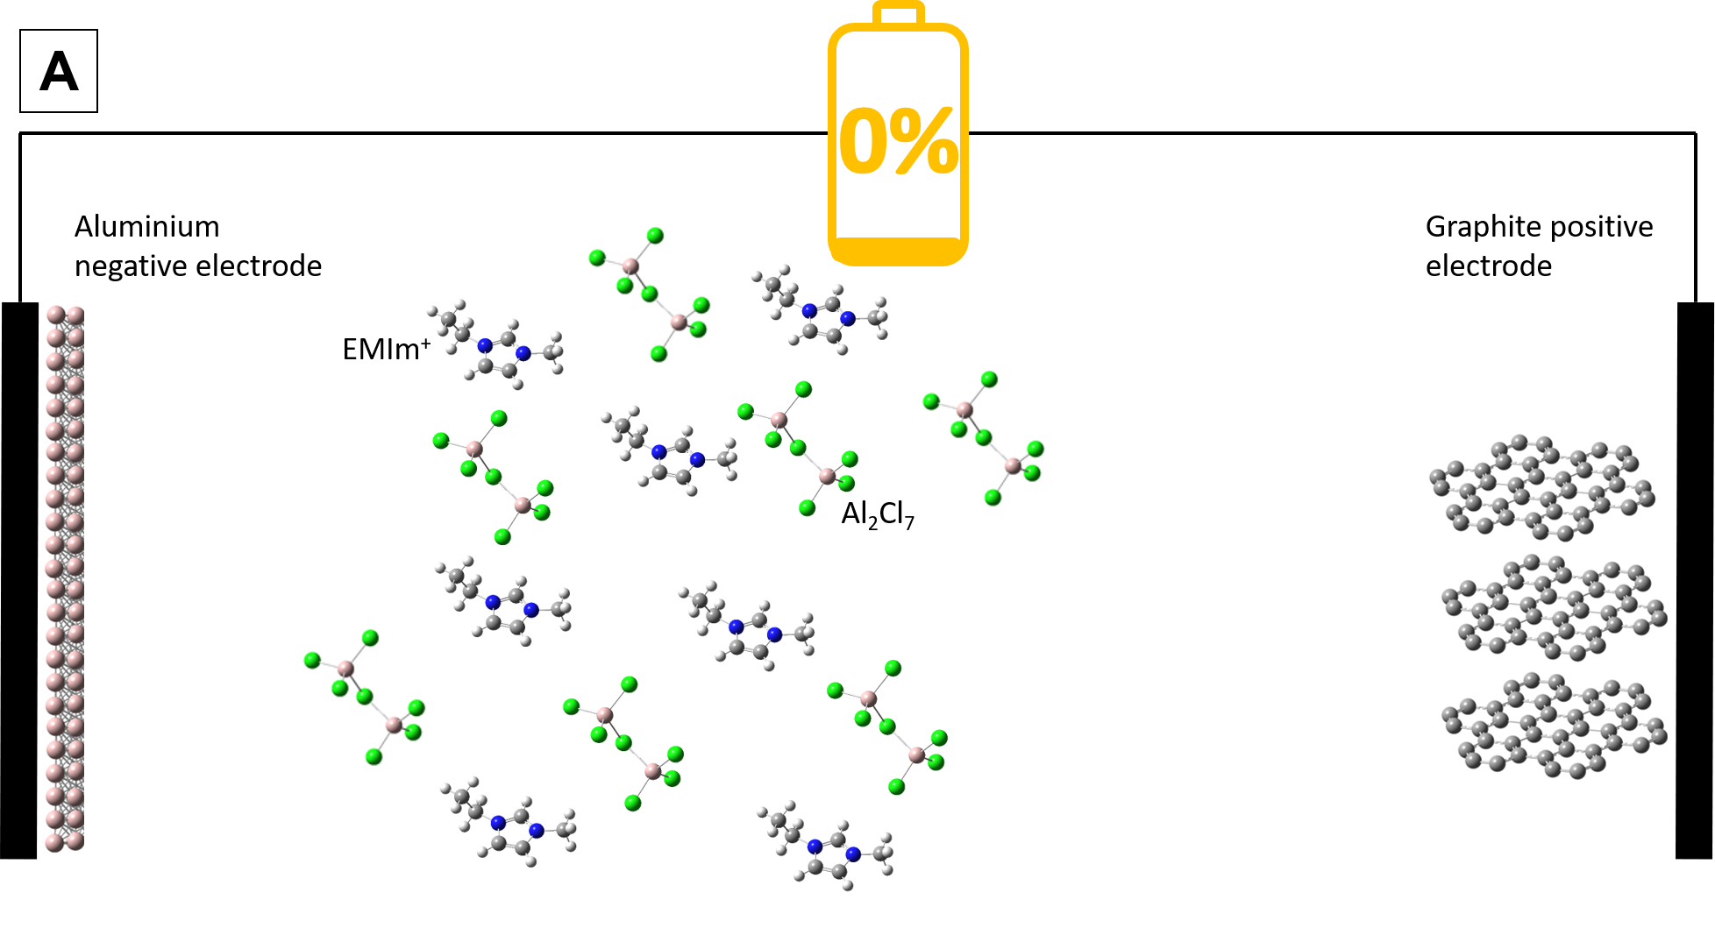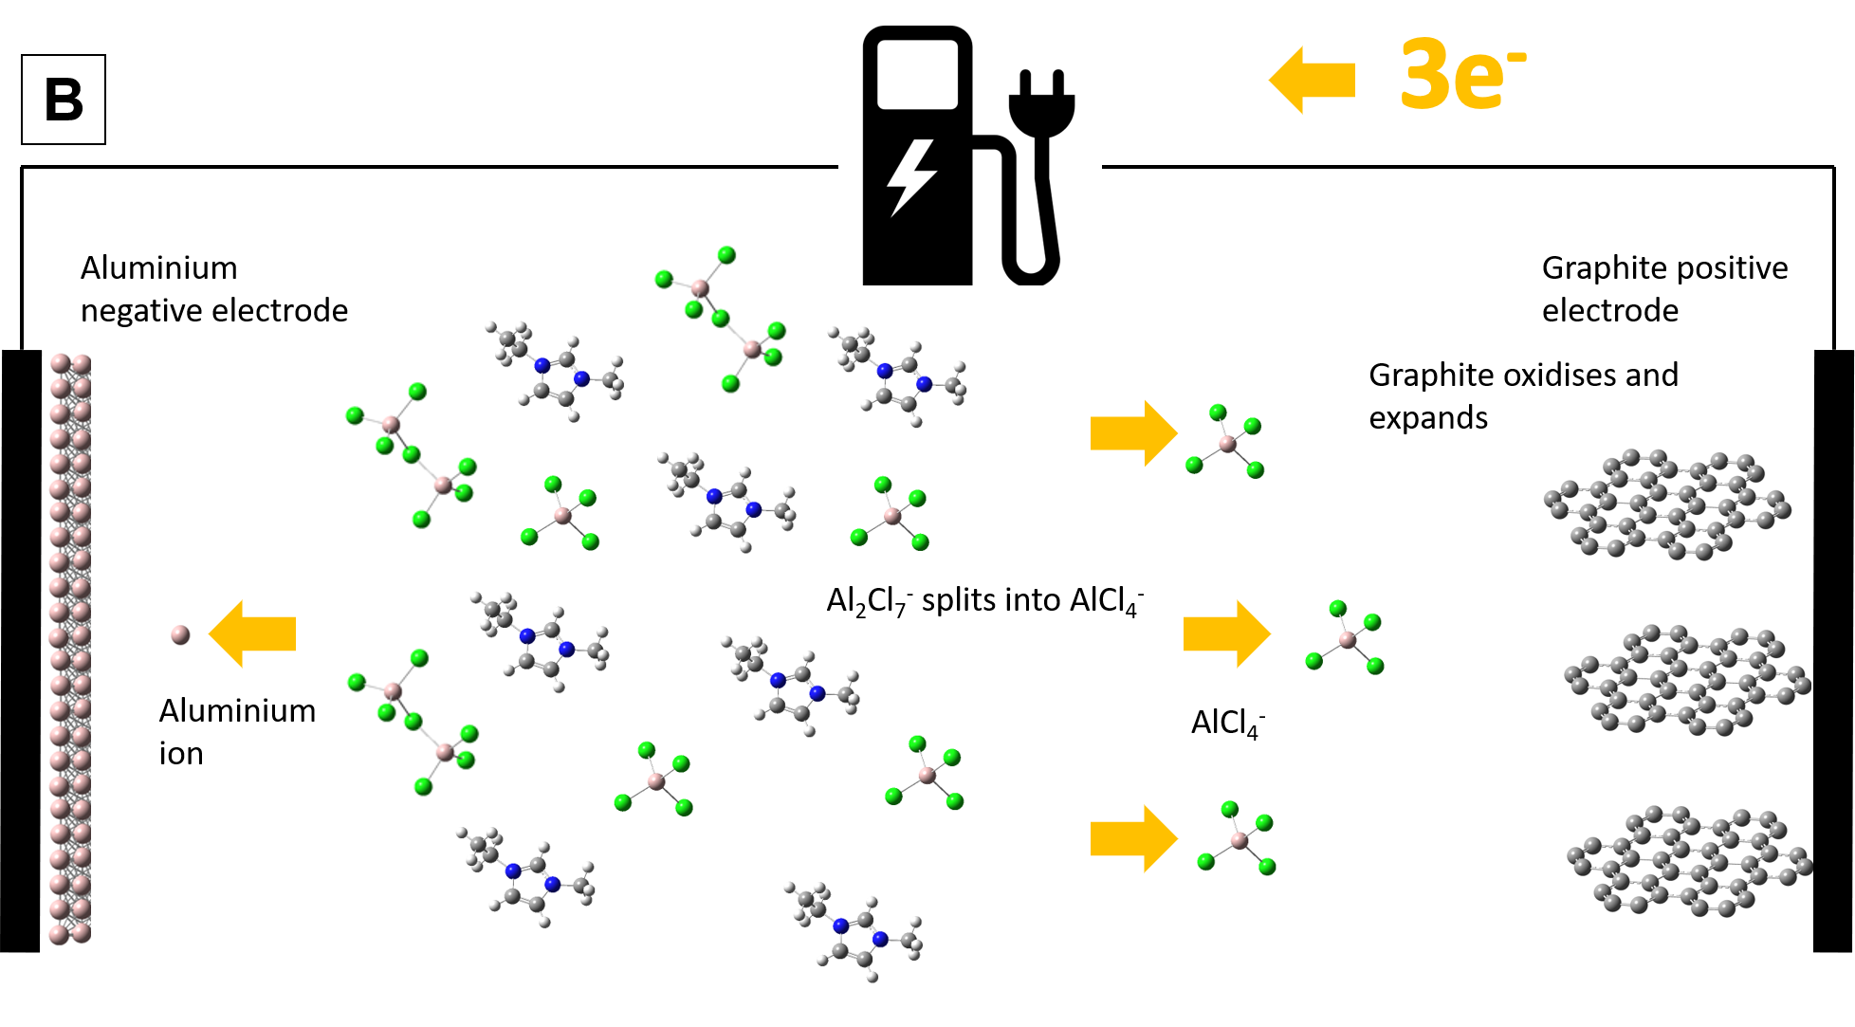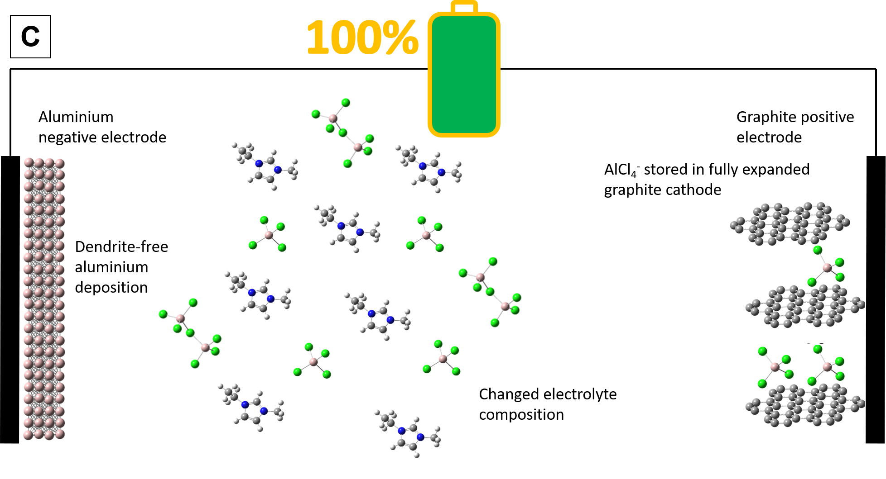

Figure 1 – Charging of a battery with aluminium negative electrode, graphite positive electrode and AlCl3-[EMIm]Cl electrolyte showing A) fully discharged, B) charging, C) fully charged (molecules drawn using Gaussview/Gaussian [44]).

Because both electrodes in the aluminium battery store species during charge and release them during discharge, the electrolyte must hold all the electroactive species when the cell is fully discharged. Because the electrolyte can only support a certain range of composition, the specific energy and energy density of the battery are dependent on the amount of electrolyte [42], unlike rocking-chair batteries where only enough electrolyte is required to saturate the electrodes.This has led some researchers to suggest that the electrolyte is actually the negative electrode and the batteries should be named aluminium-chloride batteries [42]. However, we simply refer to these systems as aluminium batteries [45]. The dependence on the quantity of electrolyte means that some authors have started to calculate energy density of aluminium batteries using the following formula. *F* is Faraday constant (26.8 × 103 mAh mol-1), is the number of electrons involved in reducing 1 mol of AlCl3 (0.75), *r* is the maximum molar ratio of the electrolyte (2), *QC* is the specific capacity of the positive electrode (in mAh g-1), and *M(AlCl3)* and *M(EMImCl)* are the molar masses of AlCl3 and EMImCl (133.34 g mol-1 and 146.62 g mol-1 respectively) [42].

${\text{Q}}_{\text{spec}}\text{=}\frac{\text{Fx(r-1)}{\text{Q}}_{\text{c}}}{\text{Fx}\left(\text{r-1}\right)\text{+}{\text{Q}}_{\text{c}}\text{(rM}\left({\text{AlCl}}_{\text{3}}\right)\text{+M}\left(\text{EMImCl}\right)\text{)}}$ Equation 2

This accounts for the entire volume of electrolyte required and the mass of active positive electrode in the discharged state (it is assumed that the fully discharged battery will have no active aluminium at the negative electrode at all). This limits the specific capacity of aluminium batteries to 48.6 mAh g-1 (in the limit of a positive electrode with infinite specific capacity) [13]. Using the highest value yet reported of 192 mAh g-1, for a PEDOT positive electrode, gives a full battery capacity of 39 mAh g-1 [46].

# Electrolytes for non-aqueous aluminium batteries

Over the history of aluminium electrochemical deposition, electrolyte research focus has progressed from organic solvents [47] to room temperature ionic liquids (RTILs). Even within these categories, the choice of electrolytes that are able to reversibly deposit aluminium over a useful electrochemical range is extremely limited [48]. RTILs are a significant improvement over organic solvents [49], which are volatile, flammable and only allow low current densities [33, 50], and to our knowledge organic electrolytes have never been used in aluminium battery research.

A suitable electrolyte for aluminium deposition must fulfil a number of criteria. The solute must be highly soluble in the solvent, but should not be held in solution so strongly that aluminium cannot be deposited. Reversible aluminium deposition/dissolution must occur within the electrochemical potential window bound by the limits at which electrolyte decomposition, electrode reaction with solvent, or other undesirable reactions occur. Finally, the electrolyte must have low viscosity at operating temperatures, in order to provide high ionic conductivity and mobility, so that the electrolyte does not contribute with a high resistance to the battery. It must also plate the aluminium negative electrode reversibly without dendrite formation [33, 51].

It is worth clarifying the differences between ionic liquids, molten salts, and deep eutectic solvents. Ionic liquids are liquid salts, consisting exclusively of weakly coordinated complex ions that are liquid below 100°C or at room temperature. Molten salts are liquefied salts at high temperatures (~800°C) and deep eutectic solvents are mixtures with a melting point much lower than their anionic and cationic components have on their own. The type of ionic liquids that are liquid at room temperature are called RTILs, and as batteries typically operate relatively near to this temperature, these are suitable candidates for battery electrolytes [19]. In fact, it is loosely conventional to describe any molten salt that is liquid below 100°C as a RTIL, but it is important to recognise that this distinction is arbitrary [52].

## Room temperature ionic liquids (RTILs)

The start of modern research on room temperature ionic liquids (RTILs) suitable for aluminium batteries began in the early 1970s, and by 1990, three RTILs had emerged: AlCl3-1-butylpyridinium chloride (AlCl3-[BP]Cl) [19, 53-55], trimethylphenylammonium chloride (AlCl3-TMPAC) [56, 57], and 1-methyl-3-methylimidazolium chloride ([EMIm]Cl) (synonymous with 1-ethyl-3-methylimidazolium chloride [56-60], and also known as EtMeImCl, MeEtImCl, MEIC and EMIC [58, 61]). Of these, [EMIm]Cl has the widest electrochemical window (0.8 V lower reduction potential than [BP]Cl), best liquidus temperatures and aluminium reactivity, while maintaining the conductivity, viscosity, Lewis acidity range, and solvation ability of the other salts. This has led to its almost exclusive use in current non-aqueous aluminium battery research [56-58, 62]. Relative to organic solvents, RTILs have good ionic conductivity, good thermal stability, low vapour pressure, and a wide electrochemical potential window [56], and can sustain much higher rates of deposition [33]. To date, applications for RTILs have included fuel cells, electrochemical capacitors, solar cells, lithium-ion and lead acid batteries, and electrolytes in sensors [63].

While tailoring of RTILs with various additives has been attempted for purposes such as reduced moisture sensitivity, these have not yet been explored in aluminium batteries. Extra additives would lower the specific energy, and it makes sense to avoid moisture completely through experimentation in inert environments [64]. Difficulties with AlCl3-[EMIm]Cl are mainly in its preparation, which must be done in an inert atmosphere due to the hygroscopicity of AlCl3, and slowly due to the exothermic nature of the mixing process. AlCl3 is low cost and widely available, but [EMIm]Cl is still a relatively niche component with a small supply chain, although it is made of abundant elements and large-scale manufacturing could probably make it economical. It is also hard to purify, and there is a lack of detailed information on its toxicity due to its use not yet having become widespread [60, 62, 63].Chloroaluminate Lewis acidic RTILs are highly corrosive, and AlCl3 reacts violently with water and is a severe irritant [49]; however these difficulties are mitigated by handling in a glovebox.

For optimal battery performance, moisture content should be as low as possible, again implying use of a glovebox. Even a low level of moisture significantly impairs coulombic efficiency due to HCl and Cl2 evolution [43]. As more water is added,the ionic nature of the mixture is reduced because large hydrogen-bonded clusters and networks formed of water molecules begin to form, separating the ions from each other and significantly altering the chemistry [65]. Water reduces the electrochemical potential window of RTILs; for example, from 4.10 V to 1.95 V in [BMIM][BF4] when 3 wt.% water is added. Finally, water can also react with ILs to create different electroactive species [66].

RTILs have a wide liquidus range that goes down to around -80°C [63], and AlCl3-[EMIm]Cl is thermally stable to +95°C; above which highly coloured decomposition products form [33, 67, 68]. While this wide temperature range seems appealing for batteries, the viscosity and hence ionic conductivity of RTILs is strongly dependent on temperature [69].At room temperature, a typical aqueous lead acid electrolyte conductivity is around 730 mS cm-1, while ionic liquids and lithium-ion electrolytes have conductivities in the region of 10-20 mS cm-1 [19]. It is possible to enhance the conductivity and reduce the viscosity of these melts without changing the types of species formed by adding organic solvent [55, 70], however this would reduce the ‘greenness’ of the mixture. Over the full liquidus range, RTILs have very low vapour pressure. This provides low volatility and is a major reason why ionic liquids are considered ‘green solvents’. This is attributable to high cohesive energy density, caused mainly by strong Coulombic interactions between the components of the ionic liquids [71].

### AlCl3-[EMIm]Cl chemistry

The speciation behaviour of AlCl3-[EMIm]Cl is largely responsible for the operation of the aluminium battery [49], so warrants detailed discussion. While [EMIm]Cl will always dissociate to [EMIm]+, the type of chloroaluminate species formed, and the Lewis acidity, depends on the molar ratio of AlCl3 to [EMIm]Cl. The parameter *r* is the molar ratio of AlCl3 to [EMIm]Cl. For example, *r* = 2 means 2 mol of AlCl3 to 1 mol of [EMIm]Cl. The effect of *r* on speciation is shown in Figure 2. If *r* < 1, a Lewis basic electrolyte containing AlCl4- and Cl- is produced. *r* = 0.5 is shown in *(a)*. If *r* = 1, a neutral mix results; this will contain only AlCl4-. *r* = 1 is shown in *(b)*. The deposition of aluminium is only possible from *r* > 1.1 liquids [72], where a large proportion of Al2Cl7- is present. The saturation limit of AlCl3 in [EMIm]Cl occurs at *r* = 2 and is shown in *(c)* [38].

As discussed, in the best performing aluminium batteries, chloroaluminate species are stored in the positive electrode during charge [42]. This causes *r* to increase as the battery is discharged, reaching a maximum when the battery is fully discharged and a minimum when the battery is fully charged. It is only possible to deposit aluminium for *r* values between 1.1 and 2 [42, 72] . This influences the chloroaluminate ions available to store in the positive electrode. At *r* = 1.1, the battery is fully charged and Al2Cl7- is depleted, so only AlCl4- is stored [42] while at partial charge levels both are present [13].

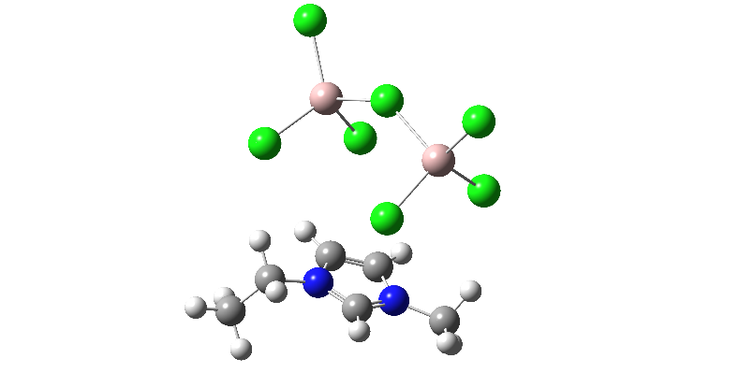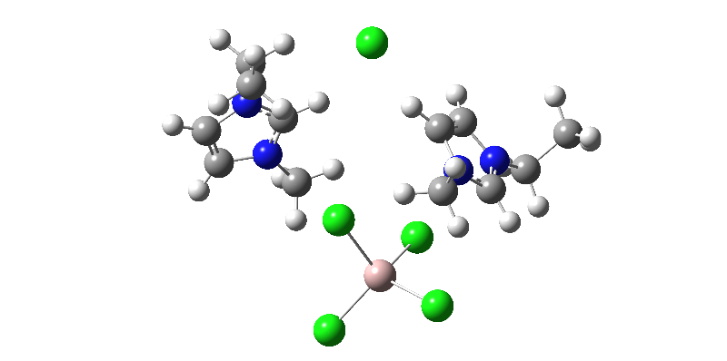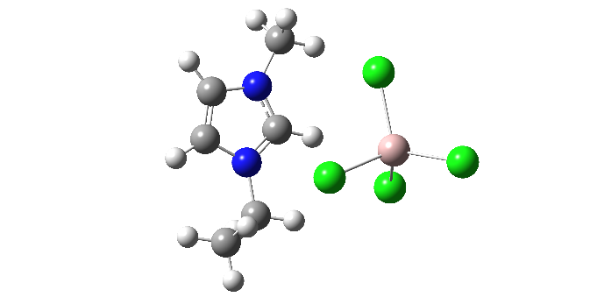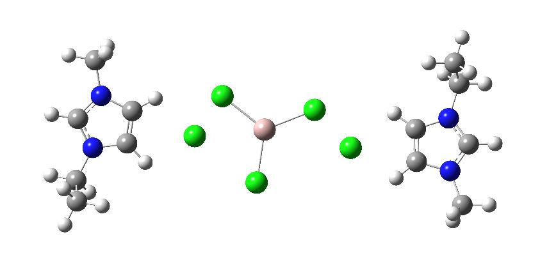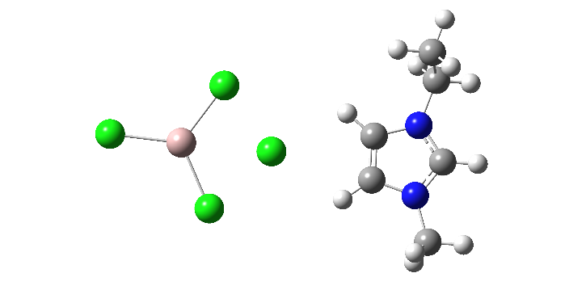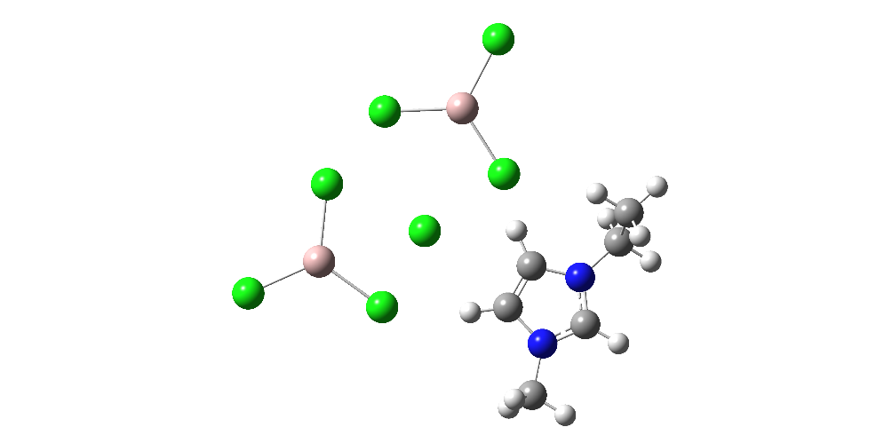

**A**

**B**

**C**

*r* = 2; 2 AlCl3 and 1 [EMIm]Cl form 1 EMIm+ and 1 Al2Cl7-

*r* = 1; 1 AlCl3 and 1 [EMIm]Cl form 1 EMIm+ and 1 AlCl4-

*r* = 0.5; 1 AlCl3 and 2 [EMIm]Cl form 2 EMIm+, 1 AlCl4- and 1 Cl-

AlCl4-

Cl-

AlCl3

[EMIm]Cl

EMIm+

AlCl4-

EMIm+

[EMIm]Cl

AlCl3

AlCl3

[EMIm]Cl

EMIm+

Al2Cl7-

Figure 2 - Formation of chloroaluminate species at different r values of AlCl3-[EMIm]Cl (molecule drawn using Gaussview/Gaussian [44]).

The balance of species present is driven by Equations 3 to 5. *K* is equilibrium constant and the given values are specific to AlCl3-[EMIm]Cl at 40°C [73].

${\text{Cl}}^{\text{-}}\left(\text{l}\right)\text{+}{\text{AlCl}}_{\text{3}}\left(\text{s}\right)\text{⇌}{\text{AlCl}}_{\text{4}}^{\text{-}}\left(\text{l}\right)\text{, }\text{K}\text{=1.6 × }{\text{10}}^{\text{19}}$ Equation 3

${\text{AlCl}}_{\text{4}}^{\text{-}}\left(\text{l}\right)\text{+}{\text{AlCl}}_{\text{3}}\left(\text{s}\right)\text{⇌}{\text{Al}}_{\text{2}}{\text{Cl}}_{\text{7}}^{\text{-}}\text{, }\text{K}\text{=1.6 × }{\text{10}}^{\text{3}}$ Equation 4

${\text{Al}}_{\text{2}}{\text{Cl}}_{\text{7}}^{\text{-}}\left(\text{l}\right)\text{+}{\text{AlCl}}_{\text{3}}\left(\text{s}\right)\text{⇌}{\text{Al}}_{\text{3}}{\text{Cl}}_{\text{10}}^{\text{-}}\left(\text{l}\right)\text{, }\text{K}\text{=1.0 × }{\text{10}}^{\text{1}}$ Equation 5

The very high equilibrium constant of Equation 3 shows that when Cl- and AlCl3 are mixed in equal proportions, the result will be the overwhelming formation of AlCl4-. The intermediate equilibrium constant of Equation 4 shows that when AlCl4- is combined with additional AlCl3, a mixture of AlCl4- and Al2Cl7- is formed. Finally the low equilibrium constant of equation 5 shows that when further AlCl3 is added to a solution already rich in Al2Cl7-, there is a low tendency for Al3Cl10- to form [74]. These equations combine to give Lewis acid/base behaviour for AlCl3-[EMIm]Cl that depends on the concentration of AlCl3 to [EMIm]Cl, whereby two amphoteric, uncharged solvent molecules undergo a Lewis acid transfer, as shown in Equation 6 [73].

${\text{AlCl}}_{\text{4}}^{\text{-}}\left(\text{l}\right)\text{+}{\text{AlCl}}_{\text{4}}^{\text{-}}\left(\text{l}\right)\text{⇌}{\text{Al}}_{\text{2}}{\text{Cl}}_{\text{7}}^{\text{-}}\left(\text{l}\right)\text{+}{\text{Cl}}^{\text{-}}\left(\text{l}\right)\text{, }\text{K}\text{=}{\text{10}}^{\text{-16}}$ Equation 6

In a Lewis neutral AlCl3-[EMIm]Cl liquid, the electrochemical limits are due to EMIm+ being reduced and AlCl4- being oxidised. This gives the widest electrochemical window – from around –2 V to +2.7 V *vs.* Al|Al(III), providing the electrolyte is free of moisture. For a Lewis acidic liquid however, Al2Cl7- reduces at 0 V to deposit aluminium on the electrode. In Lewis basic liquids, EMIm+ becomes the cathodic limit as Al2Cl7- is not present, but the presence of Cl- means that Cl- evolves before AlCl4-, reducing the anodic limit to about -1 V *vs.* Al|Al(III) [73]. Because EMIm+ is reduced before AlCl4-, aluminium cannot be deposited from AlCl4- within the electrolytic limits of the electrolyte, which is why only acidic electrolytes can be used for aluminium deposition/dissolution [67]. Above the discharge potential window of the electrolyte, side reactions involving Cl2 evolution from the electrolyte begin to occur, particularly above 2.6 V *vs.* Al|Al(III) [43, 75].A graph showing the electrochemical potential range of basic, neutral and acidic AlCl3-[EMIm]Cl is shown in Figure 3 [73].

*Figure 3 - Electrochemical potential range of AlCl3-[EMIm]Cl at Lewis basic (*r *= 0.89), neutral (*r *= 1.0) and acidic (*r *= 1.2) compositions (adapted from [73]).*

### RTIL gel electrolytes

Extending the electrochemical stability window of the ionic liquid electrolyte to – 2 V *vs.* Al|Al(III) would stabilise the [EMIm]+ sufficiently to allow deposition of aluminium from AlCl4-. Because the required quantity of electrolyte drives the specific energy and energy density of non-aqueous aluminium batteries storing chloroaluminate species at the positive electrode, this could substantially improve overall battery performance.

One promising way to achieve this is by the addition of a gelification component e.g. a polymer, though the amount must be carefully chosen as it will compromise the ionic conductivity [76-80]. The simplest approach is to introduce a small amount of non-reactive polymer into the ionic liquid, tangling the molecules of the ionic liquid, restricting their movement enough to give the electrolyte rubber-like or gel-like properties. These are referred to as gel electrolyte or ion gels, and suitable polymers include poly(phenylene oxide) (PPO), poly(methyl methacrylate) and poly(vinylidene fluoride) [77, 81]. However, these mixtures can experience problems such as phase separations, where some of the ionic liquid becomes separated from the polymer, which can lead to leakage [77]. It has been shown that simply by adding 10 wt-% PEO to an *r* = 1 AlCl3-[EMIm]Cl electrolyte, the potential stability window of the electrolyte can be increased by 1 V, but the coulombic efficiency of aluminium deposition/dissolution is brought down to below 60% [82].

Alternatively, it is possible to polymerize a component of the ionic liquid itself, for example the imidazolium cation, which would produce a polymeric ionic liquid (PIL). These also have low ionic conductivity (< 10−6 S cm-1) relative to ILs (10-2 S cm-1), raising the possibility of further tailoring by combining PILs with RTILs to gain a further intermediate compromise in electrolyte characteristics (10−3 to 10−5 S cm-1). Due to being molecularly close to ILs in the first instance, PILs mix better with ILs than polymers, potentially helping to avoid some of the aforementioned weaknesses with polymer/IL combinations [77].

## Deep Eutectic Solvents

A Deep Eutectic Solvent (DES) is a mixture of at least two components, which independently might be solids or liquids at room temperature, that when combined in a particular (eutectic) range of composition have a melting point up to 200°C lower than either constituent on its own [63] [83] [84]. Similar to ionic liquids, they contain a combination of Lewis or Brønsted-Lowry acids and bases that when solvated in one another form a range of species that may be anionic and/or cationic [85]. DESs are made of readily available, abundant, cheap materials, and are synthesised through simple mixing of the components [86], generating only moderate heat [83]. By intent, many DESs are more environmentally friendly than ILs, as in addition to having low vapour pressure, they commonly contain no components of known or unknown toxicity [63] [84]. Indeed, there is a subclass of DESs which are particularly benign, termed natural deep eutectic solvents (NADES), which consist only of bioavailable complexing agents such as choline, amino acids or their metabolites such as urea or sugars [84]. It may be that DESs are entering a period of rapid growth in research interest, as for ionic liquids in the 1990s [84]. DESs have already been used in a range of applications including electropolishing, synthesis of gold nanoparticles, metal oxide processing and biodiesel purification [63].

DESs are little researched for aluminium deposition [83] despite the work of a few key authors [87] but initial research is somewhat encouraging, with aluminium deposition demonstrated from DESs including AlCl3-4-propylpyriinde (4-Pr-Py) [88], AlCl3-acetamide [89], and AlCl3-urea with 1,2-dichloroethane [90]. The lack of Al2Cl7- means that AlCl3-4-Pr-Py is less water sensitive than AlCl3-[EMIm]Cl [88]. DESs have reduced electrochemical redox potential window relative to RTILs [63, 91] and poor ionic conductivity. Organic solvents could improve this but would make DESs less environmentally friendly [85, 90]. The composition range for aluminium deposition is also less (*r* = 1.1 to 1.5 for AlCl3-acetamide) than for AlCl3-[EMIm]Cl [89]. While DESs are generally less affected by moisture than chloroaluminate ionic liquids [63], these benefits are limited for those DESs containing AlCl3, which to date is all those from which aluminium has been deposited [87]. While worse performing than RTILs at the moment, it is possible that DESs may see developments in the future that increase their appeal.

# Aluminium Deposition and Dissolution

One of the key benefits of aluminium is its dendrite-free behaviour when deposited/dissolved at moderate current densities onto a suitable substrate such as aluminium, tungsten or planar vitreous carbon in chloroaluminate RTILs, a behaviour which it shares with magnesium [92]. The use of plain metal anodes is highly preferable to storing the active ions in a host negative electrode due to savings in mass, complexity and volume. Many metals used in batteries, including sodium, zinc and lithium, tend to form dendrites when the metal is repeatedly stripped and plated during charging [17, 28, 93], which has for example prevented the development of safe lithium metal batteries [17].

When aluminium is deposited from AlCl3-[EMIm]Cl, dendrites only form above current densities of 100 mA cm-2 [56]. This is due to plating occurring faster than diffusion can supply species from the electrolyte, causing preferential plating onto protruding parts of the electrode, leading to dendrite growth [27, 94]. Fortunately, current densities are much lower than this in batteries (80 C can be achieved at 10 mA cm-2) [95]. An Al-Ni3S2 battery with a LiAlCl4-NaAlCl4-NaAlBr4-KAlCl4 non-organic electrolyte functioned without dendrites at 70 mA cm-2 and below, and still without dendrites but with a slightly less dense plating from 100 to 706 mA cm-2 [96]. When electrodepositing aluminium from *r* = 2 AlCl3-[EMIm]Cl, dense plating has been achieved up to 70 mAh g-1 [56, 72]. Clearly, the choice of electrolyte is critical in obtaining a dendrite-free plating behaviour.

Aluminium negative electrodes in chloroaluminate electrolytes do not form a solid electrolyte interphase layer (a layer that forms on the electrode surface and separates it from the electrolyte) [97], so deposition and dissolution occur at the electrolyte/aluminium interface. Aluminium diffusion energy is less than 1/3 of that predicted by conventional diffusion mechanisms. This is due to an exchange-diffusion mechanism, where an aluminium atom with metallic bonding on the surface is extracted in exchange for another aluminium atom becoming covalently bonded [98-100]. This mechanism is the only exception known to the hard-sphere model of diffusion where an adatom will follow the lowest-energy diffusion route along a surface channel, and applies only to the (001) surfaces of platinum, nickel, aluminium and iridium [99]. Aluminium self-diffusion energy at 0.17 eV is nevertheless higher than either magnesium at 0.02 eV, which reliably plates without dendrite formation [101], or 0.14 eV for lithium and 0.16 eV for sodium, which do not [102]. However, the real benefit of the exchange-diffusion mechanism is that it has been shown in simulations to cause aluminium atoms to move down from protrusions and spread out across the plating surface in even layers, regardless of the diffusion energy [100].

Aluminium crystal structure is face-centred cubic (fcc) [92], which has a high coordination number of 12 [103], also supporting the development of a stable crystal structure through increased lattice stability. This is like magnesium, which also has a co-ordination number of 12 due to its hexagonal close packed (hcp) structure. In contrast, lithium and sodium are both body-centred cubic (bcc) with a lower co-ordination number of eight [93, 104]. The mechanism is that higher co-ordination number metals have a higher driving force to re-organise into high-coordination configurations, which tend to be achieved better by a dense, even layer rather than through dendrite formation [105].

Most papers reporting on aluminium deposition from ionic liquids found that instantaneous nucleation occurred (from AlCl3-BMIC, AlCl3-[EMIm]Cl [56, 106] and AlCl­3-TMPAC [67])**,** with only one paper reporting progressive nucleation (also from AlCl3-[EMIm]Cl) [107]. When plated from ionic liquids, aluminium follows a hemispherical (3D) growth process, which means that as the initial nuclei grow on the surface, the electroactive species are drawn from the electrolyte, creating a diffusion zone with a deficiency of electroactive species in the electrolyte. The diffusion zone grows ahead of the hemispherical nuclei into the electrolyte (hence 3D growth), and creates a ‘shadow’ region of electroactive species depletion on the electrode face, creating an exclusion zone where nucleation can no longer take place so that new nucleation is forced to take place elsewhere [107]**.** The hemispherical nuclei grow by diffusion until they meet. At this point, they coalesce into a layer (going from a 3D growth mechanism to a 2D planar growth mechanism) [67].

Once a crystal structure is established in the layer, further growth of the layer may be limited by either diffusion or kinetic rates, whichever is slowest [108]. At all but the lowest current densities [97], aluminium layer growth is diffusion limited [67, 97, 107]. Aluminium can be deposited either directly onto a suitable substrate such as vitreous carbon or an aluminium seed layer [42]. High coulombic efficiency of stripping and plating have been achieved in both organic and RTIL electrolytes, with > 99 % achievable in both AlCl3-[EMIm]Cl [109] and some organic solvents [110]. Figure 4shows SEM images of aluminium deposits obtained from *r* = 2 AlCl3-[EMIm]Cl at 60°C for 20 minutes. The top two images refer to deposition at -0.15 V *vs.* Al|Al(III) and the bottom two images to deposition at -0.30 V *vs.* Al|Al(III): the close up pictures show a dense even packing of aluminium crystallites.

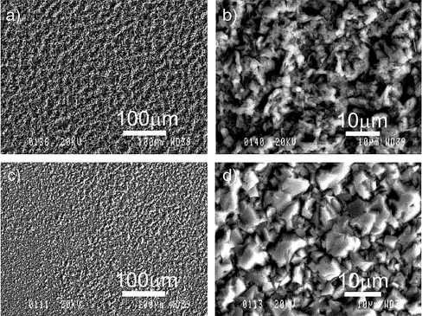

Figure 4 – SEM micrographs of aluminium electrodeposits prepared on Al electrodes from 2:1 molar ratio AlCl3–[EMIm]Cl ionic liquids at 60 °C for 20 min. The deposition potentials are − 0.15 V (a) and b)) and − 0.30 V (c) and d)), respectively. On the right are the higher magnification micrographs displaying more details of the aluminium crystallites. (Reproduced with permission from the Journal of Surface and Coatings Technology [56]).

A significant factor when dealing with aluminium is the oxide layer that forms upon exposure to air, which reaches a thickness of around 32 Å after just 10 minutes of exposure [111]. This is an important consideration for manufacturing aluminium batteries, as the oxide layer is insulating, requires additional processing steps to remove, and requires that oxygen must be excluded during battery assembly to avoid its formation [16, 56]. This oxide does not build up if the aluminium is deposited in an inert atmosphere such as inside a glove box. Researchers have also tried to remove the oxide layer from an aluminium negative electrode before experimentation, which is very difficult outside of an inert atmosphere because of the speed with which aluminium re-oxidises in the presence of any oxygen [56, 97]. This is an important issue to bear in mind when analysing or carrying out research into aluminium deposition/dissolution.

The cyclic voltammogram of aluminium deposition is shown in Figure 5. The C (cathodic) area corresponds to the deposition of aluminium and the A area (anodic) to the dissolution; the subscript 1 refers to deposition and dissolution of nanocrystalline aluminium, while 2 refers to deposition and dissolution of microcrystalline aluminium [112]. Above 0.8 V, passivation of the electrode causes the current density to drop to zero [56].

Figure 5 – Cyclic voltammograms of aluminium deposition on a tungsten electrode in r = 2 AlCl3-[EMIm]Cl at sweep rates of 10 mV s-1 (green), 20 mV s-1 (blue), 50 m V s-1 (red) and 100 mV s-1 (black). (Reproduced under Creative Commons 4.0 [https://creativecommons.org/licenses/by/4.0/] from [112])

# Positive electrode materials for non-aqueous aluminium batteries

Positive electrodes for non-aqueous aluminium batteries can be divided into two categories: those that store chloroaluminate species, which have been shown to have high performance, and those that store aluminium, which have not. However, research continues into positive electrodes that store aluminium because if good performance could be obtained, the quantity of electrolyte required would be dramatically reduced, as it would no longer have to buffer a compositional change, and so the specific energy of the battery would be greatly increased. Of the materials discussed, graphite, conducting polymers and iron chloride all store chloroaluminate species. Sulphur, vanadium-based positive electrodes, and transition metal sulphides, and anthraquinone electrodes all store aluminium. Proposed positive electrodes that demonstrated no actual storage behaviour in experiments, such as MnO2, have been omitted [113].

The highest observed specific energy of an aluminium battery with a graphite negative electrode is about 68 Wh kg-1. This takes into account the required quantity of electrolyte mass (AlCl3-[EMIm]Cl, *r* = 2 when fully discharged), as calculated via Equation 2 [114]. Applying the same analysis to PEDOT gives a specific energy of 50 Wh kg-1 [46]. In comparison, lithium-ion, based on active components only, can achieve specific energies of over 500 Wh kg-1 [10], while commercial lithium-ion cells (including the mass of the battery pouch or case) achieve around 250 Wh kg-1 [22]. Figure 6 demonstrates full cell specific energies *vs*. demonstrated cycle life for some of the discussed positive electrode materials, with lithium-ion included (active materials only) for comparison.

Figure 6 – Specific energies of some research positive electrode materials vs. lithium ion [10, 13, 40-43, 46, 115-117]

## Positive electrodes storing chloroaluminate anions

### Graphite

The first attempt at a rechargeable aluminium battery with a graphite positive electrode was in 1988 [72]. There were no further publications until 2013 [118], but then took off in earnest from 2015 [43], when Lin et al produced a battery with a graphitic foam positive electrode that had a cycle life of 7500 cycles, a discharge potential near 2 V *vs.* Al|Al(III), and a coulombic efficiency of 98%. Since then several papers, both experimental and theoretical, have been published investigating various graphite positive electrodes (see Table 1 for the characteristics of many of the reported aluminium-graphite batteries). With a flat discharge potential profile of 1.8-1.9 V *vs.* Al|Al(III) [43, 114, 119, 120], > 65 C rate capability, coulombic efficiency > 98% [43], round trip efficiency > 80% [42] [114] and achievable specific energy of around 65 Wh kg-1 [43, 114], aluminium-graphite batteries already compare favourably to lead acid and vanadium redox flow batteries, indicating their potential for large scale grid storage [121]. The cell equation for the Al-graphite battery is shown by Equation 8 [43]:

$\text{4}{\text{Al}}_{\text{2}}{\text{Cl}}_{\text{7}}^{\text{-}}\text{+}{\text{C}}_{\text{x}}\text{⇌}{\text{C}}_{\text{x}}\left[{\text{7AlCl}}_{\text{4}}^{\text{-}}\right]\text{+Al}$ Equation 8

Graphite is used ubiquitously in lithium-ion batteries as an intercalation negative electrode [37]. In aluminium batteries, however, it is used as an intercalation positive electrode with an aluminium negative electrode. While aluminium cannot intercalate into graphite, chloroaluminate anions can [122, 123]. The charge/discharge of a battery with *r* = 1.5 AlCl3-[EMIm]Cl electrolyte and a pyrolytic graphite positive electrode undergoing galvanostatic cycling at 25°C is shown in Figure 7, which shows the initial cycle development (a), very flat discharge potential (a), good life cycle stability (b) and high coulombic efficiency (c) of the aluminium-graphite battery.

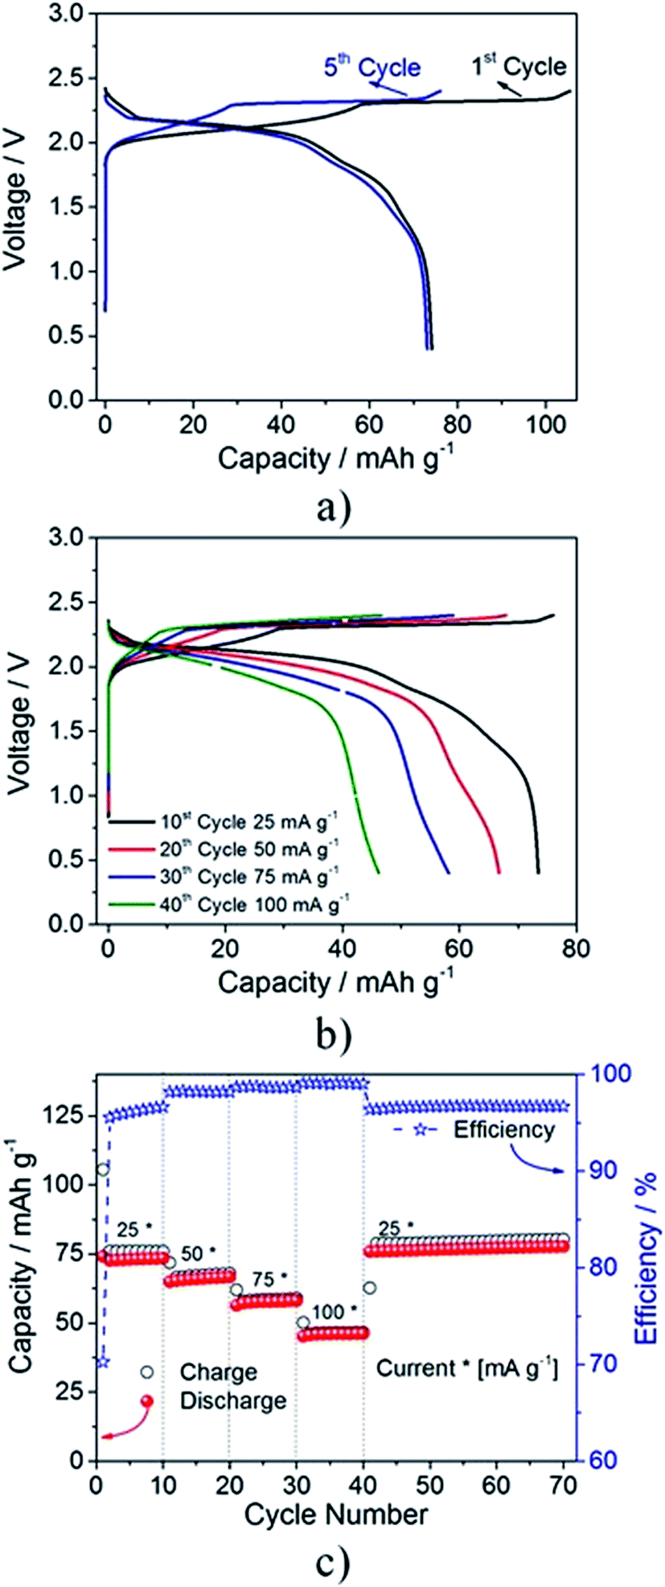

Figure 7 – Charge/discharge curve of an aluminium-graphite battery showing discharge potential at 1st and 5th cycles (a), discharge potential at different current densities (b) and coulombic efficiencies and specific charge/discharge capacities at different current densities. (Reproduced under Creative Commons 3.0 [https://creativecommons.org/licenses/by/3.0/] from [119])

While compact lithium ions intercalate easily into round, smooth graphite particles, the much larger chloroaluminate species work far better with a low-defect flaky or foamy morphology (see Table 1). This is because the positive electrode must easily expand to accommodate bulky anion intercalation between the layers of graphite. Pristine (very low defect) graphite flakes allow up to 80% geometric volumetric expansion and fast rates (notably, this is an 80% expansion of the entire positive electrode, which would be difficult to accommodate in a commercialised cell) [42]. Meanwhile, pyrolytic graphite has a very low rate capability and around half the capacity due to covalent bonding between the layers constraining expansion [43]. The high rate capabilities and flat discharge potential profiles observed with graphitic foam [43] and graphite flakes [114] are explained by the fact that all of the possible intercalation positions have very similar and very low energy, so the barrier to AlCl4- diffusion in graphite is very low (10 × lower than for lithium) [124]. Graphite has a planar structure, and is described in terms of gallery height, which is the distance (d) between the planar graphite layers (3.34 Å for un-intercalated graphite), and in terms of intercalation stage. This is the period of the repeating sequence of single occupied layers separated by a number of unoccupied layers. Figure 8 shows a stage 1 single layer intercalation in A, a stage 4 single layer intercalation in B, and a stage 4 double layer intercalation in C.

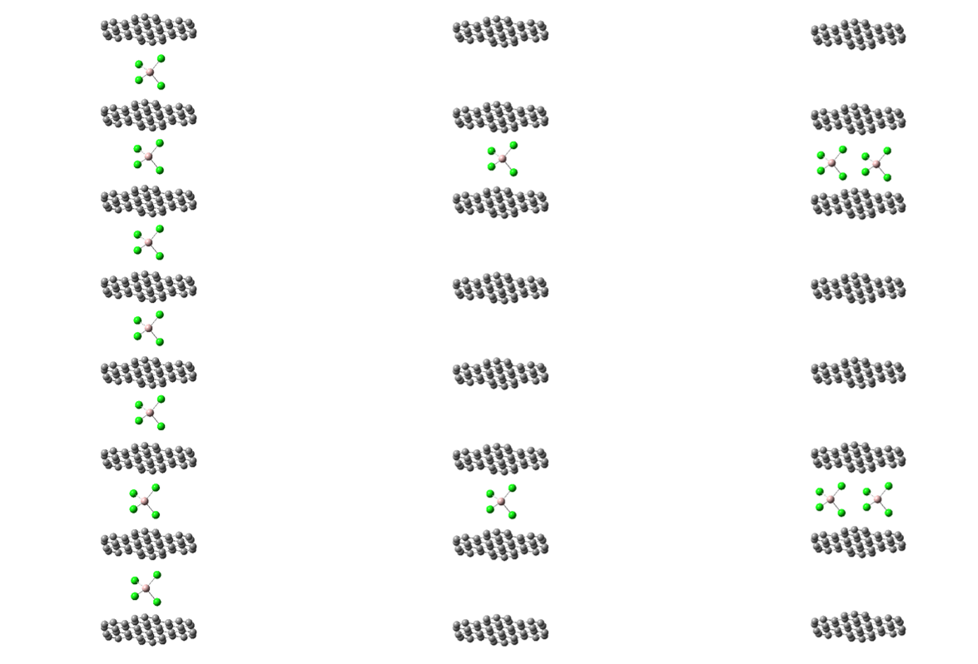

Intercalant

Gallery height

**A**

**B**

**C**

Figure 8 - A) Stage 1 single layer intercalation of graphite, B) Stage 4 single layer intercalation of graphite, C) Stage 4 double layer intercalation of graphite [120] (molecules drawn using Gaussview/Gaussian [44])

Researchers have used density functional theory (DFT) and experimental analysis to understand the performance of chloroaluminate intercalation in graphite and to establish the preferred intercalation. One publication suggests that graphite exists in a planar quadrangle structure in graphite [124], but most papers conclude that tetrahedral AlCl4- intercalation occurs [120, 125, 126].

When intercalation occurs, the gallery height of graphite increases. Both modelling and experimentation suggest an increase from a well-defined initial value of ~3.34 Å (all graphite types, experiment and modelling), to values including 5.7 Å (experimental result, pristine graphite foil) [43], 6.025 Å (DFT model, bulk graphite) [124], 8.81 Å [125] (DFT models, bulk graphite), and 8.9 – 9.3 Å (DFT model, bulk graphite) [122]. These papers all presented DFT modelling results showing that Stage 4 intercalation is the preferred state, although one paper [126] further suggested that Stage 4 would be preferred initially, but as the positive electrode reached full capacity it would shift to Stage 1 intercalation. For bulk graphite, capacities were estimated at ~70 mAh g-1 [125, 126], close to the theoretically observed values from [43] for pyrolytic and natural graphite. In contrast, another paper presented strikingly different results, achieved by modelling the graphitic foam from [43] as a few-layered structure. The diffusion rate was very sensitive to the number of adjacent layers modelled: the rate for 4-layer foam was 48× faster, and two layers 225× faster than for bulk graphite. This paper also proposed stage 3 and 4 double stacking even in bulk graphite, with gallery height up to 12.4 Å for bulk graphite and 13.3 Å for graphitic foam, and capacity up to 117 mAh g-1 [127]. These results are closer to those obtained for types of graphite flakes (124 – 142 mAh g-1) [42, 114], implying that the DFT modelling approach must fully account for the positive electrode microstructure, because gallery height expansions of this kind cannot be expected to be accommodated by the bulk graphite microstructure.

This wide range of results suggests that a consensus has not yet been reached on the mechanism of AlCl4- storage in graphite; this is partly because of comparison of models and experimental results carried out on different forms of graphite. Modelling has also not yet accounted for the cycling effects on graphite: initial cycles demonstrate poor reversibility and capacity [72, 119], with initially large and then gradual improvements over subsequent cycles, as chloroaluminate anions and EMIm+ cations forcibly alter the microstructure, with some remaining in the positive electrode permanently. The scale of the improvement can be as large as 45 mAh g-1 on the first cycle to 65 mAh g-1 on the 500th cycle [119].

Table 1 – Key performance characteristics of aluminium-graphite battery systems to date

| Positive electrode | Electrolyte | Discharge Potential (V) | Coulombic Efficiency (%) | Cycle Life achieved | C rate achieved | Positive electrode specific capacity (mAh g-1) | Specific Energy (Wh  kg-1) | Reference, year |
| --- | --- | --- | --- | --- | --- | --- | --- | --- |
| Graphite powder w. polysulfone binder | AlCl3-DMPrICl  r = 1.5 | 1.7 | 80 - 90 | 195 | 0.25 | 35 to 40 | - | [72] (1988) |
| Fluorinated graphite | AlCl3-[BIM][Br]  r = 0.5 | 0.6 | 75 | 40 | 3 | 300 | - | [118] (2013) |
| Pyrolytic graphite | AlCl3-[EMIm]Cl  r = 1.3 | 1.8 | 98.1% +/- 0.4 | > 200 | 1 | 60 – 66 | 40 | [43] (2015) |
| Natural graphite | AlCl3-[EMIm]Cl  r = 1.3 | 1.8 | - | - | 1 | 60 – 66 | 40 | [43] (2015) |
| Graphitic foam | AlCl3-[EMIm]Cl  r = 1.3 | 1.7 | 97% +/- 2.3 | 7500 | 75 | 60 | 40 | [43] (2015) |
| Kish graphite flakes | AlCl3-[EMIm]Cl  r = 2 | 1.8 | - | 200 | 67 | 142 | 65 | [114] (2017) |
| Natural graphite flakes | AlCl3-[EMIm]Cl  r = 2 | 1.8 | Up to 99 | 100 | 7.9 | 124 | 62 | [42] (2017) |
| Natural graphite flakes | AlCl3-[EMIm]Cl  r = 1.3 | 2.1 | 99 | 6000 | 6 | 110 | 69 | [120] (2017) |
| Pyrolytic graphite | AlCl3-[EMIm]Cl  r = 1.5 | 1.9 | 96 - 99 | 2000 | 1.3 | 75 | - | [119] (2017) |
| Zeolite-templated carbon | AlCl3-[EMIm]Cl  r = 1.3 | 1.05 | 99-100 | 1000 | 4.5 | 175 | 64 | [75] (2017) |

While positive electrode capacity and discharge potential are highest at around *r* = 1.3-1.5 [42, 43, 114], this is mooted by the requirement to cycle between *r* = 2 and *r* = 1.1 to maximise specific energy. The use of *r* = 2 electrolyte is required to achieve 65 Wh kg-1, which is close to the theoretical maximum possible using aluminium-graphite batteries with RTIL electrolyte [42, 114]. The future of graphite intercalation looks to more exotic architectures of carbon to achieve greater specific energy. One potentially promising area of research is single walled carbon nanotubes, which have the advantage of potentially being able to be sized optimally for AlCl4- intercalation. Modelling has indicated the potential for a 275 mAh g-1 specific capacity [128]. However, the improvements achievable from novel carbon architectures are marginal due to the dependency of the specific energy on the amount of electrolyte present. Currently, flaky graphite positive electrodes offer the best performance overall in non-aqueous aluminium batteries due to their high average discharge potential, long cycle life, and reasonable specific capacity.

### Conductive polymers

The field of conductive polymer research has been active for more than 40 years, since it was discovered that conjugated polyacetylene chains had semiconductor behaviour which could be enhanced via exposure to chlorine or bromine gas [129]. While polyacetylene was the first to be discovered, it was unstable in oxygen, and experienced decreasing conductivity with time. Further development led to (amongst others) the more stable polypyrrole and polythiophene, and then to poly-3,4-ethylenedioxythiophene (PEDOT). Conductive polymers have the advantage of low density compared to metals (1.46 g cm-3 for PEDOT relative to 8.96 g cm-3 for copper), offering the opportunity for high specific energy electrodes [130]. So far, conducting polymers have found applications in organic solar cells, organic light emitting diodes, and various kinds of sensors and processors, due to the combination of optical and electrical characteristics [131]. PEDOT is also showing promise in supercapacitors [132].

Conductive polymers store charge via oxidation of the pi-conjugated carbon backbone. As electrons are removed, the charges localise at specific points along the polymer chain due to energetically favourable relaxation of the molecular structure; these ‘defects’ cause geometry deviations from the equilibrium neutral geometry that each affect several chain units. However, they remain mobile. When anions are introduced however, they coordinate near the polymer (Figure 8 indicates the typical arrangement of an AlCl4- anion near a PEDOT chain) to counterbalance the missing electrons and balance the polymer charge. This effectively pins the localised charges in place, helping to spread the charges throughout the polymer bulk and increasing conductivity, which occurs due to electron transport between defects [133]. The exact mechanism of electrical conduction in polymers is not entirely defined, partly because it actually involves several mechanisms [134-136]. Figure 9 illustrates the storage of AlCl4- in PEDOT, while the reaction is given in Equation 9 [95]:

${\text{3[MonomerUnit]}}_{\text{α}}\text{+}{\text{4Al}}_{\text{2}}{\text{Cl}}_{\text{7}}^{\text{-}}\begin{matrix}\text{charge} \\ \text{⇌} \\ \text{discharge} \end{matrix}\text{3}{\left[\text{MonomerUnit}\right]}_{\text{α}}{\text{Al}{\text{Cl}}_{\text{4}}}^{\text{-}}\text{+Al+}{\text{4AlCl}}_{\text{4}}^{\text{-}}$ Equation 9

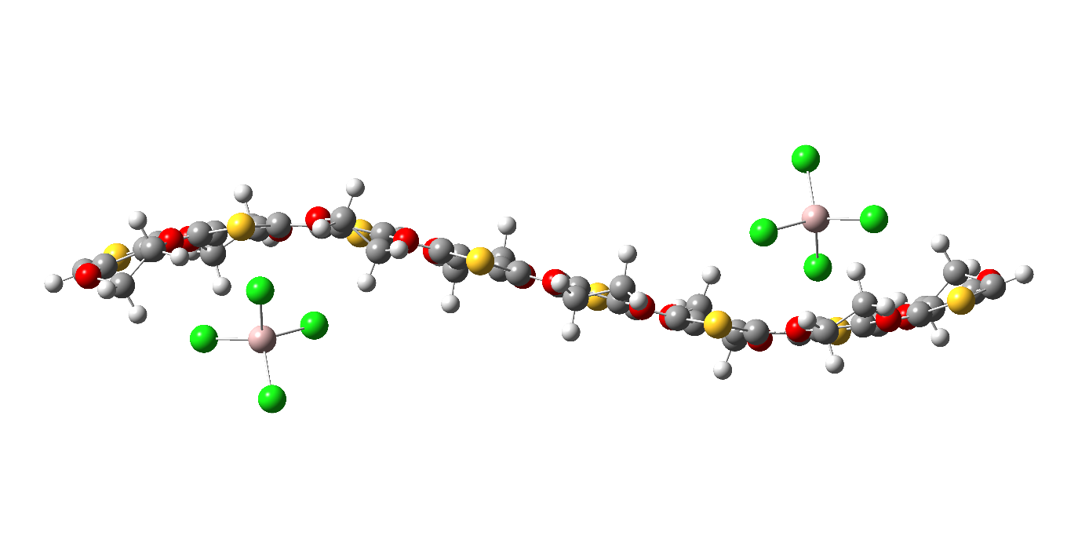

Figure 9 – Coordination of AlCl4- anions near the sulphur atoms in the PEDOT chain. Molecule optimized and visualized using Gaussview/Gaussian at the B3LYP 6-31+G(d) theory level with Grimme's D3(BJ) dispersion corrections [44, 137].

The possible range of concentration of inserted anions in a conducting polymer is large (possibly up to one anion per chain unit) [46, 138], which allows a conducting polymer to store anions in a cathodic capacity [2]. Anion insertion into polymers is analogous to anion intercalation into graphite. Intercalation involves storage of an ion in specific sites in the crystal lattice or between layers of the material, whereas insertion involves storage near preferential locations on a polymer which may have an amorphous or partially crystalline structure. Polypyrrole, polythiophene and PEDOT have all been trialled in non-aqueous aluminium batteries and are discussed here [13, 46]. PEDOT is synthesized from polythiophene. Thiophene is sourced from fossil fuels, from which it is removed by necessity to reduce sulphur emissions; therefore it is abundant, maintaining the benefits of aluminium batteries [139, 140].

#### Polypyrrole and Polythiophene

Hudak [13] investigated polypyrrole and polythiophene electrodes with an aluminium negative electrode and AlCl3-[EMIm]Cl *r* = 1.5 electrolyte. Polypyrrole was electropolymerized and the counterions inserted in the same electrolyte using galvanostatic polarization. Elemental analysis was used to determine the molar ratio of chlorine to aluminium, and the ratio of the two chloroaluminate species present was calculated to be 77.7 mol % AlCl4- and 22.3 mol % Al2Cl7-. Furthermore, the percentage of anions relative to polymer units was found to be 24.6 %. The polymers stored charge via a faradaic redox reaction until the redox potential of this process was exceeded. Above this, non-faradaic charge storage occurred, likely via a double-layer capacitor effect – in its neutrally charged form, the polymer is non-conductive, so non-faradaic charge storage can only take place once it has been oxidized. In addition to having better coulombic efficiency (> 98 % *vs.* > 96 %), polypyrrole withstood over-oxidation better than polythiophene, however, polythiophene had a slightly higher average discharge potential (1.47 V *vs.* 1.42 V). The charge/discharge is broadly reversible (> 96 % coulombic efficiency) so long as the discharge potential is kept between 0.1 and 2.0 V *vs.* Al|Al(III). Above 2.6 V, the authors proposed that the films reacted with the chloroaluminate species. Even above 1.5 V *vs.* Al|Al(III) however, some irreversibility was seen. In conclusion, maximum specific energies of 44.4 Wh kg-1 for polythiophene and 46.4 Wh kg-1 for polypyrrole were calculated based on the electrolyte and the active electrode mass. The specific capacity of the polymer films was estimated to be 30-100 mAh g-1, meaning that polypyrrole and polythiophene fall behind graphite flakes in terms of both average discharge potential and specific positive electrode capacity [13].

#### PEDOT

Poly(3,4-ethylenedioxythiophene) (PEDOT) (Figure 8), patented in 1988 [141], was initially developed to overcome the toxicity risks of polyaniline chemistry while still being soluble and fusible. PEDOT is extremely stable when charged and discharged, and has a moderate band gap [142, 143]. It can be synthesized to have higher potentials in an aluminium battery than polypyrrole or polythiophene [144]. PEDOT has found application in anti-static coatings, supercapacitor electrodes, hole injection layers in OLEDs and organic solar cells [145]. PEDOT can either be made into a free-standing film [77, 146, 147], or it can be combined with other materials such as non-conductive polymers to improve its mechanical properties [130]. All these properties point to PEDOT as a candidate positive electrode for aluminium batteries.

A PEDOT positive electrode can be electropolymerized at up to 2.3 V *vs.* Al|Al(III) in AlCl3-[EMIm]Cl before reaching the electrolytic breakdown of the ionic liquid, showing that it may have the potential to withstand even higher potentials if a suitable electrolyte is found. The charge/discharge potential of the synthesized electrode in a battery is limited by the maximum potential reached during electropolymerization. Higher potential electropolymerization is theorized to lead to a denser, cross-linked network of longer PEDOT chains which have higher potential anion insertion sites. The mechanism is not yet confirmed [80]; it is anticipated that computational techniques may reveal the mechanisms behind this phenomenon.

The discharged PEDOT film has a granular structure. As it is charged, it undergoes morphological changes, where the grains first expand, then merge. When the electrode is discharged, a new granular structure is formed. This mechanism is illustrated in Figure 10 [148].

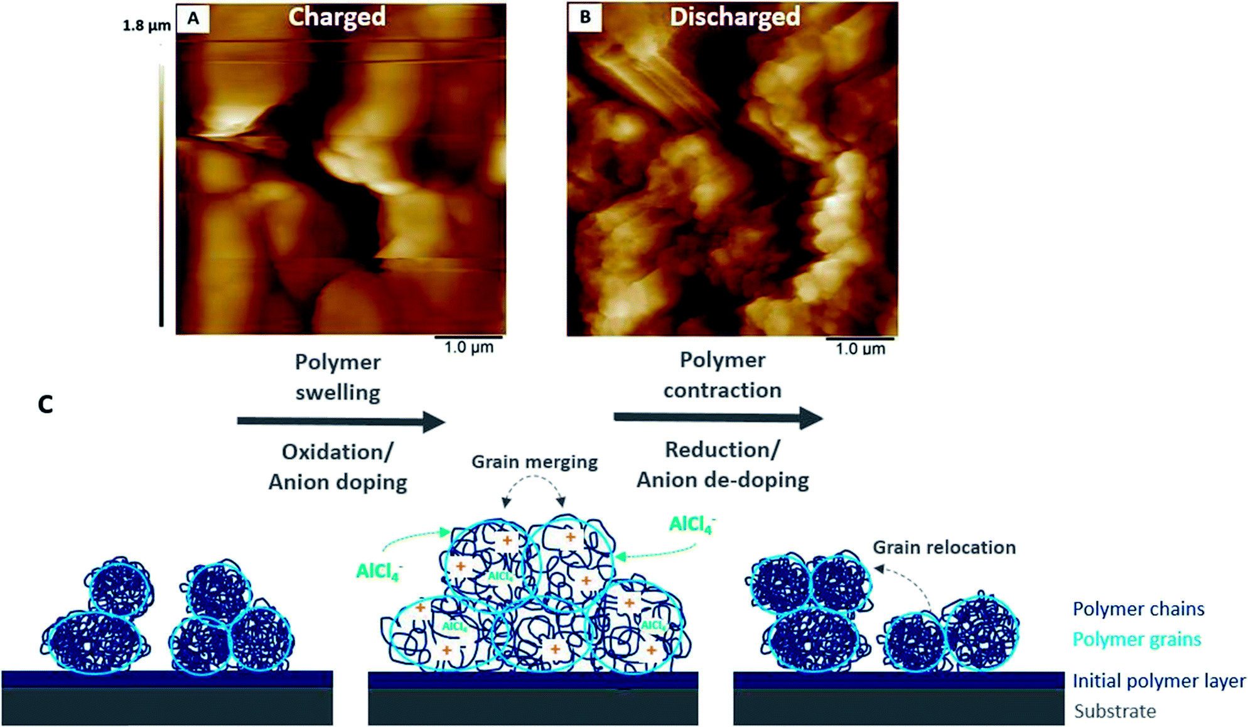

Figure 10 - Mechanism of charge storage in PEDOT (reproduced under Creative Commons 3.0 [https://creativecommons.org/licenses/by/3.0/] from [148]). AFM images of PEDOT in monomer-free Lewis neutral EMImCl–AlCl3 in the fully (A) charged and (B) discharged states and (C) schematic model of the morphological changes of a conductive polymer in an ionic liquid during charging (oxidation, anion insertion) and discharging (reduction, anion removal).

Improved structural stability and surface area of a PEDOT electrode can be achieved by using a three-dimensional reticulated vitreous carbon (RVC) substrate instead of planar vitreous carbon. The PEDOT forms a uniform film over the surface of the RVC without blocking the holes in the macrostructure, allowing for much greater surface area and improved mechanical properties relative to a planar film. The electropolymerization process was successfully reproduced on 3D RVC. The optimum method is cyclic voltammetry, from -0.5 V to 2.6 V *vs*. Al|Al(III). This is hypothesised to be due to the formation of anion paths in the polymer during repeated cycling, whereas at constant current or potential, there is no anion removal during electropolymerization. With this method, the PEDOT electrode has around 45% higher capacity than the planar carbon electrode, and has demonstrated structural stability over 250 cycles, with a coulombic efficiency of 94%. The use of a porous carbon current substrate is convenient for battery packaging, because it provides a fixed macroscopic geometry that does not change during charging – the PEDOT can expand within the pores inside the carbon. However, the latest work still demonstrates large pores of unused space in the RVC substrate, and the opportunity for significant further optimisation [144].

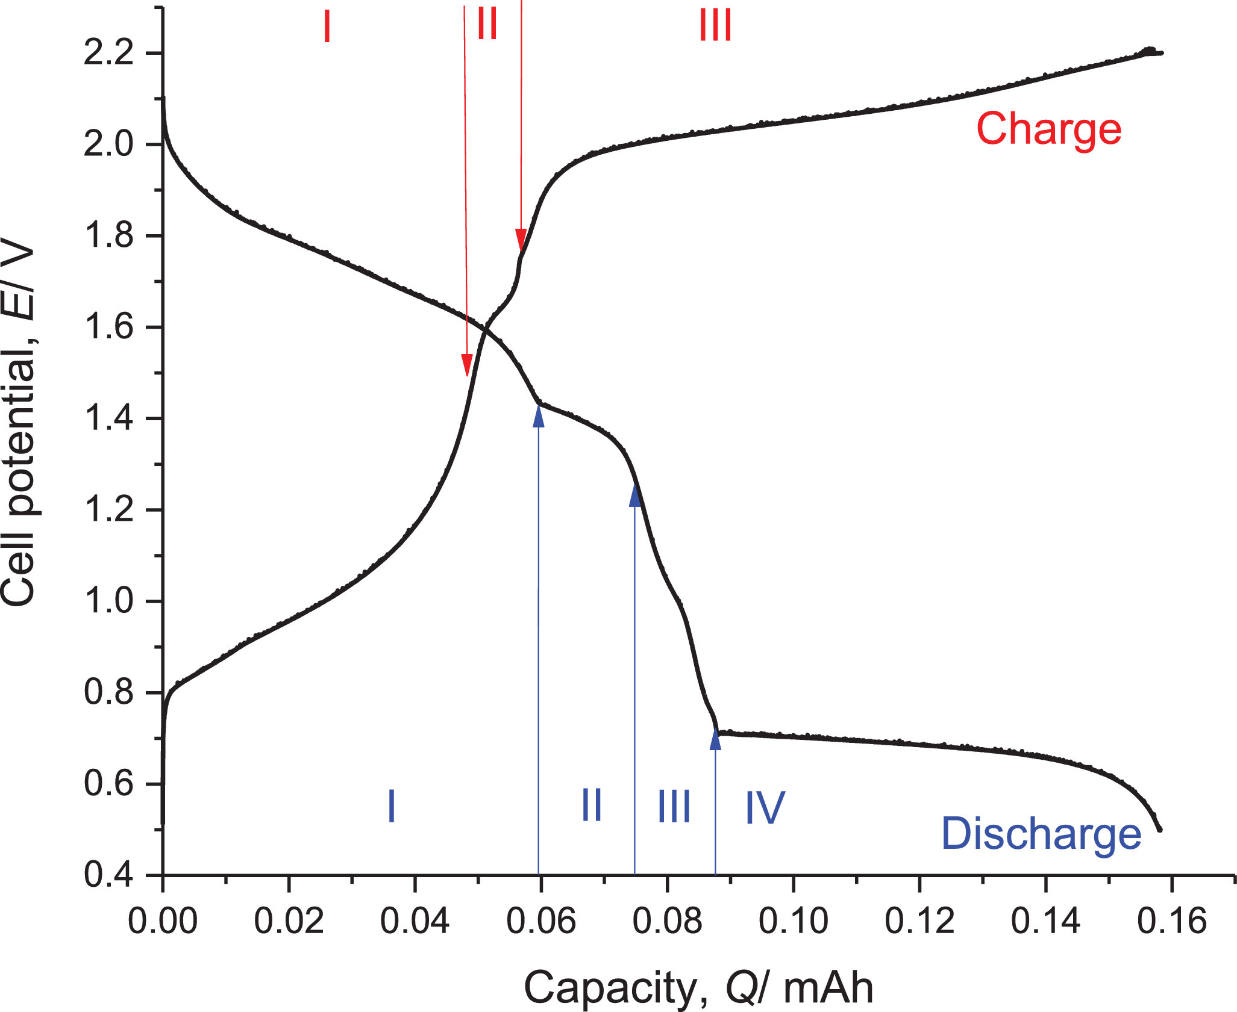

Figure 11 - charge/discharge of an aluminium-PEDOT battery, charged at 0.1 mA to 2.2 V and discharged at -0.1 mA to 0.5 V at 25°C. (Reproduced with permission from the Journal of Energy Storage [46])

The charge and discharge curve of an aluminium-PEDOT battery is shown in Figure 11. The discharged PEDOT film is compact and cannot accept the insertion of anions; this is section I and corresponds to a surface charging mechanism. The PEDOT oxidises and swells during charging, and once it reaches section III the swelling means it can accept large-scale insertion of anions. Section II corresponds to a transition between these two stages [46].

Overall, PEDOT appears to offer an improvement over polypyrrole or polythiophene due to increased chemical stability (it is less vulnerable to reacting at high potentials), and higher specific capacity of the positive electrode (192 mAh g-1 relative to 30-100 mAh g-1). Recent work indicates that the specific capacity of PEDOT is higher than graphite (191 mAh g-1 *vs.* 142 mAh g-1), but the reduced average discharge potential of 1.3 V means the specific energy of the whole battery is lower (50 Wh kg-1 *vs.* 65 Wh kg-1) [13, 43, 46, 114].

### Iron chloride

There are potential benefits to storing Cl- instead of AlCl4-, chiefly that Cl- is smaller [2, 72], assuming that Cl- can be extracted from Al2Cl7- species in the acidic electrolyte. This would have to be by preferential reaction as free Cl- is not present in acidic chloroaluminate electrolytes; researchers who intended to intercalate Cl- ions into graphite or conductive polymers either did not carry out analysis to prove Cl- had been stored [72] or later found that it was chloroaluminate anions that actually provided the charge storage [2]. Perhaps the most persuasive example of Cl- storage used an FeCl3 positive electrode that was reported to convert to FeCl2 on discharge.The FeCl2 was impregnated in reticulated vitreous carbon in AlCl3-[EMIm]Cl at a 1.38 molar ratio. A stainless steel current collector was used. A full cell discharge potential of 1.85 V *vs.* Al|Al(III) was found, and the researchers proposed Equation 10 as the cell reaction [45]:

$$\text{Al+}{\text{AlCl}}_{\text{4}}^{\text{-}}\text{+3Fe}{\text{Cl}}_{\text{3}}\text{=}{\text{Al}}_{\text{2}}{\text{Cl}}_{\text{7}}^{\text{-}}\text{+3Fe}{\text{Cl}}_{\text{2}}$$ Equation 10

However, the positive electrode was not analysed post-discharge to assess if FeCl2 to FeCl3 had actually occurred [45]. Stainless steel is also known to be electroactive in AlCl3-[EMIm]Cl, which may also have contributed [149]. The achieved energy density was not stated, and because the positive electrode was soluble in the electrolyte, the battery was prone to self-discharge, making it unsuitable for further investigation [45].

## Positive electrodes storing Al(III)

The materials discussed in this section have been claimed to intercalate Al(III) directly. While some researchers reviewing the literature up until very recently (2017) did not consider Al(III) to ever have been proved to be successfully intercalated into any positive electrode material [75, 149], we believe there is some evidence that Al(III) intercalation has taken place despite the difficulties of intercalating polyvalent ions [13]. Because the electrolyte in these systems is not depleted during charge or discharge, these papers tend to use RTIL electrolytes with *r* of 1.1-1.3, close to minimum Lewis acidity required aluminium deposition. In this section, sulphur, vanadium-based positive electrodes, and transition metal sulphides are discussed. On a side note, Al(III) intercalation has been successfully shown in aqueous aluminium batteries [150], however, this material has not been demonstrated in ionic liquid electrolytes [151].

### Sulphur

As a positive electrode material operating by a conversion reaction (stored ions react to form a new chemical phase with the positive electrode), sulphur is now being considered for use in aluminium batteries. As expected, the latest research on aluminium-sulphur makes use of chloroaluminate ionic liquids [116, 152-154]. The reaction is as shown in Equation 11:

$\text{2Al+14Al}{\text{Cl}}_{\text{4}}^{\text{-}}\text{+}{\text{Al}}_{\text{2}}{\text{S}}_{\text{3}}\text{↔}{\text{8Al}}_{\text{2}}{\text{Cl}}_{\text{7}}^{\text{-}}\text{+3S}$ Equation 11

For lithium-ion and sodium-ion batteries, sulphur is one of the most promising materials for moving forwards in terms of specific energy from the current generation of metal oxide positive electrodes. Although it offers increased specific energy and is highly abundant, it has poorer energy density than metal oxide positive electrodes. Sulphur has also been attempted as a positive electrode for aluminium batteries due to its theoretical specific energy (based on total electrode mass) of 1340 Wh kg-1 based on a discharge potential of 1.1-1.25 V *vs.* Al|Al(III) – significantly higher than current lithium-ion batteries [116]. A primary aluminium-sulphur battery has been demonstrated attaining very close to this theoretical specific energy [152]. However, as with all other positive electrodes that store aluminium, aluminium-sulphur is characterised by poor cycle life (a few tens of cycles compared to thousands for positive electrodes storing chloroaluminate anions). To improve the kinetics of the AlSx oxidation reaction, various strategies have been attempted. These include encapsulating sulphur into the micropores (2 nm) of activated carbon, achieving a cycle life of 20 with capacity retention of 65 % [116], and incorporating Li+ ions into the electrolyte, achieving a cycle life of 50 cycles with a capacity retention of 60% [154].

### Vanadium-containing positive electrodes

#### Li3VO4

Li3VO4 consists of a hollow 3D structure with pores that are intermediate in size between Al(III) and AlCl4- into which it has been theorized that Al(III) could be inserted via intercalation according to the following full-cell reaction shown in Equation 12:

${\text{Li}}_{\text{3}}{\text{VO}}_{\text{4}}\text{+xAl↔}{\text{Al}}_{\text{x}}{\text{Li}}_{\text{3}}{\text{VO}}_{\text{4}}$ Equation 12

An aluminium battery with AlCl3-[EMIm]Cl electrolyte and Li3VO4 positive electrode was reported with an initial discharge capacity of 137 mAh g-1 which dropped to 48 mAh g-1 after 100 cycles. After the initial loss of capacity was accounted for, the battery was reported to have ~100% coulombic efficiency at an average cell discharge potential of < 1 V *vs.* Al|Al(III) [38]. This study raises several questions. A stainless steel current collector was used, known to exhibit redox behaviour due to Fe and Cr redox reactions, producing similar discharge potentials to those found here [149]. It is suggested that V4+ is oxidised to V5+ during the charge process. Additionally, the Li3VO4 was completely coated with approximately 5nm of carbon, both graphitic and disordered types, strongly indicating the potential for some chloroaluminate redox reaction with graphite. The initial charge behaviour indicates that the structure has been intercalated and altered by the presence of anions, suggesting a mixture of graphitic storage and stainless steel electro-activity. Finally, the use of vanadium and lithium, neither of which are abundant elements, lowers the appeal of this positive electrode material for post-lithium batteries [38].

#### V2O5

V2O5 is one of the more controversial positive electrode materials for aluminium batteries, with researchers arguing both for and against the possible storage of Al(III). In this review, it is argued that there is some evidence for Al(III) intercalation in V2O5, but a low average discharge potential of less than 0.6 V *vs.* Al|Al(III) limits its use as a battery system. The cell reaction is as shown in Equation 13 [115]:

${{\text{V}}_{\text{2}}\text{O}}_{\text{5}}\text{+Al⟷Al}{{\text{V}}_{\text{2}}\text{O}}_{\text{5}}$ Equation 13

The reversible intercalation of Al(III), Mg(II) and Zn(II) into V2O5 was shown in a 1998 study on V2O5 aerogels. Initial intercalation was carried out by immersing aerogel electrodes for one week into dibutylmagnesium, dimethylzinc or trimethylaluminium for Mg2+, Zn2+ or Al3+ respectively, all in heptane solution. All demonstrated reversible electroactive behaviour [155].

In 2011, in one of the earliest studies on V2O5 in an aluminium battery [156], Jayaprakash et al. found that using V2O5 nanowires and a stainless steel current collector allowed for a battery system that demonstrated a sharp drop in cell discharge potential from 1.8 V *vs.* Al|Al(III) open-circuit potential to a plateau of about 0.55 V *vs.* Al|Al(III). The capacity of the positive electrode was around 273 mAh g-1 after 20 cycles, which is a good capacity, although the poor discharge potential means that the overall specific energy was not high. This paper used an *r* = 1.1 AlCl3-[EMIm]Cl electrolyte [156]. Reed et al [149] attempted in 2013 to replicate the battery system and found that the low discharge potential (0.6 V *vs.* Al|Al(III)) achieved with V2O5 in a Swagelok cell was attributable to reactions involving the iron and chromium in the stainless steel current collector, destroying the cell via dendrite growth after just 20 cycles. This was supported by the fact that V2O5 demonstrated no electrochemical activity in a battery when combined with an unreactive platinum current collector.

More recently in 2015, Wang et al [115] demonstrated that V2O5 deposited on a Ni foam current collector is electroactive, while Ni foam on its own is not. Although the cells were charged to 2.5 V *vs.* Al|Al(III), the potential dropped rapidly during discharge limiting the average discharge potential, as for Jayaprakash et al., to 0.6 V *vs.* Al|Al(III). This perhaps indicates that Al(III) or chloroaluminate species are forming stable compounds at a potential of only 0.6 V *vs.* Al/Al(III). The cell had an initial specific discharge capacity based on positive electrode mass of 239 mAh g-1 which reduces by around 20% over the first five cycles. The electrolyte was r = 1.1 AlCl3-[BMIM]Cl, the minimum value at which Al2Cl7- is present for aluminium deposition. Though it was shown that the V was oxidised from V4+ to V5+ during charging, this could account for chloroaluminate species intercalation during charging, and no conclusive evidence of Al(III) intercalation is presented.

Chiku et al [157] found that using a V2O5 positive electrode with an ionic liquid electrolyte consisting of AlCl3, dipropylsulfone and toluene in a 1:10:5 ratio, gave a 1st cycle discharge capacity of 150 mAh g-1 V2O­5, followed by 100 mAh g-1 on the 15th cycle with good coulombic efficiency. A closer analysis found that before cycling, only V5+ was present, but this was reduced to V3+ and V4+ during discharging. A molybdenum current collector was used, having been shown to be unreactive in the relevant discharge potential range in the electrolyte. Clearly, V2O5 is electroactive, and the capacity obtained is approximately matched to the theoretical calculation. The authors concluded that V2O5 is electroactive and might able to store Al(III), but in a battery system, it provides a steeply sloping and low average discharge potential profile, limiting its use based on current progress.

#### VO2

In 2013, Jiang et al [41] investigated a VO2 material with a stainless steel current collector for the positive electrode. They use computational modelling to demonstrate the potential intercalation behaviour of aluminium in the VO2 matrix via the following reaction (*x* is the experimentally found value) shown in Equation 14:

${\text{VO}}_{\text{2}}\text{+xAl}\text{⟷}{\text{Al}}_{\text{x}}{\text{VO}}_{\text{2}}\text{ (x\sim 0.17)}$ Equation 14

They found that all formation energies were negative, indicating that intercalation was possible and that intercalating a small number of aluminium atoms was well tolerated by the matrix, but above that, the bonds started to bend and break. They concluded that aluminium could not replace V in the matrix due to a positive energy of formation. The positive electrode maintains a capacity of over 100 mAh g-1 in testing based on the mass of the positive electrode alone, but the discharge potential is low at around 0.55 V *vs.* Al|Al(III). The electrolyte was *r* = 1 AlCl3-[BMIM]Cl and the authors report a 48 Wh kg-1 specific energy [41]. However, as previously discussed the use of stainless steel as a current collector means the results must be treated with caution [149].

In summary, all attempts to use vanadium-containing positive electrodes have resulted in low discharge potentials of less than 0.6 V, resulting in specific energy values that fall behind aluminium-graphite (48 Wh kg-1 *vs.* 65 Wh kg-1) [41, 43, 114].

### Transition Metal Sulphides

Conversion electrodes use chemical reactions between the positive electrode and the intercalating species to form entirely new products stored together at the positive electrode [158]. Conversion electrodes based on fluorides, oxides and sulphides have been explored for aluminium batteries, but fluorides and oxides form very strong ionic bond with aluminium, causing high binding energies. Sulphides, which form weaker ionic bonds with aluminium, remain as positive electrode materials of interest [39].

#### TiS2

In 2017, Geng et al [40] investigated a transition metal sulphide, TiS2, which has a more polarizable anionic structure than transition metal oxides like V2O5, and therefore should have reduced barriers to the transport of multivalent ions. Storage of aluminium was investigated from an *r* = 1.5 AlCl3-1-butyl-3-methylimidazolium chloride electrolyte. Reversibility was demonstrated for both layered TiS2 and spinel-based cubic Cu0.31Ti2S4, and it was shown that Al(III) resided in the octahedral sites in the layered TiS2. While Al(III) intercalation was demonstrated, its passage through the crystal structure was slow, and the binding energy of aluminium in TiS2 was still high enough to cause low discharge potential. Experimentally, for the better performing layered TiS2, a highly sloping discharge potential with an average value of less than 1 V *vs.* Al|Al(III) was found with a capacity of about 70 mA h g-1 (based on positive electrode mass) after several cycles, indicating that around 11% of the available octahedral intercalation sites were taken by Al(III). The positive electrode initially demonstrated poor discharge capacity and coulombic efficiency, and both improved on subsequent cycles to a stable value**.** However, while specific energy is not calculated, both the specific capacity of the TiS2 electrode and its average discharge potential fall far behind Al-graphite (70 mAh g-1 *vs.* 142 mAh g-1 and 1 V *vs.* 1.77 V respectively [114].

#### Ni3S2 on graphene microflakes

In 2016, Yu et al[117] investigated Ni3S2 on graphene microflakes in an AlCl3-[EMIm]Cl electrolyte. With a discharge potential of around 1 V *vs.* Al|Al(III), the discharge capacity remained over 60 mAh g-1 (based on positive electrode mass)after 100 cycles, with an initial charge/discharge capacity of 300 and 235 mAh g-1 respectively. These results are similar to those reported for TiS2, and the same comparisons to aluminium-graphite apply.

#### FeS2

Also in 2016, Mori et al. [39] investigated the theoretical mechanism for Al(III) intercalation in FeS2 – a transition metal sulphide that has been used successfully in lithium and sodium battery positive electrodes. They used an *r* = 2 AlCl3-[EMIm]Cl electrolyte. FeS2 has the advantage of being naturally abundant. For lithium-ions, the FeS2 goes through an intermediate, layered phase of Li2FeS2 before reaching its fully charged configuration. For aluminium however, the high charge density makes this intermediate phase unstable, and so diffusion into the bulk is required. The cell reaction is shown in Equation 15:

${\text{FeS}}_{\text{2}}\text{+}\frac{\text{2}}{\text{3}}\text{Al⟷FeS+}\frac{\text{1}}{\text{3}} {\text{Al}}_{\text{2}}{\text{S}}_{\text{3}}$ Equation 15

FeS2 becomes FeS and Al2S3 - a conversion reaction. In practise, sulphide dissolution occurs, causing poor cycling stability, and low discharge potential results from the difficulty of diffusing Al(III) through bulk FeS2. Nevertheless, the theoretical mechanism for intercalation was successfully demonstrated via XRD and XAS measurements. Future work includes combining with a nanostructure carbon substrate to provide diffusion paths and increased surface area.

### Anthraquinone

The aluminium-anthraquinone (AQ) battery uses an anthraquinone-based poly(antraquinoyl sulfide) (PAQS) positive electrode to store charge and a *r* = 1.5 AlCl3-[EMIm]Cl electrolyte [159]. PAQS has previously been used for lithium batteries [160], where a discharge potential of 2.2 V *vs.* Al|Al(III) has been achieved. For the AQ battery [159], XPS results were used to calculate that the major Al containing species must be AlCl2+. However, as previously discussed, this species does not appear in the electrolyte. Instead, AlCl4- and Al2Cl7- are present in *r* = 1.5 AlCl3-[EMIm]Cl. Therefore, questions remain over the operation of the battery, which cast doubt over the quoted energy density of 101 Wh kg-1; it is most likely that the Al-containing species are actually being stored. More than 60% of the initial capacity remains after 500 cycles, but this is not competitive with Al-graphite or Al-PEDOT batteries.

# Current collectors

The use of acidic ionic liquid electrolyte in aluminium batteries means that care must be taken when selecting current collectors. Materials that are completely inactive in these systems include molybdenum, tungsten and platinum, but clearly these are not abundant or affordable[42]. Other commonly used equipment also cannot withstand these electrolytes; [113] states an experimental failure due to Celgard Swagelok separator corrosion. Even some binders are active – although PTFE is stable, PVDF reacts [115]. Carbon-coated aluminium foil [144] and carbon have been used successfully as anodic current collectors [161]. If the aluminium purity is extremely high (so as not to contaminate the electrolyte), it can act as its own current collector at the negative electrode, although it might seem prudent to use an unreactive current collector to minimise the risk of holes forming because of uneven dissolution of the electrode during discharge.

# Summary and future perspective

Due to the particularly difficult challenge of finding positive electrodes that have good discharge potential and cycle life, the research focus is likely to remain towards those materials that store chloroaluminate species. No electrolytes have yet been shown to have a wider electrochemical window or better stability than AlCl3-[EMIm]Cl. Forming a gel of this electrolyte is a very interesting research avenue, as it is the only obvious route for improving the electrochemical window of RTILs.

Deep eutectic solvents are of interest because some of them are cheap and particularly non-toxic. However, they offer a limited electrochemical stability window and composition range suitable for aluminium deposition, and because specific energy is such a key parameter for new energy storage, it seems unlikely that their cost and toxicity credentials can make up for their lack of performance. Entirely new DES with improved performance need to be discovered for them to gain relevance in non-aqueous aluminium batteries.

Graphite-based positive electrodes offer the best overall performance due to the stability and high average discharge potential. Cheap and relatively abundant graphite flakes seem to offer the best balance of performance and cost and achieve near the theoretical maximum in terms of specific energy and thousands of cycle lives [114]. Conducting polymers offer similar operation but average discharge potential and cycle life are lower than for graphite [13, 46]. Elaborate structures such as carbon nanotubes may elicit marginal gains in specific capacity of graphite electrodes, but these are unlikely to be economically justified considering the cost of developing carbon nanostructures compared to assembling graphite flakes. There may also be ways to improve the capacity of conducting polymer electrodes using refined electrosynthesis techniques, but again these improvements are likely to be marginal. Other positive electrode materials that store chloroaluminate species fall far behind graphite and conducting polymers. Positive electrode materials that store Al(III) offer much better theoretical performance but there is little evidence of this theoretical performance being achieved over a long cycle life; aluminium-sulphur probably appears most promising but still only maintains 60% of its capacity over 50 cycles [154].

Considering the highest achieved specific energy of 68 Wh kg-1, and accounting for the extra mass involved in commercial packaging, current aluminium batteries may have sufficient specific energy to meet grid storage requirements. However, the cost of ionic liquids is a barrier to entering the market. Improved performance, cheaper electrolyte, or both, would help to improve prospects. If aluminium batteries could reach higher specific energies, perhaps greater than 200 Wh kg-1, they might begin to compete in the electric vehicle market. They would still not compete with lithium ion batteries on specific energy, but might offer better charging time, affordability, environmental credentials and cycle life. Then, the technology might become optimal for applications demanding predictable length journeys with regular charging opportunities. Combined with an electric drive this could fulfil a huge number of mass transit applications globally, most of which are currently serviced by diesel engines. With these potential applications in mind, aluminium battery technology should be relentlessly pursued towards its theoretical performance limits, to ensure its full potential is realised as soon as possible in the quest to develop a sustainable future.

# Acknowledgements

The authors acknowledge support from the International Consortium of Nanotechnologies (ICON) funded by Lloyd’s Register Foundation [G0086], a charitable foundation which helps to protect life and property by supporting engineering-related education, public engagement and the application of research, and from the Centre for Doctoral Training in Energy Storage and its Applications at the University of Southampton [EP/L016818/1].

# References

[1] Becke AD. Density‐functional thermochemistry. III. The role of exact exchange. The Journal of Chemical Physics. 1993;98:5648-52.

[2] Schoetz T, Ueda M, Bund A, Ponce de Leon C. Preparation and characterization of a rechargeable battery based on poly-(3,4-ethylenedioxythiophene) and aluminum in ionic liquids. Journal of Solid State Electrochemistry. 2017;21:3237-46.

[3] Nykvist B, Sprei F, Nilsson M. Assessing the progress toward lower priced long range battery electric vehicles. Energy Policy. 2019;124:144-55.

[4] Statista. Projected battery costs as a share of large battery electric vehicle costs from 2016 to 2030. Statista; 2018.

[5] She Z-Y, Qing Sun, Ma J-J, Xie B-C. What are the barriers to widespread adoption of battery electric vehicles? A survey of public perception in Tianjin, China. Transport Policy. 2017;56:29-40.

[6] Diouf B, Pode R. Potential of lithium-ion batteries in renewable energy. Renewable Energy. 2015;76:375-80.

[7] Kavanagh L, Keohane J, Garcia Cabellos G, Lloyd A, Cleary J. Global Lithium Sources—Industrial Use and Future in the Electric Vehicle Industry: A Review. Resources. 2018;7.

[8] Walt V, Meyer S. Blood, Sweat and Batteries. Fortune2018.

[9] Zhang W, Xu C, He W, Li G, Huang J. A review on management of spent lithium ion batteries and strategy for resource recycling of all components from them. Waste Manag Res. 2018;36:99-112.

[10] Manthiram A. Materials Challenges and Opportunities of Lithium Ion Batteries. The Journal of Physical Chemistry Letters. 2011;2:176-84.

[11] Dehghani-Sanij AR, Tharumalingam E, Dusseault MB, Fraser R. Study of energy storage systems and environmental challenges of batteries. Renewable and Sustainable Energy Reviews. 2019;104:192-208.

[12] Finegan DP, Scheel M, Robinson JB, Tjaden B, Hunt I, Mason TJ, et al. In-operando high-speed tomography of lithium-ion batteries during thermal runaway. Nat Commun. 2015;6:6924.

[13] Hudak NS. Chloroaluminate-Doped Conducting Polymers as Positive Electrodes in Rechargeable Aluminum Batteries. The Journal of Physical Chemistry C. 2014;118:5203-15.

[14] Li Q, Bjerrum NJ. Aluminum as anode for energy storage and conversion: a review. Journal of Power Sources. 2002;110:1–10.

[15] Holland A, McKerracher RD, Cruden A, Wills RGA. An aluminium battery operating with an aqueous electrolyte. Journal of Applied Electrochemistry. 2018;48:243-50.

[16] Chen H, Xu H, Zheng B, Wang S, Huang T, Guo F, et al. Oxide Film Efficiently Suppresses Dendrite Growth in Aluminum-Ion Battery. ACS Appl Mater Interfaces. 2017;9:22628-34.

[17] Lin D, Liu Y, Cui Y. Reviving the lithium metal anode for high-energy batteries. Nat Nanotechnol. 2017;12:194-206.

[18] Haering; Rudolph R. SJAR, Brandt; Klaus. Lithium molybdenum disulphide battery cathode. In: USPTO, editor. H01M 4/58 (20060101); H01M 10/40 (20060101); H01M 10/42 (20060101); H01M 4/36 (20060101); H01M 4/02 (20060101); H01M 10/44 (20060101); H01M 10/36 (20060101); H01M 006/14 () ed. US1980.

[19] Galiński M, Lewandowski A, Stępniak I. Ionic liquids as electrolytes. Electrochimica Acta. 2006;51:5567-80.

[20] Committee TGAR. Global Aluminium Recycling: A Cornerstone of Sustainable Development. International Aluminium Institute 2009.

[21] Li L, Zheng Y, Zhang S, Yang J, Shao Z, Guo Z. Recent progress on sodium ion batteries: potential high-performance anodes. Energy & Environmental Science. 2018;11:2310-40.

[22] Quinn JB, Waldmann T, Richter K, Kasper M, Wohlfahrt-Mehrens M. Energy Density of Cylindrical Li-Ion Cells: A Comparison of Commercial 18650 to the 21700 Cells. Journal of The Electrochemical Society. 2018;165:A3284-A91.

[23] Hwang JY, Myung ST, Sun YK. Sodium-ion batteries: present and future. Chem Soc Rev. 2017;46:3529-614.

[24] Ponrouch A, Palacin MR. On the road toward calcium-based batteries. Current Opinion in Electrochemistry. 2018;9:1-7.

[25] Mainar AR, Iruin E, Colmenares LC, Kvasha A, de Meatza I, Bengoechea M, et al. An overview of progress in electrolytes for secondary zinc-air batteries and other storage systems based on zinc. Journal of Energy Storage. 2018;15:304-28.

[26] Zhang Y, Chen Z, Qiu H, Yang W, Zhao Z, Zhao J, et al. Pursuit of reversible Zn electrochemistry: a time-honored challenge towards low-cost and green energy storage. NPG Asia Materials. 2020;12.

[27] Diggle J, Despic A, Bockris J. The Mechanism of the Dendritic Electrocrystallization of Zinc. J Electrochem Soc. 1969;116:1503-14.

[28] Higashi S, Lee SW, Lee JS, Takechi K, Cui Y. Avoiding short circuits from zinc metal dendrites in anode by backside-plating configuration. Nat Commun. 2016;7:11801.

[29] Yu W, Shang W, Xiao X, Tan P, Chen B, Wu Z, et al. Achieving a stable zinc electrode with ultralong cycle life by implementing a flowing electrolyte. Journal of Power Sources. 2020;453.

[30] Muldoon J, Bucur CB, Gregory T. Fervent Hype behind Magnesium Batteries: An Open Call to Synthetic Chemists-Electrolytes and Cathodes Needed. Angew Chem Int Ed Engl. 2017;56:12064-84.

[31] Liu J, Xu C, Chen Z, Ni S, Shen ZX. Progress in aqueous rechargeable batteries. Green Energy & Environment. 2018;3:20-41.

[32] Das SK, Mahapatra S, Lahan H. Aluminium-ion batteries: developments and challenges. Journal of Materials Chemistry A. 2017;5:6347-67.

[33] Zhao Y, VanderNoot T. Review: Electrodeposition of aluminium from nonaqueous organic electrolytic systems and room temperature molten salts. Electrochemica Acta. 1997;42:3-13.

[34] Pan W, Wang Y, Zhang Y, Kwok HYH, Wu M, Zhao X, et al. A low-cost and dendrite-free rechargeable aluminium-ion battery with superior performance. Journal of Materials Chemistry A. 2019;7:17420-5.

[35] Egan DR, Ponce de León C, Wood RJK, Jones RL, Stokes KR, Walsh FC. Developments in electrode materials and electrolytes for aluminium–air batteries. Journal of Power Sources. 2013;236:293-310.

[36] Wang H-F, Xu Q. Materials Design for Rechargeable Metal-Air Batteries. Matter. 2019;1:565-95.

[37] Manthiram A. An Outlook on Lithium Ion Battery Technology. ACS Cent Sci. 2017;3:1063-9.

[38] Jiang J, Li H, Huang J, Li K, Zeng J, Yang Y, et al. Investigation of the Reversible Intercalation/Deintercalation of Al into the Novel Li3VO4@C Microsphere Composite Cathode Material for Aluminum-Ion Batteries. ACS Appl Mater Interfaces. 2017;9:28486-94.

[39] Mori T, Orikasa Y, Nakanishi K, Kezheng C, Hattori M, Ohta T, et al. Discharge/charge reaction mechanisms of FeS2 cathode material for aluminum rechargeable batteries at 55°C. Journal of Power Sources. 2016;313:9-14.

[40] Geng L, Scheifers JP, Fu C, Zhang J, Fokwa BPT, Guo J. Titanium Sulfides as Intercalation-Type Cathode Materials for Rechargeable Aluminum Batteries. ACS Appl Mater Interfaces. 2017;9:21251-7.

[41] Wang W, Jiang B, Xiong W, Sun H, Lin Z, Hu L, et al. A new cathode material for super-valent battery based on aluminium ion intercalation and deintercalation. Sci Rep. 2013;3:3383.

[42] Kravchyk KV, Wang S, Piveteau L, Kovalenko MV. Efficient Aluminum Chloride–Natural Graphite Battery. Chemistry of Materials. 2017;29:4484-92.

[43] Lin MC, Gong M, Lu B, Wu Y, Wang DY, Guan M, et al. An ultrafast rechargeable aluminium-ion battery. Nature. 2015;520:325-8.

[44] Frisch MJ, Trucks GW, Schlegel HB, G. E. Scuseria, Robb MA, Cheeseman JR, et al. Gaussian 09, Revision C.01. Gaussian, Inc. Wallingford CT2010.

[45] Donahue F, Mancini S, Simonsen L. Secondary aluminium-iron (III) chloride batteries with a low temperature molten salt electrolyte. Journal of Applied Electrochemistry. 1992;22:230-4.

[46] Schoetz T, Craig B, Ponce de Leon C, Bund A, Ueda M, Low CTJ. Aluminium-poly(3,4-ethylenedioxythiophene) rechargeable battery with ionic liquid electrolyte. Journal of Energy Storage. 2020;28:101176-85.

[47] Bai L, Conway B. Complex Behavior of Al Dissolution in Non-aqueous Medium as Revealed by Impedance Spectroscopy. J Electrochem Soc. 1990;137:3737-47.

[48] Mandai T, Johansson P. A Challenge for Rechargeable Al-Batteries: AlCl3-Free Deep Eutectic Solvent and Cationic Solvate Based Electrolytes. Meeting Abstracts. 2016;MA2016-03:1144.

[49] Ferrara C, Dall’Asta V, Berbenni V, Quartarone E, Mustarelli P. Physicochemical Characterization of AlCl3–1-Ethyl-3-methylimidazolium Chloride Ionic Liquid Electrolytes for Aluminum Rechargeable Batteries. The Journal of Physical Chemistry C. 2017;121:26607-14.

[50] Gálová M. Electrodeposition of aluminium from organic aprotic solvents. Surface Technology. 1980;11:357-69.

[51] Graef M. The Mechanism of Aluminum Electrodeposition from Solutions of AlCl3 and LiAlH4 in THF. J Electrochem Soc. 1985;132:1038-46.

[52] Wilkes J. Molten Salts and Ionic Liquids - Are They Not the Same Thing. ECS Transactions. 2007;3:3-7.

[53] Arnett E, Wolf J. An Electrochemical Scrutiny of Organometallic Iron Complexes and Hexamethylbenzene in a Room Temperature Molten Salt. Journal of the American Chemical Society. 1975;97:3264-5.

[54] Gale R, Gilbert B, Osteryoung R. Raman Spectra of Molten Aluminum Chloride: 1-Butylpyridinium Chloride Systems at Ambient Temperatures. Inorg Chem. 1978;17:2728-9.

[55] Robinson J, Osteryoung R. An Electrochemical and Spectroscopic Study of Some Aromatic Hydrocarbons in the Room Temperature Molten Salt System Aluminium Chloride-n-Butyl Pyridinium Chloride. Journal of the American Chemical Society. 1979;101:323-7.

[56] Jiang T, Chollier Brym MJ, Dubé G, Lasia A, Brisard GM. Electrodeposition of aluminium from ionic liquids: Part I—electrodeposition and surface morphology of aluminium from aluminium chloride (AlCl3)–1-ethyl-3-methylimidazolium chloride ([EMIm]Cl) ionic liquids. Surface and Coatings Technology. 2006;201:1-9.

[57] Wilkes J, Zarowotko M. Air and Water Stable 1-Ethyl-3-methylimidazolium Based Ionic Liquids. J Chem Soc. 1992;0:965-7.

[58] Wilkes J, Levisky J, Wilson R, Hussey C. Dialkylimidazolium Chloroaluminate Melts: A New Class of Room Temperature Ionic Liquids for Electrochemistry, Spectroscopy, and Synthesis. Inorg Chem. 1982;21:1263-4.

[59] Wilkes J, Hussey C. Selection of Cations for Ambient Temperature Chloroaluminate Molten Salts using MNDO Molecular Orbital Calculations. Springfield, Virginia: Frank J. Seiler Research Laboratory; 1982.

[60] Jones S, Blomgren G. Low-Temperature Molten Salt Electrolytes Based on Aralkyl Quaternary or Ternary Onium Salts. J Electrochem Soc. 1989;136:424-7.

[61] National Center for Biotechnology Information. 1-Ethyl-3-Methylimidazolium.

[62] Zhang M, Kamavaram V, Reddy R. New Electrolytes For Aluminum Production: Ionic Liquids. JOM. 2003;55:54-7.

[63] Chakrabarti MH, Mjalli FS, AlNashef IM, Hashim MA, Hussain MA, Bahadori L, et al. Prospects of applying ionic liquids and deep eutectic solvents for renewable energy storage by means of redox flow batteries. Renewable and Sustainable Energy Reviews. 2014;30:254-70.

[64] Endres F. Ionic Liquids: Solvents for the Electrodeposition of Metals and Semiconductors. Chem Phys Chem. 2002;3:144-54.

[65] Cooper E, Andrews C, Wheatley P, Webb P, Wormald P, Morris R. Ionic liquids and eutectic mixtures as solvent and template in synthesis of zeolite analogues. Nature. 2004;430:1012-15.

[66] Alhaji A. Electrodeposition of Alloys from Deep Eutectic Solvents: University of Leicester; 2011.

[67] Zhao Y, VanderNoot T. Electrodeposition of aluminium from room temperature AlCl3-TMPAC molten salts. Electrochemica Acta. 1997;42:1639-43.

[68] Poetz S, Handel P, Fauler G, Fuchsbichler B, Schmuck M, Koller S. Evaluation of decomposition products of EMImCl·1.5AlCl3 during aluminium electrodeposition with different analytical methods. Royal Society of Chemistry. 2014;4:6685-90.

[69] Abbott AP, Frisch G, Hartley J, Karim WO, Ryder KS. Anodic dissolution of metals in ionic liquids. Progress in Natural Science: Materials International. 2015;25:595-602.

[70] Xia S, Zhang X-M, Huang K, Chen Y-L, Wu Y-T. Ionic liquid electrolytes for aluminium secondary battery: Influence of organic solvents. Journal of Electroanalytical Chemistry. 2015;757:167-75.

[71] Popolo MD, Voth G. On the Structure and Dynamics of Ionic Liquids. J Phys Chem B. 2004;108:1744-52.

[72] Gifford P, Palmisano J. An Aluminum/Chlorine Rechargeable Cell Employing a Room Temperature Molten Salt Electrolyte. J Electrochem Soc. 1988;135:650-4.

[73] Melton T, Joyce J, Maloy J, Boon J, Wilkes J. Electrochemical Studies of Sodium Chloride as a Lewis Buffer for Room Temperature Chloroaluminate Molten Salts. J Electrochem Soc. 1990;137:3865-9.

[74] Brown TL, LeMay HE, Bursten BE, Murphy C, Woodward P, Langford S, et al. Chemistry: The Central Science: Pearson Higher Education AU; 2013.

[75] Stadie NP, Wang S, Kravchyk KV, Kovalenko MV. Zeolite-Templated Carbon as an Ordered Microporous Electrode for Aluminum Batteries. ACS Nano. 2017;11:1911-9.

[76] Lloyd D, Vainikka T, Kontturi K. The development of an all copper hybrid redox flow battery using deep eutectic solvents. Electrochimica Acta. 2013;100:18-23.

[77] Mecerreyes D. Polymeric ionic liquids: Broadening the properties and applications of polyelectrolytes. Progress in Polymer Science. 2011;36:1629-48.

[78] Chaurasia SK, Singh RK, Chandra S. Structural and transport studies on polymeric membranes of PEO containing ionic liquid, EMIM-TY: Evidence of complexation. Solid State Ionics. 2011;183:32-9.

[79] Luo S, Zhang S, Wang Y, Xia A, Zhang G, Du X, et al. Complexes of ionic liquids with poly(ethylene glycol)s. J Org Chem. 2010;75:1888-91.

[80] Schoetz T, Ponce de Leon C, Bund A, Ueda M. Electro-polymerisation and characterisation of PEDOT in Lewis basic, neutral and acidic EMImCl-AlCl3 ionic liquid. Electrochimica Acta. 2018;263:176-83.

[81] Angell CA, Liu C, Sanchez E. Rubbery solid electrolytes with dominant cationic transport and high ambient conductivity. Nature. 1993;362:137-9.

[82] Schoetz T, Leung O, Ponce de Leon C, Zaleski C, Efimov I. Aluminium Deposition in EMImCl-AlCl3 Ionic Liquid and Ionogel for Improved Aluminium Batteries. Journal of The Electrochemical Society. 2020;167.

[83] Boisset A, Jacquemin J, Anouti M. Physical properties of a new Deep Eutectic Solvent based on lithium bis[(trifluoromethyl)sulfonyl]imide and N-methylacetamide as superionic suitable electrolyte for lithium ion batteries and electric double layer capacitors. Electrochimica Acta. 2013;102:120-6.

[84] Paiva A, Craveiro R, Aroso I, Martins M, Reis RL, Duarte ARC. Natural Deep Eutectic Solvents – Solvents for the 21st Century. ACS Sustainable Chemistry & Engineering. 2014;2:1063-71.

[85] Zhang C, Ding Y, Zhang L, Wang X, Zhao Y, Zhang X, et al. A Sustainable Redox-Flow Battery with an Aluminum-Based, Deep-Eutectic-Solvent Anolyte. Angew Chem Int Ed Engl. 2017;56:7454-9.

[86] Smith EL, Abbott AP, Ryder KS. Deep eutectic solvents (DESs) and their applications. Chem Rev. 2014;114:11060-82.

[87] Abbott A, Harris R, Hsieh Y, Ryder K, Sun I. Aluminium electrodeposition under ambient conditions. Royal Society of Chemistry. 2014;16.

[88] Fang Y, Yoshii K, Jiang X, Sun X-G, Tsuda T, Mehio N, et al. An AlCl3 based ionic liquid with a neutral substituted pyridine ligand for electrochemical deposition of aluminum. Electrochimica Acta. 2015;160:82-8.

[89] Li M, Gao B, Liu C, Chen W, Shi Z, Hu X, et al. Electrodeposition of aluminum from AlCl3/acetamide eutectic solvent. Electrochimica Acta. 2015;180:811-4.

[90] Zhang L, Zhang C, Ding Y, Ramirez-Meyers K, Yu G. A Low-Cost and High-Energy Hybrid Iron-Aluminum Liquid Battery Achieved by Deep Eutectic Solvents. Joule. 2017;1:623-33.

[91] Abbott AP, Alhaji AI, Ryder KS, Horne M, Rodopoulos T. Electrodeposition of copper–tin alloys using deep eutectic solvents. Transactions of the IMF. 2016;94:104-13.

[92] Feibelman PJ. Diffusion path for an Al adatom on Al(001). Phys Rev Lett. 1990;65:729-32.

[93] Jackle M, Gross A. Microscopic properties of lithium, sodium, and magnesium battery anode materials related to possible dendrite growth. J Chem Phys. 2014;141:174710.

[94] Barton J, Bockris J. The electrolytic growth of dendrites from ionic solutions. Proceedings of the Royal Society. 1962;268:485-505.

[95] Schoetz T. Preparation and Characterisation of an Aluminium-Conductive Polymer Battery in a Chloroaluminate Ionic Liquids for Future Energy Storage: University of Southampton; 2019.

[96] Hjuler H. A Novel Inorganic Low Melting Electrolyte for Secondary Aluminium-Nickel Sulfide Batteries. J Electrochem Soc. 1989;136:901-6.

[97] Legrand L, Chassaing E, Chausse A, Messina R. RDE and impedance study of anodic dissolution of aluminium in organic AlCl3/dimethylsulfone electrolytes. Electrochemica Acta. 1998;43:3109-15.

[98] Chen C, Tsong TT. Displacement distribution and atomic jump direction in diffusion of Ir atoms on the Ir(001) surface. Phys Rev Lett. 1990;64:3147-50.

[99] Kellogg GL, Feibelman PJ. Surface self-diffusion on Pt(001) by an atomic exchange mechanism. Phys Rev Lett. 1990;64:3143-6.

[100] Henkelman G, Jonsson H. Multiple time scale simulations of metal crystal growth reveal the importance of multiatom surface processes. Phys Rev Lett. 2003;90:116101.

[101] Matsui M. Study on electrochemically deposited Mg metal. Journal of Power Sources. 2011;196:7048-55.

[102] Li R, Zhong Y, Huang C, Tao X, Ouyang Y. Surface energy and surface self-diffusion of Al calculated by embedded atom method. Physica B: Condensed Matter. 2013;422:51-5.

[103] Harbick B, Suh L, Fong J. Closest Packed Structures. Chem Libretexts; 2017.

[104] Born M. On the stability of crystal lattices. I. Mathematical Proceedings of the Cambridge Philosophical Society. 2008;36.

[105] Zhang J-G, Xu W, Henderson WA. Characterization and Modeling of Lithium Dendrite Growth. Lithium Metal Anodes and Rechargeable Lithium Metal Batteries2017. p. 5-43.

[106] Pradhan D, Reddy RG. Mechanistic study of Al electrodeposition from EMIC–AlCl3 and BMIC–AlCl3 electrolytes at low temperature. Materials Chemistry and Physics. 2014;143:564-9.

[107] Carlin R, Crawford W, Bersch M. Nucleation and Morphology Studies of Aluminum Deposited from an Ambient-Temperature Chloroaluminate Molten Salt. J Electrochem Soc. 1992;139:2720-7.

[108] Allongue P, Souteyrand E. Metal electrodeposition on semiconductors Part I. Comparison with glassy carbon in the case of platinum deposition. J Electroanal Chem. 1990;286:217-37.

[109] Auborn J, Barberio Y. An Ambient Temperature Secondary Aluminum Electrode: Its Cycling Rates and Its Cycling Efficiencies. J Electrochem Soc. 1985;132:598-601.

[110] Peled E, Gileadi E. The Electrodeposition of Aluminum from Aromatic Hydrocarbon - 1. Composition of Baths and the Effect of Additives. J Electrochem Soc. 1976;123:15-9.

[111] Dumas P, Dubarry-Barbe JP, Rivière D, Levy Y, Corset J. Growth of Thin Alumina Film on Aluminium at Room Temperature : A Kinetic and Spectroscopic Study by Surface Plasmon Excitation. Le Journal de Physique Colloques. 1983;44:C10-205-C10-8.

[112] Böttcher R, Mai S, Ispas A, Bund A. Aluminum Deposition and Dissolution in [EMIm]Cl-Based Ionic Liquids–Kinetics of Charge–Transfer and the Rate–Determining Step. Journal of The Electrochemical Society. 2020;167.

[113] Paranthaman M, Brown G, Nanda XS, Manthiram A, Manivannan A. A Transformational, High Energy Density Secondary Aluminum Ion Battery. 218th ECS Meeting: The Electrochemical Society; 2010.

[114] Wang S, Kravchyk KV, Krumeich F, Kovalenko MV. Kish Graphite Flakes as a Cathode Material for an Aluminum Chloride-Graphite Battery. ACS Appl Mater Interfaces. 2017;9:28478-85.

[115] Wang H, Bai Y, Chen S, Luo X, Wu C, Wu F, et al. Binder-free V2O5 cathode for greener rechargeable aluminum battery. ACS Appl Mater Interfaces. 2015;7:80-4.

[116] Gao T, Li X, Wang X, Hu J, Han F, Fan X, et al. A Rechargeable Al/S Battery with an Ionic-Liquid Electrolyte. Angew Chem Int Ed Engl. 2016;55:9898-901.

[117] Wang S, Yu Z, Tu J, Wang J, Tian D, Liu Y, et al. A Novel Aluminum-Ion Battery: Al/AlCl3-[EMIm]Cl/Ni3S2@Graphene. Advanced Energy Materials. 2016;6:1600137.

[118] Rani JV, Kanakaiah V, Dadmal T, Rao MS, Bhavanarushi S. Fluorinated Natural Graphite Cathode for Rechargeable Ionic Liquid Based Aluminum-Ion Battery. Journal of the Electrochemical Society. 2013;160:A1781-A4.

[119] Elia GA, Hasa I, Greco G, Diemant T, Marquardt K, Hoeppner K, et al. Insights into the reversibility of aluminum graphite batteries. Journal of Materials Chemistry A. 2017;5:9682-90.

[120] Wang DY, Wei CY, Lin MC, Pan CJ, Chou HL, Chen HA, et al. Advanced rechargeable aluminium ion battery with a high-quality natural graphite cathode. Nat Commun. 2017;8:14283.

[121] Chen H, Cong TN, Yang W, Tan C, Li Y, Ding Y. Progress in electrical energy storage system: A critical review. Progress in Natural Science. 2009;19:291-312.

[122] Agiorgousis ML, Sun Y-Y, Zhang S. The Role of Ionic Liquid Electrolyte in an Aluminum–Graphite Electrochemical Cell. ACS Energy Letters. 2017;2:689-93.

[123] Juza R, Seidel H. Zur Kenntnis des Chlorgraphits. Zeitschrift für anorganische und allgemeine Chemie. 1962;317:73-83.

[124] Wu MS, Xu B, Chen LQ, Ouyang CY. Geometry and fast diffusion of AlCl4 cluster intercalated in graphite. Electrochimica Acta. 2016;195:158-65.

[125] Gao Y, Zhu C, Chen Z, Lu G. Understanding Ultrafast Rechargeable Aluminum-Ion Battery from First-Principles. The Journal of Physical Chemistry C. 2017;121:7131-8.

[126] Bhauriyal P, Mahata A, Pathak B. The staging mechanism of AlCl4 intercalation in a graphite electrode for an aluminium-ion battery. Phys Chem Chem Phys. 2017;19:7980-9.

[127] Jung SC, Kang Y-J, Yoo D-J, Choi JW, Han Y-K. Flexible Few-Layered Graphene for the Ultrafast Rechargeable Aluminum-Ion Battery. The Journal of Physical Chemistry C. 2016;120:13384-9.

[128] Bhauriyal P, Mahata A, Pathak B. A Computational Study of a Single-Walled Carbon-Nanotube-Based Ultrafast High-Capacity Aluminum Battery. Chemistry – An Asian Journal. 2017;12:1944-51.

[129] Shirakawa H, Louis E, Macdiarmid A, Chiang C, Heeger A. Synthesis of Electrically Conducting Organic Polymers: Halogen Derivatives of Polyacetylene, (CH)x. JCS Chem Comm. 1977:578.

[130] Jagur-Grodzinski J. Electronically conductive polymers. Polymers for Advanced Technologies. 2002;13:615-25.

[131] Salzner U. Electronic structure of conducting organic polymers: insights from time-dependent density functional theory. Comput Mol Sci. 2014;4:601-22.

[132] Rajesh M, Raj CJ, Manikandan R, Kim BC, Park SY, Yu KH. A high performance PEDOT/PEDOT symmetric supercapacitor by facile in-situ hydrothermal polymerization of PEDOT nanostructures on flexible carbon fibre cloth electrodes. Materials Today Energy. 2017;6:96-104.

[133] Brédas J, Street G. Polarons, Bipolarons, and Solitons in Conducting Polymers. Acc Chem Res. 1985;18:309-15.

[134] Kertesz M, Choi CH, Yang S. Conjugated polymers and aromaticity. Chem Rev. 2005;105:3448-81.

[135] Heeger AJ, Kivelson S, Schrieffer JR, Su WP. Solitons in conducting polymers. Reviews of Modern Physics. 1988;60:781-850.

[136] Tautz R, Da Como E, Limmer T, Feldmann J, Egelhaaf HJ, von Hauff E, et al. Structural correlations in the generation of polaron pairs in low-bandgap polymers for photovoltaics. Nat Commun. 2012;3:970.

[137] Craig B, Skylaris C-K, Ponce de Leon C, Schoetz T. A computational chemistry approach to modelling conducting polymers in ionic liquids for next generation batteries. Energy Reports. 2017.

[138] Heinze J, Frontana-Uribe B, Ludwigs S. Electrochemistry of Conducting Polymers - Persistent Models and New Concepts. Chem Rev. 2010;110:4724-71.

[139] Shekaari H, Zafarani-Moattar MT, Niknam M. Thermodynamic evaluation of imidazolium based ionic liquids with thiocyanate anion as effective solvent to thiophene extraction. Journal of Molecular Liquids. 2016;219:975-84.

[140] Wu X, Kang F, Duan W, Li J. Density functional theory calculations: A powerful tool to simulate and design high-performance energy storage and conversion materials. Progress in Natural Science: Materials International. 2019.

[141] Freund M, Svenda S, Deore B. In situ polymerization of conducting poly(3,4-ethylene dioxythiophene). In: Office USPaT, editor. US: University of Manatoba; 2012.

[142] Dietrich M, Heinze J, Heywang G, Jonas F. Electrochemical and spectroscopic characterization of polyalkylenedioxythiophenes. Journal of Electroanalytical Chemistry. 1994;369:87-92.

[143] Demtchenko S, Tarr NG, McGarry S. Effect of PEDOT band structure on conductive polymer-insulator-silicon junctions. Journal of Applied Physics. 2017;122.

[144] Schoetz T, Ponce de Leon C, Bund A, Ueda M. Electro-polymerisation of 3,4-ethylenedioxythiophene on reticulated vitreous carbon in imidazolium-based chloroaluminate ionic liquid as energy storage material. Electrochemistry Communications. 2018;89:52-6.

[145] Sun K, Zhang S, Li P, Xia Y, Zhang X, Du D, et al. Review on application of PEDOTs and PEDOT:PSS in energy conversion and storage devices. Journal of Materials Science: Materials in Electronics. 2015;26:4438-62.

[146] Roncali J, Blanchard P, Frère P. 3,4-Ethylenedioxythiophene (EDOT) as a versatile building block for advanced functional π-conjugated systems. J Mater Chem. 2005;15:1589-610.

[147] Groenendaal L, Jonas F, Freitag D, Pielartzik H, Reynolds J. Poly(3,4-ethylenedioxythiophene) and Its Derivatives: Past, Present, and Future. Adv Mat. 2000;12:481-94.

[148] Schoetz T, Kurniawan M, Stich M, Peipmann R, Efimov I, Ispas A, et al. Understanding the charge storage mechanism of conductive polymers as hybrid battery-capacitor materials in ionic liquids by in situ atomic force microscopy and electrochemical quartz crystal microbalance studies. Journal of Materials Chemistry A. 2018;6:17787-99.

[149] Reed LD, Menke E. The Roles of V2O5 and Stainless Steel in Rechargeable Al-Ion Batteries. Journal of the Electrochemical Society. 2013;160:A915-A7.

[150] Liu Y, Sang S, Wu Q, Lu Z, Liu K, Liu H. The electrochemical behavior of Cl − assisted Al 3+ insertion into titanium dioxide nanotube arrays in aqueous solution for aluminum ion batteries. Electrochimica Acta. 2014;143:340-6.

[151] Koketsu T, Ma J, Morgan BJ, Body M, Legein C, Dachraoui W, et al. Reversible magnesium and aluminium ions insertion in cation-deficient anatase TiO2. Nature Materials. 2017;16:1142-8.

[152] Cohn G, Ma L, Archer LA. A novel non-aqueous aluminum sulfur battery. Journal of Power Sources. 2015;283:416-22.

[153] Yu X, Manthiram A. Electrochemical Energy Storage with a Reversible Nonaqueous Room-Temperature Aluminum-Sulfur Chemistry. Advanced Energy Materials. 2017;7.

[154] Yu X, Boyer MJ, Hwang GS, Manthiram A. Room-Temperature Aluminum-Sulfur Batteries with a Lithium-Ion-Mediated Ionic Liquid Electrolyte. Chem. 2018;4:586-98.

[155] Le D, Passerini S, Coustier F, Guo J, Soderstrom T, Owens B, et al. Intercalation of Polyvalent Cations into V2O5 Aerogels. Chem Mater. 1998;10:682-4.

[156] Jayaprakash N, Das SK, Archer LA. The rechargeable aluminum-ion battery. Chem Commun (Camb). 2011;47:12610-2.

[157] Chiku M, Takeda H, Matsumura S, Higuchi E, Inoue H. Amorphous Vanadium Oxide/Carbon Composite Positive Electrode for Rechargeable Aluminum Battery. ACS Appl Mater Interfaces. 2015;7:24385-9.

[158] Yu SH, Feng X, Zhang N, Seok J, Abruna HD. Understanding Conversion-Type Electrodes for Lithium Rechargeable Batteries. Acc Chem Res. 2018;51:273-81.

[159] Bitenc J, Lindahl N, Vizintin A, Abdelhamid ME, Dominko R, Johansson P. Concept and electrochemical mechanism of an Al metal anode ‒ organic cathode battery. Energy Storage Materials. 2019.

[160] Song Z, Zhan H, Zhou Y. Anthraquinone based polymer as high performance cathode material for rechargeable lithium batteries. Chem Commun (Camb). 2009:448-50.

[161] Zhang M, Watson JS, Counce RM, Trulove PC, Zawodzinski TA. Electrochemistry and Morphology Studies of Aluminum Plating/Stripping in a Chloroaluminate Ionic Liquid on Porous Carbon Materials. Journal of The Electrochemical Society. 2014;161:D163-D7.