Study on the propagation of sustainable development concept among Gulf ports based on complex network
Changping Zhaoª, Rui Liª, Yecheng Wangª, Hang Yu ^{b}, Yu Gong^{b,}*

ªSchool of Maritime Economics and Management, Dalian Maritime University,Dalian,116026,China
^{b}Southampton Business School, University of Southampton, Southampton , SO17 1BJ, UK

ABSTRACT: The development of the Gulf ports group has brought challenges to the marine environment and global climate change. Deconstructing the propagation mechanism of the sustainable development concept among the Gulf ports group will help to provide a new perspective for the ports governance in the Gulf region. This paper constructed the ports relationship network of Gulf region with the method of complex network, established the propagation model of sustainable ports concept, and simulated the model. The results suggest that: the relationship structure of Gulf ports group affects the spread of sustainable development concept, and the political conflicts, complex interest structure and randomization of ports network in the Gulf region will hinder the spread of sustainable development concept to some extent; the enhancement of ports’ sustainable development competitiveness in Gulf region can effectively promote the spread of sustainable development concept, and the increasing pressure of international regulations on sustainable development and regional consensus will make ports more receptive to the concept of sustainable development.

Keywords: Gulf ports; sustainable development concept; complex network; propagation model.

1. Introduction
With the global climate change and population growth, human beings are facing the double threat of energy crisis and environmental deterioration. Recognizing the adverse consequences of the rapid economic and social development, people began to rethink the relationship between human and nature. The task to coordinate the development of human society with the protection of natural environment is an urgent one [1]; hence, sustainable development has gradually attracted international consensus and many countries and regions have begun to seek sustainable development modes in different settings.
As a key representative of modern transport, container transportation has changed the world’s traditional transportation industry structure, and the competition over international shipping center status is becoming increasingly fierce. To meet the loading and unloading requirements of container ships, container ports have developed into large-scale, specialized and efficient transit points [2]. Meanwhile, with the increasing role of ports in promoting the local economy, their functions have been gradually expanded to provide more value-added services to stakeholders in the supply chain [3]. Notwithstanding the improvement of ports, increasing port activities have made the port a high-energy consumption and high pollution industry, particularly during daily cargo handling and transshipment [4]. In the face of today’s global challenges, the sustainable development of ports is of great significance.
The Gulf region has long been a hot topic for scholars due to its unique history and crucial political, economic and cultural status. There are abundant oil resources in Gulf Cooperation Council (GCC) member countries, all of which are oil exporters. Due to the similar political and economic systems of GCC countries and their common interests in politics, economy, diplomacy and military affairs, trade and economic cooperation among them has developed rapidly [5]. However, Byman [6] noted that the cooperation among member states lacks political basis and often brings the dilemma of having to rely on external forces to solve regional problems. The development of ports brings opportunities and challenges to the Gulf countries: on the one hand, these ports continually extend the plans of new infrastructure construction to meet the needs of increasing container traffic; on the other hand, the special political system and complex culture of Middle East countries brings conflicts and frictions. Under these circumstances, it is doubtful whether sustainable development policies can be effectively observed and disseminated.
The Strait of Hormuz is the most important oil channel in the Middle East, and also the only channel for the Arabian Sea to enter the Persian Gulf [7]. Competition in this region is particularly intense due to the high concentration of ports near the Hormuz strait and the similarities in geographical location, services and port prices. In the face of fierce competition in the transit market, many ports are more inclined to develop their own cargo sources and gateway port strategies. After several large ports (e.g., Jebel Ali Port and Salalah Port) gained a larger share of the transit market in the region, other ports are actively grabbing the rest of the market share. Ports in the Middle East play an increasingly important role in the global supply chain network by virtue of their central location in the world They are important hubs in the Middle East, North Africa, East Africa and the Indian subcontinent [8] and are also a gateway to the rapidly growing volume of imports and exports of goods from countries in the Middle East. While many ports around the world are rethinking the need for major port expansion plans as their state economies stagnate, ports in the Middle East are continuing to grow, improving infrastructure, expanding service areas, and increasing port capacity.
Despite its natural geographical advantages and high development necessity, the port technology in the Middle East is relatively underdeveloped. Agnew [9] suggested that the Middle East is an exception to the global trend of peaceful cooperation, economic liberalization and relative democratization. Similarly, Fawcett [10] considered that the collaboration between Middle East countries is fragile and transient. The main factors that are believed to contribute to such slow development are heavy dependence on oil, frequent regional conflicts, national structure prioritizing security and traditional Islamic values [11]. Although many ports may now be able to make enough profits to support recent expansion projects, there are doubts that the handling capacity of ports in the Middle East will be excessive in the next five years, making a price war among ports inevitable [12]. Thus, in such a highly competitive and complex environment, the concern is how the concept of sustainable development will be disseminated among ports.
Therefore, our paper discusses the dissemination mechanisms behind the sustainable concept in port clusters by constructing the Gulf area ports’ relational network. In this paper, we identified two factors that influence the spread of the sustainable development concept among Gulf ports: these are public opinion pressure from international and regional regulations, and the sustainable development competitiveness of ports. We further construct a propagation model and carry out a simulation analysis. We propose a more targeted approach to improve the propagation effect of the sustainable development concept, which is of great significance for promoting sustainable development in the Middle East ports.
This paper is organized as follows: The next section reviews the literature relevant to port sustainability and outlines the factors that influence the dissemination of the sustainable development concept. The third part describes in detail the specific construction method of the propagation model on the complex network of the Gulf ports. The data results and analysis of the model simulation are given in the fourth part. In the fifth part, we discuss how to improve the propagation effect of the sustainable development concept among the Gulf ports according to the simulation results. Finally, we summarize the contributions and limitations, and suggest directions for future research.

2. Literature review
Many researchers have assessed the significance of ports to both the regional economy and world economic globalization. Ports lend significant support to the economic development of coastal cities, playing a positive role in global supply chains to facilitate international trade [13]. Ports have close connection with their economic hinterland through various modes of transport, and promote the linkage between production and consumption in the hinterland, including agriculture, commerce and foreign trade [14]. In spite of the economic contribution from port growth, though, there is also increasing discussion about the adverse impact of port operations and activities on the terrestrial and marine environment. It is acknowledged that daily operations of ports generate various pollutants, impacting on the atmosphere and surrounding waters [15]. For instance, vessels discharge their sewage when berthing, which may endanger aquatic organisms [16]. Dust and noise produced during loading, unloading and stacking of goods may endanger operators and nearby residents [17]. Accordingly, it is vital that ports are developed in sustainable ways going forward.
The concept of sustainability was defined at the 1987 Brundtland conference as meeting the needs of the present without preventing future generations from meeting their needs [18]. Lu et al. [19] systematically reviewed the definition of sustainability and summarized that ‘sustainability’ means the development strategy that put environmental concerns at the forefront by utilizing the natural resources of the whole eco-system. Bichou and Gray [20] pointed out that each port has unique geographical and hydrological conditions, and the interests and responsibilities of the parties involved vary from cultural, social, environmental and administrative perspectives. These factors, however, complicate the understanding of port sustainability as well as the sustainable management of ports. Therefore, the need to establish an effective port sustainability assessment is a new objective of increasing concern.
The concept of port sustainability, in many previous studies, includes three dimensions: economic sustainability, social sustainability and environmental sustainability [21, 22]. The economic sustainability of a port includes significant return on investment (ROI), efficient port operations, adequate facilities to optimize the performance of the company, and the ability to compete fairly with other international ports [23]. The social factors to consider when assessing port sustainability could be issues related to employment, interactivity between ports and cities and safety and security in ports and surrounding regions [24]. Regarding the environmental issues, many researchers highlighted diverse factors attributing to the assessment of a green port; these mainly include emission control, waste handling, noise management, and ecosystem preservation [25, 26]. By improving sustainability from all perspectives – namely economic prosperity, environmental quality and social responsibility [27] – ports can maintain economic stability within the limits of environmental regulations and social responsibility over the longer term [28, 3].
Sustainable development of ports is the common goal pursued by international port circles. Due to its special strategic position and complicated political environment in the Middle East, the competition among ports is fierce. In order to achieve the common sustainable development of the ports in the region, countries and ports should open up cooperation, dialogue and friendly exchanges to promote the concept and technology of sustainable development to be widely disseminated among ports. Therefore, it is necessary to sort out the factors influencing the dissemination of the concept of sustainable development of ports from the existing literature.
From the macro environment, the international and regional regulations and public opinion pressure on sustainable development is the external driving force for the spread of the concept of sustainable development. In recent years, facing the double pressures of global energy crises and environmental deterioration, the voice of society for sustainable development and the construction of green economy is getting louder. Western developed countries have implemented a series of environmental protection policies and plans, and foreign advanced ports have made great achievements by integrating the concept of sustainable development into their development processes. Some examples are the “San Pedro Bay Clean Air Action Plan” implemented jointly by Los Angeles and Long Beach, USA [29], the “Clean Air Initiatives and Harbor Air Management Plan” implemented jointly by New York and New Jersey, USA [30], the “Rijnmond Regional Air Quality Action Program” implemented by Rotterdam Port, Netherlands [30], and the “Green Port Guidelines” implemented by Sydney Harbour, Australia [31]. Such ports paid attention to water quality, air quality, biodiversity, noise control, garbage management, dangerous cargo management, and other aspects. These facts fully demonstrate the important role of public opinion pressure and policy support in spreading the concept of sustainable development within the port industry.
From the perspective of micro-subjects, the sustainable development competitiveness of the port itself is the internal driving force for the dissemination of the sustainable development concept among ports in general. The port competitiveness evaluation system includes port service, hinterland conditions, port patency, resource convenience, logistics costs, regional correlation, centralized and evacuated transportation systems, and other features [32], and it is a common practice for scholars to take port throughput as the indicator to measure port competitiveness [33]. Due to the differences in many aspects mentioned above, each port has its unique competitive advantage compared with other ports, but this is a non-cooperative competitive advantage. From a more macro point of view, the consideration of port competitiveness should include political, technological, environmental and natural factors [34]. Therefore, improvements in port competitiveness need not only the development of ports themselves, but also the support of national policies, and cooperation and exchanges among ports. Since port competitiveness is the basis for ports to adopt competitive strategies and effective actions [35], whether Middle Eastern ports choose cooperation and exchange and whether the concept of sustainable development can be disseminated smoothly among ports largely depends on individual ports’ sustainable development competitiveness.
To sum up, two major factors influence the spread of the sustainable development concept among ports in the Middle East: one is the international and regional regulations and public opinion pressure on sustainable development; the other is the sustainable development competitiveness of ports. There are some qualitative explanations for these two factors in the existing research, but it is rare to study them quantitatively in the mathematical model. In this paper, the introduction of these two factors in the construction of the propagation model and the simulation analysis will find a more targeted way to improve the propagation effect of the sustainable development concept, which is of great significance for promoting the sustainable development of the Middle East ports.
3. Methodology
The purpose of this paper is to study the propagation mechanism of the concept of sustainable development among ports in the Gulf Area, mainly using a quantitative method combining complex network and propagation model. The problem of propagation dynamics on complex networks is a hot topic in recent years; among which the spread of infectious diseases among population [36, 37], the spread of computer viruses on Internet networks [39, 39] and the spread of rumors in social networks [40, 41] are the most common issues. Some scholars have also attempted to apply the method to the field of economy and trade to explore the transmission mechanism of economic crisis in the global trade network [42]. All these studies show the strong applicability of the network propagation model for studying the propagation mechanism of different contents in various complex systems.
To apply the propagation model method on the complex network investigated in this research, we first need to construct a complex network of the Gulf ports group according to certain standards (the specific construction method will be described in detail in Section 3.2). Second, we need to design the propagation model according to the attributes of the propagating contents. For the network propagation model, SI model, SIS model and SIR model are the most studied and most widely used at present [43-45]. In the SI and SIS models, each node is only in one of two states – S (Susceptible) state and I (Infected) state, which respectively represent nodes that are not propagated but are easily propagated and nodes that actively propagate to neighbors. The SIR model introduces the state of R (Recovered); that is, a node that has been propagated but no longer propagates to others. Considering the complex co-opetition relationship of the Gulf ports group, although most ports are open to cooperation and friendly exchanges with each other, there are also some closed ports that are reluctant to share their new ideas and technologies in order to maintain their competitive advantage. Therefore, the SIR model will be more in line with reality to study the mechanism of sustainable development in the Gulf ports group.
3.1 Research scope
This paper mainly studies the propagation mechanism of the concept of sustainable development among ports in the Gulf Area which is also commonly referred to as the Persian Gulf, one of the most important inland seas in the world. From east to south, the Gulf is surrounded by eight countries – Iran, Iraq, Kuwait, Saudi Arabia, Bahrain, Qatar, United Arab Emirates and Oman – which are known as the Gulf Area or the Gulf States. From the perspective of shipping routes, the eight countries in the Gulf Area are all part of the Middle East route. The data of China's major inquiry websites of worldly ports and routes show that the eight countries of the Gulf Area have in total 78 ports, as shown in Table 1:

Table 1
Ports in the Gulf Area.
Countries | Ports
Bahrain (5) | Albajetty, Bahrain, Manamah, Mina Sulman, Sitra
Iran (23) | Abadan, Asaluyeh, Bandar Abbas, Bandar Imam Khomeini, Bandar Lengeh, Bandar Mahshahr, Bushehr, Chabahar, Chahbahar, Choghadak, Cyrus Terminal, Genaveh, Jask, Kharg Island, Khorramshahr, Kish, Lavan Island, Lingah, Norwuz Terminal, Qeshm, Ras Bahregan, Tabriz, Tehran
Iraq (5) | Basrah, Fao, Khor Al Amaya, Mina Al Bakr, Umm Qas
Kuwait (8) | Khor Al Mufatta, Kuwait, Mena Abdulla, Mena Al Ahmadi, Mena Saud, Salmiya, Shuaiba, Shuwaikh
Oman (7) | Duqm, Mina Al Fahal, Mina Qaboos, Muscat, Muttrah, Salalah, Sohar
Qatar (5) | Al Khor, Doha, Halul Island, Ras Laffan, Umm Said
Saudi Arabia (6) | Juaymah Terminal, Jubail, Ras Al Khafji, Ras Al Mishab, Ras Tanura, Riyadh
United Arab Emirates (19) | Abu Al Bukhoosh, Abu Dhabi, Ajman, Das Island, Dubai, Fateh Terminal, Fujairah, Hamriyah, Jebel Ali, Jebel Dhanna, Khor Fakkan, Mina Saqr, Mina Zayed, Mubarras Island, Port Khalid, Port Rashid, Ras Al Khaimah, Sharjah, Umm Al Quwain
Source: Sorted by authors (according to the ports and routes information of three websites: https://www.5688.com.cn/route/zd; http://port.fob365.cn/route/4.html; http://inter.chinawutong.com/ports/zdl)
3.2 Network construction
This paper adopts the complex network method to construct the ports’ relational network in the Gulf Area, mainly considering the ports’ relationships in two aspects. Firstly, the spread of the concept of sustainable development needs the support and promotion of the national government, and the policies of sustainable development vary from country to country, which leads to the differences in the response actions of ports. However, it is obvious that ports in the same country have the same policy environment and similar levels of development, so it is easier for them to disseminate the concept of sustainable development; that is to say, they have closer relations. Therefore, the first zero-one matrix of 78*78 is obtained according to whether the two ports belong to the same country. If they belong to the same country, the value is 1; otherwise, the value is 0. As can be seen from Table 1, the distribution of 78 ports among eight countries is very unbalanced. Therefore, it is not very reasonable to simply take countries as the basis for judging the relationship between ports. Therefore, the second-layer relationship, namely port type, should be considered. The concept of sustainable development includes economy, management, technology, ecology and other aspects. Ports with different functions have different priorities when practicing the concept of sustainable development. For example, oil tanker terminals and liquefied goods terminals mainly focus on pollution control; commercial ports and tourist ports focus on sustainable development of management and services; and fishing ports pay more attention to resource conservation and biodiversity protection. Obviously, it is easier to disseminate the concept of sustainable development among ports with similar functions. Therefore, the second zero-one matrix of 78*78 is obtained according to whether the two ports belong to the same type. If they belong to the same type, the value is 1; otherwise, the value is 0. Because many ports have multiple functions at the same time, the inclusion relationship is the main basis for determining whether ports belong to the same type.
In order to avoid the emergence of independent nodes, combining the above two aspects of port relations, we get a final 78*78 relationship matrix. When two ports belong to the same country or the same type, the value is assigned to be 1; that is to say, there is a connection between two nodes in the network. When two ports belong to neither the same country nor the same type, the value is 0; that is, there is no connection between the two nodes in the network. Using UCINET software to visualize the final relationship matrix, the network diagram shown in Figure 1 is obtained.
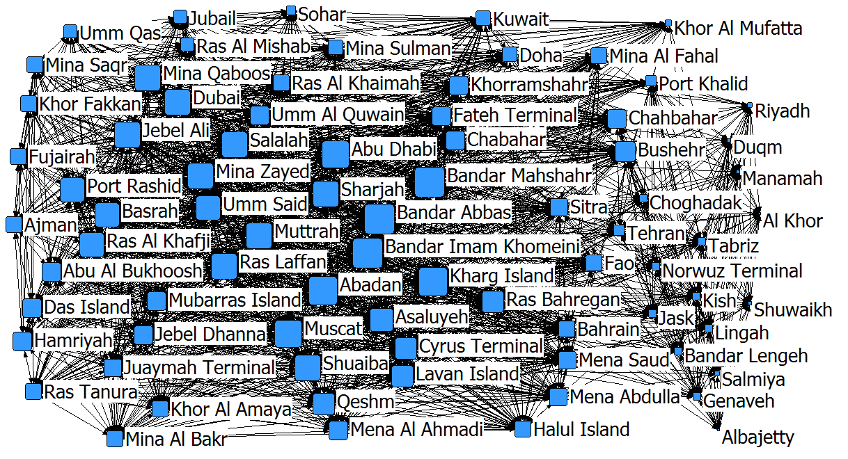
Fig. 1. Gulf ports relational network.

In the Gulf Area Ports Relational Matrix, the number 1 in each row is the number of neighbors of the corresponding node in the network, also known as degrees, which represents the number of other ports connected to the port in the network. Since the concept of sustainable development only spreads between ports that are connected to each other, it is necessary to calculate the degrees of each port. After calculation, the degrees k of each port are [67, 50, 66, 44, 21, 20, 57, 46, 70, 70, 31, 70, 59, 53, 51, 51, 31, 56, 51, 42, 62, 23, 44, 50, 44, 31, 45, 50, 31, 62, 50, 48, 41, 67, 44, 27, 44, 50, 31, 43, 56, 31, 21, 47, 49, 47, 44, 45, 62, 45, 42, 62, 50, 65, 62, 31, 35, 61, 56, 60, 45, 40, 56, 62, 46, 23, 62, 23, 62, 63, 23, 46, 32, 31, 32, 49, 40, 61], and the average degree =46.9, =2382.6.
3.3 Model design
In the SIR propagation model, each node may be in three states: Susceptible (S)—A node that has no sustainable development concept but can accept the spread from neighbors; Infected (I)—A node with a concept of sustainable development that spreads to its neighbors; and Recovered (R)—A node that already knows the concept of sustainable development but will not continue to spread. Note that S(t), I(t) and R(t) represent the density of individuals in S state, I state and R state at time t in the network, respectively, and the relationship between the three is . In the initial state, it is generally set as. is the probability that an infected node becomes a recovered node, and the probability that a susceptible node becomes an infected node is
（1）
where refers to the international and regional regulations and public opinion pressure on sustainable development, and ; and refers to the sustainable competitiveness of ports, and . There is a certain substitution relationship between the two factors and they jointly act on the propagation efficiency. By referring to the Cobb-Douglas function model, the most widely used function form in economics, we can set , which can represent the comprehensive effect of the two factors influencing the spread of the sustainable development concept in the Gulf ports’ relational network, where and represent the weights of the two factors respectively. Then we have . is the effective propagation rate, and the larger the value, the better the propagation effect.
At the same time, the network structure also has an important influence on the spread of the concept of sustainable development. According to whether the degree of each node in the network is the same, the network can be divided into uniform network and non-uniform network [46]. Obviously, the Gulf ports’ relationship network is a non-uniform network. Let be the probability that the node with degree k is randomly connected to the propagator node (I) at time t; then
（2）
where represents the density of the infected node with degree at time t+1, is the degree distribution of the network, and is the average degree of each node in the network.
The probability that a node with degree k in the network is connected to n infected nodes is defined as
（3）
According to equations (1) and (3), we can get the probability that the susceptible node (S) with degree k in the network becomes the infected node (I), as shown below:
（4）
Therefore, at time t+1, the density of the infected nodes with degree k can be described as:
（5）
where is the probability that an infected node becomes a recovered node, also known as recovery rate; and the higher the value, the worse the propagation effect. represents the density of the susceptible nodes with degree k in the network at time t.
According to equation (5), the propagation process of the concept of sustainable development in discrete time can be written as follows:
（6）
By omitting the term, when , the continuous-time equation can be obtained:
（7）
Calculating the value of , we can get:
（8）
According to the equations (7) and (8), we can obtain:
（9）
Therefore, in the SIR model, the propagation process of the sustainable development concept in continuous time can be described by the following differential equations:
（10）
According to equations (2) and (10), we set the auxiliary function ：
（11）
Since , we have
（12）
According to equation (10), we obtain
（13）
Since , combining equation (11) and omitting the higher-order term of , we can get
（14）
We then substitute equation (14) into equation (12), and get
（15）
Letting the above equation =0, we can get
（16）
There is a zero solution in the above equation. In addition, the necessary condition for the existence of a non-zero solution is
（17）
Thus, the propagation threshold of the SIR model in the network is calculated as
（18）

3.4 Analysis of model calculation results
The propagation threshold is one of the most important parameters to measure propagation behavior in the network [47]. When the effective propagation rate is less than the propagation threshold – that is, when , the propagation cannot proceed; when , the propagation behavior appears and is global. Therefore, the smaller the propagation threshold, the more conducive it is to the propagation of contents.
According to the calculation results of the model, we can preliminarily judge that:
1) The propagation threshold is inversely proportional to the network average degree, which verifies the conclusion that network structure will affect the propagation effect. On the one hand, the larger the network scale is, the better the communication effect. Pastor-Satorras and Vespignani et al. [48] showed that the threshold of scale-free networks tends to zero when the scale of networks increases indefinitely, which means that even a very small source of propagation is sufficient to spread over a large network. On the other hand, the greater the density of the network, the more the recipients and the propagation path will appear in the propagation of contents, which can also improve the propagation effect. Therefore, optimizing the structure of the Gulf ports’ relational network by expanding the network scale and increasing the network density will help spread the concept of sustainable development among ports in the region.
2) The propagation threshold is proportional to the recovery rate; that is, the higher the recovery rate is, the higher the propagation threshold will be, and the worse the propagation effect will be. This conclusion can be explained according to the propagation principle of the SIR model. The recovery rate is the probability of transitioning from the I state to the R state. The R state is a relatively closed node in the network. Although it accepts the propagation from neighbors, it is unwilling to spread it to others. When the recovery rate is greater, this means that more nodes will be changed from infected to removers, and the behavior of interrupting the propagation will obviously reduce the propagation effect.
3) The propagation threshold is inversely proportional to the international and regional regulations, public opinion pressure, and port sustainable competitiveness. On the one hand, the stronger the port sustainable development competitiveness is, the more conducive it is to the dissemination of the sustainable development concept. From the perspective of infectors, the stronger the sustainable competitiveness of ports is, the stronger their ability is to cope with competition and threats, so they also have stronger self-confidence and more open mindset, and are more open to sharing their own experiences and technology, thus making propagation more active. From the perspective of recipients, ports with stronger sustainable competitiveness also have clearer and more comprehensive sustainable development concepts and more advanced sustainable development technology, which greatly improves the acceptance of the disseminated information. On the other hand, the stronger the international and regional laws and regulations on sustainable development and the greater the pressure of public opinion, the more conducive these are to the spread of the concept of sustainable development. This point is obvious from the practical experience of Western developed countries.
The results of the model calculation can only judge whether the above factors have a positive or negative impact on the propagation effect, and the degree of influence will be shown by the more accurate simulation data in the next part. Since the network constructed in this paper is static and the degree of nodes in the network is fixed, we do not discuss the influence of network average degree change in the simulation section.
4. Analysis of simulation results
Based on the above model, we analyze the influence of various factors on the network through the PyCharm simulation. The simulation process is shown in Figure 2. Because the purpose of our paper is to investigate the influence of different factors on the propagation effect, the setting of initial values in simulation mainly takes into account the value range of the factors and the obvious degree of the presentation of the results, which will not substantially change our research results. In the simulation, we measure the propagation effect by showing the density change of S-state nodes. The smaller the density of S-state nodes the better the propagation effect, and vice versa. Based on the actual situation and data experiments, the variable values are set uniformly in the simulation process: β=0.6, λ=0.2, A=C=0.1, , . The nodes whose degrees are 46, 45, 47, 47, 45, 45, 45 and 46 are defined as the initial infected node. All the simulation results below are the statistical average of 2,000 simulations.

End
$$i≤78$$
Calculate average density of susceptible nodes
$$t≤n$$
Calculate the number of infected neighbors of $i$

$$i=i+1$$
Calculate the density of susceptible nodes
Import network matrix
The initial t=0, i=0, define initial infected node
Start
$$t=t+1$$
YES
YES
NO
NO
Fig. 2. Model simulation flow chart.

4.1 The influence of recovery rate (β)
In order to explore the influence of recovery rate, we set the values of λ, A and C to remain unchanged. Suppose that β=0.01, 0.2, 0.5, 0.8, and 1, respectively. The simulation results are shown in Figure 3.
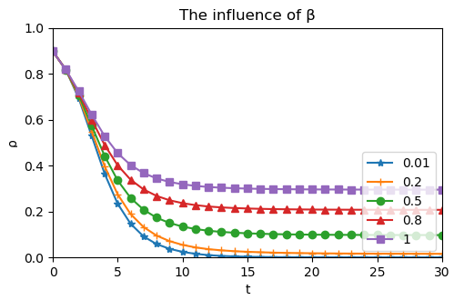
Fig. 3. The influence of recovery rate.
Figure 3 displays the density of susceptible nodes as a function of different β. As expected, the final size of susceptible nodes will be suppressed at small β while it will be promoted at large β. When the value of β is 0.01, the density of susceptible nodes is 0, which means that all nodes in the network are infected. When the value of β increased to 0.5, the density of susceptible nodes increased to about 0.1. With the increasing value of β, the density of susceptible nodes also increased. When β maximizes to 1, the density of susceptible nodes is about 0.35.

4.2 The influence of regulations and public opinion pressure (A)
In order to explore the influence of regulations and public opinion pressure, we set the values of λ, β and C to remain unchanged. Suppose that A=0.01, 0.2, 0.5, 0.8, and 1, respectively. The simulation results are shown in Figure 4. Besides, we simulate equation (18) to explore the influence of A on the threshold of propagation in Figure 5.
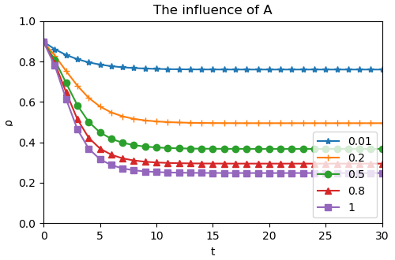
Fig. 4. The influence on the result of propagation of regulations and public opinion pressure.
Figure 4 displays the density of susceptible nodes as a function of different A. As expected, the final size of susceptible nodes will be suppressed at large A while it will be promoted at small A, which means that the density of the final susceptible nodes in the network will continue to decrease when the inhibition of these factors diminishes or the promotion effect increases in the propagation process. When the value of A is 0.01, the density of susceptible nodes is about 0.79. As the value of A increased, the density of susceptible nodes decreased accordingly. When A maximizes to 1, the density of susceptible nodes is about 0.22.

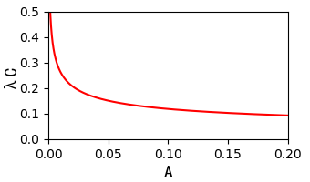
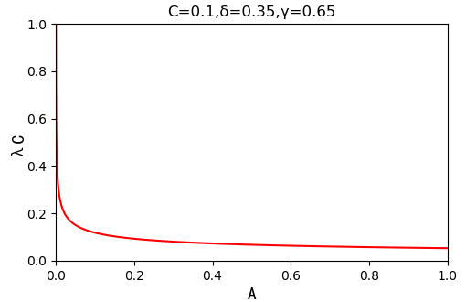
Fig. 5. The influence on the threshold of propagation of regulations and public opinion pressure.
Figure 5 displays the influence on the threshold of propagation of regulations and public opinion pressure. It can be seen that as the value of A increases, the propagation threshold becomes smaller and smaller while other conditions remain unchanged. In particular, when the value of A varies in the range of 0 to 0.05, the change of threshold decreases rapidly from infinity and then continues to decrease steadily.

4.3 The influence of sustainable competitiveness (C)
In order to explore the influence of sustainable competitiveness, we set the values of λ, β and A to remain unchanged. Suppose that C=0.01, 0.2, 0.5, 0.8, and 1, respectively. The simulation results are shown in Figure 6. Besides, we simulate equation (18) to explore the influence of C on the threshold of propagation in Figure 7.
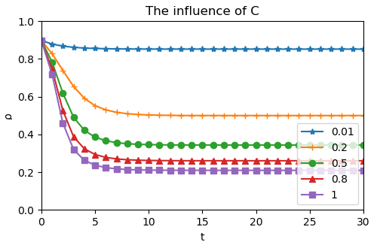
Fig. 6. The influence on the result of propagation of sustainable competitiveness.
Figure 6 displays the density of susceptible nodes as a function of different C. As expected, the final size of susceptible nodes will be suppressed at large C while it will be promoted at small C, which means that the density of the final susceptible nodes in the network will continue to decrease when the inhibition of these factors diminishes or the promotion effect increases in the propagation process. When the value of C is 0.01, the density of susceptible nodes is about 0.83. As the value of C increased, the density of susceptible nodes decreased accordingly. When C maximizes to 1, the density of susceptible nodes is about 0.2. In addition, we note that although changes in sustainable competitiveness and regulations and public opinion pressure have basically the same impact on the transmission effect, it is obvious that C has a greater impact because of the greater weight.

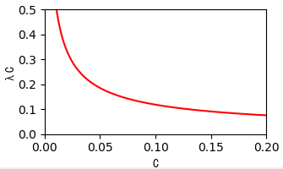
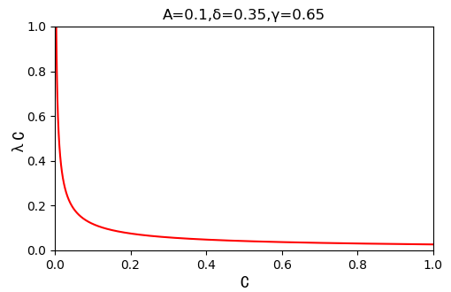
Fig. 7. The influence on the threshold of propagation of sustainable competitiveness.
Figure 7 displays the influence on the threshold of propagation of sustainable competitiveness. It can be seen that as the value of C increases, the propagation threshold becomes smaller and smaller while other conditions remain unchanged. In particular, when the value of A varies in the range of 0 to 0.1, the change of threshold decreases rapidly from infinity and then continues to decrease steadily. In addition, because of the greater weight, the effect of sustainable competitiveness on threshold is significantly greater than that of regulations and public opinion pressure.
5. Conclusions
The following three conclusions can be drawn from the results:
1) The concept of sustainable port propagating in the Gulf region is realistic, but its realization is a long-term process and is affected by many factors.
2) The network structure of the gulf ports is an important factor that affects the propagation of sustainable competitiveness. Optimizing and adjusting the relationship structure of ports in the Gulf region will promote the spread of sustainable development concepts in the region. And the attributes of the propagating contents [46] also are influencing factors, which is specifically manifested whereby the propagation probability is affected by specific factors and the propagation process has its specific rules.
3) In terms of the nature of the influence, network average degree, international and regional regulations and public opinion pressure and ports’ sustainable competitiveness have positive influence on the dissemination effect of sustainable development concept; and the effect of recovery rate is negative. In terms of the degree of influence, the influence degree of recovery rate is less than that of the influence degree of international and regional sustainable development regulations and public opinion pressure, and less than that of the influence degree of ports’ sustainable competitiveness.
Further discussion of the conclusions follows:
5.1 Discussions
First, reducing the recovery rate is conducive to the spread of the sustainable development concept among ports in the Gulf. Therefore, efforts should be made to reduce conflicts among Gulf countries and instead promote cooperation and exchanges among ports. On the one hand, it is necessary to reduce the involvement of external forces in the affairs of the Middle East region: the United Nations and relevant international peacekeeping organizations should constrain the excessive actions of some big powers; at the same time, the Middle East region as a whole should become more united and firmer in dealing with external forces.
On the other hand, countries in the Middle East region should respect each other’s religious culture, reduce unnecessary conflicts, promote regional economic integration processes, and promote diplomatic harmony through economic and trade cooperation. Ports can engage in regional cooperation on infrastructure construction and resource complementarity, and enhance the agglomeration effect of Gulf ports’ group by optimizing industrial layout. Some large ports should make full use of their own competitive advantages to exert radiating effects and drive the development of surrounding ports. Such measures will help establish closer links between countries and ports, thus promoting the spread of the sustainable development concept among ports in the Middle East.
Second, the most effective way to promote the dissemination of the concept of sustainable development is to enhance the sustainable competitiveness of the port itself. Gulf ports have been heavily dependent on oil for a long time, resulting in a relative imbalance in industrial development in different countries’ ports and great environmental pollution. In order to compete for the supply of goods, vicious competition often occurs between ports, as a result of which the allocation of resources becomes inefficient.
In order to enhance the sustainable development competitiveness of ports, in terms of operations and management, Gulf ports should promote industrial restructuring and realize resource integration and complementary advantages; at the same time, they should improve professional talent quality and supporting services. In terms of technological strength, advanced Internet, Internet of Things and automation technology should be applied to rebuild dated facilities, strengthen infrastructure construction – particularly the optimization of collection and distribution systems, benefit from the formation of logistics networks, promote the development of the sea-rail intermodal transport, and improve the efficiency of port operations. As for environmental improvement, new renewable energy sources should be developed, low-carbon technologies should be used to reduce energy consumption, pollution prevention should be comprehensively implemented, and green ports should be built. In addition, with the further development of “the Belt and Road” construction, China is increasingly participating in international cooperation in a positive and friendly way. China has taken a leading position in port management and sustainable development. Therefore, the concept of sustainable development in ports in the Middle East can be disseminated by strengthening investment cooperation between the Middle East and China as well as mergers and reorganization of port enterprises.
Third, the dissemination of the concept of sustainable development can be enhanced by formulating and perfecting international and regional sustainable development regulations and creating a sustainable development environment of public opinion. Under the background that environmental protection and sustainable development have become a global consensus, Gulf States should negotiate and formulate unified and binding laws and regulations on sustainable development of ports. International policies and norms on green ports continue to be introduced, forming a complete set of constraints from the aspects of technology, operation and market management. When referring to these norms, the Gulf States should also consider the particularity of ports in the region. The Gulf region is an oil-producing area – in particular, the ports near the Strait of Hormuz are mostly oil ports – so more specific standards and regulations should be introduced for the prevention and control of marine pollution. In addition to common laws and regulations, each region should also implement some policies according to local conditions. Due to the diversity of resources in the Gulf region, besides oil ports, there are also many ports engaged in fishing, pearl mining or commercial and tourism industries. The sustainable development laws and regulations for these ports should have specific emphasis. In addition, appropriate punitive measures such as charging heavily polluting ships and denouncing uncooperative countries or ports may also encourage the sustainable development practices of ports and the mutual exchange of sustainable development concept and technologies.
5.2. Contributions and limitations
This research makes a number of innovative contributions. First, the propagation model method on complex networks is introduced into the propagation research on the concept of sustainable development, which verifies the applicability of this method in many fields. Second, the Gulf ports’ relationship network is constructed according to the double standards of ports’ country and ports’ type, which is more scientific, reasonable and practical than the single standard network. Then, the simulation results verify the influence of network structure on the propagation effect, and we explain this in detail from two aspects – network scale and network density. Finally, through the literature review, we systematically summarize the factors affecting the dissemination of sustainable development concept into endogenous and exogenous factors. We also verify the influence nature and extent of the two factors by quantitative and simulation methods, which provides a basis for putting forward concrete and feasible measures to promote the dissemination of the concept of sustainable development.
Nevertheless, this research also has some limitations as follows: First of all, the construction of the network is subjective to some extent. Although double standards are adopted, the use of this network to illustrate the relationship between ports in the Middle East is still not objective and rigorous enough. Expert panels can be applied in the future to provide a better understanding on the relationships of ports in the Gulf Region. Second, our discussion is based on a static network; however the real network is changing dynamically at any time, so predicting the dynamic relationship according to the static network has certain limitations. Finally, this research assumes that nodes in the network can independently select from the three states of SIR, but in fact this is limited and affected by the overall network structure. Future research can discuss the game between network nodes and the whole network in greater depth.

References
[1] K. Lyles, ENVIRONMENTAL REVIEWS & CASE STUDIES: Integration of Watershed Planning and the National Environmental Policy Act, Environmental Practice 12 (2) (2010) 158-167.
[2] E.G. Frankel, Port performance and productivity measurement, Ports & Harbors 36 (8) (1991) 11–13.
[3] R. Robinson, Ports as elements in value-driven chain systems: the new paradigm, Maritime Policy & Management, 29 (3) (2002) 241- 255.
[4] M. Tull, The environmental impact of ports: an Australian case study, Proceedings of the 14th International Economic History Congress, Helsinki, Finland, 2006.
[5] B. Kamar, GCC monetary union and the degree of macroeconomic policy coordination, International Monetary Fund, 2007.
[6] D. Byman, Regime Change in the Middle East: Problems and Prospects, Political Science Quarterly 127 (1) (2012) 25-46.
[7] R. Rutter, J. Nadeau, F. Lettice, M. Lim, S. Shamaisi, Place branding of seaports in the Middle East, Place Branding and Public Diplomacy 14 (3) (2018) 197-212.
[8] Z. Li, M. Xu, Y. Shi, Centrality in global shipping network basing on worldwide shipping areas, GeoJournal 80 (1) (2015) 47-60.
[9] J. Agnew, From the political economy of regions to regional political economy, Progress in Human Geography 24 (1) (2000) 101-110
[10] L. Fawcett, International relations of the Middle East, Oxford University Press Fourth edition, 2016.
[11] J.R. Freire, Special section: place branding in the Middle East, Place Branding and Public Diplomacy 8 (2012) 46–47.
[12] A. Fitch, Too Many Ports, Not Enough Trade in the Middle East, Wall Street Journal. Available at: <http://blogs.wsj.com/middleeast/2014/06/05/too-many-ports-not-enough-trade-in-the-middle-east/> (Accessed on 10 June 2019).
[13] P. Deng, S. Lu, H. Xiao, Evaluation of the relevance measure between ports and regional economy using structural equation modeling, Transport Policy 27 (2013) 123-133.
[14] G. Wilmsmeier, R. Bergqvist, K.P.B. Cullinane. Ports and hinterland - Evaluating and managing location splitting, Research in Transportation Economics 1 (33) (2011) 1-5.
[15] J. Dinwoodie, S. Tuck, H. Knowles, J. Benhin, M. Sansom, Sustainable development of maritime operations in ports, Business Strategy and the Environment 21 (2) (2012) 111-126.
[16] D.A. Cooper, Exhaust emissions from ships at berth, Atmospheric Environment 37 (27) (2003) 3817–3830.
[17] L.F. Girard. Toward a smart sustainable development of port cities/areas: The role of the “Historic Urban Landscape” approach, Sustainability 5 (10) (2013) 4329-4348.
[18] World Commission on Environment and Development (WCED) 1987. Report of the World Commission on Environment and Development: our common future, Available at: <www.un-documents.net/wced-ocf.htm> (Accessed on 10 June 2019).
[19] C.S. Lu, K.C. Shang, C.C. Lin, Identifying crucial sustainability assessment criteria for container seaports, Maritime Business Review 1 (2) (2016) 90-106.
[20] K. Bichou, R. Gray, A critical review of conventional terminology for classifying seaports, Transportation Research Part A: Policy and Practice 39 (1) (2005) 75-92.
[21] P. Glavič, R. Lukman, Review of sustainability terms and their definitions, Journal of cleaner production 15 (18) (2007) 1875-1885.
[22] W.Y. Yap, J.S.L. Lam, 80 million-twenty-foot-equivalent-unit container port? Sustainability issues in port and coastal development, Ocean & Coastal Management 71 (2013) 13-25.
[23] UNCTAD (2009). Review of Maritime Transport, United Nations Conference on Trade and Development. Available at: <http://www.unctad.org> (Accessed on 10 June 2019).
[24] T.A. Shiau, C.C. Chuang, Social construction of port sustainability indicators: A case study of Keelung Port, Maritime Policy & Management 42 (1) (2015) 26-42.
[25] R.M. Darbra, A. Ronza, T.A. Stojanovic, C. Wiikdrudge, J. Casal, A procedure for identifying significant environmental aspects in sea ports, Marine pollution bulletin 50 (8) (2005) 866-874.
[26] R.H. Chiu, L.H. Lin, S.C. Ting, Evaluation of green port factors and performance: a fuzzy AHP analysis, Mathematical Problems in Engineering (2014) 1-12.
[27] P.M. Panayides, Maritime logistics and global supply chains: towards a research agenda, Maritime Economics & Logistics 8 (1) (2006) 3-18.
[28] B. Slack, D. Pinder, Shipping and Ports in the Twenty-first Century: Globalisation, Technological Change and the Environment, Routledge, 2004.
[29] Clean Air Action Plan. 2017 Clean Air Action Plan Update Approved by Harbor Commissions. Available at: <http://www.cleanairactionplan.org/> (Accessed 10 June 2019).
[30] International Association of Ports and Harbors. Tool Box for Port Clean Air Programs. Available at: <http://wpci.iaphworldports.org/iaphtoolbox/cp_casestudies.html> (Accessed 10 June 2019).
[31] Sydney Ports Corporation Sustainability Report. Available at: <https://docplayer.net/14851763-Sydney-ports-corporation-sustainability-report.html> (Accessed 10 June 2019).
[32] G.T. Yeo, M. Roe, J. Dinwoodie, Evaluating the competitiveness of container ports in Korea and China, Transportation Research Part A: Policy and Practice 42 (6) (2008) 910-921.
[33] J. Tongzon, W. Heng, Port privatization, efficiency and competitiveness: Some empirical evidence from container ports (terminals), Transportation Research Part A: Policy and Practice 39 (5) (2005) 405-424.
[34] W.Y. Yap, J.S.L. Lam, Competition dynamics between container ports in East Asia, Transportation Research Part A: Policy and Practice 40 (1) (2006) 35-51.
[35] M. Acosta, D. Coronado, M.M. Cerban, Port competitiveness in container traffic from an internal point of view: the experience of the Port of Algeciras Bay, Maritime Policy & management 34 (5) (2007) 501-520.
[36] A.S. Klovdahl, Social networks and the spread of infectious diseases: the AIDS example, Social science & medicine 21 (11) (1985) 1203-1216.
[37] S. Eubank, H. Guclu, V.S.A. Kumar, M.V. Marathe, A. Srinivasan, Z. Toroczkai, N. Wang, Modelling disease outbreaks in realistic urban social networks, Nature 429 (6988) (2004) 180.
[38] C. Zhang, H. Huang, Optimal control strategy for a novel computer virus propagation model on scale-free networks, Physica A: Statistical Mechanics and its Applications 451 (2016) 251-265.
[39] R.K. Upadhyay, S. Kumari, A.K. Misra, Modeling the virus dynamics in computer network with SVEIR model and nonlinear incident rate, Journal of Applied Mathematics and Computing 54 (1-2) (2017) 485-509.
[40] D.H. Zanette, Critical behavior of propagation on small-world networks, Physical Review E 64 (5) (2001) 050901.
[41] N. Liu, H. An, X. Gao, H. Li, X. Hao, Breaking news dissemination in the media via propagation behavior based on complex network theory, Physica A: Statistical Mechanics and its Applications 453 (2016) 44-54.
[42] A. Garas, P. Argyrakis, C, Rozenblat, M. Tomassini, S. Havlin, Worldwide spreading of economic crisis, New journal of Physics 12 (11) (2010) 113043.
[43] N.T.J. Bailey, The mathematical theory of infectious diseases and its applications, Charles Griffin & Company Ltd 5a Crendon Street, High Wycombe, Bucks HP13 6LE., 1975.
[44] O. Diekmann, J.A.P. Heesterbeek, Mathematical epidemiology of infectious diseases: model building, analysis and interpretation, John Wiley & Sons, 2000.
[45] W. Liu, X. Wu, W. Yang, X. Zhu, S. Zhong, Modeling cyber rumor spreading over mobile social networks: A compartment approach, Applied Mathematics and Computation 343 (2019) 214-229.
[46] X.J. Sun, S.K. Si, Complex network algorithms and applications, National defense industry press, Beijing, 2015 (in Chinese).
[47] W.O. Kermack, A.G. McKendrick, Contributions to the mathematical theory of epidemics. II. - The problem of endemicity, Proceedings of the Royal Society of London. Series A, containing papers of a mathematical and physical character 138 (834) (1932) 55-83.
[48] R. Pastor-Satorras, A. Vespignani, Epidemic spreading in scale-free networks, Physical review letters 86 (14) (2001) 3200.
Appendix: Basic Algorithm Code for Simulation Process
import pandas as pd
import random
import copy
import matplotlib.pyplot as plt

data = pd.read_excel('Network Matrix.xlsx').values[:, 1:]

print(data)
C = 0.1
x = 0.35
y = 0.65
z = 0.2
p_r = 0.6
l = list(range(len(data)))
length = 78
t = 100
charc = ['*', '+', 'o', '^', 's']

def propagation(A):
l_r = []
l_i = [l[7], l[26], l[43], l[45], l[47], l[49], l[60], l[71]]
l_s = list(set(l) - set(l_i))
l_num_s = [1 - 8 / length]

for _ in range(1, t):
l_s_copy = copy.deepcopy(l_s)
l_i_copy = copy.deepcopy(l_i)
for s in l_s_copy:
sum_neigh = 0
for ind, neigh in enumerate(data[s]):
if (neigh == 1) and (ind in l_i_copy):
sum_neigh += 1
p = 1 - (1 - A ** x * C ** y * z) ** sum_neigh
if random.random() < p:
l_i.append(s)
l_s.remove(s)
for i in l_i_copy:
if random.random() < p_r:
l_r.append(i)
l_i.remove(i)
l_num_s.append(len(l_s) / length)
return l_num_s

def solvePointData(arry):
summ = 0
result = []
for out in range(0, len(arry[0])):
for inside in range(0, len(arry)):
summ += arry[inside][out]
result.append(summ/len(arry))
summ = 0
return result

def iteration(N, A):
cnt = 0
cntOut = 0
l_num_s_count = []
resultEnd = []
while(cntOut < len(A)):
while(cnt < 2000):
result = propagation(A[cntOut])
l_num_s_count.append(result)
cnt += 1
resultEnd.append(solvePointData(l_num_s_count))
cntOut += 1
cnt = 0

return resultEnd

def drawData(reslut, A):
for i in range(len(reslut)):
plt.plot(range(t), reslut[i], label=A[i], marker=charc[i])
plt.legend(loc='lower right')
plt.xlim(0, 30)
plt.ylim(0, 1)
plt.ylabel('ρ')
plt.xlabel('t')
plt.title('The influence of A')
plt.show()

def main():
A = [0.01, 0.2, 0.5, 0.8, 1]
drawData(iteration(len(A), A), A)

if __name__ == '__main__':
main()

* Corresponding author: 02/5047, Southampton Business School, University of Southampton, Southampton, SO17 1BJ, UK E-mail address: Y.Gong@soton.ac.uk

