Protocol

Edward Meinert^{1,2}, Em Rahman³, Alison Potter³, Wendy Lawrence⁴, Terese Stenfors⁶, Michelle Helena van Velthoven^{1,5}

¹ Digitally Enabled PrevenTative Health (DEPTH) Research Group, Department of Paediatrics, University of Oxford
² Department of Primary Care and Public Health, School of Public Health, Imperial College London
³ Health Education England
⁴ University of Southampton
⁵ Nuffield Department of Primary Care Health Sciences, University of Oxford
⁶ Department of Learning, Informatics, Management and Ethics, Karolinska Institutet

Correspondence to:

Edward Meinert MA MSc MBA MPA PhD FBCS CEng EUR ING
e.meinert14@imperial.ac.uk
+44 782 444 6808

Usability of the mobile digital health ‘NoObesity’ app for families and healthcare professionals: a feasibility study

Abstract
Background: Almost a quarter or more than a fifth of children in the United Kingdom (UK) are overweight or obese by the time they start school. The UK Department of Health and Social Care has updated national policy for combating childhood obesity in 2018, with critical outcomes centred on sugar and caloric consumption reduction. Health Education England has developed two digital apps for families with children up to 15 and for their associated health care professionals (HCPs) to provide a digital learning resource and tool aimed at encouraging healthy lifestyles to prevent obesity.
Objective: This feasibility study assesses Health Education England’s NoObesity app usability and acceptability to undertake activities to improve families’ diet and physical activity. The purpose of the study is to evaluate the app’s influence on self-efficacy and goal setting and to determine what can be learned to improve its design for future studies, should there be evidence of adoption and sustainability.
Methods: The study population will include 20-40 families and their linked health care professionals. Recognising issues related to digital access associated with socioeconomic status (SES) and impact on information technology (IT) use, study recruitment will be regionally focused on a low SES area. The study will last nine-months; three months intervention period and six months follow up. The evaluation of feasibility, acceptability, and usability will be conducted using the following scales and theoretical frameworks: 1. The system usability scale; 2. The Reach Effectiveness Adoption Implementation Maintenance (RE-AIM) framework; 3. Bandura’s model of health promotion; and 4. The Nonadoption, Abandonment, and Challenges to the Scale-up, Spread, and Suitability (NASSS) framework. App use will be captured and quantitatively analysed for net use patterns (e.g. number of screens viewed, number of logins, cumulative minutes using the app, number of plans made, number of times goals met) and to triangulate qualitative feedback from study participants.
Discussion: This study will provide evidence on the NoObesity app’s influence on self-efficacy and goal-setting and to determine what can be learned to improve its design for future studies, should there be evidence of adoption and sustainability.

Keywords: Keywords: mHealth, Mobile health, Digital health, digital technology, weight loss, obesity, overweight, child health, cell phone, telecommunications.

Introduction
Obesity is a rising concern globally. In the UK, and it is projected that by 2030 41-48% of men and 35-43% of women will be obese and almost a quarter or more than a fifth of children are overweight or obese by the time they start school [1]. It is estimated that obesity-related conditions are currently costing the NHS £6.1 billion per year, with a cost to society of these conditions estimated at £27 billion per year [2–4]. The UK Department of Health and Social Care has updated national policy for combating childhood obesity in 2018, with critical outcomes centred on sugar and calorie consumption reduction [2].

The rapid development of technology has quickly led to a growing market for various devices and mobile digital software claiming to aid with weight loss, with 102.4 million products sold in 2016, and sales expected to continue to rise [5]. The effectiveness of these technologies has been subject to many studies [6–10], with some results suggesting that they can benefit weight loss temporarily. However, sustained weight loss is often unsuccessful [8,9]. Even where evidence on these interventions demonstrate a significant weight loss or reduction in weight gain, if this benefit only lasts for a short period of time, then this dramatically reduces the usefulness of these technologies [8,9]. Digital mobile technology for weight loss could be a novelty that wears off over time, rather than an intervention for sustained lifestyle change that can be maintained over the long-term. While these technologies have significant potential, the limitations noted require further analysis to see how they can be used to make a lasting impact on positive lifestyle change.

Health Education England (HEE) developed the 'NoObesity' apps as a collaborative initiative between the Universities of Bournemouth and Southampton in 2017-2018. This work centred on the development of 1) a family-focused app to enable families to set health goals, identify barriers and develop strategies to overcome them and 2) a professional focused app to help healthcare professionals provide tailored advice to families, how to handle common objections and assist families with their lifestyle objectives. The project completed development and user testing on Apple and Android platforms by producing, testing and finalising the functionality and structure of the apps and also writing, testing and finalising the content of the apps. The user testing consisted of focus groups conducted with professionals and parents or carers [11]. This feasibility study aims to gather data on the NoObesity app usability and acceptability to undertake activities improving families’ diet, physical activity, and weight.

Solution overview
NoObesity consists of two Apps (NoObesity Professional and NoObesity Family) to support the prevention and management of childhood obesity targeting professionals and families. The Apps focus on developing the workforce to support families around childhood obesity and enabling families to set behavioural goals to support their own health and wellbeing.

The Apps bring both workforce development and service delivery together, which was a result of the collaboration that led to the development of this project.

Workforce Development – NoObesity Professional App
The Professional App has functionality which supports knowledge and skills development of the workforce centred on weight management. Figure 1 outlines the functions in the professionals App, and Table 1 outlines the purpose and outcome.

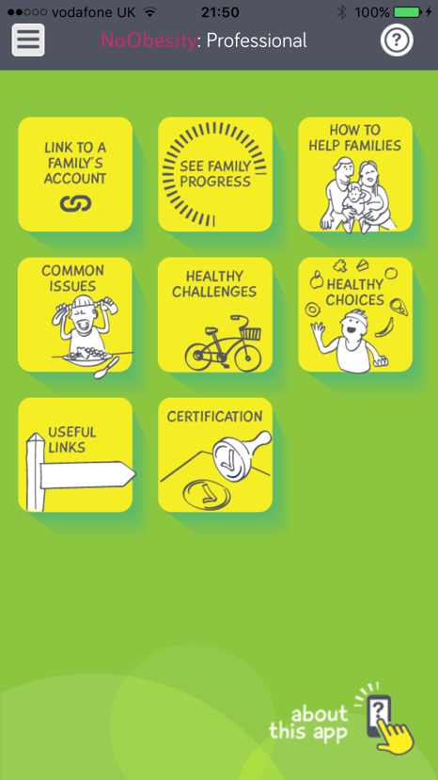
Figure 1: NoObesity Professional App main screen

Table 1: NoObesity Professional App functional overview
App Function | Purpose | Outcome
How to Help Families | This function enables the professional to follow a family (through a story) where the family comes into contact with a number of different health care workers. The task for the Professional is to:  - Read the section of the story.  - Score whether the interaction was a good one or not.  - Reflect whether there were any missed opportunities to talk about health and wellbeing with the family.  The App then provides the professional with information on how interactions with the family can be improved for their own practice. | Professionals will have an increased awareness of the potential opportunities that could be missed in supporting families around health and wellbeing.  Professionals will be enabled to reflect on their own practice when coming into contact with families.  Professionals will see (read) how a MECC approach can be used for their own practice in supporting families.
Common Issues | This function provides some of the common issues professionals face when supporting families around healthy eating, diet and activity. This function offers professionals with some solutions on how they can overcome the common issues and challenges they are faced with.  The solutions are developed with MECC principles which allow professionals to use MECC skills in supporting families. | Professionals are able to learn about solutions they can use to overcome issues and challenges they are presented with.  Professionals are enabled to practice MECC skills as they support families overcome issues and challenges.
Healthy Challenges & Healthy Choices | These two functions are developed in the form of games which professionals can play as a way of learning in a fun way on what makes a healthy diet and what level of physical activity is required to burn off calories. | Professionals will gain knowledge of the Eat Well Plate and Physical Activity to support families.
Useful Links | This function provides links to websites for professionals to access to further their own learning and CPD. | Professionals will learn about the resources available on specific aspects of health and wellbeing in order to be better informed on the topic and possible signposting.
Certification | This function encourages professionals to do all of the above as they gain bronze, silver, gold awards as they explore the content of the App more. | Professionals have used the App to develop their knowledge and skills in supporting the prevention and management of childhood obesity with the families they support.

Workforce Development – NoObesity Families App

The Family App has the following functionality enabling families to set behavioural goals to support their own health and wellbeing. These are highlighted in Figure 2.

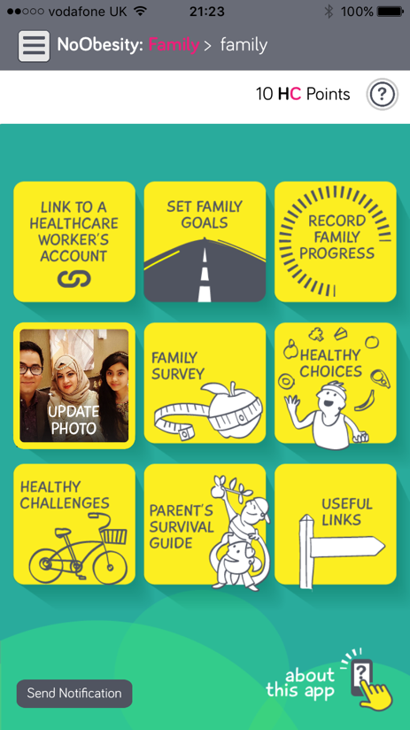
Figure 2: NoObesity Family App main screen

Table 2 outlines the purpose and outcome of the family app use cases.

Table 2: NoObesity Family App functional overview
App Function | Purpose | Outcome
Set Family Goals | This function enables families to set behavioural goals to support them in their health and wellbeing. This function takes them through a SMARTER process to set action-orientated, realistic and measurable goals. | Families are setting goals using a SMARTER process which is part of the MECC programme.
Record Family Progress | This function allows families to record how they have been progressing with the family goals and enables them to evaluate and review their goals if they have not progressed as expected. | Families are able to record their progress and review their goals.
Update Photo | This function is in place for families to be able to upload pictures of them doing healthy things. This could be a meal they’ve cooked or pictures of them on a health walk etc. | This is used as an engagement tool allowing families to upload photos of things they have done as a way of encouraging them to come back to the App.
Family Survey | This function supports families to take stock of where they are around a number of health-related areas. The family survey includes the following questions:  - How much water do you drink?  - How much fruit do you eat?  - How much veg do you eat?  - How much physical activity do you do?  - How much sleep do you have?  - How much screen time do you have?  - How often do you brush your teeth?  - How happy do you feel?  - What is your body size?  These questions can be completed by more than one person - so you could end up with a health survey for all members of your family. Once the survey is completed, the App will prompt families to think about setting a goal around one of the areas of the health survey (if they have scored low on it). | To enable baseline data to allow for a comparison of change.
Healthy Choices & Healthy Challenges | This function is the same as it is in the Professional’s App. | Enabling families to learn about the eat well plate and about physical activity.
Parent’s Survival Guide | This function supports families in thinking about how they can overcome challenges that they face when supporting their children around healthy eating etc. | Families gain solutions on how they could approach issues and challenges using a MECC approach.
Useful Links | This function is the same as it is in the Professional’s App. | Enabling families to learn about other resources available to support their health and wellbeing.

Linking the Apps
The two Apps can be linked (using a QR code) which is led by the family who may wish to share the goals and progress they have made with a healthcare worker. For example, this could be during a GP consultation or a visit to the local children’s centre. The professional will only see the family’s survey results, goals and progress. This will allow the professional to better tailor the support they provide to the family.

Research questions
The purpose of this study is to investigate the following research questions:

- What are the issues impacting self-efficacy, perceived benefits and barriers for digitally delivered interventions to prevent childhood obesity (specifically examining learning and associated actions with regard to diet and physical activity)?;

- How can interventions delivered digitally (e.g. The NoObesity app) build communication among participants (parents/guardians and health care professionals) to create engagement and education on positive lifestyle habits (parents/guardians and health care professionals)?

Methods
This investigation will take the form of a feasibility study using mixed methods. To address the study research questions, quantitative monitoring of app users will be supplemented by qualitative interviews with parents/guardians and health care professionals (Multimedia Appendix 1).
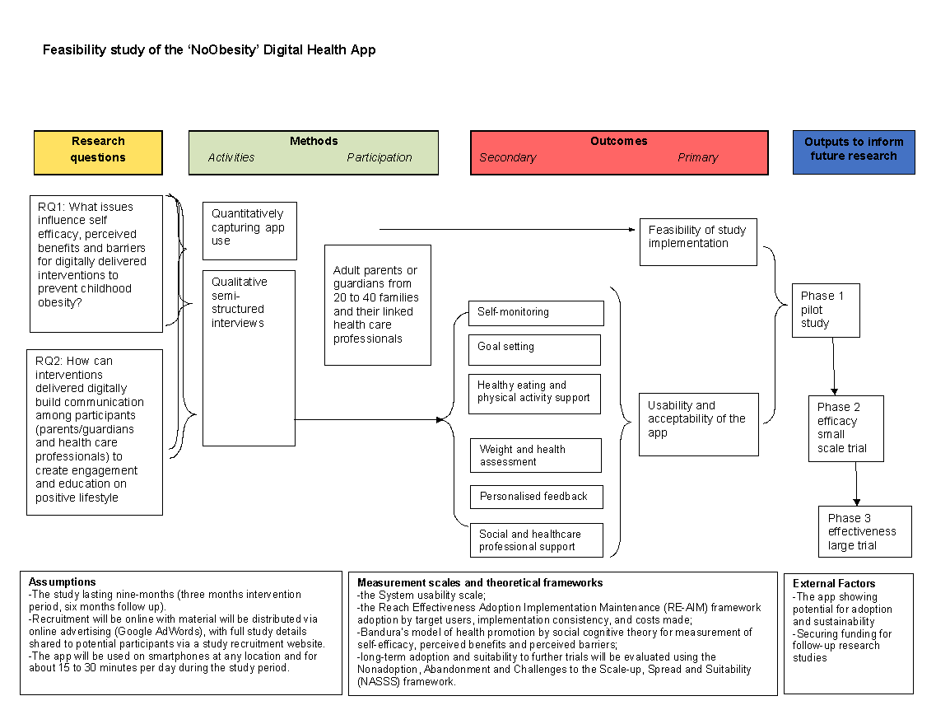
Figure 3: Study logic model

Recruitment
We will recruit 20-40 families and their associated/linked health care professionals (e.g. allied health professionals, health visitors). There will not be separate recruitment of healthcare professionals (HCPs); the only included HCPs will be those whose clients are also using the app in this study. A central objective of the study is to reach demographic saturation (ethnicity, social-economic background, and education) for family study participants; study recruitment will continue until there is a representative sample from each category. Recognising issues related to digital access with regard to socioeconomic status (SES) and its impact information technology (IT) use, study recruitment will be regionally focused on a low SES area. Recruitment material will be distributed via online advertising (Google AdWords), with full study details shared to potential participants via a University of Oxford study recruitment webpage. Once identified, potential participants will be sent copies of all consent and study information (Multimedia Appendix 2 and 3). Participants will then have an opportunity to review the materials. Should they wish to proceed, they can register for the study.

Research participants
Research participants will be limited to parents or legal guardians and their health care professionals using the app. A £100 Amazon gift voucher will be given as compensation to participants who complete the study. While children could directly participate in the family app, for this study, children are excluded from the scope because of the potential confounding impact of their use in contrast to parents or guardians.

Inclusion criteria
The inclusion criteria centred on adult users of the apps to focus on interactions associated with family goal-setting. Children were excluded from the study to focus on the capability of the app to influence adult participants.

The following inclusion criteria will be used:
- Fluency in English;
- Willing to use the app;
- Parents/legal guardians of a child/children;
- Health care professionals linked to the parent or guardian;
- Owner of a smartphone to access the app, with 4G data access.

Exclusion criteria
The following exclusion criteria will be used:
- Individuals that are known by the researchers or staff at Health Education
- England;
- Deaf/hearing impaired (there is no capability to manage this participant type in this study);
- Prior use of the app before study commencement;
- Refusal to give informed consent;
- Children, vulnerable young people or vulnerable adults.

Study duration and follow-up
The study will last nine months: three months intervention period, and six months follow up. Participants will be invited to use the NoObesity app for goal setting and monitoring family activities. Use of the app will be done online via their smartphones at any location during the study period of three months. Following a process of informed consent, should participants proceed, they will be given access to links to download and install the application. Participants will be asked to take part in 2 interviews via online conferencing or telephone lasting 40-60 minutes (Multimedia Appendix 4). It is important to note there are two separate apps, one for families and a second for AHPs/Health Visitors. While the family app is used to family goal planning, the professional app is for monitoring. Should HCPs opt into the study, they will also be interviewed, but separately from the family participants. Interview questions will be asked within the context of how the HCPs interpreted the impact of the app on their associated client family (same questions will be used but from the perspective of app use and monitoring of outcomes).

Theoretical framework
The evaluation of feasibility, acceptability and usability shall be conducted using the following scales and theoretical models/frameworks: 1) the system usability scale [12]; 2) the Reach Effectiveness Adoption Implementation Maintenance (RE-AIM) framework [13] to include information regarding target population reach, the potential for solution impact, adoption by target users, implementation consistency, and costs made during delivery and maintenance of the intervention; 3) Bandura’s model of health promotion [14] by social cognitive theory will be used in measurement development and validity, with specific emphasis on self-efficacy, perceived benefits and perceived barriers [15]; and 4) long-term adoption and suitability to further trials will be evaluated using the Nonadoption, Abandonment and Challenges to the Scale-up, Spread and Suitability (NASSS) framework [16].

Data collection

Quantitative data
App use will be captured for net system use patterns; this will include an examination of click-through and engagement throughout the system. The primary method of evaluating factors impacting uptake shall be drawn from qualitative investigation and data concerning system use will be used as a means to triangulate qualitative findings.

Qualitative data
Surveys and semi-structured interviews will be undertaken to evaluate the acceptability and usability of the app. Interviews will be scheduled to last between 40 and 60 minutes (maximum). The interviews will be executed at three-month and six-month intervals to allow for analysis of the impact of the intervention. Interviews will be conducted through online conferencing and telephone conference calls because participants are geographically dispersed. Participants will also be provided with a copy of the study findings that will be published in a peer-reviewed journal.

Data analysis

Quantitative data
Web server access logs will be used for analysis of net use patterns, e.g. number of screens viewed, number of logins, cumulative minutes using the app, number of plans made, number of times goals met.

Qualitative data
All interviews will be audio recorded on a digital recorder, transcribed and coded using thematic analysis [17]. Interviews (at three month and six-month intervals) will be used to explore factors influencing topics intervention engagement [17]: 1. Self-monitoring 2. Goal setting 3. Physical activity and healthy eating support 4. Weight and health assessment 5. Personalised feedback and motivational strategies (rewards, prompts, or gamification) 6. Social support and health care professional involvement.

Bias
Participants will be asked to provide consent and given information on the structure of the study to ensure understanding of the research study. To avoid bias, the criteria to exclude participants who have a relationship with any of the study researchers or are employed by the university. In order to address unconscious bias or other forms of interview recruitment issues, all participants will be included in the study and analysis.

Risks
Interview questions avoid areas of culturally sensitive issues and are purely focused on the impact of the intervention impact. To control any potential perceived issues in this area, participant confidentiality is protected using the enclosed data protection procedures.

Informed consent
Prior to completing informed consent, participants will be given information which fully describes the process of the study, including why their participation is necessary, how it will be used and who the results will be reported to. The research team recognise the right of the participants to withdraw from the study at any time and have their data destroyed, and participants will be informed of this. If there are issues identified during the study (by study participants), they will be documented and escalated to the Head of the Department who will take action with PI. The study will also be overseen by an operations group who will monitor adherence to the study protocol; this group will meet monthly, with minutes recorded and published capturing discussion and key points.

Data management
Each participant will be given a unique identifier (ID). The primary key between unique ID and participant will be held securely on an encrypted, secured drive within the University network. The primary key is being maintained in the event of a participant wishing to withdraw their data from the study; should such a request be received all corresponding data and files will be destroyed. Only the research administrators will have access to this file. Although basic demographic information will be captured, the only route to identification will be the unique ID as the general participants of the study and the self-selecting collection of respondents will be unknown to both parties. Sessions will be recorded then transcribed by an internal third party (a Research Assistant trained in transcription) with reference to the unique identifier only; the risk of identification will be very low due to this measure being taken. Only researchers listed in this application and the PI’s in the research team will have access to research data. No research data will be transferred to other organisations; results will be disseminated via publications. Records of consent will be kept for three years after the publication of final study results. To comply with the General Data Protection Regulation (GDPR) and the Data Protection Act 2018, personal data will be deleted three years after the publication of final study results. All electronic data will be captured and stored on a password-protected network drive within the University of Oxford network. Access to these files will be limited to the PI, the Co-Investigator, a Research Assistant and Research Associate. Electronic data will be coded using the ID and primary critical pseudonymisation process.

Discussion
This study will provide evidence on the NoObesity app’s influence on self-efficacy and goal setting to improve its design for future studies, should there be evidence of adoption and sustainability. There are gaps in the literature on the lack of effectiveness of mobile apps in improving health behaviours [18] and the need for iterative design to improve usability [8]. It is hoped this study will provide variables that can be further evaluated in future studies.

Methodological limitations
This study is a limited feasibility study observing factors influencing app usage. It is important to note that this study type does not prove effectiveness.

This study methods have been designed proportionate to the resource available for study execution. A higher investment in study resources could lead to a richer set of results; for example, an iterative approach with families and their children would lead to a richer data set and stronger triangulation of results. Due to limitations of resources, the study does not have provision for parents and parents/guardians who are deaf or hearing impaired.

The study focuses on the recruitment of participants directly via families; however, direct recruitment of HCPs could have been alternate recruitment approach which could lead to a more robust targeting of prospective family study participants. This is because HCPs would have informed views on families who would have the best potential need for the intervention. The reason the study focuses on family recruitment because the open nature of access of the app potential via digital stores; it is likely that families would potentially access the app with prompt; these assumptions will be tested within the study.

There is a risk the nature of the study, and the intervention type will not reach low SES demographic participants and bias towards educated, motivated participants. Use of these technologies could potentially create further digital access inequality. This has attempted to be mitigated in the study approach through recruitment in a low SES geographic area.

The study excludes children as study participants and focuses on parents/guardians; an alternate study design would take quantitative/qualitative feedback directly from children.

Acknowledgements
This study was funded by Health Education England. EM conceived the study topic and designed the review protocol. The protocol was written by EM and MVV with revisions from all authors. The study was reviewed and approved by the University of Oxford Central University Research Ethics Committee (CUREC), Reference ID: R62092. Kate King-Hicks, Helena Wehling and Jamie Blackshaw from Public Health England (PHE) participated in the programme steering committee and provided review comments.

Conflicts of Interest
Health Education England independently commissioned and developed the NoObesity app. The University of Oxford has an unrestricted right to execute the study and publish findings as an independent research entity.

Multimedia Appendix 1
CONSORT-EHEALTH V1.6

Multimedia Appendix 2
Participant consent form

Multimedia Appendix 3
Information sheet for participants

Multimedia Appendix 4
Topic guide

References
1. “Half of UK obese by 2030” [Internet]. NHS. 2011 [cited 2020 May 20]. Available from: https://www.nhs.uk/news/obesity/half-of-uk-obese-by-2030/
2. Global Public Health Directorate: Obesity, Food and Nutrition /. Childhood obesity: a plan for action, Chapter 2. Department of Health and Social Care; 2018 Jun.
3. Pi-Sunyer X. The Medical Risks of Obesity [Internet]. Postgraduate Medicine. 2009. p. 21–33. [doi: 10.3810/pgm.2009.11.2074]
4. Caballero B. The global epidemic of obesity: an overview. Epidemiol Rev 2007 Jun 13;29:1–5. PMID:17569676
5. Hall BMD, Chaffey BD, Llewellyn BG. Wearable Technology statistics and trends 2018 | Smart Insights [Internet]. Smart Insights. 2017 [cited 2020 May 20]. Available from: https://www.smartinsights.com/digital-marketing-strategy/wearables-statistics-2017/
6. Bardus M, Smith JR, Samaha L, Abraham C. Mobile Phone and Web 2.0 Technologies for Weight Management: A Systematic Scoping Review. J Med Internet Res 2015 Nov 16;17(11):e259. PMID:26573984
7. Beleigoli AM, Andrade AQ, Cançado AG, Paulo MN, Diniz MDFH, Ribeiro AL. Web-Based Digital Health Interventions for Weight Loss and Lifestyle Habit Changes in Overweight and Obese Adults: Systematic Review and Meta-Analysis. J Med Internet Res 2019 Jan 8;21(1):e298. PMID:30622090
8. Singh K, Drouin K, Newmark LP, Filkins M, Silvers E, Bain PA, Zulman DM, Lee J-H, Rozenblum R, Pabo E, Landman A, Klinger EV, Bates DW. Patient-Facing Mobile Apps to Treat High-Need, High-Cost Populations: A Scoping Review. JMIR Mhealth Uhealth 2016 Dec 19;4(4):e136. PMID:27993761
9. Hu R, van Velthoven MH, Meinert E. Perspectives of People Who Are Overweight and Obese on Using Wearable Technology for Weight Management: Systematic Review. JMIR Mhealth Uhealth 2020 Jan 13;8(1):e12651. PMID:31929104
10. Fawcett E, Van Velthoven MH, Meinert E. Long-Term Weight Management Using Wearable Technology in Overweight and Obese Adults: Systematic Review. JMIR Mhealth Uhealth 2020 Mar 10;8(3):e13461. PMID:32154788
11. Apps being developed to help prevent childhood obesity [Internet]. Health Education England. 2017 [cited 2020 May 20]. Available from: https://www.hee.nhs.uk/news-blogs-events/news/apps-being-developed-help-prevent-childhood-obesity
12. Brooke J. SUS - A quick and dirty usability scale [Internet]. Available from: https://hell.meiert.org/core/pdf/sus.pdf
13. Glasgow RE, Vogt TM, Boles SM. Evaluating the public health impact of health promotion interventions: the RE-AIM framework. Am J Public Health 1999 Sep;89(9):1322–1327. PMID:10474547
14. Bandura A. Health Promotion by Social Cognitive Means [Internet]. Health Education & Behavior. 2004. p. 143–164. [doi: 10.1177/1090198104263660]
15. Quelly SB. Reliability and Validity of a Tool to Measure School Nurse Perceptions and Practices Associated With Childhood Obesity Prevention. J Nurs Meas 2015;23(2):239–254. PMID:26284838
16. Greenhalgh T, Wherton J, Papoutsi C, Lynch J, Hughes G, A’Court C, Hinder S, Fahy N, Procter R, Shaw S. Beyond Adoption: A New Framework for Theorizing and Evaluating Nonadoption, Abandonment, and Challenges to the Scale-Up, Spread, and Sustainability of Health and Care Technologies [Internet]. Journal of Medical Internet Research. 2017. p. e367. [doi: 10.2196/jmir.8775]
17. Braun V, Clarke V. Using thematic analysis in psychology [Internet]. Qualitative Research in Psychology. 2006. p. 77–101. [doi: 10.1191/1478088706qp063oa]
18. Milne-Ives M, Lam C, De Cock C, Van Velthoven MH, Meinert E. Mobile Apps for Health Behavior Change in Physical Activity, Diet, Drug and Alcohol Use, and Mental Health: Systematic Review. JMIR Mhealth Uhealth 2020 Mar 18;8(3):e17046. PMID:32186518

