Multiphysics Analysis of a Hybrid Suspension System for Middle-Low-Speed Maglev Trains

Guoqing Liu¹, Jingchi Wu¹, Song Xiao¹, Yuanpei Luo¹, Can Zhang¹, Yang Rao¹, Kunlun Zhang¹, Jan K. Sykulski², Fellow, IEEE
¹ School of Electrical Engineering, Southwest Jiaotong University, Chengdu, China
xiaosong@home.swjtu.edu.cn
² Electronics and Computer Science, University of Southampton, Southampton, UK

Abstract. The suspension force – a critical factor in the operation of middle-low-speed maglev trains – is provided by electromagnets. However, the eddy current effect produced by the relative motion between electromagnets and the steel track causes a reduction of the suspension force, especially under high speed. A novel type of permanent-electro-magnetic suspension system is proposed to improve performance by considering the variation of material characteristics with temperature. A 3D dynamic finite element model of this hybrid system – accounting for the influence of temperature – has been created to study the variation of magnetic flux distribution, suspension force and guiding force under different operational speeds of the train, in comparison with the electromagnetic version. Verified by simulations, the hybrid system has superior performance offering a powerful suspension force and a reliable guidance force even at high speeds of the train.
Keywords—middle-low-speed maglev train, electromagnet, permanent-electro-magnetic suspension, eddy current effect, material characteristics

Introduction
As a highly efficient urban transportation technology, middle-low-speed maglev trains have gradually been commercialized and popularized all over the world, due to their merits, such as low space usage, low noise, no pollution, small turning radius and low electromagnetic radiation [1]-[3]. As the two critical components of middle-low-speed trains, the linear induction motors provide horizontal thrust for trains, while levitation is realized using electromagnetic suspension (EMS). Eddy currents are mainly produced on the surface of the steel track because of the relative motion and – as the train accelerates – these currents increase, which may directly affect the suspension force. When the speed exceeds 80km/h, the eddy current effect becomes dramatically strong, especially towards the front of the train. In order to mitigate the front-end eddy current effect, the structure of the electromagnet is optimized and a ‘two controller levitation system’ is proposed to adjust the input current for each electromagnet [4]. To recover the reduction of the suspension force due to eddy currents, the input power for electromagnets must increase constantly, limited only by the rated power. However, the coil insulation becomes liable to damage by prolonged large currents.
A hybrid suspension, mixing electromagnets with permanent magnets, has been considered to save energy and suppress the eddy current effect [5]-[9]. Many research programs were initiated to improve the traditional maglev trains via inserting permanent magnets, including work in our College on permanent-electro-magnetic suspension (PEMS) systems. In [10] an insertion of permanent magnets was proposed to improve the suspension force. The effects of different permanent magnet inserting schemes on suspension force and guidance force are discussed in [11]. For a hybrid system, the relationships between the suspension force, the control current and the suspension gap, as well as between the guidance force and the displacement, are derived in [12].
Until now, however, little attention has been paid to the coupled multi-physics performance of PEMS systems, especially regarding how the temperature distribution affects the performance of permanent magnets. In this paper, the impact on the material characteristics of the temperature distribution is investigated under dynamic conditions. A novel configuration of a PEMS system is proposed to enhance the suspension force and improve the thermal dissipation performance, compared with the purely electromagnetic suspension system.

Configuration of suspension electromagnets
The middle-low-speed maglev train used for the Changsha Airport Express line contains two critical components: electromagnets for providing the suspension force and induction linear motors for producing the thrust. Each carriage of the maglev train has five suspension bogies, where a suspension module – each of which has four electromagnets – are installed on both sides as shown in Fig. 1(b). The configuration of the electromagnet combination with four separates units is presented in Fig. 2(a).

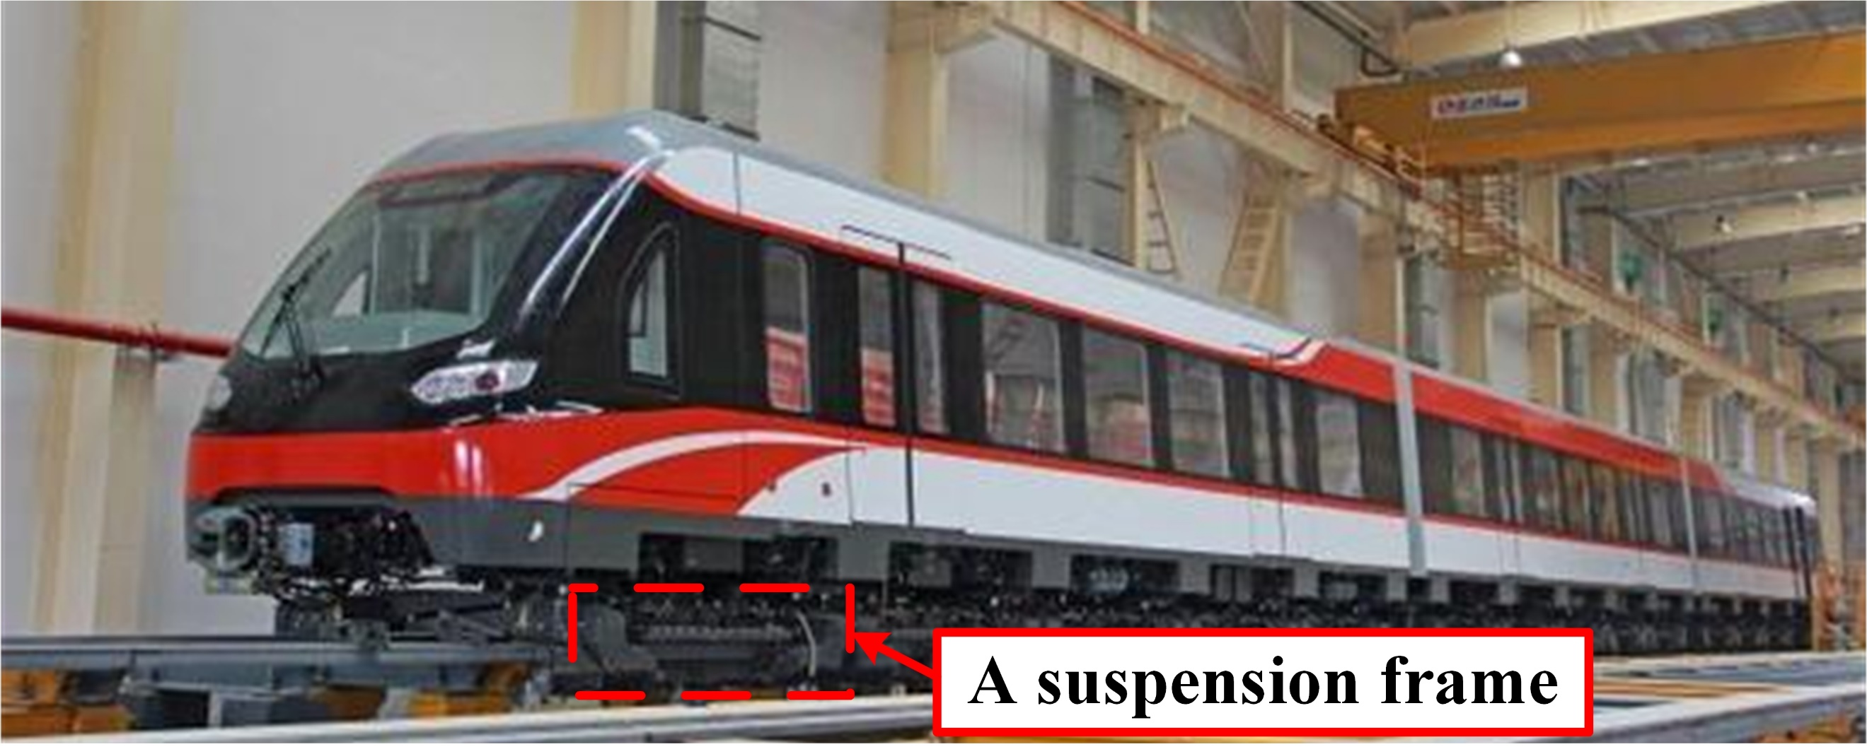
(a)

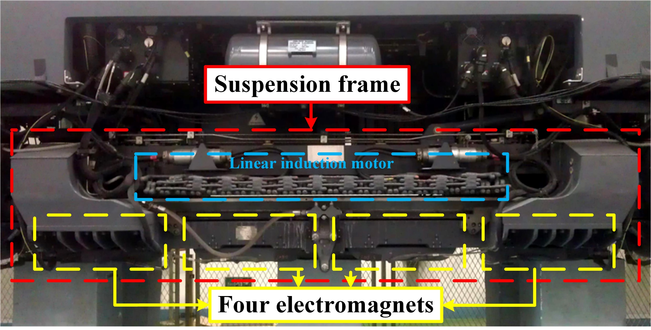
(b)
Fig. 1. (a) The middle-low-speed maglev train; (b) The suspension bogie with linear motors and electromagnets.

To facilitate the understanding of the middle-low-speed maglev train structure, some basic technical data is provided:
1) Number of carriages: 5;
2) Weight per carriage: 30t (light load), 33t (heavy load);
3) Number of suspension modules: 2/suspension bogie;
4) Number of electromagnet units: 4/suspension module.
The excitation coils are supplied with a direct current. The suspension force is produced between the F-type steel track and the U-type yoke.
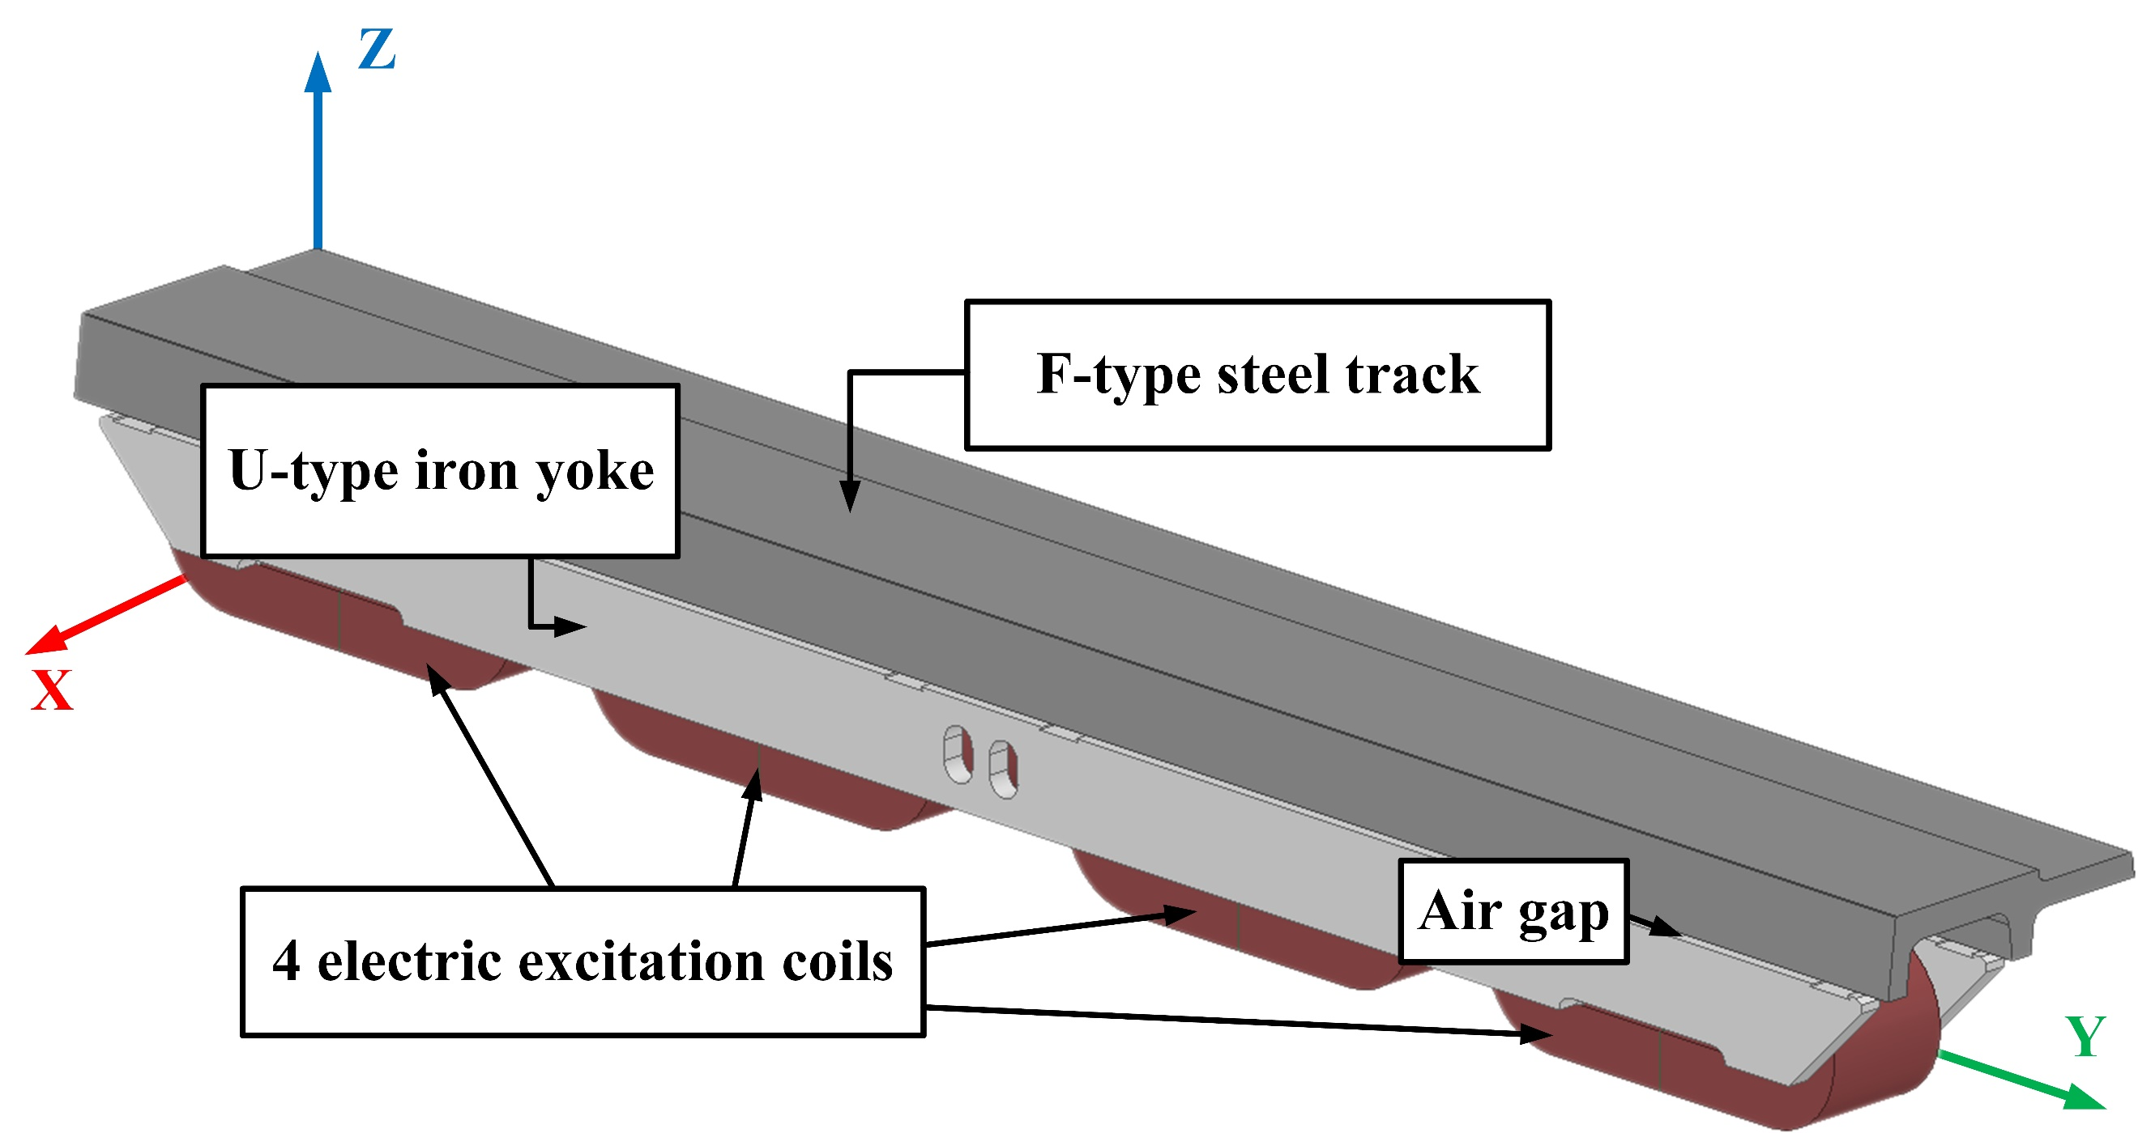
(a)
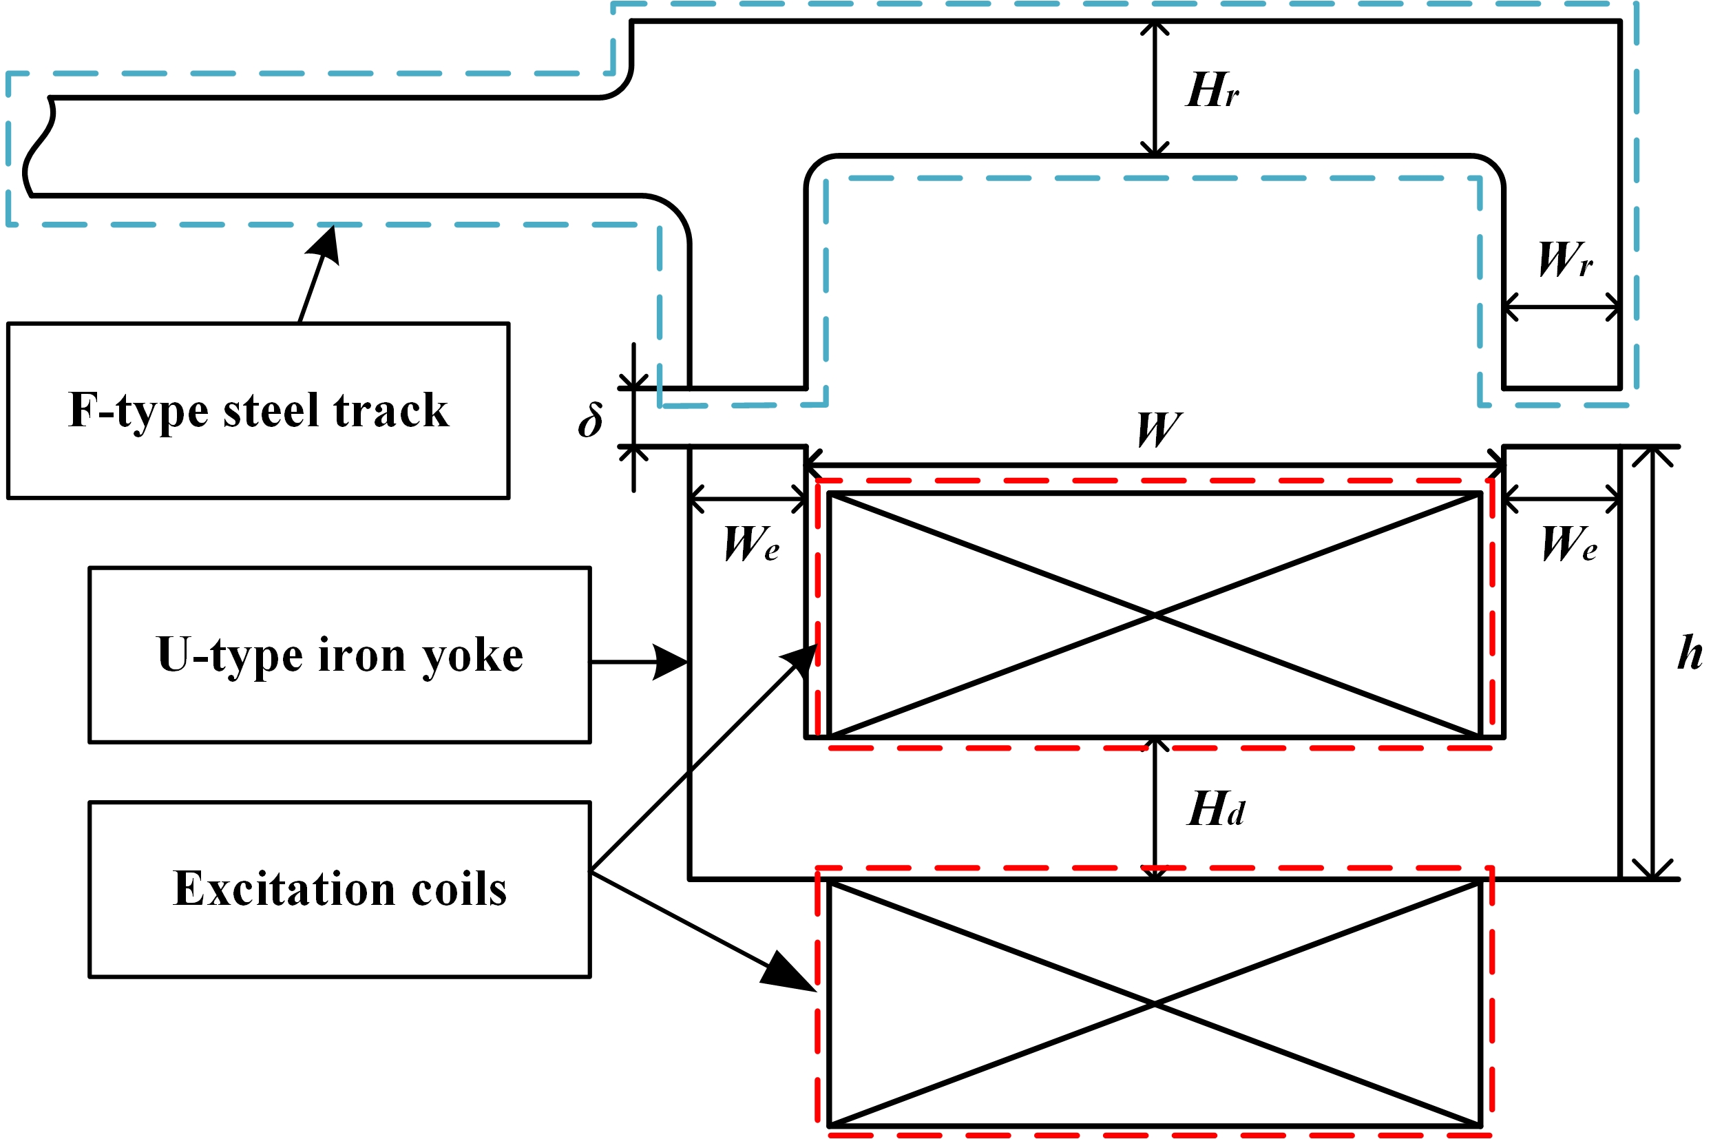
(b)
Fig. 2. (a) The configuration of the electromagnets; (b) The cross section.

The cross section of a single electromagnet unit is shown in Fig. 2(b), while the values of the relevant system parameters are listed in Table 1.
- Main system parameters of an electromagnet
Rated Air Gap δ | Suspension Rail Yoke Height H_{r}
8mm | 38mm
Suspension Rail Pole Width W_{r} | Magnetic Pole Width W_{e}
28mm | 28mm
Magnetic Pole Hight h | Window Width W
128mm | 164mm
Rated Ampere-turns | Bottom Iron Width H_{d}
30*360 (A*N) | 58mm
Bottom Iron Length | Coil Material
400mm | Copper

Using the above parameters, a multi-physics finite element (FEM) model of this suspension module was created and a series of tests undertaken under stationary conditions. The main path of the magnetic flux passes through the F-type steel track and the U-type iron yoke. The suspension force produced by the electromagnet is primarily related to the magnetic flux density distribution in both the track and the yoke. Thus particular attention is paid to the flux density distribution in the track and the yoke, while flux density distributions in the excitation coils are not illustrated as they are of marginal interest. As shown in Fig. 3(a), the highest value of the electromagnetic flux density of 1.96T in the U-type iron yoke is found at the side face of the yoke. The convective heat transfer coefficient of 5W/(m²∙K) was used throughout the tests. It can be seen that the maximum temperature of 94.16℃ is located at both front and back ends of the coils as in Fig. 3(b). Temperature distribution will affect the insulation properties of the insulation layer attached to the surface of each turn of the coil. The surface emissivity of silicon steel is much higher than of copper coils, as shown in Table 2. The maximum temperature appears at the front end, rather than at both sides of the coil covered by the silicon steal side boards, because the iron yoke made of silicon steel plays a leading role in thermal dissipation.
- The critical parameters for the thermal simulation
Environmental convective heat transfer coefficient W/(m2∙K) | Surface emissivity
 | Copper coils | Silicon steel
5 | 0.05 | 0.8

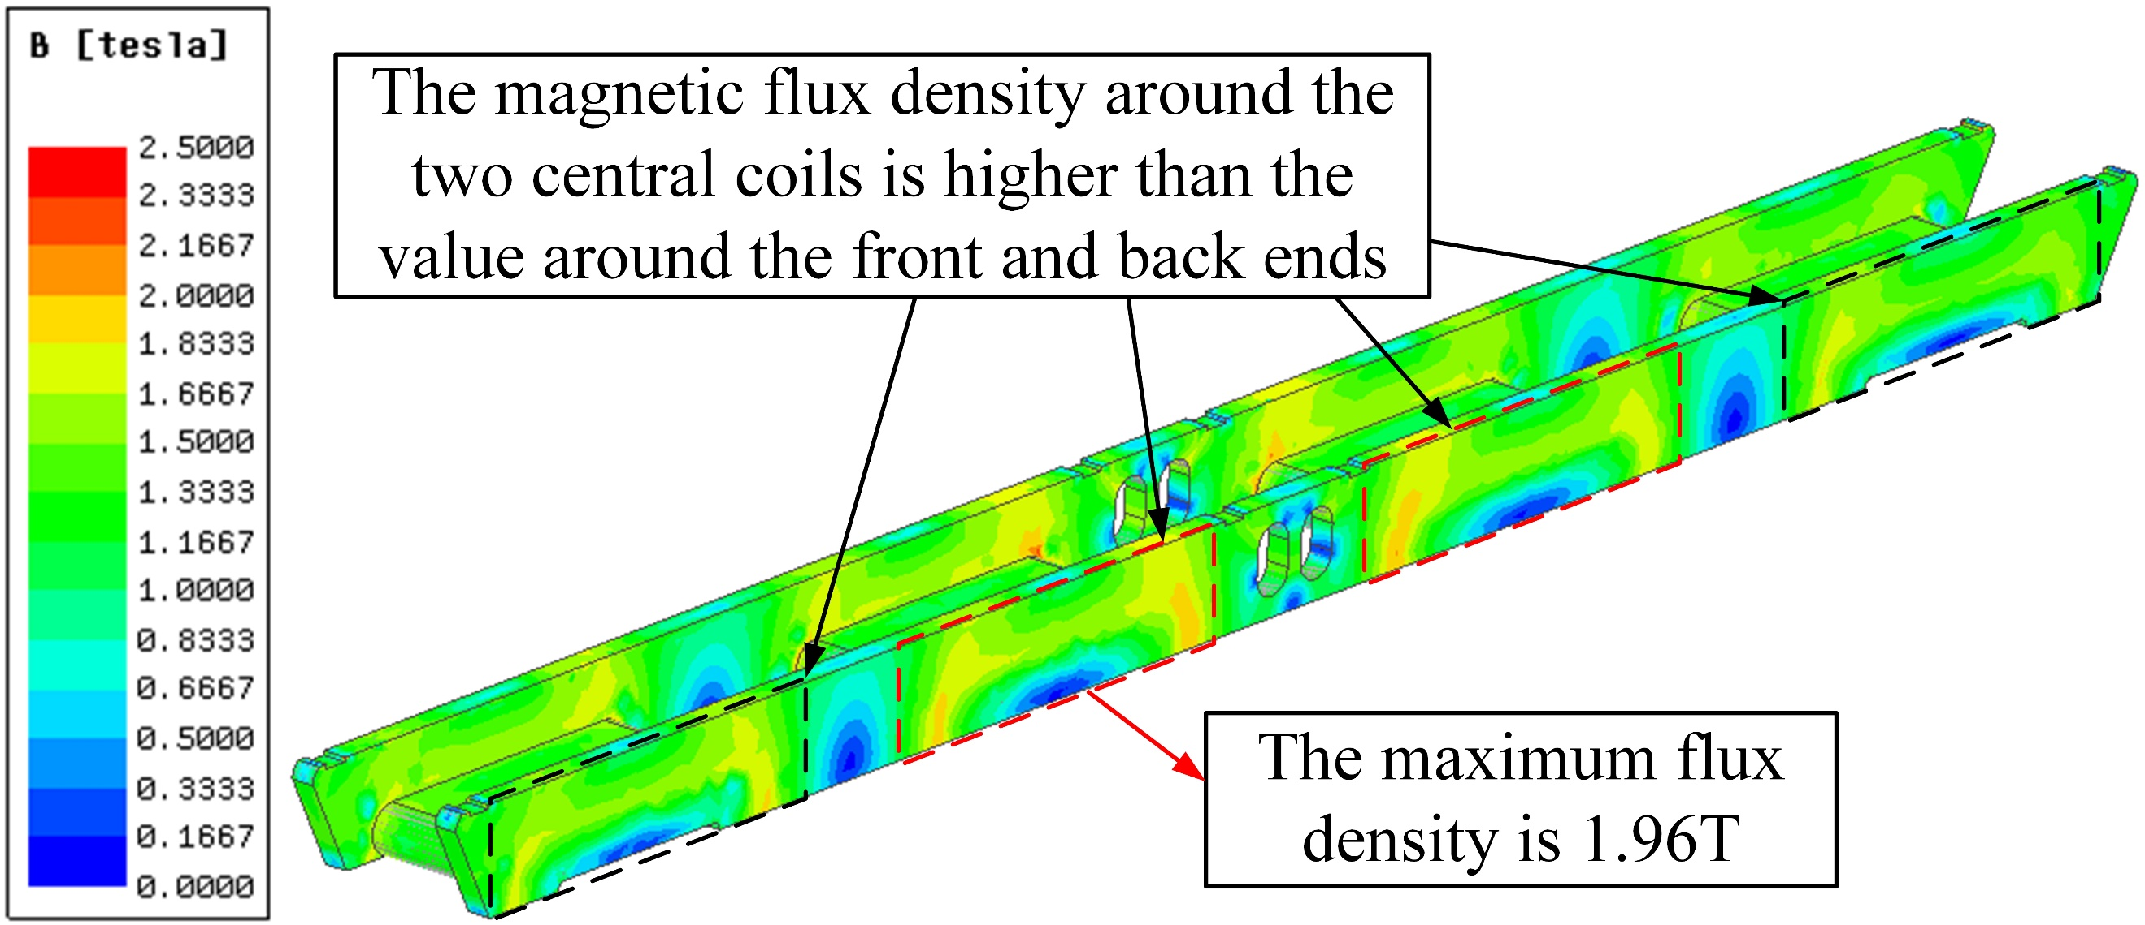
(a)
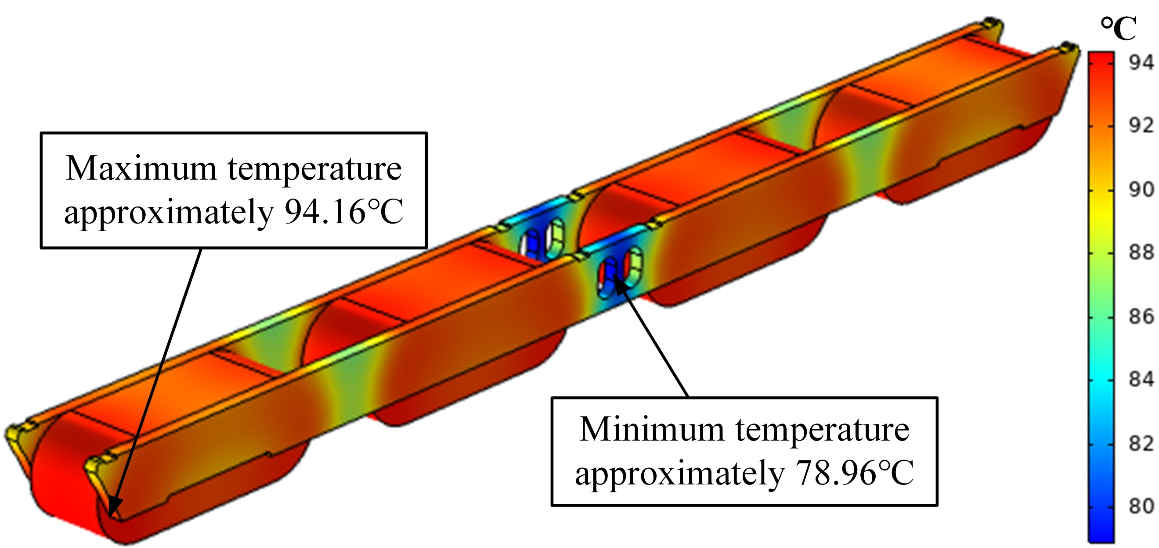
(b)
Fig. 3. (a) Magnetic flux density distribution in the original arrangement;
(b) The corresponding temperature distribution.

Impact of eddy currents on suspension force
If relative motion occurs between the F-type steel track and the suspension modules, eddy currents will be induced in the F-type steel track and the iron yoke. The effect of eddy currents will gradually become very strong as the maglev train accelerates. It is worth noting that the magnetic field generated by eddy currents in the F-type steel track will oppose the original field generated by the electromagnets. Thus the suspension force produced by the electromagnets will be reduced.
When the maglev train is stationary, the suspension force provided by an electromagnet may be expressed by
$$\begin{aligned}F_{0}=\frac{B^{2}∙{2S}_{e}}{μ_{0}}=\frac{2B^{2}W_{e}L}{μ_{0}}\#\left(1\right)\end{aligned}$$

where $μ_{0}=4π×{10}^{-7}H/m$, $S_{e}$ represents the area of the iron yoke facing the F rail, $W_{e}$ is the width of the U-type iron yoke, $L$ is the length of the electromagnet and $B$ is the magnetic flux density in the air gap, while
$$\begin{aligned}B=\frac{μ_{0}NI}{2δ}\#\left(2\right)\end{aligned}$$
where $N$ ,$I$ ,$δ$ are the coil turns, current and the length of the suspension gap, respectively.
In terms of Maxwell equations, the differential equation of the electromagnetic field is then
$$\begin{aligned}∇×\frac{1}{μ_{0}}\left(∇×A\right)=J-J_{v}\#\left(3\right)\end{aligned}$$
where $A$ represents magnetic vector potential , $J$ is the current surface density in coils and $J_{v}$ is the eddy currents in F-rail.
When relative motion occurs between the electromagnet and the F-rail, it will induce eddy currents in the F-rail, and
$$\begin{aligned}J_{v}=-σ\left(\frac{∂A}{∂t}-ν×∇×A\right)\#\left(4\right)\end{aligned}$$
where $σ$ represents conductivity of the F-rail and $ν$ denotes the relative speed of motion.
By combining (3) and (4), the electromagnetic field of the relative motion between the electromagnet and the F-rail can be expressed as [13]
$$\begin{aligned}∇×\frac{1}{μ_{0}}\left(∇×A\right)=J+σ\left(\frac{∂A}{∂t}-ν×∇×A\right)\#\left(5\right)\end{aligned}$$
Clearly, with the speed increasing, the induced eddy currents will become stronger and thus the distribution of the magnetic field will be greatly affected. Ultimately the suspension force will therefore be reduced.
The eddy current density distribution on the surface of the F-type track is presented in Fig. 4(a) at the speed of the maglev train of 120km/h. The maximum current density of around 1300kA/m² is located on the F-type track below the front head of the suspension module, in relation to the motion direction of the suspension module. Due to the relative motion between the track and the suspension module at the tail end, the area with a strong eddy current lags the back head of the suspension module. This indicates that the two coils located at the front head of the suspension module may be affected by the eddy currents more than the two coils at the back. In order to verify this observation, the vector distribution of the suspension force is presented in Fig. 4(b). Indeed, the suspension force is affected more around the front head of the suspension module. In addition, Fig. 4(c) presents the distribution of the magnetic flux density along the air gap between the suspension module and the track with the increasing velocity of the relative motion. It is clear that as the speed increases the flux density located at the front head becomes gradually weaker.

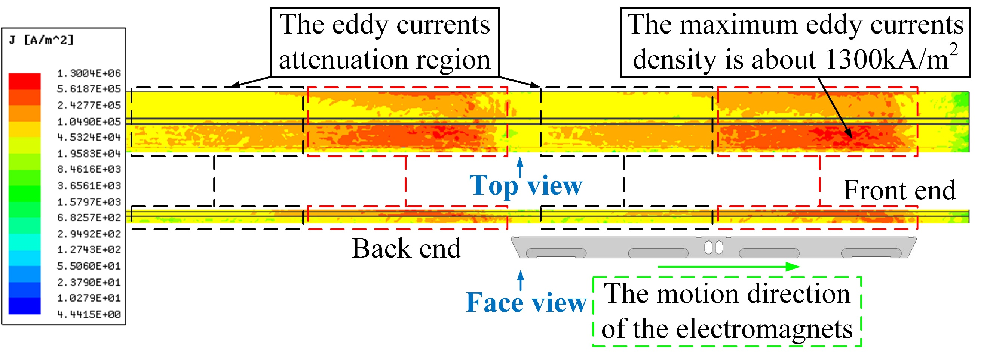
(a)
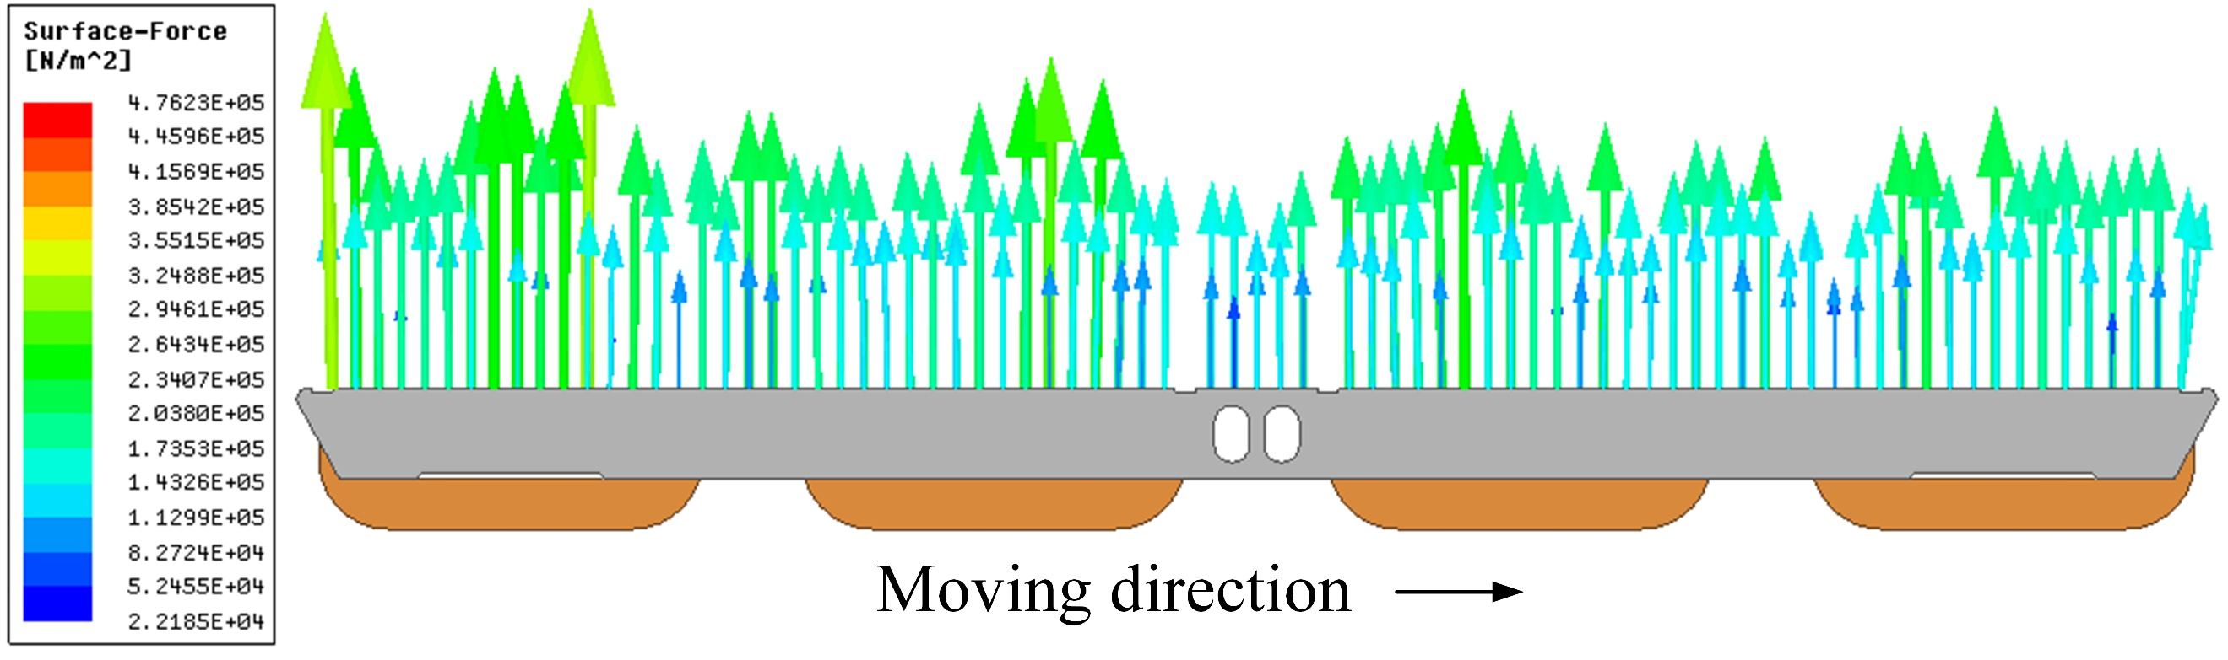
(b)
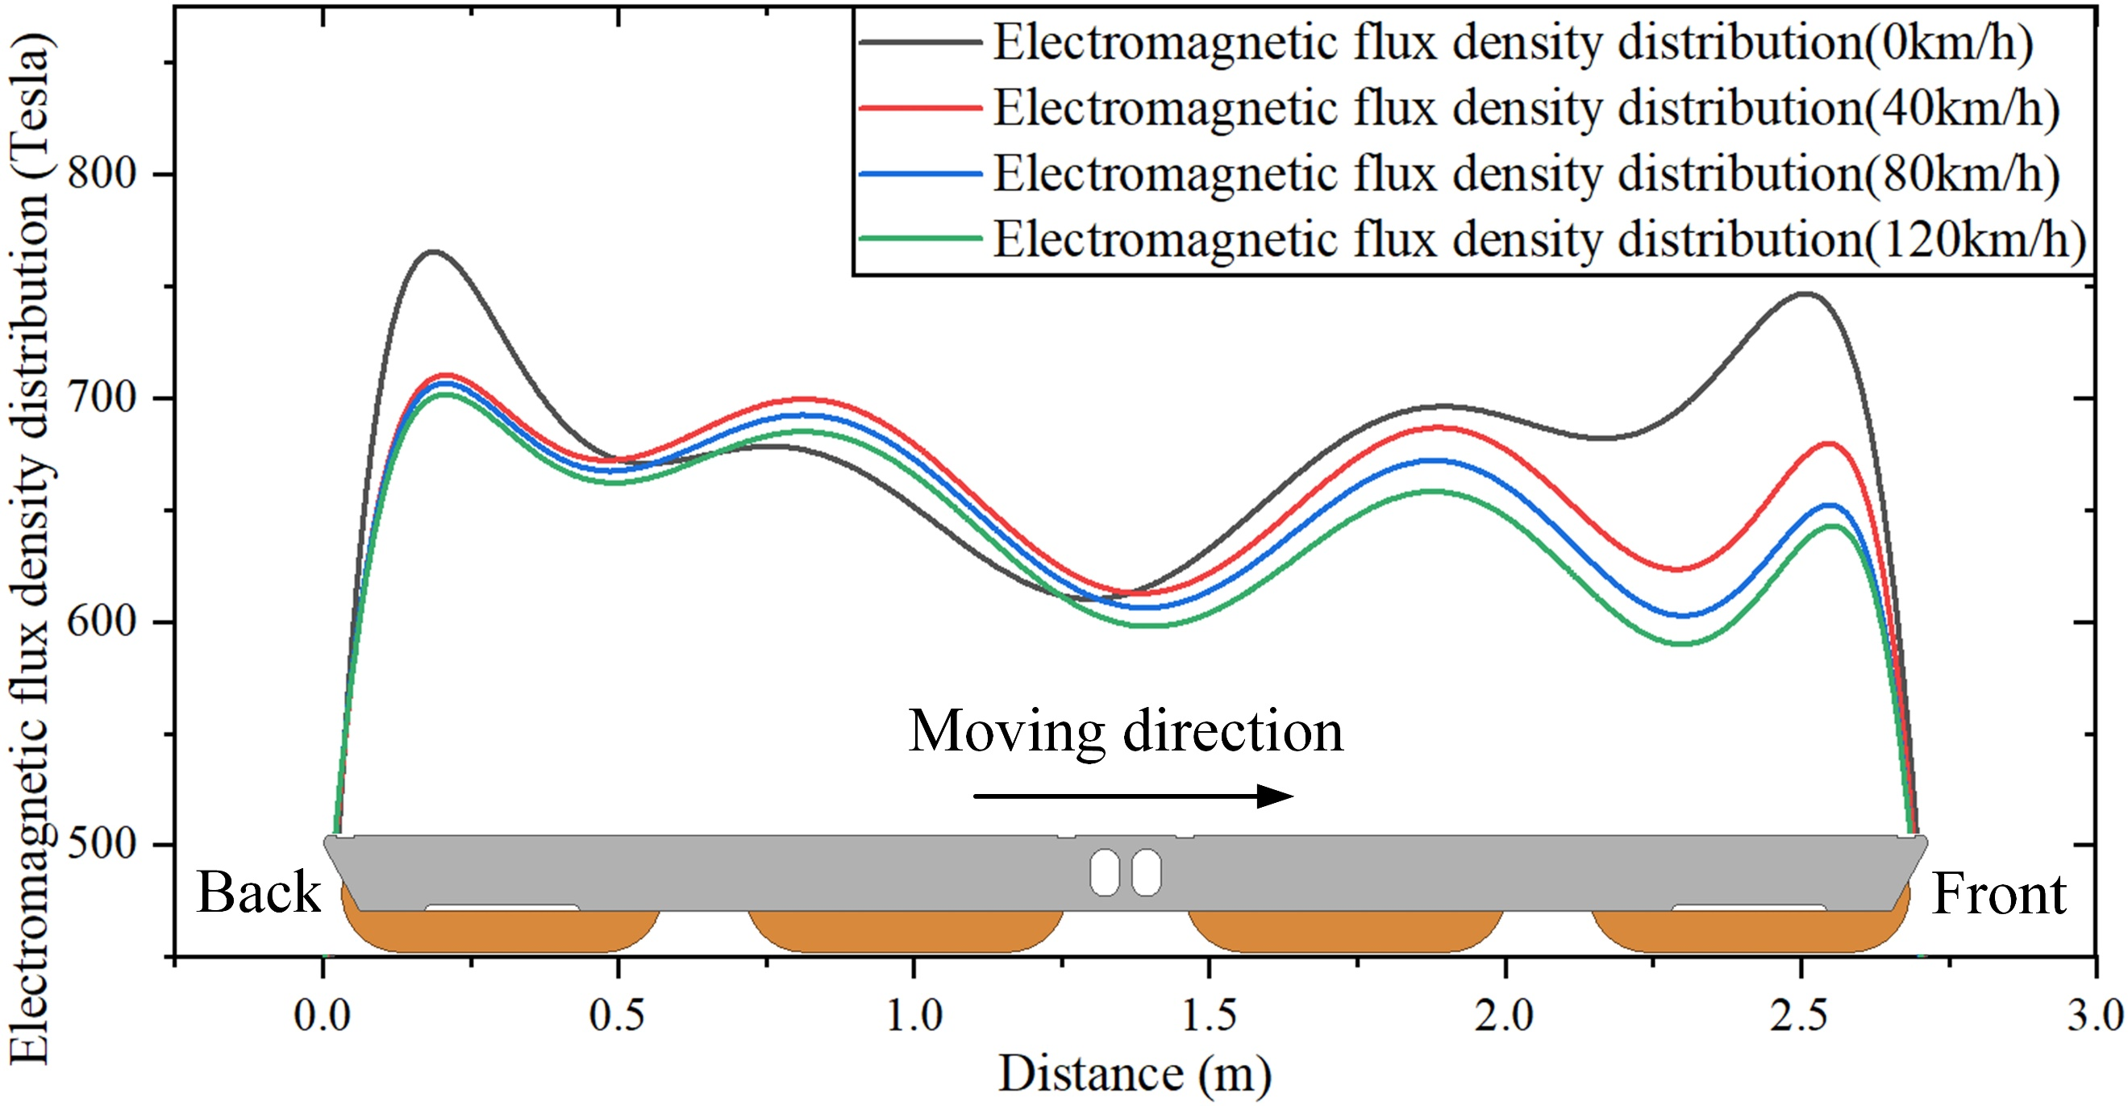
(c)

Fig. 4. (a) Eddy current distribution in the F-rail at 120km/h; (b) The force distribution of one suspension module at 120km/h; (c) The magnetic flux density distribution along the air gap at different speeds.

To analyse the tendencies of the suspension force of a single suspension module with varying velocity due to the eddy currents, a series of tests have been undertaken with the range of velocity between 0km/h to 120km/h, and the corresponding results are listed in the Table 3.
- Single electromagnet module suspension force
Speed (km/h) | 0 | 20 | 40 | 60 | 80 | 100 | 120
Force (kN) | 36.42 | 35.74 | 35.01 | 34.39 | 33.82 | 33.35 | 32.89
Loss Rate (%) | 0 | -1.9 | -3.9 | -5.6 | -7.1 | -8.4 | -9.7

As shown in Table 3, the suspension force produced by a suspension module decreases as the speed of the train rises (here the input current was maintained at 30 A). Compared with the condition at standstill, the suspension force at 120km/h is reduced by about 10%. As each carriage has five suspension bogies, each of which has two suspension modules, when the train speed reaches 120 km/h, the suspension system can only provide a suspension force of 328.9kN, compared with the requirement of 330kN under heavy load situation.
Although in order to cope with the case of a heavy load the suspension force could be enhanced by increasing the coil currents, the heat produced by long-term overcurrent would increase the risk of damage to coil insulation. Therefore, considering the performance limit of the insulation material, a hybrid suspension system incorporating a permanent magnet is proposed to alleviate this particular issue.

Impact of temperature on suspension force
As a high-performance permanent magnetic material, a neodymium magnet N35SH was chosen to provide an extra suspension force. Before actually designing the permanent-electro-magnet suspension (PEMS) system, the characteristics of N35SH were investigated, especially its performance under varying ambient temperature. Three particular parameters were considered (coercivity, remanence and energy product) and their behaviour is described in Fig. 5(a), (b) and (c). When the temperature rises from 0℃ to 100℃, the coercivity declines with relatively low descent rate, but when the temperature increases from 100℃ to 120℃, the descent rate becomes high. The remanence – which represents the magnetic flux remaining in a magnetized material – decreases as the temperature rises. The maximum magnetic energy product (BH), which represents the magnetic energy stored in a specific magnet, decreases sharply with the temperature rise.

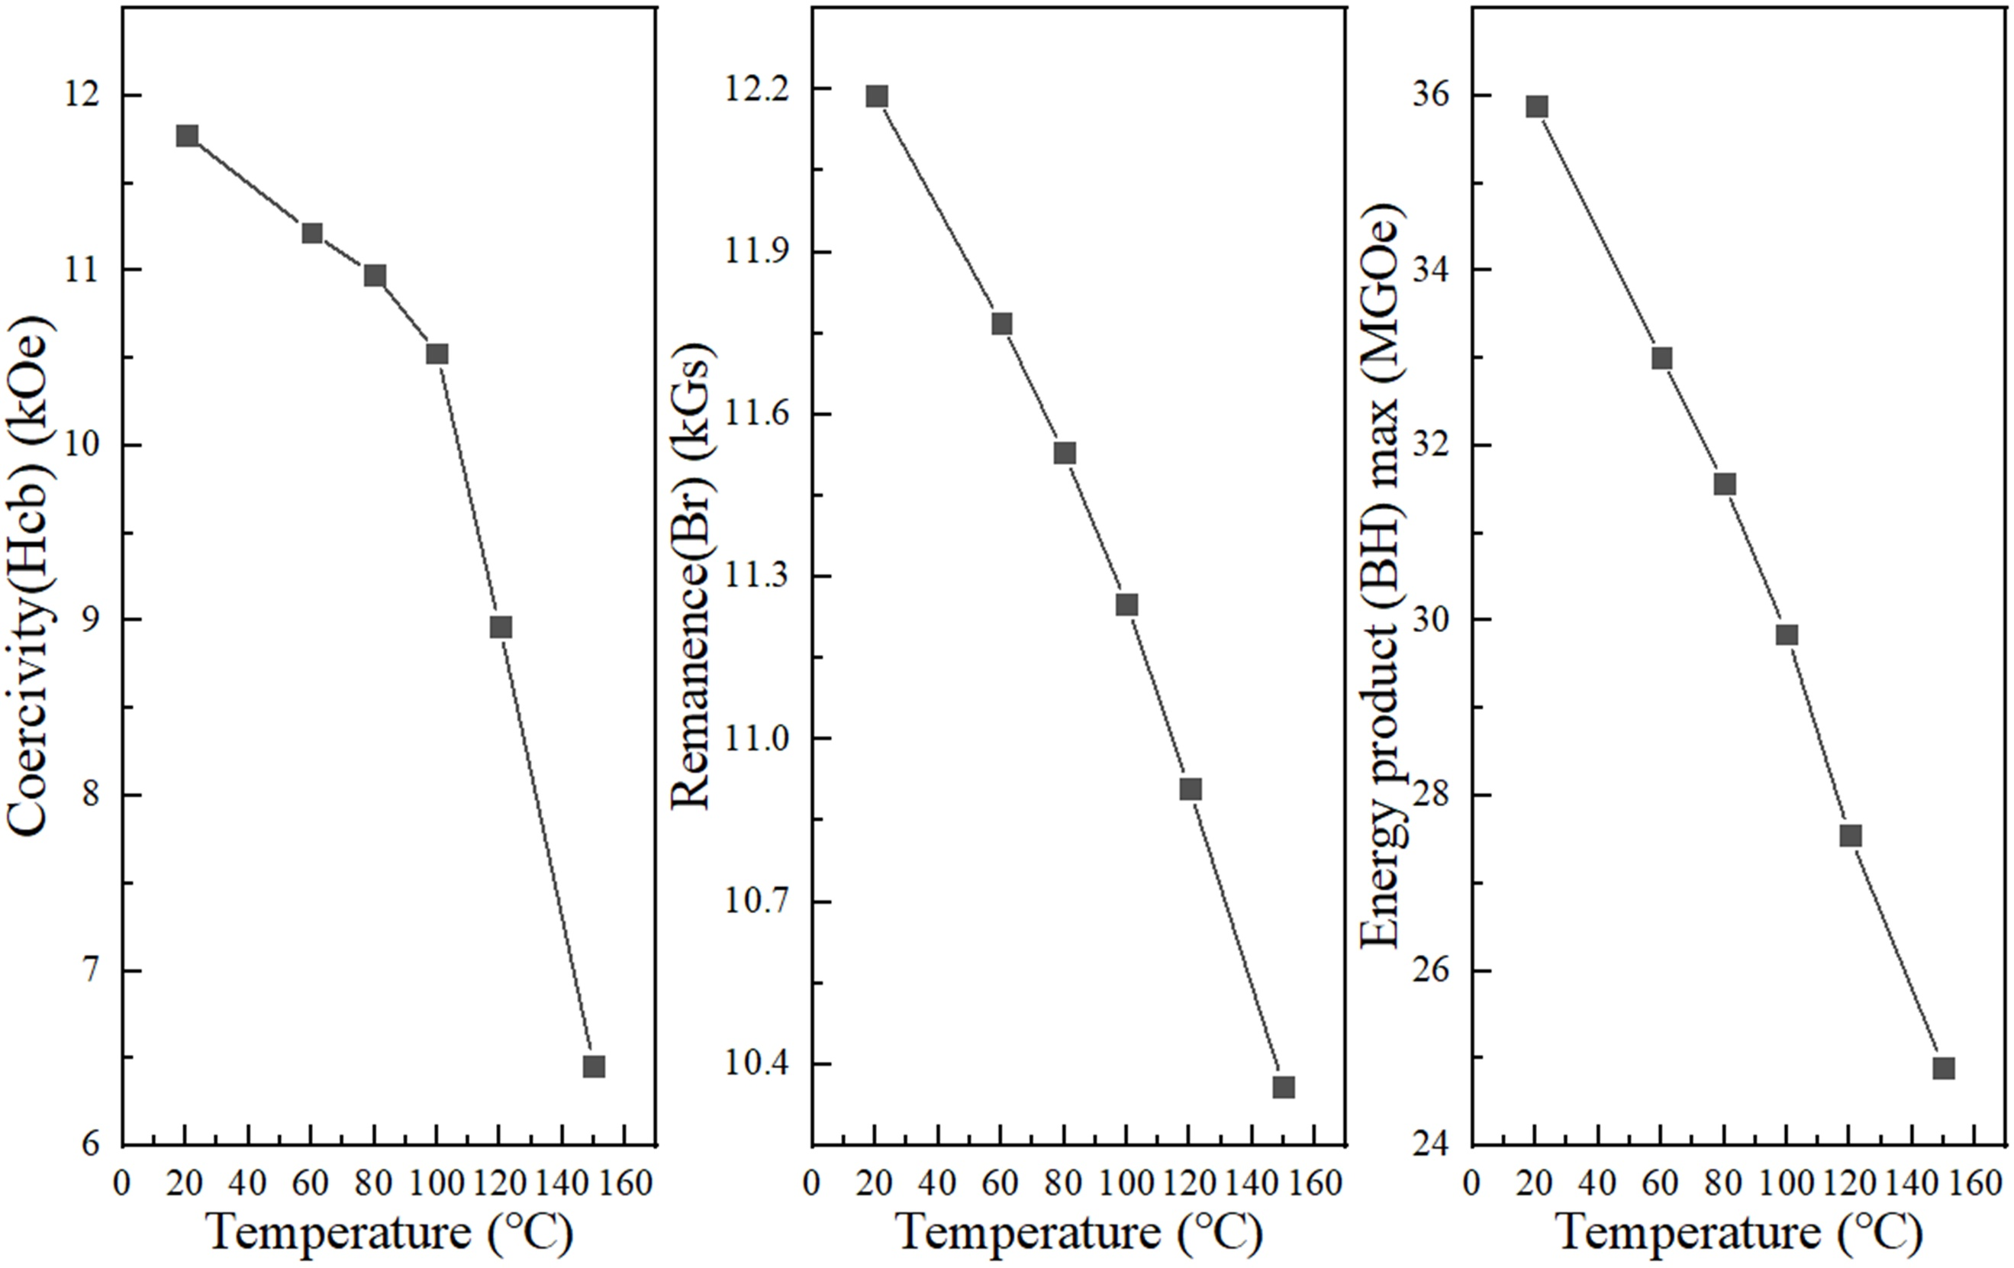
(a) (b) (c)
Fig. 5. Dependence on the temperature for N35SH of: (a) coercivity; (b) remanence; (c) the maximum magnetic energy product.

In order to improve the performance of the suspension force, especially under high-speed conditions, a hybrid suspension system with embedded permanent magnets is proposed. In order to determine the proper location for embedding such permanent magnets (PM) – and their shape – the impact of the temperature variation on material characteristics must first be considered. For example, should a permanent magnet be inserted into the centre of the U-type iron yoke where the temperature is around 100℃, as shown in Fig. 3(b), the suspension provided by the permanent magnetic material would be seriously reduced due to the high temperature, especially under standstill condition when the heat produced by the coils current is hardly removed by air convection.
- Some critical parameters of the hybrid suspension system
Width of the central PM(Wi) | Hight of the central PM(Hi) | Width of the side PM(Wo) | Hight of the side PM (Ho)
54mm | 74mm | 32mm | 58mm

With the aim to reduce the temperature to which the PMs are exposed, the position of embedded magnets was carefully explored. Through a series of simulations, one of the best performing arrangements – ultimately a prototype of a hybrid suspension system (HSS) – was designed as in Fig. 6, while consideration was given to both the suspension force and the thermal performance. The values of the critical parameters labelled in Fig. 6 may be found in Table 4, while the following information will also be pertinent: 1) the number of turns of the coils of this HSS is the same as for the electromagnetic version presented in Table 1; 2) the height and width of the magnetic pole is the same as in Table1; 3) the input current of the coil is also same as in the pure electromagnetic version.
When the speed of the maglev train reaches 120km/h, the highest value of the magnetic flux density increases to 2.71T, as shown in Fig. 7(a); the suspension force density is also increased as depicted in Fig. 7(b). According to simulation, the suspension force increases by about 16.2% when the train stops. Inside, the maximum and minimum temperatures are now 74.11℃ and 64.09℃, respectively, see Fig. 7(c). According to Fig. 5(a), the average loss of coercivity of the permanent magnets is 6.684%. The suspension force is now 43.75kN (compared with 32.89kN for the original system) at 120km/h, with the weight only increasing by 0.558kN per suspension module.

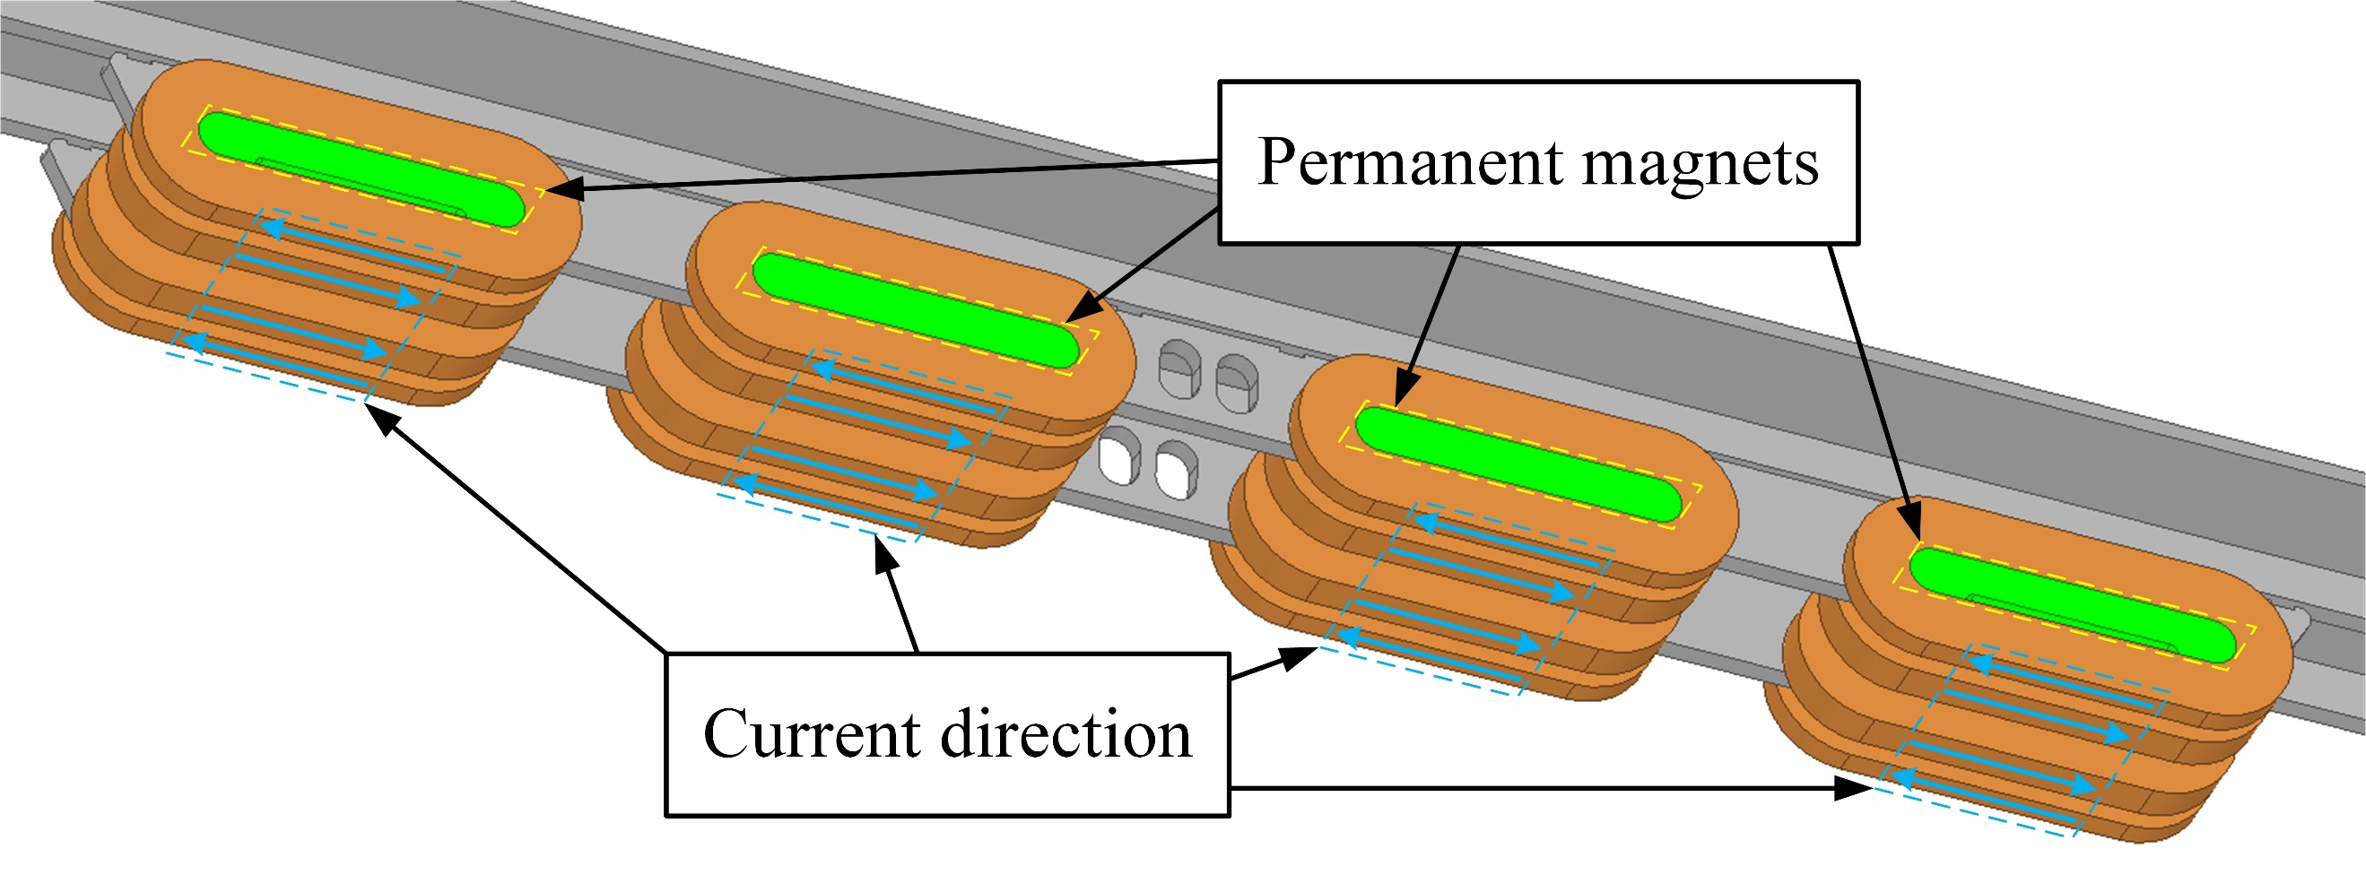
(a)
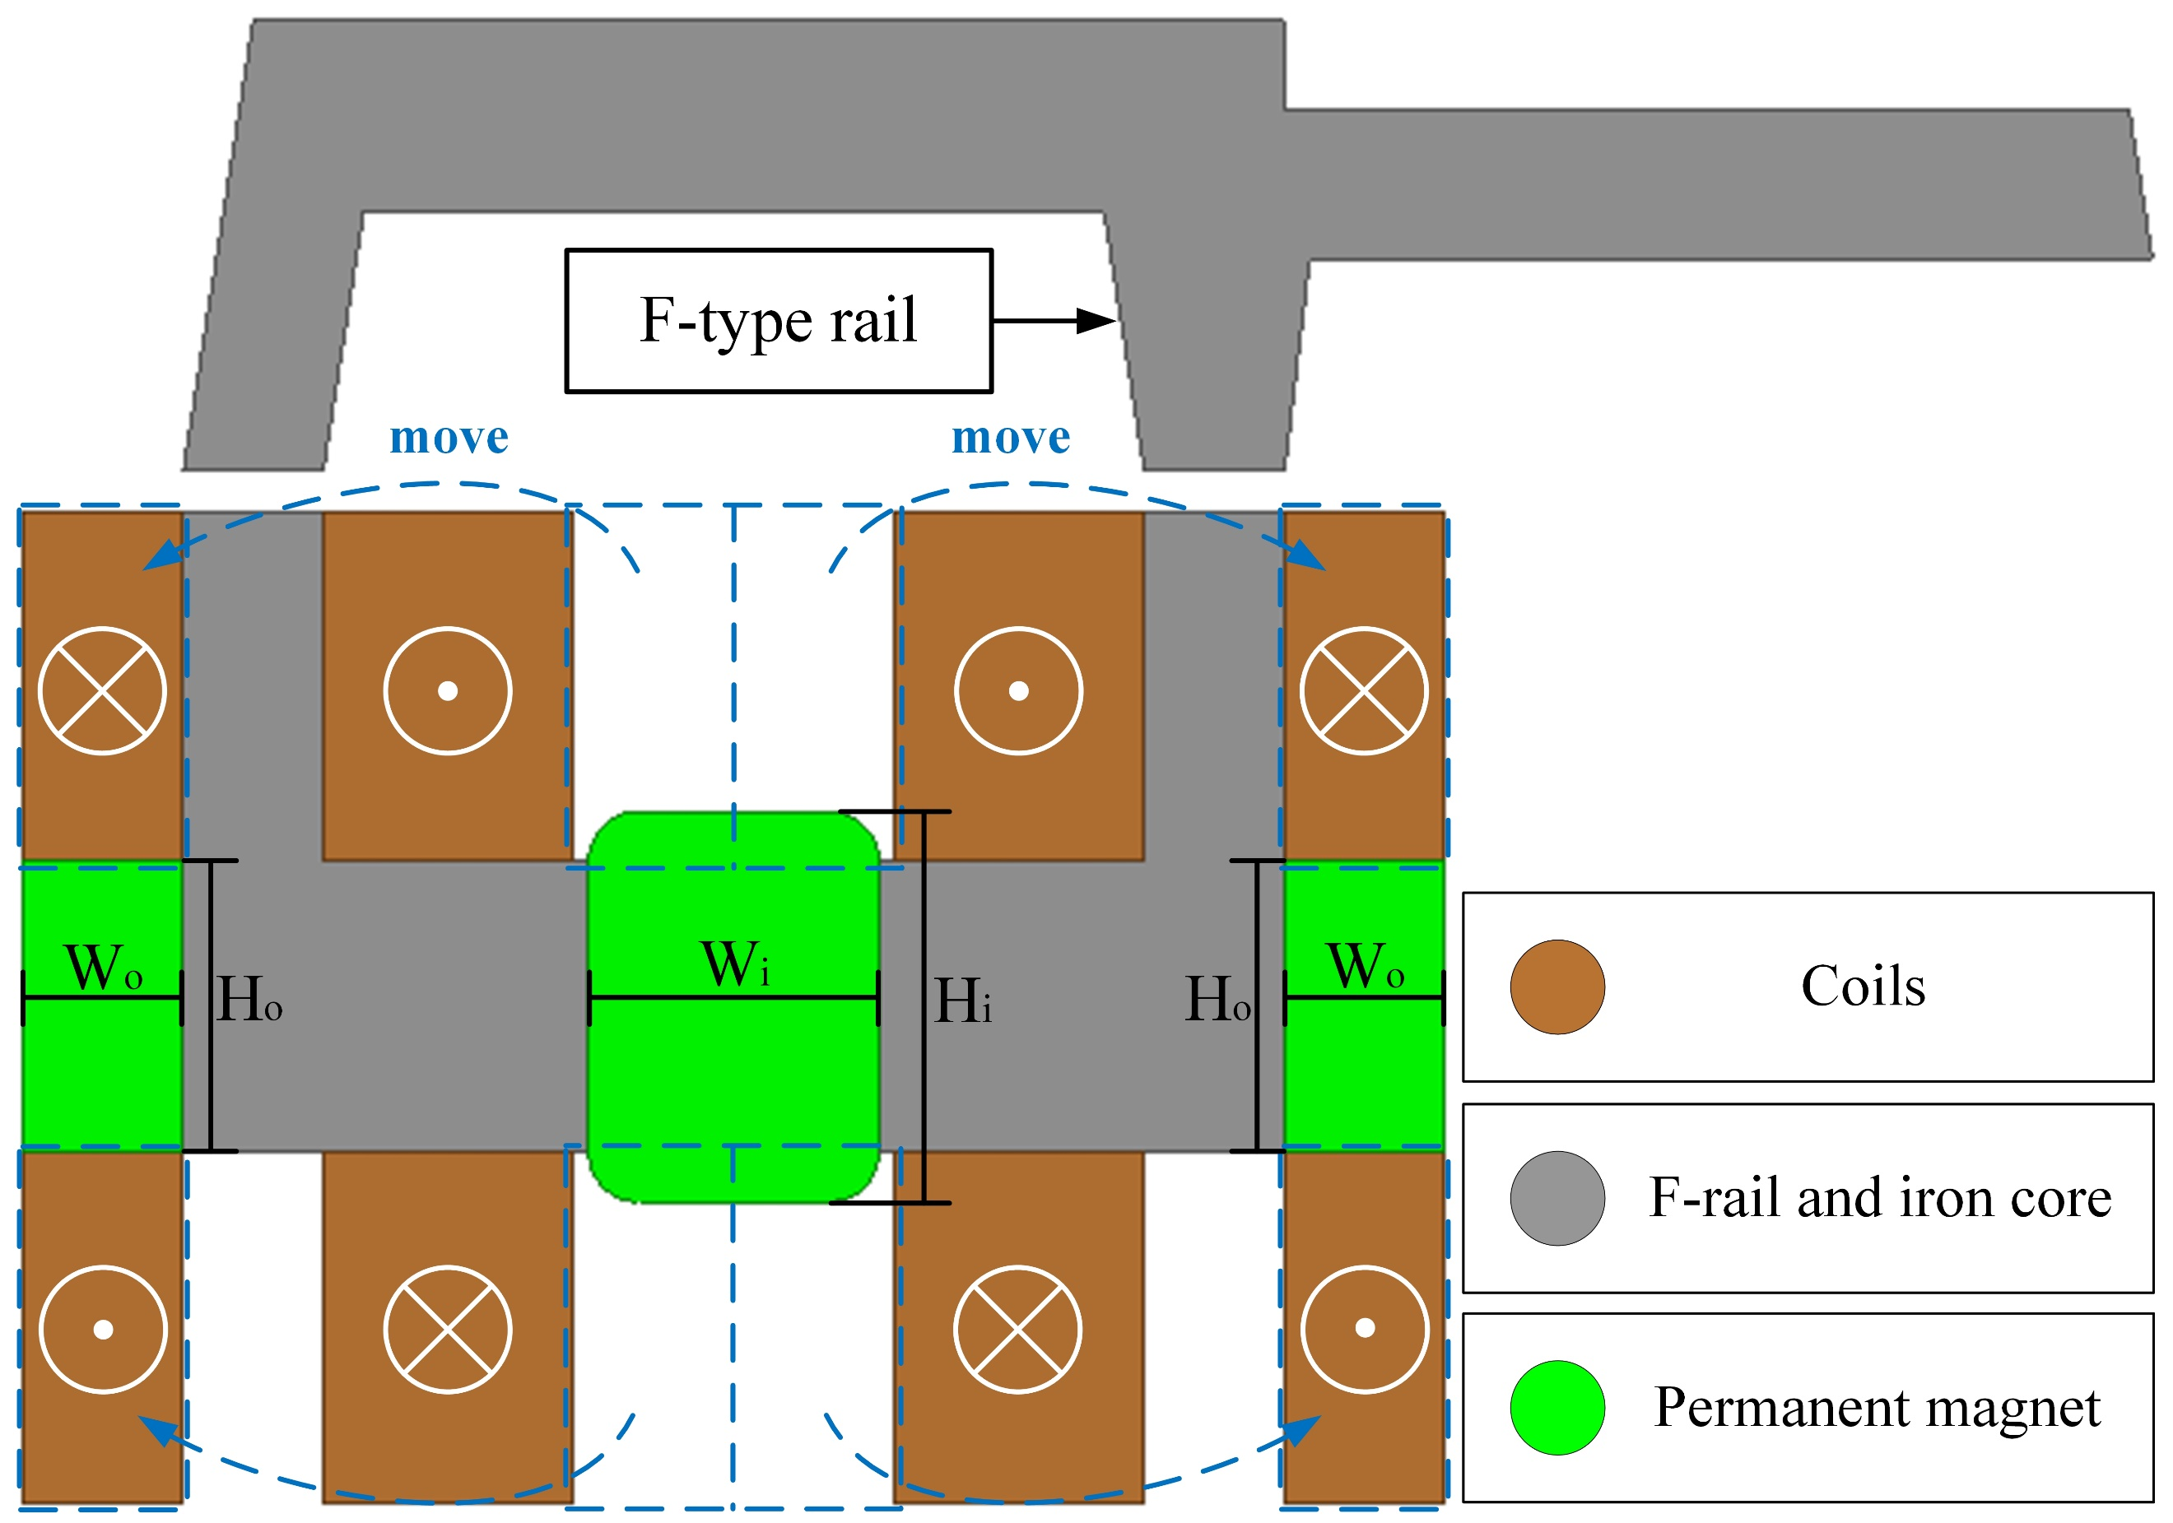
(b)
Fig. 6. (a) Configuration of the hybrid suspension system; (b) The corresponding cross section.

When the train stops at a station (at standstill there is no relative motion between the electromagnet and the F-rail), the coils have poor heat dissipation capability due to insufficient air circulation. At this point, the coil temperature is the highest, which leads to the working temperature of the permanent magnet rising. According to Fig. 7(c), when the train is stationary, the temperature of the permanent magnet is between 64℃ and 74℃, which is safe for both the coil insulation and the permanent magnet. During the simulations, the nonlinearly varying coercivity of the permanent magnet due to the thermal influence shown in Fig. 5(a) is applied to define the material characteristics of permanent magnets. When the train moves at 120km/h, the temperature of the permanent magnet will go down. Considering the worst demagnetization effect of the permanent magnet at 74℃, the magnetic flux density of the iron core is shown in Fig. 8(a).

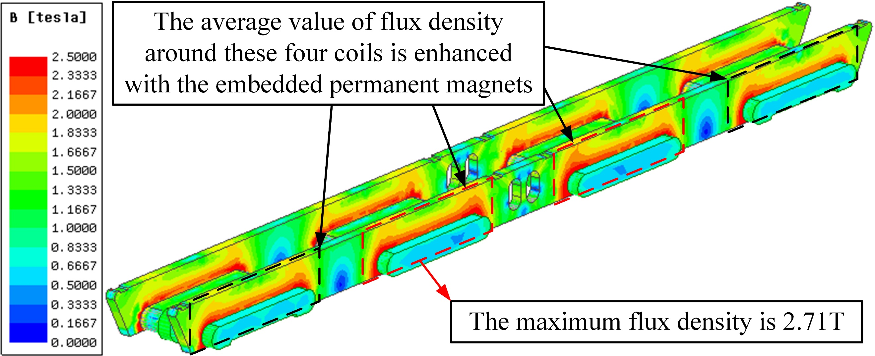
(a)

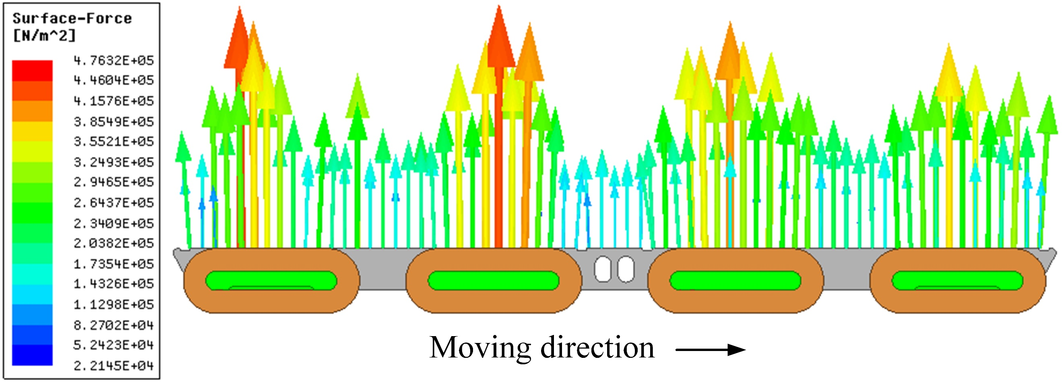
(b)
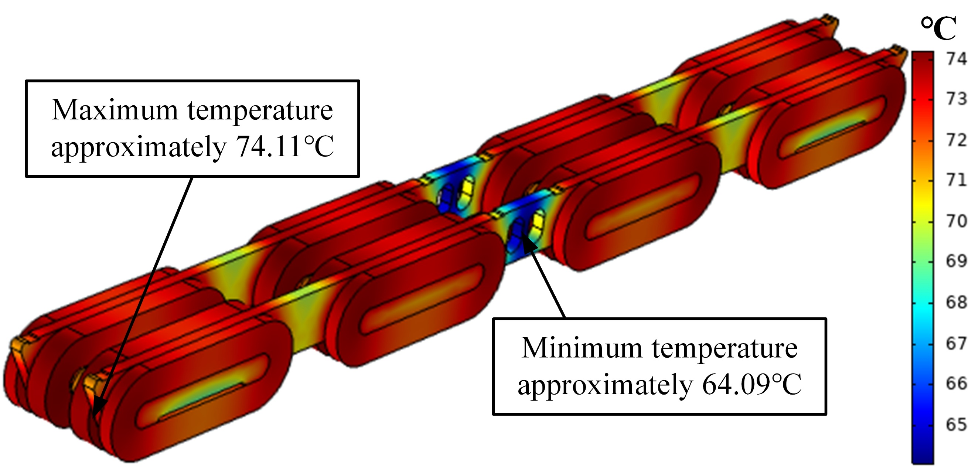
(c)
Fig. 7. (a) Flux density distribution of the hybrid system at 120km/h;
(b) The force distribution of the hybrid system at 120km/h; (c) The corresponding temperature distribution.

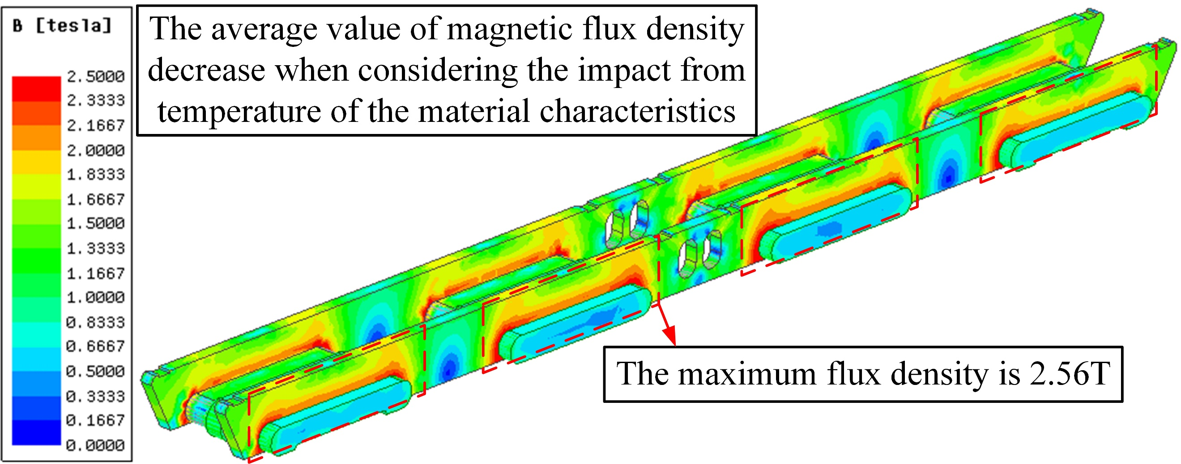
(a)
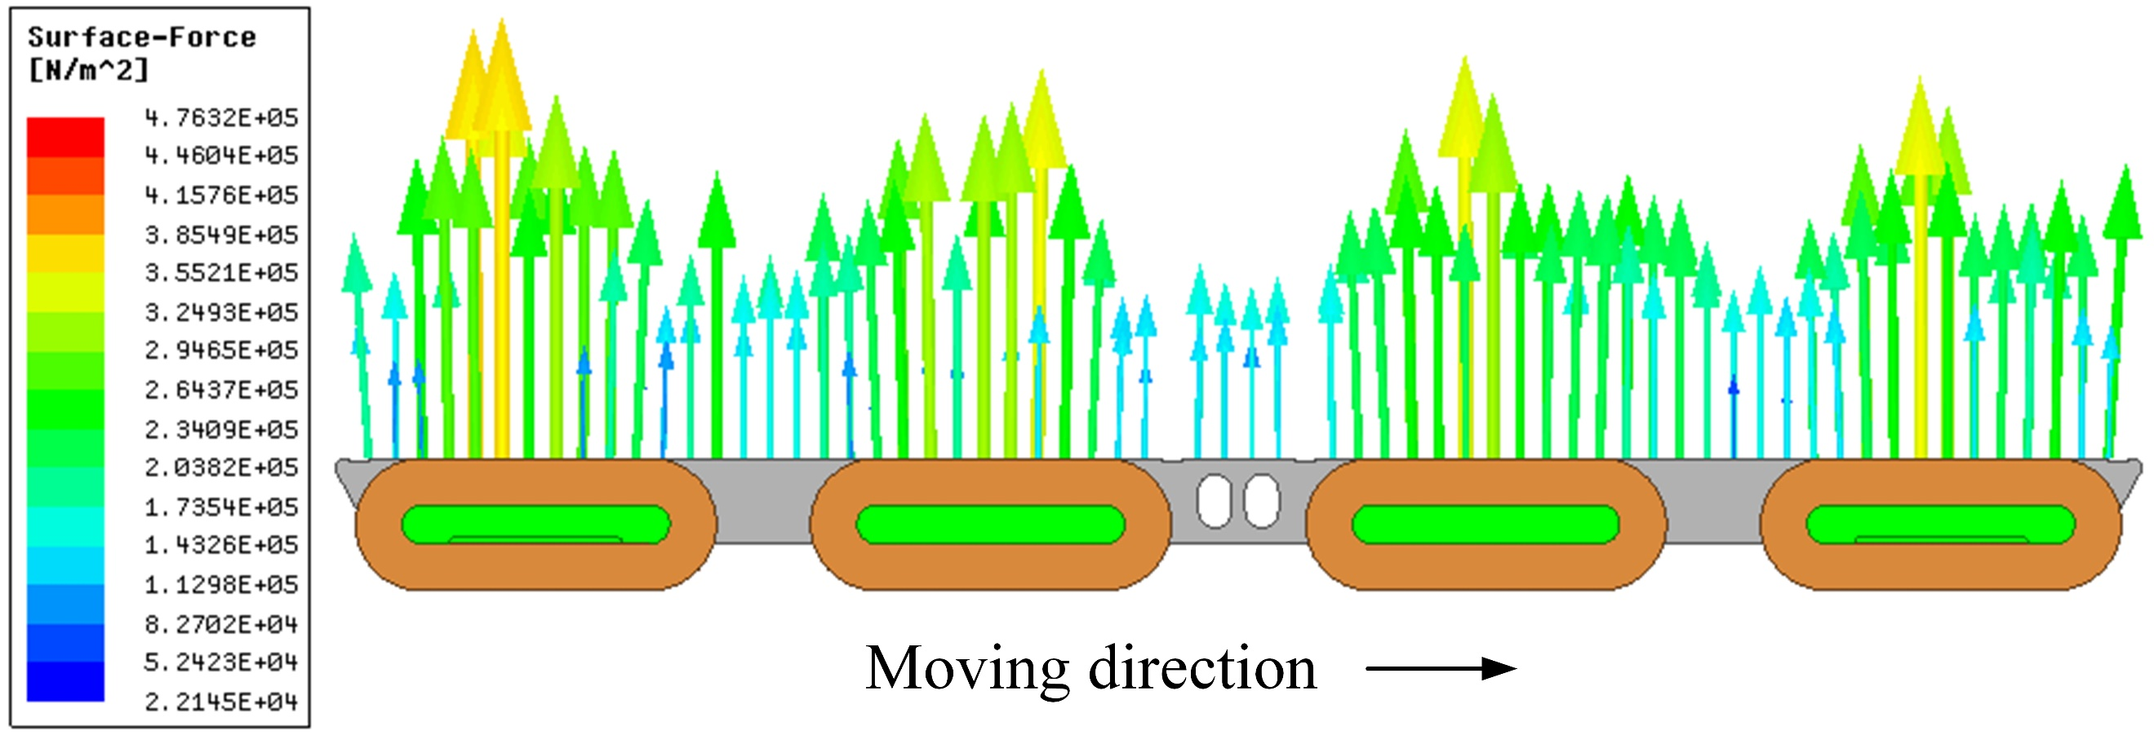
(b)
Fig. 8. Consideration of thermal affects at 120km/h: (a) Magnetic flux density distribution; (b) The force distribution.

With the increasing speed of the train, the temperature of the core of the magnet decreases from 90℃ to 70℃. Thus, considering the highest temperature situation when the train is stationary, the levitation force provided by a single suspension module at different speeds is shown in Table 5.
- Single module suspension force at different speeds
Speed (km/h) | 0 | 20 | 40 | 60 | 80 | 100 | 120
Force (kN) | 42.32 | 41.82 | 41.36 | 40.96 | 40.62 | 40.49 | 40.03
Loss Rate (%) | 0 | -1.2 | -2.3 | -3.2 | -4.0 | -4.3 | -5.4

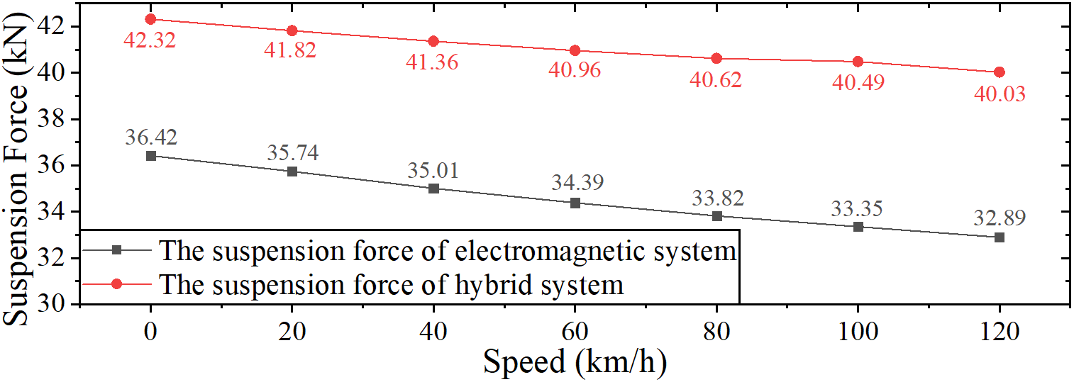
(a)
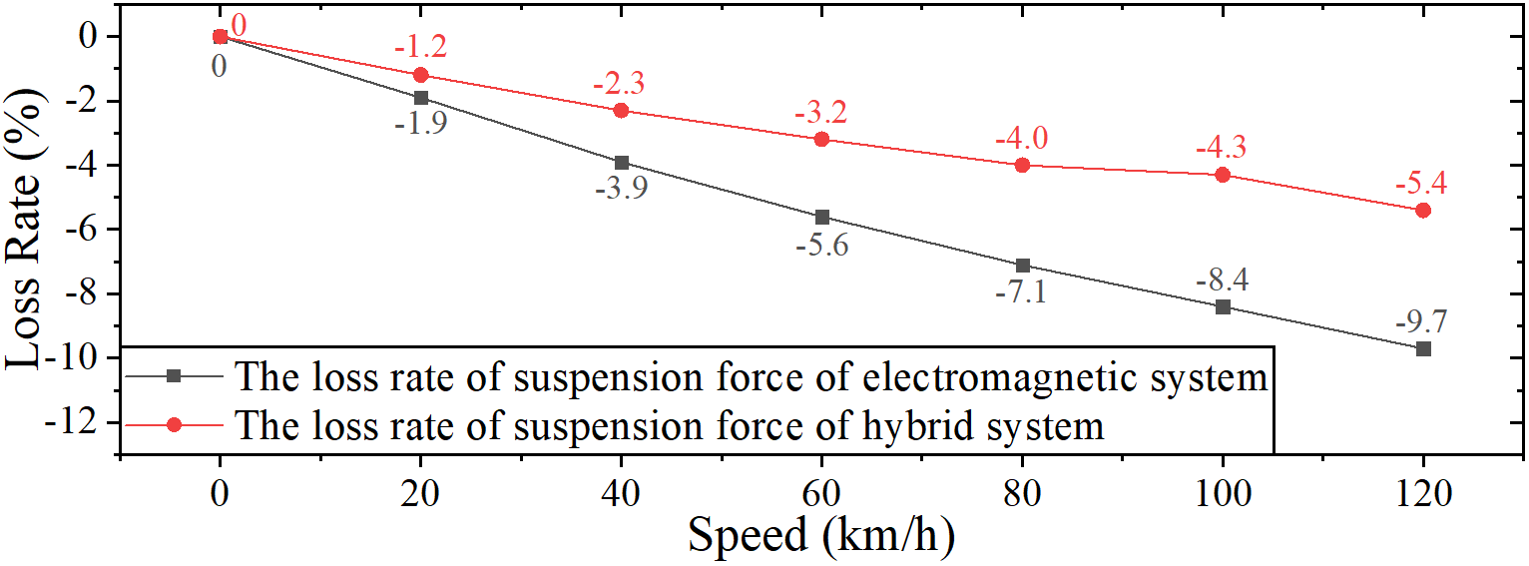
(b)
Fig. 9. (a) The comparison of suspension force between the electromagnetic system and the hybrid system; (b) The comparison of loss rate between the electromagnetic system and the hybrid system.

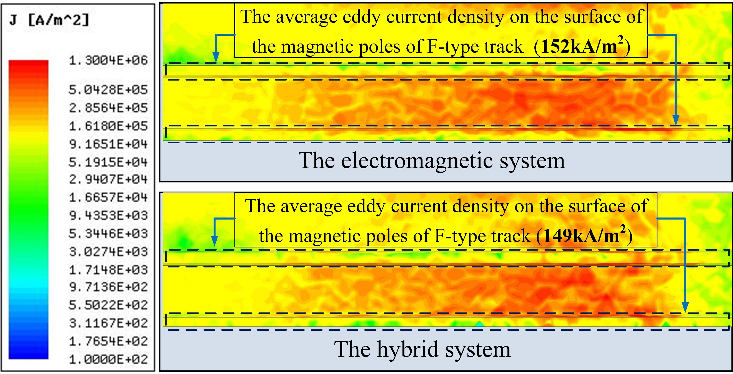
Fig. 10. Comparison of eddy current distributions in the F-type steel tracks.

A comparison of the levitation force produced by the purely electromagnetic and the hybrid suspension systems is shown in Fig. 9. As demonstrated, the novel hybrid suspension system provides more stable and more powerful suspension force than a traditional electromagnet, especially when the train is running at a high speed. A comparison of eddy current distributions in the F-type steel track for the electromagnetic and the hybrid systems is presented in the Fig. 10, where the view from above is shown. It can be deduced that the flux densities on the surface of magnetic poles in the F-type tracks in the electromagnetic and hybrid systems are very similar (152kA/m² and 149kA/m², respectively), thus the repulsion provided by eddy currents will also be similar. However, the suspension force produced by the hybrid system is noticeably higher than that in the pure electromagnetic version. Overall, the loss rate of suspension force for the hybrid system is less than for the pure electromagnetic system when the train accelerates from 0km/h to 120km/h.

Stability Performance of the Hybrid System
A displacement between the F-type steel track and the U-type iron yoke occurs frequently, as depicted in Fig. 11, mainly due to the cornering of trains, lack of smoothness of the track or even the wind pressure on the carriages. A special condition considering such displacement in the suspension system also needs to be addressed.

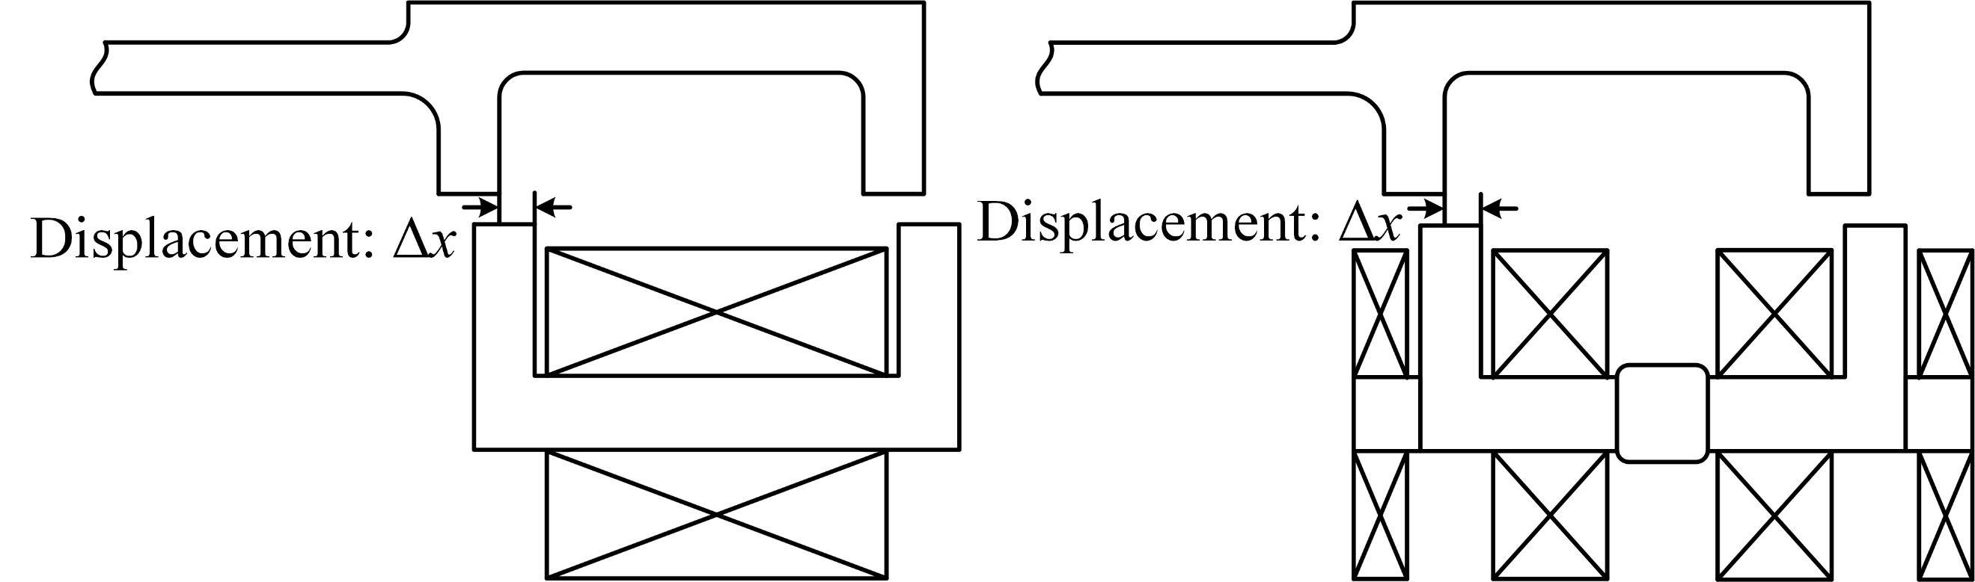
(a) (b)
Fig. 11. A cross section of the suspension module after a displacement:
(a) the origin suspension module; (b) the hybrid suspension module.

Following [14], the levitation and guidance forces can be derived as
$$\begin{aligned}\left\{\begin{aligned}F_{z}=F_{0}×\left[1-\frac{∆x}{W_{e}}+\frac{4δ∆x}{4W_{e}δ+πW_{e}∆x}\right] \\ F_{y}=F_{0}×\left[-\frac{δ}{W_{e}}+\frac{4δ^{2}}{4W_{e}δ+πW_{e}∆x}\right]\end{aligned}\right.\#\left(6\right)\end{aligned}$$
where $∆x$ is the displacement gap and $F_{0}$ represents the ideal suspension force. Simulation results for the guidance force and the suspension force for a train running at 120km/h for different displacement gaps are shown in Fig. 12.

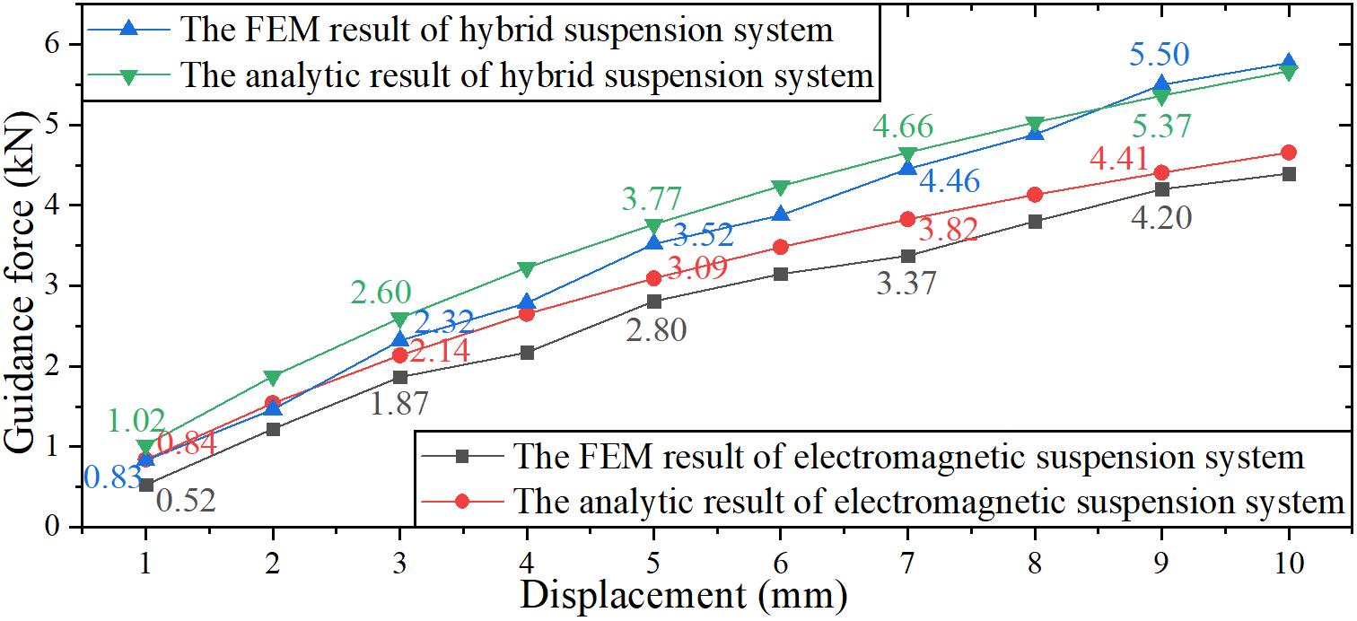
(a)
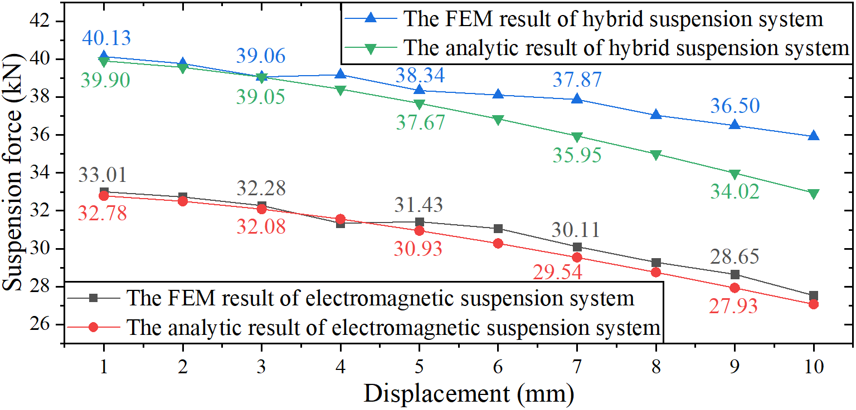
(b)
Fig. 12. The forces as a function of displacement at 120km/h: (a) The guidance force; (b) The suspension force.

As shown in Fig. 13, the guidance and suspension forces for the proposed novel hybrid system are higher than for a pure electromagnetic suspension system when the velocity of trains varies from 0km/h to 120km/h. The results were obtained using both FEM simulations and the simplified expression (6); the differences may be considered to be acceptable.
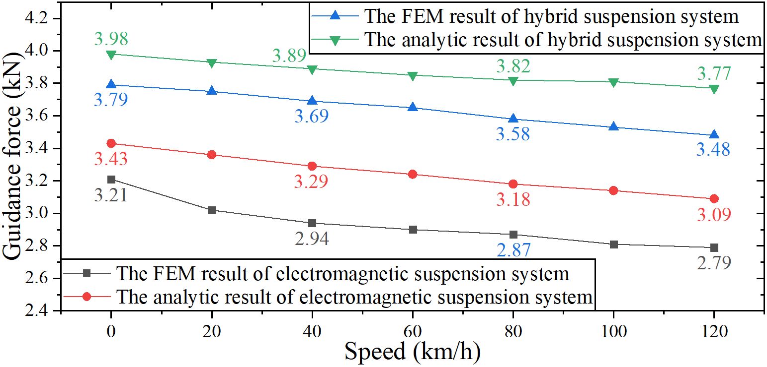
(a)
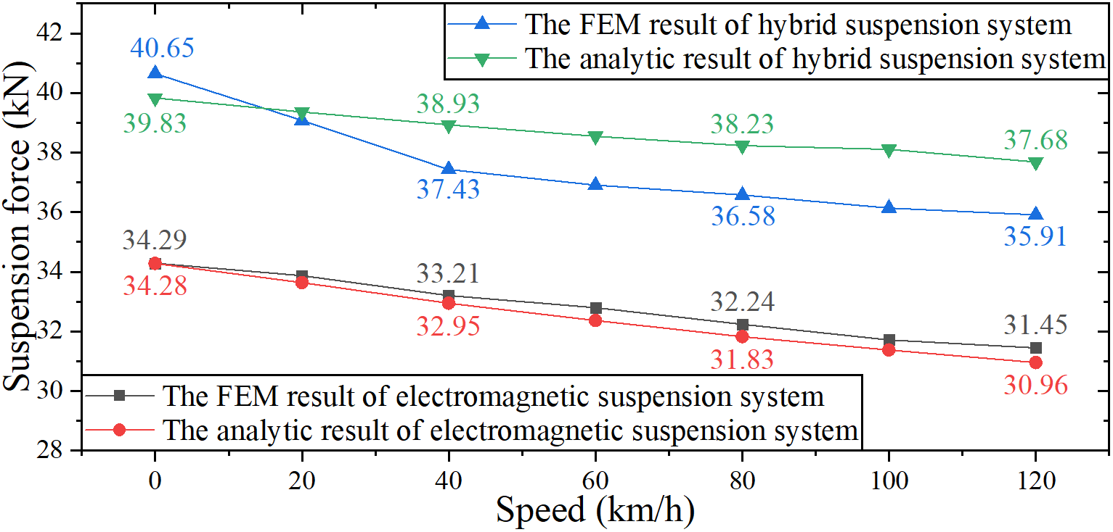
(b)
Fig. 13. The forces at 5mm displacement and different speeds: (a) The guidance force; (b) The suspension force.

Conclusions
A novel type of a hybrid suspension system, mixing electromagnets with permanent magnets, has been proposed to save energy and suppress the eddy current effect for improving the high-speed performance of maglev trains. The structural designs of this hybrid suspension system with consideration of the impact on the permanent magnets’ characteristics of the temperature distribution have been analysed with the help of multiphysics simulations. Comparisons with the original system containing electromagnets only show that the hybrid suspension system offers better performance in both electromagnetic and thermal aspects. Based on the verification of a series of multi-physics coupling simulations, the novel hybrid suspension system can provide more reliable and more powerful suspension force than the traditional electromagnet especially under high-speed conditions of the train. The special stability performance of the hybrid system considering the displacement in the suspension system when the train turns in practice is also overwhelmingly better than the original electromagnetic suspension system.

Acknowledgments
This work was supported in part by the National Natural Science Foundation for Distinguished Young Scholars of China under Grant 51707166, and in part by the Scientific Research Project of Central University Grant 2682018CX16 as well as the Sichuan Science and Technology General Project Grant 2019YJ0213.

References
- G. Liu, Y. Chen, J. Mod. Transportation, 20, 93 (2012). DOI: 10.1007 /BF03325784
- P. Cui, J. Li, De. Liu, Sci. China Ser. E. 53, 1082 (2010). DOI: 10.1007 /s11431-009-0394-8
- Z. Zhang, L. She, L. Zhang, J. Tan, J. Mech. Eng. 48(2), 146 (2012). DOI: 10.3901 /JME.2012.02.146
- J. Ding, X. Yang, Z. Q. Long, N. Dang, IEEE Access, 6, 61547 (2018). DOI: 10.1109/ACCESS.2018.2876599
- J. Jeong, C. Ha, J. Lim, J. Choi, IEEE Trans. Magn. 52(7), 8300104 (2015). DOI: 10.1109 /TMAG.2015.2506681
- F. Safaei, A. Suratgar, A. Afshar, M. Mirsalim, IEEE Trans. Energy Conver. 30, 1163 (2015). DOI: 10.1109 /TEC.2014.2388155
- C.Y. Lee, in Proceedings of the International Conference on Control, Automation and Systems, Gwangju, South Korea, 2013, p. 470
- J. Xu, Y. Sun, D. Gao, W. Ma, S. Luo, Q. Qian, IEEE Access, 6, 31571 (2018). DOI: 10.1109 /ACCESS.2018.2836348
- Z. Zhang, L. She, L. Zhang, C. Shang, W. Chang, IET Electr. Systems in Transportation, 1(2), 61 (2011). DOI: 10.1049 /iet-est.2010.0018
- S.K. Liu, B. An, S. Liu, Z.J. Guo, IET Electr. Power App. 9(3), 223 (2015). DOI: 10.1049 /iet-epa.2013.0414
- S. Xiao, K. Zhang, G. Liu, Y. Jing, J.K. Sykulski, Open Phys. 16, 168 (2018). DOI: 10.1515 /phys-2018-0024
- W. Han, J. Sun, X. Liu, H. Guo, J. Wang, J. Magn. 22, 463 (2017). DOI: 10.4283 /JMAG.2017.22.3.463
- P. Hammond, IEE Proc. A, 129(2), 106-112, (1982). DOI: 10.1049 /ip-a-1.1982.0015
- P.K. Sinha, Electromagnetic suspension: dynamics & control. (Peter Peregrinus, London, 19

