Safety and immunogenicity of the ChAdOx1 nCoV-19 vaccine against SARS-CoV-2: a Phase I/2 randomized control trial
Title | Name | Highest Degree | Institution
Dr | Pedro M Folegatti* | MSc | The Jenner Institute, Nuffield Department of Medicine, University of Oxford, and the NIHR Oxford Biomedical Research Centre, Oxford, UK
Assoc. Prof | Katie J Ewer* | PhD | The Jenner Institute, Nuffield Department of Medicine, University of Oxford, and the NIHR Oxford Biomedical Research Centre, Oxford, UK
Dr | Parvinder K Aley | PhD | Oxford Vaccine Group, Department of Paediatrics, University of Oxford, and the NIHR Oxford Biomedical Research Centre, Oxford, Uk
Dr | Brian Angus | MD | Nuffield Department of Medicine, University of Oxford, and the NIHR Oxford Biomedical Research Centre, Oxford, UK
Prof | Stephan Becker | PhD | Institute of Virology, Philipps University of Marburg, Marburg, Germany
Dr | Sandra Belij-Rammerstorfer | PhD | The Jenner Institute, Nuffield Department of Medicine, University of Oxford, and the NIHR Oxford Biomedical Research Centre, Oxford, UK
Mr | Duncan Bellamy | MSc | The Jenner Institute, Nuffield Department of Medicine, University of Oxford, and the NIHR Oxford Biomedical Research Centre, Oxford, UK
Dr | Sagida Bibi | PhD | Oxford Vaccine Group, Department of Paediatrics, University of Oxford, and the NIHR Oxford Biomedical Research Centre, Oxford, UK
Dr | Mustapha Bittaye | PhD | The Jenner Institute, Nuffield Department of Medicine, University of Oxford, and the NIHR Oxford Biomedical Research Centre, Oxford, UK
Dr | Elizabeth A Clutterbuck | PhD | Oxford Vaccine Group, Department of Paediatrics, University of Oxford, and the NIHR Oxford Biomedical Research Centre, Oxford, UK
Dr | Christina Dold | PhD | Oxford Vaccine Group, Department of Paediatrics, University of Oxford, a, Oxford, UKnd the NIHR Oxford Biomedical Research Centre,
Prof | Saul N Faust | FRCPCH | NIHR Southampton Clinical Research Facility, University Hospital Southampton NHS Foundation Trust and University of Southampton, Southampton, UK
Prof | Adam Finn | PhD | School of Population Health Sciences, University of Bristol
Dr | Amy L Flaxman | DPhil | The Jenner Institute, Nuffield Department of Medicine, University of Oxford, and the NIHR Oxford Biomedical Research Centre, Oxford, UK
Dr | Bassam Hallis | PhD | National Infection Service, Public Health England, Porton Down, Salisbury, Wilts SP4 0JG, UK.
Prof | Paul Heath | FRCPCH | Vaccine Institute, St George’s University, London
Dr | Daniel Jenkin | MRCP | The Jenner Institute, Nuffield Department of Medicine, University of Oxford, and the NIHR Oxford Biomedical Research Centre, Oxford, UK
Dr | Rajeka Lazarus | DPhil | University Hospitals Bristol and Weston NHS Foundation Trust
Ms | Rebecca Makinson | Mbiol | The Jenner Institute, Nuffield Department of Medicine, University of Oxford, and the NIHR Oxford Biomedical Research Centre, Oxford, UK
Dr | Angela M Minassian | DPhil | The Jenner Institute, Nuffield Department of Medicine, Centre for Clinical Vaccinology and Tropical Medicine, University of Oxford, and the NIHR Oxford Biomedical Research Centre, Oxford, UK
Dr | Katrina M Pollock | PhD | Imperial College, London
Dr | Maheshi Ramasamy | DPhil | Oxford Vaccine Group, Department of Paediatrics, University of Oxford, and the NIHR Oxford Biomedical Research Centre,, Oxford, UK
Ms | Hannah Robinson | DipHE | Oxford Centre for Clinical Tropical Medicine and Global Health, University of Oxford, and the NIHR Oxford Biomedical Research Centre, Oxford, UK
Assoc. Prof | Matthew Snape | MD | Oxford Vaccine Group, Department of Paediatrics, University of Oxford, and the NIHR Oxford Biomedical Research Centre,, Oxford, UK
Dr | Richard Tarrant | PhD | Clinical Biomanufacturing Facility, Nuffield Department of Medicine, University of Oxford, Oxford, UK
Dr | Merryn Voysey | DPhil | Oxford Vaccine Group, Department of Paediatrics, University of Oxford, and the NIHR Oxford Biomedical Research Centre, Oxford,UK
Assoc. Prof | Catherine Green* | PhD | Clinical Biomanufacturing Facility, Nuffield Department of Medicine, University of Oxford, Oxford, UK
Dr | Alexander D Douglas * | DPhil | The Jenner Institute, Nuffield Department of Medicine, University of Oxford, and the NIHR Oxford Biomedical Research Centre, Oxford, UK
Prof | Adrian V. S. Hill* | FMedSci | The Jenner Institute, Nuffield Department of Medicine, University of Oxford, and the NIHR Oxford Biomedical Research Centre, Oxford, UK
Assoc. Prof | Teresa Lambe* | PhD | The Jenner Institute, Nuffield Department of Medicine, University of Oxford, and the NIHR Oxford Biomedical Research Centre, Oxford, UK
Prof | Sarah Gilbert* | PhD | The Jenner Institute, Nuffield Department of Medicine, University of Oxford, and the NIHR Oxford Biomedical Research Centre, Oxford, UK
Prof | Andrew J Pollard* | FMedSci | Oxford Vaccine Group, Department of Paediatrics, University of Oxford, and the NIHR Oxford Biomedical Research Centre, Oxford, UK
and the Oxford COVID Vaccine Trial Group.
*contributed equally

Summary
Background
The ongoing devastating pandemic of SARS CoV2 might be curtailed by vaccination. We assessed the safety, reactogenicity, and immunogenicity of a viral vectored coronavirus vaccine, which expresses the spike protein of SARS-CoV-2, ChAdOx1 nCoV-19 (AZD1222)
Methods
We conducted a phase I/II single-blind randomised controlled trial of a chimpanzee adenovirus viral vector (ChAdOx1) vaccine expressing the SARS-CoV-2 spike protein, at a dose of 5x10¹⁰ viral particles, in healthy adults aged 18-55 years compared with a meningococcal conjugate vaccine (MenACWY) as control. A subset of volunteers received a two-dose schedule. We report on safety, reactogenicity and cellular and humoral immune responses. The study was registered at ISRCTN, 15281137, and ClinicalTrials.gov, NCT04324606.
Findings
Between April 23rd 2020 and May 21st 2020, 1077 volunteers, randomised 1:1, received ChAdOx1 nCoV-19 or MenACWY vaccines. Local and systemic reactions were more common in the ChAdOx1 nCoV-19 group, were reduced by use of prophylactic paracetamol. There were no serious adverse events related to ChAdOx1 nCoV-19. Spike-specific T cell responses peaked on day 14 (856 SFC/M). Anti-spike IgG responses rose by day 28, and were boosted following a second dose. Neutralising antibody responses against SARS-CoV-2 were detected in 91% or 100% of vaccinees after a single dose, when measured in an 80% micro-neutralisation (MNA80) or 50% plaque reduction neutralisation assay (PRNT50) respectively. After a booster dose, 100% of participants had neutralising activity in two different live-neutralisation assays. Neutralising antibody responses correlated strongly with antibody levels measured by ELISA.
Interpretation
ChAdOx1 nCoV-19 showed an acceptable safety profile and homologous boosting with this ChAd viral vector increased antibody responses significantly. This, together with the induction of both humoral and cellular immune responses, supports large scale evaluation of this candidate vaccine in an ongoing phase III programme.
Funding
UKRI, CEPI, NIHR, NIHR Oxford Biomedical Research Centre, Thames Valley and South Midland's NIHR Clinical Research Network and the German Center for Infection Research (DZIF), Partner site Gießen-Marburg-Langen.

Research in Context
Evidence before this study: SARS-CoV-2 was identified as the causative agent of COVID-19 disease in January 2020. There are currently no licensed vaccines to prevent COVID-19. ChAdOx1 nCoV-19 has previously been reported to be immunogenic and protective against pneumonia in a rhesus macaque challenge model. We searched PubMed for research articles published between database inception and 6th July 2020 using the terms “SARS-CoV-2”, “vaccine”, “clinical trial” and “phase”. No language restriction was applied. One clinical trial has been published describing a clinical trial conducted in China of an adenovirus-5 vectored vaccine against SARS-CoV-2, using a single dose at three different dose levels. The vaccine was tolerated, with reactogenicity increased at the highest dose. Antibodies, neutralising antibodies in a proportion of vaccinees, and cellular responses were induced. A further clinical trial has been reported on MedRXiv. This was conducted in the US and the vaccine was a lipid nanoparticle-formulated, nucleoside-modified, mRNA vaccine that encodes trimerized SARS-CoV-2 spike glycoprotein receptor binding domain (RBD) administered at one or two doses of three dose levels. The vaccine was tolerated, with reactogenicity increased at the highest dose. Antibodies and neutralising antibodies were induced in a dose-dependent manner and increased after a second dose.

Added value of this study: This study is the first clinical study of ChAdOx1 nCoV-19 (AZD1222). The vaccine was safe and tolerated, with reduced reactogenicity when paracetamol was used prophylactically for the first 24 hours after vaccination. Reactogenicity was reduced after a second dose. Four-fold increases in humoral responses to SARS-CoV-2 spike protein were induced in 95% of participants by day 28 post-prime and cellular responses were induced in all participants by day 14. Neutralising antibodies were induced in all subjects after a second vaccine dose. After two doses potent cellular and humoral immunogenicity were present in all subjects studied.

Implications of all the available evidence: A vaccine against SARS-CoV-2 could be used to prevent infection, disease and death in the whole population, with high risk populations such as hospital workers and older adults prioritised to receive vaccination. The immune correlates of protection against SARS-CoV-2 have not yet been determined. Immunisation with ChAdOx1-nCoV-19 results in rapid induction of both humoral and cellular immune responses against SARS-CoV-2, with increased responses after a second dose. Further clinical studies, including in older adults, should be done with this vaccine.

Introduction
Severe acute respiratory syndrome coronavirus-2 (SARS-CoV-2) emerged as a zoonotic virus late in 2019 and is the causative agent of coronavirus disease-2019 (COVID-19). Exposure to SARS-CoV-2 can result in a range of clinical outcomes varying from asymptomatic infection to severe acute respiratory distress and death. SARS-CoV-2 has spread globally and was declared a pandemic on March 11th by the World Health Organisation (WHO). As of 7th July 2020 11,500,302 people globally have been infected with 535,759 deaths¹. The pandemic has placed substantial pressures on health systems delivering care for COVID-19 patients and caused disruption of non-COVID-19 health-care provision, in addition to negative effects on the global economy. Further health consequences are anticipated.

No vaccines have been approved for prevention of COVID-19. There are currently more than 137 candidates undergoing preclinical and 23 in early clinical development, according to the World Health Organisation.² An ideal vaccine against SARS-CoV-2 would be effective after one or two vaccinations, in target populations including older adults and those with co-morbidities including immunocompromised individuals, would confer protection for a minimum of six months and would reduce onward transmission of the virus to contacts. Replication-deficient viral vectored vaccines have been used in immunocompromised individuals with no safety concerns ³⁻⁵ and ChAdOx1 vaccines are immunogenic in older adults⁶ and can be manufactured at large scale making this platform technology a promising candidate to develop a vaccine for the prevention of COVID-19 disease. Adenoviral vectors have previously been combined with DNA and poxviral vectors to attempt to improve immunogenicity with adenovirus and MVA prime-boost regimens demonstrating enhancement of both cellular and humoral immunity. Use of homologous adenoviral regimens has largely been avoided because of presumed induction of antivector immunity inhibiting the potency of a second dose.
Coronaviruses are enveloped, positive sense single-stranded RNA viruses with a glycoprotein spike on the surface, which mediates receptor binding and cell entry during infection. The roles of the spike protein in receptor binding and membrane fusion make it an attractive vaccine antigen. We have previously demonstrated that a single dose of ChAdOx1 MERS, a chimpanzee adenovirus vectored vaccine that encodes the spike protein of MERS-CoV, protected non-human primates (NHPs) against MERS-CoV-induced disease⁷ and data from a Phase I clinical trial demonstrated that ChAdOx1 MERS was safe and well tolerated at all three doses tested (5 × 10⁹ viral particles (vp), 2·5 × 10¹⁰ vp and 5 × 10¹⁰ vp)⁸. In addition, the highest dose elicited both humoral and cellular responses against MERS-CoV in all vaccinees within one month of vaccination.
In rhesus macaques a single vaccination with the adenovirus-vectored vaccine ChAdOx1 nCoV-19 (AZD1222), encoding the spike protein of SARS-CoV-2 induced humoral and cellular immune responses. Protection against lower respiratory tract infection was observed in vaccinated NHPs after high dose SARS-CoV-2 challenge.⁹
We conducted a phase 1/2 single-blind randomised controlled trial of ChAdOx1 nCoV-19 compared with MenACWY, as control vaccine, in healthy adults in the United Kingdom.
In this preliminary report, we describe the immunogenicity, reactogenicity, and safety of vaccination with 5x10¹⁰ vp of ChAdOx1 nCoV-19 in single and two-dose regimens.

Methods
Vaccine
The ChAdOx1 nCoV-19 vaccine consists of the replication-deficient simian adenovirus vector ChAdOx1, containing the full-length structural surface glycoprotein (spike protein) of SARS- CoV-2 (nCoV-19), with a tissue plasminogen activator (tPA) leader sequence. ChAdOx1 nCoV-19 expresses a codon-optimised coding sequence for the spike protein from genome sequence accession GenBank: MN908947. The recombinant adenovirus was produced as previously described.¹⁰ The vaccine was manufactured according to current Good Manufacturing Practice by the Clinical BioManufacturing Facility (University of Oxford, Oxford, UK) as described with only minor modifications¹¹.
A licensed meningococcal group A, C, W-135, and Y conjugate vaccine (MenACWY, Nimenrix, Pfizer, UK) was used as a comparator vaccine in order to maintain blinding of participants who experienced local or systemic reactions, since these reactions are a known association with viral vector vaccinations. Use of saline as a placebo would risk unblinding participants as those who had significant reaction would know they were in the ChAdOx1 nCoV-19 vaccine group.
Study design and participants
This is an ongoing phase 1/2, participant-blinded, multi-centre, randomised controlled trial. The study is being conducted at 5 centres in the UK (Centre for Clinical Vaccinology and Tropical Medicine, University of Oxford; NIHR Southampton Clinical Research Facility, University Hospital Southampton NHS Foundation Trust, Southampton; Clinical Research Facility at Imperial College London; St Georges University of London and University Hospital NHS Foundation Trust; and University Hospitals Bristol and Weston NHS Foundation Trust.). Healthy adult participants aged 18-55 years were recruited through local advertisements. All participants underwent a screening visit where a full medical history and examination was taken in addition to blood and urine tests (HIV, hepatitis B and C serology, full blood count, kidney and liver function tests, and urinary screen for blood, protein and glucose and a pregnancy test done in women of childbearing potential). Volunteers with a history of laboratory confirmed COVID-19, those at higher risk for COVID-19 exposure pre-enrolment and those with a new onset of fever, cough, shortness of breath and anosmia/ageusia since February 2020 were excluded from the study. A later amendment to the study protocol allowed for recruitment of healthcare workers with a negative SARS-CoV-2 serology at screening, once an antibody test became available. As it was not possible to screen for negative SARS-CoV-2 serology in all participants, some enrolled participants had high level anti-spike antibodies at baseline and their data are included in all analyses. Full details of the eligibility criteria are described in the trial protocol provided in the supplementary material.
Written informed consent was obtained from all participants, and the trial is being conducted in accordance with the principles of the Declaration of Helsinki and Good Clinical Practice. This study was approved in the UK by the Medicines and Healthcare Products Regulatory Agency (reference 21584/0424/001-0001) and the South Central Berkshire Research Ethics Committee (reference 20/SC/0145). Vaccine use was authorised by Genetically Modified Organisms Safety Committees at each participating site.
Randomisation and Masking
Participants were randomised 1:1 to receive the ChAdOx1 nCoV-19 at 5 × 10¹⁰ vp or MenACWY vaccines. Randomisation lists, using block randomisation stratified by study group and study site were generated by the study statistician. Block sizes of 2, and 4 were chosen to align with the study group sizes, the sequence of enrolment, and varied across study groups. Computer randomisation was done with full allocation concealment within the secure web platform used for the study eCRF (REDCap 9.5.22 - © 2020 Vanderbilt University). The trial staff administering the vaccine prepared vaccines out of sight of the participant and syringes were covered with an opaque material until ready for administration to ensure blinding of participants. Clinical investigators and the laboratory team remained blinded to group allocation.
Procedures
Vaccines were administered as a single intramuscular injection into the deltoid. A staggered-enrolment approach was used and interim safety reviews with the independent Data and Safety Monitoring Board (DSMB) were conducted before proceeding with vaccinations in larger numbers of volunteers. Volunteers were considered enrolled into the trial at the point of vaccination. Ten participants were enrolled in a non-randomised prime-boost group with the booster vaccine administered 28 days after the first dose.
Participants had blood samples drawn and clinical assessments for safety as well as immunology at day 0, 28 and will also be followed at day 184 and 364. In addition, participants enrolled in the phase 1 component of the study and in the prime-boost group, had visits 3, 7, 14 and 28 days after each vaccination. A later amendment to the protocol provided for additional testing of booster vaccinations in a subset of participants, the results of which are not yet available and are not included in this report.
In two of the five trial sites (Oxford and Southampton), a protocol amendment was implemented to allow prophylactic paracetamol to be administered prior to vaccination and participants were advised to continue with 1g every 6 hours for 24 hours to reduce vaccine-associated reactions. All participants enrolled after the protocol amendment at these two sites were given prophylactic paracetamol and randomised equally to the vaccine or control arms of the study.
Participants were observed in the clinic for 30-60 minutes after the vaccination procedure and were asked to record any adverse events (AEs) using electronic diaries during the 28-day follow-up period. Expected and protocol defined local site reactions (injection site pain, tenderness, warmth, redness, swelling, induration and pruritus) and systemic symptoms (malaise, myalgia, arthralgia, fatigue, nausea, headache, feverishness – a self-reported feeling of having a fever, and objective fever defined as an oral temperature of 38°C or higher) were recorded for 7 days. All other events were recorded for 28 days, and serious adverse events are recorded throughout the follow-up period.
Severity of AEs are graded with the following criteria: mild (transient or mild discomfort <48 hours, no interference with activity, no medical intervention/therapy required), moderate (mild to moderate limitation in activity, some assistance may be needed; no or minimal medical intervention/therapy required), severe (marked limitation in activity, some assistance usually required; medical intervention/therapy required), and potentially life-threatening (requires assessment in A&E or hospitalisation). Unsolicited AEs are reviewed for causality by two clinicians blinded to group allocation, and events considered to be possibly, probably, or definitely related to the study vaccines were reported. Laboratory AEs were graded by use of site-specific toxicity tables, which were adapted from the US Food and Drug Administration toxicity grading scale.
Immunogenicity measures
Humoral responses at baseline and following vaccination were assessed using a standardised total IgG ELISA against trimeric SARS CoV-2 spike protein, three live SARS Cov2 neutralisation assays and a pseudovirus neutralisation assay (See supplemental methods).
Outcomes
The co-primary objectives are to assess efficacy as measured by cases of symptomatic virologically confirmed COVID-19 disease and safety of the vaccine as measured by the occurrence of serious adverse events. Secondary outcomes include safety, reactogenicity, and immunogenicity profiles of ChAdOx1 nCoV-19, and efficacy against hospital attended COVID-19 disease, death and seroconversion against non-spike proteins. Preliminary results for secondary endpoints are reported here: occurrence of local and systemic reactogenicity signs and symptoms for 7 days after vaccination; occurrence of unsolicited adverse events for 28 days after vaccination; change from day 0 (baseline) to day 28 for safety laboratory measures; cellular and humoral immunogenicity of ChAdOx1 nCoV-19.

Convalescent plasma from COVID-19 patients and healthcare workers
Samples from individuals ≥18 years of age with PCR positive SARS-CoV-2 infection were obtained from patient cohorts admitted to hospital, or surveillance on healthcare workers who did not have symptomatic infection. The sample collection was undertaken to characterise the immunological properties of COVID19 disease and not for the purposes of the clinical trial (Gastro-intestinal illness in Oxford: COVID sub study [Sheffield REC, reference: 16/YH/0247], ISARIC/WHO Clinical Characterisation Protocol for Severe Emerging Infections [Oxford REC C, reference 13/SC/0149], Sepsis Immunomics project [Oxford REC C, reference:19/SC/0296]).

Statistical analysis
Safety endpoints are described as frequencies and percentages with 95% binomial exact confidence intervals (CI). Medians and interquartile ranges are presented for immunological endpoints and analyses are considered descriptive only as the full set of samples have not yet been analysed on all platforms and therefore results reported here are preliminary.
Participants were analysed according to the group to which they were randomised.
Statistical analyses were conducted using SAS version 9.4 and R version 3.6.1 or later.
The sample size for the study was determined by the number of doses of vaccine that were available for use after the initial clinical manufacturing process. Sample sizes for efficacy are based on the number of primary outcome events that accrue and are presented in the protocol attached as a supplementary file. Efficacy analyses have not yet been conducted and are not included in this report.
An independent Data and Safety Monitoring Board provided safety oversight (see Supplementary File).
This study is registered with ClinicalTrials.gov, NCT04324606 and with ISRCTN, number 15281137

Role of the funding source
The funders of the study had no role in the study design, data collection, data analysis, data interpretation, or writing of the report. All authors had full access to all the data in the study and had final responsibility for the decision to submit for publication.

Results
Between April 23rd and May 21st 2020, 1077 participants were enrolled into the study and vaccinated with either ChAdOx1 nCoV-19 or MenACWY control vaccine. (Figure S1).
The median age of participants was 35 years (IQR 28, 44 years), 50% of participants were female and 91% of participants were white (Table S1). Baseline characteristics were similar between randomised groups (Table S1).
In those who did not receive prophylactic paracetamol, 67% of ChAdOx1 nCoV-19 participants and 38% of MenACWY participants reported pain after vaccination which was mostly mild to moderate in intensity. With prophylactic paracetamol pain was reduced to 50% in ChAdOx1 nCoV-19 participants and 32% of MenACWY participants. Tenderness of mostly mild intensity was reported by 83% ChAdOx1 nCoV-19 participants without paracetamol and 77% with paracetamol, and by 58% without paracetamol and 46% with paracetamol of MenACWY recipients. (Figure 1, Table S2)
Fatigue and headache were the most commonly reported systemic reactions. Fatigue was reported in 70% and 71% (no paracetamol, paracetamol) ChAdOx1 nCoV-19 participants and 48% and 46% (no paracetamol, paracetamol) MenACWY recipients, whilst headaches occurred in 68% and 61% (no paracetamol, paracetamol) ChAdOx1 nCoV-19 participants and 41% and 37% (no paracetamol, paracetamol) MenACWY recipients.
Other systemic adverse reactions were common in the ChAdOx1 nCoV-19 group: muscle ache 60%, 48% (no paracetamol, paracetamol); malaise 61%, 48% (no paracetamol, paracetamol); chills 56%, 37% (no paracetamol, paracetamol); and feeling feverish 51%, 36% (no paracetamol, paracetamol). 18% and 16% of ChAdOx1 nCoV-19 participants (no paracetamol, paracetamol) reported a temperature ≥ 38ºC, and 2% had a temperature ≥ 39ºC without paracetamol. In comparison < 0.5% of those receiving MenACWY reported a fever ≥ 38ºC, and none of those who received prophylactic paracetamol. (Figure 1, Table S2).
The severity and intensity of local and systemic reactions was highest on day 1 of the study (Figure 1).
Adjusted analysis of the effect of prophylactic paracetamol on adverse reactions of any severity in the first 2 days after vaccination with ChAdOx1 nCoV-19 showed significant reductions in pain, feeling feverish, chills, muscle ache, headache, and malaise (Figures S2 and S3).
Ten people received a booster dose of ChAdOx1 nCoV-19 and solicited local and systemic reactions were measured for 7 days after both the prime and booster doses. The reactogenicity profile after the second dose appeared less severe in this subset, although the number of participants was small in this group, leading to wide confidence intervals (Figure 2, Table S3).
Unsolicited adverse events in the 28 days following vaccination considered to be possibly, probably, or definitely related to ChAdOx1 nCoV-19 were predominantly mild and moderate in nature and resolved within the follow-up period. Laboratory adverse events considered to be at least possibly related to the study intervention were self-limiting and predominantly mild or moderate in severity (Table S4). Transient haematological changes from baseline (neutropenia) were observed in 46.3% (25 in 54) of participants in the ChAdOx1 nCoV-19 arm, compared with 6.8% (3 in 44) receiving MenACWY. There was one serious adverse event consisting of a new diagnosis of haemolytic anaemia, occurring 9 days after vaccination. The participant was clinically well throughout. The event was reported as a suspected unexpected serious adverse reaction (SUSAR) relating to the MenACWY vaccine.
In the ChAdOx1 nCoV-19 group, antibodies against SARS-CoV-2 spike protein peaked by day 28 (median 157 ELISA Units [EU], IQR 96, 317) and remained elevated to day 56 (median 119 EU, IQR 70, 203) in participants who received only one dose, and increased to a median of 639EU (IQR 360, 792) in 10 participants who received a booster dose (Figure 3).
Similar increases in serum antibody levels to both the spike protein and the receptor binding domain by day 28 and after a booster dose were observed when measured by MIA (Figure S4). Immunogenicity among those who received paracetamol prophylactically was similar to that seen among those who were not advised to use it prophylactically (data not shown).
In a live neutralization assay determining the extent to which serum can be diluted and still reduce SARS-CoV-2 plaque formation by 50%, conducted at Public Health England, Porton Down (PHE PRNT₅₀), median titres of 218 (IQR 122, 395) were measured at day 28, and similar results were obtained with a rapid micro-neutralization assay conducted in the same laboratory, (PHE MNA₈₀) in which, titres inducing 80% virus neutralization were achieved in 32/35 (91%) participants after one-dose (median titre 70, IQR 33, 168), and in 100% of participants after the booster dose (median titre 136, IQR 115, 241) (Figure 4, Table S5).
In a different SARS-CoV-2 live virus neutralization assay conducted at Marburg University (Marburg VN), 23/62 (37%) of recipients had neutralising antibodies that induced complete inhibition of cytopathic effect caused by SARS-CoV-2 virus by day 56 after one dose, as did 100% participants after a booster dose, with a median titre of 29.5 (IQR 23.7, 32) (Figure 4).
Titres from an additional pseudovirus neutralization assay (PseudoNA, Figure 5) correlated positively with live virus neutralization assay titres and ELISA (Figure S5). We include responses following natural exposure as a point of reference for vaccine response data, and found that vaccine-induced responses were in a similar range. IFN-γ ELISpot responses against SARS-CoV-2 spike peptides peaked at 856 spot-forming cells per million PBMC (SFC/M) at day 14 (IQR 493.3-1802 SFC/M), declining to 424 SFC/M (IQR 221, 799) by day 56 post-vaccination (Figure 6).
Prior to vaccination only one of 98 participants who was tested had high titre (>200) neutralising antibodies against ChAdOx1. Antibodies were detectable at a lower level in a further 18 participants, and in the majority of participants there were no detectable anti-ChAdOx1 antibodies. There was no relationship between presence of low-level antibodies to ChAdOx1 on the day of vaccination and the ELISA titre to SARS-CoV-2 spike protein in those randomised to receive ChAdOx1 nCoV-19 (Figure S6)
Discussion
Our preliminary findings show that the candidate ChAdOx1 nCoV-19 vaccine given as a single dose was safe and tolerated, despite a higher reactogenicity profile than the control vaccine, MenACWY. No serious adverse reactions to ChAdOx1 nCoV-19 occurred. The majority of AEs reported were mild or moderate in severity, and all were self-limiting. The profile of adverse events reported here is similar to that for other ChAdOx1 vectored vaccines and other closely related simian adenoviruses, such as ChAdOx2, ChAd3, and ChAd63 vectored vaccines expressing multiple different antigens^{8,12-14} at this dose level, and to some licensed vaccines ¹⁵. A dose of 5x10¹⁰ vp was chosen based on our previous experience with ChAdOx1 MERS, where despite increased reactogenicity, a dose response relationship with neutralising antibodies was observed.⁸ The protocol was written when the pandemic was accelerating in the UK and a single higher dose was chosen to provide the highest chance of rapid induction of neutralising antibody. In the context of a pandemic wave where a single higher, but more reactogenic, dose may be more likely to rapidly induce protective immunity, the use of prophylactic paracetamol appears to increase tolerability and would reduce confusion with COVID19 symptoms that might be caused by short-lived vaccine-related symptoms without compromising immunogenicity.
We demonstrate that a single dose of ChAdOx1 nCoV-19 elicits an increase in spike-specific antibodies by day 28 and a neutralising antibody in all participants after a booster dose. A small number 4/98 (4%) of participants had neutralizing antibody titres > 8 against SARS-CoV-2 spike protein before vaccination (Marburg VN) and 11/270 (4%) had high ELISA titres at baseline. These pre-existing responses are likely due to asymptomatic infection as potential participants with recent COVID-19-like symptoms or with a history of positive PCR test for SARS-CoV-2 were excluded from the study. Individuals with high titres on the day of vaccination who received ChAdOx1 nCoV-19 were boosted by vaccination.
Neutralizing antibodies targeting different epitopes of the spike glycoprotein have been associated with protection from COVID disease in early preclinical rhesus macaque studies.¹⁶ Whilst a correlate of protection has not been defined for COVID-19, high levels of neutralising antibodies have been demonstrated in convalescent individuals, with a wide range, as confirmed in our study ^{17,18}
Antibodies capable of neutralising live SARS-CoV-2 were induced by day 28 with titres of 70 and 218 (PHE MNA₈₀, and PHE PRNT₅₀, respectively), and with titres of 30 or 136 after a booster dose (Marburg VN, PHE MNA₈₀, respectively) measured using different assays. In a non-human primate study where primary SARS-CoV-2 infection elicited at least short-term protection against reinfection, neutralising antibody titres of the magnitude demonstrated in our study after boosting appeared sufficient to confer protection using the Marburg VN assay methodology.¹⁹ Neutralising antibody titres were increased by a two-dose regimen, and further investigation of this approach is underway. The correlation of neutralisation assays with IgG quantitation indicates that, if confirmed, a standardised ELISA may be sufficient to predict protection, should neutralising antibody also be shown to be protective in humans. We have presented data from two different live neutralising antibody assays and a pseudo-neutralisation assay, which show tight correlation with each other but give very different neutralising antibody titres. This issue highlights the urgent need for centralised laboratory infrastructure to allow bridging between vaccine candidates and accelerate the availability of multiple products to provide the global capacity to end the pandemic. If any one candidate demonstrates efficacy, bridging this result to other candidate vaccines through rigorously conducted laboratory assays will become a critical issue for global health.
Importantly, in COVID patients, there are accumulating data to suggest T-cell responses play an important role in COVID-19 disease mitigation; individuals who were exposed but asymptomatic developed a robust memory T cell response without symptomatic disease in the absence of a measurable humoral response.²⁰⁻²² Adenoviral vectored vaccines are known to induce strong cellular immunity and ChAdOx1 nCoV-19 vaccination resulted in marked increases in SARS CoV-2 spike-specific effector T-cell responses as early as day 7, peaking at day 14 and maintained out to day 56 as expected with adenoviral vectors. However, a boost in cellular responses was not observed following the second ChAdOx1 nCoV-19 dose, This is consistent with previous findings on viral vectored vaccines given as part of a homologous prime-boost regimen.¹²
Severe and fatal cases of SARS CoV-2 disproportionally affect older individuals. Therefore, it is important that vaccines developed to reduce or prevent COVID19 are suitable for administration in older age groups. Immunogenicity of a ChAdOx1 vectored vaccine against influenza has been demonstrated in older adults (50–78 years of age).⁶ As previously reported ¹⁰ anti-vector immunity was low prior to vaccination in UK adults aged 18-55, with no relationship between the presence of antibodies to ChAdOx1 and immune response to the vaccine antigen. Future studies will address the potential impact of anti-vector antibodies on homologous boosting, although in the subgroup reported on here, who received two vaccinations 28 days apart, there was clear evidence of boosting of antibody response to SARS-CoV-2 spike protein.
Limitations of this study include the short follow-up to date and single-blinded design, although staff undertaking clinical evaluation and laboratory staff all remained blinded. Generalisability of the study findings is limited, as this is a first-in-human study of healthy volunteers. Further studies are required to assess the vaccine in various population groups including older age groups, those with comorbidities and in ethnically and geographically diverse populations. The participants recruited in this study will be followed-up for at least 1 year and further safety, tolerability and immunogenicity (in addition to efficacy) results will be reported when data are available.²³⁻²⁵
In conclusion, ChAdOx1 nCoV-19 was safe, tolerated and immunogenic, while reactogenicity was reduced with paracetamol. A single dose elicited both humoral and cellular responses against SARS-CoV-2, with a booster immunisation augmenting neutralising antibody titres. The preliminary results of this first-in-human clinical trial supported clinical development progression into ongoing phase 2 and 3 trials. Older age groups with comorbidities, health care workers and those with higher risk for SARS-CoV-2 exposure are being recruited and assessed for efficacy, safety and immunogenicity of ChAdOx1 nCoV-19 given as a single or two-dose administration regimen in further trials conducted in the UK and overseas. We will also evaluate the vaccine in children, once sufficient safety data have been accumulated in adult studies. Phase III trials are now underway in the UK, Brazil, and South Africa and will evaluate vaccine efficacy in diverse populations.

Acknowledgments
This work is funded by the UKRI (MC_PC_19055), Engineering and Physical Sciences Research Council (EP/R013756/1), Coalition for Epidemic Preparedness Innovations (CEPI), the National Institute for Health Research, the NIHR Oxford Biomedical Research Centre and the German Center for Infection Research (DZIF), Partner site Gießen-Marburg-Langen. Additional resources for study delivery were provided NIHR Southampton Clinical Research Facility and NIHR Southampton Biomedical Research Centre, University Hospital Southampton NHS Foundation Trust; the NIHR Imperial Clinical Research Facility; and NIHR North West London, South London, Wessex,and West of England Local Clinical Research Networks and NIHR Oxford Health Biomedical Research Centre. PMF received funding from the Coordenacao de Aperfeicoamento de Pessoal de Nivel Superior, Brazil (finance code 001). Development of SARS-CoV-2 reagents was partially supported by the NIAID Centers of Excellence for Influenza Research and Surveillance (CEIRS) contract HHSN272201400008C. The research reagent for SARS-CoV-2 RNA (NIBSC 20/130) was obtained from the National Institute for Biological Standards and Control, UK. The control vaccine was provided free of charge by the Department of Health and Social Care. The research reagent for SARS-CoV-2 RNA (NIBSC 20/130) was obtained from the National Institute for Biological Standards and Control, UK. The control vaccine was provided free of charge by the Department of Health and Social Care. The views expressed in this publication are those of the author(s) and not necessarily those of the National Institute for Health Research or the Department of Health and Social Care. The University of Oxford has entered into a partnership with AstraZeneca (AZ) on vaccine development; the authors are grateful to the senior management at AZ for facilitating and funding the pseudovirus neutralisation assays and Mesoscale antibody assay included in this manuscript. AZ reviewed the data from the study and the final manuscript prior to submission, but the authors retained editorial control.
The investigators express their gratitude for the contribution of all the trial participants, the invaluable advice of the international DMSB (see appendix) and the independent members of the Trial Steering Committee. We additionally acknowledge the broader support from the various teams within the University of Oxford including Medical Sciences Division, Nuffield Department of Medicine and Department of Paediatrics, the Oxford Immunology Network COVID Consortium, Clinical Trials Research Governance, Research Contracts, Public Affairs Directorate and the Clinical Biomanufacturing Facility, as well as the Oxford University Hospitals NHS Foundation Trust and Oxford Health NHS Foundation Trust and the trial sites (see appendix). We are grateful for the input of the Protein production team at the Jenner Institute and the team at the Pirbright Institute.
Author Contributions
SCG and AJP conceived and designed the trial and AJP is the chief investigator.
AJP, PMF, DJ, HR, MV contributed to the protocol and design of the study. AF, PH, RL, KMP, SNF, BA, AVSH were the study site PIs. DB, MB, CD, SAB, STB, EC, TL, KJE, ALF, BH, RM, SB-R were responsible for laboratory testing and assay development. PKA, DJ, HR, PMF, AMM, MR, MS contributed to the implementation of the study. MV conducted the statistical analysis, CG, AD, RT were responsible for vaccine manufacturing. TL, SCG were responsible for vaccine development. AVSH and SCG developed the ChAdOx1 vector. TL, KJE, MV, SCG, AVSH, PMF, AJP, contributed to the preparation of the report. All other authors contributed to the implementation of the study and data collection. All authors critically reviewed and approved the final version.

Declarations of Interest
Sarah Gilbert is co-founder and board member of Vaccitech Ltd (collaborators in the early development of this vaccine candidate) and named as an inventor on a patent covering use of ChAdOx1-vectored vaccines and a patent application covering this SARS-CoV-2 (nCoV-19) vaccine. Teresa Lambe is named as an inventor on a patent application covering this SARS-CoV-2 (nCoV-19) vaccine and consultant to Vaccitech. Pedro M Folegatti is a consultant to Vaccitech, which is developing adenoviral vectored vaccines. Andrew J Pollard is Chair of UK Dept. Health and Social Care’s (DHSC) Joint Committee on Vaccination & Immunisation (JCVI), but does not participate in policy advice on coronavirus vaccines, and is a member of the WHO’s SAGE. Adrian Hill is a co-founder of and consultant to Vaccitech Ltd and is named as an inventor on a patent covering design and use of ChAdOx1-vectored vaccines. Adam Finn is a member of JCVI, Chair of WHO ETAGE and ex officio member of WHO SAGE working group on COVID19 vaccines and acting director of NIHR West of England LCRN.

Data Sharing Statement
The study protocol is available with this publication as part of the supplementary material. Individual participant data will be made available when the trial is complete, upon request directed to the corresponding author and after approval of a proposal can be shared through a secure online platform.

Tables and Figures

Figure 1 Solicited local (A) and systemic (B) adverse reactions in first 7 days post-vaccination as recorded in participant symptom e-diaries
A.
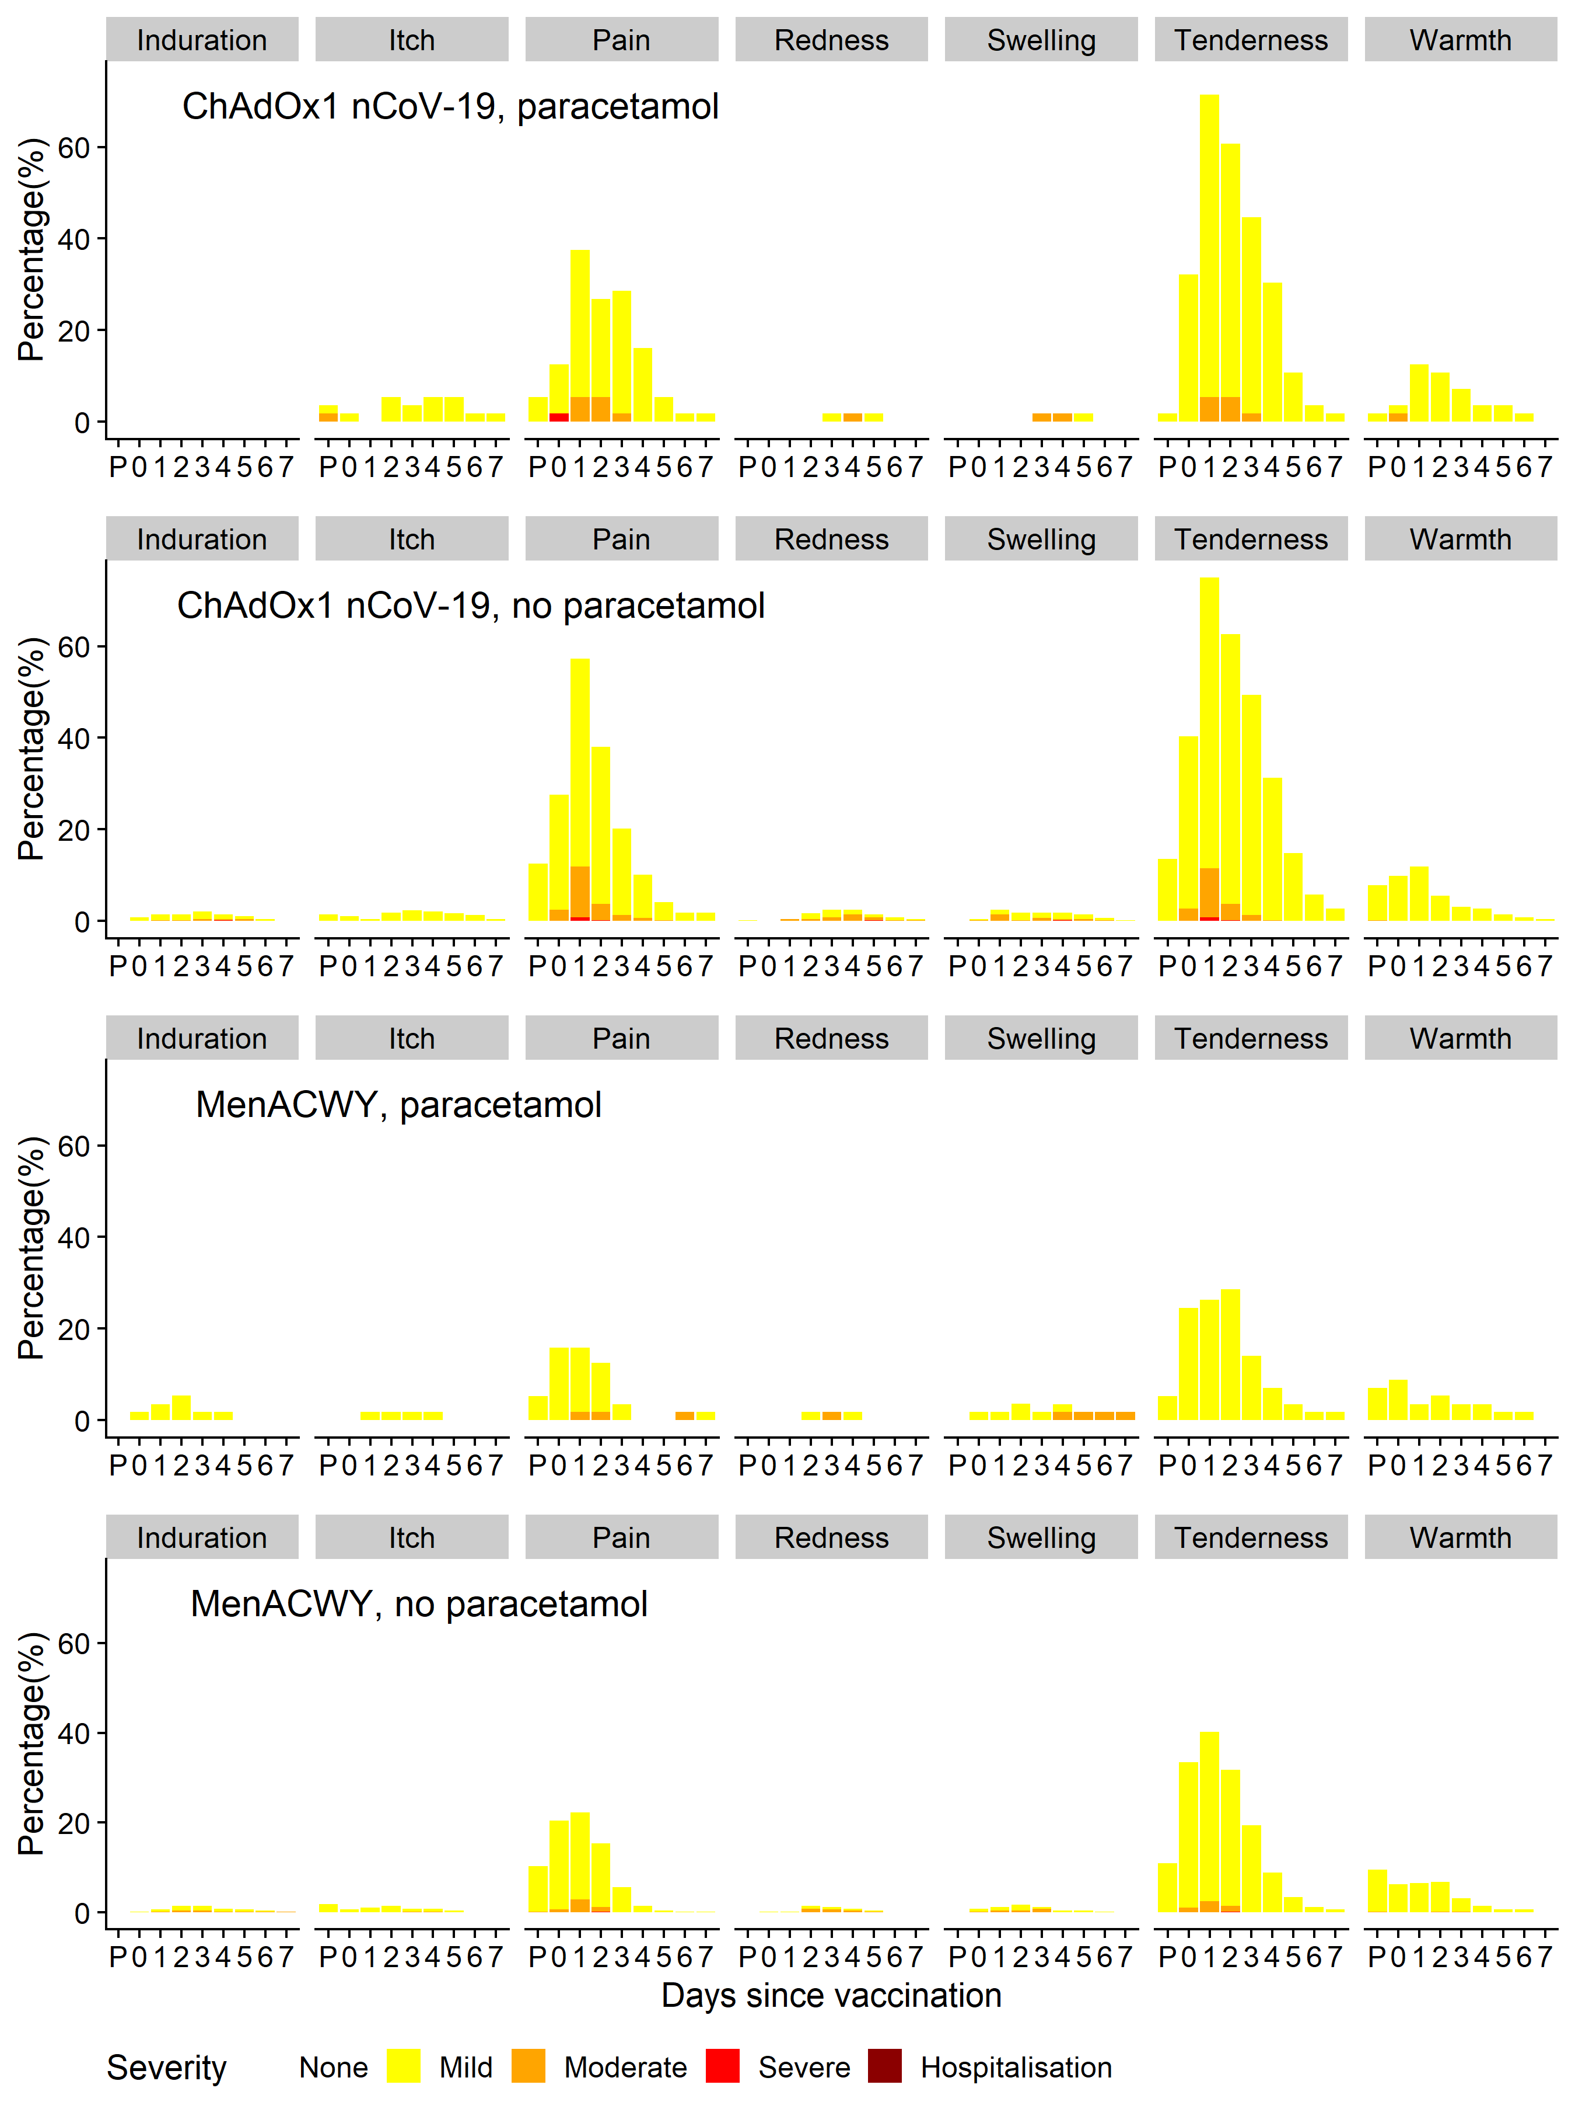

B.
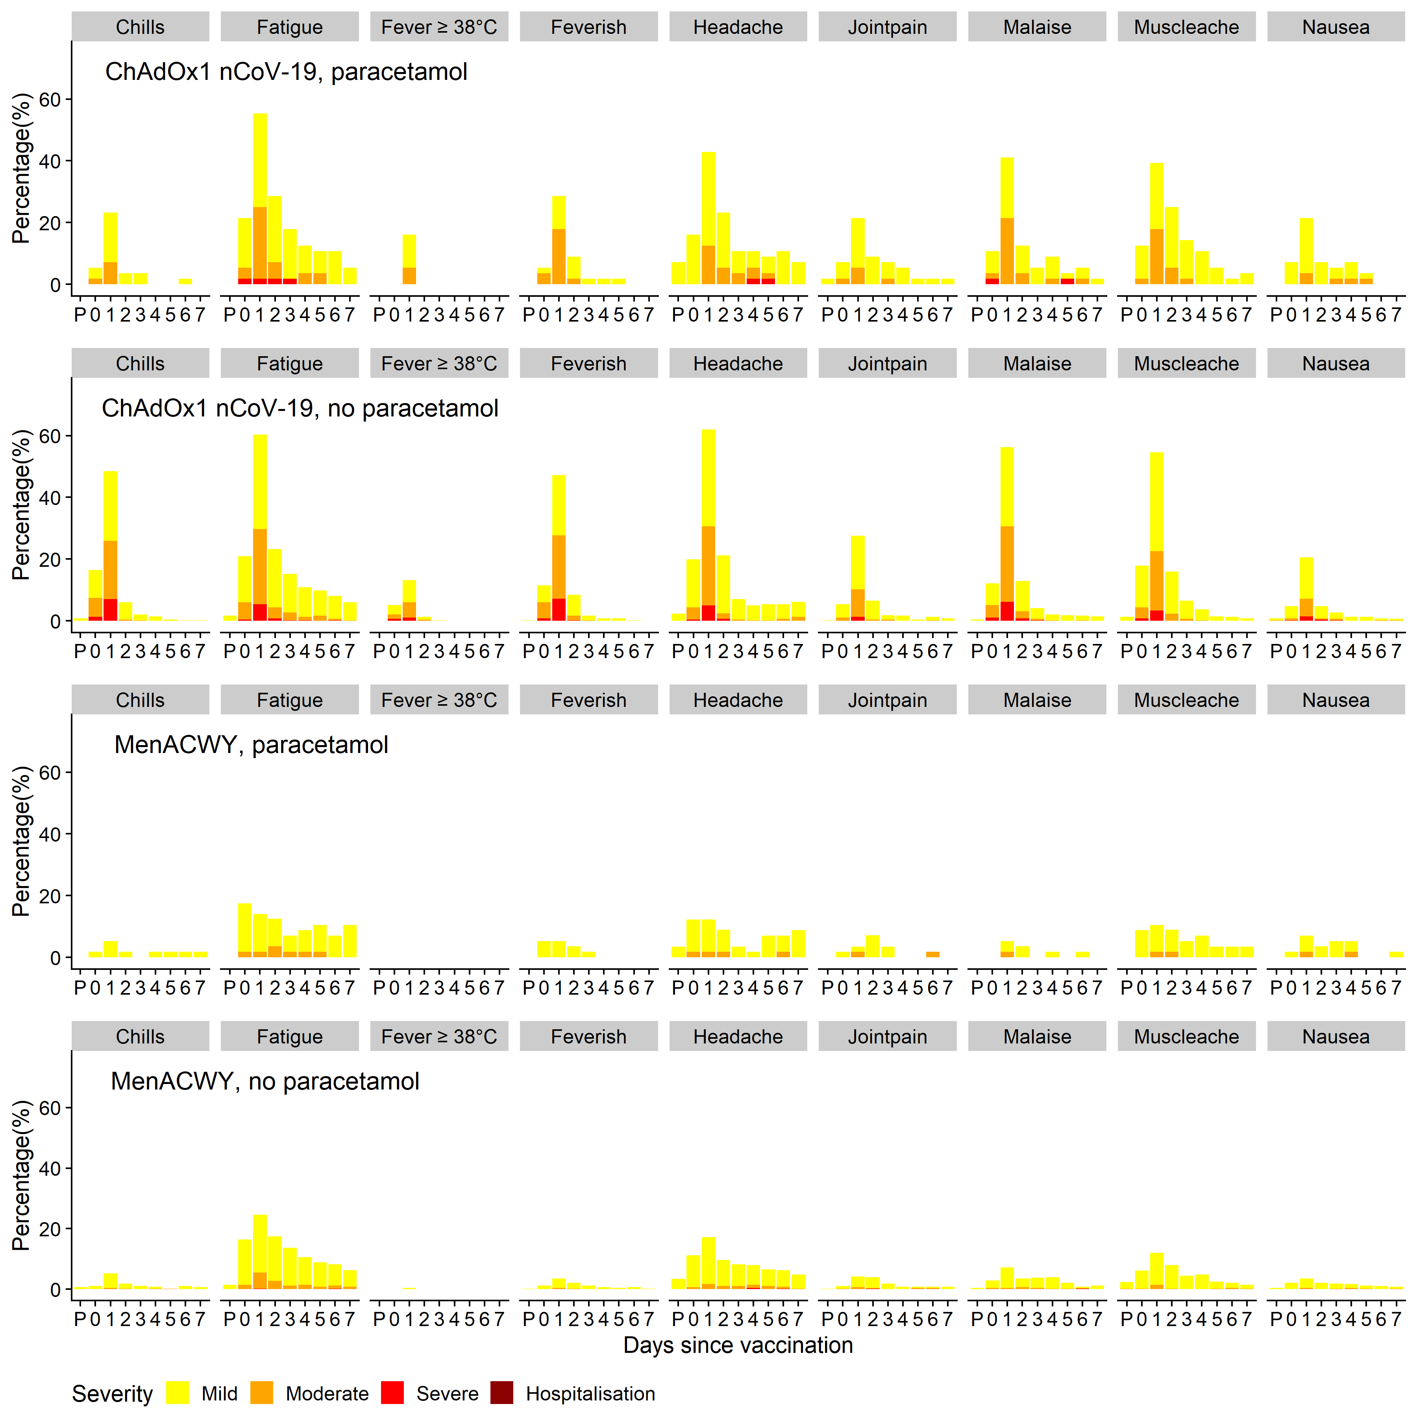
P= 60 minute post-vaccination observation period in the clinic; Day 0 is the day of vaccination. Feverish: Self-reported feeling of feverishness, Fever: objective fever measurements, mild: >= 38ºC, moderate: >=38.5ºC, severe: >=39.0ºC

Figure 2 Solicited local (A) and systemic (B) adverse reactions in first 7 days post-priming and booster doses of ChAdOx1 nCoV-19 in a non-randomised subset of 10 participants
A
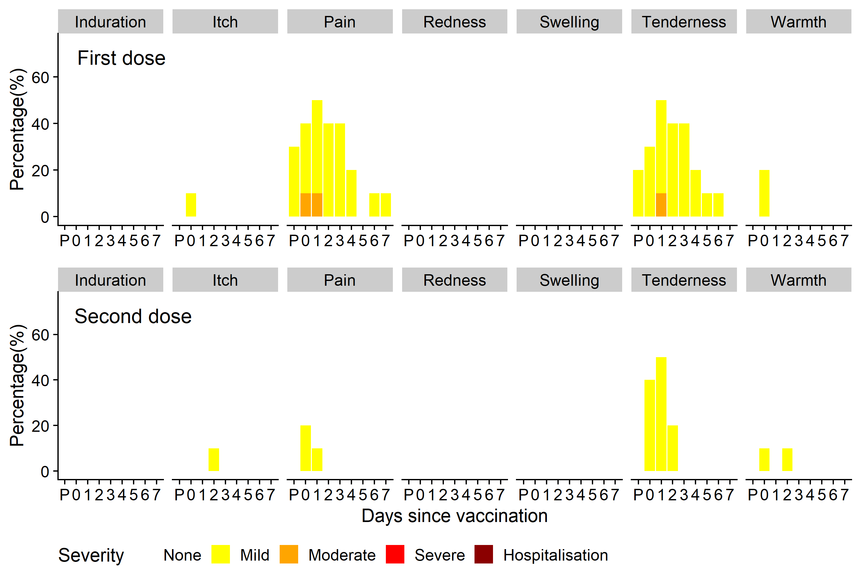
B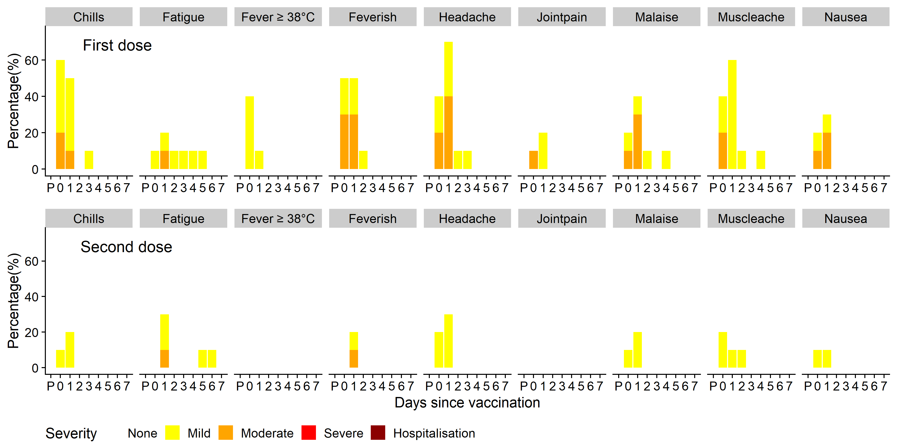

P= 60-minute post-vaccination observation period in the clinic; Day 0 is the day of vaccination. Feverish: Self-reported feeling of feverishness, Fever: objective fever measurements, mild: >= 38ºC, moderate: >=38.5ºC, severe: >=39.0ºC

Figure 3 SARS-CoV-2 IgG response by standardised ELISA to spike protein in trial participants and convalescent PCR+ COVID-19 patients
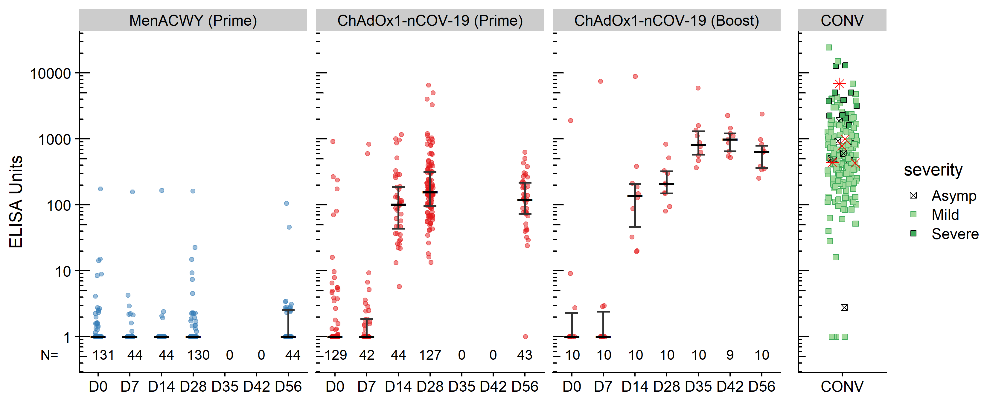
Red dots: ChAdOx1 nCoV-19 recipients; Blue dots: MenACWY recipients, CONV: convalescent plasma from PCR+ COVID-19 adults. Red stars in convalescent panel show 5 samples also tested on Marburg VN assay and shown in Figure 4. Error bars show median and IQR. Arrow: Participants in boost group received their second dose at day 28. Lower limit of quantification is 1 EU.
Figure 4 Live SARS-CoV-2 neutralisation assays (Marburg VN and PHE PRNT50), and microneutralisation (PHE MNA) assays
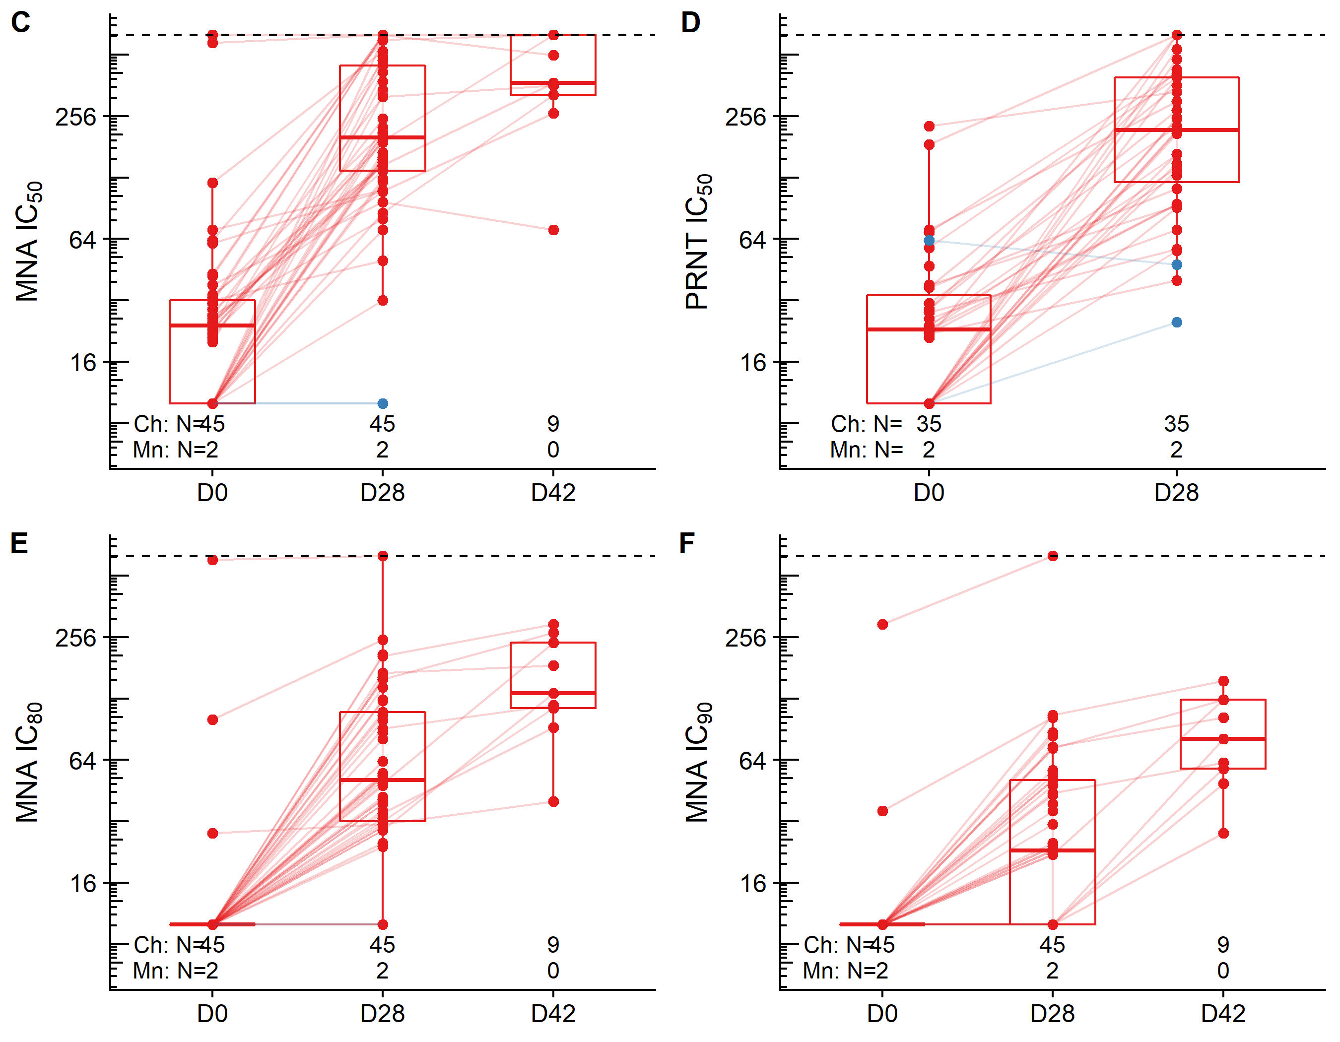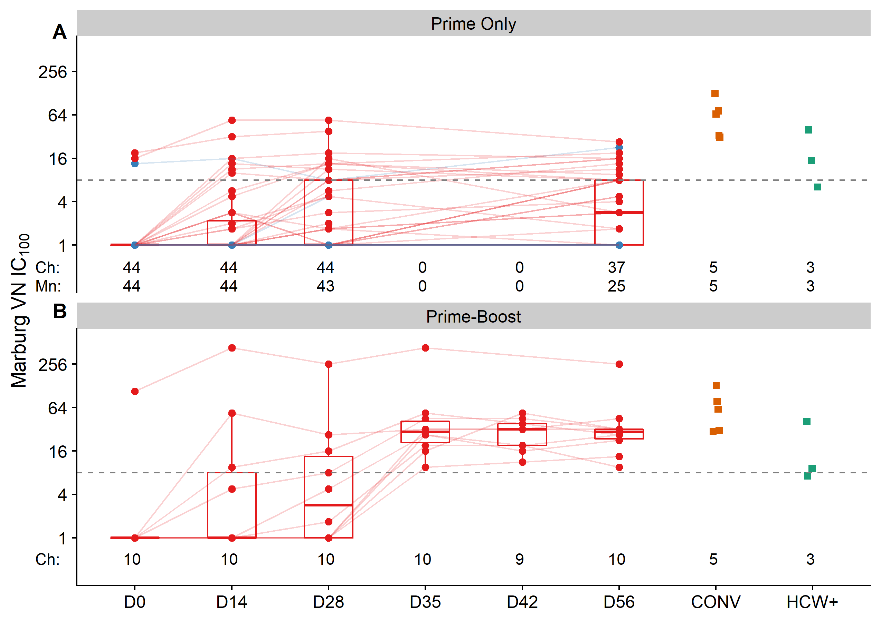
A and B: Live SARS-CoV-2 virus neutralisation (Marburg VN) in A: Prime-only and B: Prime Boost recipients (boosted at day 28).;
C,E,F: Public Health England Microneutralisation Assay (C: MNA₅₀, E: MNA₈₀, F: MNA₉₀) and D: Public Health England Plaque Reduction Neutralisation Test (PHE PRNT₅₀), D42 timepoint only measured in participants who received a booster dose at day 28. Ch: ChAdOx1 nCoV-19, Mn: MenACWY. Blue: MenACWY recipients, Red: ChAdOx1 nCoV-19 recipients. Solid lines connect samples from the same participant. Dotted line shows lower/upper limits of detection. CONV: convalescent plasma from COVID-19 cases, HCW+: Sera from health care workers who tested positive at baseline by ELISA. ELISA results for the 5 convalescent plasma samples are shown in Figure 3 as red stars.

Figure 5 Pseudotyped virus neutralisation assay (PseudoNA).
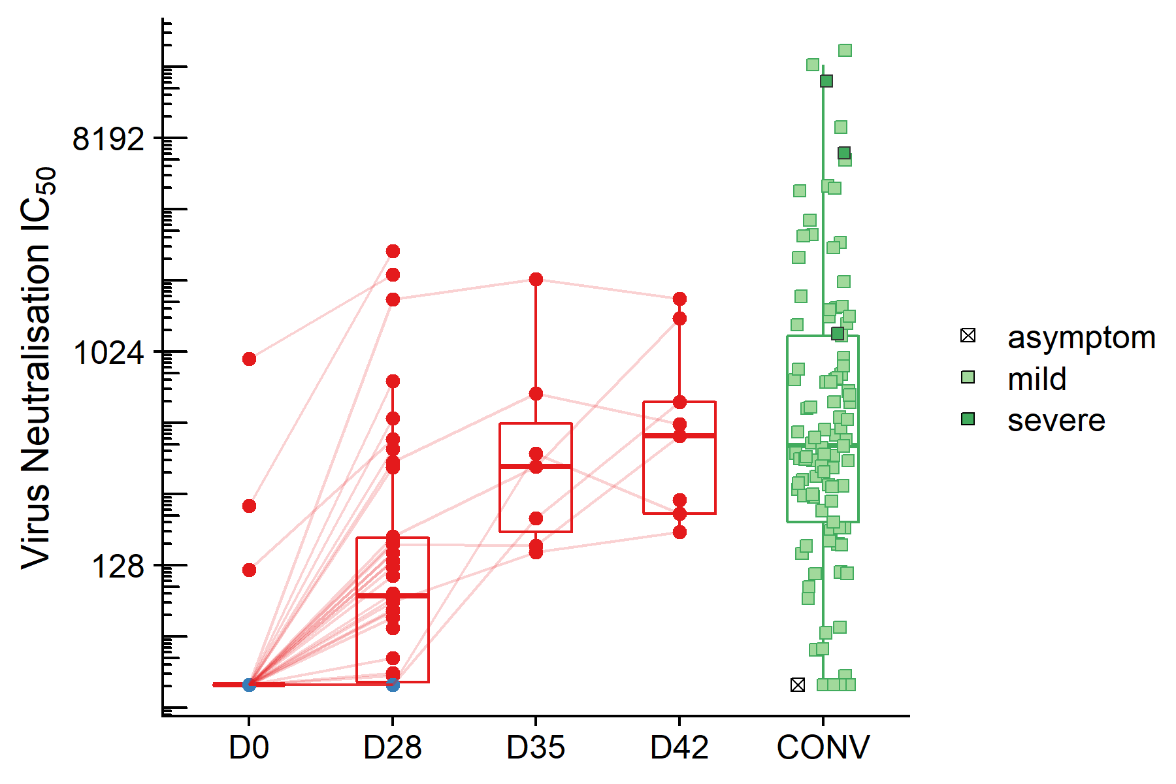
Blue: MenACWY recipients, Red: ChAdOx1 nCoV-19 recipients. Green: convalescent plasma from COVID-19 cases (CONV). Solid lines connect samples from the same participant. Day 35 and Day 42 samples from participants who received a booster dose at day 28.

Figure 6 IFNγ ELISpot response to peptides spanning the SARS-CoV-2 spike vaccine insert
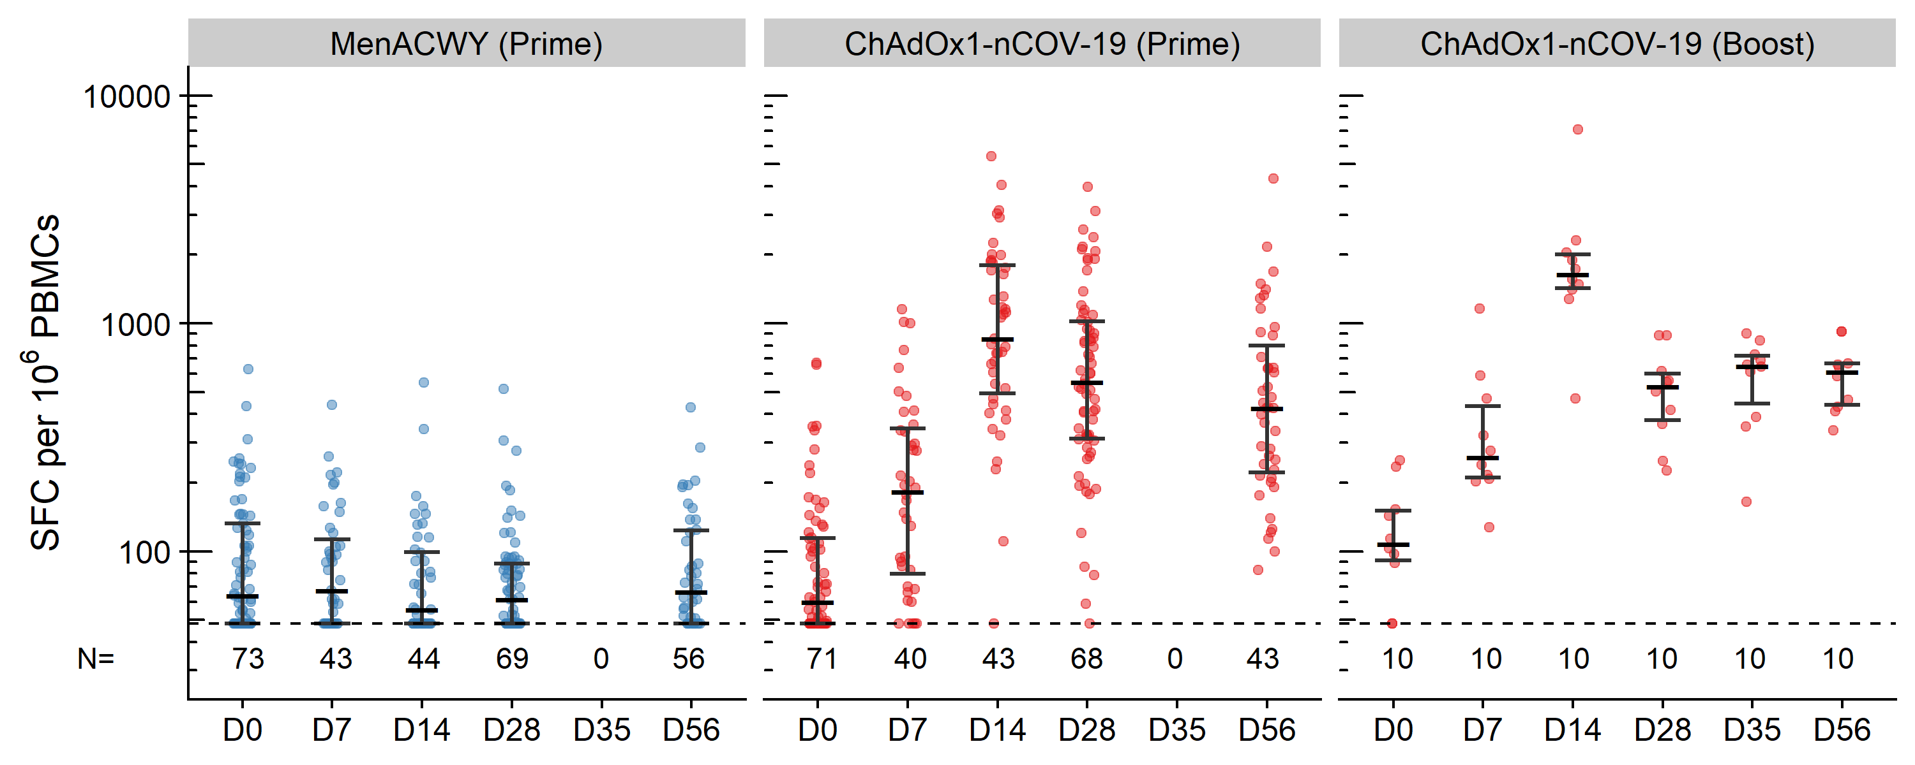
SFC: Spot-forming cells, PBMC: Peripheral blood mononuclear cells, Error bars show medians and inter-quartile ranges. LLD is 48 SFC/M (dotted line).

References (text only)
1. WHO. Coronavirus disease (COVID-19) Situation Report–169. Geneva, 2020.
2. World Health Organisation. Draft Landscape of COVID-19 candidate vaccines. 2020. https://www.who.int/publications/m/item/draft-landscape-of-covid-19-candidate-vaccines.
3. Fidler S, Stohr W, Pace M, et al. Antiretroviral therapy alone versus antiretroviral therapy with a kick and kill approach, on measures of the HIV reservoir in participants with recent HIV infection (the RIVER trial): a phase 2, randomised trial. Lancet 2020; 395(10227): 888-98.
4. Hanke T. Aiming for protective T-cell responses: a focus on the first generation conserved-region HIVconsv vaccines in preventive and therapeutic clinical trials. Expert Rev Vaccines 2019; 18(10): 1029-41.
5. Mothe B, Manzardo C, Sanchez-Bernabeu A, et al. Therapeutic Vaccination Refocuses T-cell Responses Towards Conserved Regions of HIV-1 in Early Treated Individuals (BCN 01 study). EClinicalMedicine 2019; 11: 65-80.
6. Coughlan L, Sridhar S, Payne R, et al. Heterologous Two-Dose Vaccination with Simian Adenovirus and Poxvirus Vectors Elicits Long-Lasting Cellular Immunity to Influenza Virus A in Healthy Adults. EBioMedicine 2018; 29: 146-54.
7. van Doremalen N, Haddock E, Feldmann F, et al. A single dose of ChAdOx1 MERS provides protective immunity in rhesus macaques. Science Advances 2020; 6(24): eaba8399.
8. Folegatti PM, Bittaye M, Flaxman A, et al. Safety and immunogenicity of a candidate Middle East respiratory syndrome coronavirus viral-vectored vaccine: a dose-escalation, open-label, non-randomised, uncontrolled, phase 1 trial. Lancet Infect Dis 2020; 20(7): 816-26.
9. van Doremalen N, et al. ChAdOx1 nCoV-19 vaccination prevents SARS-CoV-2 pneumonia in rhesus macaques BioRxiv (under review) 2020.
10. Dicks MD, Spencer AJ, Edwards NJ, et al. A novel chimpanzee adenovirus vector with low human seroprevalence: improved systems for vector derivation and comparative immunogenicity. PLoS One 2012; 7(7): e40385.
11. Morris SJ, Turner AV, Green N, Warimwe GM. Laboratory-Scale Production of Replication-Deficient Adenovirus Vectored Vaccines. Methods Mol Biol 2016; 1349: 121-35.
12. Bliss CM, Bowyer G, Anagnostou NA, et al. Assessment of novel vaccination regimens using viral vectored liver stage malaria vaccines encoding ME-TRAP. Scientific reports 2018; 8(1): 1-17.
13. Folegatti PM, Bellamy D, Roberts R, et al. Safety and immunogenicity of a novel recombinant simian adenovirus ChAdOx2 as a vectored vaccine. Vaccines 2019; 7(2): 40.
14. Imoukhuede E, Payne R, Fehling S, et al. A Monovalent Chimpanzee Adenovirus Ebola Vaccine Boosted with MVA. 2016.
15. Hesse EM, Shimabukuro TT, Su JR, et al. Postlicensure Safety Surveillance of Recombinant Zoster Vaccine (Shingrix) - United States, October 2017-June 2018. MMWR Morb Mortal Wkly Rep 2019; 68(4): 91-4.
16. Yu J, Tostanoski LH, Peter L, et al. DNA vaccine protection against SARS-CoV-2 in rhesus macaques. Science 2020.
17. Robbiani DF, Gaebler C, Muecksch F, et al. Convergent antibody responses to SARS-CoV-2 in convalescent individuals. Nature 2020: 1-8.
18. Wang X, Guo X, Xin Q, et al. Neutralizing antibodies responses to SARS-CoV-2 in COVID-19 inpatients and convalescent patients. Clinical Infectious Diseases 2020.
19. Deng W, Bao L, Liu J, et al. Primary exposure to SARS-CoV-2 protects against reinfection in rhesus macaques. Science 2020.
20. Grifoni A, Weiskopf D, Ramirez SI, et al. Targets of T Cell Responses to SARS-CoV-2 Coronavirus in Humans with COVID-19 Disease and Unexposed Individuals. Cell 2020; 181(7): 1489-501.e15.
21. Sekine T, Perez-Potti A, Rivera-Ballesteros O, et al. Robust T cell immunity in convalescent individuals with asymptomatic or mild COVID-19. bioRxiv 2020: 2020.06.29.174888.
22. Weiskopf D, Schmitz KS, Raadsen MP, et al. Phenotype and kinetics of SARS-CoV-2-specific T cells in COVID-19 patients with acute respiratory distress syndrome. Science Immunology 2020; 5(48): eabd2071.
23. Bolles M, Deming D, Long K, et al. A double-inactivated severe acute respiratory syndrome coronavirus vaccine provides incomplete protection in mice and induces increased eosinophilic proinflammatory pulmonary response upon challenge. Journal of virology 2011; 85(23): 12201-15.
24. Liu L, Wei Q, Lin Q, et al. Anti–spike IgG causes severe acute lung injury by skewing macrophage responses during acute SARS-CoV infection. JCI insight 2019; 4(4).
25. Weingartl H, Czub M, Czub S, et al. Immunization with modified vaccinia virus Ankara-based recombinant vaccine against severe acute respiratory syndrome is associated with enhanced hepatitis in ferrets. J Virol 2004; 78(22): 12672-6.

