The mental and physical health of older offenders: A systematic review and meta-analysis.

Carmen Solares ª *, Maja Dobrosavljevic ^{b}, Henrik Larsson ^{b,c}, Samuele Cortese ^{d,e,f,g}, Henrik Andershed ª.
- School of Law, Psychology and Social Work, Örebro University, Fakultetsgatan 1, SE-701 82, Örebro, Sweden.
- School of Medical Sciences, Örebro University, Södra Grev Rosengatan 30, SE-703 62 Örebro, Sweden.
- Department of Medical Epidemiology and Biostatistics, Karolinska Institutet, Sweden.
- Centre for Innovation in Mental Health, School of Psychology, Life and Environmental Sciences, University of Southampton, UK SO17 1BJ.
- Clinical and Experimental Sciences (CNS and Psychiatry), Faculty of Medicine, University of Southampton, UK SO16 6YD.
- Division of Psychiatry and Applied Psychology, School of Medicine, University of Nottingham, Nottingham, UK and National Institute for Health Research (NIHR) Nottingham Biomedical Research Centre NG7 2UH.
- New York University Child Study Center, New York, NY, USA 10016

* Corresponding author: Carmen Solares. School of Law, Psychology and Social Work, Örebro University, Sweden. Email address: carmen.solares-canal@oru.se

Abstract
A systematic review with meta-analysis was performed to: 1) estimate the prevalence of both mental and physical health problems in older offenders; 2) calculate relative risks for the health conditions in relation to non-offender older adults and; 3) explore the potential confounding role of several variables. We searched five databases up to August 2019. Studies involving offenders older than 50 years old were included. Fifty-five publications met criteria. The pooled prevalence for 18 mental and 28 physical health problems was calculated. In comparison with non-offender older adults, older offenders showed significantly higher risk for Hypertension (RR=1.16, CI=1.1, 1.2), Cardiovascular Diseases (RR=1.24, CI=1.09, 1.41), Respiratory diseases (RR=1.75, CI=1.29, 2.35), and Arthritis (RR=1.19, CI=1.12, 1.25). Heterogeneity was significant for all meta-analyses and partially explained by the confounding effect of country, the diagnosis assessment method, and the sample characteristics. Future research should include comparison groups of non-offender older adults and use longitudinal study designs to identify risk factors that can be targeted in preventive programmes.
Keywords: Aging, Older Offenders, Criminal Behavior, Mental health, Physical Health.

- Introduction
The World Health Organization (WHO, 2017) projects that the world’s population aged 60 years and older will raise to 2 billion by 2050, up from 900 million in 2015. Nowadays, this increasing ageing phenomenon is particularly concerning for specific contexts and population groups such as offenders and prisoners, where the proportion of prisoners over 50 years old represent between 10 and 19% of the prison population in different western-countries (BRÅ, 2018; Di Lorito et al., 2018b; Ginn, 2012). This increasing number of offenders ageing inside prisons is challenging the social and physical environments of the prisons, because they may not be adapted to the particular cognitive, functional or motor disabilities and needs of older adults (Ginn, 2012). In addition, older offenders re-entering their communities face additional medical and psychosocial challenges. These additional challenges may be related to the fact that after being in prison, older offenders may increase their risk of becoming “Institutionalized” (Williams and Abraldes, 2007). Older offenders may lack some of the skills needed to deal with the challenges of daily life outside the prison context, which may increase their anxiety levels and reduce their problem-solving abilities to handle their health and psychosocial situation. Indeed, older offenders re-entering their communities seem to exhibit a number of medical conditions, functionality problems and low psychosocial adjustment, putting them in a vulnerable situation (Williams & Abraldes, 2007).
Previous research indicates that mental illness, specifically psychotic illnesses, substance abuse and severe depression, are common health problems among young adult prisoners worldwide (Fazel & Seewald, 2012). However, until recently, little has been known about the needs of older offenders (Fazel et al., 2016), their specific mental and physical health disorders, and/or how previous life-style and health conditions are associated with these outcomes. Although the body of literature is still not extensive, current studies indicate that around 80% of older male prisoners may have at least one major illness (Fazel et al., 2001), where depression, schizophrenia/psychoses and anxiety would be the most common diagnoses (Di Lorito et al., 2018b). Importantly, several neurocognitive deficits seem to be associated with these psychiatric disorders such as executive dysfunctions or memory problems (Granacher, 2018), that may have a negative impact during ageing. Moreover, the development of neurological disorders in ageing offenders, such as aphasias, apraxias, agnosias, or other neurocognitive syndromes like Alzheimer’s disease or Vascular Dementia, may be related to previous life-span psychiatric problems (e.g., Substance abuse) or health conditions (e.g., Traumatic Brain Injury). These neurocognitive deficits and neurological disorders can affect the brain functioning and the behavior of older offenders, which impair older offenders’ functionality, understanding, and autonomy in everyday activities (Granacher, 2018). Despite of this, few studies have explored the prevalence of neurodegenerative disorders, such as primary or secondary dementias, in older offenders (Haesen et al., 2019). There is some evidence suggesting that older offenders, specifically forensic psychiatric offenders, have low prevalence rates for several neurocognitive disorders such as Alzheimer´s disease (Ekström et al., 2017), whereas other studies suggest that there is an elevated proportion of dementia diagnosis among older prisoners (Di Lorito et al., 2018b). Poor quality of life, functionality decline, and unmet social needs have also been reported previously (Di Lorito et al.,2018a; Fazel et al., 2004; Ginn, 2012; O'Hara et al., 2016). However, very few studies have used a comparison group of older adults in the general population to investigate whether older offenders show a higher burden of mental and physical health diseases.
Criminology researchers have highlighted several factors that increase the risk for persisting in a criminal career and developing adverse health and unadjusted social outcomes from childhood and adolescence up into adulthood (Corovic et al., 2017). These risk factors may refer to individual (e.g., biological and psychological traits), social (e.g. peer interactions, parenting styles and behaviors), demographic variables (e.g. socioeconomic status, geographical region, family structure, imprisonment history, education, employment situation), that offenders exhibit or are exposed to along their lifespan (Kretschmer et al., 2017). However, there is a lack of research exploring how these risk factors influence offenders in later-life stages. Furthermore, little is known about the potential effect on their ageing processes of lifespan medical conditions and mental health problems, the familiar structure, the income and employment situation, the geographical region where the offender grows older, the imprisonment status, the offender´s trajectory (e.g., persistent offender, first time offender) or the type of crime committed, among other factors.
We are aware of previous systematic reviews that have attempted to explore medical problems in older offenders or prisoners (Di Lorito et al., 2018; Di Lorito et al., 2018b; Haesen et al., 2019; Munday et al., 2019; Skarupski et al., 2018). However, these reviews can be expanded in a number of ways. Three of these systematic reviews were qualitative or scoping reviews (Di Lorito et al., 2018; Haesen et al., 2019; Skarupski et al., 2018) in which no meta-analyses were performed due to the lack of comparable estimates between the included studies. Several of these reviews (Di Lorito et al., 2018; Di Lorito et al., 2018b; Haesen et al., 2019) focused on substance abuse and mental health problems. Only one systematic review (Munday et al., 2019) reported a quantitative analysis of chronic physical diseases with long duration and slow progression, so the prevalence of other physical health problems has not yet been studied. The majority of these reviews were conducted on older prisoners (Di Lorito et al., 2018b; Haesen et al., 2019; Munday et al., 2019; Skarupski et al., 2018), but did not focus on the health of those older offenders who were under parole, ex-prisoners, in probation sentence, or in other types of institutions. To the best of our knowledge, no available review reported the prevalence of both mental and physical health problems and explored how the health estimates vary depending on potential confounders. In addition, to what extent older offenders present a higher risk for some of the mental and physical health problems in comparison with older adults without criminal history is unclear.
In this systematic review and meta-analysis, we sought to provide a comprehensive picture of the health profile of older offenders. We aim to address three main questions: 1) What is the pooled prevalence of mental and physical health problems in older offenders; 2) Whether and to what extent this population shows a higher risk for different mental and physical health problems in comparison to older adults without criminal history; 3) What are the effects of different potential confounding variables on the prevalence rates of the different mental and physical health problems. Given the exploratory nature of this review, no a priori hypotheses were formulated.
- Method
A systematic review and meta-analysis were conducted following the guidelines of the Preferred Reporting Items for Systematic Reviews and Meta-Analyses (PRISMA) statement (Moheret al., 2009). The protocol of this systematic review was pre-registered with PROSPERO (CRD42019137464).
  - Search Strategy
The strategy for the search in the electronic databases was developed with assistance of librarians from the Main Library of Örebro University. We searched PubMed, PsycINFO, Scopus, EMBASE and Web of Science databases with no restrictions regarding language, year of publication, and type of documents. The search strategy involved different combinations of terms related to three main concepts: Older Adults, Health, and Offenders. The following search terms and adequate adjustments for each database were used: aged, aging, older adults, elder; health, health status, disease, disorder, illness, somatic health, psychiatric health, mental health, physical health; criminal, criminal behavior, antisocial personality disorder, offenders, prisoners, inmates, perpetrators. For a complete description of the combinations of different terms and the different search strategies, please see Appendix F. In addition, we conducted a manual search where the reference lists of the included articles and previous narrative or systematic reviews on the topic were screened for any potential pertinent study not detected in the search of databases. The corresponding authors were contacted to request additional useful information to establish if their study met the inclusion criteria. The searches were carried out between December 2018 and January 2019. In order to identify any possible new evidence and to ensure we included all relevant publications, an update of the search was carried out between the first and the fifteenth of August 2019.
  - Selection criteria
We included observational studies, cohort studies (prospective, retrospective and population-based registry) and cross-sectional studies that met the following criteria:
- The studied population were female and/or male offenders aged 50 years old or above. There is a lack of agreement about the chronological age at which an offender become an older adult (Williams et al., 2012). However, the selection of 50 years as the age cut-off is in accordance with previous research showing that offenders can experience an accelerated ageing onset in comparison with adults without criminal history who usually are considered older adults when above 65 years old (Bedard et al., 2016; Combalbert et al., 2018; Ginn, 2012; Loeb & AbuDagga, 2006). In fact, ageing-related health and functionality problems in offenders tend to occur 10 to 15 years earlier than in the general population (Wangmo et al, 2016; Williams et al., 2012). Therefore, we decided to select this age cut-off for being considered an older offender because it reflects the accumulation of unhealthy and negative life experiences (e.g., life-span substance abuse problems, poor family interactions, poor socioeconomic levels) that may accelerate the onset of age-related medical and psychosocial problems in adults with a criminal history (Kakoullis et al., 2010).
- Quantitative information that allowed the estimation of the prevalence of different mental or physical health problems (outcomes). As we aimed to be comprehensive and exploratory, we did not restrict to any health conditions.
- In the included studies, the presence of any health problem was established via a clinical diagnosis, a research diagnosis or a sum score of mental and physical symptoms based on validated rating scales and questionnaires. The scales and questionnaires had to be rated by the clinician/researcher, a health professional, or self-reported. In addition, the mental and physical health problems had to be diagnosed according to definitions of disorders and diseases in the Diagnostic and Statistical Manual of Mental Disorders (DSM III; III-R; IV; IV-TR or 5) or the International Classification of Diseases (ICD 9 or10) criteria.
  - Data extraction (selection and coding)
Endnote X9 was used to manage all references identified by the electronic and manual searches. After removing duplicates one author (CS) selected potentially relevant studies based in their title and abstract. In case of any uncertainty while screening the titles and abstract two senior authors (HA and HL) were consulted and they assessed the potential inclusion/exclusion of the paper. The full-text version of the articles selected were downloaded and two authors (CS and MD) independently assessed the relevant papers based on their full text. Discrepancies were solved by consensus between the two authors. In case consensus was not achieved, a third senior author (HA) acted as an arbitrator. Papers meeting the predetermined inclusion criteria were selected, and the reasons for excluding non-selected studies were recorded.
After the full-text selection, two authors (CS and MD) extracted the following data: first author; year of publication; year of data collection; country where the study was conducted; study design; method to establish the diagnosis (i.e., medical/jail records, research diagnosis, combination of records + research diagnosis, self-reported); number of cases for each health outcome reported in the studies; sample size; mean age and standard deviation; gender; percentage of males in the sample; type of sample (i.e., prisoners; offenders who were under parole, probation sentence, ex-prisoners or the imprisonment status was not mentioned, forensic psychiatric offenders). In case of doubt or disagreement between the two authors, a third senior author (HA) was consulted. If there were important data not reported in the full text articles, the corresponding authors were contacted to request additional information.
  - Risk of bias appraisal
Two authors (CS and MD) independently assessed the quality and risk of bias of the included studies using the Joanna Briggs Institute (JBI) Critical Appraisal Checklist for Studies Reporting Prevalence Data (Munn et al., 2014). This tool includes a checklist of 10 items to assess the methodological quality of studies reporting prevalence data. Studies with high risk of bias and/or low quality were not excluded from the meta-analysis.
  - Statistical analysis
Descriptive information of each health outcome was synthetized in order to explore the variety of mental and physical health outcomes reported for the included studies.
When prevalence estimates were found in two or more studies, we conducted meta-analyses to calculate the pooled prevalence and its 95% confidence intervals. The prevalence estimate for each study was obtained by dividing the number of cases for each health outcome by the number of older offenders included in the study. Then, in order to explore the potential impact of confounders, we carried out meta-regression analyses using categorical variables. In accordance to the recommendations of the Cochrane Group (Higgins & Green, 2011), meta-regression was only conducted for those outcomes including ten or more studies. The regressors that were analyzed as categorical variables were: country or geographical region (i.e., Europe, North-America, Other country); method to establish the diagnosis (i.e., medical/jail records, research diagnosis, combination of records + research diagnosis, self-reported); mean age (i.e., mean age between 50-60, mean age between 60-70); gender (i.e., only males, only females, both males and females); and sample type (i.e., prisoners, offenders that were under parole, probation sentence, ex-prisoners or the imprisonment status was not mentioned, forensic psychiatric offenders). We were not able to include other individual, social or demographic risk factors as confounders in our analysis because information was not consistently reported among the included studies. If a meta-regression showed a significant impact of one confounder, follow-up sub-group analyses were conducted in order to explore how the prevalence estimates varied controlling for that confounding variable.
In addition, we ran a second meta-analysis for those mental and physical health problems reported in two or more studies and including a comparison group of non-offender older adults. When data were available, we calculated the individual Risk Ratios (RRs) for the studies and then the pooled RRs were estimated.
All the meta-analyses were conducted using Comprehensive Meta Analysis V3 (https://www.meta-analysis.com). Heterogeneity of results was assessed using the Cochran Q test and I² statistics. Due to the methodological differences between the included studies, we applied a random-effects model for all the analyses, as random-effects models are recommended when high between-study heterogeneity is expected (Fazel & Seewald, 2012; Higgins & Green, 2011).
- Results
  - Description of included articles
The study selection process is shown in the Prisma Flow Chart (Figure 1). The literature search yielded 3962 articles: 2169 from PubMed, 1125 from Scopus, 334 from Psychinfo, 296 from Embase, 32 from Web of Science; 6 additional articles were retrieved through manual searches (e.g., screening reference lists). After removing duplicates, 3389 were identified. Finally, after title-abstract and full-text revision, 55 publications were selected. The characteristics of the included papers can be found in Appendix A. Appendix H shows the complete reference list for the 55 included papers. Among the included 55 studies, 43 were on older prisoners, six on older forensic psychiatric offenders and six on older offenders who were under parole, probation sentence, ex-prisoners or with no specified imprisonment status. Most of the samples had a low proportion of females and just three of the included studies were carried out only on females (Handtke et al., 2015; Leigey & Johnston, 2015; Williams et al., 2006). The majority (n = 51) of the studies were carried out in European countries, United States of America, and Canada, except two studies conducted in Australia (D'Souza et al., 2005; Rodriguez et al., 2017), one in Nigeria (Majekodunmi et al., 2017), and one in Israel (Heinik et al., 1994). Only seven studies (Binswanger et al., 2009; Combalbert et al., 2016; Fazel et al., 2001; Greene et al., 2018; Koenig et al, 1995; Meyer, 2016; Williams et al., 2010) included a comparison group of non-offender older adults. The methods for establishing the diagnosis of the outcomes were based mainly on the use of medical/jail records or a combination of the medical/jail records, and a research diagnosis. Five studies (Maschi et al., 2017; Merten et al., 2012; Meyer, 2016; Williams et al., 2006; Williams et al., 2010a) based the diagnosis only on self-reports of health conditions.
-----------------------------------------Insert Figure 1------------------------------------------------------
We identified 25 different mental health problems from 40 publications and 34 different physical health problems from 36 publications. We found prevalence estimates in two or more studies for 72% (18 outcomes) of the identified mental health problems and for 28 of the physical health outcomes (82% of all the identified physical health problems). Only 32% (eight outcomes) of the mental health outcomes and 29% (ten outcomes) of the physical health problems were reported in more than ten publications. Table 1 highlights eight specific mental health problems and ten specific physical health problems that were the most frequently reported health outcomes, i.e., outcomes that were reported in ten or more publications. A complete list with the frequency (number of studies that provided prevalence rates) and the pooled prevalence of all the other mental and physical health outcomes that were meta-analyzed is reported in Appendix B.
-----------------------------------------Insert table 1--------------------------------------------------------
Below, we present and discuss the results of the most frequently reported mental and physical health problems. This decision was taken after performing the systematic search and due to the large amount of different mental and physical health that were found in the included papers. Therefore, this decision was not pre-established in the PROSPERO protocol (see Appendix G for further clarifications).
  - Mental Health Problems
For older offenders, the pooled prevalence of the most frequently reported mental health problems (identified in ten or more publications) are shown in Figure 2. The prevalence for these health problems ranged from 36.5 % for Alcohol abuse (95% CI: 27.3, 46.8) to 5.3 % for Schizophrenia (95% CI: 2.9, 9.6). Heterogeneity was significant for all the meta-analyses with I² values higher than 90% (see table 1 for all the Q and I² values). The forest-plots with the random-effects pooled prevalence and the papers included in the meta-analysis of each of these eight mental health problems are reported in Appendix C, tables C.1-C.8.
-----------------------------------------Insert Figure 2------------------------------------------------------
In order to explain possible sources of heterogeneity, and to explore how different confounders affected the random-effects pooled prevalence of the different outcomes, we ran meta-regression and follow-up subgroup analyses. Our analyses revealed a significant effect of country, the method to establish the diagnosis, the gender and the sample type for Substance abuse, Alcohol Abuse, Personality Disorders, Depression, Schizophrenia, and Psychotic Disorders (see table 2). The detailed results of the meta-regression and the forest-plots showing follow-up subgroup analyses are reported in Appendix E, Table E.1, Figure E.1.
-----------------------------------------Insert table 2--------------------------------------------------------
Finally, only two of the studies included a comparison group that allowed conducting a meta-analysis to explore the relative risk of depression among older adults with and without criminal history. Although not statistically significant, older offenders showed a 2.2 higher relative risk (RR) (95% CI: 0.87, 5.5) of depression than non-offender older adults.
  - Physical Health Problems
The pooled prevalence of the most frequently reported physical health problems (identified in ten or more publications) is shown in Figure 3. Prevalence for these health problems ranged from 42% for Hypertension (95% CI: 37, 48) to 3% for HIV (95% CI: 2, 5). Heterogeneity was significant for all the meta-analyses with I² values higher than 80% except for Cancer (I²=69.87) (see Table 1 for all the Q and I² values). The forest-plots with the random-effects pooled prevalence and the papers included in the meta-analysis of each of these ten physical health problems are reported in Appendix C, tables C.9-C.18.
-----------------------------------------Insert Figure 3------------------------------------------------------
Similarly to what was found for mental health problems, the meta-regression analyses showed a significant confounding effect of the country, the method to establish the diagnosis, the gender, and the sample type for Hypertension, Asthma, Hepatitis C, HIV and Arthritis, Rheumatism or Osteoporosis (ARO) (see table 2). The detailed results of the meta-regression and the forest-plots showing follow-up subgroup analyses are reported in Appendix E, Table E.2, Figure E.2.
Finally, we found that older offenders showed a significantly higher risk of having Hypertension (RR= 1.15, 95% CI: 1.1, 1.2), Cardiovascular Diseases (RR= 1.24, 95% CI: 1.09, 1.41), Diseases of the respiratory system (RR= 1.74, 95% CI: 1.29, 2.35) and ARO (RR= 1.91, 95% CI: 1.12, 1.25), in comparison to non-offender older adults. However, Cancer showed the opposite pattern of results (RR= .78, 95% CI: .66, .91) (see Figure 4). The forest-plots of each of these meta-analyses are reported in Appendix D.
-----------------------------------------Insert Figure 4------------------------------------------------------
- Discussion
In this systematic review and meta-analysis, we aimed to qualitatively and quantitatively summarize the existing evidence around the mental and physical health conditions of older offenders. We found that the pooled prevalence of the eight mental and ten physical most common health problems ranged between 3% and 42% among this population group. We explored how the random-effect pooled prevalence of these outcomes was affected by the confounding effect of several variables. We provided evidence indicating that the prevalence of Hypertension, Cardiovascular diseases, Diseases of the respiratory system and Arthritis is higher in older offenders than in the general population.
The most frequently reported health problems for older offenders were Alcohol abuse, Substance Abuse, Depression, Personality Disorders, Anxiety, Psychotic Disorders, Dementia, Schizophrenia, Hypertension, ARO, Hepatitis C, Cardiovascular Diseases, Diabetes, Respiratory Diseases, Asthma, Stroke, Cancer and HIV, with prevalence rates ranging from 42 to 3 percent. These results are in line with previous studies showing an elevated burden of psychiatric disorders (Di Lorito et al., 2018b; Haesen et al., 2019; Skarupski et al., 2018) and non-communicable diseases (Munday et al., 2019; Skarupski et al., 2018) among older people in prisons.
In addition, we found that heterogeneity was significant for all the outcomes meta-analyzed. Heterogeneity has been a matter of debate for previous researchers in the area (Fazel et al., 2016; Munday et al., 2019). It has been suggested that the observed prevalence rates of each study might be determined by methodological factors such as the diagnostic assessment tool and diagnostic criteria, the definition or nomenclature of the health problems, or the selected age cut-off for being considered older. Inconsistencies in these methodological factors across studies made it difficult to compare and pool together the estimates from different studies, to interpret them, and therefore, to accurately inform the research community and policy makers about the health problems of this population. Thus, in an attempt to explain possible sources of the heterogeneity and reporting more adjusted pooled prevalence, we employed meta-regression and sub-groups analyses to investigate the potential confounding effect of country, diagnostic assessment method, sample type, gender, and age of the sample. Our findings suggest that European in comparison with North-American countries showed significantly higher rates of depression, schizophrenia and personality disorders, whereas we found the opposite pattern of results for substance abuse and hypertension. Furthermore, for those outcomes where there was a confounding effect of the diagnostic assessment method, significantly lower prevalence rates were found for substance abuse, depression, hypertension, asthma, hepatitis C and ARO, when the diagnosis of the health problem was based only on medical or jail records in comparison with other assessment methods. These differences are consistent with previous research showing that the prevalence rates of chronic disorders in older adults varied depending on whether they were based on medical records or other assessment methods such as self-report, which tend to overestimate the prevalence (Galenkamp et al., 2014). In addition, the results of our analyses also indicate that forensic psychiatric offenders showed a higher prevalence of psychotic disorders and schizophrenia than non-forensic prisoners, and it seems that the prevalence of hypertension was higher in prisoners than in older offenders under parole, probation sentence, ex-prisoners or when the imprisonment status was not mentioned.
Nevertheless, we are aware that other variables may also affect the prevalence of the health problems studied. In fact, we also aimed to identify and explore other sources of variability across the included studies that may influence the reported prevalence rates, but, unfortunately, there were not enough data in existing studies to include them as confounders. For instance, we lacked information about the types of crimes committed by the individuals included in the studies, the previous medical history, the length of the sentence, the socioeconomic and educational level, among other risk factors that were not always reported or analyzed by the included studies. In addition, it may be possible that some interaction effects among confounders exist. Therefore, even though our findings provided different prevalence rates for the mental and physical health problems depending on the country, the assessment methods, the characteristics of the sample, and gender, these results should be interpreted carefully because methodological differences among the studies, interaction effects or other no controlled confounders might also affect the prevalence rates. Future studies should include more homogeneous samples and diagnostic assessment methods, but should also control for possible confounding effects of different individual, social and demographic risk factors.
One of our main goals with this systematic review was to understand if the most common health problems of older offenders differed from the health problems of older adults in the general population, and if they showed a special pattern of health needs. However, due to the limited number of studies reporting prevalence and including a comparison group of older adults without criminal history, risk ratios were only calculated for Depression, Hypertension, Cardiovascular Diseases, Endocrine and Metabolic disorders, Diseases of the respiratory system, ARO, and cancer. In comparison with non-offender older adults , older offenders showed a significantly higher risk of exhibiting Hypertension, Cardiovascular Diseases, Diseases of the respiratory system and ARO. Except for cancer, this pattern of results is consistent with previous research indicating a higher burden of diseases in prisoners in comparison with the general population (Fazel et al., 2001; Fazel et al., 2016; Munday et al., 2019). Previous studies have also shown that mental health problems are overrepresented in prison populations (Fazel et al., 2016; Fazel & Seewald, 2012). Although not significant, our results showed a higher risk for depression among older offenders, but we were not able to calculate risk ratio estimates for the other reported mental health outcomes.
According to the World report on Ageing and Health (WHO, 2015) the most common health problems in older adults include cardiovascular diseases, osteoarthritis, pulmonary disease, diabetes, depression, and dementia. The prevalence rates of the most common mental health problems for adults older than 65 years old in the community fluctuate between 2-10% for depression, between 6-10% for anxiety and between 5-8% for dementia (WHO, 2015, 2017a). The World Health Organization also estimates that approximately 1% of adults older than 65 years old present substance abuse problems. Based on the existing evidence, it seems that older offenders show a more complex combination of mental and physical health problems that lead to a higher burden of health conditions in comparison with older adults in the general population..
  - Limitations and future lines of research
Our systematic review highlighted several limitations to be addressed in future research. First, we assessed study quality and risk of bias using the JBI assessment tool where critical appraisal is evaluated for each individual publication. All the selected studies showed good study quality and low levels of risk of bias. However, methodological differences between studies are not appraised by this tool. These methodological differences across included studies might entail a main difficulty when pooling together the estimates of the respective health problems. For instance, studies differed in the diagnostic assessment method and diagnostic criteria to establish the health outcomes, the health problems nomenclature was not always well defined by the studies or it was inconsistent among studies, and the selected age cut-off for being consider older prisoner or offender varied between fifty, fifty-five, sixty and sixty-five years old. In addition, we lacked information about the type of prisoners included in some of the studies. Therefore, it is important to consider the possibility that some of the prisoners included in the publications might not have been older offenders convicted of a crime but older adults charged for crime and waiting for the sentence. Over the last years, there has been an increased interest in the study of older prisoners and offenders from different research disciplines (e.g., criminology, psychology, health science). Each discipline has approached the study of this population from its own theoretical and practical paradigms, which may explain the methodological inconsistencies found across studies. Hence, this area of research should face the challenge of developing a more common multidisciplinary methodological framework to support future studies on the health and needs of older offenders.
Secondly, little research has been conducted from a longitudinal perspective thus not exploring how lifespan risk factors may affect the health of older adults with criminal history. Actually, due to the lack of consistent information among the reviewed studies, we could not include these factors as confounder variables in our analyses. Ageing is just possible to reach after living throughout childhood, adolescence, and adulthood life experiences. Thus, in order to understand ageing, studies should follow a life-course theoretical framework where ageing cannot just be described as a chronological age stage, but as a life process made up of biological, psychological and social experiences, which may affect health and the subjective perception of ageing (Settersten & Godlewski, 2016). In criminology, life-course theories have also tried to explain the stability of deviant and criminal behavior taking into account the importance of the sequences of transitions (life-events) and long-term patterns of ill-adjusted behavior (Sampson & Laub, 2001). In this line, theories of cumulative disadvantages, developed within sociological (see Settersten & Godlewski, 2016), psychological (Brown, 2010), and criminological (Sampson & Laub, 2001) research, claim that to understand later-life trajectories, we need to consider several different variables that may contribute to this cumulative disadvantage in ageing. In fact, a life of criminal behavior is associated with risk factors that interact with each other along the life of offenders, creating a loop of unhealthy and unadjusted psychosocial habits. This may influence not just the chances of perpetuating criminal behavior patterns but also of developing mental health, physical health and psychosocial problems in later life stages. For instance, poor-family structure, peer rejection, academic failure during childhood, or mid- to late-life low sociodemographic and mental health status, are some of the risk factors that offenders face along their life (Corovic et al., 2017), and therefore needs to be incorporated to the study of health, ageing, and criminal behavior.
Finally, few studies included a comparison group of non-offender older adults. Based on the existing literature we were able to report a tendency showing that the risk for several health problems in older offenders differed and was slightly higher than in the general older population. However, we lacked information to delve into the reasons that might explain this pattern of results. Additional studies including a comparison group of older adults without criminal history are needed. Understanding whether there are special health needs among older offenders may be a fundamental issue for policy makers and public health care services. This will allow to create accurate medical treatments, to adapt prison physical and social environments, and to develop adjusted intervention programs for this special ageing population.

- Conclusions
To the best of our knowledge, this is the first systematic review and meta-analysis reporting both mental and physical health problems of older offenders. We found an elevated burden of health problems and a diverse profile of mental and physical health outcomes in older offenders and prisoners. In addition, and despite the limited number of available studies that compared health problems of older adults with and without criminal history, we provide some evidence showing that the prevalence of Hypertension, Cardiovascular diseases, Diseases of the respiratory system and Arthritis is higher in older prisoners and offenders in comparison with older adults in the general population. We also found that heterogeneity was significant across all the meta-analyzed health problems, which was partially explained by the confounding effect of the country where the study was conducted, the diagnosis assessment method that the studies used, and the type of older prisoners and offenders included in the sample. However, the effect of these variables should be interpreted with caution because interaction effects among these confounders or the confounding effect of uncontrolled variables (e.g., type of crime, length of sentence, previous health problems) could also explain part of our results.
More research is needed including a comparison group of non-offender older adults in order to explore whether older prisoners and offenders represent a special and vulnerable ageing group. This may help to develop accurate and adapted interventions for this population. Future research may also focus on developing more studies controlling for the influence that the offender´s trajectory, the type of crime or the accumulation of risk factors across the lifespan may have on the health, cognitive and psychosocial needs of older offenders.

Declaration of competing interest:
C. Solares does not declare any competing interest.
M. Dobrosavljevic does not declare any competing interest.
Professor H. Andershed does not declare any competing interest.
Professor H. Larsson has served as a speaker for Evolan Pharma and Shire and has received research grants from shire; all outside the submitted work.
Professor S. Cortese declares no competing interests in relation to this manuscript.

Acknowledgements:
The authors acknowledge the librarians at the Main Library of Örebro University, Sweden, who helped to develop and design the search strategy for electronic search. The authors also thank Dr. Adrian Meehan, affiliated researcher at the School of Medical Sciences, Örebro University, who assisted with guidance on how to classify, group and organize the physical health problems reported in the included review.
Funding:
This project has received funding from the European Union’s Horizon 2020 research and innovation programme under the Marie Skłodowska-Curie grant agreement No 754285.

SUPPLEMENTARY MATERIAL
Appendix A. Descriptive characteristics of the 55 studies included in the systematic review.
Appendix B. Mental and physical health outcomes (reported in more than two and in less than ten studies) that were meta-analyzed
Appendix C. Forest-Plots with pooled prevalence for the most frequently reported mental and physical health outcomes.
Appendix D. Forest-plots with risk ratios for health outcomes where a comparable estimate for older adults without criminal history was found.
Appendix E. Meta-regression and sub-group meta-analyses for Mental and Physical Health outcomes
Appendix F. Search strategy for the five databases.
Appendix G. Clarifications/additions to the published PROSPERO protocol
Appendix H. Complete reference list of the 55 paper included in the systematic review and meta-analysis.

Appendix A. Descriptive Characteristics of the 55 studies included in the systematic review.

First author | Design | Country | Age Range | Mean Age (sd) | Sample size | Gender | % of males | Sample Type | Category outcomes | Specific Health Outcomes | Assessment Method
Al-Rousan (2017) | Cross-sectional | USA | 50-88 | 57.2 (6.8) | 1467 | MF | 93.4 | Prisoners | MH | Psychosomatic disorders, Eating disorders, Sexual disorders, Dementia, Psychotic disorder, Schizophrenia, PTSD, Anxiety disorders, Bipolar disorder, Dysthymia, Depression, Personality disorders, Alcohol abuse, SUD. | Medical/Jail records review
Arndt (2002) | Cross-sectional | USA | 55-83 | 61.31 (5.79) | 127 | MF | 94.5 | Prisoners | MH | Alcohol abuse. | Medical/Jail records review
Baillargeon (2009) | Retrospective cohort | USA | ≥ 50 |  | 31013 | MF |  | Prisoners | MH | Psychotic disorder, Schizophrenia, Bipolar disorder, Depression. | Medical/Jail records review
Brown. (2003) | Cross-sectional | Canada | >50 |  | 1871 | MF | 94 | Prisoners | MH | Depression. | Medical/Jail records review
Caverley (2006) | Cross-sectional | USA | 50-96 |  | 360 | MF | 88.3 | Prisoners | MH | Schizophrenia, Bipolar disorder, Depression. | Medical/Jail records review
Coid (2002) | Cross-sectional | Uk | ≥ 60 |  | 52 | MF |  | Forensic Psychiatric Offenders | MH | Psychotic disorder, Schizophrenia, Anxiety disorders, Bipolar disorder, Depression, Antisocial personality, Paranoid personality, Schizoid Personality Disorder, Alcohol abuse. | Medical/Jail records review
Combalbert (2016) | + Cross-sectional | France | 54-89 | 59.72 (8.02) | 138 | M | 100 | Prisoners | MH | Dementia, Psychotic disorder, PTSD, OCD, Anxiety disorders, Maniac episode, Dysthymia, Depression, Antisocial personality, SUD. | Mini International Neuropsychiatric Interview (MINI); Frontal Assessment Battery (FAB); The Mini Mental State Examination (MMSE)
Fazel (2001a) | Cross-sectional | UK | 60-88 | 65.5 (4.8) | 203 | M | 100 | Prisoners | MH | Dementia, Psychotic disorder, Depression, Antisocial personality, Personality disorders, SUD. | Geriatric mental state examination (GMSE); The Structured Clinical Interview for DSM-IV Axis II personality disorders (SCID-II)
Fazel (2002) | Cross-sectional | Sweden | ≥ 60 | 65.8 (5.6) | 210 | MF | 92.4 | Forensic Psychiatric  Offenders | MH | Sexual disorders, Dementia, Psychotic disorder, Schizophrenia, Personality disorders, Alcohol abuse. | Medical/Jail records review (Forensic Psychiatric examinations)
Fitton (2018) | Cross-sectional | UK | 50-75 | 58.1 (6.9) | 32 | M |  | Offenders | MH | Psychotic disorder, PTSD, OCD, Anxiety disorders, Depression, Alcohol abuse, SUD. | The Mini-international Neuropsychiatric Interview (MINI 5.0.0); The Geriatric Depression Scale-short form (GDS-15); The AUDIT; The Drug Abuse Screening Test-short form (DAST-10); The six-item cognitive impairment test (6CIT)
Heinik (1994) | Cross-sectional | Israel | ≥ 60 |  | 57 | M | 100 | Forensic  Psychiatric Offenders | MH | Dementia, Psychotic disorder, Personality disorders,. | Medical/Jail records review
Kingston (2011) | Cross-sectional | UK | 50-78 | 58.4 (6.3) | 121 | M | 100 | Prisoners | MH | Dementia, Schizophrenia, Anxiety disorders, Depression. | Geriatric mental state examination (GMSE);The Mini-Mental State Examination (MMSE); The short-form 12.
Koenig (1995) | + Cross-sectional | USA | 50-72 | 57 | 95 | M | 100 | Prisoners | MH | Dementia, Schizophrenia, Anxiety disorders, Bipolar disorder, Dysthymia, Depression, Antisocial personality. | Diagnostic Interview Schedule (DIS) DSM-III-R
Murdoch (2008) | Cross-sectional | UK | ≥ 55 |  | 121 | M | 100 | Prisoners | MH | Depression. | Geriatric Depression Scale (GDS)
O'Hara (2016) | Cross-sectional | UK | 60-81 | 65.5(5.35) | 100 | M | 100 | Prisoners | MH | Depression. | Geriatric Depression Scale (GDS); Camberwell Assessment of Need-Short Forensic Version.
O'Sullivan (2007) | Cross-sectional | UK | 60-86 | 67.22 (5.463) | 282 | MF | 92.2 | Forensic Psychiatric Offenders | MH | Dementia, Psicoaffective disorder, Schizophrenia, Bipolar disorder, Depression, Personality disorders. | Medical/Jail records review
Putkonen (2010) | Cross-sectional | Finland | ≥ 60 |  | 25 | MF | 88 | Forensic Psychiatric Offenders | MH | Dementia, Psychotic disorder, Schizophrenia, Antisocial personality, Borderline Personality, Personality disorders, Alcohol abuse. | Medical/Jail records review (Forensic Psychiatric Examination)
Regan (2002) | Cross-sectional | USA | ≥ 55 |  | 671 | MF | 87.7 | Prisoners | MH | Dementia, Schizophrenia, Anxiety disorders, Depression. | Medical/Jail records review
Stoliker (2017) | Cross-sectional | USA | 50-84 | 56 (5.78) | 1907 | MF | 80.5 | Prisoners | MH | Schizophrenia, Anxiety disorders, Depression, Personality disorders. | Modified structured clinical interview for the DSM-IV.
Ahalt (2018) | Combined data cross-sectional and longitudinal | USA | 55-80 | 59.2 (7.4) | 310 | MF | 95 | Prisoners | MPH | MCI, Alcohol abuse, SUD, Hypertension, CVD, Stroke, Chronic, Lung Disease, Diabetes, ARO, Hepatitis C, HIV, Cancer | Jail medical records review; MOCA; Questions about health conditions from the Health and Retirement *; the Drug abuse screening test-10; The Modified Alcohol Use Disorders Identification Test.
Baillargeon (2000) | Cohort | USA | ≥ 50 |  | 13027 | MF | 95 | Prisoners | MPH | Schizophrenia, Mood disorders, Hypertension, CVD, Asthma, Diabetes, ARO, Bones Fractures, Epilepsy, Tuberculosis, Hepatitis C, HIV, Cirrhosis, Hernia. | Medical/Jail records review
Bolano (2016) | Cross-sectional | USA | 55-87 | 60.1 (5) | 125 | MF | 94 | Prisoners | MPH | Alcohol abuse, SUD, Hypertension, CVD, Other specific CVD, Stroke, Chronic Lung Disease, Other respiratory diseases, Diabetes, ARO, Hepatitis C, HIV, Cirrhosis, Cancer. | Medical records review; Memorial Symptom Assessment Scales (PH Distress); Patient Dignity inventory(PDI); Self-rated disease assessed by the Health and Retirement (HRS); Drug abuse screening test-10 (DAST-10); Modifies Alcohol Use Disorders Identification Test AUDIT-C.
Chodos (2014) | Cross-sectional | USA | 55-75 | 59 | 247 | MF | 95 | Prisoners | MPH | Dementia, Hypertension, CVD, Other specific CVD, Stroke, Chronic Lung Disease, Diabetes, ARO, Hepatitis C, HIV. | Medical Charts review; Self-reported questions from the Health and Retirement ; AUDIT-C
Davoren (2015) | Cross-sectional | Ireland | ≥ 60 | 64.5 (4.2) | 213 | MF | 73.7 | Prisoners | MPH | Psychotic disorder, Mood disorders, Alcohol abuse, SUD, CVD, CNS Diseases. | Medical/Jail records review
De Smet (2016) | Cross-sectional | Belgium | ≥ 60 |  | 167 | MF | 90.1 | Offenders | MPH | Sexual disorders, Dementia, Psychotic disorder, Mood disorders, Psychopathy, Personality disorders, Alcohol abuse, Hypertension, Stroke, Other respiratory diseases, Diabetes, Hypercholesterolemia, ABI, Epilepsy. | Medical/Jail records review
Flatt (2017) | Cross-sectional | USA | 55-74 | 59 (3.9) | 237 | MF | 95.4 | Prisoners | MPH | Alcohol abuse, SUD, ABI. | Medical chart review ; Self-rated health disorders using the SF-12; AUDIT_C;Primary Care PTSD screening (PC-PTSD)
Gates (2018) | Cross-sectional | USA | ≥ 50 | 57.1 (6.6) | 2270 | M | 100 | Prisoners | MPH | Anxiety disorders, Depression, Alcohol abuse, Hypertension, CVD, Other respiratory diseases, Diabetes, Obesity, Dyslipidemia. | Medical/Jail records review
Greene (2018) | + Cross-sectional | USA | 55-75 | 59 | 238 | M | 100 | Prisoners | MPH | Depression, Alcohol abuse, Hypertension, CVD, Stroke, Chronic Lung Disease, Diabetes, ARO, Hepatitis C, HIV, Cancer. | Medical Charts review; Self-rated health report and chronic disorders from the Health and Retirement (HRS-12, wave).
Hayes (2012) | Cross-sectional | UK | ≥ 50 |  | 262 | M | 100 | Prisoners | MPH | Dementia, Psychotic disorder, Anxiety disorders, Mood disorders, Depression, Personality disorders, Alcohol abuse, SUD, Hypertension, CVD, Other specific CVD, Asthma, Other respiratory diseases, Diabetes, Endocrine Diseases, Hypercholesterolemia, ARO, Musculoskeletal diseases, CNS Diseases, Genitourinary diseases, Hernia, Haematological Diseases. | Medical charts review; The structured Clinical Interview for Diagnostic and Statistical Clinical Interview for DSM-IV Axis I (SCID-I) and Axis II (SCID-II); Mini-Mental State Examination (MMNS); The Camberwell Assessment of Need Forensic Short Version (CANFOR-S)
Humphreys (2018) | Longitudinal cohort | USA | 55-87 | 60.25 (4.8) | 101 | MF | 93 | Prisoners | MPH | Anxiety disorders, Depression, Alcohol abuse, SUD, Hypertension, CVD, Other specific CVD, Stroke, Chronic Lung Disease, Diabetes, ARO, Hepatitis C, HIV, Cancer | Medical records review; Self reported health disorders from the health and retirement (HRS); Drug abuse screening test-10 (DAST-10);The Modified Alcohol Use Disorders Identification Test (AUDIT_C); Questions regarding functionality; Memorial Symptom Assessment Scales (MSAS); PHQ-2 and GAD-2; Patient Dignitary Inventory.
Lewis (2006) | Cross-sectional | USA | 60-82 | 66.8 (5.29 | 99 | MF | 87.9 | Forensic Psychiatric Offenders | MPH | Intellectual developmental disorder, Dementia, Psicoaffective disorder, Schizophrenia, PTSD, Bipolar disorder, Dysthymia, Depression, Antisocial personality, Paranoid personality, Alcohol abuse, SUD, Hypertension, CVD, Stroke, Other respiratory diseases, Diabetes, ABI, Epilepsy, Sexually transmitted disease, Cirrhosis, Cancer. | Medical/Jail records review
Majekodunmi (2017) | Cross-sectional | Nigeria | ≥ 50 |  | 85 | M | 100 | Prisoners | MPH | Depression, Hypertension, Diabetes, Hernia | Self reported health disorders; SCID-I; Montgomery-Asberg Depression Rating Scale (MADRS)
McKinnon (2017) | Cross-sectional | UK | ≥ 50 |  | 57 | MF | 84.2 | Offenders | MPH | Dementia, Hypertension, CVD, Asthma, Diabetes, Epilepsy, Gastrointestinal Diseases. | Mini International Neuropsychiatric Interview (MINI); Brief Psychiatric Rating Scale (BPRS); CAGE questionnaire for alcohol misuse; Severity of Dependence Scale for drug use; Beck Scale for Suicide Ideation; A proforma to capture the presence of PH conditions adapted from the Faculty of Forensic and Legal Medicine.
Moschetti (2015) | Cross-sectional | Switzerland | 50-82 | 57.02 (6.07) | 136 | MF | 89.7 | Prisoners | MPH | Intellectual developmental disorder, Schizophrenia, Mood disorders, Personality disorders, Alcohol abuse, SUD, Hypertension, CVD, Asthma Other respiratory diseases Diabetes, Endocrine Diseases, Musculoskeletal diseases, CNS Diseases, Migraines, Hepatitis C, HIV, Infectious disease, Gastrointestinal Diseases, Dermatological diseases. | Medical/Jail records review
Rodriguez (2017) | Cross-sectional | Australia | 50-85 | 61.2 (7.1) | 100 | M | 100 | Offenders | MPH | Depression, Alcohol abuse, Hypertension, Diabetes, ABI. | Medical/Jail files review; Semi-structured interview; Addenbrooke´s Cognitive Examination-Revised (ACE-R); The Depression, Anxiety, and Stress Scale (DASS); The Wechsler Abbreviated Scale of Intelligence (WASI); The Haylin Test; The controlled Oral Word Association Test (COWAT); The Iowa Gambling Test (IGT); The Trial Making Test (TMT); The Rey Complex Figure Test (RCFT); The Rey Auditory Verbal Learning Test (RAVLT)
Williams (2006) | Cross-sectional | USA | 55-82 | 62 | 120 | F | 0 | Prisoners | MPH | Depression, Hypertension, CVD, Stroke, Asthma, Diabetes, ARO, Cancer | Self reported diseases
Williams (2009) | Cross-sectional | USA | 55-80 |  | 618 | MF |  | Prisoners | MPH | Dementia, Hypertension, CVD, Stroke, Chronic Lung Disease, Diabetes, ARO, Non specific Hepatitis, HIV, Cancer. | Medical/Jail records review
Williams (2010a) | Cross-sectional | USA | 55-84 | 61 | 360 | M | 93.8 | Prisoners | MPH | Schizophrenia, PTSD, Bipolar disorder, Depression, Alcohol abuse, SUD, Hypertension, CVD, Stroke, Asthma, Diabetes, ARO, Non specific Hepatitis, Kidney problems, Cirrhosis, Cancer. | Self reported diseases
Williams (2014) | Cross-sectional | USA | 55-75 | 59.4 (3.8) | 210 | MF | 95 | Prisoners | MPH | Alcohol abuse, SUD, Hypertension, CVD, Other specific CVD, Stroke, Chronic Lung Disease, Diabetes, ARO, Hepatitis C, HIV, Cancer. | Medical/Jail records review; Memorial Symptom Assessment Scales (MSAS) ; Questions from the Health and Retirement (HRS); AUDIT-C.
Williams (2010) | + Cross-sectional | USA | 55-91 | 60.1 (5.2) | 13117 | MF | 95 | Prisoners | MPH | Dementia, Hypertension, CVD, Other respiratory diseases, Diabetes, Hepatitis C, HIV. | Medical/Jail records review
Baillargeon (2008) | Cohort | USA | ≥ 50 |  | 28529 | MF |  | Prisoners | PH | Hepatitis C, Non specific Hepatitis, HIV. | Medical/Jail records review
Beaufrère (2015) | Cross-sectional | France | ≥ 60 | 63 | 211 | MF | 84 | Offenders | PH | Hypertension, CVD, Asthma, Diabetes. | Medical/Jail records review
Beaufrère (2014) | Cross-sectional | France | ≥ 60 |  | 172 | MF | 92 | Offenders | PH | Hypertension, CVD, Asthma, Diabetes, ARO, Epilepsy, Cancer. | Medical/Jail records review
Binswanger (2009) | + Cross-sectional | USA | 50-65 |  | 1788 | MF |  | Prisoners | PH | Hypertension, CVD, Other specific CVD, Asthma, Diabetes, Obesity, Overweight, ARO, Non specific Hepatitis, Cancer. | Self-reported diseases. Data from the Survey of Prisoners in State and Federal Correctional Facilities (SISFCF)
D'Souza (2005) | Cross-sectional | Australia | 55-64 |  | 37 | MF |  | Prisoners | PH | Hypertension, Other specific CVD, Obesity, Hypercholesterolemia. | Interview and PH examination
Fazel (2001) | + Cross-sectional | UK | ≥ 60 | 64.9 (4.8) | 203 | M | 100 | Prisoners | PH | CVD, Other respiratory diseases, Endocrine Diseases, Musculoskeletal diseases, CNS Diseases, Genitourinary diseases, Gastrointestinal Diseases, Dermatological diseases, Hematological Diseases. | Medical records review; Semi-structured interview; Self-reported health problems collected using the scheme described by Burvil et al. (1990); Barthel Index¹
Handtke (2015) | Cross-sectional | Switzerland | 51-70 | 56.3 | 13 | F | 0 | Prisoners | PH | CVD, Other respiratory diseases, Endocrine Diseases, Musculoskeletal diseases, Gastrointestinal Diseases. | Medical/Jail records review
Harzke (2010) | Cross-sectional | USA | 55-64 |  | 13574 | MF | 89.9 | Prisoners | PH | Hypertension, Other specific CVD, Asthma, Other respiratory diseases, Diabetes, CNS Diseases. | Medical/Jail records review
Leigey (2015) | Cross-sectional | USA | 50-95 | 56.1 | 458 | F | 0 | Prisoners | PH | Obesity, Overweight. | Medical/Jail records review
Loeb (2006) | Cross-sectional | USA | 50-80 | 57.3 | 51 | M | 100 | Prisoners | PH | Hypertension, CVD, Hypercholesterolemia, ARO. | Self-reported disorders questions from: The Older Men´s Health Program and Screening Inventory (OMHPSI), the Health Promotion Activities of Older Adults Measure (HPAOAM)
Macalino (2004) | Longitudinal | USA | ≥ 50 |  | 148 | M | 100 | Prisoners | PH | Hepatitis C, Non specific Hepatitis. | PH examination
Maschi (2017) | Cross-sectional | USA | ≥ 50 |  | 625 | M | 100 | Prisoners | PH | Hypertension, CVD, Stroke, Other respiratory diseases, Diabetes, ARO, Bones Fractures, HIV, Cancer. | Self-reported diseases.
Merten (2012) | Cross-sectional | USA | 55-80 |  | 163 | M | 100 | Prisoners | PH | Hypertension, CVD, Asthma, Diabetes, Hypercholesterolemia, Hepatitis C, Hernia, Cancer. | Self-reported checklist of health conditions.
Meyer (2016) | + Cross-sectional | Germany | 55-69 |  | 113 | M | 100 | Prisoners | PH | Hypertension, CVD, Other specific CVD, Chronic Lung Disease, Diabetes, Hypercholesterolemia, ARO, Cancer. | Self reported diseases
Stawińska-Witoszyńska (2019) | Cross-sectional | Poland | ≥ 50 |  | 93 | M | 100 | Prisoners | PH | Epilepsy. | Medical/Jail records review
Table A.1. Characteristics of the included studies. Abbreviations: MF= Males and Females; M= Males; F= Females; MPH= Mental and Physical Health; MH= Mental Health; PH= Physical Health; SUD = Substance Use Disorder; OCD = Obsessive Compulsive Disorder; PTSD = Posttraumatic Stress disorder; CVD = Cardiovascular Diseases; CNS = Central Nervous System; ABI = Acquired Brain Injury; ARO = Arthritis, Rheumatism or Osteoporosis; Offenders = older offenders who were under parole, probation sentence, ex-prisoners or the imprisonment status was not mentioned. +. Studies including a control group of non-offender older adults. 1.Only data from the medical records was used in our analyses.

Appendix B. Mental and physical health outcomes (reported in more than two and in less than ten studies) that were meta-analyzed.
The health outcomes in the present list were reported in more than two and less than ten publications. For a list of the most frequently reported health outcomes (those reported in ten or more publications) see table 1 in the main manuscript.
Category | Health Problem | N of publication | Pooled Prevalence (95% CI) | Heterogeneity
 |  |  |  | Q | P | I²
MH | Bipolar Disorders | 8 (Al-Rousan et al., 2017; Baillargeon et al., 2009; Caverley, 2006; Coid et al., 2002; Koenig et al.,1995; Lewis et al., 2006; O'Sullivan & Chesterman, 2007; Williams et al., 2010a) | 3.3% (2, 5.2) | 68.79 | < .001 | 89.82
MH | Antisocial Personality | 6 (Coid et al., 2002; Combalbert et al., 2016; Fazel, 2001a; Koenig et al., 1995; Lewis et al., 2006; Putkonen et al., 2010) | 10.6% (4.9, 21.3) | 42.34 | < .001 | 88.19
MH | Mood Disorders | 5 (Baillargeon et al., 2000; Davoren et al., 2015; De Smet et al., 2016; Hayes et al., 2012; Moschetti et al., 2015) | 12.2% (3, 38.4) | 630.22 | < .001 | 99.36
MH | Posttraumatic stress disorder | 5 (Al-Rousan et al., 2017; Combalbert et al., 2016; Fitton et al., 2018; Lewis et al., 2006; Williams et al., 2010a) | 6.1% (4.5, 8.4) | 7.12 | 0.129 | 43.88
MH | Dysthymia | 4 (Al-Rousan et al., 2017; Combalbert et al., 2016; Koenig et al., 1995; Lewis et al., 2006) | 7.5% (1.8, 26) | 107.26 | < .001 | 97.2
MH | Sexual Disorders | 3 (Al-Rousan et al., 2017; De Smet et al., 2016; Fazel & Grann, 2002) | 3.1% (0.3, 23) | 72.38 | < .001 | 97.23
MH | Paranoid Personality | 2 (Coid et al., 2002; Lewis et al., 2006) | 2.4% (0.7, 8.1) | 1.22 | 0.269 | 18
MH | Obsessive-compulsive Disorders (OCD) | 2 (Combalbert et al., 2016; Fitton et al., 2018) | 2.4% (0.9, 6.2) | 0.1 | 0.75 | 0.00
MH | Schizoaffective disorder | 2 (Lewis et al., 2006; O'Sullivan & Chesterman, 2007) | 3.9% (2.4, 6.4) | 0.004 | 0.95 | 0.00
MH | Mental Retardation | 2 (Lewis et al., 2006; Moschetti et al., 2015) | 6.7% (2.2, 18.7) | 4.54 | 0.033 | 77.97
PH | Other Specific Heart Diseases | 9 (Binswanger et al., 2009; Bolano et al., 2016; Chodos et al., 2014; D'Souza et al., 2005; Harzke et al., 2010; Hayes et al., 2012; Humphreys et al., 2018; Meyer, 2016; Williams et al., 2014) | 9.4% (6.7, 13) | 94.59 | < .001 | 91.54
PH | Chronic Lung Diseases | 8 (Ahalt et al., 2018; Bolano et al., 2016; Chodos et al., 2014; Greene et al., 2018; Humphreys et al., 2018; Meyer, 2016; Williams et al., 2014; Williams et al., 2009) | 15.5% ( 13.9, 17.2) | 7.04 | 0.425 | 59.1
PH | Hypercholesterolemiaemia | 6 (D'Souza et al., 2005; De Smet et al., 2016; Hayes et al., 2012; Loeb & Steffensmeier, 2006; Merten et al., 2012; Meyer, 2016) | 34% (21.2, 49,6) | 72.53 | < .001 | 93.1
PH | Epilepsy | 6 (Baillargeon et al., 2000; Beaufrère et al., 2014; De Smet et al., 2016; Lewis et al., 2006; McKinnon et al., 2017; Stawińska-Witoszyńska et al., 2019) | 4.1% (1.7, 9.7) | 61.78 | < .001 | 91.9
PH | Hepatitis (not specific) | 5 (Baillargeon et al., 2008; Binswanger et al., 2009; Macalino et al., 2004; Williams et al., 2009; Williams et al., 2010a) | 6.8% (1.7, 23.7) | 725.88 | < .001 | 99.44
PH | Disease of Central Nervous System | 5 (Davoren et al., 2015; Fazel, 2001; Harzke et al., 2010; Hayes et al., 2012; Moschetti et al., 2015) | 7% (1.6, 25.7) | 443.69 | < .001 | 99.09
PH | Endocrine Disorders | 4 (Fazel, 2001; Handtke et al., 2015; Hayes et al., 2012; Moschetti et al., 2015) | 17.3%(11.6, 25.2) | 11.43 | 0.01 | 73.76
PH | Obesity | 4 (Binswanger et al., 2009; D'Souza et al., 2005; Gates et al., 2018; Leigey & Johnston, 2015) | 25.9% (20.2, 32.6) | 46.71 | < .001 | 93.57
PH | Musculoskeletal problems | 4 (Fazel, 2001; Handtke et al., 2015; Hayes et al., 2012; Moschetti et al., 2015) | 30.6% ( 14.5, 53.4) | 69.65 | < .001 | 95.69
PH | Acquire Brain Injury | 4 (De Smet et al., 2016; Flatt et al., 2017; Lewis et al., 2006; Rodriguez et al., 2017) | 37.4% (13.1, 70.3) | 141.41 | < .001 | 97.87
PH | Gastrointestinal Problems | 4 (Fazel, 2001; Handtke et al., 2015; McKinnon et al., 2017; Moschetti et al., 2015) | 15.1% ( 7.4, 28.6) | 18.76 | < .001 | 84
PH | Cirrhosis | 4 (Baillargeon et al., 2000; Bolano et al., 2016; Lewis et al., 2006; Williams et al., 2010a) | 5% (2.6, 9.4) | 120.86 | < .001 | 85.61
PH | Hernia | 4 (Baillargeon et al., 2000; Hayes et al., 2012; Majekodunmi et al., 2017; Merten et al., 2012) | 7.3% (3.8, 13.4) | 135.74 | < .001 | 91.60
PH | Overweight | 2 (Binswanger et al., 2009; Leigey & Johnston, 2015) | 38.4% ( 30.6, 46.7) | 10.29 | < .001 | 90.28
PH | Genitourinary problems | 2 (Fazel, 2001; Hayes et al., 2012) | 15.5% (11.1, 21.3) | 2.25 | 0.13 | 55.68
PH | Dermatological Problems | 2 (Fazel, 2001; Moschetti et al., 2015) | 5.9% (3.8, 9) | 0.00 | 0.99 | 0.00
PH | Haematological Problems | 2 (Fazel, 2001; Hayes et al., 2012) | 2.8% (1.6, 4.8) | 0.034 | 0.85 | 0.00
PH | Bones Fractures | 2 (Baillargeon et al., 2000; Maschi et al., 2017) | 6.1% ( 2.2, 16.1) | 61.91 | < .001 | 98.38
Table B.1. Mental and physical health outcomes (reported in more than two and in less than ten studies) that were meta-analysed. Abbreviations: MH= Mental Health; PH= Physical Health; N. = Number.

Appendix C. Forest-Plots with pooled prevalence for the most frequently reported mental and physical health outcomes.
First Author | Rate | Lower | Upper | Events/total | Weight | 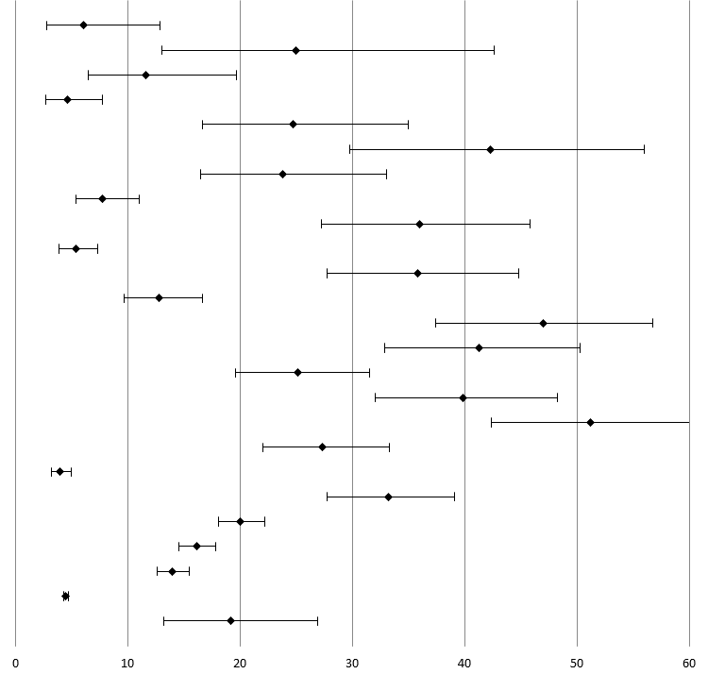
Lewis, (2006) | 6.06 | 2.75 | 12.84 | 6 / 99 | 3.76
Fitton, (2018) | 25.00 | 13.02 | 42.59 | 8 / 32 | 3.79
Koenig, (1995) | 11.58 | 6.53 | 19.71 | 11 / 95 | 3.98
O'Sullivan, (2007) | 4.61 | 2.70 | 7.78 | 13 / 282 | 4.05
Majekodunmi,(2017) | 24.71 | 16.70 | 34.94 | 21 / 85 | 4.11
Coid, (2002) | 42.31 | 29.73 | 55.97 | 22 / 52 | 4.06
Humphreys (2018) | 23.76 | 16.47 | 33.01 | 24 / 101 | 4.13
Caverley (2006) | 7.78 | 5.42 | 11.03 | 28 / 360 | 4.19
Rodriguez (2017) | 36.00 | 27.22 | 45.83 | 36 / 100 | 4.17
Regan (2002) | 5.37 | 3.89 | 7.35 | 36 / 671 | 4.22
Williams (2006) | 35.83 | 27.77 | 44.78 | 43 / 120 | 4.20
Williams (2010a) | 12.78 | 9.71 | 16.64 | 46 / 360 | 4.24
O'Hara (2016) | 47.00 | 37.45 | 56.77 | 47 / 100 | 4.18
Kingston (2011) | 41.32 | 32.90 | 50.28 | 50 / 121 | 4.21
Fazel (2001a) | 25.12 | 19.64 | 31.54 | 51 / 203 | 4.23
Combalbertl, (2016) | 39.86 | 32.03 | 48.23 | 55 / 138 | 4.22
Murdoch(2008) | 51.24 | 42.39 | 60.01 | 62 / 121 | 4.21
Greene (2018) | 27.31 | 22.03 | 33.32 | 65 / 238 | 4.25
Brown. (2003) | 4.01 | 3.21 | 5.00 | 75 / 1871 | 4.28
Hayes (2012) | 33.21 | 27.77 | 39.13 | 87 / 262 | 4.27
Al-Rousan (2017) | 20.04 | 18.07 | 22.17 | 294 / 1467 | 4.31
Stoliker (2017) | 16.15 | 14.57 | 17.87 | 308 / 1907 | 4.31
Gates (2018) | 14.01 | 12.64 | 15.50 | 318 / 2270 | 4.31
Baillargeon (2009) | 4.50 | 4.28 | 4.74 | 1396/ 31013 | 4.32
Overall: I² = 98.98% | 19.17 | 13.23 | 26.94
Table C.1 Meta-analysis of the prevalence of Depression

First Author | Rate | Lower | Upper | Events/total | Weight | 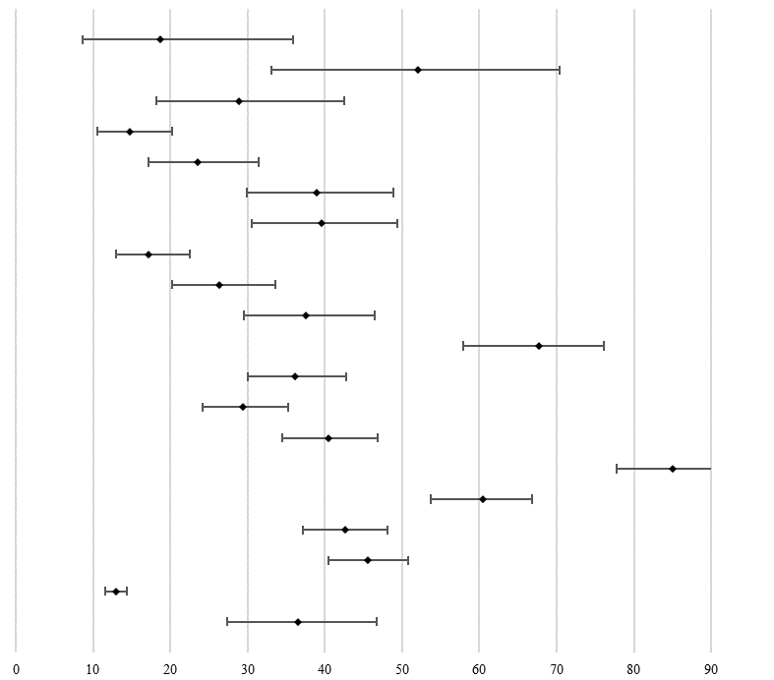
Fitton (2018) | 18.75 | 8.67 | 35.92 | 6 / 32 | 4.46
Putkonen (2010). | 52.00 | 33.08 | 70.36 | 13 / 25 | 4.66
Coid (2002). | 28.85 | 18.20 | 42.48 | 15 / 52 | 5.00
Fazel (2002). | 14.76 | 10.58 | 20.23 | 31 / 210 | 5.31
Moschetti (2015) | 23.53 | 17.15 | 31.38 | 32 / 136 | 5.30
Rodriguez (2017). | 39.00 | 29.96 | 48.86 | 39 / 100 | 5.29
Humphreys (2018) | 39.60 | 30.56 | 49.42 | 40 / 101 | 5.29
Greene (2018). | 17.23 | 12.94 | 22.56 | 41 / 238 | 5.36
De Smet (2016). | 26.35 | 20.23 | 33.54 | 44 / 167 | 5.36
Bolano (2016). | 37.60 | 29.56 | 46.39 | 47 / 125 | 5.34
Lewis (2006). | 67.68 | 57.88 | 76.14 | 67 / 99 | 5.26
Davoren (2015). | 36.15 | 29.98 | 42.82 | 77 / 213 | 5.42
Hayes (2012). | 29.39 | 24.19 | 35.19 | 77 / 262 | 5.43
Flatt (2017). | 40.51 | 34.44 | 46.88 | 96 / 237 | 5.44
Arndt, (2002). | 85.04 | 77.73 | 90.25 | 108 / 127 | 5.17
Williams (2014) | 60.48 | 53.71 | 66.86 | 127 / 210 | 5.42
Ahalt (2018) | 42.58 | 37.19 | 48.15 | 132 / 310 | 5.47
Williams (2010a) | 45.56 | 40.48 | 50.73 | 164 / 360 | 5.48
Gates (2018). | 12.91 | 11.59 | 14.35 | 293 / 2270 | 5.53
Overall: I² = 97.32% | 36.50 | 27.33 | 46.75
Table C.2. Meta-analysis of the prevalence of Alcohol Abuse

First Author | Rate | Lower | Upper | Events/total | Weight | 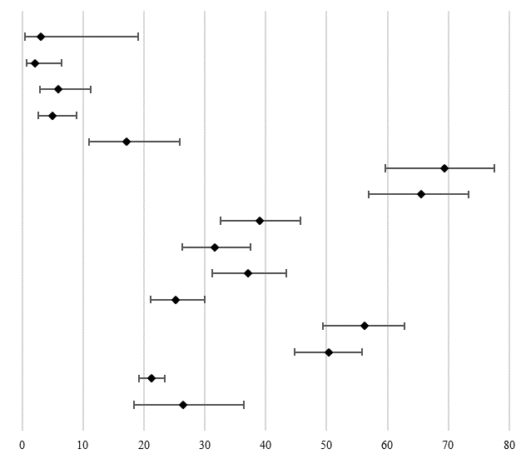
Fitton (2018) | 3.12 | 0.44 | 19.11 | 1 / 32 | 3.27
Combalbert, (2016) | 2.17 | 0.70 | 6.52 | 3 / 138 | 5.43
Moschetti (2015) | 5.88 | 2.97 | 11.32 | 8 / 136 | 6.77
Fazel (2001a) | 4.93 | 2.67 | 8.91 | 10 / 203 | 7.00
Lewis (2006) | 17.17 | 10.95 | 25.90 | 17 / 99 | 7.30
Humphreys (2018) | 69.31 | 59.67 | 77.51 | 70 / 101 | 7.54
Bolano (2016) | 65.60 | 56.87 | 73.39 | 82 / 125 | 7.65
Davoren (2015) | 38.97 | 32.65 | 45.68 | 83 / 213 | 7.81
Hayes (2012) | 31.68 | 26.33 | 37.56 | 83 / 262 | 7.84
Flatt (2017) | 37.13 | 31.21 | 43.46 | 88 / 237 | 7.83
Williams (2010a) | 25.28 | 21.06 | 30.02 | 91 / 360 | 7.87
Williams (2014) | 56.19 | 49.41 | 62.75 | 118 / 210 | 7.82
Ahalt (2018) | 50.32 | 44.78 | 55.86 | 156 / 310 | 7.89
Al-Rousan (2017) | 21.27 | 19.25 | 23.44 | 312 / 1467 | 7.99
Overall: I² = 96.88% | 26.43 | 18.36 | 36.46
Table C.3. Meta-analysis of the prevalence of Substance Abuse

First Author | Rate | Lower | Upper | Events/total | Weight | 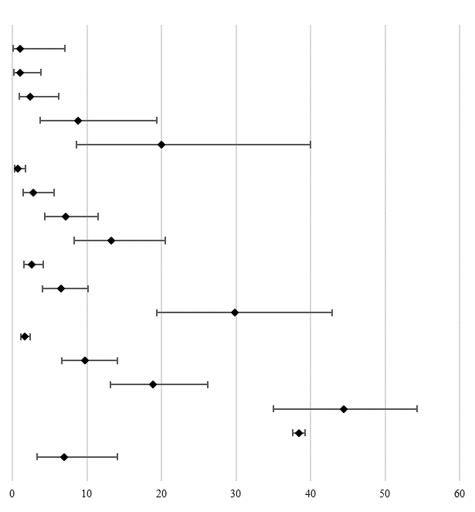
Koenig, (1995) | 1.05 | 0.15 | 7.09 | 1 / 95 | 4.49
Fazel (2001-a) | 0.99 | 0.25 | 3.85 | 2 / 203 | 5.23
De Smet, (2016) | 2.40 | 0.90 | 6.21 | 4 / 167 | 5.69
McKinnon, (2017) | 8.77 | 3.70 | 19.40 | 5 / 57 | 5.77
Putkonen, (2010) | 20.00 | 8.58 | 39.98 | 5 /25 | 5.71
Regan, (2002) | 0.75 | 0.31 | 1.78 | 5 / 671 | 5.81
O'Sullivan, (2007) | 2.84 | 1.42 | 5.57 | 8 / 282 | 5.96
Fazel, (2002) | 7.14 | 4.35 | 11.51 | 15 / 210 | 6.09
Kingston, (2011) | 13.22 | 8.26 | 20.50 | 16 / 121 | 6.09
Williams, (2009) | 2.59 | 1.59 | 4.18 | 16 / 618 | 6.11
Hayes, (2012) | 6.49 | 4.07 | 10.19 | 17 / 262 | 6.11
Heinik, (1994) | 29.82 | 19.42 | 42.84 | 17 / 57 | 6.06
Al-Rousan, (2017) | 1.64 | 1.10 | 2.43 | 24 / 1467 | 6.16
Chodos,(2014) | 9.72 | 6.60 | 14.09 | 24 / 247 | 6.15
Combalbert, (2016) | 18.84 | 13.16 | 26.24 | 26 / 138 | 6.15
Lewis, (2006) | 44.44 | 34.99 | 54.32 | 44 / 99 | 6.16
Williams (2010) | 38.39 | 37.56 | 39.22 | 5035/13117 | 6.26
Overall: I² = 98.33% | 6.95 | 3.29 | 14.07
Table C.4. Meta-analysis of the prevalence of Dementia

First Author | Rate | Lower | Upper | Events/total | Weight | 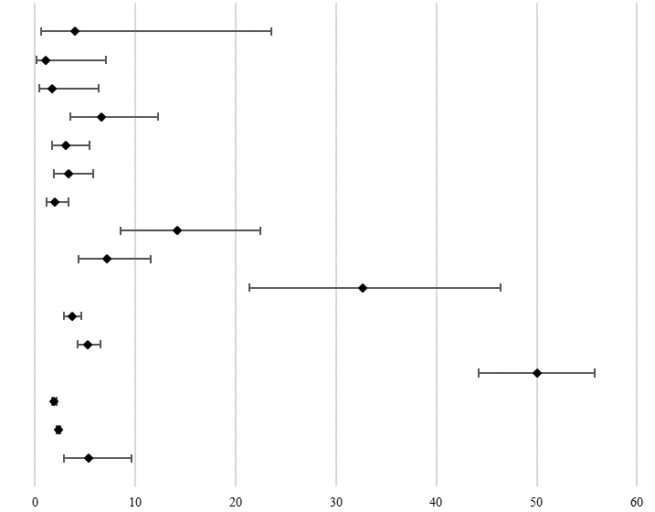
Putkonen, (2010) | 4.00 | 0.56 | 23.55 | 5/25 | 4.30
Koenig, (1995) | 1.05 | 0.15 | 7.09 | 1 / 95 | 4.36
Kingston, (2011) | 1.65 | 0.41 | 6.37 | 2 / 121 | 5.48
Moschetti, (2015) | 6.62 | 3.48 | 12.23 | 9 / 136 | 6.86
Williams (2010a) | 3.06 | 1.70 | 5.43 | 11 / 360 | 6.97
Caverley, (2006) | 3.33 | 1.90 | 5.78 | 12 / 360 | 7.01
Regan, (2002) | 1.94 | 1.13 | 3.31 | 13 / 671 | 7.04
Lewis,(2006) | 14.14 | 8.56 | 22.47 | 14 / 99 | 7.02
Fazel, (2002) | 7.14 | 4.35 | 11.51 | 15 / 210 | 7.07
Coid, (2002) | 32.69 | 21.39 | 46.44 | 17 / 52 | 7.00
Stoliker, (2017) | 3.67 | 2.91 | 4.61 | 70 / 1907 | 7.35
Al-Rousan, (2017) | 5.25 | 4.22 | 6.51 | 77 / 1467 | 7.36
O'Sullivan,(2007) | 50.00 | 44.19 | 55.81 | 141 / 282 | 7.35
Baillargeon, (2000) | 1.87 | 1.65 | 2.11 | 243 / 13027 | 7.41
Baillargeon, (2009) | 2.30 | 2.14 | 2.47 | 713 / 31013 | 7.42
Overall: I² = 98.75% | 5.33 | 2.89 | 9.64
Table C.5. Meta-analysis of the prevalence of Schizophrenia

First Author | Rate | Lower | Upper | Events/total | Weight | 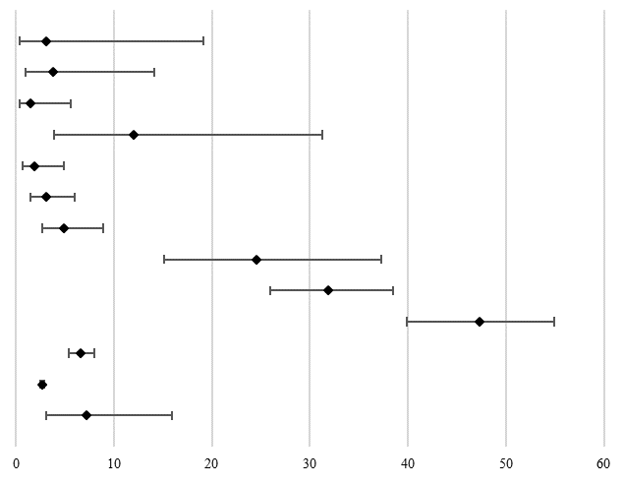
Fitton, (2018) | 3.12 | 0.44 | 19.11 | 1 / 32 | 6.31
Coid, (2002) | 3.85 | 0.96 | 14.12 | 2 / 52 | 7.46
Combalbert, (2016) | 1.45 | 0.36 | 5.61 | 2 / 138 | 7.50
Putkonen, (2010) | 12.00 | 3.92 | 31.30 | 5/25 | 7.86
Davoren, (2015) | 1.88 | 0.71 | 4.90 | 4 / 213 | 8.24
Hayes, (2012) | 3.05 | 1.53 | 5.99 | 8 / 262 | 8.67
Fazel (2001a) | 4.93 | 2.67 | 8.91 | 10 / 203 | 8.76
Heinik, (1994) | 24.56 | 15.12 | 37.31 | 14 / 57 | 8.79
Fazel, (2002) | 31.90 | 25.95 | 38.51 | 67 / 210 | 9.07
De Smet, (2016) | 47.31 | 39.85 | 54.88 | 79 / 167 | 9.06
Al-Rousan, (2017) | 6.61 | 5.45 | 8.00 | 97 / 1467 | 9.11
Baillargeon, (2009) | 2.70 | 2.52 | 2.89 | 837 / 31013 | 9.15
Overall: I² = 98.74% | 7.16 | 3.05 | 15.92
Table C.6. Meta-analysis of the prevalence of Psychotic Disorders

First Author | Rate | Lower | Upper | Events/total | Weight | 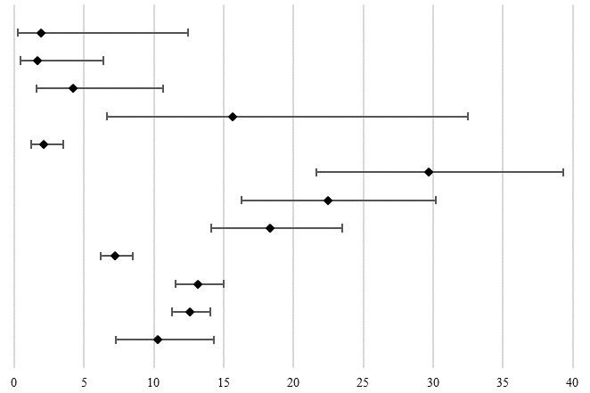
Coid, (2002) | 1.92 | 0.27 | 12.43 | 1 / 52 | 2.82
Kingston, (2011) | 1.65 | 0.41 | 6.37 | 2 / 121 | 4.60
Koenig, (1995) | 4.21 | 1.59 | 10.69 | 4 / 95 | 6.62
Fitton, (2018) | 15.63 | 6.66 | 32.47 | 5 / 32 | 6.91
Regan, (2002) | 2.09 | 1.24 | 3.49 | 14 / 671 | 9.93
Humphreys, (2018) | 29.70 | 21.61 | 39.30 | 30 / 101 | 10.65
Combalbert, (2016) | 22.46 | 16.27 | 30.17 | 31 / 138 | 10.83
Hayes, (2012) | 18.32 | 14.09 | 23.47 | 48 / 262 | 11.37
Stoliker, (2017) | 7.24 | 6.16 | 8.49 | 138 / 1907 | 12.01
Al-Rousan, (2017) | 13.16 | 11.52 | 14.98 | 193 / 1467 | 12.08
Gates, (2018) | 12.60 | 11.30 | 14.03 | 286 / 2270 | 12.16
Overall: I² = 93.65% | 10.24 | 7.25 | 14.28
Table C.7. Meta-analysis of the prevalence of Anxiety Disorders

First Author | Rate | Lower | Upper | Events/total | Weight | 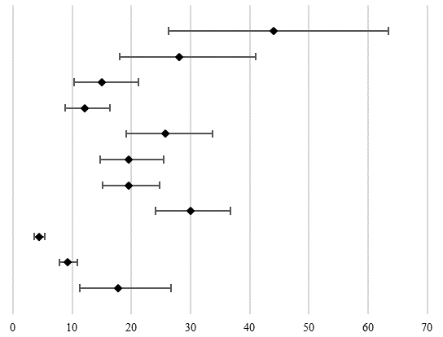
Putkonen, (2010). | 44.00 | 26.29 | 63.38 | 11/25 | 8.59
Heinik, (1994) | 28.07 | 17.96 | 41.02 | 16 / 57 | 9.44
De Smet, (2016) | 14.97 | 10.32 | 21.22 | 25 / 167 | 9.96
O'Sullivan, (2007) | 12.06 | 8.74 | 16.40 | 34 / 282 | 10.15
Moschetti, (2015) | 25.74 | 19.09 | 33.73 | 35 / 136 | 10.08
Fazel, (2002) | 19.52 | 14.71 | 25.44 | 41 / 210 | 10.20
Hayes, (2012) | 19.47 | 15.11 | 24.71 | 51 / 262 | 10.29
Fazel (2001a) | 30.05 | 24.14 | 36.70 | 61 / 203 | 10.30
Stoliker, (2017) | 4.35 | 3.52 | 5.37 | 83 / 1907 | 10.46
Al-Rousan, (2017) | 9.20 | 7.83 | 10.79 | 135 / 1467 | 10.53
Overall: I² = 96.27% | 17.76 | 11.32 | 26.74
Table C.8. Meta-analysis of the prevalence of Personality Disorders.

First Author | Rate | Lower | Upper | Events/total | Weight | 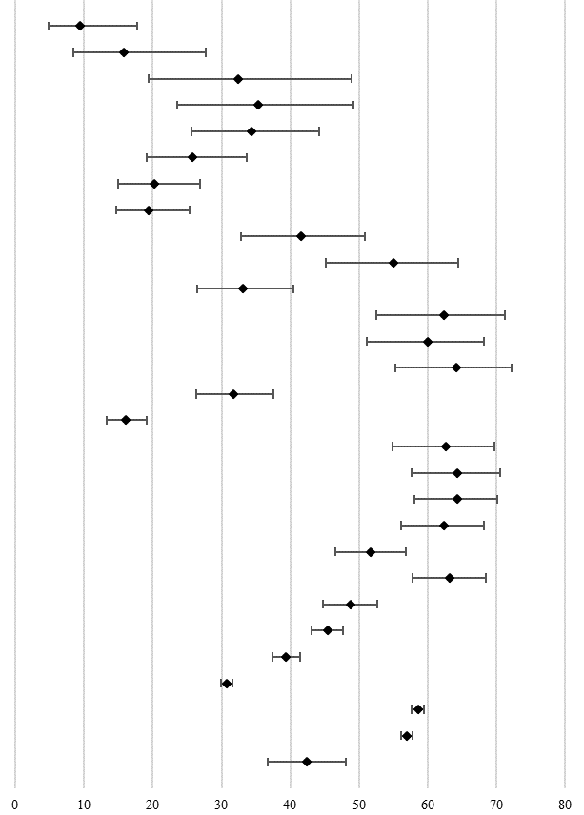
Majekodunmi (2017) | 9.41 | 4.78 | 17.71 | 8 / 85 | 2.82
McKinnon (2017) | 15.79 | 8.43 | 27.65 | 9 / 57 | 2.85
D'Souza (2005) | 32.43 | 19.43 | 48.86 | 12 / 37 | 2.90
Loeb, (2006) | 35.29 | 23.50 | 49.20 | 18 / 51 | 3.14
Lewis, (2006) | 34.34 | 25.68 | 44.20 | 34 / 99 | 3.46
Moschetti, (2015) | 25.74 | 19.09 | 33.73 | 35 / 136 | 3.52
De Smet, (2016) | 20.23 | 14.90 | 26.88 | 35 / 173 | 3.54
Beaufrère, (2015) | 19.43 | 14.64 | 25.33 | 41 / 211 | 3.59
Meyer, (2016) | 41.59 | 32.88 | 50.86 | 47 / 113 | 3.53
Rodriguez (2017) | 55.00 | 45.18 | 64.44 | 55 / 100 | 3.50
Beaufrère, (2014) | 33.14 | 26.52 | 40.51 | 57 / 172 | 3.63
Humphreys (2018) | 62.38 | 52.57 | 71.26 | 63 / 101 | 3.48
Bolano, (2016) | 60.00 | 51.19 | 68.21 | 75 / 125 | 3.56
Williams (2006). | 64.17 | 55.22 | 72.23 | 77 / 120 | 3.54
Hayes, (2012). | 31.68 | 26.33 | 37.56 | 83 / 262 | 3.71
Maschi, (2017). | 16.00 | 13.33 | 19.09 | 100 / 625 | 3.77
Merten, (2012). | 62.58 | 54.91 | 69.66 | 102 / 163 | 3.63
Williams, (2014) | 64.29 | 57.58 | 70.48 | 135 / 210 | 3.68
Greene (2018) | 64.29 | 58.00 | 70.12 | 153 / 238 | 3.70
Chodos, (2014). | 62.35 | 56.14 | 68.17 | 154 / 247 | 3.71
Williams (2010a) | 51.67 | 46.51 | 56.79 | 186 / 360 | 3.77
Ahalt, (2018) | 63.23 | 57.71 | 68.41 | 196 / 310 | 3.75
Williams,(2009) | 48.71 | 44.78 | 52.65 | 301 / 618 | 3.82
Binswanger, (2009) | 45.41 | 43.12 | 47.73 | 812 / 1788 | 3.87
Gates, (2018) | 39.38 | 37.39 | 41.41 | 894 / 2270 | 3.87
Baillargeon, (2000) | 30.77 | 29.99 | 31.57 | 4009 / 13027 | 3.89
Williams (2010) | 58.55 | 57.70 | 59.39 | 7680 / 13117 | 3.89
Harzke, (2010) | 57.01 | 56.18 | 57.84 | 7739 / 13574 | 3.89
Overall: I² = 99.14% | 42.33 | 36.77 | 48.09
Table C.9 Meta-analysis of the prevalence of Hypertension.

First Author | Rate | Lower | Upper | Events/total | Weight | 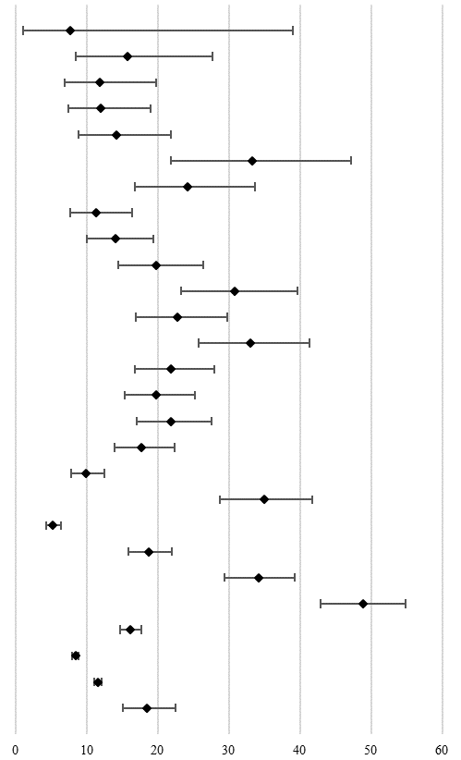
Handtke, (2015) | 7.69 | 1.07 | 39.06 | 1 / 13 | 1.09
McKinnon, (2017) | 15.79 | 8.43 | 27.65 | 9 / 57 | 3.18
Humphreys (2018) | 11.88 | 6.87 | 19.77 | 12 / 101 | 3.44
Bolano, (2016) | 12.00 | 7.37 | 18.95 | 15 / 125 | 3.59
Meyer,(2016) | 14.16 | 8.86 | 21.87 | 16 / 113 | 3.62
Loeb, (2006) | 33.33 | 21.83 | 47.23 | 17 / 51 | 3.49
Lewis, (2006) | 24.24 | 16.81 | 33.63 | 24 / 99 | 3.77
Beaufrère, (2015) | 11.37 | 7.74 | 16.41 | 24 / 211 | 3.84
Davoren, (2015) | 14.08 | 10.03 | 19.43 | 30 / 213 | 3.92
Beaufrère, (2014) | 19.77 | 14.48 | 26.39 | 34 / 172 | 3.94
Williams, (2006) | 30.83 | 23.23 | 39.64 | 37 / 120 | 3.92
Merten, (2012) | 22.70 | 16.91 | 29.76 | 37 / 163 | 3.96
Moschetti, (2015) | 33.09 | 25.70 | 41.41 | 45 / 136 | 3.98
Williams, (2014) | 21.90 | 16.82 | 28.00 | 46 / 210 | 4.03
Chodos, (2014) | 19.84 | 15.33 | 25.28 | 49 / 247 | 4.06
Greene, (2018) | 21.85 | 17.05 | 27.55 | 52 / 238 | 4.07
Ahalt, (2018) | 17.74 | 13.88 | 22.40 | 55 / 310 | 4.09
Maschi, (2017) | 9.92 | 7.81 | 12.52 | 62 / 625 | 4.14
Fazel (2001) | 34.98 | 28.73 | 41.78 | 71 / 203 | 4.10
Binswanger, (2009) | 5.20 | 4.26 | 6.33 | 93 / 1788 | 4.21
Williams, (2009) | 18.77 | 15.88 | 22.04 | 116 / 618 | 4.22
Williams (2010-a) | 34.17 | 29.45 | 39.22 | 123 / 360 | 4.20
Hayes, (2012) | 48.85 | 42.85 | 54.89 | 128 / 262 | 4.17
Gates, (2018) | 16.17 | 14.71 | 17.74 | 367 / 2270 | 4.30
Baillargeon, (2000) | 8.42 | 7.96 | 8.91 | 1097 / 13027 | 4.33
Williams (2010) | 11.59 | 11.05 | 12.15 | 1520 / 13117 | 4.33
Overall: I² = 97.44% | 18.52 | 15.09 | 22.52
Table C.10. Meta-analysis of the prevalence of Cardiovascular Diseases

First Author | Rate | Lower | Upper | Events/total | Weight | 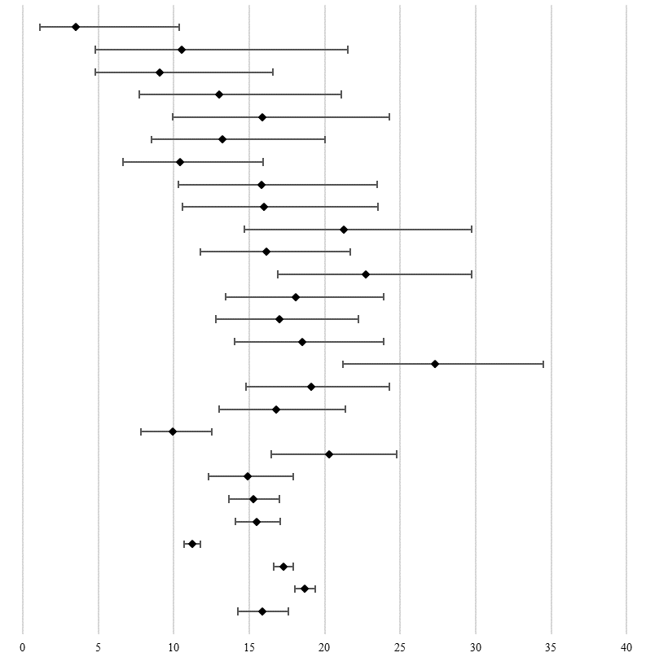
Majekodunmi, (2017). | 3.53 | 1.14 | 10.38 | 3 / 85 | 0.98
McKinnon, (2017). | 10.53 | 4.81 | 21.52 | 6 / 57 | 1.59
Lewis, (2006). | 9.09 | 4.80 | 16.56 | 9 / 99 | 2.11
Rodriguez, (2017) | 13.00 | 7.70 | 21.11 | 13 / 100 | 2.56
Humphreys (2018) | 15.84 | 9.94 | 24.31 | 16 / 101 | 2.81
Moschetti, (2015) | 13.24 | 8.50 | 20.03 | 18 / 136 | 3.02
De Smet, (2016) | 10.40 | 6.65 | 15.91 | 18 / 173 | 3.07
Williams, (2006) | 15.83 | 10.33 | 23.50 | 19 / 120 | 3.05
Bolano, (2016) | 16.00 | 10.56 | 23.50 | 20 / 125 | 3.12
Meyer, (2016) | 21.24 | 14.66 | 29.74 | 24 / 113 | 3.29
Beaufrère, (2015) | 16.11 | 11.75 | 21.71 | 34 / 211 | 3.84
Merten, (2012). | 22.70 | 16.91 | 29.76 | 37 / 163 | 3.84
Williams, (2014) | 18.10 | 13.46 | 23.89 | 38 / 210 | 3.95
Chodos, (2014) | 17.00 | 12.82 | 22.21 | 42 / 247 | 4.08
Greene, (2018) | 18.49 | 14.05 | 23.93 | 44 / 238 | 4.12
Beaufrère, (2014) | 27.33 | 21.19 | 34.46 | 47 / 172 | 4.06
Hayes, (2012). | 19.08 | 14.77 | 24.30 | 50 / 262 | 4.25
Ahalt, (2018) | 16.77 | 13.01 | 21.35 | 52 / 310 | 4.32
Maschi, (2017) | 9.92 | 7.81 | 12.52 | 62 / 625 | 4.58
Williams (2010a) | 20.28 | 16.44 | 24.75 | 73 / 360 | 4.61
Williams, (2009) | 14.89 | 12.29 | 17.92 | 92 / 618 | 4.85
Binswanger, (2009). | 15.27 | 13.67 | 17.01 | 273 / 1788 | 5.39
Gates, (2018). | 15.51 | 14.08 | 17.05 | 352 / 2270 | 5.46
Baillargeon, (2000) | 11.22 | 10.69 | 11.78 | 1462 / 13027 | 5.66
Harzke, (2010) | 17.25 | 16.63 | 17.90 | 2342 / 13574 | 5.68
Williams (2010) | 18.67 | 18.01 | 19.35 | 2449 / 13117 | 5.68
Overall: I² = 93.27% | 15.85 | 14.25 | 17.60
Table C.11. Meta-analysis of the prevalence of Diabetes

First Author | Rate | Lower | Upper | Events/total | Weight | 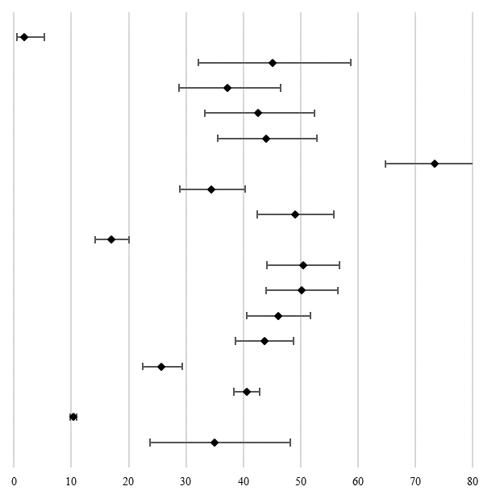
Beaufrère, (2014) | 1.74 | 0.56 | 5.27 | 3 / 172 | 5.04
Loeb, (2006) | 45.10 | 32.12 | 58.78 | 23 / 51 | 6.06
Meyer, (2016) | 37.17 | 28.77 | 46.42 | 42 / 113 | 6.26
Humphreys, (2018) | 42.57 | 33.32 | 52.38 | 43 / 101 | 6.24
Bolano, (2016) | 44.00 | 35.56 | 52.80 | 55 / 125 | 6.28
Williams, (2006) | 73.33 | 64.73 | 80.47 | 88 / 120 | 6.23
Hayes, (2012) | 34.35 | 28.85 | 40.31 | 90 / 262 | 6.36
Williams, (2014) | 49.05 | 42.34 | 55.79 | 103 / 210 | 6.35
Maschi, (2017) | 16.96 | 14.22 | 20.11 | 106 / 625 | 6.39
Greene, (2018) | 50.42 | 44.10 | 56.73 | 120 / 238 | 6.36
Chodos, (2014) | 50.20 | 44.00 | 56.40 | 124 / 247 | 6.37
Ahalt, (2018) | 46.13 | 40.65 | 51.70 | 143 / 310 | 6.38
Williams (2010a) | 43.61 | 38.57 | 48.78 | 157 / 360 | 6.39
Williams, (2009) | 25.73 | 22.43 | 29.32 | 159 / 618 | 6.41
Binswanger,(2009). | 40.55 | 38.29 | 42.84 | 725 / 1788 | 6.44
Baillargeon, (2000) | 10.38 | 9.87 | 10.91 | 1352 / 13027 | 6.45
Overall: I² = 99.25% | 34.97 | 23.71 | 48.21
Table C.12. Meta-analysis of the prevalence of Arthritis, Rheumatism or Osteoporosis (ARO)

First Author | Rate | Lower | Upper | Events/total | Weight | 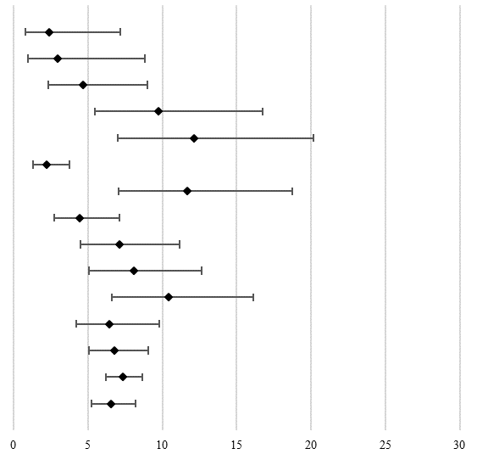
Bolano, (2016) | 2.40 | 0.78 | 7.18 | 3 / 125 | 3.16
Humphreys, (2018) | 2.97 | 0.96 | 8.81 | 3 / 101 | 3.14
Beaufrère, (2014) | 4.65 | 2.34 | 9.02 | 8 / 172 | 5.75
Meyer, (2016) | 9.73 | 5.47 | 16.73 | 11 / 113 | 6.52
Lewis, (2006) | 12.12 | 7.01 | 20.14 | 12 / 99 | 6.70
Maschi, (2017) | 2.24 | 1.33 | 3.75 | 14 / 625 | 7.43
Williams (2006) | 11.67 | 7.03 | 18.74 | 14 / 120 | 7.15
Williams (2010a) | 4.44 | 2.74 | 7.13 | 16 / 360 | 7.73
Greene, (2018) | 7.14 | 4.49 | 11.19 | 17 / 238 | 7.82
Williams, (2014) | 8.10 | 5.09 | 12.64 | 17 / 210 | 7.79
Merten, (2012) | 10.43 | 6.58 | 16.14 | 17 / 163 | 7.72
Ahalt, (2018) | 6.45 | 4.20 | 9.79 | 20 / 310 | 8.25
Williams, (2009) | 6.80 | 5.06 | 9.07 | 42 / 618 | 9.78
Binswanger, (2009) | 7.33 | 6.21 | 8.63 | 131 / 1788 | 11.04
Overall: I² = 69.87% | 6.57 | 5.26 | 8.20
Table C.13. Meta-analysis of the prevalence of Cancer

First Author | Rate | Lower | Upper | Events/total | Weight | 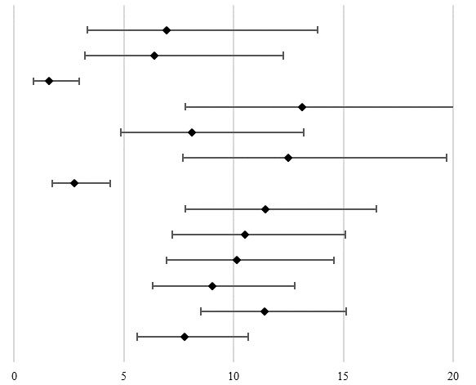
Humphreys (2018) | 6.93 | 3.34 | 13.83 | 7 / 101 | 6.84
Bolano, (2016) | 6.40 | 3.23 | 12.28 | 8 / 125 | 7.15
Maschi, (2017) | 1.60 | 0.86 | 2.95 | 10 / 625 | 7.71
Lewis, (2006) | 13.13 | 7.78 | 21.31 | 13 / 99 | 7.97
De Smet, (2016) | 8.09 | 4.85 | 13.20 | 14 / 173 | 8.19
Williams, (2006) | 12.50 | 7.68 | 19.70 | 15 / 120 | 8.22
Williams, (2009) | 2.75 | 1.72 | 4.38 | 17 / 618 | 8.57
Williams, (2014) | 11.43 | 7.78 | 16.48 | 24 / 210 | 8.90
Greene, (2018) | 10.50 | 7.20 | 15.08 | 25 / 238 | 8.96
Chodos, (2014) | 10.12 | 6.93 | 14.55 | 25 / 247 | 8.96
Ahalt, (2018) | 9.03 | 6.31 | 12.77 | 28 / 310 | 9.10
Williams (2010-a) | 11.39 | 8.50 | 15.10 | 41 / 360 | 9.42
Overall: I² = 83.65% | 7.76 | 5.60 | 10.64
Table C.14. Meta-analysis of the prevalence of Stroke

First Author | Rate | Lower | Upper | Events/total | Weight | 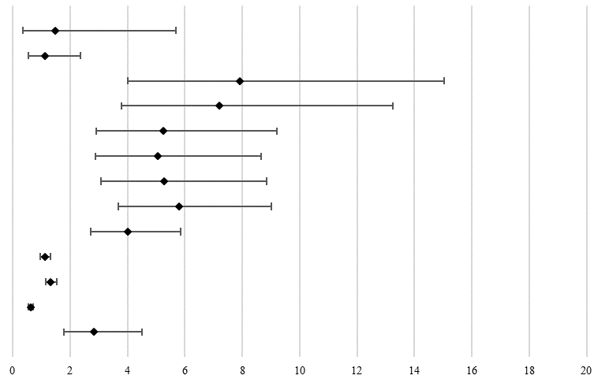
Moschetti, (2015) | 1.47 | 0.37 | 5.69 | 2 / 136 | 5.26
Williams, (2009). | 1.13 | 0.54 | 2.36 | 7 / 618 | 7.75
Humphreys, (2018) | 7.92 | 4.01 | 15.05 | 8 / 101 | 7.84
Bolano, (2016) | 7.20 | 3.79 | 13.26 | 9 / 125 | 8.01
Williams, (2014) | 5.24 | 2.92 | 9.21 | 11 / 210 | 8.27
Greene, (2018) | 5.04 | 2.89 | 8.67 | 12 / 238 | 8.37
Chodos, (2014) | 5.26 | 3.08 | 8.85 | 13 / 247 | 8.45
Ahalt, (2018) | 5.81 | 3.69 | 9.03 | 18 / 310 | 8.72
Maschi, (2017) | 4.00 | 2.72 | 5.85 | 25 / 625 | 8.95
Baillargeon, (2000) | 1.13 | 0.96 | 1.32 | 147 / 13027 | 9.45
Williams (2010) | 1.33 | 1.14 | 1.54 | 174 / 13117 | 9.46
Baillargeon, (2008) | 0.62 | 0.54 | 0.72 | 178 / 28529 | 9.46
Overall: I² = 96.25% | 2.84 | 1.78 | 4.51
Table C.15. Meta-analysis of the prevalence of HIV

First Author | Rate | Lower | Upper | Events/total | Weight | 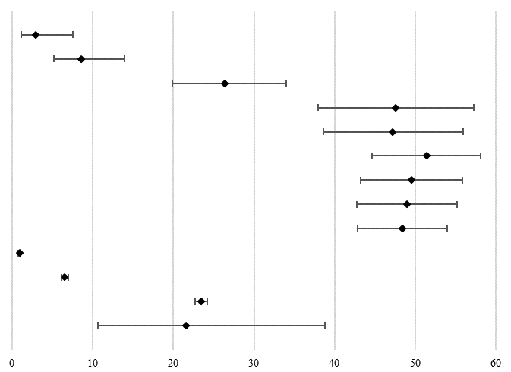
Moschetti, (2015) | 2.94 | 1.11 | 7.57 | 4 / 136 | 7.59
Merten, (2012). | 8.59 | 5.15 | 13.98 | 14 / 163 | 8.19
Macalino, (2004) | 26.35 | 19.89 | 34.03 | 39 / 148 | 8.36
Humphreys, (2018) | 47.52 | 38.00 | 57.23 | 48 / 101 | 8.34
Bolano, (2016) | 47.20 | 38.62 | 55.95 | 59 / 125 | 8.37
Williams, (2014) | 51.43 | 44.68 | 58.12 | 108 / 210 | 8.42
Greene, (2018) | 49.58 | 43.27 | 55.90 | 118 / 238 | 8.43
Chodos, (2014) | 48.99 | 42.80 | 55.21 | 121 / 247 | 8.43
Ahalt, (2018) | 48.39 | 42.87 | 53.95 | 150 / 310 | 8.44
Baillargeon, (2008) | 0.89 | 0.79 | 1.01 | 254 / 28529 | 8.48
Baillargeon, (2000) | 6.54 | 6.13 | 6.98 | 852 / 13027 | 8.49
Williams (2010) | 23.45 | 22.73 | 24.18 | 3076 / 13117 | 8.49
Overall: I² = 99.75% | 21.53 | 10.60 | 38.83
Table C.16. Meta-analysis of the prevalence of Hepatitis B

First Author | Rate | Lower | Upper | Events/total | Weight | 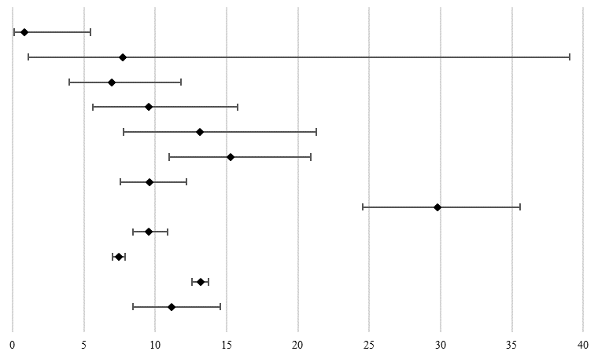
Bolano, (2016) | 0.80 | 0.11 | 5.46 | 1 / 125 | 2.03
Handtke, (2015) | 7.69 | 1.07 | 39.06 | 1/13 | 1.91
De Smet,(2016) | 6.94 | 3.98 | 11.82 | 12 / 173 | 8.56
Moschetti, (2015) | 9.56 | 5.63 | 15.77 | 13 / 136 | 8.69
Lewis, (2006) | 13.13 | 7.78 | 21.31 | 13 / 99 | 8.59
Fazel, (2001) | 15.27 | 10.95 | 20.90 | 31 / 203 | 10.44
Maschi, (2017) | 9.60 | 7.53 | 12.17 | 60 / 625 | 11.40
Hayes, (2012) | 29.77 | 24.54 | 35.59 | 78 / 262 | 11.41
Gates, (2018) | 9.56 | 8.42 | 10.84 | 217 / 2270 | 12.15
Harzke, (2010) | 7.45 | 7.02 | 7.90 | 1011 / 13574 | 12.40
Williams (2010) | 13.16 | 12.59 | 13.75 | 1726 / 13117 | 12.43
Overall: I² = 97.03% | 11.13 | 8.44 | 14.54
Table C.17. Meta-analysis of the prevalence of Respiratory Diseases

First Author | Rate | Lower | Upper | Events/total | Weight | 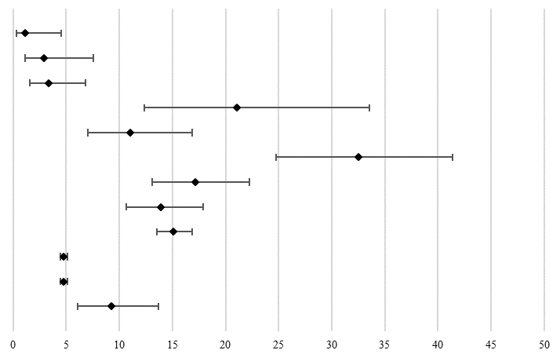
Beaufrère, (2014) | 1.16 | 0.29 | 4.53 | 2 / 172 | 5.19
Moschetti, (2015) | 2.94 | 1.11 | 7.57 | 4 / 136 | 6.93
Beaufrère, (2015) | 3.32 | 1.59 | 6.79 | 7 / 211 | 8.13
McKinnon, (2017) | 21.05 | 12.36 | 33.52 | 12 / 57 | 8.71
Merten, (2012) | 11.04 | 7.07 | 16.85 | 18 / 163 | 9.39
Williams, (2006) | 32.50 | 24.73 | 41.37 | 39 / 120 | 9.83
Hayes, (2012) | 17.18 | 13.08 | 22.23 | 45 / 262 | 10.05
Williams (2010a) | 13.89 | 10.69 | 17.86 | 50 / 360 | 10.12
Binswanger, (2009). | 15.10 | 13.51 | 16.84 | 270 / 1788 | 10.51
Baillargeon, (2000) | 4.78 | 4.43 | 5.16 | 623 / 13027 | 10.57
Harzke, (2010) | 4.78 | 4.43 | 5.15 | 649 / 13574 | 10.57
Overall: I² = 98.14% | 9.22 | 6.11 | 13.69
Table C.18. Meta-analysis of the prevalence of Asthma

Appendix D. Forest-plots with risk ratios for those health outcomes where a comparable estimate for older adults without criminal history was found.
 |  | 95% CI |  | Events/total |  |  | 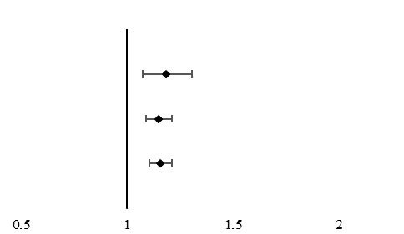
First Author | RR | Lower | Upper | Older offenders | Older adults | Weight
Greene (2018) | 1.18 | 1.07 | 1.30 | 153 / 238 | 3731 / 6871 | 23.24
Binswanger (2009) | 1.15 | 1.09 | 1.21 | 812 / 1788 | 8444 / 21350 | 76.76
Overall, I² = 30.36% | 1.16 | 1.10 | 1.21
Table D.1. Meta-analysis of the risk ratio of Hypertension

 |  | 95% CI |  | Events/total |  |  | 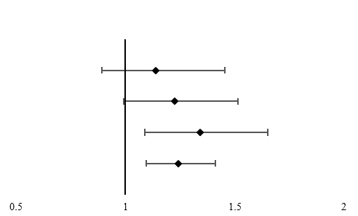
First Author | RR | Lower | Upper | Older offenders | Older adults | Weight
Greene (2018) | 1.14 | 0.89 | 1.45 | 52 / 238 | 1319 / 6871 | 26.93
Fazel (2001) | 1.23 | 0.99 | 1.52 | 72 / 203 | 259 / 895 | 35.98
Binswanger (2009) | 1.34 | 1.09 | 1.65 | 93 / 1788 | 828 / 21350 | 37.09
Overall, I² = 0.00% | 1.24 | 1.09 | 1.41
Table D.2. Meta-analysis of the risk ratio of Cardiovascular Diseases

 |  |  | 95% CI |  | Events/total |  |  | 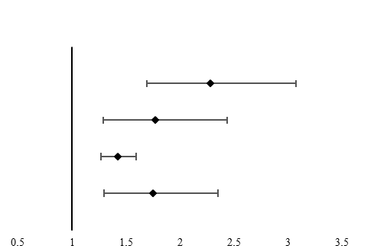
First Author | Health problem | RR | Lower | Upper | Older offenders | Older adults | Weight
Greene (2018) | Chronic Lung Disease | 2.28 | 1.69 | 3.07 | 39 / 238 | 494 / 6871 | 30.23
Fazel (2001) | Respiratory problems | 1.77 | 1.29 | 2.44 | 43 / 203 | 107 / 895 | 29.00
Binswanger (2009) | Asthma | 1.42 | 1.27 | 1.60 | 270 / 1788 | 2268 / 21350 | 40.77
Overall, I² = 78.12% |  | 1.75 | 1.30 | 2.35
Table D.3. Meta-analysis of the risk ratio of Diseases of the respiratory system

 |  | 95% CI |  | Events/total |  |  | 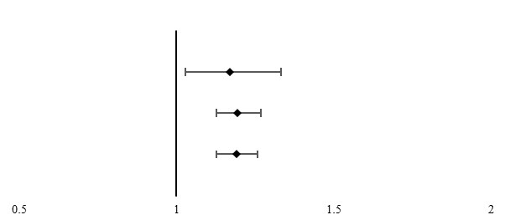
First Author | RR | Lower | Upper | Older offenders | Older adults | Weight
Greene (2018) | 1.17 | 1.03 | 1.33 | 120 / 238 | 2961 / 6871 | 17.41
Binswanger (2009) | 1.19 | 1.13 | 1.27 | 725 / 1788 | 7245 / 21350 | 82.59
Overall, I² = 0.00% | 1.19 | 1.13 | 1.26
Table D.4. Meta-analysis of the risk ratio of Arthritis, Rheumatism or Osteoporosis (ARO)

 |  |  | 95% CI |  | Events/total |  |  | 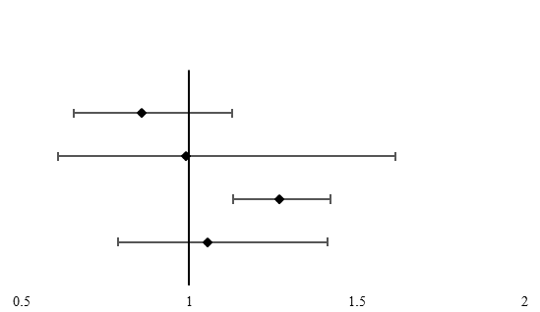
First Author | Health problem | RR | Lower | Upper | Older offenders | Older adults | Weight
Greene (2018) | Diabetes | 0.86 | 0.66 | 1.13 | 44 / 238 | 1477 / 6871 | 34.25
Fazel (2001) | Endocrine problems | 0.99 | 0.61 | 1.62 | 18 / 203 | 80 / 895 | 20.54
Binswanger (2009) | Diabetes | 1.27 | 1.13 | 1.42 | 273 / 1788 | 2570 / 21350 | 45.21
Overall, I² = 72.38% |  | 1.06 | 0.79 | 1.41
Table D.5. Meta-analysis of the risk ratio of Endocrine and Metabolic Disorders

 |  | 95% CI |  | Events/total |  |  | 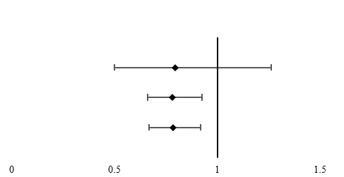
First Author | RR | Lower | Upper | Older offenders | Older adults | Weight
Greene (2018) | 0.79 | 0.50 | 1.26 | 17 / 238 | 618 / 6871 | 11.83
Binswanger (2009) | 0.78 | 0.66 | 0.93 | 131 / 1788 | 2002 / 21350 | 88.17
Overall, I² = 0.00% | 0.78 | 0.67 | 0.92
Table D.6. Meta-analysis of the risk ratio of Cancer.

 |  | 95% CI |  | Events/total |  |  | 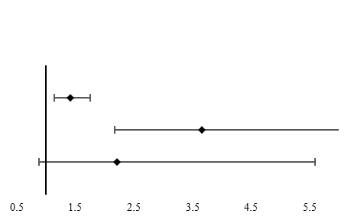
First Author | RR | Lower | Upper | Older offenders | Older adults | Weight
Greene (2018) | 1.42 | 1.15 | 1.76 | 65 / 238 | 1319 / 6871 | 53.27
Combalbert (2016) | 3.67 | 2.18 | 6.17 | 55 / 138 | 15 / 138 | 46.73
Overall, I² = 90.83% | 2.21 | 0.88 | 5.59
Table D.7. Meta-analysis of the risk ratio of Depression.

Appendix E. Meta-regression analyses for Mental and Physical Health outcomes
 |  | Substance Abuse |  | Alcohol Abuse |  | Personality Disorders |  | Depression |  | Schizophrenia |  | Psychotic Disorder
Variablesª | Comparisons ^{b} | β | s.e. (β) | β | s.e. (β) | β | s.e. (β) | Β | s.e. (β) | β | s.e. (β) | β | s.e. (β)
Country | EU v. NA | 1.82*** | 0.57 | - | - | -1.38*** | 0.32 | -1.21*** | 0.34 | -1.42** | 0.53 | - | -
 | EU v. OC | - | - | - | - | 0.36 | 0.51 | -0.07 | 0.62 | - | - | - | -
Diagnostic Assessment | Records v. research Diagnosis | -2.22*** | 0.55 | - | - | - | - | 1.46*** | 0.33 | - | - | - | -
 | Records v. Combination | 1.14** | 0.39 | - | - | - | - | 1.5*** | 0.47 | - | - | - | -
 | Records v. self-report | -0.69 | 0.52 | - | - | - | - | 1.15** | 0.47 | - | - | - | -
Gender | M v. F | - | - | - | - | - | - | 0.25 | 0.76 | - | - | - | -
 | M v. F&M | 1.98** | 0.67 | 0.94** | 0.39 | - | - | -1.3*** | 0.3 | - | - | - | -
Sample Type | Prisoners v. ¹Offenders | - | - | - | - | - | - | - | - | - | - | 2.55*** | 0.59
 | Prisoners v. Forensic Psychiatric Offenders | - | - | - | - | - | - | - | - | 2.12*** | 0.4 | 1.88*** | 0.45
Table E.1. Meta-regression Analyses of sources of heterogeneity in the prevalence of Mental Health Problems. EU= European Countries; NA = North-American Countries; OC = Other Countries; Combination = combination of medical/jail and research diagnosis; M = Males; F = Females; M&F = Males and Females. 1. Older offenders who were under parole, probation sentence, ex-prisoners or the imprisonment status was not mentioned; *** p< 0.001; ** p<0.01; *p<0.05. a. Only variables where the meta-regression showed an effect are presented in the table. b. For comparisons the reference category is given first.
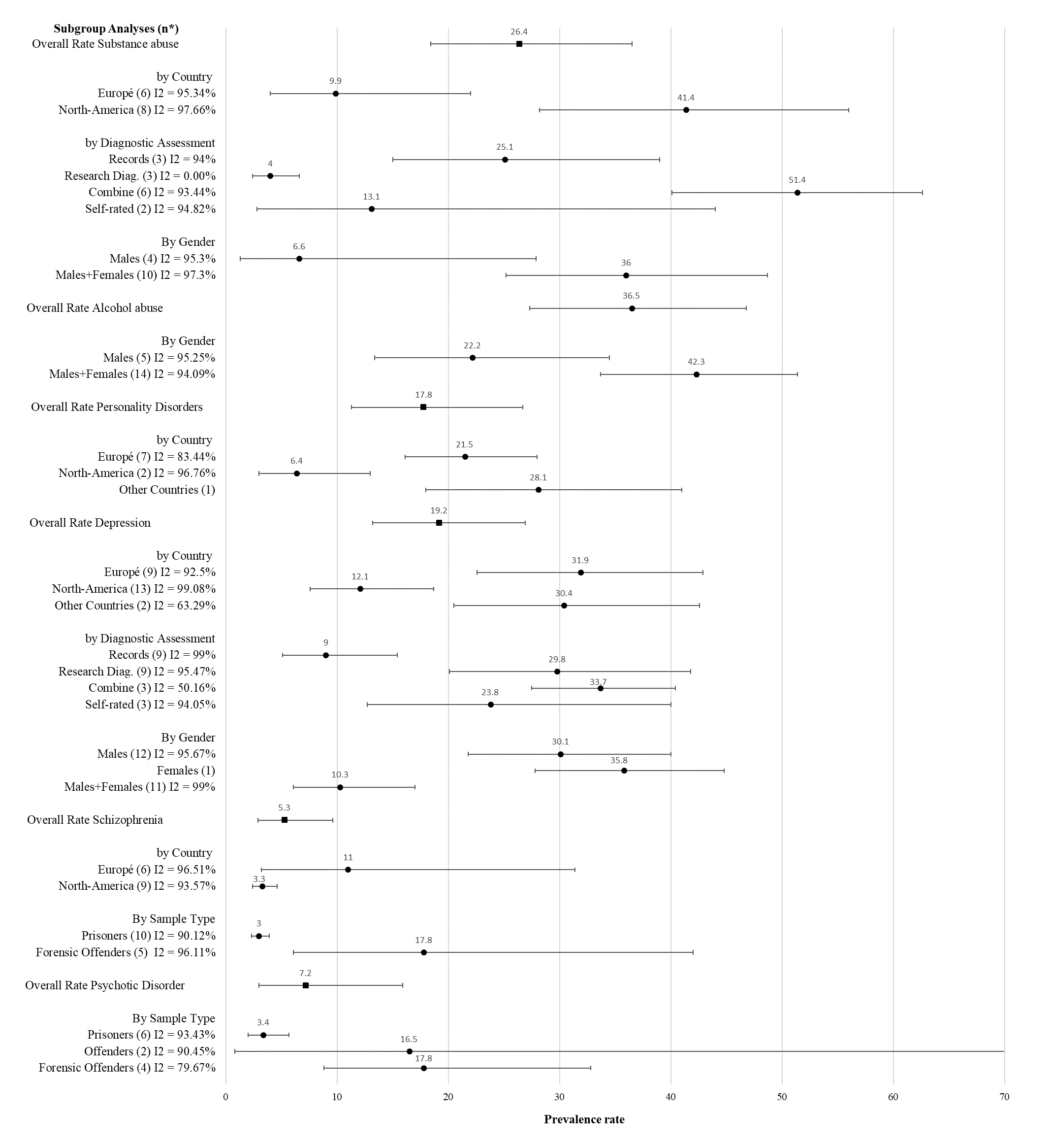
Figure E.1. Overall prevalence of mental health problems and subgroup analyses. Substance abuse: subgroup analyses by country and diagnostic assessment; Alcohol abuse: subgroup analysis by gender; Personality disorders: subgroup analyses by country; Depression: subgroup analyses by country, diagnostic assessment and gender; Schizophrenia: subgroup analyses by county and sample type; Psychotic Disorder: subgroup analyses by sample type. Note: n*= number of studies included in the subgroup analyses of the outcome. I2 = I² . Combine = combination of medical/jail and research diagnosis

 |  | Hypertension |  | Asthma |  | Hepatitis C |  | HIV |  | ARO
Variablesª | Comparisons ^{b} | β | s.e. (β) | β | s.e. (β) | β | s.e. (β) | β | s.e. (β) | Β | s.e. (β)
Country | EU v. NA | 1.05*** | 0.27 | - | - | - | - | - | - | - | -
 | EU v. OC | 0.18 | 0.45 | - | - | - | - | - | - | - | -
Diagnostic Assessment | Records v. research Diagnosis | -0.69 | 0.55 | 1.84*** | 0.47 | 1.94* | 0.87 | - | - | - | -
 | Records v. Combination | 0.83** | 0.31 | 1.59*** | 0.37 | 2.92*** | 0.5 | 1.82*** | 0.2 | 1.92*** | 0.44
 | Records v. self-report | 0.06 | 0.3 | 1.57*** | 0.24 | 0.604 | 0.89 | 1.41*** | 0.32 | 1.77*** | 0.45
Gender | M v. F | - | - | 1.05 | 0.69 | - | - | - | - | - | -
 | M v. F&M | - | - | -0.97* | 0.42 | - | - | - | - | - | -
Sample Type | Prisoners v. ¹Offenders | - | - | - | - | - | - | - | - | -
 | Prisoners v. Forensic Psychiatric Offenders | - | - | - | - | - | - | - | - | -3.58*** | 0.92
Table E.2. Meta-regression Analyses of sources of heterogeneity in the prevalence of Physical Health Problems. EU= European Countries; NA = North-American Countries; OC = Other Countries; Combination = combination of medical/jail and research diagnosis; M = Males; F = Females; M&F = Males and Females; 1. Older offenders who were under parole, probation sentence, ex-prisoners or the imprisonment status was not mentioned. *** p< 0.001; ** p<0.01; *p<0.05. a. Only variables where the meta-regression showed an effect are presented in the table. b. For comparisons the reference category is given first.

Figure E.2. Overall prevalence of physical health outcomes and subgroup analyses. Hypertension: subgroup analyses by country, diagnostic assessment and sample type; Asthma: subgroup analyses by diagnostic assessment and gender; Hepatitis C: subgroup analyses by diagnostic assessment; HIV: subgroup analyses by diagnostic assessment; ARO: subgroup analyses by diagnostic assessment and sample type. Note: n*= number of studies included in the subgroup analyses of the outcome. I2 = I² . Combine = combination of medical/jail and research diagnosis

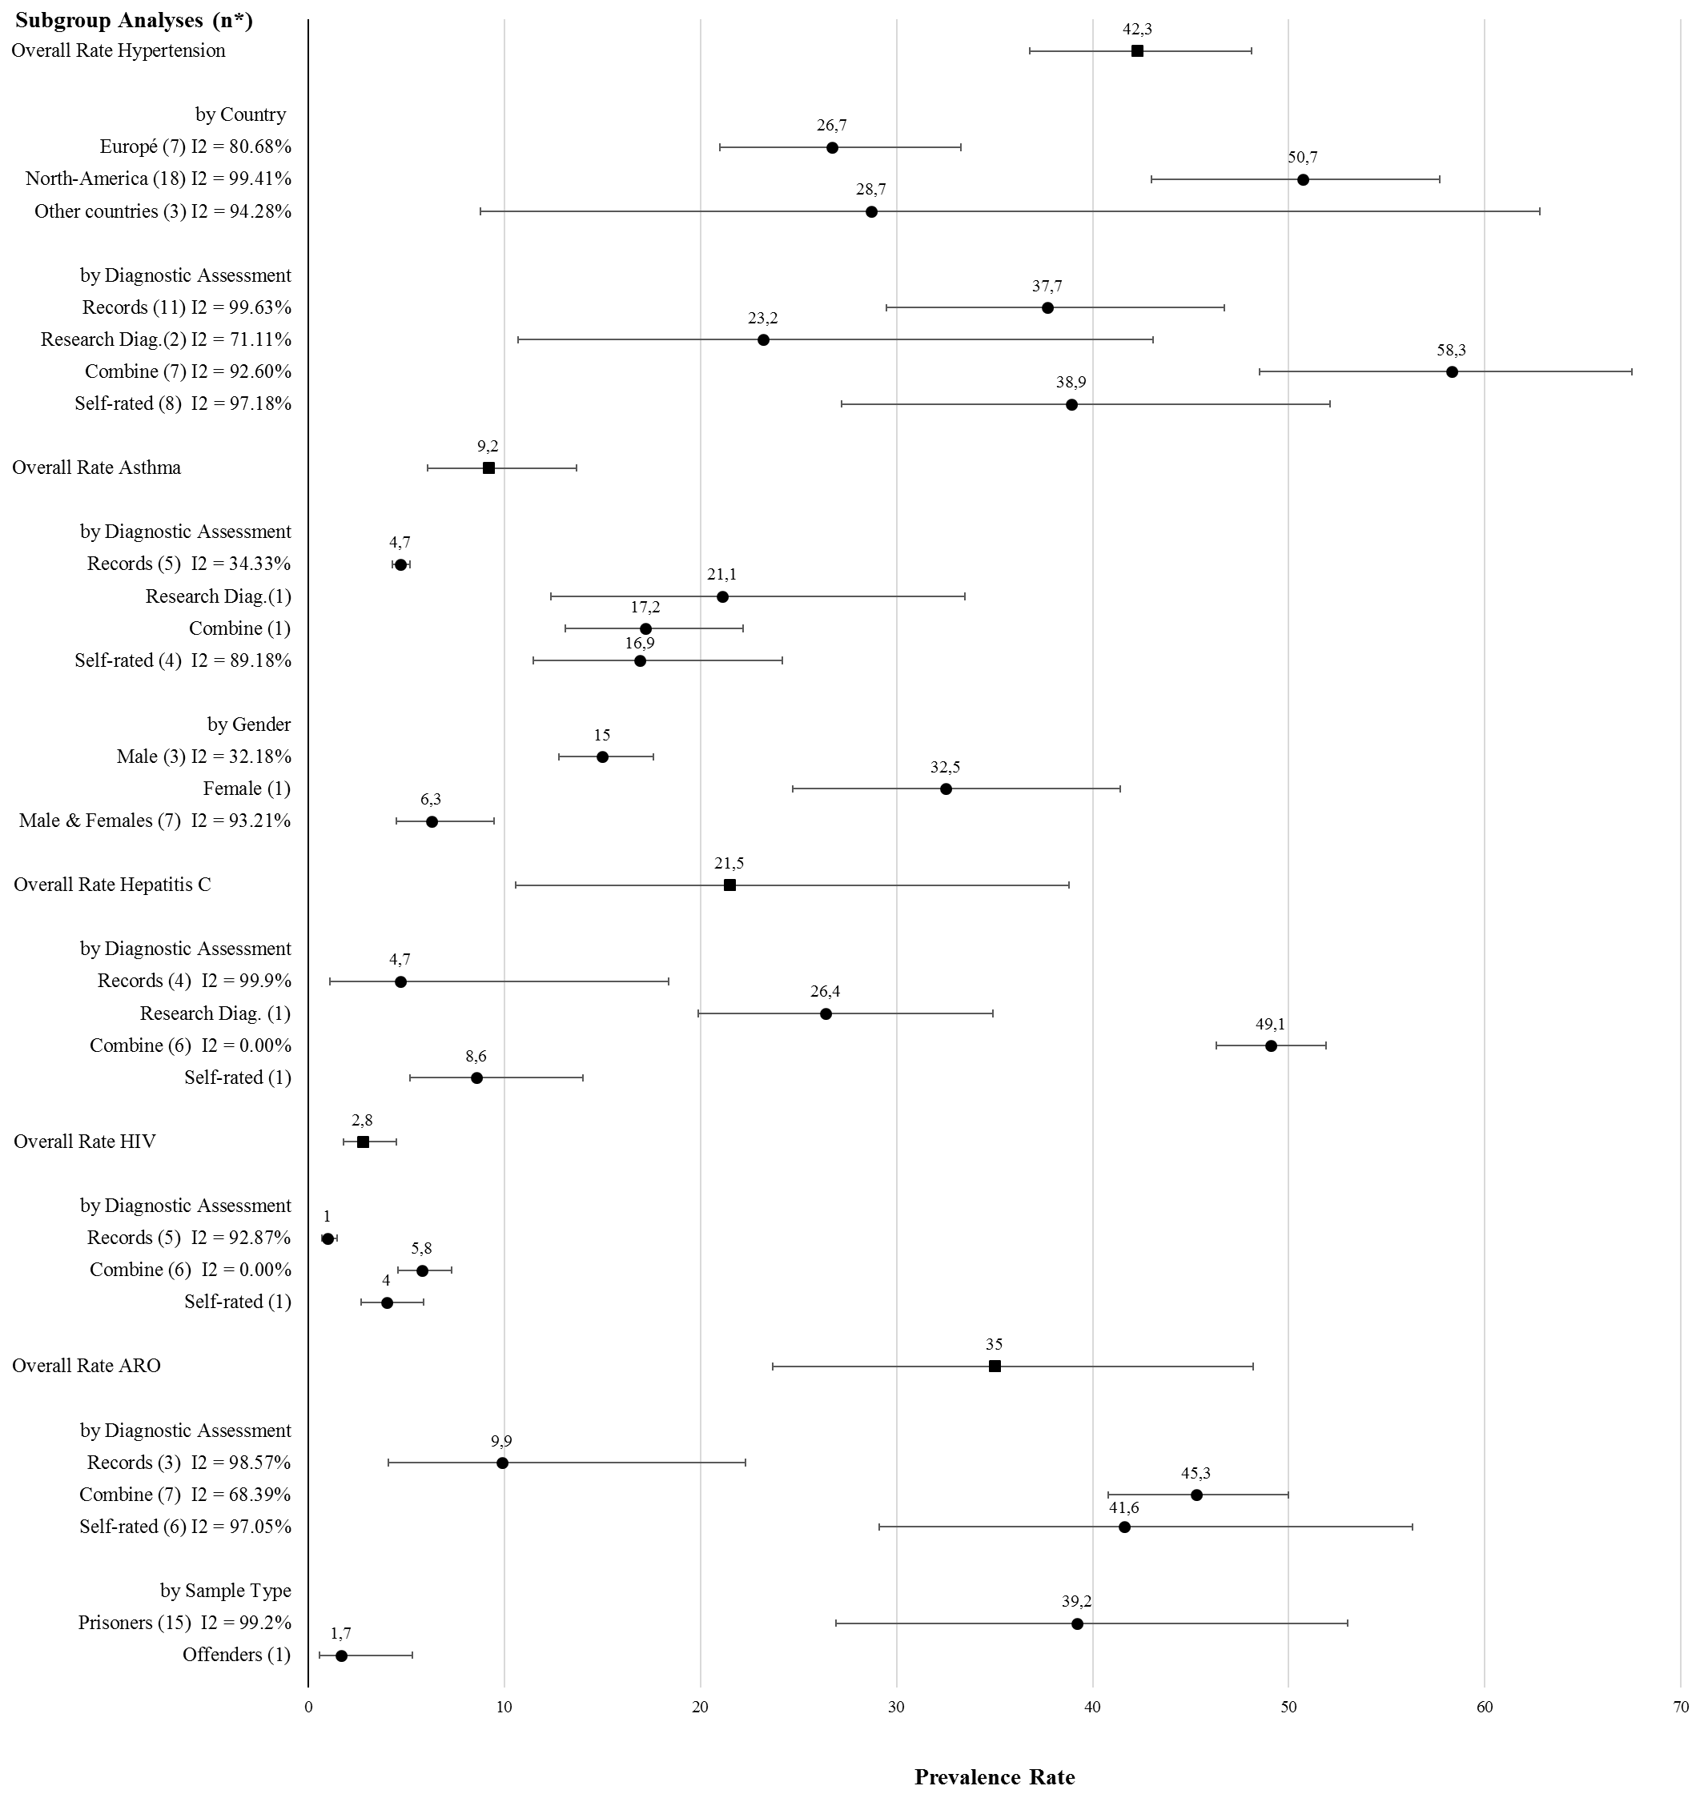

Appendix F. Search strategy for five databases
PubMed Database:
First search performed the 29-11-18
Number | Search Terms | Items found
#1 | Search ("Aged"[Mesh] OR "Middle Aged"[Mesh] OR "Aged, 80 and over"[Mesh]) OR "Aging"[Mesh]Sort by: Best Match | 4825372
#2 | Search (("Health"[Mesh]) OR "Health Status"[Mesh]) OR "Disease"[Mesh] Sort by: Best Match | 770690
#3 | Search ("Criminals"[Mesh] OR "Criminal Behavior"[Mesh]) OR "Antisocial Personality Disorder"[Mesh] Sort by: Best Match | 13362
#4 | Search (older[Title/Abstract]) OR elder*[Title/Abstract] Sort by: Best Match | 594484
#5 | Search (((((disorders[Title/Abstract]) OR illness[Title/Abstract]) OR somatic health[Title/Abstract]) OR psychiatric health[Title/Abstract]) OR mental health[Title/Abstract]) OR physical health[Title/Abstract]Sort by: Best Match | 944655
#6 | Search (((offenders[Title/Abstract]) OR prisoners[Title/Abstract]) OR inmates[Title/Abstract]) OR perpetrators[Title/Abstract] Sort by: Best Match | 20486
#7 | #1 OR #4 | 5042706
#8 | #2 or #5 | 1630563
#9 | #3 OR #6 | 31134
#10 | #7 AND #8 AND #9 | 2128

Search update performed the 1ST August 2019
Number | Search Terms | Items found
#1 | Search (((((("Aged"[Mesh] OR "Middle Aged"[Mesh] OR "Aged, 80 and over"[Mesh]) OR "Aging"[Mesh])) OR ((older[Title/Abstract]) OR elder*[Title/Abstract]))) AND ((((("Health"[Mesh]) OR "Health Status"[Mesh]) OR "Disease"[Mesh])) OR ((((((disorders[Title/Abstract]) OR illness[Title/Abstract]) OR somatic health[Title/Abstract]) OR psychiatric health[Title/Abstract]) OR mental health[Title/Abstract]) OR physical health[Title/Abstract]))) AND (((("Criminals"[Mesh] OR "Criminal Behavior"[Mesh]) OR "Antisocial Personality Disorder"[Mesh])) OR ((((offenders[Title/Abstract]) OR prisoners[Title/Abstract]) OR inmates[Title/Abstract]) OR perpetrators[Title/Abstract])) Sort by: Best Match Filters: Publication date from 2018/11/29 to 2019/12/31 | 41

Scopus Database:
First search performed the 29-11-18
Number | Search Terms | Items found
#1 | ( TITLE-ABS-KEY ( "older adults" ) OR TITLE-ABS-KEY ( elder* ) OR TITLE-ABS-KEY ( ag#ing ) ) | 1,404,469
#2 | ( TITLE-ABS-KEY ( offender# ) OR TITLE-ABS-KEY ( criminal# ) OR TITLE-ABS-KEY ( prisoner# ) OR TITLE-ABS-KEY ( antisocial AND personality ) OR TITLE-ABS-KEY ( inmate# ) ) | 160,249
#3 | ( TITLE-ABS-KEY ( disorder# ) OR TITLE-ABS-KEY ( "mental health" ) OR TITLE-ABS-KEY ( "physical health" ) OR TITLE-ABS-KEY ( "psychiatric health" ) OR TITLE-ABS-KEY ( illness ) OR TITLE-ABS-KEY ( "somatic health" ) OR TITLE-ABS-KEY ( "health status" ) OR TITLE-ABS-KEY ( health ) ) | 6,579,911
#4 | #1 AND #2 AND #3 | 1076

Search update performed the 1ST August 2019
Number | Search Terms | Items found
#1 | ( ( TITLE-ABS-KEY ( offender# ) OR TITLE-ABS-KEY ( criminal# ) OR TITLE-ABS-KEY ( prisoner# ) OR TITLE-ABS-KEY ( antisocial AND personality ) OR TITLE-ABS-KEY ( inmate# ) ) ) AND ( ( TITLE-ABS-KEY ( "older adults" ) OR TITLE-ABS-KEY ( elder* ) OR TITLE-ABS-KEY ( ag#ing ) ) ) AND ( ( TITLE-ABS-KEY ( disorder# ) OR TITLE-ABS-KEY ( "mental health" ) OR TITLE-ABS-KEY ( "physical health" ) OR TITLE-ABS-KEY ( "psychiatric health" ) OR TITLE-ABS-KEY ( illness ) OR TITLE-ABS-KEY ( "somatic health" ) OR TITLE-ABS-KEY ( "health status" ) OR TITLE-ABS-KEY ( health ) ) ) AND ORIG-LOAD-DATE AFT 20181210 | 49

PSYCHINFO:
First search performed the 30-11-18
Number | Search Terms | Items found
#1 | DE "Aging" | 71,121
#2 | (DE "Criminals") OR (DE "Prisoners") | 26,264
#3 | DE "Health" | 51,227
#4 | AB older adults OR AB elder* OR AB ag#ing | 134160
#5 | AB offender# OR AB perpetrator# OR AB inmate# OR AB antisocial personality | 47,952
#6 | AB "mental health" OR AB "physical health" OR AB "somatic health" OR AB "psychiatric health" OR AB illness OR AB disorder# OR AB "health status" OR AB disease | 810,133
#7 | #1 OR #4 | 157302
#8 | #2 OR #5 | 60069
#9 | #3 OR #6 | 840,444
#10 | #7 AND #8 AND #9 | 329

Search update performed the 1ST August 2019
Number | Search Terms | Items found
#1 | #7 AND #8 AND #9 20181201-20191231 | 5

Embase database:
First search performed the 22-01-19.
Number | Search Terms | Items found
#1 | 'aging'/exp | 253,458
#2 | 'older adults ':ab,ti OR 'aged':ab,ti OR 'senior':ab,ti | 789,049
#3 | #1 OR #2 | 982,213
#4 | 'health'/exp | 629,817
#5 | 'health status' /exp | 213,769
#6 | 'mental health':ab,ti OR 'physical health' :ab,ti OR 'somatic health': ab,ti OR 'psychiatric health' :ab,ti OR 'diseases': ab,ti | 1,379,459
#7 | #4 OR # 5 OR #6 | 1,889,569
#8 | 'offender' /ex p | 12,596
#9 | 'criminal behavior'/exp | 8,011
#10 | 'prisoner':ab,ti OR 'inmates':ab,ti | 7,164
#11 | #8 OR #9 OR #10 | 25,978
#12 | #3 AND #7 AND #11 | 280

Search update performed the 14-08-19
Number | Search Terms | Items found
#1 | #12 AND 2019:py | 16

WEB of SCIENCE:
First search performed the 22-01-19
Number | Search Terms | Items found
# 1 | TITLE: (aging) OR TITLE: (older adults) OR TITLE: (aged) OR TITLE: (senior) OR TITLE: (elder*) | 728,219
# 2 | TITLE: (Health) OR TITLE: (Health status) OR TITLE: (mental health) OR TITLE: (physical health) OR TITLE: (somatic health) OR TITLE: (psychiatric health) OR TITLE: (disorder) OR TITLE: (illness) | 976,905
# 3 | TITLE: (offender) OR TITLE: (criminal behavior) OR TITLE: (prisoner) OR TITLE: (inmate) OR TITLE: (criminal) | 47,120
# 4 | #3 AND #2 AND #1 | 30

Search update performed the 1ST August 2019
Number | Search Terms | Items found
# 1 | #3 AND #2 AND #1 2019 | 2

Appendix G. Clarifications/additions to the published PROSPERO protocol

In the main text of this manuscript, we discuss the results of the most frequently reported mental and physical health problems. This was not pre-established in the PROSPERO protocol because we were not aware of the amount of mental and physical health outcomes that we would find after performing the systematic search. Once the data was extracted and analyzed, we realized it was not feasible to describe all the health outcomes with the same level of detail. Thus, we decided to focus on the most frequent mental and physical health problems that were defined as those outcomes that were reported in 10 or more included publications.

Appendix H. Complete reference list of the 55 paper included in the systematic review and meta-analysis.

Ahalt, C., Stijacic-Cenzer, I., Miller, B. L., Rosen, H. J., Barnes, D. E., & Williams, B. A. (2018). Cognition and Incarceration: Cognitive Impairment and Its Associated Outcomes in Older Adults in Jail. Journal of the American Geriatrics Society, 66(11), 2065-2071. doi:10.1111/jgs.15521
Al-Rousan, T., Rubenstein, L., Sieleni, B., Deol, H., & Wallace, R. B. (2017). Inside the nation's largest mental health institution: A prevalence study in a state prison system. BMC Public Health, 17(1). doi:10.1186/s12889-017-4257-0
Arndt, S., Turvey, C. L., & Flaum, M. (2002). Older offenders, substance abuse, and treatment. The American Journal of Geriatric Psychiatry, 10(6), 733-739. doi:10.1176/appi.ajgp.10.6.733
Baillargeon, J., Black, S. A., Pulvino, J., & Dunn, K. (2000). The disease profile of Texas prison inmates. Ann Epidemiol, 10(2), 74-80.
Baillargeon, J., Penn, J. V., Thomas, C. R., Temple, J. R., Baillargeon, G., & Murray, O. J. (2009). Psychiatric disorders and suicide in the nation's largest state prison system. J Am Acad Psychiatry Law, 37(2), 188-193.
Baillargeon, J. G., Paar, D. P., Wu, H., Giordano, T. P., Murray, O., Raimer, B. G., . . . Pulvino, J. S. (2008). Psychiatric disorders, HIV infection and HIV/hepatitis co-infection in the correctional setting. AIDS Care, 20(1), 124-129. doi:10.1080/09540120701426532
Beaufrère, A., Belmenouar, O., & Chariot, P. (2014). Elderly arrestees in police custody cells: Implementation of detention and medical decision on fitness to be detained. Forensic Science International, 241, 15-19. doi:10.1016/j.forsciint.2014.04.031
Beaufrère, A., & Chariot, P. (2015). The health of older arrestees in police cells. Age and Ageing, 44(4), 662-667. doi:10.1093/ageing/afv022
Binswanger, I. A., Krueger, P. M., & Steiner, J. F. (2009). Prevalence of chronic medical conditions among jail and prison inmates in the USA compared with the general population. J Epidemiol Community Health, 63(11), 912-919. doi:10.1136/jech.2009.090662
Bolano, M., Ahalt, C., Ritchie, C., Stijacic-Cenzer, I., & Williams, B. (2016). Detained and Distressed: Persistent Distressing Symptoms in a Population of Older Jail Inmates. Journal of the American Geriatrics Society, 64(11), 2349-2355. doi:10.1111/jgs.14310
Brown, G. P., & Brozowski, K. (2003). Golden years? The incarceration of the older offender. Geriatrics Today: Journal of the Canadian Geriatrics Society, 6(1), 32-35.
Caverley, S. J. (2006). Older mentally ill inmates: A descriptive study. Journal of Correctional Health Care, 12(4), 262-268. doi:10.1177/1078345806295546
Chodos, A. H., Ahalt, C., Cenzer, I. S., Myers, J., Goldenson, J., & Williams, B. A. (2014). Older jail inmates and community acute care use. American Journal of Public Health, 104(9), 1728-1733. doi:10.2105/AJPH.2014.301952
Coid, J., Fazel, S., & Kahtan, N. (2002). Elderly patients admitted to secure forensic psychiatry services. Journal of Forensic Psychiatry, 13(2), 416-427. doi:10.1080/09585180210154470
Combalbert, N., Pennequin, V., Ferrand, C., Vandevyvère, R., Armand, M., & Geffray, B. (2016). Mental disorders and cognitive impairment in ageing offenders. Journal of Forensic Psychiatry & Psychology, 27(6), 853-866. doi:10.1080/14789949.2016.1244277
D'Souza, R. M., Butler, T., & Petrovsky, N. (2005). Assessment of cardiovascular disease risk factors and diabetes mellitus in Australian prisons: is the prisoner population unhealthier than the rest of the Australian population? Aust N Z J Public Health, 29(4), 318-323. doi:10.1111/j.1467-842x.2005.tb00200.x
Davoren, M., Fitzpatrick, M., Caddow, F., Caddow, M., O'Neill, C., O'Neill, H., & Kennedy, H. G. (2015). Older men and older women remand prisoners: Mental illness, physical illness, offending patterns and needs. International Psychogeriatrics, 27(5), 747-755. doi:10.1017/S1041610214002348
De Smet, S., De Keyzer, W., De Donder, L., Ryan, D., Verté, D., Broekaert, E., & Vandevelde, S. (2016). Older offenders deemed criminally irresponsible in Flanders (Belgium): Descriptive results from a retrospective case note study. International Journal of Law and Psychiatry, 46, 35-41. doi:10.1016/j.ijlp.2016.02.025
Fazel, S., & Grann, M. (2002). Older criminals: A descriptive study of psychiatrically examined offenders in Sweden. International Journal of Geriatric Psychiatry, 17(10), 907-913. doi:10.1002/gps.715
Fazel, S., Hope, T., O'Donnell, I., Piper, M., & Jacoby, R. (2001). Health of elderly male prisoners: Worse than the general population, worse than younger prisoners. Age and Ageing, 30(5), 403-407. doi:10.1093/ageing/30.5.403
Fazel, S., Hope, T., O'Donnell, I., & Jacoby, R. (2001a). Hidden psychiatric morbidity in elderly prisoners. The British Journal of Psychiatry, 179(6), 535-539. doi:10.1192/bjp.179.6.535
Fitton, L., Bates, A., Hayes, A., & Fazel, S. (2018). Psychiatric disorders, substance use, and executive functioning in older probationers. Crim Behav Ment Health, 28(6), 447-459. doi:10.1002/cbm.2094
Flatt, J. D., Williams, B. A., Barnes, D., Goldenson, J., & Ahalt, C. (2017). Post-traumatic stress disorder symptoms and associated health and social vulnerabilities in older jail inmates. Aging and Mental Health, 21(10), 1106-1112. doi:10.1080/13607863.2016.1201042
Gates, M. L., Hunter, E. G., Dicks, V., Jessa, P. N., Walker, V., & Yoo, W. (2018). Multimorbidity patterns and associations with functional limitations among an aging population in prison. Archives of Gerontology and Geriatrics, 77, 115-123. doi:10.1016/j.archger.2018.03.012
Greene, M., Ahalt, C., Stijacic-Cenzer, I., Metzger, L., & Williams, B. (2018). Older adults in jail: high rates and early onset of geriatric conditions. Health and Justice, 6(1). doi:10.1186/s40352-018-0062-9
Handtke, V., Bretschneider, W., Elger, B., & Wangmo, T. (2015). Easily forgotten: Elderly female prisoners. Journal of Aging Studies, 32, 1-11. doi:10.1016/j.jaging.2014.10.003
Harzke, A. J., Baillargeon, J. G., Pruitt, S. L., Pulvino, J. S., Paar, D. P., & Kelley, M. F. (2010). Prevalence of chronic medical conditions among inmates in the texas prison system. Journal of Urban Health, 87(3), 486-503. doi:10.1007/s11524-010-9448-2
Hayes, A. J., Burns, A., Turnbull, P., & Shaw, J. J. (2012). The health and social needs of older male prisoners. International Journal of Geriatric Psychiatry, 27(11), 1155-1162. doi:10.1002/gps.3761
Heinik, J., Kimhi, R., & Hes, J. P. (1994). Dementia and crime: A forensic psychiatry unit study in israel. International Journal of Geriatric Psychiatry, 9(6), 491-494. doi:10.1002/gps.930090608
Humphreys, J., Ahalt, C., Stijacic-Cenzer, I., Widera, E., & Williams, B. (2018). Six-Month Emergency Department Use among Older Adults Following Jail Incarceration. Journal of Urban Health, 95(4), 523-533. doi:10.1007/s11524-017-0208-4
Kingston, P., Le Mesurier, N., Yorston, G., Wardle, S., & Heath, L. (2011). Psychiatric morbidity in older prisoners: Unrecognized and undertreated. International Psychogeriatrics, 23(8), 1354-1360. doi:10.1017/S1041610211000378
Koenig, H. G., Johnson, S., Bellard, J., Denker, M., & Fenlon, R. (1995). Depression and anxiety disorder among older male inmates at a federal correctional facility. Psychiatr Serv, 46(4), 399-401. doi:10.1176/ps.46.4.399
Leigey, M. E., & Johnston, M. E. (2015). The prevalence of overweight and obesity among aging female inmates. Journal of Correctional Health Care, 21(3), 276-285. doi:10.1177/1078345815588171
Lewis, C. F., Fields, C., & Rainey, E. (2006). A Study of geriatric forensic evaluees: Who are the violent elderly? Journal of the American Academy of Psychiatry and the Law, 34(3), 324-332.
Loeb, S. J., & Steffensmeier, D. (2006). Older Male Prisoners: Health Status, Self-Efficacy Beliefs, and Health-Promoting Behaviors. Journal of Correctional Health Care, 12(4), 269-278. doi:10.1177/1078345806296031
Macalino, G. E., Vlahov, D., Sanford-Colby, S., Patel, S., Sabin, K., Salas, C., & Rich, J. D. (2004). Prevalence and incidence of HIV, hepatitis B virus, and hepatitis C virus infections among males in Rhode Island prisons. Am J Public Health, 94(7), 1218-1223.
Majekodunmi, O. E., Obadeji, A., Oluwole, L. O., & Oyelami, O. (2017). Depression and associated physical co-morbidities in elderly prison inmates. International Journal of Mental Health, 46(4), 269-283. doi:10.1080/00207411.2017.1345040
Maschi, T., Shi, Q., Forseth, K., Laureano, P., & Viola, D. (2017). Exploring the Association between Race and Health among Older Adults Who Are Incarcerated. Social Work in Public Health, 32(3), 143-153. doi:10.1080/19371918.2016.1160342
McKinnon, I., Hayes, A., & Grubin, D. (2017). Health characteristics of older police custody detainees in London, UK. Journal of Forensic Psychiatry and Psychology, 28(3), 331-340. doi:10.1080/14789949.2017.1280071
Merten, M. J., Bishop, A. J., & Williams, A. L. (2012). Prisoner health and valuation of life, loneliness, and depressed mood. American Journal of Health Behavior, 36(2), 275-288. doi:10.5993/AJHB.36.2.12
Meyer, L. (2016). Elderly arrested people in correctional facilities: Challenge for health care. Zeitschrift fur Gerontologie und Geriatrie, 49(1), 37-43. doi:10.1007/s00391-015-0888-x
Moschetti, K., Stadelmann, P., Wangmo, T., Holly, A., Bodenmann, P., Wasserfallen, J. B., . . . Gravier, B. (2015). Disease profiles of detainees in the Canton of Vaud in Switzerland: gender and age differences in substance abuse, mental health and chronic health conditions. BMC Public Health, 15, 872. doi:10.1186/s12889-015-2211-6
Murdoch, N., Morris, P., & Holmes, C. (2008). Depression in elderly life sentence prisoners. International Journal of Geriatric Psychiatry, 23(9), 957-962. doi:10.1002/gps.2017
O'Hara, K., Forsyth, K., Webb, R., Senior, J., Hayes, A. J., Challis, D., . . . Shaw, J. (2016). Links between depressive symptoms and unmet health and social care needs among older prisoners. Age and Ageing, 45(1), 158-163. doi:10.1093/ageing/afv171
O'Sullivan, P. C. J., & Chesterman, L. P. (2007). Older adult patients subject to restriction orders in England and Wales: A cross-sectional survey. Journal of Forensic Psychiatry & Psychology, 18(2), 204-220. doi:10.1080/14789940601110906
Putkonen, H., Weizmann-Henelius, G., Repo-Tiihonen, E., Lindberg, N., Saarela, T., Eronen, M., & Häkkänen-Nyholm, H. (2010). Homicide, psychopathy, and aging—A nationwide register-based case-comparison study of homicide offenders aged 60 years or older. Journal of Forensic Sciences, 55(6), 1552-1556. doi:10.1111/j.1556-4029.2010.01488.x
Regan, J. J., Alderson, A., & Regan, W. M. (2002). Psychiatric disorders in aging prisoners. Clinical Gerontologist: The Journal of Aging and Mental Health, 26(1-2), 117-124. doi:10.1300/J018v26n01_10
Rodriguez, M., Boyce, P., & Hodges, J. (2017). A neuropsychological study of older adult first-time sex offenders. Neurocase, 23(2), 154-161. doi:10.1080/13554794.2017.1334802
Stawińska-Witoszyńska, B., Czechowska, K., & Wiȩckowska, B. (2019). The prevalence of Epilepsy and its co-occurrence with alcohol dependence among polish prisoners. International Journal for Equity in Health, 18(1). doi:10.1186/s12939-019-1009-z
Stoliker, B. E., & Varanese, J. (2017). Spending the golden years behind bars: Predictors of mental health issues among geriatric prisoners. Victims & Offenders, 12(5), 718-740. doi:10.1080/15564886.2016.1170086
Williams, B., Lindquist, K., Sudore, R. L., Strupp, H. M., Willmott, D. J., & Walter, L. C. (2006). Being Old and Doing Time: Functional Impairment and Adverse Experiences of Geriatric Female Prisoners. Journal of the American Geriatrics Society, 54(4), 702-707. doi:10.1111/j.1532-5415.2006.00662.x
Williams, B. A., Ahalt, C., Stijacic-Cenzer, I., Smith, A. K., Goldenson, J., & Ritchie, C. S. (2014). Pain behind bars: the epidemiology of pain in older jail inmates in a county jail. Journal of palliative medicine, 17(12), 1336-1343. doi:10.1089/jpm.2014.0160
Williams, B. A., Baillargeon, J. G., Lindquist, K., Walter, L. C., Covinsky, K. E., Whitson, H. E., & Steinman, M. A. (2010). Medication prescribing practices for older prisoners in the Texas Prison System. American Journal of Public Health, 100(4), 756-761. doi:10.2105/AJPH.2008.154591
Williams, B. A., Lindquist, K., Hill, T., Baillargeon, J., Mellow, J., Greifinger, R., & Walter, L. C. (2009). Caregiving behind bars: correctional officer reports of disability in geriatric prisoners. J Am Geriatr Soc, 57(7), 1286-1292.
Williams, B. A., McGuire, J., Lindsay, R. G., Baillargeon, J., Cenzer, I. S., Lee, S. J., & Kushel, M. (2010a). Coming home: Health status and homelessness risk of older pre-release prisoners. Journal of General Internal Medicine, 25(10), 1038-1044. doi:10.1007/s11606-010-1416-8

References:
Ahalt, C., Stijacic-Cenzer, I., Miller, B. L., Rosen, H. J., Barnes, D. E., & Williams, B. A. (2018). Cognition and Incarceration: Cognitive Impairment and Its Associated Outcomes in Older Adults in Jail. Journal of the American Geriatrics Society, 66(11), 2065-2071. doi:10.1111/jgs.15521
Al-Rousan, T., Rubenstein, L., Sieleni, B., Deol, H., & Wallace, R. B. (2017). Inside the nation's largest mental health institution: A prevalence study in a state prison system. BMC Public Health, 17(1). doi:10.1186/s12889-017-4257-0
Arndt, S., Turvey, C. L., & Flaum, M. (2002). Older offenders, substance abuse, and treatment. The American Journal of Geriatric Psychiatry, 10(6), 733-739. doi:10.1176/appi.ajgp.10.6.733
Baillargeon, J., Black, S. A., Pulvino, J., & Dunn, K. (2000). The disease profile of Texas prison inmates. Ann Epidemiol, 10(2), 74-80.
Baillargeon, J., Penn, J. V., Thomas, C. R., Temple, J. R., Baillargeon, G., & Murray, O. J. (2009). Psychiatric disorders and suicide in the nation's largest state prison system. J Am Acad Psychiatry Law, 37(2), 188-193.
Baillargeon, J. G., Paar, D. P., Wu, H., Giordano, T. P., Murray, O., Raimer, B. G., Avery, E.N., Diamond, P.M. & Pulvino, J. S. (2008). Psychiatric disorders, HIV infection and HIV/hepatitis co-infection in the correctional setting. AIDS Care, 20(1), 124-129. doi:10.1080/09540120701426532
Beaufrère, A., Belmenouar, O., & Chariot, P. (2014). Elderly arrestees in police custody cells: Implementation of detention and medical decision on fitness to be detained. Forensic Science International, 241, 15-19. doi:10.1016/j.forsciint.2014.04.031
Beaufrère, A., & Chariot, P. (2015). The health of older arrestees in police cells. Age and Ageing, 44(4), 662-667. doi:10.1093/ageing/afv022
Bedard, R., Metzger, L., & Williams, B. (2016). Ageing prisoners: An introduction to geriatric health-care challenges in correctional facilities. International Review of the Red Cross, 98(903), 917-939. doi:10.1017/S1816383117000364
Binswanger, I. A., Krueger, P. M., & Steiner, J. F. (2009). Prevalence of chronic medical conditions among jail and prison inmates in the USA compared with the general population. J Epidemiol Community Health, 63(11), 912-919. doi:10.1136/jech.2009.090662
Bolano, M., Ahalt, C., Ritchie, C., Stijacic-Cenzer, I., & Williams, B. (2016). Detained and Distressed: Persistent Distressing Symptoms in a Population of Older Jail Inmates. Journal of the American Geriatrics Society, 64(11), 2349-2355. doi:10.1111/jgs.14310
Brown, G. P., & Brozowski, K. (2003). Golden years? The incarceration of the older offender. Geriatrics Today: Journal of the Canadian Geriatrics Society, 6(1), 32-35.
Brown, M. T. (2010). Early-life characteristics, psychiatric history, and cognition trajectories in later life. Gerontologist, 50(5), 646-656. doi:10.1093/geront/gnq049
BRÅ. (2018). The Prison and Probation Service. Retrieved from https://www.bra.se/bra-in-english/home/crime-and-statistics/crime-statistics/the-prison-and-probation-service.html (accessed 18 December 2019)
Caverley, S. J. (2006). Older mentally ill inmates: A descriptive study. Journal of Correctional Health Care, 12(4), 262-268. doi:10.1177/1078345806295546
Chodos, A. H., Ahalt, C., Cenzer, I. S., Myers, J., Goldenson, J., & Williams, B. A. (2014). Older jail inmates and community acute care use. American Journal of Public Health, 104(9), 1728-1733. doi:10.2105/AJPH.2014.301952
Coid, J., Fazel, S., & Kahtan, N. (2002). Elderly patients admitted to secure forensic psychiatry services. Journal of Forensic Psychiatry, 13(2), 416-427. doi:10.1080/09585180210154470
Combalbert, N., Pennequin, V., Ferrand, C., Armand, M., Anselme, M., & Geffray, B. (2018). Cognitive impairment, self-perceived health and quality of life of older prisoners. Criminal Behaviour and Mental Health, 28(1), 36-49. doi:10.1002/cbm.2023
Combalbert, N., Pennequin, V., Ferrand, C., Vandevyvère, R., Armand, M., & Geffray, B. (2016). Mental disorders and cognitive impairment in ageing offenders. Journal of Forensic Psychiatry & Psychology, 27(6), 853-866. doi:10.1080/14789949.2016.1244277
Corovic, J., Andershed, A.-K., Colins, O. F., & Andershed, H. (2017). Risk factors and adulthood adjustment outcomes for different pathways of crime: Key findings from the Swedish IDA program. In The Routledge International Handbook of Life-Course Criminology (pp. 220-244): Routledge.
D'Souza, R. M., Butler, T., & Petrovsky, N. (2005). Assessment of cardiovascular disease risk factors and diabetes mellitus in Australian prisons: is the prisoner population unhealthier than the rest of the Australian population? Aust N Z J Public Health, 29(4), 318-323. doi:10.1111/j.1467-842x.2005.tb00200.x
Davoren, M., Fitzpatrick, M., Caddow, F., Caddow, M., O'Neill, C., O'Neill, H., & Kennedy, H. G. (2015). Older men and older women remand prisoners: Mental illness, physical illness, offending patterns and needs. International Psychogeriatrics, 27(5), 747-755. doi:10.1017/S1041610214002348
De Smet, S., De Keyzer, W., De Donder, L., Ryan, D., Verté, D., Broekaert, E., & Vandevelde, S. (2016). Older offenders deemed criminally irresponsible in Flanders (Belgium): Descriptive results from a retrospective case note study. International Journal of Law and Psychiatry, 46, 35-41. doi:10.1016/j.ijlp.2016.02.025
Di Lorito, C., Vllm, B., & Dening, T. (2018). Ageing patients in forensic psychiatric settings: A review of the literature. Int J Geriatr Psychiatry, 33(12), 1548-1555. doi:10.1002/gps.4981
Di Lorito, C., Völlm, B., & Dening, T. (2018a). The individual experience of ageing prisoners: systematic review and meta-synthesis through a Good Lives Model framework. International Journal of Geriatric Psychiatry, 33(2), 252-262. doi:10.1002/gps.4762
Di Lorito, C., Völlm, B., & Dening, T. (2018b). Psychiatric disorders among older prisoners: a systematic review and comparison study against older people in the community. Aging Ment Health, 22(1), 1-10. doi:10.1080/13607863.2017.1286453
Ekström, A., Kristiansson, M., & Björkstén, K. S. (2017). Dementia and cognitive disorder identified at a forensic psychiatric examination - A study from Sweden. BMC Geriatrics, 17(1). doi:10.1186/s12877-017-0614-1
Fazel, S., & Grann, M. (2002). Older criminals: A descriptive study of psychiatrically examined offenders in Sweden. International Journal of Geriatric Psychiatry, 17(10), 907-913. doi:10.1002/gps.715
Fazel, S., Hope, T., O'Donnell, I., Piper, M., & Jacoby, R. (2001). Health of elderly male prisoners: Worse than the general population, worse than younger prisoners. Age and Ageing, 30(5), 403-407. doi:10.1093/ageing/30.5.403
Fazel, S., Hope, T., O'Donnell, I., & Jacoby, R. (2001a). Hidden psychiatric morbidity in elderly prisoners. The British Journal of Psychiatry, 179(6), 535-539. doi:10.1192/bjp.179.6.535
Fazel, S., Hayes, A. J., Bartellas, K., Clerici, M., & Trestman, R. (2016). Mental health of prisoners: Prevalence, adverse outcomes, and interventions. The Lancet Psychiatry, 3(9), 871-881. doi:10.1016/S2215-0366(16)30142-0
Fazel, S., Hope, T., O'Donnell, I., & Jacoby, R. (2004). Unmet treatment needs of older prisoners: A primary care survey. Age and Ageing, 33(4), 396-398. doi:10.1093/ageing/afh113
Fazel, S., Hope, T., O'Donnell, I., Piper, M., & Jacoby, R. (2001). Health of elderly male prisoners: Worse than the general population, worse than younger prisoners. Age and Ageing, 30(5), 403-407. doi:10.1093/ageing/30.5.403
Fazel, S., & Seewald, K. (2012). Severe mental illness in 33,588 prisoners worldwide: systematic review and meta-regression analysis. Br J Psychiatry, 200(5), 364-373. doi:10.1192/bjp.bp.111.096370
Fitton, L., Bates, A., Hayes, A., & Fazel, S. (2018). Psychiatric disorders, substance use, and executive functioning in older probationers. Crim Behav Ment Health, 28(6), 447-459. doi:10.1002/cbm.2094
Flatt, J. D., Williams, B. A., Barnes, D., Goldenson, J., & Ahalt, C. (2017). Post-traumatic stress disorder symptoms and associated health and social vulnerabilities in older jail inmates. Aging and Mental Health, 21(10), 1106-1112. doi:10.1080/13607863.2016.1201042
Galenkamp, H., Huisman, M., Braam, A. W., Schellevis, F. G., & Deeg, D. J. (2014). Disease prevalence based on older people's self-reports increased, but patient-general practitioner agreement remained stable, 1992-2009. J Clin Epidemiol, 67(7), 773-780. Doi:10.1016/j.jclinepi.2014.02.002
Gates, M. L., Hunter, E. G., Dicks, V., Jessa, P. N., Walker, V., & Yoo, W. (2018). Multimorbidity patterns and associations with functional limitations among an aging population in prison. Archives of Gerontology and Geriatrics, 77, 115-123. doi:10.1016/j.archger.2018.03.012
Ginn, S. (2012). Elderly prisoners. BMJ (Online), 345(7879). doi:10.1136/bmj.e6263
Granacher, R.P. (2018). Neuropsychiatric aspects involving the elderly and the law. In Holzer, J.C., Kohn, R., Ellison, J.M. & Recupero, P.R. (Eds.), Geriatric Forensic Psychiatry: Principeles and Practice, (pp. 9-16). New York: Oxford University Press.
Granacher, R.P. (2018). Behavioral neurological aspects involving the elderly and the law. In Holzer, J.C., Kohn, R., Ellison, J.M. & Recupero, P.R. (Eds.), Geriatric Forensic Psychiatry: Principeles and Practice, (pp. 17-26). New York: Oxford University Press.
Greene, M., Ahalt, C., Stijacic-Cenzer, I., Metzger, L., & Williams, B. (2018). Older adults in jail: high rates and early onset of geriatric conditions. Health and Justice, 6(1). doi:10.1186/s40352-018-0062-9
Haesen, S., Merkt, H., Imber, A., Elger, B., & Wangmo, T. (2019). Substance use and other mental health disorders among older prisoners. International Journal of Law and Psychiatry, 62, 20-31. doi:10.1016/j.ijlp.2018.10.004
Handtke, V., Bretschneider, W., Elger, B., & Wangmo, T. (2015). Easily forgotten: Elderly female prisoners. Journal of Aging Studies, 32, 1-11. doi:10.1016/j.jaging.2014.10.003
Harzke, A. J., Baillargeon, J. G., Pruitt, S. L., Pulvino, J. S., Paar, D. P., & Kelley, M. F. (2010). Prevalence of chronic medical conditions among inmates in the texas prison system. Journal of Urban Health, 87(3), 486-503. doi:10.1007/s11524-010-9448-2
Hayes, A. J., Burns, A., Turnbull, P., & Shaw, J. J. (2012). The health and social needs of older male prisoners. International Journal of Geriatric Psychiatry, 27(11), 1155-1162. doi:10.1002/gps.3761
Heinik, J., Kimhi, R., & Hes, J. P. (1994). Dementia and crime: A forensic psychiatry unit study in israel. International Journal of Geriatric Psychiatry, 9(6), 491-494. doi:10.1002/gps.930090608
Higgins, J. P., & Green, S. (2011). Cochrane handbook for systematic reviews of interventions (Vol. 4): John Wiley & Sons.
Humphreys, J., Ahalt, C., Stijacic-Cenzer, I., Widera, E., & Williams, B. (2018). Six-Month Emergency Department Use among Older Adults Following Jail Incarceration. Journal of Urban Health, 95(4), 523-533. doi:10.1007/s11524-017-0208-4
Kakoullis, A., Mesurier, N. L., & Kingston, P. (2010). The mental health of older prisoners. International Psychogeriatrics, 22(5), 693-701. doi:10.1017/S1041610210000359
Kingston, P., Le Mesurier, N., Yorston, G., Wardle, S., & Heath, L. (2011). Psychiatric morbidity in older prisoners: Unrecognized and undertreated. International Psychogeriatrics, 23(8), 1354-1360. doi:10.1017/S1041610211000378
Koenig, H. G., Johnson, S., Bellard, J., Denker, M., & Fenlon, R. (1995). Depression and anxiety disorder among older male inmates at a federal correctional facility. Psychiatr Serv, 46(4), 399-401. doi:10.1176/ps.46.4.399
Kretschmer, T., Dijkstra, J. K., & Veenstra, R. (2017). Social and individual antecedents of adolescent-onset conduct problem behaviour. In A. Blokland & V. v. d. Geest (Eds.), The Routledge International Handbook of Life-Course Criminology (pp. 179-199). New York: Routledge.
Leigey, M. E., & Johnston, M. E. (2015). The prevalence of overweight and obesity among aging female inmates. Journal of Correctional Health Care, 21(3), 276-285. doi:10.1177/1078345815588171
Lewis, C. F., Fields, C., & Rainey, E. (2006). A Study of geriatric forensic evaluees: Who are the violent elderly? Journal of the American Academy of Psychiatry and the Law, 34(3), 324-332.
Loeb, S. J., & AbuDagga, A. (2006). Health-related research on older inmates: An integrative review. Research in Nursing & Health, 29(6), 556-565. doi:10.1002/nur.20177
Loeb, S. J., & Steffensmeier, D. (2006). Older Male Prisoners: Health Status, Self-Efficacy Beliefs, and Health-Promoting Behaviors. Journal of Correctional Health Care, 12(4), 269-278. doi:10.1177/1078345806296031
Macalino, G. E., Vlahov, D., Sanford-Colby, S., Patel, S., Sabin, K., Salas, C., & Rich, J. D. (2004). Prevalence and incidence of HIV, hepatitis B virus, and hepatitis C virus infections among males in Rhode Island prisons. Am J Public Health, 94(7), 1218-1223.
Majekodunmi, O. E., Obadeji, A., Oluwole, L. O., & Oyelami, O. (2017). Depression and associated physical co-morbidities in elderly prison inmates. International Journal of Mental Health, 46(4), 269-283. doi:10.1080/00207411.2017.1345040
Maschi, T., Shi, Q., Forseth, K., Laureano, P., & Viola, D. (2017). Exploring the Association between Race and Health among Older Adults Who Are Incarcerated. Social Work in Public Health, 32(3), 143-153. doi:10.1080/19371918.2016.1160342
McKinnon, I., Hayes, A., & Grubin, D. (2017). Health characteristics of older police custody detainees in London, UK. Journal of Forensic Psychiatry and Psychology, 28(3), 331-340. doi:10.1080/14789949.2017.1280071
Merten, M. J., Bishop, A. J., & Williams, A. L. (2012). Prisoner health and valuation of life, loneliness, and depressed mood. American Journal of Health Behavior, 36(2), 275-288. doi:10.5993/AJHB.36.2.12
Meyer, L. (2016). Elderly arrested people in correctional facilities: Challenge for health care. Zeitschrift fur Gerontologie und Geriatrie, 49(1), 37-43. doi:10.1007/s00391-015-0888-x
Moher, D., Liberati, A., Tetzlaff, J., Altman, D. G., & The, P. G. (2009). Preferred Reporting Items for Systematic Reviews and Meta-Analyses: The PRISMA Statement. PLOS Medicine, 6(7), e1000097. doi:10.1371/journal.pmed.1000097
Moschetti, K., Stadelmann, P., Wangmo, T., Holly, A., Bodenmann, P., Wasserfallen, J. B., Elger, B. & Gravier, B. (2015). Disease profiles of detainees in the Canton of Vaud in Switzerland: gender and age differences in substance abuse, mental health and chronic health conditions. BMC Public Health, 15, 872. doi:10.1186/s12889-015-2211-6
Munday, D., Leaman, J., O'Moore, E., & Plugge, E. (2019). The prevalence of non-communicable disease in older people in prison: A systematic review and meta-analysis. Age and Ageing, 48(2), 204-212. doi:10.1093/ageing/afy186
Munn, Z., Moola, S., Riitano, D., & Lisy, K. (2014). The development of a critical appraisal tool for use in systematic reviews addressing questions of prevalence. Int J Health Policy Manag, 3(3), 123-128. doi:10.15171/ijhpm.2014.71
Murdoch, N., Morris, P., & Holmes, C. (2008). Depression in elderly life sentence prisoners. International Journal of Geriatric Psychiatry, 23(9), 957-962. doi:10.1002/gps.2017
O'Hara, K., Forsyth, K., Webb, R., Senior, J., Hayes, A. J., Challis, D., Fazel, S. & Shaw, J. (2016). Links between depressive symptoms and unmet health and social care needs among older prisoners. Age and Ageing, 45(1), 158-163. doi:10.1093/ageing/afv171
O'Sullivan, P. C. J., & Chesterman, L. P. (2007). Older adult patients subject to restriction orders in England and Wales: A cross-sectional survey. Journal of Forensic Psychiatry & Psychology, 18(2), 204-220. doi:10.1080/14789940601110906
Putkonen, H., Weizmann-Henelius, G., Repo-Tiihonen, E., Lindberg, N., Saarela, T., Eronen, M., & Häkkänen-Nyholm, H. (2010). Homicide, psychopathy, and aging—A nationwide register-based case-comparison study of homicide offenders aged 60 years or older. Journal of Forensic Sciences, 55(6), 1552-1556. doi:10.1111/j.1556-4029.2010.01488.x
Regan, J. J., Alderson, A., & Regan, W. M. (2002). Psychiatric disorders in aging prisoners. Clinical Gerontologist: The Journal of Aging and Mental Health, 26(1-2), 117-124. doi:10.1300/J018v26n01_10
Rodriguez, M., Boyce, P., & Hodges, J. (2017). A neuropsychological study of older adult first-time sex offenders. Neurocase, 23(2), 154-161. doi:10.1080/13554794.2017.1334802
Sampson, R. J., & Laub, J. H. (2001). A life-course theory of cumulative diadvantage and the stability of delinquency. In A. Piquero & P. Mazerolle (Eds.), Life-course criminology: contemporary and classic readings (pp. 146-169). Canada: Wadsworth.
Settersten, R., & Godlewski, B. (2016). Concepts and theories of age and aging. In V. Bengtson & R. Settersten (Eds.), Handbook of theories of aging (Third ed., pp. 9-25). New York: Springer.
Skarupski, K. A., Gross, A., Schrack, J. A., Deal, J. A., & Eber, G. B. (2018). The Health of America’s Aging Prison Population. Epidemiologic Reviews, 40(1), 157-165. doi:10.1093/epirev/mxx020
Stoliker, B. E., & Varanese, J. (2017). Spending the golden years behind bars: Predictors of mental health issues among geriatric prisoners. Victims & Offenders, 12(5), 718-740. doi:10.1080/15564886.2016.1170086
Wangmo, T., Meyer, A. H., Handtke, V., Bretschneider, W., Page, J., Sommer, J., Stuckelberger, A., Aebi, M. & Elger, B. S. (2016). Aging prisoners in Switzerland: An analysis of their health care utilization. Journal of Aging and Health, 28(3), 481-502. doi:10.1177/0898264315594137
Williams, B., & Abraldes, R. (2007). Growing older: Challenges of prison and reentry for the aging population. In Public Health Behind Bars: From Prisons to Communities (pp. 56-72). New York, NY.: Springer.
Williams, B. A., Ahalt, C., Stijacic-Cenzer, I., Smith, A. K., Goldenson, J., & Ritchie, C. S. (2014). Pain behind bars: the epidemiology of pain in older jail inmates in a county jail. Journal of palliative medicine, 17(12), 1336-1343. doi:10.1089/jpm.2014.0160
Williams, B. A., Baillargeon, J. G., Lindquist, K., Walter, L. C., Covinsky, K. E., Whitson, H. E., & Steinman, M. A. (2010). Medication prescribing practices for older prisoners in the Texas Prison System. American Journal of Public Health, 100(4), 756-761. doi:10.2105/AJPH.2008.154591
Williams, B. A., Lindquist, K., Hill, T., Baillargeon, J., Mellow, J., Greifinger, R., & Walter, L. C. (2009). Caregiving behind bars: correctional officer reports of disability in geriatric prisoners. J Am Geriatr Soc, 57(7), 1286-1292.
Williams, B., Lindquist, K., Sudore, R. L., Strupp, H. M., Willmott, D. J., & Walter, L. C. (2006). Being Old and Doing Time: Functional Impairment and Adverse Experiences of Geriatric Female Prisoners. Journal of the American Geriatrics Society, 54(4), 702-707. doi:10.1111/j.1532-5415.2006.00662.x
Williams, B. A., McGuire, J., Lindsay, R. G., Baillargeon, J., Cenzer, I. S., Lee, S. J., & Kushel, M. (2010a). Coming home: Health status and homelessness risk of older pre-release prisoners. Journal of General Internal Medicine, 25(10), 1038-1044. doi:10.1007/s11606-010-1416-8
Williams, B. A., Stern, M. F., Mellow, J., Safer, M., & Greifinger, R. B. (2012). Aging in correctional custody: Setting a policy agenda for older prisoner health care. American Journal of Public Health, 102(8), 1475-1481. doi:10.2105/AJPH.2012.300704
World Health Organization (2015). World report on ageing and health.: World Health Organization. Retrieved from: https://www.who.int/ageing/events/world-report-2015-launch/en/ (accessed 18 December 2019)
World Health Organization (2017). Ten facts on ageing and health. Retrieved from: https://www.who.int/features/factfiles/ageing/en/ (accessed 18 December 2019)
World Health Organization (2017a). Global action plan on the public health response to dementia 2017–2025. Retrieved from: https://www.who.int/mental_health/neurology/dementia/action_plan_2017_2025/en/ (accessed 18 December 2019)

------------------------------------Tables and Figures to be inserted in main text----------------------------

FIGURE 1:

Screening

Included

Eligibility

Identification
Records identified through database searching (PubMEd; Scopus; Psychinfo; Embase; Web of Science
(n = 3956)
Additional records identified through other sources
(n = 6)
Records after duplicates removed
(n = 3389)
Records screened title-abstract
(n =3389)
Records excluded
(n = 2869)
Full-text articles assessed for eligibility
(n = 520)
Full-text articles excluded
(n = 465).
Reasons for exclusion:
-Only younger offenders or prevalence for older offenders is not reported (n=247).
-No health outcomes (e.g. mortality) (n=48)
- Unspecific/broad health outcomes (n=28)
- Case studies, Reviews, No empirical studies (n=83)
- Sample is already used in other included studies (n=9)
- Other older adults population (n=41)
-Not original source of data (n=1)
- Lack of data. No answer from authors after email contact (n=8)

Studies included in qualitative synthesis
(n = 55)
Studies included in quantitative synthesis (meta-analysis)
(n =55)
Figure 1 PRISMA flow diagram that shows the selection process for the inclusion of the papers.

TABLE 1:

Category | Health Problem | N of publications | Pooled Prevalence (95% CI) | Heterogeneity
 |  |  |  | Q | P | I²
MH | Depression | 24 (Al-Rousan et al., 2017; Baillargeon et al., 2009; Brown & Brozowski, 2003; Caverley, 2006; Coid et al., 2002; Combalbert et al., 2016; Fazel et al., 2001a; Fitton et al., 2018; Gates et al., 2018; Greene et al., 2018; Hayes et al., 2012; Humphreys et al., 2018; Kingston et al., 2011; Koenig et al.,1995; Lewis et al., 2006; Majekodunmi et al., 2017; Murdoch et al., 2008; O'Hara et al., 2016; O'Sullivan & Chesterman, 2007; Regan et al., 2002; Rodriguez et al., 2017; Stoliker & Varanese, 2017; Williams et al., 2006; Williams et al., 2010a) | 19.2% (13.2, 26.9) | 2268.54 | < .001 | 98.98
MH | Alcohol Abuse | 19 (Ahalt et al., 2018; Arndt et al., 2002; Bolano et al., 2016; Coid et al., 2002; Davoren et al., 2015; De Smet et al., 2016; Fazel & Grann, 2002; Fitton et al., 2018; Flatt et al., 2017; Gates et al., 2018; Greene et al., 2018; Hayes et al., 2012; Humphreys et al., 2018; Lewis et al., 2006; Moschetti et al., 2015; Putkonen et al., 2010; Rodriguez et al., 2017; Williams et al., 2014; Williams et al., 2010a) | 36.5% (27.3,46.8) | 671.80 | < .001 | 97.32
MH | Dementia | 17 (Al-Rousan et al., 2017; Chodos et al., 2014; Combalbert et al., 2016; De Smet et al., 2016; Fazel & Grann, 2002; Fazel et al., 2001a; Hayes et al., 2012; Heinik et al., 1994; Kingston et al., 2011; Koenig et al., 1995; Lewis et al., 2006; McKinnon et al., 2017; O'Sullivan & Chesterman, 2007; Putkonen et al., 2010; Regan et al., 2002; Williams et al., 2010; Williams et al., 2009) | 6.9% (3.3, 14) | 961.77 | < .001 | 98.33
MH | Schizophrenia | 15 (Al-Rousan et al., 2017; Baillargeon et al., 2000; Baillargeon et al., 2009; Caverley, 2006; Coid et al., 2002; Fazel & Grann, 2002; Kingston et al., 2011; Koenig et al., 1995; Lewis et al., 2006; Moschetti et al., 2015; O'Sullivan & Chesterman, 2007; Putkonen et al., 2010; Regan et al., 2002; Stoliker & Varanese, 2017; Williams et al., 2010a) | 5.3% (2.9,9.6) | 1127.58 | < .001 | 98.75
MH | Substance Abuse | 14 (Ahalt et al., 2018; Al-Rousan et al., 2017; Bolano et al., 2016; Combalbert et al., 2016; Davoren et al., 2015; Fazel et al., 2001a; Fitton et al., 2018; Flatt et al., 2017; Hayes et al., 2012; Humphreys et al., 2018; Lewis et al., 2006; Moschetti et al., 2015; Williams et al., 2014; Williams et al., 2010a) | 26.4% (18.4, 36.5) | 416.95 | < .001 | 96.88
MH | Psychotic Disorders | 12 (Al-Rousan et al., 2017; Baillargeon et al., 2009; Coid et al., 2002; Combalbert et al., 2016; Davoren et al., 2015; De Smet et al., 2016; Fazel & Grann, 2002; Fazel et al., 2001a; Fitton et al., 2018; Hayes et al., 2012; Heinik et al., 1994; Putkonen et al., 2010) | 7.2% (3, 15.9) | 873.22 | < .001 | 98.74
MH | Anxiety | 11(Al-Rousan et al., 2017; Coid et al., 2002; Combalbert et al., 2016; Fitton et al., 2018; Gates et al., 2018; Hayes et al., 2012; Humphreys et al., 2018; Kingston et al., 2011; Koenig et al., 1995; Regan et al., 2002; Stoliker & Varanese, 2017) | 10.2% (2.7, 14.6) | 157.47 | < .001 | 93.65
MH | Personality Disorders | 10 (Al-Rousan et al., 2017; De Smet et al., 2016; Fazel & Grann, 2002; Fazel et al., 2001a; Hayes et al., 2012; Heinik et al., 1994; Moschetti et al., 2015; O'Sullivan & Chesterman, 2007; Putkonen et al., 2010; Stoliker & Varanese, 2017) | 17.8% (11.3, 26.7) | 241.58 | < .001 | 96.27
PH | Hypertension | 28 (Ahalt et al., 2018; Baillargeon et al., 2000; Beaufrère et al., 2014; Beaufrère & Chariot, 2015; Binswanger et al., 2009; Bolano et al., 2016; Chodos et al., 2014; D'Souza et al., 2005; De Smet et al., 2016; Gates et al., 2018; Greene et al., 2018; Harzke et al., 2010; Hayes et al., 2012; Humphreys et al., 2018; Lewis et al., 2006; Loeb & Steffensmeier, 2006; Majekodunmi et al., 2017; Maschi et al., 2017; McKinnon et al., 2017; Merten et al., 2012; Meyer, 2016; Moschetti et al., 2015; Rodriguez et al., 2017; Williams et al., 2006; Williams et al., 2014; Williams et al., 2010; Williams et al., 2009; Williams et al., 2010a) | 42% (37, 48) | 3153.35 | < .001 | 99
PH | Cardiovascular Diseases | 26 (Ahalt et al., 2018; Baillargeon et al., 2000; Beaufrère et al., 2014; Beaufrère & Chariot, 2015; Binswanger et al., 2009; Bolano et al., 2016; Chodos et al., 2014; Davoren et al., 2015; Fazel et al., 2001; Gates et al., 2018; Greene et al., 2018; Handtke et al., 2015; Hayes et al., 2012; Humphreys et al., 2018; Lewis et al., 2006; Loeb & Steffensmeier, 2006; Maschi et al., 2017; McKinnon et al., 2017; Merten et al., 2012; Meyer, 2016; Moschetti et al., 2015; Williams et al., 2006; Williams et al., 2014; Williams et al., 2010; Williams et al., 2009; Williams et al., 2010a) | 18.5% (15, 25) | 979.48 | < .001 | 97.44
PH | Diabetes | 26 (Ahalt et al., 2018; Baillargeon et al., 2000; Beaufrère et al., 2014; Beaufrère & Chariot, 2015; Binswanger et al., 2009; Bolano et al., 2016; Chodos et al., 2014; De Smet et al., 2016; Gates et al., 2018; Greene et al., 2018; Harzke et al., 2010; Hayes et al., 2012; Humphreys et al., 2018; Lewis et al., 2006; Majekodunmi et al., 2017; Maschi et al., 2017; McKinnon et al., 2017; Merten et al., 2012; Meyer, 2016; Moschetti et al., 2015; Rodriguez et al., 2017; Williams et al., 2006; Williams et al., 2014; Williams et al., 2010; Williams et al., 2009; Williams et al., 2010a) | 16% (14,17.8) | 371.99 | < .001 | 93.27
PH | Arthritis, Rheumatism or Osteoporosis (ARO) | 16 (Ahalt et al., 2018; Baillargeon et al., 2000; Beaufrère et al., 2014; Binswanger et al., 2009; Bolano et al., 2016; Chodos et al., 2014; Greene et al., 2018; Hayes et al., 2012; Humphreys et al., 2018; Loeb & Steffensmeier, 2006; Maschi et al., 2017; Meyer, 2016; B. Williams et al., 2006; Williams et al., 2014; Williams et al., 2009; Williams et al., 2010a) | 35% (24, 48) | 2015.72 | < .001 | 99.25
PH | Cancer | 14 (Ahalt et al., 2018; Beaufrère et al., 2014; Binswanger et al., 2009; Bolano et al., 2016; Greene et al., 2018; Humphreys et al., 2018; Lewis et al., 2006; Maschi et al., 2017; Merten et al., 2012; Meyer, 2016; Williams et al., 2006; Williams et al., 2014; Williams et al., 2009; Williams et al., 2010a) | 7% (5, 8) | 43.15 | < .001 | 69.87
PH | Hepatitis C | 12 (Ahalt et al., 2018; Baillargeon et al., 2000; Baillargeon et al., 2008; Bolano et al., 2016; Chodos et al., 2014; Greene et al., 2018; Humphreys et al., 2018; Macalino et al., 2004; Merten et al., 2012; Moschetti et al., 2015; Williams et al., 2014; Williams et al., 2010) | 22% (11, 39) | 4516,97 | < .001 | 99.75
PH | Stroke | 12 (Ahalt et al., 2018; Bolano et al., 2016; Chodos et al., 2014; De Smet et al., 2016; Greene et al., 2018; Humphreys et al., 2018; Lewis et al., 2006; Maschi et al., 2017; Williams et al., 2006; Williams et al., 2014; Williams et al., 2009; Williams et al., 2010a) | 8% (6, 11) | 67.72 | < .001 | 83.75
PH | HIV | 12 (Ahalt et al., 2018; Baillargeon et al., 2000; Baillargeon et al., 2008; Bolano et al., 2016; Chodos et al., 2014; Greene et al., 2018; Humphreys et al., 2018; Macalino et al., 2004; Merten et al., 2012; Moschetti et al., 2015; Williams et al., 2014; Williams et al., 2010) | 3% (2, 5) | 293.30 | < .001 | 96.25
PH | Respiratory Diseases | 11 (Bolano et al., 2016; De Smet et al., 2016; Fazel et al., 2001; Gates et al., 2018; Handtke et al., 2015; Harzke et al., 2010; Hayes et al., 2012; Lewis et al., 2006; Maschi et al., 2017; Moschetti et al., 2015; Williams et al., 2010) | 11% (8, 15) | 337.06 | < .001 | 97.03
PH | Asthma | 11 (Baillargeon et al., 2000; Beaufrère et al., 2014; Beaufrère & Chariot, 2015; Binswanger et al., 2009; Harzke et al., 2010; Hayes et al., 2012; McKinnon et al., 2017; Merten et al., 2012; Moschetti et al., 2015; Williams et al., 2006; Williams et al., 2010a) | 9% (6, 14) | 537.78 | < .001 | 98.14
Table 1. Most frequently reported Health Outcomes. MH = Mental Health; PH= Physical Health. Cardiovascular diseases included Heart attack, Coronary disease in general or angina. Respiratory diseases included lung problems and respiratory disorders in general except asthma. Diabetes included any type of diabetes disorder.

FIGURE 2:
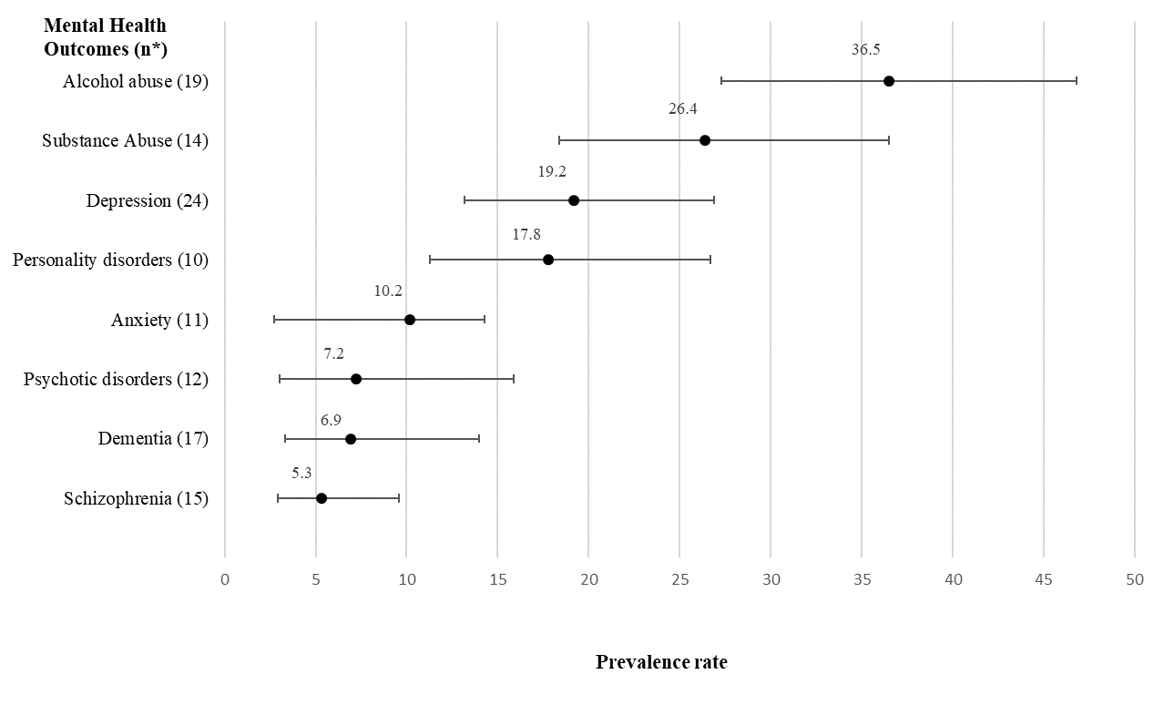
Figure 2. Overall pooled prevalence for most frequently reported Mental Health Outcomes. Note: n*= number of studies included in the meta-analysis of the outcome. The forest plots with the prevalence rates for each study, the pooled prevalences for the meta-analysis of each mental health outcome and the heterogeneity measure ( I²) are reported in Appendix C, Tables C1 – C8.

TABLE 2:

 |  |  | Modelª |  | Goodness of fit^{b} |  | Total^{c}
Category | Outcome | Confounder | Q | Df | Q | Df | Q | Df | R²
MH | Substance abuse | Country | 10.13*** | 1 | 407.21*** | 12 | 416.96*** | 13 | 0.43
 |  | Diagnosis Method | 51.13*** | 3 | 130.58*** | 10 | 416.96*** | 13 | 0.38
 |  | Gender | 8.58** | 1 | 399.97*** | 12 | 416.96*** | 13 | 0.38
MH | Alcohol Abuse | Gender | 5.56* | 1 | 304.44*** | 17 | 671.81** | 18 | 0.24
MH | Personality Disorders | Country | 19.94*** | 2 | 67.14*** | 7 | 241.59*** | 9 | 0.73
MH | Depression | Country | 13.59** | 2 | 14.96*** | 21 | 2268.54*** | 23 | 0.38
 |  | Diagnosis Method | 22.37*** | 3 | 1094.05*** | 20 | 2268.54*** | 23 | 0.51
 |  | Gender | 19.89*** | 2 | 1263.37*** | 21 | 2268.54*** | 23 | 0.48
MH | Schizophrenia | Country | 7.03*** | 1 | 267.78*** | 13 | 1127.58*** | 14 | 0.38
 |  | Sample Type | 27.42*** | 1 | 194.17*** | 13 | 1127.58*** | 14 | 0.70
MH | Psychotic Disorder | Sample Type | 27.88*** | 2 | 101.40*** | 9 | 873.22*** | 11 | 0.79
PH | Hypertension | Country | 16.51*** | 2 | 2975.34*** | 25 | 3153.35*** | 27 | 0.39
 |  | Diagnosis Method | 10.99* | 3 | 3045.64*** | 25 | 3153.35*** | 27 | 0.3
PH | Asthma | Diagnosis Method | 50.35*** | 3 | 33.84*** | 7 | 537.78*** | 10 | 0.9
 |  | Gender | 12.31** | 2 | 91.42*** | 8 | 537.78*** | 10 | 0.62
PH | Hepatitis C | Diagnosis Method | 35.75*** | 3 | 3631.59*** | 8 | 4516.98*** | 11 | 0.76
PH | HIV | Diagnosis Method | 87.05*** | 2 | 57.89*** | 9 | 293.3 | 11 | 0.93
PH | Arthritis, Rheumatism or Osteoporosis (ARO) | Diagnosis Method | 19.75*** | 2 | 329-53*** | 13 | 2015.72*** | 15 | 0.6
 |  | Sample Type | 15.11*** | 1 | 1994.09*** | 14 | 2015.72*** | 15 | 0.47
Table 2. Meta-regression analyses for mental health and physical health outcomes. Separate meta-regression analyses were ran for each confounder and outcome. MH = Mental health.PH = Physical health. a. Test of the model: Simultaneous test that all coefficients (excluding intercept) are zero. b. Goodness of fit: test that unexplained variance is zero. c. Total between-study variance (intercept only). *** p< 0.001; ** p<0.01; *p<0.05. Only variables where the meta-regression showed a significant effect are presented in the table.

FIGURE 3:
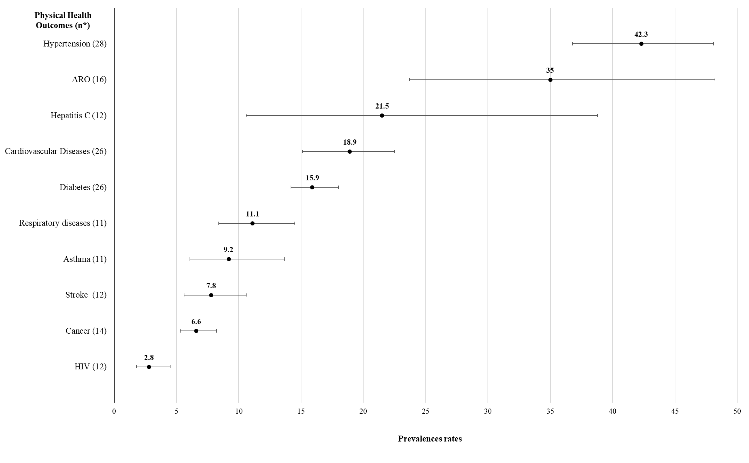
Figure 3. Overall pooled prevalence for most frequently reported Physical Health Outcomes. Note: n*= number of studies included in the meta-analysis of the outcome. The forest plots with the prevalence rates for each study, the pooled prevalences for the meta-analysis of each physical health outcome and the heterogeneity measure (I²) are reported in Appendix C, Tables C9 – C18.

FIGURE 4:

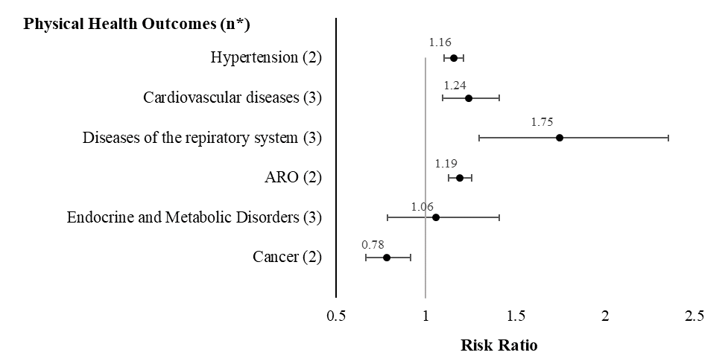
Figure 4. Risk Ratios physical health outcomes. Note: n*= number of studies included in the meta-analysis of the outcome. ARO = Arthritis, Rheumatism or Osteoporosis. The forest plots, the risk ratio for each study, the overall risk ratio for each outcome and the measure of heterogeneity (I² ) for the meta-analysis of each physical health outcome are reported in Appendix D.

