Supplementary Information

Silver nanofluids based broadband solar absorber obtained by tuning nanosilver geometries
Harriet Kimpton^{ab}, Eugen Stulz^{b*}, Xunli Zhang^{a*}
ª School of Engineering, University of Southampton, University Road, Southampton, SO17 1BJ, UK
^{b} School of Chemistry, University of Southampton, University Road, Southampton, SO17 1BJ, UK
* Corresponding Authors: X. Zhang (XL.Zhang@soton.ac.uk); E. Stulz (est@soton.ac.uk)

Supplementary information

Concentrations of nanofluids
The concentration of silver in the nanofluids employed are given in Table S1. Note that this is the concentration of silver in the starting solution and is not necessarily the concentration of nanoparticles. The starting concentrations for P-A, P-B and P-C were selected based on prior knowledge of the synthesis to ensure ease and consistency of reaction and to give a final H_{peak} of < 1.6 au for the mixture M using a 10 mm path length cuvette without the need to centrifuge to concentrate the nanofluids.
Table S1 Concentration of nanofluids
Nanofluid | Concentration Ag / mM | Concentration Ag / wt% Ag
P-A | 0.100 | 0.00108
P-B | 0.300 | 0.00324
P-C | 0.457 | 0.00493
P-D | 0.247 | 0.00266

Calculation of AE_{(300-1350nm)} to determine the optimum mixture
The values obtained for the UV-vis-IR spectra for the three repeats of each of the three nanofluids (P-A1, A2, A3, P-B1, B2 and B3 and P-C1, C2 and C3) were averaged and AE_{(300-1350nm)} for various mixtures calculated. To allow for the dilution of P-B and P-C, the spectra for P-B was times by 3 (diluted 1 ml in 3 ml) and for P-C by 5 (diluted 0.6 ml in 3 ml).
The results are given in Table S2.
Table S2 Calculations of optimum mixture. Note although not the optimum in terms of AE_{(300-1350nm)}, the recipe corresponding to calculation 7 was chosen as it minimized the amount of P-B, the least stable nanofluid.
Calculation number | P-A / % | P-B / % | P-C / % | Calculated AE_{(300-1350nm)} / % | Concentration Ag / mM | Concentration Ag / wt%
1 | 70 | 10 | 20 | 80.28 | 0.1914 | 0.00207
2 | 70 | 20 | 10 | 80.79 | 0.1757 | 0.00190
3 | 60 | 10 | 30 | 80.93 | 0.2271 | 0.00245
4 | 60 | 20 | 20 | 82.45 | 0.2114 | 0.00228
5 | 60 | 30 | 10 | 82.20 | 0.1957 | 0.00211
6 | 50 | 10 | 40 | 80.33 | 0.2628 | 0.00283
7 | 50 | 20 | 30 | 82.52 | 0.2471 | 0.00267
8 | 50 | 30 | 20 | 83.14 | 0.2314 | 0.00250
9 | 50 | 40 | 10 | 82.61 | 0.2157 | 0.00233
10 | 40 | 10 | 50 | 78.71 | 0.2985 | 0.00322
11 | 40 | 20 | 40 | 81.43 | 0.2828 | 0.00305
12 | 40 | 30 | 30 | 82.63 | 0.2671 | 0.00288
13 | 40 | 40 | 20 | 82.86 | 0.2514 | 0.00271
14 | 40 | 50 | 10 | 82.31 | 0.2357 | 0.00254

Measurements of Intensity for the Xenon lamp
Measurement performed using a ReRA System calibrated silicon cell connected to a Keithly Power supply. Cell calibrated at Radboud University Nijmegen PV measurement facility. The calibration is performed using an NREL calibrated reference cell. This type of reference is well suited for indoor solar simulator applications.
The fill factor (FF) of a PV cell is defined as:
$$FF= \frac{V_{max}I_{max}}{V_{oc}I_{sc}}×100$$
Equation S1
Where V_{max} in volts is the maximum voltage obtained from the cell, I_{max} is the maximum current (A), V_{oc} is the open circuit voltage and I_{sc} is the short circuit current. This can then be used to calculate the cell efficiency η_{cell}:
$$η_{cell}= \frac{FFV_{oc}I_{sc}}{P_{in}}$$
Equation S2
Where P_{in} is the power incident on the cell (equivalent to the intensity) in W. If the area of the cell is then known this can be equated to the intensity of the light.
When the value of I_{sc} is equal to the calibration value of the cell the output from the lamp is 1000 W/m². The calculated value of η_{cell} is then used to determine the new value of P_{in} with the lamp at the setting used in the experiments from rearranging Equation S2.
Table S3 Measurements of I_{s} / Wm⁻²using a ReRA System calibrated silicon cell (area of cell 3.6 cm²).
 | I_{sc} / mA | V_{oc} / V | I_{max} /mA | V_{max} / V | FF / % | η_{cell} | P_{in} / W | Intensity I_{s} / Wm⁻²
Calibration value | 89.7
Measured value (1000 W/m²) | 89.9 ± 3.5 (n=4) | 0.547 | 79.55 | 0.374 | 60.46 | 8.26 ± 0.25 | 0.36 | 1000
At lamp setting (n = 9) | 107.46 ± 5.7 | 0.554 | 103.14 ± 6.38 | 0.344 ± 0.02 | 59.54 ± 2.72 | 8.26 | 0.429 ± 0.01 | 1191.2 ± 40.29

Uncertainty Analysis

Table S4 Uncertainty of constant C_{w}M_{w}/I_{s}A_{s} for SSL tests. The half width between the upper and lower limits is denoted by a. The standard deviation is denoted by s and n is the number of measurements
Source of Uncertainty | Comment | Value / % | Probability distribution | Divisor | Standard uncertainty | Unit
Change in C_{w} with temperature | C_{w} changes from 4.184 to 4.180 KJKg⁻¹K⁻¹ over range 20 - 40°C | 0.11 | rectangular | a/√3 | 0.07 | %
Uncertainty in measuring M_{w} | 1000 µl Micropipette used to measure amount with accuracy of ± 0.3% | 0.3 | rectangular | a/√3 | 0.17 | %
Change in A_{s} with temperature | Due to thermal expansion of liquid | 2.0 | rectangular | a/√3 | 1.15 | %
Variation in I_{s} due to lamp output variation | Lamp output varies by ± 6% | 6.0 | rectangular | a/√3 | 3.46 | %
Uncertainty in measuring I_{s} | Using ReRA calibrated PV cell I is 1191.16 ± 40.29. n is 9 | 3.38 | normal | s/√n | 1.13 | %
Uncertainty of temperature measurement because of thermocouples | Assumed to be ± 0.5°C which equates to 0.5/20*100 % | 2.50 | rectangular | a/√3 | 1.44 | %
Combined standard uncertainty |  |  | Assumed normal |  | 4.09 | %
Expanded uncertainty (k = 2 is approximately 95% confidence level) |  |  | assumed normal (k = 2) |  | 8.18 | %

Table S5 Values obtained for the expanded uncertainty (total of type A and Type B) for the different nanofluids measured under SSL. A coverage factor (k) of 2 has been used which corresponds to a confidence interval of approximately 95%
Sample | ∆T / °C | Combined total uncertainty (A + B) / % | Expanded uncertainty (k = 2) / %
Water | 3.641 ± 0.177 (n = 3) | 4.96 | 9.92
M | 10.590 ± 0.165 (n = 9) | 4.12 | 8.24
P-A | 8.231 ± 0.619 (n = 9) | 4.80 | 9.59
P-B | 8.538 ± 0.817 (n = 9) | 5.19 | 10.37
P-C | 6.822 ± 0.419 (n = 9) | 4.57 | 9.15

Table S6 Uncertainty of UV-visible-IR measurements (type B only). The half width between the upper and lower limits is denoted by a. The standard deviation is denoted by s and n is the number of measurements
Source of Uncertainty | Comment | Value / % | Probability distribution | Divisor | Standard uncertainty | Unit
Resolution of wavelength | Step rate 1 nm. Max uncertainty is at 200 nm | 0.5 | rectangular | a/√3 | 0.29 | %
Ability to determine H_{peak} | Assumed similar to wavelength resolution | 0.5 | rectangular | a/√3 | 0.29 | %
AE calculations | Taken as the combined standard uncertainty of H_{peak} x λ_{max} |  | Assumed normal |  | 0.41 | %
Expanded uncertainty for λ_{max} | Using k = 2 |  | Assumed normal |  | 0.58 | %
Expanded uncertainty for H_{peak} | Using k = 2 |  | Assumed normal |  | 0.58 | %
Expanded uncertainty for AE calculations | Using k = 2 |  | Assumed normal |  | 0.82 | %

Table S7 Values obtained for the expanded uncertainty (total of type A and Type B) for the calculation of AE from UV-visible-IR spectroscopy. A coverage factor (k) of 2 has been used which corresponds to a confidence interval of approximately 95%
Sample | AE_{lamp (330 – 1100 nm)} | Combined total uncertainty (A + B) / % | Expanded uncertainty (k = 2) / %
M | 92.75 ± 1.37 (n = 12) | 0.59 | 1.18
P-A | 57.81 ± 1.78 (n = 9) | 1.10 | 2.21
P-B | 73.97 ± 2.02 (n = 9) | 1.00 | 2.00
P-C | 46.29 ± 4.61 (n = 9) | 3.34 | 6.69

Table S8 Uncertainty of TEM measurements using P-A triangles and P-A thickness as examples. The half width between the upper and lower limits is denoted by a. The standard deviation (StDev) is denoted by s and n is the number of measurements
Source of Uncertainty | Comment | Value / % | Probability distribution | Divisor | Standard uncertainty | Unit
calibration of line length (type B) | Resolution of 100 nm line used to calibrate line length 200 pixels - assumed to be ± 1 nm | 1.00 | rectangular | a/√3 | 0.58 | %
Resolution of TEM (type B) | Assumed to be ± 1 nm - for a particle of 50 nm | 2.00 | rectangular | a/√3 | 1.15 | %
For P-A triangles before SSL (Type A) | Mean = 52.2 ± 17.6 where n = 153 | 33.72 | normal | s/√n | 2.73 | %
For P-A thickness before SSL (Type A) | Mean = 5.9 ± 2.6 where n = 102 | 44.07 | normal | s/√n | 4.36 | %
Expanded uncertainty for P-A triangles | Using k = 2 |  | Assumed normal |  | 6.03 | %
Expanded uncertainty for P-A thickness | Using k = 2 |  | Assumed normal |  | 9.10 | %

IR results before exposure to SSL

P-A
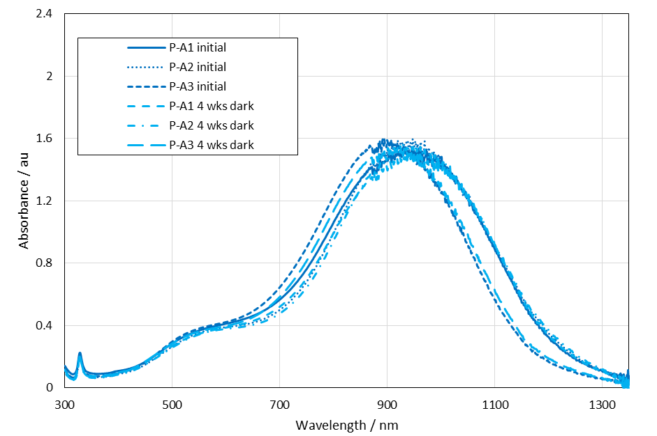Figure S1 UV-visible-IR spectra for P-A samples initially and after storage in the dark for 4 weeks. All measured with a 10mm path length cuvette
Table S9 λ_{max} and H_{peak} values for P-A samples initially and after 4 weeks storage in the dark
Sample | λ_{max} / nm | H_{peak} / au | Sample | λ_{max} / nm | H_{peak} / au
P-A1 initial | 946 | 1.542 | P-A1 4 wks dark | 947 | 1.517
P-A2 initial | 948 | 1.595 | P-A2 4 wks dark | 930 | 1.560
P-A3 initial | 892 | 1.595 | P-A3 4 wks dark | 913 | 1.538
Average | 929 | 1.577 | Average | 930 | 1.538
Standard deviation (StDev) | 31.8 | 0.031 | StDev | 16.5 | 0.022
N | 3 | 3 | N | 3 | 3

Significance testing of change for P-A
Using a two sample T-test (see below) the significance of the change in spectra after 4 weeks storage in the dark at 4ºC was calculated. For λ_{max} and H_{peak} the difference was not significant at the 95% confidence interval.

Definition of T-test
A T-test is a hypothesis test that allows you to compare means. A two-sample T-test allows the comparison between two means from two different sets of samples. The null hypothesis is that the two means are the same. The formula is:

$$t= \frac{{\overline{X}}_{2}-{\overline{X}}_{1}}{\sqrt{s^{2}\left(\frac{1}{n_{1}}\right.}+\left.\frac{1}{n_{2}}\right)}$$
Equation S3
Where t = T value (which can be looked up in standard T-tables or using a statistical software package to determine significance). ${\overline{X}}_{1}$ = Mean of sample 1 and ${\overline{X}}_{2}$ = Mean of sample 2, n₁ and n₂ are the number of results in each sample set and s² is the pooled sample variance given by the equation:

$$s^{2}= \frac{\sum_{i=1}^{n_{1}}{{\left(X_{i}-{\overline{X}}_{1}\right)}^{2}+\sum_{j=1}^{n_{2}}{{\left(X_{j}-{\overline{X}}_{2}\right)}^{2}}}}{n_{1}+n_{2}-2}$$
Equation S4

P-B
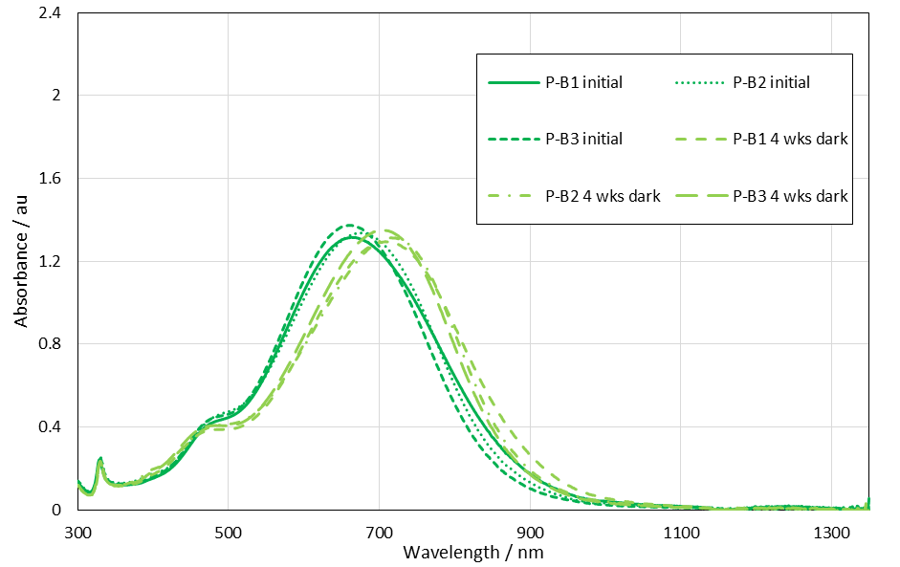Figure S2 UV-visible-IR spectra for P-B samples initially and after storage in the dark for 4 weeks. All measured with a 10mm path length cuvette. Note that P-B samples diluted 1 ml in 3 ml from initial concentration

Table S10 λ_{max} and H_{peak} values for P-B samples initially and after 4 weeks storage in the dark
Sample | λ_{max} / nm | H_{peak} / au | Sample | λ_{max} / nm | H_{peak} / au
P-B1 initial | 664 | 1.315 | P-B1 4 wks dark | 708 | 1.294
P-B2 initial | 676 | 1.336 | P-B2 4 wks dark | 716 | 1.312
P-B3 initial | 661 | 1.374 | P-B3 4 wks dark | 704 | 1.352
Average | 667 | 1.342 | Average | 709 | 1.319
StDev | 7.9 | 0.030 | StDev | 6.1 | 0.030
N | 3 | 3 | N | 3 | 3

Significance testing of change for P-B
Using a two sample T-test the significance of the change in spectra after 4 weeks storage in the dark at 4ºC was calculated. For H_{peak} the difference was not significant at the 95% confidence interval, however, for λ_{max} the difference was significant.

P-C
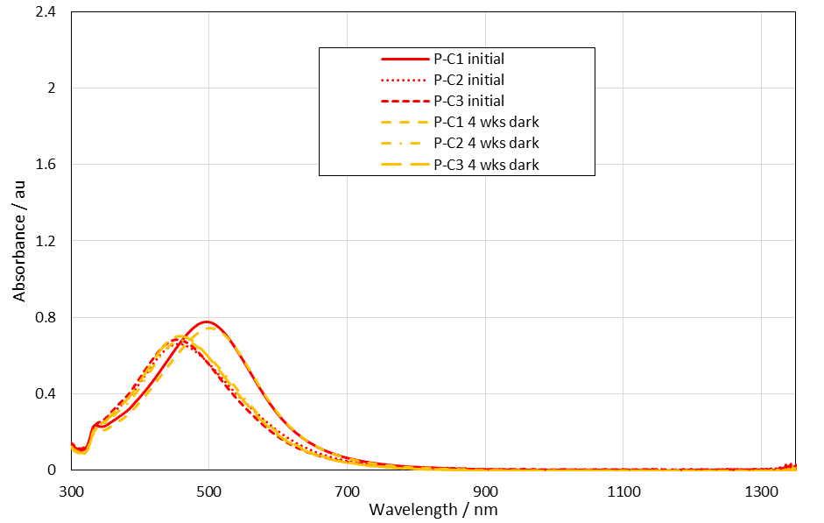Figure S3 UV-visible-IR spectra for P-C samples initially and after storage in the dark for 4 weeks. All measured with a 10mm path length cuvette.P-C samples diluted 0.6 ml in 3 ml.
Table S11 λ_{max} and H_{peak} values for P-C samples initially and after 4 weeks storage in the dark
Sample | λ_{max} / nm | H_{peak} / au | Sample | λ_{max} / nm | H_{peak} / au
P-C1 initial | 497 | 0.777 | P-C1 4 wks dark | 499 | 0.744
P-C2 initial | 454 | 0.662 | P-C2 4 wks dark | 460 | 0.679
P-C3 initial | 454 | 0.684 | P-C3 4 wks dark | 457 | 0.704
Average | 468 | 0.708 | Average | 472 | 0.709
StDev | 24.8 | 0.061 | StDev | 23.4 | 0.033
N | 3 | 3 | N | 3 | 3

Significance testing of change for P-C
Using a two sample T-test the significance of the change in spectra after 4 weeks storage in the dark at 4ºC was calculated. For λ_{max} and H_{peak} the difference was not significant at the 95% confidence interval.

Mixture M

Figure S4 UV-visible-IR spectra for M samples calculated from component nanofluid spectra. Mixture recipe 50% P-A, 20% P-B, 30% P-C. All initial measurements performed with a 10mm path length cuvette.
Table S12 λ_{max} and H_{peak} values for M samples calculated from absorption values of component nanofluids
Sample | λ_{max} / nm | H_{peak} / au
M1 - calculated | 504 | 1.576
M2 - calculated | 470 | 1.319
M3- calculated | 466 | 1.358
Average | 480 | 1.418
StDev | 20.9 | 0.138
N | 3 | 3

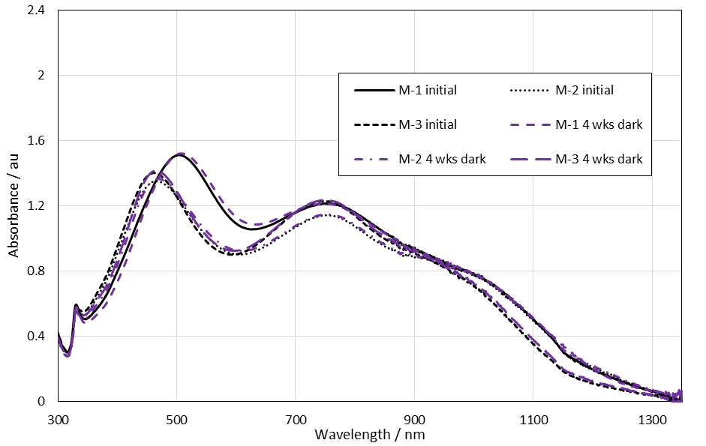Figure S5 UV-visible-IR spectra for M samples initially and after storage in the dark for 4 weeks. All measured with a 10mm path length cuvette..
Table S13 λ_{max} and H_{peak} values for M samples initially and after 4 weeks storage in the dark. Only the primary peak position shown
Sample | λ_{max} / nm | H_{peak} / au | Sample | λ_{max} / nm | H_{peak} / au
M-1 initial | 502 | 1.511 | M-1 4 wks dark | 506 | 1.520
M-2 initial | 463 | 1.351 | M-2 4 wks dark | 468 | 1.365
M-3 initial | 462 | 1.400 | M-3 4 wks dark | 466 | 1.417
Average | 476 | 1.421 | Average | 480 | 1.434
StDev | 22.8 | 0.082 | StDev | 22.5 | 0.079
N | 3 | 3 | N | 3 | 3

Significance testing of change for M
Using a two sample T-test the significance of the change in spectra after 4 weeks storage in the dark at 4ºC was calculated. For λ_{max} and H_{peak} the difference was not significant at the 95% confidence interval.

Size analysis from TEM before solar simulator testing
Table S14 Size analysis initial
 |  | P-A | P-B | P-C | M
Triangles | Mean / nm | 52.2 | 27.5 | 27.3 | 31.2
 | StDev / nm | 17.6 | 7.6 | 15.9 | 13.9
 | N | 153 | 157 | 5 | 67
 | % | 68.6 | 43.8 | 1.0 | 7.7
Rounded corner triangles | Mean /nm | 22.8 | 23.7 | 17.3 | 19.4
 | StDev /nm | 7.2 | 6.7 | 4.5 | 5.7
 | N | 13 | 89 | 30 | 75
 | % | 5.8 | 24.9 | 6.1 | 8.7
Other | Mean / nm | 17.6 | 18.2 | 15.9 | 15.1
 | StDev / nm | 8.0 | 6.7 | 4.2 | 5.1
 | N | 32 | 58 | 204 | 347
 | % | 14.4 | 16.2 | 41.6 | 40.0
Small (< 10 nm) | Mean / nm | 6.1 | 5.8 | 6.3 | 6.4
 | StDev / nm | 1.6 | 1.2 | 1.6 | 2.2
 | N | 25 | 54 | 252 | 378
 | % | 11.2 | 15.1 | 51.3 | 43.6
Thickness | Mean / nm | 5.9 | 4.7 | 5.0 | 4.1
 | StDev / nm | 2.6 | 1.3 | 1.1 | 1.2
 | N | 102 | 75 | 143 | 103
P-A thickness significantly thicker compared to P-B thickness according to a two sample T-test at a confidence level of 95%. Range of values for P-A thickness = 5.4 -6.4 nm (95% confidence interval (CI) for mean) and for P-B = 4.4 – 5.0 nm (95% CI). This analysis excludes the measurement uncertainty for the technique (2.6%).
P-A thickness significantly thicker compared to P-C again using a two sample T-test. P-C range of thickness = 4.8 – 5.2 nm (95% CI).
P-B thickness the same as P-C thickness according to a two sample T-Test.

Amount of G173 solar spectra absorbed
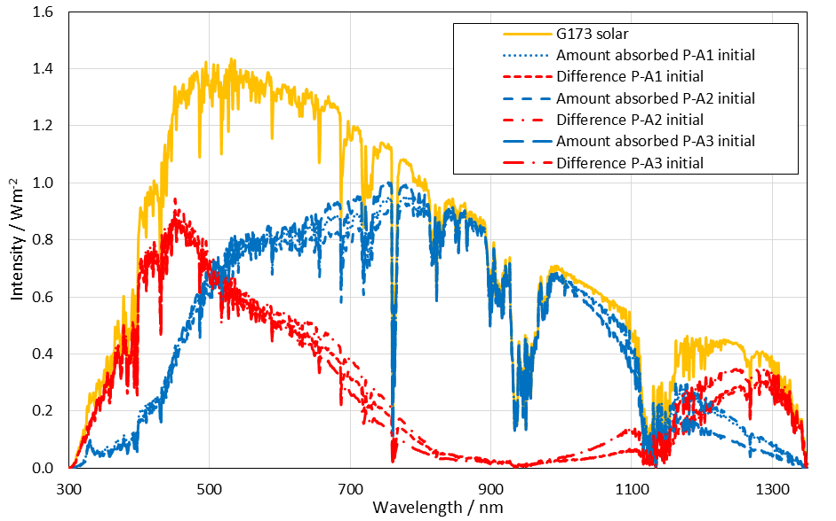Figure S6 Amount of G173 solar reference spectra power absorbed and not absorbed (labeled as difference) at different wavelength for the P-A samples calculated from the UV-visible-IR measurements undertaken initially
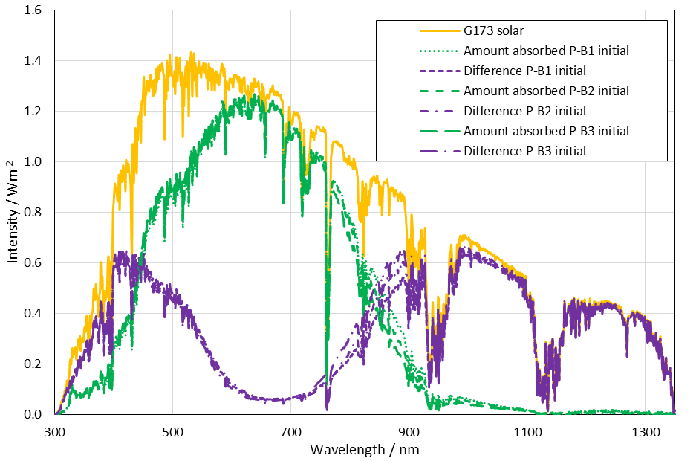Figure S7 Amount of G173 solar reference spectra power absorbed and not absorbed (labeled as difference) at different wavelength for the P-B samples calculated from the UV-visible-IR measurements undertaken initially
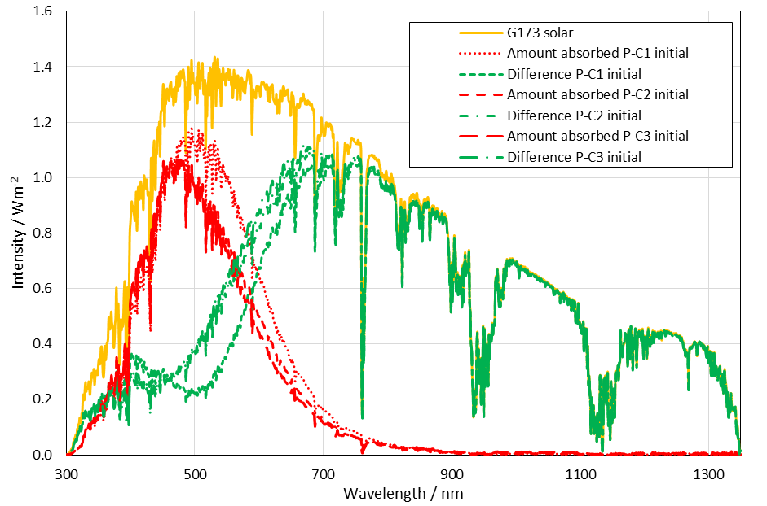Figure S8 Amount of G173 solar reference spectra power absorbed and not absorbed (labeled as difference) at different wavelength for the P-C samples calculated from the UV-visible-IR measurements undertaken initially
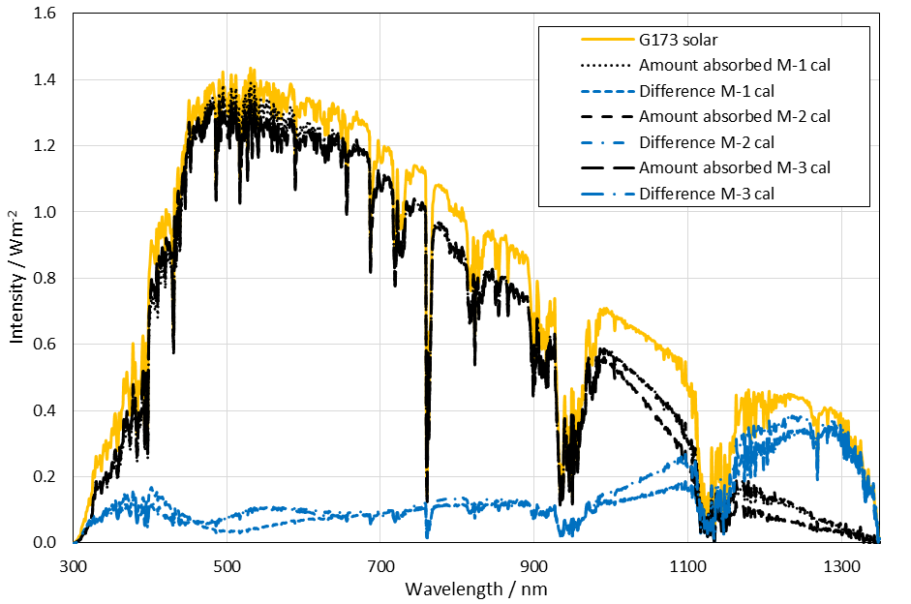Figure S9 Amount of G173 solar reference spectra power absorbed and not absorbed (labeled as difference) at different wavelength for the M samples calculated from the UV-visible-IR measurements undertaken on the componet nanofluids P-A, P-B and P-C
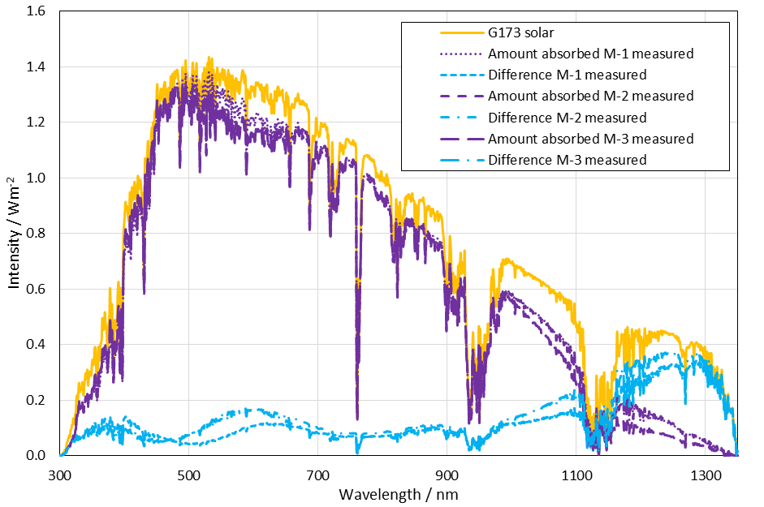Figure S10 Amount of G173 solar reference spectra absorbed and not absorbed (labeled as difference) at different wavelength for the M samples calculated from the UV-visible-IR measurements undertaken initially

Analysis of variance (ANOVA)
One way ANOVA is a generalisation of the two sample t-test for more than two samples. The null hypothesis is that all the means are equal and the alternative hypothesis is that at least one mean is different. Normally equal variances and normally distributed data are assumed for the analysis. Instead of a T value an F statistic is used (again this can be looked up in standard tables or using a statistics software package). In this case:
$$F= \frac{MST}{MSE}$$
Equation S5
Where MST is the mean square between different groups and MSE is the mean square due to error.
$$MST= \frac{\sum_{i=1}^{k}{\left({T_{i}^{2}}/{n_{i}}\right)-{G^{2}}/n}}{k-1}$$
Equation S6
Where T_{i} is the total for one group, G is the total for all observations, k is the number of means, n_{i} is the number of observations in group i and n is the total number of observations.
$$MSE= \frac{\sum_{i=1}^{k}{\sum_{j=1}^{n_{i}}{Y_{ij}^{2}- \sum_{i=1}^{k}{\left({T_{i}^{2}}/{n_{i}}\right)}}}}{n-k}$$
Equation S7
Where MSE is the mean square due to error and Y_{ij} is an observation or measurement. In this work a standard software package (Minitab version 17.3.1) was used to undertake ANOVA analysis. The output from this software package assigns a different letter to each group that is significantly different from another group.
Table S15 Results of calculating AE_{(300-1350 nm)} from the UV-visible-IR data. The initial, after 4 weeks storage and after exposure to SSL for 30 minutes has been used giving N = 9. In addition for M the calculated spectral data has been included (hence for M, N = 12). Means that do not share the same letter are significantly different (see analysis of variance section in SI)
Nanofluid type | N | Grouping | Mean AE_{(300-1350 nm)} / % | StDev / % | 95% CI
M | 12 | A | 81.80 | 2.23 | 80.11 – 83.48
P-A | 9 | B | 62.80 | 1.96 | 60.86 – 64.75
P-B | 9 | C | 52.93 | 4.65 | 50.99 – 54.88
P-C | 9 | D | 28.32 | 1.95 | 26.38 – 30.27

UV-visible-IR after SSL testing
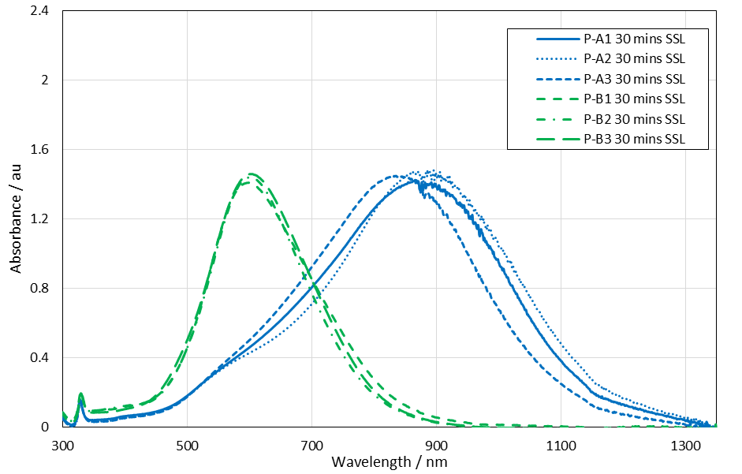Figure S11 UV-visible-IR spectra for P-A and P-B samples after 30 minutes exposure to SSL. All measured with a 10mm path length cuvette.P-B samples diluted 1 ml in 3 ml.
Table S16 λ_{max} and H_{peak} values for P-A and P-B samples after 30 minutes exposure to SSL
Sample | λ_{max} / nm | H_{peak} / au | Sample | λ_{max} / nm | H_{peak} / au
P-A1 30 minutes SSL | 866 | 1.423 | P-B1 30 minutes SSL | 598 | 1.409
P-A2 30 minutes SSL | 886 | 1.481 | P-B2 30 minutes SSL | 602 | 1.441
P-A3 30 minutes SSL | 840 | 1.447 | P-B3 30 minutes SSL | 601 | 1.457
Average | 864 | 1.451 | Average | 600 | 1.436
StDev | 23.1 | 0.029 | StDev | 2.1 | 0.024
N | 3 | 3 | N | 3 | 3

Significance testing of change after SSL testing for P-A and P-B
Using a two sample T-test the significance of the change in spectra after SSL exposure for 30 minutes compared with the spectra after 4 weeks storage in the dark at 4ºC was calculated. For P-A and P-B λ_{max} and H_{peak} were both significantly different after 30 minutes of exposure to SSL.

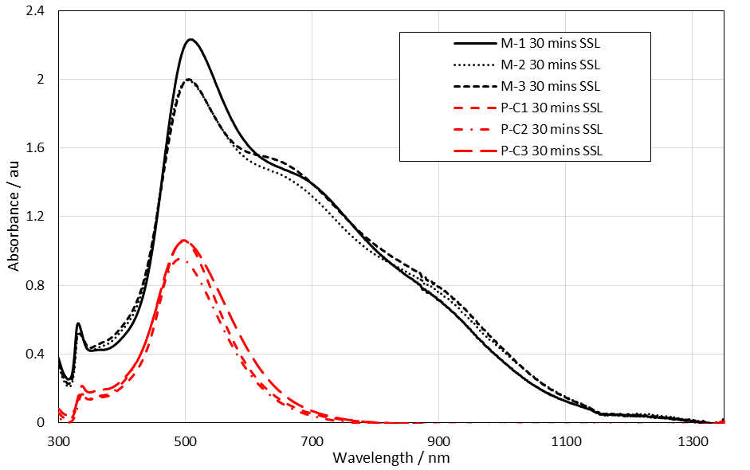Figure S12 UV-visible-IR spectra for P-C and M samples after 30 minutes exposure to SSL. All measured with a 10mm path length cuvette.P-C samples diluted 0.6 ml in 3 ml.
It should be noted that the value of H_{peak} for the mixture was on average >2 which is not ideal due to potential linearity issues when H_{peak} > 2 but it was felt important to use the same path length for the mixture as used previously.
Table S17 λ_{max} and H_{peak} values for P-C and M samples after 30 minutes exposure to SSL. Note that for M samples only the position and height of the primary peak is shown
Sample | λ_{max} / nm | H_{peak} / au | Sample | λ_{max} / nm | H_{peak} / au
P-C1 30 minutes SSL | 497 | 1.060 | M-1 30 minutes SSL | 509 | 2.231
P-C2 30 minutes SSL | 493 | 0.957 | M-2 30 minutes SSL | 505 | 1.993
P-C3 30 minutes SSL | 498 | 1.059 | M-3 30 minutes SSL | 506 | 2.000
Average | 496 | 1.025 | Average | 507 | 2.075
StDev | 2.6 | 0.059 | StDev | 2.1 | 0.136
N | 3 | 3 | N | 3 | 3

Significance testing of change after SSL for P-C and M
Using a two sample T-test the significance of the change in spectra after SSL exposure for 30 minutes compared with the spectra after 4 weeks storage in the dark at 4ºC was calculated. For P-C and M the change in λ_{max} was not significant but the change in H_{peak} was at a confidence interval of 95% after 30 minutes of exposure to SSL.

Amount of solar spectrum absorbed after exposure to SSL
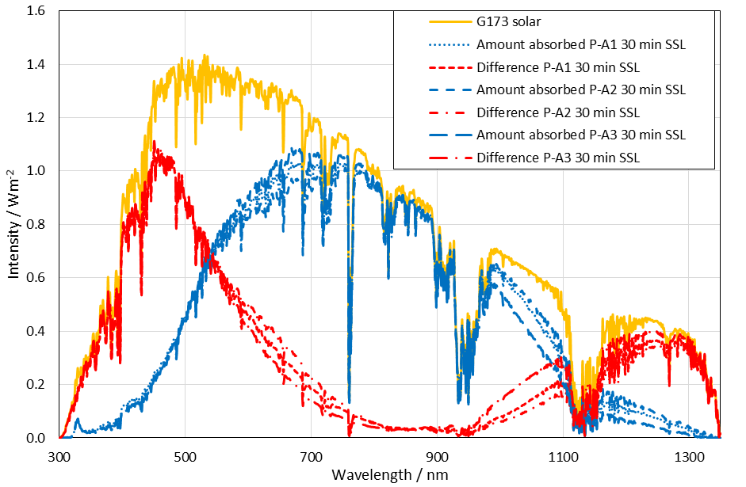Figure S13 P-A after SSL amount of reference spectra absorber / not absorbed
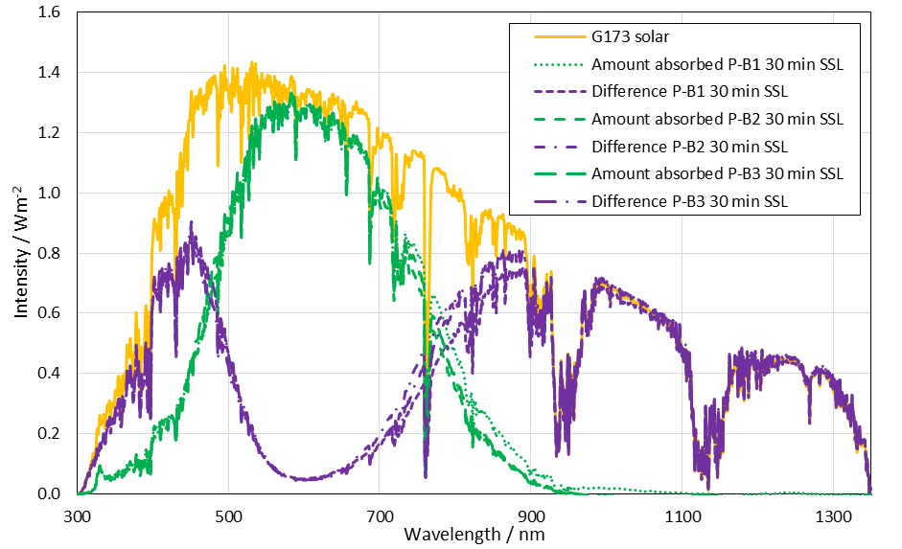Figure S14 P-B after SSL amount of reference spectra absorber / not absorbed

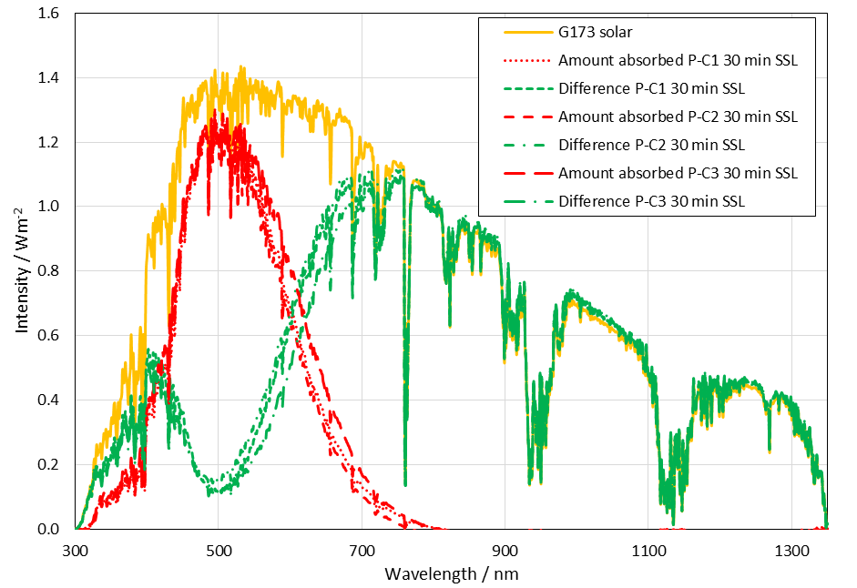Figure S15 P-C after SSL amount of reference spectra absorber / not absorbed
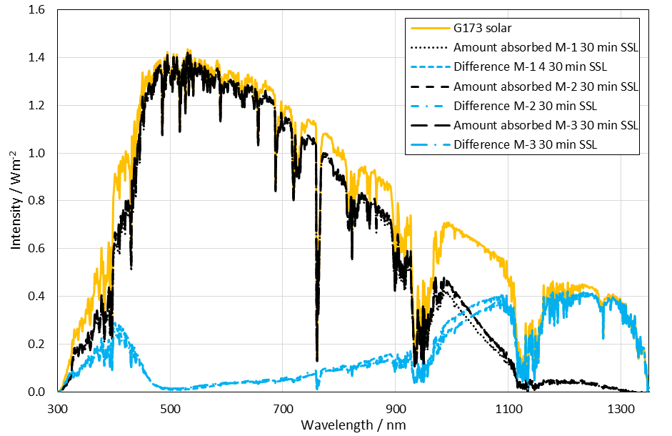Figure S16 Mixture M after SSL amount of reference spectra absorber / not absorbed

Size analysis from TEM after exposure to SSL
Table S18 Size analysis from TEM micrographs after 30 minutes SSL exposure
 |  | P-A | P-B | P-C | M
Triangles | Mean / nm | 54.5 | 30.6 | 27.9 | 27.5
 | StDev / nm | 15.4 | 7.2 | 12.1 | 10.3
 | N | 95 | 27 | 4 | 71
 | % | 32.2 | 11.0 | 1.3 | 6.0
Rounded corner triangles | Mean /nm | 37.9 | 23.3 | 18.6 | 21.2
 | StDev /nm | 9.4 | 6.1 | 6.2 | 7.4
 | N | 114 | 50 | 10 | 110
 | % | 38.7 | 20.3 | 3.3 | 9.2
Other | Mean / nm | 36.1 | 20.8 | 15.6 | 15.3
 | StDev / nm | 19.7 | 6.4 | 4.8 | 4.2
 | N | 57 | 141 | 142 | 475
 | % | 19.3 | 57.3 | 47.0 | 39.9
Small (< 10 nm) | Mean / nm | 7.3 | 6.5 | 6.3 | 6.6
 | StDev / nm | 1.8 | 1.9 | 2.0 | 2.1
 | N | 29 | 28 | 146 | 534
 | % | 9.8 | 11.4 | 48.4 | 44.9
Thickness | Mean / nm | 5.6 | 5.0 | 4.6 | 4.5
 | StDev / nm | 1.6 | 1.5 | 1.3 | 0.9
 | N | 49 | 69 | 67 | 180

P-A thickness range at 95% confidence interval = 5.2 – 6.1 nm, P-B thickness range – 4.6 – 5.3 nm and P-C thickness 4.3 – 4.9 nm and the mixture M thickness range = 4.4 – 4.7 nm.

