Cohesion Network Analysis:
Customized Curriculum Management in Moodle

Gabriel Gutu-Robu, Darius Mihai, Mihai Dascalu, Mihai Carabas, Stefan Trausan-Matu
Computer Science Department
University Politehnica of Bucharest
Bucharest, Romania
{gabriel.gutu, darius.mihai, mihai.dascalu, mihai.carabas, stefan.trausan}@upb.ro
Sunhea Choi, Keith M. Godfrey
Faculty of Medicine, University Hospital Southampton
University of Southampton
Southampton, United Kingdom
s.choi@soton.ac.uk, kmg@mrc.soton.ac.uk
Brigitte Angela Brands, Berthold Koletzko⁵
Division of Metabolic Diseases and Nutritional Medicine
Ludwig-Maximilians-Universität Munich
München, Germany
{brigitte.brands, berthold.koletzko}@med.uni-muenchen.de

Abstract—Learning Management Systems frequently act as platforms for online content which is usually structured hierarchically into modules and lessons to ease navigation. However, the volume of information may be overwhelming, or only part of the lessons may be relevant for an individual; thus, the need for customized curricula emerges. We introduce a Moodle plugin developed to help learners customize their curriculum to best fit their learning needs by relying on specific filtering criteria and semantic relatedness. For this experiment, a Moodle instance was created for doctors working in the field of nutrition in early life. The platform includes 78 lessons tackling a wide variety of topics, organized into five modules. Our plugin enables users to specify basic filtering criteria, including their field of expertise, topics of interest from a predefined taxonomy, or expected themes (e.g., background knowledge, practice & counselling, or guidelines) for a preliminary pre-screening of lessons. In addition, learners can also provide a description in natural language of their learning interests. This text is compared with each lesson’s description using Cohesion Network Analysis, and lessons are selected above an experimentally set threshold. Our approach also takes into account prior knowledge requirements, and may suggest lessons for further reading. Overall, the plugin covers the management of the entire course lifecycle, namely: a) creating a customized curriculum; b) tracking the progress of completed lessons; c) generating completion certificates with corresponding CME points.
Keywords—Curriculum Customization; Learning Management System; Cohesion Network Analysis

Introduction
Learning Management Systems (LMSs) have gained an increasing popularity due to digitalization and the necessity for continuing education to accommodate frequent advancements in all domains. Lifelong learning is a challenge for learners who have to study continuously to be up-to-date with advancements in their field. This induces an additional complexity of systems based on machine learning algorithms that need to account for the continual addition of learning content, which may interfere with existing data [1].
In general, courses have their lessons organized in modules to ease navigation. However, students may find it difficult to select the most appropriate lessons when a large number of learning units is provided, or when they want to focus only on specific topics. With so much content available, learners may find themselves confused and may wish to access only part of the content, which might be challenging when performed manually. Computer systems capable of suggesting customized curricula adapted to learners’ needs may support learners in this endeavor.
In this paper we introduce a plugin for the Moodle LMS (https://moodle.org) which generates customized curricula that fit learners’ needs by relying on specific filtering criteria and semantic relatedness. The plugin incorporates several functionalities for handling the entire course lifecycle, namely: a) providing adequate filtering criteria according to learners’ interests, both as predefined options, as well as open-text descriptions of their needs that are semantically linked to the lessons ; b) selecting lessons to be added to the customized curriculum from a list of recommended lessons, including lessons providing recommended prior knowledge and follow-up lessons; c) managing the customized curriculum and tracking current progress; and d) the ability to generate a certificate based on the completed lessons. The novelty of our study comes in incorporating traditional filtering criteria with semantics for generating customized curricula integrated in a LMS. To our knowledge, there are currently no systems available to recommend lessons in Moodle, based on semantic similarity. There are also no existing systems that bring all these facilities together. In addition, the system is highly generalizable by supporting the development of customized curricula for other domains, if specific corpora for training the semantic models is provided.
The paper is structured as follows. First, we provide a state-of-the-art on Learning Management Systems. Second, we briefly describe Natural Language Processing (NLP) techniques relevant for our project, including Cohesion Network Analysis as theoretical framing. The third section explains how the training corpus and the collection of lessons was created, as well as details on the method including an overview of the functionalities provided by the Moodle plugin. The fourth section presents our results, followed by conclusions and future work.

State of the Art
The idea of customizing learning curricula for a particular individual was explored by several researchers looking for suitable methods of providing personalized learning materials, tailored to students’ needs. For example, in a study performed by Sumner, Devaul, Davis and Weatherley [2] teachers were asked to use a curriculum customization service for providing instructions for their classes. The service included animations, together with other visual elements and lists of articles related to the topic of the studied lesson. The aim of this experiment was to replace older techniques that used search mechanisms based on users’ text inputs. Teachers concluded that it was really helpful to integrate such facilities into their teaching, after only using these tools in their class for ten weeks. Students were also pleased and more committed to learning. A similar experiment was performed by the Ministry of Singapore which promoted ideas on redesigning existing learning for curriculum innovation [3]. Teachers could build personalized learning materials for their students using a method that considered common requirements between groups of learners with the final aim of reshaping traditional classroom practices through a redesigned teaching process. Both studies show an emerging need to provide customized curriculum that fit learners’ needs. This served as a motivation for developing our plugin, which enables learners to personalize their curriculum based on their preferences or research interests, which can be expressed in natural language.
Studying based on a course structure induced by curriculum improves learning, as compared to when no curricula are provided [4]. A study by Narvekar, Sinapov and Stone [4] employed automated computer agents to learn sequences of tasks using Markov Decision Processes. Their progress was monitored to produce agent-specific curricula. Algorithms that approximate traces for optimal policies were proposed, and the system was tested in a simulated world, with each automated agent having different capabilities and modelling different learners. A limitation was identified in the experiment: although the approach created a specific curriculum for each particular agent, initial learning content was required. No proper mechanism for generating this initial content was discovered, and different sets of initial tasks potentially had different outcomes. Different scenarios may be required to cover particularities of all individuals, which has to be performed manually. To ease the process, an already created curriculum may be adapted when a new individual appears. Their study [4] also shows that there is a need of an initial set of learning content to rely upon. In our experiment, the knowledge base consists of five learning modules, each containing lessons organized in units. Learners can follow the pre-imposed learning path or create a customized one by applying filtering criteria and describing in natural language their learning interests.
A study by Chen, Liu and Chang [5] proposed a web-based system for generating personalized instructions based on different estimators of learners’ abilities. The aim of their system was to generate an appropriate curriculum for learners, and to facilitate learning by recommending suitable courseware, based on lessons’ difficulty levels. The system found suitable content by analyzing lessons already visited by the learners, together with provided responses to two questions related to the difficulty level and the comprehension score of the courseware. The study showed that generating such personalized courseware can accelerate learning effectiveness. Moreover, Chen, Liu and Chang [5] suggested diagnostic automated agents and user-generated learning pathways as future research ideas. This experiment emphasized the need to allow learners create their own curriculum to improve their learning.
In a follow-up study, Chen [6] considered generating learning paths using genetic-based algorithms to support personalized learning in online platforms. Their system considered the sequence of existing lessons for initiating the learning process, besides the level of difficulty of the tasks. This step brought benefits to those learners who were not aware of any specific learning needs, did not have enough time, or were not willing to cover a large number of learning units for each specific topic. Results showed that the genetic-based e-learning system was preferable to free browsing through the curriculum, due to the quality and conciseness of the generated learning paths. This aspect is clearly covered by our plugin, which not only generates customized curricula, but allows users to select appropriate lessons of interest.
In addition, the idea of curriculum sequencing was investigated by Huang, Huang and Chen [7] to generate individualized courses for each learner, by choosing the most suitable teaching task (such as presentation, example, question, or problem) at a specific time. This approach considered the level of difficulty of the curriculum, as well as the continuity of successive curriculums. A genetic-based approach was used to generate curriculum sequencing, while empirical experiments were performed to indicate that the approach can generate proper lessons, based on individual learners’ requirements.
The previously described studies argue for the efficiency of automated systems to generate personalized curricula based on learner’s particular characteristics, while accounting for the difficulty of learnings units or specific course sequencing constraints. Previous studies by Nistor et al. [8, 9] introduced Natural Language Processing techniques to perform mass customization, a process inspired by economists targeting group learners with similar interests and providing tailored curricula for these clusters. We take the approach one step further by building a system that allows learners to generate customized curricula, rather than following a pre-imposed curriculum. Advanced techniques of estimating semantic similarity scores based on text cohesion are used with the aim of finding the most similar texts out of a collection [10].
Cohesion Network Analysis (CNA) [11] provides a strong background for modeling discourse structure in terms of semantic links between different text units. In this paper we propose an adapted CNA graph containing semantic relations between a description of learner’s interests and lesson descriptions. Besides filtering criteria, learners can customize their curriculum based on a free text describing their learning needs. A semantic similarity threshold is imposed experimentally to filter out associations that are not meaningful enough [12]. ReaderBench [13] (http://readerbench.com) is an advanced multilingual Natural Language Processing framework which incorporates multiple functionalities grounded in CNA for automated text analyses [14, 15]. ReaderBench supports multiple languages, but English language was used for this experiment as the Moodle lessons were written in English.

Method

Moodle Instance
The Moodle instance considered in our experiments contains 78 lessons grouped into five modules, addressing the following topics: a) nutrition and lifestyle during pregnancy; b) breastfeeding; c) breast milk substitutes; d) nutritional care of preterm infants; e) complementary feeding. Each module contains multiple units, and each unit contains multiple lessons. Hierarchical codification is used to understand the linkage between a lesson and its lessons providing prior knowledge and follow-up lessons, which are marked in a separate annotation file created by experts in the medical field (see Table I). In our experiments, lessons are inter-linked based on expert recommendations of prior or future learning materials.
- Filtering criteria included in the annotation list file.
Field | Explanation
Module.Unit.Lesson | Hierarchical codification for each lesson
Topics | List of relevant topics for the lesson
Title | Lesson’s title as shown in the Moodle Instance
Description | Lesson’s text description
Themes | Themes covered by the lesson
Profession | Professions for which the lesson is suitable
Prior knowledge | Links to other lessons to be studied before
Follow-up lessons | Links to other lessons to be studied afterwards
Duration | The required time to study the lesson

The annotation file contains predefined keywords organized in two levels: a central module keyword, and fine-grained keywords specific for different learning modules. Lessons’ descriptions contained an average of 100.2 words, with a standard deviation of 37.4 words, showing a normal distribution. Themes and profession contained subfields that allowed annotators to mark entries where the lessons were most suitable. Each lesson in this annotation file has a corresponding lesson in the Moodle platform.

CNA Curricula Recommendations
Our customized curriculum uses Cohesion Network Analysis to filter out lessons that are not semantically related to the learner’s interests. A CNA graph between learner’s text description and all lesson descriptions is built to best map his/her interests from a semantic perspective, as shown in Fig. 1. Lessons are organized hierarchically. The basic filtering removes lessons according to user’s initial strict choices (the corresponding lessons are crossed with a double blue line in the figure), while semantic filtering is performed using user’s learning interests (lessons bellow an imposed threshold are crossed with a single red line). In the end, lessons providing recommended prior knowledge (colored in light green) and follow-up lessons (colored in cyan) are appended in the recommendations list.

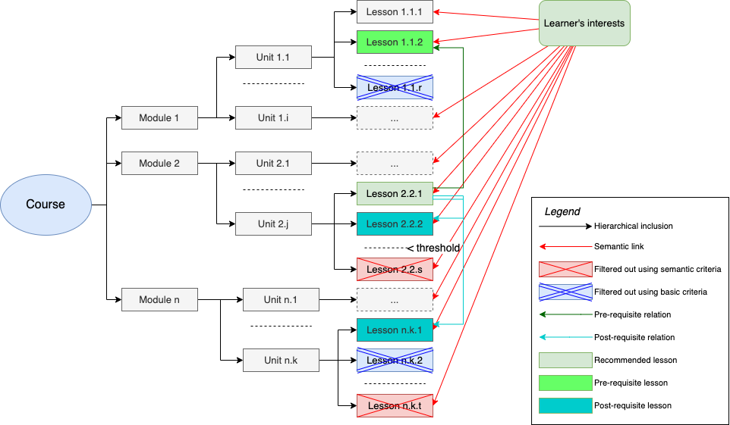
- Cohesion Network Analysis graph applied on a customized curriculum

Moodle Plugin Workflow
Our customized curriculum plugin integrated in Moodle allows the management of the entire lifecycle of the curriculum. Fig. 2 shows the three main components: a) the required training data and corresponding processes; b) the web-based form that generates the customized curriculum for each learner; c) the curriculum dashboard.
Training considers two independent processes. The first refers to training semantic models (e.g., Latent Semantic Analysis [16] or word2vec [17]) based on a collection of domain specific documents. We considered 1,700 medical documents related to pregnancy, nutrition, epigenetics, and nutrients summing up to 20 million tokens that were combined with the TASA corpus (http://lsa.colorado.edu/spaces.html). All texts were passed through a pre-processing pipeline that removed stop words, eliminated misspelled words, and transformed each word to its corresponding lemma. The second training process refers to establishing an adequate semantic similarity threshold based on samples of learning interests that are compared to the corresponding descriptions of the annotated lessons.

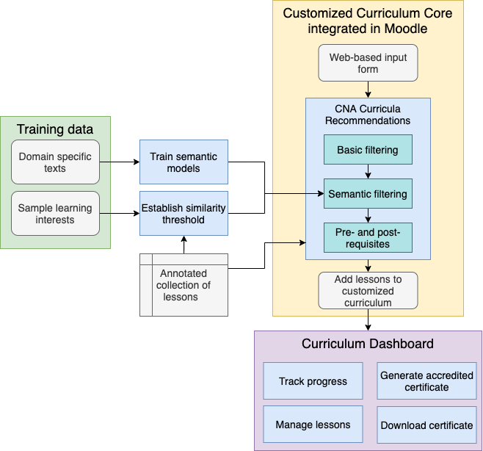
- Workflow diagram of Customized Curriculum lifecycle.
The core module uses a web-based form in which users input options for the filtering criteria and a free text description of their interests (see Fig. 3). This data is passed to the CNA curricula recommendation engine which performs three steps: 1) basic filtering matching annotated lessons; 2) semantic filtering using the similarity threshold; 3) appending lessons providing recommended prior knowledge and follow-up lessons. The field of expertise is mandatory and contains subfields and only lessons suitable for the selected domains of expertise will be recommended. Predefined topics are structured hierarchically on two levels, while the free input text of at least 15 words is entered in the “Refine your search” text area. The themes criterion allows users to limit the list of lessons to those matching one of the three types of learning materials: background, practice & counselling, or guidelines.
A final step appends lessons providing recommended prior knowledge and follow-up lessons corresponding to each recommended lesson. These lessons are then displayed in three distinct areas of the plugin’s result page (see Fig. 4): lessons providing recommended prior knowledge at the beginning, recommended lessons in the middle, and follow-up lessons at the bottom. All recommended lessons in Fig. 4 relate to potential disorders during pregnancy. The prior knowledge lessons are broader and should be considered before having an in-depth perspective, whereas follow-up lessons consider potential interventions in extreme cases. The estimated amount of time needed to study each lesson and the number of Continuous Medical Education (CME) credits are also displayed. Afterwards, users can add the recommended lessons to their customized curriculum, while considering the total amount of time and the total number of CME credits to be received upon course completion. Users can iteratively build their curriculum by sending multiple requests.
The third component is the Curriculum Dashboard which allows learners to track their progress (see Fig. 5), manage lessons, and perform CME specific functions (e.g., generate and download an accredited certificate).
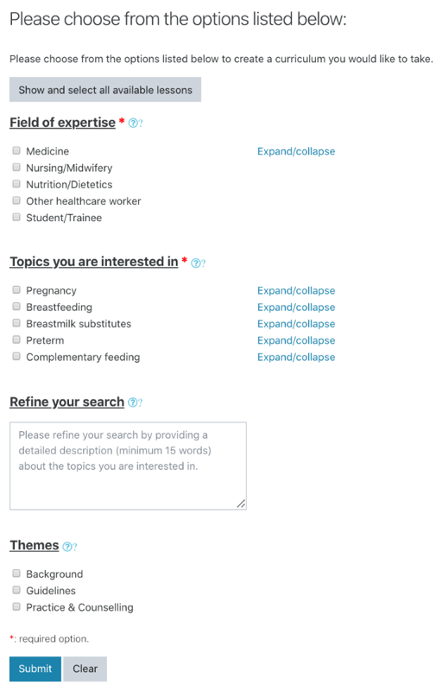
- Preview of the Customized Curriculum plugin input form

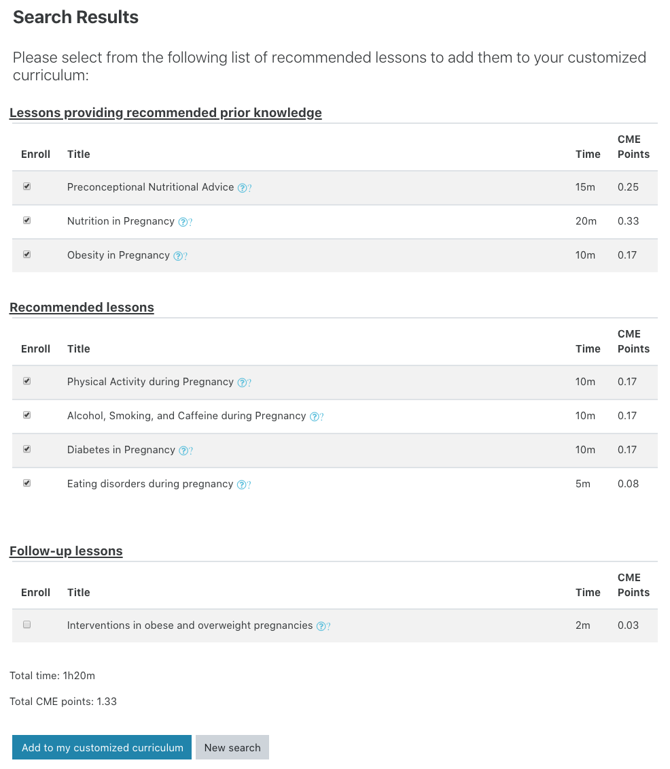
- Sample of a proposed curriculum displayed inside the plugin, including prior knowledge and follow-up lessons linked to the recommend lessons
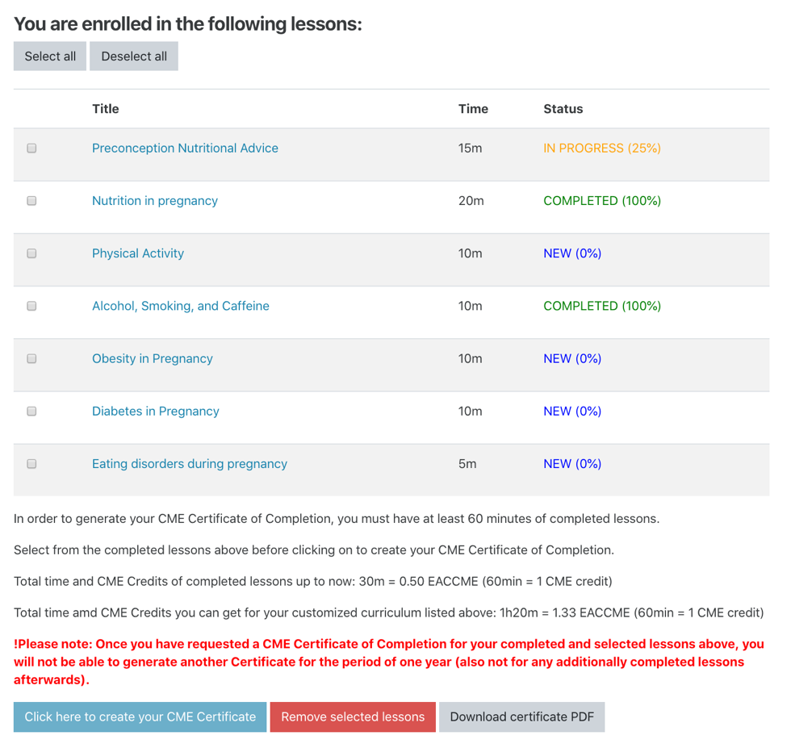
- Curriculum Dashboard

Users can select completed lessons that they would like to include in an accredited certificate. At least 1 CME credit point (corresponding to a total of minimum 60 minutes) is required. If all these conditions are met, users are informed that they will not be able to generate another certificate within the following year. This constraint was introduced only to discourage an abundance of generated accredited certificates.

Results
Our approach narrows down further the results from the pre-set filters, by personalizing the list of lessons to semantically match learning needs using CNA. A semantic threshold was used to filter out irrelevant lessons; its corresponding value was experimentally set. Experts were asked to imagine that they are searching for information on one or more specific medical topics; 21 individuals provided one or more texts per person (M = 1.86) and our collection contained a total of 39 free text entries. These inputs were used to compute the similarity between each text and the description of each of the 78 lessons from the five modules. A total number of 3,042 similarity scores was obtained. The average similarity score between a text and a lesson’s description was of .515, with a standard deviation of .074. A semantic similarity threshold of .589 was imposed as the sum of average and standard deviation of previous semantic similarity scores to ensure highly relevant matches. Afterwards, part of these free input texts were used to create use case scenarios (see Table 2) from distinct experts (e.g., A and B), but also different texts provided by the same person (e.g., C with two use cases – C1 and C2).
- Samples use cases.
Use case | Filters | Results
A | I would like to know the common breastfeeding problems in a teenage mother and how to overcome them.  Expertise: Other healthcare worker  Topics: Breastfeeding, Breastmilk substitutes  Themes: all | Module 2. Breastfeeding (2/14 rec. + 2 prior)  Module 3. Breast Milk Substitutes (1/13 prior)  Total: 2 rec. + 3 prior
B | I am a medical student. I would like to learn more about appropriate nutrition during pregnancy and physiologic change.  Expertise: Student/Trainee  Topics: Pregnancy  Themes: Guidelines | Module 1. Pregnancy (14/18 rec. + 1 prior)  Total: 14 rec. + 1 prior
C1 | When and how to wean babies? Which type of food to choose? Are there any contraindications?  Expertise: Nutrition/Dietetics  Topics: Breastfeeding, Breastmilk substitutes, Complementary feeding  Themes: Guidelines, Practice & Counselling | Module 5. Complementary feeding (4/18 rec. + 1 prior)  Total: 4 rec. + 1 prior
C2 | Is there any food that pregnant women should avoid? Especially those with chronic diseases like diabetes and hypertension?  Expertise: Other healthcare workers  Topics: Pregnancy  Themes: all | Module 1. Pregnancy (7/18 rec. + 3 prior + 2 fol.)  Total: 7 rec. + 3 prior + 2 fol.
rec. = recommend lessons
prior = lessons providing recommended prior knowledge
fol. = follow-up lessons

The use cases were built to qualitatively assess the adequacy of the provided recommendations by including variations of filtering criteria, which translated to variations in the total number of recommended lessons, including lessons providing recommended prior knowledge and follow-up lessons An average of 6.75 lessons were returned, while only the C2 use case included follow-up lessons. At least 1 prior was returned for each use case. Use cases A and C2 did not impose any limitation on the type of themes for lessons, while B restricted them to guidelines. C1 included both guidelines and practice & counselling. An interesting fact is that although use case A allowed all types of themes, it included only 2 recommended lessons because the selected topics which were very specific. Use case B focused on a medical student interested in pregnancy. The themes consisted of guidelines and results included the highest number of recommend lessons, which may be understandable given the text description which covers almost all theoretical aspects. Use case C1 was again fairly specific, both in terms of filtering criteria, as well as the filtering text, which focused mainly on food for babies and contraindication. Use case C2 was the most balanced one as the user received all types of recommendations, including lessons providing recommended prior knowledge and follow-up lessons.

Conclusions and Future Work
Curriculum personalization allows learners to easily navigate through learning management systems, while being provided with suitable learning content, rather than navigating through a large number of lessons. Learners are provided with learning materials that fit their needs based on filtering criteria, rather than pre-imposed curricula. Our plugin helps learners and experts in the field build customized curricula matching their interests, and handles the entire lifecycle of the curriculum, including the management of lessons and obtaining an accredited certificate.
Our plugin was tested on a Moodle instance on early nutrition containing lessons split into five distinct modules. The lessons are written in English and cover topics such as nutrition during pregnancy, breastfeeding, breastmilk substitutes, nutritional care of preterm infants, and complementary feeding. The plugin relies on Cohesion Network Analysis and incorporates basic predefined filters for an initial pre-screening of lessons, followed by semantic recommendations. First, basic filters cover criteria like the type of the learning material (e.g., background, guidelines), the field of expertise of the learner (e.g., medicine, nursing, student), or major keywords of interest, previously annotated for each lesson. These filters were established by domain experts and the list can be easily adapted for different Moodle instances. Second, advanced filtering based on a textual description of learning interests allows users to narrow down the wide list of lessons which met the previous basic criteria. This description is compared in terms of semantic similarity with the lesson description, and only lessons that have a relatedness higher than an imposed threshold are recommended. In addition to these recommendations, each lesson may suggest lessons providing recommended prior knowledge to be studied before, or lessons providing follow-up knowledge.
Testing scenarios were provided by experts in the field, and variations of basic filtering criteria were also assessed, including different expertise, topics, or themes. Each use case showed different results in the number of recommended lessons, lessons providing recommended prior knowledge and follow-up lessons. Natural language descriptions tended to be either too broad, covering too many topics and relying mostly on the basic filtering, or too limited when the included details limited the curriculum to only a few lessons. The performed use cases and experiments argue for the plugin’s usability when handling the entire process of curricula customization, but further validations with learners are required.
Nevertheless, a large-scale evaluation of the system needs to be performed. The envisioned questionnaire will take into account the plugin’s usability, as well as the impact and quality of the results, in relation to each student’s learning purposes.
The plugin is easily generalizable to new courses, as it can be tailored to customize the learning paths for other courses, by providing a different configuration file with the lessons’ descriptions, the dependencies between them, together with values for the filtering criteria. The plugin can be also adapted to any new research area by using a domain-specific collection of relevant documents for that field. A limitation may be the finetuning of semantic models and of the imposed semantic similarity threshold; however, a general model pre-trained on a large text corpus, coupled with a high threshold value (e.g., 0.7 that ensures semantic resemblance) is adequate for most initial setups. Moreover, the backend recommendation engine may be reused in other Learning Management Systems to establish learning paths aligned to the learner’s interests.
Further optimizations envision iterative recommendations based on completed lessons, together with refinements to the semantic matching component as the pre-defined topics could be automatically inferred from the content of the lessons.

Acknowledgements
This work was financially supported by the European Union’s Erasmus+ Programme Capacity Building in Higher Education, Early Nutrition eAcademy Southeast Asia (Project Number: 573651-EPP-1-2016-1DE-EPPKA2-CBHE-JP), the European Union's Seventh Framework Programme (FP7/2007-2013), project EarlyNutrition (grant agreement number 289346), as well as by a grant of the Romanian National Authority for Scientific Research and Innovation, CNCS – UEFISCDI, project number PN-III-P1-1.2-PCCDI-2017-0689, Lib2Life - Revitalizing Libraries and Cultural Heritage through Advanced Technologies” within PNCDI III. KMG is supported by the UK Medical Research Council (MC_UU_12011/4) and the National Institute for Health Research (NIHR Senior Investigator (NF-SI-0515-10042), NIHR Southampton 1000DaysPlus Global Nutrition Research Group (17/63/154) and NIHR Southampton Biomedical Research Centre (IS-BRC-1215-20004).

References
- Parisi, G.I., Kemker, R., Part, J.L., Kanan, C., and Wermter, S.: ‘Continual lifelong learning with neural networks: A review’, Neural networks, 2019, 113, pp. 54-71
- Sumner, T., Devaul, H., Davis, L., and Weatherley, J.: ‘A curriculum customization service’. Proc. Proceedings of the 9th ACM/IEEE-CS joint conference on Digital libraries, Year pp. 479
- Koh, E., Ponnusamy, L.D., Tan, L.S., Lee, S.-S., and Ramos, M.E.: ‘A Singapore Case Study of Curriculum Innovation in the Twenty-First Century: Demands, Tensions and Deliberations’, The Asia-Pacific Education Researcher, 2014, 23, (4), pp. 851-860
- Narvekar, S., Sinapov, J., and Stone, P.: ‘Autonomous Task Sequencing for Customized Curriculum Design in Reinforcement Learning’. Proc. International Joint Conferences on Artificial Intelligence Organization (IJCAI), Year pp. 2536-2542
- Chen, C.M., Liu, C.Y., and Chang, M.H.: ‘Personalized curriculum sequencing utilizing modified item response theory for web-based instruction’, Expert Systems with Applications: An International Journal, February 2006, 30, (2), pp. 378-396
- Chen, C.M.: ‘Intelligent web-based learning system with personalized learning path guidance’, Computers & Education, 2008, 51, pp. 787–814
- Huang, M.J., Huang, H.S., and Chen, M.Y.: ‘Constructing a personalized e-learning system based on genetic algorithm and case-based reasoning approach’, Expert Systems with applications, 2017, 33, (3), pp. 551-564
- Nistor, N., Dascalu, M., Gutu, G., Trausan-Matu, S., Choi, S., Haberman-Lawson, A., Brands, B., Korner, C., and Koletzko, B.: ‘Mass Customization in Continuing Medical Education: Automated Extraction of E-Learning Topics’. Proc. 12th European Conference on Technology Enhanced Learning (EC-TEL 2017), Tallinn, Estonia, Year pp. 576–579
- Nistor, N., Dehne, A., and Drews, F.T.: ‘Mass customization of teaching and training in organizations. Design principles and prototype evaluation.’, Studies in Continuing Education, 2010, 32, (3), pp. 251-267
- Dascalu, M., Sirbu, M.-D., Gutu-Robu, G., Ruseti, S., Crossley, S.A., and Trausan-Matu, S.: ‘Cohesion-Centered Analysis of Sociograms for Online Communities and Courses using ReaderBench’. Proc. 13th European Conference on Technology Enhanced Learning (EC-TEL 2018), Leeds, UK, Year pp. 622–626
- Dascalu, M., McNamara, D.S., Trausan-Matu, S., and Allen, L.K.: ‘Cohesion Network Analysis of CSCL Participation’, Behavior Research Methods, 2018, 50, (2), pp. 604–619
- Gutu, G., Dascalu, M., Rebedea, T., and Trausan-Matu, S.: ‘Time and Semantic Similarity – What is the Best Alternative to Capture Implicit Links in CSCL Conversations?’. Proc. 12th Int. Conf. on Computer-Supported Collaborative Learning (CSCL 2017), Philadelphia, PA, Year pp. 223–230
- Dascalu, M., Trausan-Matu, S., McNamara, D.S., and Dessus, P.: ‘ReaderBench – Automated Evaluation of Collaboration based on Cohesion and Dialogism’, International Journal of Computer-Supported Collaborative Learning, 2015, 10, (4), pp. 395–423
- Dascalu, M., Gutu, G., Ruseti, S., Paraschiv, I.C., Dessus, P., McNamara, D.S., Crossley, S., and Trausan-Matu, S.: ‘ReaderBench: A Multi-Lingual Framework for Analyzing Text Complexity’. Proc. 12th European Conference on Technology Enhanced Learning (EC-TEL 2017), Tallinn, Estonia, Year pp. 495–499
- Gutu, G., Dascalu, M., Carabas, M., Elisei, A., Trausan-Matu, S., Nistor, N., Choi, S., Spoerl, R., and Koletzko, B.: ‘Curricula Customization with the ReaderBench Framework’. Proc. 6th Int. Workshop on Semantic and Collaborative Technologies for the Web, in conjunction with the 14th Int. Conf. on eLearning and Software for Education (eLSE 2018), Bucharest, Romania, Year pp. 384–391
- Landauer, T.K., and Dumais, S.T.: ‘A solution to Plato's problem: the Latent Semantic Analysis theory of acquisition, induction and representation of knowledge’, Psychological Review, 1997, 104, (2), pp. 211–240
- Mikolov, T., Chen, K., Corrado, G., and Dean, J.: ‘Efficient Estimation of Word Representation in Vector Space’. Proc. Workshop at ICLR, Scottsdale, AZ, Year pp.

