Structured nanofilms comprising Laponite® and bone extracellular matrix for osteogenic differentiation of skeletal progenitor cells
Daheui Choiª, Jiwoong Heoª, Juan A. Milán^{b}, Richard O. C. Oreffo^{b}, Jonathan I. Dawson^{b,*}, Jinkee Hong^{a,*} and Yang-Hee Kim^{b,*}
ª Department of Chemical and Biomolecular Engineering, Yonsei University, Seoul 03722,
Republic of Korea
E-mail: jinkee.hong@yonsei.ac.kr,
Tel: +82-2-2123-5748

^{b} Bone and Joint Research Group, Centre for Human Development, Stem Cells and Regeneration, Institute of Developmental Sciences, University of Southampton, SO16 6YD, United Kingdom
E-mail: jid@soton.ac.uk, Yanghee.Kim@soton.ac.uk
Tel: +44-23-8120-3293

Abstract
Functionalized scaffolds hold promise for stem cell therapy by controlling stem cell fate and differentiation potential. Here, we have examined the potential of a 2-dimensional (2D) scaffold to stimulate bone regeneration. Solubilized extracellular matrix (ECM) from human bone tissue contains native extracellular cues for human skeletal cells that facilitate osteogenic differentiation. However, human bone ECM displays limited mechanical strength and degradation stability under physiological conditions, necessitating modification of the physical properties of ECM before it can be considered for tissue engineering applications. To increase the mechanical stability of ECM, we explored the potential of synthetic Laponite® (LAP) clay as a counter material to prepare a 2D scaffold using Layer-by-Layer (LbL) self-assembly. The LAP and ECM multilayer nanofilms (ECM/LAP film) were successfully generated through electrostatic and protein–clay interactions. Furthermore, to enhance the mechanical properties of the ECM/LAP film, application of a NaCl solution wash step, instead of deionized water following LAP deposition resulted in the generation of stable, multi-stacked LAP layers which displayed enhanced mechanical properties able to sustain human skeletal progenitor cell growth. The ECM/LAP films were not cytotoxic and, critically, showed enhanced osteogenic differentiation potential as a consequence of the synergistic effects of ECM and LAP. In summary, we demonstrate the fabrication of a novel ECM/LAP nanofilm layer material with potential application in hard tissue engineering.

Graphical abstract
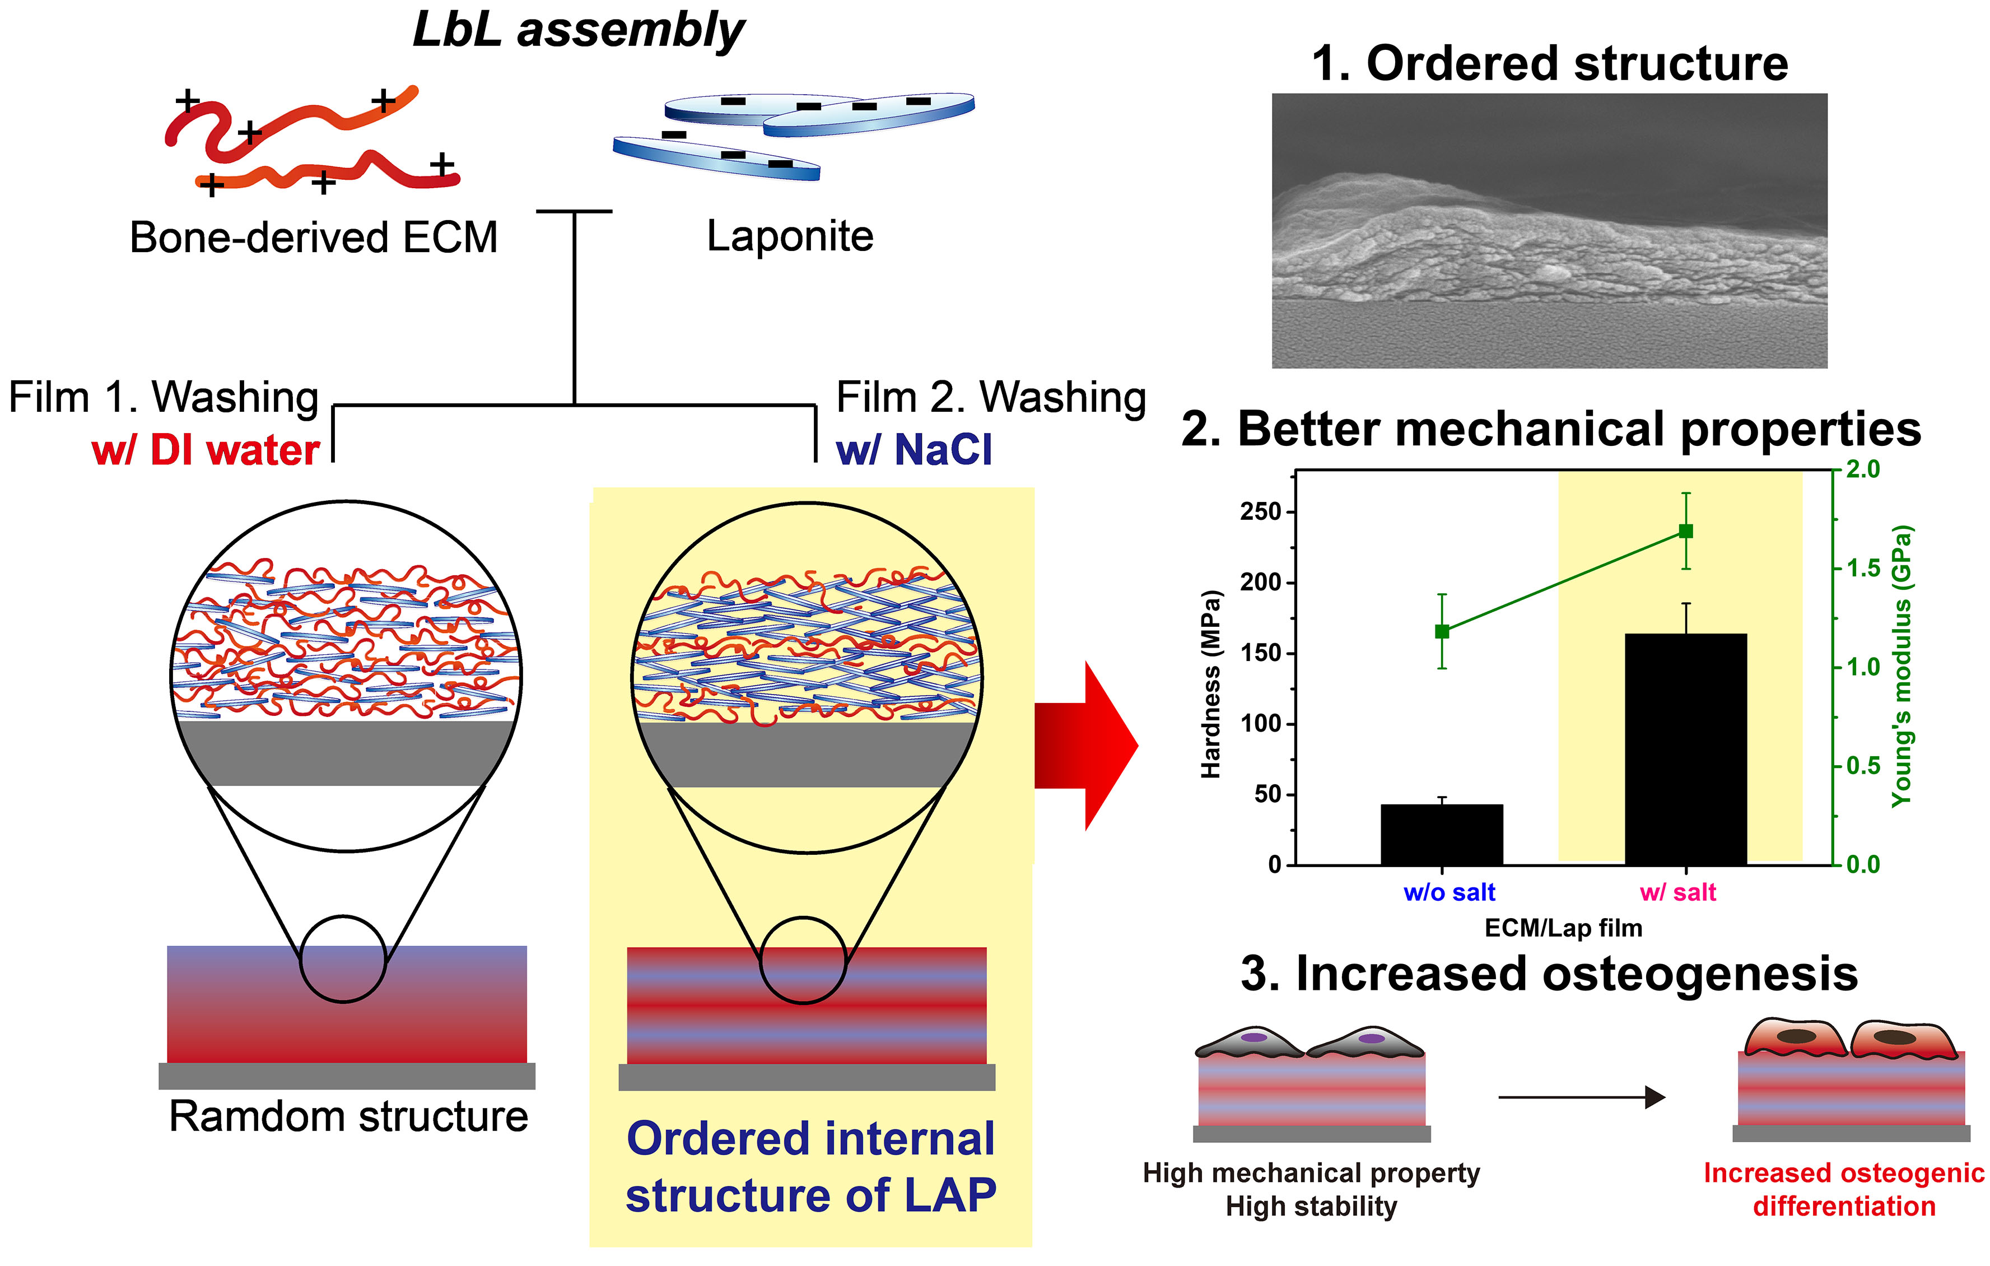
Keywords: multilayer nanofilm, Laponite®, bone extracellular matrix, layer-by-layer, osteogenic differentiation

- Introduction
Over the last decades, the production of multifunctional scaffolds, with the capacity to control stem cell fate have come to the fore in the field of stem cell implants and transplantation [1-3]. Bone differentiation of stem cells is essential for healing bone fractures and innate osteogenic disease, such as osteogenesis imperfecta [4, 5]. A number of studies have examined the essential factors responsible for inducing osteogenesis and have indicated a role for the following: 1. A high material mechanical property (stiffness) to simulate bone tissue feature [6-8], 2. A material that can mimic the bone matrix microenvironment harnessing materials with specific chemical functional groups [9, 10], and, 3. Materials that can control the release kinetics of bone differentiation growth factors such as bone morphogenetic protein 2 or 7 (BMP-2 and BMP-7) [11-13]. Previously, researchers have used bulk sized hydrogels, fibres prepared by electrospinning, as well as porous ceramic or polymer scaffolds, all of which have advantages and disadvantages for bone regeneration [5, 13-17]. The preparation of scaffolds using synthetic materials for bio-applications, typically involves complex synthesis and fabrication processes, that can introduce cell toxicity and modulate cell immunity. To address these limitations, tissue derived material matrices have garnered significant interests in recent years as materials with significant potential biomedical application
Biological scaffolds composed of extracellular matrix (ECM) from decellularized tissue can be digested, solubilized, and used for tissue repair [16, 17]. The ECM materials derived from native bone tissue have been demonstrated to retain a variety of proteins, including type I collagen, glycosaminoglycans (GAGs), and growth factors [16]. These materials are likely to provide native bone-like environments for transplanted stem cells as well as provide the requisite factors required for osteogenic differentiation and bone growth. However, the decellularization and demineralization processes employed to generate a soluble ECM material typically employ enzymatic and chelating agents, which can weaken the mechanical properties and induce rapid degradation of the material of interest.
In this study, we have examined the development of a multifunctional 2-dimensional (2D) scaffold for the osteogenic differentiation of human bone marrow stromal cells (HBMSCs). To enhance the mechanical properties of the human bone ECM scaffold we sought to incorporate Laponite® (LAP, Na^{+0.7}[(Si₈Mg_{5.5}Li_{0.3})O₂₀(OH)₄]^{−0.7}), a synthetic clay widely used in the development of polymer nanocomposites to enhance mechanical properties [18]. LAP comprises particles of 1 nm in thickness and approximately 25–30 nm in diameter, with a negative face charge and positive edge charge [19]. These particles are hydrated and dispersed in water, forming clear colloidal dispersion manner with stable electrical double layers by Na+ ions. At high ionic strength or in the presence of charged solutes such as proteins however, dispersed LAP platelets undergo face-edge aggregation as the salts reduce electrical double layers and induce gel formation (Figure 1A) [20]. This presents challenges for maximizing nanoclay delamination and dispersion within charged polymers required for the interfacial interactions that mediate mechanical enhancement [21, 22]. To overcome this challenge and maximize nanoclay interfacing with ECM protein in a 2-D structure, we introduced a multilayer protocol, a Layer-by-Layer (LbL) self-assembly method [23-25]. LbL assembly is a widely used multilayer nanofilm preparation method that employs two or more polymers that display mutually complementary interactions such as electrostatic interaction, covalent bonding, or hydrogen bonding [26-29]. The multilayer films are formed by continuous self-assembly of each polymer chain onto certain substrates at the molecular level. Through the control of the number of layers or building blocks, it is possible to develop the film at the angstrom to nanometer scale. Furthermore, LbL assembly is versatile, simple, and offers precisely controlled functionality through modulation of the individual building blocks as well as through pH and salt concentration [30]. By harnessing the added advantage of LbL assembly, we here present the development of ECM and LAP multilayer films (ECM/LAP film) with a controllable internal structure through a LAP layer. In comparison to ECM and LAP only drop-casted films, the multilayer film showed enhanced stability and, importantly, the strength to support human bone marrow stromal cells (HBMSCs) growth and critically, induce differentiation of bone marrow stromal cells in the absence of any cytotoxicity.

- Experimental section
  - Materials
ECM digests from human bone extracellular matrix were prepared by a modified version of the method developed by Sawkins et al [16]. The final concentration of human bone powders in the digestion solution was 20 mg/ml. The ECM digest solution was stored at 4 °C and diluted with 100 mM of sodium acetate buffer solution (pH 5.4) to 2 mg/mL prior to making films. LAPONITETM (Na_{h}(Mg_{3-h}Li_{h})Si₄O₁₀(OH)₂.nH₂O) was obtained from BYK-ALTANA (Widnes, UK). Sodium acetate buffer (pH 5.4), sodium chloride, dexamethasone, L-ascorbic acid, β-glycerophosphate, 4% PFA (paraformaldehyde) and BCIP/NBT (5-bromo-4-chloro-3-indolyl phosphate/nitro blue tetrazolium) tablets were purchased from Sigma-Aldrich (St. Louis, MO, USA). H₂O₂ and H₂SO₄ were obtained from Daejung (Siheung-si, Korea).
  - Film preparation
For the multilayer film preparation, ECM and LAP materials were dissolved in 100 mM sodium acetate buffer and DI water to provide concentrations of 2 mg/mL and 5 mg/mL, respectively. The Si-wafer or quartz crystal microbalance (QCM) electrode were immersed in piranha solution (3:1 = H₂SO₄:H₂O₂) for 5 min to remove organic pollutants and sequentially treated with oxygen plasma (CUTE; Femto Science, Yongin, Korea) for 2 min to provide negative surface charge. For multilayer preparation, the substrates were immersed in ECM solution for 5 min to allow adsorption of ECM materials onto the substrate. To remove unbound and weakly bound ECM material, the substrates were placed in DI water for 1 min, twice. A second LAP layer was then prepared by immersing the substrate in LAP solution for 5 min. The washing step for LAP layer was processed in two ways, either by washing with 0.5M NaCl solution (film w/ salt) or with DI water (film w/o salt) to modulate the LAP internal structure during washing step. The above steps were repeated until the desired number of layers were formed. After preparation of the film, it was dried with nitrogen gas.
For ECM and LAP films, we first calculated the total amount of each building block absorbed onto the substrate by QCM measurement. We then prepared the same amount of ECM (22.94 μg/cm²) and LAP solution (2.78 μg/cm² for film w/o salt and 34.84 μg/cm² for film w/ salt) in DI water, respectively. To distinguish the LAP films, we have discretely named the films as “LAP film (Low)” for the films with a reduced amount of LAP-incorporated film (2.78 μg/cm²) and “LAP film (High)” for films with a large amount of LAP-incorporated film (34.84 μg/cm²). The 1.5$×$1.5 cm sized Si-wafer or cut slide glass was immersed in piranha solution (3:1 = H₂SO₄:H₂O₂) for 5 min to remove organic pollutants and treated with oxygen plasma for 2 min to provide negative surface charge. The ECM and LAP films were prepared by drop casting of solution on each substrate and dried overnight. Each film was irradiated under UV light for 20 min for sterilization before cell treatment.
  - Characterization of films
Film thickness was confirmed by profilometer (Dektak 150, Veeco, Plainview, NY, U.S.A.). The amount of attached ECM and LAP molecules per layer was measured by QCM (quartz crystal microbalance; QCM 200; Stanford Research Systems Inc., Sunnyvale, CA, U.S.A). The resonant frequency of the quartz crystal substrate under applied alternating electric field is changed when a material is attached or detached to the substrate. When materials are attached, the resonant frequency of the crystal substrate is decreased proportional to the attached weight. The attached weight of each material (ECM and LAP) per area can be calculated by Sauerbrey equation.
$$∆F=\frac{2F_{0}}{A{(μ_{q}ρ_{q})}^{1/2}}∆m$$
where, $∆$F is the change in resonant frequency, $∆$m is a change in mass, $μ_{q}$is the shear modulus of the quartz, $ρ_{q}$is the density of the quartz, A is the electrode area and F₀ is operating frequency of bare quartz. The $μ_{q}$, $ρ_{q}$, A and F₀ are substrate-dependent values.
Film morphology was characterized by FE-SEM (field-emission scanning electron microscope; Sigma, Carl Zeiss, Germany) and AFM (atomic force microscope; X-10, Park Systems, Suwon, Korea) for top view, and FE-SEM for cross-section view after breaking the film with liquid nitrogen to minimize morphological damage. The cross-sectional TEM (transmission electron microscope; JEM-F200, JEOL, Japan) images were obtained after the film cutting process by ion beam. Using AFM nanoindentation, we compared the relative mechanical strength of two films (Hardness and Young’s modulus). The internal structure of the film was confirmed by XRD (X-ray diffraction; Smartlab, Rigaku, Japan). The basal plane spacing of each film was calculated by Bragg’s equation.
$$nλ=2d sinθ$$
where, n is positive integer, λ is wavelength of incident X-ray beam and theta (θ) is incident angle.
  - Film stability test
Film stability under physiological conditions was assessed by measuring the thickness of the film and the amount of protein released from ECM. The ECM/LAP films (w/o salt and w/ salt, respectively) were immersed into α-minimum essential medium (α-MEM, Gibco, Grand Island, NY, U.S.A.) and incubated for 7 days at 37 °C. At various time points (1, 3, 6, 24, 48, 72, 120, and 168 h), we collected the films, dried, and measured the thickness of the films using a profilometer.
The concentration of proteins released from ECM composite films was determined using a BCA assay kit (ThermoFisher Scientific, Waltham, MA, U.S.A.) according to the manufacturer’s protocol. To collect samples, the films were incubated in phosphate buffered saline (PBS) at 37 °C and we collected 100 μL of supernatants at each determined timepoint (1, 3, 6, 24, 48, 72, 120, and 168 hours), followed by freeze drying.
  - BMP-2 incorporation test and release test
The 19.5 bilayers (top layer: ECM) and 20 bilayers (top layer: LAP) of ECM/LAP films were prepared in order to evaluate the effect of top layer material on BMP-2 incorporation capability. We hypothesized that 20 bilayers of film with outermost LAP layer could incorporate more BMP-2 (InductOs®, Wyeth, Madison, NJ) onto their surface. The ECM and LAP drop-casted films were also tested. Those films were immersed in 2 mL of BMP-2 solution at a concentration of 100 ng/mL in the formulation buffer (0.07% L-glutamic acid, 2.5% glycine, 0.5% sucrose, 0.029% sodium chloride, and 0.01% polysorbate) and incubated at 37 °C for 6 hours to saturate incorporation. At 1, 3, and 6 hours of incubation, we collected the supernatants and measured the concentration of BMP-2 solution by an ELISA (enzyme-linked immunosorbent assay; Peprotech, NJ, U.S.A.) according to the manufacturer’s protocol.
For the release of BMP-2 from ECM/LAP film, the BMP-2 incorporated films were incubated in culture media for 7 days. The supernatants were collected at a certain period of time (6, 48, 96, and 168 h), followed by measuring the BMP-2 concentrations by an ELISA.
  - HBMSCs cell culture
Human bone marrow stromal cells (HBMSCs) were isolated from femoral bone marrow obtained from haematologically normal patients undergoing hip replacement surgery at Southampton General Hospital with approval from the North West - Greater Manchester East Research Ethics Committee (18/NW/0231). The HBMSCs were isolated by repeat perfusion of the marrows and filtration through 100 μm filter before centrifugation at 1200 rpm for 5 min. The BMSCs pellets were resuspended in minimum essential medium alpha modification (α-MEM) with supplements of 10% fetal bovine serum (FBS, Welgene, Daegu, South Korea) and 1% penicillin/streptomycin (P/S, Gibco), and culture expanded in monolayer at 37 °C and under humidified 5% CO₂. The media was changed every 3 days.
  - Cell viability test
Each film was prepared on the slide glass (1.5$×$1.5 cm size) and placed into 12 well plate. The BMSCs were collected by 0.05% trypsinization, the cells were seeded onto 12 well plate at a density of 5$×$10⁴ cells/well. After 1 day of incubation, 10% of CCK-8 agent (Dojindo, Kumamoto, Japan) was added and further incubated for 2 hours at 37°C. The absorbance of color at 450 nm visible wavelength was measured by a plate reader (SpectraMax 340 PC; Molecular Devices, San Jose, CA, USA).
  - Bone differentiation assay (Alkaline phosphatase (ALP) staining)
Five different types of films were prepared for a bone differentiation assay: (1) 19.5 bilayers of ECM/LAP w/o salt, (2) 19.5 bilayers of ECM/LAP w/ salt, (3) ECM film, (4) LAP film (w/o salt) and (5) LAP film (w/ salt). The BMSCs were seeded on the films in 12 well plate at a density of 2$×$10⁴ cells/well with culture media. For osteogenesis, ECM/LAP films were prepared with 19.5 bilayers (Top surface: ECM layer) to generate a cell biocompatible environment. After 1 day, we changed the medium to differentiation media. The differentiation medium was prepared by adding 10⁻⁸ M of dexamethasone, 0.2 mM of ascorbic acid,10 mM of β-glycerophosphate and 100 ng/mL of BMP-2 (only for BMP-2 treatment groups) into the culture media. The differentiation medium was changed every 3 days. After 5 days of differentiation, cells were fixed with 4% paraformaldehyde (PFA) and treated with BCIP/NBT aqueous solution (St. Louis, MO, USA) for alkaline phosphatase staining. The stained area (%) was measured by an optical microscope (Leica, Germany) and analyzed by Image J software.
  - Statistical analysis
Statistical analysis was performed using GraphPad Prism 8 (GraphPad Software, La Jolla, CA) by a 1-way ANOVA with Tukey’s multiple comparison test. Data are presented as mean +/- standard deviation (SD). Values of p < 0.05 were considered statistically significant. P values smaller than 0.05 marked as *p <0.05, **p <0.01 and ***p <0.001, ***p<0.0001 and greater than 0.05 marked as “NS” meaning non-significance. All experiments were repeated at least three times.

- Results and Discussion
ECM extracted from bone matrix is predominantly composed of type I collagen and displays remarkable rheological and biological properties for bone tissue regeneration applications [16, 31]. The ECM material was dissolved in 100 mM of sodium acetate buffer (pH 5.4) to keep the collagen in its molecular state, as opposed to fiber structure. LAP at 5 mg/mL was observed to be well-dispersed in DI water (pH 10). The pI value of type I collagen is approximately 8.2–8.4; the net charge of ECM solution is positive at pH 5.4 [32]. Therefore, the main driving forces in the generation of the ECM/LAP film are electrostatic interactions between ECM and the face component of LAP as well as clay–protein adsorption [33]. In addition, hydrogen bonding and van der Waals forces exist between clay mineral and proteins. As shown in Figure 1B, we prepared a multilayer film with ECM and LAP and provided a different deposition amount of LAP through modulation of the wash conditions, leading to a different internal structure of LAP layers. We hypothesized that washing with NaCl solution following deposition of LAP would result in stabilization of the LAP layer structure through face–edge aggregation and thus an increased proportion of LAP within the multilayer. The objective was generation of a multilayer nanofilm scaffold to facilitate osteogenic differentiation as well as fabrication of nanofilms that displayed structural stability and enhanced mechanical strength.

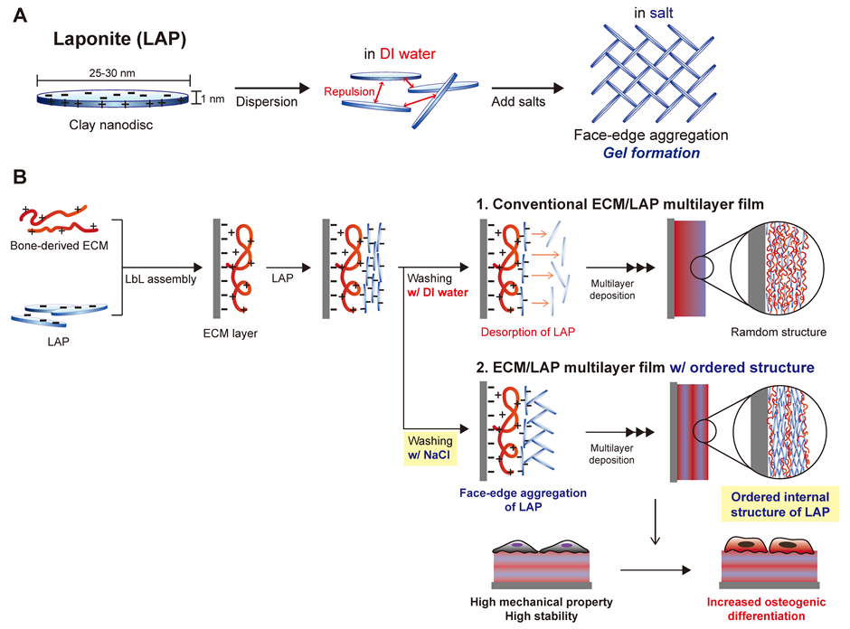
Figure 1. Schematic illustration of Laponite (LAP) and ECM/LAP multilayer films. (A) LAP is disc-type nanoparticle which has 25-30 nm length and 1 nm thick. The LAP particles are well dispersed in deionized (DI) water; however, it aggregates and become a gel at high concentration of salts. (B) We prepared a multilayer film by using different washing steps for LAP layers; 1. washed with DI water (conventional LbL) and 2. washed with 0.5 M NaCl solution to provide ordered internal LAP structure. Each film was named as film w/o salt and film w/ salt, respectively.

The LbL film thickness growth curves shown in Figure 2A indicate that the films increase linearly with the number of layers deposited. Both the films showed a highly linear growth pattern with a high value of R² (correlation coefficient) (0.9865 for film w/o salt and 0.9948 for film w/ salt). The linear growth curve of the LbL film indicates that the interlayer diffusion phenomena during deposition is prevented by clay platelets and, critically, that almost the same amount of material was deposited at each step [34]. Due to the LAP clay, it was noted the ECM materials could not diffuse throughout LbL film layers during layer deposition, resulting in the generation of a highly organized multilayer film.
The surface roughness of the Layer-by-layer assembled multilayer film (i.e. film based on polymeric interactions) is normally increased depending on the number of deposition layer due to the increase of the polymeric assembly and complexes within the film layers [35, 36]. The current studies indicated that strong polymer (ECM)-clay (LAP) assembly increased as a consequence of layer number, resulting in increased surface roughness (Figure 2B). Therefore, it is not surprising that the non-salt washed ECM/LAP film showed increased roughness manner as layer increased. As described above, nanofilms with lower number of layers could have relatively reduced roughness on SEM or AFM images. In contrast, for the salt-washed film, the salts onto LAP surface are continuously deposited in each LAP layer. Consequently, roughness increases as the LAP layer increases compared to that of non-salt washed film due to the continuous adsorption of ECM and LAP onto the previously deposited salts. This phenomenon is not noticeable in the first several initial layers, since inner salt layer contains a small amount that does not play a large role in roughness.
AFM and SEM images assessed whether the outer surface of film was affected by salt (Figure 2C). For the film w/o salt wash, the top morphology indicates an even distribution across the substrate. We observed the complexation of proteins and LAP due to the strong binding affinity on films. In the case of the salt wash films, NaCl crystals were deposited despite additional washing with DI water before imaging. However, we could not observe any morphological differences in the films due to the salt wash; the non-crystal area had a similar morphology as the film w/o salt, even though overall roughness of both films was different (Figure 2B). In the magnified AFM images, LAP platelets of 30-40 nm were observed as an evenly formed layer on the surface [37].
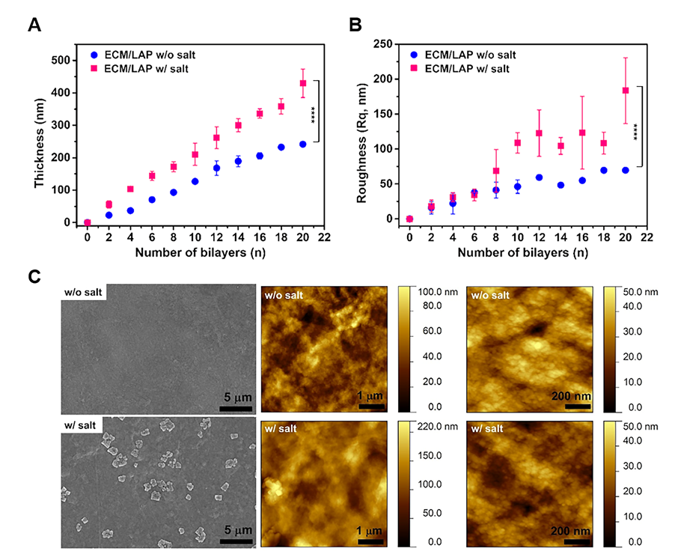
Figure 2. ECM and LAP were distinctly deposited by layer-by-layer method. (A and B) The thickness and roughness of 20 layered ECM/LAP films were linearly increased with the number of layers deposited. ECM/LAP film w/salt showed significantly higher thickness and roughness than ECM/LAP film w/o salt (Error bar = standard deviation, n = 4; **** indicates P value of 0.0001, t-test). (C) The morphology of outer surface was observed by SEM and AFM. There was no morphological difference between ECM/LAP films w/o and w/ salt, except for salt crystals on the film w/ salt.

The amount of each molecule present was confirmed by QCM analysis, indicating similar adsorption trends as observed with the film growth curves (Figure 3A and B). Notably, we observed increased thickness and roughness values in samples generated using a NaCl solution (film w/ salt) wash protocol (Figure 2A and B). The amount of ECM material present on the LAP for both films is shown including calculation of the attached weight from frequency decrement by Sauerbrey equation: 1.265 μg/cm² for film w/o salt and 1.029 μg/cm² for film w/ salt (no significant differences between the two films) (Figure 3B). However, in the case of LAP, 12.53 times significantly higher deposition was observed for film w/ salt (0.139 μg/cm² for film w/o salt and 1.742 μg/cm² for film w/ salt), indicating that the detachment of LAP during the washing step was inhibited. These observations confirm fabrication of ECM/LAP multilayer films with altered thickness and levels of LAP deposition as a consequence of wash solution modulation.
Figure 3C depicts XRD patterns of ECM/LAP films and drop-casted LAP film. The ECM/LAP film w/o salt (blue line) showed poorly defined peaks, indicating a significantly lower amount of LAP and, interestingly, a lattice disorder within the multilayer [38]. According to QCM results (Figure 3A and B), the ratio of ECM to LAP for film w/o salt was around 9.1:1, indicating that ECM deposition was dominant. However, similar diffraction patterns were also observed for ECM/LAP film w/ salt, and LAP only film (pink and gray lines). The LAP clay showed a crystalline structure, composed of tetrahedral sheets at both ends. (001) basal plane spacing of clay is described as the distance between a plane in one layer to the another corresponding parallel plane [38]. According to the Bragg’s raw (equation 1), the low angle diffraction peak at 2 theta = 5.12° for ECM/LAP film w/ salt, and 2 theta = 8.06° for LAP film, corresponded to 17.26 Å and 10.97 Å, respectively. The edge size of clay platelet was around 1 nm; the lattice expansion may have happened by intercalation of ECM materials within LAP clay. According to a previous study, the LAP and gelatin mixture showed an expanded d-spacing value depending on the increase in gelatin proportions [38]. Thus, the XRD patterns confirm and demonstrate the stacking of LAP layers within the multilayer film is a consequence of salt washing (Figure 3D).
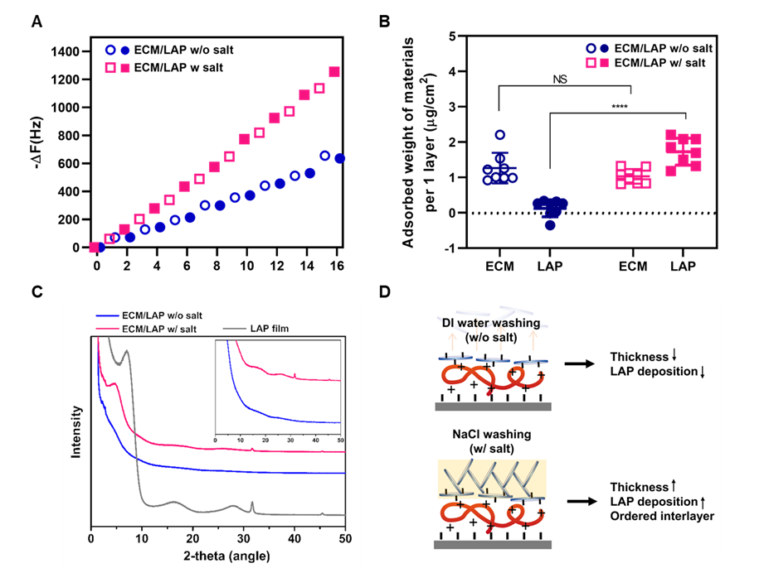
Figure 3. Salt washing process enhanced LAP deposition via LAP platelet rearrangement. (A) Stepwise frequency decrease of ECM/LAP multilayer films with the increase in deposition layers of ECM (open marks) and LAP (solid marks) was observed, indicating similar adsorption trends as the film growth curves shown in A and B. (B) The attached weight of ECM and LAP per unit area which is derived from Figure 3A. Interval frequency changes for each layer were calculated using the Sauerbrey equation (see experimental section). The weight of adsorbed ECM per layer without salt washing process was similar as that after salt washing, while the LAP amount after salt washing was significantly higher than that without salt washing (Error bar = standard deviation, n = 8; **** indicates P value of 0.0001 and non-significance marked as NS, two-way Anova, Tukey’s multiple comparisons test). (C) X-ray diffraction (XRD) pattern for ECM/LAP films and LAP dispersed in water and dried as a film. The low angle diffraction peak ((001) plane) (at 2 theta = 5.12° for ECM/LAP film w/ salt, and 2 theta = 8.06° for LAP film) indicates distance of plain-to-plain in LAP clay. A low angle diffraction peak is not observed in the film w/o salt due to the low amount of LAP. (D) Schematic highlights possible model of LAP particle rearrangement depending on washing method.

The microstructure of ECM/LAP is shown in Figure 4A. Cross-sectional SEM images for film w/o salt indicated that the internal structure was not distinguishable and appeared to comprise a mixture of ECM and LAP materials. However, in the case of film w/ salt, the interlayer showed clear and distinguishable stacking layers in the high magnified image. The LAP platelets displayed a higher electron density than ECM, and therefore, occupy the lighter part in SEM image. LAP layers in film w/ salt, indicated by the dark area, display a discrete layered structure. This phenomenon was also observed in cross-sectional TEM images (Figure S1); the film w/ salt showed crystalline planes, whereas the film w/o salt showed a mixed internal structure. It is likely that the diffusion of monovalent cations to LAP by salt washing, induced cluster formation driven by face–edge aggregation, which would have been stronger than the effects from DI water washing [39]. This enabled the LAP particles to build discrete layered structures and to prevent interlayer diffusion of the subsequent ECM layer, resulting in distinguishable LAP layers within film.
We speculated that an increased proportion of LAP within the layers would enhance mechanical stability. Figure 4B shows the mechanical properties of ECM/LAP film measured by AFM nanoindentation; the load-depth curve was obtained using a sharp AFM indenter, and fitting the unloading portion of the data using the Oliver and Pharr model [40]. Using AFM nanoindentation, hardness and Young’s modulus were obtained across the range of MPa to GPa. The results showed 3 times higher hardness and 1.5 times higher Young’s modulus values for the ECM/LAP film w/ salt. Thus, with an increase in LAP deposition within the film layer, stiffness and hardness of the film were increased.
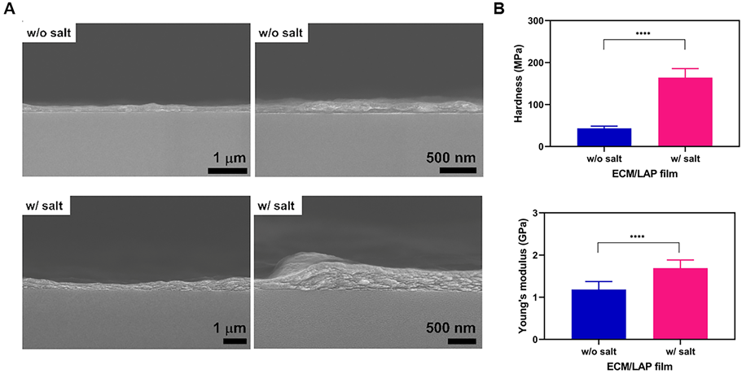
Figure 4. Distinguishable LAP layer stacking within ECM/LAP film w/salt improved mechanical properties. (A) Cross-sections of nanofilms were prepared using liquid nitrogen and observed by scanning electron microscopy (SEM). The internal microstructure of ECM/LAP film w/o salt was not distinguishable, while ECM/LAP film w/ salt showed ECM and LAP interlayers clearly. (B) Hardness and Young’s modulus of ECM/LAP films calculated by AFM nanoindentation. Both ECM/LAP films were adjusted their thickness to 200 nm and measured modulus (Error bar = standard deviation, n = 11; **** indicates P value of 0.0001, t-test)

We hypothesized that the stacking of LAP discs, inducing multilayer ordered structures, would stabilize the films against external stresses. To validate this hypothesis, we assessed the thickness and morphological changes of the ECM/LAP films as well as the degradation of the ECM layers in two films (with and without salt washing). As shown in Figure 5A, the thickness of the ECM/LAP films in both conditions increased in the same manner up to 3 times their original thickness. Furthermore, no significant difference between the release patterns of ECM proteins from the films was observed (Figure 5B). The measured surface morphology change was due to ECM, but LAP platelets of sizes 10-25 nm were still present on the nanofilm (Figure S2). This indicates that ECM nanolayers in both films had swelled in comparable fashion and the water and ions in the solvent were able to penetrate the multilayer films. Given that both films had comparable ECM (p value= 0.19), but more LAP had deposited in the film with salt washing (Figure 3B), it can be concluded ECM is the main contributor to the change of the thickness and surface morphology through ECM swelling.
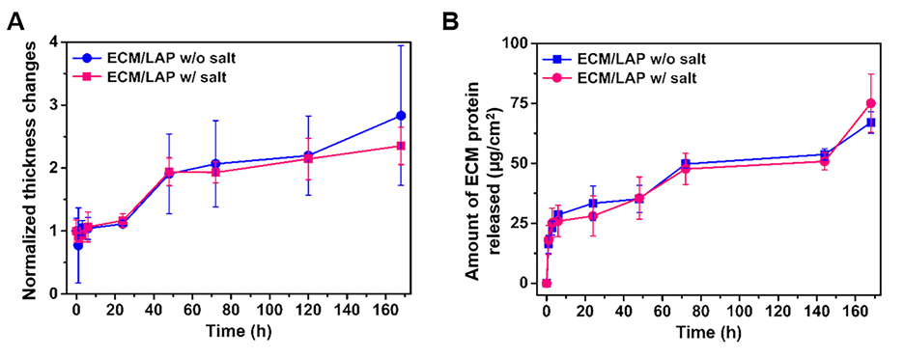
Figure 5. No effect of salt washing process on ECM/LAP film stability under physiological conditions. ECM/LAP films were incubated for 7 days at 37 °C and measured (A) the thickness of the films by a profilometer, (B) the concentration of ECM protein released from the films using a BCA assay kit at each time points. Both films were showed similar trends of thickness change and degradation rate, indicating there was no effect of salt washing on film stability.

Our previous study on the application of LAP gel for osteogenesis confirmed that BMP-2 can be localized onto LAP gel surfaces [19]. The suggested mechanism was via electrostatic interaction, leading to strong bone differentiation of C2C12 on LAP gels. Accordingly, we hypothesized that layering LAP and ECM alternately would result in enhanced uptake of BMP-2 in comparison to ECM film, and thus enhance the films’ osteogenic differentiation ability. We first demonstrated that the ECM/LAP nanofilms could incorporate significantly more BMP-2 molecules, compared to drop-cast ECM and LAP films (Figure 6). The latter were created after ensuring films had exactly the same amount of ECM or LAP, respectively, as the ECM/LAP nanofilms. Interestingly, BMP-2 incorporation remained almost unchanged regardless of the material (ECM or LAP) that comprised the top layer of the nanofilms (Figure 6A, 19.5 bi; ECM top layer, 20.0 bi; LAP top layer) possibly indicating the persevered availability of LAP binding sites after ECM layer deposition – though we note that ECM itself also displays some binding affinity for growth factors [41]. We observed that the salt washing process enhanced LAP deposition onto the ECM nanofilms (LAP film (Low): 0.139 μg/cm², and LAP film (High): 1.742 μg/cm², Figure 2D), but deteriorated their capacity for BMP-2 (Figure 6B) suggesting that LAP aggregation occurs at the expense of BMP-2 binding. A possible explanation for this result is that given the large size of BMP-2 molecules (7 nm $×$ 3.5 nm$×$3 nm dimension) [42], the molecules may not have been able to reach the lowest components of the film within the measured 6 hours. Thus, BMP-2 incorporation may only have happened at the outermost surface of the film. Interestingly, in examination of film stability under physiological conditions, we did not observe any thickness changes or swelling over 6 hours (Figure 5). Furthermore, even if some molecules penetrated inside the nanofilm following swelling, it is unlikely the molecules would have reached the aggregated-LAP disk surface given the salt at the LAP/ECM interface. This is because the salt wash enhances the propensity for the LAP disks to stack on top of each other (Figure 1), and with the increased ordering, there is reduced space for the molecules to diffuse and to bind. Further studies are warranted to demonstrate this and other possible mechanism.
On the other hand, in terms of BMP-2 release after incorporation, it is observed that negligible BMP-2 release from both ECM/LAP multilayer nanofilms 7 days after incubation in culture media (Figure S3) and less than 1% of BMP-2 were released from the films. This indicates that the salt washing enhances LAP layer deposition, but there is no considerable effect on BMP-2 molecule incorporation and its release.
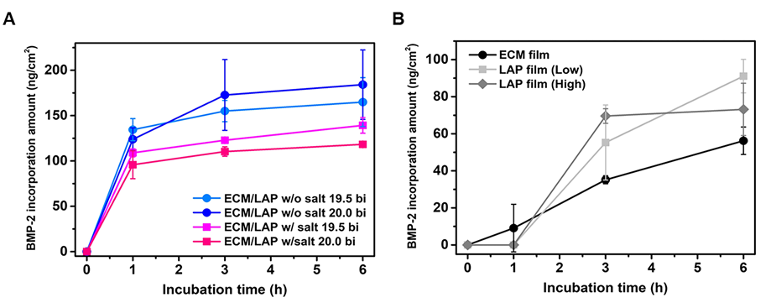
Figure 6. ECM/LAP films incorporated more BMP-2 molecules then drop-cased films. Four types of ECM/LAP films were prepared; 1-2) 19.5 bilayers (top layer: ECM) of ECM/LAP films w/o and w/ salt, and 3-4) 20 bilayers (top layer: LAP) of ECM/LAP films w/o and w/ salt. As control groups, ECM and LAP drop-casted films were prepared based on the amounts of ECM and LAP deposited within ECM/LAP films w/o and w/ salt (ECM film: 1.147 μg/cm², LAP film (Low): 0.139 μg/cm², and LAP film (High): 1.742 μg/cm²). All the films were incubated for 6 hours at 37 °C and then cumulative BMP-2 incorporation amount (ng/cm²) of (A) ECM/LAP films with different number of layers and (B) drop-casting ECM and LAP films at each determined time points (1, 3 and 6 hours).

Finally, we evaluated the impact of ECM/LAP films in osteogenic differentiation. Before then, the multilayer films were tested toxicity for HBMSCs, indicating no or little cytotoxicity for both films (Figure S4). The slightly reduced cell survival rate from the salt-washed film was mainly derived from the crystalized NaCl. Residue of salt on the film surface (Figure 2C) can dissociate into Na+ ions that affect cellular membrane integrity [43]. To check osteogenic potential, we first prepared films on 1.5 × 1.5 cm-cut slide glasses, placed the films on 12 well plates, and cultured HBMSCs for 5 days on the films prior to ALP staining, a marker of early osteogenesis, using the BCIP/NBT method. As shown in Figure 7, LAP film with salt washing displayed increased ALP activity than both the control group and the LAP film w/o salt washing. The ECM film alone was not sufficiently stable in the absence of Laponite to support cell growth. This lack of stability in the presence of cells was also observed in the ECM/LAP film without salt washing. As the internal structure of the films under physiological condition without cells were stable even after 7 days incubation, we would not anticipate dramatic changes in structure, however with addition cells and resultant enzymatic degradation more significant changes may occur. It is likely to due to the susceptibility of ECM to enzymatic degradation [44-46]. Further study on the effect of enzymatic degradation of ECM on ECM-LAP internal structure is warranted.
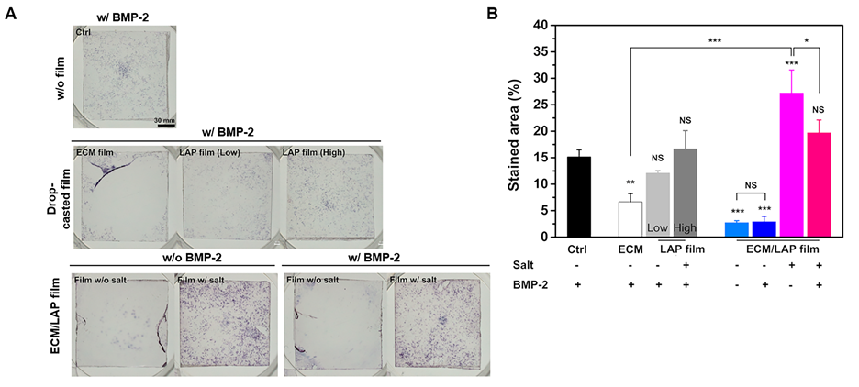
Figure 7. ECM/LAP films enhanced osteogenic differentiation of human skeletal progenitor cells. Osteogenic differentiation potential of ECM/LAP films compared to ECM and LAP films. (A) Alkaline phosphatase (ALP) staining of HBMSCs cultured on films at day 5 and (B) ALP stained area (%) calculated by image J software. Error bar = standard deviation, n = 3; p value on each bar is smaller than 0.05, 0.01 and 0.001 is marked as *, ** and ***, respectively and non-significance marked as NS compared to control (Ctrl).

In contrast, the ECM/LAP film following salt washing was stable in cell culture conditions for 5 days presumably due to the increased concentration of LAP achieved through the salt washing step. These displayed a strong osteogenic response. Unexpectedly, there was no added effect of BMP-2 on osteogenesis when we applied 100 ng/ml BMP-2 to the film, though we note considerable variability reported in the literature on the effects of BMP2 at this concentration [47-51]. Interestingly, nanofilms lacking BMP-2, in comparison to nanofilms containing BMP-2 displayed a significantly larger area of ALP stained cells (Figure 7, p<0.05). While there was no effect of BMP-2 on osteogenesis following the addition of 100 ng/ml BMP-2 to the film it should be noted that the effect of BMP2 on HBMSCs in vitro is somewhat ambiguous. Studies have shown that 100 ng/ml BMP-2 can enhance ALP activity of MSCs [47-49], whereas other authors have reported the absence of a stimulatory effect on ALP following the addition of 100 ng/ml BMP-2 [50, 51]. The differences in the reported results may be a consequence of variations in the experimental setups and the variable differentiation state of primary cells. It is important to note materials which are osteoinductive, such as ECM and LAP, are used [31, 52, 53], the effect of BMP-2 may be dampened. This indicates that the addition of BMP-2 into the ECM/LAP films did not show a synergistic effect on osteogenesis, although the salt washed films enhanced ALP activity regardless of BMP-2 presence. We observed ECM/LAP film with salt washing significantly improved the nanofilm mechanical strength (Figure 4B). Given stiffness affects not only cell proliferation but also differentiation [10], it is important to note the enhanced osteogenic differentiation could be due to the stiffness of the LAP film as a consequence of salt washing. Further studies on effect of the mechanical properties are thus warranted to confirm this mechanism of action. Taken together with our new findings on the effect of ECM/LAP films and salt washing process, imply that multi-layering two materials and salt washing are crucial factors in compensating vulnerable points of the materials and maximizing their strength for tissue engineering applications.

- Conclusion
In this study, we have prepared multilayer nanofilms using Laponite (LAP) and bone extracellular matrix (ECM) for osteogenesis. In order to overcome the mechanical weakness of the ECM material while maintaining osteogenic differentiation potential, we employed LAP platelets as a LbL multilayer building block. We used a different washing step after LAP deposition with high salt concentrated solution to minimize the desorption of LAP layer during the washing step, as well as to induce stable, ordered stacking of LAP interlayer by face–edge aggregation. We confirmed the LAP interlayer structure by cross-sectional SEM and XRD pattern, which showed the stacking of LAP layers with a basal d-spacing of 1.72 nm. The periodic stacking LAP layers induced enhanced mechanical strength, as determined by hardness and Young’s modulus. ECM degradation kinetics up to 7 days were observed, and the strong LAP layers remained intact during that period. In long-term cell culture, the ECM/LAP film washed with DI water was swollen and cells were detached from the films. We observed that film washed with salt was stable and facilitated osteogenic differentiation potential, with enhanced mechanical property and ECM environment. The current studies demonstrate the fabrication of a nano-2D scaffold to complement the mechanical weakness of bone extracted materials under physiological conditions, using LAP. The platform technology generated offers potential biomedical or tissue engineering applications.

Conflicts of interest
There are no conflicts to declare.

Acknowledgements
This work was supported by the UK-Korea Partnering Award funded by the UK Medical Research Council (MRC) and the Korea Health Industry Development Institute (KHIDI) (grant number MC_PC_18015) and Jonathan Dawson’s EPSRC fellowship (grant number EP/L010259/1). And this research was also supported by a grant of the Korea Health Technology R&D Project through the Korea Health Industry Development Institute (KHIDI), funded by the Ministry of Health & Welfare, Republic of Korea (HI18C2021), and Basic Science Research Program through the National Research Foundation of Korea (NRF) funded by the Ministry of Science and ICT (NRF-2017R1E1A1A01074343).
References
[1] G. Kumar, C.K. Tison, K. Chatterjee, P.S. Pine, J.H. McDaniel, M.L. Salit, M.F. Young, C.G. Simon Jr, Biomaterials, 32 (2011) 9188-9196.
[2] R.A. Marklein, J.A. Burdick, Advanced materials, 22 (2010) 175-189.
[3] E. Piva, A.F. Silva, J.E. Nör, Journal of endodontics, 40 (2014) S33-S40.
[4] M. Mathieu, S. Rigutto, A. Ingels, D. Spruyt, N. Stricwant, I. Kharroubi, V. Albarani, M. Jayankura, J. Rasschaert, E. Bastianelli, Bone, 53 (2013) 391-398.
[5] V. Karageorgiou, D. Kaplan, Biomaterials, 26 (2005) 5474-5491.
[6] M.K. Jaiswal, J.R. Xavier, J.K. Carrow, P. Desai, D. Alge, A.K. Gaharwar, ACS nano, 10 (2015) 246-256.
[7] M.B. Keogh, F.J. O’Brien, J.S. Daly, Acta Biomaterialia, 6 (2010) 4305-4313.
[8] L. Jiang, Z. Sun, X. Chen, J. Li, Y. Xu, Y. Zu, J. Hu, D. Han, C. Yang, ACS nano, 10 (2015) 207-217.
[9] D.S. Benoit, M.P. Schwartz, A.R. Durney, K.S. Anseth, Nature materials, 7 (2008) 816.
[10] J.-H. Hwang, U. Han, M. Yang, Y. Choi, J. Choi, J.-M. Lee, H.-S. Jung, J. Hong, J.-H. Hong, Acta biomaterialia, 86 (2019) 247-256.
[11] M.L. Macdonald, R.E. Samuel, N.J. Shah, R.F. Padera, Y.M. Beben, P.T. Hammond, Biomaterials, 32 (2011) 1446-1453.
[12] C. Salvi, X. Lyu, A.M. Peterson, Biomacromolecules, 17 (2016) 1949-1958.
[13] Y.-I. Chung, K.-M. Ahn, S.-H. Jeon, S.-Y. Lee, J.-H. Lee, G. Tae, Journal of Controlled Release, 121 (2007) 91-99.
[14] X. Chen, X. Fu, J.-g. Shi, H. Wang, Nanomedicine: Nanotechnology, Biology and Medicine, 9 (2013) 1283-1292.
[15] H. Ohgushi, V.M. Goldberg, A.I. Caplan, Journal of Orthopaedic Research, 7 (1989) 568-578.
[16] M. Sawkins, W. Bowen, P. Dhadda, H. Markides, L. Sidney, A. Taylor, F. Rose, S. Badylak, K. Shakesheff, L. White, Acta biomaterialia, 9 (2013) 7865-7873.
[17] B.N. Brown, S.F. Badylak, Translational Research, 163 (2014) 268-285.
[18] F.A. Aouada, L.H. Mattoso, E. Longo, Journal of Thermoplastic Composite Materials, 26 (2013) 109-124.
[19] J.I. Dawson, J.M. Kanczler, X.B. Yang, G.S. Attard, R.O. Oreffo, Advanced Materials, 23 (2011) 3304-3308.
[20] H.Z. Cummins, Journal of Non-Crystalline Solids, 353 (2007) 3891-3905.
[21] T. Fornes, D.R. Paul, Polymer, 44 (2003) 4993-5013.
[22] J.I. Dawson, R.O. Oreffo, Advanced Materials, 25 (2013) 4069-4086.
[23] G. Decher, Science, 277 (1997) 1232-1237.
[24] G. Decher, M. Eckle, J. Schmitt, B. Struth, Current opinion in colloid & interface science, 3 (1998) 32-39.
[25] D. Choi, J. Hong, Archives of pharmacal research, 37 (2014) 79-87.
[26] J. Hong, W.K. Bae, H. Lee, S. Oh, K. Char, F. Caruso, J. Cho, Advanced Materials, 19 (2007) 4364-4369.
[27] J. Hong, N.J. Shah, A.C. Drake, P.C. DeMuth, J.B. Lee, J. Chen, P.T. Hammond, Acs Nano, 6 (2011) 81-88.
[28] D. Choi, J. Park, J. Heo, T.I. Oh, E. Lee, J. Hong, ACS applied materials & interfaces, 9 (2017) 12264-12271.
[29] H. Jeong, J. Heo, B. Son, D. Choi, T.H. Park, M. Chang, J. Hong, ACS applied materials & interfaces, 7 (2015) 26117-26123.
[30] J. Hong, J.Y. Han, H. Yoon, P. Joo, T. Lee, E. Seo, K. Char, B.-S. Kim, Nanoscale, 3 (2011) 4515-4531.
[31] N. Alom, H. Peto, G.R. Kirkham, K.M. Shakesheff, L.J. White, J Biomed Mater Res B Appl Biomater, 106 (2018) 900-908.
[32] J.A. Uquillas, O. Akkus, Annals of biomedical engineering, 40 (2012) 1641-1653.
[33] W.H. Yu, N. Li, D.S. Tong, C.H. Zhou, C.X.C. Lin, C.Y. Xu, Applied Clay Science, 80 (2013) 443-452.
[34] K.C. Wood, H.F. Chuang, R.D. Batten, D.M. Lynn, P.T. Hammond, Proceedings of the National Academy of Sciences, 103 (2006) 10207-10212.
[35] N. Cini, T. Tulun, G. Decher, V. Ball, Journal of the American Chemical Society, 132 (2010) 8264-8265.
[36] A.M. Yashchenok, D.A. Gorin, M. Badylevich, A.A. Serdobintsev, M. Bedard, Y.G. Fedorenko, G.B. Khomutov, D.O. Grigoriev, H. Möhwald, Physical Chemistry Chemical Physics, 12 (2010) 10469-10475.
[37] J. Min, R.D. Braatz, P.T. Hammond, Biomaterials, 35 (2014) 2507-2517.
[38] T. Blanton, D. Majumdar, S. Melpolder, Adv. X-ray Anal, 42 (2000) 562-568.
[39] P. Shi, Y.H. Kim, M. Mousa, R.R. Sanchez, R.O. Oreffo, J.I. Dawson, Advanced healthcare materials, 7 (2018) 1800331.
[40] Q. Kan, W. Yan, G. Kang, Q. Sun, Journal of the Mechanics and Physics of Solids, 61 (2013) 2015-2033.
[41] M.H. Hettiaratchi, T. Miller, J.S. Temenoff, R.E. Guldberg, T.C. McDevitt, Biomaterials, 35 (2014) 7228-7238.
[42] C. Scheufler, W. Sebald, M. Hülsmeyer, Journal of molecular biology, 287 (1999) 103-115.
[43] T. Hu, H.-y. Li, X.-z. Zhang, H.-j. Luo, J.-m. Fu, Ecotoxicology and Environmental Safety, 74 (2011) 2050-2056.
[44] J.W. Wassenaar, R.L. Braden, K.G. Osborn, K.L. Christman, Journal of Materials Chemistry B, 4 (2016) 2794-2802.
[45] S. Kubinova, Neural regeneration research, 12 (2017) 1430.
[46] J.A. Claudio-Rizo, J. Delgado, I.A. Quintero-Ortega, J.L. Mata-Mata, B. Mendoza-Novelo, Hydrogels, (2018) 1.
[47] O. Fromigué, P.J. Marie, A. Lomri, Journal of Cellular Biochemistry, 68 (1998) 411-426.
[48] F. Gori, T. Thomas, K.C. Hicok, T.C. Spelsberg, B.L. Riggs, J Bone Miner Res, 14 (1999) 1522-1535.
[49] F. Lecanda, L.V. Avioli, S.-L. Cheng, Journal of Cellular Biochemistry, 67 (1997) 386-398.
[50] N.R. Jørgensen, Z. Henriksen, O. Sørensen, R. Civitelli, Steroids, 69 (2004) 219-226.
[51] D.L. Diefenderfer, A.M. Osyczka, G.C. Reilly, P.S. Leboy, Connective tissue research, 44 (2003) 305-311.
[52] D. Gibbs, C. Black, G. Hulsart-Billstrom, P. Shi, E. Scarpa, R. Oreffo, J. Dawson, Biomaterials, 99 (2016) 16-23.
[53] Y.-H. Kim, X. Yang, L. Shi, S.A. Lanham, J. Hilborn, R.O.C. Oreffo, D. Ossipov, J.I. Dawson, Nature Communications, 11 (2020) 1365.

