Supplementary Figure 1: Matrix showing correlations between height components and regional body composition measures
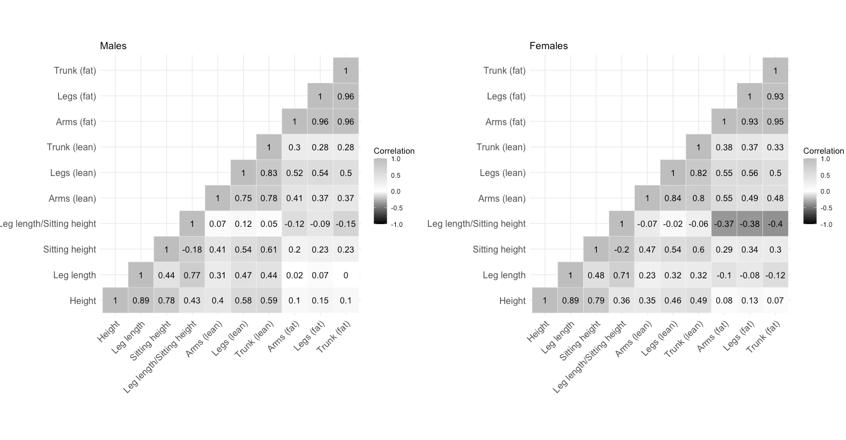

Supplementary Figure 2: Relationships of leg length and sitting height with selected CVD risk factors
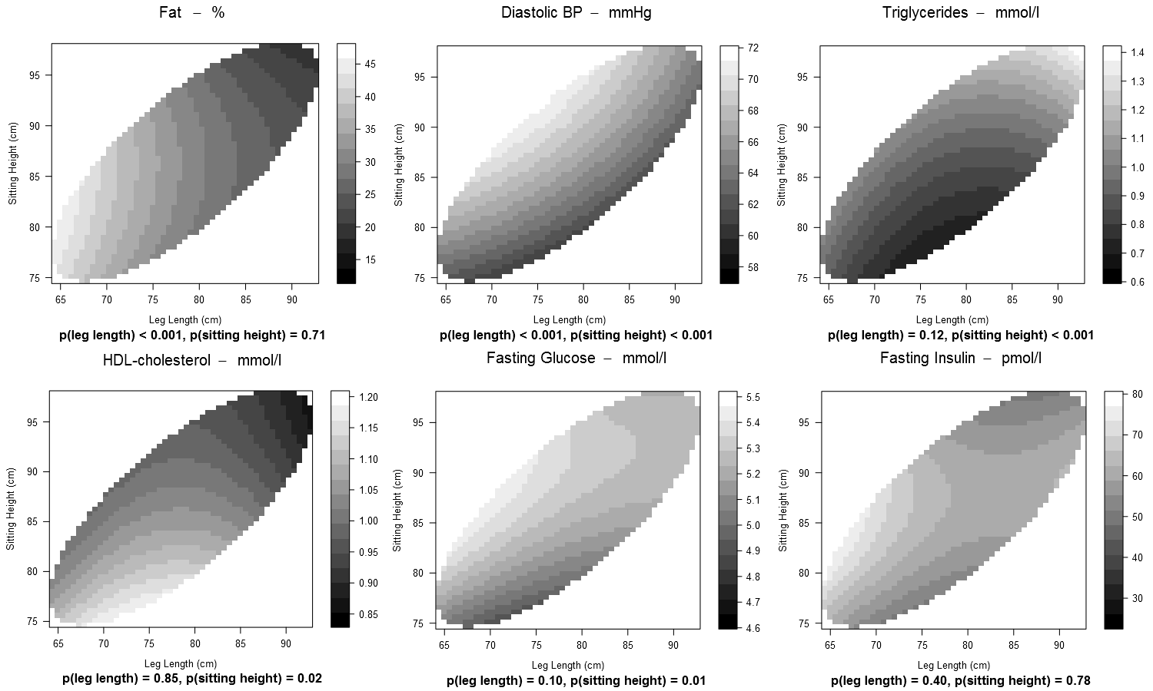
Supplementary Figure 3: Relationships of leg length and sitting height with selected CVD risk factors
