Turing in the Driver’s Seat: Can People Distinguish Between Automated and Manually Driven Vehicles?

N. A. Stanton ^{a*}, A. Eriksson ª, V. A. Banks ª, P. A. Hancock ^{b}

ªHuman Factors Engineering, Transportation Research Group, University of Southampton, Southampton, U.K.

^{b}Department of Psychology, University of Central Florida, Florida, USA.
*Corresponding author: n.stanton@soton.ac.uk

Abstract
As the number of automated vehicles is increasing on our roads, we wanted to know if people could detect if a car was being driven by a human driver or automation in a lane change task. This is particularly relevant, as most of the road collisions involve automated vehicles being struck from behind by manually driven vehicles. To address the detection of automated vehicles, an online survey presented videos of lane change manoeuvres on multilane carriageways from behind the automated vehicle. We reasoned that, on such roads, the behaviour of the vehicles in front would have more of an affect on drivers than those of the vehicles behind. To this end, an online survey was conducted with 769 people judging 60 video clips, classifying the lane change either being performed by Autopilot software or a human driver. Over 34,000 responses were recorded. It was found that automated and manual lane changes were virtually indistinguishable from the rear of the vehicle. The main conclusion of the research was that vehicles in automated mode should display this fact to other road users all around the vehicle as this may have an affect on other road users in anticipating the behaviour of the other vehicle.

Practitioner Summary:
We wanted to know if people could detect if a car was being driven by a human driver or automation in a lane change task. An online survey was conducted with people judging video clips. It was found that automated and manual lane changes were virtually indistinguishable.

Keywords: automation; autopilot, turing test, self-driving, road user interaction

Running Head: Turing in the driver’s seat

Acknowledgement
This work was supported by Jaguar Land Rover and the UK-EPSRC grant EP/N011899/1 as part of the jointly funded Towards Autonomy: Smart and Connected Control (TASCC) Programme.

Keywords: automation; autopilot, turing test, self-driving, road user interaction

Introduction
Automated, self-driving automobiles have moved from being science fiction to simple fact (Stanton, 2015). This is, no doubt, driven by perceived consumers desire to be chauffeured from origin to destination, allowing them to get on with, putatively, more interesting activities than driving per se (Carsten, Lai, Barnard, Jamson, & Merat, 2012; Banks, Eriksson, O'Donoghue, & Stanton, 2018). The utility of automated driving has been much discussed in the academic (De Winter, Happee, Martens, & Stanton, 2014; Hancock, 2018, 2019) and more general public literature (Stanton, 2015). There are those that argue that human drivers need to be in charge of vehicle automation; that automated driving systems in the intermediary levels need to be designed for appropriate reliance, keeping the driver in the control ‘loop’ (Banks & Stanton, 2016), and those that argue that the driver needs to be removed altogether (Alessandrini, Campagna, Delle Site, Filippi, & Persia, 2015). Most motor vehicle manufacturers are working on producing the former in the short to medium term, whilst retaining an eye on the latter for developments in the longer term.

Currently, the electric motor vehicle manufacturer Tesla is offering an Autopilot System as a downloadable software option (with the promise of regular updates) when customers buy their cars. This software claims to steer within a lane, change lanes with the simple tap of a turn signal and manage speed by using active, traffic-aware, cruise control (Tesla Motors, 2016). Driving is however, in fact, a very demanding activity, comprising over 1600 sub-tasks (Walker, Stanton, & Salmon, 2015). Learning to drive is effortful and takes some considerable amount of time to master successfully (Stanton, Walker, Young, Kazi, & Salmon, 2007). Currently, over 1.35 million people a year die in traffic collisions around the world (World Health Organization, 2018). Further, it has been suggested that drivers blamed for over 90% of collisions, whether it is their fault or not (Singh, 2015; Stanton & Salmon, 2009; Thorpe, Jochem, & Pomerleau, 1997). Automated driving holds the potential to reduce this figure substantially (Musk, 2016; Stanton & Marsden, 1996). Elon Musk (Musk, 2016) has gone so far to say: “The probability of having an accident is 50% lower if you have Autopilot on. Even with our first version. So we can see basically what’s the average number of kilometers to an accident – accident defined by airbag deployment. Even with this early version, it’s almost twice as good as a person.” Whilst this claim is not based on any scientific studies, driver assistance systems could not only save many hundreds of thousands of lives worldwide, but also would have help the European Commission reach its goal of reducing road traffic deaths by 50% by 2030 (European Commission, 2019). It must be noted that consumer adoption of automated vehicles cannot happen overnight even if this were desired. Consequentially, a transition period must be expected in which automated and manually driven vehicles share the same infrastructure (Ioannou, 1998). This has raised some safety concerns, as automated vehicles will have to be able to predict the behaviour of somewhat unpredictable human drivers, whilst drivers of manual vehicles must anticipate and adapt to the driving style of automated vehicles seeking to improve their performance (van Loon & Martens, 2015). What is not yet known is how drivers of other, manually driven, vehicles will react to the presence of automated vehicles on the road in front of them. There is some suggestion that automated vehicles do not necessarily behave like manually driven vehicles and that drivers following such vehicles might not anticipate their behaviour correctly (Wang and Li, 2019). This is important, as their perception of a car driven by an autopilot, rather than one driven by a human, may change the way in which they interact with it on the road (Thompson et al, 2020). For example, Millard-Ball (2016) suggest that drivers may ‘play a game of chicken’ with automated vehicles, as such vehicles are, in their nature, cautious in order to ensure safety. Indeed, Chris Urmson at Google has stated that “We make the cars as paranoid as possible, because there are some things they won’t be able to avoid” (quoted in: Rogers, 2016).

Normally, pedestrians and drivers alike use certain strategies to negotiate traffic. For example, research has indicated that pedestrians tend to look directly at drivers before crossing the road (Evans & Norman, 1998), and often provide signals of gratitude (e.g., hand gestures, nodding or smiling). However, such cues are not currently available when automation is involved, especially if there is no ‘driver’ to communicate with (Lundgren et al., 2017). Similarly, Rodríguez (2017) found that cyclists feel less safe when interacting with pod-like automated vehicles in intersections. Thompson et al (2020) suggest that automated vehicles could create conflicts with other road users, particularly with cyclists and pedestrians. One way of resolving this was proposed via ‘the smiling car’ (Semcon, 2017), which shows a pedestrian that they have been detected, and that the vehicle will yield through a means of ‘humanlike’ communication, something that has been previously suggested by Eriksson and Stanton (2017a) and Norman (1993).

The question remains however, are human road users able to detect a vehicle being driven by a set of computer algorithms rather than by another human driver in moving traffic? Whilst for some vehicles, this differentiation is relatively simple (e.g., Waymo vehicles, previously known as Google Car, are equipped with a large LIDAR scanner on the roof of the vehicle), vehicles equipped with automated functionality enabling periods of ‘hands and feet free driving’ (Banks et al. 2014) are increasingly resembling normal cars. The Tesla Model S for example, looks like any other medium sized saloon vehicle. Even if the driver following an automated vehicle recognises it as such (from the vehicle shape and/or badge), it does not necessarily mean that it is being driven in automated mode. This adds an additional layer of complexity to the driving task (Walker et al, 2018) as road users will not be able to distinguish what is an automated vehicle simply from the make and model. The concern here is that automated and manual driving might be quite different it terms of setting appropriate expectations about their future behaviour for drivers of manually drive vehicles following them. Reports on collisions with self-driving vehicles suggest that the majority are being rear-ended by drivers of manual vehicles (Wang and Li, 2019). Being able to differentiate between a vehicle being driven by an automated algorithm and a manually driven vehicle essentially represents the on-road equivalent of the ‘Turing Test’. In 1950, Alan Turing (Turing, 1950) argued that to pass his test, a machine would need to exhibit intelligent behaviour equivalent to, or at least indistinguishable from, that of a human. This is the much-discussed ‘imitation game’. We are not suggesting that the Autopilot ‘thinks’ like a human driver, rather that people will be unable to distinguish between the external, observable behaviour of the Autopilot and human drivers in our lane change test specified below, much like Searle’s Chinese room experiment (Searle, 1980). Searle (1980) argued that whilst a computer following rules set out in a set algorithms might be able to mimic the behaviour of a human (in Searles’s thought experiment it was the exchanging of Chinese symbols following as set of rules does not mean that you understand Chinese), it does not necessarily follow that the machine is thinking like the human, nor that human thinking is like that of machine computation. We chose a lane changing task as our referent, as weaving crashes (which are comparable to the lane-change manoeuvers; Pande & Abdel-Aty, 2006) is the cause of more that 20% of collisions on US freeways (motorways) (Golob & Recker, 2004). Such manoeuvres are one of the most challenging on multi-lane carriageways (Heesen, Baumann, Kelsch, Nause, & Friedrich, 2012; Young, Lenné, & Williamson, 2011). Human recognition and decision errors have been shown to be one of the causes of such collisions (Treat et al., 1979; Stanton & Salmon, 2009). For road users, in the target lane for the lane change drivers need approximately 8-14 seconds to anticipate and react to an entering vehicle (Heesen et al., 2012; Zheng, Ahn, Chen, & Laval, 2013). We anticipated that the study of the lane-change manoeuvres should reveal differences in manual and automated driving behavior if they are to be found, and (much more so than simple lane keeping or longitudinal car following) would. To do this, our plan was to present video clips of lane change maneuvers to drivers and ask them to classify them as either manual or automated.

Method
In order to submit the Tesla Model S P90D (with the first generation of Autopilot) to the Turing test (Turing, 1950), we video recorded a number of lane changes on multi-lane carriageways (the A46, M40 and M42 between Coventry and Birmingham in the UK). The video recordings were from a following vehicle using a GoPro camera with a standard lens capturing the leading vehicle as well as all three lane of the full road view in front of the camera. The filming was from behind the target vehicle to represent the view a vehicle following would have, as the lane change would most likely to affect this vehicle (a lane change is unlikely to affect a vehicle in front of the target vehicle). This camera angle was chose because the vehicle was on a British motorways and dual carriageways (aka Freeway) where all the traffic flows in the same direction (oncoming traffic is separated by a central median and collision barrier) and there were no vulnerable road users (such as pedestrians and cyclists). All lane changes were successful. Clips were limited to 5 seconds due to image size constraints, and to ensure that the participants focused on the lane change rather than other traffic information. Examples stills for one video clip showing a vehicle vehicle changing lanes can been seen in Figures 1 (before), 2 (during) and 3 (after). Finnegan and Green (1990) estimate that it takes 1.5 seconds on average to change lanes. This estimate does not include the preparatory activities, which as glancing around and making judgments about the traffic, which raises the lane change time to 6.6 seconds. All of the video clips had completed lane changes within them. No information was provided on the other traffic and the image sequences were randomised. Half of these lane change manoeuvres were performed by the Autopilot software whilst the other half were completed by a human driver (half of the lane changes in both manual and automated conditions were to the left-hand lane). The automated lane changes were initiated by the driver moving the indicator stalk in the intended direction of the move. No other driver interaction was performed.
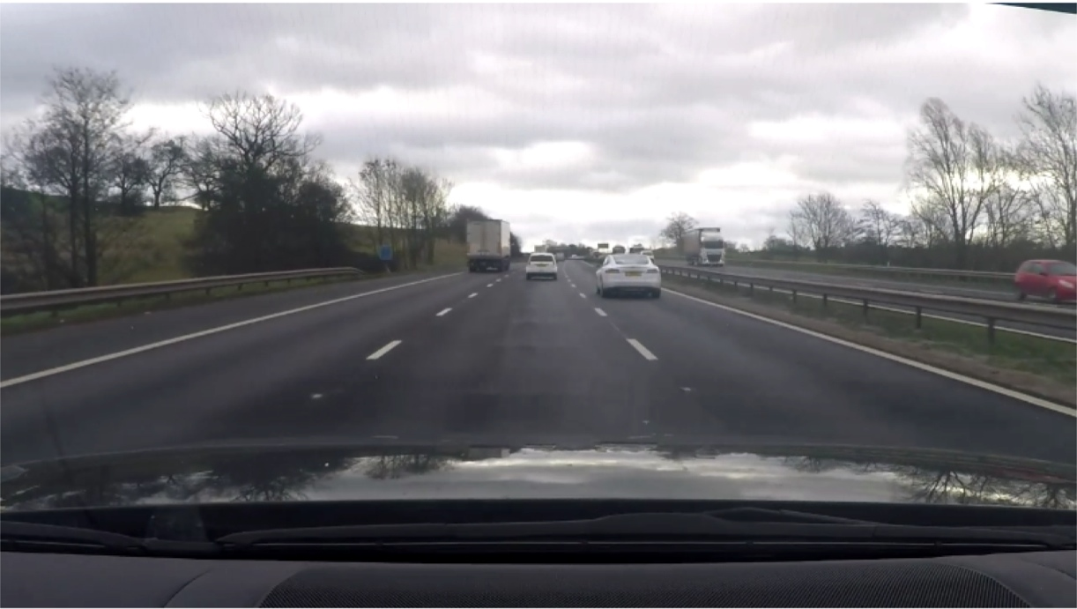
Figure 1: Still image from video clip showing white vehicle before the lane change had begun.

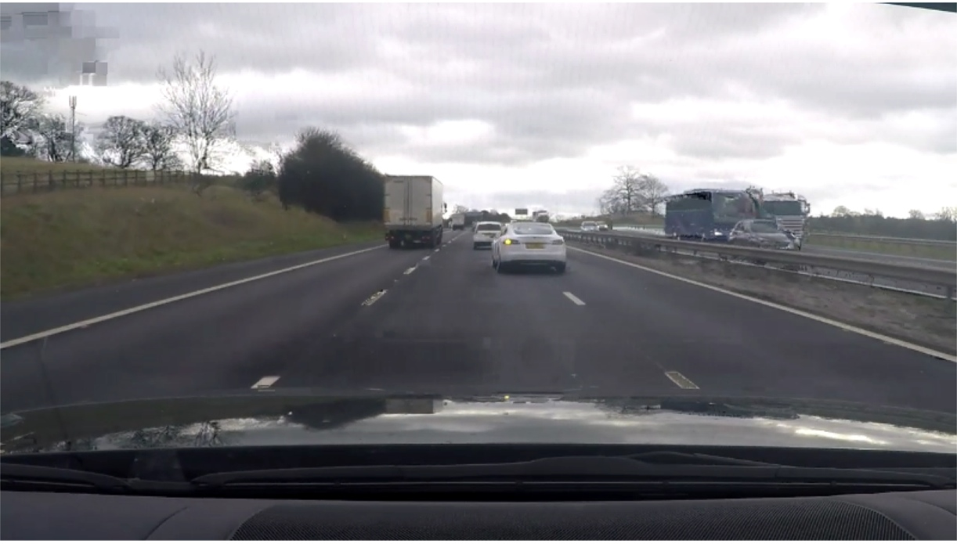
Figure 2: Still image from video clip showing white vehicle during the lane change.

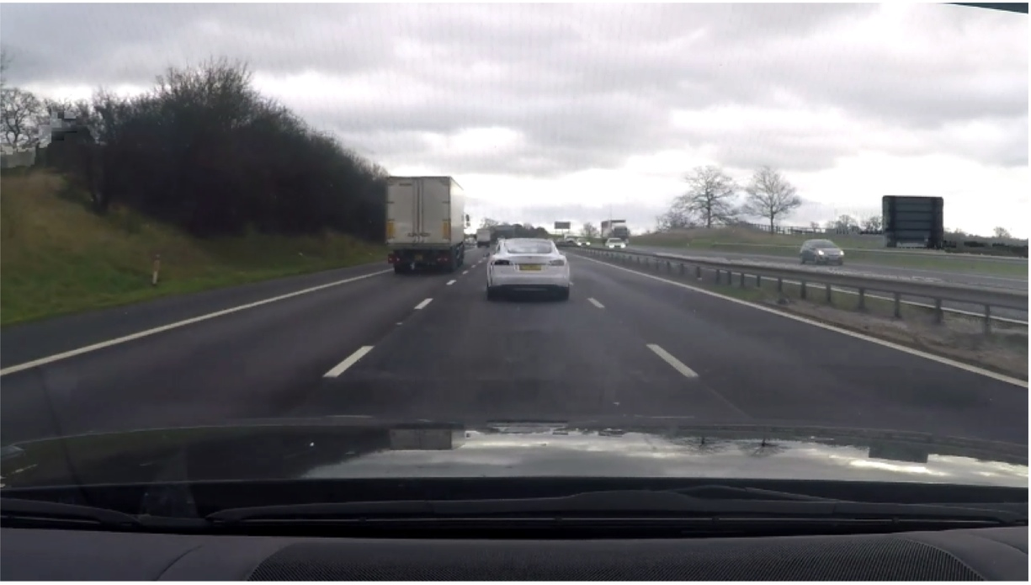
Figure 3: Still image from video clip showing white vehicle after the lane change had been completed.

The videos were then processed in a generic video editing software to select lane changes that fulfilled the following requirements: good visibility and no identifiers visible (e.g., license plate numbers). The videos were further processed using a bespoke C# program that utilized the Open Source tool FFMPEG to batch-convert the files to .GIF and compress the resulting files into a size suitable for web-use. A total of 60 lane change manoeuvres were chosen for inclusion in an online survey (30 manual and 30 automated). This survey was designed using an on-line survey tool (iSurvey), which is owned by the University of Southampton. The primary aim was to explore whether people could correctly identify whether the Tesla was being driven by the Autopilot software or by the human driver.

Participants
A total of seven-hundred and sixty-nine (n=769) people responded to the online survey (of which 156 were female), with an average age of 39 years (standard deviation 14 years). They self-declared 20 years of driving experience (standard deviation 14 years), of which 331 said they had some previous experience of advanced driver assistance systems (such as adaptive cruise control and lane keeping assist systems). Permission for the study was provided by the University of Southampton Ethics and Research Governance Office (ERGO number 24961).

Procedure
Upon providing consent, the participants filled out a short demographics questionnaire, including response to a question regarding their familiarity with advanced driver assistance systems. They were then invited to view two example GIF (Graphics Interchange Format) clips of lane change manoeuvers. One of these manoeuvers was conducted by a human driver and the other was conducted by the Autopilot software, which was explained to them in the text accompanying the video clip. After viewing the two test items, they completed the classification task of categorising the lane change as performed by a human driver or Autopilot software for the 60 clips presented to them. The classification was undertaken using a drop-down menu below each video. The total time of the survey was approximately 20 minutes from entering the questionnaire until its completion.

Analysis
The data were partitioned into TP = true positives (classified as Autopilot and it was Autopilot), TN = true negatives (classified as a human driver and it was a human driver), FP = false positives (classified as Autopilot and it was a human driver) and FN = false negatives (classified as human driver and it was Autopilot). From this Matthews Correlation Coefficient (MCC) was computed as described in the equation below (Matthews, 1975):

The MCC is essentially a correlation coefficient between the observed data actual actual data in a binary classification. As such, it reveals peoples (in)ability to discriminate between the Autopilot software and human driver, as described below.

Results
Overall, participants had significant difficulty in distinguishing the difference between the lane changes performed by the Autopilot software and those performed by a human driver. The data show that Phi = 0.01, where a coefficient of +1 represents a perfect positive prediction, 0 a random prediction and -1 a perfect negative prediction. As Table 1 show, the weak positive prediction means that people were only very marginally more likely to identify the Autopilot when it was driving but, at the same time, more likely to ascribe the Autopilot as driving when in fact it was a human driver in control. With over 34,000 individual lane changes classified in this survey, the findings appear to be determinative.

Table 1: Responses to our on-line survey of video clips of lane changes conducted in the Tesla Model S P90D

 |  | Who was actually driving the car
 |  | Autopilot software | Human driver
Who people thought was driving the car | Autopilot software | 8889 (TP) | 8241 (FP)
Who people thought was driving the car | Human driver | 8804 (FN) | 8391 (TN)

Discussion
What does this outcome mean? In essence, it determines that even at the current time, people find it very difficult to distinguish between a vehicle driven by a human driver and that driven by the Autopilot system in the context of the present lane change test, when the vehicle is viewed from behind. This is a very specific set of circumstances and the research needs to be extended to other viewing angles. For the present study however, one could go so far as to say that, based on the reported data, the two are virtually indistinguishable, and driving automation features are likely to become even more difficult to discern in the future. We therefore need to consider the possible implications this can have on the safety of other road users who are unable to determine “who” is in control of other vehicles (Banks and Stanton, 2016). This is particularly important when we consider the safety of vulnerable road users, especially given the recent fatality involving the Uber vehicle and a cyclist crossing the road (Stanton et al, 2019). This unfortunate event is likely to further exacerbate the feeling of unease surrounding the use of automated vehicles on our roads.

Seventy years after Turing (1950) set up his challenge, machines, namely the Tesla Model S, are beginning to imitate human behavior in a convincing manner. We suggest that over the coming years, more vehicle manufacturers will release vehicles capable of passing the Turing Test. However, much like in Searle’s (1980) thought experiment, these vehicles may seem intelligent, but they are still controlled by computer algorithms, without any full understanding of the traffic system around them. This is likely to create a number of issues, especially when we consider that technical systems are vulnerable to the onset of failure (Goodall, 2014; Stanton and Marsden, 1996; Stanton et al, 1997). This means that they may still not function in a satisfactory manner all of the time, especially when they reach the limits of their operational design domain, or experience sudden changes in driving environment (Eriksson & Stanton, 2017a; Hancock, 2018). In such cases, at least for the intermediary stages of automation, we anticipate that the driver will have to step in as a fallback, resuming manual vehicle control. Depending on the level of automation, and the time frame to resume control afforded by the vehicle, it is likely that these vehicles will, from an external perspective, express puzzling behaviors. This is because drivers will find themselves being entered back into the main control-feedback loop despite external conditions having changed. This may result in over and undershoot in the steering input (Russell et al. (2016). Further, Desmond, Hancock, and Monette (1998) found larger heading errors and poorer lateral control in the first 20 seconds after resuming control from automated driving following a failure. Also, it takes up to 40 seconds for the driver to regain control stability after a transition to manual driving (Meret et al, 2014; Eriksson & Stanton, 2017c). In the worst case scenario, the driver may be forced to conduct harsh braking, rapid lane changes and unnecessary stopping of the vehicle (Gold, Damböck, Lorenz, & Bengler, 2013). In the best case scenario, with ample time to resume control, almost no detrimental effects on lateral behaviors may be evident (Eriksson & Stanton, 2017b). This means that, if drivers cannot distinguish automatically driven vehicles from those who are driven by human drivers, a sudden change in control authority in one of these vehicles, with sudden and severe lateral movements, may pose significant safety risks as drivers of manual vehicles either fail to react, or over-react (Young and Stanton, 2002). Such an event may well propagate through the traffic stream (Young and Stanton, 2007), and potentially lead to fatal collisions, such as vehicles leaving the roadway. These events may spark an overall distrust in automated driving systems (Hancock et al., 2011; Schaefer et al., 2016; Walker et al, 2016), despite the potential safety improvements and accident reductions that they bring when functioning safely within their operational parameters (Stanton and Marsden, 1996). Thus, the status of the automation, and potentially whether a vehicle is automated or not, should not only be communicated through the human-machine interface to a driver of such a vehicle, but also to other road users through external communication channels (in the cases where it is not obvious that a vehicle possesses such features, by, for example, being with a salient LIDAR scanner), so that behavioral change may be anticipated.

In recent years, external human-machine interfaces for autonomous vehicles have been explored (e.g. Böckle, Brenden, Klingegård, Habibovic, & Bout, 2017; Lundgren et al., 2017; Matthews, Chowdhary, & Kieson, 2017). Such literature mostly covers vulnerable road users (VRU). There are a number of ways a vehicle can communicate its intentions to a VRU, for example through vehicle kinematics (such as slowing down and stopping, see Lundgren et al., 2017) or through the use of external human machine interfaces (eHMI). eHMIs may utilize different design patterns, such as icons (Fridman et al., 2017), textual information (Matthews et al., 2017), a simulated smile/frown (Semcon, 2017), or patterns of light (Böckle et al., 2017; de Clercq, Dietrich, Núñez Velasco, de Winter, & Happee, 2018). Amongst these eHMI variations, textually based interfaces have shown evident promise. For example, in an Amazon Mechanical Turk survey, Fridman et al. (2017) found that participants preferred the textual eHMI over icon based alternatives. This has been further corroborated by de Clercq et al. (2018) who reported that participants found that the textual HMI was less ambiguous than other eHMI types and that eHMIs increase the time participants felt safe to cross in front of an approaching vehicle. Indeed, utilizing an eHMI may increase the resolution of potentially dangerous and inefficient vehicle-pedestrian deadlock situations by up to 38% (Matthews et al., 2017). One obvious conclusion of this study is the eHMI should communicate the driving mode all around the vehicle, such as the rear and sides, and not just from the front, which is where most of the research is focused. More research into the 360 degrees eHMI is needed for the effectiveness of this strategy can be ascertained. It also remains uncertain whether or not eHMIs, targeted at facilitating driver-vehicle interaction in traffic could be of practical use. Volvo Cars stated that they will not mark their automated driving prototype vehicles as ‘automated’ to avoid automation abuse (Parasuraman, Molloy, & Singh, 1993) resulting from divulging such information (Connor, 2016). A recent example of such abuse was seen by Waymo, whose vehicle was held up at an on ramp as other road users would not give berth to merge for their ‘self-driving’ prototype vehicle (Gupta, 2017). Therefore, were commended that eHMIs should be further researched in an effort to facilitate interaction between road users in the traffic environment.

There are some limitations with this study however, and future work should replicate with a camera directed at the driver of the automated vehicle. Arguably, people might perform this detection task if the vehicle is being viewed from the front, the side, or any other angle. Also, the lane change task, swapping lane from left to right or vice versa, is only one aspect of vehicle control. Changes of speed were no considered, only changes of direction (although this is quite a frequent task performed on British motorways). Clearly then, other driving tasks need to be considered). Extending the study to a wider variety of driving tasks and different road types, as well as interactions with vulnerable road users remains an important goal for future research. A final limitation of the study was gender imbalance in the participants, with approximately 20 percent females, whereas in the UK driving population the balance is roughly equal. Any future study should address this gender imbalance with a more representative sample of participants.

Conclusion
In this study, we queried 769 people on 60 video clips of a Tesla Model S carrying out a lane-change under the control of a driver, or the autopilot software in an online survey. In essence, the process was subjecting them to the Turing Test (Turing, 1950) using partially automated vehicles. The results revealed that our participants were unable to distinguish between the human driver, or the autopilot manoeuvering the vehicle, in a total of 34,325 classifications. This has significant implications for traffic safety, as drivers tend to use non-verbal, non-symbolic, cues to negotiate interactions with other drivers, and vulnerable road users. If a vehicle is not able to indicate whether it is in automated mode to other road users, then they may mistake it for a manually driven vehicle, which could then lead to inappropriate interaction. A solution to this problem would be eHMI all around the vehicle that communicates that the vehicle is in automated driving mode to other road users. If the vehicle does communicate it is automated driving mode however, then it might be bullied by drivers of manually driven vehicles. There seems to be no simple solution to this problem, and new rules of the road may be required.

References
Alessandrini, A., Campagna, A., Delle Site, P., Filippi, F., & Persia, L. (2015). Automated vehicles and the rethinking of mobility and cities. Transportation Research Procedia, 5, 145-160.
Banks, V. A., Eriksson, A., O'Donoghue, J., & Stanton, N. A. (2018). Is partially automated driving a bad idea? Observations from an on-road study. Applied Ergonomics, 68, 138-145. doi:https://doi.org/10.1016/j.apergo.2017.11.010
Banks, V. A., & Stanton, N. A. (2016). Keep the driver in control: Automating automobiles of the future. Appl Ergon, 53 Pt B, 389-395. doi:10.1016/j.apergo.2015.06.020
Böckle, M.-P., Brenden, A. P., Klingegård, M., Habibovic, A., & Bout, M. (2017). SAV2P: Exploring the Impact of an Interface for Shared Automated Vehicles on Pedestrians' Experience. Paper presented at the Proceedings of the 9th International Conference on Automotive User Interfaces and Interactive Vehicular Applications Adjunct.
Carsten, O., Lai, F. C., Barnard, Y., Jamson, A. H., & Merat, N. (2012). Control task substitution in semiautomated driving: does it matter what aspects are automated? Hum Factors, 54(5), 747-761. doi:10.1177/0018720812460246
Connor, S. (2016). First self-driving cars will be unmarked so that other drivers don’t try to bully them. The Guardian.
de Clercq, G. K., Dietrich, A., Núñez Velasco, J. P., de Winter, J. C. F., & Happee, R. (2018). External Human-Machine Interfaces on Automated Vehicles: Effects on Pedestrian Crossing Decisions. preprint.
De Winter, J., Happee, R., Martens, M. H., & Stanton, N. A. (2014). Effects of adaptive cruise control and highly automated driving on workload and situation awareness: A review of the empirical evidence. Transportation research part F: traffic psychology and behaviour, 27, 196-217.
Desmond, P. A., Hancock, P. A., & Monette, J. L. (1998). Fatigue and automation-induced impairments in simulated driving performance. Human Performance, User Information, and Highway Design(1628), 8-14. doi:10.3141/1628-02
Eriksson, A., & Stanton, N. A. (2017a). The chatty co-driver: A linguistics approach applying lessons learnt from aviation incidents. Safety Science, 99, 94-101. doi:10.1016/j.ssci.2017.05.005
Eriksson, A., & Stanton, N. A. (2017b). Driving Performance after Self-regulated Control Transitions in Highly Automated Vehicles. Human Factors, 59 (8), 1233-1248.
Eriksson, A. and Stanton, N. A. (2017c) Take-over time in highly automated vehicles: transitions to and from manual control. Human Factors, 59 (4), 689–705.
European Commission. (2019). EU Road Safety Policy Framework 2021-2030 - Next steps towards "Vision Zero". European Commission, Brussels.
Evans, D., & Norman, P. (1998). Understanding pedestrians' road crossing decisions: an application of the theory of planned behaviour. Health Education Research, 13(4), 481-489.
Finnegan, P. and Green, P., 1990. The time to change lanes: A literature review (No. IVHS-TR-90-13). University of Michigan, Transportation Research Institute.
Fridman, L., Mehler, B., Xia, L., Yang, Y., Facusse, L. Y., & Reimer, B. (2017). To Walk or Not to Walk: Crowdsourced Assessment of External Vehicle-to-Pedestrian Displays. arXiv preprint arXiv:1707.02698.
Gold, C., Damböck, D., Lorenz, L., & Bengler, K. (2013). “Take over!” How long does it take to get the driver back into the loop? Proceedings of the Human Factors and Ergonomics Society Annual Meeting, 57(1), 1938-1942.
Golob, T. F., & Recker, W. W. (2004). A method for relating type of crash to traffic flow characteristics on urban freeways. Transportation Research Part A: Policy and Practice, 38(1), 53-80.
Goodall, N. J. (2014). Machine ethics and automated vehicles. In Road vehicle automation (pp. 93-102): Springer.
Gupta, N. (2017). Video of Waymo vehicle stuck on on-ramp.
Hancock, P.A. (2019). Some pitfalls in the promises of automated and autonomous vehicles. Ergonomics, 62(4), pp.479-495.
Hancock, P.A. (2018). Self-driving cars and humans face inevitable collisions. The Conversation. April 24th.
Hancock, P.A., Billings, D.R., Olsen, K., Chen, J.Y.C., de Visser, E.J., & Parasuraman, R. (2011). A meta-analysis of factors impacting trust in human-robot interaction. Human Factors, 53 (5),517-527.
Heesen, M., Baumann, M., Kelsch, J., Nause, D., & Friedrich, M. (2012). Investigation of cooperative driving behaviour during lane change in a multi-driver simulation environment. Paper presented at the Human Factors and Ergonomics Society (HFES) Europe Chapter Conference Touluse.
Ioannou, P. (1998). Evaluation of mixed automated/manual traffic. California Partners for Advanced Transit and Highways (PATH).
Lundgren, V. M., Habibovic, A., Andersson, J., Lagström, T., Nilsson, M., Sirkka, A., . . . Krupenia, S. (2017). Will There Be New Communication Needs When Introducing Automated Vehicles to the Urban Context? In Advances in Human Aspects of Transportation (pp. 485-497): Springer.
Matthews, B. W. (1975). Comparison of the predicted and observed secondary structure of T4 phage lysozyme. Biochimica et Biophysica Acta (BBA)-Protein Structure, 405(2), 442-451.
Matthews, M., Chowdhary, G., & Kieson, E. (2017). Intent Communication between Autonomous Vehicles and Pedestrians. arXiv preprint arXiv:1708.07123.
Merat, N., Jamson, A. H., Lai, F. F. C. H., Daly, M., & Carsten, O. M. J. (2014). Transition to manual: Driver behaviour when resuming control from a highly automated vehicle. Transportation Research Part F: Traffic Psychology and Behaviour, 26, Part A, 1-9. doi:http://dx.doi.org/10.1016/j.trf.2014.05.006
Millard-Ball, A. (2016). Pedestrians, Autonomous Vehicles, and Cities. Journal of Planning Education and Research, 0739456X16675674.
Musk, E. (2016). Interview at ‘Future Transport Solutions’ conference. https://youtube/HaJAF4tQVbA?t=1341 Quote at 22 minutes 36 seconds: retrieved on 12 May 2016.
Norman, D. (1993). Turn signals are the facial expressions of automobiles. New York: Basic Books.
Pande, A., & Abdel-Aty, M. (2006). Assessment of freeway traffic parameters leading to lane-change related collisions. Accident Analysis & Prevention, 38(5), 936-948.
Parasuraman, R., Molloy, R., & Singh, L. I. (1993). Performance Consequences of Automation-Induced "complacency". The International Journal of Aviation Psychology, 3.
Rodríguez, P. (2017). Safety of Pedestrians and Cyclists when Interacting with Automated Vehicles: A Case Study of the WEpods. MSc Thesis). Delft, the Netherlands: Delft University of Technology,
Rogers, A. (2016). Welcome to the Metastructure: The New Internet of Transportation. Wired, January 2016.
Russell, H. E. B., Harbott, L. K., Nisky, I., Pan, S., Okamura, A. M., & Gerdes, J. C. (2016). Motor learning affects car-to-driver handover in automated vehicles. Science Robotics, 1(1). doi:10.1126/scirobotics.aah5682
Schaefer, K.E., Chen, J.Y., Szalma, J.L., & Hancock, P.A. (2016). A meta-analysis of factors influencing the development of trust in automation: Implications for understanding autonomy in future systems, Human Factors, 58 (3), 377-400.
Searle, J. R. (1980). Minds, brains, and programs. Behavioral and brain sciences, 3(3), 417-424.
Semcon. (2017). The smiling car. https://semcon.com/sv/smilingcar.
Singh, S. (2015). Critical reasons for crashes investigated in the national motor vehicle crash causation survey. Retrieved from
Stanton, N. A. (2015, March 2015). Responses to Autonomous Vehicles. Ingenia, 9.
Stanton, N. A., & Marsden, P. (1996). From fly-by-wire to drive-by-wire: Safety implications of automation in vehicles. Safety Science, 24(1), 35-49. doi:Doi 10.1016/S0925-7535(96)00067-7
Stanton, N. A. and P. M. Salmon (2009). Human error taxonomies applied to driving: A generic driver error taxonomy and its implications for intelligent transport systems. Safety Science, 47 (2), 227-237.
Stanton, N. A., Salmon, P. M., Walker, G. H and Stanton, M. (2019). Models and Methods for Collision Analysis: A Comparison Study based on the Uber collision with a pedestrian. Safety Science, 120, 117-128.
Stanton, N. A., Walker, G. H., Young, M. S., Kazi, T., & Salmon, P. M. (2007). Changing drivers' minds: the evaluation of an advanced driver coaching system. Ergonomics, 50(8), 1209-1234.
Stanton, N. A., Young, M. and McCaulder, B. (1997) Drive-by-wire: the case of mental workload and the ability of the driver to reclaim control. Safety Science, 27 (2-3), 149-159.
Tesla Motors. (2016). Model S Software Version 7.0. https://www.tesla.com/en_GB/presskit/autopilot.
Thorpe, C., Jochem, T. and Pomerleau, D., (1997). The 1997 automated highway free agent demonstration. In: Proceedings of Conference on Intelligent Transportation Systems, November, (pp. 496-501). IEEE.
Thompson, J., Read, G.J., Wijnands, J.S. and Salmon, P.M. (2020). The perils of perfect performance; considering the effects of introducing autonomous vehicles on rates of car vs cyclist conflict. Ergonomics, pp.1-16.
Treat, J.R., Tumbas, N.S., McDonald, S.T., Shinar, D., Hume, R.D., Mayer, R.E., Stansifer, R.L. and Castellan, N.J., 1979. Tri-level study of the causes of traffic collisions: final report. Executive summary. Indiana University, Bloomington, Institute for Research in Public Safety.
Turing, A. M. (1950). Computing machinery and intelligence. Mind, 59(236), 433-460.
Walker, G. H., Stanton, N. A., & Salmon, P. M. (2015). Human Factors in Automotive Engineering and Technology: Ashgate Publishing, Ltd.
Walker, G. H., Stanton, N. A. and Salmon, P. M. (2016) Trust in vehicle technology. International Journal of Vehicle Design, 70 (2), 157-182.
Walker, G. H., Stanton, N. A. and Salmon, P. M. (2018) Vehicle Feedback and Driver Situation Awareness. CRC Press: Boca Raton, USA.
Wang, S. and Li, Z., 2019. Exploring the mechanism of crashes with automated vehicles using statistical modeling approaches. PloS one, 14(3), p.e0214550.
World Health Organization, 2018. Global status report on road safety 2018: Summary (No. WHO/NMH/NVI/18.20). World Health Organization.
van Loon, R. J., & Martens, M. H. (2015). Automated driving and its effect on the safety ecosystem: How do compatibility issues affect the transition period? Procedia Manufacturing, 3, 3280-3285.
Young, K. L., Lenné, M. G., & Williamson, A. R. (2011). Sensitivity of the lane change test as a measure of in-vehicle system demand. Applied Ergonomics, 42(4), 611-618.
Young, M. S. and Stanton, N. A. (2002). Malleable Attentional Resources Theory: A new explanation for the effects of mental underload on performance. Human Factors, 44 (3), 365-375.
Young, M. S. and Stanton, N. A. (2007). Back to the future: Brake reaction times for manual and automated vehicles. Ergonomics, 50 (1), 46-58.
Zheng, Z., Ahn, S., Chen, D., & Laval, J. (2013). The effects of lane-changing on the immediate follower: Anticipation, relaxation, and change in driver characteristics. Transportation Research Part C: Emerging Technologies, 26, 367-379.

