- Identification of uncertainty sources in quasi-global discharge and inundation simulations using satellite-based precipitation products

Zhongwang Wei^{1,2} Xiaogang He³, Yonggen Zhang⁴, Ming Pan³, Justin Sheﬃeld⁵, Liqing Peng³, Dai Yamazaki⁶, Abdul Moiz², Yaping Liu⁷ and Koji Ikeuchi²

¹Southern Marine Science and Engineering Guangdong Laboratory (Zhuhai), Guangdong Province Key Laboratory for Climate Change and Natural Disaster Studies, School of Atmospheric Sciences, Sun Yat-sen University, Guangzhou, China
²River and Environmental Engineering Laboratory, Department of Civil Engineering, The University of Tokyo, Tokyo, Japan
³Civil and Environmental Engineering, Princeton University, Princeton, NJ, United States
⁴Institute of Surface-Earth System Science, Tianjin University, Tianjin 300072, P.R. China
⁵School of Geography and Environmental, University of Southampton, Southampton, United Kingdom.
⁶Institute of Industrial Science, The University of Tokyo, Tokyo, Japan.
⁷College of Resource Environment and Tourism, Capital Normal University, Beijing 100048, China.

Corresponding author(s): Zhongwang Wei (zhongwang007@gmail.com)

For submission to the Journal of Hydrology

Abstract
Predicting river discharge and inundation is crucial for water resources management and flood hazard reduction; however, it is still unclear to what extent their variabilities can be captured on global scale. This study evaluates uncertainty sources in the quasi-global river discharge and inundation simulations using the Variable Infiltration Capacity (VIC) macroscale hydrologic model and the Catchment-based Macroscale Floodplain (CaMa-Flood) hydrodynamic model, forced with five high-resolution satellite precipitation datasets. The simulated discharge is first evaluated against more than 2852 sites selected from the Global Streamflow Indices and Metadata Archive (GSIM) dataset, and then the simulated inundation is compared with complementary multiple satellite observations. Globally, about 38% – 43% of the stations produce reasonable discharge simulations with positive Kling-Gupta Efficiency (KGE) on monthly time scale. The simulations show good agreement for flood fractions with mean correlations ranging from 0.47 – 0.62 for satellite detected events. The potential uncertainties sources of discharge and inundation simulation related to physics setting and forcing datasets, such as precipitation, land surface model, routing model, and observation from site and satellite are discussed, as well as future directions for improving large-scale model applications. By using default model settings, we hope our study can offer valuable insights into the applicability of flood simulations and provide guides for model development.

1. Introduction
River discharge is a key component in the terrestrial water cycle and provides goods and services to human society, such as irrigation, urban water supply, and hydropower generation. While sufficient river charge is important for maintaining ecosystem services and water use, extreme river discharge, that is, flood, can cause substantial losses of human lives and economies, as well as damages to agricultural lands, infrastructures, and energy production (Hirabayashi et al., 2013; Jongman, 2018; Lehner et al., 2006; Muis et al., 2015; Sheffield et al., 2012; Trenberth et al., 2014). Both risks and costs of floods are expected to increase (Hirabayashi et al., 2013) with future climate change (Hirabayashi et al., 2013; Seneviratne et al., 2012) and economic growth (UNISDR, 2016; UNISDR, 2015),
Global-scale hydrological models (GHMs) have been used to simulate discharge, surface water extent and project hydrological extremes under climate change (Alfieri et al., 2013; Grundemann et al., 2018; Hirabayashi et al., 2013; Lehner et al., 2006; Prudhomme et al., 2014; Zhao et al., 2017). However, current GHMs are not even able to reproduce the observed variability and magnitude of river discharge on monthly scale at basin level (Hattermann et al., 2017; Veldkamp et al., 2018). Although some models show the abilities to simulate discharge and inundation in tropical regions (Siqueira et al., 2018; Yamazaki et al., 2011), large challenges still exist in arid and semiarid regions. Previous studies have explored the uncertainties sources of discharge and inundation simulations (Zhao et al., 2017; Wu et al., 2014; Lehner et al., 2006; Gründemann et al., 2018; Hattermann et al., 2017; Krajewski et al., 1991; Masaki et al., 2017; Prudhomme et al., 2014; Singh, 1997; Veldkamp et al., 2018). In summary, the first source of uncertainty pertains to the model structure and parameter. The representation of hydrological processes can lead to errors, including the snowmelt and groundwater processes, the partitioning of rainfall into evapotranspiration and runoff, soil moisture parameterization, and river routing schemes (Haddeland et al., 2011; Liang et al., 1996). Besides, the representation of human activities that significantly alter river discharge is poorly represented in model setups, such as dam construction and operation, canal and weir regulation, irrigation activities, and land cover change, which should be incorporated in future modeling studies (Fleischmann et al., 2019a; Masaki et al., 2017). He et al. (2017) and Veldkamp et al. (2018) showed that the simulated monthly discharge could be improved by better representing human interventions. However, to what extent human activities affect the river discharge remains unclear (Masaki et al., 2017), and incorporating human-induced processes in a physically-based modeling framework still poses significant challenges (Wei et al., 2018).
The second source of uncertainty originates from biases in model input, especially precipitation (Biemans et al., 2009; Cavalcante et al., 2020), which is the critical input for discharge simulation (Arnaud et al., 2002; Artan et al., 2007; Wu et al., 2017; Wu et al., 2014). Assessments of how precipitation datasets affect streamflow simulations were conducted across a wide range of scales, such as basin scales including the Huaihe River Basin (Wu et al., 2018), the Ganges–Brahmaputra–Meghna river basins (Siddique-E-Akbor et al., 2014) and the Iowa-Cedar River basin (Wu et al., 2017); regional scales including the United States (Pan et al., 2010), Amazon (Collischonn et al., 2008; Fleischmann et al., 2018; Siqueira et al., 2018) and Northern Italy (Nikolopoulos et al., 2013); and (quasi-) global scale (Biemans et al., 2009; Li et al., 2015; Wu et al., 2014). Voisin et al. (2008) highlighted the influence of data resolution on errors in discharge simulations. They found that precipitation derived from reanalysis products perform better than those from satellite products due to their high spatiotemporal resolution. On the other hand, there are increasing number of satellite-derived precipitation datasets. While it is still unclear to what extent discharge variability can be captured by these satellite datasets on a (quasi-) global scale.
This study aims to investigate the effect of input data (precipitation) and the model structure and parameterization uncertainties on discharge and inundation simulations. Here the gridded runoff is simulated using the Variable Inﬁltration Capacity (VIC) model (Liang et al., 1994), which has been widely used in hydrological studies at the global/regional scale (Crow et al., 2018; Hamlet et al., 2007; Xia et al., 2012). Since the default river routing module in the VIC model does not consider floodplain storage and backwater effects, we coupled VIC with a highly efficient and realistic global hydrodynamic model, namely, the Catchment-based Macroscale Floodplain (CaMa-Flood) global river routing model (Yamazaki et al., 2011). This model takes advantage of HydroSHEDS topography-based flow accumulation and direction and solves a one-dimensional local inertial equation without accounting for the advection term in the momentum calculation (Yamazaki et al., 2013; Yamazaki et al., 2011). It has been shown that peak river discharge and floodplain inundation simulations can be greatly improved by coupling CaMa-Flood with land surface models (Yamazaki et al., 2014; Zhao et al., 2017). Yet, this model has not been validated coherently with VIC output driven by satellite precipitation. Nevertheless, our focus is to investigate the potential sources of uncertainty from the physics setting and forcing datasets rather than the sensitivity analysis for model parameterization. Although inherent model parameters such as manning roughness can affect the model performance (Wu et al., 2014), we do not perform any calibration to tune the model performance.
2. Data and Methods
Figure 1 shows the schematic of data flow for driving the VIC-CaMa-Flood model in this study. Multiple satellite precipitation products were used to drive the VIC land surface model and generate daily runoff, which was then used to produce daily and monthly river discharge simulations using CaMa-Flood. In this section, we provide an overview of the five global satellite-observed precipitation datasets, a brief description of the land surface model and river routing model, and descriptions of the discharge and inundation observation data used for validation.
2.1 Satellite-based precipitation datasets
We used five satellite-based precipitation datasets corrected by rain gauges (summarized in Table 1) to drive the VIC land surface model over 2001-2016, namely, the Climate Hazards Group InfrarRed Precipitation with Station (CHIRPS), Multi-Source Weighted-Ensemble Precipitation (MSWEP), JAXA Global Rainfall Watch (GSMaP), the Precipitation Estimation from Remotely Sensed Information using Artificial Neural Networks-Climate Data Record (PERSIANN-CDR) and the real-time TRMM Multi-Satellite Precipitation Analysis (TMPA) datasets. We remapped and averaged these datasets to 0.25◦ in daily temporal resolution. In particular, PERSIANN-CDR V1R1 and MSWEP V2.1 were produced by combining gauge, satellite, and reanalysis data.
2.2 Models
2.2.1 Land surface model
The VIC land surface model is a large-scale, semi-distributed hydrologic model (Cherkauer et al., 2003; Liang et al., 1994; Liang et al., 1996). The soil texture and properties used in VIC were taken from the SoilGrids global dataset (Hengl et al., 2014) using the newly generated soil pedotransfer functions (Toth et al., 2015). VIC has three soil layers (Nijssen et al.,2001). The topsoil layer (0 – 0.3 m) is often where the soil evaporation occurs, while the second layer (0.3 – 0.7 m) is generally the thickest layer and is comprised of the primary soil water storage layer. A thinner third layer (0.7 – 1.0 m) is set as the depth at which baseflow is generated. The third layer, which varies from 0.25 m and 4 m, is obtained from the calibrated soil depth from previous global model simulations (Sheffield and Wood, 2007).
Vegetation types were divided into 12 classes based on the University of Maryland (UMD) classification scheme. The distribution of vegetation cover for each vegetation class was taken from the AVHRR-based, 1 km global land cover dataset of Hansen et al. (2000). For each vegetation type, the monthly mean leaf area index (LAI) was resampled from MODIS LAI dataset (Myneni et al., 1997). Other vegetation parameters, such as vegetation height and canopy conductance, were specified for each class, as suggested by Nijssen et al. (2001).
The Digital Elevation Model data were taken from the National Geophysical Data Center (NGDC) ETOPO 2-min global elevation and bathymetry dataset. The elevation was also used to calculate the subgrid tiling in the VIC model. The VIC snow model has a two-layer structure and represents snow accumulation and ablation on the ground. The upper layer was used for initializing the energy balance (Chen et al., 2014). More details on the VIC land surface model configurations can be found in He et al. (2020).
Here, we ran VIC version 4.0.5 (parallelized version) using the water balance mode at a daily time step and 0.25◦ spatial resolution over the quasi-global domain (50°S-50°N) for the period of 2001-2016. The input forcings for VIC were taken from the Princeton Global Forcing (PGF, (Sheffield et al., 2006), including precipitation, daily maximum and minimum air temperature and daily average 10-m wind speed. The PGF simulation result of the year of 2000 is used as the initial condition (He et al., 2020).
2.2.2 Hydrodynamic model
CaMa-Flood is a distributed global river-routing model (codes and data are available at http://hydro.iis.u-tokyo.ac.jp/~yamadai/cama-flood/index.html). CaMa-Flood is able to simulate floodplain storage with reduced computational time and has been widely used in large-scale discharge and inundation simulations on various time scales (Hirabayashi et al., 2013; Koirala et al., 2014; Pappenberger et al., 2012). CaMa-Flood computes physically-based hydrodynamics using a simplified shallow water momentum equation, which allows the simulation of the backwater effect and floodplains (Yamazaki et al., 2013; Yamazaki et al., 2011). Cama-Flood calculates the flow velocity and river discharge using a local inertial equation proposed by Bates et al. (2010). In addition to discharge, CaMa-Flood can simulate water level and flooded area. The water level for each catchment was assumed to be uniform. The parameterization of the subgrid topography of river channels and the floodplain storage in each grid box was estimated from the mean flow and satellite observation (Yamazaki et al., 2011; Yamazaki et al., 2014; Zhao et al., 2017). Additionally, water exchange in CaMa-Flood between different catchments only occurs with the adjunctive river network.
Ground elevation was initially adopted from the SRTM3 DEM. The river networks were prepared based on a HydroSHEDS flow direction map for mid-latitudes (± 60°). SRTM3 DEM was further modified to satisfy the condition that the downstream cells always have a lower altitude than the upstream cells (Yamazaki et al., 2012). To obtain a better river network, we also used satellite-derived river width data from the Global Width Database for Large Rivers (GWD-LR) (Yamazaki et al., 2014). The riverbank heights for each simulation were determined by a function of maximum 30-day climatological mean upstream runoff (2000 -2016). To reduce computational costs, the river networks were discretized to hydrological units. In this study, high latitude areas beyond 50◦ were excluded because the accuracy of snowmelt runoff from the land surface model simulation is still questionable, and the quality of the satellite-based river width (GWD-LR) used in CaMa-Flood is not yet sufficiently validated in high latitude areas (Yamazaki et al., 2014).
The CaMa-Flood model was driven by the daily gridded total runoff (surface runoff and subsurface runoff) obtained from VIC at 0.25◦. Our simulations were only conducted at a quasi-global scale (50°N – S). Simulations in 2001 were repeated five times to allow for an initial spin-up of 5 years.
2.3 Validation data
2.3.1 Discharge data
The Global Streamflow Indices and Metadata Archive (GSIM) (Do et al., 2018; Gudmundsson et al., 2018), which consists of more than 35,000 stations globally at monthly time scale, was used in this study. We selected stations for model validation based on the following criteria: (1) have more than 5-year coverage during 2001 - 2016 to ensure sufficient spatiotemporal coverage, and (2) are located within the mid-latitudes (50°S - 50°N). (3) Gauge locations were adjusted within ±0.25◦ for latitude and longitude based on the least square error between observed and modeled upstream catchment area. If the error of upstream area is larger than ±10%, the site is discarded. If the observed upstream catchment area is not available, no correction is performed as there is no better alternative. (4) The sites with small upstream catchment areas (< 5000 km²) are excluded could not be resolved given are excluded given that the model is run in relatively coarse resolution (0.25◦).
In total, 2852 sites were selected to evaluate the model performance (Figure 2). Our study used more gauges than others (e.g., 1121 gauges in Wu et al. (2014), 663 gauges in Biemans et al. (2009), 620 gauges in Alfieri et al. (2013) and 1674 gauges in Li et al. (2015)). Four stations, Jatuaranal Station in Brazil, Kinshasa Station in Congo, the Mississippi River in the US, and Tone River in Japan, which have different upstream areas, are selected as examples shown in Section 3.2. To further investigate how human interventions affect the discharge simulation, we classified these stations into three categories, not effected, moderately effected, and strongly affected, based on the framework proposed by Nilsson et al. (2005). This framework has been adapted by various studies to understand the effect of human activities on model simulation (see Li et al. (2015).
2.3.2 Inundation data
To estimate the monthly surface water extent at 0.25◦ spatial resolution, a global dataset, namely Global Inundation Extent from Multi-Satellites (GIEMS), which covers a period of 1993-2004 (Papa et al., 2010) was used to validate the inundation fraction simulated by CaMa-Flood. This dataset was developed through the fusion of multiple-satellite microwave radiometer measurements, and the overall uncertainty is about 10% compared to the surface water body map of IGBP DISCover (Frappart et al., 2011; Papa et al., 2010). In this study, monthly data between the 2001-2004 period were used to compare simulated and observed surface water extents.
2.4 Performance metrics
The model performance was evaluated using four different metrics, namely, the Kling-Gupta Efficiency (KGE) (Gupta et al., 2009), Pearson’s correlation coefficient (R), Percentage Bias (PBIAS) and the Root Mean Square Error (RMSE). The hydrological performance of the monthly simulated discharge and simulated surface water extent from five products were assessed. Among these metrics, KGE is a model performance criterion to identify possible sources of systematic errors from mean, variance, and correlation data. KGE values range between −∞ and 1, with 1 indicating a perfect model performance. Positive KGE indicates that the simulated discharge has higher skills than the simple arithmetic average of observations (Sutanudjaja et al., 2018; Towner et al., 2019), although some authors suggested this threshold should not be attached to KGE = 0 (e.g., KGE = −0.4 in Knoben et al. (2019)). Nevertheless, considering the traditional use of KGE, here we place the threshold for reasonable model performance at KGE = 0. PBIAS shows whether the simulated discharge underestimates or overestimates the observed discharge (Grundemann et al., 2018; Gupta et al., 1999). Acceptable values are considered to be in a range of ± 25 % (Moriasi et al., 2007). Pearson’s correlation coefficient (R, ranging from −1 to 1) is widely used for describing the similarity of time series of two variables and is sensitive to extreme values (Legates and McCabe, 1999). RMSE is frequently used to measure the differences between observed and simulated discharge. RMSE is able to aggregate the magnitudes of errors in discharge prediction for an entire period well. A detailed description of these performance metrics is shown in Table 2. In addition, the mean relative uncertainties defined as the mean ratios between the monthly standard deviation and the monthly ensemble mean of the variable (e.g., precipitation or inundation fraction) for each Pixel (Tian and Peters-Lidard, 2010) are used as a metric for investigating the uncertainties across different simulations.
3. Results
3.1 Variability in the precipitation datasets
For global land surface, the five precipitation datasets show substantially different means but have similar interannual variabilities (Figure 3a). GSMAP has a substantially lower mean area-weighted annual mean precipitation than other datasets, followed by MSWEP (green line). The highest mean precipitation occurred in 2010, and the lowest precipitation occurs in 2015 for all datasets. No significant trends among datasets are detected. The magnitudes of the multi-year monthly mean vary significantly among these datasets (Figure S1). Precipitation in the boreal summer (June-July-August, JJA) shows the greatest inter-dataset differences (> 0.4 mm day⁻¹), while the variability in boreal autumn (September-October-November, SON) is the smallest (< 0.2 mm day⁻¹). The zonally averaged precipitation exhibits distinct latitudinal patterns, varying from 1.5 to 6.4 mm day⁻¹ (Figure 3b). The lowest values are found in near-desert regions between 20°N - 30°N and 20°S − 30°S. The mean values of CHIRPS, TMPA and PERSIANN, are very similar in most of the longitude zones. Except for the zone between 40°S and 50°S, the annual mean precipitation datasets depart significantly. Although the zonal averages of the precipitation datasets are highly consistent with each other, the standard deviation of precipitation is the largest between 20°N − 20°S, particularly over the coastal and mountainous areas (Figure 3c), including the Himalaya mountains and Southeast Asian islands. GSMAP has lower overall precipitation in coastal and mountain areas, with maximum differences of 10.0 and 12.0 mm day⁻¹, respectively (Figure S2). The maximum intraseasonal variability among different datasets is observed in coastal regions, ranging from 15.0 mm day⁻¹ in JJA to 7.2 mm day⁻¹ in SON (not shown). Figure S3 showed the mean relative uncertainties of five precipitation products for each Pixel. Consistent with Tian and Peters-Lidard (2010), the relative uncertainties (see Section 2.4) are relatively low in the tropical regions but high in arid, semi-arid, coastal, and mountain regions. There are significant uncertainties (100% – 170%) in arid regions due to various reasons (such as overestimation of precipitation due to raindrop re-evaporation). Precipitation in coastal and mountain regions is more variable than that in other regions partly due to complex interactions with steep elevations and storm track positions (Islam and Déry, 2017).
3.2 Discharge
Simulated river discharge was evaluated using four different performance metrics (Table 2) against observed monthly streamflow on a quasi-global scale. Table 3 and Figure 4 show the discharge simulations of Jatuaranal Station in Brazil, Kinshasa Station in Congo, the Mississippi River in the US, and the Tone River in Japan. For all cases, CaMa-Flood generally reproduced the observed seasonal variability of discharge. Negative values of PBIAS indicate that the model generally underestimates the observed discharge. These underestimations are more significant for stations with large catchment areas. For example, among four stations, Jatuaranal station in Brazil is in the largest basin, and the discharge at this station is significantly underestimated, varying from −60% (simulation driven by GSMAP) to −36% (simulation driven by TMPA). On the other hand, the PBIAS values in the small basin of Tone River in Japan are relatively small, ranging from −32% (simulation driven by GSMAP) to −0.02% (simulation driven by PERSIANN).
Figure 4 shows that all datasets yield reasonable R values, except for the GSMAP dataset at the Tone River, which has the lowest R-value (0.27). The RMSEs are relatively consistent across different datasets with increased values over large river basins. TMPA shows the best KGE for all four stations, with values of 0.63, 0.40, 0.70 and 0.79 for Jatuaranal, Kinshasa, Mississippi River, and Tone River, respectively. All datasets exhibit a poor discharge simulation performance at Kinshasa Station. At quasi-global scale, Figure 5 shows that KGE and R for discharge between observations and model simulations vary significantly across different input forcings. The overall KGE performances of the models are quite poor, even though some simulations perform relatively well. Globally, 41.3%, 38.9%, 40.8%, 39.5%, and 43.3% of the total stations driven by CHIRPS, GSMAP, MSWEP, PERSIANN, and TMPA, respectively, exhibit positive KGE values. Despite the low KGE scores, the R values for all datasets are significantly high.
Figure 6 provides the global distribution of KGE and R values for the five discharge datasets. Validations in East Asia (e.g., China) and East Europe (e.g., Russia) are not available due to the limited observational data. Sites in Africa (mainly located in Coastal area) showed relatively higher scores overall (61.8% (21/34) sites show KGE > 0 in the simulation driven by TMPA), albeit the significant biases in all precipitation datasets, which were caused by the high prevalence of localized and short-lived natural convection precipitation events over the region (Beck et al., 2017b; Cecil et al., 2014). All datasets performed poorly with relatively low KGE scores in arid regions (e.g., central America). This is mainly due to uncertainties raised from precipitation, land surface model, and routing model (see Discussion). In contrast, all simulations performed relatively well in humid areas, which have mild winters (e.g., Amazon, Eastern America, and Southern Japan). The relatively high scores over these regions reflect the ability of the VIC model to simulate runoff in regions with either high soil/canopy water storage capacities and regions where snowmelt is not dominant (Chen et al., 2014), as well as the reasonably good accuracy of precipitation datasets. Compared to the KGE scores, we find high R values in most areas, except for arid regions (e.g., central America and Australia). All products underestimated the discharge in Amazon and Europe while overestimating the discharge in India, Australia, and Central America (PBIAS scores in Figure S4).
Overall, all performance metrics calculated from the five datasets show similar spatial patterns. In regions with dense rain gauge networks, all datasets yield similar performance. The relatively low KGE scores in the simulation driven by GSMAP in most areas reflect a dry bias in the GSMAP dataset (see Figure 3). In the Amazon basin, the dry bias of GSMAP precipitation forcing induces the highest uncertainties among the five datasets, while CHIRPS shows the best performance. The MSWEP dataset has the most stations with the best simulated discharge in North America, and the PERSIANN dataset performs the best over Europe. CHIRPS and TMPA show high KGE and low PBIAS values in Asia, while neither of these products presents reasonable results over Australia.
3.3 Flood inundation extent
In general, five precipitation-driven simulations show a consistent mean flood extent during 2001- 2004 (not shown). Figure S6 shows the satellite-derived and TMPA product maps of the mean inundation fraction during 2001-2004. The simulated inundation has a wider spatial extent than the satellite estimates. We compared the simulated monthly maximum water extent with those derived from satellite observations over time (Figure 7). The fluvial inundation fraction in major river basins is larger than that of satellite-based measurements, although satellite-derived inundation maps also include other types of inundation (see the Discussion). For grids with positive R values (where flood event was well detected by satellite), the CHIRPS and TMPA driven simulations well captured the ﬂooding regions such as Indian monsoon areas and the Amazon (mean R = 0.51/0.62 for CHIRPS/TMPA, respectively), and PERSIANN has the best performance in South Asia (R = 0.48). The MSWEP and GSMAP driven simulations have relatively high mean R values in Africa (mean R = 0.47 and R= 0.49 for MSWEP and GSMAP, respectively). In South America, no signiﬁcant diﬀerences of R were found among these simulations. For pixels where flood events are detected, KGE varied between -0.4 and 0.2. Generally, TMPA based simulation has the best KGE and R performance, while GSMAP based simulation is less robust (Figure 7). Generally, the KGE value of inundation fraction simulation is even lower than that of discharge. River discharge is mainly regulated by “large-scale” water balance (runoff amount), while the inundation extent is also affected by “local-scale” topography. This makes the simulation of flood extent more difficult compared to the simulation of discharge.
Although the KGE values of inundation simulation are similar and less robust, the relative uncertainty of inundation fractions calculated based on the difference of five simulations are significantly large ( See Section 2.4 and Figure S5). There are large uncertainties (100% – 180%) over major inundation regions, especially in Northern India and Eastern China.

4. Discussion
In summary, we first evaluated how different satellite-derived precipitation products affect VIC runoff simulations, which in turn affect the performance of CaMa-Flood in river discharge and simulations. The intercomparison of the precipitation and the discharge reveals widespread differences at the quasi-global scale, indicating that the crucial role of precipitation in discharge simulation. While the water extent showed relatively low KGE, regardless of the precipitation dataset used. Nevertheless, our simulations based on multiple precipitation datasets offer significant values to the hydrological modeling community to guide current and future water and energy resources management. Meanwhile, the low KGE scores for all discharge and inundation simulations suggest that the uncertainties magnitudes are substantial. For certain regions, such as Australia and the Midwestern United States, none of the five simulations show reasonable results. These results implied that other uncertainty sources might also play important roles. In the following section, the uncertainties raised by precipitation, human interventions, the land surface model, the routing model, and observation bias are discussed.
4.1 Impact of precipitation
In general, the simulations forced by five satellite-derived precipitation products capture the monthly variability of observed discharges reasonably well. For instance, the high correlation coefficients between observed and simulated discharge suggest that simulations using different precipitation datasets can capture the variability of time series of the observed discharge quite well.
Precipitation uncertainties play a crucial role in discharge and inundation estimations, leading to different spatial patterns and temporal variations in the simulations of the two. We found that performance metrics are better with large precipitation events (Figure 8). R and KGE are positively correlated with the precipitation amount, while PBIAS shows high positive values in arid and semi-arid regions (Precipitation amount < 800 mm/year) and slight negative values in the relatively wet regions (Precipitation amount > 800 mm/year). This is consistent with KGE and R in central America and Australia, which showed a significant bias in discharge simulation. Over dry regions, the difference across five precipitation products is significant (Figure S3), which resulted in a large discrepancy in discharge simulation (not shown). It should be noted that the uncertainties of discharge simulation over arid regions can also be induced by the model structure as well (see Section 4.3).
We also conducted a comparison between observed and simulated discharge on a daily scale in the Tone station (See Figure S7). Despite that discharge is well simulated, large negative biases remain in the extreme flood events. Global studies showed that all precipitation datasets exhibit the most considerable biases in the coastal and mountainous areas, mainly due to negative biases in satellite measurements over regions with intense large-scale convective rain events (Beck et al., 2017b). A lack of ability to capture such extreme precipitation events can result in significant underestimation of discharge on monthly scale (Figure S7), for example, in the Amazon region (as shown as negative PBIAS in Figure S4). At the same time, the large relative uncertainties are shown in Figure S3 and Figure S5 also highlights the vital impact of precipitation uncertainties on inundation simulation accuracy.
Although most of our discharge simulations resulted in relatively low KGE scores at global scale, their agreement with observations shows improvement over several previous studies (Beck et al., 2017a; Beck et al., 2017b; Newman et al., 2015). For instance, Li et al. (2015) investigated the impacts of precipitation uncertainties on streamflow simulation and found larger biases from reanalysis precipitation compared to satellite precipitation. Gründemann et al. (2018) investigated the potential of global reanalysis datasets in simulating daily discharge and flood events using four global hydrological models in Southern Africa. The value of PBIAS was basically higher than 25%, and the R-value was generally lower than 0.5 on daily scale. We also conducted a simulation using precipitation data from Princeton Global Forcing (PGF) reanalysis dataset. Comparing with the results from satellite driven simulation, most of the sites showed a reduced KGE (Figure S8) and reduced R values (not shown). This indicates the strength of utilizing satellite precipitation as input for discharge simulations. Moreover, Wu et al. (2014) estimated the quasi-global discharge using the gauge corrected TMPA precipitation and a coupled land surface and routing model. They found that about 51% of the gauges have reasonable estimates, which are slightly better than this study (43%).
In addition, without model calibration efforts (using the default setting of VIC and CaMa-Flood), 40% of the basins have KGE scores ≥ 0.3 during the 2001-2016 period, and 13 % of the basins have KGE scores ≥ 0.6 when the best ensemble member is selected from the five products at each station (Figure S9). Recent studies have explored several novel methods to improve model performance through the ensemble approach (Zaherpour et al., 2018). Therefore, although the results of global/regional-scale discharge and inundation simulations are currently largely uncertain, it is still possible to reduce uncertainty by taking advantage of data fusion (Zhao et al. 2017).
4.2 Impact of human interventions
Human interventions such as levee systems, dams, reservoirs, and water withdrawal are essential for surface water dynamics. The current setting of VIC and CaMa-Flood does not consider these human interventions. In this study, we chose the Upper-Mississippi Rivers as a case study to investigate the impact of human interventions on discharge. The Mississippi River is one of the most engineered and hence modified rivers in the world, with human interventions that significantly altered the river’s sediment levels and channel morphology (Munoz et al., 2018). Figure 9 showed an example of R and KGE values from the TMPA precipitation-driven simulation. 75% (9 of 12) sites showed reasonable performance (KGE > 0), with a median value of 0.51. R values varied from 0.19 to 0.87, with a median value of 0.65. Wu et al. (2014) evaluated the performance of Global Flood Monitoring System (GFMS, http://flood.umd.edu/) with 29 USGS streamflow gauges in the same region. Their results are highly consistent with ours on the monthly time scale, with 41% stations showing a reasonable simulation (Nash–Sutcliffe efficiency coefficient >0) and with a mean R of 0.77. Note that their model performance did not degrade gradually from upstream to downstream as well, which is consistent with our results.
Figure 10 shows the percentage of sites with positive KGE values classified by three different levels of human influence, according to the framework proposed by Nilsson et al. (2005). Overall, our model performs the best over moderately affected sites. It is worth noting that the worst model performances are visible for sites without human activities, regardless of which precipitation forcing is used (Figure 10). The sites without human activities are mainly located in arid and semi-arid regions except for five sites in the tropical region with relatively good performance (mean KGE = 0.4). Li et al. (2015) conducted a similar experiment using VIC coupled with the MOSART routing model. They found that the effect of the dam/reservoir is higher in dry regions with streamflow lower than 100 m³/s. This suggests that other uncertainties (such as precipitation biases) may play a more important role than those of human activities in discharge simulation. Lohmann et al. (2004) found that the largest differences of discharge within the continental United States are visible in strongly regulated regions such as Columbia, Arkansas, Colorado, and Mississippi. This conclusion is questionable because they generally ignored the natural source of uncertainties. The inter-comparison of different precipitation-based simulations in our study also reveals spatially widespread differences of KGE in some large river systems (Figure S10), suggesting that human activities do not always have a substantial influence on large surface water dynamics.
Our conclusion is more consistent with Dai et al. (2009), which found that direct human impacts on large river streamflow are relatively limited compared to precipitation (natural impact). At the same time, as changes in atmospheric boundary conditions (precipitation) and human water management might simultaneously trigger changes in the simulated streamflow such as in the Mississippi basin, it is difficult to separate anthropogenic impacts from climate change impacts, which requires physically-based attribution analysis (He et al., 2017). Since the classification of Nilsson et al. (2005) is mainly based on dam regulation and irrigation and may be out of date, future studies need to consider other human activities such as groundwater pumping (Li et al., 2015). In addition to the improvement of model physics and forcing datasets, human society has re-modified rivers in terms of flood mitigation, hydropower generation, agricultural activity, and commercial navigation. There is no doubt that the development of comprehensive human impact assessments in physically-based models is an urgent task. It should be noted that the criteria (positive KGE values) we used to determine “good” model simulations is somehow ambiguous and remains controversial.
4.3 Uncertainties induced from the land surface model
The uncertainty from VIC is associated with both forcing datasets and model physics. We used the daily mode of VIC 4, which uses the Mountain Microclimate Simulation Model (MTCLIM) to disaggregate the daily forcing to a sub-daily scale, although the model still runs at the sub-daily timescale internally. This resulted in a negtive PBIAS in most areas due to sub-daily rainfall smearing. Here a sub-daily run, which uses 3-hour TRMM precipitation forcing, was conducted to investigate these uncertainties. For positive KGE sites, the sub-daily run improves the mean PBIAS (−3.3 %) compared to the daily run (−15.6 %), while no significant improvement is found in KGE, with mean KGE values of 0.38 and 0.33 for sub-daily and daily runs, respectively.
Snow processes representation is also a source of major uncertainties (Lohmann et al., 2004). This is especially important for runoff generated from high-altitude regions where runoff is dominated by snow and glacier processes. To illustrate the effect of snowmelt on discharge simulations, we presented an example of the relationship between model performance (R) and latitude and winter (DJF) air temperature for sites with upstream area >1000 km² in the main island of Japan. This region was chosen because of the availability of sufficient data, and all of the observation stations were equally affected by human impacts. Figure 11 shows a clear negative/positive slope between the correlation and latitude/temperature. The simulation in southern Japan with lower latitude and higher temperature (which has less snow cover) generally has better performance than those in northern Japan. These results imply that uncertainties in snow sub-model physics may substantially affect the simulated runoff and discharge.
The treatment of rain/snow partitioning, snow surface albedo surface energy budget, air/surface temperature, atmospheric stability, and turbulent fluxes still demonstrate great discrepancies among models (Chen et al., 2014). A model comparison study showed that differences in snow melting modules could lead to differences in the streamflow timing as large as four months (Lohmann et al., 2004). Snowmelt-generated runoff simulations also depend critically on atmospheric forcing datasets, particularly precipitation and air temperature data. The temperature bias in forcing datasets can also lead to inaccurate runoff simulations in mountain areas if the elevation dependence on snow accumulation and ablation is not modeled properly in the VIC model (Islam and Déry, 2017). This can be confirmed by the significantly improved R values based on the summer season data compare to that based on the whole season data in central America (not shown). Thus, in addition to precipitation, an inter-dataset comparison of temperature and other forcing datasets will be a future research direction. Moreover, the saturated excess runoff assumptions employed in VIC were initially developed in humid areas and may not work well for simulations in arid areas (Sheng et al., 2017).
The surface data such as LAI and land-use change are temporally dynamic while it is treated as static in VIC. This may affect runoff simulation in some regions, such as the Amazon basin. Several studies have shown that anthropogenic activities such as deforestation can be impacted in land-use change, thus widely change the pattern of the discharges and evapotranspiration (Cavalcante et al., 2019; Pontes et al., 2019). Yet, this is not well considered in most of large scale land surface models. Nevertheless, it is still necessary to examine model input, model parameters and structures, and calibration processes from the perspective of land surface model development.
4.4 Uncertainties induced from the routing model
Currently, CaMa-Flood is only able to simulate fluvial flood inundation while ignoring other types of inundations (i.e., coastal surge flood inundation, pluvial surface flood inundation). This is part of the reason why CaMa-Flood mismatched the inundation event shown in Figure S6 over coastal regions. A further update that enables the CaMa-Flood to adopt all types of inundation should be undertaken. At the same time, there is a need for developing new methods to integrate the bidirectional interaction between LSM and routing calculation. Currently, there is no feedback from CaMa-Flood to VIC. This lack of full coupling may result in a large bias for inland river basins where the inundation evaporation and infiltration are essential. This could also partly explain the unforvalable model performance in inland basin of Central America and Australia. Since the local inertial algorithms (used for determining the streamflow for a specifical grid cell) used in CaMa-Flood rely on the information of discharge in previous time step (Wu et al., 2017; Yamazaki et al., 2013), the full coupling may change the water storage then lead to instability when solving the momentum and water balance equations. Therefore, it is difficult to consider the feedback from flood simulation (flood area and depth delineation) in LSM under current framework.
More significant sources of uncertainties come from the sub-grid topography parameters, such as catchment area, channel length, river width and depth, floodplain elevation profile, and bank-top elevation. Except for river width and depth, these parameters are derived from the SRTM3 DEM and its hydrography map HydroSHEDS in CaMa-Flood. It is well known that these parameters are essential for hydrodynamic simulation (Fleischmann et al., 2019b) since the water stage (level, area) is diagnosed from the water storage using these parameters. However, it remains great uncertainties due to the speckle and stripe noises and the biases of sensor and tree height in the DEM and river network map (Yamazaki et al., 2017). Recent developed Multi-Error-Removed Improved-Terrain (MERIT) DEM and hydrography map (MERIT Hydro) demonstrate significant improvement in estimating these parameters, especially in the river delta region and flat area (Yamazaki et al., 2017), yet it has not been tested in hydrodynamic simulations.
In addition, river width and depth are fundamental parameters of river hydrodynamic simulations as well. Based on the global snapshots derived from multi-satellite observations, the Global Width Database for Large Rivers (GWD-LR) (Yamazaki et al., 2014) was developed and used in CaMa-Flood. Recently, machine learning-based river width has been developed (Lin et al., 2020) with substantial improvements in channel shape parameterization. However, their usage within river hydrodynamic models has not been fully assessed, and further systematical tests are required. On the other hand, to date, there is no global-scale river depth database based on observation available. The most widely accepted form for its estimation is given by a power-low function of mean flow (Andreadis et al., 2013; Yamazaki et al., 2011). This form is oversimplified and may result in significant bias in inundation simulations. Note that here we exclusively focus on sub-grid topography parameters used in CaMa-Flood. Other uncertainties in routing model, raised by the Maning coefficient estimation, river bank/levee representation, river network upscaling algorithms, parameterization of human activities, and sediment transportation and lake/water fall, are not discussed here.
4.5 Uncertainties in measurements
The GSIM dataset we used for streamflow validation combines information from all gauge stations near both natural and human-affected catchments (Do et al., 2018; Gudmundsson et al., 2018). Unfortunately, GSIM was not able to separate the two categories in current study. Therefore, discrepancies may exist as CaMa-Flood does not account for the influence of human activity on river discharge and inundation, as mentioned previously. Additionally, the data quality of the GSIM archive could vary significantly across different periods (Do et al., 2018), since the main objective of the GSIM project is to harness as much data as possible. Additional efforts are needed to establish data quality control criteria for station selection. At the same time, the spatial and temporal coverage of available station data varies substantially around the globe. For instance, North America and Europe have the largest number of stations, while the observational network over regions of Central Asian and African countries where water resources are scarce, or flood risks are high is still poor due to socioeconomic and political issues. This highlights the critical importance of continually expanding data collection efforts. However, this lack of spatially and/or temporally consistent datasets is one of the major issues for model validation. This is especially true over Africa countries, where the problem of limited availability and relatively poor rain gauge and/or discharge data quality pose major challenges in hydrological studies. Data quality and/or availability of discharge measurement also remain a great challenge in China, Russia. Although there are historical discharge datasets available at variable data centers in China (e.g., National earth system science data center), most of these datasets do not meet the criteria defined in Section 2.3.1, and certain crucial information such as upstream area (used for site location correction) is generally missing. Therefore, both simulation and observation results from such data-sparse areas are naturally unreliable and should be interpreted with caution. Despite that, our simulation offers valuable insights for managing water resources and identifying the impacts of flood events over data-sparse regions.
In this study, the model estimated inundation was compared against satellite-derived monthly surface water extent. However, satellite water extent observations from satellites have significant biases, correcting this bias remains a major challenge. A recent study showed that there are significant discrepancies among temporary inundation areas (i.e., not permanently inundated) varying from 0.48~10.39 million km² (Aires et al., 2018). Since the accuracy of GIEMS used here is about 10%, the pixel with small inundated or dry patches covering less than 10% can show a significant bias (Fluet-Chouinard et al., 2015; Papa et al., 2010). Removing measurements with inundation fraction less than 10% leads to a significant improvement in both mean R (16%) and mean KGE (13%), mainly in the Amazon basin, North India, and China (Figure S11). Nevertheless, data fusion of several data sources or the utilization of observations using data assimilation may improve our understanding of global river discharge and flood simulation at high temporal and spatial resolutions using VIC-CaMa-Flood and satellite observations.
In summary, these uncertainties are coexisting and may be unobservable. Errors from different sources might compensate for each other, resulting in relatively reliable discharge simulations even under physically unrealistic parameterization (Lin et al., 2020). For example, biases in precipitation are sometimes compensated by model calibration, such as parameter tuning, which can lead to an unrealistic partitioning of precipitation among different water balance terms (Biemans et al. 2009). It is theoretically impossible to calculate the ratio of contribution for each source, and thus our discussion is to provide an overview of potential sources and highlight the future directions for improving the global river hydrodynamic simulations.
5. Conclusions
In this study, a physically-based land surface model (VIC) was coupled with a catchment-based macroscale floodplain model (CaMa-Flood) to investigate uncertainties pertaining to the structure and parameterization of the model and input forcings (i.e., precipitation), in simulations of river discharge and inundation. Five global satellite-based and gauge-corrected precipitation datasets were used to drive the VIC-CaMa-Flood model. Intercomparison of precipitation and discharge reveals widespread differences across different scenarios at the global scale, highlighting the crucial role of precipitation uncertainty in surface water simulation. At the monthly time scale, about 38-43% of the stations produce a reasonable discharge simulation with positive KGE. Overall, we also find a good agreement between satellite-derived and model-simulated inundation areas with correlation ranging from 0.47-0.62 for satellite detected events. TMPA driven simulation produces the best performance among five products, for both flood fraction and discharge simulation. We provide an overview of the sources of uncertainty in discharge and inundation simulation, relate to precipitation, land surface model, routing model, and measurements. It is shown that the coupled model has difficulties to well capture the magnitude and variability of discharge over areas dominated by large-scale convective precipitation (e.g., Amazon) and dry region (e.g., Australia) due to significant biases in all five precipitation products. In the snow-dominated regions (e.g., north of Mainland Japan, central America), uncertainties mainly came from the poor skill of simulating snow-related hydrological processes in the land surface model. In addition, a mismatch of the inundation fraction over coastal regions is generally occurred due to a lack of ability to simulate coastal surge flood inundation. Data quality and/or availability of discharge measurement remain a great challenge in China, Russia, and Africa countries. The extent to which human activities influence discharge still remains controversial in current studies. This study shows that human activities may not always change river water dynamics significantly. Further investigation on this impact is needed to reach a more robust and reliable conclusion.

Acknowledgment
This work is supported by the National Natural Science Foundation of China (under Grants 41730962, 51809173, 51879136 and 41807181), National Key R&D Program of China (Grant 2017YFA0604300) and the DIAS project funded by the Japanese Ministry of Education, Culture, Sports, Science and Technology (MEXT). All data used in this study are available upon request from the corresponding author (zhongwang007@gmail.com). The CHIRPS data are available at http://chg.geog.ucsb.edu/data/, and the MSWEP data are available at http://www.gloh2o.org/. TMPA data are available at https://disc.gsfc.nasa.gov/datasets/TRMM_3B42_V7/summary, GSMAP data are available at https://sharaku.eorc.jaxa.jp/GSMaP/, and PERSIANN data are available at https://chrsdata.eng.uci.edu/. The shape file of Mississippi River Basin is obtained from USGS (https://www.sciencebase.gov/catalog/item/get/55de04d5e4b0518e354dfcf8) and The dam information is obtained from National Transportation Atlas Database (https://data-usdot.opendata.arcgis.com/datasets/locks). The hydrodynamic model (CaMa-Flood) used in this paper is available at http://hydro.iis.u-tokyo.ac.jp/~yamadai/cama-flood/index.html.

Reference
Aires, F. et al., 2018. Comparison of visible and multi-satellite global inundation datasets at high-spatial resolution. Remote Sensing of Environment, 216: 427-441. DOI:10.1016/j.rse.2018.06.015
Alfieri, L. et al., 2013. GloFAS &ndash; global ensemble streamflow forecasting and flood early warning. Hydrol. Earth Syst. Sci., 17(3): 1161-1175. DOI:10.5194/hess-17-1161-2013
Andreadis, K.M., Schumann, G.J.P., Pavelsky, T., 2013. A simple global river bankfull width and depth database. Water Resour Res, 49(10): 7164-7168. DOI:10.1002/wrcr.20440
Arnaud, P., Bouvier, C., Cisneros, L., Dominguez, R., 2002. Influence of rainfall spatial variability on flood prediction. J Hydrol, 260(1): 216-230. DOI:https://doi.org/10.1016/S0022-1694(01)00611-4
Artan, G. et al., 2007. Adequacy of satellite derived rainfall data for stream flow modeling. Nat Hazards, 43(2): 167-185. DOI:10.1007/s11069-007-9121-6
Ashouri, H. et al., 2015. PERSIANN-CDR Daily Precipitation Climate Data Record from Multisatellite Observations for Hydrological and Climate Studies. B Am Meteorol Soc, 96(1): 69-+.
Ashouri, H. et al., 2016. Assessing the Efficacy of High-Resolution Satellite-Based PERSIANN-CDR Precipitation Product in Simulating Streamflow. J Hydrometeorol, 17(7): 2061-2076.
Bates, P.D., Horritt, M.S., Fewtrell, T.J., 2010. A simple inertial formulation of the shallow water equations for efficient two-dimensional flood inundation modelling. J Hydrol, 387(1-2): 33-45.
Beck, H.E. et al., 2017a. MSWEP: 3-hourly 0.25 degrees global gridded precipitation (1979-2015) by merging gauge, satellite, and reanalysis data. Hydrol Earth Syst Sc, 21(1): 589-615. DOI:10.5194/hess-21-589-2017
Beck, H.E. et al., 2017b. Global-scale evaluation of 22 precipitation datasets using gauge observations and hydrological modeling. Hydrol Earth Syst Sc, 21(12): 6201-6217. DOI:10.5194/hess-21-6201-2017
Biemans, H. et al., 2009. Effects of Precipitation Uncertainty on Discharge Calculations for Main River Basins. J Hydrometeorol, 10(4): 1011-1025. DOI:10.1175/2008jhm1067.1
Bras, R.L., 1990. Hydrology, an introduction to hydrologic science, 283-312 pp.
Cavalcante, R.B.L. et al., 2020. Evaluation of extreme rainfall indices from CHIRPS precipitation estimates over the Brazilian Amazonia. Atmos Res, 238: 104879. DOI:https://doi.org/10.1016/j.atmosres.2020.104879
Cavalcante, R.B.L., Pontes, P.R.M., Souza-Filho, P.W.M., de Souza, E.B., 2019. Opposite Effects of Climate and Land Use Changes on the Annual Water Balance in the Amazon Arc of Deforestation. Water Resour Res, 55(4): 3092-3106. DOI:10.1029/2019WR025083
Cecil, D.J., Buechler, D.E., Blakeslee, R.J., 2014. Gridded lightning climatology from TRMM-LIS and OTD: Dataset description. Atmos Res, 135-136: 404-414. DOI:https://doi.org/10.1016/j.atmosres.2012.06.028
Chen, F. et al., 2014. Modeling seasonal snowpack evolution in the complex terrain and forested Colorado Headwaters region: A model intercomparison study. J Geophys Res-Atmos, 119(24): 13795-13819.
Cherkauer, K.A., Bowling, L.C., Lettenmaier, D.P., 2003. Variable infiltration capacity cold land process model updates. Global and Planetary Change, 38(1-2): 151-159. DOI:10.1016/S0921-8181(03)00025-0
Collischonn, B., Collischonn, W., Tucci, C.E.M., 2008. Daily hydrological modeling in the Amazon basin using TRMM rainfall estimates. J Hydrol, 360(1-4): 207-216. DOI:10.1016/j.jhydrol.2008.07.032
Crow, W.T., Chen, F., Reichle, R.H., Xia, Y., Liu, Q., 2018. Exploiting Soil Moisture, Precipitation, and Streamflow Observations to Evaluate Soil Moisture/Runoff Coupling in Land Surface Models. Geophys Res Lett, 45(10): 4869-4878. DOI:10.1029/2018gl077193
Dai, A., Qian, T., Trenberth, K.E., Milliman, J.D., 2009. Changes in Continental Freshwater Discharge from 1948 to 2004. Journal of Climate, 22(10): 2773-2792. DOI:10.1175/2008JCLI2592.1
Do, H.X., Gudmundsson, L., Leonard, M., Westra, S., 2018. The Global Streamflow Indices and Metadata Archive (GSIM) – Part 1: The production of a daily streamflow archive and metadata. Earth Syst. Sci. Data, 10(2): 765-785. DOI:10.5194/essd-10-765-2018
Fleischmann, A., Collischonn, W., Paiva, R., Tucci, C.E., 2019a. Modeling the role of reservoirs versus floodplains on large-scale river hydrodynamics. Nat Hazards, 99(2): 1075-1104. DOI:10.1007/s11069-019-03797-9
Fleischmann, A., Paiva, R., Collischonn, W., 2019b. Can regional to continental river hydrodynamic models be locally relevant? A cross-scale comparison. Journal of Hydrology X, 3: 100027. DOI:https://doi.org/10.1016/j.hydroa.2019.100027
Fleischmann, A. et al., 2018. Modelling hydrologic and hydrodynamic processes in basins with large semi-arid wetlands. J Hydrol, 561: 943-959. DOI:https://doi.org/10.1016/j.jhydrol.2018.04.041
Fluet-Chouinard, E., Lehner, B., Rebelo, L.-M., Papa, F., Hamilton, S.K., 2015. Development of a global inundation map at high spatial resolution from topographic downscaling of coarse-scale remote sensing data. Remote Sensing of Environment, 158: 348-361. DOI:https://doi.org/10.1016/j.rse.2014.10.015
Funk, C. et al., 2015a. The climate hazards infrared precipitation with stations-a new environmental record for monitoring extremes. Scientific Data, 2. DOI:ARTN 150066
10.1038/sdata.2015.66
Funk, C. et al., 2015b. A global satellite-assisted precipitation climatology. Earth System Science Data, 7(2): 275-287. DOI:10.5194/essd-7-275-2015
Grundemann, G.J., Werner, M., Veldkamp, T.I.E., 2018. The potential of global reanalysis datasets in identifying flood events in Southern Africa. Hydrol Earth Syst Sc, 22(9): 4667-4683. DOI:10.5194/hess-22-4667-2018
Gründemann, G.J., Werner, M., Veldkamp, T.I.E., 2018. The potential of global reanalysis datasets in identifying flood events in Southern Africa. Hydrol Earth Syst Sc, 22(9): 4667-4683. DOI:10.5194/hess-22-4667-2018
Gudmundsson, L., Do, H.X., Leonard, M., Westra, S., 2018. The Global Streamflow Indices and Metadata Archive (GSIM) – Part 2: Quality control, time-series indices and homogeneity assessment. Earth System Science Data, 10(2): 787-804. DOI:10.5194/essd-10-787-2018
Gupta, H.V., Kling, H., Yilmaz, K.K., Martinez, G.F., 2009. Decomposition of the mean squared error and NSE performance criteria: Implications for improving hydrological modelling. J Hydrol, 377(1-2): 80-91. DOI:10.1016/j.jhydrol.2009.08.003
Gupta, H.V., Sorooshian, S., Yapo, P.O., 1999. Status of Automatic Calibration for Hydrologic Models: Comparison with Multilevel Expert Calibration. J Hydrol Eng, 4(2): 135-143. DOI:Doi 10.1061/(Asce)1084-0699(1999)4:2(135)
Haddeland, I. et al., 2011. Multimodel Estimate of the Global Terrestrial Water Balance: Setup and First Results. J Hydrometeorol, 12(5): 869-884. DOI:10.1175/2011jhm1324.1
Hamlet, A.F., Mote, P.W., Clark, M.P., Lettenmaier, D.P., 2007. Twentieth-century trends in runoff, evapotranspiration, and soil moisture in the western United States. Journal of Climate, 20(8): 1468-1486.
Hansen, M.C., Defries, R.S., Townshend, J.R.G., Sohlberg, R., 2000. Global land cover classification at 1 km spatial resolution using a classification tree approach. International Journal of Remote Sensing, 21(6-7): 1331-1364. DOI:10.1080/014311600210209
Hattermann, F.F. et al., 2017. Cross-scale intercomparison of climate change impacts simulated by regional and global hydrological models in eleven large river basins. Climatic Change, 141(3): 561-576.
He, X., Pan, M., Wei, Z., Wood, E.F., Sheffield, J., 2020. A Global Drought and Flood Catalogue from 1950 to 2016. B Am Meteorol Soc. DOI:10.1175/BAMS-D-18-0269.1
He, X., Wada, Y., Wanders, N., Sheffield, J., 2017. Intensification of hydrological drought in California by human water management. Geophys Res Lett, 44(4): 1777-1785. DOI:10.1002/2016GL071665
Hengl, T., de Jesus, J.M., MacMillan, R.A., Batjes, N.H., Heuvelink, G.B.M., 2014. SoilGrids1km - Global Soil Information Based on Automated Mapping (vol 9, e105992, 2014). PloS one, 9(12). DOI:ARTN e114788
10.1371/journal.pone.0114788
Hirabayashi, Y. et al., 2013. Global flood risk under climate change. Nat Clim Change, 3(9): 816-821. DOI:10.1038/Nclimate1911
Huffman, G.J. et al., 2007. The TRMM multisatellite precipitation analysis (TMPA): Quasi-global, multiyear, combined-sensor precipitation estimates at fine scales. J Hydrometeorol, 8(1): 38-55. DOI:10.1175/Jhm560.1
Islam, S.U., Déry, S.J., 2017. Evaluating uncertainties in modelling the snow hydrology of the Fraser River Basin, British Columbia, Canada. Hydrol Earth Syst Sc, 21(3): 1827-1847. DOI:10.5194/hess-21-1827-2017
Jongman, B., 2018. Effective adaptation to rising flood risk. Nat Commun, 9(1): 1986. DOI:10.1038/s41467-018-04396-1
Kimball, J.S., Running, S.W., Nemani, R., 1997. An improved method for estimating surface humidity from daily minimum temperature. Agricultural and Forest Meteorology, 85(1-2): 87-98. DOI:Doi 10.1016/S0168-1923(96)02366-0
Knoben, W.J.M., Freer, J.E., Woods, R.A., 2019. Technical note: Inherent benchmark or not? Comparing Nash–Sutcliffe and Kling–Gupta efficiency scores. Hydrol. Earth Syst. Sci., 23(10): 4323-4331. DOI:10.5194/hess-23-4323-2019
Koirala, S., Hirabayashi, Y., Mahendran, R., Kanae, S., 2014. Global assessment of agreement among streamflow projections using CMIP5 model outputs. Environ Res Lett, 9(6). DOI:Artn 064017
10.1088/1748-9326/9/6/064017
Krajewski, W.F., Lakshmi, V., Georgakakos, K.P., Jain, S.C., 1991. A Monte Carlo Study of rainfall sampling effect on a distributed catchment model. Water Resour Res, 27(1): 119-128. DOI:10.1029/90wr01977
Legates, D.R., McCabe, G.J., 1999. Evaluating the use of "goodness-of-fit" measures in hydrologic and hydroclimatic model validation. Water Resour Res, 35(1): 233-241. DOI:Doi 10.1029/1998wr900018
Lehner, B., Doll, P., Alcamo, J., Henrichs, T., Kaspar, F., 2006. Estimating the impact of global change on flood and drought risks in europe: A continental, integrated analysis. Climatic Change, 75(3): 273-299. DOI:10.1007/s10584-006-6338-4
Li, H.-Y. et al., 2015. Evaluating Global Streamflow Simulations by a Physically Based Routing Model Coupled with the Community Land Model. J Hydrometeorol, 16(2): 948-971. DOI:10.1175/jhm-d-14-0079.1
Liang, X., Lettenmaier, D.P., Wood, E.F., Burges, S.J., 1994. A Simple Hydrologically Based Model of Land-Surface Water and Energy Fluxes for General-Circulation Models. J Geophys Res-Atmos, 99(D7): 14415-14428. DOI:Doi 10.1029/94jd00483
Liang, X., Wood, E.F., Lettenmaier, D.P., 1996. Surface soil moisture parameterization of the VIC-2L model: Evaluation and modification. Global and Planetary Change, 13(1-4): 195-206. DOI:Doi 10.1016/0921-8181(95)00046-1
Lin, P. et al., 2020. Global Estimates of Reach-Level Bankfull River Width Leveraging Big Data Geospatial Analysis. Geophys Res Lett, 47(7): e2019GL086405. DOI:10.1029/2019GL086405
Lohmann, D. et al., 2004. Streamflow and water balance intercomparisons of four land surface models in the North American Land Data Assimilation System project. J Geophys Res-Atmos, 109(D7). DOI:Artn D07s91
10.1029/2003jd003517
Masaki, Y. et al., 2017. Intercomparison of global river discharge simulations focusing on dam operation—multiple models analysis in two case-study river basins, Missouri–Mississippi and Green–Colorado. Environ Res Lett, 12(5). DOI:10.1088/1748-9326/aa57a8
Moriasi, D.N. et al., 2007. Model evaluation guidelines for systematic quantification of accuracy in watershed simulations. T Asabe, 50(3): 885-900.
Muis, S., Guneralp, B., Jongman, B., Aerts, J.C.J.H., Ward, P.J., 2015. Flood risk and adaptation strategies under climate change and urban expansion: A probabilistic analysis using global data. Science of the Total Environment, 538: 445-457. DOI:10.1016/j.scitotenv.2015.08.068
Munoz, S.E. et al., 2018. Climatic control of Mississippi River flood hazard amplified by river engineering. Nature, 556(7699): 95-+. DOI:10.1038/nature26145
Myneni, R.B., Nemani, R.R., Running, S.W., 1997. Estimation of global leaf area index and absorbed par using radiative transfer models. Ieee Transactions on Geoscience and Remote Sensing, 35(6): 1380-1393. DOI:Doi 10.1109/36.649788
Newman, A.J. et al., 2015. Development of a large-sample watershed-scale hydrometeorological data set for the contiguous USA: data set characteristics and assessment of regional variability in hydrologic model performance. Hydrol Earth Syst Sc, 19(1): 209-223. DOI:10.5194/hess-19-209-2015
Nijssen, B., Schnur, R., Lettenmaier, D.P., 2001. Global retrospective estimation of soil moisture using the variable infiltration capacity land surface model, 1980-93. Journal of Climate, 14(8): 1790-1808. DOI:Doi 10.1175/1520-0442(2001)014<1790:Greosm>2.0.Co;2
Nikolopoulos, E.I., Anagnostou, E.N., Borga, M., 2013. Using High-Resolution Satellite Rainfall Products to Simulate a Major Flash Flood Event in Northern Italy. J Hydrometeorol, 14(1): 171-185. DOI:10.1175/jhm-d-12-09.1
Nilsson, C., Reidy, C.A., Dynesius, M., Revenga, C., 2005. Fragmentation and flow regulation of the world's large river systems. Science, 308(5720): 405-408. DOI:10.1126/science.1107887
Pan, M., Li, H.B., Wood, E., 2010. Assessing the skill of satellite-based precipitation estimates in hydrologic applications. Water Resour Res, 46.
Papa, F. et al., 2010. Interannual variability of surface water extent at the global scale, 1993-2004. J Geophys Res-Atmos, 115. DOI:Artn D12111
10.1029/2009jd012674
Pappenberger, F., Dutra, E., Wetterhall, F., Cloke, H.L., 2012. Deriving global flood hazard maps of fluvial floods through a physical model cascade. Hydrol Earth Syst Sc, 16(11): 4143-4156. DOI:10.5194/hess-16-4143-2012
Pontes, P.R.M. et al., 2019. The role of protected and deforested areas in the hydrological processes of Itacaiúnas River Basin, eastern Amazonia. Journal of Environmental Management, 235: 489-499. DOI:https://doi.org/10.1016/j.jenvman.2019.01.090
Prudhomme, C. et al., 2014. Hydrological droughts in the 21st century, hotspots and uncertainties from a global multimodel ensemble experiment. Proceedings of the National Academy of Sciences of the United States of America, 111(9): 3262-3267.
Seneviratne, S.I. et al., 2012. Changes in climate extremes and their impacts on the natural physical environment.
Sheffield, J., Goteti, G., Wood, E.F., 2006. Development of a 50-year high-resolution global dataset of meteorological forcings for land surface modeling. Journal of Climate, 19(13): 3088-3111. DOI:Doi 10.1175/Jcli3790.1
Sheffield, J., Wood, E.F., 2007. Characteristics of global and regional drought, 1950–2000: Analysis of soil moisture data from off-line simulation of the terrestrial hydrologic cycle. Journal of Geophysical Research: Atmospheres, 112(D17). DOI:10.1029/2006JD008288
Sheffield, J., Wood, E.F., Roderick, M.L., 2012. Little change in global drought over the past 60 years. Nature, 491(7424): 435-+.
Sheng, M., Lei, H., Jiao, Y., Yang, D., 2017. Evaluation of the Runoff and River Routing Schemes in the Community Land Model of the Yellow River Basin. J Adv Model Earth Sy, 9(8): 2993-3018. DOI:10.1002/2017ms001026
Siddique-E-Akbor, A.H.M. et al., 2014. Satellite Precipitation Data-Driven Hydrological Modeling for Water Resources Management in the Ganges, Brahmaputra, and Meghna Basins. Earth Interact, 18.
Singh, V.P., 1997. Effect of spatial and temporal variability in rainfall and watershed characteristics on stream flow hydrograph. Hydrol Process, 11(12): 1649-1669. DOI:10.1002/(sici)1099-1085(19971015)11:12<1649::Aid-hyp495>3.0.Co;2-1
Siqueira, V.A. et al., 2018. Toward continental hydrologic–hydrodynamic modeling in South America. Hydrol. Earth Syst. Sci., 22(9): 4815-4842. DOI:10.5194/hess-22-4815-2018
Sutanudjaja, E.H. et al., 2018. PCR-GLOBWB 2: a 5 arcmin global hydrological and water resources model. Geosci Model Dev, 11(6): 2429-2453. DOI:10.5194/gmd-11-2429-2018
Thornton, P.E., Running, S.W., 1999. An improved algorithm for estimating incident daily solar radiation from measurements of temperature, humidity, and precipitation. Agricultural and Forest Meteorology, 93(4): 211-228. DOI:Doi 10.1016/S0168-1923(98)00126-9
Tian, Y., Peters-Lidard, C.D., 2010. A global map of uncertainties in satellite-based precipitation measurements. Geophys Res Lett, 37(24). DOI:10.1029/2010GL046008
Toth, B. et al., 2015. New generation of hydraulic pedotransfer functions for Europe. Eur J Soil Sci, 66(1): 226-238. DOI:10.1111/ejss.12192
Towner, J. et al., 2019. Assessing the performance of global hydrological models for capturing peak river flows in the Amazon basin. Hydrol. Earth Syst. Sci., 23(7): 3057-3080. DOI:10.5194/hess-23-3057-2019
Trenberth, K.E. et al., 2014. Global warming and changes in drought. Nat Clim Change, 4(1): 17-22. DOI:10.1038/Nclimate2067
UNISDR, 2016. IUCN (2009) Making disaster risk reduction gender-sensitive.
UNISDR, U., 2015. Sendai framework for disaster risk reduction 2015–2030, 3rd United Nations World Conference on DRR. UNISDR Sendai, Japan.
Ushio, T. et al., 2009. A Kalman Filter Approach to the Global Satellite Mapping of Precipitation (GSMaP) from Combined Passive Microwave and Infrared Radiometric Data. Journal of the Meteorological Society of Japan. Ser. II, 87A: 137-151. DOI:10.2151/jmsj.87A.137
Veldkamp, T.I.E. et al., 2018. Human impact parameterizations in global hydrological models improve estimates of monthly discharges and hydrological extremes: a multi-model validation study. Environ Res Lett, 13(5). DOI:ARTN 055008
10.1088/1748-9326/aab96f
Voisin, N., Wood, A.W., Lettenmaier, D.P., 2008. Evaluation of precipitation products for global hydrological prediction. J Hydrometeorol, 9(3): 388-407. DOI:10.1175/2007jhm938.1
Wei, L.R., Ji, D.Y., Miao, C.Y., Muri, H., Moore, J.C., 2018. Global streamflow and flood response to stratospheric aerosol geoengineering. Atmos Chem Phys, 18(21): 16033-16050.
Wu, H., Adler, R.F., Tian, Y., Gu, G., Huffman, G.J., 2017. Evaluation of Quantitative Precipitation Estimations through Hydrological Modeling in IFloodS River Basins. J Hydrometeorol, 18(2): 529-553. DOI:10.1175/jhm-d-15-0149.1
Wu, H. et al., 2014. Real-time global flood estimation using satellite-based precipitation and a coupled land surface and routing model. Water Resour Res, 50(3): 2693-2717. DOI:10.1002/2013wr014710
Wu, Z.Y. et al., 2018. Hydrologic Evaluation of Multi-Source Satellite Precipitation Products for the Upper Huaihe River Basin, China. Remote Sens-Basel, 10(6).
Xia, Y.L. et al., 2012. Continental-scale water and energy flux analysis and validation for North American Land Data Assimilation System project phase 2 (NLDAS-2): 2. Validation of model-simulated streamflow. J Geophys Res-Atmos, 117.
Yamazaki, D., de Almeida, G.A.M., Bates, P.D., 2013. Improving computational efficiency in global river models by implementing the local inertial flow equation and a vector-based river network map. Water Resour Res, 49(11): 7221-7235. DOI:10.1002/wrcr.20552
Yamazaki, D. et al., 2017. A high-accuracy map of global terrain elevations. Geophys Res Lett, 44(11): 5844-5853. DOI:10.1002/2017gl072874
Yamazaki, D., Kanae, S., Kim, H., Oki, T., 2011. A physically based description of floodplain inundation dynamics in a global river routing model. Water Resour Res, 47. DOI:Artn W04501
10.1029/2010wr009726
Yamazaki, D. et al., 2012. Analysis of the water level dynamics simulated by a global river model: A case study in the Amazon River. Water Resour Res, 48. DOI:Artn W09508
10.1029/2012wr011869
Yamazaki, D., Sato, T., Kanae, S., Hirabayashi, Y., Bates, P.D., 2014. Regional flood dynamics in a bifurcating mega delta simulated in a global river model. Geophys Res Lett, 41(9): 3127-3135. DOI:10.1002/2014gl059744
Zaherpour, J. et al., 2018. Worldwide evaluation of mean and extreme runoff from six global-scale hydrological models that account for human impacts. Environ Res Lett, 13(6).
Zhao, F. et al., 2017. The critical role of the routing scheme in simulating peak river discharge in global hydrological models. Environmental Research Letters, 12(7). DOI:10.1088/1748-9326/aa7250

Table 1. Description of the five high-spatiotemporal-resolution global gridded precipitation datasets used in this study.
Abbreviation | Full name | Source | Spatial/temporal resolution | Space/time span | References
GSMaP V6 | Global Satellite Mapping of Precipitation | Gauge  +  Satellite | 0.1°  /Hourly | ±60°  Since 2000 | Ushio et al. (2009)
TMPA 3B42 V7 | Tropical Rainfall Measuring Mission (TRMM) Multisatellite Precipitation Analysis | Gauge  +  Satellite | 0.25°  / 3-Hourly | ±50°  Since 2000 | Huffman et al. (2007)
MSWEP V2.1 | Multi-Source Weighted-Ensemble Precipitation | Gauge +  Reanalysis +  Satellite | 0.1°  /3-Hourly | Global  1979-2016 | (Beck et al., 2017a; Beck et al., 2017b)
PERSIANN-CDR  Version 1 Revision 1 | The Precipitation Estimation from Remotely Sensed Information using Artificial Neural Networks- Climate Data Record | Gauge  +  Satellite | 0.1°  /6-Hourly | ±60°  1983-2017 | (Ashouri et al., 2015; Ashouri et al., 2016)
CHIRPS V2.0 | Climate Hazards Group InfraRed Precipitation with Station data | Gauge +  Reanalysis +  Satellite | 0.05°  /daily | ±50°  Since 1981 | (Funk et al., 2015a; Funk et al., 2015b)

Table 2. Description of the four performance metrics used in this study. $Q$ represents the calculated discharge from VIC-CAMA. Time is represented by t (month or day), with a total step of T. The obs and sim subscripts represent observation and simulation, respectively. The mean value of the entire time series is indicated by the avg subscript. σ is the standard deviation, α is the ratio between the simulated and observed discharge variance and β is the ratio between the mean simulated and observed discharge.
Abbreviation | Name | Calculation procedure | Range
r | Pearson correlation | $$r=\frac{\sum_{t=1}^{T}{\left(Q_{obs,t}-Q_{obs,avg}\right)}\left(Q_{sim,t}-Q_{sim,avg}\right)}{Tσ_{sim}σ_{obs}}$$ | [−1; 1]
PBIAS | percentage bias | $$PBIAS=\frac{\sum_{t=1}^{T}{\left(Q_{sim,t}-Q_{obs,t}\right)}}{\sum_{t=1}^{T}{\left(Q_{obs,t}\right)}}×100 \%$$ | [−∞; +∞]
KGE | Kling-Gupta Efficiency | $$KGE=1-\sqrt{{\left(r-1\right)}^{2}+{\left(α-1\right)}^{2}+{\left(β-1\right)}^{2}}$$ | [−∞; 1]
RMSE | root mean square error | $$RMSE=\sqrt{\frac{\sum_{t=1}^{T}{\left[{\left(Q_{sim,t}-Q_{obs,t}\right)}^{2}\right]}}{T}}$$ | [−∞; +∞]

Table 3 Statistical summary of the simulated and observed monthly river discharge for the Jatuaranal station in Brazil (BJ), Kinshasa station in Congo (CK), Mississippi River in the US (MR) and Tone River in Japan (TR), with upstream areas of 2930000, 3475000, 348127 and 9441 km², respectively.

Precipitation | RMSE (m³/s⁻¹) |  |  |  | R |  |  |  | PBIAS (%) |  |  |  | KGE
Precipitation | BJ | CK | MR | TR | BJ | CK | MR | TR | BJ | CK | MR | TR | BJ | CK | MR | TR
CHIRPS | 58874 | 25072 | 1568 | 86 | 0.93 | 0.51 | 0.86 | 0.79 | -42.83 | -58.52 | -54.36 | -19.99 | 0.54 | 0.04 | 0.26 | 0.58
GSMAP | 82622 | 16444 | 1196 | 143 | 0.86 | 0.50 | 0.87 | 0.27 | -60.14 | -32.96 | -40.32 | -32.2 | 0.31 | 0.39 | 0.54 | 0.11
MSWEP | 61184 | 23758 | 1804 | 83 | 0.93 | 0.37 | 0.86 | 0.86 | -44.71 | -54.22 | -63.68 | -29.88 | 0.52 | 0.10 | 0.12 | 0.58
PERSIANN | 52349 | 23028 | 1252 | 126 | 0.93 | 0.61 | 0.82 | 0.44 | -37.79 | -53.58 | -38.28 | -0.02 | 0.62 | 0.31 | 0.58 | 0.4
TMPA | 50300 | 17581 | 1016 | 75 | 0.94 | 0.54 | 0.85 | 0.83 | -36.36 | -37.42 | -25.89 | -7.97 | 0.63 | 0.40 | 0.70 | 0.79

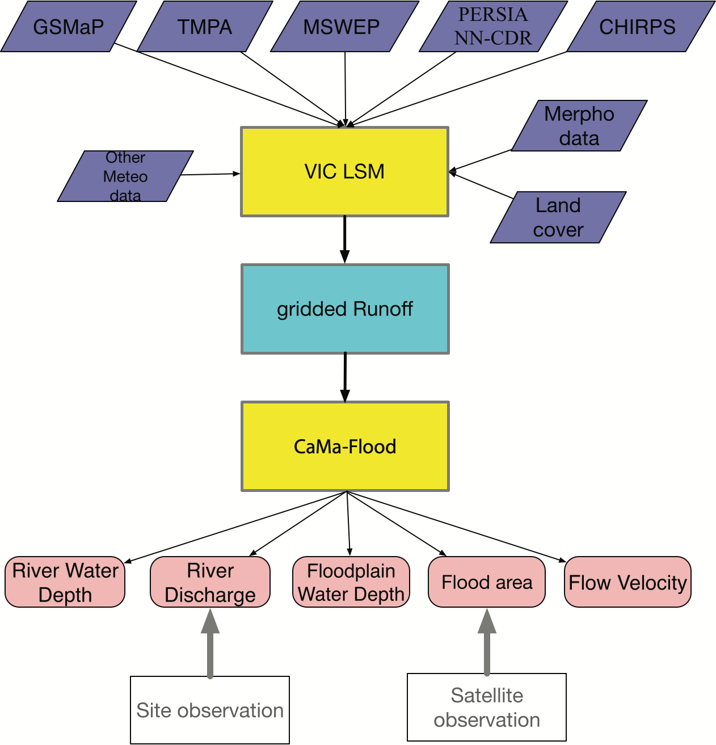

Figure 1. Schematic of data flow for driving the VIC-CaMa-Flood model.

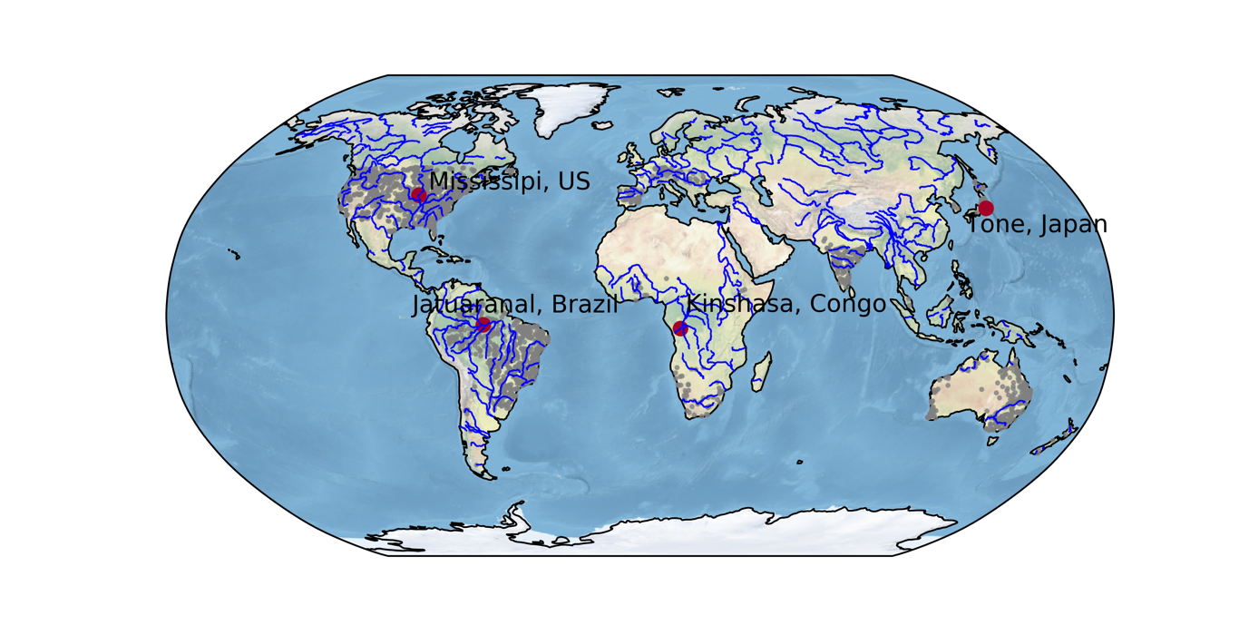
Figure 2. Global map of gauge stations used in this study. Each grey point represents a gauge station. Four stations (red color), including Jatuaranal Station in Brazil, Kinshasa Station in Congo, the Mississippi River in the US and Tone River in Japan are selected as examples shown in Section 3.2.

Figure 3. Comparisons of five precipitation datasets over land surface. (a) Annual mean, (b) zonal mean and (c) global standard deviation across five precipitation products.

Figure 4 Time series of the observed and simulated monthly discharge values at the four gauging stations. Statistics errors are displayed in Table 3.

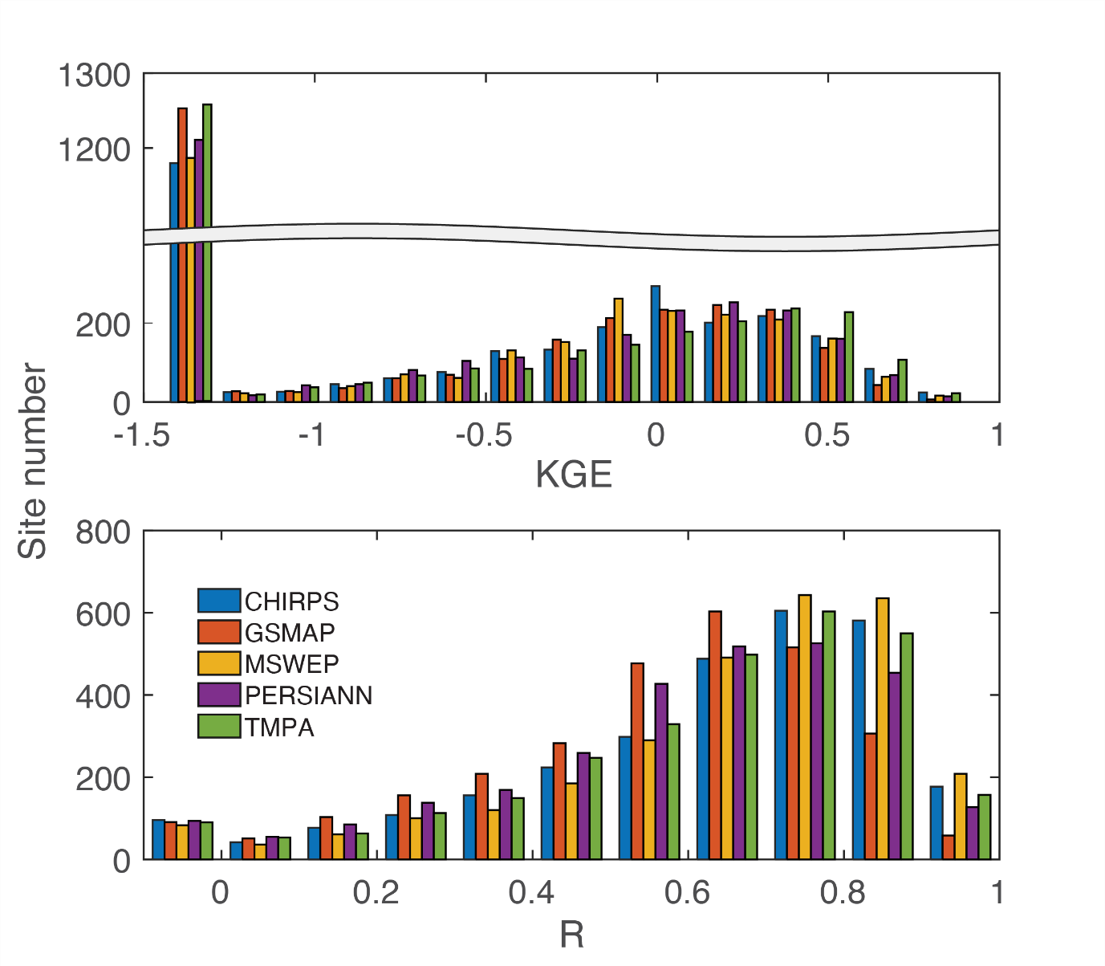Figure 5. Distribution of KGE and R values for all available stations.

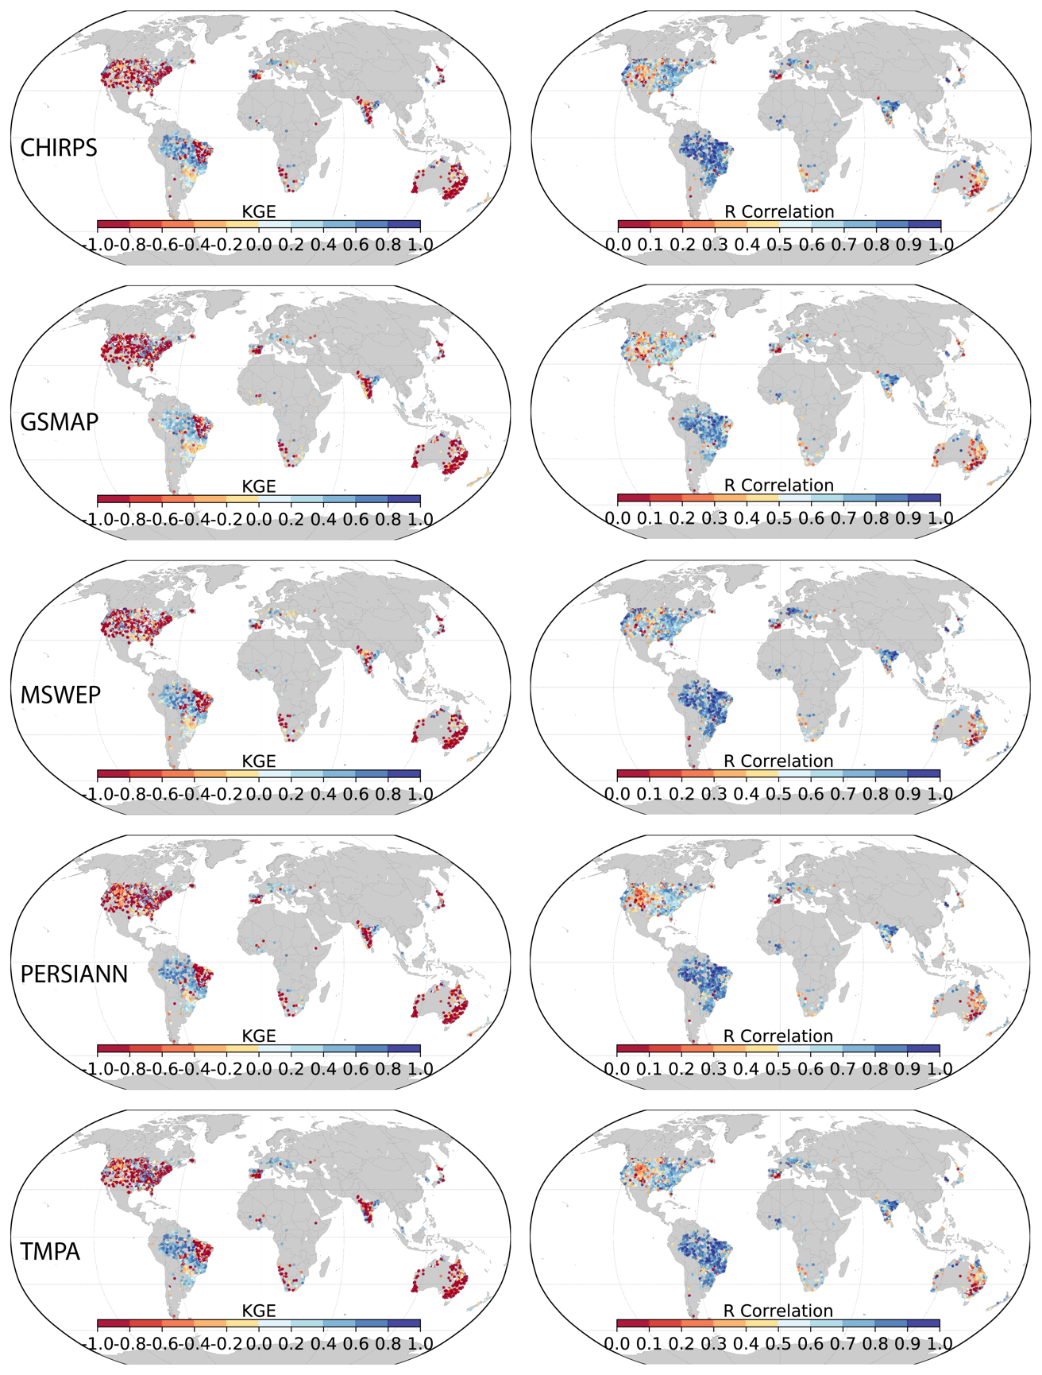
Figure 6. Global maps of KGE and R values for five simulated discharge datasets.

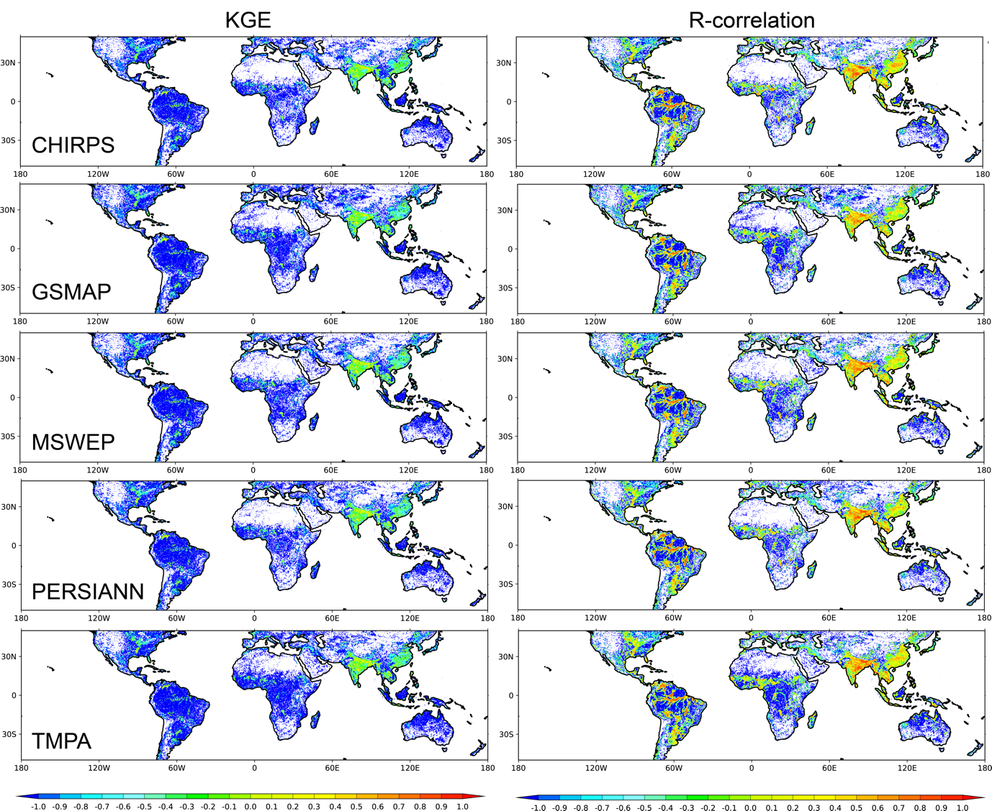
Figure 7. The KGE and R correlation between the simulated and observed water extent in each grid. The grid that flood event is not detected by satellite was marked as -1.
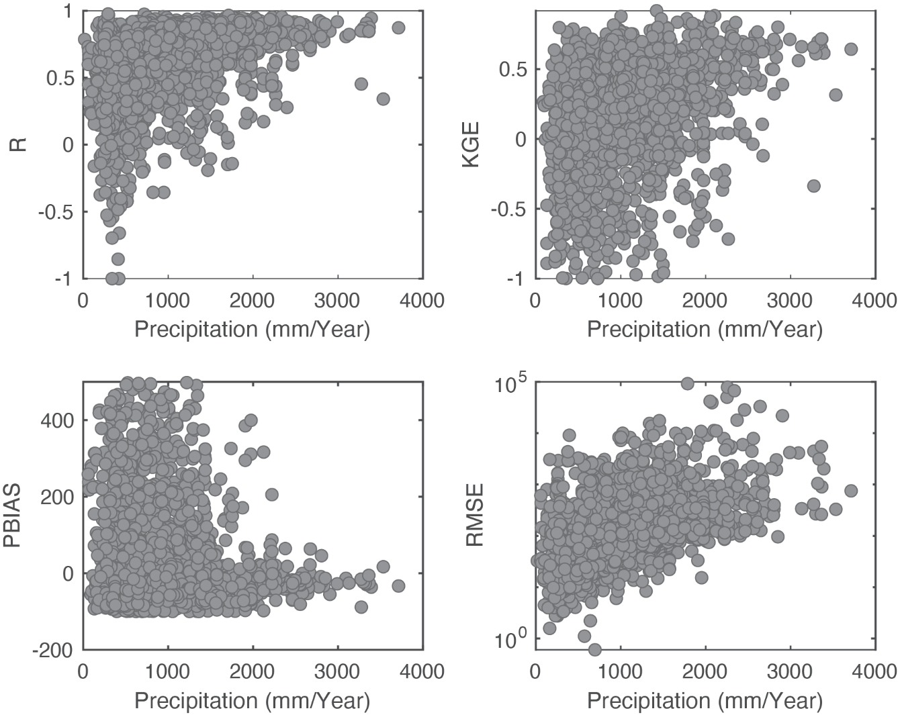
Figure 8. Relationship between the performance metrics (using TMPA precipitation-based simulation) and precipitation amount.

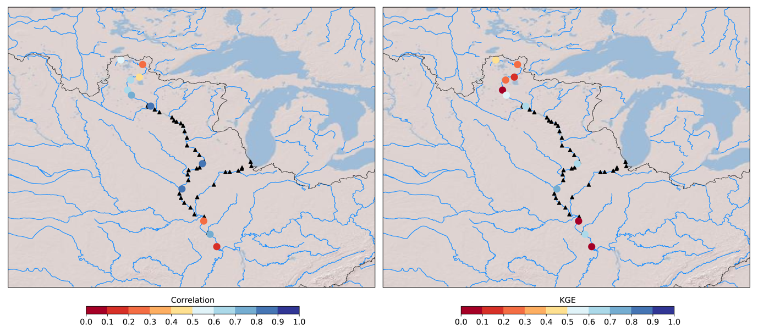
Figure 9. Maps showing R (left) and KGE (right) using the TMPA precipitation driven simulation in the upper Mississippi river basin. The black triangles represent the dams and reservoirs.

Figure 10. The percentage of streamflow sites with positive KGE values classified by three different levels of human influence.

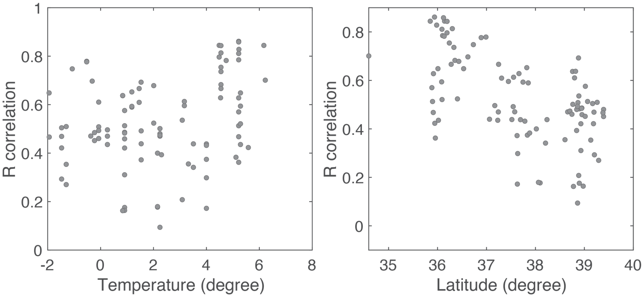
Figure 11. Relationship between the performance metric R (using TMPA precipitation-based simulation), latitude and DJF air temperature in mainland Japan.

