NOTE: This template is meant to provide high-level assistance with formatting manuscripts for submission to Agronomy Journal; Soil Science Society of America Journal; and Urban Agriculture & Regional Food Systems. More information is provided about the formatting of each of these sections in our official style guide: https://dl.sciencesocieties.org/publications/style/.

Running title (optional)
Core ideas (3-5 impact statements, 85 char max for each)
- The initial release of phosphorus (P) from fertilizer pellets is not well studied
- Microdialysis and X-ray CT permit non-invasive time-resolved monitoring
- A lab-scale setup was used to study solution P concentration in time and space
- A rapid initial release of P from the pellet was measured, with no replenishment
- P concentration decreased over time compatible with adsorption onto soil

Space and Time-Resolved Monitoring of Phosphorus Release from a Fertilizer Pellet and its Mobility in Soil Using Microdialysis and X-ray Computed Tomography
Chiara Petroselli*¹, Katherine A. Williams*¹, Arpan Ghosh¹, Daniel McKay Fletcher¹, Siul A. Ruiz¹, Tiago Gerheim Souza Dias¹, Callum P. Scotson¹, Tiina Roose¹
¹University of Southampton, Faculty of Engineering and Physical Sciences, Southampton (UK)
*these authors contributed equally to this study

Abbreviations:
ICP-MS, Inductively Coupled Plasma – Mass Spectrometry
MD, Microdialysis
RR, Relative Recovery Rates
SC, Suction Cups
TSP, Triple Super Phosphate
XCT, X-ray Computed Tomography

Abstract

Phosphorus (P) is an essential nutrient for crops and precise spatiotemporal application of P fertilizer can improve plant P acquisition and reduce run-off losses of P. Optimizing application would benefit from understanding the dynamics of P release from a fertilizer pellet into bulk soil, which requires space and time-resolved measurements of P concentration in soil solution. In this study, we combined microdialysis and X-ray Computed Tomography to investigate P transport in soil. Microdialysis probes enable repeated solute sampling from one location with minimal physical disturbance, and their small dimensions permit spatially-resolved monitoring. We observed a rapid initial release of P from the source, producing high dissolved P concentrations within the first 24 hours, followed by a decrease in dissolved P over time compatible with adsorption onto soil particles. Soils with greater bulk density (i.e. reduced soil porosity) impeded the P pulse movement, which resulted in a less homogeneous distribution of total P in the soil column at the end of the experiment. Model fit to the data showed that the observed phenomena can be explained with diffusion and adsorption. Results showed that compared with conventional measurement techniques (e.g. suction cups), microdialysis measurements present a less invasive alternative. The time resolved measurements ultimately highlight rapid P dynamics that require more attention for improving P use efficiency.

Introduction
Phosphorus is one of the major limiting nutrients for crop yields (Shen, Yuan et al. 2011) and global food production relies on fertilizer application (Ashley, Cordell et al. 2011). The most widely used source for producing phosphorus fertilizer is rock phosphate (Smil 2000). However, the global reserves of this is a non-renewable resource could run out in less than 100 years (Cordell, Drangert et al. 2009). Improving fertilizer practices involves maximizing crop production whilst minimizing costs and avoiding phosphorus losses and subsequent contamination of water bodies (Smil 2000). In order to optimize these factors, crop plants need to absorb the delivered nutrients efficiently. Plants can only take up phosphorus from soil water solution, but phosphorus concentrations in soil solution are usually very low (<10µM; (Schachtman, Reid et al. 1998)) due to its fast adsorption onto soil particles and microbial and degradation processes (Barber 1995). Precision agriculture can improve fertilization practice by limiting P runoff (Withers, Neal et al. 2014) and minimizing unintended side effects that contribute to P removal from the soil solution, i.e. fixation or competition with other plant species (Grant, Flaten et al. 2001, Blackshaw and Molnar 2017). However, in order to develop precision agriculture strategies, it is necessary to gain a fundamental understanding of the movement and behavior of fertilizer products in soil.
In this context understanding the spatial and temporal scales of phosphorus (P) mobility in soil is critical for understanding its availability to plants and ultimately for optimizing the fertilizer application. To achieve this, highly resolved spatial measurements in solute are needed to investigate localized movement of this low-mobility nutrient, and high temporal resolution is required for assessing the initial release of P from the inorganic P fertilizer pellet along with the timescales of P transport and immobilization in soil. However, achieving high spatiotemporal resolution presents some technical challenges. Firstly, low P concentrations in soil solution (<10µM; (Schachtman, Reid et al. 1998)) mean sensitive analytical techniques are required to detect and quantify them. Additionally, to acquire representative and accurate time-resolved data, the chosen soil solution sampling method should be minimally invasive allowing the collection of multiple samples without perturbing the experimental setup.
Suction cups are widely used in situ sampling devices for soil solution. They directly extract soil solution by inducing lower pressure in the probe compared to soil water, drawing water into the probe through a porous ceramic cup (Göttlein, Hell et al. 1996). Suction cups come in a range of sizes and they are routinely used for sampling soil solution both in laboratory (Vetterlein and Jahn 2004, Gao, Blaser et al. 2019) and field-scale experiments (Blicher-Mathiesen, Andersen et al. 2014). However, as they directly sample soil solution, they can affect the flow of water through the soil.
Microdialysis provides a minimally invasive and non-destructive in situ sampling technique designed for sampling small quantities of solutes from living organisms (Bourne 2003, Hammarlund-Udenaes 2017). Microdialysis relies on the principle of passive diffusion of solutes through a semi-permeable membrane. Therefore, the device does not actively remove water from the system, reducing its invasiveness compared with suction cups. Although microdialysis is primarily a technique in pharmacokinetics, and despite the fragility of the probes, it has been successfully applied to soil (Miró and Frenzel 2004, Miró and Frenzel 2005) and recently to sampling phosphorus from soil solution (Demand, Schack-Kirchner et al. 2017, McKay Fletcher, Shaw et al. 2019). Microdialysis relative recovery rates (RR) of solutes can be very high (RR>100% have previously been reported; (Torto, Buttler et al. 1995)) but RR are highly dependent on the perfusion flow rate, with slower flow rates promoting higher RR (Miró and Frenzel 2004, Inselsbacher, Öhlund et al. 2011). The relative recovery also depends strongly on the composition of the perfusion fluid (Buckley, Brackin et al. 2020), soil moisture (Buckley, Brackin et al. 2017, Jämtgård, Robinson et al. 2018) and on physical, chemical and biological processes that happen in soil (Demand, Schack-Kirchner et al. 2017).
X-ray computed tomography (XCT) is a powerful technique for investigating 3D pore space (Lehmann, Wyss et al. 2006) and in situ root structure (Mooney, Pridmore et al. 2012). Coupling XCT with non-destructive in situ sampling techniques (e.g. microdialysis) shows promise for elucidating structural and spatial factors that influences solute transport in porous media, which could ultimately help interpreting the fate of P in the pore space. For example, XCT visualization of microdialysis probes in soil revealed the presence of a cavity around the membrane due to the insertion needle used, which could affect the probe recovery efficiency at different water saturation levels (Brackin, Atkinson et al. 2017). The same study combined microdialysis and XCT to measure nutrients concentrations at different distances from the roots (Brackin, Atkinson et al. 2017). Recently, Gao, Blaser et al. 2019 used suction cups and XCT for assessing root architecture response to different spatial distributions of phosphorus fertilizer in soil. They demonstrated a species-specific response of maize root structure to localized P supply in the first 2.5 cm from the fertilizer pellets.
The aim of this work is to gain an insight into the first steps of phosphorus release from a fertilizer pellet and its diffusion into bulk soil using a coupled microdialysis and XCT approach. As the fertilizer pellet is placed in soil, many processes take place as reviewed by (Hedley and McLaughlin 2005). The initial wetting of the pellet (Hettiarachchi, Lombi et al. 2006) is followed by the release of P producing a highly concentrated and strongly acidic solution in the vicinity of the pellet. The transport of the released P can be slowed down by the movement of water towards the pellet and also by the advection of cations which can determine the precipitation of secondary P compounds. Two different concentration zones establish outside the residual pellet (Benbi and Gilkes 1987), one P saturated zone near the pellet where soil sorption capacity is exceeded and precipitation is the main P immobilization mechanism, and a wider P unsaturated zone where P movement is mainly by diffusion. Phosphorus is not expected to travel far from the source due to its slow diffusivity and high susceptibility to adsorption onto soil particles. Therefore, high spatial resolution is required to capture any movement within soil solution. Moreover, we hypothesize that diffusion timescales are linked to hydraulic connectivity in soil and available surface area of soil for adsorption. These in turn depend on soil porosity and soil particle size. To test these hypotheses, samples were collected at high temporal resolution for two different soil particle size distributions in order to assess the influence of soil porosity on phosphorus movement. Subsequently, a comparison with an active soil water sampling technique (suction cups) was carried out in order to assess the effect of sampling method on observed patterns of phosphorus movement, in particular the influence of active water flow caused by the suction cups. Understanding these small-scale processes can give useful information to help optimize the spatiotemporal scales of phosphorus fertilization in terms of both maximizing plant P uptake and minimizing P runoff.

Materials and Methods

Experimental setup
The experimental setup consisted of a 20 mL syringe barrel tube filled with soil kept at close to 100% water saturation by supplying MilliQ water (18 MΩ) from the bottom of the soil column (see Supplementary Material, Figures S1 and S2). The soil was kept at 100% saturation in order to maintain a continuous water domain throughout the soil. This does mean that anaerobic conditions (and reducing conditions for iron oxides) were maintained during the experiment period. However, had the soil been partially saturated, there would likely have been considerable spatial variation in water saturation. Since the spatial variation in water saturation could not be continuously assessed in this setup, it would not have been possible to control for the effect of a non-continuous water domain on the movement of P through the system. In addition, microdialysis probes function on the principle of diffusion across a semi-permeable membrane and operate best when the semi-permeable tip is fully saturated. This is easier to achieve in a soil system which has 100% water saturation than one which has spatial variation in saturation. Preliminary experiments performed watering from the top of the soil column, indicated that watering from the top accelerates P washout in the first 50 h, but the overall trend is comparable (see Supplementary Material, Figure S3). Despite watering from the top would give a more realistic representation of what happens in the field, the proposed setup is aimed at being as simplified and controlled as possible in order to actively change one parameter at a time.
The chosen soil was a sandy clay loam Eutric Cambisol, collected from the Ah horizon of an agricultural grassland in the Henfaes Research Station in Abergwyngregyn, Wales (UK; 53°14’N, 4°01’W). A summary of the soil properties is presented in Supplementary Material Table S1. A more detailed description of the soil properties can be found in (Oburger, Jones et al. 2011, McKay Fletcher, Keyes et al. 2019). Two soil fractions were used in order to investigate the effect of the particle size on P movement. Both soil fractions were obtained starting from the same soil sieved below 2 mm. The fine fraction comprised all the particles with diameter below 2 mm, while for obtaining the coarse fraction the particles with diameter below 1.18 mm were removed. Dry bulk density was $ρ_{b,c}$= 1.02 ± 0.01 g mL⁻¹ in coarse soil and $ρ_{b,f}$= 1.26 ± 0.01 g mL⁻¹ in fine soil. Initial soil blank P concentration was 597±16 ppm for the coarse and 682±23 ppm for the fine fraction. A comparison between the two soil fractions compositions is shown in the Supplementary Material Figure S4. One triple super phosphate (TSP) fertilizer pellet per tube (mass range 50-60 mg) was used as a localized phosphorus source and positioned 1.5 cm below the soil surface. The average P concentration in the fertilizer used was 2.1$×$10⁵ ppm. P was therefore added at a rate of 333 kg ha⁻¹.
In situ sampling was performed using microdialysis CMA 11 metal free (4 mm) probes (CMA Microdialysis AB, Sweden) with a 6 kDa molecular weight cut-off. Microdialysis probes were perfused with MilliQ water (18 MΩ) at 3.3 µL min⁻¹ flow rate (McKay Fletcher, Shaw et al. 2019) using a PHD 2000 Programmable Syringe Pump (Harvard Apparatus, UK). Three probes per tube were set up for assessing phosphorus movement spatial scales, one placed 0.5 cm above the pellet, and the other two placed below the pellet, at 1.5 cm and 3.0 cm distance from the P source, respectively (Figure S2). In the first 12 hours of measurements, sampling was performed at high time resolution by perfusing the probes for consecutive 2 hours periods (sample volume 0.396 mL). For the remainder of the two-week experiment, one sample was collected every 24h by perfusing the probes over a 12-hour period (sample volume 2.376 mL).
MicroRhizon suction cup samplers, whose ceramic tips have a mean pore size of 0.15 µm (Rhizosphere Research Products B.V., Netherlands) were used for comparison with microdialysis probes. Suction cups were deployed in replicate setups at the same positions as the microdialysis probes and operated at a 33 µL min-1 flow rate using the same syringe pump. A fixed volume of 0.6 mL of soil solution for each probe was sampled every 24h. High resolution sampling was not performed due to the volume of water removed from the soil column at each timepoint in relation to the total volume of water present in the system.
Both microdialysis (dialysates) and suction cup samples were kept sealed and refrigerated (+4°C) until analysis.
In order to assess the baseline P values for the chosen soil, a soil blank treatment was set up with the same characteristics and sampling procedure as the others but without the pellet. Phosphorus concentrations in dialysates from blank soil were consistently lower than detection limits (LOD; data not shown), while in suction cups samples blanks were two orders of magnitude higher than LOD, but still two orders of magnitude lower than fertilizer treatment data.
The two sampling techniques were inter-calibrated in order to obtain comparable values. Calibration standards were made from extraction of ground TSP pellets in MilliQ water, filtration of the obtained solution and subsequent dilution of the stock concentration. A four-standard calibration was performed for both microdialysis and suction cups and calibration curves are shown in Supplementary Material Figure S5. Data shows that absolute recovery using microdialysis decreases with increasing phosphorus concentrations (Figure S5). A correction factor derived from calibration experiments was therefore applied to all the microdialysis data in order to normalize them to effective soil solution concentrations. Furthermore, probe inter-variability was evaluated by replicating the calibration using three different probes of each kind. Microdialysis probes show higher variability (with a standard deviation of 6% the mean) with respect to suction cups (2%).
Quantitative phosphorus determination by ICP-MS
Inductively Coupled Plasma Mass Spectrometry (ICP-MS) analyses were performed at the School of Ocean and Earth Science, University of Southampton using a quadrupole ICP-MS (Thermo-Scientific, XSeries2). Thirteen elements were quantified, namely Na, Mg, Al, Si, P, K, Ca, Mn, Fe, Cu, Zn, Sr, Pb. Calibration was performed with seven custom synthetic standard solutions prepared from single element standards (Inorganic VenturesTM). All samples and standards were prepared in 3% sub boiled nitric acid spiked with internal standard elements (Be, In and Re) to correct for drift and matrix effects during ICP-MS measurements. The dialysate and suction cups samples were diluted by 25-fold prior to analysis to fit within the measurement range of the instrument.
At the end of the experiment, the total P concentration at different heights along the column (both in solution and bound to the soil) was measured in the following way. The soil columns were isolated from the watering system by closing the tap and immediately frozen standing vertically without allowing water to drain or dry. The soil columns were then sliced at a 0.5 cm resolution using a ceramic knife, the obtained samples were air-dried for 48 hours and then oven-dried at 65°C overnight. An aliquot of approximately 100 mg of oven-dried sample was weighed for digestion. The soil digestions were performed using a combined aqua regia and HF/HClO₄ protocol to give total digestion (see Supplementary Material). The final solutions were sub sampled, dried and then dissolved for analysis.
X-Ray Computed Tomography
XCT scans were carried out to visualize changes in pellet structure over time and to demonstrate that all the components in the microdialysis setup could be visualized in 3D using XCT. Scans were carried out using a modified 225 kVp Nikon/Xtek HMX CT scanner at the Mu-VIS imaging centre, University of Southampton, UK. Each scan used 1601 projections, with 8 frames per projection, and 134 ms exposure per frame. The energy chosen was 120 kV, at 44 W. The resulting voxel size was 20 µm. These parameters were chosen to provide sufficient contrast to visualize the differences between the soil, soil water, probes, fertilizer pellet, whilst minimizing scan time (each scan took approximately 30 minutes). The voxel size was the smallest possible so that the entire column fitted within the field of view, to give the highest resolution possible. Scans were reconstructed using a filtered back-projection algorithm in CTPro (Nikon).

Model parameter estimation
 | $$\frac{∂c_{sol}}{∂t}\left(z,t\right)= D\frac{∂^{2}c_{sol}}{∂z^{2}}\left(z,t\right)- β_{1}c_{sol}\left(z,t\right)+ β_{2}c_{ad}\left(z,t\right), 0<z<L, 0<t<T,$$ | (1)
 | $$\frac{∂c_{ad}}{∂t}\left(z,t\right)= β_{1}c_{sol}\left(z,t\right)-β_{2}c_{ad}\left(z,t\right), 0<z<L, 0<t<T,$$ | (2)
The parameter estimation for diffusion of P through soil and its adsorption onto soil particles is based on the model presented by McKay Fletcher, Shaw et al. (2019). This model describes the evolution of P concentration in soil solution (dissolved P) as well as concentration of P adsorbed onto the soil particles. However, unlike (McKay Fletcher, Shaw et al. 2019), we do not consider the removal of P by the microdialysis probes. At any time $t$ and depth $z$ in the sample, we denote the concentration of dissolved P by $c_{sol}(z,t)$ and adsorbed P by $c_{ad}(z,t)$. The model that we use is given by the following equations
where D [m² s⁻¹] is the effective diffusivity of P in the sample (including geometric impedance, but not the buffer power of soil) , $β_{1}$ [s⁻¹] is the rate of adsorption of dissolved P onto the soil particles and $β_{2}$ [s⁻¹] is the rate of desorption of P from the soil particle surfaces to the solution, L is the total depth of the column used in the setup and T is the total duration of the experiment. The model assumes that no amount of P is lost or gained in the system. This implies that any loss of P due to sampling is considered negligible. It is also assumed that P disperses through the soil only through diffusion.
The boundary conditions for equation (1) is taken to be no flux of P through either the top or bottom surfaces, in accordance with the experimental setup. That is expressed by equation (3) and equation (4), below
 | $$\frac{∂}{∂z}c_{sol}\left(0,t\right)=0, 0<t<T,$$ | (3)
 | $$\frac{∂}{∂z}c_{sol}\left(L,t\right)=0, 0<t<T.$$ | (4)
Given the above boundary conditions, the one-dimensional model equations can be uniquely solved for any given initial concentrations $c_{sol}(z,0)$ and $c_{ad}(z,0).$
We numerically estimate the model parameters$D$, $β_{1}$ and $β_{2}$ for coarse soil using data from the experiments using the following methodology. Let us denote the depths of the three probes by$l_{1}$, $l_{2}$ and$l_{3}$. Let us also denote the mean value of the data at sampling time $t_{j}$ for the probe at depth $l_{i}$ by $ϕ_{ij}$ and the corresponding standard deviation by$σ_{ij}$.
The parameters in equations (1) and (2) are estimated by minimizing the error functional R described by equation (5).
 | $$R=\sum_{i,j}{\frac{{\left\|c_{sol}({l_{i},t}_{j})-ϕ_{ij}\right\|}^{2}}{{σ_{ij}}^{2}}.}$$ | (5)
The minimization is performed using the MATLAB function “fmincon” while the partial differential equations for $c_{sol}$ and $c_{ad}$ is solved at each optimization step using a finite difference approximation and the MATLAB function “ode45”.

Results and Discussion

Phosphorus pellet dissolution
The XCT data (Figure 1) demonstrates that the TSP pellet remained in place for the 8 days that the soil was scanned for. However, the appearance of the pellet changed over time, particularly in the first 24 hours. One hour after wetting, the pellet has two distinct bands of X-ray attenuation, showing water infiltrating partway into the pellet. After 24 hours the solid parts of the pellet are completely wetted though pockets of air remain. The initial pellet wetting was rapid and occurred within the first 24 hours, maximizing diffusion pathway for P throughout the pellet to the soil. The pellet reduced in X-ray attenuation by 96 hours, becoming increasingly difficult to distinguish from the surrounding soil. We interpret this as a sign of dissolution, although the pellet changed very little in geometry. Therefore, either no dissolution occurred within the experimental period or, while P dissolved and diffused away from the pellet, parts of the pellet were insoluble and the pellet therefore remained geometrically sound. This second hypothesis is supported by the observations by Hettiarachchi, Lombi et al. 2006, who observed via X-ray CT a decrease in the pellet density along with an increase in its porosity over time and attributed that to the progress of the pellet water absorption and inorganic P compound dissolution. No further changes were recorded after 96 hours, with the pellet showing the same attenuation after 168 hours.
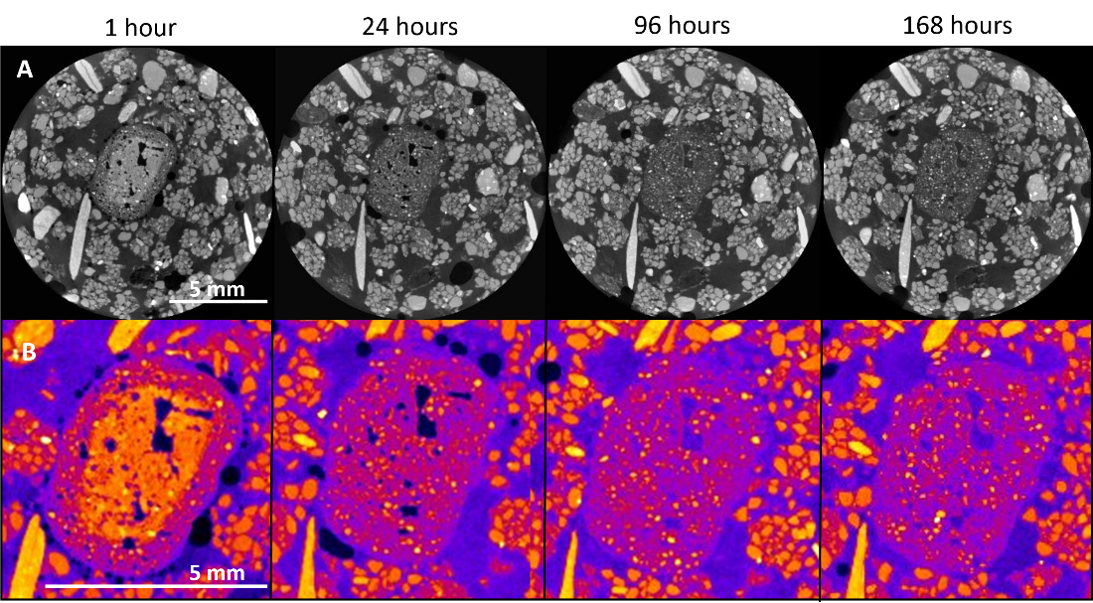
Figure 1. Triple Super Phosphate pellet dissolution in coarse soil visualized using X-ray Computed Tomography imaging. Top row is reconstructed grey value slices through the same region of the pellet at different time points, lower row is the pellet enlarged and a heat-map look up table (Fire in ImageJ) applied to the pellet to accentuate the differences in grey values.

Phosphorus space and time-resolved pattern
Figure 2a shows the time resolved data from the three microdialysis probes at different depths in the coarse soil experiment. The two probes positioned below the pellet (C2 and C3) show the same temporal pattern and comparable P concentrations: an initially very high concentration of P which subsequently decays exponentially. This pattern suggests an ‘instantaneous’ (below sampling frequency) release of P from the pellet that occurs within the first 2 hours from wetting the soil, followed by a P concentration decrease in soil solution over time, that can be attributed to different processes that determine immobilization of P like its adsorption onto soil particles. This ‘instantaneous’ release is supported by the rapid wetting of the TSP pellet shown in the XCT scans (Figure 1). Probe C1, which is positioned above the fertilizer pellet, shows a slower increase in P concentration in soil solution (over the first 83 hours), followed by a decrease compatible with adsorption onto soil particles. Moreover, the maximum P concentration detected by the probe positioned above the pellet (C1; 3.3 ± 0.7 ppm) was one order of magnitude lower than the ones detected by the probes below the pellet (C2 and C3; 45 ± 8 ppm and 48 ± 16 ppm), suggesting that P movement is favored in the downward direction, likely due to gravity. This hypothesis was tested with a set of experiments in non-stirred water columns, which showed that P concentrations increased 10 times faster in the downward compared with the upward direction. Details and data from this experiment can be found in the Supplementary Material (Figure S6).
The effect of soil particle size on the phosphorus dispersion rates was investigated. Estimating the mean particle density with the density of quartz ($ρ_{s}$= 2.65 g mL_{solid}⁻¹), we estimated the soil porosity as $ϕ=1-\frac{ρ_{b}}{ρ_{s}}$, thus an overall decrease in soil porosity from $ϕ_{c}=0.614$ L_{pore} L_{bulk}⁻¹ to $ϕ_{f}=0.525$ L_{pore} L_{bulk}⁻¹ was observed. This change in soil porosity leads to a decrease in the effective diffusion of P in soil due to decreased soil pore volume (Barraclough and Tinker 1981). However, the increase in soil surface area could play a role as well, due to P adsorption onto soil particles. We therefore expect an overall nonlinear decrease of effective diffusion of P in the fine soil case due to the sum of these two processes.
The results from the experiment conducted in fine soil (particle diameter below 2 mm) are shown in Figure 2b. The trend detected by the probes below the pellet (F2 and F3) confirm the ‘instantaneous’ release of a pulse of P from the pellet. Probe F3, which is positioned 3 cm below the pellet, captured the whole profile of the pulse, the start of which was missed in coarse soil and in probe F2, resulting in a high apparent initial P concentrations. In the fine soil, this pulse lasted 125 hours. The time shift between the maximum concentration recorded by probe F2 and probe F3 is about 31 hours and the maximum P concentrations detected by probe F3 (11±3 ppm) are almost one order of magnitude lower than those detected by probe F2 (72±16). These results support the hypothesized role of smaller particles in slowing down the movement of phosphorus through the soil column. In fact, the more effective packing of small particles can lead to a decrease in soil porosity and connectivity, together with increased tortuosity of the diffusive paths, therefore slowing down the movement of solutes through soil. Moreover, colloidal particles can adsorb high quantities of P due to their high surface area to mass ratio and can contribute to its mobility by particles diffusion through soil (de Jonge, Kjaergaard et al. 2004). As all of these processes affect the speed of P movement in soil, and they can affect the adsorption/desorption equilibrium determining a different distribution of P associated to soil particles in the soil column. Above the fertilizer pellet, the P concentration values are still above the limit of detection (LOD), however, no clear concentration trend is recorded. This is due to a higher variability between the three replicates, attributed to the lower soil homogeneity given by the presence of different sized particles in the system and to a lower control on the reproducibility of the soil column packing stage.
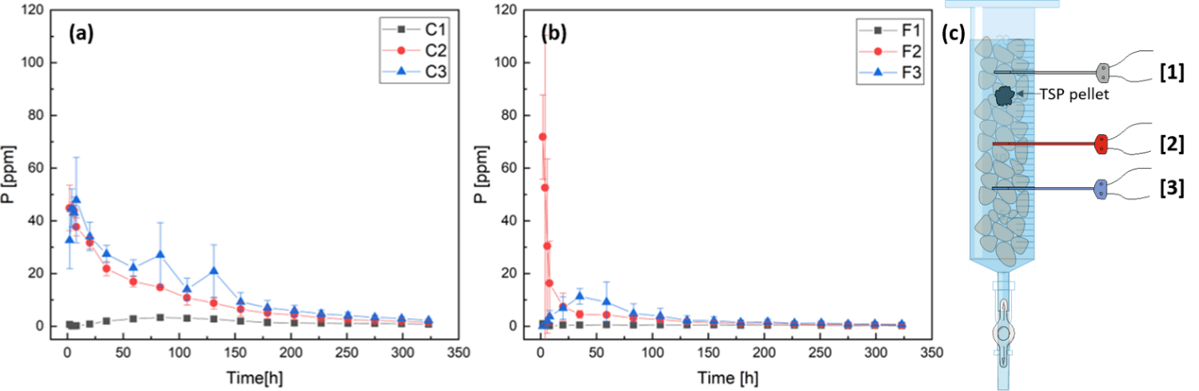
Figure 2. Microdialysis results for (a) coarse soil (1.18<d<2 mm) and (b) fine soil (d<2mm). Average and standard deviation are shown for each probe. (c) Schematic of the setup. Probe 1 (grey) is positioned 0.5 cm above the pellet, probes 2 (red) and probe 3 (blue) are positioned below the pellet, at 1.5 cm and 3 cm distance from it, respectively

Total P concentration profile
Total P concentrations in both soil types were recorded at the end of the experiment by total soil digestion followed by ICP-MS analysis. Total P concentrations expressed as mass by mass ppm (μg(P)/g(soil)) per each layer in coarse and fine soil are shown in Figure 3. The TSP pellet is located 1.5–2 cm from the top of the soil column, and its presence is evidenced by a spike of P concentration in both soil types. P concentrations above the pellet are consistently lower than below the pellet in both soil types, confirming the trend observed in soil solution and demonstrating the overall effect of gravity on P distribution. In coarse soil, P movement is promoted in both upward and downward directions from the pellet, producing higher concentrations in all the layers and lower concentration in the pellet layer compared to fine soil. On the other hand, fine soil impedes the movement causing more P to be trapped in the pellet layer and causing decreasing concentrations at increasing distances from the pellet.
Overall, experimental data show faster diffusion of P from the fertilizer pellet to bulk soil, faster pulse movement, and a more homogeneous distribution of P over the soil column in the coarse case compared to the fine one. This experiment showed that, among all the complex processes regulating P mobility in soil, a finer soil particles size distribution contributes to actively slow down the pulse, and a decreasing P concentration trend in soil at the end of the experiment is also observed with increasing distance from the P source.
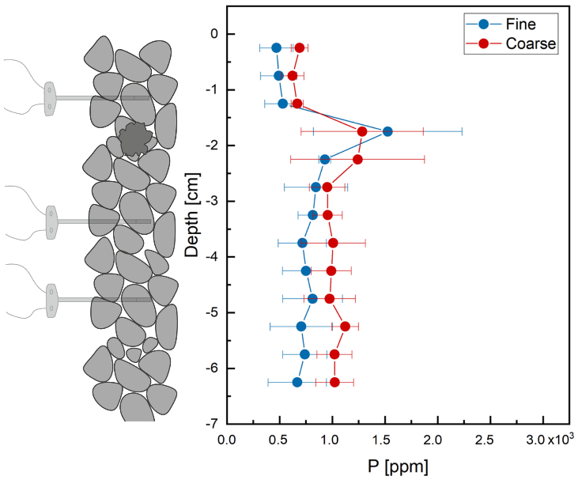
Figure 3. Total P concentration profiles in the soil columns at the end of the experiment, measured by soil digestion. Fine soil is sieved below 2 mm, coarse soil between 1.18 mm and 2 mm. Errors are reported as standard deviations over three replicates

Modeling of P movement pattern in coarse soil
Data for the coarse soil (Figure 2a), show high initial concentrations (i.e. after the first two hours) for both the probes positioned below the pellet. After the first 8 hours, a steady diffusion pattern can be observed for these two probes. This suggests that the concentration pulse emanated by the fertilizer pellet disperses down the column and settles into a certain distribution, early in the experiment. We estimated the parameters D, β₁ and β₂ by fitting the data recorded after 8 hours from the start of the experiment. We used an effective continuous initial distribution that would best explain the eventual distributions observed in the data. Running iterations of the model using values close to the estimated values of the parameters given in (McKay Fletcher, Shaw et al. 2019), we noticed that the initial profile of P concentrations in soil solution is reflected in the final profile of total P concentration, which is mainly determined by P adsorbed onto soil particles, suggesting that adsorption occurs at a higher rate than diffusion. Based on the soil digestion data (total P concentrations) we assumed a Gaussian profile for the initial concentration of dissolved P, with its peak value c_{pulse} at the initial position of the pellet, and variances a² above the pellet and b² below the pellet till a depth 27.5 mm. Below this, we assumed a constant uniform profile for the initial concentration of dissolved P through to the bottom. The parameters c_{pulse}, a and b are also determined by the optimization of the function R as defined in equation (5). The initial distribution of the concentration of adsorbed P, that is c_{ad} (z,0), is taken to be a uniform pre-fertilization equilibrium value. The expressions for c_{sol} (z,0) and c_{ad} (z,0) are provided in equations (S1) and (S2) in Supplementary Material. The initial distribution profile of dissolved P is shown in Supplementary Material (Figure S7) where the estimated values of c_{pulse}, a and b have been used.
Table 1 shows the estimated values of the model parameters along with the corresponding initial values used to initialize the optimization algorithm.
Table 1. Initial values of optimization parameters
Parameter | Description | Initial guess | Estimated value | Units
$$D$$ | Diffusion rate | $$1.9×{10}^{-11}$$ | $$1.6×{10}^{-11}$$ | $$m^{2}s^{-1}$$
$$β_{1}$$ | Adsorption rate | $$3.1×{10}^{-6}$$ | $$2.7×{10}^{-6}$$ | $$s^{-1}$$
$$β_{2}$$ | Desorption rate | $$3.6×{10}^{-9}$$ | $$5.2×{10}^{-9}$$ | $$s^{-1}$$
$$c_{pulse}$$ | Maximum strength of initial pulse | $$8.5×{10}^{2}$$ | $$9.0×{10}^{2}$$ | $$ppm$$
$$a$$ | Spread of initial pulse above the pellet | 3.0 | 3.0 | $$mm$$
$$b$$ | Spread of initial pulse below the pellet | 12 | 12 | $$mm$$
With the estimated values of the model parameters, the model fits the data with 22% error.
Figure 4 shows the model fit of the P concentrations recorded by the three microdialysis probes in coarse soil. As can be observed in the figure, the concentrations of dissolved P as predicted by the model using the estimated parameters are close to the recorded data and mostly lie within the standard deviations of the data points. At the top probe position, the model predicts an initial rise in dissolved P concentration which results from diffusion of the pulse and then a subsequent decrease in concentration which is due to adsorption of P onto soil, all in agreement with the data. At the bottom two probe positions, the model predicts adsorption to be the dominant process resulting in an exponential decrease in the dissolved P concentrations, once again in close agreement with the observed data.
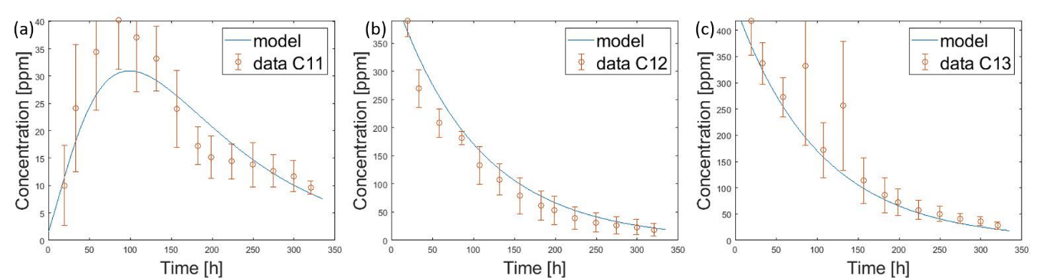
Figure 4. Data from the probes with standard deviation in red and the fitted curve in blue. Panel (a) corresponds to probe 1 positioned 0.5 cm above the pellet, panel (b) corresponds to probe 2 positioned 1.5 cm below the pellet and panel (c) probe 3 positioned 3.0 cm below the pellet.

Comparison between microdialysis probes and suction cups
The effect on P movement using passive sampling from microdialysis was compared with the active uptake of soil solution using suction cups in an experiment using fine soil. The phosphorus concentrations and the trend detected from the two suction cups positioned below the pellet are compatible with microdialysis results (Figure 5b and 5c). However, while suction cup sampling was carried out in fine soil, the recorded concentrations resemble more the ones detected by microdialysis in coarse soil. This suggests that advection caused by the active suction of the devices transports P through the fine soil at rates comparable with the passive transport monitored using microdialysis in the coarse soil. In addition, above the pellet (Figure 5a), microdialysis in fine soil recorded no trend in P concentration. Suction cups, on the other hand, recorded a clear trend with a delayed peak with respect to the one detected by microdialysis in coarse soil: P concentrations rise slowly over the first 175 hours when they reach a peak and start declining again. The discrepancy between microdialysis and suction cups suggest that water movement caused by the active sampling technique could lead to an overestimation of P mobility. It is worth noting that the temporal resolution of suction cups in the first 12h is lower than the microdialysis experiment, because of the active uptake of soil water by the suction cups. Due to this resolution limitation, the maximum concentration recorded 1.5 cm below the pellet (SC2) were lower than 3 cm below the pellet (SC3) at the same timepoint, despite being closer to the pellet. Moreover, it was not possible to capture the whole pulse profile as was achieved with microdialysis. Therefore, it was not possible to quantify the effect of the active sampling procedure on counteracting the decreased movement of the pulse due to fine soil particles and possibly overestimate P mobility in fine soil. A thorough modeling approach that accounts for pellet dissolution rate (Ruiz, Fletcher et al. 2020) and for probe uptake in the different sampling techniques could shed some light on these aspects, as could further studies dealing with device specific sampling methodology.
The suction cup experiment allowed our microdialysis results to be compared with a similar study that investigated the plant response to localized versus homogeneous P fertilizer distribution using suction cups (Gao, Blaser et al. 2019). The authors observed very high P concentrations in the localized P treatment on the first day, followed by a concentration decrease over time. Despite our use of microdialysis, the different scales of the setup, and the plant in their system, our results are all compatible with what they observed below the pellet. (Gao, Blaser et al. 2019) also observed maize root response to the localized phosphorus supply in the first 2.4 cm below the fertilizer pellets layer, but no increased root biomass was observed above the layer. We hypothesize that the preferential movement of P in the downward direction observed in this study induces root proliferation in the area below the pellet but the concentrations above the pellet do not reach the required levels to induce a plastic response (Drew 1975).
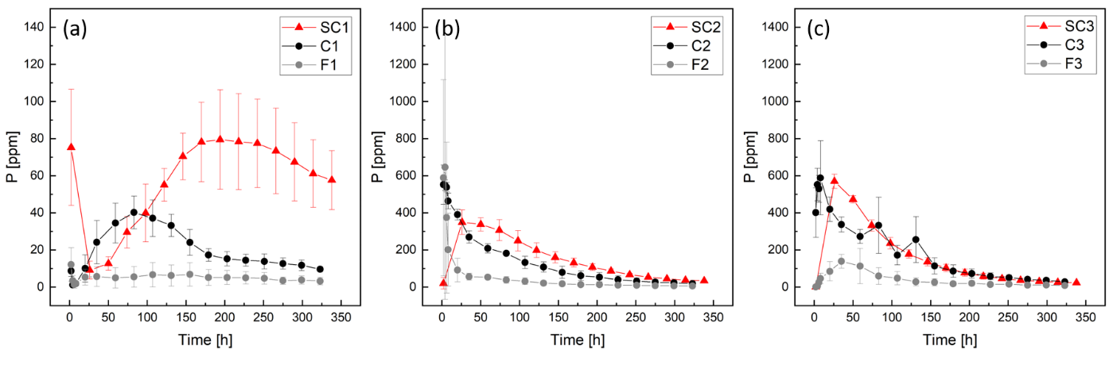
Figure 5. Comparison between suction cups (red, fine soil) and microdialysis in fine (grey) and coarse (black) soil. Average and standard deviation are shown for each data point. Lefthand panel show probe 1 positioned 0.5 cm above the pellet. Central panel shows probe 2 positioned 1.5 cm below the pellet and righthand panel show probe 3 positioned 3 cm below the pellet.
In summary, we developed an assay for monitoring phosphorus release from a fertilizer pellet and its movement into bulk soil. Microdialysis allows for space and time resolved measurements of P in soil solution and yields comparable results to the popular suction cups, which are more invasive. The results show a rapid release of P from the fertilizer pellet, which happens with a narrower timescale than the sampling resolution, followed by a decrease over time compatible with adsorption onto soil particles. For agricultural applications, this might indicate that there are only narrow time windows after fertilizing where actions can be taken to mitigate P pollution. This is also a point that requires more research and further verification at larger spatial scales, as it is not clear to what extent P is able to transport through the soil domain. Furthermore, modeling of P diffusion and adsorption onto soil particles reproduced the experimental data and allowed to determine P diffusion coefficients in the soil. Future studies could enhance these models to consider different convective fluxes associated with changes in soil moisture, water uptake by suction cups, and the influence of gravitation on P transport in the soil domain.

Acknowledgments
C.P., K.W., A.G., C.S. and D.M.F. are funded by ERC Consolidator grant 646809 (Data Intensive Modelling of the Rhizosphere Processes). S.R. and T.R. are funded by BBSRC SARISA BB/L025620/1, BBSRC SARIC BB/P004180/1 and NERC NE/L00237/1, T.G.D. and T.R. are funded by EPSRC EP/M020355/1. The authors would also like to thank Dr. Matt Cooper for the valuable support in ICP-MS analyses and the µ-VIS X-Ray Imaging Centre at the University of Southampton for provision of tomographic imaging facilities, supported by EPSRC grant EP-H01506X.

Supplemental Material
Supplementary Material includes more detailed schematics of the setup, preliminary experiments on the effect of the watering direction and gravity on P movement, passive sampling techniques calibration, more detailed digestion protocol and modeling equations.

data availability
Data from this study are available at https://doi.org/10.5258/SOTON/D1377.

authors contributions
CP conducted the experiments, carried out the analytical lab work, analysed data, participated in designed the study and drafted the manuscript. KAW participated in designed the study, conducted the computed tomography scans and analysed the data, participated in lab work and critically revised the manuscript. AG conducted the modelling work and helped drafting the manuscript. DMF, SAR and TGSD participated in modelling work and critically revised the manuscript. CPS participated in designing the study and helped with lab work. TR conceived the study, coordinated the study and critically revised the manuscript.

References
Ashley, K., D. Cordell and D. Mavinic (2011). "A brief history of phosphorus: from the philosopher's stone to nutrient recovery and reuse." Chemosphere 84(6): 737-746.
Barber, S. A. (1995). Soil nutrient bioavailability: a mechanistic approach, John Wiley & Sons.
Barraclough, P. and P. Tinker (1981). "The determination of ionic diffusion coefficients in field soils. I. Diffusion coefficients in sieved soils in relation to water content and bulk density." Journal of Soil Science 32(2): 225-236.
Benbi, D. and R. Gilkes (1987). "The movement into soil of P from superphosphate grains and its availability to plants." Fertilizer Research 12: 21-36.
Blackshaw, R. E. and L. J. Molnar (2017). "Phosphorus Fertilizer Application Method Affects Weed Growth and Competition with Wheat." Weed Science 57(3): 311-318.
Blicher-Mathiesen, G., H. E. Andersen and S. E. Larsen (2014). "Nitrogen field balances and suction cup-measured N leaching in Danish catchments." Agriculture, Ecosystems & Environment 196: 69-75.
Bourne, J. A. (2003). "Intracerebral microdialysis: 30 years as a tool for the neuroscientist." Clinical and experimental pharmacology and physiology 30(1‐2): 16-24.
Brackin, R., B. S. Atkinson, C. J. Sturrock and A. Rasmussen (2017). "Roots‐eye view: Using microdialysis and microCT to non‐destructively map root nutrient depletion and accumulation zones." Plant, cell & environment 40(12): 3135-3142.
Buckley, S., R. Brackin, S. Jämtgård, T. Näsholm and S. Schmidt (2020). "Microdialysis in soil environments: Current practice and future perspectives." Soil Biology and Biochemistry 143: 107743.
Buckley, S., R. Brackin, T. Näsholm, S. Schmidt and S. Jämtgård (2017). "Improving in situ recovery of soil nitrogen using the microdialysis technique." Soil Biology and Biochemistry 114: 93-103.
Cordell, D., J.-O. Drangert and S. White (2009). "The story of phosphorus: Global food security and food for thought." Global Environmental Change 19(2): 292-305.
de Jonge, L. W., C. Kjaergaard and P. Moldrup (2004). "Colloids and colloid-facilitated transport of contaminants in soils: an introduction." Vadose Zone Journal 3: 321-325.
Demand, D., H. Schack-Kirchner and F. Lang (2017). "Assessment of diffusive phosphate supply in soils by microdialysis." Journal of Plant Nutrition and Soil Science 180(2): 220-230.
Drew, M. (1975). "Comparison of the effects of a localised supply of phosphate, nitrate, ammonium and potassium on the growth of the seminal root system, and the shoot, in barley." New Phytologist 75(3): 479-490.
Gao, W., S. R. G. A. Blaser, S. Schlüter, J. Shen and D. Vetterlein (2019). "Effect of localised phosphorus application on root growth and soil nutrient dynamics in situ – comparison of maize (Zea mays) and faba bean (Vicia faba) at the seedling stage." Plant and Soil 441(1-2): 469-483.
Göttlein, A., U. Hell and R. Blasek (1996). "A system for microscale tensiometry and lysimetry." Geoderma 69(1-2): 147-156.
Grant, C., D. Flaten, D. Tomasiewicz and S. Sheppard (2001). "The importance of early season phosphorus nutrition." Canadian Journal of Plant Science 81(2): 211-224.
Hammarlund-Udenaes, M. (2017). "Microdialysis as an important technique in systems pharmacology—a historical and methodological review." The AAPS journal 19(5): 1294-1303.
Hedley, M. and M. McLaughlin (2005). "Reactions of phosphate fertilizers and by-products in soil." J.T. Sims and A.N. Sharpley (ed.) Phosphorus: Agriculture and the environment. Agron. Monogr. No. 46. ASA, CSSA, and SSSA, Madison, WI: 181-252.
Hettiarachchi, G. M., E. Lombi, M. J. McLaughlin, D. Chittleborough and P. Self (2006). "Density Changes around Phosphorus Granules and Fluid Bands in a Calcareous Soil." Soil Science Society of America Journal 70(3): 960-966.
Inselsbacher, E., J. Öhlund, S. Jämtgård, K. Huss-Danell and T. Näsholm (2011). "The potential of microdialysis to monitor organic and inorganic nitrogen compounds in soil." Soil Biology and Biochemistry 43(6): 1321-1332.
Jämtgård, S., N. Robinson, T. Moritz, M. L. Colgrave and S. Schmidt (2018). "Optimising methods for the recovery and quantification of di-and tripeptides in soil." Soil Research 56(4): 404-412.
Lehmann, P., P. Wyss, A. Flisch, E. Lehmann, P. Vontobel, M. Krafczyk, A. Kaestner, F. Beckmann, A. Gygi and H. Flühler (2006). "Tomographical Imaging and Mathematical Description of Porous Media Used for the Prediction of Fluid Distribution." Vadose Zone Journal 5(1): 80-97.
McKay Fletcher, D., R. Shaw, A. Sánchez-Rodríguez, K. Daly, A. Van Veelen, D. Jones and T. Roose (2019). "Quantifying citrate-enhanced phosphate root uptake using microdialysis." Plant and Soil: 1-21.
McKay Fletcher, D. M., S. D. Keyes, K. R. Daly, A. Van Veelen and T. Roose (2019). "A multi image-based approach for modelling plant-fertiliser interaction." Rhizosphere 10: 100152.
Miró, M. and W. Frenzel (2004). "Implantable flow-through capillary-type microdialyzers for continuous in situ monitoring of environmentally relevant parameters." Analytical chemistry 76(19): 5974-5981.
Miró, M. and W. Frenzel (2005). "The potential of microdialysis as an automatic sample-processing technique for environmental research." TrAC Trends in Analytical Chemistry 24(4): 324-333.
Mooney, S. J., T. P. Pridmore, J. Helliwell and M. J. Bennett (2012). "Developing X-ray computed tomography to non-invasively image 3-D root systems architecture in soil." Plant and soil 352(1-2): 1-22.
Oburger, E., D. L. Jones and W. W. Wenzel (2011). "Phosphorus saturation and pH differentially regulate the efficiency of organic acid anion-mediated P solubilization mechanisms in soil." Plant and Soil 341(1-2): 363-382.
Ruiz, S., D. M. Fletcher, A. Boghi, K. Williams, S. Duncan, C. Scotson, C. Petroselli, T. Dias, D. Chadwick and D. Jones (2020). "Image-based quantification of soil microbial dead zones induced by nitrogen fertilization." Science of The Total Environment: 138197.
Schachtman, D. P., R. J. Reid and S. M. Ayling (1998). "Phosphorus uptake by plants: from soil to cell." Plant physiology 116(2): 447-453.
Shen, J., L. Yuan, J. Zhang, H. Li, Z. Bai, X. Chen, W. Zhang and F. Zhang (2011). "Phosphorus dynamics: from soil to plant." Plant Physiol 156(3): 997-1005.
Smil, V. (2000). "Phosphorus in the environment: natural flows and human interferences." Annual review of energy and the environment 25(1): 53-88.
Torto, N., T. Buttler, L. Gorton, G. Marko-Varga, H. Stålbrand and F. Tjerneld (1995). "Monitoring of enzymatic hydrolysis of ivory nut mannan using on-line microdialysis sampling and anion-exchange chromatography with integrated pulsed electrochemical detection." Analytica chimica acta 313(1-2): 15-24.
Vetterlein, D. and R. Jahn (2004). "Gradients in soil solution composition between bulk soil and rhizosphere–In situ measurement with changing soil water content." Plant and Soil 258(1): 307-327.
Withers, P., C. Neal, H. Jarvie and D. Doody (2014). "Agriculture and Eutrophication: Where Do We Go from Here?" Sustainability 6(9): 5853-5875.

