**The leak Noise Spectrum in Gas pipeline systems:**

**Theoretical and Experimental Investigation**

Rui Xiaoa, Phillip Josephb, Jie Lia,c,[1]*

a School of Civil Engineering, Tongji University, 1239 Siping Road, Shanghai 200092, China

b Institute of Sound and Vibration Research, University of Southampton, Southampton, SO17 1BJ, UK

c The State Key Laboratory on Disaster Reduction in Civil Engineering, Tongji University, Shanghai 200092, China

**Abstract**

This paper is concerned with a theoretical and experimental investigation into the pressure spectrum in a pressurised fluid-filled pipe containing a leak. A general theoretical framework for predicting the leak noise spectrum is derived. A simple relationship is developed between the leak noise pressure spectrum in the pipe and the velocity spectrum at the leak orifice. Measurements of the leak noise spectrum are also presented from a pipe rig with air under pressure. The variation in noise spectrum is investigated for various leak orifice diameters and pipe pressures and compared against predictions from the theoretical model. The model is shown to predict the general shape of the pressure spectrum when the turbulence quantities are appropriately chosen. The variation in overall noise with leak orifice radius and exit velocity are also well-captured by the theoretical model.

**Keywords:** Leak noise; Pressure spectrum; Leak detection; Gas pipelines.

1. **Introduction**
   1. *Overview*

As pipelines are an essential part of modern infrastructure for distributing gas to many homes and commercial buildings. However, as a result of corrosion, construction defects and mechanical or material failure, ground movement, natural hazards, pipeline leakage frequently occurs causing significant economic and energy loss [1]. Leak detection for natural gas pipelines has therefore become one of the main concerns for pipeline operators and researchers over the past decades [2,3].

A number of technologies have been investigated to detect pipe leakage. They can be divided into two categories: internal methods such as real-time transient models [4] and acoustic methods [3,5], external methods such as the use of fiber-optic leak detection [6] and tracer gas [7]. Of the various detection strategies, acoustic methods have been proven to be particularly effective for its high sensitivity, efficiency, accuracy and low false alarm rate [8–10]. However, the effectiveness of acoustic methods depends critically on the magnitude and shape of the pressure spectrum generated within the pipe. This is the subject of the current paper.

A number of experimental investigations have been performed aimed at the characterisation of leak noise. Hunaidi investigated the characterization of the frequency spectrum of sound or vibration signals as a function of leak type, flow rate, pipe pressure, season, etc [5]. Meng et al. [8] constructed a pipeline test loop to measure the characteristics of the leak noise. Their studies concluded that most acoustic energy concentrated in the low frequency range up to about 100 Hz and was strongly affected by the leak size and pipe pressure. Khulief et al. [11] conducted an experimental study to characterize leak noise in pipelines and found that the noise generated by the leak was broadband in character and the frequency bandwidth and leak-signature strength of leak noise varied for the same pipe setup depending on the leak size and pipe pressure. In all these studies no model was proposed to predict the noise spectrum in the pipe due to the leak.

* 1. *Mechanisms of leak noise generation*

When a fluid (gas or liquid) escapes from a small orifice under pressure, unsteady pressure fluctuations are created in the pipe system which propagate along the pipe away from the leak. Measurements of the correlation function of the acoustic pressure either side of the leak suggest the disturbance is localised on the leak and hence we can be certain that the source of the leak is highly localised at the leak orifice.

A number of authors have investigated the physical mechanisms of leak noise generation in gas distribution systems [12–14]. Liu et al. [12] have undertaken both measurements and numerical predictions of leak noise. Xu et al. [13] and Jin et al [14] have also explored the leak noise generation mechanism. All three papers argue that the principal noise producing mechanism arises from the generation of aerodynamic quadrupole sources generated in the jet mixing region *outside* of the pipeline. However, this hypothesis contradicts the experimental results presented by Papastefanou et al [15] in water and the current paper in air (see Section 6) in which leak noise found to vary as *U*2 rather than *U*8 that would be predicted from classical aeroacoustics theory [16] if aerodynamic quadrupoles were the dominant source terms, where *U* is the leak exit mean flow speed.

Papastefanou et al [15] have explicitly investigated the leak noise power (what about the rest term? Change all of them?) spectrum for water distribution pipes and its dependence on leak size and flow speed. They derived a semi-analytic expression for the leak noise spectrum. The leak noise spectrum was shown to vary as *U*2, which they suggest is due to aeroacoustic sources of monopole order. However they accept that “the precise mechanism of noise generation remains to be determined.” Papastefanou et al also generalised their predict to arbitrary duct radius based on the assumption that the sound power generated by the leak is independent of the pipe diameter, which we show in this paper to be incorrect. The exact mechanism of leak noise generation remains to be determined. In this paper we propose a mechanism for leak noise generation and derive an expression for the leak noise spectrum terms of fundamental turbulence quantities.

1. **Leak noise spectrum model**

Figure 1 shows a sketch of an infinite circular hard-walled duct of radius *R* containing a circular orifice of diameter 2*a*. Flow is assumed to exit the pipe at a velocity *U* with axial component *U*1 and normal component *U*2, and therefore exits the pipe at an angle to the duct axis of cos-1*U*1/*U* [17].



#### Figure 1 Schematic diagram of the fluctuating velocity around the leak orifice.

Turbulence is generated at the leak orifice due to three possible mechanisms:

1. Turbulence generated locally at the leak orifice by the edge discontinuities.
2. Residual turbulence in the pipe upstream of the orifice being accelerated toward the orifice, which will have the effect of stretching of the turbulent eddies as they arrive at the orifice location.
3. Turbulence generated in the highly sheared flow across the highly accelerated flow in the close vicinity of the orifice.

In every case, turbulent flow exists locally at the orifice location. We therefore speculate that the principal noise generation mechanism is through the fluctuating mass flux through the orifice, thereby generating aerodynamic monopole sources. This conclusion is consistent with the *U*2 power law observed by Papastefanou [15] in water and confirmed again in Section 7 below in air but contrary to the jet noise quadrupole source hypothesis proposed in refs [16,18].

The starting point of our analysis is the Green function solution for the acoustic pressure  due to an arbitrary unsteady velocity field  distributed over a stationary rigid surface *S*. We assume that the pressure radiated into the pipe is due to the fluctuating mass flux at the leak orifice. We further assume that quadrupole source due to Reynold stresses *uiuj* and fluctuating forces *pij* acting on the duct walls can be neglected. In this case the linearised solution for the time varying acoustic pressure  at any observer location **x**=(*x*1,x2, *x*3) is of the form,



where  and *nj* is the *j*th component of the unit vector normal to the surface and where the coordinate system, where **y**=(*y*1,*y*2, *y*3) refers to the coordinates of the source location, as shown in figure 1. Noting that *nj* = *n*2 in the direction normal to the pipe wall and taking the Fourier Transform to obtain the pressure frequency spectrum and , the expression for the acoustic pressure Power Spectral density (PSD) is of the form,



where  is the cross spectral density of the turbulence velocity normal to the duct wall,



where *T* is the measurement duration, where it is assumed that .



#### Figure 2 Schematic illustration of the mass flow through the leak orifice.

*3.1. Greens function*

The Greens function solution for an infinite cylinder hard-walled duct may be expressed as the sum of a finite number of propagating and an infinite number of cutoff modes [19]. In small gas distribution pipes *kR* < 1.84 over most of the important frequency range, in which case only the plane wave mode can propagate with all other modes being cutoff. At the very low Mach numbers of interest in gas pipe distribution systems, *M* < 0.1, and at many acoustic wavelengths  from the leak orifice ,  is of the form,



where in which  and *c* are angular frequency and wave speed respectively, and *S* = *πR*2 the duct cross sectional surface area.

* 1. *Velocity cross spectrum* 

All the turbulence information required to predict the acoustic pressure transmitted along the pipe is contained in the velocity cross spectrum  evaluated over the surface area  of the leak orifice. In order to make predictions of the leak noise spectrum, we propose the simple separable expression for  of the form,



where  is the PSD distribution of the normal velocity component  over the area of the orifice . We make the frozen-turbulence assumption in which the turbulence is unchanged as it convects past the leak orifice and hence . Here, *F* is a non-dimensional, normalised function which specifies the variation of the cross spectrum in the direction transverse to the flow such that , assumed here to be homogeneous, i.e., a function of  only. Substituting Eq. (4), (5) into Eq. (2), the acoustic pressure PSD inside the pipe is given by,



where the in-pipe pressure spectrum is predicted to be independent of measurement position in the pipe. We now make the assumption that the velocity spectrum is constant over the area of the orifice and hence  and we assume a particular form for *F* of the form,



where  is the frequency-dependent coherence length , where  is the velocity coherence function and . Integrating over the circular orifice, the expression for the pressure PSD therefore becomes,



Since the transverse coherence must be a decaying function of  we restrict the integral to  and introduce a factor of 2 since, by the symmetry of Eq. (8) between  and , the contribution to the integral form  must be identical to that from . Evaluating the integral over  and  gives,



Finally, making the substitution ,  gives,



where,



No simple closed form solution exists for , which must be computed numerically. It is solely a function of the two non-dimensional parameters of leak radius compared to the transverse length-scale  and non-dimensional frequency *K*1*a*. A plot of  against *K*1*a* for a range of values of  between 0 and 2 is given in figure 3.





Figure 3. Variation of  with frequency non-dimensional *K1a* for values of *a/l3* between 0.01 and 2.

The results for different values of *a/l3* almost overlay and hence the leak noise spectrum is predicted to have a weak dependence on the turbulence length-scale *l*3, while it varies strongly with non-dimensional frequency as ~ (*K*1*a*)2. A good approximation to  may therefore be obtained by putting *a/l*3 = 0 in Eq (11), which may then be evaluated in terms standard functions,



where *H*0(*K*1*a*) is the Struve function of order 0 [20].

The dependence of  on *a/l*3, although weak, may be estimated by making the assumption of separability, i.e.,



which is plotted in figure 4 below against *a/l*3



Figure 4. Variation of with frequency *K*1*a* for values of *a/l3* between 0.01 and 2.

Finally, we note that *K*1*a* < 1 for most of the important range of interest (corresponding to a maximum frequency of 25kHz for a leak radius of 1cm) and therefore to leading order term [21],



Combining the above and neglecting the dependence on *a*/*l*3 leads to a good approximation to the pressure spectrum within the pipe of the form,



The leak noise spectrum is therefore predicted to be directly related to the velocity spectrum at the orifice location.

1. **Characteristics of the leak velocity spectrum **

*4.1. Velocity spectrum*

The analysis above demonstrates that predicting the acoustic pressure spectrum in the pipe essentially involves predicting the velocity spectrum at the location of the orifice. For the reasons discussed in Section 3 the behaviour of the turbulent flow in the vicinity of the leak orifice is likely to be highly complex since it is the result of highly accelerating flow as the fluid travels from well upstream of the leak orifice to the orifice itself where its flow speed is much higher. The behaviour of the velocity spectrum  is therefore expected to be complex and have a complicated dependence on flow speed and leak orifice size.

In this paper we adopt the expression for the velocity spectrum that is consistent with the measured pressure frequency spectra presented in Section 6 below. We now make the simplifying assumption that the turbulence at the orifice location is isotropic. We emphasise that there is no justification for this assumption since the turbulence length-scale in the streamwise direction is likely to be much longer than in the transverse directions owing to the stretching of the turbulent eddies as they accelerate towards to leak orifice. However, we will demonstrate that the isotropic assumption provides a satisfactory agreement with the measured data once the turbulence intensity and integral length-scales are appropriately chosen.

We now make the assumption that *U*2~*U* and hence , where  is the spectrum of the velocity in the streamwise direction. One of the most widely used models of  for isotropic turbulence is the Liepman spectrum [22]. The PSD of the streamwise velocity fluctuations for isotropic turbulence convecting at a flow speed of *U* with mean square velocity  and integral length-scale ☹ is given by,



The expression for the pressure spectrum  in the pipe is therefore given by,



The velocity spectrum  of Eq. (17) is predicted to have the high frequency  asymptotic behaviour of . We note that the spectral shape is determined only by ratio , which is the time taken for the largest eddy to convect past a fixed point in the pipe.

* 1. *Overall noise transmission*

Very often we are interested in the overall noise radiation  and the sound power *W* and its  spectrum transmitted along the pipe. The mean square pressure may be obtained by integrating Eq. (17) over all frequencies,



Note that the overall noise radiation into the pipe is independent of the turbulence length scale, which only affects the shape of the pressure spectrum.

* 1. *Sound power transimsson*

For *kR* < 1.84 where sound is transmitted in the form of plane waves, the total radiated acoustic power spectrum is given by,



where the factor of 2 is introduced to include upstream and downstream propagating energy, while the total overall transmission sound power *W* is given by,



The important feature of Eq. (20) is that the total sound power radiated by the leak into the pipe depends on the pipe surface area. The leak sound power is therefore *not* identical for all pipe diameters, which is the assumption made by Papastefanou [15] to generalise her leak spectral data to all pipe diameter, but is inversely proportional to the pipe cross-section area *S*. More sound power is therefore generated in a pipe with small diameter than large diameter. This is a consequence of the strong filtering properties of the pipe in which sound is restricted to propagate as plane waves for the frequency range *kR*<1.84 for which the theory above is valid. The sound power of the leak will approach that radiated into free field as the pipe diameter is increased and an increasing number of higher order modes become cuton. In this case the theory in this section is no longer valid.

# **Experimental Setup**

Validation of the leak spectrum model presented above were carried out using the experimental pipeline shown schematically in figures 4 and in figure 5. An air compressor was used to supply air to the pipeline via a gas tank to ensure that air flows into the test pipeline smoothly. The test pipeline was made up of three sections of which Section 1 and Section 3 were 30 m long and Section 2 was 3 m long. Section 1 and Section 3 were composed of steel wire hose of internal diameter 50mm. Section 1 was placed between the gas tank and Section 2 to reduce the compressor noise at the monitoring points due to the high attenuation of the soft plastic hose. Moreover, the end of Section 3 was placed far away from monitoring locations to reduce the influence reflections which would attenuate significantly after propagating to the monitoring locations over a long distance. Section 2 was a steel pipeline with an external diameter of 108 mm and a thickness of 4 mm which was used for monitoring leak acoustic signals, a pressure gauge was mounted on the start of Section 2 to measure the line pressure. The pipe pressure ranged from 0.1 MPa ~ 0.5 MPa. Artificial leaks were created by mounting screws penetrated through with orifices of radius 0.5 mm, 1 mm, 1.5mm, 2mm and 2.5 mm, which located in the middle of Section 2. The test conditions of this experiment are summarized in Table 2. Two acoustic sensors were inserted into the pipe on each side of the leak point at a distance of 300 mm and 700 mm from the leak location. Connectors used to connect the different pipe sections are shown schematically as black rectangular boxes in figure 5.

PCB 105B50 acoustic sensors with a frequency range of 0.5 Hz ~ 40 kHz were used to measure the acoustic pressure within the pipeline. Signals were acquired using a data acquisition card and a personal computer. Signals were acquired for 60s at a rate of 4kHz, and a personal computer (PC) was used to process the data.



#### Figure 5 Schematic diagram of the experimental setup.

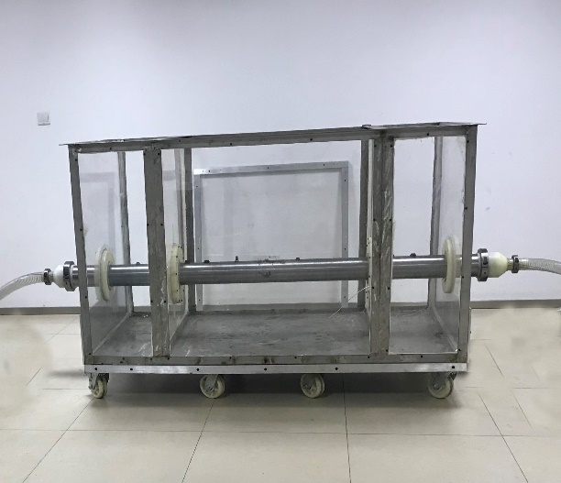

#### Figure 6 Experimental pipeline set up

|  |  |
| --- | --- |
| Quantity | Values |
| Leak radius *a* (mm) | 0.5, 1, 1.5, 2, 2.5 |
| Pipe pressure *P*2 (MPa(G)) | 0.1, 0.15, 0.2, 0.25, 0.3 |

#### Table 1. Leak radii and pipe pressure investigated experimentally

## **Comparison of measured and predicted in-pipe pressure spectrum**

*6.1. Leak exit velocity U*

The simple analytic model for the leak spectrum proposed in Section 4 requires the speed *U* with which the leak exits the orifice. The exit velocity *U* can be estimated from a simple mathematical model of the mass flow rate *Q* of gas through a leak orifice of radius *a*, and velocity *U*, , derived by Wang et al [23] and Montiel et al [24]. Two different expressions are derived depending on whether the pressure in the pipe *P*2 is below or above the critical pressure *Pcr* at which the flow is sonic, given by,



where *C*0 is the leakage coefficient of gas,  is the area of pipeline leakage point, *M* is the molar mass of gas, *R* is the gas constant, *T*2 is the temperatures in the pipe, ** is the adiabatic exponent of gas, *P*a is the atmospheric pressure, and  is the critical pressure. The exit velocities under different pressure calculated by the model are as follows

|  |  |  |  |  |  |
| --- | --- | --- | --- | --- | --- |
| Pipe pressure (MPa(G)) | 0.1 | 0.15 | 0.2 | 0.25 | 0.3 |
| Exit velocity *U*(m/s) | 175.51 | 219.39 | 263.27 | 307.15 | 351.03 |

Table 2. Predicted relationship between exit velocity *U* and pipe pressure

The exit flow speed is therefore predicted to be close to sonic at the highest pressure under investigation in this paper.

*6.2. Comparison of spectra*

The measured sound pressure level spectrum is plotted in figures 7a to e for the 5 pipe pressures of 0.1MPa, 0.15MPa, 0.2MPa, 0.25MPa and 0.3MPa respectively for the sensor 300mm from the leak location. Each figure shows the spectra for the five leak orifice radii *a* of 0.5, 1.0, 1.5, 2.0 and 2.5mm. Whilst the spectra were measured up to 2kHz they are plotted up to 200Hz. Above this frequency the spectra generally fall into the background noise and are therefore not plotted. Each spectrum can be observed to exhibit a number of oscillations whose peaks are independent of leak orifice radius of pipe pressure and are therefore associated with axial acoustic resonances in the pipe system. Nevertheless, the general shape of the pressure frequency spectrum is clearly seen.

Also shown in these figures is their corresponding predicted pressure spectra obtained from Eq. (17), shown as dashed curves. Note that to allow comparison with the measured data we have converted the theoretical spectrum from radian frequency to Hertz using the identity . The turbulence parameters of turbulence intensity and integral length-scale ☹ are unknown and were therefore chosen to provide the best fit to the measured data. Values of 0.5% turbulence intensity (i.e., ) and a length-scale of ☹ = 100*R* were chosen for all the predictions presented in this paper. This value of turbulence integral length-scale is rather large and suggests that, assuming the correctness of the isotropic turbulence assumption, the source of turbulence at the leak orifice is due to stretching of large turbulent eddies upstream of the leak orifice. However, we also acknowledge that this assumption may be incorrect in which case more work is needed to establish the source of turbulence at the leak orifice to determine the leak velocity spectrum.

Using these values of turbulence intensity and integral length-scale the measured spectral shapes can be observed to be well captured by the theoretical model of Eq. (17).

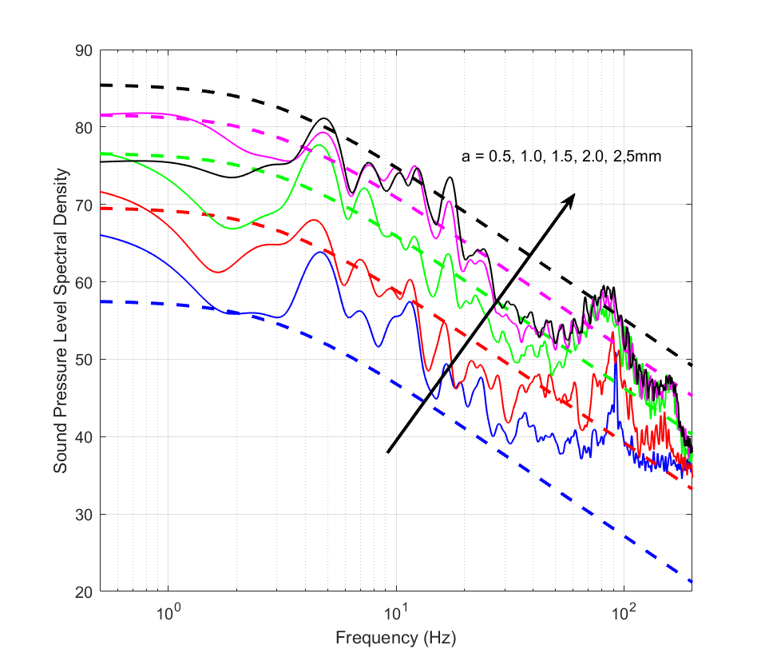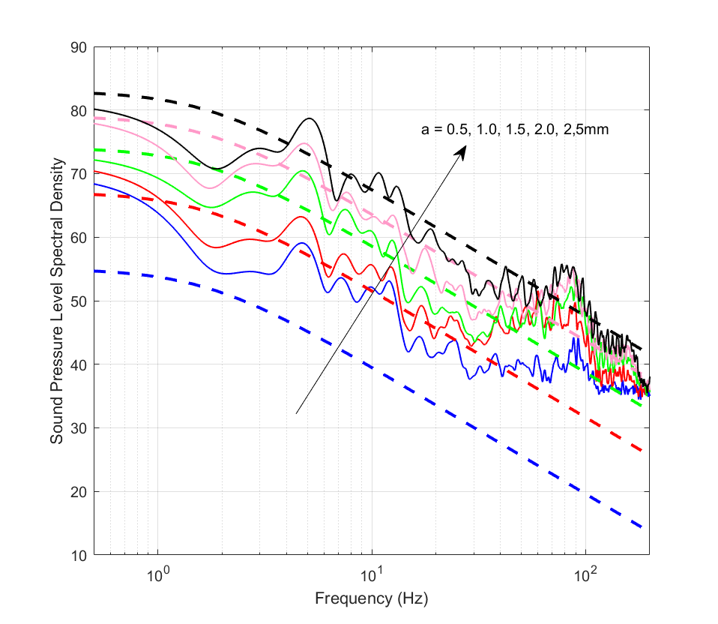

|  |  |
| --- | --- |
|  |  |

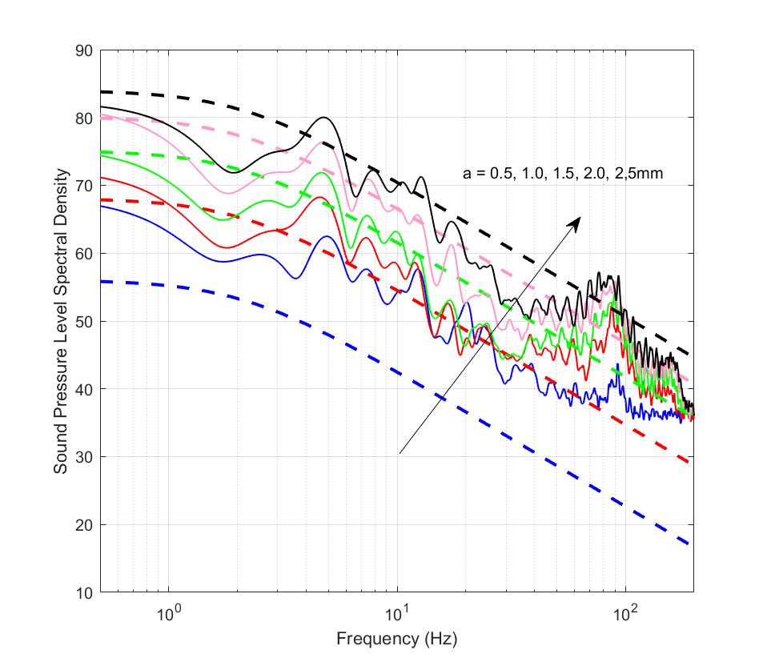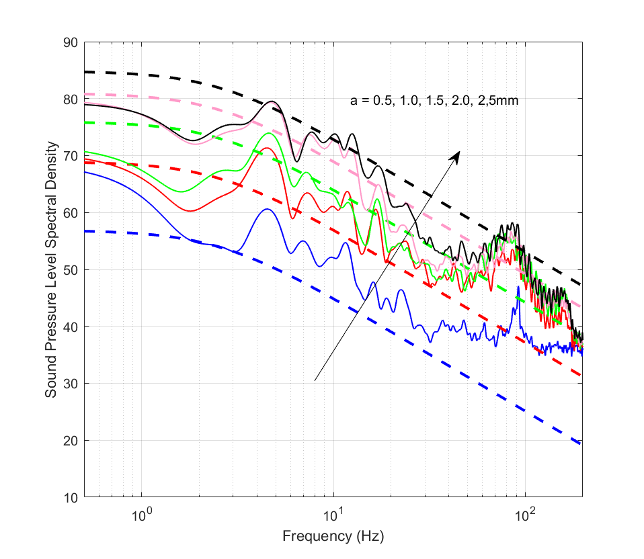

|  |  |
| --- | --- |
|  |  |

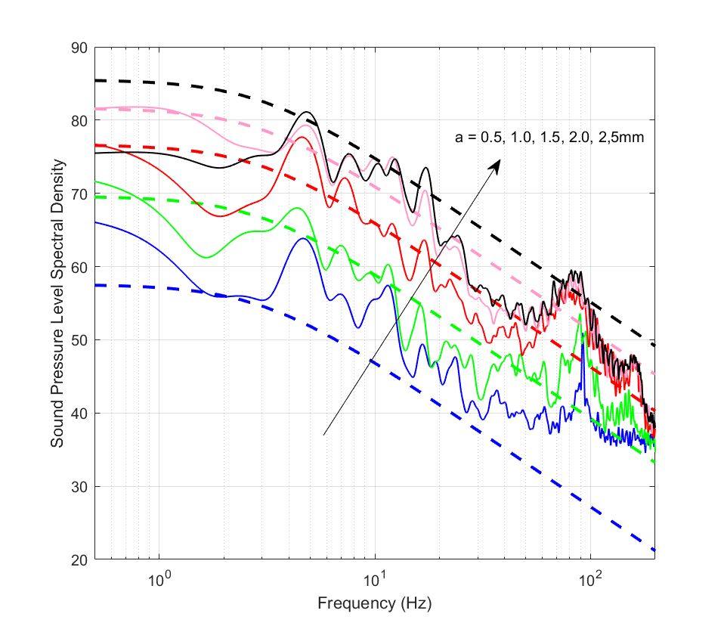

 

Figure 7. Comparison of sound pressure level spectrum for five different leak orifice radii of 0.5, 1, 1.5, 2 and 2.5mm at a pressure of (a) 0.1MPa, (b) 0.15MPa (c) 0.20MPa (d) 0.25MPa (e) 0.3MPa.

1. **Overall sound pressure levels**

*7.1. Effect of leak orifice radius a.*

The theoretical analysis in Section 4 predicts that the overall mean square pressure varies as the leak orifice radius to the fourth power. This is an important result as it suggests that small leaks are disproportionately much more difficult to detect than larger ones. In order to validate this prediction the experimental spectra plotted in figures 7a to 7e were integrated over all frequency to determine  and the results compared against the theoretical expression of Eq. (18). The comparison is shown separately below in figures 8a, b and c plotted against leak radius *a* for the three pressures of 0.1, 0.2 and 0.3MPa.

|  |  |
| --- | --- |
|  |  |

|  |  |
| --- | --- |
|  |  |
| (a) | (b) |
|  |  |
| (c) | (d) |
|  | |
| （e） | |

Figure 8. Comparison of measured Overall Sound Pressure Level versus leak orifice radii with predictions obtained from Eq. (18) at a pressure of (a) 0.1MPa, (b) 0.15MPa (c) 0.20MPa (d) 0.25MPa (e) 0.3MPa.

Agreement at the smallest leak radius of 0.5mm is generally the worst with discrepancies of up to 10dB being observed. However, the experimental and theoretical values can be seen to converge as the leak radius is increased with the *a*4 dependence being clearly observed in the experimental data. A smaller gradient closer to *a*3 is apparent in the experimental data for the smallest values of *a*. A *a*3–scaling law was also observed in the leak noise measurements of Papastefanou [15]. The reason for this discrepancy at small *a* values is currently not known but may be related to viscosity effects and the breakdown of the validity of Eq. (16) for the leak velocity spectrum. High fidelity, eddy-resolving CFD simulations are needed to verify this hypothesis.

Whilst the model is able to capture the general trends in the measured noise spectra, particularly in relation to the scaling with leak velocity *U*, radius *a*, and spectral shape, there appears to be a systematic bias in the predicted spectra at very small leak radii. For *a* < 2mm, predictions are observed to be up to 10dB lower than measured values. We speculate that the main reason for this under prediction is an incorrect choice of mean square velocity $\overline{u^{2}}$, which we obtain by assuming a constant 0.5% turbulence intensity, i.e. . The data would therefore suggest that the turbulence intensity increases for small leak radius and we note that excellent agreement for the smallest leak radius *a* = 0.5mm could have been obtained by assuming .

* 1. *Velocity scaling law*

Finally, overall noise is now plotted against velocity to confirm the theoretical *U*2 velocity power-law predicted by the theoretical model in Section 4. Figure 9 shows a comparison of the overall Sound Pressure Level versus estimated convection speed for the five leak orifice radii.



Figure 9. Comparison of Overall Sound Pressure Level versus estimated exit speed at leak radii of *a* =0.5, 1.0, 1.5, 2.0 and 2.5mm compared with predictions obtained from Eq. In general the measured overall noise variation with estimated *U* is well represented by the predicted *U*2 power-law, thereby validating the principal assumption made in this paper that leak noise is generated by the fluctuating velocity at the leak orifice, which are aerodynamic sources of monopole order. The agreement between measured and predicted overall noise is also a validation of the assumption that the turbulence intensity remains roughly constant so that there is proportionality between the *rms* and mean velocities.

1. **Conclusion**

This paper has presented a general theoretical framework for predicting the leak noise spectrum in fluid-filled pipes. Central to the model is the assumption that the source of leak noise is the distribution of the fluctuating normal component of velocity over the leak orifice. A simple relationship has been derived between the leak noise pressure spectrum in the pipe and the velocity spectrum at the leak orifice. Measurements of the leak noise spectrum are also presented from a pipe rig with air under pressure. The variation in noise spectrum was investigated for various orifice diameters and pipe pressures.

A highly idealised velocity spectrum was proposed to fit the measured pressure spectrum based on the assumption that the leak turbulence at the orifice is isotropic and can be fully described by a single value of the turbulence intensity and integral length-scale. This paper has shown that, through appropriate choice of turbulence intensity and length-scale, that the theory can provide acceptable agreement to the measured spectral shape and its variation with leak radius and exit velocity.

The main findings of this paper are that leak noise is predicted to vary as the fourth power of the leak orifice radius. Leak noise varies as the square of the flow speed, which is indicative of the fluctuating velocity at the leak orifice as the principal source of leak noise, which contradicts a number of previous studies which propose fluctuating quadrupole sources as the dominant mechanism. The sound power radiating by the leak varies in inverse proportion to the pipe surface area. This result suggests that the leak source is not power-conserving but is affected by the diameter of the pipe.

# **Acknowledgments**

This work was supported by The National Key Research and Development Program of China（Grant No. 2016YFC0802400）.

**References**

[1] S. Li, Y. Wen, P. Li, J. Yang, X. Dong, Y. Mu, Leak location in gas pipelines using cross-time-frequency spectrum of leakage-induced acoustic vibrations, J. Sound Vib. 333 (2014) 3889–3903. doi:10.1016/j.jsv.2014.04.018.

[2] P.S. Murvay, I. Silea, A survey on gas leak detection and localization techniques, J. Loss Prev. Process Ind. 25 (2012) 966–973. doi:10.1016/j.jlp.2012.05.010.

[3] H. V. Fuchs, R. Riehle, Ten years of experience with leak detection by acoustic signal analysis, Appl. Acoust. 33 (1991) 1–19. doi:10.1016/0003-682X(91)90062-J.

[4] A.F. Colombo, P. Lee, B.W. Karney, A selective literature review of transient-based leak detection methods, J. Hydro-Environment Res. 2 (2009) 212–227. doi:10.1016/j.jher.2009.02.003.

[5] O. Hunaidi, W.T. Chu, Acoustical characteristics of leak signals in plastic water distribution pipes, Appl. Acoust. 58 (1999) 235–254. doi:10.1016/S0003-682X(99)00013-4.

[6] S.C. Huang, W.W. Lin, M.T. Tsai, M.H. Chen, Fiber optic in-line distributed sensor for detection and localization of the pipeline leaks, Sensors Actuators, A Phys. 135 (2007) 570–579. doi:10.1016/j.sna.2006.10.010.

[7] M. Henrie, P.C. Pe, R.E. Nicholas, Pipeline Leak Detection Handbook, 2016. doi:10.1016/c2014-0-01914-4.

[8] L. Meng, L. Yuxing, W. Wuchang, F. Juntao, Experimental study on leak detection and location for gas pipeline based on acoustic method, J. Loss Prev. Process Ind. 25 (2012) 90–102. doi:10.1016/j.jlp.2011.07.001.

[9] Y. Gao, Y. Liu, Y. Ma, X. Cheng, J. Yang, Application of the differentiation process into the correlation-based leak detection in urban pipeline networks, Mech. Syst. Signal Process. 112 (2018) 251–264. doi:10.1016/j.ymssp.2018.04.036.

[10] Y. Gao, M.J. Brennan, P.F. Joseph, J.M. Muggleton, O. Hunaidi, A model of the correlation function of leak noise in buried plastic pipes, J. Sound Vib. 277 (2004) 133–148. doi:10.1016/j.jsv.2003.08.045.

[11] Y.A. Khulief, A. Khalifa, R. Ben Mansour, M.A. Habib, Acoustic Detection of Leaks in Water Pipelines Using Measurements inside Pipe, J. Pipeline Syst. Eng. Pract. 3 (2012) 47–54. doi:10.1061/(ASCE)PS.1949-1204.0000089.

[12] C. Liu, Y. Li, L. Meng, W. Wang, F. Zhang, Study on leak-acoustics generation mechanism for natural gas pipelines, J. Loss Prev. Process Ind. 32 (2014) 174–181. doi:10.1016/j.jlp.2014.08.010.

[13] Q. Xu, L. Zhang, W. Liang, Acoustic detection technology for gas pipeline leakage, Process Saf. Environ. Prot. 91 (2013) 253–261. doi:10.1016/j.psep.2012.05.012.

[14] H. Jin, L. Zhang, W. Liang, Q. Ding, Integrated leakage detection and localization model for gas pipelines based on the acoustic wave method, J. Loss Prev. Process Ind. 27 (2014) 74–88. doi:10.1016/j.jlp.2013.11.006.

[15] A.S. Papastefanou, P.F. Joseph, M.J. Brennan, Experimental investigation into the characteristics of in-pipe leak noise in plastic water filled pipes, Acta Acust. United with Acust. 98 (2012) 847–856. doi:10.3813/AAA.918568.

[16] M.J. Lighthill, On Sound Generated Aerodynamically. I. General Theory, Proc. R. Soc. A Math. Phys. Eng. Sci. 211 (1952) 564–587. doi:10.1098/rspa.1952.0060.

[17] Y. Shao, T. Yao, J. Gong, J. Liu, T. Zhang, T. Yu, Impact of main pipe flow velocity on leakage and intrusion flow: An experimental study, Water (Switzerland). 11 (2019). doi:10.3390/w11010118.

[18] N. Curle, The Influence of Solid Boundaries upon Aerodynamic Sound, Proc. R. Soc. A Math. Phys. Eng. Sci. 231 (1955) 505–514. doi:10.1098/rspa.1955.0191.

[19] W.K. Blake, Dipole Sound From Cylinders, in: Mech. Flow-Induced Sound Vib. Vol. 1, Elsevier, 2017: pp. 251–322. doi:10.1016/B978-0-12-809273-6.00004-X.

[20] I.S. Gradshteyn, I.M. Ryzhik, Table of Integrals, Series, and Products, Corrected and Enlarged Edition, 1980. doi:10.1017/CBO9781107415324.004.

[21] C.W. Olver, F. W., Lozier, D. W., Boisvert, R. F., & Clark, NIST Handbook of Mathematical Functions, Cambridge University Press, 2010.

[22] H. JO, Turbulence, 2nd ed, McGraw-Hill, New York, 1975.

[23] K. Wang, T. Shi, Y. He, M. Li, X. Qian, Case analysis and CFD numerical study on gas explosion and damage processing caused by aging urban subsurface pipeline failures, Eng. Fail. Anal. 97 (2019) 201–219. doi:10.1016/j.engfailanal.2019.01.052.

[24] H. Montiel, J.A. Vílchez, J. Casal, J. Arnaldos, Mathematical modelling of accidental gas releases, J. Hazard. Mater. 59 (1998) 211–233. doi:10.1016/S0304-3894(97)00149-0.

[1] S. Li, Y. Wen, P. Li, J. Yang, X. Dong, Y. Mu, Leak location in gas pipelines using cross-time-frequency spectrum of leakage-induced acoustic vibrations, J. Sound Vib. 333 (2014) 3889–3903. doi:10.1016/j.jsv.2014.04.018.

[2] P.S. Murvay, I. Silea, A survey on gas leak detection and localization techniques, J. Loss Prev. Process Ind. 25 (2012) 966–973. doi:10.1016/j.jlp.2012.05.010.

[3] H. V. Fuchs, R. Riehle, Ten years of experience with leak detection by acoustic signal analysis, Appl. Acoust. 33 (1991) 1–19. doi:10.1016/0003-682X(91)90062-J.

[4] A.F. Colombo, P. Lee, B.W. Karney, A selective literature review of transient-based leak detection methods, J. Hydro-Environment Res. 2 (2009) 212–227. doi:10.1016/j.jher.2009.02.003.

[5] O. Hunaidi, W.T. Chu, Acoustical characteristics of leak signals in plastic water distribution pipes, Appl. Acoust. 58 (1999) 235–254. doi:10.1016/S0003-682X(99)00013-4.

[6] S.C. Huang, W.W. Lin, M.T. Tsai, M.H. Chen, Fiber optic in-line distributed sensor for detection and localization of the pipeline leaks, Sensors Actuators, A Phys. 135 (2007) 570–579. doi:10.1016/j.sna.2006.10.010.

[7] M. Henrie, P.C. Pe, R.E. Nicholas, Pipeline Leak Detection Handbook, 2016. doi:10.1016/c2014-0-01914-4.

[8] L. Meng, L. Yuxing, W. Wuchang, F. Juntao, Experimental study on leak detection and location for gas pipeline based on acoustic method, J. Loss Prev. Process Ind. 25 (2012) 90–102. doi:10.1016/j.jlp.2011.07.001.

[9] Y. Gao, Y. Liu, Y. Ma, X. Cheng, J. Yang, Application of the differentiation process into the correlation-based leak detection in urban pipeline networks, Mech. Syst. Signal Process. 112 (2018) 251–264. doi:10.1016/j.ymssp.2018.04.036.

[10] Y. Gao, M.J. Brennan, P.F. Joseph, J.M. Muggleton, O. Hunaidi, A model of the correlation function of leak noise in buried plastic pipes, J. Sound Vib. 277 (2004) 133–148. doi:10.1016/j.jsv.2003.08.045.

[11] Y.A. Khulief, A. Khalifa, R. Ben Mansour, M.A. Habib, Acoustic Detection of Leaks in Water Pipelines Using Measurements inside Pipe, J. Pipeline Syst. Eng. Pract. 3 (2012) 47–54. doi:10.1061/(ASCE)PS.1949-1204.0000089.

[12] C. Liu, Y. Li, L. Meng, W. Wang, F. Zhang, Study on leak-acoustics generation mechanism for natural gas pipelines, J. Loss Prev. Process Ind. 32 (2014) 174–181. doi:10.1016/j.jlp.2014.08.010.

[13] Q. Xu, L. Zhang, W. Liang, Acoustic detection technology for gas pipeline leakage, Process Saf. Environ. Prot. 91 (2013) 253–261. doi:10.1016/j.psep.2012.05.012.

[14] H. Jin, L. Zhang, W. Liang, Q. Ding, Integrated leakage detection and localization model for gas pipelines based on the acoustic wave method, J. Loss Prev. Process Ind. 27 (2014) 74–88. doi:10.1016/j.jlp.2013.11.006.

[15] A.S. Papastefanou, P.F. Joseph, M.J. Brennan, Experimental investigation into the characteristics of in-pipe leak noise in plastic water filled pipes, Acta Acust. United with Acust. 98 (2012) 847–856. doi:10.3813/AAA.918568.

[16] M.J. Lighthill, On Sound Generated Aerodynamically. I. General Theory, Proc. R. Soc. A Math. Phys. Eng. Sci. 211 (1952) 564–587. doi:10.1098/rspa.1952.0060.

[17] Y. Shao, T. Yao, J. Gong, J. Liu, T. Zhang, T. Yu, Impact of main pipe flow velocity on leakage and intrusion flow: An experimental study, Water (Switzerland). 11 (2019). doi:10.3390/w11010118.

[18] N. Curle, The Influence of Solid Boundaries upon Aerodynamic Sound, Proc. R. Soc. A Math. Phys. Eng. Sci. 231 (1955) 505–514. doi:10.1098/rspa.1955.0191.

[19] W.K. Blake, Dipole Sound From Cylinders, in: Mech. Flow-Induced Sound Vib. Vol. 1, Elsevier, 2017: pp. 251–322. doi:10.1016/B978-0-12-809273-6.00004-X.

[20] I.S. Gradshteyn, I.M. Ryzhik, Table of Integrals, Series, and Products, Corrected and Enlarged Edition, 1980. doi:10.1017/CBO9781107415324.004.

[21] C.W. Olver, F. W., Lozier, D. W., Boisvert, R. F., & Clark, NIST Handbook of Mathematical Functions, Cambridge University Press, 2010.

[22] H. JO, Turbulence, 2nd ed, McGraw-Hill, New York, 1975.

[23] K. Wang, T. Shi, Y. He, M. Li, X. Qian, Case analysis and CFD numerical study on gas explosion and damage processing caused by aging urban subsurface pipeline failures, Eng. Fail. Anal. 97 (2019) 201–219. doi:10.1016/j.engfailanal.2019.01.052.

[24] H. Montiel, J.A. Vílchez, J. Casal, J. Arnaldos, Mathematical modelling of accidental gas releases, J. Hazard. Mater. 59 (1998) 211–233. doi:10.1016/S0304-3894(97)00149-0.

1. * Corresponding author. Tel.: +86-21-65983526; Fax: +86-21-65986345.

   Email: lijie@tongji.edu.cn (J. Li).